## **Real Time Caption Generation for Visually Impaired**

## 

## 

## 

**BACHELOR OF TECHNOLOGY**

**in**

**COMPUTER SCIENCE & ENGINEERING**

**by**

## 

## 

| **Name** | **Roll no.** |
| --- | --- |
| **Mahi Pahuja** | **R2142221415** |
| **Soumil Jain** | **R2142220943** |
| **Lakshya Aggarwal** | **R2142220338** |
| **Ishaan Kaul** | **R2142220333** |

## 

## 

**under the guidance of**

**Mr. Dhinesh Kumar R**

## 

## 

## 

## 

**School of Computer Science**

**University of Petroleum & Energy Studies Bidholi, Via Prem Nagar, Dehradun, Uttarakhand May – 2025**

**CANDIDATE’S DECLARATION**

We hereby certify that the project work entitled **“Real-Time Caption Generation for the Visually Impaired”**, submitted in partial fulfillment of the requirements for the award of the degree of **Bachelor of Technology in Computer Science and Engineering with specialization in Artificial Intelligence and Machine Learning**, is an authentic record of the work carried out by us during the period **January 2025 to May 2025**.

This project has been completed under the supervision of **Mr. Dhinesh Kumar R**, School of Computer Science, **University of Petroleum and Energy Studies, Dehradun**, and is being submitted to the **AI Cluster, School of Computer Science, University of Petroleum and Energy Studies, Dehradun**.

The matter presented in this project has not been submitted by us for the award of any other degree of this or any other University.

| Lakshya Aggarwal | Ishaan Kaul | Mahi Pahuja | Soumil Jain |
| --- | --- | --- | --- |
| R2142220338 | R2142220333 | R2142221415 | R2142220943 |

This is to certify that the above statement made by the candidate is correct to the best of my knowledge.

Date: 1 May 2025 Mr. Dhinesh Kumar

Project Mentor

**ACKNOWLEDGEMENT**

We wish to express our deep gratitude to our guide Mr. Dhinesh Kumar R, for all the advice, encouragement and constant support he has given us throughout our project work. This work would not have been possible without his support and valuable suggestions.

We sincerely thank our respected Dr. Anil Kumar, Cluster Head, AI Cluster, School of Computer Science, University of Petroleum & Energy Studies, Dehradun, for his great support in doing our project.

We are also grateful to Dean SoCS UPES for giving us the necessary facilities to carry out our project work successfully. We also thank our Course Coordinator and our Activity Coordinator Dr. Sonal Talreja for providing timely support and information during the completion of this project.

We would like to thank all our friends for their help and constructive criticism during our project work. Finally, we have no words to express our sincere gratitude to our parents who have shown us this world and for every support they have given us.

| **Name** | Soumil Jain | Ishaan Kaul | Lakshya Aggarwal | Mahi Pahuja |
| --- | --- | --- | --- | --- |
| **Roll No.** | R2142220943 | R2142220333 | R2142220338 | R2142221415 |

# **Table of Contents**

| **Topic** | | **Page No** |
| --- | --- | --- |
| Table of Content | |  |
| 1 | Introduction | 5 |
|  | 1.1 Purpose of the Project | 5 |
|  | 1.2 Target Beneficiaries | 5 |
| 2 | Abstract | 10 |
| 3 | Real-Time Accessible Image Captioning (Working Model) | 11 |
| 4 | Technical Implementation of Real-Time Vision Assistant | 18 |
| 5 | Comparative Analysis of Visual-Language Models for Real-Time Image Captioning and Accessibility | 25 |
|  | 5.1 CLIP Model | 25 |
|  | 5.2 DenseNet201 + RNN-based Image Captioning Model | 29 |
|  | 5.3 BLIP Model with Fine Tuning (Flickr8k) | 33 |
| 6 | System Requirements | 38 |
|  | 6.1 Functional Requirements | 38 |
|  | 6.2 Non-Functional Requirements | 40 |
| 7 | SWOT Analysis | 43 |
| 8 | Diagram | 46 |
| 8 | FlowChart | 47 |
| 9 | References | 48 |

# 

## **1. Introduction**

### **1.1 Purpose of the Project**

This project aims to develop a real-time, AI-powered vision assistant system that is specifically tailored to meet the needs of visually impaired individuals. The core objective is to bridge the large gap by converting complex visual data from the real world into meaningful auditory information using cutting-edge computer vision and natural language processing (NLP) techniques. Our solution is designed to offer a scalable,effective yet easy to use system, enabling users to independently interact with and understand their surroundings through audio feedback.

The system captures live video feeds using a camera, processes the visual input using a pipeline of AI models with the help of Computer Vision , and translates it into spoken language. This provides users with context-aware auditory descriptions in real time. For instance, a user could ask, “What is in front of me?” or “What does this sign say?” and the system would provide immediate, relevant responses based on the scene being observed.

To enable such functionality, the system leverages the BLIP (Bootstrapping Language-Image Pre-training) model for Visual Question Answering (VQA), which interprets and responds to natural language queries based on the visual context. For reading text in the environment, such as signs or labels, the system integrates EasyOCR, which excels at recognizing printed and handwritten characters across multiple languages.

The supporting components of the system include OpenCV for real-time video capture and frame processing, pyttsx3 for generating spoken output via text-to-speech, and the SpeechRecognition library to handle voice-based commands and queries from the user. This multimodal approach allows for a hands-free, seamless interaction between the user and the environment, promoting ease of use and accessibility.

Ultimately, this solution is designed to enhance mobility, independence, and quality of life by making the visual world accessible through audio. It combines artificial intelligence, computer vision, and user-centric design to deliver a deeply impactful technological aid.

### **1.2 Target Beneficiaries**

This system is designed with inclusivity and accessibility in mind, catering to a broad range of users who can benefit from real-time, AI-driven visual assistance.

#### **1. Visually Impaired Individuals**

The primary beneficiaries of the project are individuals with partial or complete vision loss. By delivering real-time auditory feedback about their surroundings, the system allows visually impaired people to understand their surroundings and navigate their environment more safely and independently. Tasks like identifying people, reading signs, locating objects, or understanding dynamic scenes (like a street crossing) become possible without direct human assistance.

#### **2. Elderly Individuals**

Seniors experiencing age-related vision decline often struggle with everyday activities that involve reading small print, recognizing people, or navigating unfamiliar places. The system serves as a personal visual narrator, interpreting scenes and providing spoken summaries. This can reduce the risk of falls, misreading important information, or feeling disoriented in new settings.

#### **3. Individuals with Cognitive Disabilities**

Certain cognitive conditions can impair a person's ability to process visual data or complex scenes. For such users, converting visual information into simplified spoken language enhances comprehension and decision-making. This auditory format can help them engage more effectively with their environment, improving both confidence and independence.

#### **4. Caregivers and Support Systems**

The tool is also valuable for caregivers and family members who assist individuals with visual or cognitive impairments. By offering consistent, real-time updates about the environment, the system reduces the burden on human helpers and ensures that users are not solely dependent on others for navigation or understanding.

**Motivation:**

Vision impairment affects approximately 285 million people worldwide according to the World Health Organization, with 39 million classified as blind. For these individuals, accessing and interpreting visual information presents a significant daily challenge that impacts nearly every aspect of life. Our real-time image captioning project addresses this fundamental need through innovative technology, creating a bridge between the visual world and those who cannot fully access it through sight.

## **Addressing a Critical Need:**

The motivation for this project is deeply rooted in providing a better quality of life and digital inclusivity. Visual content has become increasingly prevalent in our digital ecosystem—from educational materials and workplace documents to social media and entertainment. Without accessible alternatives, visually impaired individuals face systematic exclusion from these information sources. Our image captioning system transforms inaccessible visual data into comprehensible audio descriptions, democratizing access to information that sighted individuals take for granted.

## **Beyond Basic Accessibility:**

Traditional accessibility solutions often provide only rudimentary descriptions or rely on manual input from sighted individuals. Our project represents a significant advancement by leveraging artificial intelligence to generate rich, contextual descriptions automatically. This automation not only improves the quality of information available but also promotes independence and dignity by reducing reliance on assistance from others.

## **Real-Time Processing: A Game-Changer**

The real-time video frame processing capability of your system represents a particularly innovative aspect. While static image captioning tools have existed, extending this functionality to video creates opportunities for:

* **Dynamic environmental awareness**: Helping users understand changing scenes around them
* **Navigation assistance**: Providing information about obstacles, pathways, and environmental features
* **Social interaction support**: Describing facial expressions, gestures, and group dynamics in real-time
* **Immediate object identification**: Recognizing and naming items as they appear in the field of view

## **Technological Inclusivity:**

By adapting your implementation to function without specialized GPU hardware, we have addressed not only accessibility for users but also accessibility of the technology itself. This approach aligns with the ethos of assistive technology development—creating solutions that can reach those who need them most, regardless of economic constraints or technical infrastructure limitations.

## **Psychological and Social Impact:**

The benefits of your system extend beyond mere information access into profound psychological and social domains:

* **Reducing social isolation**: Enabling participation in visually-oriented conversations and activities.
* **Enhancing confidence**: Providing users with information that helps them navigate unfamiliar environments independently without seeking help.
* **Improving educational outcomes**: Making visual learning materials accessible to visually impaired students.
* **Workplace inclusion**: Enabling professionals with visual impairments to engage with visual documents and presentations.

## **Technological Innovation with Human Impact:**

Our project exemplifies how cutting-edge technological innovations in computer vision and natural language processing can be harnessed for profound human impact. It justifies that advancement in artificial intelligence need not remain technological achievements but can be directed toward solving real, pressing human needs. By combining image recognition, natural language generation, and speech synthesis, we have created a multifaceted system that transforms raw visual data into meaningful, spoken information.

## **Future Potential:**

Beyond its immediate applications, this project lays groundwork for further innovations in assistive technology. The foundation you've built could potentially extend to:

* Scene understanding with spatial relationship descriptions
* Recognition of specific individuals familiar to the user
* Custom vocabulary development for specialized environments (workplaces, educational settings)
* Integration with other assistive technologies to create comprehensive accessibility ecosystems.

## **2. Abstract:**

Vision impairment affects over 285 million people globally, significantly limiting access to vital visual information in daily life. This project introduces a **real-time, AI-powered vision assistant system** designed to bridge the gap between sight and perception for visually impaired individuals. By integrating state-of-the-art models such as **BLIP for Visual Question Answering**, and **EasyOCR for text reading**, the system transforms live visual data into meaningful audio output. Supported by **OpenCV** for video processing, **pyttsx3** for voice output, and **SpeechRecognition** for voice input, the assistant delivers context-sensitive, spoken descriptions of the environment in real time.

Unlike traditional accessibility tools that rely on manual input or static descriptions, this system autonomously interprets and narrates complex, dynamic scenes—empowering users with enhanced **mobility**, **independence**, and **digital inclusion**. The design prioritizes low computational requirements, ensuring broad accessibility without the need for specialized hardware. With applications spanning from navigation and object detection to social interaction support and educational inclusion, the project not only meets a critical accessibility need but also demonstrates the human-centered potential of artificial intelligence. Future developments include spatial scene understanding, personalized recognition, and seamless integration into wider assistive ecosystems, reinforcing the project's foundation as a transformative step toward inclusive technology.

# **3. Real-Time Accessible Image Captioning System(Working Model):**

### **Introduction:**

In today’s visually dominated digital environment, individuals with visual impairments encounter significant challenges when accessing and interpreting visual data. Our **Real-Time Image Captioning System** addresses this critical accessibility gap through a seamless blend of computer vision, natural language processing, and text-to-speech technologies. Designed with both functionality and accessibility in mind, the system transforms visual inputs—captured through a webcam—into meaningful spoken descriptions, enabling visually impaired users to perceive and interact with their surroundings in real time.

### **1. System Architecture Overview**

The system is modular, with each component performing a specialized function. The key modules include:

| **Module** | **Tool/Library Used** | **Function** |
| --- | --- | --- |
| Image Acquisition | OpenCV | Captures live video frames |
|  |  |  |
| Visual Question Answering | BLIP | Answers image-based questions |
| Text Detection | EasyOCR | Extracts readable text from images |
| Voice Input | SpeechRecognition | Captures and transcribes user queries |
| Voice Output | pyttsx3 | Converts textual output to speech |
|  |  |  |

### **2. Input and Output Workflow**

* **Input:**
  + Real-time video frames via webcam
  + Voice commands or questions from the user
* **Processing:**
  + Frames are sent to BLIP/EasyOCR based on the context
  + Voice commands are processed via SpeechRecognition
  + Textual insights (e.g., object names, answers, or extracted text) are generated
* **Output:**
  + Audio descriptions via pyttsx3
  + Answers to questions or live environment commentary

### **3. Detailed Module Flow**

#### **3.1. OpenCV (Video Input)**

* Captures frames in real-time and forwards them to other modules.
* Adjusts to lighting conditions and frame rates.

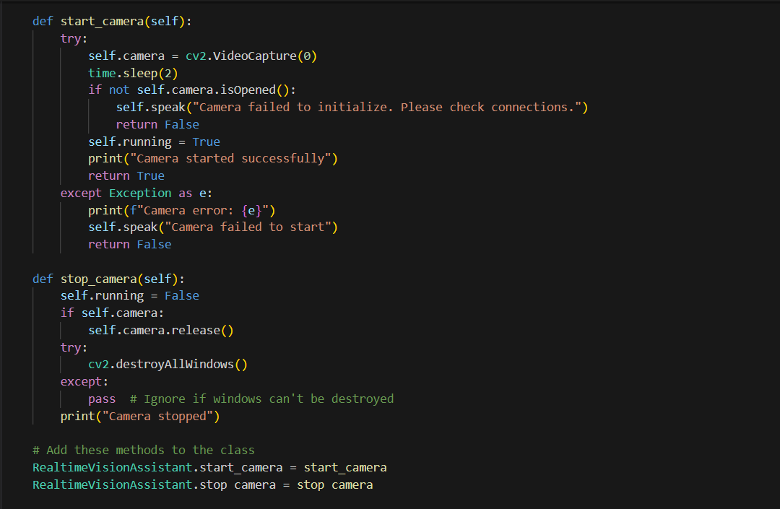

#### **3.2 BLIP (Visual Question Answering)**

* Accepts an image and a voice-transcribed question.
* Returns human-like, context-aware answers.
* **Diagram Suggestion:** Frame + Voice (as Text) → BLIP → Natural Language Answer → TTS

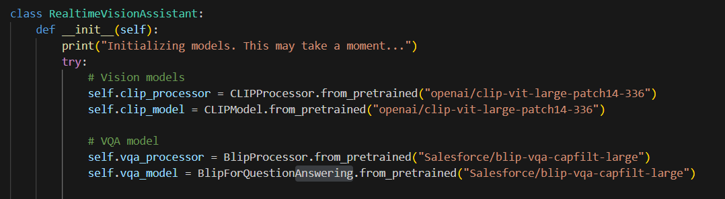

#### **3.3. EasyOCR (Text Reading)**

* Extracts text (e.g., signs, labels) from frames.
* Supports multiple languages and fonts.
* **Diagram Suggestion:** Frame → EasyOCR → Extracted Text → TTS  
  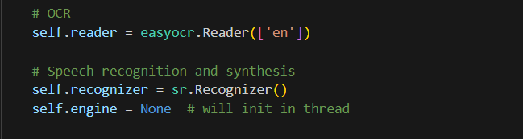

#### **3.4. Speech Recognition (Voice Input)**

* Listens for queries or commands and converts them to text.
* Interprets questions for VQA or commands for OCR/CLIP.

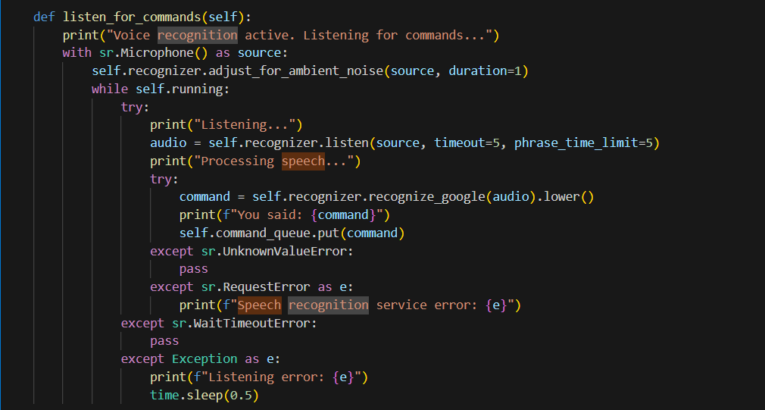

#### **3.5. pyttsx3 (Voice Output)**

* Converts textual results (objects, text, or VQA answers) into audio.

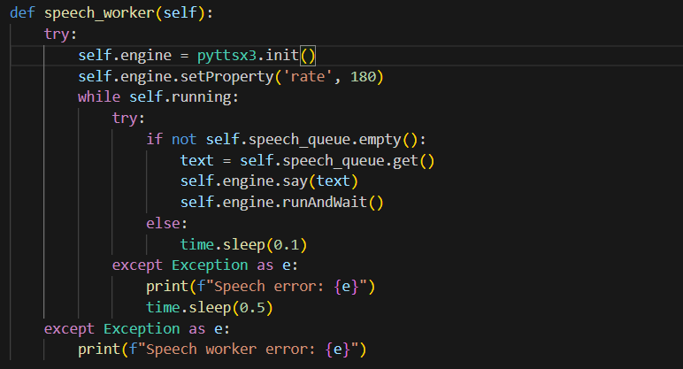

### **4. Advantages and Limitations**

**Advantages:**

* Real-time feedback.
* Multimodal interaction (visual + audio).
* Offline capabilities (TTS).
* Modular and extensible.

**Limitations:**

* GPU required for optimal performance in case we
* OCR/text detection sensitive to orientation and light.
* Voice recognition requires stable internet (Google API).
* No bounding boxes or localization for objects yet.

### **5. Future Enhancements**

* **LLaVA Integration:** For richer multimodal understanding.
* **Bounding Boxes + Tracking:** Add object localization.
* **Offline Speech Recognition:** Enhance offline usage.
* **Navigation & Path Guidance:** Real-time obstacle avoidance.
* **User Profiles & Preferences:** Personalized interaction.

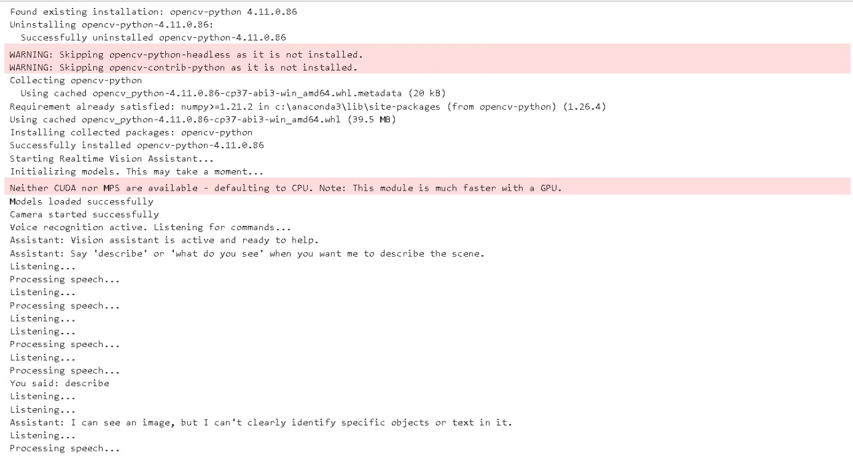

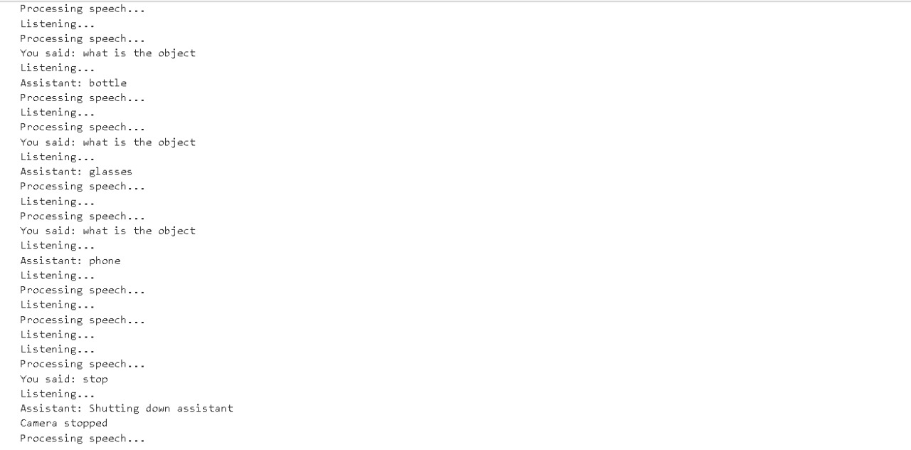

# 

# **4. Technical Implementation of the Real-time Vision Assistant:**

## **1. System Architecture Overview**

The Real-time Vision Assistant is implemented as a comprehensive Python application designed to provide real-time visual interpretation for visually impaired users. The architecture follows a **monolithic class-based design**, encapsulated in the RealtimeVisionAssistant class. This simplifies state management but may limit modularity.

The system uses a **multithreaded approach** to handle concurrent tasks:

* **Main thread**: Handles camera input and coordination
* **Speech synthesis thread**: Manages text-to-speech output
* **Voice command thread**: Continuously listens for voice input

These threads **communicate via thread-safe queues**, enabling real-time responsiveness without blocking.

## **2. Component Initialization and Setup**

Initialization occurs in the __init__ method and includes:

### **2.1 Model Loading**

* **CLIP**: Zero-shot object recognition
* **BLIP**: Visual question answering
* **EasyOCR**: Text detection

All models are loaded with **pre-trained weights** and default configurations.

### **2.2 Speech and Command Setup**

* Configures **speech recognition**
* Prepares **speech synthesis engine**

### **2.3 Object Lists**

* **30 common object classes**
* **7 prioritized "important objects"**

### **2.4 State Initialization**

* **Frame tracking**
* **Timestamps** for rate-limiting
* **Mode flags**: auto-describe, verbosity, etc.

Error handling ensures critical failures are reported and stop system startup if necessary.

## **3. Visual Processing System**

### **3.1 Camera Management**

Implemented via **OpenCV’s VideoCapture**, accessing the default camera:

* **start_camera**:  
  + Opens camera and waits 2 seconds
  + Validates camera readiness
  + Updates system flags
* **stop_camera**:  
  + Releases camera
  + Closes OpenCV windows
  + Ensures hardware cleanup

### **3.2 Frame Processing Pipeline**

The run() method orchestrates the pipeline:

* Continuously captures and updates current frames
* Displays frame (with display error handling)
* Processes voice commands (if available)
* Auto-describes scene based on time interval

#### **Performance Optimizations:**

* Retains only the **latest frame**
* Adds a small **sleep interval (50ms)**
* Rate-limits auto-descriptions
* Avoids processing when idle

## **4. BLIP-Based Visual Question Answering**

Implemented in the answer_question method:

### **4.1 Workflow**

* Validates current frame
* Converts frame to **PIL Image (RGB)**
* Detects **question types**:  
  + Description → routed to description generator
  + Text reading → routed to OCR
  + Other → passed to BLIP model
* **Generates answer (max 50 tokens)**
* Adds context prefix for short answers
* Converts text to speech output

### **4.2 Special Routing**

* Uses **routing logic** to optimize user interaction
* Contextualizes answers beyond object labels

## **5. EasyOCR-Based Text Recognition**

Implemented in the detect_text method:

* Verifies image as **NumPy array**
* Runs through **EasyOCR reader**
* Filters results with **0.3 confidence threshold**
* Returns list of detected texts

Used in both:

* Scene descriptions
* Direct user requests (e.g., “read the sign”)

## **6. Speech Synthesis System**

Composed of:

* **speak() method**: Queues speech tasks
* **speech_worker() thread**: Processes queue

### **6.1 Speech Worker Design**

* Initializes **pyttsx3 engine**
* Processes speech **sequentially**
* Avoids overlapping messages
* Handles synthesis errors gracefully

This **queue-based** design preserves **order and coherence** during rapid responses.

## **7. Automatic Description and Rate Limiting**

### **7.1 Auto-Description Feature**

Controlled by auto_describe flag and implemented in analyze_current_frame:

* Checks **time elapsed** since last description
* Only processes if **interval threshold** is passed
* Allows **manual override**
* Speaks out the generated description

Default interval: **3 seconds**

### **7.2 Rate Limiting Strategy**

* Based on **timestamps**, not frame counts
* Adjustable using analysis_interval
* Allows **adaptive processing**:  
  + Reduces load
  + Avoids user overwhelm
  + Remains responsive for manual requests

## **8. Error Handling and Robustness**

### **8.1 Comprehensive Exception Management**

Handled across all components:

* **Model loading**: Reports and halts on critical issues
* **Camera usage**: Validates and provides user feedback
* **Voice recognition**: Handles network/microphone errors
* **Inference and TTS**: Fail gracefully without full system crashes

### **8.2 Graceful Degradation Patterns**

Ensures continued functionality even when subsystems fail:

* Skips failed **frame displays**
* Returns empty results for **recognition issues**
* Logs **speech errors** without stopping
* Retries **frame capture** on failure

### **8.3 Resource Management**

Carefully implemented:

* Acquires/releases **camera and display**
* **Cleanup via exception blocks**
* Sleep intervals prevent **CPU overload**

# **5. Comparative Analysis of Vision-Language Models for Real-Time Image Captioning and Accessibility:**

This section details our systematic approach to developing an effective image captioning system for visually impaired users. We explored multiple models with varying architectures, capabilities, and resource requirements to identify the optimal solution. Our methodology involved implementing, testing, and evaluating four distinct approaches before finalizing our system.

## **5.1. CLIP Model:**

### **Description**

**CLIP (Contrastive Language–Image Pretraining)** is a transformative multimodal model developed by OpenAI that learns to understand visual concepts in the context of natural language. Unlike traditional supervised models that rely on manually labeled datasets, CLIP was trained on a **massive dataset of 400 million image–text pairs** collected from the internet. It leverages **contrastive learning**, which teaches the model to bring matching image and text representations closer together in a shared embedding space, while pushing apart mismatched pairs.

CLIP is composed of two main components:

* A **vision encoder** (typically a Vision Transformer (ViT) or ResNet) that converts images into embeddings.
* A **text encoder** (based on a Transformer architecture) that converts textual prompts or captions into corresponding embeddings.

In our system, we adopted **CLIP’s zero-shot classification capability** to perform **image captioning** without explicitly training the model on a captioning dataset. The image is first encoded, and then compared against a set of **predefined candidate captions**. The caption whose embedding is **most similar** to the image embedding (using cosine similarity) is selected as the output.

This approach allows for **immediate caption generation** without the need for extensive supervised training, making it an ideal starting point for initial system prototyping and experimentation.

### **Why This Model Was Used:**

CLIP was selected for our early-stage model testing for several compelling reasons:

* **Zero-Shot Capability**: CLIP does not require additional domain-specific training. This makes it highly attractive for rapid prototyping, especially when labeled training data (such as image-caption pairs) is scarce or unavailable.
* **Strong Generalization**: Due to its pre-training on a massive and diverse dataset, CLIP exhibits robust understanding of an extensive range of objects, scenes, and activities. It can recognize uncommon or complex items without prior exposure in a specific dataset.
* **Ease of Implementation**: CLIP offers out-of-the-box usability. By using only the pre-trained weights and a curated set of text prompts or caption candidates, we were able to deploy a functioning prototype with minimal engineering effort.
* **Multimodal Representation**: The shared embedding space enables semantic matching between images and natural language, a key requirement for any assistive captioning system.

### **Advantages:**

* **Versatility** CLIP is designed to handle a wide variety of image types—natural scenes, objects, activities, even abstract visuals—without requiring specialized retraining for each domain.
* **Contextual Understanding** The model demonstrates strong semantic comprehension, allowing it to pick the most relevant caption among a list of candidates. This understanding is deeper than just object detection—it can associate context, actions, and interactions in the scene.
* **Efficiency in Development** Since no additional captioning-specific training is required, CLIP significantly reduces development time and computational costs during the initial experimentation phase.
* **Multimodal Learning** CLIP’s joint image–text embedding space allows for a rich representation of visual and textual content. This is particularly useful for retrieval-based captioning methods, where images can be matched with a dynamic or curated caption set.

### **Disadvantages:**

* **Limited Caption Granularity** CLIP doesn’t generate captions from scratch. Instead, it chooses the best-matching caption from a pre-written list. This restricts the **descriptive granularity** of outputs—it can miss nuances in the image if the correct phrase is not among the candidates.
* **High Computational Demand** Although inference is relatively efficient, the **full CLIP model is large**, and the vision encoder, especially the ViT-Large variant, requires **significant GPU memory**. This may limit its use on mobile or edge devices, which are important for real-time assistive applications.
* **Lack of Customization** The model is not fine-tuned on our target use case (visually impaired assistance), which means it might not prioritize accessibility-related language such as color cues, object placement, or navigational information.

**Use Case Assessment: CLIP for Visually Impaired Assistance:**

In the context of assistive technologies, CLIP provides an excellent **baseline model** due to its speed and generalization. However, its **captioning strategy is too constrained** for real-world deployment in accessibility scenarios. Visually impaired users require captions that are not only accurate, but also **rich in detail, orientation, and context**—for instance, "A man walking on a sidewalk to the right of a red car parked near a tree," rather than "A man walking."

Thus, while CLIP served as a valuable **proof-of-concept tool**, it lacks the **narrative flexibility** and **contextual tailoring** that advanced models like BLIP or transformer-based image captioning systems can provide.

### **Conclusion**

CLIP’s innovative architecture and zero-shot capabilities enabled a fast and robust start to our exploration of image captioning models. However, due to its limitations in sentence generation, customization, and caption specificity, it is best suited for **preliminary testing or retrieval-based tasks** rather than as a final solution for assistive image captioning. It informed our design choices and helped benchmark the performance and usability of more advanced generative models that followed in our pipeline.



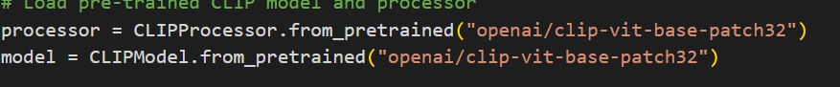

## **5.2. DenseNet201 + RNN-based Image Captioning Model**

### **Description**

The DenseNet201 + RNN image captioning model is a two-part architecture combining a **CNN-based feature extractor** and an **RNN-based sequence generator**, built to generate descriptive captions for images. This architecture represents a **"encoder-decoder" model**, where the encoder processes the image to extract semantic features, and the decoder learns to generate a sequence of words based on those features.

* **Encoder (DenseNet201)**:  
  We use a pre-trained DenseNet201, a state-of-the-art convolutional neural network (CNN), as the image feature extractor. By removing the final classification layer and tapping into the penultimate layer, the model outputs high-level visual embeddings representing the core features of each image.
* **Decoder (LSTM with Embedding + Dense layers)**:  
  The decoder is a recurrent neural network (RNN), typically based on LSTM (Long Short-Term Memory), which takes the image feature and the partial caption as input and learns to predict the next word in the sequence.  
   During training, we use teacher forcing by feeding ground-truth partial captions and predicting the next word token using **categorical cross-entropy loss**.
* **Training Data Generator**:  
   A custom CustomDataGenerator is used to dynamically create input-output pairs. For each image-caption pair:  
  + The image is encoded once using DenseNet201.
  + The caption is tokenized and split into (input_seq, output_word) pairs for supervised learning.

### **Why This Model Was Used**

The DenseNet201 + RNN-based approach was chosen for its strengths in **learning fine-grained visual details** and **generating free-form text**, especially in contexts requiring tailored, custom captions:

* **Strong Feature Extraction**:  
   DenseNet201, due to its dense connectivity between layers, captures rich spatial and semantic features from the image, outperforming simpler CNNs in many visual tasks.
* **Customizable Text Generation**:  
   Unlike CLIP, which only selects from fixed captions, this model *generates* unique captions tailored to each image using an RNN, enabling greater flexibility and detail.
* **End-to-End Trainability**:  
   This architecture is trainable on any paired image-caption dataset (like MSCOCO or Flickr8k), allowing domain adaptation (e.g., for visually impaired applications).

### **Advantages:**

* **Detailed Captions**:  
   Since the model learns to generate captions word by word, it can describe specific objects, actions, and scenes in detail not possible with retrieval-based models like CLIP.
* **Trainable and Adaptable**:  
   You can fine-tune this model on any custom dataset to focus on accessibility-specific language, such as spatial cues, color descriptors, and object relationships.
* **Sequence Learning Capabilities**:  
   LSTM-based decoders are well-suited for modeling temporal dependencies in language, making them ideal for generating grammatically coherent sentences.

### **Disadvantages:**

* **Training Complexity**:  
   Requires a large number of image-caption pairs and computational resources for training. Data augmentation and preprocessing are essential to prevent overfitting.

* **Longer Inference Time**:  
   Unlike zero-shot models, this model generates captions token by token, which increases inference latency—especially for real-time applications.
* **Sequential Limitations**:  
   LSTMs generate one word at a time, making it difficult to capture global sentence structure as effectively as newer transformer-based architectures like BLIP or ViLT.
* **Dependence on Vocabulary**:  
   The model can only generate words that exist in the vocabulary built during training. Unknown or rare words can be omitted or misrepresented.

### 

### **Use Case Assessment: Assistive Captioning for Visually Impaired**

For visually impaired assistance, this generative model provides key benefits over retrieval-based models:

* **Context-Rich Descriptions**:  
   It can generate contextual phrases like “A child sitting on a yellow slide next to a red swing” rather than selecting generic labels like “A child playing.”
* **Extensible Vocabulary**:  
   By expanding the training dataset or tuning the tokenizer, the model can be taught to use language focused on navigation, object placement, or auditory cues.
* **Custom Training**:  
   We can fine-tune on datasets labeled specifically for visually impaired users to improve relevance (e.g., emphasizing relative directions, warnings, or actions).

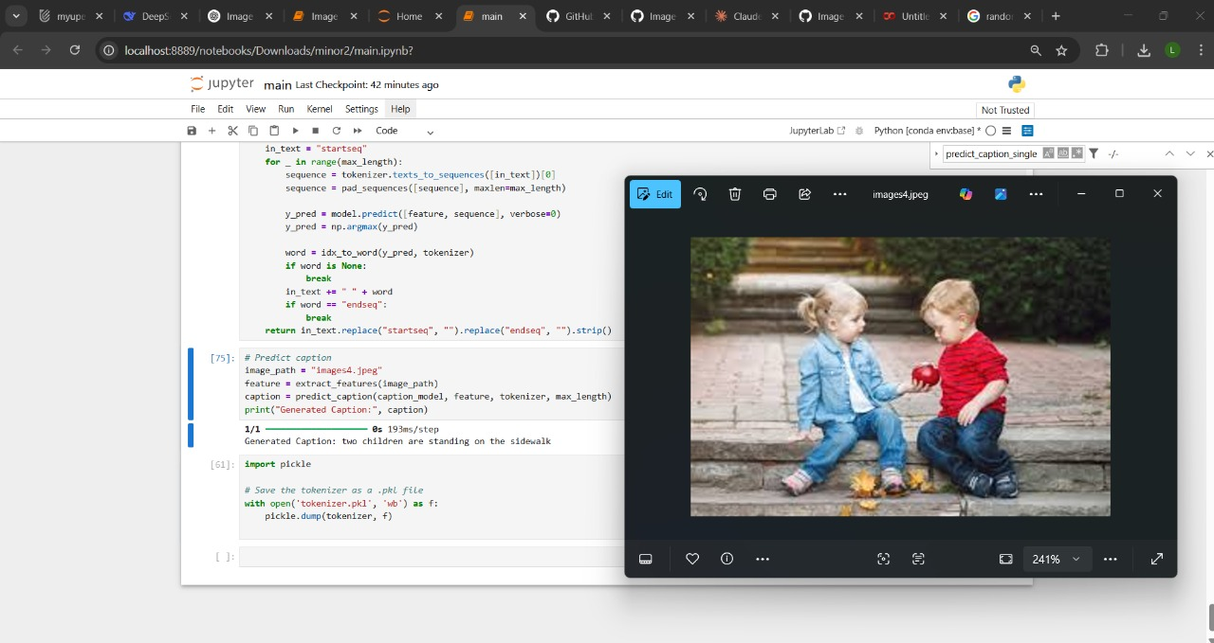

### **5.3. BLIP Model with Fine Tuning (flickr 8k)**

### **Description**

BLIP (Bootstrapping Language-Image Pre-training) is a state-of-the-art multimodal architecture developed by Salesforce Research, designed to bridge the gap between image understanding and natural language generation. Unlike earlier models that used a combination of Convolutional Neural Networks (CNNs**) and Recurrent Neural Networks (RNNs), BLIP employs transformer-based encoders and decoders for both image and text modalities, allowing it to generate captions with remarkable contextual understanding and fluency.**

BLIP is pre-trained using a multi-task learning paradigm that includes:

* Image-Text Contrastive Learning: Aligns vision and language representations in a shared embedding space.
* Image-Text Matching: Trains the model to determine whether a given image-text pair matches.
* Caption Generation: Enables the model to produce natural language descriptions based on the image content.

The vision encoder (usually a Vision Transformer, or ViT) extracts high-dimensional visual embeddings, which are then fed into a text decoder (a Transformer-based language model) that generates descriptive captions.

### **Implementation:**

In our system, we implemented the BLIP model using pre-trained weights provided by Salesforce, and fine-tuned it on the Flickr8k dataset—a curated set of 8,000 images, each with five human-annotated captions.

Purpose of Fine-Tuning

The goal of fine-tuning was to:

* Adapt the general capabilities of BLIP to the specific types of scenes and objects commonly encountered by visually impaired users.
* Improve caption specificity, including spatial relationships, object attributes, and contextual nuances (e.g., "A child playing under a red umbrella").
* Ensure that the captions align with real-world environments, making them more helpful and meaningful for accessibility scenarios.

**Fine-Tuning Details:**

* Epochs: Multiple epochs of fine-tuning were conducted to ensure convergence.
* Loss Function: Cross-entropy loss for caption generation, combined with contrastive loss for semantic alignment.
* Hardware: Due to the model's computational demands, training was limited by the available CPU resources, with limited GPU availability.

### **Why This Model Was Used:**

We selected BLIP with fine-tuning as a key component of our methodology for the following reasons:

* Transformer-Based Architecture: BLIP uses the Vision Transformer (ViT) and a Transformer decoder, providing significantly improved representational power and attention-based context modeling compared to CNN-RNN combinations.
* Semantic Richness: The model has a deep understanding of the semantic and spatial relationships within an image, making it well-suited for generating high-quality, informative captions.
* Caption Generation Capability: Unlike CLIP, which selects from predefined captions, BLIP is a generative model—it can craft grammatically correct, coherent, and visually grounded captions.
* Fine-Tuning Flexibility: BLIP allows customization via fine-tuning, enabling us to tailor the model's focus to specific scenarios, such as assisting visually impaired users by highlighting orientation cues, object details, and action descriptions.

### **Advantages:**

* Superior Caption Quality  
   BLIP produces highly descriptive and fluent captions that often include important details such as object color, position, and interactions (e.g., "A man in a blue jacket standing next to a bicycle"). This is especially beneficial for visually impaired users who depend on detailed and context-aware information.
* Better Understanding of Relationships  
   The attention mechanisms in the Transformer architecture allow the model to capture complex relationships between multiple objects, their positions, and actions—something traditional LSTM-based models often struggle with.
* Transfer Learning Benefits  
   Even with limited data (Flickr8k), BLIP’s robust pretraining on larger datasets ensures that it can perform well in downstream tasks with minimal fine-tuning.
* Customizability for Accessibility  
   By fine-tuning on specific datasets or adding synthetic accessibility-focused data, the model can be adapted to emphasize relevant details for the visually impaired—such as directions, landmarks, or hazard cues.

### **Disadvantages:**

* High Computational Requirements:  
   BLIP is a heavyweight model. Both training and inference require significant GPU memory and compute power, making it unsuitable for lightweight deployment on mobile devices or embedded systems without optimization.
* Fine-Tuning Complexity:  
   Fine-tuning BLIP requires careful selection of hyperparameters (e.g., learning rate, number of layers to freeze), balancing between retaining general knowledge and adapting to new tasks. Mistuned parameters can lead to overfitting or degraded performance.
* Dataset Limitations:  
   The Flickr8k dataset, while useful for initial testing, is relatively small and contains limited diversity. This constrains the model’s ability to generalize to unseen environments or less common object combinations, which are important for real-world usage.
* Deployment Challenges:  
   Due to the model’s large size and reliance on Transformer computations, real-time deployment—especially on battery-powered devices used by the visually impaired—is currently impractical without further optimization or hardware acceleration (e.g., TensorRT, ONNX Runtime).

### **Use Case Assessment: BLIP for Visually Impaired Assistance**

In the context of assistive technology, BLIP stands out due to its ability to generate custom, coherent, and detail-rich captions—a critical feature for users who rely entirely on verbal feedback to interpret their surroundings. Unlike retrieval-based models (like CLIP), BLIP can dynamically describe new, previously unseen scenes with rich vocabulary and spatial context.

However, its high computational requirements and latency limit its real-time use on edge devices such as smartphones or smart glasses, which are preferred platforms for visually impaired tools. Future work could include:

* Model pruning
* Knowledge distillation
* Quantization to reduce BLIP’s size and improve runtime performance.

### **Conclusion:**

BLIP with fine-tuning on the Flickr8k dataset represents a significant step forward in our exploration of image captioning models. It delivers superior semantic understanding and natural language generation, enabling captions that are both informative and user-relevant. Despite its limitations in processing speed and hardware demands, BLIP provides a high-quality captioning backbone that could be refined and optimized for practical assistive applications. As such, it plays a critical role in shaping the design and capabilities of our final system.

## **6. System Requirements:**

## **6.1. Functional Requirements:**

Functional requirements define what the system must do. For the Realtime Vision Assistant, these include:

1. Live Video Capture:

* The system must continuously capture video frames from a connected webcam or camera module.
* It should allow users to start, pause, and stop the video stream using voice commands or GUI options.

2. Speech Recognition:

* The assistant must accurately recognize and interpret voice commands using the microphone input.
* It must support essential commands like “describe,” “read text,” “answer question,” “change mode,” and “exit.”

3. Object Detection and Scene Description:

* The system should identify and describe prominent objects in the camera frame.
* Casual mode must provide brief summaries, while detailed mode should include deeper context and relationships between objects.

4. Text Recognition (OCR):

* The assistant should detect and read aloud any visible printed or handwritten text in the video frame.
* It must support multilingual OCR capability (e.g., English, Hindi, etc., if models are extended).

5. Visual Question Answering:

* The user should be able to ask questions such as “What is the person doing?” or “What is written on the board?”
* The system must provide accurate answers based on visual input using a pretrained VQA model.

6. Voice Feedback:

* The assistant must read out its results (descriptions, text, answers) clearly via a text-to-speech engine.
* Feedback should be prompt (within a few seconds of receiving input).

7. Mode Switching:

* The system must allow users to toggle between different modes: casual, detailed, auto-captioning, etc.
* Modes should be activated using voice commands or hotkeys.

8. User Query Logging (Optional):

* The application may optionally maintain a log of all queries and responses for debugging or performance evaluation.
* It can support timestamping and saving logs in a CSV or text file.

### 6.2. Non-Functional Requirement

1. Performance

* Response latency for a command should not exceed 3–5 seconds in normal usage.
* Image recognition and voice output should complete in under 7 seconds under moderate load.
* The frame rate for live camera feed should ideally remain above 15 FPS for smooth visual tracking.

2. Reliability

* The system should run continuously without crashes during normal operation.
* Background threads for speech and listening should operate independently to avoid blocking the main loop.

3. Usability

* Users should be able to interact hands-free using simple, natural language.
* No keyboard or GUI interaction should be required during runtime except optional quitting via 'q'.

4. Scalability

* The architecture should support easy integration of additional features like face recognition, navigation, or mobile deployment.
* It should be modular enough to allow upgrades of CLIP/BLIP models without rewriting the core logic.

5. Portability

* The system should run on standard Python environments across Windows, macOS, and Linux.
* With minor optimizations, it should be portable to edge devices like Raspberry Pi or Jetson Nano (with sufficient hardware support).

6. Maintainability

* The codebase should be organized into modular components (camera, voice, vision, etc.) for easier debugging and upgrades.
* Logs and printed debug information should assist in diagnosing runtime issues.

7. Security & Privacy

* The system should work offline by default (no cloud processing), ensuring user privacy.
* Captured frames and audio should not be stored unless explicitly allowed by the user.

8. Accessibility

* The system should support users with visual impairments by providing auditory feedback.
* It should be operable by people who cannot use keyboards or screens.

9. Resource Utilization

* The system should manage GPU and memory efficiently, loading models only once.
* CPU usage should remain below 70% during idle listening and 90% during full activity.

## 

## **7. Swot Analysis**

### **Strengths:**

1. Real-Time Interaction:

* Offers immediate visual and audio feedback, making it highly suitable for accessibility applications and real-time monitoring tasks.

2. Multimodal Input Handling:

* Integrates voice, image, and text processing to offer an immersive, user-friendly experience that doesn’t rely on screen-based input.

3. Based on Proven ML Models:

* Utilizes cutting-edge, pretrained models like CLIP, BLIP, and EasyOCR, which have demonstrated strong performance across various datasets.

4. Cross-Platform Compatibility:

* Designed to run on Windows, macOS, and Linux systems, offering flexibility in deployment.

5. Customizable Pipeline:

* Open-source and modular, allowing developers to swap out models, add new commands, or connect with IoT devices and assistive hardware.

### **Weaknesses:**

1. Hardware Dependency:

* Performance varies significantly based on hardware specs. Without GPU support, processing delays may affect user experience.

2. Speech Sensitivity:

* Accuracy of speech recognition drops in noisy environments or with accents/dialects not supported by the default recognition model.

3. Limited Scene Understanding:

* Descriptions are based on object-level detection rather than comprehensive scene understanding or spatial reasoning.

4. Resource Intensive:

* Running multiple deep learning models simultaneously can be memory and CPU/GPU intensive, which may not be ideal for low-end systems.

### **Opportunities:**

1. Assistive Technology for the Visually Impaired:

* The system can be developed into a wearable assistant (e.g., smart glasses) to empower visually challenged individuals with environmental awareness.

2. Integration with AR/VR and Robotics:

* Can be incorporated into autonomous robots, drones, or augmented reality systems for real-time guidance or navigation support.

3. Multilingual Support and Accessibility:

* Extending voice recognition and OCR to regional languages can make it a powerful tool in educational and public service domains.

4. Edge AI Deployment:

* With optimizations, the system could run on devices like NVIDIA Jetson Nano or Raspberry Pi with Coral Edge TPU for offline processing.

5. Enterprise Use Cases:

* Adaptable for security surveillance, warehouse automation, or visual documentation in fields like healthcare, law enforcement, and construction.

### **Threats:**

1. Privacy and Ethical Concerns:

* Constant video and audio monitoring may raise legal and ethical issues related to surveillance and data security, especially in public or shared environments.

2. Model Reliability:

* Dependence on pretrained models may limit performance on unseen or specialized environments (e.g., underwater, thermal imaging, etc.).

3. Rapid Technological Evolution:

* Competitors or emerging tools with more optimized models (e.g., with on-device processing or better compression) could outperform this system in the near future.

4. Open-Source Dependencies:

* If the APIs or dependencies (e.g., Hugging Face models, pyttsx3, etc.) change, break, or get deprecated, the system’s integrity could be compromised

## 

## **8.Technical- Diagrams:**

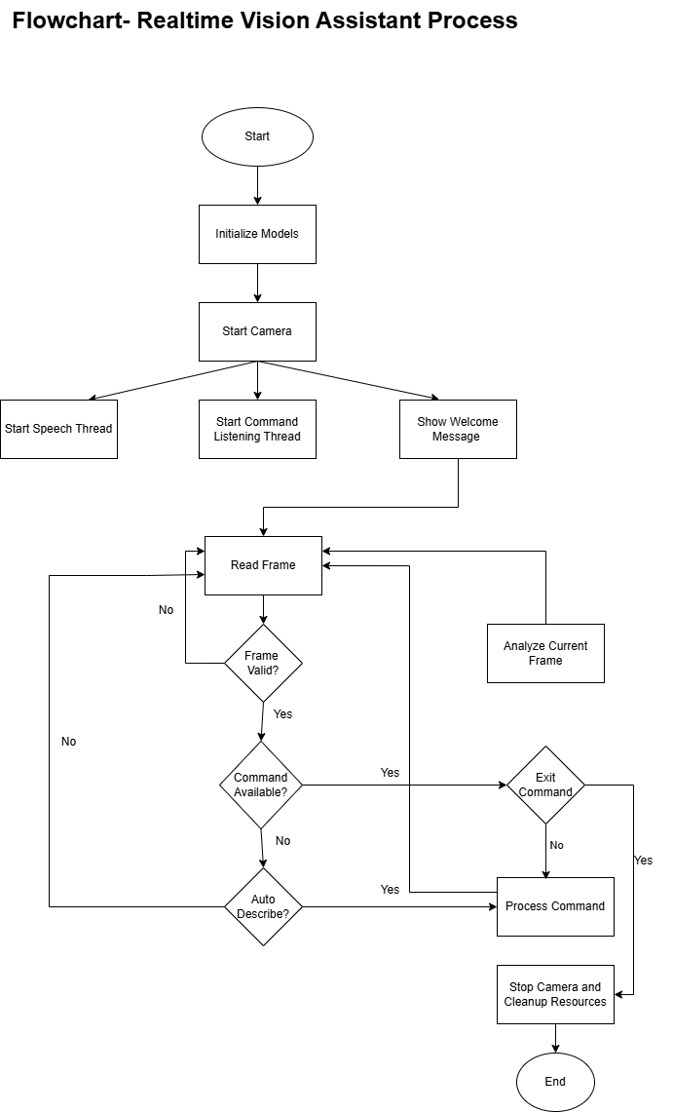

*(figure: 1)*

**Data Flow Diagram:**

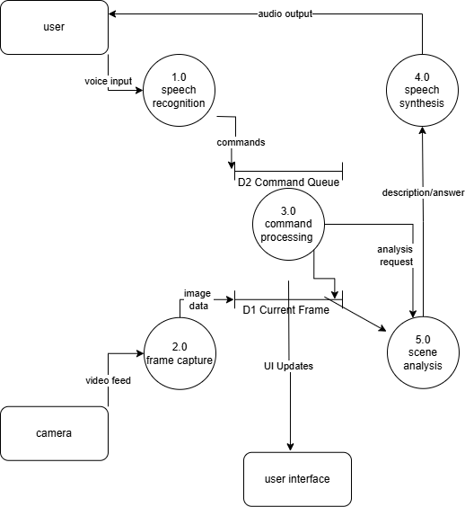

*(figure: 2)*

**Use-case Diagram:**

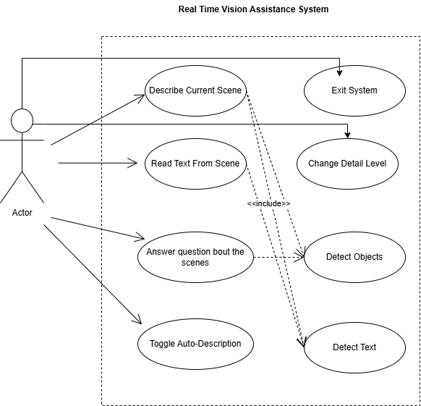

*(Figure :3)*

**Pert Chart :**

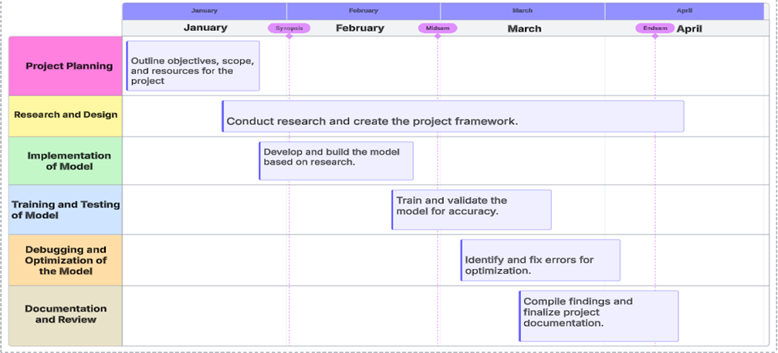

*(figure:4)*

## 

## **9. References:**

1. OpenAI. "CLIP: Learning Transferable Visual Models From Natural Language Supervision." (OpenAI GitHub, 2021).<https://github.com/openai/CLIP>
2. Li, Junnan et al. "BLIP: Bootstrapped Language-Image Pretraining for Unified Vision-Language Understanding and Generation." (Hugging Face, Salesforce Research, 2022).<https://huggingface.co/Salesforce/blip-vqa-capfilt-large>
3. JaidedAI Team. "EasyOCR: Ready-to-use OCR with 80+ Languages Supported." (GitHub, 2020).<https://github.com/JaidedAI/EasyOCR>
4. Reddy, Nirant. "pyttsx3: Text-to-Speech Conversion Library in Python." (PyPI, 2020).<https://pypi.org/project/pyttsx3/>
5. Uberi et al. "SpeechRecognition: Speech Recognition Library for Python." (PyPI, 2020).<https://pypi.org/project/SpeechRecognition/>
6. Bradski, Gary. "OpenCV-Python: Open Source Computer Vision Library." (PyPI, 2020).<https://pypi.org/project/opencv-python/>
7. Rane, Chinmayi et al. "Image captioning-based smart navigation system for visually impaired" *(ICCICT, IEEE, 2021).*
8. Hossain, MD Zakir et al. "A comprehensive survey of deep learning for image captioning." *(ACM Computing Surveys, 2019).*
9. Delloul, K., & Larabi, S. "Towards Real-Time Egocentric Segment Captioning for The Blind and Visually Impaired in RGB-D Theatre Images." *(ICMI, ACM, 2023).*
10. Al-Malla, M.,& Goel, N. "Multi-Modal Image Captioning to Aid Visually Impaired Persons." *(NANO, 2023).*