Name:Sofia B.Tapdasan

Grade & Section: Grade 9 Del Pilar

Subject: ICT-CSS 9

ICT-CSS

First Quarter Outline

Module 1-Applying Quality Standard

Entrepreneurial Competencies

* Refer to the ability to develop,organize and manage a business venture alonmg with any of its risks.
* It includes key characteristics that should be possessed by a person in order to successfully run a new venture.

Below are few important characteristics/traits/attributes of a good entrepreneur.

Hardworking-A successful entrepreneurs are hard workers,and they also enjoy what they are doing.

Confident-Normally confident enough that their knowledge and their know-how will help them make their business idea a success and they never asks the question or keeps doubts in their mind about if they can succeed.

Application software-is a program or group of programs design for end users.

Word processor-software program capable of creating,storing, and printing documents.

Spreadsheet- A data file made up of rows and columns that are used to sort data and allow a user to manipulate and arrange data easily, commonly numerical data.

Presentation software- A software program that helps create a slideshow that addresses a topic.

Database Management System (DBMS) Software

* A program that controls the organization, storage, management, and retrieval of data in a database.

Desktop Publishing Software

* Used to produce high-quality printed documents such as magazine,greeting card,posters,etc.

Web Browser

* Web Broser is a software application used to locate and display web pages.

Graphic Software

* Image editing software is a program or collection of programs that enable a person to manipulate visual images on a computer.

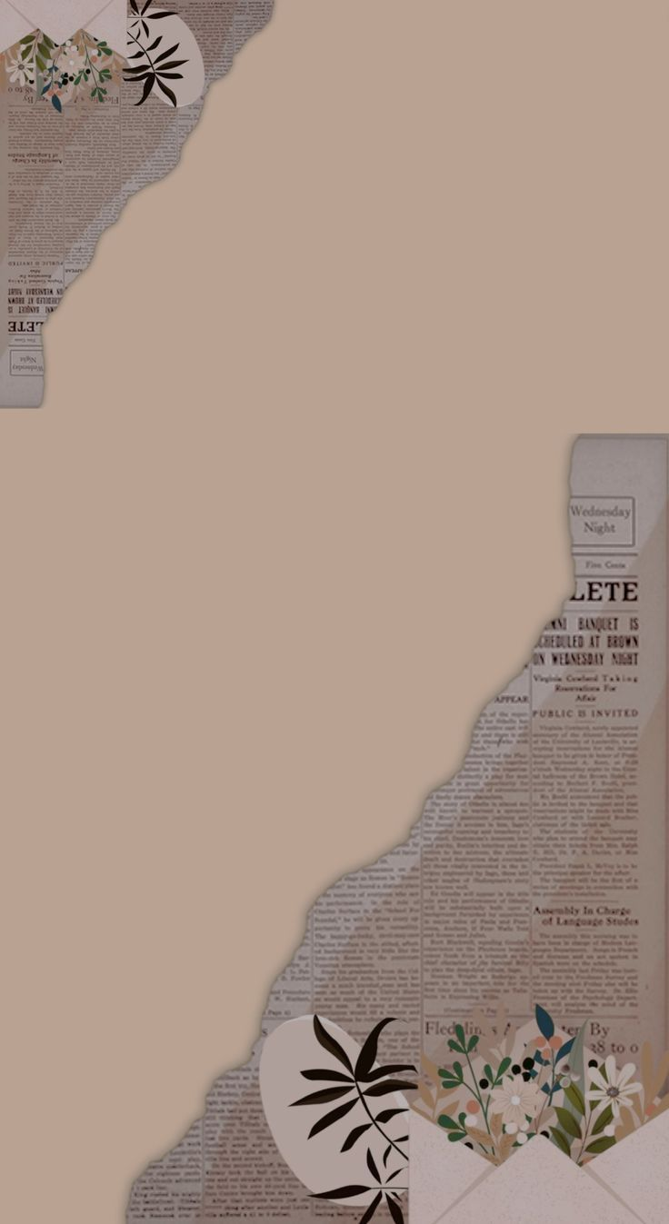Raster Graphic Software

A raster graphics editor is a computer program that allows users to paint and edit pictures interactively on the computer screen and save them in one of many popular “bitmap” or “raster” formats

* Select a region for editing
* Draw lines with brushes of different color, size, shape and pressure
* Add typed letters in different font styles
* Apply various filters for effects
* Convert between various image formats.

Save and save as

* In the File Tab, hover over and click Save As (saving for the first time and saving to another file name or another copy), click browse for you to access the Save As dialog box and it will appear.
* In the save as dialog box, you need to have the following information: File name –is a name used to uniquely identify a computer file stored in a file system.

Extension or File name Extension

* is the ending of a file that helps identify the type of file in operating systems, such as Microsoft Windows.
* In Microsoft Windows, the file name extension is a period that is often followed by three characters but may also be one, two, or four characters long.

File Location or Path

* defines the location of a file or folder in a computer's file system. Paths are also called "directory paths" because they often include one or more directories that describe the path to the file or folder.

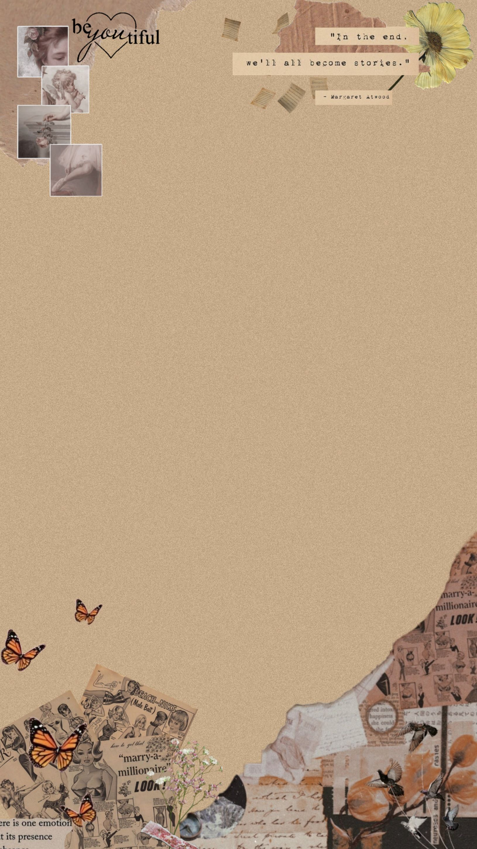What is a Storage Device?

* 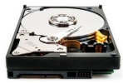A storage device is any hardware capable of holding information either temporarily or permanently.

Hard Disk Drive

* A hard disk drive (sometimes abbreviated

as a hard drive, HD, or HDD is a non-volatile data

storage device.

* . It is usually installed internally in a computer, attached directly to the disk controller of the computer's motherboard

Solid State Drive

* Short for solid-state drive, an SSD is a storage medium that uses non-volatile memory as a means of holding and accessing data.
* Unlike a hard drive, an SSD has no moving parts which gives it advantages such as faster access time, noiseless operation, higher reliability, and lower power consumption

USB Thumb Drive

* Alternatively referred to as a USB flash drive, data stick, pen drive, memory unit, keychain drive, and thumb drive, a jump drive is a portable storage device.
* It is often the size of a human thumb (hence the name) and connects to a computer via a USB port

SD Card

* Short for Secure Digital card, the SD card is one of the more common types of memory cards used with electronics.
* VThe SD technology is used by over 400 brands of electronic equipment and over 8000 different models, including digital cameras and cell phones.

Types of SD cards

* The three versions of the SD card, along with their physical dimensions, are shown below.

SD - 32mm x 24mm x 2.1mm

. MiniSD - 21.5mm x 20mm x 1.4mm.

MicroSD - 15mm x 11mm x 1.0mm

CD

* Abbreviated as CD, a compact disc is a flat, round, optical storage medium invented by James Russell.
* The first CD was created at a Philips factory in Germany on August 17, 1982.

DVD

* Short for digital versatile disc or digital video disc, a DVD or DVD-ROM is a disc capable of storing a significant amount more data than a standard compact disc. DVDs are widely used for storing and viewing movies and ot her data
* The picture of the Matrix DVD movie disc is an example of a DVD movie.

Floppy Diskette

* Alternatively referred to as a floppy or floppy disk, a floppy diskette is a type of storage media, capable of storing electronic data, like a computer file.
* 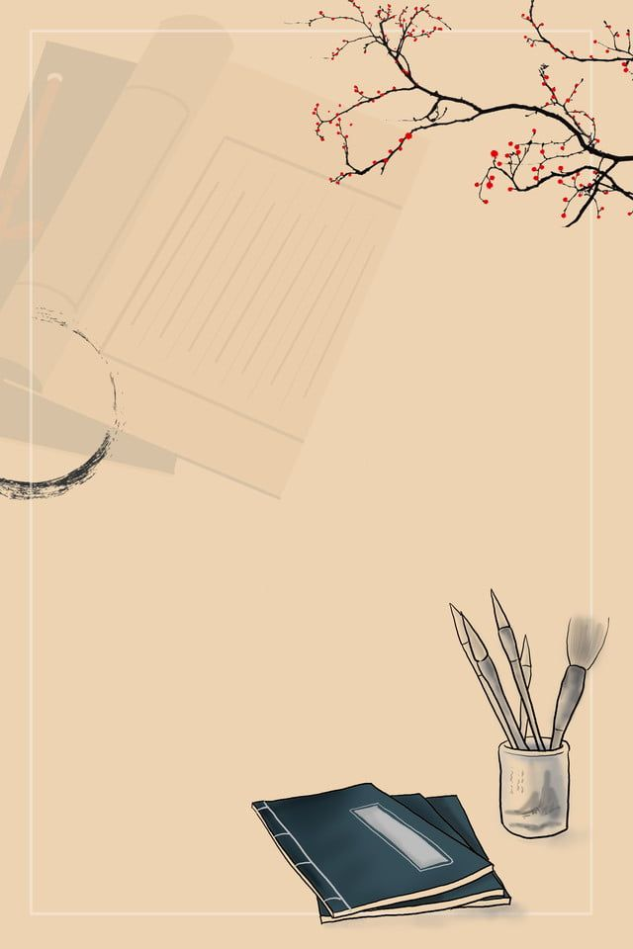The floppy diskette was first created in 1967 by IBM as an alternative to buying hard drives, which were extremely expensive at the time.

Tape Drive

* A tape is a magnetically thin coated piece of plastic wrapped around wheels capable of storing data.
* Tape is less expensive than other storage mediums, but it is a much slower solution because it is sequential access and is often used for backing up large amounts of data.

Which storage devices are used today?

* Most of the storage devices mentioned above are no longer used with today's computers.
* Most computers today primarily use an SSD to store information, as well as the ability to use USB flash drives and access to cloud storage.

What storage device has the largest capacity?

* For most computers, the largest storage device is the hard drive or SSD. However, networked computers may also have access to larger storage with large tape drives, cloud computing, or NAS devices.

Lesson 2 Work Ergonomics

Computer Workstation Ergonomics

* There are various health problems associated with the regular use of computers, such as stress, eyestrain, and injuries to the wrists, neck, and back.

This can be simplified to -Modify the workplace, not the individual"

. Consideration should be given to:

• The accessories required to operate properly

• The layout of equipment on the desk

• The location of furniture in the roo Work Surface Height

* Adjust the height of the work surface and/or the height of the chair so that the work surface allows your elbows to be bent at 90 degrees, forearms parallel with the floor, wrist straight, shoulders relaxed.

Chair

* Adjust the seat tilt so that you are comfortable when you are

Keyboard Placement

* Place the keyboard in a position that allows the forearms to be close to the horizontal and the wrists to be straight.

Screen Placement

* Set the eye to screen at the distance that permits you to most easily focus on the screen.

Desk-Top Layout

* Place all controls and task materials within a comfortable reach of both hands so that there is no unnecessary twisting of any part of the body.

Document Holder

* Place this close to the monitor screen in the position that causes the least twisting or inclination of the head.

Posture and environment

* Change posture at frequent intervals to minimize fatigue.

Lighting

* Place the monitor to the side of the light source/s, not directly underneath.

Glare and Reflection

* It is important to detect the presence of glare and reflection.

Using a Mouse

* A well-designed mouse should not cause undue pressure on the wrist and forearm muscles.

Posture during Keying

Good posture is essential for all users of computers..

It is not a single, rigidly defined position.

Typing Technique

* Typing is a physical activity, and using a keyboard requires skill, hence the need to learn correct typing technique.

Speed of Keying

* The efficiency and speed of modern computers makes it possible for a skilled operator to type extremely quickly.

Length of time on the keyboard

* The maintenance of a fixed posture for long periods is tiring and increases the likelihood of muscular aches and pains.

POINTS TO REMEMBER

Computers –Ergonomic Guidelines

• Viewing distance: The monitor should be 2 –2½ feet from the child’s eyes.

• Time at computer: Encourage children to use their physical energy

. • Seat and height posture: The child should sit high enough to have his arms bent at 90°

• Footrest: Use it prevent dangling feet.

• Mouse: Find one that fits small hands.

• Keyboard: Child-sized keyboards with light pressure keying are recommended.