

**TECHNOLOGICAL COLLEGE, Inc.**

NORTHLINK

New Pandan, Panabo City, Davao del Norte

Tel. No.: (084) 628-6884, Mobile: 09228167544

Email: northlinkpanabocity@gmail.com

**RE: INTENT LETTER FOR WORK IMMERSION**

February 22, 2024

**Rachelyn Gimongala**

General Manager

SENA Gladyz Suites

Gredu, Panabo City

**Thru : Rogelio Saygo Jr**

Personnel Development - Workplace Training Head

SENA Gladyz Suites

Gredu, Panabo City

Ma’am:

Warm Greetings!

We would like to humbly request your good office to be one of our partner institutions that would expose our students to the real world setting and instil standards comparable to industry practices through practicum / apprenticeship / work immersion program. In return, you will have **80 hours** free labor from our trainee/s through his/her work immersion tasks.

The trainees have satisfactorily completed the minimum requirements for **Technical Vocational and Livelihood Track- Home Economics (HE) Strand and Academic Track-Accountancy, Business and Management (ABM) Strand**. We believe that your office can assist our students to gain more knowledge and skills and optimize their potentials for their future work.

We would appreciate it much if you can send response on this regard through the undersigned by any of the following communication lines:

Mobile Number :  **09912021578**

Email Address : **geagarcia@northlink.edu.ph**

Please accept our sincerest appreciation for partnering with us in this endeavour.

Very truly yours,



**GEANICA N. GARCIA, RPm**

Work Immersion Coordinator

Noted by:

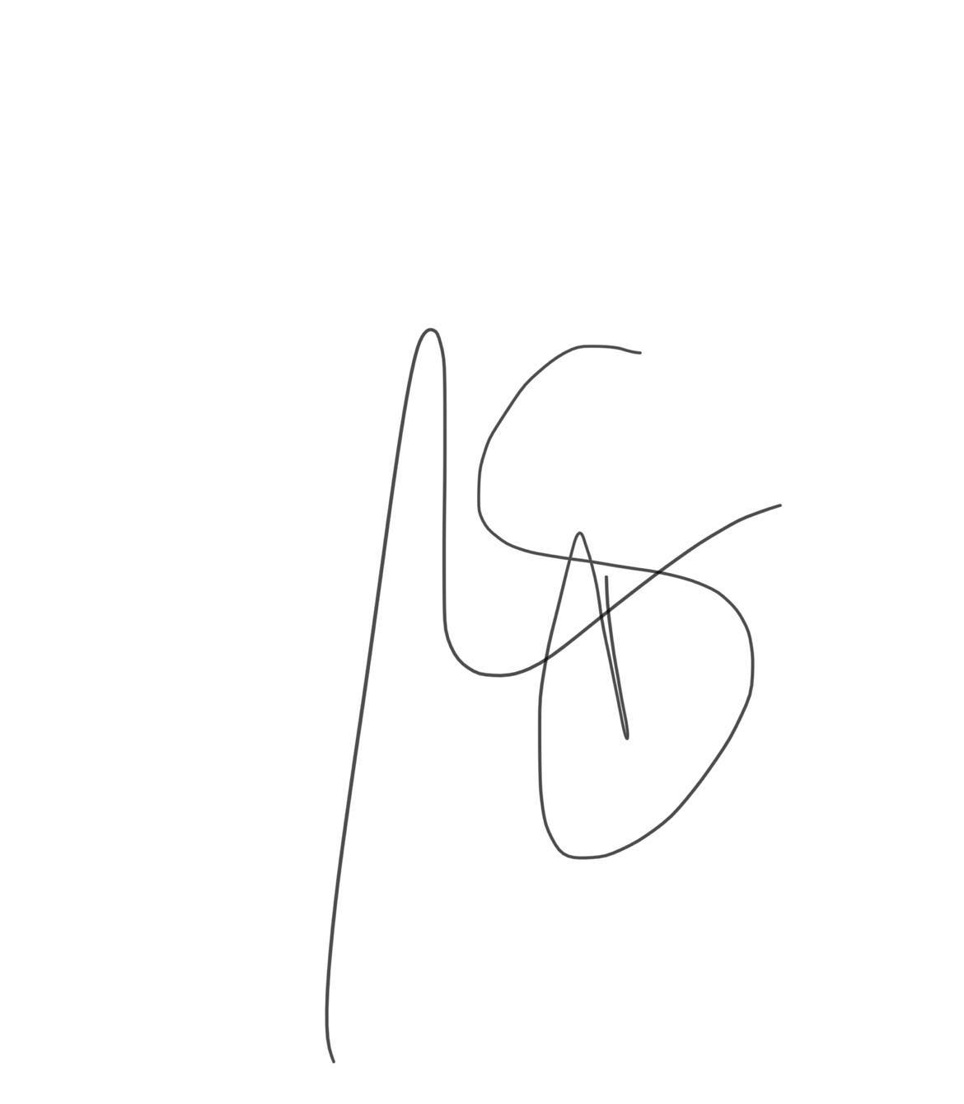

**RIZZA CAWAS, LPT**

SHS Coordinator



CHED REGISTERED



TECHNICAL EDUCATION AND SKILLS DEVELOPMENT AUTHORITY

*Accredited Training and Assessment Center*