General layout of graphical user interface
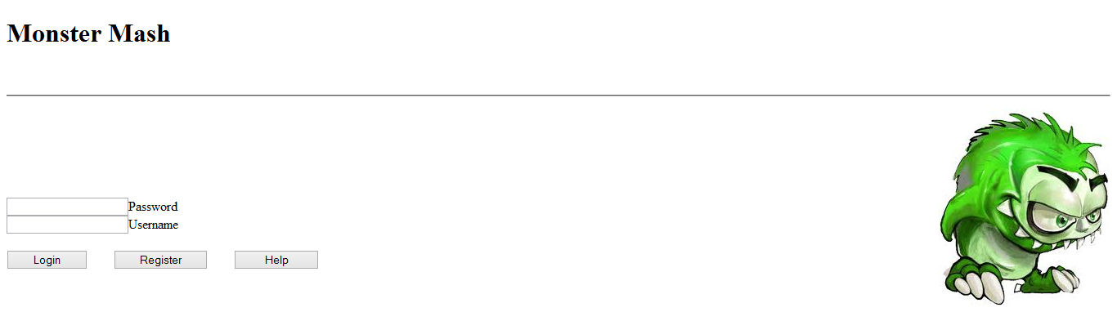
When the game is started the first page the user should see is the log in page. As you can see here one can log in with their correct credentials. If the user were not to have any they can register or view the help page.
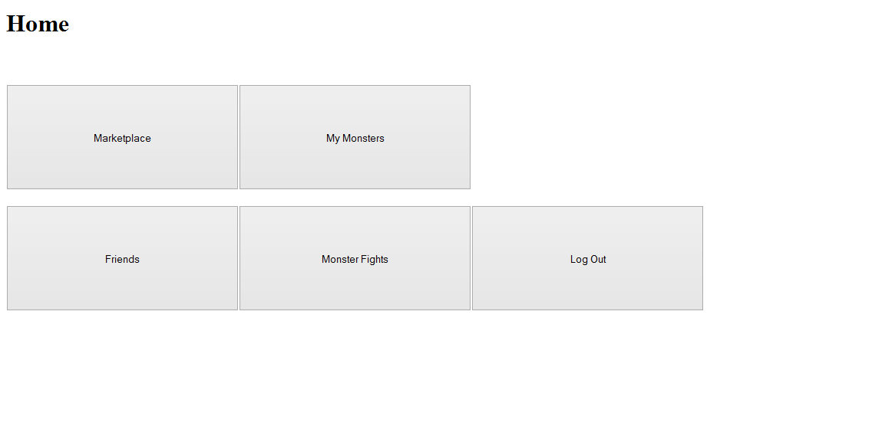
After logging in with the correct credentials, the next page to the user will be the home page.
Each button will take you to the following:
Marketplace > marketplace.html (where monsters are bought and rented)
My Monsters > myMonsters.html (where one can breed, sell and loan monsters)
Friends > friends.html (used to see and delete current friends as well as add new ones and manage friend requests.
Monster Fights > monsterFights.html (To challenge monsters of other friends)
Log Out > login.html (Takes you back to the log in page.)
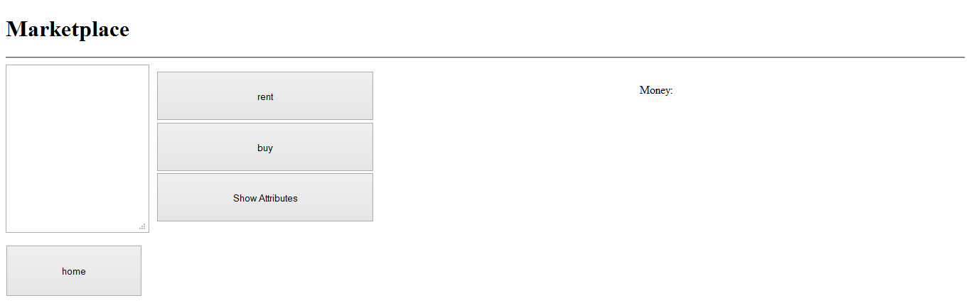
After clicking the marketplace button on the home page the showed page shall load. There is a list box on the left hand side which will display monsters that other friends are selling or loaning out. After clicking on the monster the user shall be able to rent or buy them by clicking the appropriate buttons. The show attributes button will tell you more and general info about the monster. At the top right corner of the screen where it says “Money:” will show the available funds to the user. The home button will of course take you back to the home page.

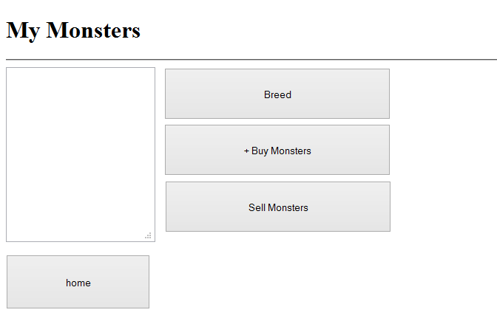

After clicking the my monsters button on the home page the following page will be shown. As you can see a user will be able to breed a monster as when the button is clicked a prompt box with a drop down box of your monsters will be shown enabling you to choose which monsters to breed. The buy monsters button will take you back to the marketplace page. As for the sell monsters button a prompt box will display enabling the user to specify whether they want to sell a monster or loan it out to another user and for how much money. The home button of course takes you back to the home page.
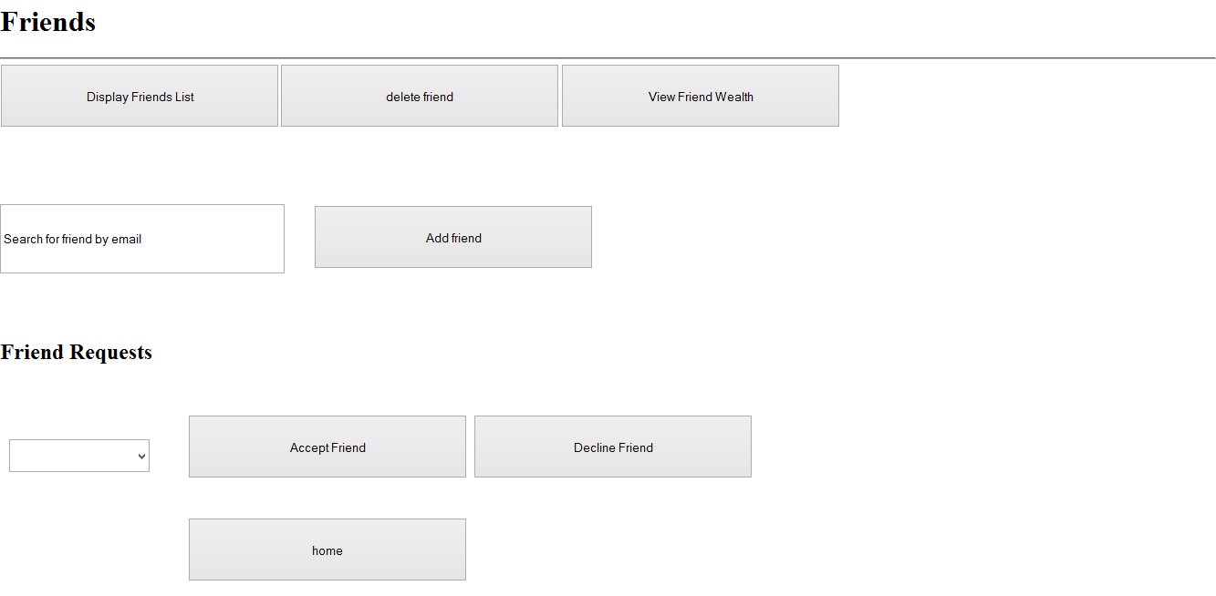
After clicking the friends page the following page will be displayed. In this page one can manage their current friends by deleting and adding them. The display friends list will bring up a list of all current connected friends. View friend wealth will show a rich list of the richest players in terms of money in the game. By entering a valid user email address users will be added via the add friend button. Friend requests will show in the drop down box towards the bottom left of the screen shot, by selecting the appropriate request it is easy to see how the user will accept or delete the friend request. As per usual the home page takes the user back to the home page.

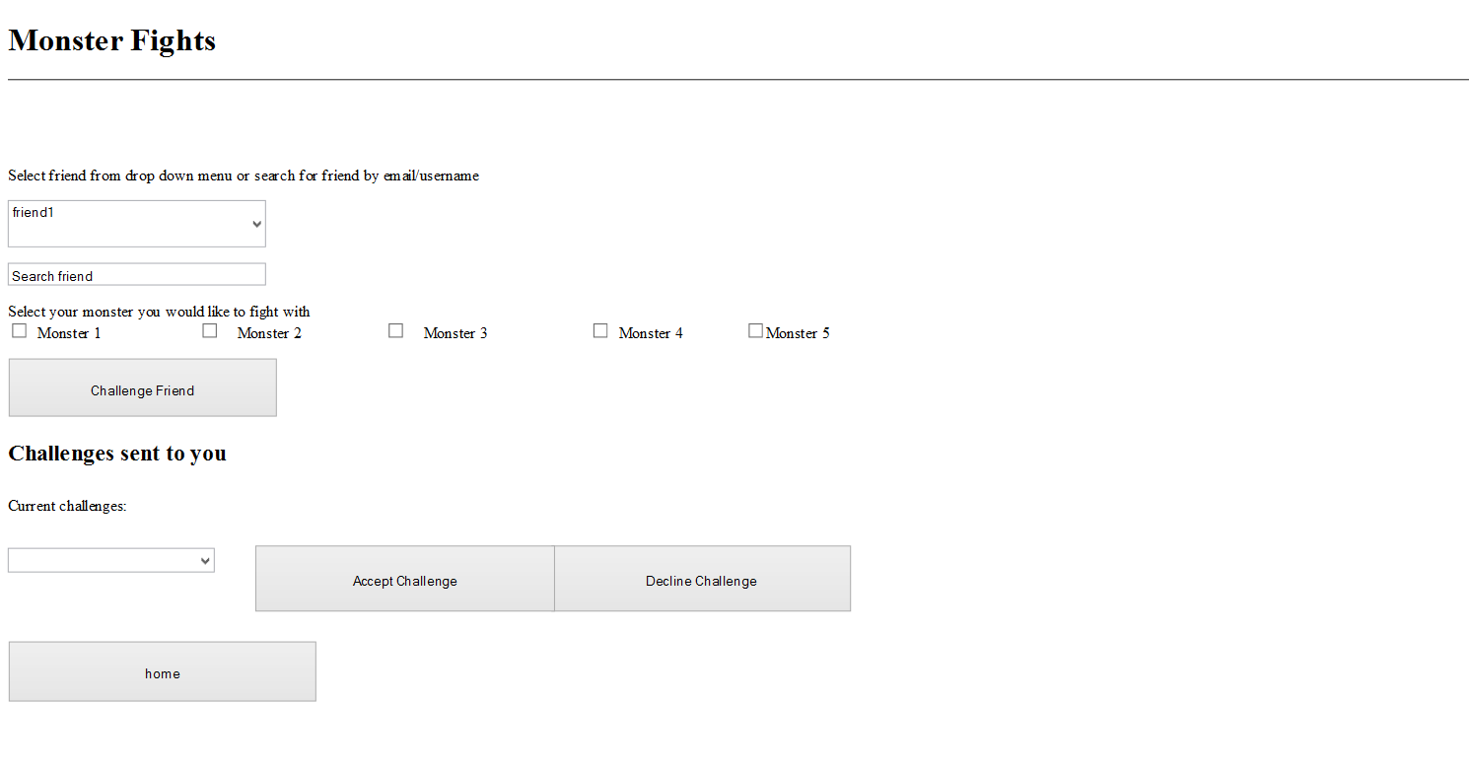
Via the monster fights button on the home page this page shall be reached. To challenge a friend the user can either search for them by their email or select them from the drop down menu. You will then select which monster to fight with and click challenge friend, a pop up box will then display the fight outcome. Challenges sent to you can also be managed in a very similar way to friend requests. Current challenges are displayed in the drop down menu and with the appropriate buttons one can accept or decline the challenges.

