
eXo Social User Guide
Version 1.1

Contents
1 Preface 5
1.1 Overview 5
1.2 Why Uses eXo Social 5
1.3 About this document 6
1.4 References & Related documents 6
2 Glossary 8
2.1 Social Network 8
2.2 People 8
2.3 Profile 8
2.4 Connections 8
2.5 Request 8
2.6 Activity 8
2.7 Spaces 9
2.8 Space manager 9
2.9 Different visibility options for a group 9
2.10 Different registrations for a group available 9
3 People: Enterprise Social Networking 10
3.1 Update Profile 10
3.1.1 Change Avatar 11
3.1.2 Change Current Position 12
3.1.3 Change Basic Information 12
3.1.4 Change Contact Information 13
3.1.5 Change Experiences 13
3.2 Connections 14
3.2.1 Search Contacts 16
3.2.2 Send Request 17
3.3 Activities 17
3.3.1 Update Status 18
3.3.2 Share Link 19
3.3.3 Delete Activity 19
3.3.4 Comment Activity 19
3.3.5 Like/Unlike Activity 20
4 Space: Community Management 22
4.1 Create Space 23
4.2 Edit Space Settings 27
4.2.1 Change Space's Information 28
4.2.2 Change Space Avatar 28
4.2.3 Manage Visibility 28
4.2.4 Manage Member 29
4.2.5 Manage Space Applications 33
4.3 Edit Space's Navigation 36
4.4 Leave Space 37
4.5 Delete Space 37
5 Conclusion 38

Preface

Overview
Beginning as an Open Source project in the year 2002, eXo is well-known as the industry's first Java portlet container. With the aim of dominating the potential portal market through robust and easy-to-use applications, eXo Project succeeded in attracting consumers in the whole world. eXo actually opened the floodgates to various options in many markets, and customers have been choosing eXo as the best method for their success.
The eXo Platform™ software is a powerful Open Source corporate portal and content management system. Users of the platform have a customized single point of access to the company's information system and resources.
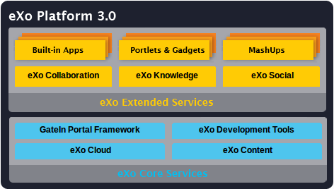
Developed on eXo Platform 3.0, eXo Social is one of eXo Extended Services that provides a social network with much more features to share, and communicate between individuals and organizations. With eXo Social, it is easy to approach many easy-to-use social networking applications and more.

Why Uses eXo Social
With eXo Social, users can do many actions with outstanding benefits such as:
- Write Social Gadgets intuitively and easily: eXo Social provides built-in JavaScript client libraries for OpenSocial API so developers can easily leverage data produced by social-enabled applications to build mashups.
- Offer Rich Experience to Existing Applications: eXo Social provides end-users with features that are similar to social networking sites Facebook and Linkedln, etc, allowing users to establish more meaningful connections and improve communication and collaboration.
- Turn Company Directory into a Social Network: eXo Social provides users with the ability to add details to their profiles, like experience, skill and team information and to establish connections based on defined and relationships.
- Extend an Enterprise Social Network Easily: Built-in applications and other Extended Services can be added to shaaboration features within eXo Social network, providing many capabilities like Calendar, Address Book, Chat, Email and more.

About this document
The book was written as a handbook, aiming at instructing step-by-step on how to use this application to the utmost. Thus, the information included herein will give basic steps that makes it easy for users to follow through in-depth examples and clear explanations. Whether you major in technology or not, you are able to learn about or work with eXo Social easily and efficiently.
The information provided in the guide has been arranged into such a way that ensures readers to search and implement them quickly. Initialized with the Glossary, the guide will give basic terms used in eXo Social. The next named "People: Enterprise Social Networking" will represent most of steps necessary to use the People application, one of the most important parts in Social. Users will also experience the Spaces application in the section named "Space: Community Management". With the aim of helping users better understand eXo Social, we offer some references and resources in the Conclusion section.
The guide can be widely used for everyone interested in learning and using Social application, especially for normal users who apply eXo Social with People and Spaces applications in work and business.

References & Related documents
Information
- eXo Home Page
- eXo Wiki
Support
- Forums
- FAQ
Download
- eXo Content
- eXo Development tools
- Gatein Portal Framework
- eXo Collaboration
- eXo Knowledge
- eXo Social
Resource Center
- Video demos, tutorials, webinar archives, features & benefits tables and more

Glossary

Social Network
Social Network is not a new concept. It can be your diary, address book, or news, instant messages, conversations, and more. It combines many applications to make an easy connectivity among users. eXo Social mainly focuses on creating a favorable interaction for companies.

People
People is an application used to add profile information, connections among users. With People, profile information and relationships can be managed and customized easily.

Profile
Profile is a set of information which can be entered and supplemented by users. This feature can improve the company directory's usability, such as basic information, avatars, experiences, contacts, and more.

Connections
Connections is to display information related to connections among users, including established connections, incoming and outgoing invitations.

Request
Request is the act of asking or expressing a connection desire that can be accepted and/or denied by receivers and sending requests also can be cancelled by users.

Activity
Activity is an application where users can do many actions such as publishing their own respective activity stream, showing recent activities or updates, new connections or updating status and more.

Spaces
Spaces is a working environment which can be created easily. With Spaces, users and communities will be managed more conveniently. It helps regrouping people by various interests or projects and leverages any existing application, such as portlets or gadgets to enable a collaborative work.

Space manager
Space manager is a user with special rights within a space. He can manage the list of members, configuration and installation applications. When a user creates a space, he/she automatically becomes the space's manager who can validate space subscription requests.

Different visibility options for a group
- Visible: The space is always visible.
- Hidden: The space is not visible in the space list.

Different registrations for a group available
- Open: The user can join a space without any validation.
- Validation: The user's membership has to be validated by a space manager.
- Close: The user cannot request for joining, but only the space manager can invite him.

People: Enterprise Social Networking
Before using the eXo Space, you should have basic knowledge about GateIn. Before reading further, you need to learn how to login and navigate in GateIn.

Update Profile
By default, the profile is just initialized with basic account information entered in the Registration form. You can complete your profile with more detailed information in Position, Contact, Experiences, and Avatar.
To go to Profile, hover your mouse over the display user name (e.g, demo gtn) on the Administration bar and select Profile.
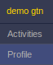
Or, click Activities, then select Profile in the left pane.
The Profile page will be displayed as below:
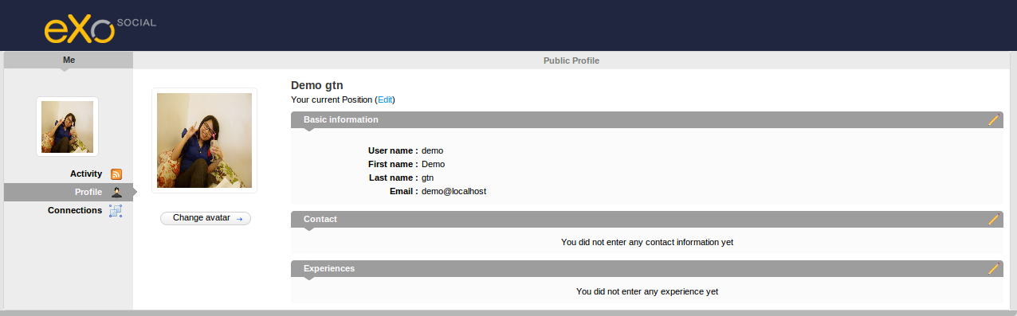

Change Avatar
You easily change your avatar by following these steps:
Step 1: Click Change Avatar to open the Avatar Upload form:
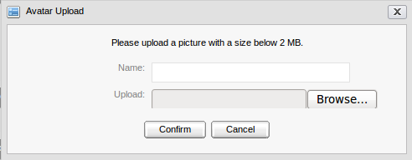
Step 2: Click Browse to open the folder containing image which you want to upload and select that image. The uploaded photo must not be bigger than 2MB.
Step 3: After uploading, click Confirm to open the Avatar Preview form and some related information such as: file name, file type and image size.
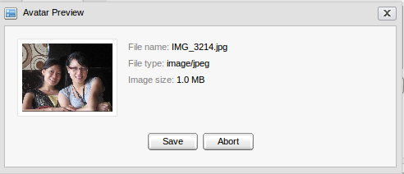
Step 4: Click Save to accept or Abort to quit without saving.

Change Current Position
To change the current position, do as follows:
Step 1: Click Edit.

The form to update the current information will appear:
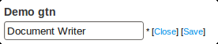
Step 2: Enter your new position and click Save. It will immediately update your current position.

Change Basic Information
To change basic information, do as follows:
Step 1: Click the icon to edit basic information. The Account Profile tab will appear:
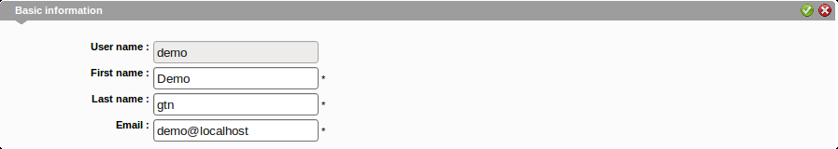
Step 2: Change information related to your account.
Step 3: Click the iconto accept all changes orto delete these input information. After you have clicked , a message which informs the successful account information update will display.
Step 4: Click OK, or the icon to quit the form after changing.

Change Contact Information
To change contact information, do as follows:
Step 1: Click the icon that corresponds to the Contact pane. The form to edit contact information will display:
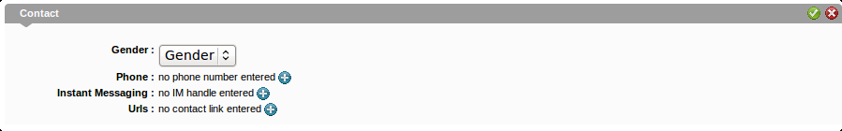
Step 2: Select a value for the Gender field.
Step 3: Click the iconcorresponding to one field you want to update: Phone, Instant Messaging and Urls.
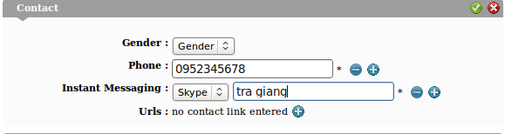
Step 4: Click the icon to save all changes or the icon to close this form without any change.

Change Experiences
To change Experiences, do as follows:
Step 1: Click the icon that corresponds to the Experiences pane. The edit form will display.
Step 2: Click the icon to open the detailed form that allows you to enter information related to your experience.
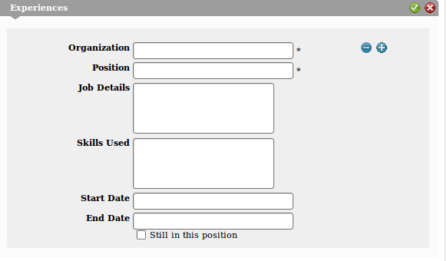
The iconbeside is used to delete this experience.
- Input values for fields: Organization, Position, Job Details, Skills Used, Start Date, End Date and Still in this position.
- After updating information, click to save all changes orto close this form without saving any change.

Connections
The Connections page lists all contacts who accepted as your contacts and who are waiting for your acceptance and contacts in request.
To enter Connections, hover your mouse over the display user name (for example, giang tran), and select Profile | Connections in the left pane; or hover your mouse over People on the Administration bar, and select Connections.

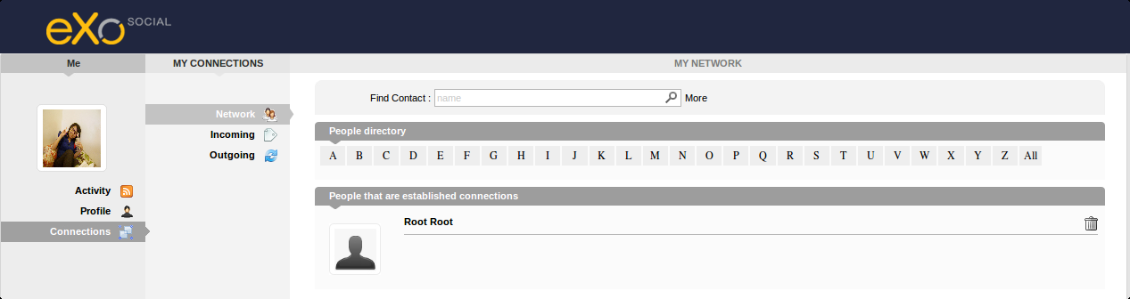
In the Network pane, you can delete users you don't want to be as your contact anymore clicking the icon .
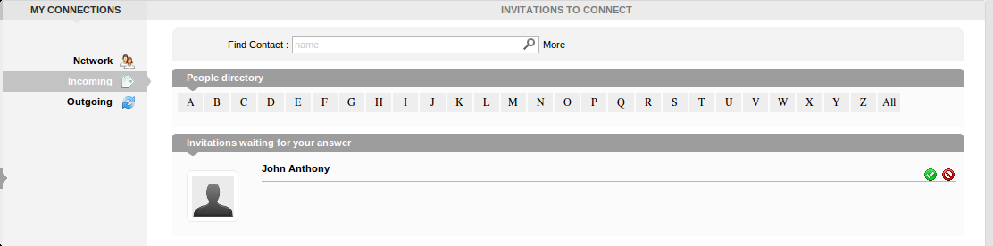
The Incoming pane lists contacts inviting you to become their contact. You can click to accept being as his/ her contact or clickto refuse.
The Outgoing pane lists contacts you have sent requests for becoming your contacts. You also can click the corresponding icon to remove your request.
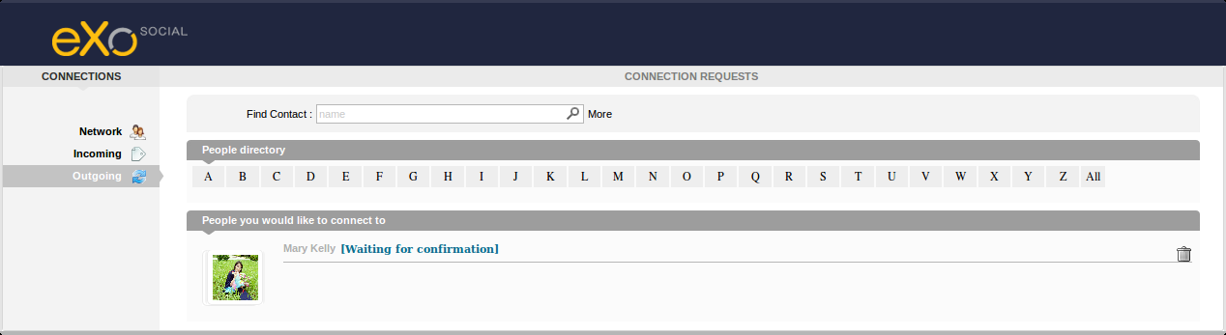

Search Contacts
Click People, all contacts who use eXo Social are listed in the People page. The function is to search contacts conveniently as follows:
Step 1: Enter the contact name you want to search in the Find contact field:
- If you want to filter a contact with more information, click More. You can specify a contact filtering by position, skills and gender.
- If you donot want to filter contacts by above information, click Hide.
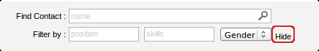
These results will be listed with all contacts whose names contain the same string as entered in the Search field.
Step 2: Click the glass icon to find a contact. The results will be listed in the People Found pane:
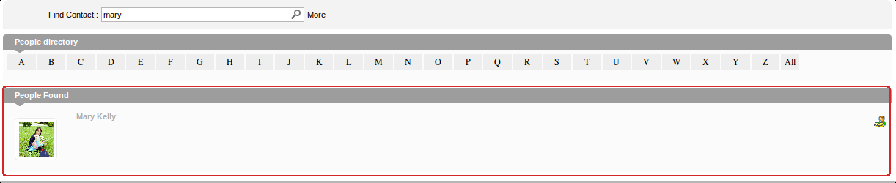

Send Request
You easily send a request by following these steps:
Step 1: Click the icon which corresponds to your desired contact.
A textwill be displayed next to the contact name, it means that your connection request has been pending until your contact confirms it.
You can also click the icon to remove your request to that contact.
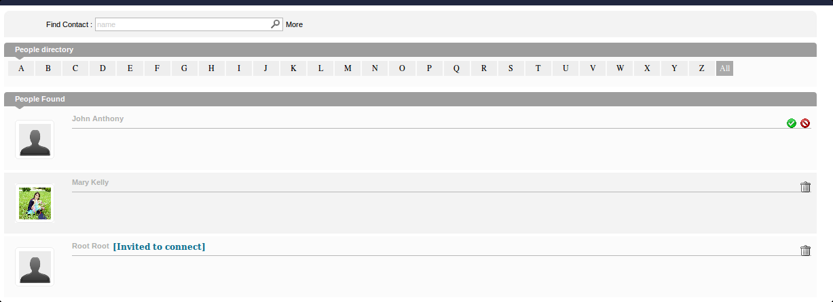
If someone sends requests to you, in the People Found pane, you can click to become their contact, or click to refuse becoming their contact.

Activities
To enter Activities, hover your mouse over the User Profile icon on the administration bar and select Activities:
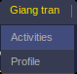
In the Activities, you can do the following actions:

Update Status
To change your status, do as follows:
Step 1: Enter your current status in the Status Update form:
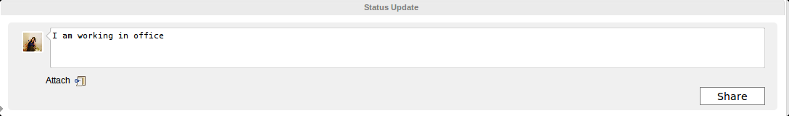
Step 2: Click Share to accept sharing your status.
In the Activity space, you can see your own activities by clicking Expand icon. Your contacts' activity stream is displayed above.
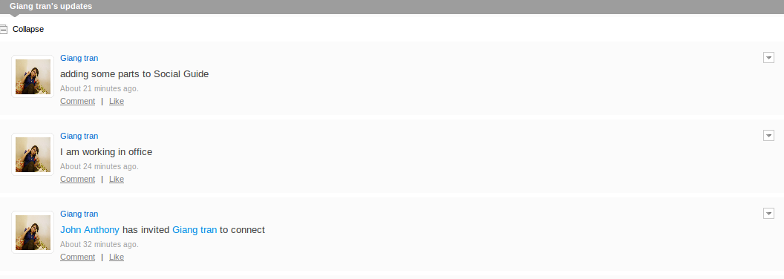

Share Link
You can share your prefered links as follows:
Step 1: Click Attach.
Step 2: Enter the link into the Attach field and press Attach. If the link address is correct, it will be attached, then shown below the Attach link line with the link's overall introduction. Click Share if you want members to see it. The link will be displayed in your updates as below:
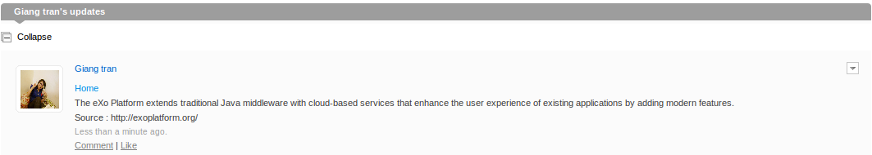

Delete Activity
To delete an activity, do as follows:
Step 1: Choose one profile containing the activity you want to delete and hover your mouse over the icon .
Step 2: Click Delete.

Comment Activity
To comment activities, do as follows:
Step 1: Choose one profile containing the activity you want to comment.
Step 2: Click Comment in the bottom line of the profile. The Comment form will appear below.
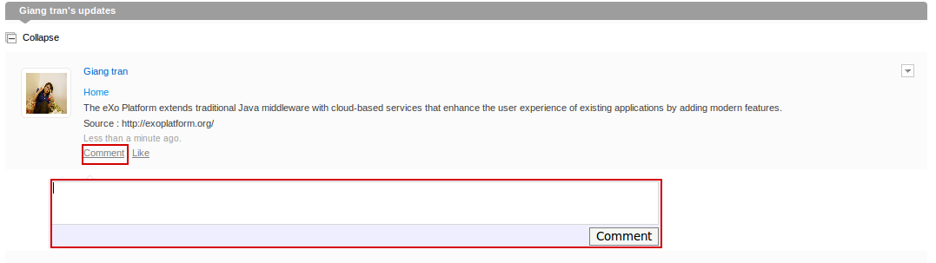
Step 3: Enter your comment into the Comment form and press the Comment button.
Your comment will be displayed right below the profile and you can delete your comment by clicking X.
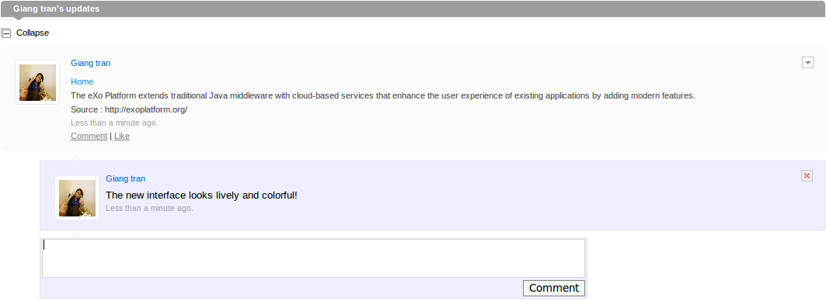

Like/Unlike Activity
You can show your interest by choosing to like/unlike activities as follows:
Step 1: Choose the profile containing the activity you want to like/unlike.
Step 2: Click Like beside Comment.
After you choose Like, the text 'You like this' will be displayed below and Like will be turned into Unlike.
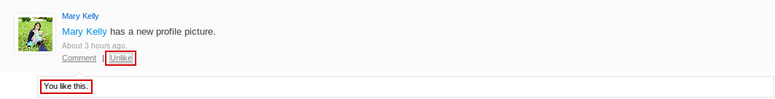
You can choose to Unlike one activity in the same way as steps for Like.

Space: Community Management
Before using the eXo Space, you should have basic knowledge about GateIn. Before reading further, you need to learn how to login and navigate in GateIn.

To enter a space, click Spaces on the administration bar. The Space navigation on the left pane includes:
- My Spaces: to list spaces where you are member or manager.
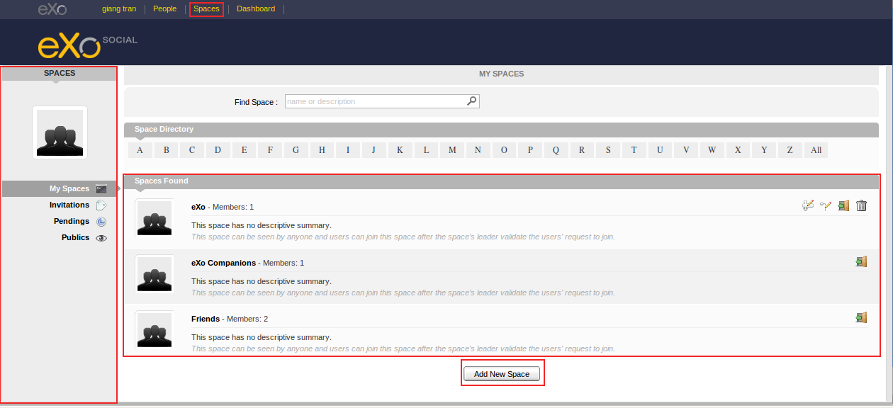
- Invitations: to list spaces where you are invited to become members by space managers.
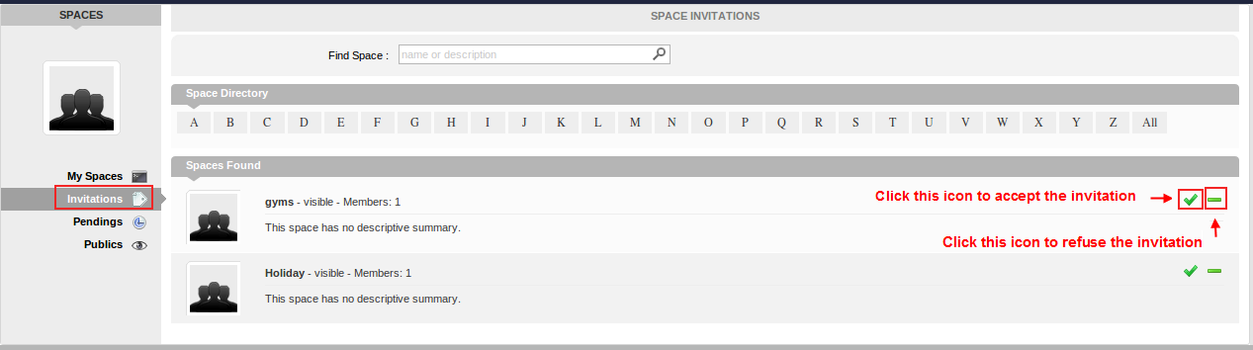
- Pendings: to list spaces where you have requested for becoming members.
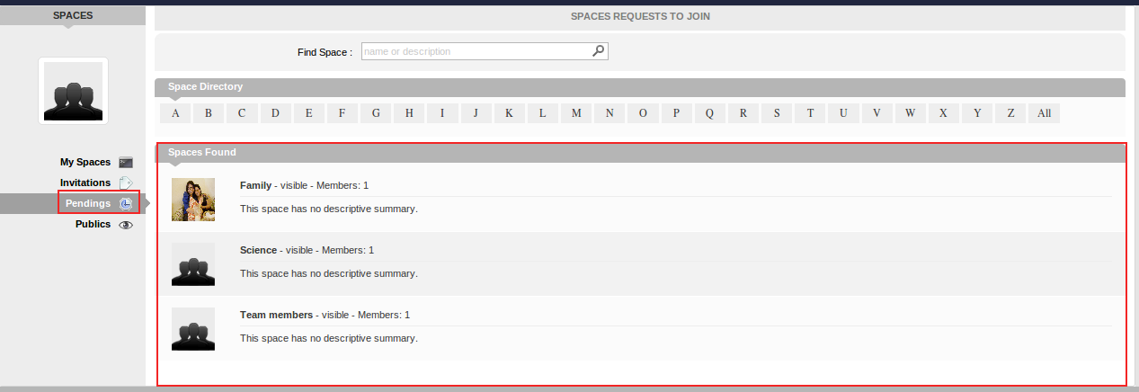
- Publics: to list all spaces which have been created with the Visibility value as Visible.
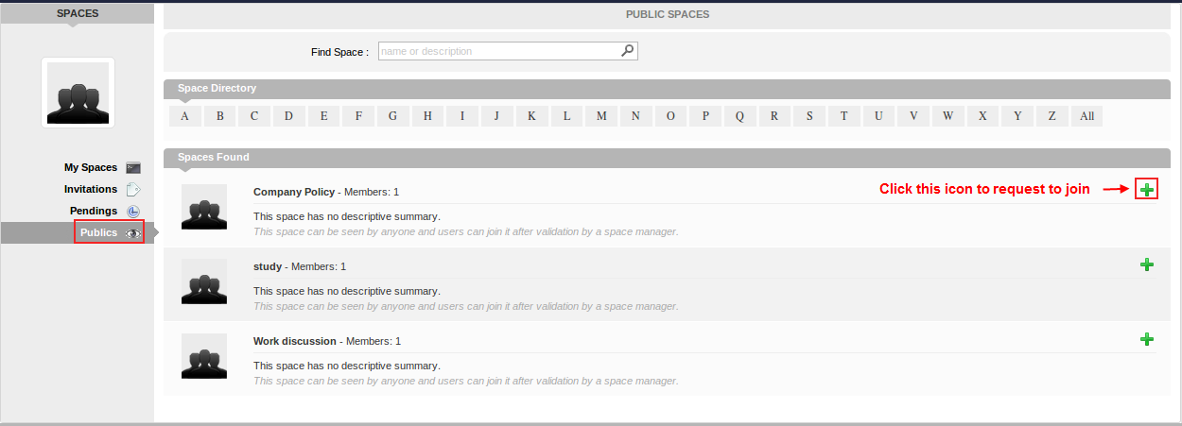
In the eXo Social, root is an administrator who has the highest permission and can see all spaces whether root is a member or not.

Create Space
To create a space, do as follows:
Step 1: Click Add New Space. The Add New Space form will appear:
Details:
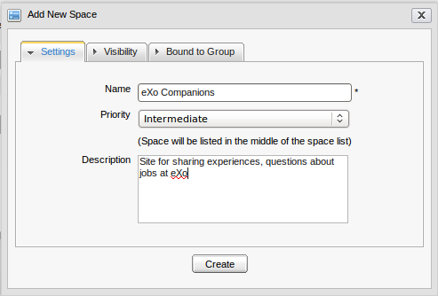
The Settings tab includes:
Name | Enter the space name which is required. Only alphabet, digit and space characters are allowed for this field.
Priority | Choose the preference order for the space, including three levels: High, Intermediate, and Low. There will be a textual explanations corresponding to each selected priority value.
Description | Fill detailed information about the space. (For example, the space is used for which purposes.)

When you input more than 2 spaces between words, these spaces will be converted to ONLY ONE space when being displayed. With space characters at the beginning and end of space names, these space characters will be omitted.

The Visibility tab:
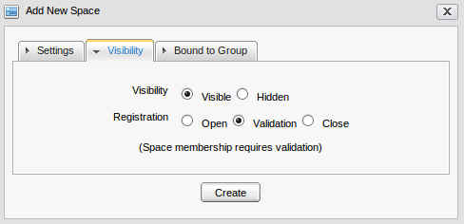
Visibility | By default, the Visibility value is set to be Visible that means this space is listed in the public spaces directory. If Hidden is selected, this space is not listed in the public spaces directory.
Registration | By default, the Registration value is set to be Validation. If Open is checked, users who have sent requests will automatically become the space's members without any validation; or if the Validation is selected, users will become the space's members only after being accepted by this space's manager; or if Close is checked, users cannot send their requests for becoming members, except that they receive one invitation from the space manager.

The Bound to Group tab: enables users to bind a space ONLY to groups where they are already 'manager'. If one user is the group's manager, the group will be displayed in the group list for choice. When one space is created by Bound to Group, the group's members will be invited to become members of that space.
Select the Use an existing group checkbox if you want members of the selected existing group to become this space's members. The Use an existing group will appear:
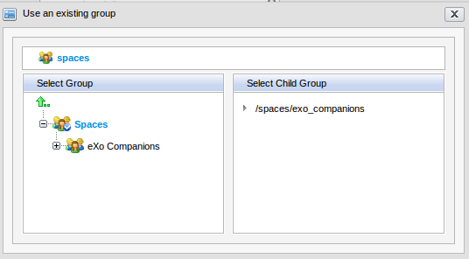
After an existing group has been selected, all users in that group will be the space members with the manager role by default.
Step 2: Enter values for fields in the Add new space form.
Step 3: Click Create to complete creating a new space.
You will see your new space in the list. Click its name and start exploring it.
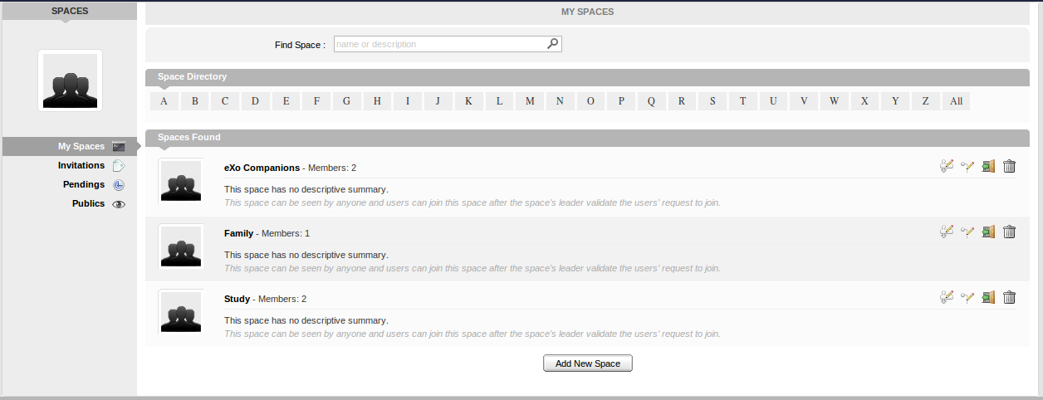

Edit Space Settings
This function allows you to change setting information of a space, manage members and applications if you are the space's creator or have a manager right on it. Follow these steps:
Step 1: Click the icon that corresponds to the space which you have the edit right.
Step 2: In the Settings tab, change information related to the space:
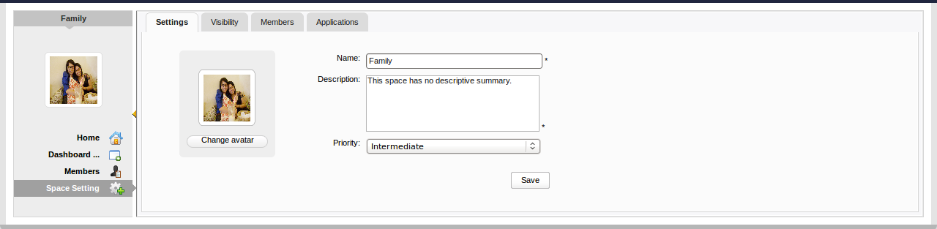

Change Space's Information
This function allows you to edit basic information about a space.
Step 1: Change information that you want to edit.
Details:
Name | The current name of space which is required, so you can not leave it blank.
Description | The brief description about the space.
Priority | The priority affects the space order in the space list.

Step 2: Click Save to accept all changes.

Change Space Avatar
To change avatar, refer to the section 3.1.1.

Manage Visibility
Step 1: Click the edit icon that corresponds to the space which you have the edit right.
Step 2: Select the Visibility tab:
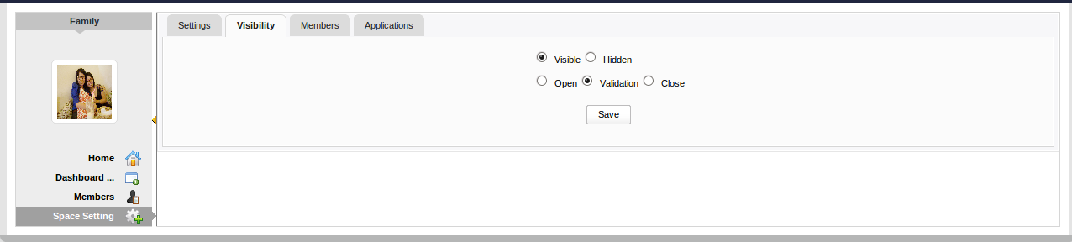
Step 3: Change the Visibility and Registration modes to your needs. By default, Visibility is Visible and Registration is Validation.
Step 4: Click Save to accept changes.

Manage Member
Click the Members tab to open the edit member interface:
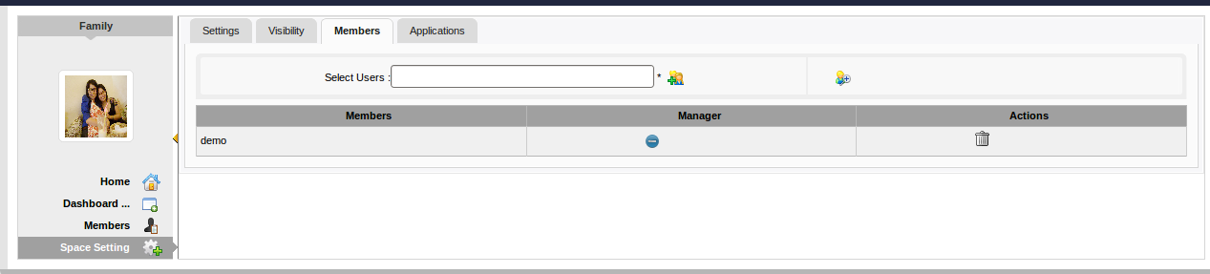
In this tab, you can take the following actions:
- Invite new members to join this space.
- Promote a user to manager.
- Remove users.

Invite New Member
If you know the username of a person, you can easily invite him/her to your space by following these steps:
Step 1: Simply enter his/her user name in the text box and click the icon .If you have multiple people to invite, you can enter multiple user names separated by a comma.
Step 2: If you don't know the user name of a person who you want to invite, you can click the icon to open the Select Users form:

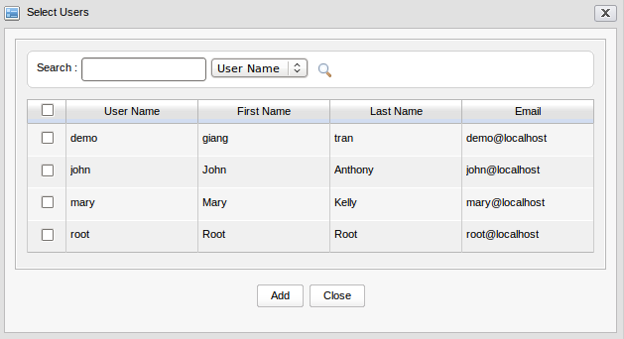
Step 3: Search among members of a portal as follows:
- Enter a search term in the Search box.
- Then, select a criterion you want to find by in the combo box next to this Search box.
- Click the search icon to perform searching.
The results will be listed in the table under. When you have found people you want to invite, select them by checking the corresponding check boxes and click the Add button.

Then, click the icon to accept the invitee. After inviting, you will see the invited user list.
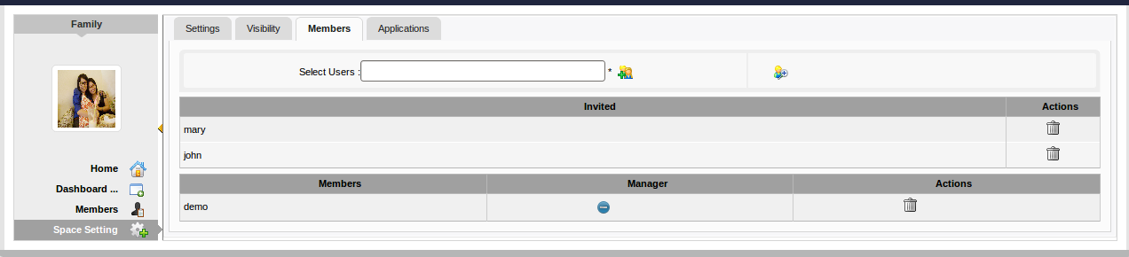
In the invited users' space, he/she will see those spaces in the Invited part.
Please note that Root who has the highest right will automatically become the member of spaces whenever invited.

Revoke Invitation
If invitations aren't accepted by the invited users yet, you can revoke the invitations by yourself.
To revoke the invitation of the invited user, just clickthat corresponds to that user. That user will be removed from the Invited list column.

Accept & Deny Invitation
This function allows you to accept an invitation that you received from others.
Spaces which are being waited for acceptance will be listed in the Invitations space of the invited users:
If you want to accept the invitation, clickcorresponding to the space you want to accept.
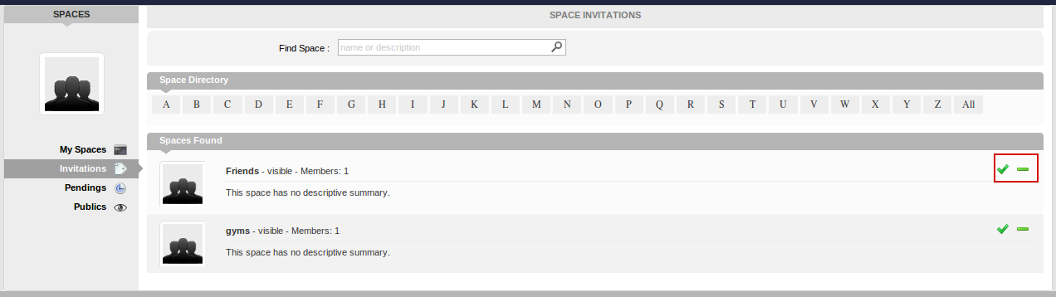
If you don't want to accept the invitation, click corresponding to the space you donot want to accept.

Promote Member to Manager or Vice-versa
Just clickcorresponding to the member name in the Manager column. The user will be automatically promoted as a manager in the current space.
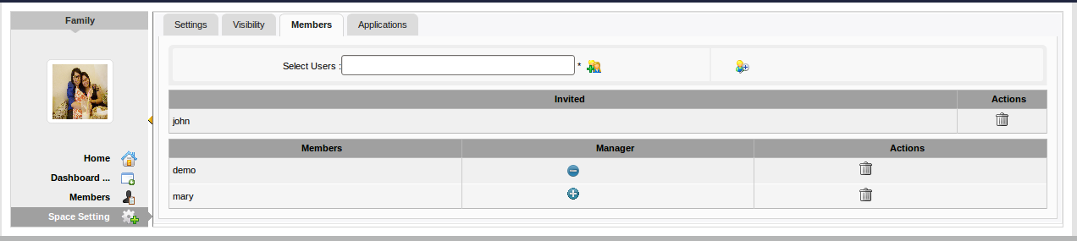
To remove the manager status, just click. Be careful not to remove the rights for yourself, or you will not be able to edit settings anymore, except that you are an administrator.

Remove Member
Simply clickcorresponding to the member you want to remove.

Manage Space Applications
Step 1: Click the Applications tab to open the application list:

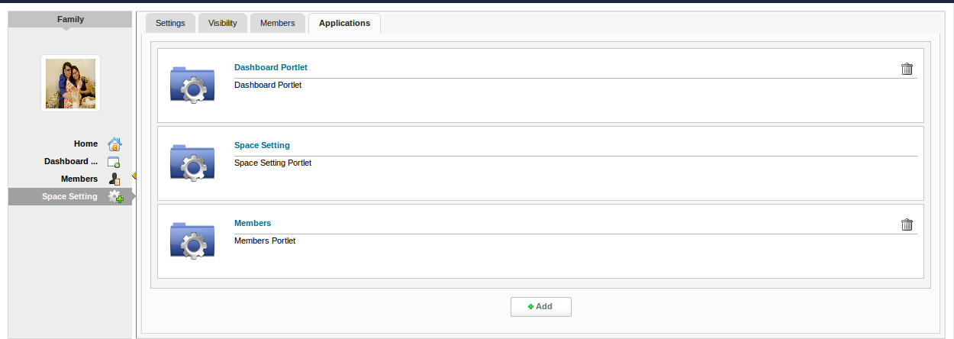
To remove an application, just click the icon next to the application name.
To add an application,
You can add a new application to your application list of the current space. Do as follows:
Step 2: Click Add to open the available applications list:

Step 3: Select the application you want to install by clicking the iconwhich corresponds to that application.
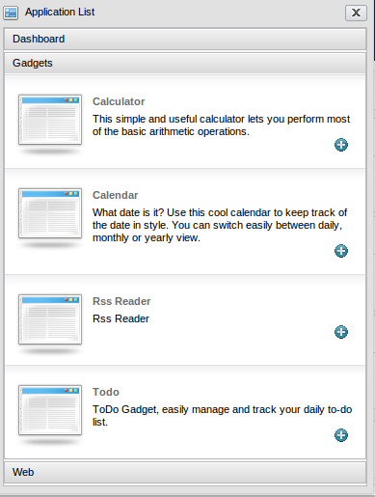
If there is no available application, ask your system administrator to give you the access right to them.

Edit Space's Navigation
Users can easily edit a space's navigation by following these steps:
Step 1: Clickwhich corresponds to the space you have the edit right. The Navigation Management will appear:

Users can take the following actions: (refer to GateIn guide for more details):
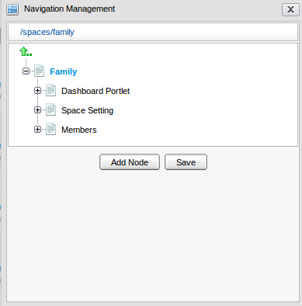
- Right-click the node name (space name) to add a new node, edit a node, edit a node's page, copy a node, clone a node, etc.
- Click Add Node.
Step 2: Click Save to accept all changes.

Leave Space
This function allows users to quickly leave the space that users donot want to stay anymore or to be the space's member.
Step 1: Click that corresponds to the space to leave that space.
If a user is only the leader of that space, the message which informs that you cannot leave a space will appear:
However, when you are members invited by the leader, you can leave the space by clicking corresponding to the space.
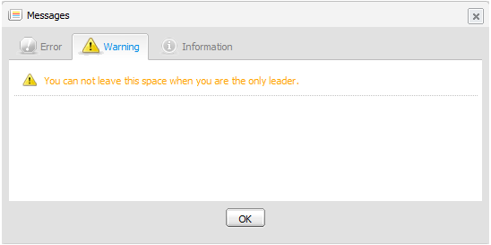
After you can leave one space, the space will not exist in My Spaces other than in Publics in the left pane.

Delete Space
Only the space manager can delete their spaces by clicking that corresponds to the desired space to delete all information and navigations related to that space.

Conclusion
This user manual has provided a thorough explanation of basic terms and features within eXo Social. Now, you have known how to use People, Activities and Spaces easily and effectively. To learn more and contribute to the open source development, please see the followings.
- Learn more about eXo Platform 3.0
- Video demos, tutorial and more in the eXo Resource Center
- Access another eXo documents in the eXo Wiki

