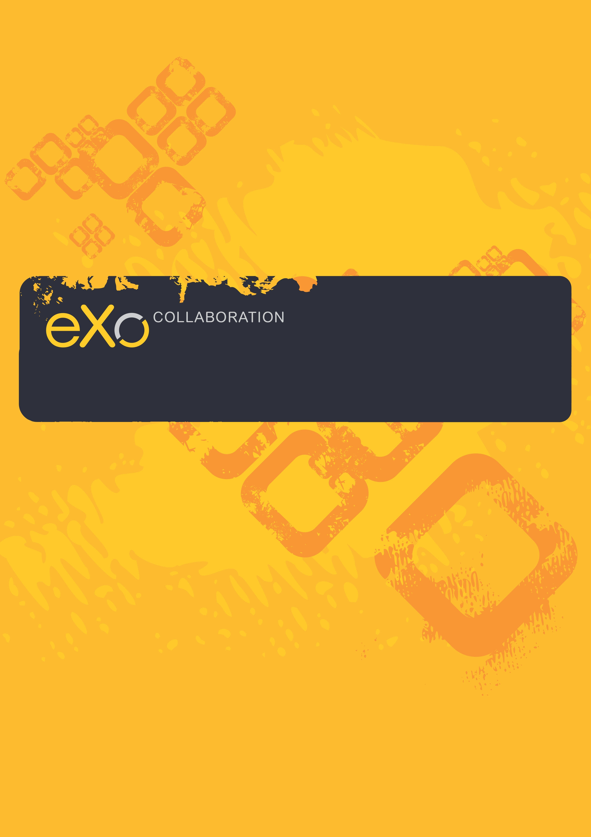
eXo Address Book Manual
Version 2.0

eXo Collaboration provides a rich, Web 2.0 browser-based interface with comprehensive messaging and indexing; archival and search capabilities; shared calendars, address books, and much more features soon.
eXo Address Book manages your private and public contacts in your organization. A contact lets you keep precious information such as personal or professional address and other reaching information such as telephone, fax, email or IM. We support VCard format import/export so that you can consolidate your existing contacts into a single place. Additionally, you can refer your contacts from other applications such as eXo Calendar, eXo Web Mail.
eXo Address Book is built on foundation of eXo WebOS with several new features designed to make your online contact experience more productive and convenient. All actions are easily reached by contextual menus and intuitive drag and drop. Searching for contacts is very convenient with full text search and criteria based search on contact properties.

eXo Team
Contents
1 Preface 5
1.1 Overview 5
1.2 About this document 6
1.3 References & related resources 6
Related Documents 6
Info & Support 6
2 Overall Introduction 8
2.1 What is eXo Address Book? 8
2.2 eXo Address Book interface 8
2.3 eXo Address Book configuration 9
3 How to use eXo Address Book? 10
3.1 Getting Started 10
3.1.1 Register new account 10
3.1.2 Sign in & sign out 12
3.2 Address Book Management 14
3.2.1 What is an address book? 14
3.2.2 Create an Address book 14
3.2.1 Edit an address Book 15
3.2.2 Remove an address book 16
3.2.3 Export an address book 16
3.2.4 Share an address book 18
3.2.5 Print an address book 21
3.3 Contact management 22
3.3.1 What is a contact? 22
3.3.2 Add a new contact 22
3.3.3 Edit a contact 27
3.3.4 Delete a contact 28
3.3.5 Copy/paste a contact 29
3.3.6 Move a contact 29
3.3.7 Export contacts 31
3.3.8 Import contacts 32
3.3.9 Print contacts 34
3.3.10 Share contacts 36
3.3.11 Send mail to a contact 39
3.3.12 Search contacts 41
3.4 Tag 43
3.4.1 Tag a contact 43
3.4.2 Edit a tag 44
3.4.3 Delete a tag 45
3.4.4 Export contacts in a tag 45
3.4.5 Print contacts in a tag 46
3.5 Change the View type 47
3.5.1 List View 47
3.5.2 VCards View 47
3.6 Change the Layout 48
4 Next Steps 49

Preface

Overview
Beginning as an Open Source project in the year 2002, eXo is well-known as the industry's first Java portlet container. With the aim of dominating the potential portal market through robust and easy-to-use applications, eXo Project succeeded in attracting consumers in the whole world. eXo actually opened the floodgates to various options in many markets, and customers have been choosing eXo as the best method for their success.
The eXo Platform™ software is a powerful Open Source corporate portal and content management system. Users of the platform have a customized single point of access to the company's information system and resources.
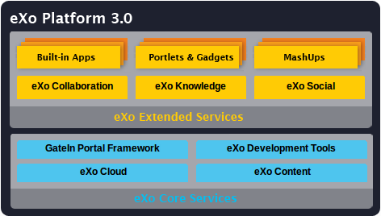
The foundation for eXo Platform 3.0 is eXo Core Services, a powerful set of REST-based services for rapid website development, content management and gadget-based development and deployment. eXo Extended Services are also a part of the eXo Platform 3.0 running on top of eXo Core Services to enable easy development of rich, user-centric web applications.
eXo Collaboration is one of eXo Extended Services,. It provides a rich Web 2.0 browser-base interface with a suite of collaborative applications targeted at team work coordination and information sharing. eXo Collaboration offers intuitive and powerful Mail, Chat, Calendar and Address Book functionality as a seamless extension to portal-based application.

About this document
The intended reader of this manual is users of eXo Address Book. This manual will explain all the basic and advanced features that eXo Address Book provides. It gives an in depth examples and easy explanation of using eXo Address Book to create, manage and share your contacts.
It is also useful for the following groups:
- Users who use eXo Collaboration with eXo Address Book in their work and business.
- Integrators who want to know more about the rich knowledge features in order to advise their customers to use eXo products.
It is also useful for the following groups:
- Users who use eXo Collaboration with eXo Address Book in their work and business.
- Integrators who want to know more about the rich knowledge features in order to advise their customers to use eXo products.
This user guide will help you:
- know basic concepts used in the eXo Address Book
- know how to create, edit, manage & share contacts.

References & related resources

Related Documents
- GateIn Guide
- eXo Calendar User Guide v2.0
- eXo Mail User Guide v2.0
- eXo Chat User Guide v2.0

Info & Support

Information
- eXo Home Page
- eXo Wiki

Support
- Forums
- FAQ

Download
- eXo Content
- eXo Development tools
- Gatein Portal Framework
- eXo Collaboration
- eXo Knowledge
- eXo Social

Resource Center
- Video demos, tutorials, webinar archives, features & benefits tables and more

Overall Introduction

What is eXo Address Book?
eXo Address Book is a web based on contact management application. Using eXo Address Book to store and maintain contact information about friends, family and your professional network, etc in a single place. You can access it with a browser connected to your enterprise network.

Access to eXo Address Book
To access to the Address book, you can follow one of these ways:
Click on from the top navigation bar:
Or click on right from the Chat bar:

eXo Address Book interface
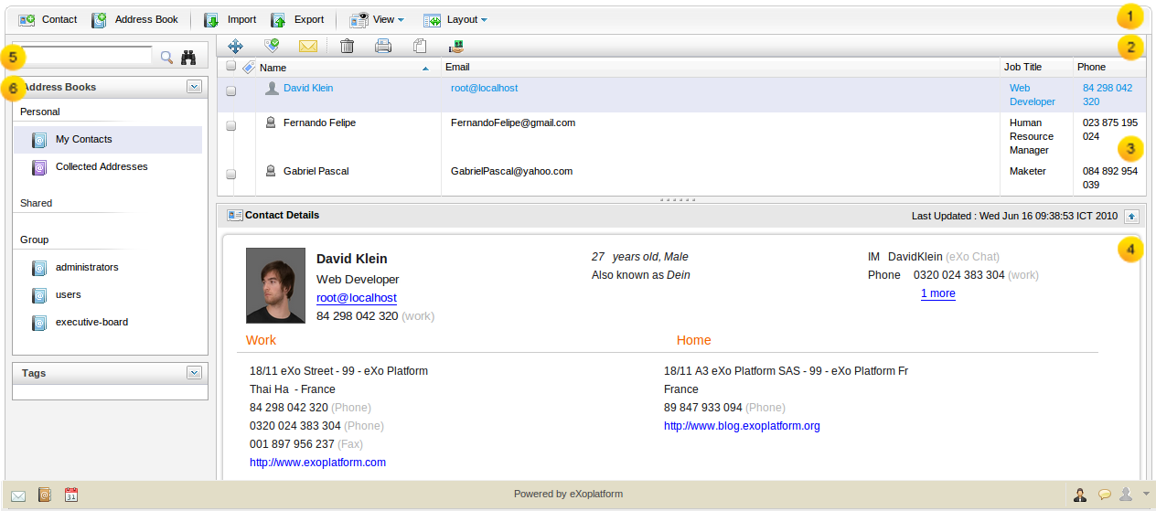Illustration 1: The main screen of the Address Book application

Details
This is the Tool bar which allows you to add new contact/address book, import/ export address book, view and customze layout.
This is the Action bar which allows you to taking basic actions such as move, delete, copy, print, add tag selected contacts
This is the Contact list which shows all contacts in a specific address book
This is the Contact view panel which displays detail information of the selected contact
This is the Navigation panel which contains search panel, address books list and tags list
This is the Search panel which allows you to do the simple and advanced search to find expected contacts.

eXo Address Book configuration
By default, there are 3 categories of address books in eXo Address Book:Personal address book: This address book which may only be viewed by you. It is stored in the Personal list. In eXo Address Book, the My contacts is the default personal address book which contains your default contact matching with your registration information. In addition, the Collected Address book contains all email contacts updated automatically during using eXo Mail. For example, when you receive an email sent from a new sender address which is not in your address book, this address will be automatically added into the Collected Address book.
- Shared address book: This address book can be shared with other users. In eXo Address Book, it is stored in the Shared list. The shared address book can be viewed and updated by shared users if they are granted edit permission .
- Public address book: This address book is shared by group and can be viewed by everyone. In eXo Address Book, the public address book contains default contacts of the other users in different groups and can be viewed only.

How to use eXo Address Book?

Getting Started

Register new account
- To register a new account on the GateIn, do as follows:
Step 1: Go to the portal by typing URL in address bar (e.g: http://localhost:8080/portal). The anonymous home page will be displayed:
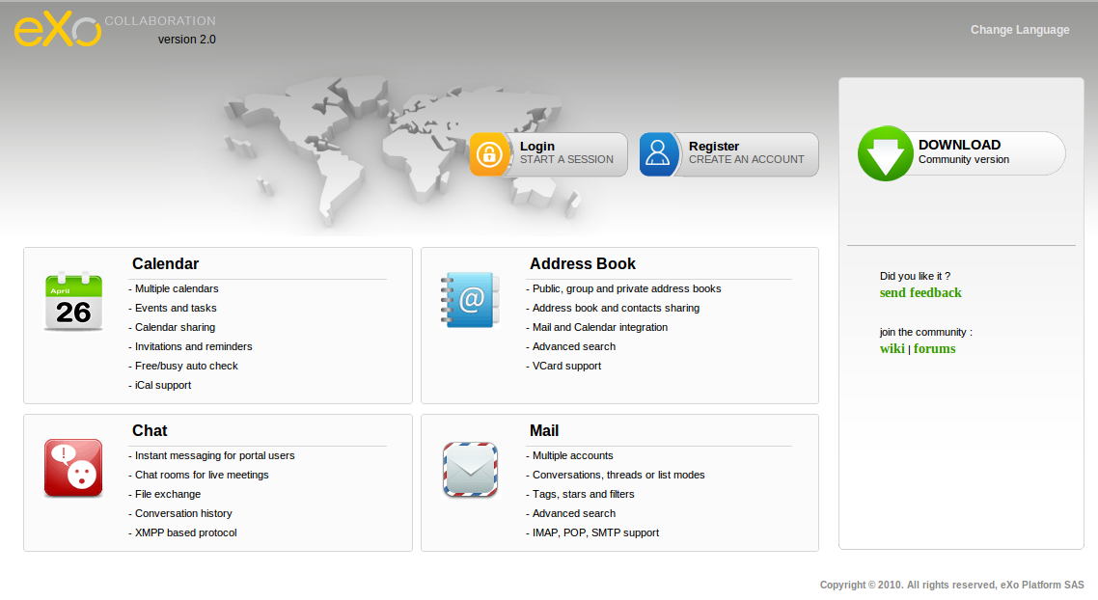Illustration 2: eXo Collaboration Homepage
Step 2: Click the 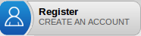 button on the navigation bar. The Sign up form will appear.
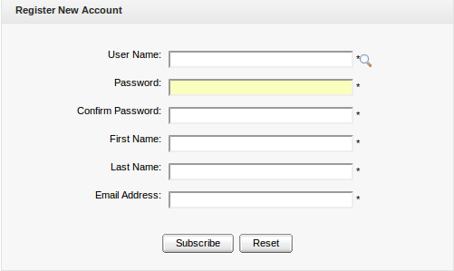Illustration 3: The Register New Account form
Details:
(*): required
User Name | The name of user that will be used to sign in. It must be unique.
Password | The secret string used to login. It must have at least 6 characters.
Confirm Password | The re-typed password. Password and Confirm Password must be the same
First Name | Your first name
Last Name | Your last name
Email Address | Your contact email address.
Subscribe button | Click this button to accept saving the new account
Reset button | Click this button to clear all inputted values.

Step 3: Click the icon to search and check for the availability of your User name
Step 4: Input values in all required fields in the Register New Account form.
Step 5: Complete registering a new account by clicking the Subscribe button.

There will have an alert messages and you can not add new account if at least one of these cases occurs:
- User name is existing or User Name is invalid
- Password has less than 6 characters.
- Password and Confirm Password are not the same
- Email Address is in invalid format
- Required fields are empty

Sign in & sign out
- To sign in, do as follows:
Step 1: Go to the portal in a public mode by typing the portal URL in your address bar (e.g: http://localhost:8080/portal)
Step 2: Click the  button . The Sign in form will be displayed:
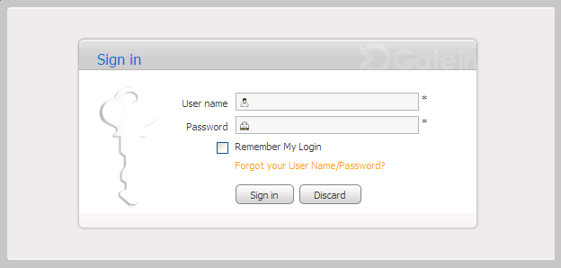Illustration 4: The Sign in form

Step 3: Input your registered User name and Password.

Details:
(*): required
User name | Your registered user name
Password | Your registered password
Remember My Login | When the Remember my Login is checked, your computer will save your login information.The next time you login, you don't have to type your User Name and password again.
Forgot your User Name/Password | To show the guide line that must be followed to get the forgotten User Name/Password
Sign in button | To accept signing in
Discard button | To exit the Sign in form

Step 4: Click the Sign in to complete signing in.
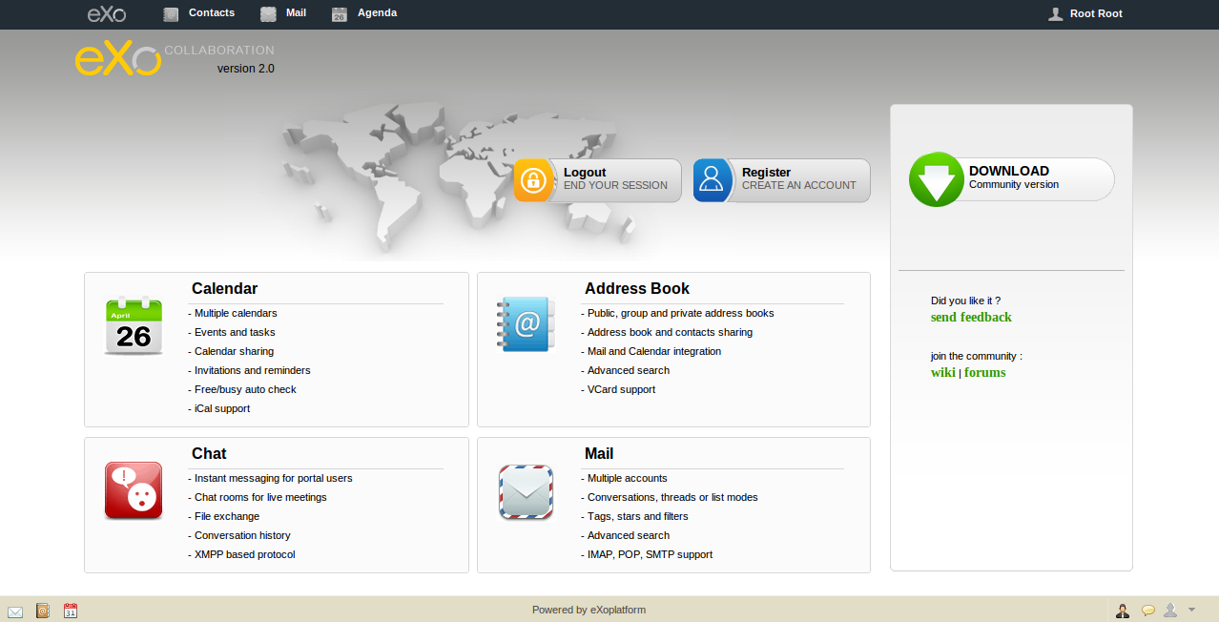Illustration 5: The GateIn page after signing in successfully
- To sign out, just click the eXo logo () and select Sign out from the menu:
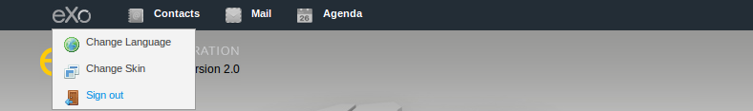

Address Book Management

What is an address book?
An address book is a book or a database used for storing entries called contacts. Each contact entry usually consists of a few standard fields (for example: first name, last name, company name, address, email, phone number...). An address book makes it easy and efficient to organize and manage contacts . As mention above, eXo Address Book has three address book types: Private , Shared and Public.

Create an Address book
- To create an address book, do as follow:
Step 1: Open the Add Address book form. There are three ways to do this step:
The 1st way: Click the button on the main tool bar.
The 2nd way: Click the icon in the Address Book bar and select Add in the drop down list menu:
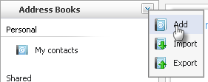
The Add/edit Address book form will appear:
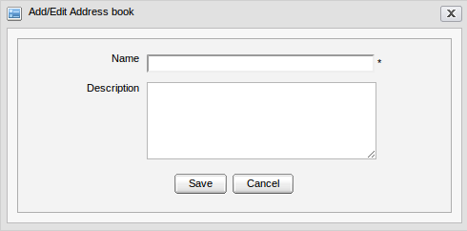Illustration 6: The Add/Edit Address Book form

Details:
(*) required
Name | The display name of the address book
Description | The brief description of the address book
Save button | To accept saving a new address book
Cancel button: | To exit/close the Add/Edit Address book without changes

Step 2: Enter values for the Name and Description fields
Step 3: Complete adding the new address book by clicking the Save button.

You can create a new address book from the Mail portlet ( See eXo Mail User Guide for details)

Edit an address Book
- To edit an address book, do as follows:
Step 1: Right click on an existing address book and select Edit in the drop down menu:
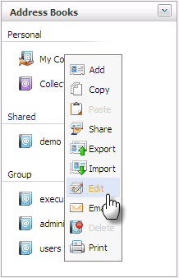
Step 2: The Add/Edit Address Book will be displayed. Now you can edit the name and description of selected address book.
Step 3: Click the Save button to accept the changes or click the Cancel button to exit the form without changes.
You can only edit a personal address book or a shared address book in case you have the edit permission. You can not edit a public address book.

Remove an address book
- To remove an address book, do as follows:
Step 1: Right click on an existing address book, and then select Delete in the menu:
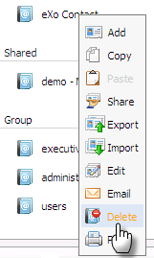
Step 2: Click the OK button in the confirmation message to accept deleting the address book or click the Cancel button to abort.
- You can not delete your default and public address book
- You can delete your personal address book which is added by yourself flexibly

Export an address book
This function allows exporting one or more address books into a separate file in your computer in order to make it easy to backup your address book or import it into another address book application.
- To export an address book, do as follows:
Step 1: Open the Export Address Books form. There are two ways to do this step:
The 1st way: Click the Export button in the main tool bar
The 2nd way: Click the icon in the Address Books bar and select Export in the menu:
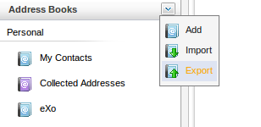
The Export Address Books form will appear with a list of all existing address books:
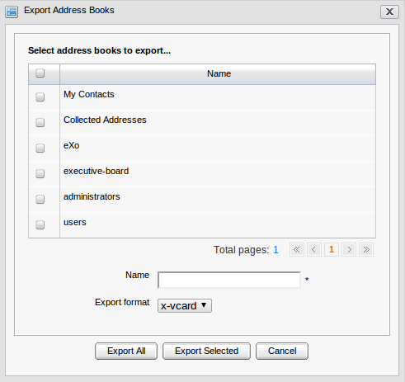Illustration 7: The Export Address Books form
Step 2: Select the address book(s) which you want to export by selecting its corresponding check box(s) (or select the top checkbox to select all)
Step 3: Enter a file name for the Name field
Step 4: Select format for the imported file (e.g x-vcard)
Step 5: Click the Export All button to start exporting all the address books or click the Export Selected button to export the selected ones only.
A download pop-up window will appear. Depend on what browser you are using, the download pop-up window may show differently.

Share an address book
This function allows you to share your personal address books with specific groups or users. The shared address book will be displayed in the shared address book list of your selected groups or users and can be viewed, exported, added, edited or deleted (if the shared user has edit permission on it).The shared address book can be distinguished by the hand icon:
- To share a personal address book, do as follows:
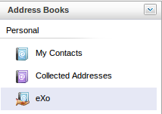Illustration 8: The shared address books
Step 1: Right click on the address book you want to share and select Share in the drop down list menu:
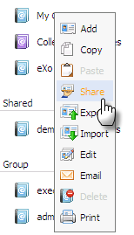
The Share address book form will appear:
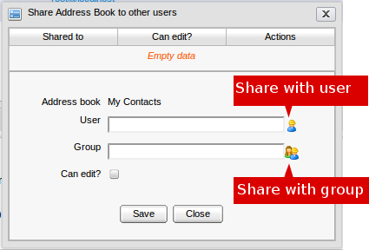Illustration 9: The Share Address Book to other users form
Step 2: Select users/group to share.
To select Users for sharing, do as follows:
1. Click the icon, the User Selector form appears:
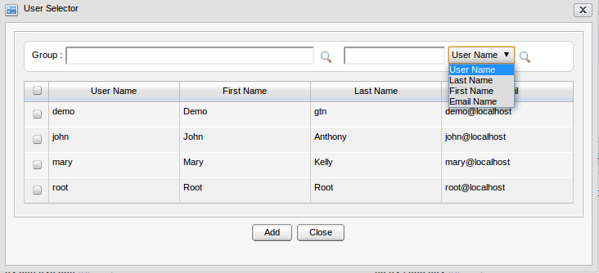Illustration 10: The User Selector form
Select user(s) to share by clicking on the corresponding check-box(s).
You can also select for specific user(s) by User name, Last name, First name, Email. Type search words in the search box, select the search criteria and then click the icon to search.
2. Click the Add button to add selected users to the shared list or click the Close button to close this form.
- To select a group for sharing, do as follows:
1. Click the icon, the Group Selector form appears:
2. Select groups in the left pane to view sub-groups in the right pane, and then select a sub-group.
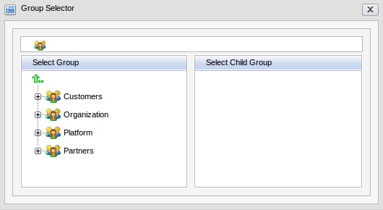Illustration 11: The Group Selector form
Step 3: After selecting User/group to share, click the Save button to accept sharing with the selected user/group or click the Close button to quit the sharing form.
You can select the “Can edit?” check box if you want to grant edit permission on this address book to the selected user/group. The user/group(s) having edit permission can view export, import, add, edit and delete the shared address book while the user/group does not have edit permission can view and export only.
After sharing, the shared users/groups will be updated into the share list with detailed information like the illustration below:
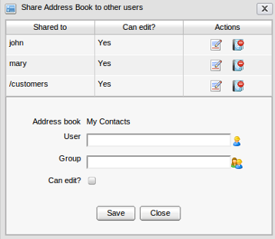
In the Actions column, you can click the icon to change the edit permission of corresponding user/group or click the icon to remove specific user/group from the Share list.

Print an address book
This function allows you to print summary information of contacts in form of visit cards. You can print all contacts of an address book at a time.
- To print address book, do as follows:
Step 1: Right click on the address book which you want to print and select Print in the drop-down menu:
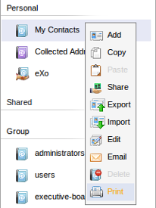
The print preview page will appear:
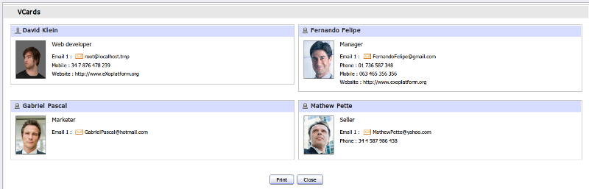Illustration 12: The VCards Print Preview form
Step 2: Click the Print button to start printing or the Close button to exit the preview print dialog.

Contact management

What is a contact?
A contact is a person or an organization you’ve added to your contact list. By adding a person as a contact, you can easily check out the person's or the organization's profile (name, address, email and phone number...)

Add a new contact
This function allows you to add new contacts to personal address books and shared address books (if you have the edit permission).
- To add a new contact, do as follows:
Step 1: Open the Add Contact form. There are 2 ways to do this step:
The 1st way: Click the button on the main tool bar .
The 2nd way: Right click on an address book (for example My Contacts), and select the Add item in the menu.
The 3rd way: You can also create a new contact from the Mail portlet ( See eXo Mail User Guide for details)
The Add/Edit Contact form will appear:
The Add/Edit Contact form consists of the Address Book Selector and the Contact Detail panel:
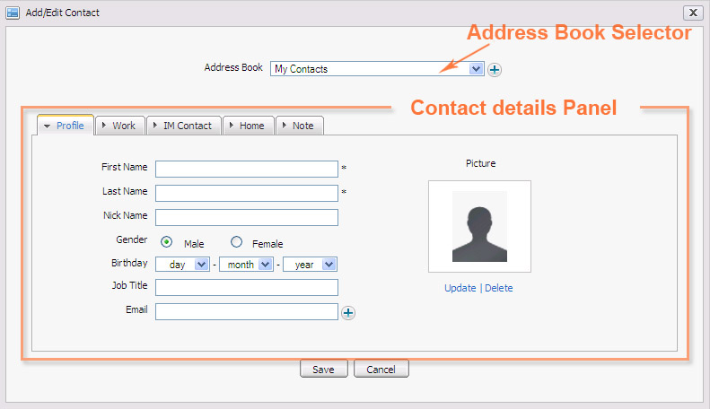Illustration 13: The Add/Edit Contact form
Address Book Selector
The Address Book Selector allows you to select one from the existing list or quickly create a new address book. To create a new address book, simply click the icon.
Contact Details Panel
It includes 5 tab: Profile, Work, IM Contact, Home and Note.
Step 2: Input information into the Add/Edit Contact form
Step 3: Click the Save button to accept adding a new contact or the Cancel button to exit this form without adding.
Details:
- The Profile tab:
(*) Required
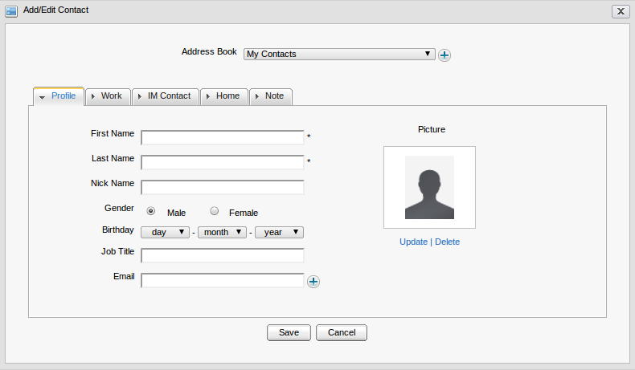Illustration 14: The Profile tab of the Add/Edit Contact form
If you want to change picture (avatar) for the contact, click the Update link to upload photo from your computer. To remove your uploaded image, simply click the Delete link below your avatar picture.
The icon at the Email field allows you to adding more email addresses for the contact. When it is clicked, more Email address fields will appear:
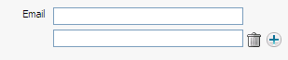
Add new email address by clicking the icon or remove by clicking the icon.

- The Work tab:
- The IM Contact tab contains information about chat nick. (IM stands for instant message).
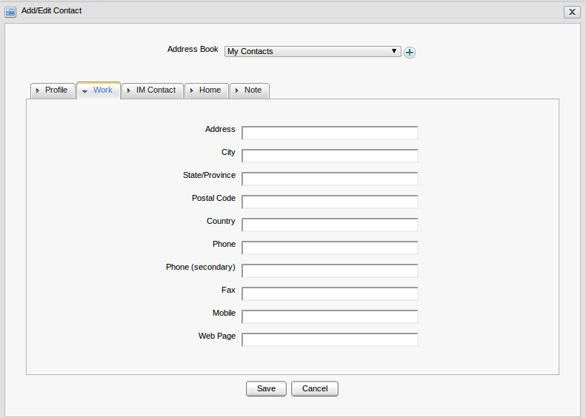Illustration 15: The Work tab of the Add/Edit Contact form
The default one is eXo Chat. You can click the icon to chose other kinds of mail service.
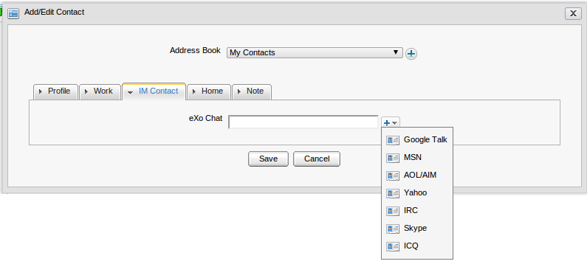Illustration 16: The IM Contact tab of the Add/Edit Contact form
- The Home tab :
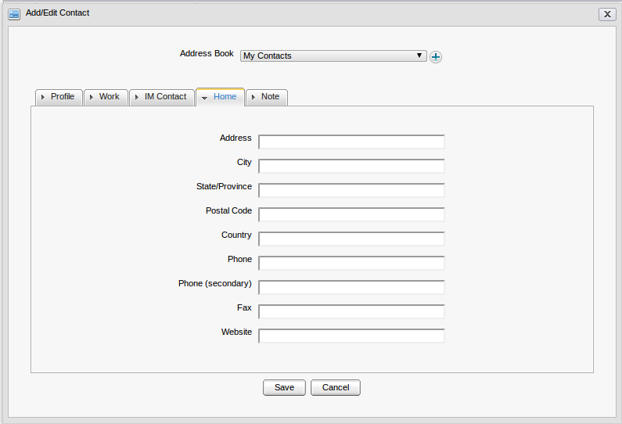Illustration 17: The Home tab of the Add/Edit Contact form
- The Note tab:
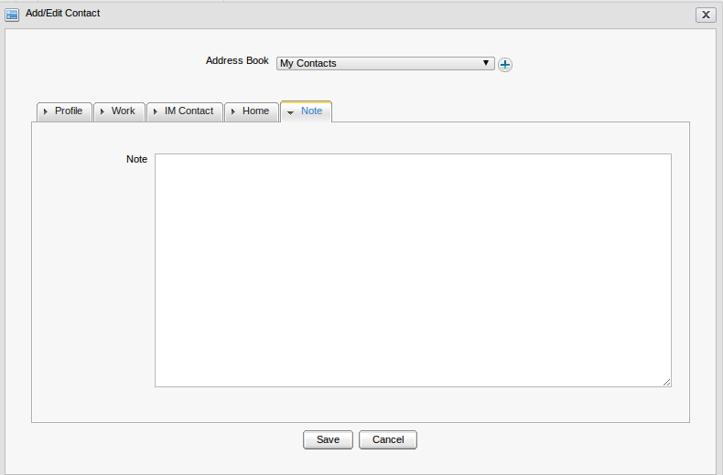Illustration 18: The Note tab of the Add/Edit Contact form

Edit a contact
This function allows you to make changes to the selected contacts. You can only edit a contact of the personal or shared address books (if you have edit permission).
- To edit a contact, do as follows:
Step 1: Right click on an available contact in list, and then select Edit in the drop list menu.
The Edit Contact form will appear with full fill information, available for editing:
Step 2: Change information of the current contact. You can change all information, picture of your expected contact its Address book. This field is disabled.
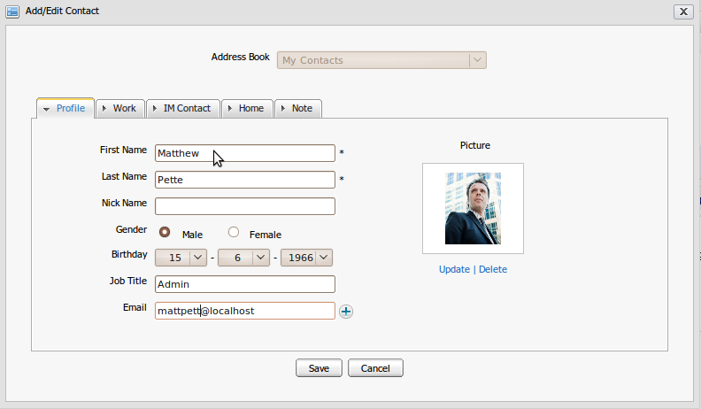Illustration 19: The Add/Edit Contact form with full filled information, available for editing
Step 3: Click the Save button to accept changes or click the Cancel button to cancel this action.
You can also edit an address book from Mail portlet ( See eXo Mail User Guide v1.3 for detail)

Delete a contact
This function allows deleting existing contacts. You can only delete a contact of personal or shared address books (if you have edit permission)
There are two ways to delete a contact:
The 1st way:
Step 1: Right click on a contact of address book which is opening and then select Delete in the menu.
Step 2: Click the Delete button on the confirmation message form to delete the selected contact or click the Cancel to quit.
The 2nd way:
Step 1: Select check box(s) in the first column to select one or more contacts and click the Delete icon on the action bar.
Step 2: Click the Delete button on the confirmation message form to delete the selected contact(s) or click the Cancel to quit.
You can also delete an address book from Mail portlet ( See eXo Mail User Guide v1.3 for detail)

Copy/paste a contact
You can copy one or more contacts to another address book:
The 1st way: Right click on a contact/an address book and select Copy in the drop list menu:
The 2nd way: Select the contacts that you want to copy by selecting check-box in the first column, and then click the Copy icon on the action bar.
The 3rd way:
Step 1 Right click on an address book which has one or more contacts and select Copy in the menu.
Step 2 Select a destination address book for coping your selected contacts by right - clicking on the destination address book and select Paste in the drop list menu:

You can copy contacts of all address books but you can only paste contacts into personal and shared address books (if you have edit permission).

Move a contact
This function allows you to move one or more contacts from one address book to another one.
- To move a contact, do as follows:
Select Move function by two ways:
The 1st way: Right click on a contact and select Move in the drop list menu
The 2nd way: Select one or more contacts you want to move by selecting check-box(s) in the first column, and then click the icon on the action bar.
The Move contact form will appear:
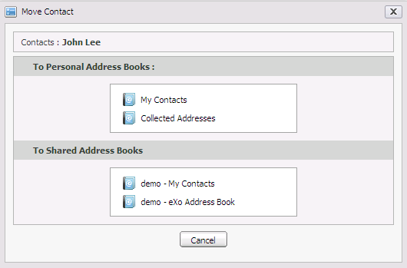Illustration 20: The Move Contact form
Move contacts by right clicking on the destination address book which you want the contact is moved to. After moving successfully, the form will be automatically closed.
You also can click the Cancel button to exit the form without moving.
The 3rd way: Move contacts by using drag and drop feature. You can drag and drop one or more contacts at the same time.
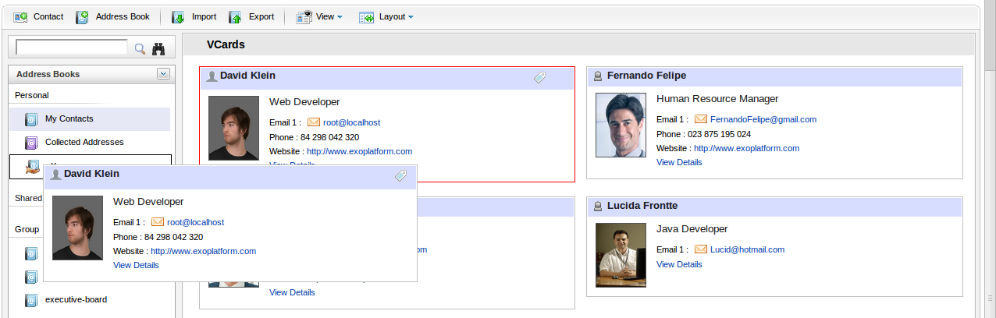
You can only move contacts of personal or shared address book if you have the edit permission. You can not move default contact or contacts in the address book which you do not have edit permission and contacts in public address book.

Export contacts
This function allows you to export one or more contacts into a file that can be used in another application.
- To export a contact, do as follows:
Step 1: Select Export function by one of two ways:
The 1st way: Right click on one contact in the contact list and select the Export item in the drop list menu:
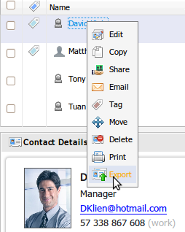
The 2nd way: Right click on a specific address book name and select the Export item in the drop list below:
The Export Contacts form will appear:
Step 2: Select one or more contact(s) which you want to export by selecting its check box(s).
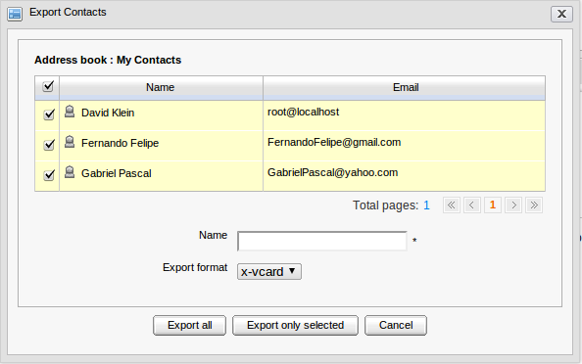Illustration 21: The Export Contacts form
Step 3: Enter a file name in the Name field and select the export format .(e.g x-card)
Step 4: Click the Export all button to export all contacts in all pages, click the Export only selected button to export selected contacts or click the Cancel button to quit.
A download pop-up window will appear. Depend on what browser you are using, this window can be displayed differently.

Import contacts
This function allows you to import one or more contacts from your computer to a selected address book in eXo Address Book.
- To import contact, do as follows:
Step 1: Select the Import function. There are by 3 ways to do this step:
The 1st way: Click the button on the main tool bar.
The 2nd way: Click the icon on the navigation pane and then select Import in the menu:
The 3rd way: Right click on a personal or shared address book which you have edit permission and select Import in the drop down list menu:
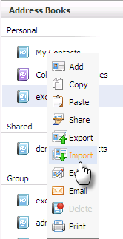
The Import contact form will appear:
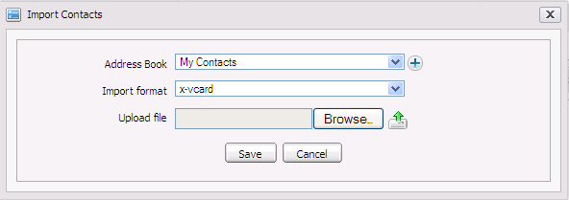Illustration 22: The Import Contacts form
Step 2: Select an address book that you want to import contacts to
Step 3: Select the file format in the Import format field. For example: x-vcard
Step 4: Browse to contact file from your computer and click the Upload icon next to the Browse... button to upload the selected file.
Step 5: Click the Save to accept importing contacts in the selected file or click the Cancel to quit.
You can only import contacts to personal or shares address books if you have edit permission.

Print contacts
Print function allows you to print information of the selected contacts. You can print one or more contacts at the same time.
- To print one contact, do as follows:
The 1st way:
Step 1: Right click directly on a contact in the contact list and select Print in the menu:
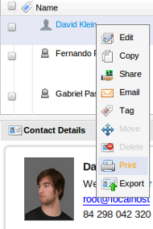
The single contact print preview will appears with the detail information:

Step 2: Click the Print button to continue printing or click the Close button to quit the Contact print preview form.
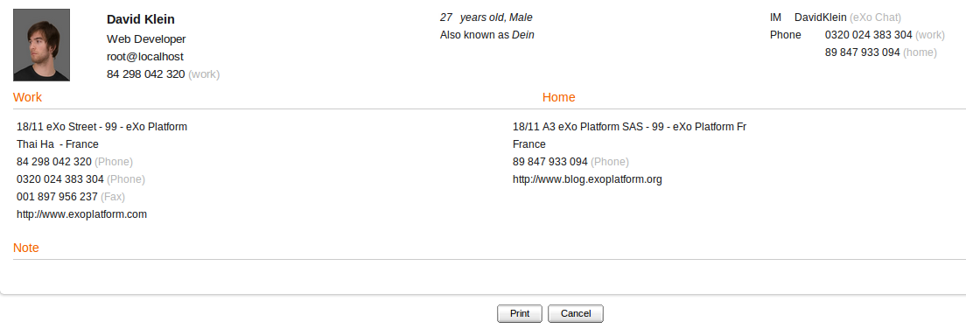Illustration 23: The Single contact print preview
The 2nd way:
Step 1: Click View in the main menu, and then select Vcard like below:
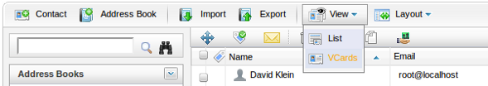
The contacts will be displayed in the Vcard view:
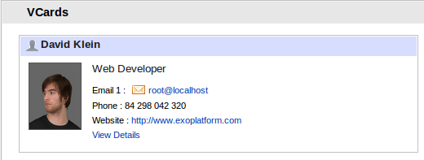
Step 2: Click View Details to open the contact in detail pop up. The pop up is shown with Print Preview button that allows you to view and print the contact like the 1st way.
- To Print multi-contacts:
Step 1: Select contact(s) you want to print by selecting its corresponding check box(s) , and then click the Print icon on the action bar:
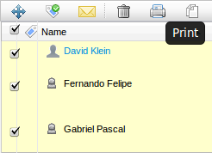
The multiple contacts print preview will appear with summary information:
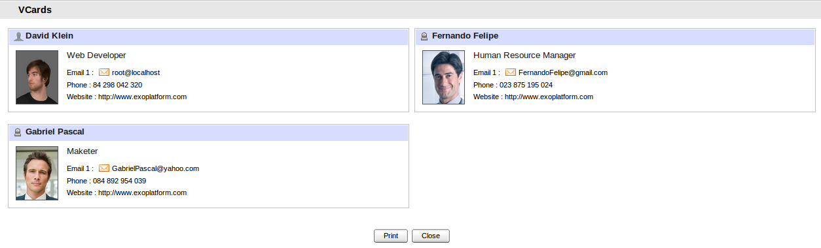
Step 2: Click the Print to print selected contact(s) or the Cancel to quit without printing.

Share contacts
This function allows you to share contact(s) with one or more users, groups. The shared user/group(s) may have view permission or edit permission on the shared contacts.
- View permission allows other users to view, copy, export, print, move and delete but can not delete your shared contacts. The shared users can not make changes on the information of the shared contacts if they have view permission only. However, they can move and delete shared contacts.
- Edit permission allows other users to view, copy, export, print, move and delete and also edit the shared contacts.
The shared users can move or delete the shared contacts from their Address Book only. The original shared contact still exists in the other shared user's contact view. The shared contact is only deleted completely and no longer sharing with all shared if the creator/author of the shared contact removes it.
- To share contact with other user:
Step 1: Right click on one contact you want to share and select Share in the menu or drag and drop this contact to Shared Address book in the Address Book panel:
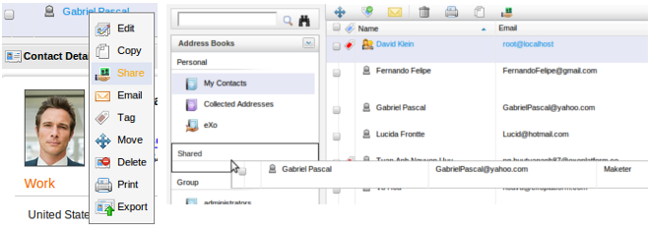

The Share contact to other users form will appear:
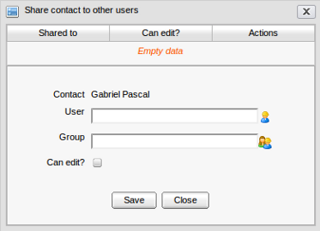
Step 2: In the Share contact to other users form, click the select user icon to open the User Selector form:
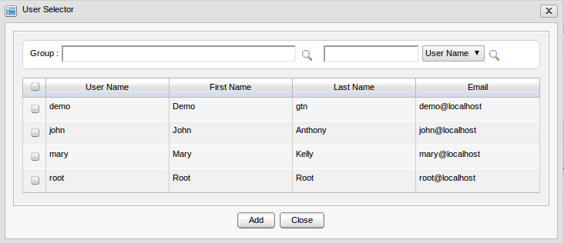Illustration 24: User selector form
Step 3: Select user(s) by selecting its check box and click the Add button.
Step 4: Select the 'Can edit?' check box if you want to grant edit permission. User in Group having edit permission can view export, import, add, edit and delete the shared contact while the others do not have edit permission can view and export only.
Click Save to share your contact(s) with selected user(s).
- To share a contact with groups:
Step 1: In the Share contact form: click the select group icon by Group field.
The Group Selector form will appear:
Step 2: Select the group path from the left panel. The group corresponding with the path will be shown at the right panel and available for selecting. The selected group will be displayed in the Group field.
Step 3: Click Save to accept sharing with the selected users or click Cancel to quit.
After sharing, the shared users/groups will be updated into the Share table in the Share Address book to other users form :
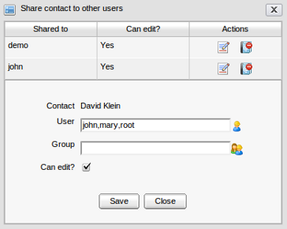
In the Actions column, you can click the icon to change the 'Can edit' right of specific user/group(s) or click the icon to remove specific user/group from the Share table. If you want to delete specific user/group, click on the delete icon corresponding to it and select the OK on the delete confirmation message.

Send mail to a contact
This function allows you to send a mail directly to one or more contacts in your address book. To take this action, you firstly need to:
1. Add at least one account in eXo Mail application (see eXo Mail User guide for more details)
2. Have the email address of the contact which you want to send mail.
3. Email address of the selected account will be used to send mail to a contact.
- To send mail to a contact:
Step 1: Select the Email function. You can do this steps in different ways:
The 1st way: Right click on the contact which you want to send a mail to and select Email in the drop down list menu:
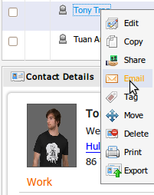
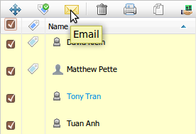
The 2nd way: Select the contact(s) that you want to send mail by selecting its check box(s) in the first column, and then click the Email icon on the action bar:
The 3rd way: Right click on the address book and select Email in the menu:
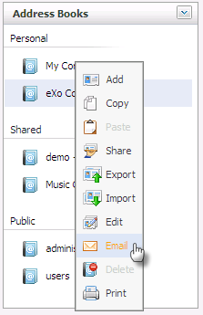
The 4th way: Click on email address of a contact when viewing contact in details.
After selecting the Email function, the Send mail form will appear:
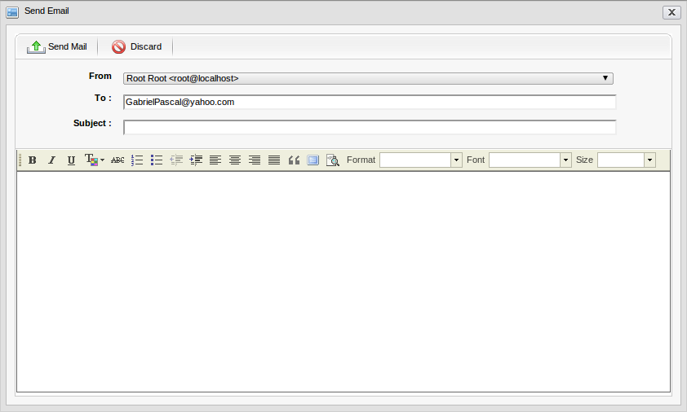Illustration 25: The Send mail form
Step 2: Input the receivers' email address.
Besides, the auto complete contacts function allows filtering and listing the receive email address according to your alphabet input.
Step 3: Input the subject and the message content.
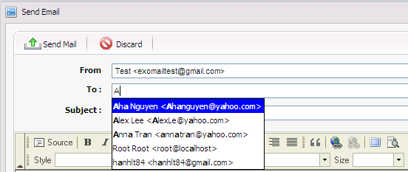Illustration 26: The auto complete feature
Step 4: Click the Send Mail button to send your message to the selected contacts.

Search contacts
The search contact function allows finding contacts easily and quickly. There are two search types: Quick search and Advanced search.

Quick search
This function allows you to do a quick search with specific keyword in all your contacts. All contacts having text matching with your search team will be displayed in the Search Result dialog.
Do as follows:
Step 1: Type search words in the Search box :
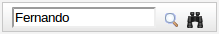
Step 2: Click the Search icon
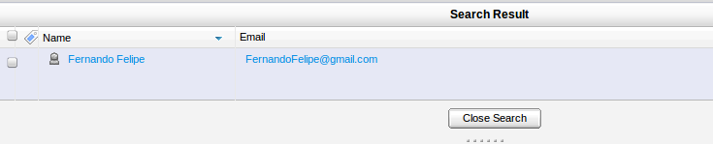
The search result(s) will be displayed in the right panel:

Advanced search
This function allows you to make a search with multiple criteria, do as follows:
Step 1: Click the Advanced Search icon next to the search box.
The Advanced Search form will appear:
Step 2: In this form, you can set the search criteria by :
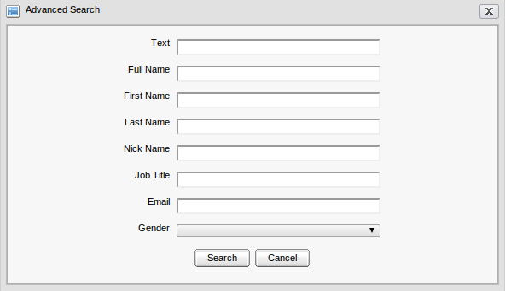Illustration 27: The Advance Search form
  - Simple text
  - Full name
  - First Name
  - Last name
  - Nick Name
  - Job title
  - Email
  - Gender
Step 3: Click the Search button to do search. All contacts which satisfy your criteria will be listed in the Search Result dialog.

Tag
eXo Address Book allows assigning tags to specific contacts. Tags are used as labels which help you filer or categorize your contacts from different address books. A single contact can be assigned to many tags at a time.

Tag a contact
There are several ways to add or remove tags to a contact.
- To tag a contact:
Select the Tag item by one of following ways:
The 1st way: Right click on the contact which you want to tag and select Tag in the drop down list menu.
The 2nd way: Select the contact(s) that you want to tag by selecting corresponding check box(s) in the first column, and then click the Tag icon on the action bar.
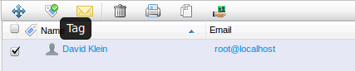
The 3rd way: Drag and drop contacts to specific tag in the Tag space in the left pane.
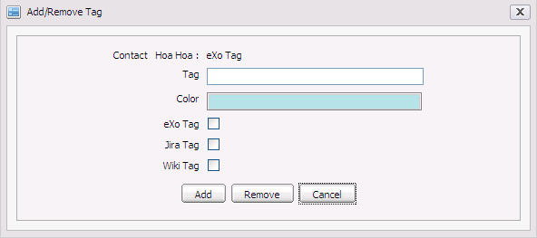Illustration 28: The Add/Remove tag form
- To add tag to a contact:
Step 1: Tag a name.
Step 2: Select color for tag in the drop down list
Step 3: Click the Add button to add tag.
- To update contact to an existing tag:
Step 1: Select tags to update by selecting available tag check box in the form
Step 2: Click the Add button to add tag.
- To remove tags from a contact:
Step 1: Select tags to remove by selecting available tag check box(es) in a form
Step 2: Click the Remove button to remove selected tag(s).
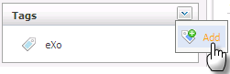
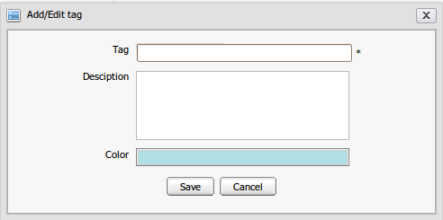
To add tag without the contact list included, click the “Add new tag” icon at left pane:The Add/edit tag will be displayed and available for adding a new tag:
When opening a tag, you can take all actions on the contacts which are tagged such as move, delete, print, edit, add tag, print, shared,copy, drag and drop,send mail

Edit a tag
- To edit a tag, do as follows:
Step 1: Right click on a tag in tag space and select the Edit item in the menu:
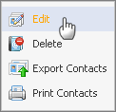

The Edit tag form will appear:
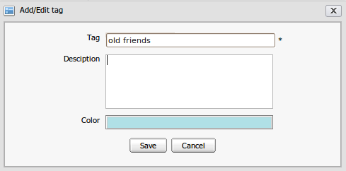
Step 2: Make changes in the form such as change the Tag name, description, color.
Step 3: Click the Save button to accept changes or click the Cancel button to quit.

Delete a tag
- To delete a tag, do as follows:
Step 1: Right click on tag name in tag space and select Delete item in the menu
Step 2: Click the OK button in the confirmation message to accept deleting tag or click the Cancel button to quit.

Export contacts in a tag
- To export contact in tag, do as follows:
Step 1: Right click on a tag and select Export contact in the drop list menu:
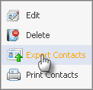
The Export Contacts form will appear:
Step 2: Select one or more contacts that you want to export by selecting its check box(s)
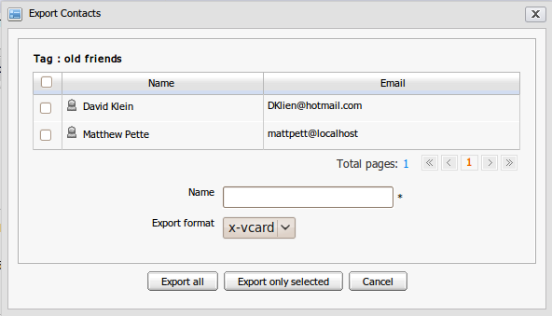Illustration 29: The Export Contacts form
Step 3: Enter a file name for the Name field.
Step 4: Select file format from the Export format combo box (e.g x-vcard)
Step 5: Click OK to accept exporting or click the Cancel to exit the form.
A download pop-up window will appear. Depend on what browser you are using, this window may display differently.

Print contacts in a tag
This function allows printing all contacts in specific tags.
- To print contacts in one tag, do as follows:
Step 1: Right click on a tag in the tag space and select Print contacts in the drop down list menu.
The contact print preview form appears with details contact information.
Step 2: Click the Print button to continue printing or the Close button to exit the Contact print view form.

Change the View type
This function allows you to personalize your contact view from many different view types. At present, your contacts can be viewed by List or Vcards.

List View
The list view displays all contacts in the list panel and detail information of the selected contact in Contact view panel.
- To view contacts by list view, do as follows:
Step 1 In Main tool bar, click View icon and then select List in the menu:
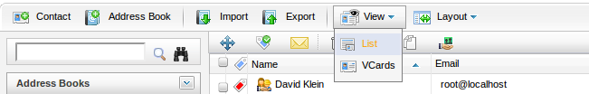
The contacts are displayed in the list below:

VCards View
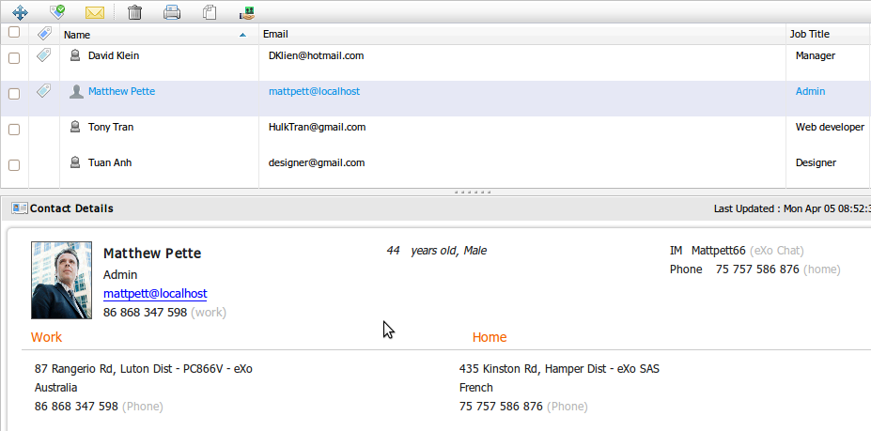Illustration 30: The List View form
The Vcards view displays all contacts in Vcard form, do as follows:
Step 1: On Main tool bar, click the View icon and then select Vcards in the menu:
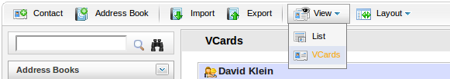
The contacts are displayed as Thumbnails:
Step 2: You can click the View Details to see the contact details in a pop up.
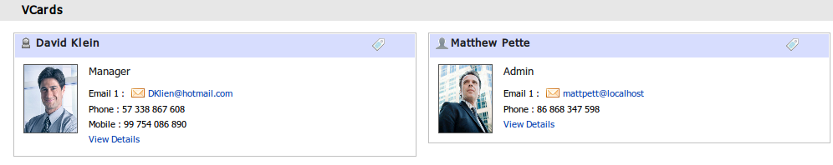Illustration 31: The VCards View form
In case the contact is tagged, a tag icon is shown at the right corner that shows all the tags of the contact. You can click on a specific tag in the menu pop up for details.

Change the Layout
eXo Address Book layout allows you to show or hide many parts of Contact interface.
- To configure layout, do as follows:
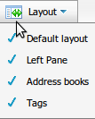
Step 1: On the main tool bar, click the Layout icon, and then select an item in the drop down list menu.

Step 2: For example, if you unselect the Navigation item in the drop down list menu, the navigation panel in the left area will be hidden.

Next Steps
It is our hope that information stated above is valuable to you, our customers and users in the process of experiencing the eXo Address Book . To clearly support for benefits recognition from customers and users, we would like to summarize key features of eXo Address Book as follows:
- User friendly interface: Clean, AJAX-enabled UI with drag-and-drop, right-click contextual menus.
- Unlimited Address Books: Create multiple private and public address books to group and share contacts more effectively.
- Sharing: Share address books or individual contacts with other users or groups.
- vCard Support:: Import or export contact information from vcard (.vcf) format.
- Tags: Keep related groups of contacts organized using tags.
- Multi-views: View contacts in list format or as thumbnails.
- Advanced Search: Find contacts in address books through an advanced search system.
- Contact Organization: Use drag-and-drop features on one or many contacts to organize them by groups, tags and/or address books
eXo Address Book is really the best choice if you want an application that helps you enhance your productivity : sharing, search, tags, vcards and other group actions.It not only helps you schedule your time more quickly and conveniently but also manages your shared and public agendas in the organization efficiently.
Our Company is always willing to receive any feedback, ideas that can make the guide better. Serving and resolving all issues related to the eXo Address Book are our responsibilities, so please post your questions at our forum freely.
This user manual has provided a thorough explanation of features and terminologies within eXo Address Book. Now that you know how to create, manage and share your contacts and address books, you may have more questions or want to get involved in the eXo community. The following links can connect you with resources to learn more and contribute to the open source development process.
- Learn more about eXo Platform 3.0
- Video demos, tutorial and more in the eXo Resource Center
- Access another eXo documents in the eXo Wiki
- Ask question about eXo Address Book in the Forum

