
eXo Calendar User Guide
Version 2.0
eXo Collaboration provides a rich, Web 2.0 browser-based interface with comprehensive messaging and indexing; archival and search capabilities; shared calendars, address books, emails and much more features soon.
eXo Calendar helps you organize your time in the life more easily and reasonably. It also manages your private and public agendas in your organization. eXo Calendar provides iCal support that you can use to exchange event/task information with other applications .
eXo Calendar is an open-source calendaring application that is built on the foundation of eXo WebOS with a variety of new features designed to make your eXo Calendar experience more productive and convenient. Users can easy take all helpful actions on a pop up menu or take some actions with dragging and dropping event/task. Searching events/tasks in the calendars is also very convenient with full text search and advanced search with many criteria.

Enjoy eXo Collaboration Suite
eXoTeam

Table of Contents
1 Preface 7
1.1 Overview 7
1.2 Purposes of this document 7
1.3 References and Related Resources 8
1.3.1 Related Documents 8
1.3.2 Info & Support 8
2 Overall introduction 9
3 How to use Calendar application? 10
3.1 Register an account 10
3.1.1 Sign in 12
3.1.2 Sign out 13
3.2 Access to Calendar Application 14
3.3 Manage Calendar Groups 16
3.3.1 Add a new calendar group 16
3.3.2 Edit a calendar group 19
3.3.3 Delete a calendar group 20
3.4 Manage Categories 22
3.4.1 Add a new category 22
3.4.2 Edit a category 23
3.4.3 Delete a category 24
3.5 Manage Calendars 25
3.5.1 Add a new calendar 26
3.5.2 Edit a calendar 31
3.5.3 Remove a calendar 33
3.5.4 Share a calendar 34
3.5.5 Change calendar color 37
3.5.6 Export calendars 38
3.5.7 Import calendars 40
3.5.8 iCal 44
3.6 Manage Events 48
3.6.1 Add a new event 48
3.6.2 View an event 59
3.6.3 Edit an event 60
3.6.4 Delete an event 61
3.6.5 Drag and drop an event 63
3.6.6 Export an event 64
3.6.7 Import an event 65
3.7 Manage Tasks 65
3.7.1 Add a new task 65
3.7.2 View a task 71
3.7.3 Edit a task 72
3.7.4 Delete a task 73
3.7.5 Drag and drop a task 74
3.7.6 Export a task 74
3.7.7 Import a task 75
3.8 Search events/tasks 76
3.8.1 Quick Search 76
3.8.2 Advanced Search 76
3.9 Calendar View 78
3.10 Calendar Settings 82
3.11 Generate RSS 84
4 Conclusion 88
ggg
Illustration Index
Illustration 1: The main screen of the Calendar application 14
Illustration 2: The anonymous home page of the classic portal 16
Illustration 3: Register new account form 16
Illustration 4: The Sign in form 18
Illustration 5: The Calendar groups form 20
Illustration 6: The confirmation message when deleting a calendar group 23
Illustration 7: The Event categories form 24
Illustration 8: The Edit category form 25
Illustration 9: The Calendar details tab of the Calendar form 27
Illustration 10: The Groups tab of the Calendar form 28
Illustration 11: The User selector form 29
Illustration 12: The Select Membership form 30
Illustration 13: Calendar form 31
Illustration 14: The Calendar form 32
Illustration 15: The Share calendar form 34
Illustration 16: The Calendar view panel with different events/tasks on different calendars 36
Illustration 17: The Export calendars form 38
Illustration 18: The download pop up on Fire Fox 38
Illustration 19: The Import calendars form 40
Illustration 20: The Quick add event form 44
Illustration 21: The Detail tab of the Add/Edit event form 45
Illustration 22: The Reminders tab of the Add/Edit event form 46
Illustration 23: The Select an email form 47
Illustration 24: The Participants tab of the Add/Edit events form 48
Illustration 25: The Invitations form 50
Illustration 26: The Select Address form` 50
Illustration 27: The Select users form 51
Illustration 28: The Schedule tab of the Add/Edit events form 52
Illustration 29: The Confirm form 53
Illustration 30: The Preview event form 54
Illustration 31: The Add/edit event form 56
Illustration 32: The Month View of the Calendar panel 58
Illustration 33: The Quick add task form 62
Illustration 34: The Detail tab of the Add/Edit tasks form 63
Illustration 35: The Reminders tab of Add/Edit tasks form 65
Illustration 36: The Search result form 72
Illustration 37: The Advanced Search form 73
Illustration 38: The Day View 75
Illustration 39: The Week View 75
Illustration 40: The Year View 75
Illustration 41: The List View 76
Illustration 42: The Work Week View 76
Illustration 43: The Month view 77
Illustration 44: The Setting tab of Calendar settings form 78
Illustration 45: The Displayed calendars tab of Calendar settings form 79
Illustration 46: The Feeds tab from the Calendar settings form 80
Illustration 47: The Edit Feed form 81

Preface

Overview
Beginning as an open source project in the year 2002, eXo is well-known as the industry's first Java portlet container. With the aim of dominating the potential portal market through robust and easy-to-use applications, eXo Project succeeded in attracting consumers in the whole world. eXo actually opened the floodgates to various options in many markets, and customers have been choosing eXo as the best method for their success.
The eXo Project grew into a company in 2003, as a response to customer demand. We can do this because we release our code in the open. It's how the DoD found us, when we were just university students hacking away, and it's how we choose to do business with our customers.
eXo platform™ software is a powerful Open Source corporate Portal and content management system. Users of the platform have a customized single point of accessing to the company's information system and resources. The purpose of this user guide is to help users who have knowledge for the Calendar application which is an application of the Collaboration Suite – a module of eXo portal.
eXo Collaboration Suite (CS) is an extension of eXo Platform™ products,. It provides a rich Web 2.0 browser-base interface with a suite of collaborative applications targeted at team work coordination and information sharing. The Suite is made of four applications: Contact book, Calendar, Mail, Chat. All applications has powerful features that help user find easy in connecting, communicating and sharing.
This documentation is an useful guide for you to learn about the Calendar Application in details. It gives an in-depth examples and easy explanation of using Calendar Application, not only allowing technical but also non-technical users to create and manage very fast and powerful website.

Purposes of this document
Welcome to the eXo Collaboration material. This document aims at guiding users of eXo Platform Calendar. This material is for anyone interested in learning and using the Calendart application of eXo Collaboration. It is also useful for the following groups:
- Users who use eXo Collaboration with the Calendar application in their work and business.
- Integrators who want to know more about the rich knowledge features in order to advise their customers to use eXo products.
This user guide will :
- Define some basic concepts used in the Calendar application.
- Show the main instructions of Calendar application.
- Guide step by step to take basic actions.

References and Related Resources

Related Documents
- eXo Gatein Guide
- eXo Mail User Guide v2.0
- eXo Chat User Guide v2.0
- eXo Address Book

Info & Support
Information
- eXo Platform Home Page: http://www.exoplatform.com/portal/public/website/
- eXo Platform Wiki: http://wiki.exoplatform.com/xwiki/bin/view/Main/
Support
- Forums: http://forums.exoplatform.org
- FAQ: http://faq.exoplatform.org
Download
- eXo Content
- eXo Development tools
- Gatein Portal Framework
- eXo Collaboration
- eXo Knowledge
- eXo Social
Resource Center
- Video demos, tutorials, webinar archives, features & benefits tables and more

Overall introduction
eXo Calendar is a web based agenda. This application allows users to record events/tasks, such as appointments, meetings, birthday, examination and etc on an electronic calendar. With eXo Calendar, it is easy to keep track of all important events/tasks in your life – all in one place.
Using eXo Calendar, you can add events and invitations effortlessly, share with colleagues, friends and family, or only keep things for yourself.
eXo Calendar includes the following features:
- Create multiple personal calendars, manage calendar easily with calendar groups.
- Quickly create an event or a task using a Quick Add dialog.
- Create events and tasks in details, classify events with event categories easily.
- Create all-day events.
- View other attenders 's availability schedules.
- Create recruiting events.
- Get reminders.
- View calendars by various views: day, week, month and year .
- Quickly view events day by day by navigating the mini-calendar.
- Share calendars with others.
- Import/Export calendars.
- Publish your calendars with RSS, CalDAV.
- Search events/tasks in calendars.
- Print your agenda.

How to use Calendar application?
Like any eXo product, eXo Collaboration portal is displayed in two modes. One is for anonymous users that does not require signing in, called 'public mode'. Another is for registered users who use registered User name and Password to sign in, called 'private mode'.
In the public mode, visitors can visit only some pages in a portal like reading news, register a
new account... By registering an account, you can access the private mode of the portal and access all applications in eXo Collaboration.

Register an account
To register a new account on a portal, do as follows:
Step 1: Go to the GateIn by typing the URL in the address bar (e.g: http://localhost:8080/portal). The anonymous home page will be displayed :

Step 2: Click Register on the upper right corner of a home page. The Sign Up page will appear:
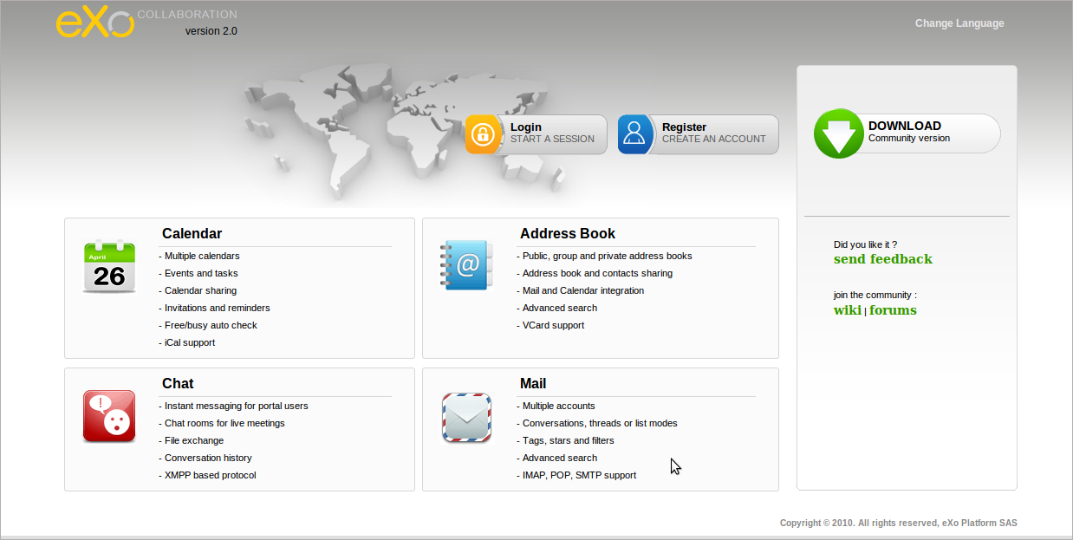Illustration 1: The anonymous home page of the eXo Collaboration portal
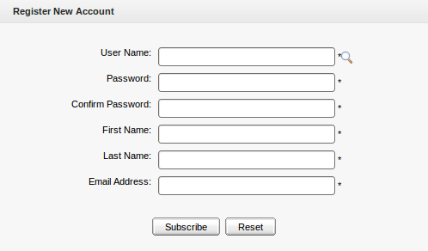Illustration 2: Register New Account form
Details:
User Name | The name of the user that will be used to sign in. It must be unique.
Password | The secret string used to log in. It must have at least 6 characters.
Confirm Password | The re-typed password. Password and Confirm Password must be the same
First Name | Your first name
Last Name | Your last name
Email Address | Youetcontact email address. It must be in the right format. For example: flower@gmail.com
Save button | To accept saving a new account
Reset button | To set blank entry for all inputted fields.
Step 3: Click the icon to search and check whether the inputted User name is available or not.
Step 4: Fill values in all the required fields in the form.
Step 5: Complete registering a new account by clicking the Subscribe button or the Reset button if you want to change values for fields.
After registering an account successfully, you can login and access to Calendar application.

Sign in
This function allows you to go into portal in the private mode.
To sign in, do as follows:
Step 1: Go to GateIn by typing the URL in your browser address bar (e.g: http://localhost:8080/portal)
Step 2: Click the  button . The Sign in form will be displayed
Step 3: Input your registered User name and Password
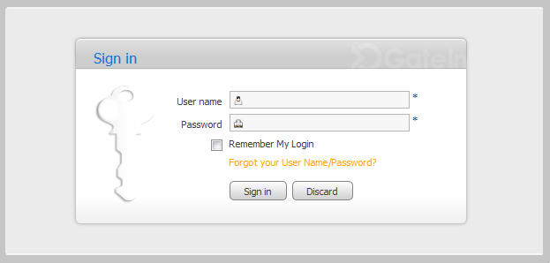Illustration 3: The Sign in form
Details:
User name | The registered user name which is used to sign in
Password | The registered password of the User name above.
Remember My Login | This option allows you to return to a portal and be authenticated based on the value of cookie provided by the browser.
Forgot your username/ Password? | This link allows you to get the forgotten User Name/Password.
Sign in button | To accept signing in.
Discard button | To exit the Sign in form without signing in
Step 4: Complete signing in by clicking the Sign in button.
After signing in successfully, you will be redirected to the authenticated home page.

Sign out
This function allows you to get back to the anonymous portal. It ends your current portal session.
To sign out, click Sign out in the menu list on the administration bar or the Logout link on the homepage:

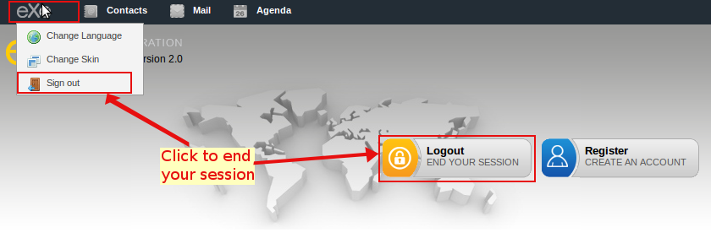
Access to Calendar Application
When you have had an account, you can access to Calendar application and use all its feature.
Do the following to access to Calendar applicaition:
Step 1: Sign in by your registered account. After signing in successfully, you will be redirected to the authenticated home page.
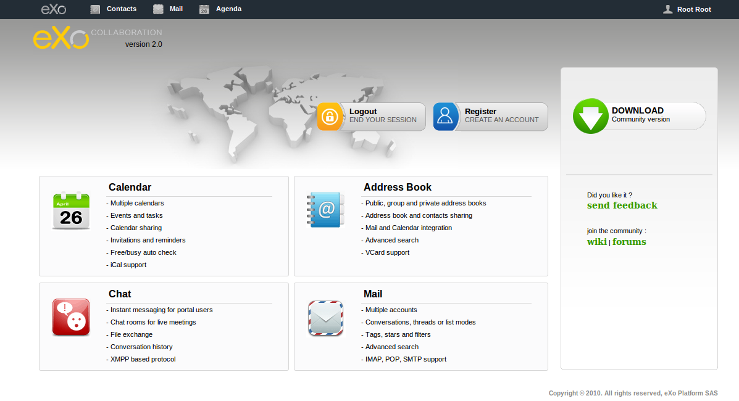Illustration 4: The authenticated homepage
Step 2: Click on Agenda on the navigation bar
or click on from Chat bar image:
Or click on right from the Chat bar:
The main screen of Calendar application is displayed.
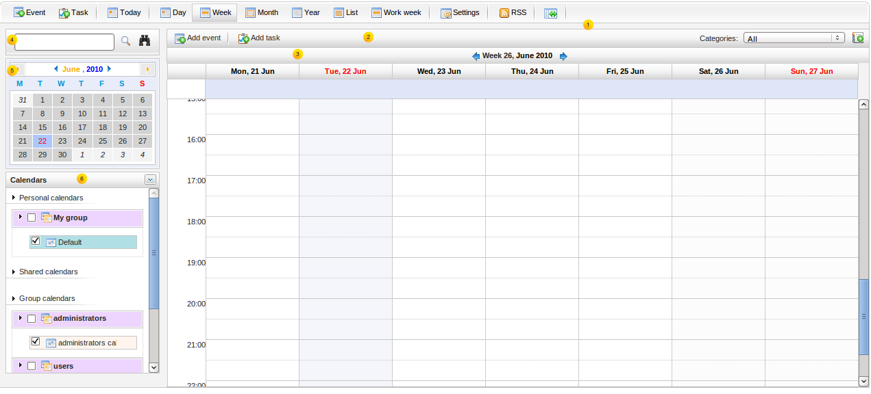Illustration 5: The main screen of Calendar Application
Details:
Indicator | Meaning
 | This is the Tool bar that allows quickly adding events/tasks, changing calendar view, setting up calendar...
 | This is the Action bar that allows adding more detail events/tasks and adding new categories
 | This is the Calendar view panel that displays all event/task(s) in the selected calendar at the current time.
 | This is the Search Panel that allows searching event/task(s) in calendar by quick search and optional search.
 | This is the Mini Calendar that allows quickly viewing event/task(s) in the selected day.
 | This is the Calendar list that shows the personal calendar, shared calendar and group calendar.

Manage Calendar Groups
The calendar groups allows you to categorize your calendar types easily. One calendar group may contain one or more calendars added by yourself. By default, eXo Calendar provides a group in Personal calendars category named 'My group'.

Add a new calendar group
This function allows adding new calendar groups in eXo Calendar which allows organizing and personalizing calendars in your own way.
To add a new calendar group, do as follows:
Step 1: Click the Calendar Options icon at the right of the calendar list panel to open the menu --> then select Add group in the menu:
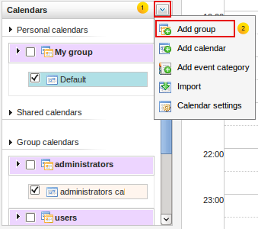
The Calendar groups form will appear:
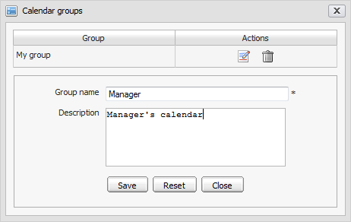Illustration 6: The Calendar groups form
Step 2: Input values in the form.
Step 3: Complete adding a new calendar group by clicking the Save button.
- After creating a new calendar group, the new created group will appears in the calendar list of the Calendar groups form like the illustration 7 below. The Calendar groups form lists all the group that you can be directly edited or deleted.
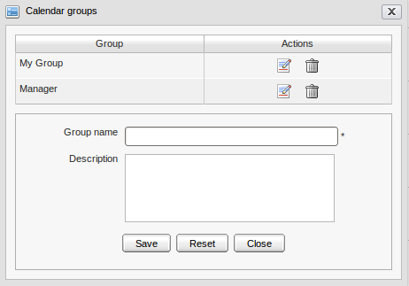Illustration 7: The Calendar Groups form
- Empty calendar groups that do not have any calendars inside it, are not displayed under the Personal Calendars, but when they are added a calender, they will be displayed as the the illustration below with the group "Manager".
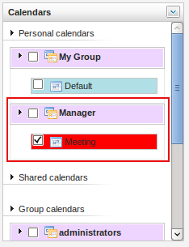
When adding a new calendar to a calendar group, you can also add new a calendar group by clicking the icon that corresponds to Group fields. When the icon is clicked, the Calendar groups form.

Edit a calendar group
This function lets you change the name and the description of a selected group.
To edit a calendar group, do as follows:
Step 1: Open the Calendar groups form by two way:
- The 1st way: Do the same as adding a new calendar group to open the Calendar Groups form--> click the Edit icon corresponding to the group that you want to edit.
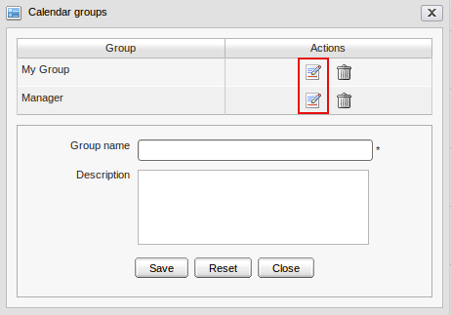
- The 2nd way: Right-click on the group name which you want to edit and select Edit in the drop down list menu:
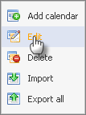
The Calendar groups form will appear:
Step 2: Change values in the Group name or Description fields
Step 3: Complete editing the calendar group by clicking the Save button.
When adding a new calendar to a calendar group, you can also add new a calendar group by clicking the icon that corresponds to Group fields. When the icon is clicked, the Calendar groups form is shown like illustration 7. (See Add a new calendar for details)

Delete a calendar group
This function allows removing calendar groups. When a calendar group is deleted, all its calendars are also deleted.
To delete a calendar group, do as follows:
Step 1: Open the Calendar groups form.
- The 1st way: Do the same as adding a new calendar group to open the Calendar Groups form--> click the Delete group icon corresponding to the group that you want to delete.
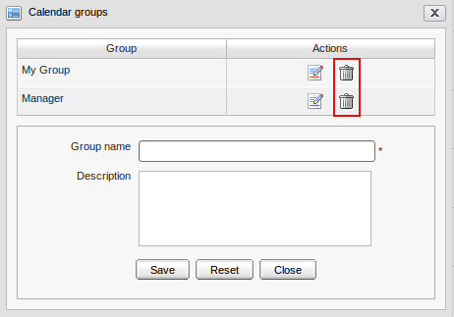
- The 2nd way: Right-click on the name of the group which you want to delete and select Delete in the drop down list menu:
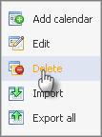
The confirmation message will appear :
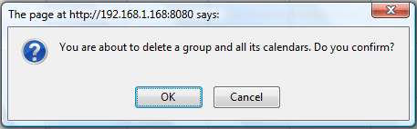Illustration 8: The confirmation message when deleting a calendar group
Step 2: Click the OK button to accept deleting the group or the Cancel button to quit without deleting.
The selected calendar group will be removed from the Group table. Besides, the deleted group and all its calendars will not be displayed in the calendar list panel.
When adding a new calendar to a calendar group, you can also add new a calendar group by clicking the icon that corresponds to Group fields. When the icon is clicked, the Calendar groups form is shown like illustration 7. (See Add a new calendar for details)

Manage Categories
Categories are used to classify events and tasks. For example, you could use a 'Meeting' category for all meetings with your colleagues or customers in your company. By default, eXo Calendar provides 5 available categories: Calls, Meeting, Holiday, Clients, Anniversary. You can add and view events/tasks in default categories. In addition, you also can edit, delete default categories or create new categories by yourself.

Add a new category
This function is used to create new categories in eXo Calendar.
To create new categories, do as follows:
Step 1: Click the icon at the right corner of the action bar:
The Event categories form will appear :
Details:
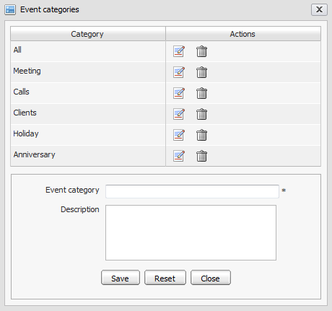Illustration 9: The Event categories form
Event category | The name of the category. This name will appear in the category list.
Description | The description of the category. This description only appears when you edit the category in this form.
Save button | To accept saving a new category.
Reset button | To set blank entry for all inputted fields.
Close button | To exit the Event categories form without adding new.
 | This button is used to edit a category corresponding to it.
 | This button is used to delete a category corresponding to it.
Step 2: Input values in all the fiels in this form
Step 3: Complete adding a new category by clicking the Save button.
The new created category will appear in the category list box.

Edit a category
This function allows changing name and description of a selected category.
To edit a category, do as follows:
Step 1: Open the Event categories form by clicking the icon in the action bar:
Step 2: Click the Edit icon corresponding to the category that you want to edit.
The properties of the selected calendar group will appear:
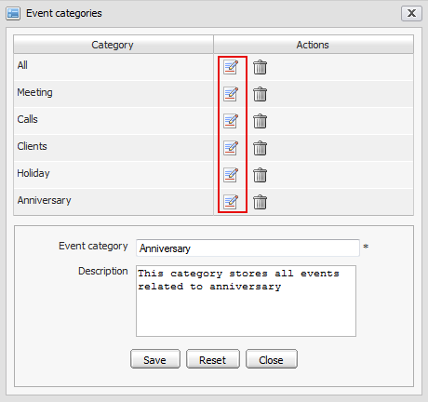Illustration 10: The Edit category form
Step 3: Change values in the Event category and the Description field.
Step 4: Click the Save button to complete deleting the category.

Delete a category
This function allows removing categories from eXo Calendar; however, all events/tasks in this category still exist.
To remove a category, do as follows:
Step 1: Open the Event categories form by clicking the icon in the action bar:
Step 2: Click the Delete icon corresponding to the category that you want to delete.
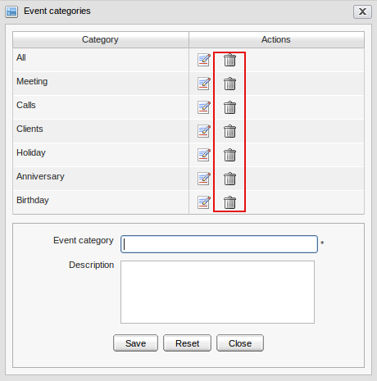
Step 3: Click the OK button in the confirmation message to accept deleting the category or click the Cancel to quit without deleting.
The deleted category will be removed from the Category table in the form and the categories list box.
The catgory "All" can not be deleted from the category list.

Manage Calendars
After being created, a calendar will be categorized in the group that you choose for it. It can be added tasks/events, edited, deleted, exported and shared with the others users. There are three types of calendar: personal calendars, shared calendars and group calendars.

Add a new calendar
This function allows adding new calendars. All created calendars will be listed under the Personal calendars category on the left navigation panel.
To create a new calendar, do as follows:
Step 1: Open the Calendar form. You can do this step in 3 different ways:
  - The 1st way: Click the Calendar Options icon at the top right of the calendar list and then select the Add calendar item in the menu:
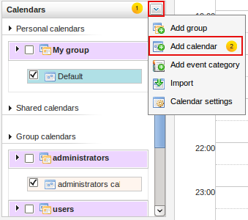
  - The 2nd way: Right-click on the name of the calendar group which exists in the list of Personal Calendars and then select Add calendar in the drop down list menu:
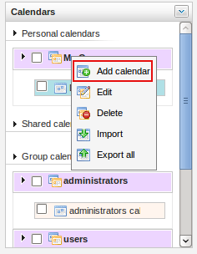
The Calendar form will appear:
Details:
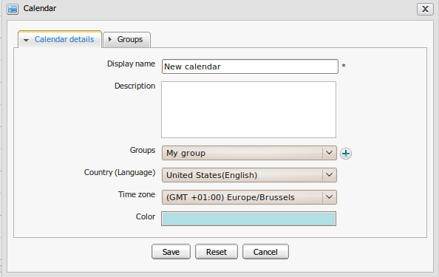Illustration 11: The Calendar details tab of the Calendar form
  - The Calendar details tab includes:

Display name | The name of the calendar. This field is required
Description | The brieft description of the calendar
Groups | The group contains your calendar. The group can be chosen in the existing group list or quickly add a new group by clicking the icon at the right Groups combo box. The Calendar group form that allows adding a new group directly in the Calendar form will be displayed.
Country(Language) | The location for the calendar
Time zone | The displayed time zone for the calendar activities. You can personalize your calendar time zone.
Color | The displayed color for the calendar activities. You can personalize it.
Save button | To accept saving a new calendar
Reset button | To set blank entry for all inputted fields
Cancel button | To exit the Calendar form without adding new

  - The Groups tab:
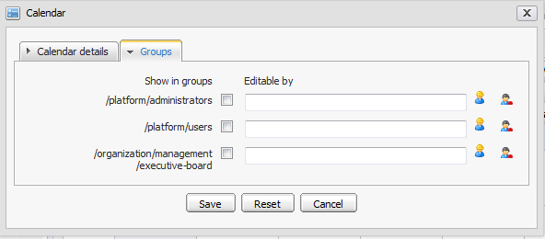Illustration 12: The Groups tab of the Calendar form
The Groups tab allows sharing the calendar with the other groups/users.
To share a calendar, check the check box(es) corresponding to a group(s) that you want to share. Users in the checked groups will be able to view this calendar. Besides, you can define who can edit the calendar in each group.
- To grant the edit permission to individual users in a group, follow these steps:
1. Click the icon at the right of the Edit permission column.
2. Select a user in the group . For example: select john in the administrators group.
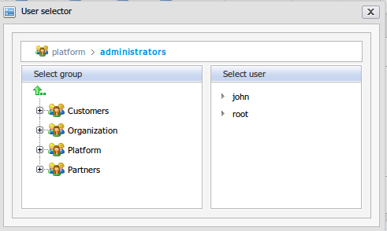Illustration 13: The User selector form
- To grant the edit permission to a membership type in group, follow these steps:
1. Click the icon at the right of Edit permission column.
2. Select a membership in the group. For example: select the manager role in the administrators group.
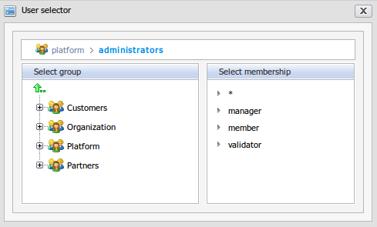Illustration 14: The Select Membership in the User Selector form
Step 3: Enter values in the Calendar form.
Step 4: Complete adding a new calendar by clicking the Save button.
The new added calendar will appear in the calendar list.
When you fill values in the Group tab, the calendar will appear in the Group calendars category. All members of the corresponding groups will be able to view that calendar. If you don't want your calendar to be a public one, leave the Group tab empty.

Edit a calendar
This function allows you to make changes to a selected calendar.
To edit a calendar, do as follows:
Step 1: Right-click on the name of the calendar (e.g: Holiday) to open the drop-down list menu and then select the Edit item:
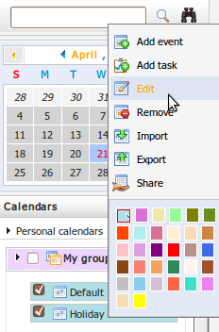
The Calendar form will appear with all information displayed, available for editing.
- With personal calendar: (it means that the calendar is not shared with any one. When adding a new calendar, all the fields in the Groups tab are blank). There is only one tab. It is Calendar details tab:
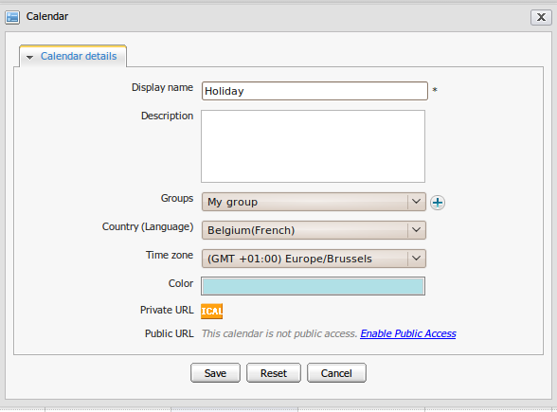Illustration 15: Calendar form
  - With group calendar: (it means the calendar is shared with the users who belong to the shared group).There are 2 tabs: the Calendar details and the Groups tab:
Step 2: Change the values in the Calendar form as you want.
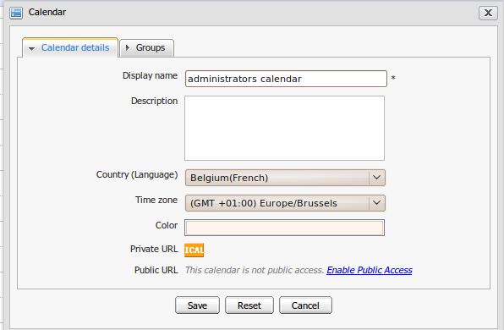Illustration 16: The Calendar form
Step 3: Complete editing the calendar by clicking the Save button.
You can edit any personal calendar. In addition, you can also edit a shared or group calendar when you have the edit permission on it. For instance, when you right click on the calendar's name that you do not have the edit permission, the Edit item will be disabled in the drop down list menu.
The Edit permission on a calendar allows you to add, edit or delete events/tasks which exist in that calendar.

Remove a calendar
This function allows removing a calendar and all events/tasks stored inside it.
To remove a calendar, do as follows:
Step 1: Right-click on the name of the calendar to open the drop-down list menu, then select the Remove item:
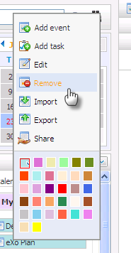
Step 2: Complete removing a calendar by clicking the OK button in the confirmation message or click the Cancel button to quit without removing a calendar.
The removed calendar will not be displayed in the calendars list panel. All events/tasks inside that calendar will also be removed.
In fact, if you do not have the edit permission on the shared calendar, removing a shared calendar means that you only remove it from your calendar list. Other users still can continue seeing and working on it in their calendars list.

Share a calendar
This function allows sharing an existing calendar with other users. It means that you allow other users to participate in activities on it. The permissions in a shared calendar are set in two levels:
- View permission allows you to view a calendar and its events/tasks, but you can not change any information. It means that you can not add/edit/delete events/tasks; edit, import and export calendars. For example, right-click on the name of the shared calendar that you do not have edit permission and select the Add event item in the menu, a warning message shows that you are not allowed to edit this calendar.
- Edit permission allows you to view, import and export a calendar or add, edit, delete events/tasks inside the shared calendar, export the shared calendar. However, you can not edit it.
To share a calendar, do as follows:
Step 1: Right click on the name of the calendar to open the drop down list menu, then select the Share item:
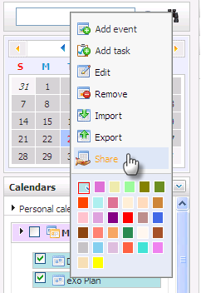
The Share calendar form will appear:
Details:
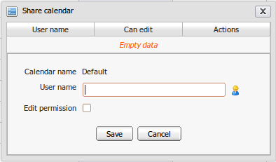Illustration 17: The Share calendar form
Calendar name | The name of the calendar that you choose to share
User name | The name of the users who you want to share your calendar with.
Edit permission | This option allows granting edit permission on the calendar to selected user
Save button | To accept sharing the calendar
Close button | To exit the Share calendar form without sharing
Step 2: Select users to share.
To select users for sharing, do the following :
1. Click on the icon at the right of the User name field.
2. Select users that you want to share. For example, select John in /platform/ administrator group or you can manually input in the User name field. The Shared users will be displayed in the User name field.
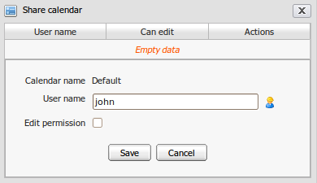
Step 3: Check the Edit permission check box if you want to share the edit right with the selected users.
Step 4: Click the Save button to complete sharing the calendar.
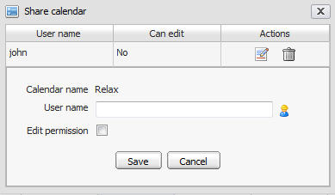
After sharing a calendar successfully, the shared users will be displayed in the Share table below:
In this form, you can:
- Change the Edit permission of a shared user by clicking the edit icon
- Delete a shared user from the shared table by clicking the Delete icon corresponding to the shared user. The deleted shared users will not able to view the shared calendar any more.

Change calendar color
This function allows changing the color of the calendar to distinguish activities between calendars better. When you are looking at all activities in Calendar view panel, different colors mean activities are on different selected calendars.
To change color, do as follows:
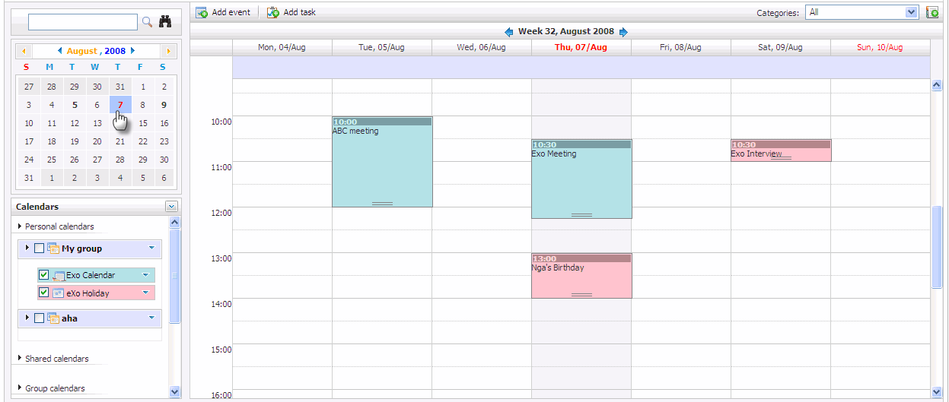Illustration 18: The Calendar view panel with different events/tasks on different calendars
Step 1: Right-click on the name of the calendar to open the drop-down menu and then select a color for your calendar from the color palette. There are 32 colors available:
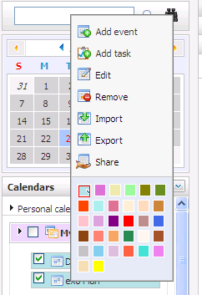
Step 2: Change color by selecting the specific color area.
After being changed a color, the calendar will be displayed with your new selected color.

Export calendars
This function allows exporting a calendar to a separate file on your computer. You can only export thee calendar which has at least one event inside it. You also can export any calendar types including personal , shared and group calendar if you have the edit permission.
To export calendars, do as follows:
Step 1: Open the Export Calendars form by two ways:
The 1st way: Right-click on the name of the calendar group to open the drop down list menu, then select Export all in the menu:
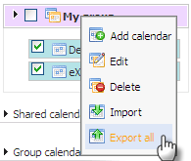
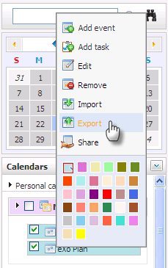
The 2nd way: Righ-click on the name of the calendar and select the Export item in the menu:
The Export calendars form will appear:
Step 2: Enter a name in the file name field.
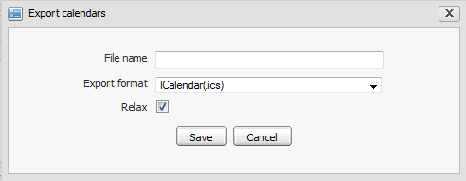Illustration 19: The Export calendars form
Step 3: Select a type of the export format in the list box. For instance, ICalendar (.ics)
Step 4: Select one or more available calendars which you want to export by checking its check box(es).
Step 5: Click the Save button to accept exporting the selected calendars.
A window pop up will appear:
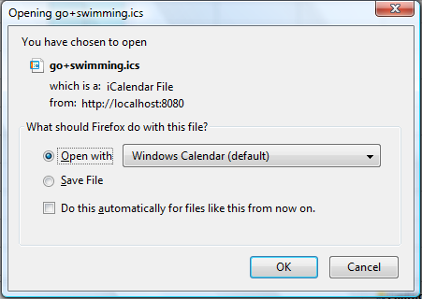Illustration 20: The download pop up on Fire Fox
      - Open with: To directly open the exported file with application on your computer
      - Save File : To download the exported file and save it on your computer.
      - Ok: To accept exporting it.
      - Cancel : To cancel exporting
You can only open the file if you have an application installed on your computer that supports the format of the exported file.
You can export personal, shared and public calendar which you have the edit permission

Import calendars
This function allows importing one or more calendars in a file from your computer to a selected calendar group in eXo Calendar.
To import calendar, do as follows:
Step 1: Open the Import Calendars form:
  - The 1st way: Left click the icon at the right top of the calendar list and then select the Import item in the menu:
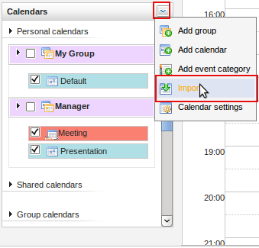
  - The 2nd way: Right-click on the name of the calendar group to open the drop down list menu and then select the Import item:
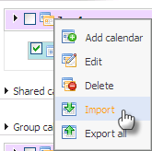
  - The 3nd way: Right-click on the specific calendar in the calendar list and select the Import item in the menu:
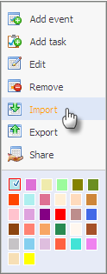
The Calendar form will appear:
Details:
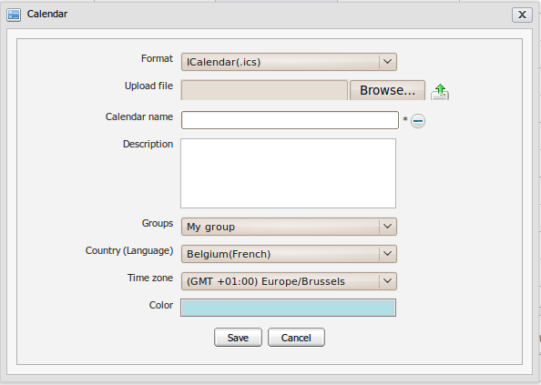Illustration 21: The Import calendars form
Format | The format of the imported file. There are 2 options: *.ics and *.csv
Upload file | The path of the upload file
Browse button | To select the uploaded file from your local computer
 | To start uploading the selected file.
Calendar name: | The display name of the imported calendar.
This icon is used to unhide a form used to import an uploaded file to existed
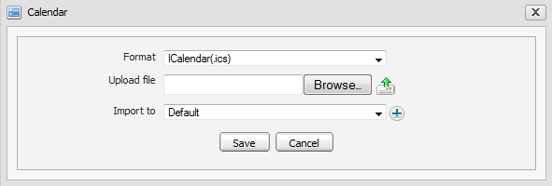
calendar:
In this form, the icon next to the Import to field is used to import an uploaded file to new calendar.
Description | The brief description about the imported calendar.
Groups | The group that the imported calendar belongs to.
Country | The country of the imported calendar.
Save button | To accept importing calendar.
Cancel button | To exit the Import calendars form.
Time zone | The time zone of the imported calendar.
Color | The color of the imported calendar.

Step 2: Select a type of the import format. For example: ICalendar(.ics)
Step 3: Click the Browse... button to select a file (For example: *.ics) which is imported from your computer and then click on the Upload icon to upload the selected file. For example select and upload Dancing.ics file.
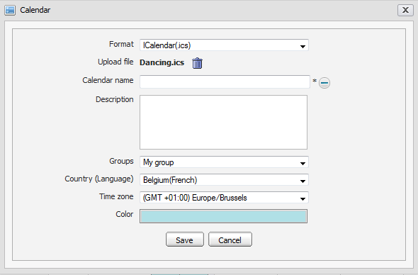
Step 4: Define the properties for the imported calendar.
Step 5 Click the Save button to accept importing a calendar with the selected file .
After importing a calendar, in case the uploaded file is imported into an existing calendarall events/task(s) inside the uploaded file will be imported into the selected calendar.
You can only import calendar to a personal calendar. At present, two file formats are supported for importing is *.ics and *.csv

iCal
iCal is a personal calendar application in eXo Calendar application. It contains a link that allows dowloading a file having all the events and taks in a calendar and also allows the creator of the calendar to be for personal use or send it to other users on the internet.
Do the following to access to iCal support:
Step 1: Right-click on the name of a calendar that you want to access to iCal (e.g: Holiday) to open the drop-down list menu and then select the Edit item:
The Calendar form will appear with a Calendar Details tab for the personal Calendar:

Step 2: You can use the Calendar for your own need with Private URL or share it to other members with Public URL.
- Private URL: ICAL is used for personal. It means that you, the creator of the calendar can download it to your computer and use any calendar products which support the .ics file format to open it. You can also import it into another calendar.
1. Click the ICAL icon in the Calendar form:
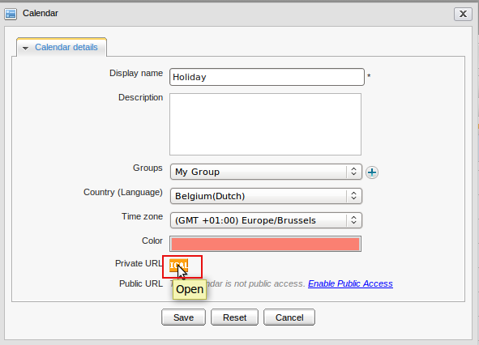
A windown pops up:
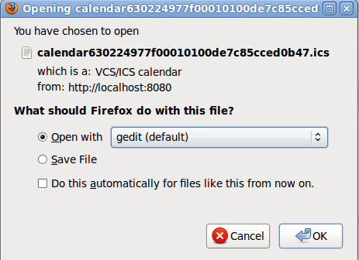
Details:

Open with | To directly open the this calendar on your computer
Save File | To download the the calendar and save it on your computer
OK | To accept opening / downloaing the calendar
Cancel | To close this windown without opening/ downloading the calendar
2. Check the Open With check box or the Save File check box --> Click the OK to accept downloading the calendar.
3. Use any calendar products which support the .ics file format (For instance: Mozilla Sunbird application) to directly view the events and tasks on that application.
- Public URL: Public URL link allows you share the calendar to other users and then they can download it to their computers. They must use a calendar product which supports the .ics file format to directly view the events and tasks in the calendar on that application, or they can import the calendar into another calendar.
By default, Public Url is empty and it is only accessible when public acess is explicitely enabled and it can be also disabled anytime by clicking "Disable Public access" as in the illustration below.
1. You can send the calender to others by clicking to the link "Enable Public Access" to make the Calendar become public access as the illustration below:
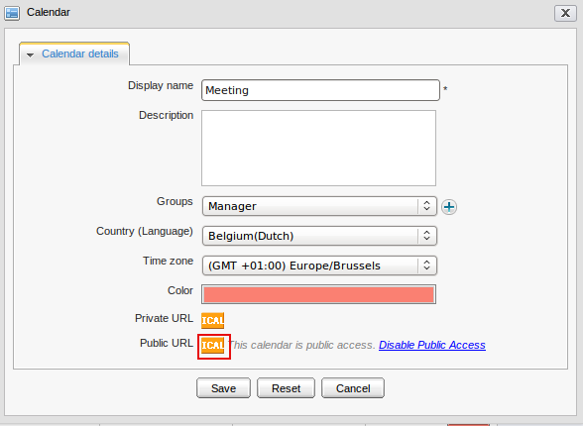
2. Click the ICAL icon, a Calendar Feed form pops up:
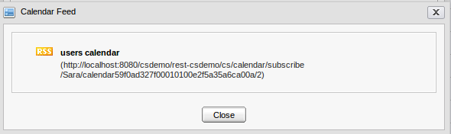
3. Copy this address link in the Calendar Feed and send to other users.
To view the events and tasks in this calendar, they must copy and paste this link into another brower, and a pop-up windown will allow them to download the calendar to their computer. They must use a calendar product which supporsts the .ics file format (For instance: Mozilla Sunbird application) to directly view that application, or they can import it into another calendar of eXo calendar application.

Manage Events

Add a new event
This function allows adding a new event in eXo Calendar application.
To add a new event, do as follows:
Step 1: Open the Add Event form.
- The 1st way: On the tool bar, click the Event icon for the Quick add event or the Add Event icon for detail one.
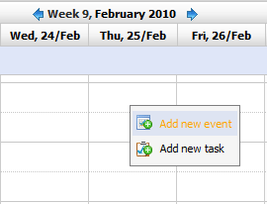
- The 2nd way: Create an event directly on the calendar view panel by right-clicking on it and select the Add new event item in the drop down list menu or left-click directly at the date/time you want to add a new event or drag/drop on calendar view panel to add an event with a specific time.
  - The 3rd way: Create an event directly at the calendars selector level by right-clicking on the calendar name and select the Add Event item in the menu:
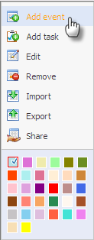
The Quick add event form will appear:
Details:
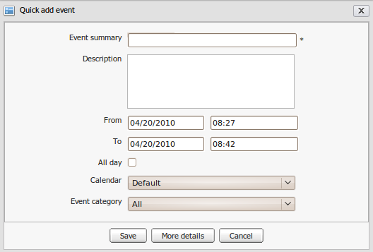Illustration 22: The Quick add event form
Event Summary | The event title. This field is required.
Description | The detailed description of the event.
From | The starting date/time of the event.
To | The ending date/time of the event.
All day | This option allows setting the event duration to be all day or not. If you don't check this option, you have to define the starting date/time and ending date/time. By default, the starting date and ending date is the current date.
Calendar | The calendar will include the event
Event Category | The category will include the event.
Save button | To accept saving a new event
More detail button | To show the event in more detail that allows defining more properties for the event
Cancel button | To exit the Add event form without adding new

Step 2: Fill values to all the required fields
Step 3: Complete adding a new task by clicking the Save button.The added task will be displayed when viewing the calendar in which it is stored.
You can finish at step 3, but if you want to add more detailed information to your event, click the More detail button, the Event form will be displayed with 4 tabs :
Detail, Reminders, Participants, Schedule
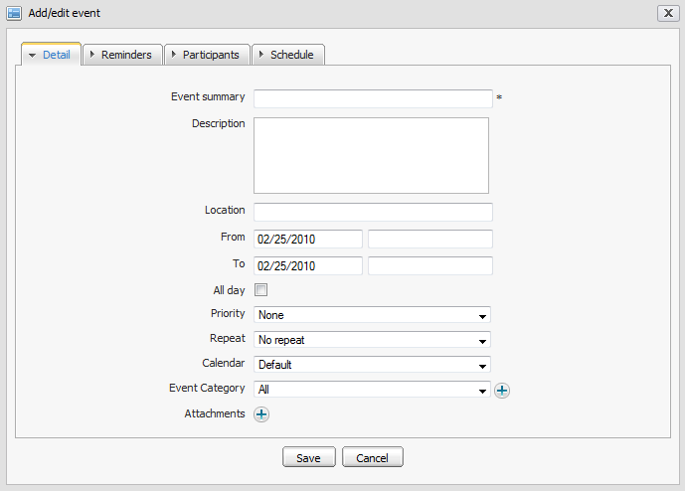Illustration 23: The Detail tab of the Add/Edit event form
    - The Detail tab contains basic information of an event:
Event Summary | The event title. This field is required.
Description | The brief description of the event.
Location | The location where the event will take place.
From | The start date/time of the event.
To | The end date/time of the event.
All day | All day option allows setting the event duration to be all day or not..If you don't check this option, you have to define the start date/time and end date/time. By default, the start date and end date is current date.
Priority | The priority level of this event: None, Normal, High and Low
Repeat | The repeat time or recurring time for the event, such as weekly team meeting, monthly report... There are many options available: No repeat, Daily, Working days, Weekend, Weekly, Monthly, Yearly.
Calendar | Chose the calendar that will include the event.
Event Category | Chose the category that will include the event. To create a new event category.
 | Click this icon to open the Event categories dialog.
Attachments | The list of attached files to the event. The attachment may be a spreadsheet or a presentation needed for the event.
    - The Reminders tab:
The reminder function is used to remind users who will take part in the event. A reminder includes the summary information about the event such as a title, time, a place where that event will happen...
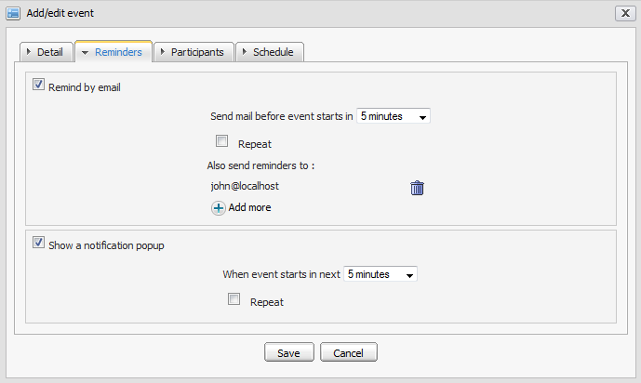Illustration 24: The Reminders tab of the Add/Edit event form
Details:
Send mail before event starts in | The interval time (in every # minutes) that the reminder will be repeated before an event starts.
Repeat | The check box allows setting the email reminder of the event repeat or not.
Also send reminders to | The list of email addresses to which the reminder will be sent. The default value is the email address of the current user.
When event starts in next | The interval time (in every xxx minutes) the pop up reminder will be repeated before the event starts.
Repeat: | The check box allows setting the event's pop up reminder repeat or not.
 | To add more emails.
 | To delete emails.
To add more emails , in the Select email form, click on the icon. The Select an email form wil appear:
- Email addresses are available in the list and can be selected by checking the corresponding check box(es).
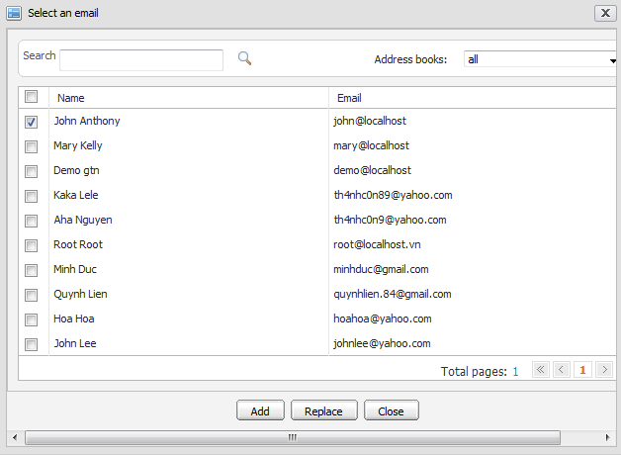Illustration 25: The Select an email form
- The Address books and the Search function allow filtering and searching the expected email result.
- Click the Add button to add the selected emails to the Also send reminders to fields or click the Replace button to replace existing emails by the selected emails or click the Cancel button to close this form.

- After adding email addresses, the email addresses of the selected contacts are displayed in the Also send reminders to field of the Reminders tab.
- When the Remind by email function is used, the notification email about the event will be sent at the defined time expectedly.
- When the Show a notification pop up is used, the notification pop up about the event will appear when using eXo Calendar at the defined time expectedly.
    - The Participants tab: This tab allows you to select the other users who will join in your event.
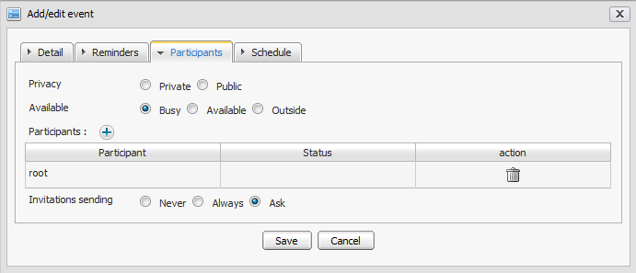Illustration 26: The Participants tab of the Add/Edit events form
Details:
Privacy | The privacy of the event. An event may be public or private. Default value of this field is 'Private'. (At present, public or private has information meaning only. There is no effect)
Available | The status of participants. There are 3 options: Busy, Available and Outside. In case Busy or Outside option is selected, when viewing the event/task schedule, the time the participant takes part in the event/task will be in red. In case the Available option is selected, when viewing the event/task schedule, the time the participant takes part in the event/task will be in white.
Participants | The list of users who will be participants and receive an invitation by email (If the Send an invitation option is selected). You can click on the icon to add more participants. The Participant table lists all users who will take part in the event and their status. The status may be Yes, No or Pending that depends on the invitation confirmation of the participant: Yes, No or May be.  - If Yes, the status will be Yes: It means that the users accept joining the event  - If No, the status wi ll be No: It means that the user will not join the event  - If the participant has not confirmed whether he/she participate or not or answer with 'May be' option, the status is Pending: It means that the invitation is pending for the user's approval .  The Action column allows deleting the participant in the list.
Invitations sending | This option will be loaded by default with the value defined in the Calendar Settings. There are 3 options that can be reselected:  - Never: The event invitation will not be sent to any participant.  - Always: The event invitation will always be sent to the participants.  - Asked: There will be a confirmation message which confirms that whether you want to send the invitation or not.

To select users to participates in invite box:
Step 1: click the icon.
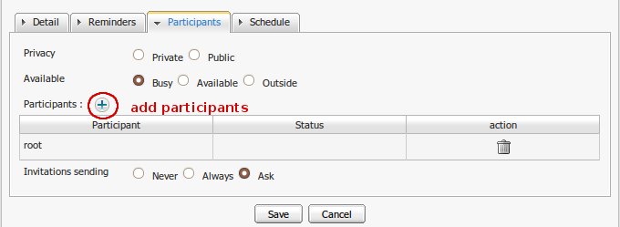
The Invitations form will appear:
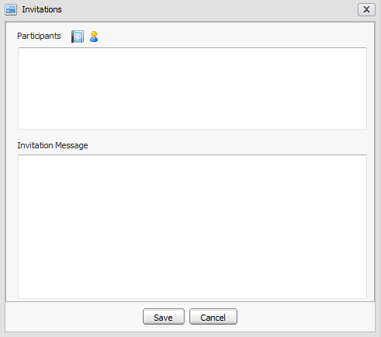Illustration 27: The Invitations form
In details, the Invitations form includes Participants information and the content of the Invitation Messages.
Step 2: The participants can be added from the Address Book by clicking the icon
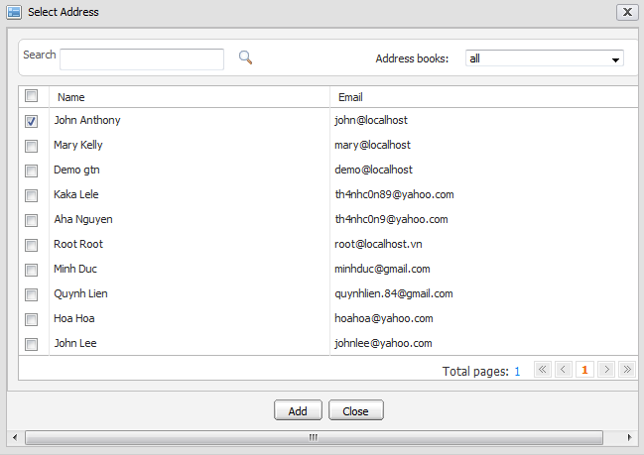Illustration 28: The Select Address form`
- User names are available in list and can be selected by selecting its check box(s).
- To search the desired users, enter a keyword and click the search icon
- Address books filter and the Search function allow filtering and searching expected user result.
    - Click the Add button to add the selected users to the Participants table or click the Close button to close this form.
The participants can be also selected from the user picker by clicking on the icon
- Email addresses are available in list and they can be selected by selecting on its check box(s).
- Group and Search function allow filtering and searching the expected mail result..
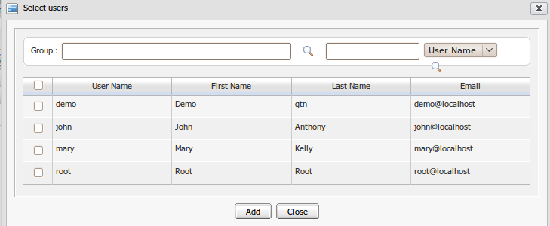Illustration 29: The Select users form
Step 3: Click the Add button to add selected emails to the Participants table or click the Close button to close this form.
After adding a user, the selected user name is displayed in the Participants table of the Participants tab.
  - The Schedule tab:
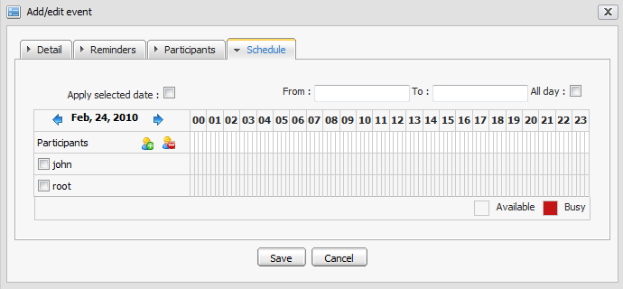Illustration 30: The Schedule tab of the Add/Edit events form
This tab allows you to check the availability of the participants in a defined slot of time (by default, it is the start and end time of the event which you define in the detail tab). By selecting the check box in front of the participants’ names, you may check the availability for all or the selected users.
The selected users in the Participants field of the Participants tab will be displayed in participant list of the Schedule tab.

- To add participants:
Step 1: Click the Add attendee icon on left panel
Step 2: The Select users form appears that allows selecting the attendees.
- To delete participants:
Step 1: Select the participant's name that you want to delete by ticking on User check box and then click the Remove attendee icon on left panel
Step 2: The selected participants are deleted from the participant list of the Schedule tab and Participants tab
- To apply selected date:
Step 1 Add any users to participants list. For example, add john and root who attends to other events.
Step 2: Check the Apply selected date check box. It means that selected date From/To in the left panel is applied
Step 3: Availability time of user John and user root are shown below:
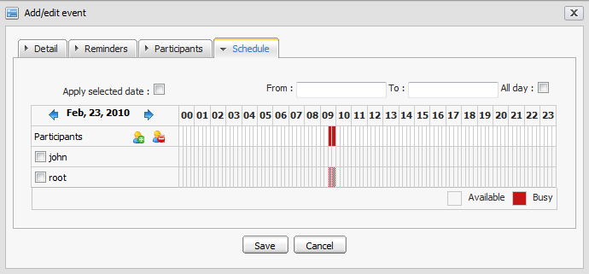
You can select the slot of time to check visual by moving mouse in time panel. The selected period will become green and the corresponding time will be displayed in 'From' and 'To' fields of the Detail tab.
- Fill values in the required fields
- Complete adding a new event by clicking the Save button. The confirmation message will appear:
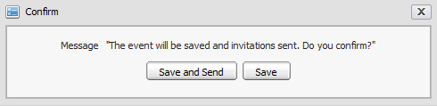Illustration 31: The Confirm form
- Click the Save and Send button to save and also send an invitation or the Save button to accept adding a new event.
The added event will be displayed when viewing the calendar in which the event is stored.

View an event
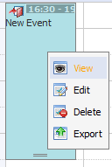
To view an event of a specific calendar more detailedly, directly right-click on the event in the Calendar View Panel and select the View item in the menu:
The Preview form will appear:
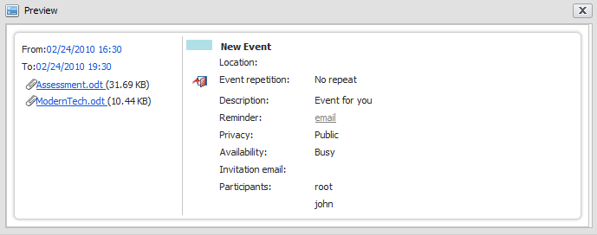Illustration 32: The Preview event form
At the Preview form, if the event includes attachments, you can download any attachment by directly clicking on the title of the attachment, a pop up will be displayed, available for saving the attachment file into your local disk :
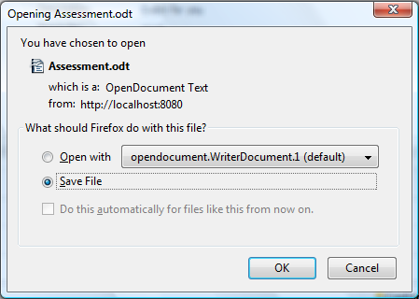

Edit an event
This function allows making changes to an existing event.
To edit an event, do as follows:
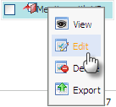
Step 1: Open the Add/ Edit form by right- clicking on the event that you want to edit and select the Edit item in the menu:
The Add/Edit event form is displayed and full filled with all information event, available for editing like adding a new event:
Step 2: Modify information of the selected event by following the steps like creating a new event.
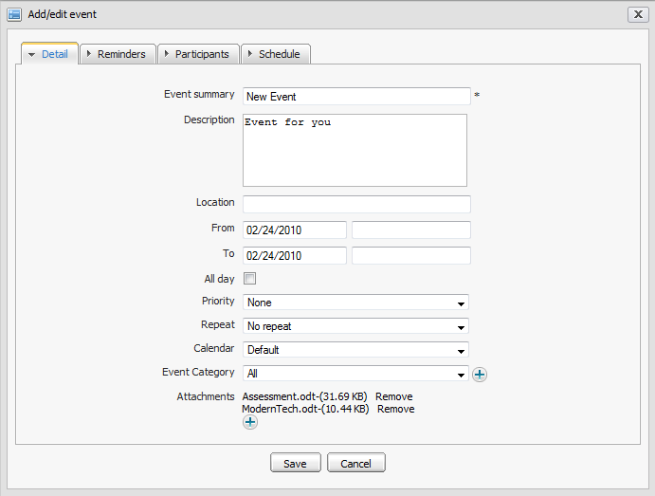Illustration 33: The Add/edit event form
Step 3: Complete editing by clicking the Save button to accept saving changes.
- When editing you can add/ remove the attachment files or download them by directly click on the titles
- If you only want to change the starting date and time of the event, you can also use the dragging and dropping feature to edit the time for the event directly on Calendar view panel.
- You can only edit events in personal, shared and group calendars which you have edit permission.

Delete an event
This function allows removing events from a calendar.
To delete an event, do as follows:
The 1st way:
Step 1: Right-click on the event that you want to delete and then select Delete item in the menu:
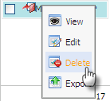
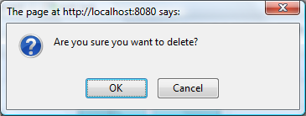
The confirmation message will appear below:
Step 2: Complete deleting the event by clicking the OK button in confirmation message.
The 2nd way:
Step 1: Choose the month view and all the events / tasks are listed in the Calendar View Panel view, --> Check to the check box(es) in front of the event name --> click the icon on the action bar:
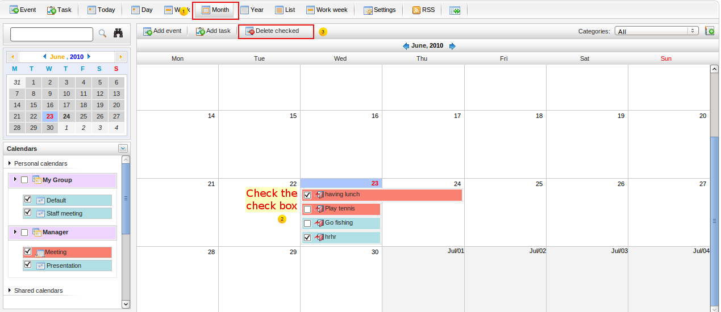Illustration 34: The Month View of the Calendar panel
Step 2: The confirmation message will appear, click the OK button to accept deleting the selected event or click the Cancel button to exit deleting the event
You can only delete events in the personal, shared and group calendars which you have edit permission.

Drag and drop an event
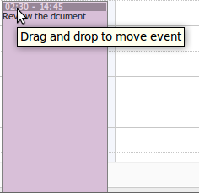
The dragging and dropping feature helps you change the starting date and time of an event more conveniently. You only need to click on the event, drag it and drop it on another new day, new time area in the Calendar view panel.
To change the event duration (in day view, week view and working view only), use your mouse and the control at the bottom of the event.
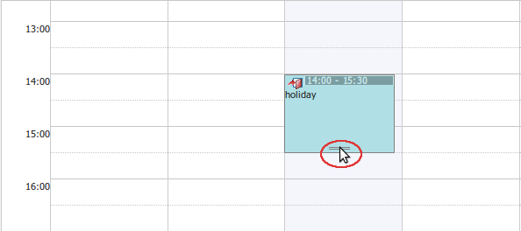
- According to the features of the Calendar panel view, the drag and drop feature can be applied to the date and time differently.
- In Day view, all events are shown in a day, you can change the time of the event in one day only.
- In Week and Work Week view, all events are shown in a week, you can change both the event time and the event date.
- In Month view, all events are shown in a moth, you can can change the event date only. You can also change more events at the same time by ticking on their check boxes and using the drag and drop feature.
You can only drag and drop events in the personal, shared and group calendars which you have edit permission. For example, if you drag and drop an event which you do not have edit permission, a warning message shows that you are not allowed to edit this event/task.

Export an event
This function allows exporting one event into a separate file on your computer.
To export anevent, do as follows:
Step 1: Right-click on the event that you want to export and select Export in the menu:
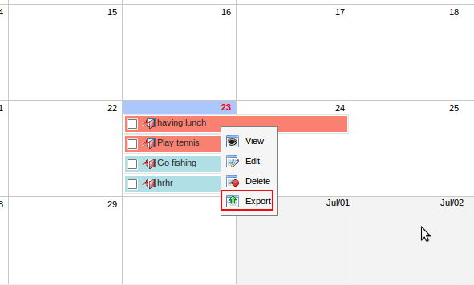
The Export calendars form will appear like the illustration below:
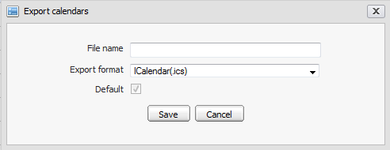
Step 2: Enter a name into the File name field to export.
Step 3: Click the Save button to accept exporting the event.
The pop up will appear to allow saving the exported file:
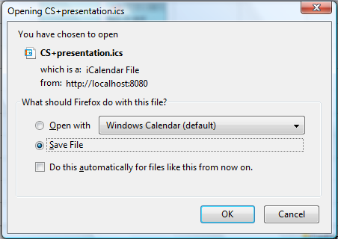
Step 4: Click the OK button to save the exported file into your local computer.
In fact, exporting an event means exporting a calendar with one event only. Therefore, the exported file format and the way to export an event is similar with the way to export a calendar with multiple events and tasks.

Import an event
This function allows importing an event into a specific calendar.
In fact, importing an event means importing a calendar with one event only. Therefore, the way to import an event is similar with import a calendar.
You can see 3.4.7 Import Calendar for details.

Manage Tasks

Add a new task
This function allows adding a new task in eXo Calendar.
To add a new task, do as follows:
Step 1: Open the Add task form. You can do this step by three ways:
- The 1st way: Click the Task icon for the quick add task or the Add Task icon for the detail add task on the tool bar:
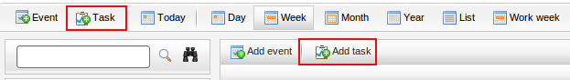
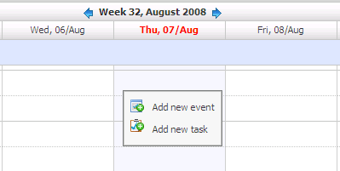
- The 2nd way: Create a task directly on the calendar view panel by right-click on it: and select Add new task item in the drop list menu :
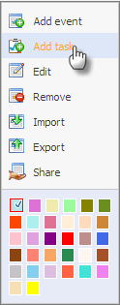
- The 3rd way: Create an event directly at the calendars selector level by right clicking on the calendar name and select Add Task item in the menu:
The Quick add task form will appear:
Details:
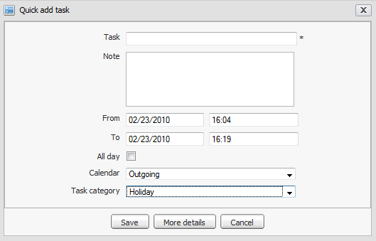Illustration 35: The Quick add task form
Task | The name of the task.
Note | The note of the task.
From | The starting date/time of the task.
To | The ending date/time of the task.
All day | All day option allows setting the duration of the task to be all day or not. If you don't check this option, you have to select the starting date/time and ending date/time. By default, the starting date and ending date is the current date.
Calendar | The calendar will include the task.
Task category | The category will include the task.
Save button | To accept saving the new task
More details | To show the event in more details that allows defining more properties for the task
Cancel button | To exit the Add task form without adding new

When the More detail button is clicked or add task by clicking the Add detail task button on the menu bar, the Add/Edit tasks form is displayed with two tabs (Detail and Reminders) which allows defining task in more details:
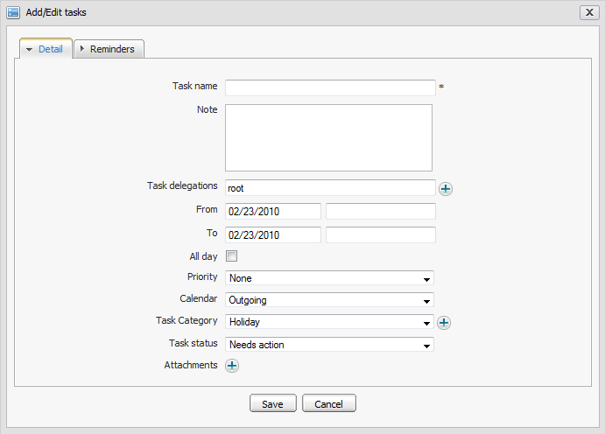Illustration 36: The Detail tab of the Add/Edit tasks form

- The Detail tab allows defining detail task information.
Details:
Task name | The name of the task.
Note | The notice or description of the task
Task delegations | The user(s) to whom you would like to delegate the task. You can manually input or click the icon to select users from the Select users form:  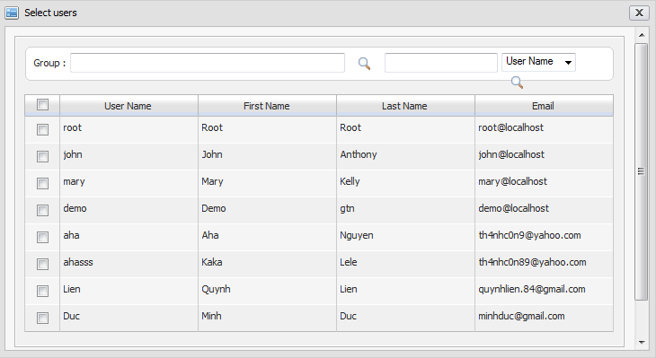
From | The starting date/time of the task
To | The ending date/time of the task
All day | All day option allows setting the task to be all day or not.
Priority | The priority level of the task.
Calendar | The calendar will include the task.
Task Category | The category will include the task that can be selected from the existing tasks or added a new one by clicking the icon to open the Event categories form:  To add new category, input values for Event category and Description field and complete adding new by clicking the Save button. The new category is immediately displayed in the Task category selector.
Task status | The status of the task. This field can be set to:: Need action, In Process, Completed or Canceled
Attachments | The list of the attached files to the task. The attachment may be a spreadsheet or a presentation needed for the task. To attach file, clicking the button, the Attach files form will appear and files can be attached or removed like when attaching file to event in 3.5.1

- The Reminders tab: The reminder function is used to remind users who will take part in the task. A reminder includes the summary information about the task such as title, time, place where the task will happen...
The Reminder by mail:
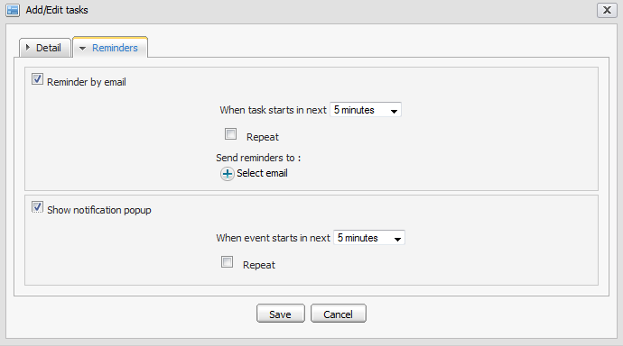Illustration 37: The Reminders tab of Add/Edit tasks form

Details:
When task starts in next | The interval time(in every xxx minutes) that the reminder will be repeated before the task starts and a mail reminder is sent before the event starts.
Repeat | This option allows setting the reminder to repeat or not for an event The interval time(in every xxx minutes) that the reminder will be repeated before the task starts.
Send reminders to | The list of email addresses to which the mail reminder will be sent. The default value is the email address of current user. You can click on the icon to select emails from the Select email form.  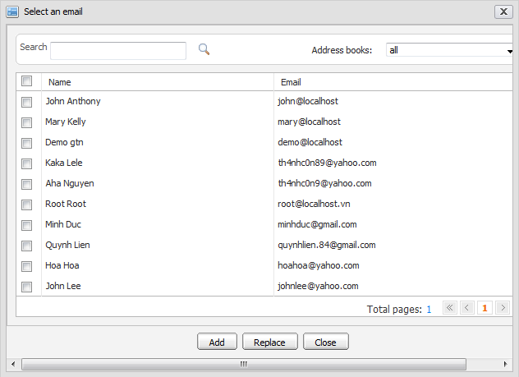  - Email addresses are available in the list, can be selected by ticking on its check box(s).  - Group and Search function allow filtering and searching expected mail result..  - Click the Add button to add selected emails to 'Send reminder to' fields or click the Replace button to replace existing emails by the selected emails or click the Cancel button to close this form.

After adding email addresses successfully, the email addresses of the selected contacts are displayed in the 'Send reminders to' field of the Reminders tab.
When Remind by email function is used, the notification email about the task will be sent at the time like its definition expectedly.
When the Show a notification pop up is used, the notification pop up about the task will appear when using eXo Calendar at the defined time expectedly.
Step 2: Complete all the field in this form
Step 3: Click the Save button to accept creating a new task or the Cancel button to quit this form.

View a task
To view detail of a task of a calendar, right-click on the task in the Calendar View Panel and select View item in the menu:
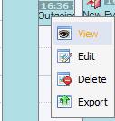
The Preview form will be displayed below:
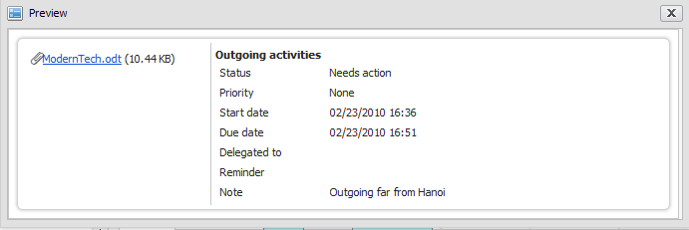
At the Preview form, if the task includes attachments, you can view the attachment by clicking on the title of the attachment, a pop up will be displayed, available for saving the attachment file into your local disk.

Edit a task
This function allows making changes to existing tasks.
To edit a task, do as follows:
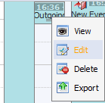
Step 1: Right click on the task you want to edit and select edit item in the menu.
The Add/Edit tasks form will be displayed and full- filled with all task information, available for editing like below:
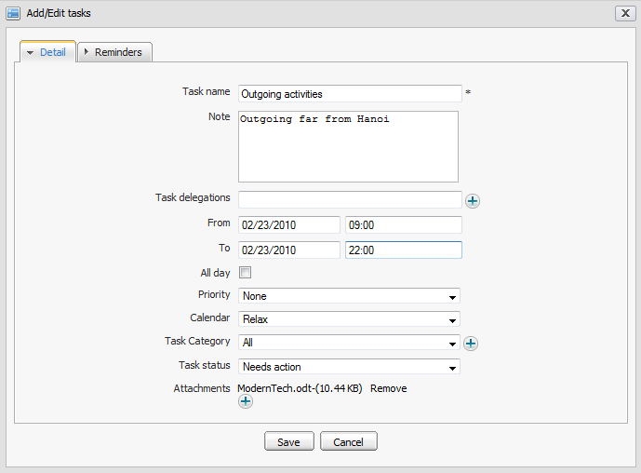
Step 2: Modify the information of the selected task by following the steps as you create a new task.
Step 3: Complete editing by clicking Save button.
- When editing the task, you can add, remove the attachment files or download them by directly click on the titles
- If you only want to change the starting date and time of the task, you can also use drag and drop feature to edit the time for the task directly on Calendar view panel.
- You can only edit tasks in personal, shared and group calendars which you have edit permission.

Delete a task
This function allows removing task from a calendar.
To delete a task, do as follows:
- The 1st way:
Step 1: Right-click on the task you want to delete and then select Delete item in the menu:
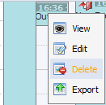
The confirmation message will appear below:

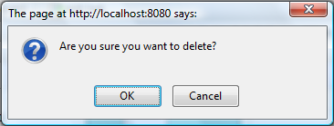
Step 2: Complete deleting by clicking the OK button in confirmation message.
- The 2nd way:
Step 1: Choose the month view and all the events / tasks are listed in the Calendar View Panel view, --> Check to the check box(es) in front of the event name --> click the icon on the action bar:
Step 2: A confirmation message will appear. Then, click the OK button to accept deleting the selected task or click Cancel button to escape deleting task.
You can only delete tasks in personal, shared and group calendars which you have edit permission.

Drag and drop a task
Like dragging and dropping an event, the drag and drop is a feature to change the starting date and time of a task. You only need to click and hold your mouse on the task, drag and drop it to a new day and a new time area in Calendar view panel.
- To change task duration (in day view, week view and working view only), use your mouse and the control at the bottom of the tasks.
- According to the features of Calendar panel view, the drag and drop feature can be applied to the date and time differently.
- In Day view, all tasks are shown in 1 day, you can change the task time in one day only.
- In Week and Work Week view, all tasks are shown in 1 week, you can change both the task time and date.
- In Month view, all tasks are shown in 1 month, you can can change the task date only. You can also change more tasks at the same time by checking on their check boxes and using the drag and drop feature.
You can only drag and drop tasks in the personal, shared and group calendars which you have edit permission. For example, if you drag and drop the task which you do not have edit permission, a warning message shows that you are not allowed to edit this event/task'.

Export a task
This function allows exporting one task to a separate file on your computer.
To export a task, do as follows:
Step 1: Right click on the task that you want to export and select Export in the menu:
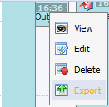
The form to export task will appear:

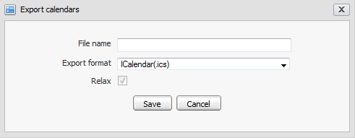
Step 2: Enter a file name to export
Step 3: Click the Save button to accept exporting the task.
A pop up that allows saving the exported file will appear:
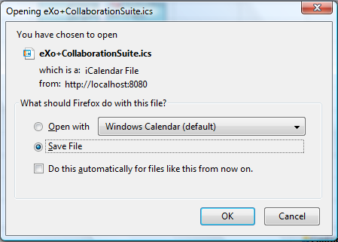
Step 4: Click the OK button to save the exported file into local disk.
In fact, exporting a task means exporting a calendar with one task only. Therefore, exported file format and the way to export a task is similar with the way to export a calendar with multiple events and tasks.

Import a task
This function allows importing a task from your local computer into a specific calendar.
In fact, importing a task means importing a calendar with one task only. Therefore, the way to import a task is similar to the way to import a calendar.
You can see 3.4.7 for details.

Search events/tasks
This function allows finding existing events/tasks according to specific search conditions easily. There are 2 search type: Quick Search and Advanced Search

Quick Search
This function allows you to do a quick search with specific keyword in all your events/tasks. All events/tasks having the text matching with your search team will be displayed in the search result form.
To do a quick search, do as follows:
Step 1: Enter a word in the Search field at the top of the mini calendar: 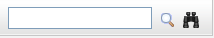
Step 2: Click the Search icon
For example, quick search with “CS” term. All events/tasks matching with “CS” term are listed in the search results form. The Search result form will be displayed like figure below:
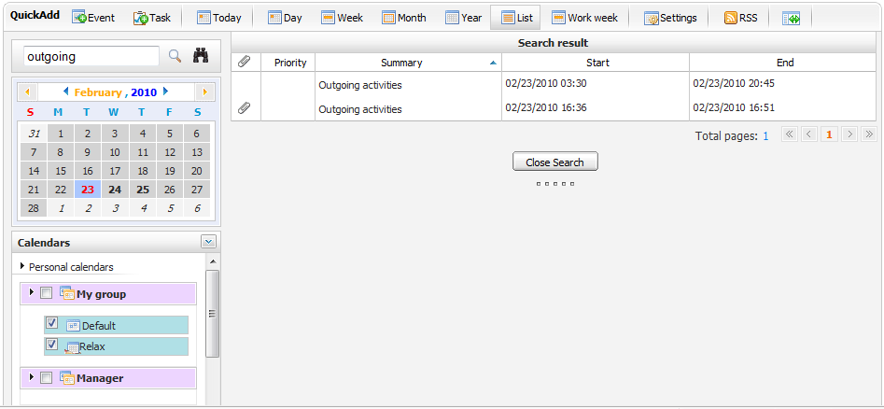Illustration 38: The Search result form

Advanced Search
Advanced Search allows you to make a search with multiple criteria.
To do an Adcanced search, do as follows:
Step 1: Click the Advanced Search button in the search area.
The Advanced Search form will appear like the illustration below:
In this form, you can set one, few or all criteria for your search:
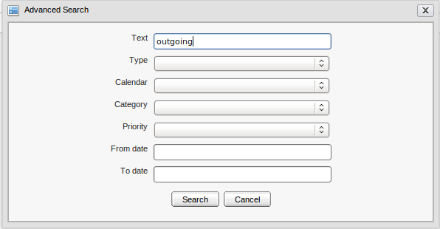Illustration 39: The Advanced Search form
Text | This field allows defining the search term or keyword for searching
Type | This field allows defining search type criteria. There are 3 options: leave Blank for searching both events and tasks, Event for searching event only and Task for searching task only
Calendar | This field allows defining the calendar in which the search action is done. All your calendars including personal, share and public calendars will be shown in the calendar drop list box, available for selecting.
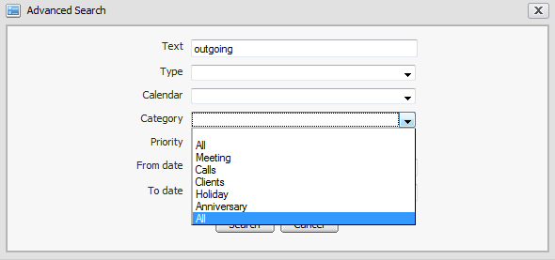  Category | This field allows defining the category criteria of event/task. All categories are listed in Category drop list box, available for selecting. Only event/tasks having category matching category criteria are shown in search result form.
Priority | This field allows defining the priority criteria. There are many options: leave blank for searching all, High for searching event/task having high priority, Normal for searching event/task having normal priority and Low for searching event/task having low priority.
From date: | This field allows defining 'From date' criteria. Only the event/task(s) having 'To date' greater than or equal entered 'From date' are listed in the search result form. You can manually input or select date from Calendar selector tool.  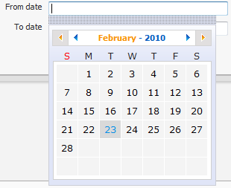
To date: | This field allows defining 'To date' criteria. Only the events/task having 'From date' less than or equal to entered 'To date' are listed in search result form. You can manually input or select date from the Calendar selector tool.
Step 2: Define some search criteria in the Advanced Search form
Step 3: Click the Search button to launch the search. All events/tasks matching with your criteria(s) will be listed in the search result form.
At the search result form, you can also view, edit or delete event/task by right click on it and select action item in menu pop up.

Calendar View
This function allows personalizing your calendar view by different view types.
By default, the Week view is set and displayed when the calendar is opened at the first time. You can change your view from the main tool bar to make it easy for you to see activities in your calendar. However, changing the calendar view from the main tool bar only has effect for current session. In the next time, you go to eXo calendar application, the view will be back to what has been set in your calendar settings.
To change your calendar view, select one view type on the main menu. There are 6 view types: Day, Week, Month, Year, List and Work Week.

Each calendar view has its own feature.
- Click the Day view icon to open the Calendar Day view:
- Click the Week view icon to open the Calendar Week view:
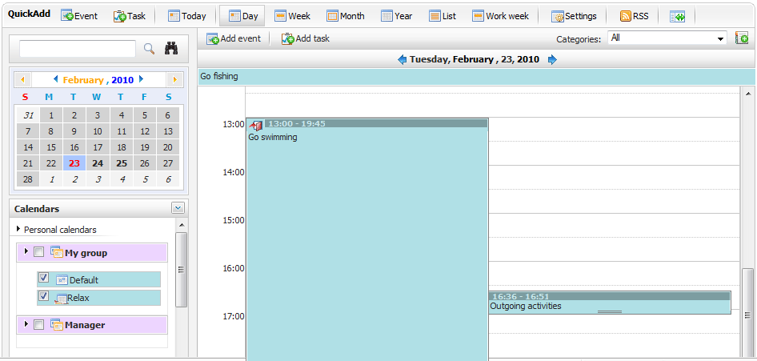Illustration 40: The Day View
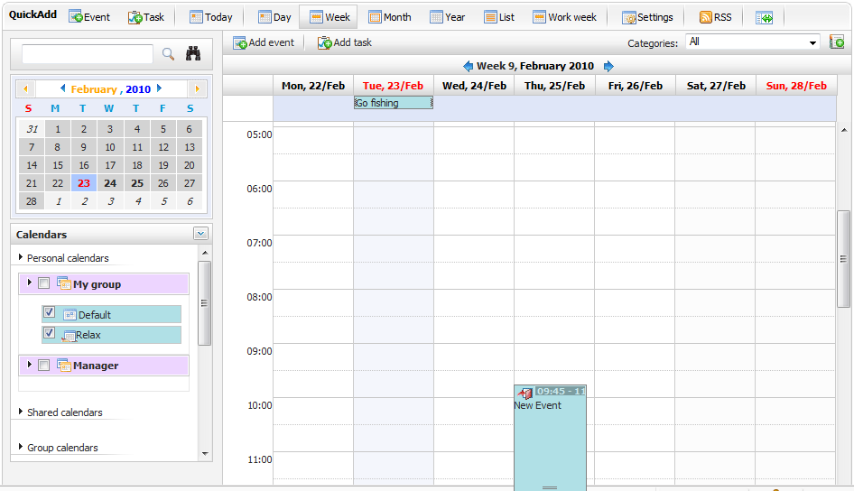Illustration 41: The Week View
- Click the Year view icon to open the Calendar Year view:
- Click the List view icon to open a list of all events and tasks as the following:
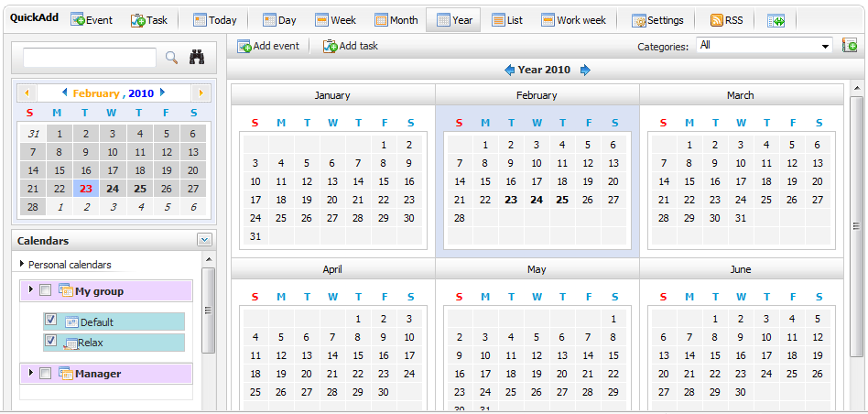Illustration 42: The Year View
- Click the Work week view icon to open the Calendar Work week view
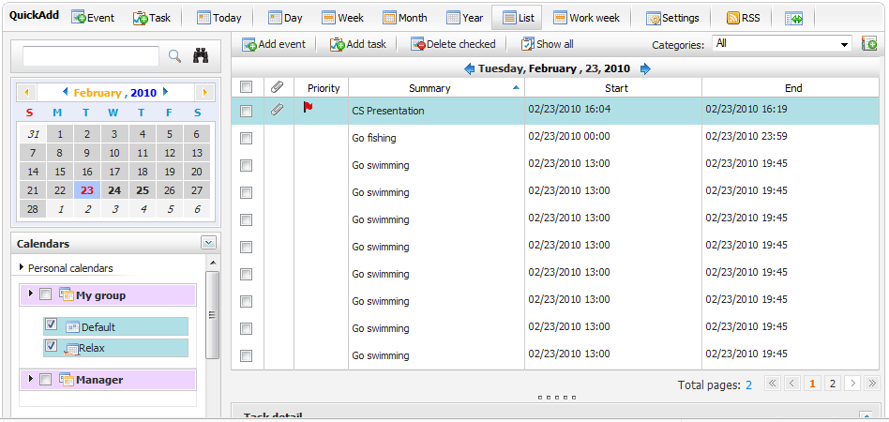Illustration 43: The List View
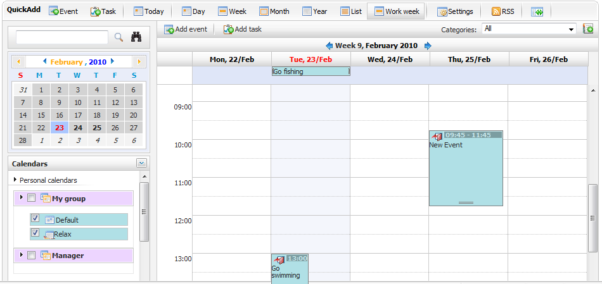Illustration 44: The Work Week View
- Click the Month view icon to open the Calendar Month view:

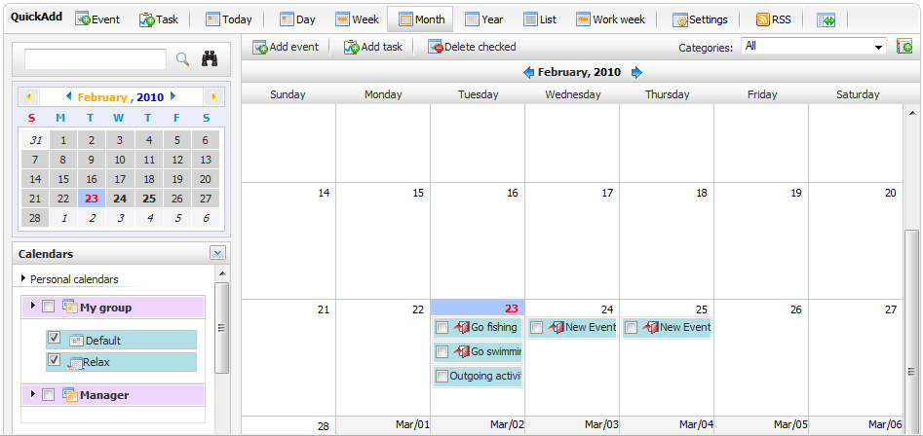Illustration 45: The Month view

Calendar Settings
This function allows personalizing your calendar view according to available features. eXo calendar brings you a wide range of custom settings to set your own calendar.
To access the settings, do as follows:
The 1st way: Click the on the main tool bar.
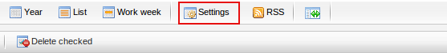
The 2nd way: Left click on the icon and select Calendar settings in the menu:
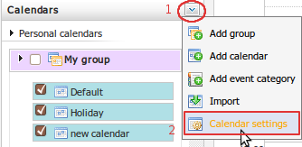
The Calendar settings form will appear:
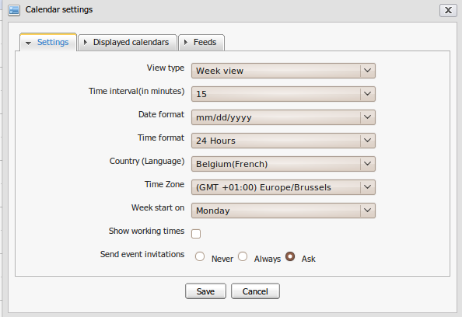Illustration 46: The Setting tab of Calendar settings form
  - The Settings tab includes:
View type | The view type of Calendar View Panel. You can define the default view type when you start the calendar application (day, week, month, year, list or working view)
Time interval(in minutes) | The value (in minute) to define the precision of time intervals. In Day view, Week view or Work Week view, the time 'ruler' will be displayed with the interval likes its definition.
Date format | The date format for the date displayed in Calendar such as Starting date, Ending date of event/task.
Time format | The time format for the time displayed in Calendar such as the time in Starting date, Ending Date, the time displayed in Calendar View Panel.
Country(Language) | The default geographical location displayed in Calendar application.
Time Zone | The default Time zone displayed in Calendar application.
Week start on | The first day of the week displayed in Week view or Work Week view
Show working times | This option allows setting working times when viewing calendar. The working time can be defined by selecting Starting and Ending time.
Send event invitations | When creating an event, you can invite the participants by sending an invitation email. This option is to set by default value for the send event invitations function. There are 3 options:  - Never: The event invitation will not be sent to any participant.  - Always: The event invitation will always be sent to the participants.  - Asked: There will be a confirmation message to ask whether you want to send the invitation or not.

  - The Displayed calendars tab:
This tab allows you to define the calendars which will be displayed when you open eXo Calendar by simply ticking on its check boxes.

Generate RSS
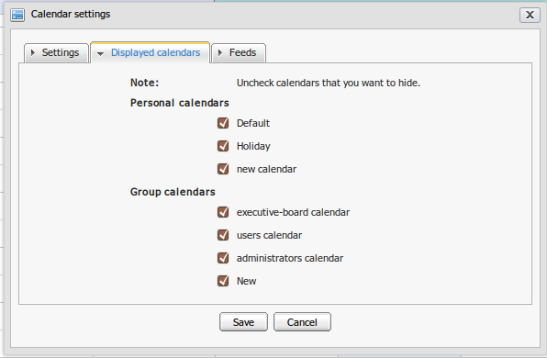Illustration 47: The Displayed calendars tab of Calendar settings form
This function allows you to publish your calendar as a RSS feed. It will build an URL that can be used to follow events in a RSS reader.
To generate RSS in the calendar, do as follows:
Step 1:
- The 1st way: Open the Calendar settings form, then chose the Feeds tab.

- The 2nd way: Click directly on the RSS icon from the Toolbar to directly open the Feeds tab in the Calendar settings form:
The Feeds tab in the Calendar settings form appears like the illustration below:
Step 2: Click the Add button to add a new feed.
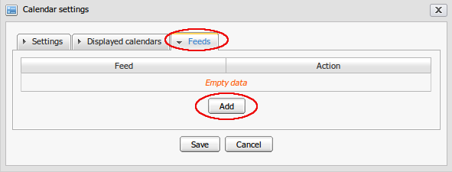Illustration 48: The Feeds tab from the Calendar settings form
The Edit Feed from will be displayed:
Details:
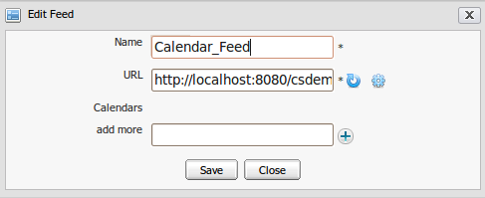Illustration 49: The Edit Feed form
Name | The name of the feed. This is a required field
URL | The link of the feed. This is a required field
 | Reset the RSS link.
 | Generate the RSS link.
Calendars | The name of the calendars.
Add more | Add the name of the calendar that you want to get RSS feed
Step 3: Input the name of RSS in the Name field
Step 4 :Input the name of calendar that you want to get RSS feed in the add more field. The auto-complete function will help you input the information faster.
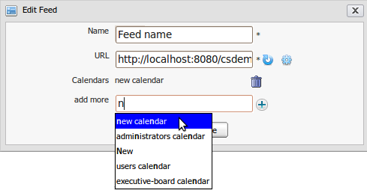
Step 5: Click the icon to add more calendars. You also can delete an added calendar by clicking on the icon corresponding to the calendar name.
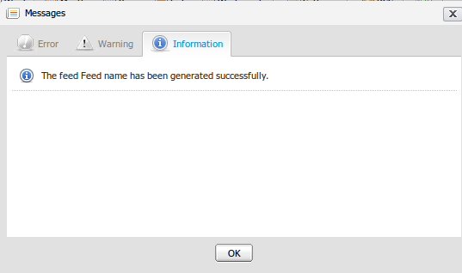
Step 6: Click the Save button to accept generating the feed or Cancel to quit this form. A message will appear to inform that you have generated the feed successfully, just click OK.
After clicking OK, the created feed will be listed like the illustration below:
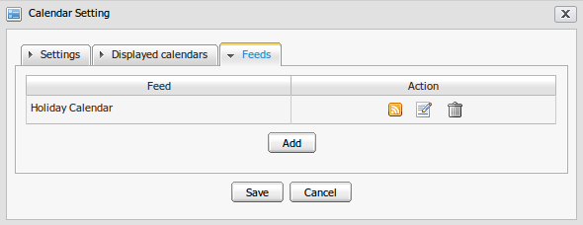
- You can get the RSS link by clicking on the icon:
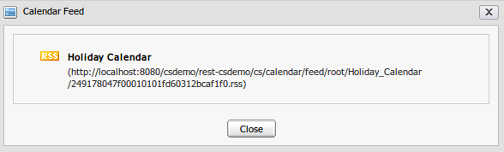
Copy and paste this address link into any calendar product which supports the Rss format (For instance: Mozilla Sunbird application). Then you can view directly in that application.
- You can edit the calendar RSS by clicking on the icon or delete it by clicking on the icon.

Conclusion
It is our hope that information stated above is valuable to you, our Corporate customers and
users in the process of experiencing the Calendar application. To clearly support for benefits
recognition from customers and users, we would like to summarize major strengths of eXo
Calendar as follows:
- Based on the robust GateIn portal, eXo Calendar really brings about interesting experiences for all users.
- With eXo Calendar, you will find it easy to schedule your time more quickly and conveniently and also manage your shared and public agendas in the organization efficiently.
- eXo Calendar offers various useful features that help users keep track of all important events/tasks in your life in one place.
- eXo Calendar also facilitates iCal support that helps you easily exchange event/task information with other applications.
Our Company is always willing to receive any feedback, including errors feedback and ideas feedback that can make the guide better. Serving and resolving all issues related to the eXo Calendar are our responsibilities, so please post your questions at our forum freely.
For more information about eXo platform and our products, please visit the our homepage. We also provides professional support via eXo Forum, where you can find useful advices and solutions to your issues.
The following links can connect you with resources to learn more and contribute to the open source development process.

REVISION HISTORY
Ver | Date | Writer | Reviewer | Change Record
1.0 | Jun 24, 2008 | Nguyen Thi Thanh Hoa | Hoang Anh Quynh Nga
1.1 | Jan 19, 2009 | Nguyen Thanh Cong | Hoang Anh Quynh Nga | - Update new illustration and illustration index  - Clarify some definition  - Improve the way to express  - Update Show a notification pop up  - Update all illustrations for different type of calendar view.  - Update detail explanation for status of participants.  - Update: import function with new features, update more ways to perform Calendar settings.  - Feature of advanced search: From & To Date.  - Import/export task and event.  - Update some small changes
1.2 | June 22, 2009 | Nguyen Thanh Cong |  | - Improve the Reminders tab  - Improve the Participants tab.  - Update Calendar settings.  - Update Calendar view
1.3 | June 28,2009 | Nguyen Thanh Cong
1.3.3 | December 22, 2009 | Luong Quynh Lien |  | - Change screen shots for adding a new event, edit a event.
2.0 | February, 22, 2010  April, 1, 2010  May 15th, 2010  June 22th, 2010 | Luong Quynh Lien | Nguyen Huu Tuan Anh  Vu Thi Hoa  Vu Thi Hoa | - New UI and changes based on 2.0  - Change screenshots  - Update layout  - Update new function.  - Fix the table of content  - Update  - Change illustrations  - Apply new template  - Add 3.5.8

