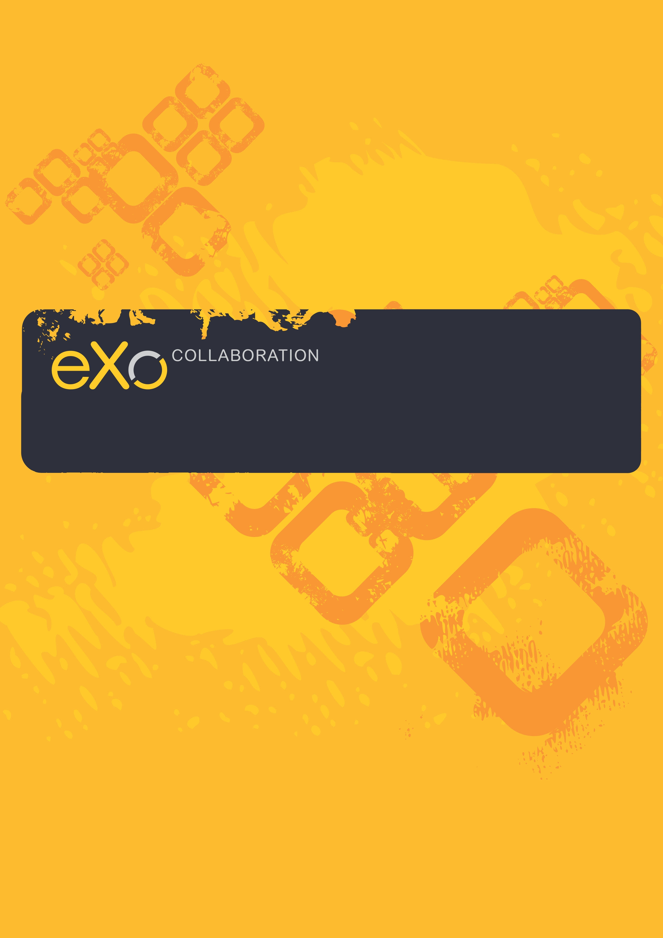
eXo Chat User Guide
Version 2.0
Contents
1 Preface 4
1.1 Overview 4
1.2 About this document 4
1.3 References & related resources 5
2 Overall Introduction 6
2.1 What is Chat? 6
2.2 What is the Chat room? 6
2.3 What is eXo Chat? 6
3 How to use in eXo Chat 7
3.1 Getting started 7
3.2 Changing the online status 11
3.1 Creating a new chat room 12
3.2 Joining a room 16
3.3 Starting a Chat 17
3.4 Adding a contact 20
3.5 Removing a contact 21
3.6 Adding contacts to a room 22
3.7 Leaving a chat room 24
3.8 Room Configuration 25
3.9 Sending files 25
3.10 Export a chat history 27
3.11 Show messages in specific time 28
4 Next steps 30

Preface

Overview
Beginning as an Open Source project in the year 2002, eXo is well-known as the industry's first Java portlet container. With the aim of dominating the potential portal market through robust and easy-to-use applications, eXo Project succeeded in attracting consumers in the whole world. eXo actually opened the floodgates to various options in many markets, and customers have been choosing eXo as the best method for their success.
The eXo Platform™ software is a powerful Open Source corporate portal and content management system. Users of the platform have a customized single point of access to the company's information system and resources.
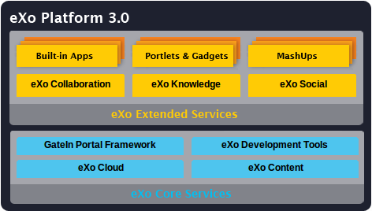
The foundation for eXo Platform 3.0 is eXo Core Services, a powerful set of REST-based services for rapid website development, content management and gadget-based development and deployment. eXo Extended Services are also a part of the eXo Platform 3.0 running on top of eXo Core Services to enable easy development of rich, user-centric web applications.
eXo Collaboration is one of eXo Core services, it provides productivity tools to extend your java applications. eXo Collaboration offers intuitive and powerful Mail, Chat, Calendar and Address Book functionality as a seamless extension to your portal-based application.

About this document
The intended reader of this manual is users of eXo Chat and eXo Collaboration. This manual will explain all the basic and advanced features that eXo Chat provides. It gives an in depth examples and easy explanation of using eXo Chat to communicate with other eXo Chat users.
It is also useful for the following groups:
- Users who use eXo Collaboration with eXo Chat in their work and business, communication.
- Integrators who want to know more about the rich features in order to advise their customers to use products.
This user guide will:
- Define some basic concepts used in eXo Chat
- Guide step by step to : create an account, add/remove contacts, send instant message to other contacts, create chat room, send files, etc.

References & related resources
Related Documents
- eXo GateIn Guide v3.0
- eXo Contact User Guide v2.0
- eXo Calendar User Guide v2.0
Info & Support
Information
- eXo Home Page
- eXo Wiki
Support
- Forums
- FAQ
Download
- eXo Content
- eXo Development tools
- Gatein Portal Framework
- eXo Collaboration
- eXo Knowledge
- eXo Social
Resource Center
- Video demos, tutorials, webinar archives, features & benefits tables and more

Overall Introduction

What is Chat?
Chat describes the way people communicate online in real time. They exchange electronic messages with one or more computer users in real time. Typically, people in online chat sessions type messages to each other using their keyboards. The message then appears on the screens of all the participants.

What is the Chat room?
A chat room is a place on the Internet where people with similar interests can meet and communicate with each other. People can often enter an un-moderated chat room without any verification of who they are.
A chat room allows several people or even a large group to communicate simultaneously.

What is eXo Chat?
eXo Chat is an application of eXo Collaboration– an extension of eXo Portal.
With eXo Chat, you can:
- Add contacts into your friend list.
- Communicate with other eXo Chat users.
- Create a new chat room or join several chat rooms.

How to use in eXo Chat

Getting started
- To register a new account on the GateIn, do as follows:
Step 1: Go to the portal by typing URL in address bar (e.g: http://localhost:8080/portal). The anonymous home page will be displayed:
Step 2: Click the  button on the navigation bar. The Sign up form will appear.
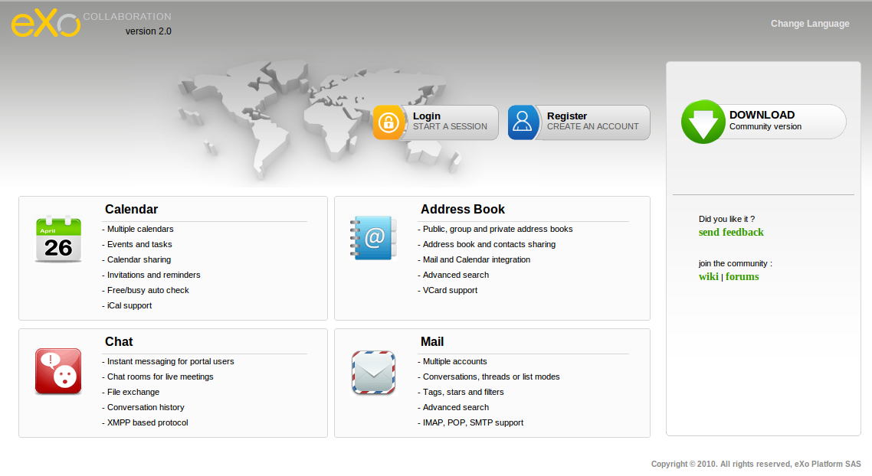Illustration 1: eXo Collaboration Homepage
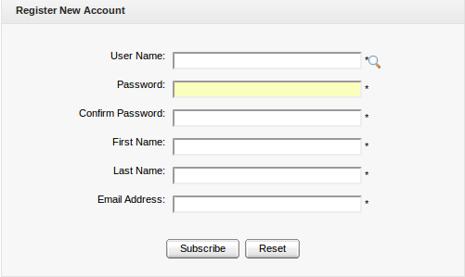Illustration 2: The Register New Account form
Details:
(*): required
User Name | The name of user that will be used to sign in. It must be unique.
Password | The secret string used to login. It must have at least 6 characters.
Confirm Password | The re-typed password. Password and Confirm Password must be the same
First Name | Your first name
Last Name | Your last name
Email Address | Your contact email address.
Subscribe button | Click this button to accept saving the new account
Reset button | Click this button to clear all inputted values.

Step 3: Click the icon to search and check for the availability of your User name
Step 4: Input values in all required fields in the Register New Account form.
Step 5: Complete registering a new account by clicking the Subscribe button.

There will have an alert messages and you cannot add new account if at least one of these cases occurs:
- User name is existing or User Name is invalid
- Password has less than 6 characters.
- Password and Confirm Password are not the same
- Email Address is in invalid format
- Required fields are empty

- To sign in, do as follows:
Step 1: Go to the portal in a public mode by typing the portal URL in your address bar (e.g: http://localhost:8080/portal)
Step 2: Click the  button . The Sign in form will be displayed:
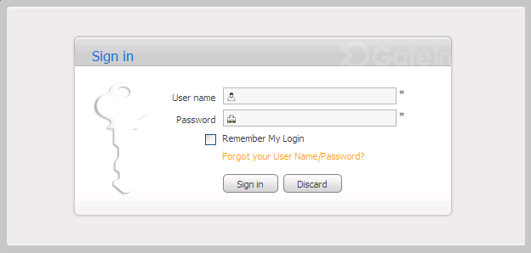Illustration 3: The Sign in form

Step 3: Input your registered User name and Password.

Details:
(*): required
User name | Your registered user name
Password | Your registered password
Remember My Login | When the Remember my Login is checked, your computer will save your login information.The next time you login, you do not have to type your User Name and password again.
Forgot your User Name/Password | To show the guide line that must be followed to get the forgotten User Name/Password
Sign in button | To accept signing in
Discard button | To exit the Sign in form

Step 4: Click the Sign in to complete signing in.
After signing in successfully, you will be redirected to the authenticated home page:
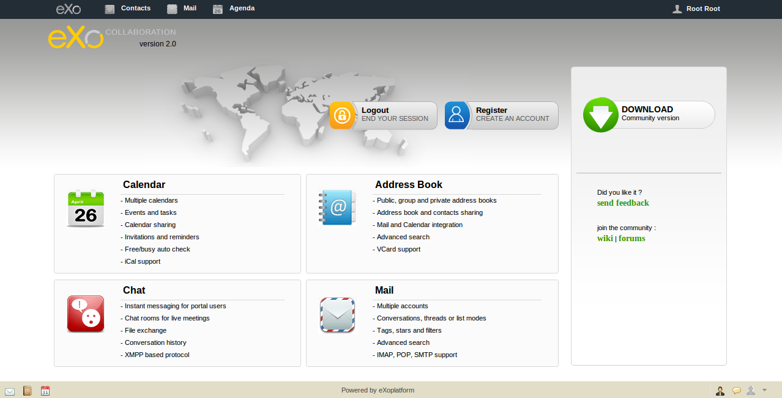Illustration 4: The GateIn page after signing in successfully
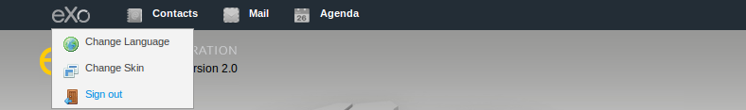
- To sign out, just click the eXo logo () and select Sign out from the menu:

Changing the online status
When you sign in eXo Chat, by default, your logged-in account is in the Online status and other eXo Chat members will see the online icon appending to your account name.
To change the online status, do as follows:
Step 1: Click on the account icon in the quick chat bar at the bottom right corner:
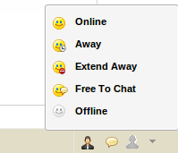
Step 2: Select one status in the status list.
- Online: This status means you are available to communicate, other users can contact you by sending instant messages. Your contacts will see theicon next to your account.
- Away: This status means you are away from computer. Other users still can send instant messages to you. Your status icon will change toicon.
- Extend Away: This status means you are away from computer for an extended period of time. Other members will see the icon next to your account.
- Free to Chat: This status means you are free to chat with everyone. The icon is appended to your account.
- Offline: Other users will see theicon appending to your account. With this status, you are invisible to other users. That means everyone will see you as offline though you are online.

Creating a new chat room
eXo Chat makes your communication with the other contacts easier by letting you create a new
chat room. It means you can add some people into a group to talk together. Chat rooms are set up to handle group discussions, and everyone sees what the others type in, although other people can decide to break off and have their own keyboard chat.
- To create a new room, do as follows:
Step 1: Click thebutton on the action bar in the Chat portlet or click on the icon and select Add Room in the pop-up menu.
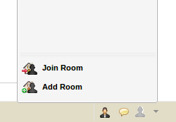
The New Room form will appear:
Details:
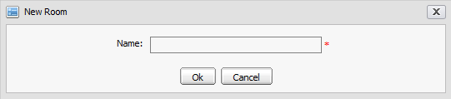Illustration 5: The New Room form
Name | The name of the room. This field is required
OK button | To accept adding a new room.
Cancel button | To exit/close the New Room form

Step 2: Type the room name into the Name field of this form.
Step 3: Click the OK button to accept creating a new room.
After creating a new room, a Room Configuration form will appear. This form allows you to configure some information related to the created room:
Details:
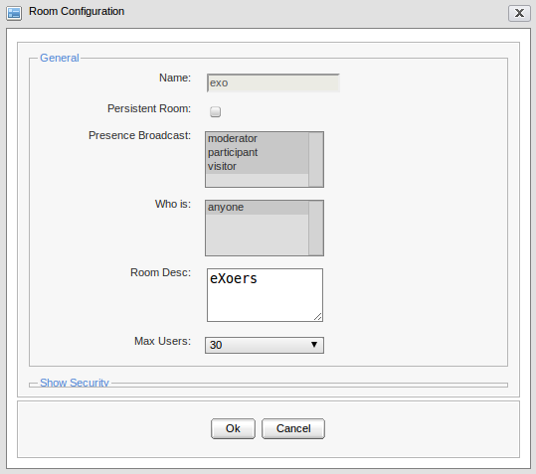Illustration 6: The General panel of the Room Configuration form
General: This area contains all general information of the created room
Room name | The name of a created room. You cannot change value for this field.
Persistent Room | A persistent room is one that does not get closed when there are no members in it. Check this check box if you want to create a persistent room.
Presence Broadcast | The groups that will be received an message about the status changes of the chat room's members.
Who is | Users that correspond to the selected groups in ''Presence Broadcast” will receive the inform message.
Room Desc | The brief description of the chat room.
Max users | The maximum number of users that can join the chat room.
Security: This area includes all security information of the created room. To show Security information, click on Show Security:
Details:
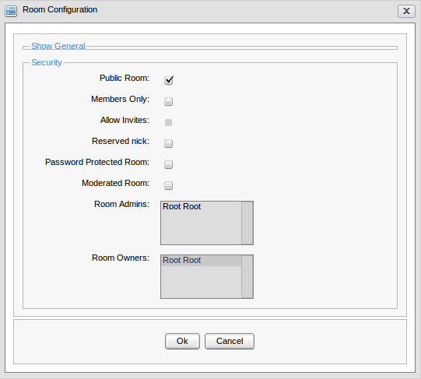Illustration 7: The Security panel of the Room Configuration form
Public Room | This option is to allow publishing the created room or not. It means after the room has been created, all users can join this room.
Member Only | This option is to publish a room for members of the created room only
Allow Invites | This option is to allow room's members to invite other users to join the room
Reserved nick | This option is to prevent anonymous users from joining the room. If this option is checked, only registered users can enter the room.
Password Protected Room | This option is to change the public room to a locked, secure protected room accessible only to specific individuals with the right password
Password | The password is used to protect the room. This field is shown only when the 'Password Protected Room' option is selected.
Moderated Room | This option is to require whether approve/reject the created room or not.
Room Admins | This option is to select the administration of the created chat room.
Room Owners | The email address of room's creator.

Step 4: Enter values in the Room Configuration form.
Step 5: Click the OK button in Room Configuration form to accept setting values or click the Cancel button to quit without creating a new room.
After creating a new room, there will be the Conversation window opened and in locked status. With this status, both the creator and other members can not join this room to chat. Until your room configuration is completed, members can enter the chat room.
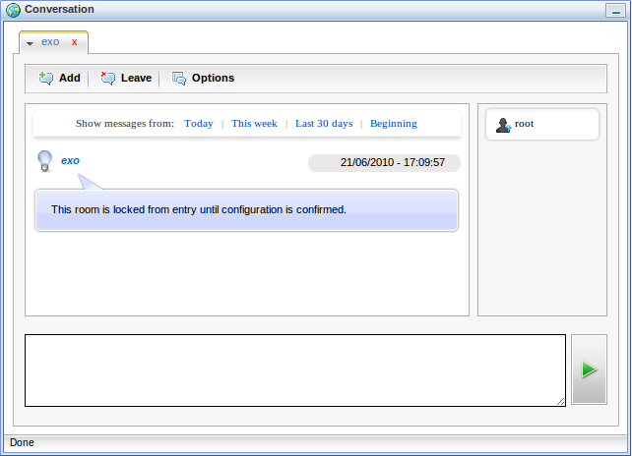Illustration 8: The Conversation window

Joining a room
- To join a room, do as follows:
Step 1: Show the Join Room form by clicking the button on the action bar or click on theicon and select Join Room in the pop-up menu:
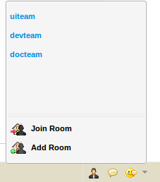
The Join Room form will appear:
Step 2: Select one room in the list by checking the radio button.
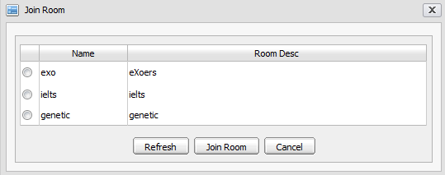Illustration 9: The Join Room form
Step 3: click the Join Room button to join the selected room. Click the Refresh button if you want to clear the selected rooms.
The Conversation window of the selected room will appear:
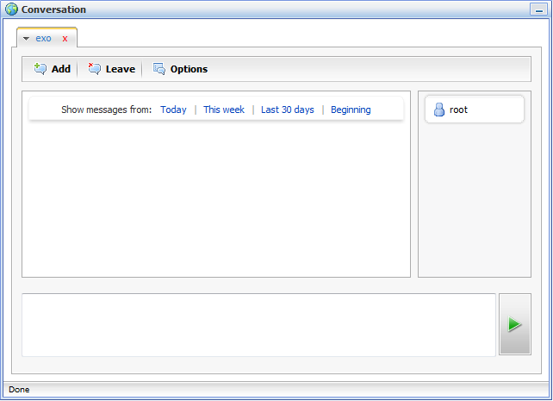Illustration 10: The Conversation window after joining a room
You can join several chat rooms at the same time. Each chat room is displayed in its own tab

Starting a Chat
- To start a chat, do as follows:
Step 1: Click the contact name you want to chat with in the contact list or join a chat room.
The Conversation window will appear:
Step 2: Type the message that you want to send into the message input box:
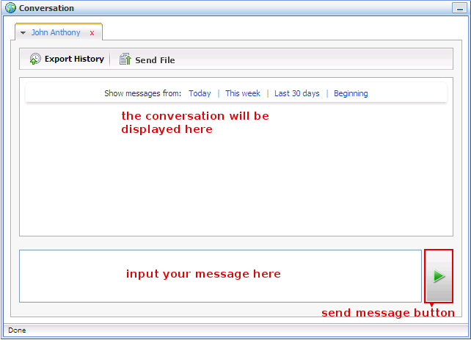Illustration 11: The Conversation window when starting chat with the other contact
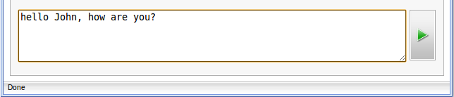
Step 3: Press the Enter key on your keyboard or click the send button ().
The selected contact will receive the message that you have typed in the conversation area.

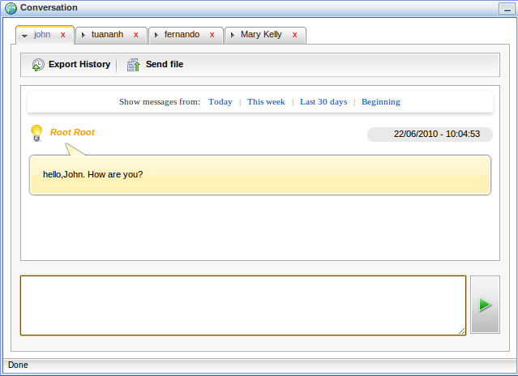Illustration 12: The Conversation window after sending a instant message

The chatting will be taken place until one of them want to stop and leave this room (for chat in a room).
Click theicon on the right corner of the Conversation window will minimize this window to the action bar . To maximize the window, click the minimized window on the action bar to show the conversation window again.
When you chat with an offline contact, this contact will receive the message after signing in the next time.
You can chat with several contacts at the same time. Each contact is displayed in its own tab.
If you receive new messages when chatting with several contacts, you will see a notification in the corresponding tab

Adding a contact to friend list
This function is used to add a contact into your friend list.
- To add a contact to your friend list, do as follows:
Step 1: Clickon the chat bar and click onin the pop-up menu.
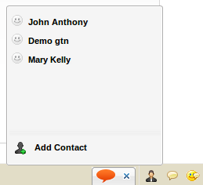
The Add Contact form will appear:
Step 2: Select one or more contacts in the account list by selecting the corresponding check boxes. You also can search for specific contact by typing the information related to the contacts you want to search in the search box. All contacts that match with the search term will be displayed:
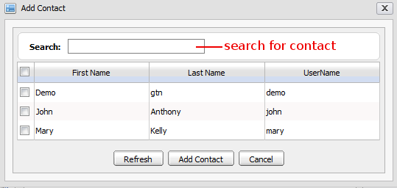Illustration 13: The Add Contact form
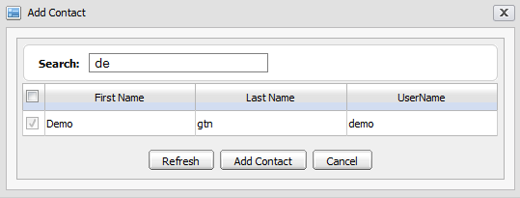
Step 3: Select contacts in the found list to add contacts into your friend list.
Step 4: Click the Refresh button to clear the selected contacts or click the Add contact button to add contacts into your friend list .
The contact that you want to add, will receive a your request message:
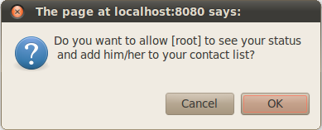
Step 5: If he/she accepts, you will receive a confirmation message.
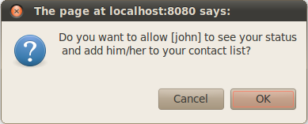
Click the OK button to accept the request .
After adding contacts successfully, the added contacts will be shown in your friends list.

Removing a contact
This function allows you to remove a contact from your friend list.
- To remove a contact, do as follows:
Step 1: Click thebutton on the action bar to show your friend list. Right click on the contact that you want to remove from your friend list and select Remove in the pop-up menu:
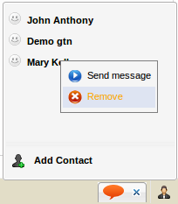
There will have the confirmation message.
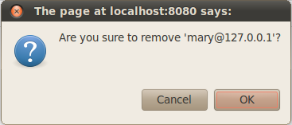
Step 2: Click the OK button to accept removing the selected contact or click the Cancel button to quit and close the message.

Adding contacts to a room
This function is used to add one or more contacts to the room where you are already in, so the added contact will be able to join this room to communicate.
- To add contact(s) to a chat room, do as follows:
Step 1: Click thebutton on the room conversation window .
The Add Contact form will appear:
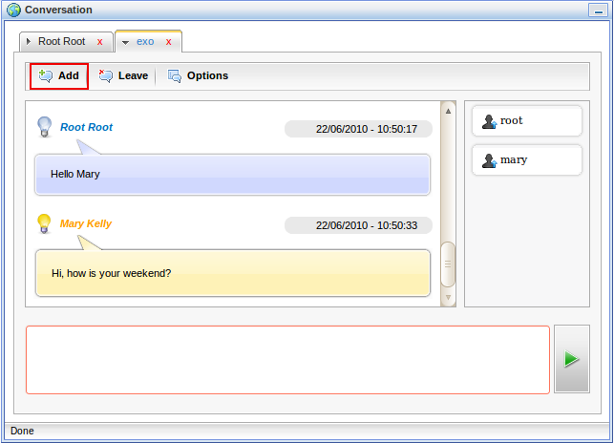
Step 2: Select the participants you would like to invite to the chat room by checking the check boxes corresponding to the contact name. You also can do a quick search in this form to display only the contacts that you need:
Enter information related to the contacts that you want to find in the Search text . All contacts that match with the search term will be displayed in a result list.
The contact you want to add will receive a confirmation message like the illustration below:
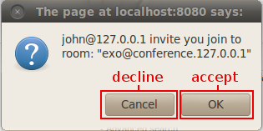
After joining a chat room, the added contact can start the chat right away.

Leaving a chat room
- To leave a chat room, do as follows:
Click the button on the room conversation window.
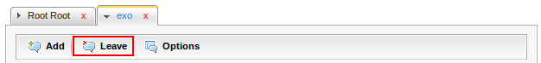
Your conversation window of this room will be closed and you will not receive any messages from the chat room. In addition, your nick name will also be removed from the member list of the room conversation window.

Room Configuration
This function allows the owner of a room to configure the room's information to suite your particular needs. As you remember, you have to configure the chat room before you can create one . You are also able to update the room configuration after the chat room was created. If you are not the owner of the chat room, you do not have the permission to perform this action.
- To configure a chat room, do as follows:
Step 1: Click thebutton in the Conversation form of the chat room. The Room Configuration form will appear like the illustration 6
Step 2: Set values for the fields in this form. For the descriptions, see Creating a new chat room
Step 3: Click the OK button to accept the configuration or click the Cancel button to quit
The chat room configuration is available only if you are the owner of that chat room. You can change the room owner in Room Configuration.

Sending files
This function allows you send a file to the other contact through the Conversation window.
- To send file to a contact, do as follows:
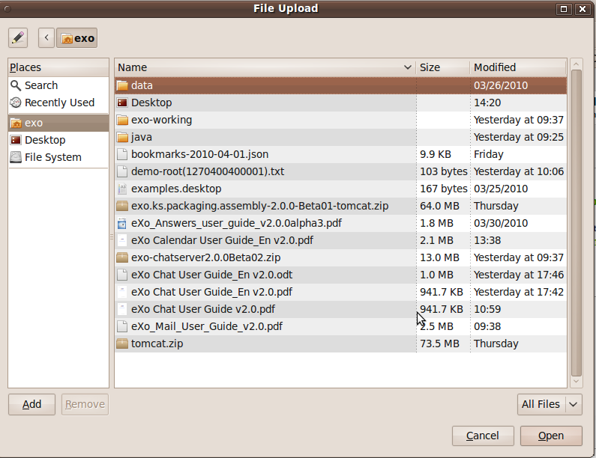
Step 1: On the Conversation window with the other, click the button in the chat window. You will be directed to select a file on your computer :
Select a file that you want to send then click Open to start sending the file.
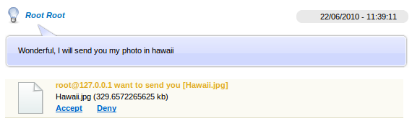Illustration 14: The receipient's conversation window

Exporting a chat history
eXo Chat can archive your chat and allows you to export and save the conversation history to your computer.
- To export a chat history, do as follows:
Step 1: Click the button on the Conversation window.
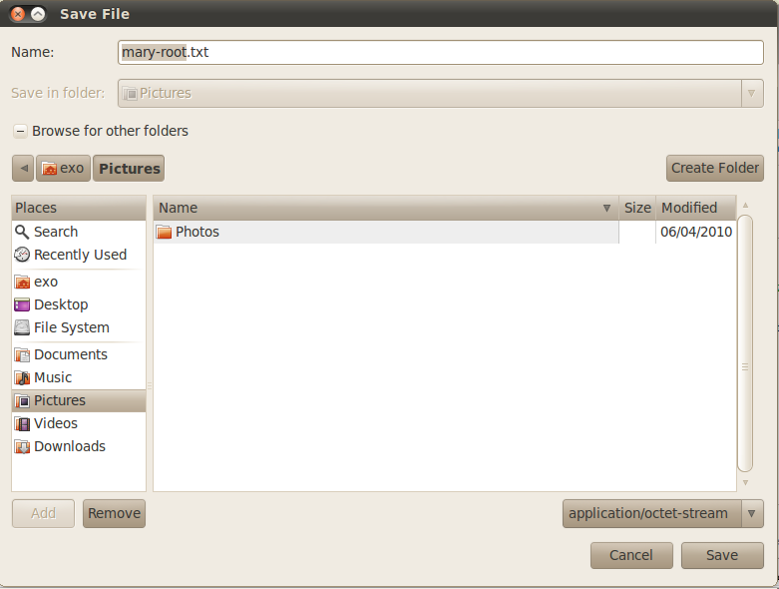
The pop up window will appear as below:

Step 2: Chose the location to save the file then click the Save button to save the exported file to your local computer or the Cancel button to abort the chat history export.
After exporting the conversation successfully, you will have a text file which record all of your conversation contents.

Showing messages in specific time
Your chat messages with other contacts can be shown in a specific time interval. The function of Show Messages allows you to take this action. Do as follows:
Step 1: Select a contact that you want to show the message log.
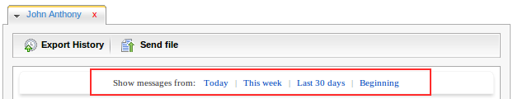
Step 2: Select a time interval in some default time intervals provided in eXo chat:
Details:
- Today: To show all instant messages of the current date.
- This week: To show all instant messages of the current week.
- Last 30 days: To show all instant messages from last 30 days to the current time.
- Beginning: To show all instant messages from the beginning to the current time.
All messages with the created time and date will be shown in the Conversation window.

Next steps
It is our hope that information stated above is valuable to you, our customers and users in the process of experiencing the eXo Chat. To support for benefits recognition from customers and users, we would like to summarize the key features of eXo Chat as follows:
- User Interface Options: Select from the "Facebook-like" Chat bar or a standalone Chat client.
- Buddy List: Users can create their own buddy list to display availability to other users.
- XMPP Protocol: Allows near-real-time extensible instant messaging.
- Chat Rooms: Join a room or create and configure private chat roans to facilitate group discussions.
- File Transfer: Transfer files through the chat interface.
- Message History: Store, search and export chat logs.
This user manual has provided a thorough explanation of features and terminologies within eXo Chat. Now that you know all the operations in eXo chat: send instant message to other contacts, add, remove contacts, create chat room,etc. You may have more questions or want to get involved in the eXo community. The following links can connect you with resources to learn more and contribute to the open source development process.
- Learn more about eXo Platform 3.0
- Video demos, tutorial and more in the eXo Resource Center
- Access another eXo documents in the eXo Wiki
- Ask question about eXo Chat in the Forums

REVISION HISTORY
Version | Date | Written by | Reviewed by | Change Description
1.0 | Oct 20, 2008 | Hoang Anh Quynh Nga
1.3 | June 25, 2009 | Nguyen Thanh Cong |  | Integrate Chat 1.0 with some changes in the CS 1.3
1.3.1 | Sep 26, 2009 | Nguyen Thanh Cong | Luong Quynh Lien | - Add description for action that can be done from the quick chat bar.  - Update some illustrations
1.3.3 | Dec 24, 2009 | Luong Quynh Lien |  | Update some illustrations.
2.0 | February 24, 2010  April 5, 2010  Jun 23, 2010 | Luong Quynh Lien | Nguyen Huu Tuan Anh | New UI and changes based on 2.0  - Correct errors in spelling and grammar  - Add some parts ( references and conclusion)  - Formatting  - Update some illustrations  - Fix the table of content  - Update: Display user name instead of user id in the Chat box  - Update new document style

