
eXo Portal
version 2.5.9

CONTENTS
1 Preface 6
1.1 Overview 6
1.2 Purposes of the Guide 6
1.3 References 7
Information 7
Support 7
2 Glossary 8
2.1 Portal 8
2.2 Portlet 8
2.3 Navigation 8
2.3.1 Portal Navigation 9
2.3.2 Group Navigation 9
2.3.3 User Navigation 10
2.4 Gadget 10
2.5 Access Mode 10
2.6 Preview Mode 11
2.7 Layout mode 11
2.8 Permission 11
2.8.1 Permission types 11
2.8.2 Permission levels 12
3 Portlet 13
3.1 Functional Portlet 13
3.1.1 Account Portlet 13
3.1.2 Organization Portlet 15
3.1.3 Application Registry Portlet 15
3.1.4 Internationalization Portlet 16
3.2 Interface Portlets 19
3.2.1 Banner Portlet 19
3.2.2 Breadcrumbs Portlet 20
3.2.3 Console Portlet 20
3.2.4 Footer Portlet 20
3.2.5 HomePage Portlet 21
3.2.6 IFrame Portlet 21
3.2.7 Navigation Portlet 22
3.2.8 SiteMap Portlet 23
3.2.9 Browser Portlet 24
3.2.10 Dashboard portlet 24
3.2.11 Gadget Wrapper Portlet 25
4 Initial implementation 27
4.1 Requirements 27
4.1.1 Software 27
4.1.2 Hardware 28
4.2 Setup 28
4.2.1 Establish A Base Structure 28
4.2.2 Configure environment 29
4.2.3 Run Commands 29
5 Portal Administration 31
5.1 Register A New Account 31
5.2 Sign In and Sign out 32
5.2.1 Sign In 32
5.2.2 Sign out 33
5.3 Change Account Settings 33
5.4 Retrieve User name/Password 35
5.5 Set the display language 37
5.6 Change the display language 38
5.7 Add a gadget in Dashboard 39

Illustration Index
Illustration 1: The Account Portlet form 13
Illustration 2: The User Profile tab 14
Illustration 3: The Organization Portlet interface 15
Illustration 4: The Application Registry Portlet interface 16
Illustration 5: The I18n Portlet form 17
Illustration 6: The Resource Data form 18
Illustration 7: The Search Resource form 19
Illustration 8: The Banner Portlet interface 19
Illustration 9: The Breadcrumbs Portlet interface 20
Illustration 10: The Console Portlet interface 20
Illustration 11: The Footer Portlet interface 20
Illustration 12: The HomePage Portlet interface 21
Illustration 13: IFramePortlet Portlet 22
Illustration 14: The Navigation Portlet interface 22
Illustration 15: The SiteMap Portlet interface 23
Illustration 16: The Browser Portlet interface 24
Illustration 17: Dashboard portlet 24
Illustration 18: The Account Profiles form 34
Illustration 19: The Change Password tab 35
Illustration 20: The Dashboard page 40

Preface

Overview
Beginning as an open source project in the year 2002, eXo is well-known as the industry's first Java portlet container. With the aim of dominating the potential portal market through robust and easy-to-use applications, eXo Project succeeded in attracting consumers in the whole world. eXo actually opened the floodgates to various options in many markets, and customers have been choosing eXo as the best method for their success.
The eXo Project grew into a company in 2003, as a response to customer demands. We can do this because we release our code in the open environment. It's how the DoD found us, when we were just university students hacking away, and it's how we choose to do business with our customers.
Today, eXo is a rapidly growing global company, with U.S. headquarters in San Francisco, California, global headquarters in France, and offices in Tunisia, Ukraine, and Vietnam. The Corporate has established technology leadership and proven values by their large European installed base and strategic partnerships with Red Hat, Capgemini, Atos Origin, and Bull.
And along with the Corporate growth, eXo Portal is really a core application which is considered as the most vital foundation for the development of many successive products in the market. Based on the Enterprise 2.0 direction, eXo Portal 2.5 is an electronic portal for businesses, enabling users to access many personalization and collaboration applications wherever and whenever. Strong flexibility and customization of eXo Portal 2.5 really faciliate the birth of many useful applications with a variety of rich utilities, contributing to the immense communication, easy transaction, user-friendly access, and collaboration simplification, etc, in such easier and more interactive manner.

Purposes of the Guide
The book was written as a handbook, aiming at instructing step-by-step on how to use and to implement this application to the utmost. Thus, the information included herein will give basic steps that makes it easy for users to follow through in-depth examples as well as clear explanations regarding to the eXo Platform technology. Whether you major in technology or not, you are able to learn about or to work on eXo Portal easily and efficiently.
The information provided in the guide will focus on the followings:
- Define the basic concepts in the eXo Portal.
- Show the main instructions of the eXo Classic Portal.
- Provide step-by-step instructions to master the eXo Portal.

References

Document
- eXo Portal Administrator Guide v2.5.9

Information
- eXo Platform Home Page: http://www.exoplatform.com/portal/public/website/
- eXo Platform Wiki: http://wiki.exoplatform.com/xwiki/bin/view/Main/

Support
- Forums: http://forums.exoplatform.org
- FAQ: http://faq.exoplatform.org

Glossary

Portal
Portal is a Web application that provides many services to users and enterprises with an interactive and consistent look and feel. Users and administrators are able to integrate information, people and processes via a web-based user interface.
The framework facilitates the content and applications aggregation with the flexible management and personalization options.

Portlet
Portlet is a small web-based application. Also, it may be understood as a pluggable user interface component that is managed and displayed in a portal. The portal generates fragments of markup codes that are aggregated into a portal page. Typically, a portal page is displayed as a collection of non-overlapping portlet windows, where each portlet window displays a portlet.
The contents generated by a portlet can vary among many users, depending on the user preferences for that portlet.
The eXo Platform is intended to create standard portlets that can be plugged into any portal.
Portlets can be divided into two following types:
- Functional Portlet
- Interface Portlet

Navigation
The navigation is composed of a number of nodes (menus) that helps users visualize the site structure and provides hyperlinks to move from one page to another quickly. Each node contains an internal name and a label which is shown on the menu. For any node, you can define either sub-nodes. The horizontal menu at the page top is called a navigation bar. The eXo Portal's navigation is established based on three levels: portal level, group level and user level. On each level, any node can be defined. The navigation structure of one particular user is made up of portal navigation nodes (that are valid to all users), the nodes of all groups the user belongs to and his individual nodes. The users' and groups' nodes are valid for all portals that are defined on the same eXo Portal server.
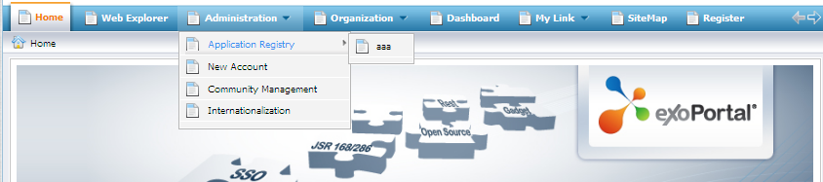

Portal Navigation
This navigation level is used to keep the links to pages of a portal. Each portal has only one navigation structure and it is automatically generated when a portal is created. Only users who have the edit permission on a portal can add nodes on this navigation level.
The portal navigation's name looks like: portal:[portal name]'s nav
Let's suppose that a portal navigation's name is: “portal:classic's nav”, in which:
- 'portal' is the navigation level, it means that navigation nodes are defined for all users of a portal.
- 'classic' is the name of portal.
- 'nav' stands for 'navigation'.

Group Navigation
All registered users are organized into groups. There is a navigation keeping the links to all pages of each group, called a group navigation. The group navigation is created manually by users who have the highest right in a group. Before adding nodes or creating pages for a group, you must create the group navigation. Also, there are nodes that are only applied to those members who have certain memberships.
The group navigation's name looks like: group:[group name]'s nav.
Let's suppose that the group navigation name is: group:platform/administrators's nav, in which:
- 'group' is a type of navigation, it means that the nodes are defined for a group.
- 'platform/administrators' is the group path.
- 'nav' stands for 'navigation'.

User Navigation
Furthermore, each user has its own navigation nodes. The user navigation is created along with the user registration and deleted along with the user deletion. By default, the user navigation is empty.
The user navigation's name has format: user:[user name]'s nav
Let's suppose that the user navigation name is: user:john's nav, in which:
- 'user' is a navigation level that navigation nodes are defined for one individual user.
- 'john' is the name of user.
- 'nav' stands for 'navigation'.

Gadget
A gadget is a mini web application running on a platform that a user can integrate in the web page.
The eXo Portal supports some gadgets such as:
- Calculator: This is the coolest calculator for your page. This mini-application lets you perform most basic arithmetic operations. This gadget also offers cool skins to make your page more lively.
- Calendar: The cool calendar is to keep track of date. You also can switch easily between daily, monthly and yearly views and change the skin as you like.
- Todo: This mini-application helps you organize your day and work group. It is designed to keep track of your tasks in a convenient and transparent way. You can highlight tasks with different colors.

Access Mode
The eXo Portal has two modes:
- Public mode: this mode is for guest users (visitors) who have not registered yet and it is not required to sign in, so they can only visit the public pages in a portal. Visitors can also register in order to get an account. After having registered, they can use the private mode and have to contact their administrators to get more rights or the group manager if they want to become a member of that group.
- Private mode: this mode is for registered users who will apply their usernames and passwords to sign in. This mode supports users in taking many actions such as: managing private resources (creating private pages, editing or deleting them), "borrowing" pages from others by creating hyperlinks to existing pages, changing the language for individual needs, managing private information.

Preview Mode
In the preview mode, you can only view and can't edit. You can see this mode when you click the Preview Page icon at step 3 to create a page by wizard or edit a page by wizard.

Layout mode
In the layout mode, you are provided with some layout templates of portal or the page and you can use these templates to edit a portal or a page.

Permission
Permission is one of the most important factors on a portal. Permission settings control what users can or can not do within the portal and set by administrators.

Permission types
Permission types define what a user can do with two permission types available as follows:
Access Permission: allows users to utilize portal contents (sigining in, viewing contents, draging and droping portlets into a page, etc). Access permissions can be set for a list of groups.
Edit Permission: allows users to change portal contents (changing portal or page information, deleting a portal/page). The edit permission is set for only one group at a time.
By default, root is set as the super user or the administrator on the eXo Portal; he can do everything while the others must get the appropriate rights (permissions) at first.
Rights in the eXo Portal are not assigned to a single user but to a users group with a specific membership type.
Similarly, the permission structure is always established as follows: [membership type]:/[group path].
For example: manager:/platform/administrators. It means the right is set for users who are “manager” of the group “administrators”. “Platform” is the parent group of “administrators”.
Seemingly, groups are managed in accordance with a hierarchy structure; but in fact, a sub- group does not have any inheritance from the parent group.
For example: we have a group structure as follows:
+ platform
- administrators
- guest
- user
If users in the group “platform” can perform a function A, it does not mean that users in “administrator” or “guest” can do function A. The roles of users in groups are independent.

Permission levels
Permission levels specifies where the users's permission types can be applied into the portal. Portal offers three permission levels as follows:
Portal: The portal permission level includes all pages within the portal. Therefore, a user with the access permission can view (but not edit) all the pages within the portal. A user with the edit permission at the portal level can change any page in the portal.
Page: The page permission level restricts the users to several particular pages. Users are only able to see and/or edit pages they have been given access to, depending on each permission type assigned to them.
Portlet: The portlet permission level allows users to create a page through dragging and dropping portlets into a page. Some portlets are only used for administrators while some are for individuals; thus, administrators need to set proper access permissions for each specific group.
Permission types and levels can be effectively implemented to control who can do and what can be performed within the portal. For more information on setting permissions, refer to the section 'Manage Permissions'.

Portlet

Functional Portlet
Functional Portlets support all functions of a portal. They are built into the portal and accessed via toolbar links when the portal-related tasks are performed.

Account Portlet
This portlet allows users to register a new account. In other words, it is also used to support users in choosing their preferred languages for displaying the Portal interfaces.
- This portlet includes two information parts:
- Account Setting: It includes information about a new account such as: User Name, Password, Confirm Password, First Name, Last Name, Email Address.
Note:
You should enter your email address exactly because you can recover your user name or password when you forget them by using this email address.
- User Profile: It includes personal information of a new account such as: User Profile, Home Info, Business Info.
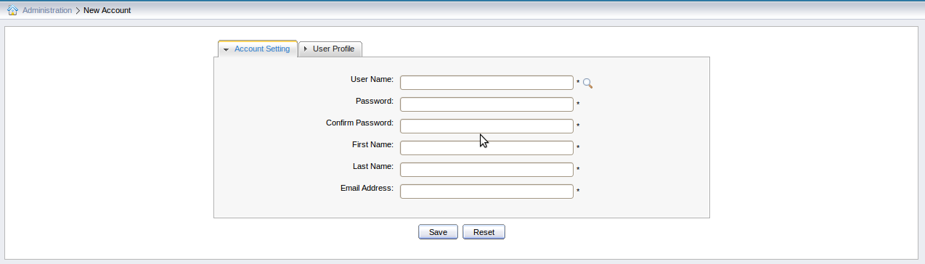Illustration 1: The Account Portlet form
Note:
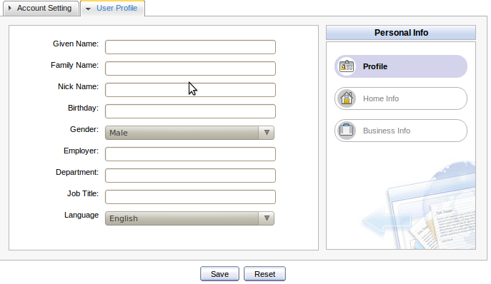Illustration 2: The User Profile tab
To choose the preferred language for displaying the Portal interface, do as follows:
There are two modes to set the displaying language of a user.
- Public Mode: The display language of this mode depends on the browser language in use.
- If you set the browser language not supported by the Portal, the display language will be the language set on the Portal.
- If you set the browser language supported by the Portal, the display language will be the language set on the browser.
- Private Mode: The display language of this mode belongs to the language set by each user when he/she registers.
- When you sign in by a default account (root, john, demo, marry): the display language of these users are none, so it will belong to the browser language. If you change a value in the Language field in the User Profile tab (only the default user: root and john can change this value by accessing the Management page: Go to Organization--> Management page), your display language will be the set value.
- When you sign in by a newly registered user: by default, your display language is English. However, if you set the another language in the Language field in the User
Profile tab when you register a new account, your display language will be the set language.

Organization Portlet
This portlet is used to manage user information, users groups and memberships. The form of this portlet is shown like:
- User Management: This tab allows users to edit, delete, search and view existing users.
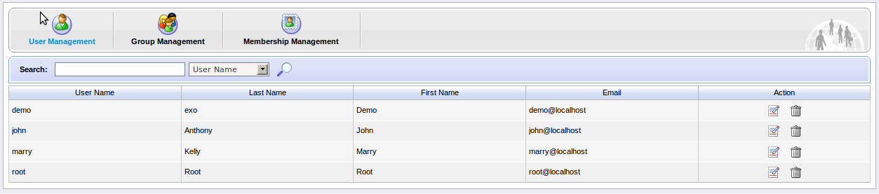Illustration 3: The Organization Portlet interface
- Group Management: This tab allows users to view, add new, edit and delete a group of users.
- Membership Management: This tab is used to add, edit and delete memberships.

Application Registry Portlet
This portlet is used to manage different application categories. You can add, edit, set permissions, or delete a category and applications. The form of this portlet is shown as below:
This portlet includes the following functions:
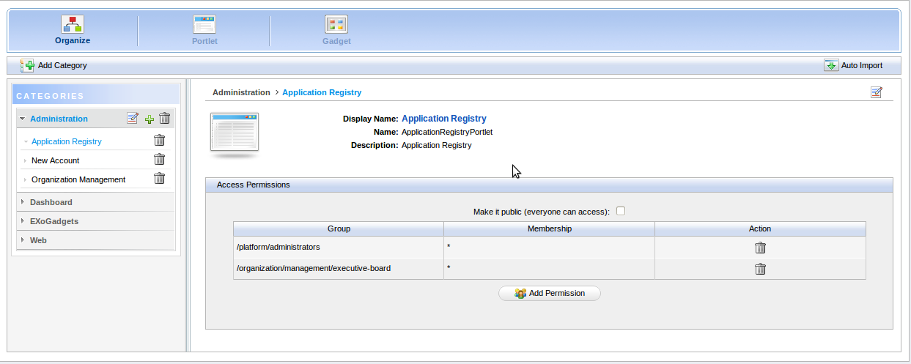Illustration 4: The Application Registry Portlet interface
- Organize portlets/gadgets into different categories such as: creating a new category, importing default porlet categories, adding a portlet/gadget into a specific category, adding permission to a portlets category, etc.
- List portlets and view detailed information regarding to a specific portlet.
- Manage gadgets: add a remote gadget, create a new gadget or delete a gadget from the list.

Internationalization Portlet
This portlet is used to define a word or a phrase of a current language to an expected language:
Each resource supports a language. So, you can define a word or a phrase to the supported language.
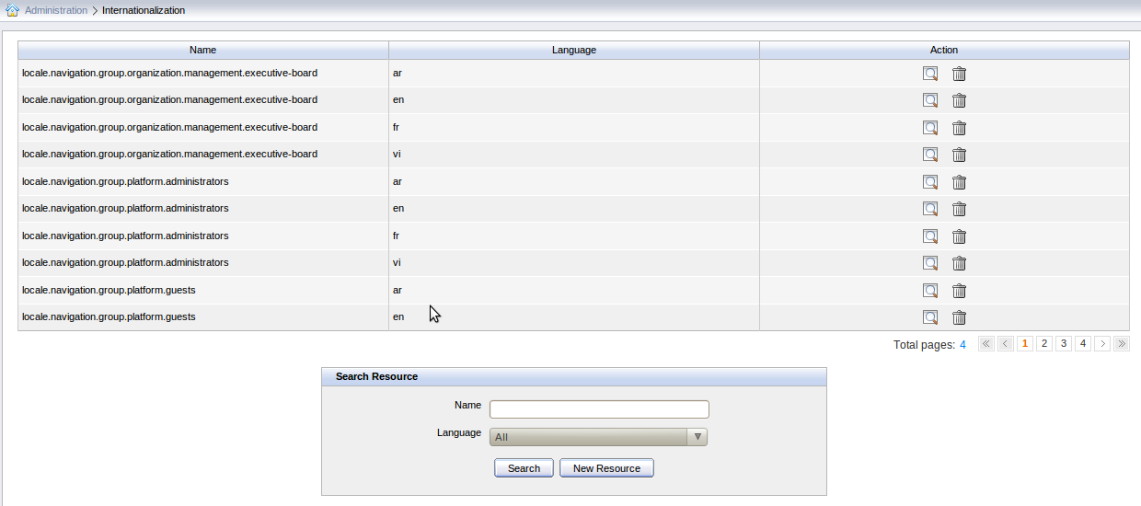Illustration 5: The I18n Portlet form
Add a new Resource:
Step 1: Select the New Resource button in the I18n Portlet form. The Resource Data form will appear:
Details :
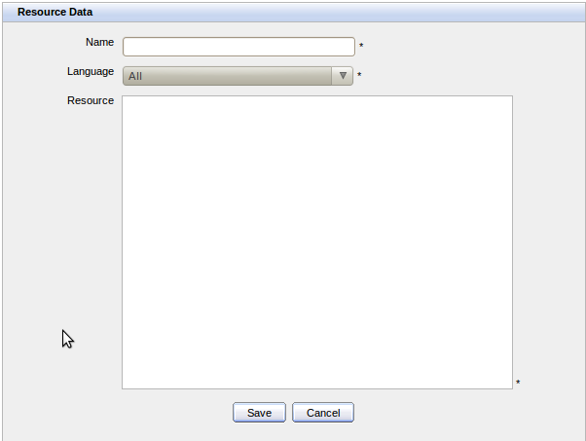Illustration 6: The Resource Data form
Name: The name of Data Source. (*Required).
Language: The language which this data source will support. (*Required).
Resource: The word or the phrase which you want to define. (*Required)
For example, we define:
Portal.classic.home = Trang chu
Portal.classic.webexplorer = Trinh duyet web
So, when you change the current language to the another supported by the data source, the phrase: “Portal.classic.home” in the current language will be changed to “Trang chu” in the supported language. Similarly, the phrase “Portal.classic.webexplore” in the current language will be changed to “Trinh duyet web” in a supported one.
Step 2: Enter values into the required fields.
Step 3: Click the Save button to accept adding a new resource or the Cancel button to quit.
Search Resource: The Search Resource form displays directly on the portlet: Enter a resource name which you want to search and select the supported language. Then, click the Search button to perform searching and display the expected Data Sources list.
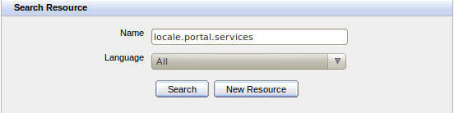Illustration 7: The Search Resource form
View a Data Source: Click the icon corresponding to the resource which you want to view. On the view form, you also can modify the resource-related information by clicking the Edit button. You only can change the Resource field, then click the Save button to accept changes or click the Cancel button to quit.
Delete a Data Source: Click the icon corresponding to the resource which you want to delete. A confirmation message will appear. Click the OK button to confirm deleting or the Cancel button to quit.

Interface Portlets
Inteface Portlets constitute the Portal interface. The group of Interface Portlets includes: Banner Portlet, Breadcrumbs Portlet, Browser Portlet, Console Portlet, Footer Portlet, HomePage Portlet, IFrame Portlet, Navigation Portlet, and SiteMap Portlet.

Banner Portlet
This portlet is considered as the welcome gateway of a portal. It contains the organization's slogan, logo and icon:
Besides, it also includes two functional buttons:
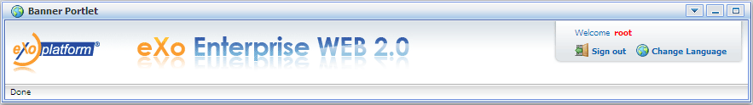Illustration 8: The Banner Portlet interface
The Change Language button allows you to set the display language. You can select one of the supported languages in the list.
The Sign out button allows you to exit from the portal.

Breadcrumbs Portlet
This portlet is used to display the navigation path of the selected page:
Illustration 9: The Breadcrumbs Portlet interface

Console Portlet
This portlet is used as a console to run Java Script commands:
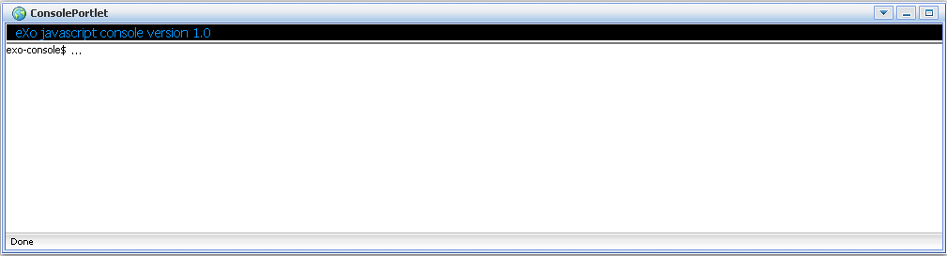Illustration 10: The Console Portlet interface

Footer Portlet
This portlet provides the portal footer. The footer may contain any text or image that is displayed at the portal bottom. The footer can provide information regarding to any author/institutional sponsor, revision date, copyright, comment form, and navigational link.
Illustration 11: The Footer Portlet interface

HomePage Portlet
This portlet is used to provide a homepage portlet on the portal. The homepage is the main page of portal. This is a default page which is displayed at first when you visit the portal.
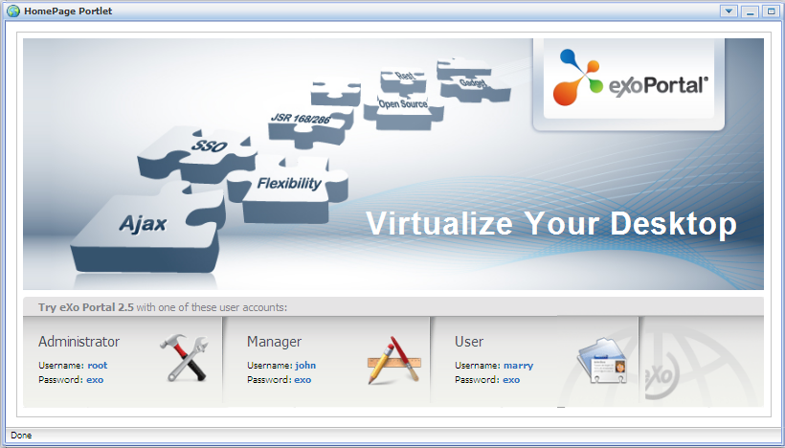Illustration 12: The HomePage Portlet interface

IFrame Portlet
This portlet is used to create IFrame elements for a site. IFrame is an HTML element which can embed a different HTML document into a HTML document. So the embedded document is displayed inside a sub-window of the browser window. This does not mean the full inclusion, the embedded document is independent and both documents are treated as separated documents.

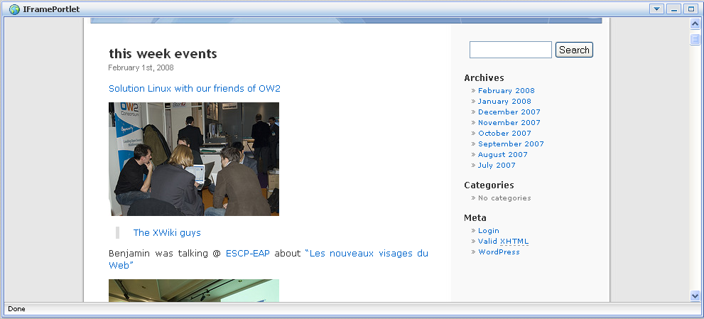Illustration 13: IFramePortlet Portlet

Navigation Portlet
This portlet provides a navigation bar. A navigation bar is a menu that helps users visualize the site structure and provide links to move from page to another quickly:
Note:
Illustration 14: The Navigation Portlet interface
When a new page that contains this portlet is created:
In the Preview mode: the portlet will be viewed as a normal page like above.
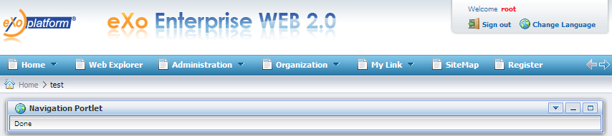
In the Save mode: the Navigation portlet will not be displayed normally when you open the page containing this portlet because only the portal navigation can be shown like below. It means that two navigations can not be shown concurrently.

SiteMap Portlet
This portlet is used to provide a sitemap page view of portal. A sitemap is a graphical representation of that portal architecture. It lists pages on a website, which is typically organized in a hierarchical structure. This helps visitors navigate pages on the portal easily.
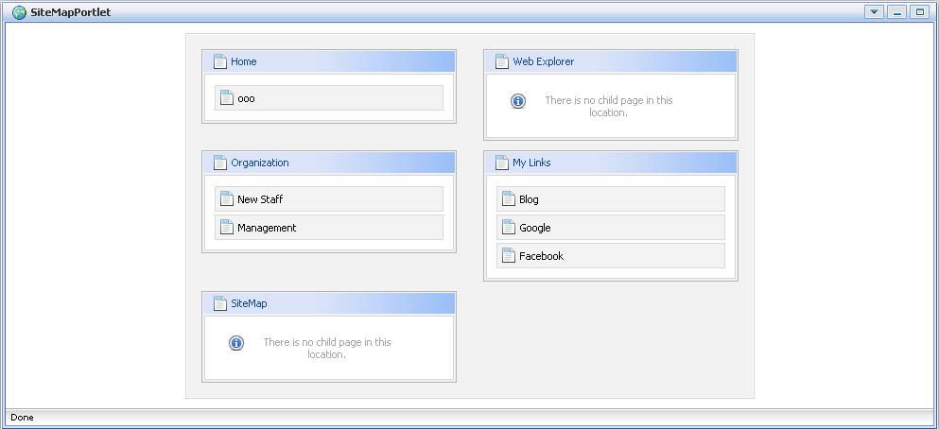Illustration 15: The SiteMap Portlet interface

Browser Portlet
This portlet provides a web-browser-like application for users. It allows users to connect to other sites over Internet.
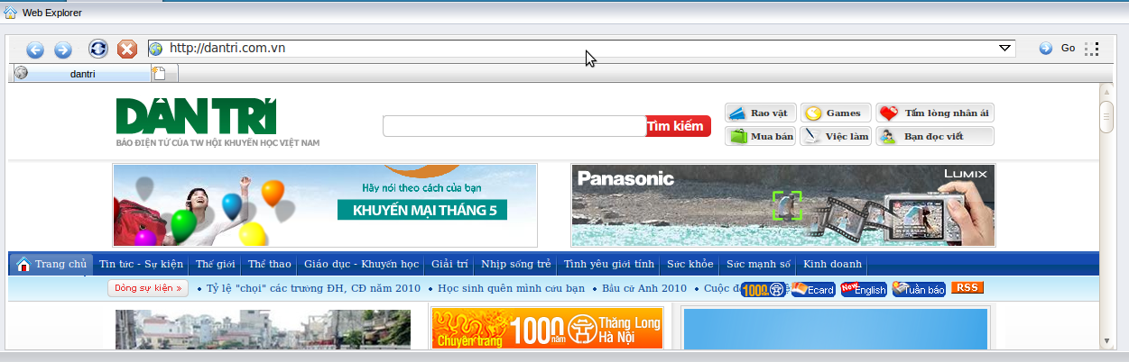Illustration 16: The Browser Portlet interface

Dashboard portlet
This portlet is used for hosting mini-applications known as gadgets. The dashboard uses a variety of graphical effects for displaying, opening, and using gadgets. Gadgets can be moved around, rearranged, deleted or recreated in the dashboard. More instances of the same gadget can be opened at the same time, possibly with different settings.
This portlet includes two parts:
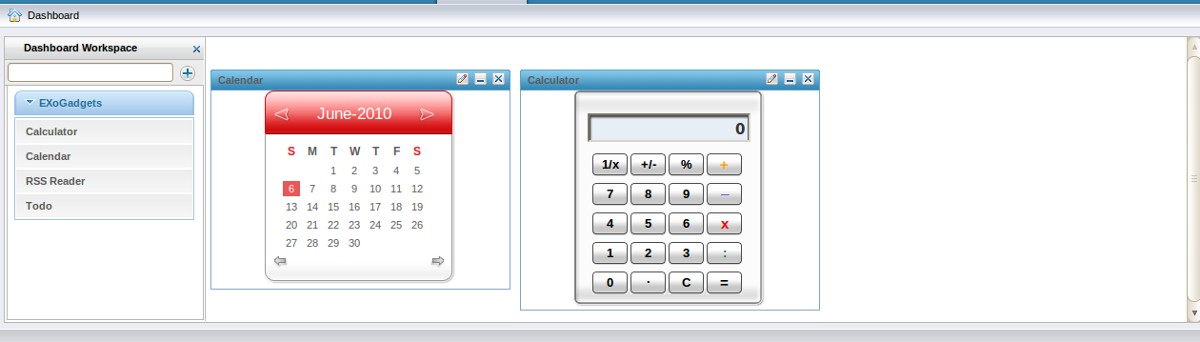Illustration 17: Dashboard portlet
Left pane: This pane lists all gadgets. These gadgets provide you with some cool features. For example, you are free to choose your preferred skins. By default, there are five following gadgets but you also can add more gadgets.
- Todo: This mini-application helps you organize your day and work group easily and quickly. It is designed to keep track of your tasks in such a convenient manner. You can highlight tasks by coloring tasks with different colors.
- Calendar: A cool calendar keeps track of date in style. You also can switch easily between daily, monthly and yearly views and change the skin as you like.
- RSS Reader: This gadget lets you get a sneak preview of your favorite feeds around the web. You can have the latest news or the latest posts from your favorite blogs, the latest email, etc, all in one gadget. This gadget is a web-based gadget for receiving and viewing RSS feeds.
- Calculator: This is the coolest calculator for your page. This mini-application lets you perform most basic arithmetic operations. This gadget also offers cool skins to make your page more lively.
Right pane: This space is used for containing and rearranging gadgets by dragging them from the left pane and dropping them into and around this space.

Gadget Wrapper Portlet
This portlet allows you to view a gadget in the canvas view mode.
To view a gadget in the canvas mode, do as follows:
Step 1: Select the Edit function in the menu:
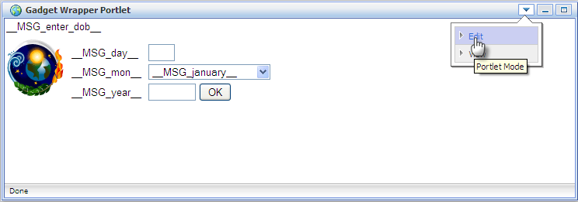
The form to set gadget's url will appear:
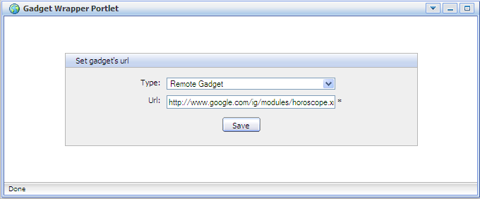
Step 2: Select a gadget type in the Type field and enter a URL (a link refers to an expected gadget url) in the Url field.
Step 3: Click the Save button to accept the entered values. The expected gadget will be viewed in the canvas view mode.

Initial implementation

Requirements

Software

eXo Portal is a Java application. The portal trial version is a free download. However, new functions are usually updated without testing and guaranty in trial versions. In order to purchase a full version with guaranty and tested functions, please contact us at sales@exoplatform.com.
You can get the latest trial version package from this link:
http://forge.objectweb.org/projects/exoplatform. After downloading, you also need to download the following software which supports running eXo Portal:
- Download JDK (Java Development Kit) with version 1.5 or later.
- Application Server: Because the eXo portal is a web application using the client-server model, we need a server browser. You can use the Jboss Application Server, Jonas Application Server or Apache Tomcat.
- Jboss Application Server version 4.2.0 : http://labs.jboss.com/
- Jonas Application Server version 4.8.4: http://wiki.jonas.objectweb.org/
- Apache Tomcat version 6.x http://tomcat.apache.org
- You need a database. By default, HSQL is delivered with eXo Portal so that you do not need to install a database. The eXo Portal can be used with the following databases:
- HSQL (used by default)
- My SQL
- SQL Server
- Oracle
- PostGreSQL
- DB2

Hardware
  - Processor: 2.0 Ghz or higher
  - RAM : at least 512MB

Setup

Establish A Base Structure
- Create a "java" directory which is called $EXO_BASE_DIRECTORY. By default, the $EXO_BASE_DIRECTORY directory will be in your $HOME directory in Linux and in D: drive in Windows.
- Install JDK and maven2 in the java directory.
- Set the environment variable: JAVA_HOME= EXO_BASE_DIRECTORY/JDK.
- Create an “exo-dependencies” and and “exo-working” directories in the “java” directory
- Copy a desired template application server directory to exo-dependencies. The directory name should have the form name of application server -${version}. So the directory name may be (tomcat-$, jboss-$, jonas-$)
- In the end, you need to have the following directory structure:
java/
exo-dependencies/
tomcat-${version}
jboss-${version}
jonas-${version}

exo-working
jdk1.5
maven2

Configure environment
Step 1: Copy$EXO_BASE_DIRECTORY/eXoProjects/tools/trunk/config/maven2/template-settings.xml to your $HOME/.m2/settings.xml and adapt the configuration to your environment. If you do this, the maven2/conf/settings.xml will be ignored. This step is mandatory for window environment.
Step 2: For Linux or Cygwin environment, you can bypass this step as the exoenv.sh script can copy and configure the settings.xml file automatically for you.
Step 3: In Linux or Cygwin environment: Copy $EXO_BASE_DIRECTORY/eXoProjects/ tools/trunk/build/src/main/resources/linux/exoenv.sh to your $HOME or $EXO_BASE_DIRECTORY directory. Backup the old one if you have one.
In Window and DOS Environment: Copy $EXO_BASE_DIRECTORY/eXoProjects/tools/trunk/build/src/main/resources/window/exoenv.bat to your $HOME or EXO_BASE_DIRECTORY directory. Backup the old one if you have one.
Step 4: Update the Configuration: Edit the exoenv.sh or exoenv.bat file to adapt it to your environment. You should only have to change the PORTABLE_DIR variable at the beginning.
Step 5: Run the command to setup the environment: In linux or cygwin: source exoenv.sh
To check if it has worked well, open $EXO_BASE_DIRECTORY/maven2/conf/settings.xml and check that the file corresponds to your environment, especially the definition of the repositories.
On window and dos prompt: exoenv.bat

Run Commands
- Launch Tomcat
In Linux or Cygwin Environment
- Go to $EXO_BASE_DIRECTORY/exo-working/exo-tomcat/bin directory
- Change the rights on .sh files to make them executable: chmod +x *.sh
- Run the command : eXo.sh run
- Launch Jonas
On Command line (Windows)
- Run exoenv.bat in java directory
- Go to $EXO_BASE_DIRECTORY/exo-working/exo-jonas/bin/nt directory
- Run the command exo.bat start -fg
- Launch Jboss
On Cygwin
- Go to $EXO_BASE_DIRECTORY/exo-working/exo-jboss/bin directory
- Run the command: run.sh

Portal Administration

Register A New Account
Unregistered users visiting the portal will be limited in the contents and several applications which are not set as public. Meanwhile, users who want to access in-depth contents or perform some actions in various applications should register by themselves and then contact the portal administrators to gain certain rights or permissions.
The users can register an account quickly as follows:
Step 1: Click Register on the navigation bar.
The Register Page appears:
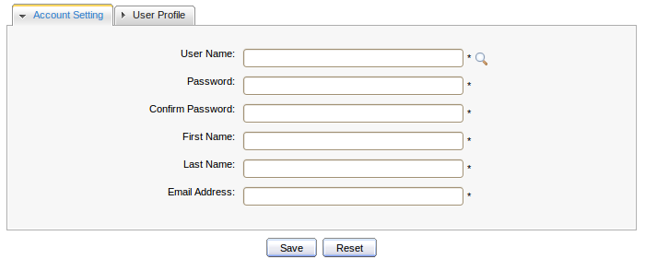
Information in the Account Setting is required, so the user has to input all fields, including:
- User Name: The name used to log in.
- Password: The password used to log in that must be between 6 and 30 characters, including spaces.
- Confirm Password: The retyped password above. Both fields, including Password and Confirm Password must be the same.
- First Name: The user's first name.
- Last Name: The user's last name.
- Email Address: The user's email address which must be in the right format, such as abc@yahoo.com.

Step 2: Fill in the form.
Step 3: Click the Search icon next to the User Name field to see whether the selected user name has been existing or not.
Step 4: Click the Save button to accept or Reset button to refresh all inputed information.

Sign In and Sign out

Sign In
To sign in the Portal, do as follows:
Step 1: Go to your portal by entering the URL into the address bar of your browser. (For example, http://localhost:8080/portal).
Step 2: Click the Sign In link at the top right of the page if you are currently in the Classic portal. The Sign In form appears:

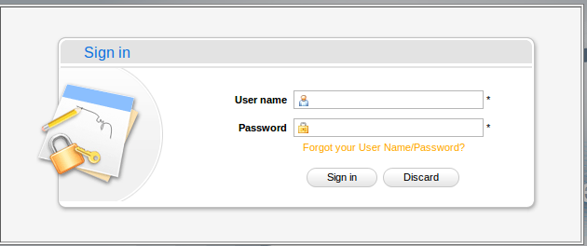
Step 3: Input your registered User name and Password.
Step 4: Click the Sign In button to submit the form or Discard to exist.
If the User name does not exit or User name and/or Password is invalid, an alert message will appear. To attempt to log in again, click the OK button on the alert message to return to the Sign In form. Enter the User name and Password again.
After signing in the form successfully, you will be redirected to the homepage and wellcomed with your full name in the top right corner of the page.

Sign out
This feature ends the authenticated session and returns the user to the anonymous portal. To sign out, just hover your mouse over the Sign Out icon on the top right corner and click that icon.

Change Account Settings
This function allows changing your account information.
Do as follows:
Just click your account name after logging in to open the Account Profiles form:
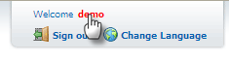
The Account Profiles form will appear:
To change values in the account-related information, do as follows:
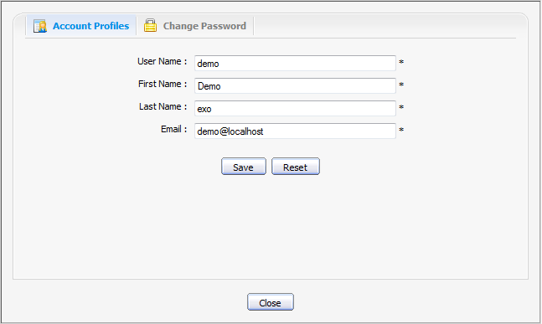Illustration 18: The Account Profiles form
Step 1: Select the Account Profiles tab.
Step 2: Change your First Name, Last Name, Email, except your User Name.
Step 3: Click the Save button to accept any change or the Reset button to refresh values.
To change your password, do as follows:
Step 1: Select the Change Password tab, the following form will be displayed:

Step 2: Enter your current password to identify that you are the owner of this account.
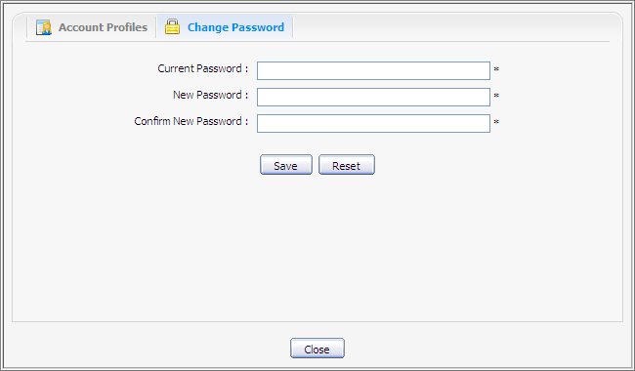Illustration 19: The Change Password tab
Step 3: Enter your new password which must have at least 6 characters.
Step 4: Re-enter your password in the Confirm New Password field.
Step 5: Click the Save button to accept any change or Reset button to refresh all inputed values.

Retrieve User name/Password

In case you forget your account or password, you can recover by following these steps:
Step 1: Click the link "Forget your User Name/Password?" beneath the Password field in the Sign in form.
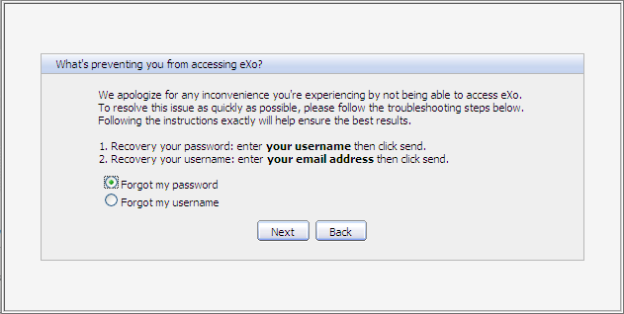
This form offers two options:
- Forget my password
- Forget my username
Step 2: Select the appropriate option.
Step 3: Click Next to go the next step. You will be prompted to provide information, depending on which option you have selected.
- If you selected the 'Forgot my password' option, you will be promoted for your user name:
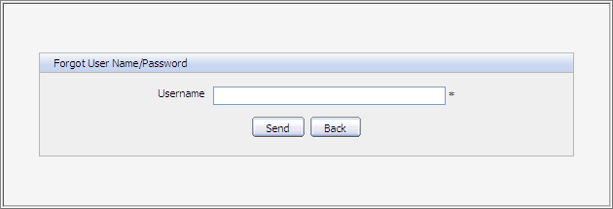
- If you selected the 'Forgot my username' option, you will be promoted for your email address:
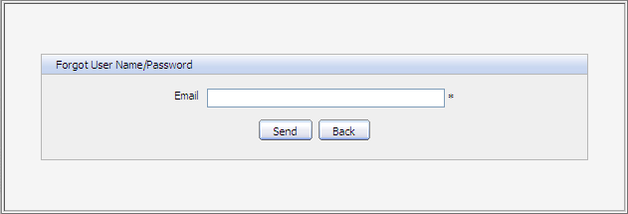
Step 4: Enter your Username or Email in the field of the above form.
Step 5: Click the Send button to submit the entered values.
After you submit the form, an email will be sent to your email address with the requested information.
- If you forgot Username: when retrieving Username, your old Username is still recovered and reused.
- If you forgot Password: a new password (as temporary) will be sent to you, then you will be redirected to change password when you sign in.
The Username/ Password that you received only takes effect for 1 day. It means that if the current date is over 1 day as from the receipt date, you can not use the received Username/ Password. Thus, you have to get another active email.

Set the display language
You can set language for yourself when you register a new account. To choose a preferred language for displaying Portal interface, do as follows:
There are two modes to set displaying language for a user.
- Public Mode: The display language of this mode depends on the language of browser that you are using.
- If you set the browser language not supported by Portal, the display language will be the Portal language.
- If you set the browser language supported by Portal, the display language will be the browser language.
- Private Mode: The display language of this mode belongs to the language of each user which is set when they register.
- When you sign in by a default account (root, john, demo, marry): the display language of these users are none, so it will belong to browser's language. If you change value of the Language field in the User Profile tab (only default user: root and john can change this value by accessing the Management page: Go to Organization-->Management page), your displaying language will be the set value.
- When you sign in by a new registered user: by default, your display language is English. However, if you set by another language in the Language field in the User Profile tab, your display language is the set language.

Change the display language
The priority order of display language is 1. User language 2. Browser language 3. Portal language. Thus, to display your preferred language, you should pay attention to this order to change language type appropriately.
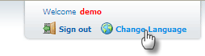
Step 1: Click Change Language on the right corner to open the Interface Language Setting form:The Interface Language Setting form will appear:

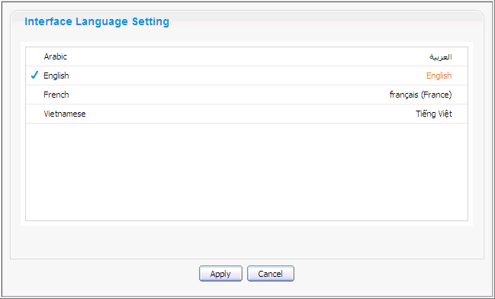
Step 2: Select another language in the list. The selected language will be marked by the icon .
Step 3: Click the Apply button to change the displaying language temporary and wait for few seconds to take affect or click Cancel button to quit without any change.

Add a gadget in Dashboard
Access the Dashboard page by clicking the Dashboard page on the Navigation bar:
Step 1: Click the Add Gadgets link in this page to open the Dashboard workspace at the left pane:
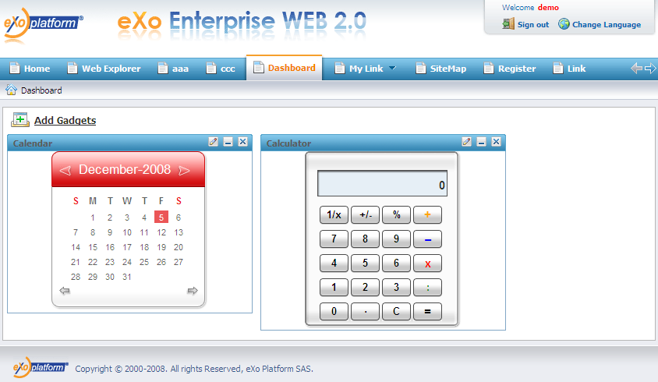Illustration 20: The Dashboard page
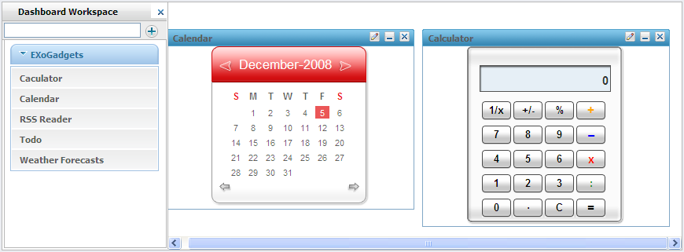
Step 2: Enter a link (remote or local) to a .xml file in this text box at the left pane.
Step 3: Click the icon to add a new gadget into the gadget list under.
Note:
In the public mode, a normal user only may view gadgets without adding a new gadget or dragging and dropping them into the space at the right pane.

