
GateIn
version 3.1

REVISION HISTORY
Version | Date | Author | Reviewer | Change description
2.2.1 | August 25, 2008 | Hoang Anh Quynh Nga | Nguyen Thanh Cong
2.5 | December 05, 2008 | Hoang Anh Quynh Nga |  | - Add: 4.2 & 4.3  - Add: 4.5 & 4.6  - Update: Structure of the document.
2.5.1 | December 11, 2008 | Nguyen Thi An  Hoang Anh Quynh Nga | Hoang Anh Quynh Nga | - Add: 2.1.1.5  - Add 2.1.2.11
2.5.3 | March 27, 2009 | Hoang Anh Quynh Nga |  | - Update illustrations
2.5.4 | July 23, 2009 |  | Luong Quynh Lien | - Review all and check typos, sentences.
2.5.6 | Oct 06, 2009 | Nguyen Thanh Cong |  | - Check for small error typo  - Check for small UI changes
3.0 | Oct 07, 2009 | Nguyen Thanh Cong |  | - Update Portal 3.0 in form of GateIn Beta2  - Change major UI and description.
3.0 | Oct 26, 2009 | Nguyen Thanh Cong |  | Update changes (UI for some portlets, add description for more portlets, add gadgets function)
3.0 | March 10, 2010  March 31, 2010  May 13, 2010 |  | Luong Quynh Lien  Tran Thi Tra Giang  Vu Thi Hoa | Review and improve the guide.  Reconstruct, repair, supplement some parts.  Fix the table of content

CONTENTS
1 Preface 9
1.1 Overview 9
1.2 Purposes of the Guide 9
1.3 References 10
Information 10
Support 10
2 Glossary 11
2.1 Portal 11
2.2 Portlet 11
2.3 Toolbar 11
2.4 Navigation 11
2.4.1 Portal's Navigation 12
2.4.2 Group's Navigation 12
2.4.3 User's Navigation 13
2.5 Gadget 13
2.6 Access Mode 13
2.7 Preview Mode 14
2.8 Layout mode 14
2.9 Permission 14
2.9.1 Permission types 14
2.9.2 Permission levels 15
3 PORTLET 16
3.1 Functional Portlet 16
3.1.1 Register Portlet 16
3.1.2 Account Portlet 16
3.1.3 Organization Portlet 17
3.1.4 Application Registry Portlet 18
3.1.5 Group Navigation Portlet 18
3.1.6 Page Management Portlet 19
3.1.7 Portal Navigation Portlet 20
3.1.8 Star Toolbar Portlet 20
3.1.9 Tabbed Dashboard 20
3.1.10 User Info Portlet 21
3.1.11 User Toolbar Dashboard Portlet 21
3.1.12 User Toolbar Group Portlet 21
3.1.13 User Toolbar Site Portlet 21
3.2 Interface Portlet 21
3.2.1 Banner Portlet 22
3.2.2 Breadcrumbs Portlet 22
3.2.3 Footer Portlet 22
3.2.4 HomePage Portlet 22
3.2.5 IFrame Portlet 23
3.2.6 Navigation Portlet 24
3.2.7 SiteMap Portlet 24
3.2.8 Web Browser Portlet 25
3.2.9 Dashboard Portlet 25
3.2.10 Gadget Wrapper Portlet 26
3.3 Dashboard Portlet 26
3.3.1 Use the Dashboard Workspace 27
3.3.2 Add More Gadgets 28
4 Initial implementation 30
4.1 Requirements 30
4.1.1 Software 30
4.1.2 Hardware 30
4.2 Setup 31
4.2.1 Establish A Base Structure 31
4.2.2 Configure an environment 31
4.2.3 Run Commands 32
5 account 34
5.1 Register A New Account 34
5.2 Sign In and Sign out 36
5.2.1 Sign In 36
5.2.2 Sign out 39
5.3 Remember User Account 39
5.4 Change Account Settings 39
5.5 Retrieve Account & Password 41
5.6 Language Administration 44
5.6.1 Change the display language permanently 44
5.6.2 Change the display language for another user 46
5.7 Sitemap management 48

Illustration Index
Illustration 1: Register Portlet 20
Illustration 2: Account Portlet 21
Illustration 3: The Organization Portlet interface 21
Illustration 4: The Application Registry Portlet 22
Illustration 5: Group Navigation Portlet 23
Illustration 6: Page Management Portlet 23
Illustration 7: Administration Toolbar Portlet 24
Illustration 8: Portal Navigation Portlet 24
Illustration 9: Star Toolbar Portlet 24
Illustration 10: Tabbed Dashboard Portlet 24
Illustration 11: The User Info Portlet Interface 25
Illustration 12: The User Toolbar Dashboard Portlet Interface 25
Illustration 13: The User Toolbar Group Portlet Interface 25
Illustration 14: The Banner Portlet interface 26
Illustration 15: The Breadcrumbs Portlet interface 26
Illustration 16: The Footer Portlet interface 26
Illustration 17: The HomePage Portlet interface 27
Illustration 18: The IFrame Portlet interface 27
Illustration 19: The Navigation Portlet interface 28
Illustration 20: The SiteMap Portlet interface 29
Illustration 21: The Browser Portlet interface 29
Illustration 22: The Dashboard portlet interface 30
Illustration 23: Gadget Wrapper Portlet 30
Illustration 24: More gadgets on Google 32
Illustration 25: The Register New Account form 39
Illustration 26: Edit Mode of Register Portlet 41
Illustration 27: The main screen of GateIn Portal 43
Illustration 28: The Sign in form 43
Illustration 29: The Account Profiles Dialog 46
Illustration 30: The Change Password tab 47
Illustration 31: The Portal Setting tab 51
Illustration 32: The Properties tab 52
Illustration 33: The Portal Setting tab of the portal properties form 56
Illustration 34: Portal Navigation 57
Illustration 35: The Access Permissions form 58
Illustration 36: The Portlet Setting tab 59
Illustration 37: The Portlet Icon tab 61
Illustration 38: The Decoration Themes tab 62
Illustration 39: The Access Permisson Tab 62
Illustration 40: The Edit Mode tab of the IFrame Portlet 63
Illustration 41: The Edit Mode of the Dashboard Portlet 64
Illustration 42: Portal Navigation 65
Illustration 43: The Page Node Setting tab of the Add/Edit Page Node form 70
Illustration 44: The Page Selector tab of the Add Page Node form 71
Illustration 45: The Select Page form 72
Illustration 46: Page Creation Wizard: Select a Navigation Node and create the Page 77
Illustration 47: Page Creation Wizard: Step 2- Setting a Page Layout Template 78
Illustration 48: The Page Configurations type 79
Illustration 49: Re-arrange Page Layout and add portlets into the page 80
Illustration 50: The Manage pages form 81
Illustration 51: The Page Layout tab of the Add New Page form 83
Illustration 52: The Page Setting tab of the Portal Properties form 86
Illustration 53: The Access Permission Setting form of the Permission Setting tab 87
Illustration 54: The Edit Permission form 88
Illustration 55: The Organization form 94
Illustration 56: The Account Info tab of the Edit User Info form 95
Illustration 57: The User Profile tab of the Edit User Info form 96
Illustration 58: The User Membership tab of the Edit User Info form 96
Illustration 59: The Group Management form 97
Illustration 60: The Add New Group form 98
Illustration 61: The Edit Current Group form 99
Illustration 62: The Add member form 100
Illustration 63: The Select User form 101
Illustration 64: The Edit Membership form 102
Illustration 65: The Membership Management form 103
Illustration 66: The Group Navigation page 105
Illustration 67: The Edit Navigation form 108
Illustration 68: The Interface Language Setting form 116
Illustration 69: The Dashboard main screen 123

Preface

Overview
Beginning as an open source project in the year 2002, eXo is well-known as the industry's first Java portlet container. With the aim of dominating the potential portal market through robust and easy-to-use applications, eXo Project succeeded in attracting consumers in the whole world. eXo actually opened the floodgates to various options in many markets, and customers have been choosing eXo as the best method for their success.
The eXo Project grew into a company in 2003, as a response to customer demands. We can do this because we release our code in the open environment. It's how the DoD found us, when we were just university students hacking away, and it's how we choose to do business with our customers.
Today, eXo is a rapidly growing global company, with U.S. headquarters in San Francisco, California, global headquarters in France, and offices in Tunisia, Ukraine, and Vietnam. The Corporate has established technology leadership and proven values by their large European installed base and strategic partnerships with Red Hat, Capgemini, Atos Origin, and Bull.
GateIn is the perfect merge between Red Hat and eXo Platform in creating a new generation of Open Source portal which is actually robust and intuitive. With GateIn, both normal users and enterprises can enjoy many personalization and collaboration applications wherever and whenever. Advantages generated in GateIn, including interactive user interface, customizable look and feel, flexible internationalization and localization, facilitate the birth of many useful applications with a variety of rich utilities in the world market.

Purposes of the Guide
The book was written as a handbook, aiming at instructing step-by-step on how to use and to implement this application to the utmost. Thus, the information included herein will give basic steps that makes it easy for users to follow through in-depth examples and clear explanations regarding to the eXo Platform technology. Whether you major in technology or not, you are able to learn about or to work on GateIn 3.1 easily and efficiently.
The information provided in the guide is arranged into such a way that ensures readers to search and implement quickly and easily. With the aim of helping users better understand about GateIn 3.1, we hope that readers can know more and master almost key strengths when using the GateIn 3.1.
In general, the book provides basic instructions for users. This user guide will focus on the followings:
- Define the basic concepts in GateIn 3.1
- Provide basic instructions to use GateIn 3.1.

References
- GateIn Administrator Guide v3.1
Info & Support

Information
- eXo Platform Home Page: http://www.exoplatform.com/portal/public/website/
- eXo Platform Wiki: http://wiki.exoplatform.com/xwiki/bin/view/Main/

Support
- Forums: http://forums.exoplatform.org
- FAQ: http://faq.exoplatform.org

Glossary

Portal
A portal can be defined as a key environment for making and implementing many applications and contents. In other words, the portal is a web-based application providing means to gather and personalize information via specific portlets with an interactive and consistent look and feel. Users and administrators are able to integrate information, people and processes via a web-based user interface. The framework is to facilitate contents and applications aggregation with the flexible management and personalization options.

Portlet
A portlet is a pluggable component in a portal through which users can access some specific information, including supports, updates, or mini-applications, etc). The portlet produces fragments of a markup code that are aggregated into a portal page. Typically, a portal page is displayed as a non-overlapping portlet windows collection, where each portlet window displays a portlet. The contents generated by a portlet can vary from one user to another, depending on the configuration set by each user.
Portlets can be divided into two following types:
- Functional Portlet
- Interface Portlet

Toolbar
The Toolbar is a set of icons or buttons that is considered as a part of interface. It spans the top of the portal application and provides links to users and administrative actions.

Navigation
Navigation is composed of a nodes set (menus) that helps users visualize the site structure and provides hyperlinks to move from one page to another quickly. Each node contains an internal name and a label which is shown on the menu. For any node, you can define either sub-nodes. The horizontal menu at the top of page is called a navigation bar. The GateIn's navigation is established based on three levels: portal level, group level and user level. On each level, any node can be defined. The navigation structure of one particular user is made up of portal navigation nodes (that are valid to all users), the nodes of all groups the user belongs to and his individual nodes. The users' and groups' nodes are valid for all portals that are defined on the same eXo Portal server.

Portal's Navigation
This navigation type links to separate sites/portals of the parent portal. Each portal/site has only one navigation and it is automatically generated when a portal/site is created. Only users who have the edit permission on a portal can add nodes on this navigation level.
The portal's navigation name looks like: portal:[portal name]'s nav
Let's suppose that the portal's navigation name is: “portal:classic's nav”:
- 'portal' is the navigation level, it means that navigation nodes are defined for all users of a portal.
- 'classic' is the portal name.
- 'nav' stands for 'navigation'.

Group's Navigation
All registered users are organized into groups. The group's navigation links to all pages of each group, called a group navigation. The content of this navigation differs, depending on the logged-in account type. The group's navigation is created manually by users who have the highest right in a group. Before adding nodes or creating pages for a group, you must create the group navigation. Also, there are nodes that are only applied to those members who have certain memberships.
The group's navigation name looks like: group:[group name]'s nav.
Let's suppose that the group's navigation name is: group:platform/administrators's nav:
- 'group' is a navigation type, it means that the nodes are defined for a group.
- 'platform/administrators' is the group's path. It means that navigation nodes are defined for the 'administrators' - the group that is a sub-group of 'platform' group.
- 'nav' stands for 'navigation'.

User's Navigation
Each user has its own navigation that contains links and portlets (or gadgets) selected by the user. A user's navigation is created or deleted automatically when the user is registered or deleted respectively. By default, the user navigation is empty.
The user's navigation name has format: user:[user name]'s nav
Let's suppose that the user's navigation name is: user:john's nav
- 'user' is a navigation level that navigation nodes are defined for one individual user.
- 'john' is the name of user.
- 'nav' stands for 'navigation'.

Gadget
A gadget is a mini web application running on a platform that a user can integrate and customize in the website.
To further see default gadgets in GateIn 3.1, please refer to the section "Using the Dashboard Workspace".

Access Mode
GateIn has offered two modes by default:
- Public mode: This mode is for guest users (visitors) who have not registered yet. This mode is not required to sign in, so they can only visit the public pages in a portal. Visitors can also register to get an account. After registering, they can use the private mode and have to contact their administrators to get more rights or the group manager if they want to become a member of that group.
- Private mode: This mode is for registered users who will apply their usernames and passwords to sign in. This mode supports users in taking many actions such as: managing private resources (create private pages, edit or delete them), "borrowing" pages from others by creating hyperlinks, changing the language for individual needs, managing private information.

Preview Mode
In the preview mode, you can only view, not edit.
You can see this mode when you click the Preview Page icon at step 3 of creating and/or editing a page by wizard.

Layout mode
In the layout mode, you are provided with some layout templates of portal or the page and you can use these templates to edit a portal or a page.

Permission
Permission is one of the most important factors on a portal. Permission settings control what users can or can not do within the portal and set by the portal administrators.

Permission types
Permission types define what a user can do within the portal. There are two available types as follows:
Access Permission: allows users to utilize portal contents (signing in, viewing contents, rearranging portlets, etc). This permission can be set for multiple member groups.
Edit Permission: allows users to change portal contents (changing portal or page information, deleting a portal/page). The edit permission is set for only one group at a time.
By default, root is set as the super user or the administrator of GateIn; he can do everything while the others must get the appropriate rights (permissions) at first.
Rights in GateIn are not assigned to a single user but to a users group with specific membership types.
Similarly, the permission structure is always established as follows: [membership type]:/[group path]
For example: manager:/platform/administrators. It means the right is set for users who are “manager” of the group “administrators”. “Platform” is the parent group of “administrators”.
Seemingly, groups are managed in accordance with a hierarchy structure; but in fact, a sub-group does not have any inheritance from the parent group.
For example: we have a group structure as follows:
+ platform
- administrators
- guest
- user
If users in the group “platform” can perform a function A, it does not mean that users in “administrator” or “guest” groups can do function A. The roles of users in groups are independent.

Permission levels
Permission levels specify where the users's permission types can be applied into the portal. GateIn offers three permission levels as follows:

Portal: The portal permission level includes permissions performed on all pages within the portal. So, a user with the access permission can view (but not edit) all the pages within the portal. A user with the edit permission at the portal level can change any page in the portal.

Page: The page permission level restricts the users to several particular pages. Users are only able to see and/or edit pages they have been given access, depending on each permission type assigned to them.

Portlet: The portlet permission level allows users to create a page through dragging and dropping portlets into a page. Some portlets are only used for administrators while some are for individuals; thus, administrators need to set proper access permissions for each specific group.
Permission types and levels can be effectively implemented to control who can do and what can be performed within the portal.

PORTLET

Functional Portlet
Functional Portlets support all functions of a portal. They are built into the portal and accessed via toolbar links when the portal-related tasks are performed.

Register Portlet
This portlet is used to register a new account, including fields: User Name, Password, Confirm Password, First Name, Last Name, Email Address, and Text validation.
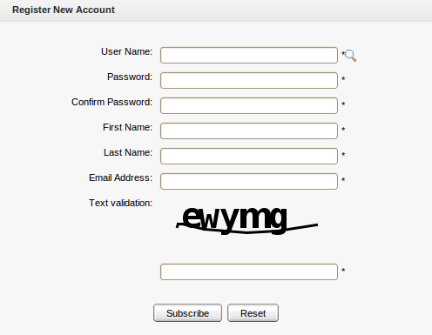Illustration 1: Register Portlet

Account Portlet
This portlet allows users to add a new account and choose their preferred languages for displaying the portal interface.
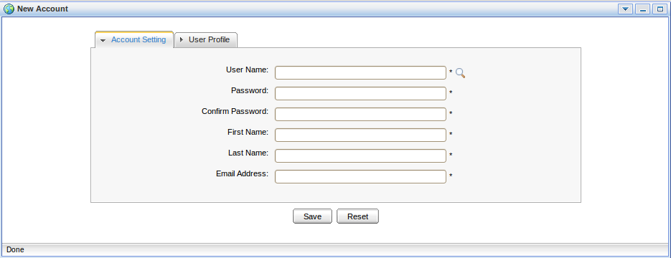Illustration 2: Account Portlet

Organization Portlet
This portlet is used to manage user information, users groups and memberships. The form of this portlet is shown like:
- User Management: This tab allows users to edit, delete, search and view existing users.
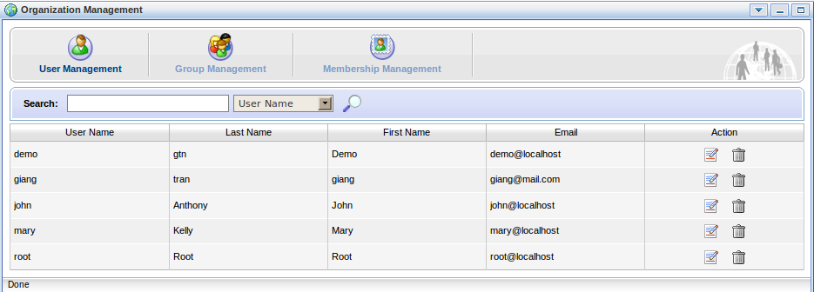Illustration 3: The Organization Portlet interface
- Group Management: This tab allows users to view, add new, edit and delete a users group.
- Membership Management: This tab is used to add, edit and delete memberships.

Application Registry Portlet
This portlet is used to manage different application categories. You can add, edit, set permissions, or delete categories and applications. The portlet form is shown as below:
This portlet includes the following functions:
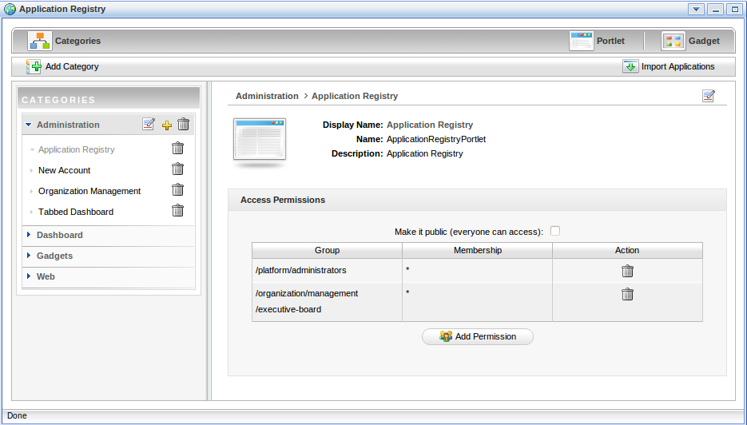Illustration 4: The Application Registry Portlet
- Organize portlets/gadgets into different categories such as: creating a new category, importing default porlet categories, adding a portlet/gadget into a specific category, adding permission to a portlets category, etc.
- List portlets and view detailed information regarding to a specific portlet.
- Manage gadgets that includes: adding a remote gadget, creating a new gadget or deleting a gadget from the list.

Group Navigation Portlet
The Group Navigation Portlet is used to manage the navigation of different groups. In this portlet, it is possible to add, edit and delete a specific navigation.

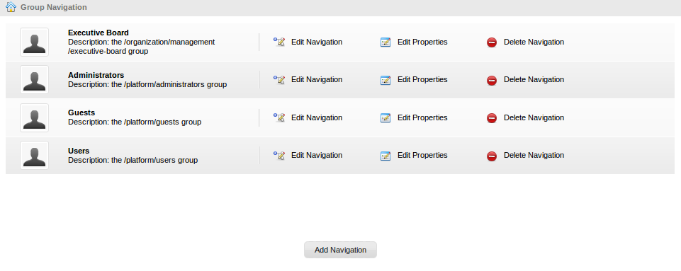Illustration 5: Group Navigation Portlet

Page Management Portlet
The Page Management Portlet is used to manage all pages on the portal. In the Page Management Portlet, it is possible to add, edit and delete a specific page.
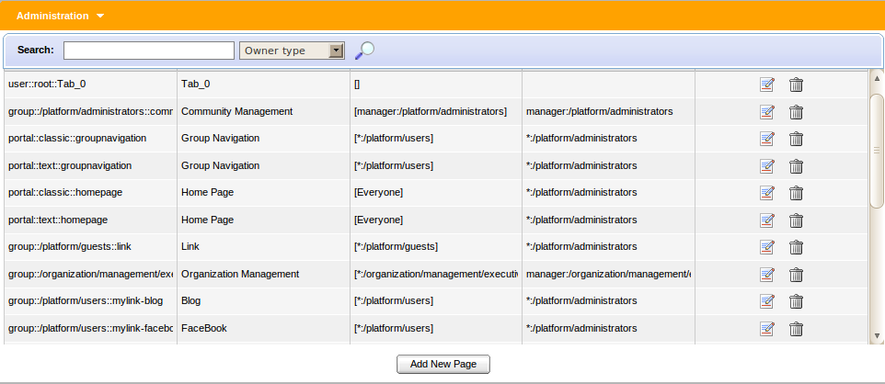Illustration 6: Page Management Portlet
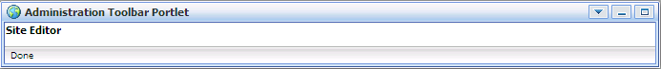Illustration 7: Administration Toolbar Portlet

Portal Navigation Portlet
The portlet is used to manage all portals in the GateIn. In the Portal Navigation portlet, you can add, edit and delete a portal.
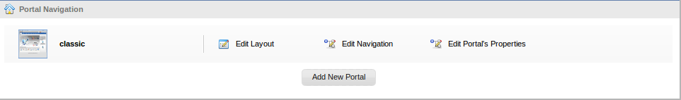Illustration 8: Portal Navigation Portlet

Star Toolbar Portlet
The portlet is used to display a menu that contains a list of actions such as Change Language, Change Skin, Sign Out.
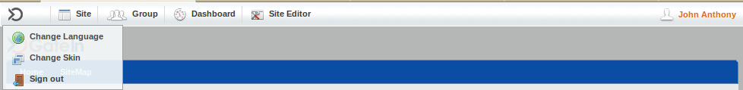Illustration 9: Star Toolbar Portlet

Tabbed Dashboard
The portlet is used to display Dashboard tabs that you can add gadgets inside by dragging and dropping them.
Illustration 10: Tabbed Dashboard Portlet

User Info Portlet
The portlet displays personal information of a specific user that can be viewed and edited.
Illustration 11: The User Info Portlet Interface

User Toolbar Dashboard Portlet
The portlet is used to display the main dashboard menu that you can go inside to create dashboard tabs, add and remove gadgets for each tab.
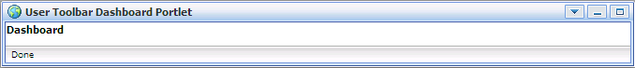Illustration 12: The User Toolbar Dashboard Portlet Interface

User Toolbar Group Portlet
The portlet is used to display the main group menu that you can go inside to create, edit and delete a specific group and the navigation for each group.

User Toolbar Site Portlet
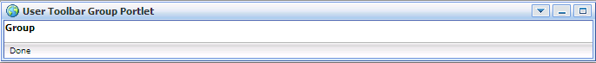Illustration 13: The User Toolbar Group Portlet Interface
The portlet is used to display the site menu that you can go inside to manage all portals.

Interface Portlet

Interface Portlets constitute the interface of the GateIn that are the front-end components of the portal. They provide users with ways to interact with the portal. GateIn 3.1 provides the following Interface Portlets:

Banner Portlet
The portlet is considered as the welcome gateway of a portal. It contains the organization's slogan, logo and icon:
Illustration 14: The Banner Portlet interface

Breadcrumbs Portlet
The portlet displays the navigation path of the selected page:
Illustration 15: The Breadcrumbs Portlet interface

Footer Portlet
The portlet provides a footer for a site. This footer can be text, images that are displayed at the website bottom. It provides information about author/institutional sponsor, revision date, copyright, comments form, and navigational links.
Illustration 16: The Footer Portlet interface

HomePage Portlet
This is the GateIn homepage. The homepage is a main page (default page) which is the first page displayed when you visit the portal.
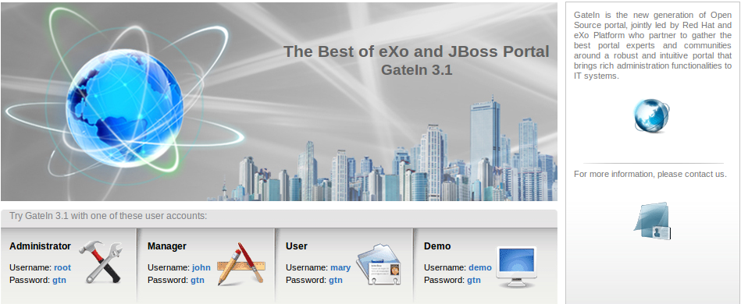Illustration 17: The HomePage Portlet interface

IFrame Portlet
The portlet is used to create IFrame elements for a site. The IFrame is an HTML element which can embed a different HTML document into a HTML document. So, the embedded document is displayed inside a sub-window of the browser window. This does not mean the full inclusion, the embedded document is independent and both documents are considered as separated documents.
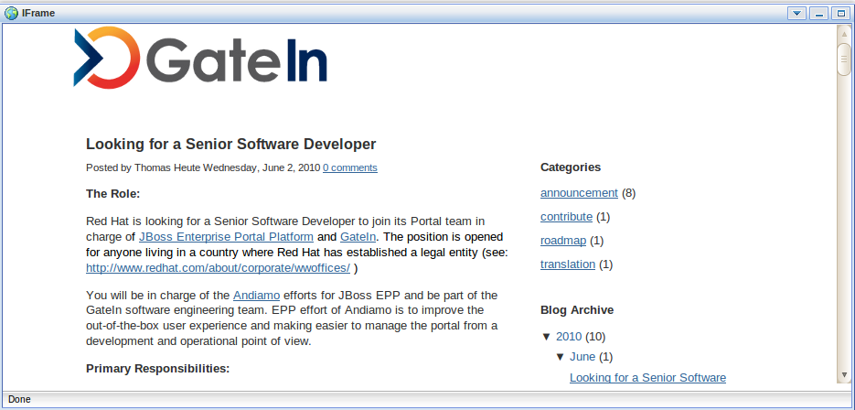Illustration 18: The IFrame Portlet interface

Navigation Portlet
The portlet provides a navigation bar. A navigation bar is a menu that helps users visualize the site structure and provide links to move from one page to another quickly:
Note:
Illustration 19: The Navigation Portlet interface
When you create a new page that contains this portlet:
In the Preview mode: the portlet will be viewed as a normal page like above.
In the Save mode: the Navigation portlet will not be displayed normally when you open the page containing this portlet because only the portal's navigation can be shown like below. It means that two navigations can not be shown at the same time.

SiteMap Portlet
The portlet displays a sitemap page of a website. It is a graphical representation of a website. It lists pages on a website, which is typically organized in the hierarchical architecture to help visitors find pages on the site easily.
There are two options:
Collapse All: The sitemap will be displayed with the parent path only.
Expand All: The sitemap will be displayed with the parent paths and all their children paths.

Web Browser Portlet
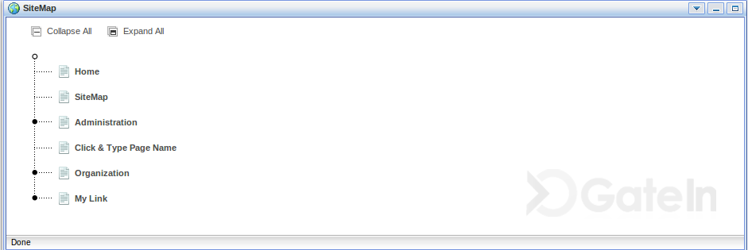Illustration 20: The SiteMap Portlet interface
The portlet provides a web-browser-like application for users. It allows users to connect to other sites over Internet.
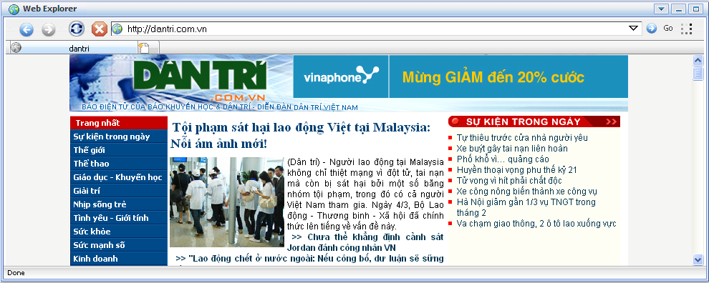Illustration 21: The Browser Portlet interface

Dashboard Portlet
The portlet is used for hosting mini-applications known as gadgets. The dashboard uses a variety of graphical effects for displaying, opening, and using gadgets. Gadgets can be moved around, rearranged, deleted and recreated in the dashboard. More than one instance of the same gadgets can be opened at the same time, possibly with different settings.
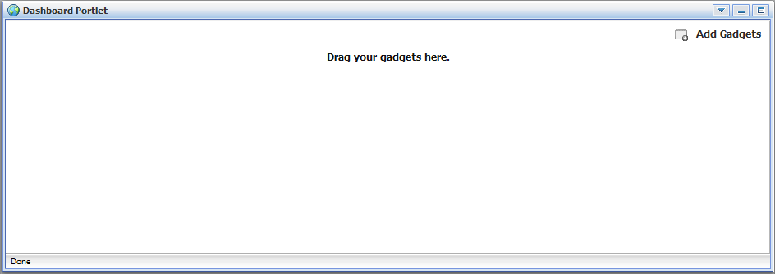Illustration 22: The Dashboard portlet interface

Gadget Wrapper Portlet
This portlet allows users to view a gadget in the canvas mode.
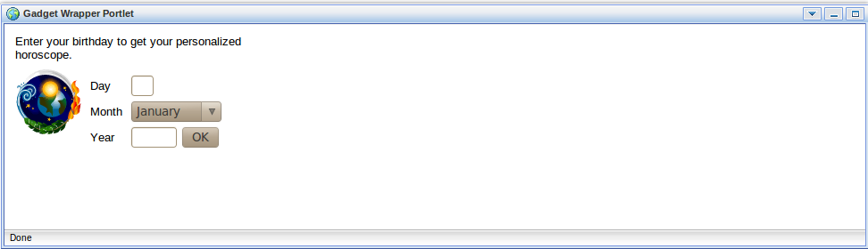Illustration 23: Gadget Wrapper Portlet

Dashboard Portlet
The dashboard portlet is to host mini-applications known as gadgets. The dashboard uses a variety of graphical effects for displaying, opening and using gadgets.
Gadgets within the Dashboard portlet may be moved, or rearranged. Users can create new gadgets and delete unnecessary ones. Also, users can open many gadgets with different settings at one time.

Use the Dashboard Workspace
To use the Dashboard Workspace, do as follows:
Step 1: Click Dashboard on the toolbar.
Step 2: Click Add Gadgets to open the Dashboard Workspace.
The Dashboard Workspace lists all available gadgets. Four default gadgets are provided
in GateIn 3.1; but you can add more.
The followings are default gadgets:
Calendar: A cool calendar keeps track of date in style. You also can switch between daily, monthly and yearly views and change the skins as you like easily.
Todo: This mini-application helps you organize your day and work group. It is designed to keep track of your tasks in a convenient way. You can highlight tasks with different colors.
Calculator: This is the coolest calculator for your page. This mini-application lets you perform most basic arithmetic operations and can be themed to match with your portal.
RSS Reader: This gadget lets you get a sneak preview of your favorite feeds in one location. This content includes, but not limit to, news, posts, emails, all in one gadget. This gadget is a web–based one for receiving and viewing RSS feeds.
Step 3: Select a gadget in the Dashboard Workspace.
Step 4: Drag and drop the selected gadget into the Workspace.
In addition, many more gadgets can be found at Google Gadget: http://www.google.com/ig/directory?synd=open. GateIn 3.1 is compatible with most gadgets available here.

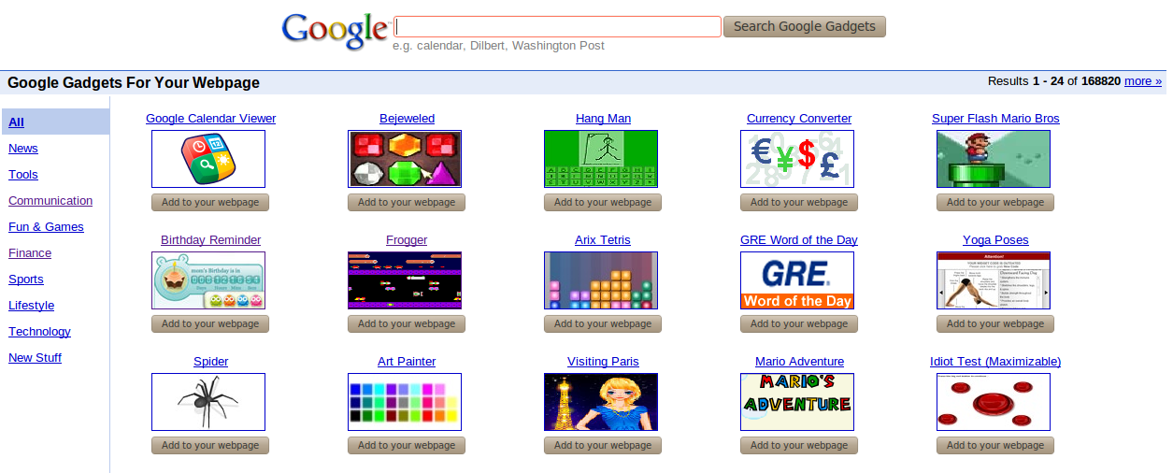Illustration 24: More gadgets on Google

Add More Gadgets
To add more gadgets from external sources, do as follows:
Step 1: Open the URL (.xml or .rss) of your desired gadget.
For example, http://bejeweledg.googlecode.com/svn/trunk/bejeweled.xml.
Step 2: Return to your portal, and click Dashboard on the administration toolbar.
Step 3: Click Add Gadgets in the Dashboard to open the Dashboard Workspace.
The Dashboard Workspace will appear:
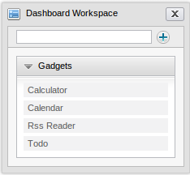
Step 4: Paste the URL achieved in step 1 into the text box next to the icon.

Step 5: Click the plus icon to add the new gadget to the page.
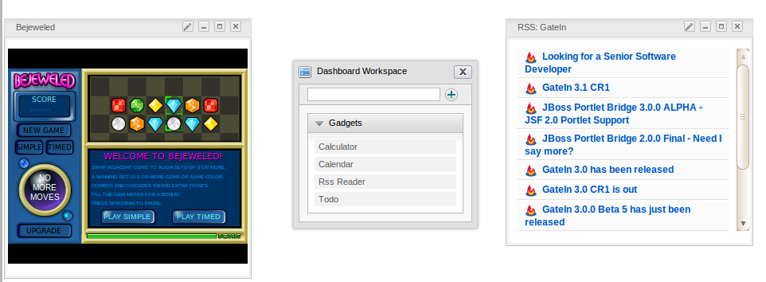

Initial implementation

Requirements

Software
GateIn is a Java application. The GateIn trial version is free download. However, new functions are usually updated without test and guaranty in trial versions. In order to purchase a full version with guaranty and tested functions, please contact us at sales@exoplatform.com.
You can get the latest trial version package from this link:
http://forge.objectweb.org/projects/exoplatform. After downloading, you also need to download the following software which supports running GateIn:
- Download JDK (Java Development Kit) with version 1.5 or later.
- Application Server: GateIn is a web application using the client–server model. So we need a server browser. You can use Jboss Application Server, Jonas Application Server or Apache Tomcat.
- Jboss Application Server version 4.2.0 : http://labs.jboss.com/
- Jonas Application Server version 4.8.4: http://wiki.jonas.objectweb.org/
- Apache Tomcat version 6.x http://tomcat.apache.org
- A database is required. By default, HSQL is delivered with GateIn so that you do not need to install a database. GateIn can be used with the following databases:
- HSQL (used by default)
- My SQL
- SQL Server
- Oracle
- PostGreSQL
- DB2

Hardware
Processor: 2.0 Ghz or higher
RAM : at least 512MB

Setup

Establish A Base Structure
To establish a base structure, do as follows:
Step 1: Create a "java" directory which is called $EXO_BASE_DIRECTORY. By default, the $EXO_BASE_DIRECTORY directory will be in your $HOME directory in Linux and in D: drive in Windows.
Step 2: Install JDK and maven2 in the java directory.
Step 3: Set environment variable: JAVA_HOME= EXO_BASE_DIRECTORY/JDK.
Step 4: Create an “exo-dependencies” and “exo-working” directories in the “java” directory.
Step 5: Copy a desired template application server directory to exo-dependencies. The directory name should have the form name of application server -${version}. So the name of the directory may be (tomcat-$, jboss-$, jonas-$).
By the end, you have to have the following directory structure:
java/
exo-dependencies/
tomcat-${version}
jboss-${version}
jonas-${version}

exo-working
jdk1.5
maven2

Configure an environment

To configure a suitable environment for GateIn implementation, do as follows:
Step 1: Copy $EXO_BASE_DIRECTORY/eXoProjects/tools/trunk/config/maven2/template-settings.xml to your $HOME/.m2/settings.xml and adapt the configuration to your environment. If you do this, the maven2/conf/settings.xml will be ignored. This step is mandatory for window environment.
Step 2: For Linux or Cygwin environment, you can bypass this step as the exoenv.sh script can copy and configure the settings.xml file automatically for you;
Step 3: In Linux or Cygwin environment:
- Copy $EXO_BASE_DIRECTORY/eXoProjects/tools/trunk/build/src/main/resources/linux/exoenv.sh to your $HOME or $EXO_BASE_DIRECTORY directory.
- Backup the old one if you have one.
In Window and DOS Environment:
- Copy $EXO_BASE_DIRECTORY/eXoProjects/tools/trunk/build/src/main/resources/window/exoenv.bat to your $HOME or EXO_BASE_DIRECTORY directory.
- Backup the old one if you have one.
Step 4: Update the Configuration: Edit exoenv.sh or exoenv.bat file to adapt it to your environment. You should only have to change the PORTABLE_DIR variable at the beginning.
Step 5: Run the command to setup the environment: In linux or cygwin: source exoenv.sh.
To check that it has worked well, open $EXO_BASE_DIRECTORY/maven2/conf/settings.xml and check that the file corresponds to your environment, especially the definition of the repositories.
On window and dos prompt: exoenv.bat

Run Commands
- Launch Tomcat
In Linux or Cygwin Environment
- Go to $EXO_BASE_DIRECTORY/exo-working/exo-tomcat/bin directory
- Change the rights on .sh files to make them executable : chmod +x *.sh
- Run the command : gatein-dev.sh run or gatein.sh run
- Launch Jonas
On Command line (Windows)
- Run exoenv.bat in java directory
- Go to $EXO_BASE_DIRECTORY/exo-working/exo-jonas/bin/nt directory
- Run the command exo.bat start -fg
- Launch Jboss
On Cygwin
- Go to $EXO_BASE_DIRECTORY/exo-working/exo-jboss/bin directory
- Run the command: run.sh

account

Register A New Account

Unregistered users visiting the portal will be limited to several contents and applications which are not set as public. Meanwhile, users who want to access in-depth contents or perform some actions in various applications, they should register by themselves and then contact the portal administrators to gain certain rights or permissions. To register a new account, do as follows:
Step 1: Click Register on the upper right corner of the GateIn homepage. The Register New Account form will appear.
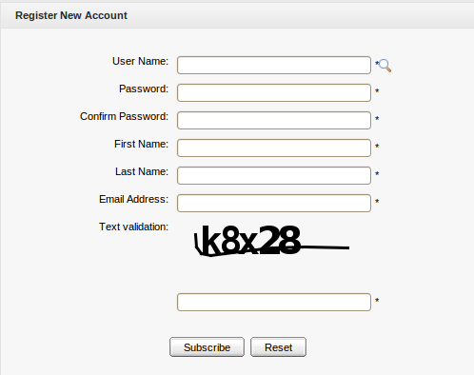Illustration 25: The Register New Account form
Details:
User Name: The user's login name that must be unique with at least 3 characters.
Password: The password used to login that must have at least 6 characters.
Confirm Password: The re-typed password. The Password and Confirm Password must be the same.
First Name: The user's first name which must start with a character.
Last Name: The user's last name which must start with a character.
Email Address: The user's email which must be in the right format, for example: username@abc.com.
Text validation: The text which is required to enter to validate the registration.
These are required fields, the User Name must contain only alpha, digit and underscore characters and must be unique.
Step 2: Enter values for fields in this form.
Step 3: Click the Subscribe button to accept adding a new account or the Reset button to clear the entered values. After you click the Subscribe button, there will be a message which informs that you have registered your account successfully.
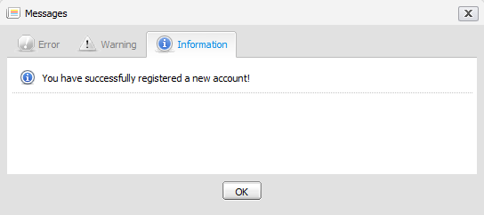
Step 4: Click OK to finish creating your account.
There will be an alert message which informs that you can not add a new account if one of these cases occurs:
- User name is existing or User Name is invalid.
- Password has less than 6 characters.
- Password and Confirm Password are not the same.
- Email Address is in a invalid format.
- Required fields are blank (empty).
- Text verification isn't correct.
After adding a new account, contact with administrator to get rights or only be a visitor.
Note:
1. The magnifying glass icon is used to search whether the entered User Name exists or not. Once a user has registered by himself or the administrator has created a new account, the new user will become a part of the group "/platform/users" with membership by default.
2. The text validation can appear or not, depending on the customization of portal's administrator.

Sign In and Sign out

Sign In
By default, GateIn initializes some users with specific rights.

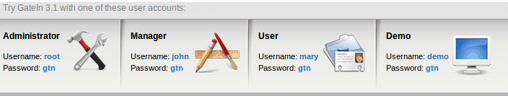
Details:
- Being an administrator, root has the highest right in any portal. Root controls all resources such as: users, groups, memberships, pages, navigations, portlets. Root can do anything in a portal except the private resources of another users.
- Being a manager, john can take some actions that are supported only for a manager.
- Being a visitor, marry is like a freedom user, so she can only visit and read news.
GateIn may be accessed by using a browser with a regular connection (HTTP). If you are using a default bundle installation in your local computer, you can access it through the URL and by default, the address: http://localhost:8080/portal/ runs into a portal named “classic”. Otherwise, you will have to contact your administrator to ask for the initial URL.
With GateIn 3.1, users can sign in the portal via 2 ways:
The 1st way:
Step 1: Click the Sign in link at the page's top right. The Sign in form appears:
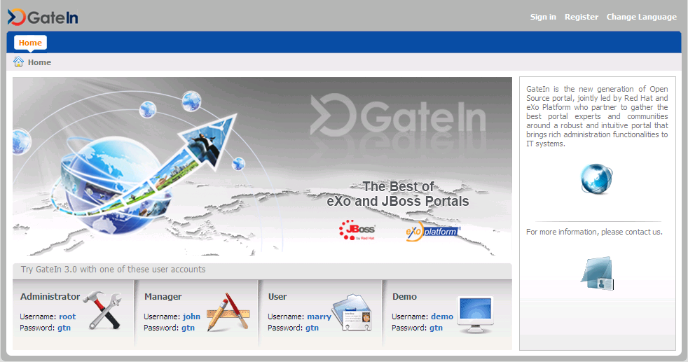Illustration 26: The main screen of GateIn Portal
Details:
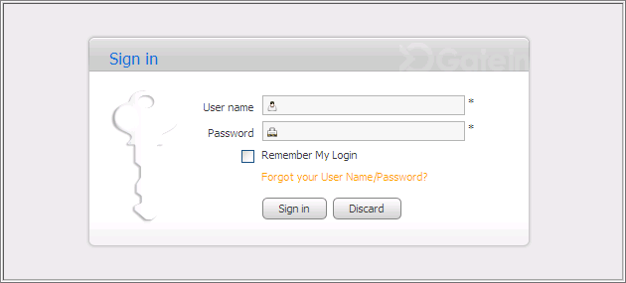Illustration 27: The Sign in form
User Name: To input the registered user name.
Password: To give the password of your user name.
Remember My Login: To allow you to return to GateIn and to be automatically authenticated based on the cookie value provided by the browser. Thus, you do not have to perform an explicit authentication again.
Forgot your User Name: To follow some steps to get the forgotten user name or password.
Sign in To sign into GateIn by the inputted username and password.
Discard To close the Sign In form.
Step 2: Input your registered User name and Password.
Step 3: Select the Remember My Login checkbox when you sign in GateIn 3.1 at the first time if you want to automatically return to GateIn 3.1 without signing in again. You can see the section "Remember User Account" for more details.
Step 4: Click the Sign in button to submit the form or the Discard button to quit.
Note that in case the username does not exist or the username/password is invalid, you will be returned to the Sign In form with an alert message. Type your username or password again.
After signing in successfully, you will be redirected to the homepage and welcomed with your full name on the top right corner of the page.
The 2nd way: Click directly the default user accounts at the lower of screen. You will be directed to the portal.

Sign out
This feature ends the authenticated session and returns the user to the anonymous portal. To sign out, just hover your mouse over the Sign Out icon on the top right corner and click that icon.
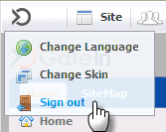

Remember User Account
Users who regularly return to GateIn 3.1 can be automatically authenticated to avoid doing
an explicit authentication each time they access the portal. Follow these steps:
Step 1: Input your registered username and password.
Step 2: Select the Remember My Login checkbox when logging in GateIn 3.1 at the first
time.
Step 3: Click the Sign In button to submit the form.
To be authenticated for the next time you sign in automatically, do not sign out when you leave the portal.

Change Account Settings
This function allows you to change your account information. To do so, click directly your account after logging in to open the Account Profiles form.
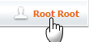
The Account Profiles form will be shown:
To change your Account Profiles, do as follows:
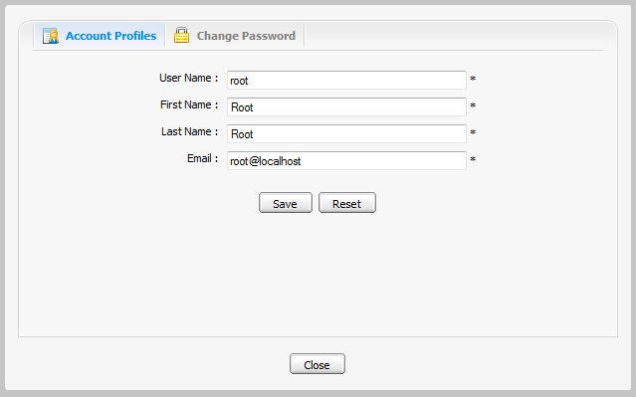Illustration 28: The Account Profiles Dialog
Step 1: Select the Account Profiles tab.
This tab displays basic information about the current user.
Step 2: Change your First Name, Last Name, Email. Your User Name can not be changed.
Step 3: Click Save to accept changes.
To change your Password, do as follows:
Step 1: Select the Change Password tab.
Step 2: Enter your current password to identify that you are the owner of this account.
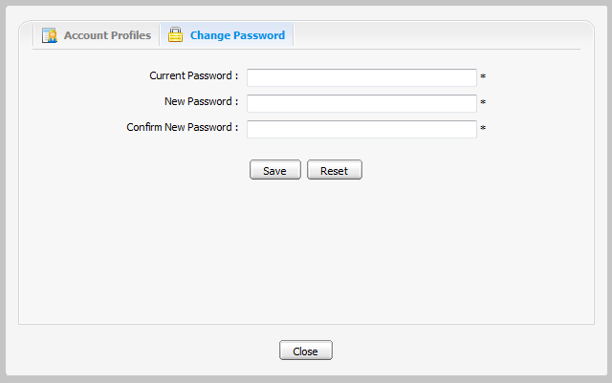Illustration 29: The Change Password tab
Step 3: Enter your new password which must have at least 6 characters.
Step 4: Enter your new password again in the Confirm New Password field.
Step 5: Click the Save button to accept changes.

Note: If the default accounts' passwords have been changed, the user can no longer sign in the portal by clicking the default accounts directly in the lower of the page.

Retrieve Account & Password

In case you forget your account or password, you can recover by following these steps:
Step 1: Click the link 'Forget your User Name/Password?' beneath the Password field in the Sign in form.
This form offers two options:
  - Forgot my password.
  - Forgot my username.
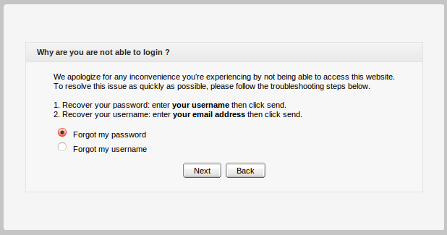
Step 2: Select one appropriate option.
Step 3: Click the Next button to go the next step. You will be prompted to provide identification information, depending on your choice.
- If you selected the Forgot my password option, you will be prompted for your user name:
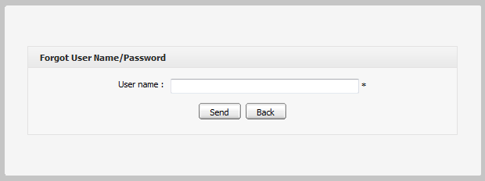
- If you selected the Forgot my username option, you will be prompted for your email:
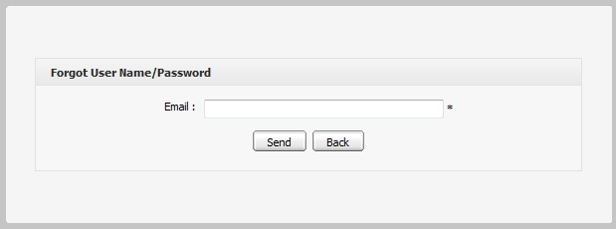
Step 4: Enter your Username or Email.
Step 5: Click Send to submit the entered values.
After the form is sent, an email will be sent to your email address with the requested information.
- If you forgot Username: when your Username is retrieved, your old Username is recovered and can be reused.
- If you forgot Password: you will be sent a new password (as temporary) and then you will be redirected to change password when you sign in.
Note that the User name/Password that you received only takes effect for one day. It means that if the current duration is over one day as from the receipt day, you can not use the received User name/Password. Thus, you have to get another active email.

Language Administration
The priority order of displaying language is 1. User's language 2. Browser's language 3. Portal 's language. Thus to display your preferred language, you should pay attention to this order to change language type appropriately.

Change the display language permanently
Do as any of following ways:
The 1st way:
Step 1: Click Site on the administration toolbar and select the portal that you want to edit.
Step 2: Click the button which corresponds to the portal that you want to edit.
The portal will be displayed under the edit mode.
Step 3: Click the button to edit portal properties.
Step 4: In the Portal Setting tab: You can change display language of a Portal by selecting another language in the Locale field.
Step 5: Click Save and Finish icon to take affect.
The 2nd way:
Step 1: Click Site on the administration toolbar to open the portal list
Step 2: Click Site Editor and select Edit Layout in the menu:
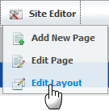
The portal will be displayed under the edit mode.
Step 3: Click the button to edit portal properties.
Step 4: In the Portal Setting tab: You can change display language of a Portal by selecting another language in the Locale field.
Step 5: Click Save and Finish icon to take affect.
The 3rdway: This way is used to set the displaying language for yourself, not for displaying the language of Portal.
Only users having administration role can do this:
Step 1: Go to Star--> Change Language
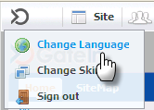
The Interface Language Setting form is displayed with a list of all supported languages. The current using language is marked by the icon.
Step 2: Select another one by clicking on the name of that language.
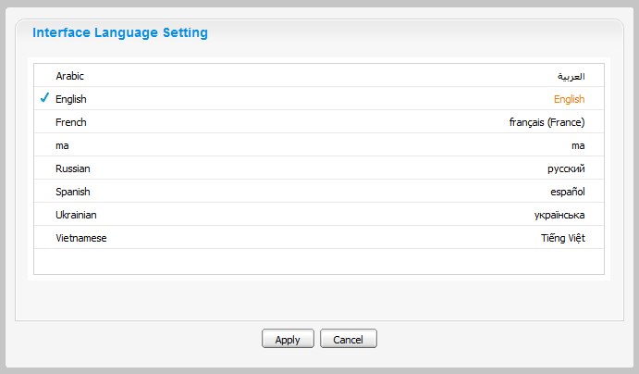Illustration 30: The Interface Language Setting form
Step 3: Click Apply and wait for few seconds to take affect.

Note:
- This displaying language will be kept permanently till you change your displaying language by another one.
- When you change from other language to Arabic or set the displaying language is Arabic. The displaying on Portal will be changed to Right to Left (RTL) direction because when Arabists read, they usually read from Right to left.

Change the display language for another user
By this way, you can change not only your displaying language but also the displaying language of another users if you have the access right in the Organization portlet.
Do as follows:
Step 1: Go to Group --> Organization --> Users and groups management
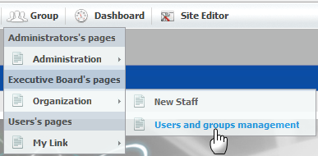
Step 2: Show the form to edit a user in list by clicking the edit icon which corresponds to the user that you want to change the displaying language.
Step 3: Select the User Profile tab:
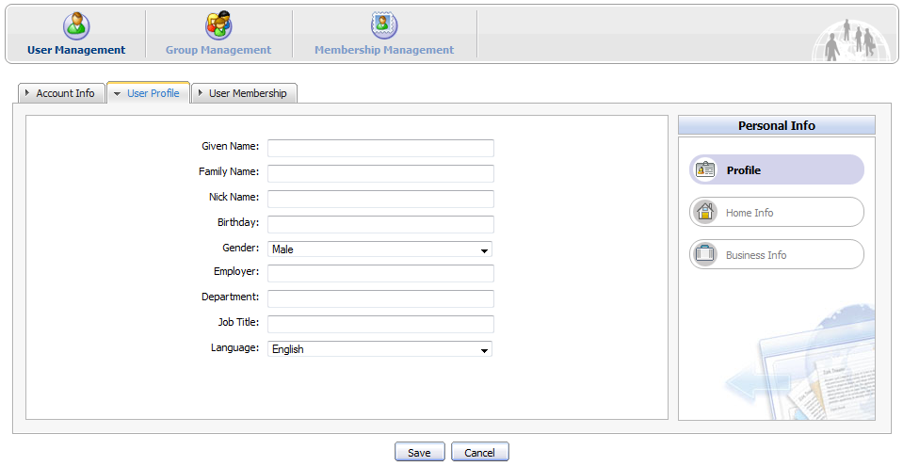
Step 4: Change the displaying language of this user by changing the value of the Language field.
Step 5: Click the Save button to accept and save changes or click the Cancel button to quit.
The next time when the selected user signs in, the displaying language will be the language changed by the administrator.

Sitemap management

GateIn Site Map provides users with overall view of GateIn, users can go directly pages through the SiteMap without going through the Administration tool bar.
Step 1: Go to the GateIn SiteMap on the navigation bar or go to Site → classic → SiteMap. The SiteMap page will appear:
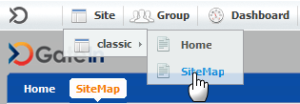
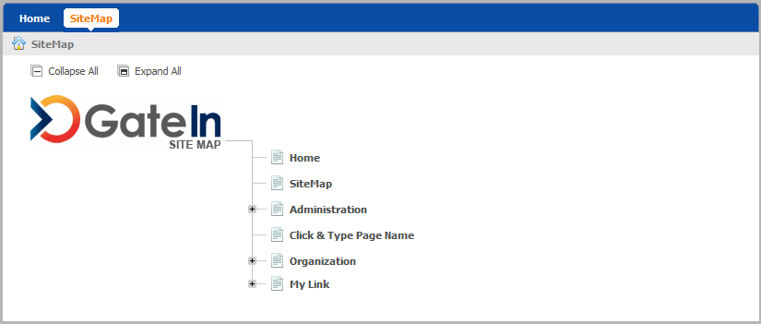
Step 2: Click the Expand All to see all pages inside ( the Collapse All button allows backing to the initial).
Step 3: Click directly on the title of a page that users want to manipulate.

