
eXo Forum User Guide
Version 2.0
Table of Contents
1 Preface 6
1.1 Overview 6
1.2 Purposes 6
1.3 References and Related Resources 7
2 Terminology 8
2.1 Concept overview 8
2.1.1 Category 8
2.1.2 Forum 8
2.1.3 Topic 8
2.1.4 Reply 8
2.2 User groups 8
2.2.1 Administrator 8
2.2.2 Moderator 8
2.2.3 Viewer 9
2.3 The Forum application main screen 9
3 How to use Forum application 11
3.1 Register a new account 11
3.2 Sign in/Sign out 13
3.2.1 Sign in 13
3.2.2 Sign out 15
3.3 User Settings 15
3.4 Manage Account 19
3.5 Collapse /Expand a category 21
3.6 Topic management 21
3.6.1 Add new topics 21
3.6.2 Edit topics 28
3.6.3 Lock topics 30
3.6.4 Unlock topics 31
3.6.5 Delete topics 32
3.6.6 Add a poll topic 33
3.6.7 Vote a poll topic 35
3.6.8 Vote topics 36
3.6.9 Tag topics 37
3.7 Post management 38
3.7.1 Post a reply 39
3.7.2 Post Quick Reply 40
3.7.3 Private posts 41
3.7.4 Quote posts 41
3.7.5 Approve posts 43
3.7.6 Edit posts 45
3.7.7 Delete posts 46
3.8 Bookmark management 46
3.8.1 Add bookmarks 46
3.9 Search 48
3.9.1 Quick Search 48
3.9.2 Advanced Search 50
3.9.3 Delete bookmarks 54
3.10 Watch 55
3.11 Send private messages 57
3.12 View all topics/posts 61
3.13 Share links 62
3.14 RSS feed 62
4 Conclusion 65

Illustration Index
Illustration 1: The Forum Application main screen 10
Illustration 2: The anonymous home page of the classic portal 12
Illustration 3: The Create my account form 13
Illustration 4: The Sign in form 14
Illustration 5: The authenticated homepage 15
Illustration 6: The Profile tab of the User Settings form 17
Illustration 7: The Forum Settings tab of the User Settings form 18
Illustration 8: The My Subscriptions tab of the User Settings form 20
Illustration 9: The Content tab of the New topic form 23
Illustration 10: The Attach File form 24
Illustration 11:The Icon tab of the New topic form 25
Illustration 12: The Options tab of the New Topic form 26
Illustration 13: The Permissions tab of the New Topic form 27
Illustration 14: The View topic form 28
Illustration 15: The New Topic form 29
Illustration 16: The Edit Topic form 31
Illustration 17: The Option tab in the Edit topic form 32
Illustration 18: The Poll form 35
Illustration 19: The Rate this topic form 38
Illustration 20: The tag list assigned to a topic screen 39
Illustration 21: The Content tab of the New Post form 40
Illustration 22: The Icons and smileys tab of the New Post form 41
Illustration 23: The Quick Reply form 42
Illustration 24: The Quote form 43
Illustration 25: The Edit post form 46
Illustration 26: The My Bookmarks form 48
Illustration 27: The Advanced Search- Search in Category 52
Illustration 28: The Advanced Search- Search in Forum 53
Illustration 29: The Advanced Search- Search in Topic 54
Illustration 30: The Advanced Search- Search in Post form 55
Illustration 31: The Watch alert form 57
Illustration 32: Email notification 57
Illustration 33: The Quote form 58
Illustration 34: The Private Messages form 59
Illustration 35: The Inbox tab of Private Message form 61
Illustration 36: The Message tab in the Private Message form 62
Illustration 37: The Posts by user form 63

Preface

Overview
Beginning as an open source project in the year 2002, eXo is well-known as the industry's first Java portlet container. With the aim of dominating the potential portal market through robust and easy-to-use applications, eXo Project succeeded in attracting consumers in the whole world. eXo actually opened the floodgates to various options in many markets, and customers have been choosing eXo as the best method for their success.
The eXo Project grew into a company in 2003, as a response to customer demand. We can do this because we release our code in the open. It's how the DoD found us, when we were just university students hacking away, and it's how we choose to do business with our customers.
Today, eXo is a rapidly growing global company, with U.S. headquarters in San Francisco, California, global headquarters in France, and offices in Tunisia, Ukraine, and Vietnam. The company has established technology leadership and proven value by their large European installed base and strategic partnerships with Red Hat, Capgemini, Atos Origin, and Bull.
And along with many Corporate products, eXo Forum is an application developed upon the eXo Platform™ software. As an extension of eXo Platform™ software, eXo Forum has been creating an interesting environment along with discovering many rich applications.

Purposes
The document was written as a detailed manual, aiming at instructing step by step on how to use and implement this application to the utmost. Thus, the information included herein will give basic steps that makes it easy for users to follow through in-depth examples as well as clear explanations regarding to the eXo KS technology. Whether you major in technology or not, you are able to learn about or work on eXo Forum easily and efficiently.
The information provided in the guide has been arranged into such a way that ensures readers to search and implement them quickly. Initialized with the overview of terminologies, the guide will give main definitions used in this book. Next, the guide focuses on the most important so-called “How to use the Forum applications”. The part will represent most of steps necessary in the process of using and mastering the eXo Forum. Finally, with the aim of helping users better understand eXo Forum, we also mention some major strengths when using the applications in the Conclusion section.
The document aims at guiding various users of eXo Platform. The material is for anyone interested in learning and using the Forum application. It is also useful for the following groups:
- Users who implement the eXo Knowledge Suite with the Forum applications in their work and business.
- Integrators who want to know more about the rich knowledge features in order to advise their customers to use eXo products.
From above, the Forum User Guide objectives can be summarized as follows:
- Define some basic concepts used in the Forum application.
- Show the main instructions of the Forum application.
- Guide step by step to take basic actions.

References and Related Resources
Related Documents
- Forum Administration Guide_En v2.0
Info & Support
Information
- eXo Platform Home Page: http://www.exoplatform.com/portal/public/website/
- eXo Platform Wiki: http://wiki.exoplatform.com/xwiki/bin/view/Main/
Support
- Forums: http://www.exoplatform.com/portal/private/en/
- FAQ: http://www.exoplatform.com/portal/public/website/community/faq
- JIRA: http://jira.exoplatform.org/browse/KS
Download
- Download Zone: http://forge.ow2.org/project/showfiles.php?group_id=151&release_id=2949

Terminology

Concept overview

Category
A category is the name for a collection of content items related in some ways. In the eXo Knowledge, a category can be defined as a domain including various forums which may be related to the same field. A forum application may include many various discussing domains so that it may also include many various categories.

Forum
A forum is a web application holding online discussions and posting user generated content. Thus, a forum is the best place to ask questions about certain development topics.

Topic
A topic is a subject matter of a conversation or discussion in a forum. Each topic contains one original message and all its replies. When you enter/ access into a forum, there is a list of topics which are being discussed.

Reply
A reply is a post in a topic. With a message in the topic that you are interested, you can read and have any reply if you want. Thus, a reply is your idea about that topic.

User groups

Administrator
Users in the administrator group are users who typically have the right to create, edit, delete, move and modify, etc... any forum and its topics, posts. The administrators can also open/close, lock/unlock forums or topics. It can be said that the administrators have the highest right to take any actions which they want. Otherwise, administrators also have the right to manage members in a forum and they can set rights for members.
At the runtime of the Forum service, the default administrators, categories and forums are created. These administrators are defined at the Forum Roles Plugin in xml file. These administrators can be changed if the value in xml file is changed. The default administrators are the ones who initialize the Forum and assign role to normal users. A normal user can be an administrator if the default administrator directly assign the administration role to him in the Forum application.

Moderator
Moderators have a subset of administrator's rights that allows them to edit, delete and move topics in a special forum which they have the moderation right. Otherwise, a moderator also can open/close, lock/unlock, stick/un-stick, split/merge or approve/disapprove topics in a special forum.
When administrators create a new forum, they have to set this right to some users or some groups. If not, only the administrators can mange that forum.

Viewer
Viewers includes guests and logged users. Guests only have the view permission while logged users can take some basic actions in the Forum application. By default, all users can view forum, all its topics and replies. However, if the administrator only set the view right for some users or some groups to specific categories, forums or topics, only users or groups which have the view right can view them. When having the adding post right, any viewer can add his/her reply to the topic which he/she interests.

All users after registering successfully can do basic actions in the Forum application. These users are viewers of this application.

The Forum application main screen
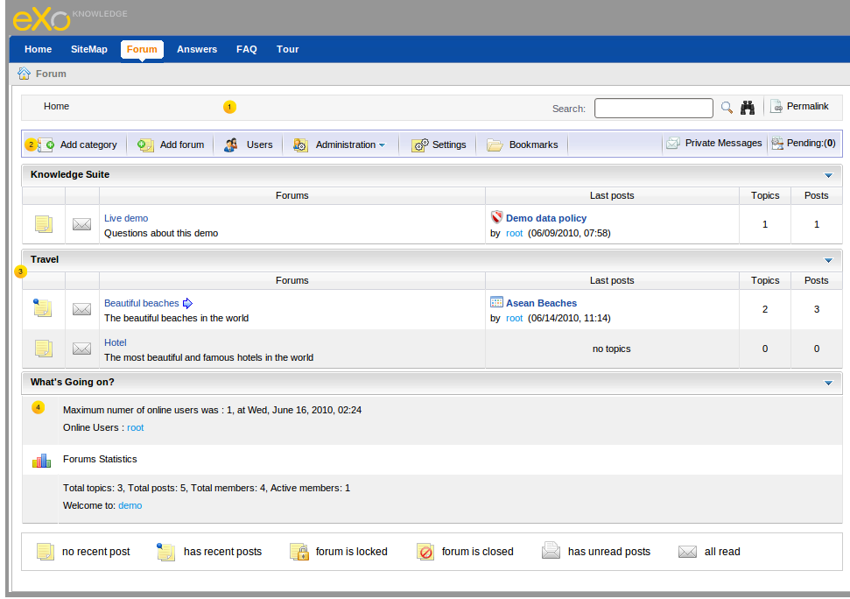Illustration 1: The Forum Application main screen

Indicator | Meaning
 | This is the Breadcrumb bar that shows the forum path, quick search and advanced search, permalink.
 | This is the Main action bar that displays all main function buttons, link private messages, total of pending posts/topics information, the number of function buttons depending on the role of user login.
 | This is the Forum panel that displays all categories and forums inside.
 | This is the Statistic Panel that displays Forum statistics about user information.

How to use Forum application
Firstly, you need a portal account to use the eXo Forum. You can register a new one or use your existing account.

Register a new account
To register a new account on eXo portal, proceed as follows:
Step 1: Go to the portal by inputting URL in the address bar (e.g: http://localhost:8080/portal). The anonymous home page will be displayed:
Step 2: Select the Register on the upper right corner. The Register page will appear and input values into all the fields as the illustration below:
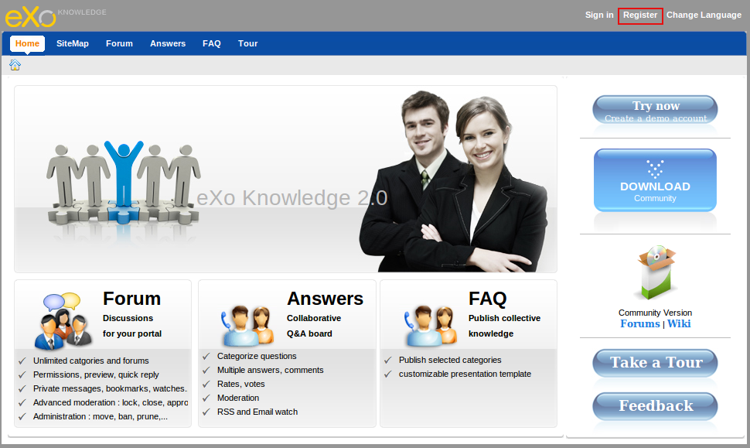Illustration 2: The anonymous home page of the classic portal
Details:
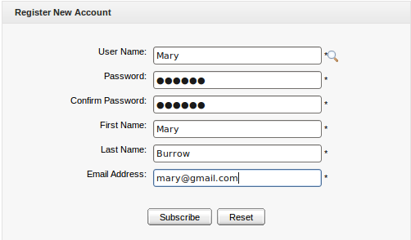Illustration 3: The Create my account form

User name | The name of user applied for signing in. It must be unique. (*Required).
Password | The secret string used to login. It must have at least 6 characters. (*Required).
Confirm Password | Your first name. (*Required)
First Name | This link helps users retrieve user name and password when they forgot.
Last Name | Your last name. (*Required).E
Email Address | Your contact email address. It must be in the right format. For example: mary@gmail.com
Subscribe button | The subscription of account
Reset button | To refresh entries for all text fields.

Click the icon to search and check whether the inputted User name is available or not.
Step 3: Click the Subcribe button to accept creating the new account and a message pops up and informs that you have created the account successfully.
There will be an alert message informing that you can not add a new account if at least one of these cases occurs:
  - The User name is existing or User Name is invalid
  - The Password has less than 6 characters.
  - The Password and Confirm Password are not the same
  - The Email Address is invalid format
  - The required fields are blank (empty)
After registering a new account, you can login and access to the eXo Forum application.

Sign in/Sign out

Sign in
This function allows you to go into the portal in the private mode.
To sign in, do as follows:
Step 1: Go to the portal in the public mode by inputting the URL in the address bar (e.g: http://localhost:8080/portal)
Step 2: Click the Sign in link at the top right of a page if you are in the classic portal.
The Sign in form will appear:
Details:
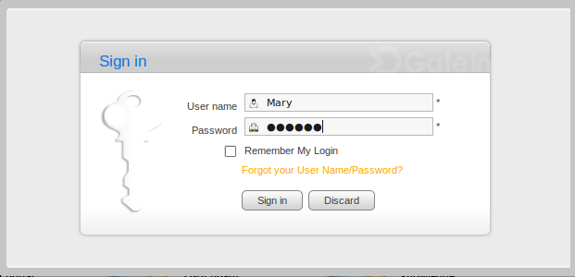Illustration 4: The Sign in form

User name | The registered user name
Password | The registered password
Remember My Login | This checkbox helps users automatically sign in the portal without inputting username and password again in the next login
Forgot your User Name/Password? | This link helps users retrieve user name and password when they forgot.
Sign in button | To accept signing in
Discard button | To close the Sign in form

Step 3: Login by your registered User name and Password
Step 4: Complete signing in by clicking the Sign in button.

In case, the User Name does not exist or invalid inputted User name/Password, there is an alert message that requires to input a correct value. To sign in again, you click the OK button on the alert message and re-enter the User Name and Password.
After signing in, you will be redirected to the authenticated homepage: .
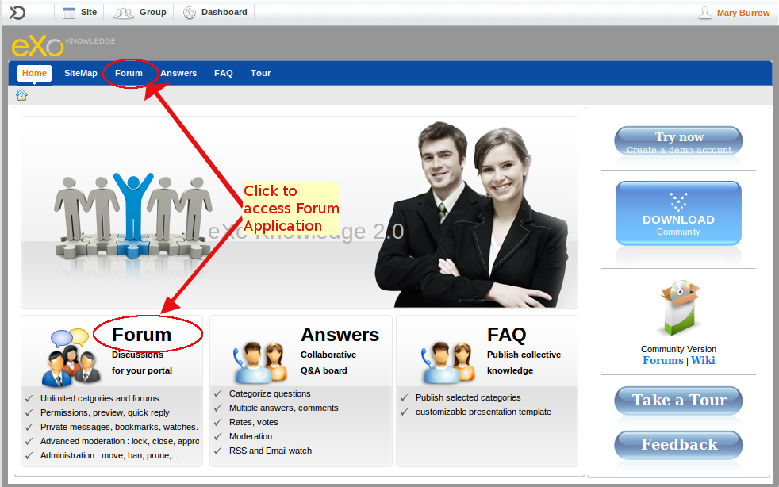Illustration 5: The authenticated homepage
Click Forum as the illustration above to take actions in the Forum application,

Sign out
This function allows you to get back to the anonymous portal. It ends your current portal session.
To sign out, click Sign out in the Star menu list on the administration bar:

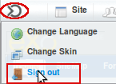

User Settings
This function allows you to personalize your settings in the Forum application.
Step 1: Click the button to take this action.
The User Settings form will appear:
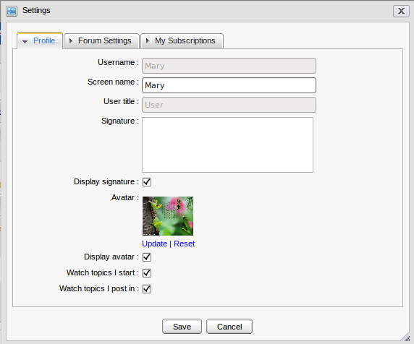Illustration 6: The Profile tab of the User Settings form
The Profile tab includes your common information:

User name | Your user name. It can not be edited.
Screen name | The name displayed on the screen
Signature | Your signature. The signature will be displayed under each post/topic created by yourself
Display Signature | The option is whether to display your signature under each post/topic or not.
Avatar | The avatar of your account
Update | To open Upload File form to change avatar
Reset | To remove the current avatar and set by the default one.
Display avatar | This option is to display your avatar or not.
Watch topics I start | This option is to add you to the watchers of the topic you create. You will receive notification mail when there is new post added to your posted topic.
Watch topics I post in | This option is to add you to the watchers of the topic when you post to a topic . You will receive the notification mail when there is new post added to the topic that you added post.

The Forum Settings tab includes information related to Forum application:
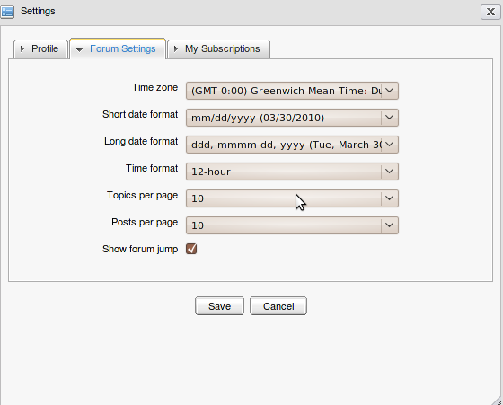Illustration 7: The Forum Settings tab of the User Settings form

Time zone | Your user name. It can not be edited.A region that has the same time as everywhere within it. This field refers to as local time and as standard time.
Short date format: | The format is to display short date in an application
Long date format: | The format is to display long date in an application.
Time format | The format is to display time in an application.
Topics per page | The maximum number of topics can be displayed per page.
Post per page | The maximum number of posts can be displayed per page.
Show forum jump | This option is to display Forum link or not.
Save button | To accept saving new setting
Cancel button | To close the User Setting form.
Step 2: Enter and set values in this form.
Step 3: Complete saving your settings by clicking the Save button.
To change the avatar, do as follows:
Step 1: Click on the Update link to open the Attach File form:

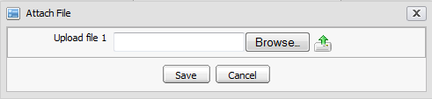
Step 2: Click the Browse... button to select file to upload.
Step 3: Click the icon to upload the selected file.
Step 4: Click the Save button to accept changing avatar.
The My Subscriptions tab: It lists all your being watched objects (category, forum, topic) that makes it easy for you to manage your watch list in the Forum application. To view your object watched, simply click on the title of the object in the Title column.
- To view your being watched objects, click on the title of the object in the Title column.
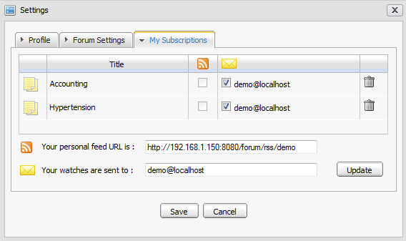Illustration 8: The My Subscriptions tab of the User Settings form
- To get a new RSS feed that contains the selected RSS feeds in the column, check the check boxes which correspond to RSS feeds you want, then click on the Save button, the selected objects (categories, forums, topics) will be updated to the Your personal feed URL is link. The Your personal feed URL is field is always default for each user. Users can copy and use this link to view the detail information of categories/forums or topics.
- To send notifications to your friends, tick check boxes in the column and then enter one or more email addresses in the Your notifications are sent to field. Click the Update button to add the entered email addresses in the column.
- To remove being watched object from your watch list, click on the trash can icon correspondingly. After being removed, you will not receive notification mails about the removed object anymore.

Manage Account
This function allows you to change some information set up when registering a new account such as first name, last name, email and password.
Do as follows:
Step 1: Click the displaying use name on the top right concern of the adminstration bar:
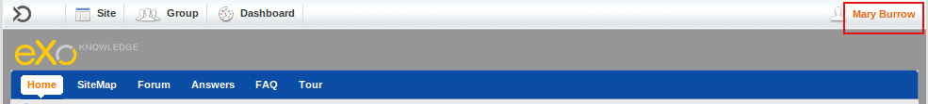
Step 2: A window pops up as the illustration below.
In Account Profiles tab: You can change your first name, last name and email
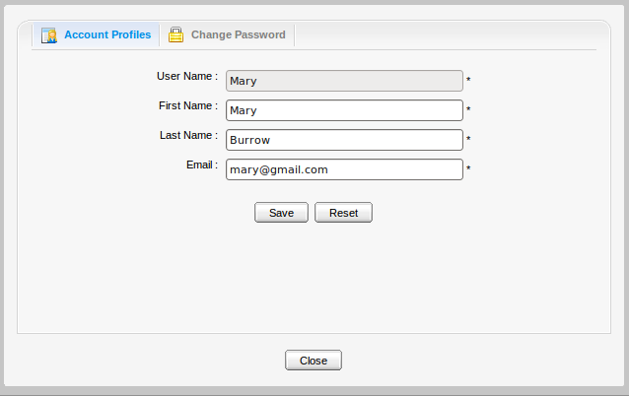
Step 3: Choose the Change Password tab and enter the values in the tab:
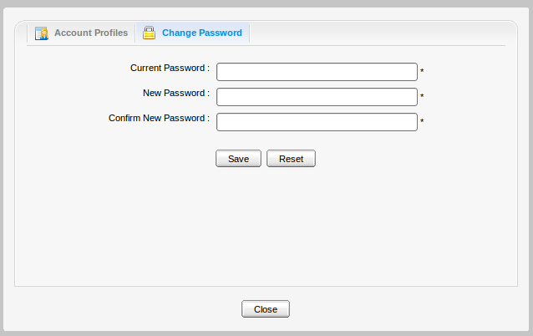
Details:

Current Password | The password that you are using to log in the account.
New Password | The password that is used to change the current password.
Confirm New Password | Re-type the new password above. The value in the New Password field and the Confirm New Password is the same.
Step 4: Click Save to accept changing the password or Reset to clear all the fields.
Step 5: Click Close to quit this window.

Collapse /Expand a category
The convenient function allows you to collapse or expand a category just by clicking on the arrow at the end of the category pane as you can see below:
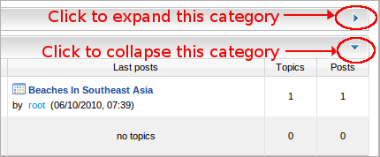
Note that when you log out and then log in again, the state of the category pane will be restored as the state when you left them before logging out.

Topic management
This section is about how to mange topics in a forum such as adding a new one, editing, deleting, closing, opening, locking, unlocking, sticking, moving, deleting, merging etc...

Add new topics
This function is used to create new topics inside a forum. A topic is a thread where all members in a forum can discuss by giving their questions, answers or opinions in the form of adding posts or replies.
- To add a new topic, do as follows:
Step 1: Go into the forum which you want to add a new topic
Step 2: Click the button to open a new topic form:
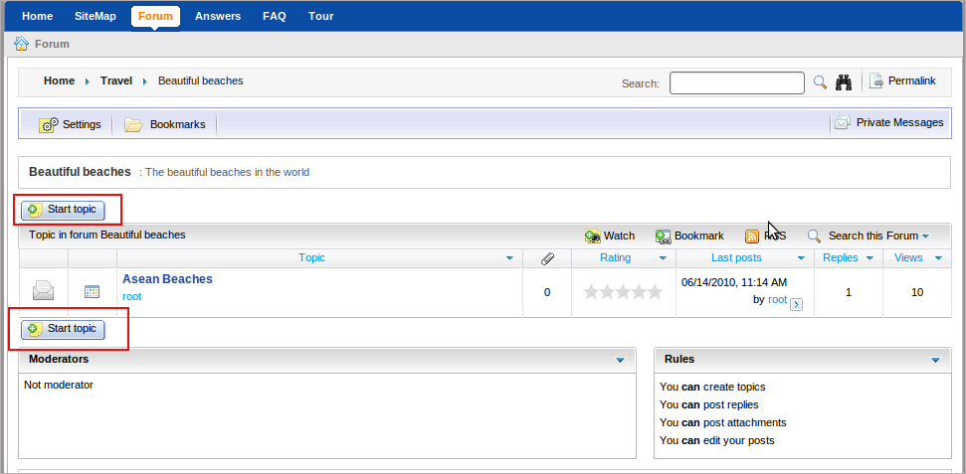
The New topic form will appear with the available Content tab:
Step 3: Enter values for the fields in this form.
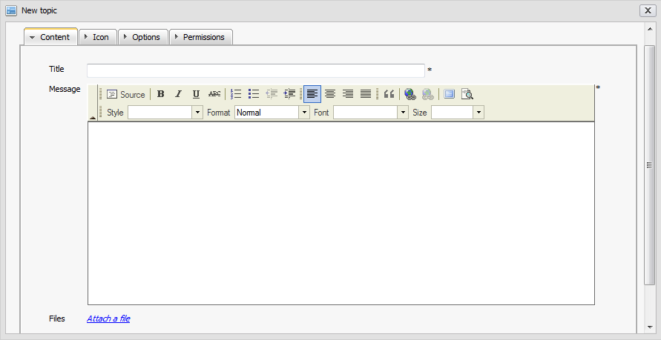Illustration 9: The Content tab of the New topic form
The Content information includes:

Title | The title of the topic. This field is required and limited by 100 characters.
Message | The content of the topic.
Files | The files attached into this topic.
Preview button | To preview the topic before submitting.
Submit button | To accept submitting the topic.
Attachment button | To perform attaching files
Cancel button | To close the New Topic form without submitting a post.

- To attach files, do as follows:
Step 1: Click the Attach a file link to open the Attach File form:
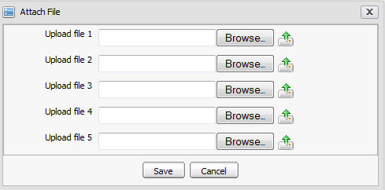Illustration 10: The Attach File form
Step 2: Select files to upload by clicking the Browser... button in order to select the path of the file from your local computer.
Step 3: Click the icon to upload the files.
Step 4: Click the Save button to complete attaching files.
After attaching files, the New topic form is shown below:
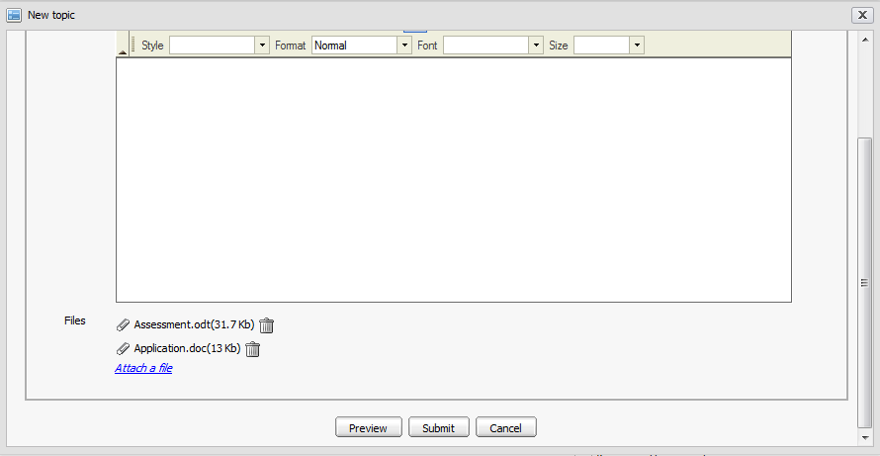
Many different file types can be attached. To remove an attached file, simply click on the Remove link besides the file attachment that you want to delete.
The Icon tab: It allows you to select an icon for a topic. Choose the icon by clicking it.
The Options tab: It is used to set some properties for the topic:
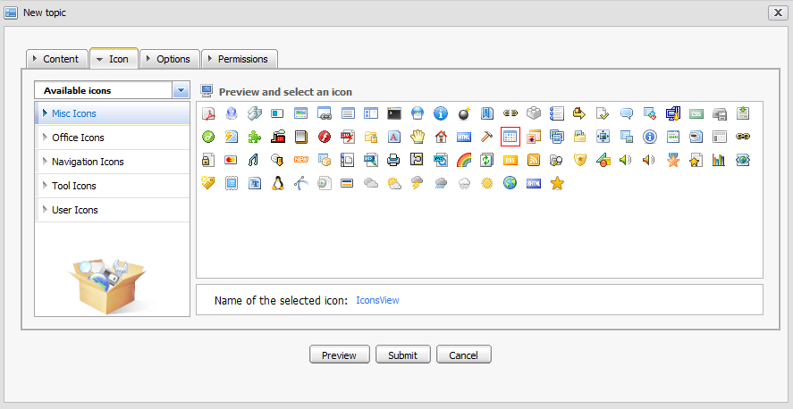Illustration 11:The Icon tab of the New topic form
Details:
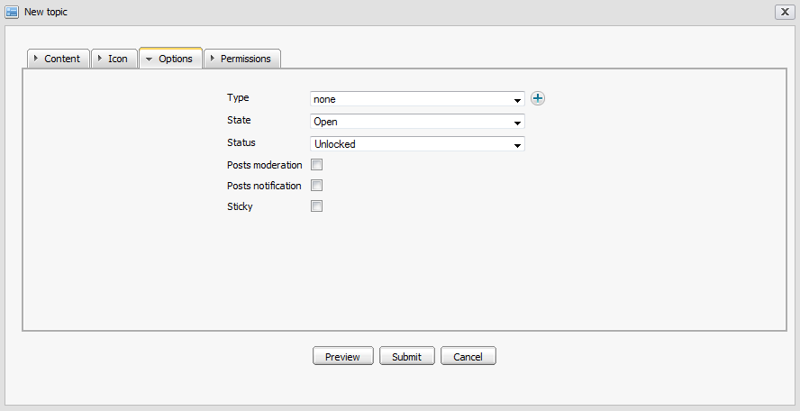Illustration 12: The Options tab of the New Topic form
Type | The type of the topic that specified by the topic type name and its icon. It can be selected from the existing list or added a new one by clicking the icon.
State | The state of the topic. The default value of this field is 'Open'. The other state is 'Closed'
Status | The status of the topic. The default value of this field is 'Unlocked'. The other status is 'Locked'
Posts moderation | This option is to require/not require approving new added posts to be visible or not.
Posts notification | This option is to send (or not send) notification mails to the topic creator whenever new posts are created.
Sticky | This option allows to marke a topic or not. After marking sticky, the topic will be set out by a sticky title and located at the top order of the topic list.
The Permissions tab:
It is used to set the view and post rights to some users. You can set information for this tab or not. By default, all users can view and reply this topic.
Details:
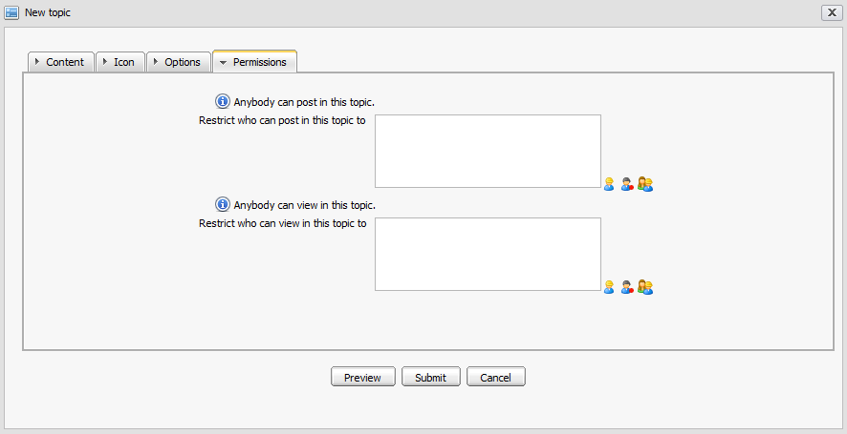Illustration 13: The Permissions tab of the New Topic form
Restrict Who can post in this topic to | By default this field is blank, it means that all users can post replies in this topic. But if you want to limit number of users, you can manually input or select users or group for the this field ( refer to the restricted audience in the part Adding New Categories).
Restrict who can view in this topic to | By default this field is blank, it means all users can view this topic. To limit users who can view it, you can manually input or select users or groups for the Viewers field ( refer to the restricted audience in the part Adding New Categories). You can only enter values for this field after you have inputted values for this field.

The text “ Anybody can post and view this topic” will be displayed if restrictions do not apply for setting permissions on categories and forums (The Who can post ? and Who can only view posts? field).
To preview the topic before submitting, click the button, the View topic form is shown:
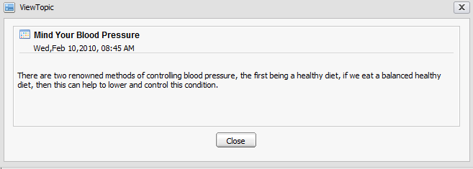Illustration 14: The View topic form
Step 5: Complete adding a new topic by clicking the Submit button.
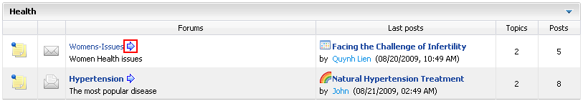
After being added successfully, the new topic will be updated in the topic list in the forum. If it is the newest one, its information will be shown at the Last Post column information of the forum, the topic is located below:
The icon that corresponds to the forum will let you jump to the last read post of that forum by clicking on that icon.
Beside the Text Editor tool, you can use BB code (Bold tag, Italic tag, Underline tag, Size tag, Color tag, Combined formatting tag, Quote tag, Code tag, Unordered list, Ordered list, Link, Adding image...) to create text and picture effects for topics.
The topic will be displayed like:
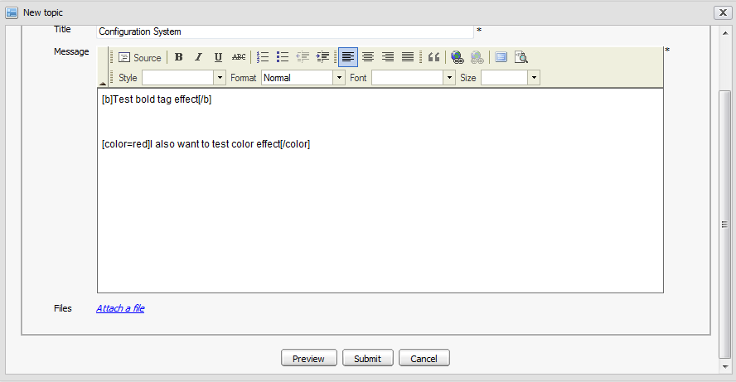Illustration 15: The New Topic form

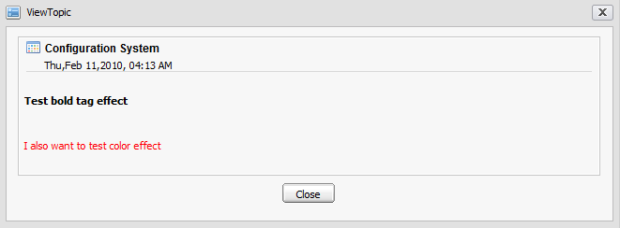
Edit topics
This function is used to edit topics. This action can be also taken by the creator of the topic.
Do as follows:
Step 1: Go into the topic which you want to edit by clicking the tittle of the topic.
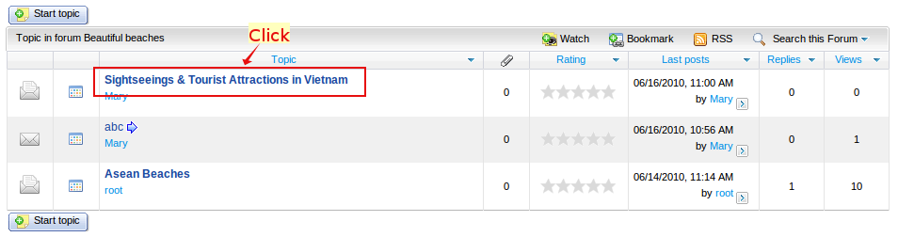
Step 2: Click the More actions on the topic bar:
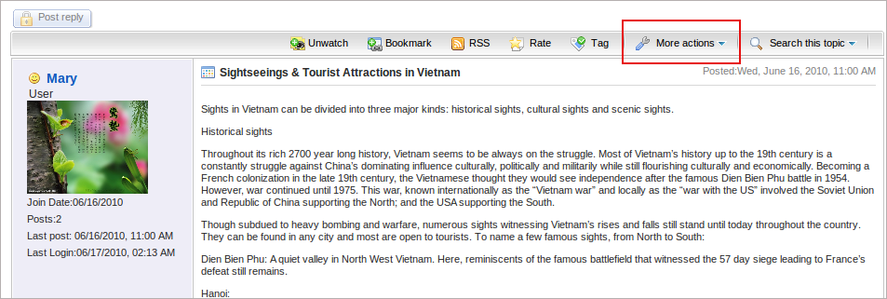
Step 3: Select Edit in the menu.
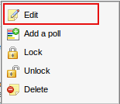
The Edit topic form will be displayed like the illustration below, the information of the current topic are displayed in this form.
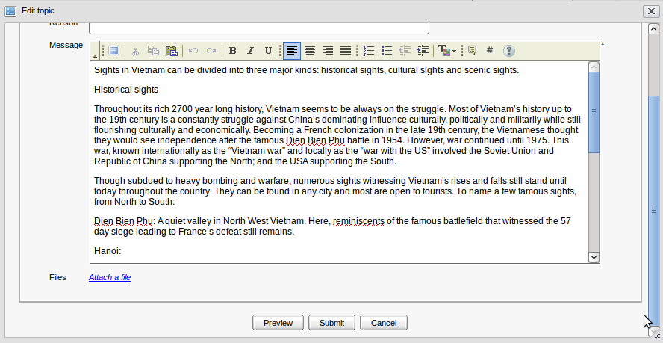Illustration 16: The Edit Topic form
Step 3: Change the information of the topic like when creating a new topic.
Step 4: Preview the topic before submitting by clicking the Preview button.
Step 5: Complete editing a topic by clicking the Submit button or the Cancel button to quit without saving.
If you change a topic that does not require posts moderation into the one requiring posts moderation, all posts which have been added before do not need to be moderated. Only new posts after you editing are required moderating
.

Lock topics
This function is used to lock one or more topics because of some particular reasons. The locked topics can only be viewed but can not be added any posts.
Do as follows:
The 1st way:
Step 1: Go into the topic which you want to lock by clicking the title of the topic
Step 2: Click the More actions on the topic bar and select Lock in the menu:
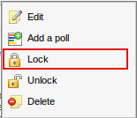
The 2nd way: Simply edit the topic, go to the Options tab and change its Status from Locked into Locked.
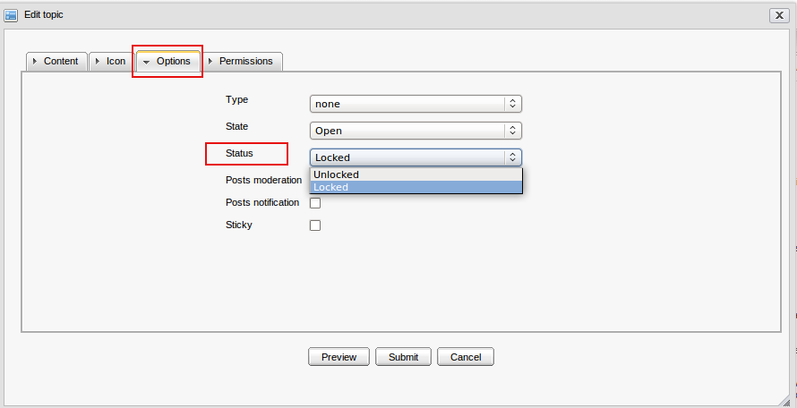Illustration 17: The Option tab in the Edit topic form
After being locked, the icon(s) corresponding to all locked topic(s) will be changed from normal status into the locked status. Some functions of this topic will be disabled.

Unlock topics
This function is used to unlock one or more locked topics. This action can be done by the creator of the topic.
Do as follows:
The 1st way:
Step 1: Go into the locked topic which you want to unlock by clicking the title of the topic
Step 2: Click the More actions on the topic bar and select Unlock in the menu:
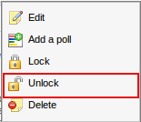
The 2nd way:
Simply edit the topic, go to the Options tab and change its Status from Locked into Unlocked.
After being unlocked, the icon(s) of the unlocked topic(s) will be changed from locked status into normal status and users can normally quote and post replies.
You can not unlock topics in a forum locked or closed by the administrator or moderator. To do that, you need to wait until the administrator or moderator unlocks that forum.

Delete topics
This function is used to remove one or more topics from the list.
Do as follows:
Step 1: Go into the topic which you want to delete by clicking the title of the topic
Step 2: Click the More actions on the topic bar and select Delete in the menu:

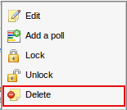
Step 3: Click the OK button in the confirmation message to accept deleting or the Cancel button to quit.

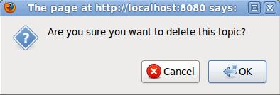
Add a poll topic
This function is used to add a poll question into a topic. Each topic has only one poll question related to the topic, that offers the available anwers and allows users to select one or more answers fromt the anwser list. As the creator of that topic, you only add a poll question into a topic.
Do as follows:
Step 1: Go into the topic which you want to add a poll by clicking the title of the topic
Step 2: Click the More actions on the topic bar and select Add a poll in the menu:
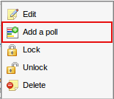
The Poll form will appear:
Details:
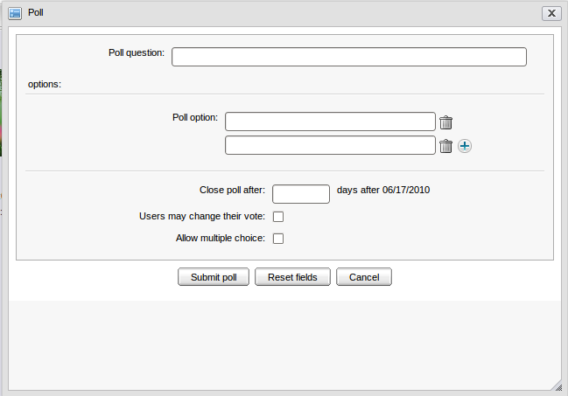Illustration 18: The Poll form
Poll question | The question is used to poll. (Required)
Poll Option | The different answer options is for the poll question. By default, there are two options to choose. But if you want to have more, click the icon to add more poll options or click the icon if you want to remove options.
Close poll after | The number of days that the poll will be closed.
User may change their vote | This option is to allow users to change their vote or not.
Allow multiple choice | This option is to allow multiple choices or not. It means users can have several answers for one poll.
Submit poll | To accept submitting poll.
Reset field | To set blank or default entry for all inputted fields
Cancel button | To close the Poll form.

Step 3: Enter values for fields in the Poll form.
Step 4: Complete adding a poll for a topic by clicking the Submit poll button.
After adding a poll for a topic, an icon will appear as the illustration below.

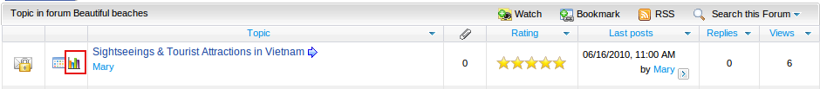
Vote a poll topic
When a topic has been added a poll question, users can vote it.
Do as follows:
Step 1: Go into the topic that has a poll. The poll will be displayed above the selected topic:
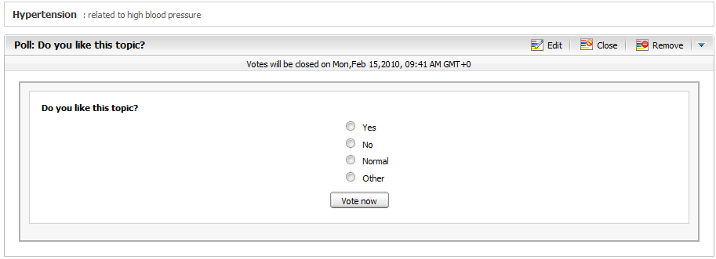
Step 2: Select one answer that you want. Note that if the poll has multiple options, many answers can be selected. If not, only one answer can be selected at one time like a poll above.
Step 3: Click the Vote now button under the poll to vote.
After voting, the result of the poll will be displayed immediately:
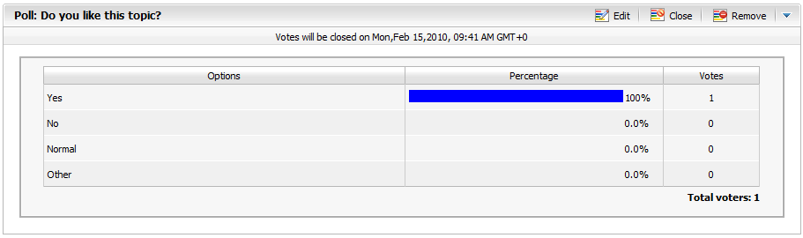
After being untagged, the topic will not be assigned the tag anymore.

Vote for poll question function is only available for member of the Forum and can only be voted in case the topic is opened.

Vote topics
This function allows users to evaluate a topic by voting in the form of rating star from 1 to 5. The more star rate the topic has, the more interesting it is.
Do as follows:
Step 1: Go into the topic which you want to vote.
Step 2: Click the button on the topic bar.
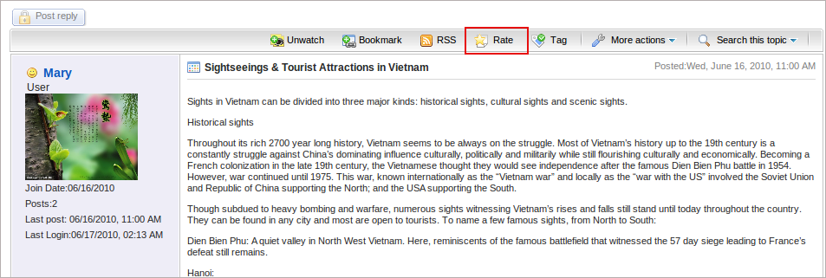
Step 3: The Rate this topic form will appear:
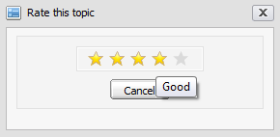Illustration 19: The Rate this topic form
Step 4: Rate the topic by left clicking on the star. The number selected star will be changed from grey into yellow. Click the Cancel button if you want to quit this form.

Each user can only vote 1 time for one topic and the vote function is not available for closed topic and banned user

Tag topics
This function is used to assign tags for each topic. Tags are words which are used as labels to describe or group the same topics, each tag corresponds to a word. For example, you have a tag named 'Interesting' and you can assign different topics to this tag. However, one topic can have various tag names that can be created at the same time, separated by a space and belong to tag groups. Using tags helps you and other users easily find your topics.
Do as follows:
Step 1: Go into the topic which you want to tag.
Step 2: Click the button on the topic bar to open the Add Tag form:
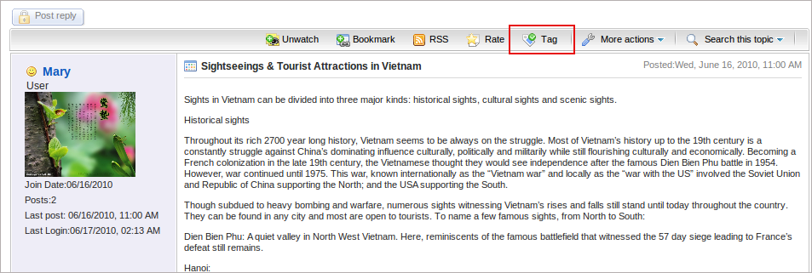
Step 3: Input a new Tag name or an existing one --> Click the Add Tag button to accept assigning tags.
In case you input a new tag name, the new one will be created. In case using the an existing one, the topic will be tagged into the existing one.
After assigning tags to the topic, it will show all the tag names that the topic is assigned.
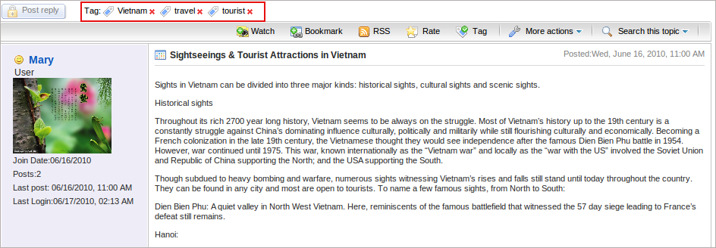Illustration 20: The tag list assigned to a topic screen
When directly click on a tag name, topics added with the tag name will be listed as the illustration below with tag: travel:
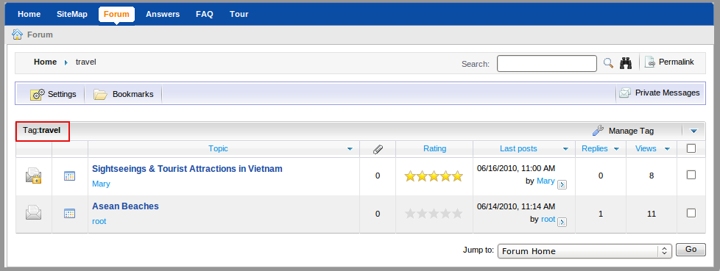
- The icon that is behind each tag allows you to remove this tag.
- To untag a topic from a tag, go to the tag page --> check in the check box to choose a topic that you want to untag --> click on the Manage Tag and select Untag in the menu popup.

Post management
This section is about how to mange posts such as adding a new post, editing, deleting, moving, hiding, showing and etc.

Post a reply
This function is used to respond to the main post in a topic. All responses will be displayed in the form of posting reply in the topic. By default, a post reply will have the title with a format Re: <The title of the topic>. However, you can personalize the title of their post reply. Normally, all users can post replies to the main post in a topic but if an administrator and moderators set the post right to some users, only the users who have the add post right can take this action.
Do as follows:
Step 1: Go into the topic which you want to post a reply.
Step 2: Click the button to post your response to this topic.
Step 3: The New Post form will appear:
Details:
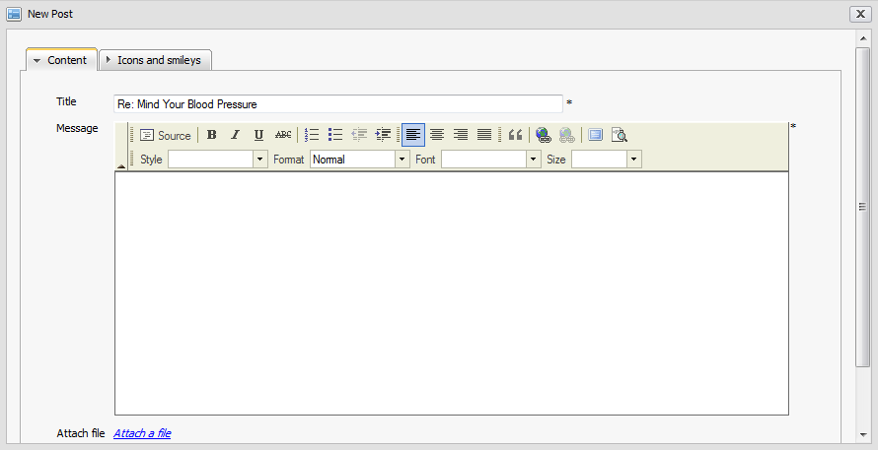Illustration 21: The Content tab of the New Post form
The Content tab includes:
Title | The title of the topic which you want to post a reply. You also can change this title.
Message | The content of your reply. The message can be decorated by FCK Editor. There will be an inform message when this content is short. (at least 3 characters)
Attach File | The files that attach with your post reply. If you want to attach files into this topic, click the Attach a file button to open the Attach File form and attach file like above

The Icons and smileys tab allows you to select an icon for the post. The icons list is shown:
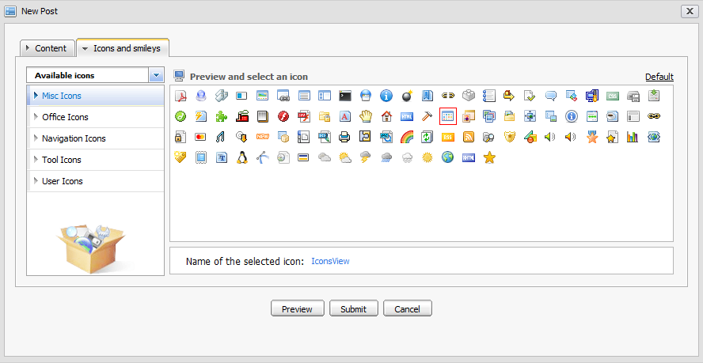Illustration 22: The Icons and smileys tab of the New Post form
Step 4: Enter values for fields, select an icon for your post reply (BB code) can also be used to input values for text area field) in the New Post form.
Step 5: Preview a post before submitting by clicking the Preview button.
Step 6: Complete adding a new post by clicking the Submit button .

Post Quick Reply
This function is used to post a reply quickly with a simple text. However, you can decorate their post by using BB Code tags.When you go into a topic, by default there will be a form to post quick reply under the list of current topic's posts:
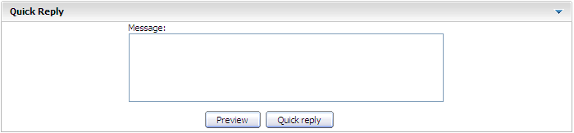Illustration 23: The Quick Reply form
Step 1: Enter the content of the message.
Step 2: Preview the message before posting by clicking the Preview button
Step 3: Complete quick replying by clicking the Quick reply button.

Private posts
This function is used to respond privately to a post in a topic. Only the creator and the author of the responded post can see the private post.
Do as follows:
Step 1: Go into the topic that you want to post reply.
Step 2: Click the button under the post that you want to reply. There will be a form like when you post a reply.
Step 3: Enter values for fields in this form.
Step 4: Preview a post before submitting by clicking the Preview button
Step 5: Complete submitting a private post by clicking the Submit button.
Private posts are personal exchanges between two users (creator and receiver). Thus, private posts will not be checked for approval in case the topic having the 'Posts moderation' option. A private posts is displayed with label 'This post is private' in order to differ with normal posts.

Quote posts
This function is used to post a reply to a specific post in the topic in the form of using quotation. The message of the post that you are going to quote post is also added into the message content of the reply.
Do as follows:
Step 1: Click the button under the post which you want to add quote.
Step 2: The Quote form will appear:

Details:
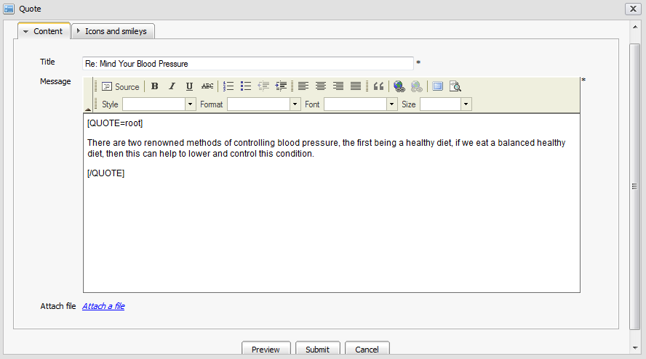Illustration 24: The Quote form
The Content tab includes:

Title | The title of the topic which you want to quote. You also can change this title.
Message | The content of your reply with quote. Quote content is in [Quote] tag.
Attach file | The files attaching with your reply with quote. If you want to attach a file into this post, click the Attach a file button to open the Attach File form.
Preview button | To preview the reply with quote before submitting.
Submit button | To accept submitting the reply with quote
Cancel button | To close the Quote form.

The Icons and smileys tab allows changing an icon for the reply with quote. It is like the Icon and smileys tab in the New Post form (See detail)
Step 3: Make changes on your quote. e.g adding more comments... Or you can also add your quote into the message by clicking the icon to get the [QUOTE] tag and after getting the [QUOTE] tag, you enter your quote between [QUOTE] and [/QUOTE].
Step 4: Preview your reply with quote by clicking the Preview button.
Step 5: Complete replying with quote by clicking the Save button.
A reply with quote will be displayed:

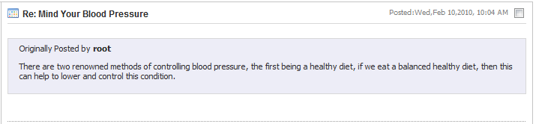
Approve posts
The function is used to approve pending posts in a topic that is set up with the 'Post moderation' option as the illustration below:
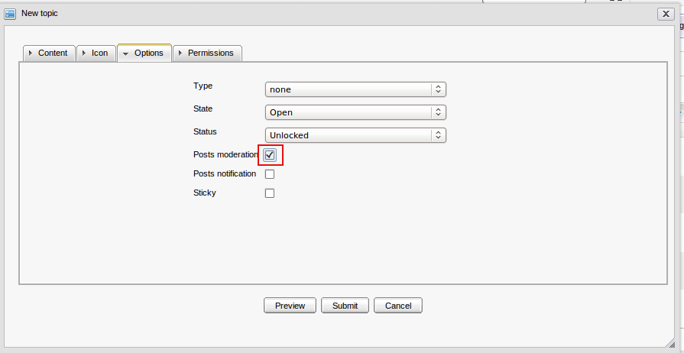
All new posts that are added into such topics will be in the 'pending for approval' status:
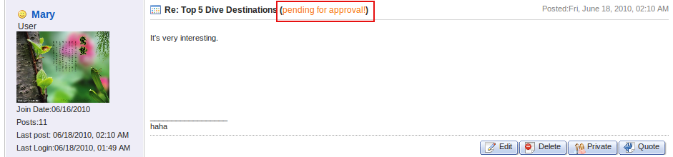

It means that nobody can view these posts except the administrator, the forum moderators and the creator of the topic. Only after the administrator/moderator or the creator approves, the post with 'pending for approval' status will be displayed and the 'pending for approval' status label will be removed, then normal users can view it.
Do as follows to approve pending posts:
Step 1: Click the More Actions on the topic bar and select Approve in the menu to open the Post to approve form.
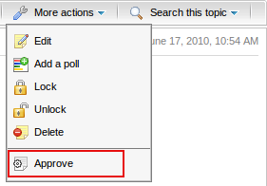
Step 2: In the Post to approve form, check the check boxes corresponding to the posts that you want to approve. To know the content of the post, move the mouse to the post and the content appears:
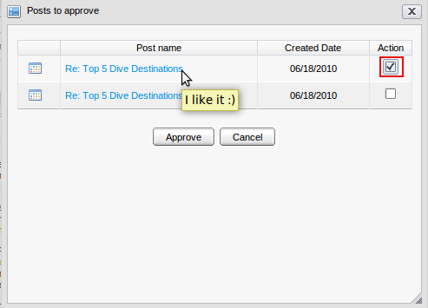
Step 3: Click the Approve button to accept approving it or the Cancel button to quit this form.
These posts will be approved and shown normally. Thus, normal users can view and take some actions with these posts.

Edit posts
This function is used to edit posts of topics. Addition to the administrators and moderators, the post creator can also take this action.
Do as follows:
Step 1: Click the button under the post that you want to edit.
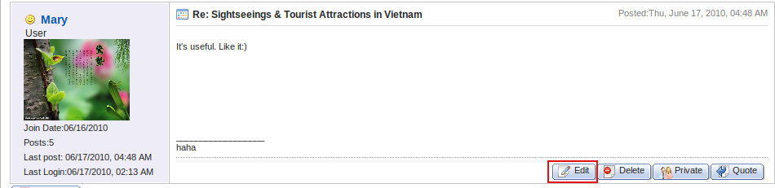
The Edit Post form will appear:

Step 2: Change the current information of the post, add or remove attachment, etc.
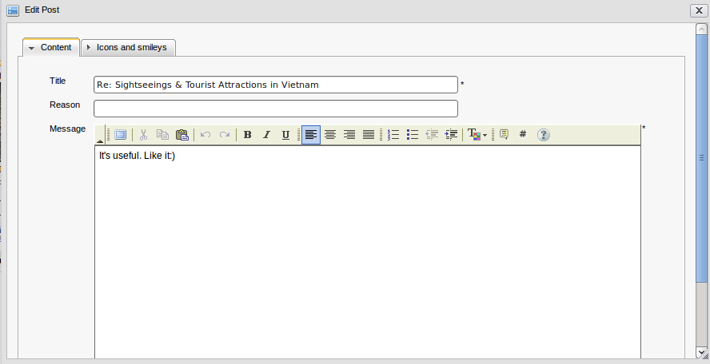Illustration 25: The Edit post form
Step 3: Complete editing the post by clicking the Submit button.

Delete posts
This function is used to remove a post from a topic. The administrator, moderators and the post creator can also take this action.
Do as follows:
Step 1: Click the button under the post that you want to delete.
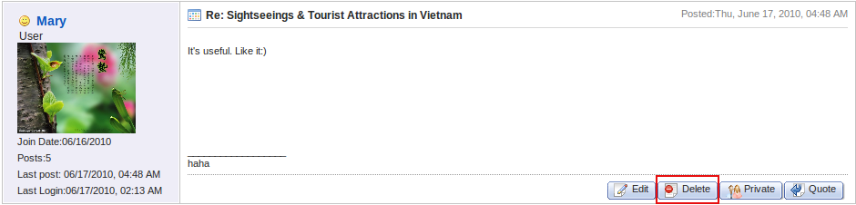
Step 2: Click the OK button in the confirmation message to delete the post or the Cancel button to quit.

Bookmark management
In the eXo Forum, a bookmark is the creation of a link to a category, forum or topic already visited, so that you can return to that category, forum or topic directly, without using a search engine or directory.

Add bookmarks
This function is used to add a link (a link to a category, a forum, or a topic) into the Bookmark form.
Do as follows:
Step 1: Go inside the object (category , forum or topic) that you want to add a bookmark
Step 2: Click the button on its main bar
or right click on the title of the object and select Bookmark in the menu.
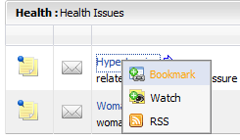
The selected link will be added into the bookmark table.
To view the bookmarked links, click the button on the main action bar.
The list of all bookmarked links will be displayed:
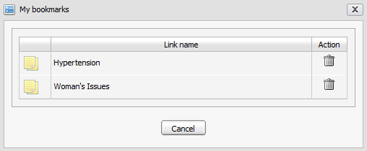Illustration 26: The My Bookmarks form

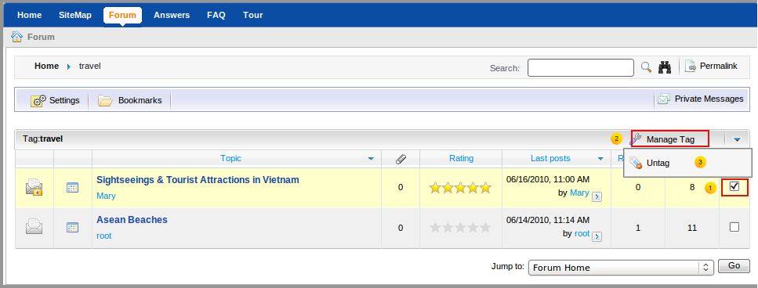
Search
This function is used to search existing forums, topics and posts according to specific search conditions. With the Quick Search and the Advanced Search, both anonymous and logged users can find expected result quickly and flexibly.
There are 2 type of searching: Quick search and Advanced Search

Quick Search
With the quick search, you can directly type a search term in the search field. All the forums, topics and posts that have a keyword matching the search term will be quickly displayed in the search result form.
Do as follows:
- To quick search any forum, any topic or any post simultaneously:
Step 1: Enter a search term into the 'Search' field at the right top of your screen after you have gone into the Forum application:
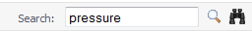
Step 2: Click the icon next to the search box to do search.
Step 3: All Forums/Topics/Posts in categories that match with the entered search term are listed in the search result form:
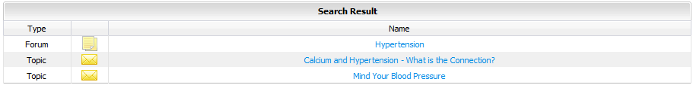
- To concurrently quick search forums/topics/posts in a specific category:
Step 1: Click on the name of the category that you want to do a quick search.
Step 2: Show the Search box by clicking the button on the category bar.
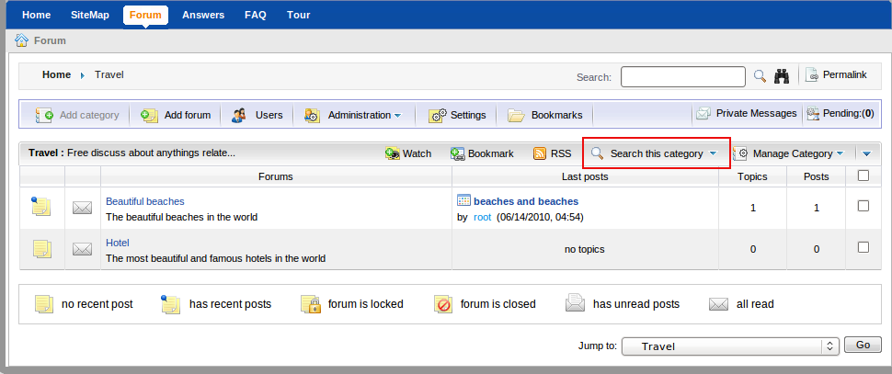
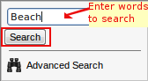
Step 3: Enter the information related to the objects that you want to search into the search box.

Step 4: Click the Search button to do searching. All matched objects will be displayed in the search result form.
- To quick search topics/posts concurrently in a specific forum:
Step 1: Go into the forum that you want to find topics/posts in it.
Step 2: Click the button on the forum bar to display the search box and then enter the search term that you want to find in this forum:
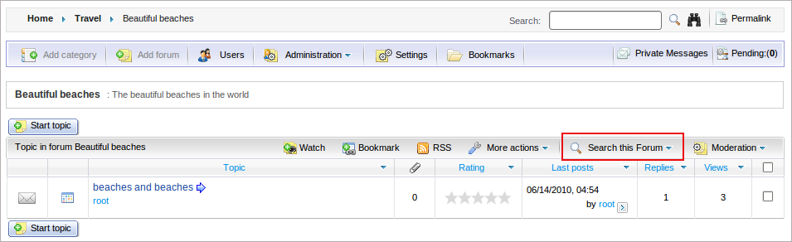
Step 3: Click the Search button to do search. All topics and posts in this forum that match with the entered keyword are listed in the search result form.
- To quick search posts in a specific topic:
Step 1: Go into the topic that you want to find posts in it.
Step 2: Click the button on the topic bar to display the search box and then enter the search term that you want to find in this topic.
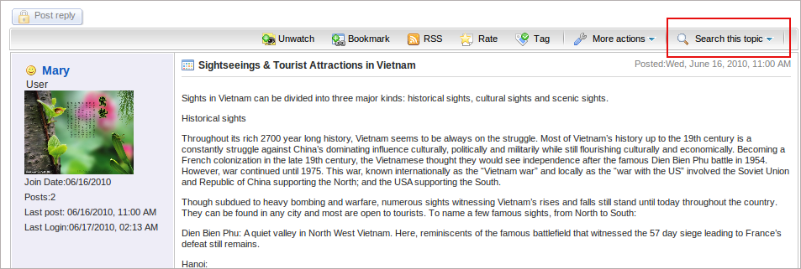
Step 3: Click the Search button to do search
Step 4: All posts in this topic that match with the entered keyword are listed in the search result form.

Advanced Search
The advanced search allows you to make a search with particular criteria corresponding to the object that is expected to be found. Using the advanced search, you can find forums/topics/posts more exactly.
Do as follows:
Step 1: Click the icon at the top right of the screen when you go into the Forum application or the icon in "search this category" or in "search this forum" or "search this topic" like the illustration below:
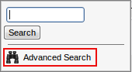
Step 2: Enter the values of properties corresponding to each object that you want to search.
Step 3: Click the Clear Fields button to reset the inputted values, click the Search button to do search or click the Cancel to escape.
The list of the found objects will be displayed in the search result form or there will have an alert message when no objects match with the inputted properties.
By default, the advanced search form will be displayed corresponding to the 'Category' object. But with 'Forum' or 'Post' object, properties of these objects will be different.
With a 'Category' object:
Details:
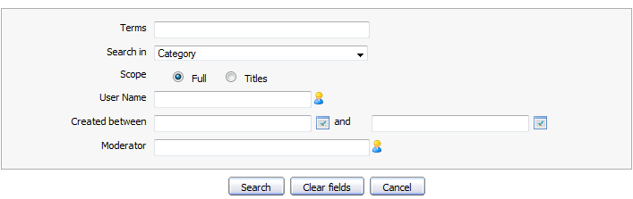Illustration 27: The Advanced Search- Search in Category
Terms | The keyword that you want to search.
Search in | The object that you want to search. If you want to find categories, the value of this field is 'Category'
Scope | The scope will be used to search. With the 'Full' option, the entered keyword will be matched with the entire object (includes both title and content). With 'Titles', the entered keyword only is matched with the object's titles.
User name | The user name of the object's creator that you want to search. Manual input or click the icon to select users from a specific group.
Created between and | The created date interval in which you want to search for categories. Manually input or click the icon to open the calendar pop up and select a date.
Moderator | The user name of the object's moderator that you want to search. Manual input or click the icon to select users from a specific group.

With a 'Forum' object:
Details:
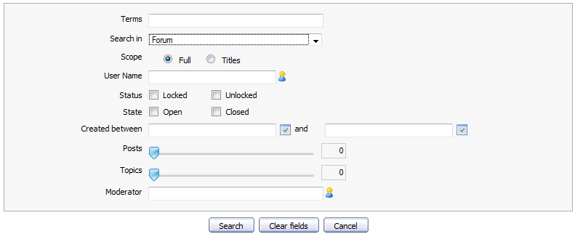Illustration 28: The Advanced Search- Search in Forum
Terms | The keyword related to forums that you want to search.
Search in | The object that you want to search. If you want to find forums, the value of this field is 'Forum'.
Scope | The scope will be used to search. With the 'Full' option, the entered keyword will be matched with the entire object (includes both title and content). With 'Titles', the entered keyword only is matched with the object's titles.
User name | The user name of the object's creator that you want to search. Manual input or click the icon to select users from a specific group.
Status | The status of forums that you want to search
State | The state of forums that you want to search
Created between... and | The created date interval in which you want to search for forums. Manually input or click the icon to open the calendar pop up and select a date.
Post | The interval of forum's posts number that you want to search in. Simply click and drag mouse on the slider bar to define the post interval.
Topics | The interval of forum's topics number that you want to search in. Simply click and drag mouse on the slider bar to define the topic interval.
Moderator | The user name of the object's moderator that you want to search. Manual input or click the icon to select users from a specific group.

With a 'Topic' object:
Details:
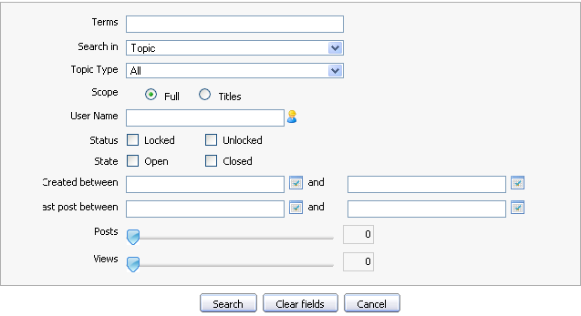Illustration 29: The Advanced Search- Search in Topic
Terms | The keyword related to the topic that you want to search.
Search in | The object that you want to search. If you want to find topics, value of this field is 'topic'
Topic Type | The type of the topic that specified by the topic type name and its icon. It can be selected from the existing list.
Scope | The scope will be used to search. With the 'Full' option, the entered keyword will be matched with the entire object (includes both title and content). With 'Titles', the entered keyword only is matched with the object's titles.
User name | The user name of the object's creator that you want to search. Manual input or click the icon to select users from a specific group.
Status | The status of topics that you want to search
State | The state of topics that you want to search
Created between... and | The created date interval in which you want to search for topics. Manually input or click the icon to open calendar pop up and select date.
Last post between - and: | The last post 's created date interval in topics that you want to search in. Manually input or click the icon to open the calendar pop up and select date.
Post | The number of topic's posts interval in which you want to search for those topics. Simply click and drag mouse on the slider bar to define post interval.
Views | The number of views interval of topics that you want to search in. Simply click and drag mouse on the slider bar to define the view interval.

With 'Post' object:
Details:
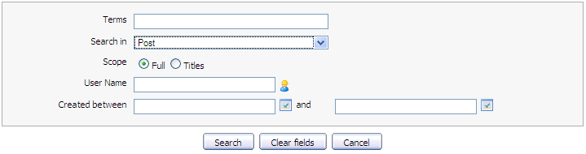Illustration 30: The Advanced Search- Search in Post form

Terms | The keyword that you want to search.
Search in | The object that you want to search. If you want to find posts, the value of this field is 'Post'.
Scope | The type will be used to search. With 'Search Entire', the entered keyword will be matched with the entire object (includes both title and content). With 'Search Title Only', the entered keyword only is matched with the object's titles.
User name | The user name of the object's creator that you want to search. Manual input or click the icon to select users from a specific group.
Created between... and | The created date interval in which you want to search for posts. Manually input or click the icon to open the calendar pop up and select date.
Search button | To do search on specific criteria.
Clear Fields button | To set blank or default entry for all inputted fields.
Cancel button | To close the search form

Delete bookmarks
This function is used to delete bookmark links from the Bookmark form.
Do as follows:
Step 1: Open the My bookmark form by clicking the Bookmark button in the main action bar.
Step 2: Click the icon corresponding to the link that you want to delete.
The selected link will be removed from the bookmark list.

Watch
This function allows you to keep track new changes to a specific category, a forum or a topic via notification emails. You only need to register an account, whenever there are new changes such new categories, new topics or new posts... you will receive a notification from the Forum application.
Do as follows:
Step 1: Go to inside the object (category, forum or topic) that you want to add watch Step 2: Click the button on its main bar
or right-click on the title of the object and select Watch in the menu:
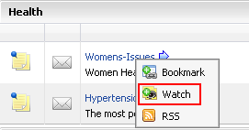
When a category/forum or topic has already been watched, the UnWatch item will appear in the right click menu or on its main bar with the purpose of removing the watch subscription on the currently selected category/forum/topic.
The watched objects are also listed in the My Subscriptions tab in the Settings form. When being unwatched, they also haven't been existed in this list.
The alert message that informs watching successfully is shown:
Users also receive the email notifications about new posts/ replies of the forum that has just been watched.
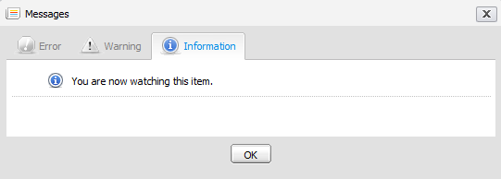Illustration 31: The Watch alert form
When new replies of the forum that you have watched have been posted, they will be notified in your email:
Click on the first click here in your email to go directly to the topic or the second click here to go to the topic and view the reply that has just been posted. The new reply will be displayed in the Quote form.
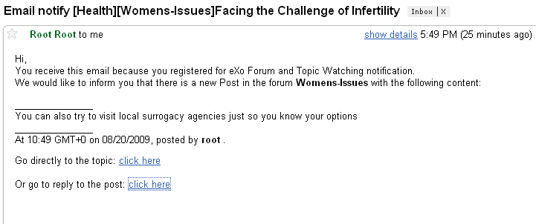Illustration 32: Email notification

Send private messages
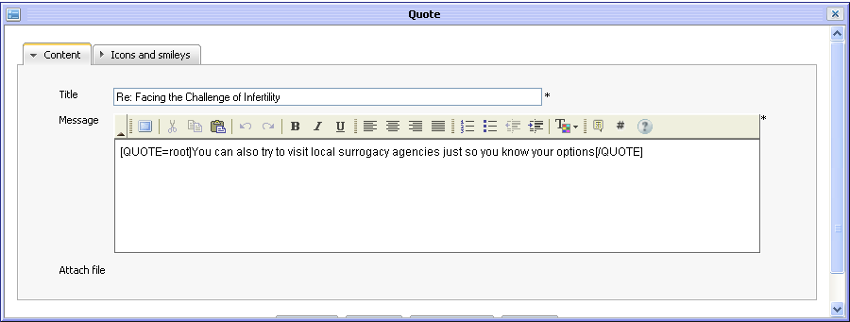Illustration 33: The Quote form
This function is used to exchange private messages among users.
- To send private message, do as follows:
Step 1: Go into the topic that contains posts of the user who you want to send a private message to.
Step 2: Click on a specific user name and select Send private message in the menu to send him a message:
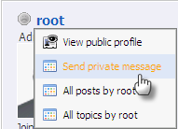
The Private Messages form will appear:
Details:
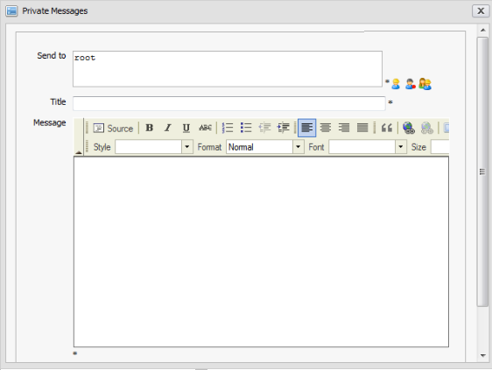Illustration 34: The Private Messages form
Send to | The user names of all users who will receive this private message. By default, value of this field is the user name of selected user
Title | The subject of private message.
Message | The content of private message.
Send button | To accept sending private message
Closet button | To close the Private Messages form.
To add more users in the Send to field, do as follows:
- Click the icon to select users from the groups list as the figure below. Firstly, select a group from the left list and then select an user on the right. The selected users will be displayed in the 'Send To' field.
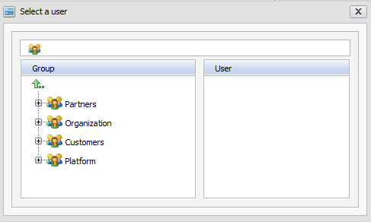
- Click the icon to select all users with a specific membership in a group. Firstly, select one group from the left pane and then select a membership on the right :
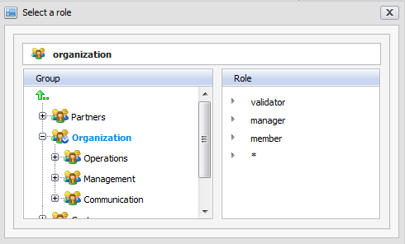
- Similarly, click the icon to select all users in a specific group.
Step 3: Enter values for the fields in this form.
Step 4: Complete sending message to users in 'Send to' field by clicking the Save button.
After signing in successfully, the receiver will see an alert with content Private Message (number private messages) at the right corner.
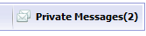
- To view these private messages, do as follows:
Step 1: Click on the inform message:
The Private Messages form will appear:
Step 2: Select each message in the list to view it.
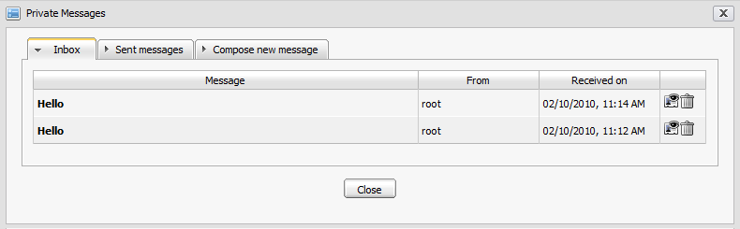Illustration 35: The Inbox tab of Private Message form
Details:
The Inbox tab includes all received messages, the reply and delete icons
The Sent messages tab includes all sent messages, the forward and delete icons.
The Compose new message tab is the form to compose a message.
Step 3: Click the icon to reply to the received message. The form to reply is shown:
- Enter the response in the 'Message' field. Do as above to add more receivers in the Send to field.
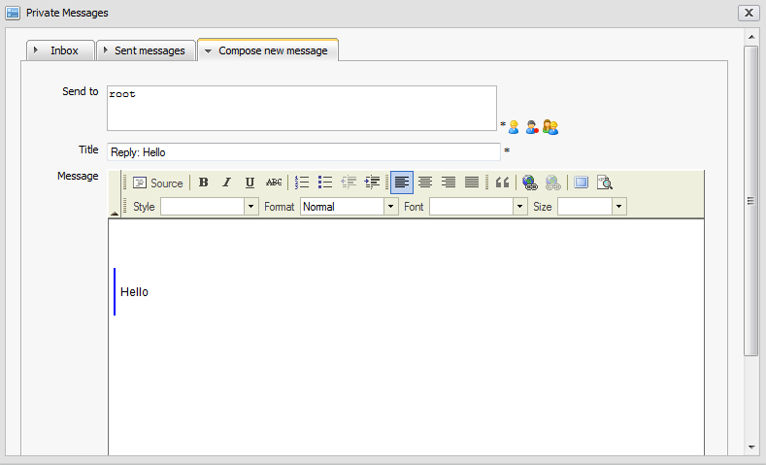Illustration 36: The Message tab in the Private Message form
- Click the Send button to send reply to the sender.
Step 4: Click the icon to delete the message corresponding to it. Click the OK button in the confirmation message to accept deleting or click the Cancel button to quit.

View all topics/posts
This function is used to view all topics/posts of a specific user.
Do as follows:
Step 1: Go into the topic that contains posts of the user who you want to view all his/her topics/posts.
Step 2: Click on a specific user name and select All posts by <screen name> or All topics by <screen name>.

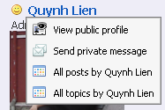
All topics/posts of selected user will be listed in the Posts/topics by user form:
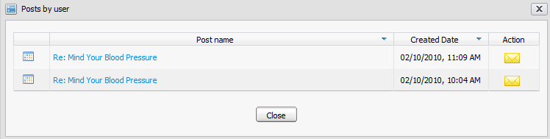Illustration 37: The Posts by user form
Step 3: Click the Close button to escape from this form.

Share links
This function allows you to view and copy the link to a specific forum/topic and share it with your friends or use for your own purpose.
Go into the Forum application and do as follows:
Step 1: Go to Forum/topic which you want to share link
Step 2: Click Permalink label at the right corner:
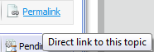
The link of the page you want to share will be displayed in the address bar of the Web explorer . You can copy and share it to the other.

RSS feed
This function provides RSS feeds that are used to get RSS of a specific category, forum, topic. Each time if there is any change, the feed of the corresponding category, forum or topic will be updated.
Do as followss:
Step 1: Right-click on a category, a forum or a topic that you want to get RSS
feeds and then select the RSS item in the menu.

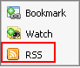
The detail information of the category/forum/topic will be displayed on another tab:

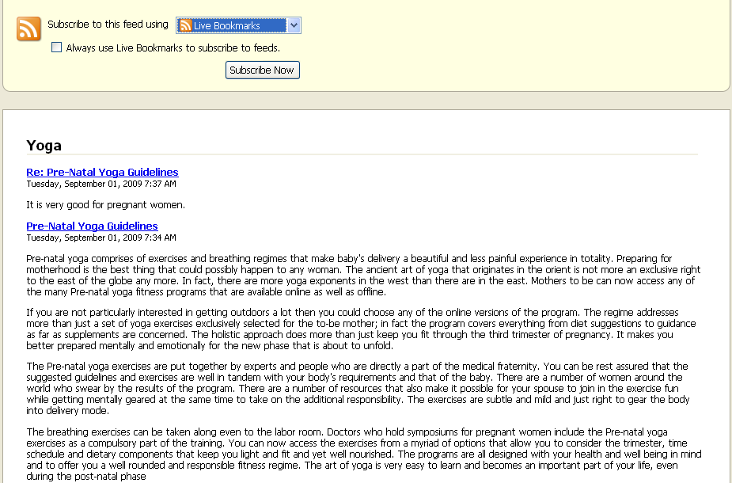
- Category feeds contain all posts from all topics in all forums in a category. The Category Feeds shows the title (title of the category), description (category description), link (permalink to the category), pubdate (creation date of the category).
- Forum feeds contain all posts in all topics in a forum. The Forum Feeds shows title (Name of the forum), description (description of the forum), link (permalink of the forum), pubdate (creation date of the forum ).
- Topic feeds contain all posts in a topic. The Topic Feeds shows title (Title of the topic), description (content of the topic's initial post), link (permalink to the topic), pubdate (creation date of the topic).
Private posts, Censoring Topics/Posts, Hiding Posts, Disapproved Topics/Posts don't go to the feed.

Conclusion
It is our hope that information stated above is valuable to you, our Corporate customers and users in the process of experiencing the eXo Knowledge applications. To clearly support for benefits recognition from customers and users, we would like to summarize major strengths of eXo Knowledge as follows:
- Based on mature and robust GateIn portal, the eXo Forum really brings about interesting experiences that facilitates users to solve and discovers all functions of the system.
- With the eXo Forum, the collaboration can be enhanced in such new but easy-to-use manner. Now, you can freely discuss in a space with multi-functions.
- From the certain standards, eXo Forum has created favorable conditions for every user everywhere with a series of networking features.
Our Corporate is always willing to receive any feedback, including errors and ideas that can make the guide better. Serving and resolving all issues related to the eXo Forum are our responsibilities, so please post your questions at our forum freely.
For more information about eXo and our products, please visit our homepage. Our Corporate is always willing to receive any feedback that can make the guide better. We also provides professional support via eXo Forum, where you can find useful advices and solutions to your issues.

REVISION HISTORY
Version | Date | Written by | Reviewed by | Change Record
1.0 | January 03th , 2009 | Hoang Anh Quynh Nga | Nguyen Thanh Cong
1.1 | March 18th , 2009 | Nguyen Thanh Cong | Hoang Anh Quynh Nga | - User Setting: change avatar  - User Setting: Option to receive mails, user watches  - One click watch  - Update/delete avatar  - Enhance User Profile menu
1.2 | May 22th , 2009 | Nguyen Thi Thanh Hoa | Luong Quynh Lien | - Informations of RSS feed  - Add poll in topic
1.2 | May 09th , 2009  August 20th | Nguyen Thanh Cong |  | - Tagging topic  - Topics Types.  - Screen name.  - View posts/replies in emal notification.  -Change screenshots.
2.0.0 alpha 3 | Feb 10th, 2010  March 29th , 2010  May 15th , 2010 | Luong Quynh Lien | Tran Thi Tra Giang  Vu Thi Hoa | - Upgrade  - Change screenshots  - Update  - Change screenshots  - Repair errors  - Fix the table of content
2.0.0 | June 18th, 2010 | Vu Thi Hoa |  | - Update  - Change screenshots  - Reorganize the content  - Add 3.4  - Apply the new style

