
eXo Social User Guide
Version 1.1
Contents
1 Preface 4
1.1 Overview 4
1.2 Why uses eXo Social 4
1.3 About this document 5
1.4 References & Related documents 5
2 Glossary 7
2.1 Social network 7
2.2 People 7
2.3 Profile 7
2.4 Connections 7
2.5 Request 7
2.6 Activity 7
2.7 Space 8
2.8 Space manager 8
2.9 Different visibility options for a group 8
2.10 Different registrations for a group available 8
3 People: Enterprise Social Networking 9
3.1 Update Profile 9
3.1.1 Change avatar 10
3.1.2 Change current position 11
3.1.3 Change basic information 12
3.1.4 Change contact information 12
3.1.5 Change experiences 13
3.2 Manage Connections 14
3.2.1 Search contacts 17
3.2.2 Send requests 18
3.3 Manage Activities 19
3.3.1 Update status 19
3.3.2 Share links 20
3.3.3 Delete activities 21
3.3.4 Comment on activities 22
3.3.5 Like/Unlike activities 22
4 Space: Community Management 24
4.1 Create new spaces 26
4.2 Edit space settings 31
4.2.1 Change space's information 31
4.2.2 Change space avatar 31
4.2.3 Manage visibility 31
4.2.4 Manage members 32
4.2.5 Manage space applications 35
4.2.6 Edit space's navigation 38
4.3 Leave spaces 39
4.4 Delete spaces 40

Preface

1.1 Overview
Beginning as an Open Source project in the year 2002, eXo is well-known as the industry's first Java portlet container. With the aim of dominating the potential portal market through robust and easy-to-use applications, eXo Project succeeded in attracting consumers in the whole world. eXo actually opened the floodgates to various options in many markets, and customers have been choosing eXo as the best method for their success.
The eXo Platform™ software is a powerful Open Source corporate portal and content management system. Users of the platform have a customized single point of access to the company's information system and resources.
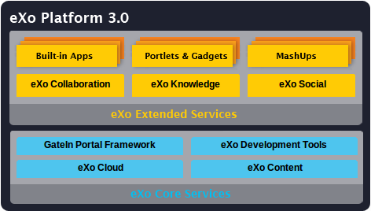
eXo Social is one of eXo Extended Services that provides a social network with much more features to share, and communicate between individuals and organizations. With eXo Social, it is easy to approach many easy-to-use social networking applications and more.

1.2 Why uses eXo Social
With eXo Social, users can do many actions with outstanding benefits, such as:
- Write Social Gadgets intuitively and easily: eXo Social provides built-in JavaScript client libraries for OpenSocial API, so developers can easily leverage data produced by Social-enabled applications to build mashups.
- Offer Rich Experience to Existing Applications: eXo Social provides end-users with features that are similar to social networking sites, such as Facebook and Linkedln, allowing users to establish more meaningful connections and improve communication and collaboration.
- Turn Company Directory into a Social Network: eXo Social provides users with the ability to add details to their profiles, like experience, skill and team information and to establish connections.
- Extend an Enterprise Social Network Easily: Built-in applications and other Extended Services can be added to collaboration features within eXo Social network, providing many capabilities like Calendar, Address Book, Chat, Email, and more.

1.3 About this document
The eXo Social User Guide is written as a handbook, aiming at instructing step-by-step on how to use this application quickly and efficiently.
The guide has been arranged into the following information:
- Preface: Overview, why uses eXo Social, information, and references.
- Glossary: Basic terms used in eXo Social.
- People: Enterprise Social Networking: How to work with People application, including updating profile, managing connections, and managing activities.
- Space: Community Management: How to work with Space, including creating, editing, leaving and deleting spaces.
The guide is aimed at everyone interested in learning and using the eXo Social application, especially for those who apply eXo Social with People and Spaces applications into their work and business.

1.4 References & Related documents
Information
- eXo Home Page
- eXo Wiki
Support
- Forums
- FAQ
Download
- eXo Content
- eXo Development tools
- GateIn Portal Framework
- eXo Collaboration
- eXo Knowledge
- eXo Social
Resource Center
- Video demos, tutorials, webinar archives, features & benefits tables and more

Glossary

Social network
Social network is not a new concept. It is a network of people who have some common things and want to share their works, interests via connections. The Social network combines multiple applications to create an easy connectivity among users. eXo Social aims at creating a favorable interaction for companies.

People
People is an application used to add profile information, connections among users. With People, profile information and connections can be managed and customized easily.

Profile
Profile is a set of information which can be entered and updated by users. This feature can improve the company directory's usability, such as basic information, avatars, experiences, contacts, and more.

Connections
Connections will display information about relations among users, including established connections, incoming and outgoing invitations.

Request
Request is the act of asking or expressing a connection desire that can be accepted, or denied by receivers and sending requests also can be canceled by users.

Activity
Activity is an application where users can do many actions, such as publishing their own respective activity stream, showing recent activities or updates, new connections or updating status and more.

Space
Space is a working environment where you can manage users and communities more conveniently. It enables you to regroup people by various interests or projects and to leverage any existing application, such as portlets or gadgets.

Space manager
Space manager is a user with special rights within a space. He can manage the list of members, configuration and install applications. When the user creates a space, he/she automatically becomes the space's manager who can validate space subscription requests.

Different visibility options for a group
- Visible: The space is always visible in the public spaces list.
- Hidden: The space is not visible in the public spaces list.

Different registrations for a group available
- Open: The user can join a space without any validation.
- Validation: The user's membership must be validated by a space manager.
- Close: The user cannot request for joining, but only the space manager can invite him.

People: Enterprise Social Networking

Update Profile
By default, the profile is just initialized with basic account information entered in the Registration form. You can complete your profile with more detailed information in Position, Contact, Experiences, and Avatar.
To go to Profile, hover your mouse over the display username (for example, Jonny Nguyen) on the administration bar and select Profile.
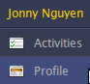
Or, click Activities and select Profile in the left pane.
The Profile page will be displayed as below:
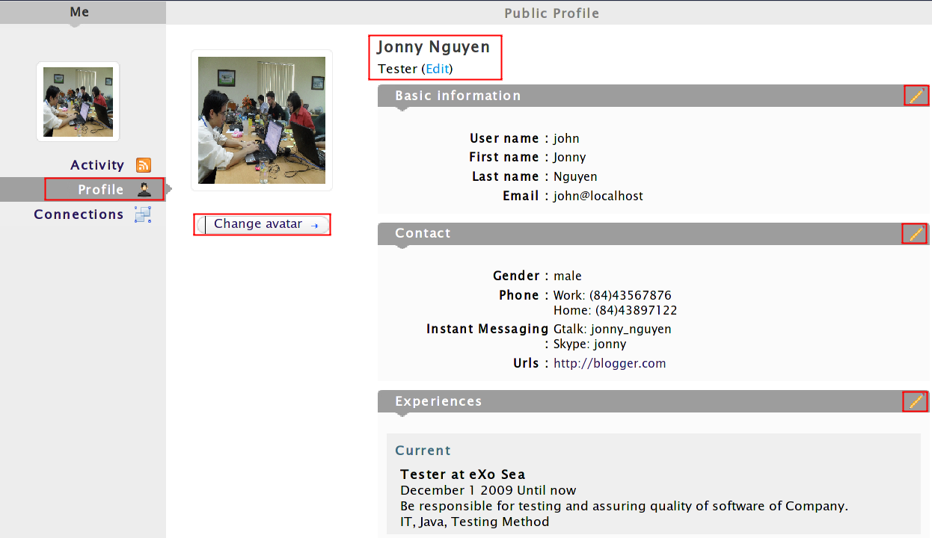

Change avatar
1. Click Change Avatar to open the Avatar Upload form.
2. Select and upload one photo which must be less than TWO MBs as your avatar.
3. Click Confirm to open the Avatar Preview form with some related information, such as file name, file type and image size. The avatar will be automatically resized to a suitable scale.
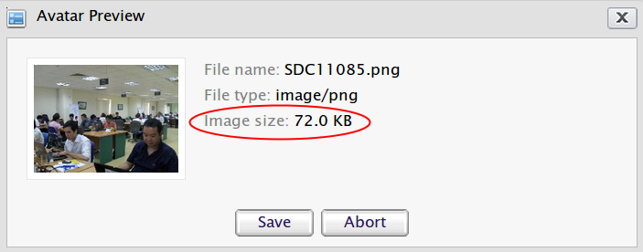
4. Click Save to accept your changes.

Change current position
1. Click Edit on the top of the Public Profile pane.
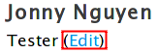
The form to update the current information will appear:
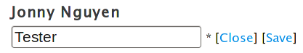
2. Enter your new position in the textbox and click Save. Your current position will be immediately updated.

Change basic information
1. Click to edit basic information. The Account Profile tab will appear:
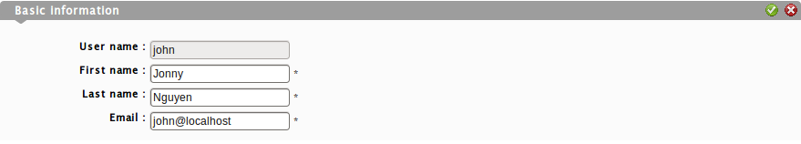
2. Change information related to your account, including Username, First name, Last name and Email.
3. Clickto accept all changes. There will be a message which informs the successful update. Click OK to accept.

You can also change your basic information by clicking your name directly on the administration bar. For more details, see GateIn User Guide.

Change contact information
1. Click that corresponds to the Contact pane.

2. Enter your information in fields, including Gender, Phone, Instant Messaging, and Urls.
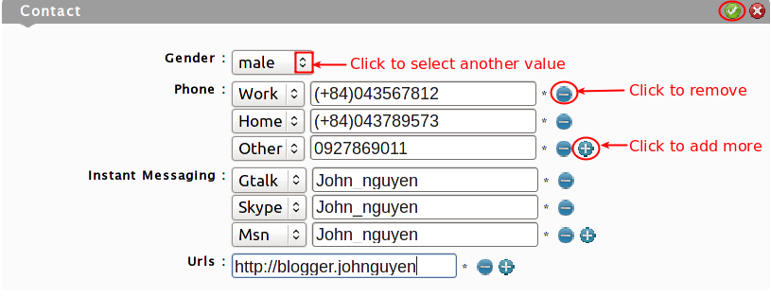
3. Clickcorresponding to each field you want to add more or to remove your entered information.
4. Click to save all changes.

Change experiences
1. Click that corresponds to the Experiences pane. The edit form will be displayed.
2. Enter your experiences into fields.
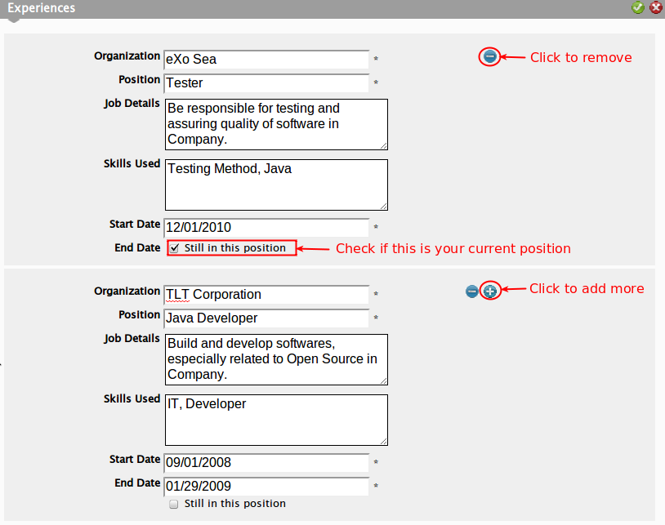
3. Click to save all changes.

Information entered in the Position field is only used for providing more details, not for searching. Meanwhile, information entered in the Skills Used field will be retrieved when you do the Search function.

Manage Connections
The Connections page lists all contacts who accepted as your contacts and who are waiting for your acceptance and contacts in request.
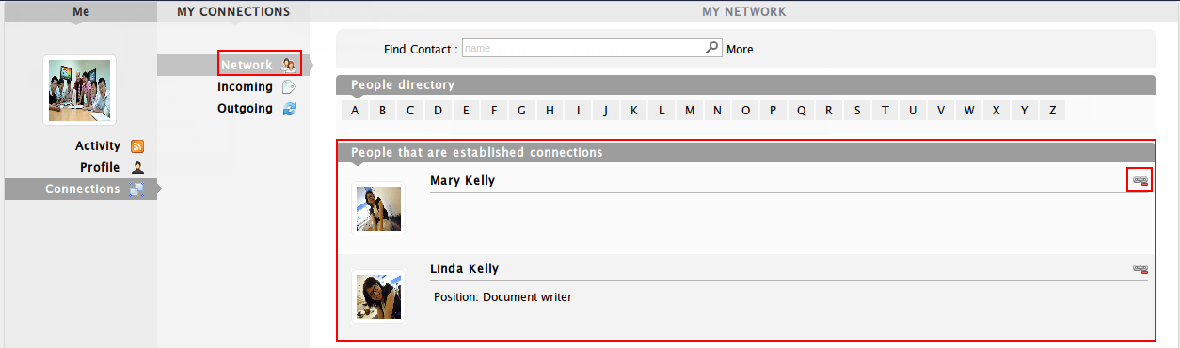
To enter Connections, hover your mouse over the display username (for example, Jonny Nguyen) on the toolbar, then click Profile → Connections in the left pane; or hover your mouse over People on the administration bar, and select Connections.
In the Network pane, you can remove connections with the users you do not want to be as your contacts anymore via one of two following ways:
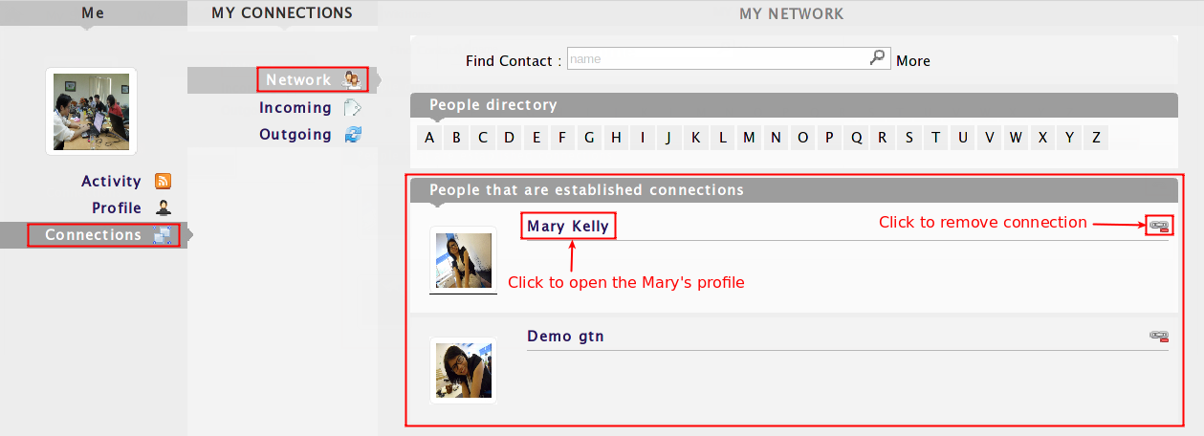
The 1st way: Clickcorresponding to your desired user to delete the connection.
The 2nd way: Click the name of user to go to the user's profile and then click the Disconnect the connection to Mary text to remove the connection.

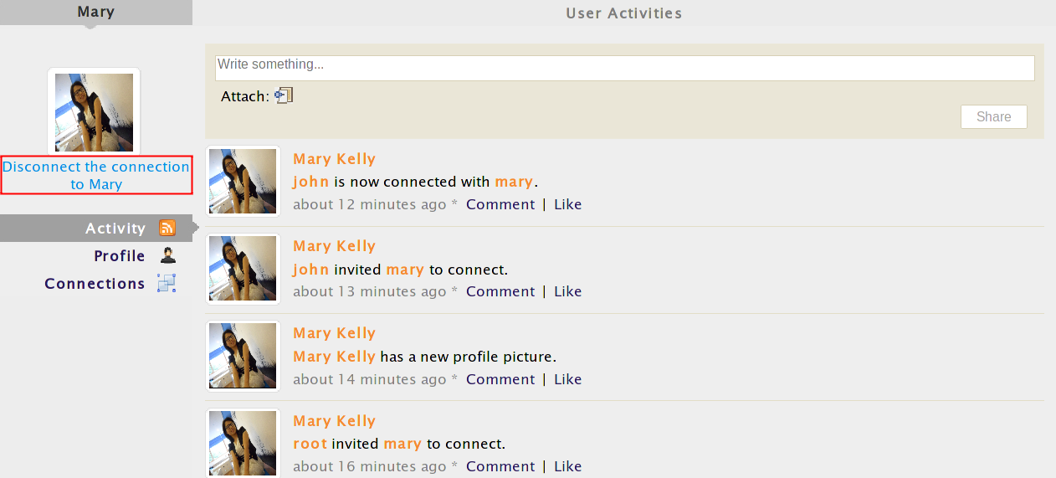
The Incoming pane lists users inviting you to connect with them. You can click to accept being as his/her contact or clickto refuse.
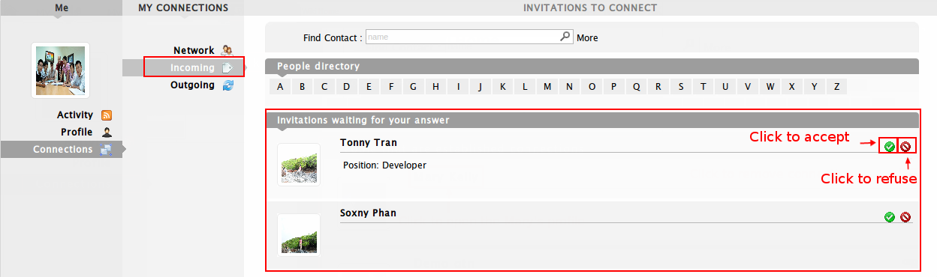
The Outgoing pane lists users you have sent requests for becoming your contacts. You can also click the corresponding icon to revoke your request.

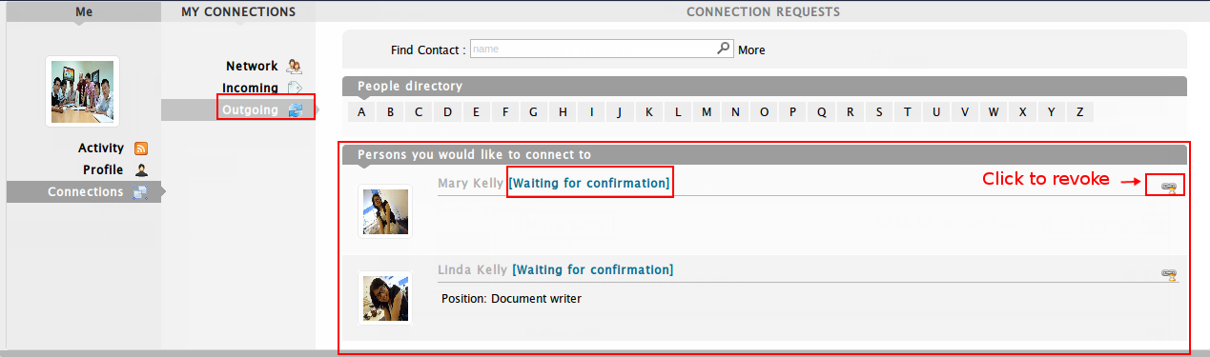

Search contacts
Click People. All contacts who use eXo Social will be listed in the People page.
The function enables users to search contacts conveniently as follows:
1. Enter the contact name you want to search in the Find contact field. With the auto-suggest feature, you only need to enter the first letter of contact name and select the suggested names if you see it right.
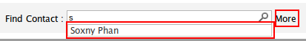
i. If you want to filter a contact with more information, click More. You can specify a contact filtering by position, skills and gender.
ii. If you do not want to filter contacts by above information, click Hide.
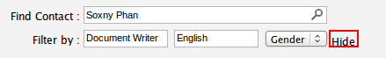
2. Click to find a contact. The results will be listed in the People Found pane:
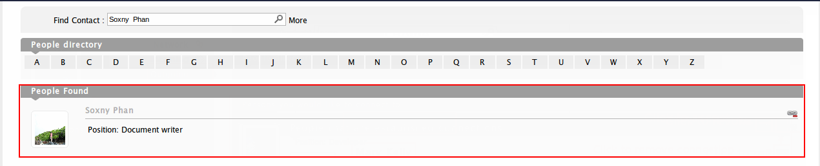

Send requests
1. Hover your mouse on People on the administration bar, then select Directory. All users will be listed in the People Found pane.
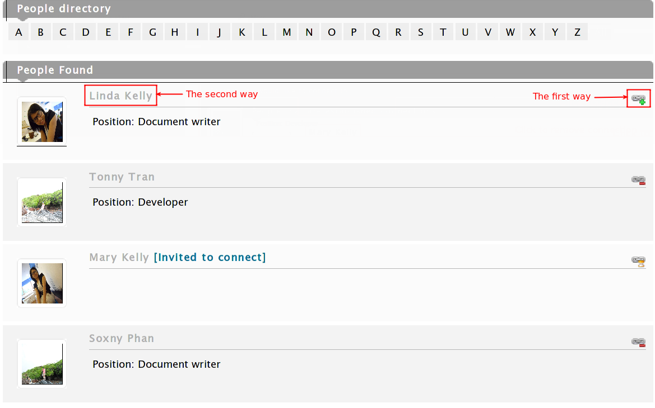
2. Invite your desired contact via one of two ways:
The 1st way: Click to send your connection request.
The 2nd way: Click the name of contact to go to his/her profile and then click Invite to connect below the avatar in the left pane.
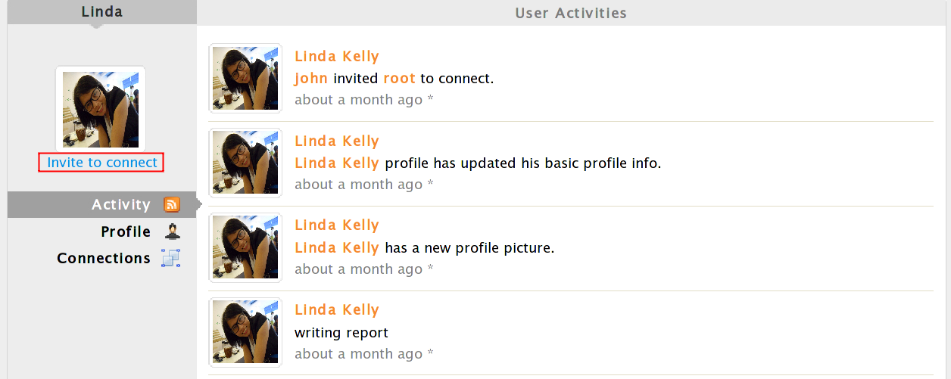
The textwill be displayed next to the contact name and the icon will be turned into the icon automatically. This means that your connection request is in the pending status until the invited contact confirms it.
To remove your request, simply clickor click the name of contact and select Revoke under the avatar in the contact's profile.
If someone sends requests to you, in the People Found pane, you can click to become their contact, or click to deny.

Manage Activities
To enter Activities, hover your mouse over the User Profile (for example, Jonny Nguyen) on the administration bar and select Activities:
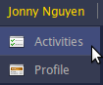
In the Activities, you can do the following actions:

Update status
1. Enter your current status in the Status Update form:
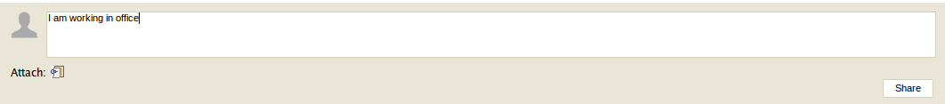
2. Click Share to accept sharing your status.
3. Click My Status below the Status Update form to see your own activities.
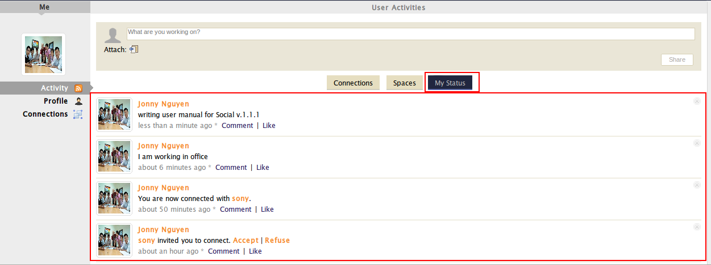

Share links
1. Click the Attach icon .
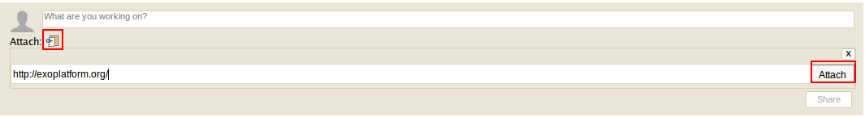
2. Enter the link into the Attach field and press Attach. If the link address is correct, it will be attached, then shown below the Attach icon with the overall introduction.
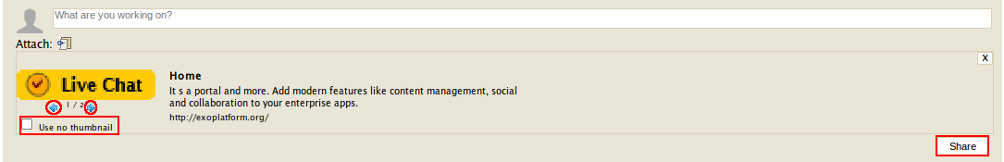
If you do not want the thumbnail to be displayed, select the Use no thumbnail checkbox. Similarly, deselect the checkbox to display the thumbnail. Also, if there is more than one thumbnail, you can click blue arrows to change the thumbnail.
3. Click Share to share with your connections. The link will be displayed in the My Status:
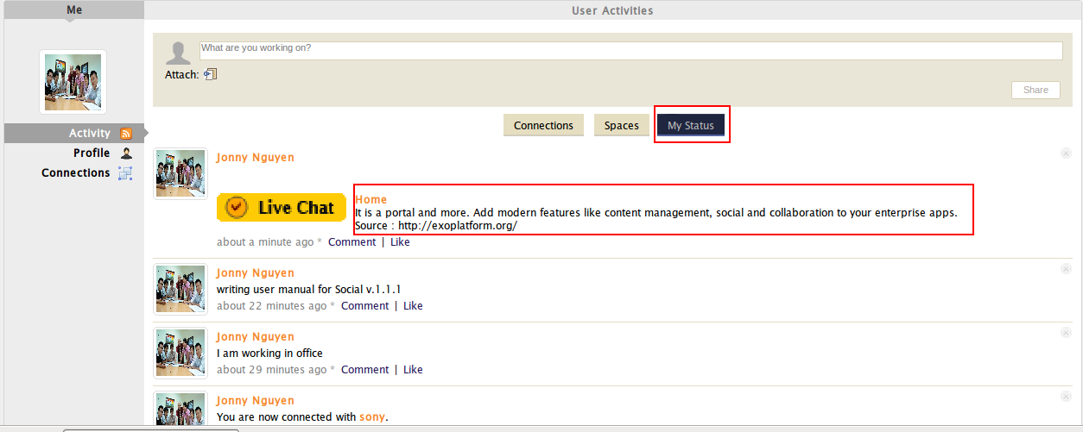

Delete activities
1. Click My Status to view all your own activities.
2. Choose one profile containing the activity you want to delete, then hover your mouse and click the icon . The confirmation message will be displayed.
3. Click OK to accept deleting your selected activity.
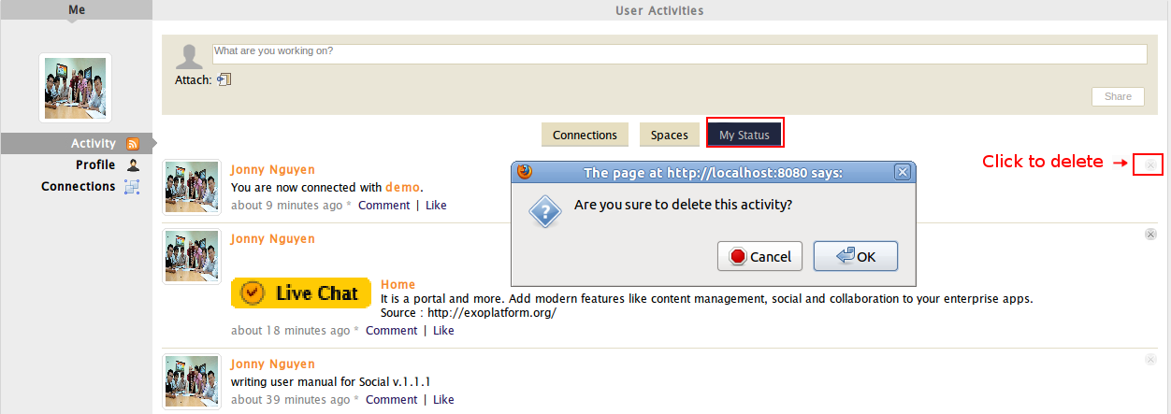

Comment on activities
1. Click Connection below the Status Update to see all activities of your established contacts.
2. Select one profile containing the activity you want to comment.
3. Click Comment in the bottom line of the profile. The Comment form will appear as below.
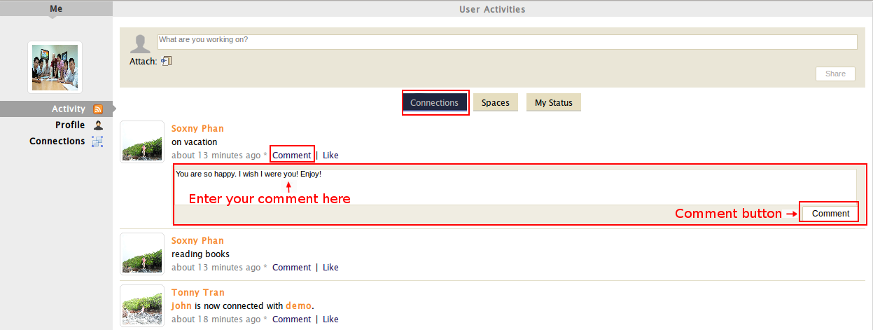
4. Enter your comment into the Comment form and press the Comment button.
Your comment will be displayed right below the profile and you can delete it by clicking .
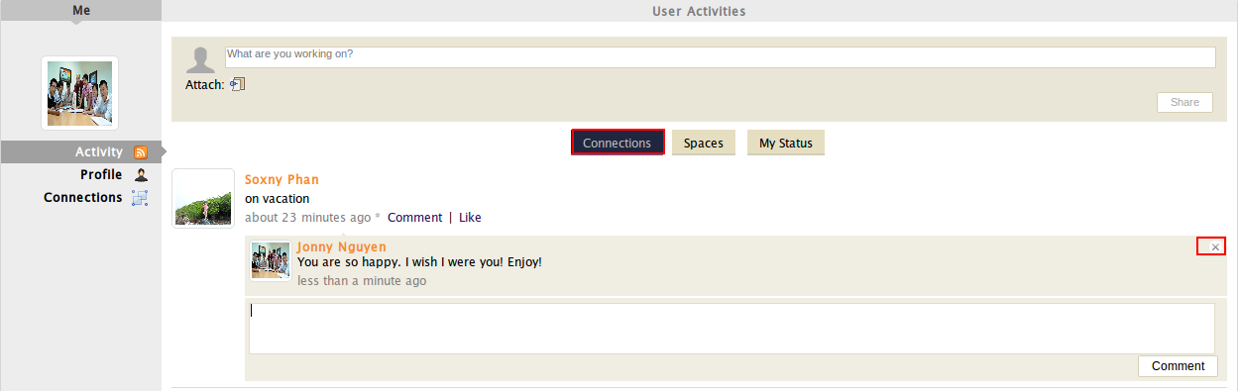

Like/Unlike activities
1. Choose the profile containing the activity you want to like or unlike.
2. Click Like beside Comment.
After you have chosen Like, the text 'You like this' will be displayed below and Like will be turned into Unlike.

You can Unlike one activity in the same way as steps when selecting Like.

Space: Community Management
Before using the eXo Space, you should have basic knowledge of GateIn. Before reading further, you need to learn how to login and navigate in GateIn.

To enter a space, click Spaces on the administration bar. The Space navigation on the left pane includes:
- My Spaces: lists spaces where you are member or manager.
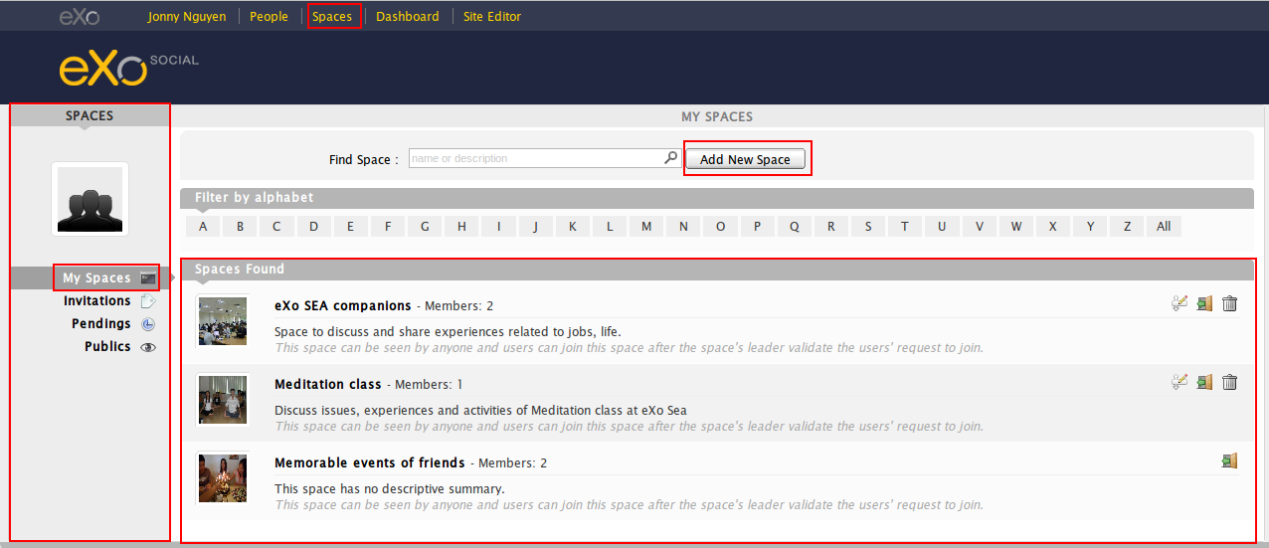
- Invitations: lists spaces where you are invited to become members by space managers.
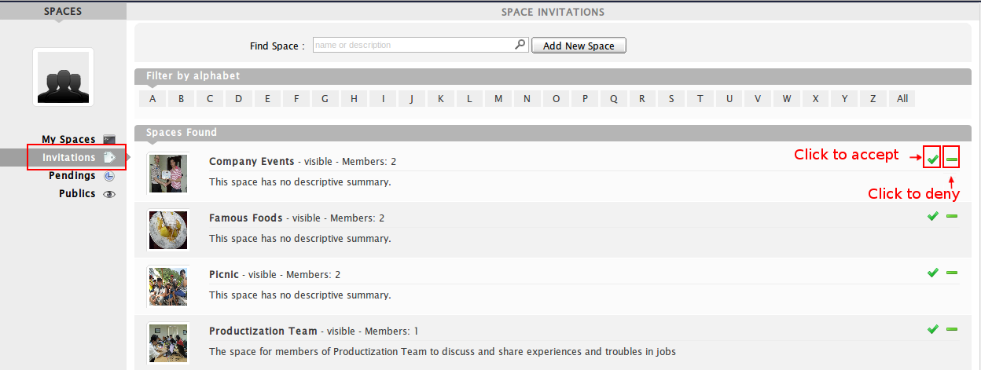
- Pendings: lists spaces where you have requested to become their members.
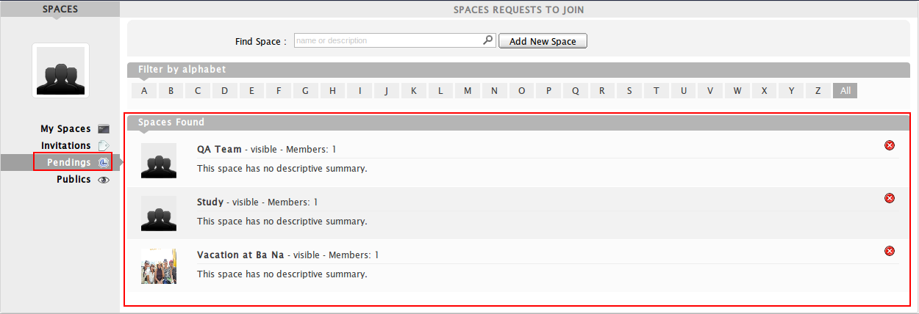
- Publics: lists all spaces which have been created with the Visibility value as Visible.
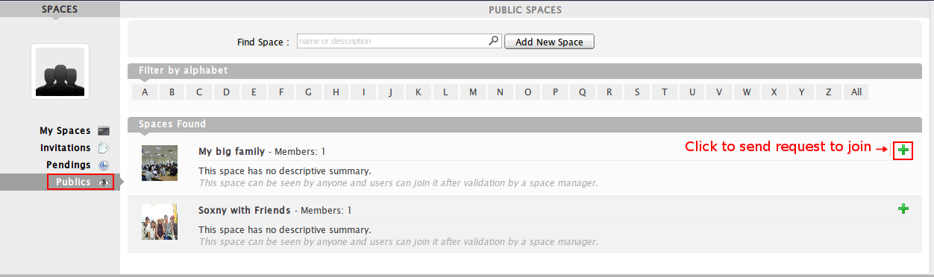
In the eXo Social, the administrators, who has the highest permission, can see all spaces whether they are members or not.

Create new spaces
1. Click Add New Space to open the Add New Space form.
2. Enter values for fields in the Add new space form.
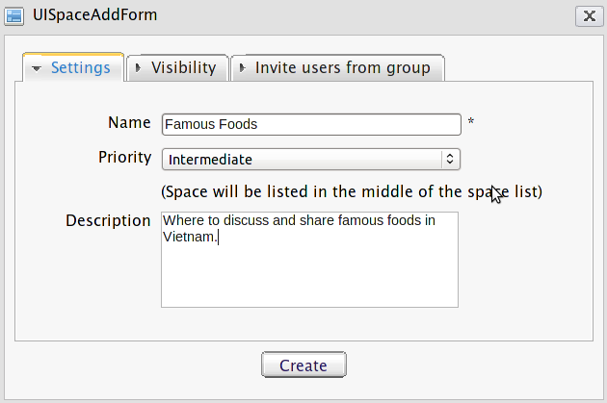
Details:
The Settings tab includes:
Name | Enter the space name which is required. Only alphabet, digit and space characters are allowed for this field.
Priority | Choose the preference order for the space, including three levels: High, Intermediate, and Low. There will be a textual explanations corresponding to each selected priority value.
Description | Enter detailed information about the space. (For example, the space is used for which purposes.)

When you input more than two space characters between words, these spaces will be converted to ONLY ONE space when being displayed. With space characters at the beginning and end of space names, these space characters will be omitted.

The Visibility tab:
Visibility | By default, the Visibility value is set to be Visible. This means this space is listed in the public spaces directory. If Hidden is selected, this space will not be listed in the public spaces directory.
Registration | By default, the Registration value is set Validation. If Open is checked, users who have sent requests will automatically become the space's members without any validation; or if the Validation is selected, users will become the space's members only after being accepted by this space's manager; or if Close is checked, users cannot send their requests for becoming members, except that they receive one invitation from the space manager.

The Invite users from group tab: enables you to select one target group ONLY for your space where you are already 'manager'. There will be TWO instances when you select the Invite users from group tab.
The 1st instance: If you have been already manager of any group, the Invite users from group tab will be displayed as below:
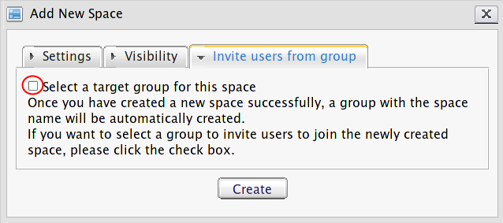
    - Tick the Select a target group for this space checkbox to open the selection form.
    - Select the group in the left pane and then click the Select this group to invite users text in the right pane to accept your selection.
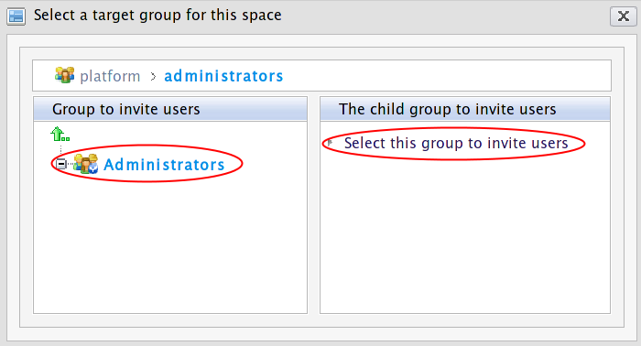
You will see your selected group as below:
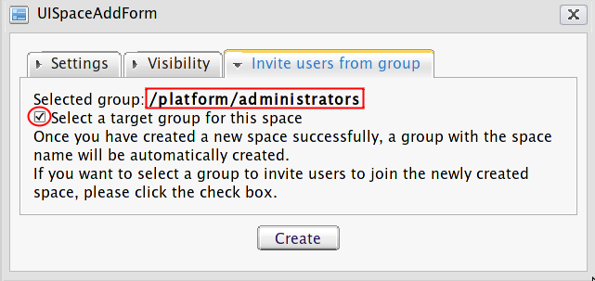
iii. Deselect the Select a target group for this space checkbox to remove your selected groups.
The 2nd instance: If you have not been a manager of any group, you can not select a target group as described in the illustration below:
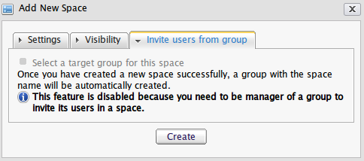
3. Click Create to complete creating a new space.
You will see your new space in the spaces list. Click and start exploring the space.

After being created, your space will be automatically added to the drop-down menu of Spaces from the administration bar. You can access this space by clicking there.

Edit space settings
This function enables you to change information of a space, manage members and applications if you are the space's creator or have a manager right on it. To enter the Space Settings, simply click the edit icon that corresponds to the space which you have the edit right.

Change space's information
1. Choose the Settings tab in the Space Settings.
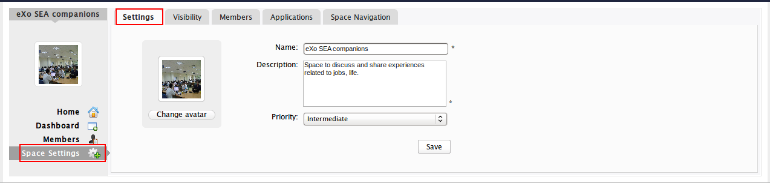
2. Change information you want to edit.
Details:
Name | The current name of space is required, so you cannot leave it blank.
Description | The brief description about the space that cannot be left blank.
Priority | The priority affects the space order in the space list.

3. Click Save to accept all changes.

Change space avatar
To change the space avatar, refer to the section 3.1.1.

Manage visibility
1. Select the Visibility tab.
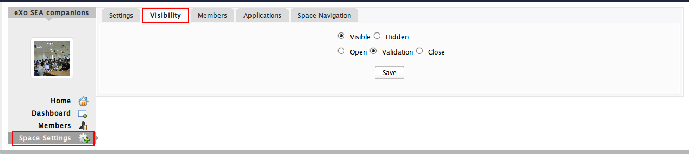
2. Change the Visibility and Registration modes to your needs. By default, Visibility is Visible and Registration is Validation. This means that your created spaces will be in the public mode and can be seen by other users.
3. Click Save to accept your changes.

Manage members
Click the Members tab to open the edit member interface:
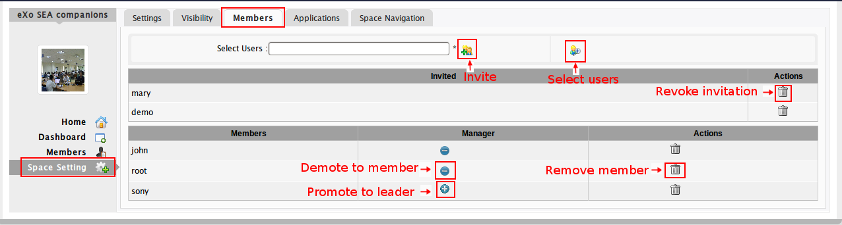
In this tab, you can take the following actions:
- Invite new members to join this space.
- Revoke invitations.
- Accept/Deny invitations.
- Promote/Demote users.
- Remove members.

Invite new members
1. Enter your desired username in the textbox and click.If you have multiple people to invite, you can enter multiple usernames separated by a comma.
If you do not know the username of a person who you want to invite, you can click to open the Select Users form:

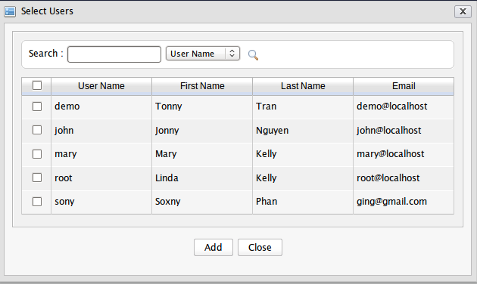
2. Search among members of a portal as follows:
- Enter a search term in the Search box.
- Select a criterion you want to find in the combo box next to this Search box.
- Click the glass icon to perform searching.
The results will be listed in the table below. Select users by ticking the corresponding checkboxes and click Add.
Then, click to invite your selected users. After inviting, you will see the list of invited users.

You can invite multiple users which will be separated by comma in the Select Users field.

Revoke invitations
If your invited users have not accepted your requests, you can revoke your invitations by clicking . The users will be removed from the Invited list column.

Accept/Deny invitations
This function enables you to accept and/or deny invitations that you received from others.
Spaces which are being waited for acceptance will be listed in the Invitations space:
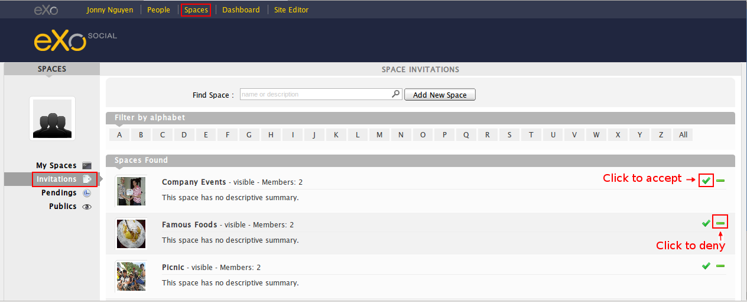
If you want to accept, click. If not, click.

Promote/Demote a member
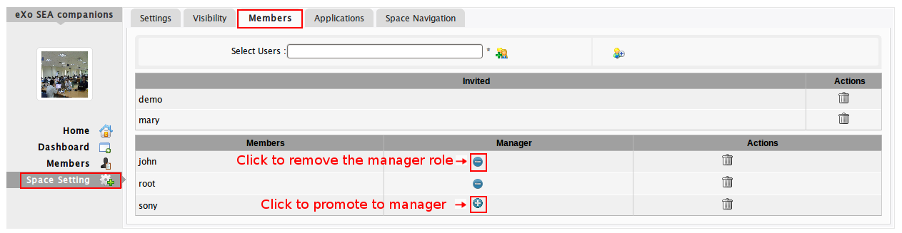
To promote a member to the manager position, clickin the Manager column. The user will be automatically promoted as a manager in the current space.
To demote a member, click. Be careful not to remove the rights for yourself; otherwise, you will not be able to edit settings anymore, except that you are an administrator.

Remove members
To remove members, simply click the correspondingin the Actions bar.

Manage space applications
To manage space applications, click the Applications tab to open the applications list:
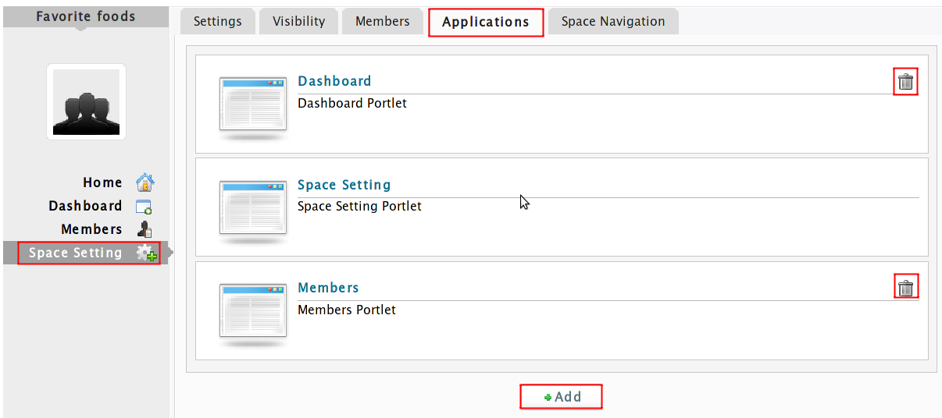
To remove an application, just click next to the application name. You cannot delete the Space Setting application because it is set as default.

Add new space applications
1. Click Add to open the available applications list:

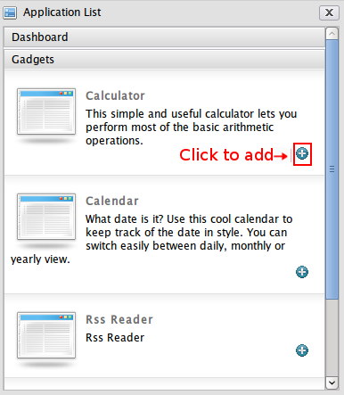
2. Select the application you want to install by clicking the corresponding icon.
If there is no available application, ask your system administrator to gain the access right.

Rename space applications
You can rename your added applications and the Dashboard application listed in the right pane as follows:
1. Click the relevant application.
2. Double-click the selected application until the input text box is displayed as below:
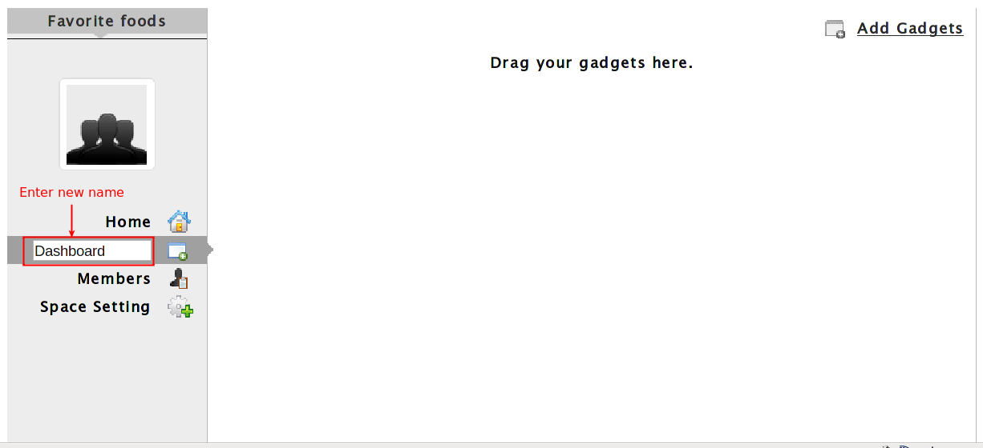
3. Enter the new name into the input textbox, for example "Workspace" and press Enter to save your new name. The position of applications will be changed to the alphabetic
order.

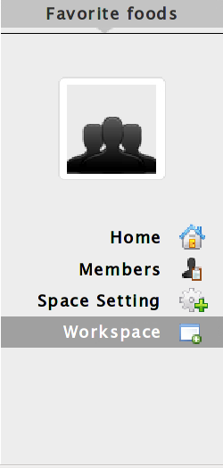

Edit space's navigation
1. Click the Space Navigation tab to open the space's navigation:

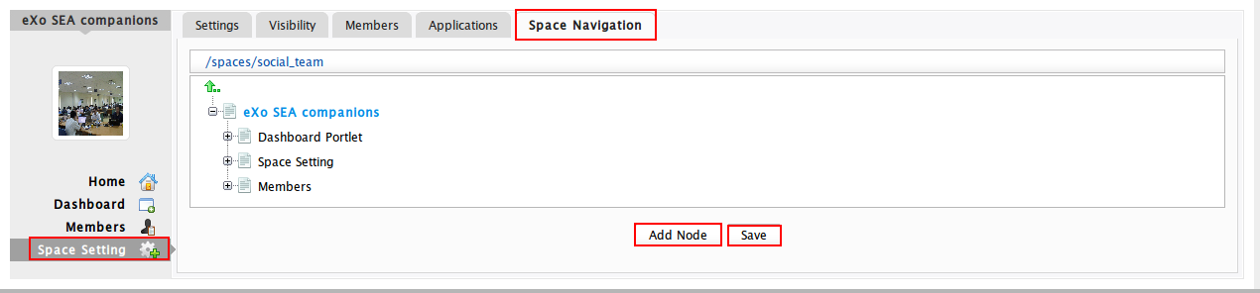
Users can take the following actions:
- Right-click the node name (space name) to add a new node, edit a node, edit a node's page, copy a node, clone a node.
- Click Add Node.
2. Click Save to accept all changes.

Leave spaces
You can quickly leave the space where you do not want to stay anymore or to be the space's member by clicking.
If you are the only leader of that space, the message which informs that you cannot leave a space will appear:
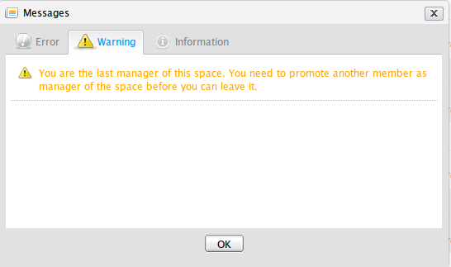
However, when you are only a member invited by the leader, you can leave the space by clicking.
After you have left a space, the space will not exist in My Spaces, but in Publics in the left pane.

Delete spaces
Only the space manager can delete their spaces by clickingto delete all information and navigations related to that space.

