
eXo Social User Guide
Version 1.0.1

Contents
1 Preface 5
1.1 Overview 5
1.2 Why Uses eXo Social 5
1.3 About this document 6
1.4 References & Related documents 7
2 Glossary 8
2.1 eXo People 8
2.2 Profile 8
2.3 Connection 8
2.4 Request 8
2.5 eXo Activity 8
2.6 eXo Spaces 8
2.7 Space manager 9
2.8 Different visibility options for a group 9
2.9 Different registrations to a group available 9
3 People: Enterprise Social Networking 10
3.1 Profile 10
3.2 Connection 13
3.2.1 Search Contacts 14
3.2.2 Send Request 15
3.3 Activities 16
3.3.1 Update Status 16
3.3.2 Share links 17
3.3.3 Delete activities 18
3.3.4 Comment activities 18
3.3.5 Like/Unlike activities 19
4 Space: Community Management 20
4.1 Create a space 20
4.2 Edit Space Settings 23
4.2.1 Change space's information 24
4.2.2 Change Space avatar 24
4.2.3 Manage the visibility 26
4.2.4 Manage members 26
4.2.5 Manage applications of a space 30
4.3 Edit a space's navigation 34
4.4 Leave spaces 34
4.5 Delete spaces 35
4.6 Administrate Spaces 35
4.6.1 Define access rights to Applications 36
4.6.2 Add users 38
5 Conclusion 41

Preface

Overview
Beginning as an Open Source project in the year 2002, eXo is well-known as the industry's first Java portlet container. With the aim of dominating the potential portal market through robust and easy-to-use applications, eXo Project succeeded in attracting consumers in the whole world. eXo actually opened the floodgates to various options in many markets, and customers have been choosing eXo as the best method for their success.
The eXo Platform™ software is a powerful Open Source corporate portal and content management system. Users of the platform have a customized single point of access to the company's information system and resources.
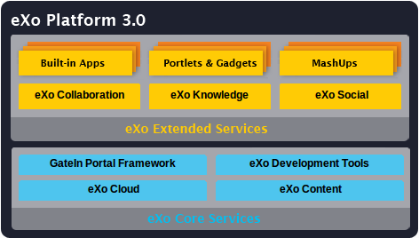
Developed on eXo Platform 3.0, eXo Social is one of eXo Extended Services that provides a social network with much more features to share, and communicate between individuals and organizations. With eXo Social, it is easy to approach many easy-to-use social networking applications and more.

Why Uses eXo Social
With eXo Social, users can do many actions with outstanding benefits such as:
- Write Social Gadgets intuitively and easily: eXo Social provides built-in JavaScript client libraries for OpenSocial API so that developers can easily leverage the data produced by social-enabled applications to build mashups.
- Offer a Rich User Experience to Existing Applications: eXo Social provides end-users with features that are similar to social networking sites Facebook and Linkedln, etc, allowing users to establish more meaningful connections and improve communication and collaboration.
- Turn Company Directory into a Social Network: eXo Social provides users with the ability to add details to their profiles, like experience, skill and team information and to establish connections based on defined and relationships.
- Extend an Enterprise Social Network Easily: Built-in applications and other Extended Services can be added to share collaboration features within eXo Social network, providing many capabilities like Calendar, Address Book, Chat, Email and more.

About this document
The book was written as a handbook, aiming at instructing step-by-step on how to use this application to the utmost. Thus, the information included herein will give basic steps that makes it easy for users to follow through in-depth examples and clear explanations. Whether you major in technology or not, you are able to learn about or work on eXo Social easily and efficiently.
The information provided in the guide has been arranged into such a way that ensures readers to search and implement them quickly. Initialized with the basic terms mentioned in eXo Social, the guide will give main knowledge about eXo Social. Next, the most important section so-called “Social Administration” will represent most of steps necessary in the process of using and mastering the eXo Social. Also in this section, the spaces administration is emphasized. And the last but not the least important part in guiding users is named as “Social Network Features” with many useful functions for meeting other demands by users and customers. And with the aim of helping users better understand eXo Social, we mentioned references and other resources in the Conclusion section.
The guide can be widely used for everyone interested in learning and using Social application. In particular, the manual can be used by the following groups:
- Normal users who use eXo Social with Spaces applications in their work and business.
- Integrators who want to know more about the rich knowledge features to give reasonable advices for their customers.
From above, the guide objectives can be summarized as follows:
- Define some basic concepts used in Social applications.
- Guide step-by-step for basic actions.

References & Related documents
Information
- eXo Home Page
- eXo Wiki
Support
- Forums
- FAQ
Download
- eXo Content
- eXo Development tools
- Gatein Portal Framework
- eXo Collaboration
- eXo Knowledge
- eXo Social
Resource Center
- Video demos, tutorials, webinar archives, features & benefits tables and more

Glossary

eXo People
eXo People is an application providing a way to add profile information, connections between users. With People, profile information and relationships can be managed and customized easily.

Profile
Profile is a set of information which can be entered and supplemented by users. This feature can improve the company directory's usability, such as basic information, avatars, experiences, contacts, and more.

Connection
Connection is to display information related to relations between users, including established connections, incoming and outgoing invitations.

Request
Request is the act of asking or expressing a desire for connections that can be accepted and/or denied by receivers and sending requests also can be cancelled by users.

eXo Activity
eXo Activity is an application where users can do many actions such as publishing their own respective activity stream, showing recent activities or updates, new connections or update status and more.

eXo Spaces
eXo Spaces is an application or a working environment which is made to create and manage users and communities more easily than with Portal. It helps regrouping people by various interests or projects and leverages any existing application such as Portlets or Gadgets to enable a collaborative work.

Space manager
Space manager is a user with special rights within a space. He can manage the list of members, configuration and installation applications. When a user creates a space, he automatically becomes the space's manager who can validate space subscription requests.

Different visibility options for a group
- Visible: The space is always visible.
- Hidden: The space is not listed in the space list.

Different registrations to a group available
- Open: The user is free to join a space without any validation.
- Validation: The user's membership has to be validated by a space manager.
- Close: The user cannot request for joining, only a space manager can invite him.

People: Enterprise Social Networking
Before using the eXo Space, you should have basic knowledge about GateIn. Before reading further, you need to learn how to login and navigate in GateIn.

Profile
By default, the profile information is just initialized with basic account information entered in the Registration form. You can complete your profile with more detailed information.

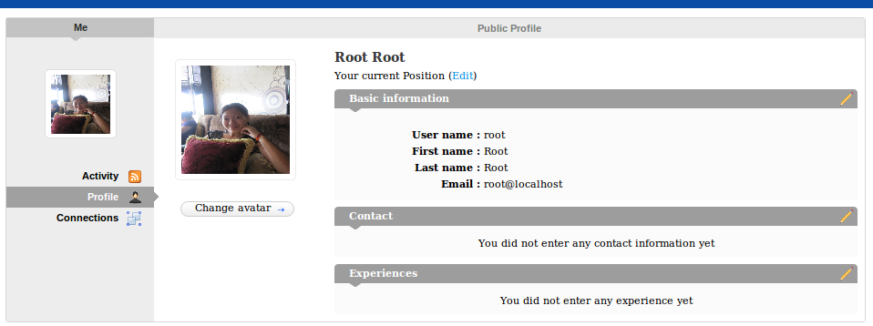
Change avatar
To change avatar, see more details in the section 4.2.2.

Change current position
To change the current position, do as follows:
Step 1: Click Edit. The form to update the current information will appear:
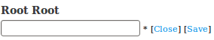
Step 2: Enter your new position in the text box and click Save. It immediately updates your current position.

Change basic information
To change basic information, do as follows:
Step 1: Click the icon in order to edit basic information. The Account Profile tab will appear:
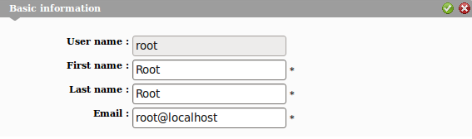
Step 2: Change information related to your account.
Step 3: Click the iconto accept all changes orto delete these input information. After clicking , there will be a message which informs that the account information has been updated.
Step 4: Click OK
Step 5: Click Close button to close this form after changing.

Change contact information
To change contact information, do as follows:
Step 1: Click the icon that corresponds to the Contact pane. The form to edit contact information will display:
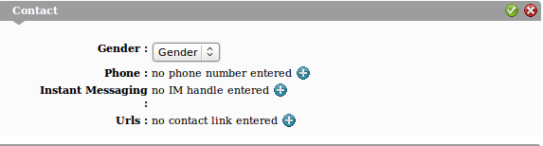
Step 2: Select a value for the Gender field.
Step 3: Click the iconthat corresponds to fields which you want to update: Phone, Instant Messaging and Urls.
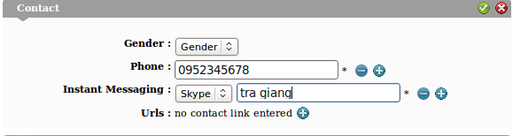
Step 4: Click the icon to save all changes or the icon to close this form without any change.

Change Experience
To change Experience, do as follows:
Step 1: Click the icon that corresponds to the Experiences pane. A form will display that allows you to edit this information.
Step 2: Click the icon to open a form that allows you to enter information related to your experience.
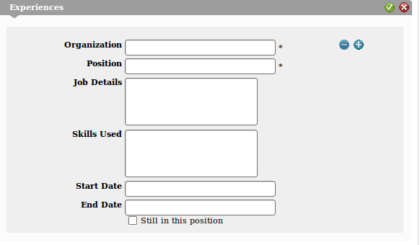
The beside the is used to delete this experience.
- Input values for fields: Organization, Position, Job Details, Skills Used, Start Date, End Date and Still in this position.
- After updating information, click the icon to save all changes or the iconto close this form without saving any change.

Connection
Click Connections in the left pane, or hover your mouse over People on the Administration bar and select Connections. The Connections page lists all contacts who accepted as your contacts as well as the contacts are waiting for your acceptance and the contacts are in request.

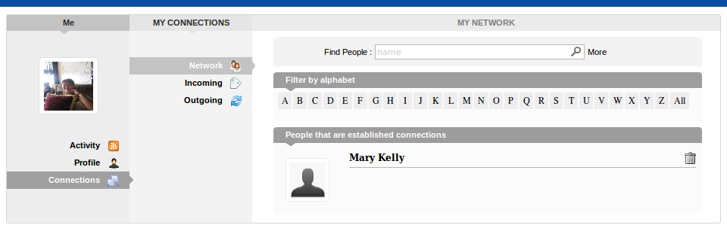
In the Network list, you can delete the users if you don't want to be as your contact anymore by clicking the icon .
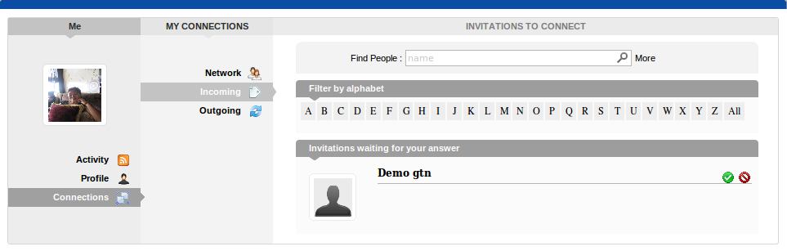
The Incoming pane lists contacts that are inviting you as their contact: You can click the icon to accept being as his/ her contact or click the icon to refuse.
The Outgoing pane lists contacts that you are requesting as your contact. You also can click the icon that correspond to users who you want to remove your request.

Search Contacts
Click People, all contacts who use eXo Social are listed in the People page. The Search function facilitates users to search contacts conveniently:
Step 1: Enter the contact name that you want to search in the Find contact field:
- If you want to filter a contact with more information, click the More label that lies behind the Search text box. More fields: position, professional, gender will appear in order to specify a contact.
- In case you don't want to filter contacts by these information, you can click the Hide label to hide. These search results will be listed with all contacts who have the same names as compared to the name that you entered in the Search text box.
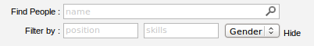
Step 2: Click the magnifying search icon to find a contact. The Search results will be listed below:
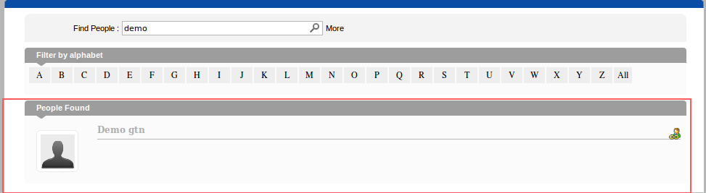

Send Request
You easily send a request by following these steps:
Step 1: Click the icon which corresponds to the contact that you want to send a request.
The contact name will display a text , it means that your connection request has been pending until your contact confirms it.
You can also click the icon to remove your request to that contact.
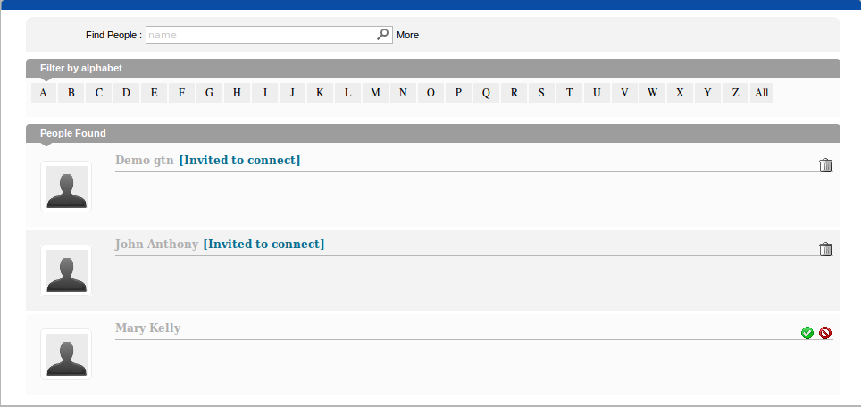
Others can send requests for you, in People listing you can see two icons that correspond to that user.
- Click the icon to become the user's contact.
- Or click the icon to refuse becoming the user's contact.

Activities
To enter Activities, hover your mouse over the User Profile icon on the administration bar and select Activities:
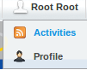
In the Activities, you can do the following actions:

Update Status
To change your status, do as follows:
Step 1: Enter your current status in the Status Update form:
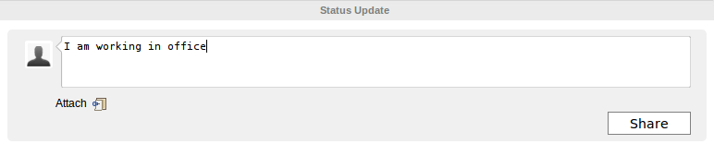
Step 2: Click the Share button to accept sharing your status.
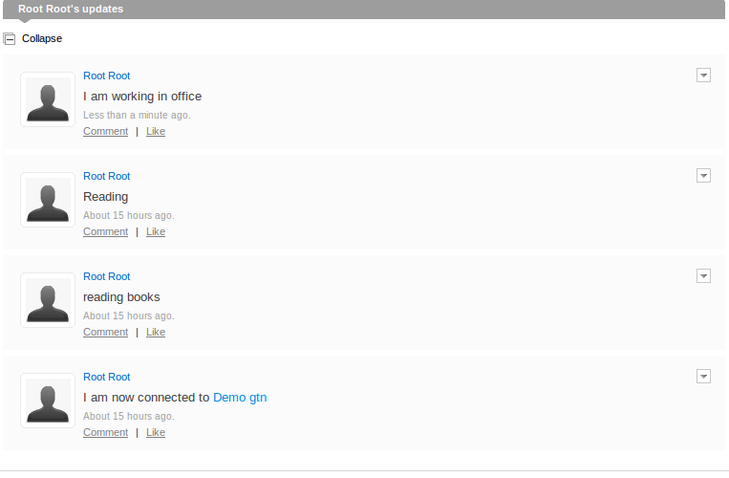
In the Activity space, you can see your own activities by clicking Expand icon. Your contacts' activity stream is displayed above.

Share links
You can share your prefered links as follows:
Step 1: Click the Attach link icon .
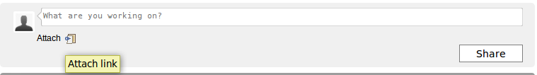
Step 2: Enter the link into the Attach field and press the Attach button. If the link address is correct, it will be attached, then shown below the Attach link line with the link's overall introduction. Click the Share button if you want members to see it or the link to be displayed in your updates as below:

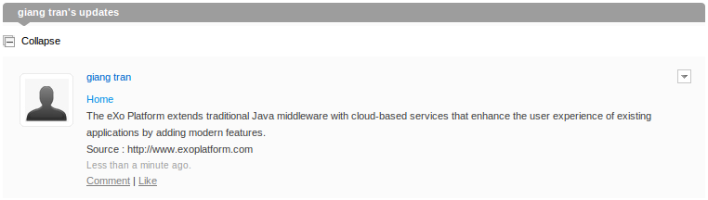

Delete activities
To delete an activity, do as follows:
Step 1: Choose one profile containing the activity you want to delete and hover your mouse over the icon .
Step 2: Click the Delete icon. The selected activity will be deleted.
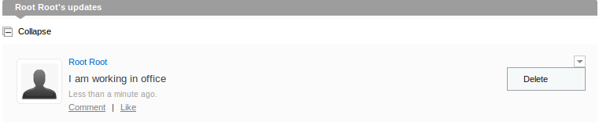

Comment activities
To comment activities, do as follows:
Step 1: Choose one profile containing the activity you want to comment
Step 2: Click the Comment in the bottom line of the profile. The Comment form will appear below the Comment.
Step 3: Enter your comment into the Comment form and press the Comment button.
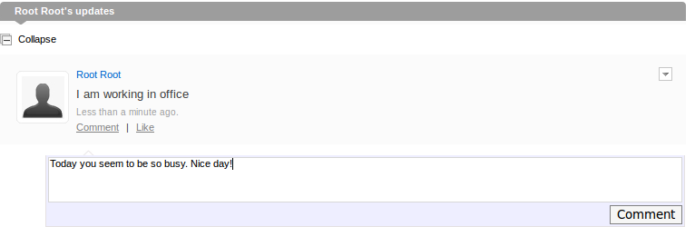
Your comment will be displayed right below the profile and you can delete your comment by clicking the X icon.
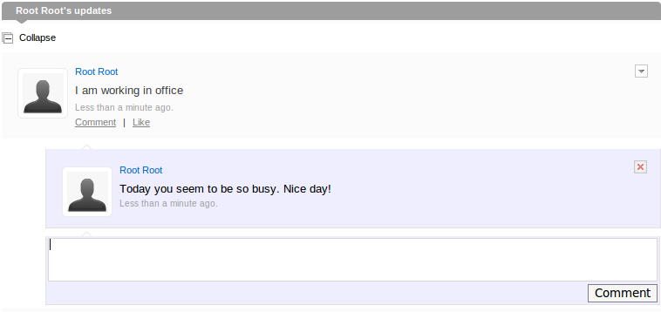

Like/Unlike activities
You can show your interest by choosing to like/unlike activities as follows:
Step 1: Choose the profile containing the activity you want to like/unlike.
Step 2: Click Like beside Comment.
After you choose Like, a text 'You like this' will be displayed below the Profile form and Like will be turned into Unlike.
You can choose to Unlike one activity in the same way as steps for Like.

Space: Community Management
Before using the eXo Space, you should have basic knowledge about GateIn. Before reading further, you need to learn how to login and navigate in GateIn.

Create a space
To create a space, do as follows:
Step 1: Click Spaces on the administration bar.
Step 2: Click Add New Space button below the space list.
The Add New Space form will appear:
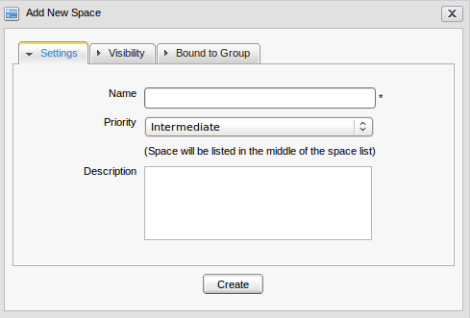Illustration 1: The Add New Space form
Details:
The Settings tab includes:
Name | The space's name to be created that must be filled. Only alphabet, digit and space characters are allowed for this field.
Priority | The preference order which is applied for a space, including three priority levels: High, Intermediate, and Low. There will be three textual explanations corresponding to 3 priority values.
Description | This field is to fill detailed information about the space, such as the space is used for which purposes.

When you input more than 2 spaces between words, these spaces will be converted to ONLY ONE space character when being displayed. With space characters at the beginning and end of space names, these space characters will be omitted.

The Visibility tab:
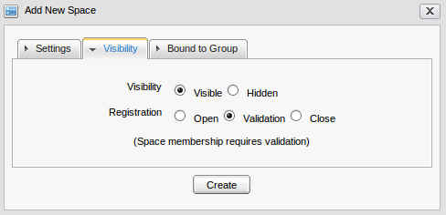Illustration 2: The Visibility tab in Add New Space form
Visibility | By default, the Visibility value is set to be Visible that means this space is visible to public spaces. If Hidden is selected, it means this space is invisible to public spaces.
Registration | By default, the Registration value is set to be Validation. If Open is checked, users will automatically become the space's members after sending requests; or if the Validation is selected, users will become the space's members after being accepted by this space's manager; or in case Close is checked, users are unable to send a request to this space, only this space's manager can send requests to users.

The Bound to Group tab: allow users to bind a space ONLY to groups where they are already 'manager'. If one user is the group's manager, the group will be displayed in the group list for choice. When one space is created by Bound to Group, the group's members will be invited to be members in that space.
Select the Use an existing group checkbox if you want members of the selected existing group to become this space's members. The Use an existing group will appear:
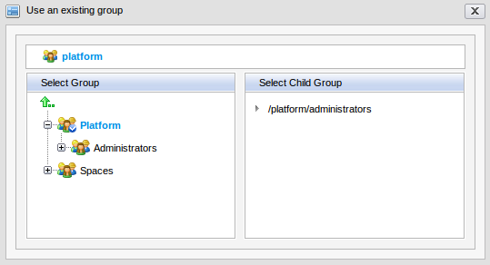
After an existing group has been selected, all users in that group will be the space members with the manager role by default.
Step 2: Enter values for fields in the Add new space form.
Step 3: Click Create to complete adding a new space.
You will see your new space in the list. Click its name and start exploring it.
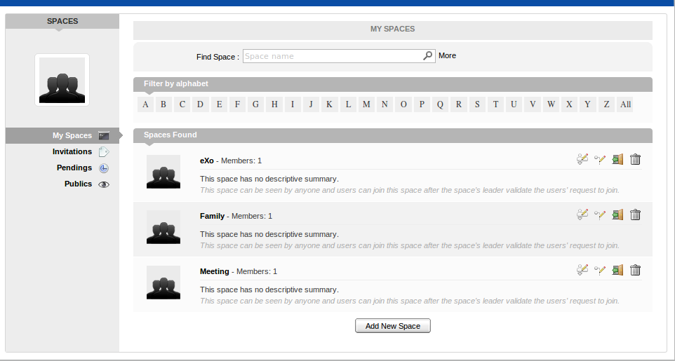Illustration 3: The Space Listing in My Spaces form

Edit Space Settings
This function allows you to change setting information of a space, manage members and applications if you are the space's creator or have a manager right on it. Follow these steps:
Step 1: Click the icon that corresponds to the space which you have the edit right.
Step 2: In the Settings tab, change information related to the space:
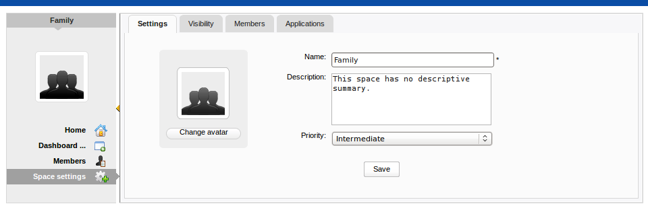Illustration 4: The Setting tab in the Space form

Change space's information
This function allows you to edit basic information about a space.
Step 1: Change information that you want to edit.
Details:
Name | The space's current name. This field is required, so you can not leave it blank.
Description | The space's brief description.
Priority | The priority affects the space order in the space list.

Step 2: Click Save to save all changes.

Change Space avatar
You easily change your avatar by following these steps:
Step 1: Click the Change Avatar button to open the Avatar Upload form:
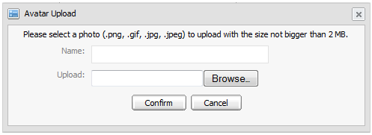Illustration 5: The Avatar Upload form
Step 2: Click the Browse button to open the folder that contains an image which you want to upload and select that image.
Step 3: After uploading, click the Confirm button to open the Avatar Preview form in order to review the selected avatar and some related information such as: file name, file type and image size:
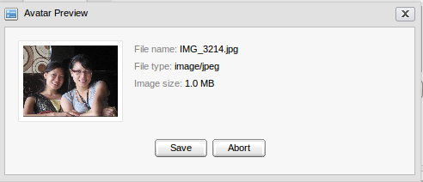Illustration 6: The Avatar Preview form
Step 3: Click Save to save this image as the current avatar or Abort to quit without saving.

Manage the visibility
Step 1: Click the edit icon that corresponds to the space which you have the edit right.
Step 2: Select the Visibility tab:
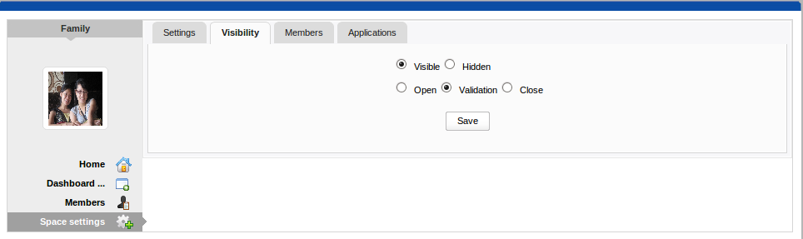Illustration 7: The Visibility tab
Step 3: Change the Visibility and Registration modes to meet your needs. By default, Visibility is Visible and Registration is Validation.
Step 4: Click Save to save changes.

Manage members
Click the Members tab to open the edit member interface:
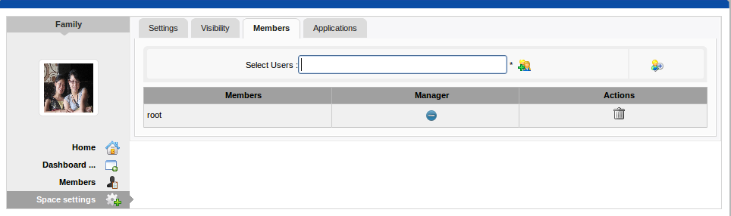Illustration 8: The Members tab in the Space setting form
In this tab, you can take the following actions:
- Invite new members to join this space.
- Change a user to a manager.
- Remove users.

Invite new members
If you know the user name of a person, you can easily invite him/her to your space by following these steps:
Step 1: Simply enter his/her user name in the text box and click the icon .If you have multiple people to invite, you can enter multiple user names separated by a comma.
Step 2: If you don't know the user name of a person who you want to invite, you can click the icon to open the Select Users form:

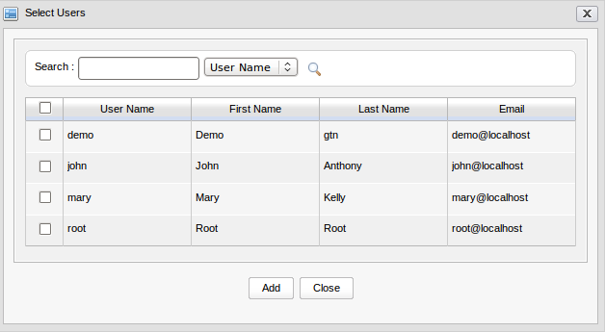Illustration 9: The Select Users form
Step 3: Search among members of a portal as follows:
- Enter a search term in the Search box.
- Then, select a field that you want to find in the combo box next to this Search box.
- Click the search icon to perform searching.
The search results will be listed in the table under. When you have found the people you want to invite, select them by checking the corresponding check boxes and click the Add button.

Then, click the icon to accept the invitee.
After inviting, you will see the invited user list.
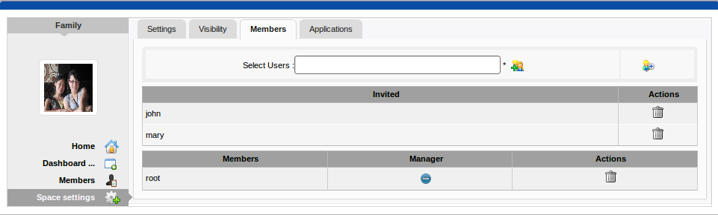Illustration 10: The Members tab in the Space settings form
In the invited users' space, he/she will see those spaces in the Invited part.
Please note that Root is an administrator who automatically becomes a member of spaces whenever invited.

Revoke the invitation
If invitations aren't accepted by the invited users yet, you can revoke the invitations by yourself.
To revoke the invitation of the invited user, just click the button that corresponds to that user. That user will be removed from the Invited list column.

Accept and deny the invitation
This function allows you to accept an invitation that you received from others.
Spaces which are being waited for acceptance will be listed in the Invitations space of the invited users:
If you want to accept the invitation, click the iconthat corresponds to the space which you want to accept.
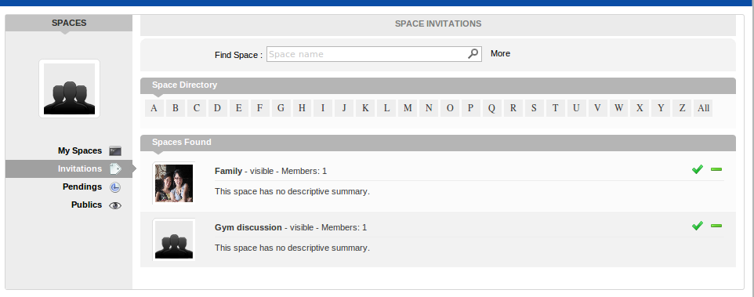Illustration 11: The Space Listing in the Invitations Space
If you don't want to accept the invitation, click the icon that corresponds to the space which you don't want to accept.

Change a user to manager or vice-versa
Just click the iconthat corresponds to the member's name in the Manager column. The user will be automatically promoted as a manager in the current space.
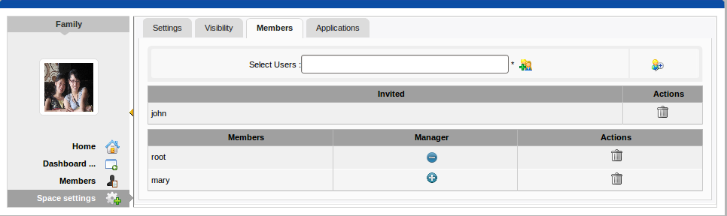Illustration 12: The Members tab in the Space settings
To remove the manager status, just click the icon. Be careful not to remove the rights for yourself, or you will not be able to edit the settings anymore.

Remove a user
Simply click the icon on the same line as the member you want to remove.

Manage applications of a space
Step 1: Click the Applications tab to open the application list:

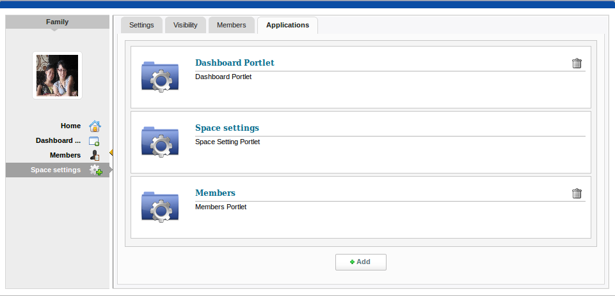Illustration 13: The Applications tab in the Space settings
To remove an application:
This function is used to remove an application in the application list. Just click the icon next to the application name.
To add an application:
You can add a new application to your application list of the current space. Do as follows:
Step 2: Click the Add button to open the available application list:

Step 3: Select the application that you want to install by clicking the iconwhich corresponds to that application.
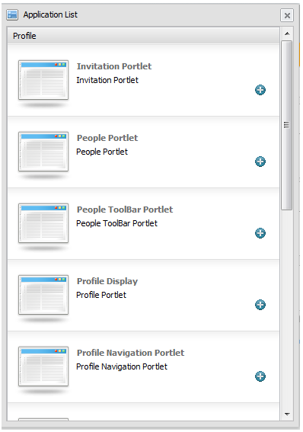Illustration 14: The Application List form
If there is no available application, ask your system administrator to give you the access right to them.

Edit a space's navigation
Users can easily edit a space's navigation by following these steps:
Step 1: Click the icon which corresponds to the space that you have the edit right. The Navigation Management will appear:
Users can take the following actions: (refer to GateIn guide for more details):
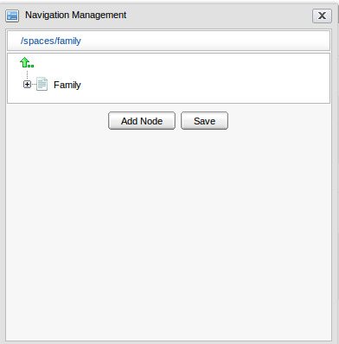Illustration 15: The Navigation Management form
- Right-click the node's name (space's name) in order to add a new node, edit a node, edit a node's page, copy a node, clone a node, etc.
- Click the Add Node button.
Step 2: Click Save to save all changes.

Leave spaces
This function allows users to quickly leave the space that users don't want to stay anymore or to be the space's member.
Step 1: Click the icon that corresponds to the space in order to leave that space.
If a user is only the leader of that space, the message which informs that you cannot leave a space will appear:
However, when you are members invited by the leader, you can leave the space as follows by click the icon corresponding to the space.
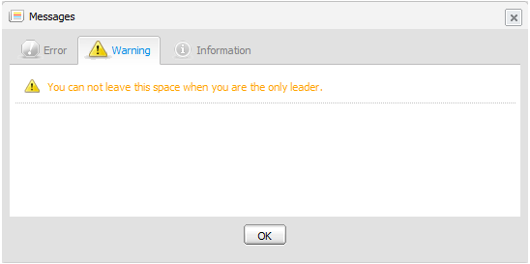Illustration 16: The Warning Message
After you can leave one space, the space will not exist in My Spaces other than in Publics in the left pane.

Delete spaces
Only the space manager can delete their spaces by clicking the icon that corresponds to the desired space to delete all information and navigations related to that space.

Manage Spaces

Define access rights to Applications
To be able to do this, it's recommended the GateIn Administration Guide should be read, because the section is about the Application Registry.

By default, applications are not available to users in eXo Spaces. eXo Spaces leverages the rights on applications defined in the Application Registry. Every eXo Space has a group under the group /Spaces.
There are 2 configuration levels for applications:
Step 1: Go to Group → Administration → Application Registry on the Administration toolbar.
Step 2: Click the application category on the left to select it:
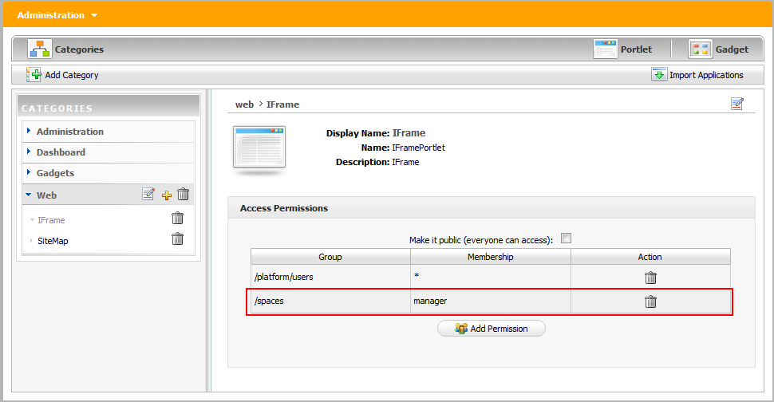Illustration 17: The Category page
Step 3: Allow all space managers to install an application: Add the right on an application to the Spaces group with the manager membership.
  - Click the Add Permission button to open the Select Permission form:
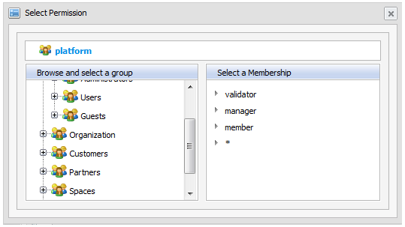Illustration 18: The Select Permission
  - Select the spaces group on the left pane and the manager membership on the right pane.

Illustration 19: Access Right on an application
In order to allow the specific space to install an application: Add the right on an application to the group Spaces/SpaceName (where SpaceName is the name of the space that you want to allow to install the app) with the manager membership.
Be careful to make sure the category of the portlet added has the right permissions.

Add users
After a new space has been created, it automatically has its own group's navigation. An administrator can add new users to a space's group by following steps:
Step 1: Go to Group on the administration toolbar.
Step 2: Select Organization → Users and groups management.
In order to add users to a group, select Group Management. Follow these simple steps:
- Select the path to the Spaces group that you want to add a new user by selecting the group from the list on the left pane. The Group's information is displayed, including the user list and a form which allows a new user to be added.
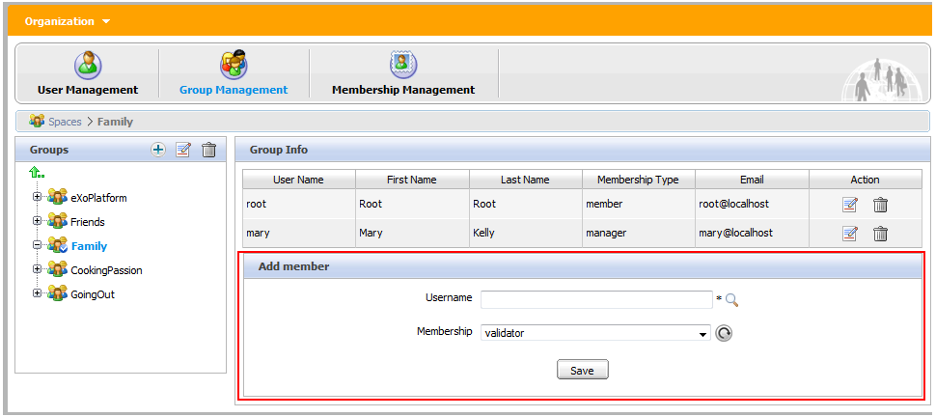Illustration 20: The Group Management
- Enter the exact user name of the user that you want to add to the selected group or you can enter some characters if you are not sure about exact spelling.
  - Click the magnifying Search icon to select users.
  - After you click the magnifying glass icon, there will be a list of all existing users:
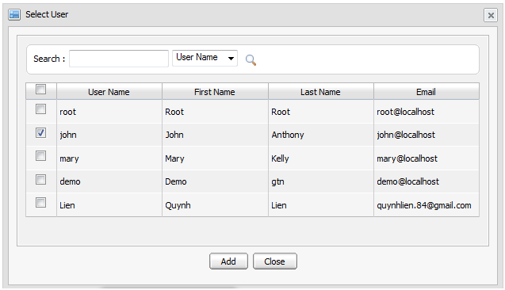Illustration 21: The Select User
- Select the check box of the user(s) that you want to add to the group.
- After clicking the Add button, you will see user name(s) in the table:

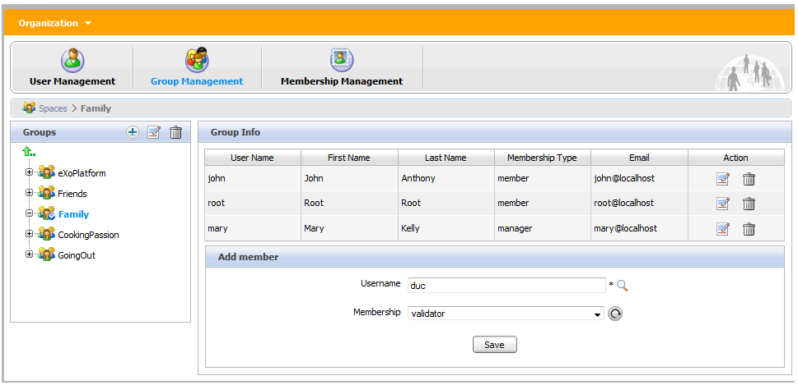
- Select a membership for a user in a group from the membership list. The refresh icon can be used to update the membership list in case there is any change.
- Click Save to accept adding the selected user to a specific group with the selected membership type.

Conclusion
This user manual has provided a thorough explanation of basic terms and features within eXo Social. Now, you have known how to use People, Activity and Spaces easily and effectively. The following links can connect you with resources to learn more and contribute to the open source development process.
- Learn more about eXo Platform 3.0
- Video demos, tutorial and more in the eXo Resource Center
- Access another eXo documents in the eXo Wiki

