
eXo Knowledge FAQ & Answers
Version 2.0
REVISION HISTORY
Version | Date | Written by | Reviewed by | Change Record
1.0 | Jan 01, 2009 | Hoang Anh Quynh Nga | Nguyen Thanh Cong
1.1 | Mar 18, 2009 | Nguyen Thanh Cong | Hoang Anh Quynh Nga | - New FAQ UI with left pane, category tree and question panel  - New Submit Question form: Question title, question detail.  - Add category with order  - Move category by drag and drop feature  - Improve the way to add question in multiple languages.  - Answer question in multiple answers  - View question in multiple answers  - Approve/disapprove answer  - Activate/inactivate answer  - Delete answer  - Vote question  - Vote answer  - Delete answer  - Comment question in multiple languages  - Custom view  - View user profile  - Discussion in Forum  - Set Discussion properties  - Set Enable RSS properties  - Set Vote and comment properties  - RSS feed  - Update Tool bar and Breadcrumb enhancements.  - Update vote question, answer.  - Unvote question and rate up/down answer  - Changes on watch function. - Update Unwatch function  - Change on question template.  - Update User Settings function  - Submit/Edit question form with FCK Editor  - User Setting: manage watch, change and delete avatar.  - Answer question with new feature and UI  - Update Manage Category menu  - Edit answer functions
1.2 | June 09, 2009  August 20,2009 | Nguyen Thanh Cong  Luong Quynh Lien |  | - Setting properties: category scoping  - Email notifications tab in Setting Properties  -Change screenshots.  - Answers portlet.  - FAQ Porltet.
1.2.2 | November 22, 2009  February 4, 2010 | Luong Quynh Lien |  | - Upgrade to 1.2.2  - Review
2.0.0 Alpha3 | 05/05/10 | Tuan Anh | Tuan Anh | - Review to 2.0.0 Alpha 3
2.0.0 | 06/14/10 | Tra Giang | Tra Giang | - Update sceenshots  - Repair errors  - Add somes parts

Contents
1 Preface 7
1.1 Overview 7
1.2 Why uses FAQ & Answers 7
1.3 Purpose of the Guide 7
1.4 References 8
2 Glossary 9
2.1 What is Answers application? 9
2.2 What is Category? 9
2.3 What is Question? 9
2.4 What is Answer? 9
2.5 What is Comment? 9
2.6 Answers main screen 9
3 FAQ & Answers Administration 12
3.1 Main Work flow 12
3.2 Register A New Account 13
3.3 Sign In/Sign Out 14
3.3.1 Sign In 14
3.3.2 Sign Out 16
3.4 Add an Answer portlet 16
3.5 Category management 20
3.5.1 Add a new category 20
3.5.2 Add a sub-category 24
3.5.3 Edit categories 25
3.5.4 Delete categories 26
3.5.5 Move a category 27
3.5.6 Watch 27
3.5.7 Unwatch 28
3.5.8 Manage Watch 29
3.6 Question Management 31
3.6.1 Add questions 31
3.6.2 Answer Questions 34
3.6.3 Edit questions 38
3.6.4 Delete questions 41
3.6.5 Move questions 42
3.6.6 Send questions to friends 43
3.6.7 Approve/disapprove questions 46
3.6.8 Activate/Deactivate questions 47
3.6.9 Approve/Disapprove answers 48
3.6.10 Activate/Deactivate answers 49
3.6.11 Edit Answers 49
3.6.12 Delete answers 50
3.6.13 View questions 50
3.6.14 Vote questions 53
3.6.15 Remove question vote 53
3.6.16 Rate up/down questions 54
3.6.17 Comment question 54
3.6.18 Promote comments 56
3.7 Search 56
3.7.1 Quick search 56
3.7.2 Advanced search 57
3.8 User Settings 62
3.9 Answer portlet setting 64
3.10 Print 73
3.11 Export/Import 74
3.11.1 Export 74
3.11.2 Import 76
3.12 Show/hide the left panels 78
3.13 Drag and drop 78
3.14 View User Profile 79
3.15 Discuss in forum 80
3.16 Rss feed 81
3.17 FAQ Portlet 82
4 Conclussion 87

Preface

Overview
Beginning as an open source project in the year 2002, eXo is well-known as the industry's first Java portlet container. With the aim of dominating the potential portal market through robust and easy-to-use applications, eXo Project succeeded in attracting consumers in the whole world. eXo opened the floodgates to various options in many markets, and customers have been choosing eXo as the best method for their success.
Today, eXo is a rapidly growing global company, with U.S headquarters in San Francisco, California, global headquarters in France, and offices in Tunisia, Ukraine, and Vietnam. The company has established technology leadership and proven its values by their large European installed base and strategic partnerships with Red Hat, Capgemini, Atos Origin, and Bull.
And along with many eXo products, eXo Knowledge, an extended service of eXo will help you collect, organize, and publish knowledge, aiming at enhancing your company's internal productivity and creativity through effective collaboration tools. With two applications, including Forum and FAQ & Answers, you can not only hold online discussions and post user-generated contents, but also view and respond to most frequently asked questions regarding to sites and/or services. With FAQ & Answers, you can look and feel many benefits, such as empowering users and customers via information exchange channels, or encouraging innovation and awareness through new ideas and useful feedbacks.

Why uses FAQ & Answers
The application provides many useful features to users as summarized below:
- Categorize questions.
- Pose multiple questions and comments.
- Rate and/or vote.
- Moderate.
- Rss and email watch.

Purpose of the Guide
The book was written as a detailed manual, aiming at instructing step-by-step on how to implement this application to the utmost. Thus, the information included herein will give basic steps that makes it easy for users to follow through in-depth examples as well as clear explanations regarding to the eXo Knowledge technology. Whether you major in technology or not, you are able to learn about or work on eXo FAQ & Answers easily and efficiently.
The information provided in the guide has been arranged into such a way that ensures readers to search and implement them quickly. Initialized with the glossary section, the guide will give main definitions used in this book. Next, the guide focuses on the most important so-called “ FAQ & Answers administration”. The part will represent most of steps necessary in using and mastering the eXo FAQ & Answers. Finally, with the aim of helping users better understand eXo FAQ & Answers, we also mention some major strengths in the Conclusion section.
The material is useful for anyone interested in learning and using the FAQ & Answers, especially for users who have administration privileges. It covers administration of users, permissions and all management actions.
From above, the aim of FAQ & Answers Administrator's Guide can be summarized as follows:
- Define some basic concepts used in the FAQ & Answers.
- Show the main instructions of FAQ & Answers.
- Let you set permission and take all management actions of FAQ & Answers to take basic actions step-by-step.

References
- FAQ & Answers User Guide version 2.0

Glossary

What is Answers application?
Answers is an online application that allows users to post common questions and answers about a specific topic. The application may be seen as a way to reply to questions about rules or any problem when users implement a specific system.
Answers familiarizes visitors with answers to most frequently asked questions about a site/service or about the entity/subject responsible for the site/service. Repeatedly received questions will be added to Answers and newcomers with Site/Service are encouraged to view Answers.

What is Category?
Category is a questions and/or answers collection about specific topics. In Answers, one category may include one or more sub-categories. One category may also contain both sub-categories and questions inside.

What is Question?
Question is an expression applied by users for asking and getting information. In Answers, all questions related to the same topic have to be posted and grouped in the same category.

What is Answer?
Answer is a response to specific questions. In Answers, all responses are posted below its questions. Only people who have moderation right can answer questions.

What is Comment?
Comment is an opinion on a specific question given by a user. In Answers, all comments are posted below their questions. A comment can be promoted to an answer by the administrator.

Answers main screen

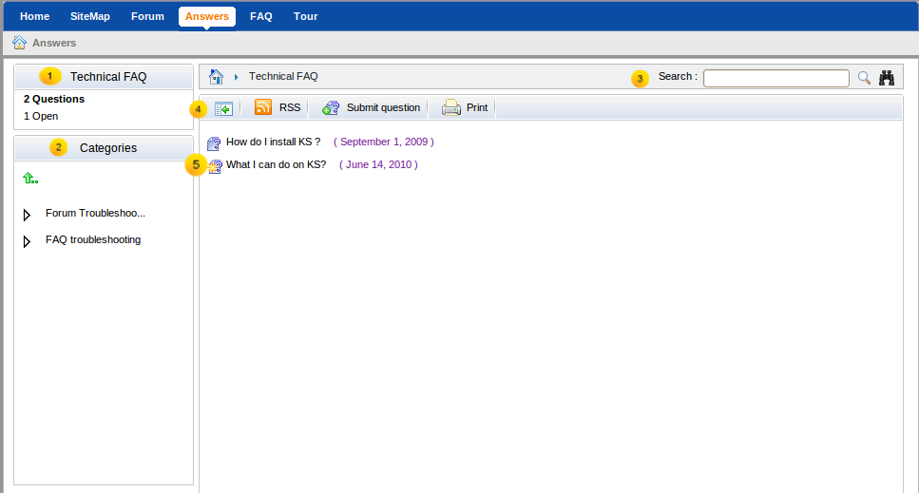Illustration 1: Answers Main screen
Indicator | Meaning
 | The Categories Status panel displays information of a current category which is being viewed. It includes the total number of open questions (not answered yet), pending questions (waiting for approval) and the total number of questions.
 | The Categories Panel explores the category in the tree view. A click on one category will browse into it on the Answers view panel.
 | The Breadcrumb bar shows answers path and search function with simple and advanced options.
 | The Action bar allows administrator to add category, question, manage question, import, export, print, settings quickly and easily.
 | The Answers view panel displays all categories, sub-categories and questions.

FAQ & Answers Administration

Main Work flow
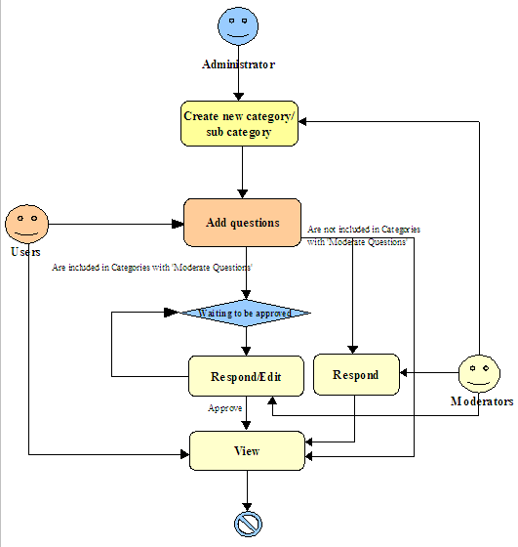Illustration 2: The Mail work flow of Answers application
Explanation:
From the above chart, the operation system in FAQ & Answers can be expressly seen. In details, an administrator creates a new category/sub-category. The category/sub-category can be set with 'Moderate new questions' or not. If the 'Moderate new questions' option is set, all questions in this category/sub-category must be approved/disapproved by moderators or administrators. Besides, all users can add new questions to a specific category/sub-category.

Register A New Account
Unregistered users visiting the portal will be limited to several contents and applications which are not set as public. Meanwhile, users who want to access in-depth contents or perform some actions in various applications, they should register by themselves and then contact the portal administrators to gain certain rights or permissions. To register a new account, do as follows:
Step 1: Click Register on the upper right corner of the homepage. The Register New Account form will appear.
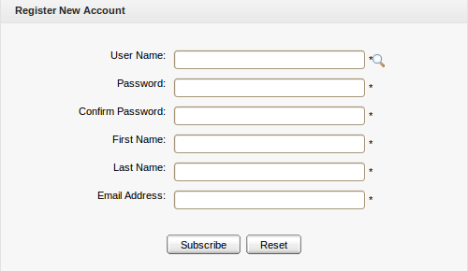Illustration 3: Register New Account
Details:
User Name: The user's login name that must be unique with at least 3 characters.
Password: The password used to login that must have at least 6 characters.
Confirm Password: The re-typed password. The Password and Confirm Password must be the same.
First Name: The user's first name which must start with a character.
Last Name: The user's last name which must start with a character.
Email Address: The user's email which must be in the right format, for example: username@abc.com.
These are required fields, the User Name must contain only alpha, digit and underscore characters and must be unique.
Step 2: Enter values for fields in this form.
Step 3: Click Subscribe to accept adding a new account or Reset to clear the entered values. After you click Subscribe, there will be a message which informs that you have registered your account successfully.
Step 4: Click OK to finish creating your account.
There will be an alert message which informs that you can not add a new account, such as:
- The User name is existing or User Name is invalid.
- The Password has less than 6 characters.
- Password and Confirm Password must be the same.
- Your email address is invalid. Please enter a different address.
- The field (field name) is required.
After adding a new account, contact your administrator to get rights or only be a visitor.
The magnifying glass icon is used to search whether the entered User Name exists or not. Once a user has registered by himself or the administrator has created a new account, the new user will become a part of the group "/platform/users" with membership by default.

Sign In/Sign Out

Sign In
The function allows you to go into the portal and/or Answers in the private mode.
To sign in, do as follows:
Step 1: Go to the portal in the public mode by inputting URL in the address bar (e.g: http://localhost:8080/portal).
Step 2: Click the Sign in link at the top right of portal if you are in the Classic portal.
The Sign in form will appear:
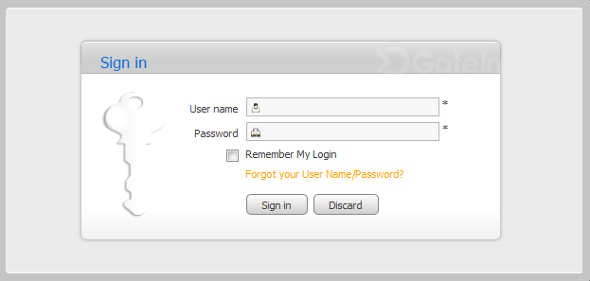\Illustration 4: The Sign in form
Details:
User name: The registered user name (*required).
Password: The registered password (*required).
Remember My Login: The checkbox helps users automatically sign in a portal without signing in again for the next time.
Forgot your User Name/Password? The link helps users retrieve user name and password when they forgot.

Step 3: Sign in by the administrator account.
Step 4: Complete signing in by clicking the Sign in button.
In case the User name does not exist or the inputted User name/Password is invalid, there will be an alert message and you can not add a new account if at least one of these cases occurs:
  - The User name is existing or User Name is invalid.
  - The Password has less than 6 characters.
  - The Password and the Confirm Password are not the same.
  - The Email Address is invalid format.
  - The required fields are blank (empty).
After signing in, you will be redirected to the authenticated home page:
To take actions in the Answers application, you have to add the Answers portlet to a page.
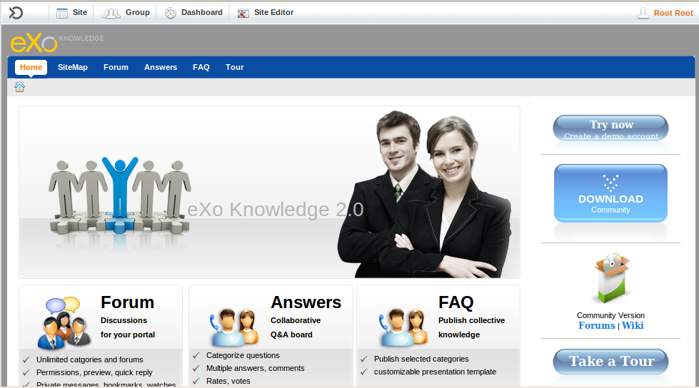Illustration 5: The authenticated homepage

Sign Out
The function allows you to get back to the anonymous portal. It ends your current portal session.
To sign out, click Sign out in the Star menu list on the administration toolbar:
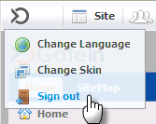

Add an Answer portlet
Step 1: Click Add new page in the Site Editor menu on the administration toolbar. The Page Creation Wizard will appear. This consists of the following steps to complete creating a new page.
Step 2: Select a navigation where a page locates on the left panel. Enter a page name (*required) and a display name. Click Next to move to the next step.
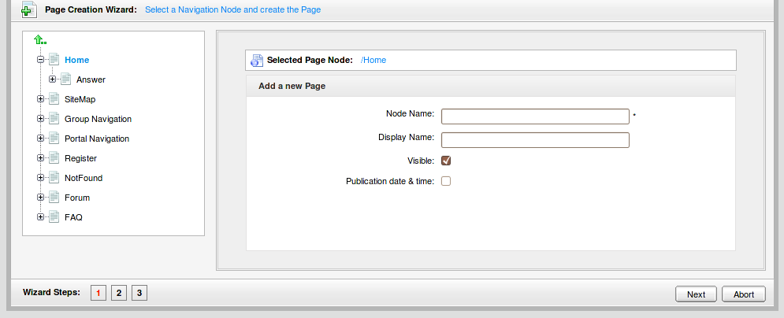Illustration 6: The Page Creation Wizard (step 1)
Step 3: Choose the page layout template:
In the step, you can configure the desired page layout. By clicking the drop-down list on the right top corner, you will see all the configurations available, including Page, Column Page, Tape Page, Rows Page and Mix Page. Select which parts you want to modify by clicking the relevant entries.
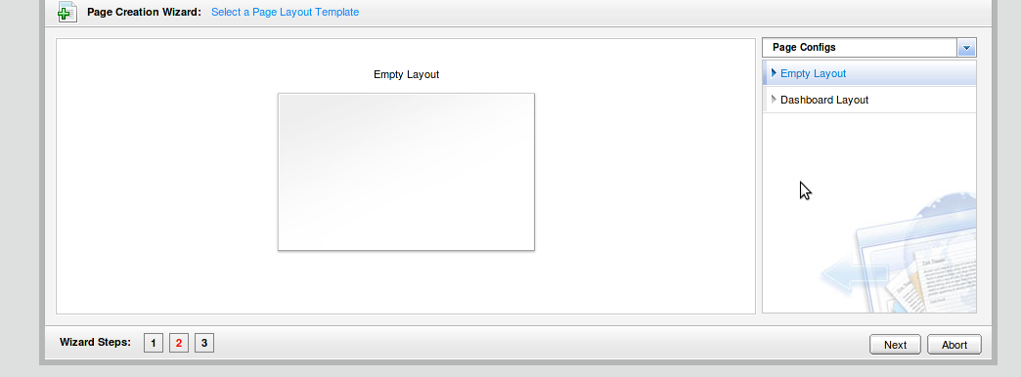Illustration 7: Select a Page Layout Template (Step 2)
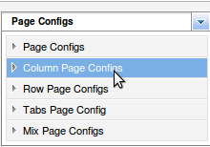
The preview illustration will fully display all configurations for each above choice as follows:
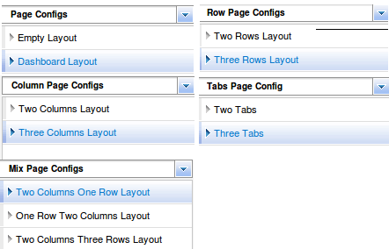

Step 4: Click Next, the Page Editor appears as follows:
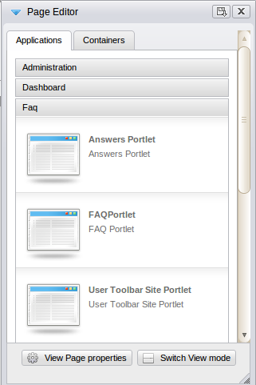Illustration 8: Page Editor
Step 5: Drag and drop the Answers Porlet from Page Editor into a page area:
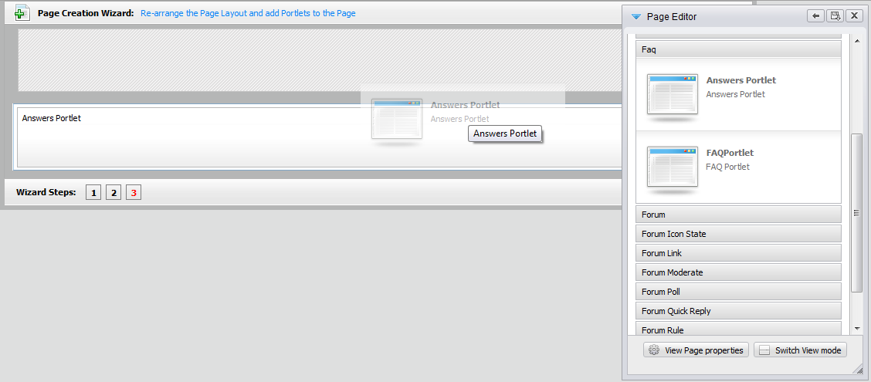
Step 6: Click the Finish icon to complete adding an Answers portlet to a page. You can take all actions related to Answers from now by opening that page.
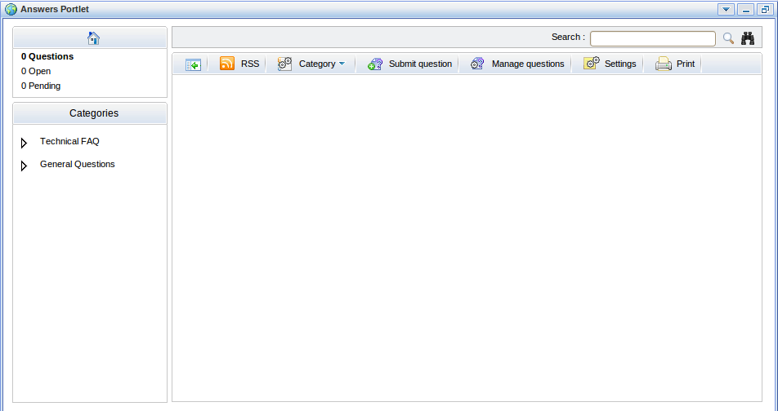

Category management
The section includes all actions related to a category in the Answers application.

Add a new category
The function is used to add a new category in the Answers application. Only the Answers administrators can take this action.
Do as follows:
Step 1: Click the Category button on the action bar and select Add Category in the menu:
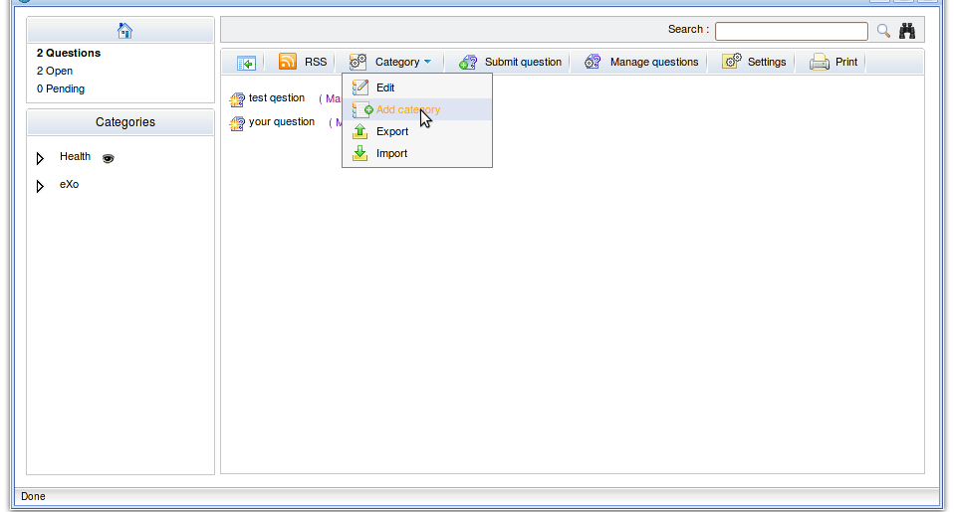
The Add Category form will appear:

Step 2: Enter values for fields in this form.
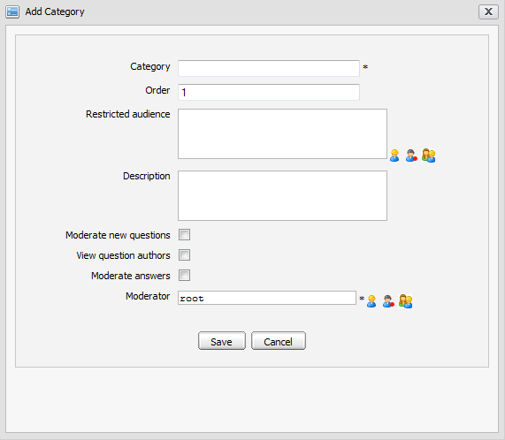Illustration 9: The Add Category form
Details:
Category: The category's name. (*Required).
Order: The category's order in a category 'tree' on the left pane.
Restricted Audience: List of all users who can access a category. By default, this field is blank, indicating that all users can access this category.
Description: The brief description about a category.
Moderate new questions: This option is to require/not require approving new questions in a category to be visible or not.
View question authors: This option is to display author information of a question added to the category. If it is selected, author information is shown. If not, all author information in this category is hidden.
Moderate answers: This option is to require and/or not require approving new answers in a category to be visible or not.
Moderator: The list of users/groups responsible for approving/disapproving questions and answering all questions in this category. The default value is root. (Required).
Save button: It is to accept adding a new category.
Cancel button: It is to close the Add Category form.
The restricted audience and moderator can be inputted manually or selected from the selector:
- Click the icon to select users from the group list: Firstly, select a group from the left list and then select a user on the right. The selected users will be displayed in the 'Moderator' field.
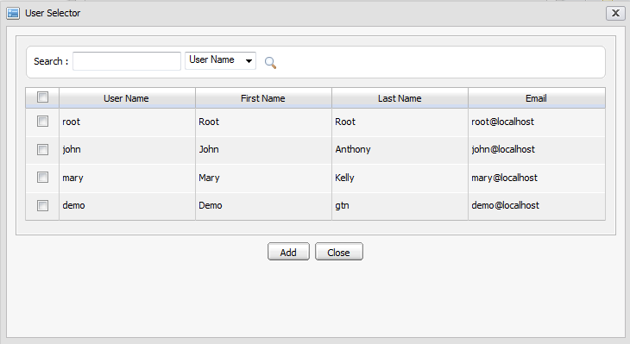Illustration 10: The User Selector form
- Click the icon to select all users with a specific membership in a group. Firstly, select one group on the left pane and select a membership on the right. The selected role will be displayed in the 'Moderator' field.

- Similarly, click the icon to select all users in a specific group.
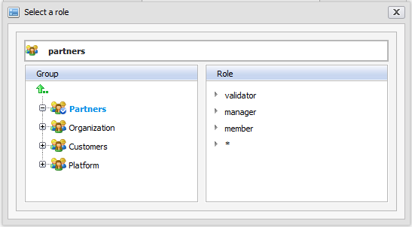Illustration 11: The Select a role form
Step 3: Complete adding a new category by clicking the Save button.

Add a sub-category
The function is used to add a new sub-category into an existing category.
Do as follows:
Step 1: Open the Add Category form via one of two following ways:
The 1st way: Right-click the category that you want to add a sub-category into and select Add Category.
The 2nd way: Go into the category that you want to add a sub-category into and click Category on the main action bar and select Add Category in the menu:
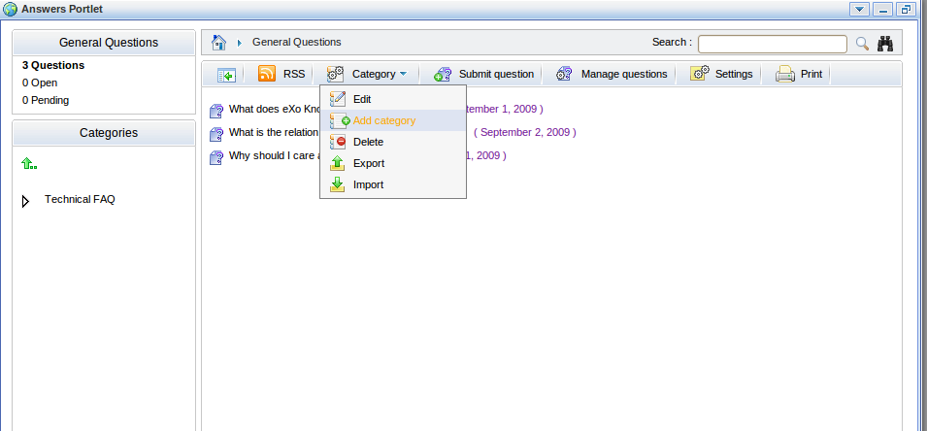
The Add Category form will appear as stated above.
Step 2: Enter the required values for fields in the Add Category form.
Step 3: Complete adding a new sub-category by clicking the Save button.

Edit categories
The function is used to edit categories or sub-categories in Answers.
Do as follows:
Step 1: Open the Edit category form via:
The 1st way: Right-click the category/sub-category that you want to edit and then select Edit in the menu.
The 2nd way: Click the Category on the main action bar and select Edit in the menu.
The Category form will appear with detailed information which is available for editing.
Step 2: Change the current category's information.
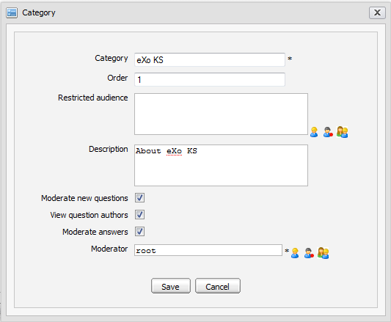Illustration 12: The Edit Category form
Step 3: Complete editing a category by clicking the Save button.

Delete categories
The function is used to delete categories in the Answers.
Do as follows:
The 1st way:
Step 1: Right-click the category/sub-category that you want to delete and select Delete in the menu.
Step 2: Click OK in the confirmation message to accept deleting or click Cancel.
The 2nd way:
Step 1: Click the Category button on the main action bar and select Delete in the menu.
Step 2: Click OK in the confirmation message to accept deleting or click Cancel to quit.

Move a category
The function is used to move a category from the current place to another.
Do as follows:
Step 1: Right-click the category that you want to move and then select Move in the menu:
The Move category to form will appear:
Step 2: Move the category by double-clicking the destination category in the category list.
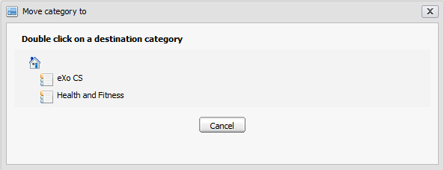Illustration 13: The Move category to form
After being moved, the Move category to form is closed, the moved category is moved to a new destination category.
The Cancel button is to close the Move category to form without moving.
Only the administrator can move categories to anywhere in the Answers, while the moderator is checked permission when moving categories. The moderator can only move categories to the categories where he plays the moderation role.

Watch
The function allows logged users to keep track of changes of specific categories in the Answers application such as new editions, new questions, question responses, etc. You only need to register an account, add watch to specific categories. Users will receive notification mails from the Answers if any change.
To add watch, simply right-click any category in the category list and select Watch in the menu:
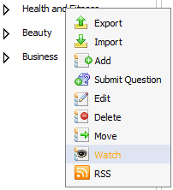
The alert message that informs watching successfully is shown:
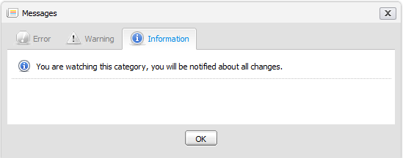Illustration 14: The watch alert message form
After a watch is added successfully, the category which is being watched will be marked by the eye icon .

Unwatch
The function allows you to remove your watches on specific categories. When unwatching, you will not receive notification mails about the categories that you had watched anymore.
To unwatch, simply right-click the category that you are watching and select Unwatch in the menu:
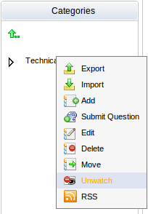

Manage Watch
The function allows you to manage watches of categories such as edit, delete, etc.
Do as follows:
Step 1: Open the Watch Manager form by clicking the eye icon of the category which is being watched:
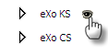
The Watch Manger form is displayed with all email addresses used for watching.
Step 2: To open the watched category content, click the icon .
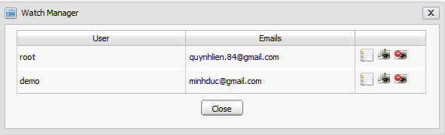Illustration 15: The Watch Manager form
Step 3: To modify any email address, do as follows:
- Click the edit icon correspondingly.
The Edit form will be displayed with the current information, available for editing:
Details:
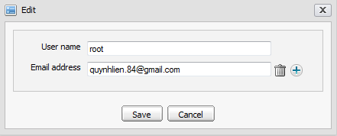Illustration 16: The Edit email for watching form
User name: The registered user name. The field can not be changed.
Email address: The registered email address for watching.
Save button: It is to accept saving changes.
Cancel button: It is to close the Edit form.
- Change your email address by manually inputting your email into the Email address field. You can also add or remove the email addresses for watching.
- Complete editing a watch by clicking the Save button.
Step 3: To delete this watch in the Watch Manager form, click the delete icon and click OK in the confirmation message form.

Question Management
The section contains all actions related to questions in a category.

Add questions
The function is used to add questions to the Answers homepage or a specific category.
Do as follows:
Step 1: Show the Submit question form via one of two following ways:
The 1st way: Right-click the category/sub-category that you want to add new a question into and then select Submit Question in the menu.
The 2nd way: In the homepage or go into the category that you want to add a question into and then click the button on the toolbar.
The Submit question form will appear:
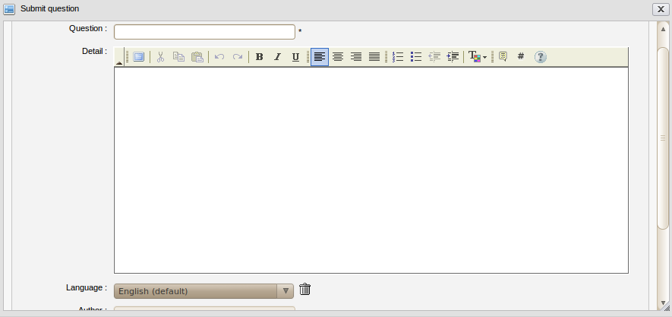Illustration 17: Submit question form

Details:
Question: To input your question.
Detail: To describe detailed information regarding to the question.
Language: To select the language used to add a question. By default, the language is English. The language combo box allows selecting a language option.
Author: To show the author's name. (Required)
Email: To show the email address which must be in a valid format like: username@abc.com. (Required)
Attach a file: To attach files into the question.
Step 2: Input values into fields in the Submit question form.
- To add this question by another language, do as follows:
1. Click the language combo box in the Submit question form. The language drop-down list will be displayed:
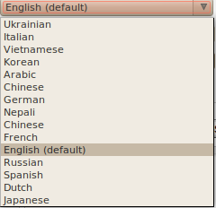
2. Select a language by clicking the language that you want add to a question.
3. Click the Save button to accept adding another language or click the Cancel button to quit.
There will be a text box that corresponds to the selected language in the Submit question.
- To remove a question in the specific language, simply select the language that you want to delete and click the delete icon next to the language combo box.
After the deletion, the corresponding language content will be deleted.
- To attach files, click the attach a file link in the Submit question form. The Upload File form will appear:
1. Select files to upload by clicking Browser... to select the file's path from local computer.
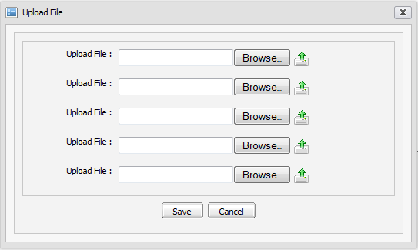Illustration 18: The Upload File form
2. Upload the selected files by clicking the icon to upload.
3. Complete attaching files to a topic by clicking the Save button.
Note that many different file types can be attached. To remove attached files, simply click the Remove link beside the file attachments which you want to delete.
Step 4: Complete submitting a question by clicking the Save button.
The question is added to the selected category and an alert message is shown to inform that the question is added successfully. In case the question added to the category is required to have the moderation before displaying, the alert message will appear that informs the question will be checked by the moderator for approval.
The question list is shown below:

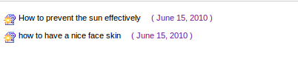
: The icon means that the question has not been answered.
: The icon means that the question has been answered.

Answer Questions
This function is used to respond/answer questions. A question may have multiple answers and each can be moderated independently.
If you have the administration role, you can answer all questions in all categories. Meanwhile, the moderation role only enables you to answer questions in the categories where you are the moderator.
Do as follows:
The 1st way:
Step 1: Right-click the question that you want to answer and select Answer question:
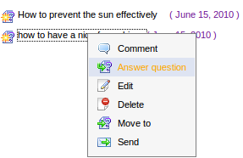
The Answer form will appear:
Details:
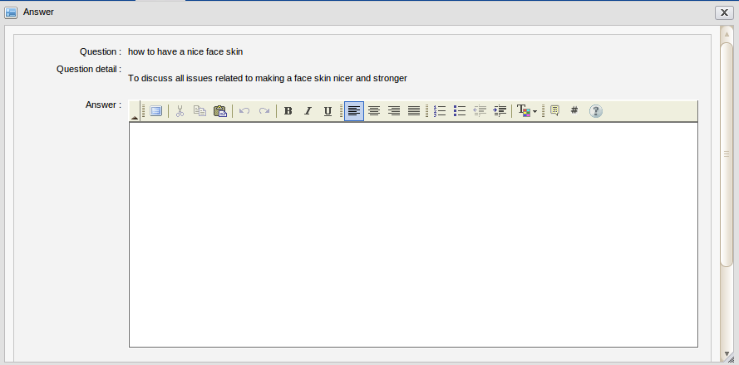Illustration 19: The Answer form
Question: The question's brief content which can be viewed only.
Question detail: The question's detailed content which can be viewed only.
Answer: The answer's content. A question can have multiple answers.

- If this question is in the category that does not need moderating, this option is checked.
- If this question is in the category that need to be moderated, this option is not checked.
- To approve this question, check this field.
Activated: This option is to display the answer or not. It means the answer of this question with the selected language will be displayed or not. By default, the answer is always shown.
Related to: All questions related to the question that you want the other users to refer to.
Plus icon To link the current question to the other entry/question(s).

To add related questions, do as follows:
- Click the icon to display the question list in all categories. The Related questions form will appear:
- Select one or more questions in list by checking the checkboxes that correspond to the questions.
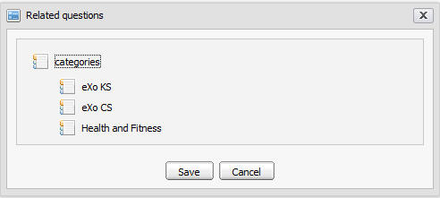Illustration 20: The Related questions form
- Click the Save button to add the selected questions into the Related to field or click the Cancel button to quit.
To remove a related question from list, click the remove iconthat corresponds to the question you want to remove.
Step 2: Enter values for required fields in the Answer form.
Step 3: Complete answering a question by clicking the Save button.
The 2nd way:
Step 1: Click the button on the toolbar.
The All questions tab allows users to view all questions in all categories. Users can also view questions of each existing category by selecting a filter in the Select category field.
Step 2: Click the Open questions tab. This tab allows users to view all questions that have not been answered yet.
Step 3: Click the iconwhich corresponds to the question that you want to answer.
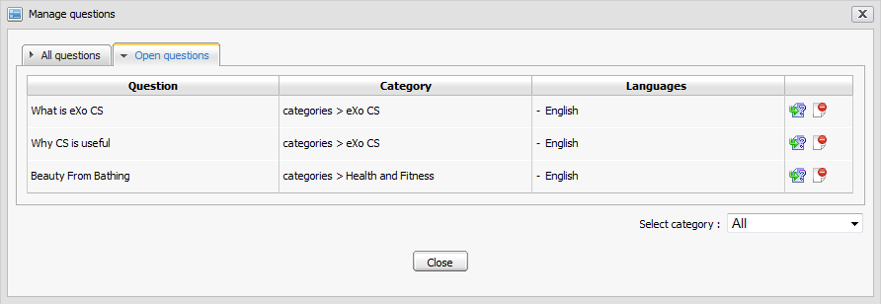Illustration 21: The Open questions tab of Manage questions form
The form to answer question will be displayed under the question list:
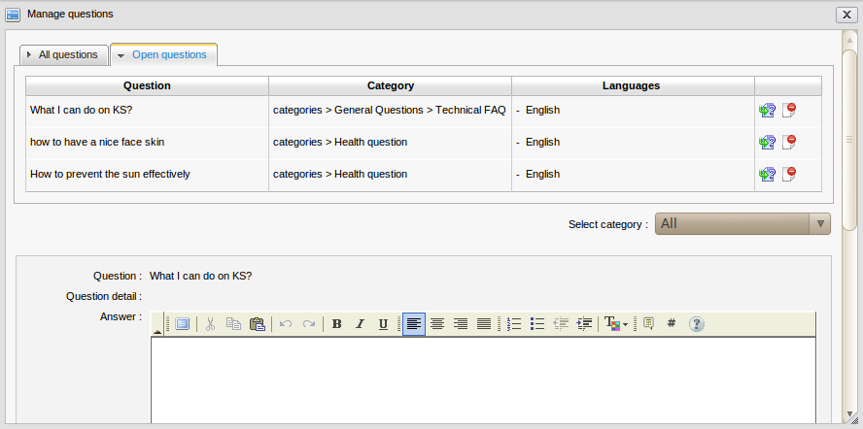
Step 4: Enter values for required fields.
Step 5: Complete answering questions by clicking the Save button.
Note that questions can be viewed by two ways:
- Quick view: questions can be viewed by the question list:
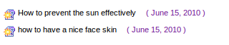
- Detailed view: click directly the question that you want to view in details.

Edit questions
The function is used to edit questions in a specific category.
Only the Answers administrators and moderators of one category can edit questions inside it.
Do as follows:
The 1st way:
Step 1: Right-click the question that you want to edit and then select Edit in the menu:
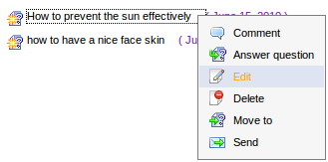
The Edit question form will appear with the current information, available for editing:
Details:
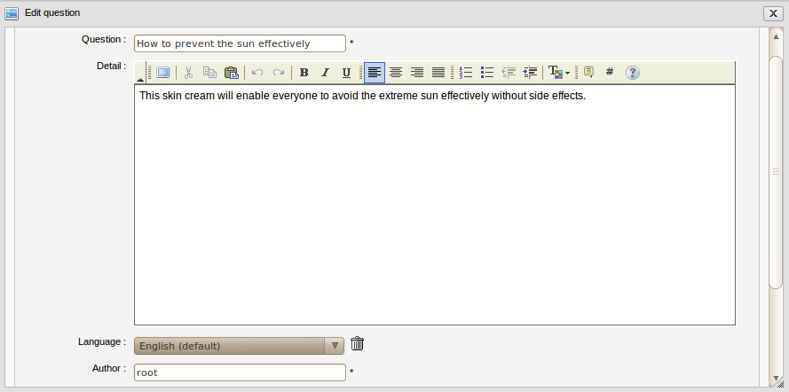Illustration 22: The Edit question form
Question: The question's brief content.
Detail: The question's detailed explanation which can be decorated.
Language: The language which is used to add questions. By default, the language is English. Language combo box allows selecting one desired language.
Author: The edited question's author.
Email: The email address of the edited question's author.
Validation: The option is to validate the question. It includes activated and approved options.
Approved: The option is to approve the edited question or not.
- If this question is in the category that does not need to be moderated, this option is checked.
- If this question is in the category that needs to be moderated, this option is not checked.
- To approve this question, check this field.
Activated: The option is to whether display this question or not. By default, the option will be checked. It means the question is displayed, all users can view it. But if Answers Administrators or Moderators don't want to display this question, don't select this option.

Attach a file: This is to attach files into the edited question.
Step 2: Change the current information of the selected question like when adding a new question. You can add more or remove the language option, attach file, etc.
Step 3: Complete editing the question by clicking the Save button.
The 2nd way:
Step 1: Click the button on the toolbar.
The Manage questions form will appear:
Step 2: Click the icon to edit the question in the question list.
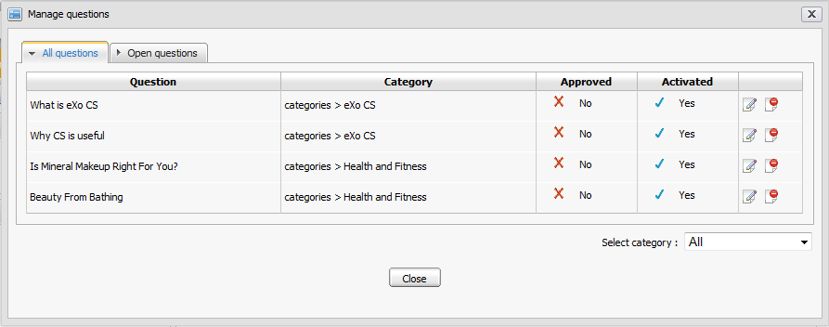Illustration 23: The All questions tab of the Manage questions form
The form to edit question will be displayed under the question list:
Step 3: Change the current information of the selected question. You can activate, inactivate, approve, disapprove, attach files or add more language options for the edited question.
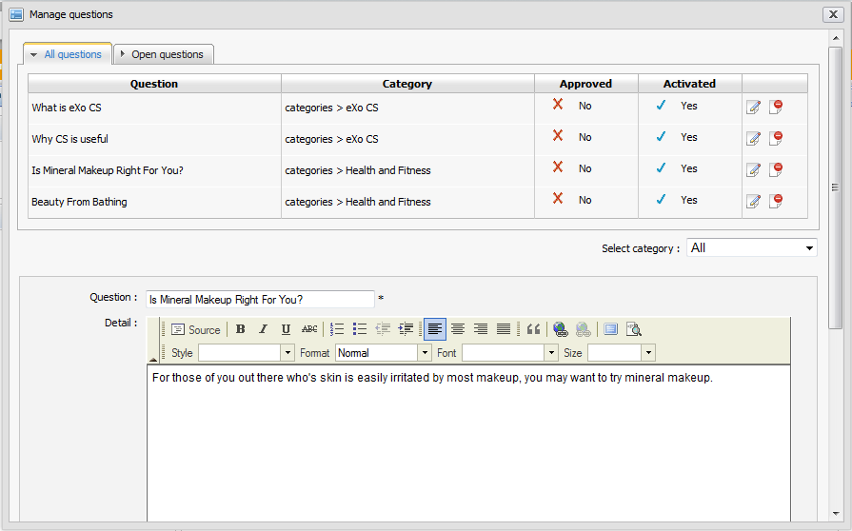Illustration 24: The Edit question in the Manage questions form
Step 4: Complete editing a question by clicking the Save button.
The select category combo box allows filtering the question by a specific category.

Delete questions
The function is used to remove questions from a specific category.
Only the Answers administrators and moderators of a category containing this question can remove that question.
Do as follows:
The 1st way:
Step 1: Right-click the question that you want to delete and then select Delete in the menu.
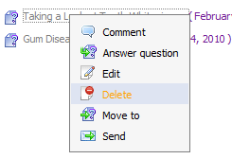
Step 2: Click OK to accept deleting or Cancel to quit.
The 2nd way:
Step 1: Click the button on the toolbar. The Manage questions form will appear.
Step 2: Click the iconthat corresponds to the question in the list that you want to delete.
Step 3: Click OK in the confirmation message to accept deleting the selected question or click Cancel to escape without deleting.
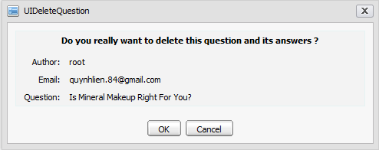Illustration 25: The Confirm deletion form
After being deleted, the selected question will be removed from the list.

Move questions
The function is used to move one question from one category to another.
Only the Answers administrators and moderators of one category can move questions inside it.
Do as follows:
Step 1: Right-click the question that you want to move and then select Move to in the menu. The Move question form will appear.
Step 2: Move the question by double clicking the destination category in the category list.
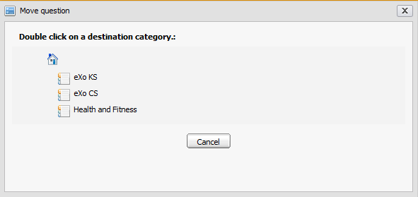Illustration 26: Move question form
After moving, the Move question form is closed, the question is moved to the new destination category.
The Cancel button is used to escape the Move question form without moving.

Only the administrator can move questions to anywhere in the Answers while the moderator is checked permission when moving question. The moderator can only move question to the category that he is also the moderator.
The Move Notification is only sent to the owner of the questions that have been moved.

Send questions to friends
The function is used to send a specific question to your friends via emails. When you visit an interesting question, you may want to share with your friends for reference. This action supports the purpose.
In the eXo Answers, only Administrators and Moderators can send pending questions.
Do as follows:
Step 1: Show the Send question by email form by one of two following ways:
The 1st way: Right-click the question that you want to send to your friend and then select Send in the menu:
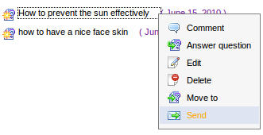
The 2nd way:
Step 1: Click the question you want to send to open.
Step 2: Click the Send icon at the top right corner of the question when viewing it in details:
The Send question by email form will be displayed:
Details:
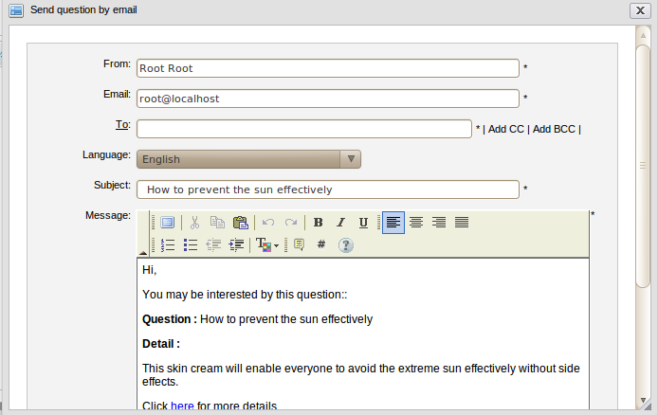Illustration 27: The Send question by email form
From: The sender's name.
Email: The sender's email address.
To: The receiver's email address. Using CC and BCC to send this message to more than one person easily and fast by clicking the 'Add CC' or 'Add BCC'. Use the 'Add CC' when you want other users to know and refer to this message. Use the 'Add BCC' when you want other users to receive this message but all receivers do not know that you also send this message to others.
Language: The language is used to display question's contents. By default, it is English. However, if the sent question has been submitted in the other language such as French or Vietnamese, you can select the favorite for sending. When the language has been changed, the question's subject and message content are changed correspondingly.
Subject: The subject that you want to send to your friend.
Message: The content of message that you want to send to your friend.
Send button: To accept sending a question to friends.
Cancel button: To close the Send question by email form.
Step 2: Enter values for fields in the Send question by email form
Step 3: Complete sending the question by clicking the Send button.
The users with email addresses in the To, CC and BBC fields will receive this message. The receivers can click the 'here' link in the content of the message to view the question in details in the Answers application.

Approve/disapprove questions
The function is used to moderate questions in a category that is set the 'Require approval on new questions' option.
One category may be set 'Moderate new questions' or not. If the 'Moderate new questions' option is not set, all questions in this category are approved and displayed by default. But when 'Moderate new questions' is set in one category, the new questions are added will be in the unapproved status and need to be moderated.
There are 2 modes for Answers: All and Approved.
- The All mode means that all approved and unapproved questions are displayed and visible for all users.
- The Approved mode means that only the approved questions are displayed and visible while the unapproved questions are not displayed and invisible.
In the Approved mode, the Moderate question function will determine the unapproved questions to be displayed or not.
Do as follows:
The 1st way:
Step 1: Go to the Edit question function which corresponds to the question that you want to approve or not.
Step 2: Select the Approved checkbox or not.
After being approved, all users can view these questions normally whatever Answers mode is.
The 2nd way:
Step 1: Go to the Answer question function which corresponds to the question that you want to approve or not.
Step 2: Select the Approved checkbox corresponding to the question you want to approve. Otherwise, don't select this checkbox.
After being approved, all users can view these questions normally whatever Answers mode is.
The 3rd way:
Step 1: Click the button on the toolbar. The Manage questions form will appear.
Step 2: You can approve by clicking the current status of the question to change. If you want to disapprove, you can do it vice-versa.

Activate/Deactivate questions
The function is used to activate/inactivate questions. When a question is activated, it will be displayed and visible for all users to view. If not, it is hidden and invisible.
Do as follows:
The 1st way:
Step 1: Go to the Edit question function that corresponds to the question you want to activate and/or deactivate.
Step 2: Select the Activated checkbox. Otherwise, don't select the checkbox.
The selected question will not be displayed.
The 2nd way:
Step 1: Go to the Answer question function that corresponds to the question you want to activate or not.
Step 2: To activate, select the Activated checkbox. Otherwise, don't select the checkbox.
After being activated, all users can view these questions normally whatever the Answers mode is.
The 3rd way:
Step 1: Click the button on the toolbar. The Manage questions form will appear.
Step 2: Activate the question by clicking the current status of the question:
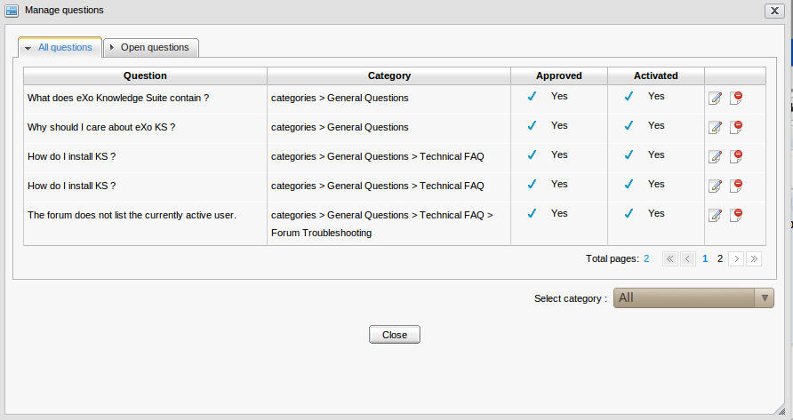
If you want to change a question from inactivated status into activated status, follow the above steps.

Approve/Disapprove answers
The function is used to approve/disapprove answers of specific questions. When the administrator or the moderator views the question answer, if they want to approve/disapprove a specific answer, he can click directly the approval/disapproval icon beside the answer.
To approve an answer, click its disapproved icon to change the current status:
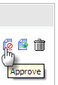
To disapprove an answer, click its approved icon to change the current status:
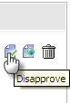
The approved answer will be visible to the normal users while the unapproved question will be invisible.

Activate/Deactivate answers
The function is used to activate/inactive answers of specific questions. When administrators or moderators view an answer, if they want to activate/inactivate a specific answer, he can click directly on the activate/inactive icon besides the answer.
To activate an answer, click its inactivated icon to change the current status:
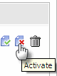
To inactivate an answer, click its activated icon to change the current status:
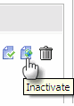
The inactivated answer will be hidden to the normal users while the activated question is shown.

Edit Answers
The function allows editing a specific answer.
Do as follows:
Step 1: Click the edit icon which corresponds to the answer that you want to edit.
The Answer form will be displayed with the current answer's information, available for editing:
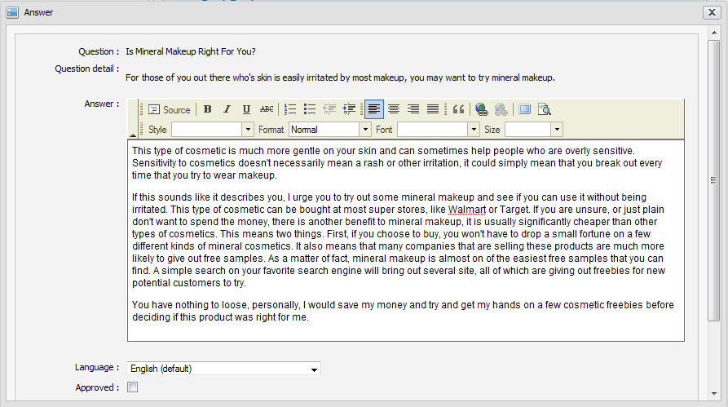
Step 2: Make changes in the form.
Step 3: Click the Save button to accept saving the changes.

Delete answers
The function is to delete specific answers.
When viewing question, if you are the administrator/moderator, you can see all answers of a specific question.
To delete one answer, simply click the trash icon below the answer that you want to delete:
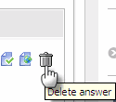
The deletion confirmation message is shown. Click OK to accept deleting or Cancel to quit.

View questions
Each question in the questions list has the collapse/expand mode.
To view a specific question, click the question title. For example, click 'Where are sites?'.
The question details will be shown below:
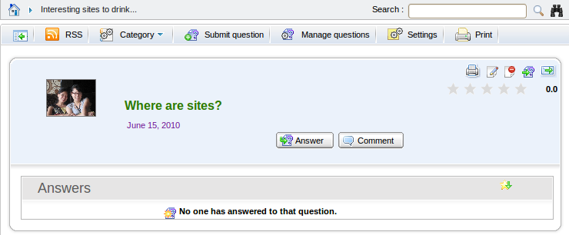Illustration 28: The question panel in case it has not been answered
It includes the question content, the answer content (in case the question has not been answered, the 'No one has answered to that question' message is shown).
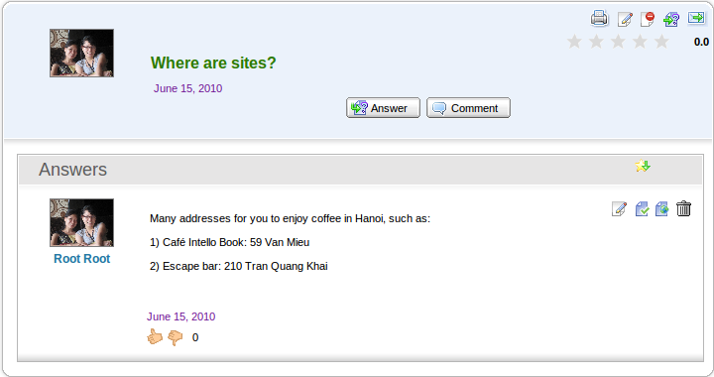Illustration 29: The question panel in case it has been answered
: Print the question.
: Edit a question or an answer.
: Delete a question.
: Move a question
: Send the question.
: Sort question by its star rating.
: Rate up/down the answer.
To download the attachments, click the attachment title. The download pop-up will appear with 3 options:
- Open with: To directly open the attachment with proper application
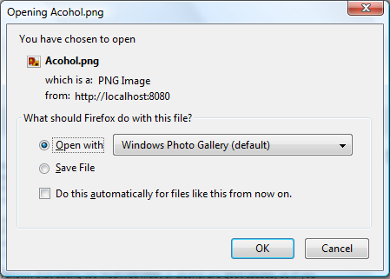Illustration 30: The download file pop-up on Fire Fox
- Save File: To save the attachment.
- Cancel: To close the download pop-up without downloading.

To close the view question form, click its title again, its answers and related questions will be hidden.
In the Manage questions form, the Answers administrators can view all questions in all categories or all questions that have not been answered.
This action supports the administrators to view questions generally.
Do as follows:
- To view the question list in general, click the button on the toolbar. The Manage questions form will appear.
This form includes two tabs, in which:
- The All questions tab includes all questions in all categories.
- The Pending questions tab includes all questions that have been not answered.

Vote questions
This function allows logged users to evaluate a question by voting in form of rating star from 1 to 5. The more star rate the question has, the more interesting it is.
Do as follows:
Step 1: Go into the question which you want to vote.
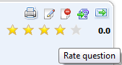
Step 2: Rate the question by left-clicking the star. The selected stars will be changed from gray to yellow. Click Cancel if you want to quit the Vote form.
After being voted, the vote statistics will be updated.
Each user can only vote one question at once. The vote function is not available to anonymous users.

Remove question vote
This function allows you to remove your vote on a specific question that let you vote it again.
Do as follows:
Step 1: Go to the question that you have voted it before.
Step 2: Click the vote star at the top right question panel:
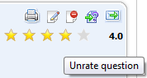
The alert message will appear.
Step 3: Click OK to confirm removing your vote or Cancel to close the alert message without removing.

Rate up/down questions
This function allows you to rate up/down an answer of a specific question. Each voter can only rate Up (+1) or Down (-1).
To rate up/down, simply click the relevant thumb icon:
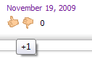
You can not rate twice but you can change your rate. When being changed, the old rate will be removed, recalculated and updated with a new score.

Comment question
The function allows logged users to give comments on specific questions.
Do as follows:
Step 1: Click the Add comment button or right-click a specific question and select Comment in the menu:
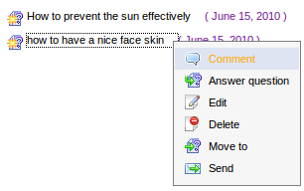
The Comment form will appear:
Step 2: Input a comment into the text editor.
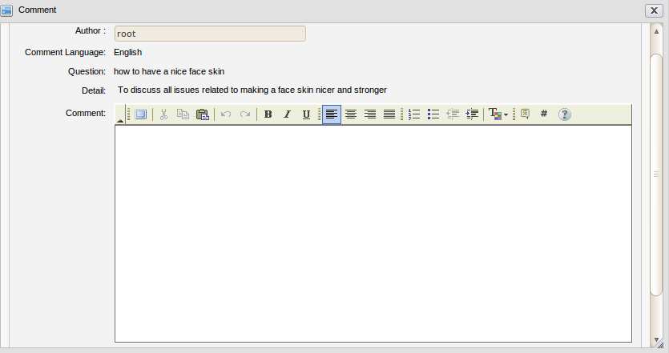Illustration 31: The Comment form
Step 3: Click the Save button to accept saving a comment.
After you comment a question, the comment will be displayed below:
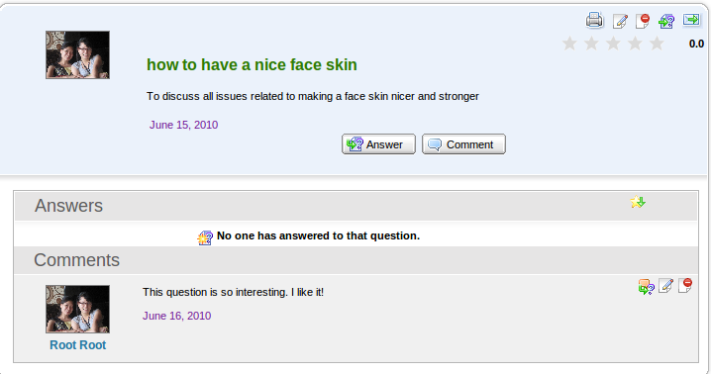
To promote a comment as an answer, click the icon on the top right of the comments panel. To edit a comment, simply click the edit icon on the top right of the comments panel.
To delete a comment, simply click the delete icon on the top right of the comments panel.
Comments can be written in different languages. If a question is posted in multiple languages, it can also have comments in multiple languages.

Promote comments
The function allows you to promote comments of a specific question to be its answer.
Do as follows:
Step 1: Click the question which has a comment that users want to promote to be its answer.
Step 2: Click the promote icon to change the comment into the question's answer.
After being promoted, the comment becomes the question's answer.

Search
The function is used to search existing categories and questions. With Quick Search and Advanced Search, you can find expected results quickly and flexibly.

Quick search
With the quick search, you can directly type a search term in the search field. All the categories and questions which have a keyword that matches with the search term will be displayed in the Search results form.
Do as follows:
Step 1: Enter a search term into the search box at the top right of the Answers screen:
Step 2: Click the search icon next to the search box to do search.
All categories/questions that match with the search term will be listed in the Search results form:
To view a category or a question in details, you can click the icon which corresponds to the category or the question that you want to view.
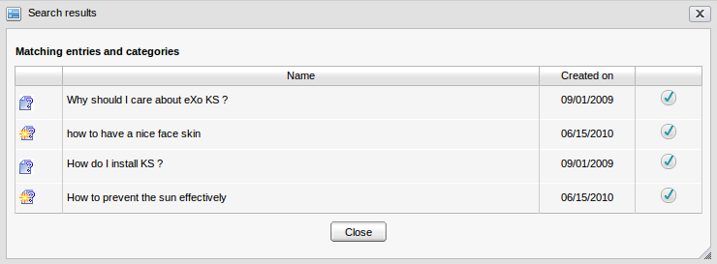Illustration 32: The simple Search Result form
In case you click the question's title, its detailed content will be shown:
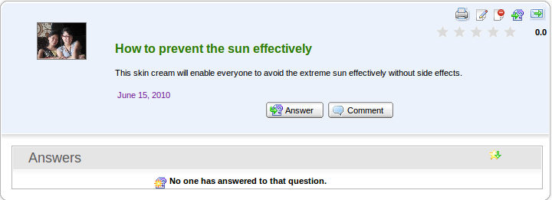Illustration 33: Question's detailed content

Advanced search
The advanced search allows users to do a search with particular criteria that corresponds to the object that is expected to be found. By using the advanced search, you can find questions/categories more exactly.
Do as follows:
Step 1: Click the advanced search icon at the right corner of your screen when you go into the Answers application.
By default, you can find both categories and questions concurrently. But if you choose an object in the 'Search in' field, it means that you only search that object.
Details:
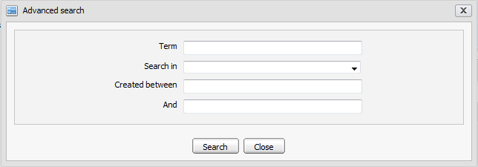Illustration 34: The Advanced search form
Term: The search term which relates to the categories/questions that you want to search.
Search in: The object you want to search in. By default, the field is blank. It means both categories and entries will be searched concurrently.
Created between – And: The created date interval in which you want to search for the selected object.
Search button: To accept doing search.
Close button: To close the Advanced search form.
The Advanced Search form will be displayed differently corresponding to each object that is selected in the 'Search in' field.
With 'Categories' object: The Advanced Search form will appear:
Details:
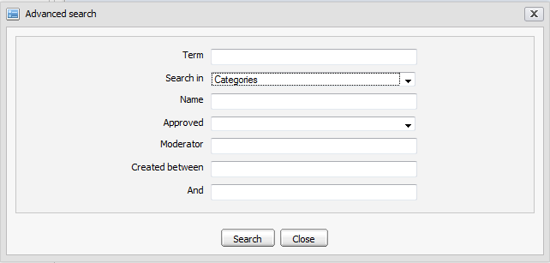Illustration 35: The Advanced search form with Search in Categories
Term: The keyword related to categories that you want to search.
Search in: The object that you want to search. If you want to search categories, value of this field is 'Category'.
Name: The name of categories that you want to search.
Approved: The question's status in the categories that you want to search. There are two statuses: 'Yes' and 'No'. With 'yes', all questions in these categories were approved. With 'No', all questions in these categories were not approved.
Moderator: The name of all category's moderators that you want to search.
Created after – Created before: The created date interval in which you want to search for the categories.
With 'Entries' object, The Advanced Search form will appear:

Details:
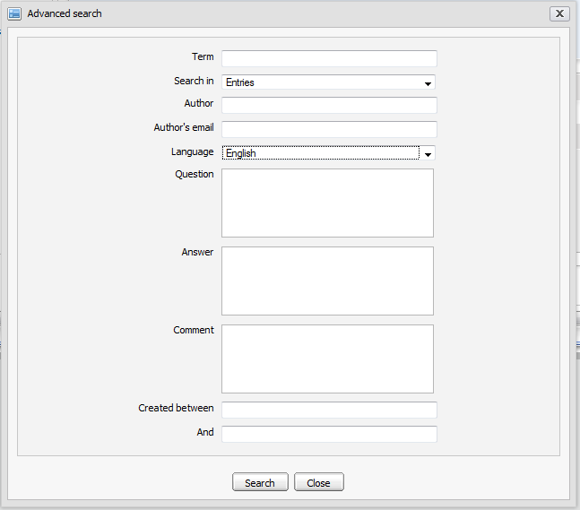Illustration 36: The Advanced Search form with Search in Entries
Term: Keyword related to the questions that you want to search.
Search in: Object that you want to search. If you want to search questions or answers, this field's value is 'Entries'.
Author: Name of the entries' creator.
Author's mail: Email address of the entries' creator.
Language: Language of the entries that you want to search.
Question: Content of the questions that you want to search.
Answer: Response of the questions that you want to search.
Created between – And: Created date interval in which you want to search for the questions.
Step 2: Enter properties' values corresponding to each object that you want to search.
Step 3: Complete the advanced search by clicking the Search button.
The list of found objects will be displayed in the search result form or there will be an alert message which informs that no objects match with the inputted properties.

To view details about one object in the Search results form, select the found object's name in the list or click the icon corresponding to the object you want to view.
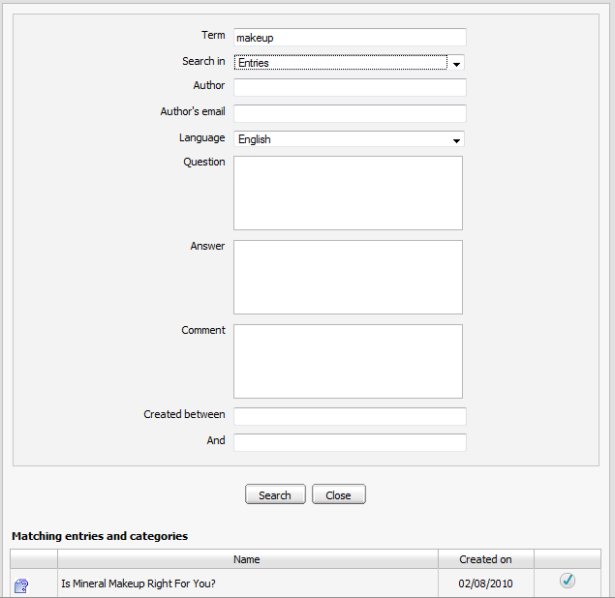Illustration 37: The Search results form

User Settings
The function allows users to set some display properties of the Answers application. Besides, it allows users to sort the Answers by popularity, to manage watch and to change avatars.
Do as follows:
Step 1: Click the button on the toolbar, the Settings form will appear:
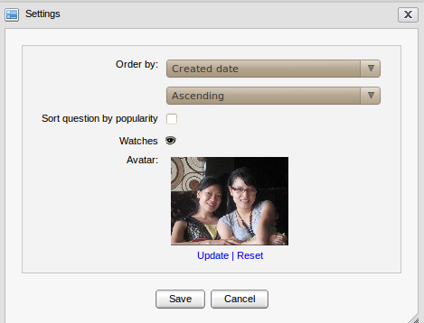Illustration 38: Settings form

Details:
Order by: The way is used to order the entries in list.
- With the 'Created Date': The entries in the question list will be displayed to the entries' created date order.
- With the 'Alphabet/Index': The entries in the question list will be displayed to the alphabet/index order.
The type of sorting entries in the question list may be: Ascending or Descending.
Sort question by popularity: This option is whether to sort question by popularity or not.
Watches: To mange watches of current login users.
Avatar: To show your avatar.
Update: To change an avatar.
Reset: To remove the current avatar and set by the default one.
Save button: To accept saving current settings.
Cancel button: To close the Settings form.
Step 2: Select values for fields in this form.
Step 3: Saving the settings by clicking the Save button.
To manage watches, do as follows:
Step 1: Click the watch icon to open the User Watch Manager form:
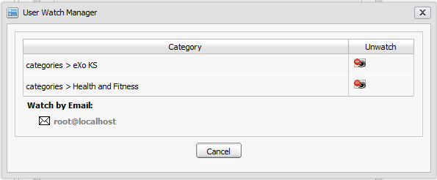Illustration 39: The User Watch Manager form
Step 2: Click the category title to view in details.
Step 3: Click the unwatch icon which corresponds to the category you want to remove a watch.
To change an avatar, do as follows:
Step 1: Click the Upload link to open the Upload File form:
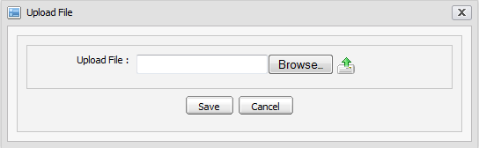
Step 2: Click the Browse... button to select a file to upload.
Step 3: Click the icon to upload the selected file.
Step 4: Click Save to accept changing the avatar.

Answer portlet setting
The function allows the administrators to set some properties for the Answers application.
Do as follows:
Step 1: Go to Group--> Administration--> Page Management on the administration toolbar.
Step 2: Click the icon that corresponds to the answers page in the page list:
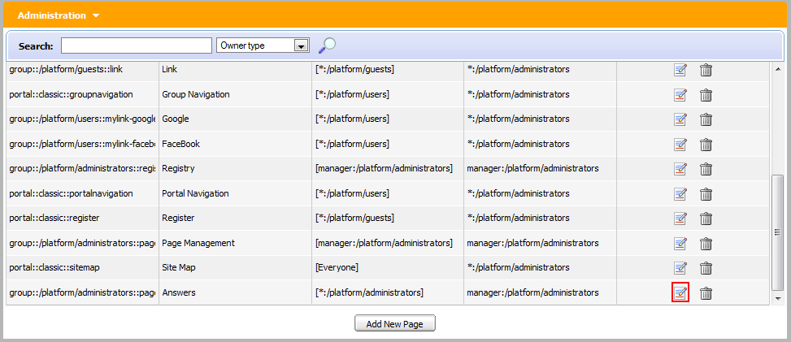
The Answers Portlet will appear:
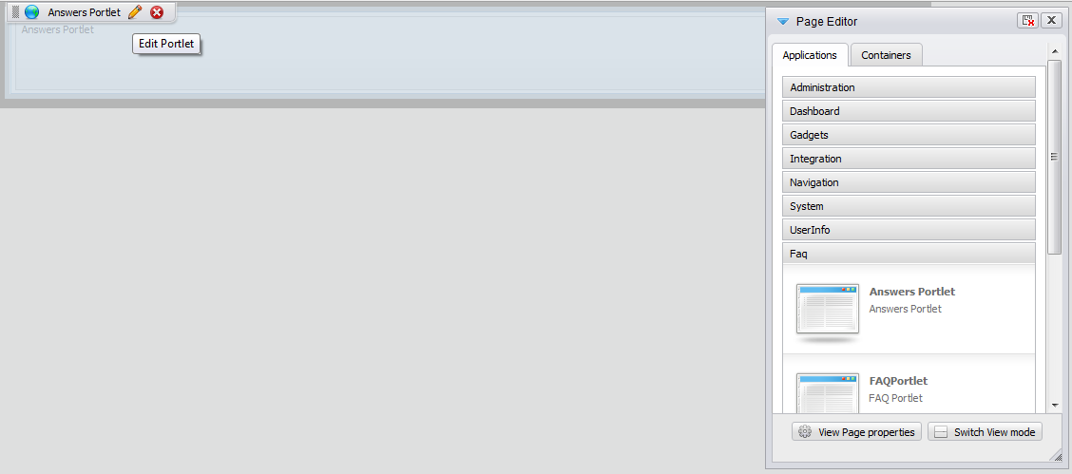
Step 3: Click the iconon the right corner of this portlet. The form to edit the Answers portlet will appear:
Details:
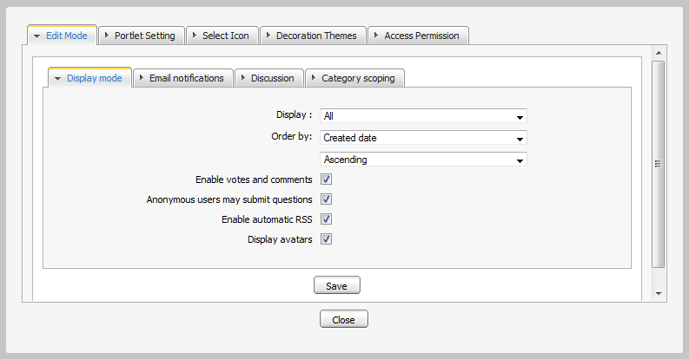Illustration 40: The Display Mode tab
The Display Mode tab includes all default display properties of the Answers application.
Display: The mode is used to display all entries in the Answers application.
- 'All': all entries (including: approved and unapproved entries/questions) are displayed in a list when users view.
- 'Approved': Only approved entries are displayed in the list when users view.
Order by: The way is used to display all entries in the Answers application.
- With 'Created Date': Entries in the list will be displayed to the entries' created date order.
- With 'Alphabet/Index': Entries in the list will be displayed to the alphabet order.
The type of sorting entries in the list may be: Ascending or Descending.
Enable votes and comments: This option is to allow votes and comments to be available or further assistances unavailable in the Answers. If the Enable vote and comments checkbox is selected, users can comment and vote in Answers. If not, these functions are disabled.
Anonymous users may submit questions: This option is to allow the anonymous users to submit question in Answers or not. If the Anonymous users may submit question checkbox is selected, anonymous users are entitled to submit questions. If it is not selected, anonymous users can not submit questions.
Enable automatic RSS: This option is to allow RSS feeds function to be available in the Answers or not. If the Enable automatic RSS is selected, users can get RSS information in Answers. If not, the RSS function is disabled.
Display avatars: The option is to allow an avatar to be viewed in Answers or not. If the Display avatars checkbox is selected, the avatar of eXo members are shown in Answers. If not, they are hidden.
The Email notifications tab allows the content of notification mails to be defined or not. It includes The New question, the Edit/answer tab and the Move Question tab:
Details:
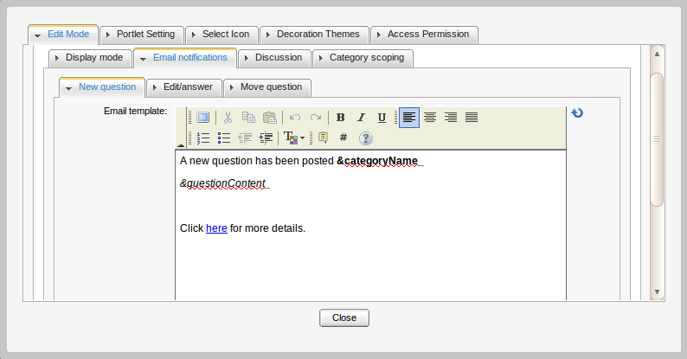Illustration 41: The Email notification tab
The New question tab contains the default content of notification mail about new questions.
The Edit/answer tab contains the default content of notification mail about the question which is answered or edited.
To change the content of the notification mails, manually edit the text in the FCK editor. The content can be decorated with multi effects such as font style, size, color, image, etc.
The Move question tab contains the default content of notification mail about moving questions.
There are some parameters which are used to load the category and question's content dynamically. So, you should not edit them.

The Discussion tab allows the Forum discussion function to be enabled and/or disabled in Answers and set the default forum for this function.
To enable/disable the Forum discussions, simply select/unselect the Discuss in forum checkbox.
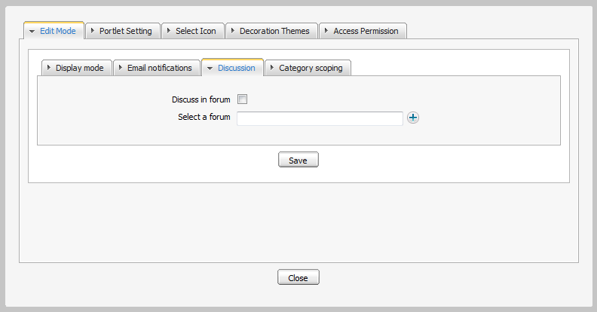Illustration 42: The Discussion tab
To define the default category for discussions, do as follows:
Step 1: Clickto open the Select a forum form. The Select a forum form will appear.
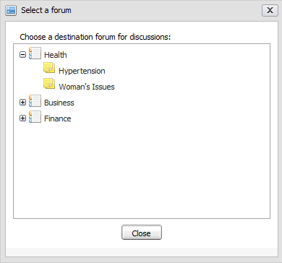Illustration 43: The Select a forum form
Step 2: Click a specific category/forum title to select it.
Step 3: Click Save to accept saving changes in the Discussion tab.
The Category scoping tab allows you to hide/show categories in the Answers application. The hidden category will not be displayed in the Answers application.
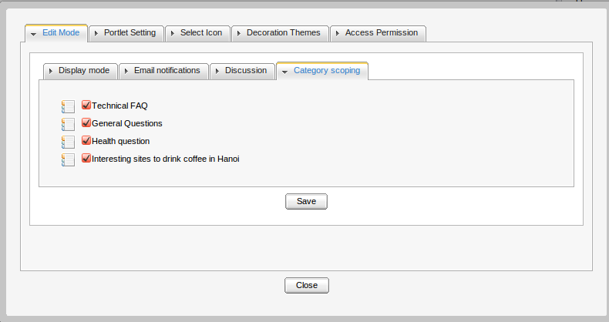Illustration 44: Category scoping
To hide/show any category, simply unselect or select its checkbox and click Save.
As a result, the Forum portlet settings will be saved. The selected category will be displayed in the Answers application while the unselected category will be hidden.
The Portlet Setting tab includes:

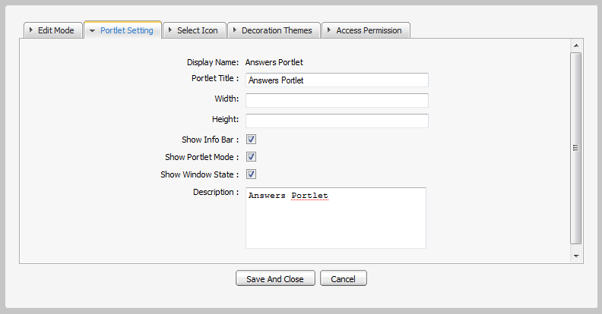Illustration 45: The Portlet Setting tab
Display Name: The portlet's display name.
Portlet Title: The Answers portlet's title.
Width: The portlet's vertical size. Value of this field should be in a numeric format. This field can be changed. (Not required).
Height: The portlet's horizontal size. It should be in a numeric format. This field can be changed. (Not required).
Show Infor Bar: This option enables users to show the information bar of the portlet or not.
Show Portlet Mode: This option enables users to show the portlet mode or not.
Show Window State: This option enables users to show window state of the portlet or not.
Description: This brief description about the portlet. It must has length from 0 to 255 characters.
The Select Icon tab allows you to select icon for the portlet. By clicking the Get Default, you do not have to choose any icon from the list, it will automatically get the default one for the portlet.
The Decoration Themes tab allows you to select one theme for the portlet. There are some themes collections. By clicking Get Default, you do not have to choose any theme, because the theme will be automatically set by default.
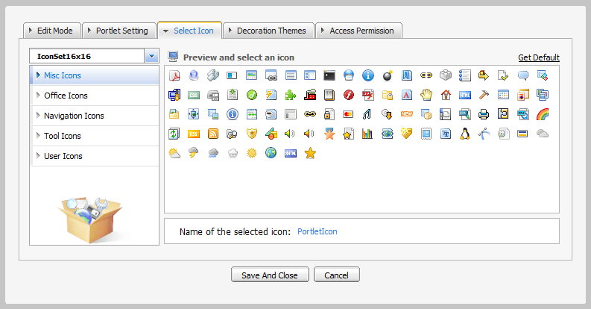Illustration 46: The Select Icon tab
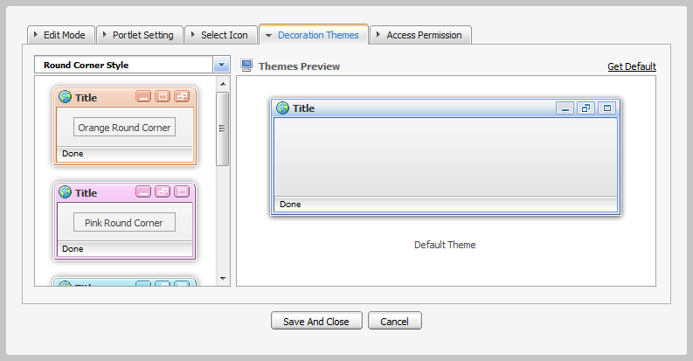Illustration 47: The Decoration Themes tab
The Access Permission tab allows you to set the access right for users: select Make it public checkbox in order to allow everyone to access this portlet or click the Add Permission button to add permission for the selected groups and memberships.
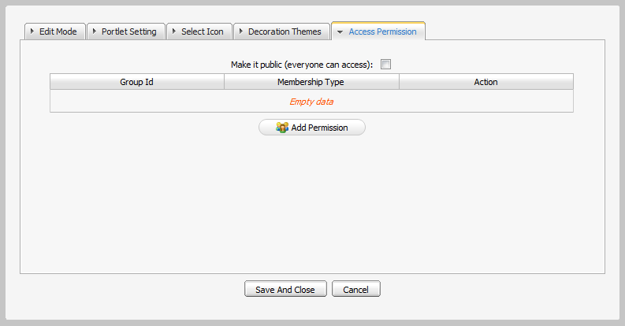Illustration 48: The Access Permission tab
Step 1: You can set values in the Display Mode tab to set properties in the Answers or check 'Show Info Bar' and 'Show Portlet Mode' option to set properties.
Step 2: Click the icon to save all changes.
All entries/questions in the Answers will be shown according to your setting in the Edit Mode tab.
You can also set the display properties as follows:
Step 1: Open the Answers application and select the Edit function in the menu when you click the icon on the right corner of the Answers portlet.
Step 2: The form to edit some display properties will appear like the Edit Mode tab above.
Step 3: Change values in these fields.
Step 4: Click Save to save all changes.

Print
The function is used to print a question or all questions in a specific category.
Do as follows:
Step 1: Go to the Answers screen view that you want to print.
Step 2: Click the button on the toolbar to print all the questions in the current category in details or click the print icon on the right question panel to print that question only.
The print preview page will appear:
Step 3: Click Print to set up the printer or Close to quit the print preview mode.
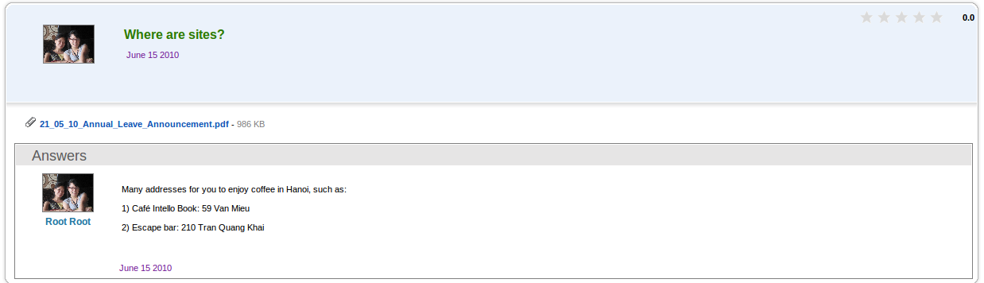Illustration 49: The print preview page

Export/Import

Export
The function is used to export categories and questions in the Answers into your local computer in the *zip file form. The Export function can be executed on all categories and questions in the Answers or a specific category.
To export all categories and questions, do as follows:
Step 1: Go to Answers application.
Step 2: Right-click the category that you want to export and select Export in the menu:
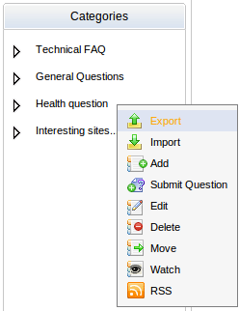
The Export form will appear:
Details:
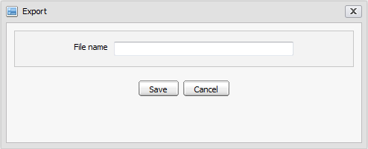Illustration 50: The Export form
File Name: The exported file's name.
Save button: To accept exporting all categories and questions.
Cancel button: To exit the Export form.
Step 3: Input a file to export.
Step 4: Click Save to accept exporting all categories and questions.
A download pop-up will appear:
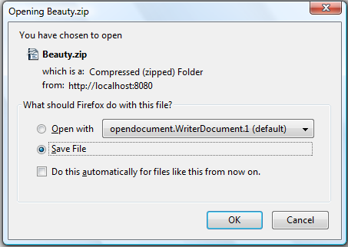
Simply select the Save File option and click OK to accept saving the exported file.
Similarly, to export a specific category, go to the Answers application and go to inside specific category. Click the Export button on the main action bar or right-click the category and select the Export option to open the Export form and take actions like steps above.
The exported file can be used to import exported files into the Answers system.

Import
The function is used to import categories and questions from a zip file which has a valid content into the Answers system. An exported file can be imported directly into the Answers homepage or a specific category in the Answers.
To import a zip file into the Answers homepage, do as follows:
Step 1: Go to Answers.
Step 2: Right-click the category that you want to import and select Import in the menu.
The Import form will appear:
Details:
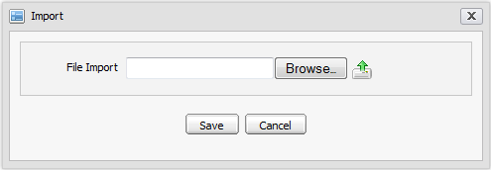Illustration 51: The Import form
File Import: To show the imported file's path.
Browser : To select the imported file's path.
: To upload the selected file.
Step 3: Click the Browser... button and select a file from the local disk.
Step 4: Clickto upload the selected file. For example, select and upload the exported file named Assessment.zip. After uploading, the Import form is shown:
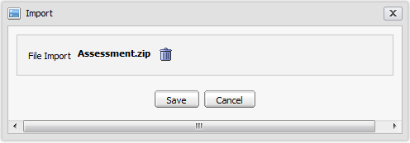
Step 5: Click Save to accept importing the uploaded file into the Answers system.
After being imported, all categories and questions which are defined in the zip file will be imported and displayed properly in the Answers homepage.
Similarly, to import a zip file into a specific category, go to the Answers application and go inside a specific category. Click the Import button on the main action bar or right-click the category and select the Import option to open the Import form and take actions like steps above.
The imported categories and questions will be displayed properly in the selected category.

Show/hide the left panels
The function allows personalizing the Answers view by showing/hiding the left panels.
By default, the Answers application is displayed with all panels. In case you want to hide/show all panels on the left, you can click the button on the main action bar.

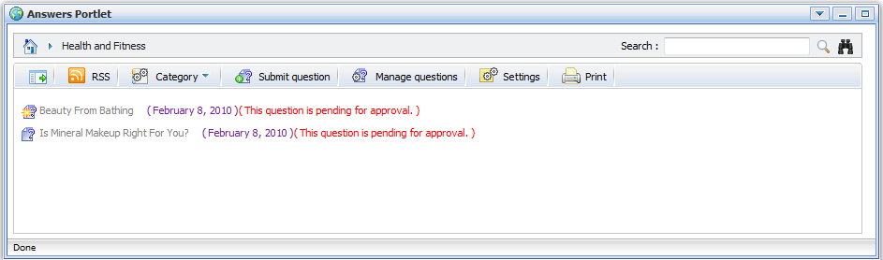Illustration 52: Custom view without left pane

Drag and drop
The feature is used to change the category position in the category list or move a sub-category to its parent list.
Do as follows:
Step 1: Right-click the icon of the category that you want to change the display position.
Step 2: Drag and drop it above / below the current position or to the green arrow icon.
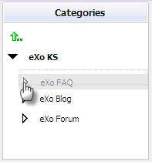
The dropped category will be moved to the new position properly. The category list will be changed properly. The order of all categories will be updated correspondingly.
This feature is available for the administrator only.

View User Profile
The function allows viewing the profile of specific users who submit, answer or comment questions.
To view a specific user's profile, simply click his/her user name, the user profile pop-up will be displayed:

Discuss in forum
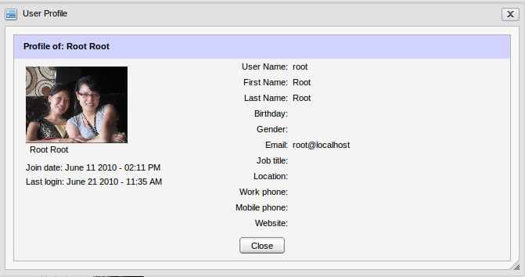Illustration 53: View User Profile form
The function allows users to discuss a question in the Forum application.
When a question is discussed, it will become a new topic in the Forum application. The new topic created with the topic title is the question title, the topic content is the question content and the post is the question answer or comment.
To discuss or view the question's discussion, click the icon at the top left of the question panel or right-click a specific question and select Discuss in forum in the menu:
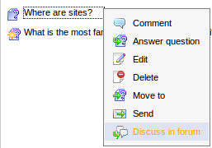
After being discussed, a new topic is created into the forum which is defined as the discussed forum in the Answers Setting and you are redirected directly to the Forum application.
When there is an answer added, a comment added or any edition in a question, an answer or a comment, the discussed topic in the Forum application is changed correspondingly.
However, when the question is clicked to discuss at the first time, its status is pending for approval. You can only view the discussed topic when the Forum administrator/moderator approve it.
After a question is discussed, to view it, simply click the Discuss in forum option in its right click menu.

Rss feed
The function provides RSS feeds. Each time an entry is added or updated, the corresponding category's feed will be updated.
Do as follows:
Step 1: Click the category that you want to get the RSS feed.
Step 2: Click the RSS button on the main action bar or select RSS in the right click menu of a specific category:
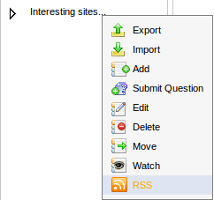
The RSS information page will appear on another tab:
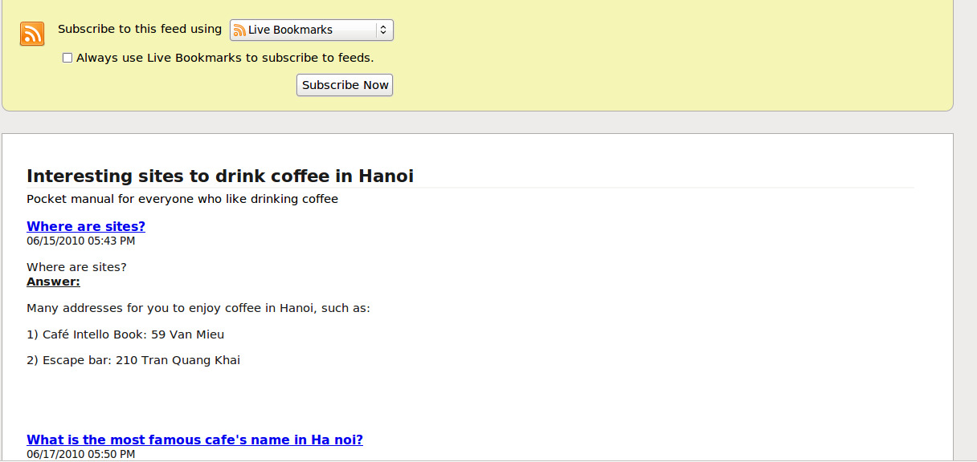
All question information of the category that is being watched will be listed.
To add a live bookmark, simply click the Subscribe Now button, then click the Add button in the menu pop-up.

FAQ Portlet
You can add the FAQ Portlet to a page for using. eXo KS facilitates users with the FAQ portlet that helps users quickly and easily view the questions and answers from the Answers portlet by the tree view type.

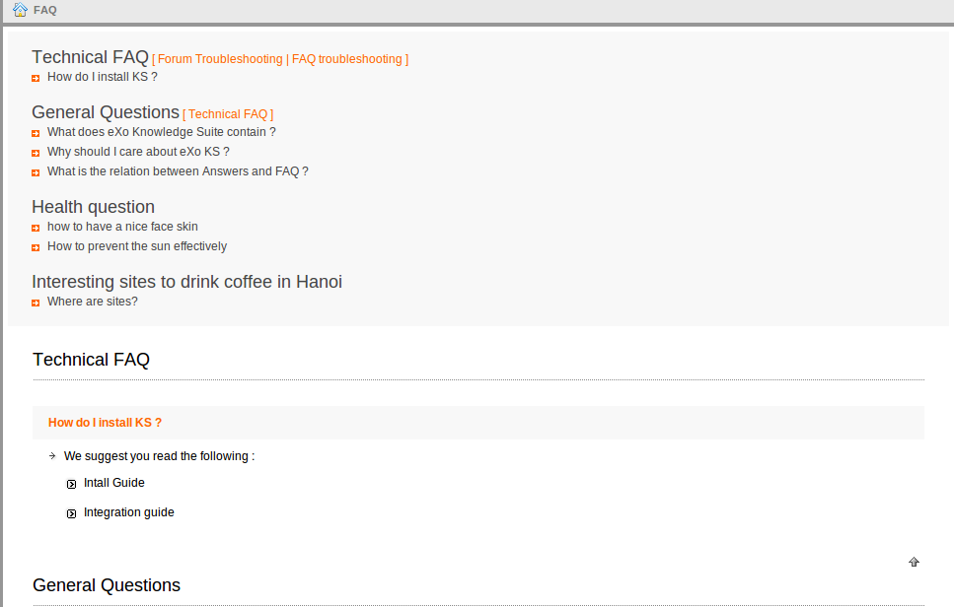Illustration 54: The FAQ Portlet in the View mode
The FAQ Portlet's Edit Mode allows users to set the properties to display questions and answers in the View mode.
To edit the FAQ portlet, do as follows:
Step 1: Click the FAQ portlet to go into the FAQ main screen.
Step 2: Click Site Editor on the Administration toolbar and choose Edit page.
Step 3: Move the mouse over the FAQPortlet area and click the edit icon.
The FAQ portlet's Edit Mode will appear:
The Displaying Category tab: allows users to select the category which contains questions and answers that will be displayed in the View mode.
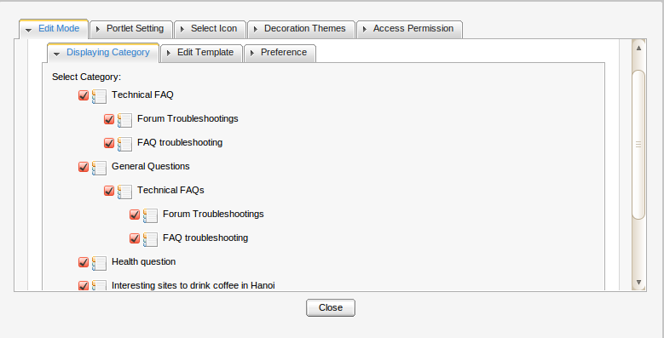Illustration 55: The FAQ Portlet in the Edit mode
- Select the checkboxes which correspond to the categories you want to display the content in the View mode.
The Edit Template tab: the content template that will be displayed in the View mode. If you want to edit this template, you need to have a knowledge about css.
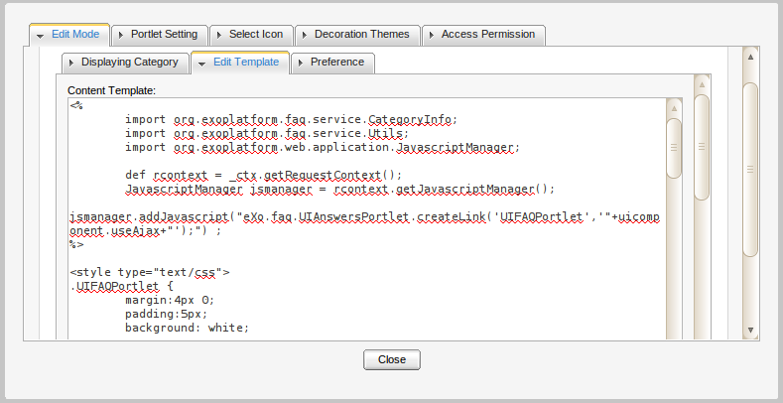
- Edit the template according to your need (in case you have a knowledge about css).
- Click the Save button to save all changes.
The Preference tab: Users need to have a knowledge about Ajax. Ajax (stands for Asynchronous JavaScript and XML) is used here with the purpose of updating a whole web page or a part of a web page.
The Use Ajax's default value is false that means a whole page is loaded. When users select the Use Ajax checkbox, it will load a part of a page.
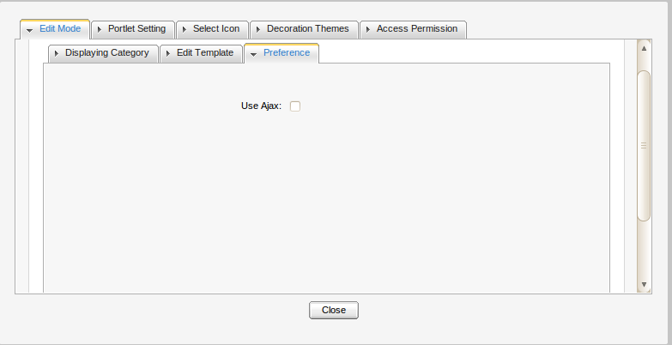Illustration 56: The Preference tab

Conclussion
It is our hope that information stated above is valuable to you, all eXo customers and users when they experience FAQ & Answers. To clearly support for benefits recognition from customers and users, we would like to summarize major strengths of eXo FAQ & Answers as follows:
Answers | Post questions and answers in multiple languages.
Question Management | Answer, edit, delete or move question.
Comment | Make comments directly to the user who originally raised questions and/or promote comments as answers.
Rating | Use the star-based rating system to show the preference levels to various questions.
Thumb up and down | These button types help user specify the most useful answers.
Attachments | Be entitled to attach files to questions using the upload system.
Moderation | Admins can create categories for moderators based on groups, users or memberships, and deactivate or reject questions.
FAQ | Users can publish and view contents clearly and quickly.

Our support is always willing to receive any feedback, including errors notifications and ideas that can make the guide better. Serving and resolving all issues related to the eXo Forum are our responsibilities, so please post your questions at our forum freely.
For more information about eXo platform and our products, please visit our homepage.We also provides professional support via eXo Forum, where you can find useful advice and solutions to your issues.

