
eXo Knowledge FAQ & Answers
Version 2.0
Ver. | Date | Written by | Reviewed by | Change Record
1.0 | Jan, 3, 2009 | Hoang Anh Quynh Nga | Nguyen Thanh Cong
1.1 | Mar, 18, 2009 | Nguyen Thanh Cong | Hoang Anh Quynh Nga | - New FAQ UI with left pane, category tree and question panel  - New Submit Question form: Question title, question detail.  - Improve the way to add question in multiple languages.  - View question in multiple answers  - Vote question  - Vote answer  - Comment question in multiple languages  - Custom view  - View user profile  - RSS feeds  - Update Tool bar and Breadcrumb enhancements.  - Update vote question, answer.  - Unvote question and rate up/down answer  - Changes on Watch function  - Update Unwatch function  - Changes on question template.  - Update User Settings function  - Submit question form with FCK Editor  - User Setting: manage watch and change and delete avatar.
1.2 | Sep, 01, 2009 | Luong Quynh Lien |  | - Change screenshots.  - Answers portlet.  - FAQ Portlet
1.2.2 | Nov, 22, 2009 | Luong Quynh Lien |  | - Upgrade to 1.2.2  - Review
2.0 alpha3 | Feb, 09, 2010  Mar, 25, 2010  May 15, 2010 | Luong Quynh Lien | Nguyen Huu Tuan Anh  Vu Thi Hoa | - Update to 2.0.0 with new screenshots based on Gatein.  -Review  - Repairing errors in spelling, grammars.  - Adding some parts (overview, conclusion, advantages, etc)  - Formatting  - Update screenshots  - Fix the table of Content
2.0.0 | 06/16/10 | Tra Giang |  | - Update sceenshots  - Arrange the guide to the new template  - Add some parts  - Fix errors

Contents
1 Preface 6
1.1 Overview 6
1.2 Why uses FAQ & Answers 6
1.3 Purpose of the Guide 6
1.4 References 7
2 Glossary 8
2.1 What is Answers application? 8
2.2 What is Category? 8
2.3 What is Question? 8
2.4 What is Answer? 8
2.5 What is Comment? 8
2.6 Answers main screen 8
3 FAQ & Answers Administration 10
3.1 Main Work Flow 10
3.2 Register A New Account 11
3.3 Sign In/Sign Out 12
3.3.1 Sign In 12
3.3.2 Sign Out 14
3.4 Question Management 14
3.4.1 Add questions 14
3.4.2 Answer questions 18
3.4.3 View questions 19
3.4.4 Edit questions 21
3.4.5 Vote questions 23
3.4.6 Remove question vote 23
3.4.7 Rate up/down answers 24
3.4.8 Comment questions 24
3.4.9 Send question to friends 26
3.4.10 Watch 28
3.4.11 Unwatch 29
3.5 Search 30
3.5.1 Quick search 30
3.5.2 Advanced search 31
3.6 User Settings 36
3.7 Print 38
3.8 Show/hide the left panels 39
3.9 View User Profile 39
3.10 Discuss in forum 40
3.11 Rss feed 41
3.12 FAQ Portlet 42
4 Conclussion 44

Preface

Overview
Beginning as an open source project in the year 2002, eXo is well-known as the industry's first Java portlet container. With the aim of dominating the potential portal market through robust and easy-to-use applications, eXo Project succeeded in attracting consumers in the whole world. eXo opened the floodgates to various options in many markets, and customers have been choosing eXo as the best method for their success.
Today, eXo is a rapidly growing global company, with U.S headquarters in San Francisco, California, global headquarters in France, and offices in Tunisia, Ukraine, and Vietnam. The company has established technology leadership and proven its values by their large European installed base and strategic partnerships with Red Hat, Capgemini, Atos Origin, and Bull.
And along with many eXo products, eXo Knowledge, an extended service of eXo will help you collect, organize, and publish knowledge, aiming at enhancing your company's internal productivity and creativity through effective collaboration tools. With two applications, including Forum and FAQ & Answers, you can not only hold online discussions and post user-generated contents, but also view and respond to most frequently asked questions regarding to sites and/or services. With FAQ & Answers, you can look and feel many benefits, such as empowering users and customers via information exchange channels, or encouraging innovation and awareness through new ideas and useful feedbacks.

Why uses FAQ & Answers
The application provides many useful features to users as summarized below:
- Categorize questions.
- Pose multiple questions and comments.
- Rate and/or vote.
- Moderate.
- Rss and email watch.

Purpose of the Guide
The book was written as a detailed manual, aiming at instructing step-by-step on how to use and implement this application to the utmost. Thus, the information included herein will give basic steps that makes it easy for users to follow through in-depth examples as well as clear explanations regarding to the eXo Knowledge technology. Whether you major in technology or not, you are able to learn about or work on eXo FAQ & Answers easily and efficiently.
The information provided in the guide has been arranged into such a way that ensures readers to search and implement them quickly. Initialized with the glossary section, the guide will give main definitions used in this book. Next, the guide focuses on the most important so-called “ FAQ & Answers administration”. The part will represent most of steps necessary in the process of using and mastering the eXo FAQ & Answers. Finally, with the aim of helping users better understand eXo FAQ & Answers, we also mention some major strengths in the Conclusion section.
The material is useful for anyone interested in learning and using the FAQ & Answers applications.
From above, the aim of FAQ & Answers User's Guide can be summarized as follows:
- Define basic concepts used in the FAQ & Answers applications.
- Show the basic instructions.

References
- FAQ & Answers Administrator's Guide_En v2.0

Glossary

What is Answers application?
Answers is an online application that allows users to pose common questions and answers about a specific topic. The application may be seen as a way to reply questions about rules or any problem when users implement a specific system.
Answers familiarizes visitors with answers to most frequently asked questions about a site/service or about the entity/subject responsible for the site/service. Repeatedly received questions will be added to Answers and newcomers with Site/Service are encouraged to view Answers.

What is Category?
Category is a questions and/or answers collection about specific topics. In Answers, one category may include one or more sub-categories. One category may also contain both sub-categories and questions inside.

What is Question?
Question is an expression applied by users for asking and getting information. In Answers, all questions related to the same topic have to be posted and grouped in the same category.

What is Answer?
Answers is a response to specific questions. In the Answers, all responses are posted below its questions. Only people who have moderation right can answer questions.

What is Comment?
Comment is an opinion on a specific question given by a user. In Answers, all comments are posted below their questions. A comment can be promoted to an answer by the administrator.

Answers main screen

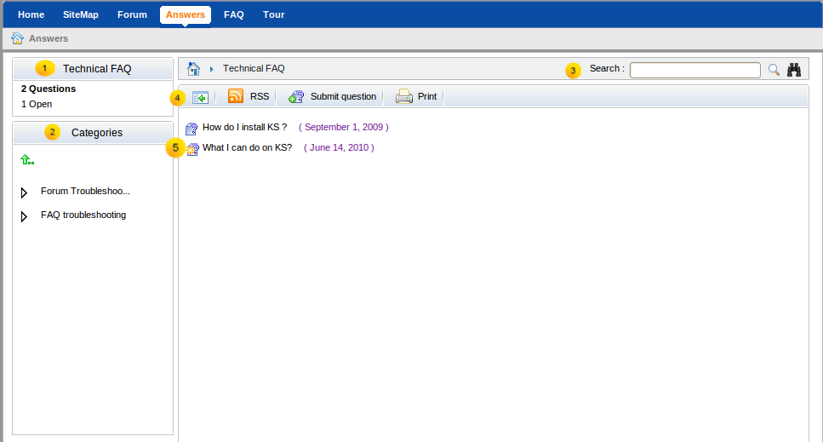Illustration 1: Answers Main screen
Indicator | Meaning
 | The Categories Status panel displays information of a current category which is being viewed. It includes the total number of open questions (not answered yet), pending questions (waiting for approval) and the total number of questions.
 | The Categories Panel explores the category in the tree view. A click on one category will browse into it on the Answers view panel.
 | The Breadcrumb bar shows answers path and search function with simple and advanced options.
 | The Action bar allows administrator to add category, question, manage question, import, export, print, settings quickly and easily.
 | The Answers view panel displays all categories, sub-categories and questions.

FAQ & Answers Administration

Main Work Flow
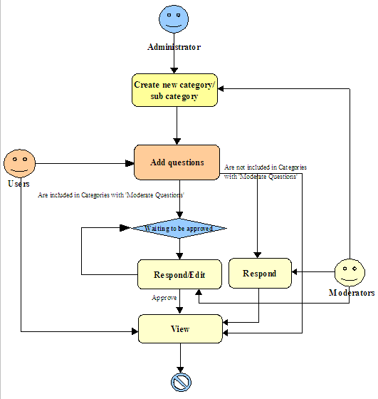Illustration 2: The Mail work flow of Answers application
Explanation:
From the above chart, the operation system in FAQ & Answers can be expressly seen. In details, an administrator creates a new category/sub-category. The category/sub-category can be set with 'Moderate new questions' or not. If the 'Moderate new questions' option is set, all questions in this category/sub-category must be approved/disapproved by moderators or administrators. Besides, all users can add new questions to a specific category/sub-category.

Register A New Account
Unregistered users visiting the portal will be limited to several contents and applications which are not set as public. They can only see, submit and send questions. Therefore, users who want to access in-depth contents or perform some actions in various applications, they should register by themselves and then contact the portal administrators to gain certain rights or permissions. To register a new account, do as follows:
Step 1: Click Register on the upper right corner of the homepage. The Register New Account form will appear.
Details:
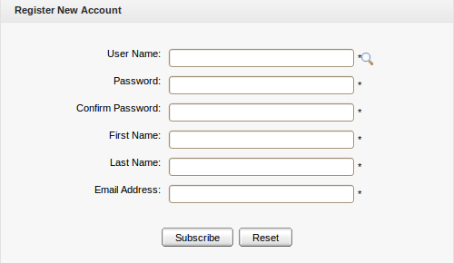Illustration 3: Register New Account
User Name: The user's login name that must be unique with at least 3 characters.
Password: The password used to login that must have at least 6 characters.
Confirm Password: The re-typed password. The Password and Confirm Password must be the same.
First Name: The user's first name which must start with a character.
Last Name: The user's last name which must start with a character.
Email Address: The user's email which must be in the right format, for example: username@abc.com.
These are required fields, the User Name must contain only alpha, digit and underscore characters and must be unique.
Step 2: Enter values for fields in this form.
Step 3: Click the Subscribe button to accept adding a new account or the Reset button to clear the entered values. After you click the Subscribe button, there will be a message which informs that you have registered your account successfully.
Step 4: Click OK to finish creating your account.
There will be an alert message which informs that you can not add a new account, such as:
- The User name is existing or User Name is invalid.
- The Password has less than 6 characters.
- Password and Confirm Password must be the same.
- Your email address is invalid. Please enter a different address.
- The field (field name) is required.
After adding a new account, contact your administrator to get rights or only be a visitor.
The magnifying glass icon is used to search whether the entered User Name exists or not. Once a user has registered by himself or the administrator has created a new account, the new user will become a part of the group "/platform/users" with membership by default.

Sign In/Sign Out

Sign In
The function allows you to go into the portal and/or Answers in the private mode.
To sign in, do as follows:
Step 1: Go to the portal in the public mode by inputting URL in the address bar (e.g: http://localhost:8080/portal).
Step 2: Click the Sign in link at the top right of portal if you are in the Classic portal.
The Sign in form will appear:
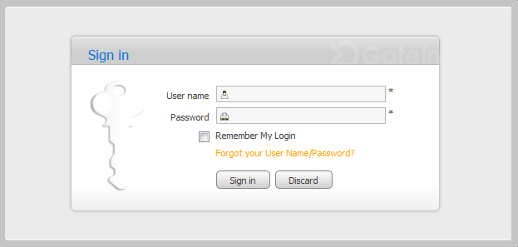\Illustration 4: The Sign in form
Details:
User name: The registered user name (*required).
Password: The registered password (*required).
Remember My Login: The checkbox helps users automatically sign in a portal without signing in again for the next time.
Forgot your User Name/Password? The link helps users retrieve user name and password when they forgot.
Step 3: Sign in by the administrator account.
Step 4: Complete signing in by clicking the Sign in button.
In case the User name does not exist or the inputted User name/Password is invalid, there will be an alert message and you can not add a new account if at least one of these cases occurs:
  - The User name is existing or User Name is invalid.
  - The Password has less than 6 characters.
  - The Password and the Confirm Password are not the same.
  - The Email Address is invalid format.
  - The required fields are blank (empty).
After signing in, you will be redirected to the authenticated home page:
To take actions in the Answers application, you have to add the Answers portlet to a page.
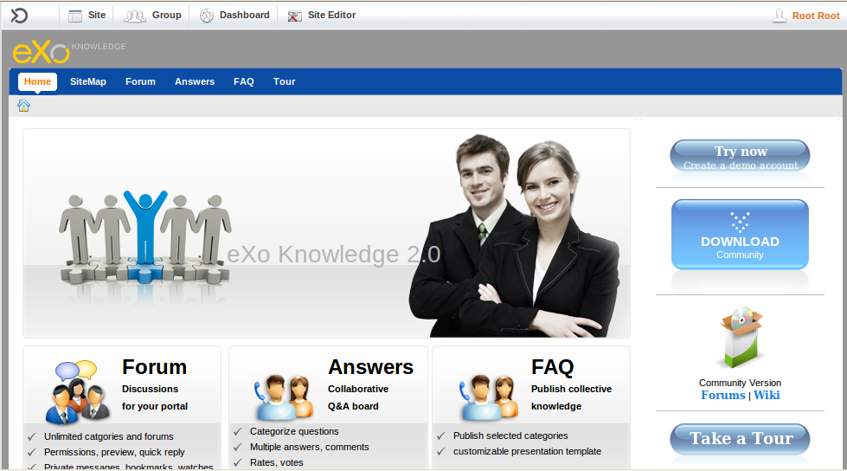Illustration 5: The authenticated homepage

Sign Out
The function allows you to get back to the anonymous portal. It ends your current portal session.
To sign out, click Sign out in the Star menu list on the administration toolbar:
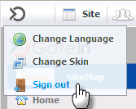

Question Management
The section contains all actions related to questions in a category.

Add questions
The function is used to add questions to the Answers homepage or a specific category.
Do as follows:
Step 1: Show the Submit question form via one of two following ways:
The 1st way: Right-click the category/sub-category that you want to add a new question into and then select Submit Question in the menu.
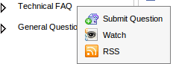
The 2nd way: In the homepage or go into the category that you want to add a question into and then click the button on the toolbar.
The Submit question form will appear:
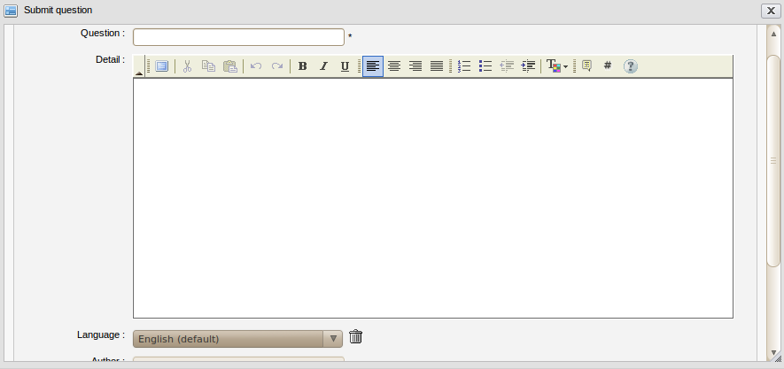Illustration 6: Submit question form
Details:
Question: To input your question.
Detail: To describe detailed information regarding to the question.
Language: To select the language used to add a question. By default, the language is English. The language combo box allows selecting a language option.
Author: To show the author's name. (Required)
Email: To show the email address which must be in a valid format like: username@abc.com. (Required)
Attach a file: To attach files into the question.
Step 2: Input values into fields in the Submit question form.
- To add this question in another language, do as follows:
1. Click the language combo box in the Submit question form. The language drop-down list will be displayed:
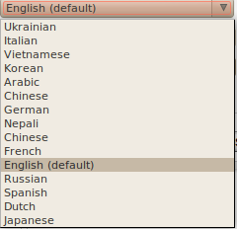
2. Select a language by clicking on the language that you want add to a question.
3. Click the Save button to accept adding another language or click the Cancel button to quit.
There will be a text box that corresponds to the selected language in the Submit question.
- To remove a question in the specific language, simply select the language that you want to delete and click the delete icon next to the language combo box.
After the deletion, the corresponding language content will be deleted.
- To attach files, click the attach a file link in the Submit question form. The Upload File form will appear:

1. Select files to upload by clicking Browser... to select the file's path from local computer.
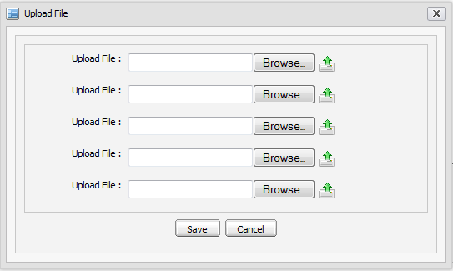Illustration 7: The Upload File form
2. Upload the selected files by clicking the icon to upload.
3. Complete attaching files to a topic by clicking the Save button.
Note that many different file types can be attached. To remove attached files, simply click the Remove link beside the file attachments which you want to delete.
Step 4: Complete submitting a question by clicking the Save button.
The question is added to the selected category and an alert message is shown to inform that the question is added successfully. In case the question added to the category is required to have the moderation before displaying, the alert message will have a content to inform that the question will be checked by the moderator for approval.
The question list is shown below:
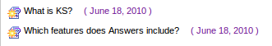

Answer questions
The user who has logined in can answer questions by following these steps:
Step 1: Right-click the question that you want to answer and select Answer question;
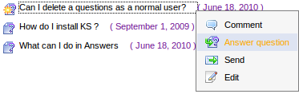
or select the Answer button when viewing the answer in details.
The Answer form will appear:
Details:
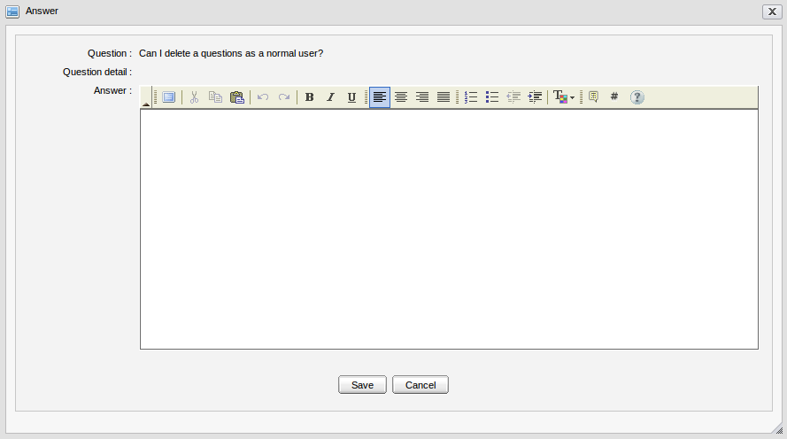Illustration 8: The Answer form
Question: The question's brief content which can be viewed only.
Question detail: The question's detailed content which can be viewed only.
Answer: The answer's content. A question can have multiple answers.
Step 2: Enter values for required fields in the Answer form.
Step 3: Complete answering a question by clicking the Save button.

View questions
Each question in list has collapse and expand modes.
- To view a specific question, click the question that you want to view in list.
The question details will be shown:
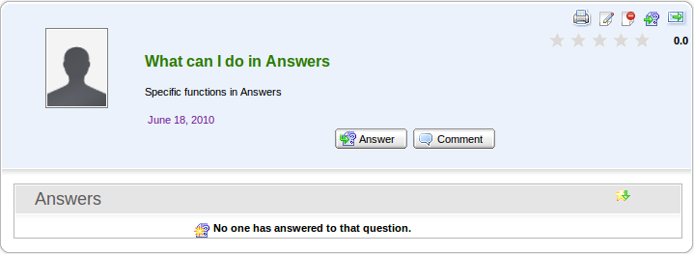Illustration 9: The question panel without answer
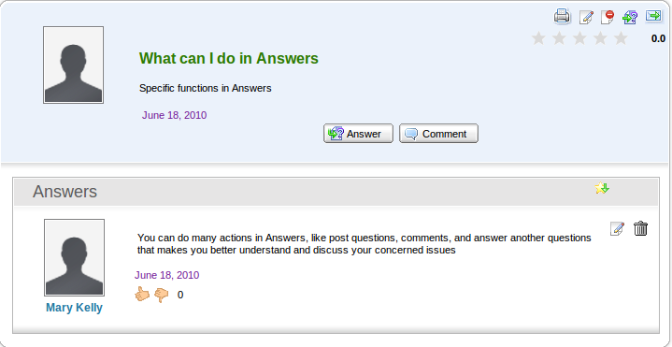Illustration 10: Question pannel with answer
- It includes: question content, answer content (in case the question has not been answered, 'No one has answered to that question' message is shown).
- It may include attachments, related questions, languages to display (the default is English). Besides:
: This icon is used to print the question, send icon.
: This icon is used to send the question.
: This icon is used to vote the question.
: This icon is to used to sort questions by its star rate.
- To view the image attachment in the preview mode, simply click the image that you want to view, the image will be shown in the preview mode.
- To close the image preview mode, simply left-click the previewed image, the preview mode will be closed.
- To download the attachments, simply click the attachment title. The download pop-up will appear with 3 options:
Open with: To directly open the attachment with proper application
Save File: To save the attachment.
Cancel: To close the down load pop up without downloading.
- To view the related question to the question, simply click the related question's title, its content will be displayed:
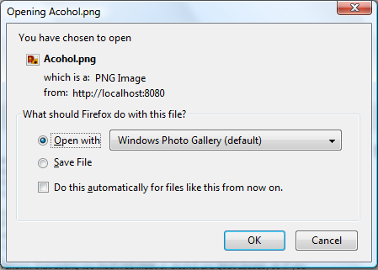Illustration 11: The download file pop up on Fire Fox
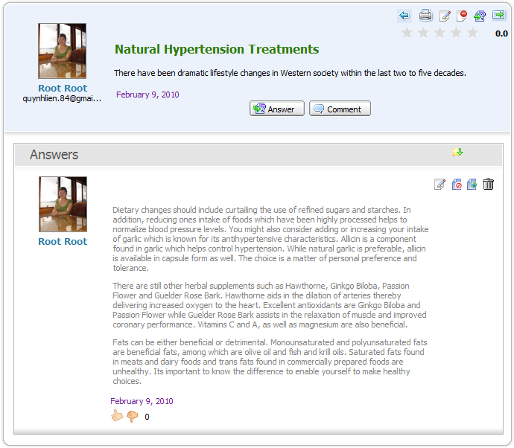
In which, the back iconallows backing the question that contains the related question list.
- To close view question form, simply click on its title again, its answer and related questions will be hidden.

Edit questions
The function is used to edit questions in a specific category. Normal users can only edit questions posted by himself/herself.
Do as follows:
Step 1: Right-click the question that you want to edit and then select Edit in the menu:
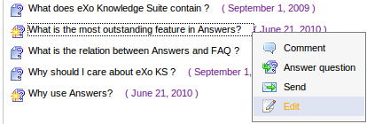
or select the edit icon on the top right of the answer area when viewing the answer in details:
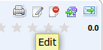
The Edit question form will appear with the current information, available for editing:
Details:
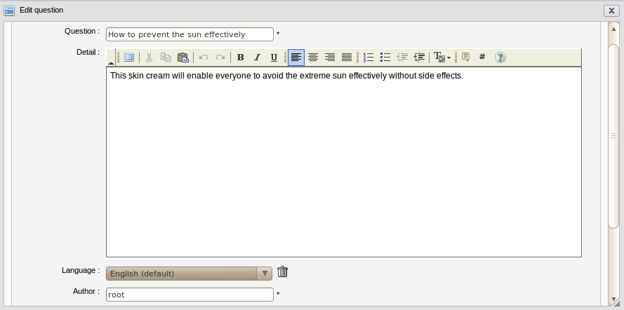Illustration 12: The Edit question form
Question: The question's brief content.
Detail: The question's detailed explanation which can be decorated.
Language: The language which is used to add questions. By default, the language is English. Language combo box allows selecting one desired language.
Author: The edited question's author.
Email: The email address of the edited question's author.
Validation: The option is to validate the question. It includes activated and approved options.
Approved: The option is to approve the edited question or not.
                - If this question is in the category that does not need to be moderated, this option is checked.
                - If this question is in the category that needs to be moderated, this option is not checked.
                - To approve this question, check this field.
Activated: The option is to whether display this question or not. By default, the option will be checked. It means the question is displayed, all users can view it. But if Answers Administrators or Moderators don't want to display this question, don't select this option.

Attach a file: This is to attach files into the edited question.
Step 2: Change the current information of the selected question like when adding a new question. You can add more or remove the language option, attach file, etc.
Step 3: Complete editing the question by clicking Save.

Vote questions
This function allows logged users to evaluate a question by voting in form of rating star from 1 to 5. The more star rate the question has, the more interesting it is.
Do as follows:
Step1: Go into the question which you want to vote.
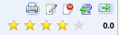
Step 2: Rate the question by left-clicking the star. The number of the selected star will be changed from gray to yellow. Click the Cancel button if you want to quit the Vote form.

Remove question vote
This function allows you to remove your vote on a specific question that let you vote it again.
- To remove question vote, do as follows:
Step 1: Go to the question that you have voted it before.
Step 2: Click the vote star at the top right question panel:
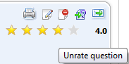
The alert message will appear:
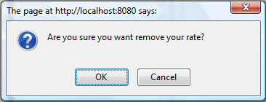
Step 3: Click OK to confirm removing your vote or the Cancel to close the alert message without removing.

Rate up/down answers
This function allows you to rate up/down the specific question's answer. Each voter can only rate Up (+1) or Down (-1).
- To rate up/down, simply click the rate icon:
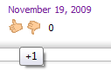
You can not rate twice but you can change your rate. When changing, the old rate will be removed, recalculated and updated with new score.

Comment questions
This function allows logged users to give comments on specific questions.
- To make a comment for a question, do as follow:
Step1: Click on the Add Comment button or right-click a specific question and select Comment in the menu:
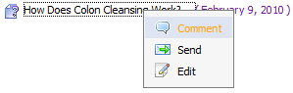
The Comment form will appear:
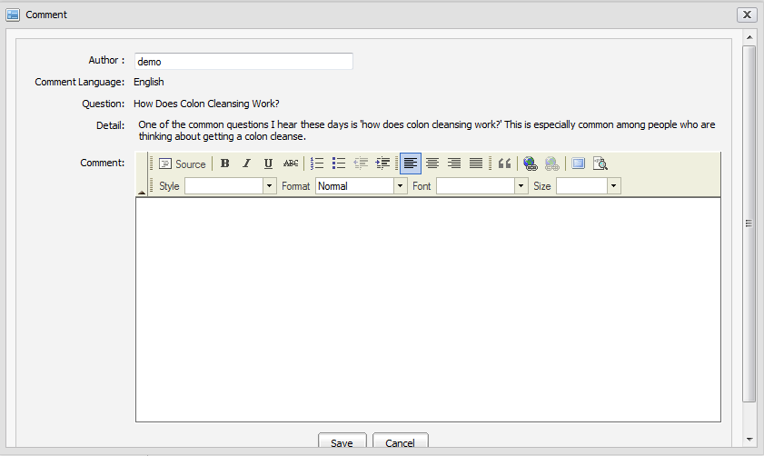Illustration 13: The Comment form
Step 2: Input your comment into the text editor.
Step 3: Click Save to accept saving a comment.
The comment will be displayed:
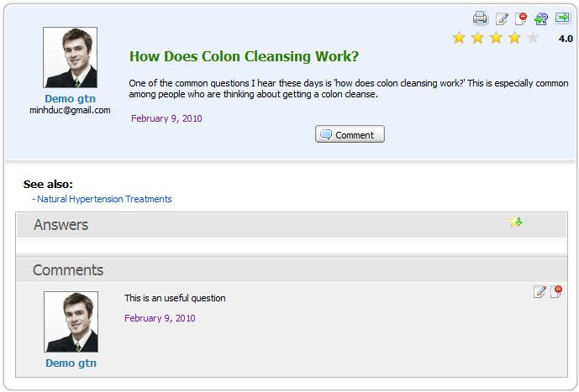
- To edit a comment, simply click on the icon on the top right of the question panel.
- To delete a comment, simply click the delete icon on the top right of the question panel.
- Comments can be written in different languages. If a question is posted in multiple languages, it can have comments in multiple languages, too.
- Only the administrator/moderator or the author of a comment can edit it.
- The comment function is not available to the anonymous user.

Send question to friends
This function is used to send question to friends via email. When you are interested in a question, you can share it with your friends. This action supports this purpose.
In the eXo Answers, one question can be sent when it is approved.
- To send question to friends, do as follows:
Step 1: Show the Send question by email form by one of two following ways:
  - The 1st way: Right-click the question that you want to send to your friends and then select Send in the menu.
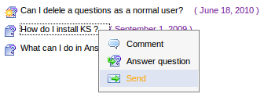
  - The 2nd way: Click the Send icon at the top right corner of the question when viewing it in details:
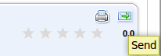
The Send question by email form will be displayed:
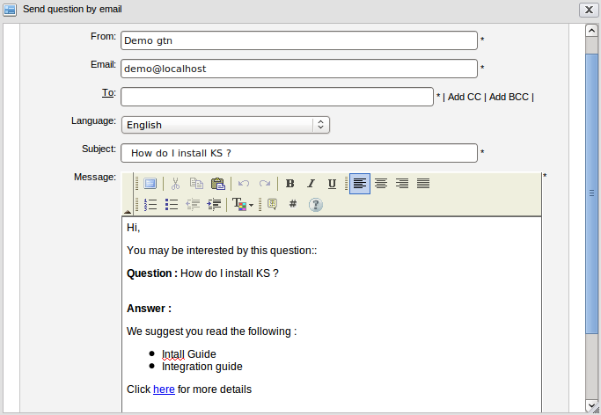Illustration 14: The Send question by email form

Details:

From | The sender's name .
Email | The sender's email address.
To | The receivers's email address. Using CC and BCC to easily send this message to more than one person and fast by clicking the 'Add CC' or 'Add BCC'. Using 'Add CC' when you want other users know and refer to this message. Using 'Add BCC' when you want other users also receive this message but all receivers do not know that you also send this message to others.
Subject | The subject that you want to send to your friend.
Language | The language is used to display a content of the question. By default, it is English. However, if the sent question has been submitted in the other language such as French or Vietnamese, you can select the favorite for sending, When the language is changed, the question's subject and message content are changed correspondingly.
Message | The content of the message that you want to send to your friend.
Send button | To accept sending question to friend.
Cancel button: | To close the Send question by email form.

Step 2: Enter values for fields in the Send question by email form.
Step 3: Complete sending a question by clicking the Send button.
The users with email addresses in the To, CC and BBC field will receive this message. Receivers can click the 'here' link in the content of the message to view the question in details in the Answers application.
Only the administrator can send a pending question.

Watch
This function allows logged users to keep track of changes of specific categories in the Answers application such as new edition, new question, question response, etc. You only need to register an account, add watch to specific category, whenever there is a new change, users will receive notification emails from the Answers.
- To add watch, simply right-click any category in list and select Watch in the menu.
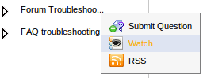
The alert message that informs the watching is shown:
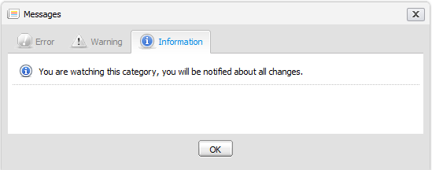Illustration 15: The watch alert message form

- This function is not available to anonymous users. Only logged users can watch category in the FAQ.
- One user can only have 1 email address for receiving notification mail. It is the default mail when registering an account.

Unwatch
This function allows you to remove your watch on a specific category that called unwatch. When unwatching, you will not receive notification mails about the category that you used to add watch anymore from Answers.
- To unwatch, simply right-click the category that you are watching and select Unwatch in the menu:
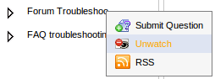

Search
The function is used to search existing categories and questions. With Quick Search and Advanced Search, you can find expected results quickly and flexibly.

Quick search
With the quick search, you can directly type a search term in the search field. All the categories and questions which have a keyword that matches with the search term will be displayed in the Search results form.
Do as follows:
Step 1: Enter a search term into the search box at the top right of the Answers screen:
Step 2: Click the search icon next to the search box to do search.
All categories/questions that match with the search term will be listed in the Search results form:
To view a category or a question in details, you can click the icon which corresponds to the category or the question that you want to view.
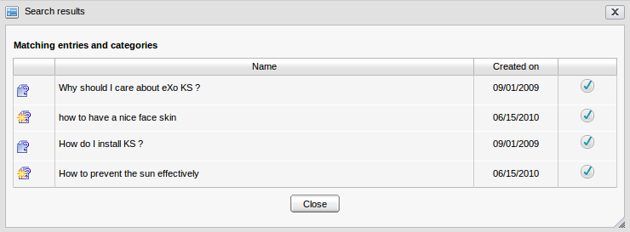Illustration 16: The simple Search Result form
In case you click the question's title, its detailed content will be shown:
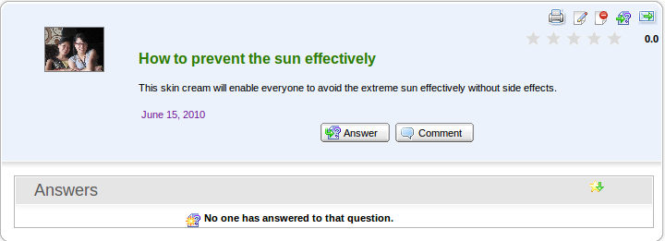Illustration 17: Question's detailed content

Advanced search
The advanced search allows users to do a search with particular criteria that corresponds to the object that is expected to be found. By using the advanced search, you can find questions/categories more exactly.
Do as follows:
Step 1: Click the advanced search icon at the right corner of your screen when you go into the Answers application.
By default, you can find both categories and questions concurrently. But if you choose an object in the 'Search in' field, it means that you only search that object.
Details:
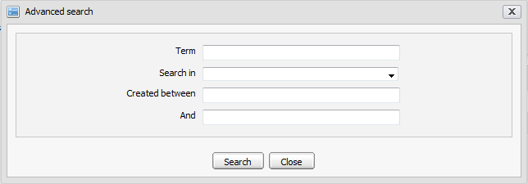Illustration 18: The Advanced search form
Term: The search term which relates to the categories/questions that you want to search.
Search in: The object you want to search in. By default, the field is blank. It means both categories and entries will be searched concurrently.
Created between – And: The created date interval in which you want to search for the selected object.
Search button: To accept doing search.
Close button: To close the Advanced search form.
The Advanced Search form will be displayed differently corresponding to each object that is selected in the 'Search in' field.
With 'Categories' object: The Advanced Search form will appear:
Details:
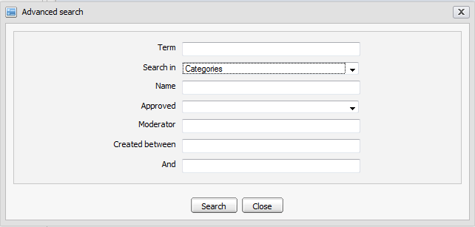Illustration 19: The Advanced search form with Search in Categories
Term: The keyword related to categories that you want to search.
Search in: The object that you want to search. If you want to search categories, value of this field is 'Category'.
Name: The name of categories that you want to search.
Approved: The question's status in the categories that you want to search. There are two statuses: 'Yes' and 'No'. With 'yes', all questions in these categories were approved. With 'No', all questions in these categories were not approved.
Moderator: The name of all category's moderators that you want to search.
Created after – Created before: The created date interval in which you want to search for the categories.
With 'Entries' object, The Advanced Search form will appear:

Details:
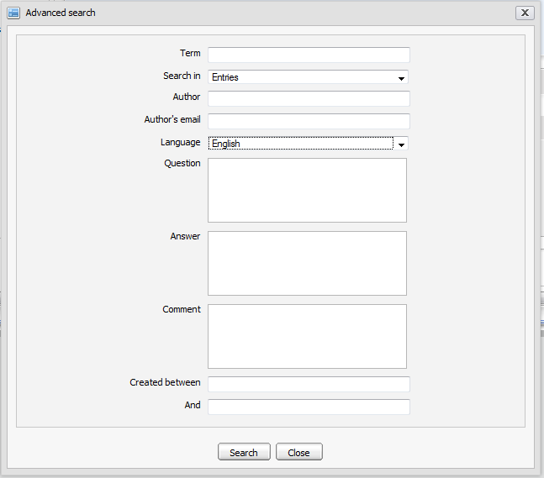Illustration 20: The Advanced Search form with Search in Entries
Term: Keyword related to the questions that you want to search.
Search in: Object that you want to search. If you want to search questions or answers, this field's value is 'Entries'.
Author: Name of the entries' creator.
Author's mail: Email address of the entries' creator.
Language: Language of the entries that you want to search.
Question: Content of the questions that you want to search.
Answer: Response of the questions that you want to search.
Created between – And: Created date interval in which you want to search for the questions.
Step 2: Enter properties' values corresponding to each object that you want to search.
Step 3: Complete the advanced search by clicking the Search button.
The list of found objects will be displayed in the search result form or there will be an alert message which informs that no objects match with the inputted properties.

To view details about one object in the Search results form, select the found object's name in the list or click the icon corresponding to the object you want to view.
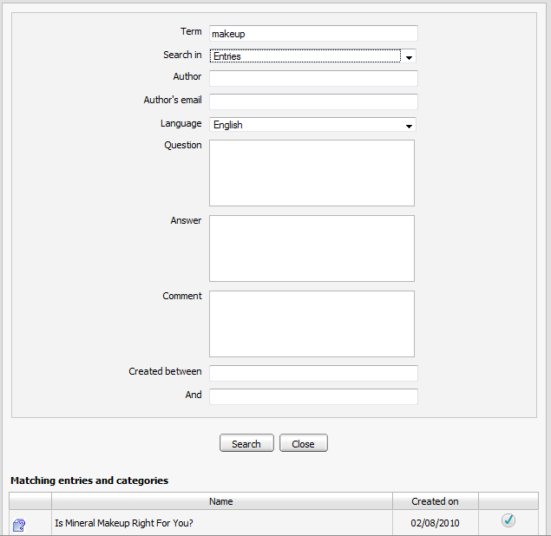Illustration 21: The Search results form

User Settings
The function allows users to set some display properties of the Answers application. Besides, it allows users to sort the Answers by popularity, to manage watch and to change avatars.
Do as follows:
Step 1: Click the button on the toolbar, the Settings form will appear:
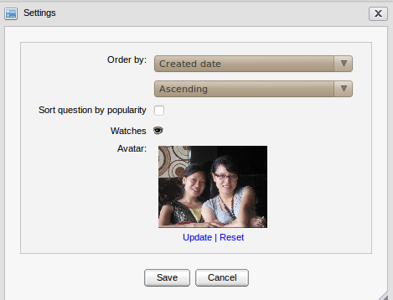Illustration 22: Settings form

Details:
Order by: The way is used to order the entries in list.
- With the 'Created Date': The entries in the question list will be displayed to the entries' created date order.
- With the 'Alphabet/Index': The entries in the question list will be displayed to the alphabet/index order.
The type of sorting entries in the question list may be: Ascending or Descending.
Sort question by popularity: This option is whether to sort question by popularity or not.
Watches: To mange watches of current login users.
Avatar: To show your avatar.
Update: To change an avatar.
Reset: To remove the current avatar and set by the default one.

Step 2: Select values for fields in this form.
Step 3: Saving the settings by clicking the Save button.
To manage watches, do as follows:
1. Click the watch icon to open the User Watch Manager form:
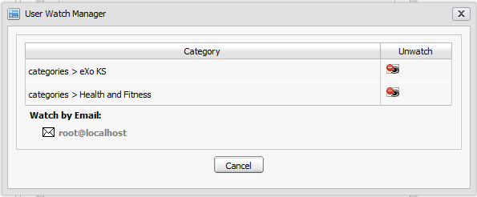Illustration 23: The User Watch Manager form
2. Click the category title to view in details.
3. Click the unwatch icon which corresponds to the category you want to remove a watch.
To change an avatar, do as follows:
1. Click the Upload link to open the Upload File form:

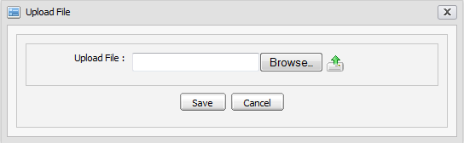
2. Click the Browse... button to select a file to upload.
3. Click the icon to upload the selected file.
4. Click Save to accept changing the avatar.

Print
The function is used to print a question or all questions in a specific category.
Do as follows:
Step 1: Go to the Answers screen view that you want to print.
Step 2: Click the button on the toolbar to print all the questions in the current category in details or click the print icon on the right question panel to print that question only.
The print preview page will appear:
Step 3: Click the Print button to set up the printer or click the Close button to quit the print preview mode.
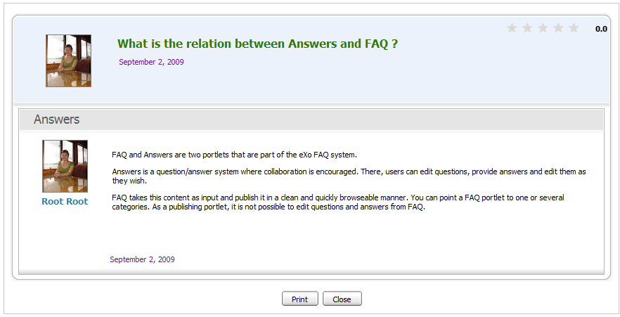Illustration 24: The print preview page

Show/hide the left panels
The function allows personalizing the Answers view by showing/hiding the left panels.
By default, the Answers application is displayed with all panels. In case you want to hide/show all panels on the left, you can click the button on the main action bar.
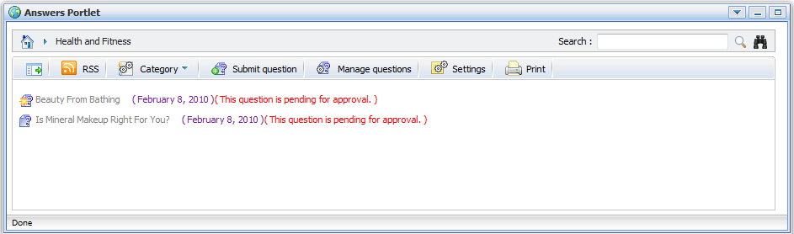Illustration 25: Custom view without left pane

View User Profile
The function allows viewing the profile of specific users who submit, answer or comment questions.
To view a specific user's profile, simply click his/her user name, the user profile pop-up will be displayed:

Discuss in forum
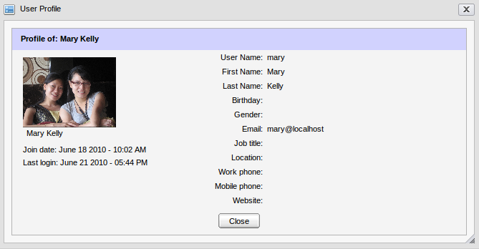Illustration 26: View User Profile form
The function allows users to discuss a question in the Forum application.
When a question is discussed, it will become a new topic in the Forum application. The new topic created with the topic title is the question title, the topic content is the question content and the post is the question answer or comment.
To discuss or view the question's discussion, click the icon at the top left of the question panel or click a specific question and select Discuss in forum in the menu:
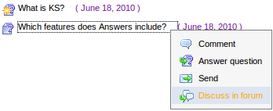
After being discussed, a new topic is created into the forum which is defined as the discussed forum in the Answers Setting and you are redirected directly to the Forum application.
When there is an answer added, a comment added or any edition in a question, an answer or a comment, the discussed topic in the Forum application is changed correspondingly.
However, when the question is clicked to discuss at the first time, its status is pending for approval. You can only view the discussed topic when the Forum administrator/moderator approve it.
After a question is discussed, to view it, simply click the Discuss in forum option in its right click menu.

Rss feed
The function provides RSS feeds. Each time an entry is added or updated, the corresponding category's feed will be updated.
Do as follows:
Step 1: Click the category that you want to get the RSS feed.
Step 2: Click the RSS button on the main action bar or select RSS in the right click menu of a specific category:
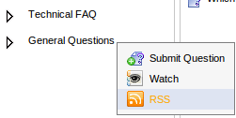
The RSS information page will appear on another tab:

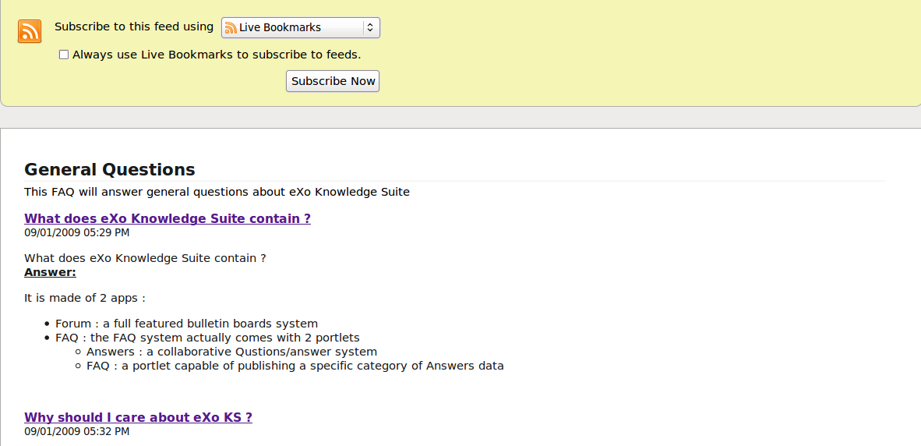

All question information of the category that is being watched will be listed. To add a live bookmark, simply click the Subscribe Now button, then click the Add button in the menu pop-up.

FAQ Portlet
You can add the FAQ Portlet to a page for using. eXo KS facilitates users with the FAQ portlet that helps users quickly and easily view the questions and answers from the Answers portlet by the tree view type.
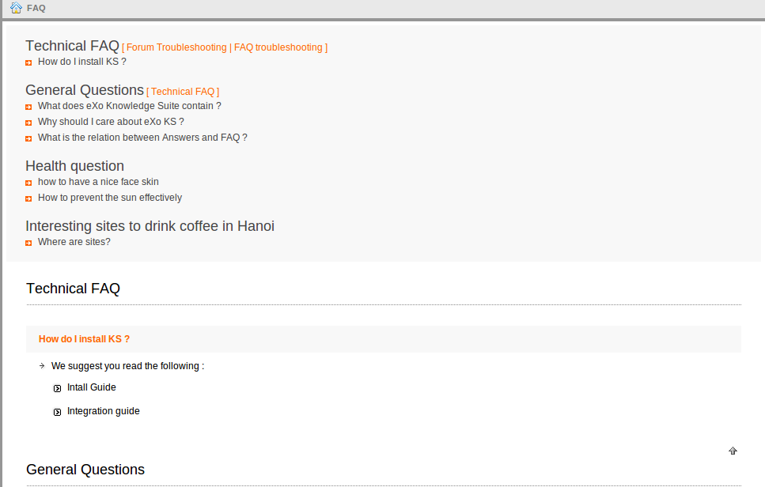Illustration 27: The FAQ Portlet in the View mode

Conclussion
It is our hope that information stated above is valuable to you, all eXo customers and users when they experience FAQ & Answers. To clearly support for benefits recognition from customers and users, we would like to summarize major strengths of eXo FAQ & Answers as follows:
Answers | Post questions and answers in multiple languages.
Question Management | Answer, edit, delete or move question.
Comment | Make comments directly to the user who originally raised questions and/or promote comments as answers.
Rating | Use the star-based rating system to show the preference levels to various questions.
Thumb up and down | Help user specify the most useful answers.
Attachments | Get right to attach files to questions using the upload system.
Moderation | Admins can create categories for moderators based on groups, users or memberships, and deactivate or reject questions.
FAQ | Users can publish and view contents clearly and quickly.

Our support is always willing to receive any feedback, including errors notifications and ideas that can make the guide better. Serving and resolving all issues related to the eXo Forum are our responsibilities, so please post your questions at our forum freely.
For more information about eXo platform and our products, please visit our homepage.We also provides professional support via eXo Forum, where you can find useful advice and solutions to your issues.

