
GateIn
version 3.1

CONTENTS
1 Preface 11
1.1 Overview 11
1.2 Purposes of the Guide 11
1.3 References 12
Information 12
Support 12
Download 12
2 Glossary 14
2.1 Portal 14
2.2 Portlet 14
2.3 Toolbar 14
2.4 Navigation 15
2.4.1 Portal/Site's Navigation 15
2.4.2 Group's Navigation 15
2.4.3 User's Navigation 16
2.5 Gadget 16
2.6 Access Mode 16
2.7 Preview Mode 17
2.8 Layout mode 17
2.9 Permission 17
2.9.1 Permission types 17
2.9.2 Permission levels 18
3 Portlet 20
3.1 Functional Portlet 20
3.1.1 Register Portlet 20
3.1.2 Account Portlet 20
3.1.3 Organization Portlet 21
3.1.4 Application Registry Portlet 22
3.1.5 Group Navigation Portlet 22
3.1.6 Page Management Portlet 23
3.1.7 Portal Navigation Portlet 24
3.1.8 Star Toolbar Portlet 24
3.1.9 Tabbed Dashboard 24
3.1.10 User Info Portlet 25
3.1.11 User Toolbar Dashboard Portlet 25
3.1.12 User Toolbar Group Portlet 25
3.1.13 User Toolbar Site Portlet 25
3.2 Interface Portlet 25
3.2.1 Banner Portlet 26
3.2.2 Breadcrumbs Portlet 26
3.2.3 Footer Portlet 26
3.2.4 HomePage Portlet 26
3.2.5 IFrame Portlet 27
3.2.6 Navigation Portlet 28
3.2.7 SiteMap Portlet 28
3.2.8 Web Browser Portlet 29
3.2.9 Dashboard Portlet 29
3.2.10 Gadget Wrapper Portlet 30
3.3 Dashboard Portlet 30
3.3.1 Use the Dashboard Workspace 31
3.3.2 Add More Gadgets 32
4 Initial implementation 34
4.1 Requirements 34
4.1.1 Software 34
4.1.2 Hardware 35
4.2 Setup 35
4.2.1 Establish A Base Structure 35
4.2.2 Configure an environment 35
4.2.3 Run Commands 36
5 accounts 38
5.1 Register A New Account 38
5.2 Sign In and Sign out 42
5.2.1 Sign In 42
5.2.2 Sign out 44
5.3Remember User Account 45
5.4 Change Account Settings 45
5.5 Retrieve Account & Password 47
6 Gatein administration 50
6.1 Manage portals 50
6.1.1 Create a new portal 50
6.1.2 Access a portal 52
6.1.3 Edit/Delete a portal 54
6.1.4 Access a specific portlet 58
6.1.5 Edit a specific portlet 59
6.1.6 Edit Portal's navigation 64
6.1.7 Edit Portal's Properties 66
6.1.8 Change Portal Skin 67
6.1.8.1 Change the skin permanently 67
6.1.8.2 Change the portal's skin temporarily 67
6.1.9 Switch between portals 68
6.2 Nodes Management 68
6.2.1 Add a new node 68
6.2.2 Edit a node 73
6.2.3 Copy/Paste a node 73
6.2.4 Clone a node 74
6.2.5 Cut a node 75
6.2.6 Delete a node 75
6.2.7 Change nodes order 76
6.3 Pages Management 76
6.3.1 Create a new page 76
6.3.1.1 Create a new page using Page Creation Wizard 76
6.3.1.2 Create a new page using Page Management 80
6.3.2 Edit a page 83
6.3.2.1 Edit a page using Site Editor 84
6.3.2.2 Edit a page using Edit Portal's Navigation 84
6.3.2.3 Edit a page using Page Management 90
6.3.3 Delete a page 92
6.3.4 Preview pages 92
6.3.5 Edit page container layout 93
6.3.6 Edit page portlet layout 93
6.4Users and Groups Management 93
6.4.1 Manage Users 94
6.4.1.1 Search for users 94
6.4.1.2 Edit a user 95
6.4.1.3 Delete a user 97
6.4.2 Manage groups 97
6.4.2.1 Add a new group 98
6.4.2.2 Edit a group 99
6.4.2.3 Add a new user to a group 100
6.4.2.4 Edit a user membership in a group 101
6.4.2.5 Delete a group 102
6.4.3 Manage Memberships 102
6.4.3.1 Add a new membership type 103
6.4.3.2 Edit a membership type 103
6.4.3.3 Delete a membership type 103
6.5 Navigations Management 104
6.5.1 Portal's page navigation 104
6.5.2 User's page navigation 104
6.5.3 Group's page navigation 104
6.5.3.1 Edit Group's page navigation 105
6.5.3.2 Create a new page navigation 106
6.5.3.3 Edit group's navigation properties 107
6.5.3.4 Delete a group's navigation 108
6.6 Manage Permissions 108
6.6.1 Set an access permission on a portal 109
6.6.2 Set an edit permission on a portal 110
6.6.3 Set a permission on a page 112
6.6.3.1Set an access permission on a page 112
6.6.3.2 Set an edit permission on a page 113
6.6.4 Set an access permission on a portlet 113
7 Language Administration 114
7.1 Change the display language 114
7.1.1 Change the displaying language permanently 115
7.1.2 Changing the display language for another user 117
8 Portlets/Gadgets/categories/sitemap management 119
8.1 Add a portlet/gadget to a specific category 119
8.2 Auto-import default portlets/gadgets 120
8.3 View detailed information of a specific portlet 120
8.4 Manage gadgets 121
8.4.1 Where you can use a gadget 121
8.4.2 Why we need a gadget 121
8.4.3 Add a gadget 121
8.4.3.1 Add a remote gadget 122
8.4.3.2 Add a gadget to the Dashboard 123
8.4.4 Create a new gadget 126
8.5 Category Management 128
8.5.1 Add a new category 128
8.5.2 Set permissions for a new category 131
8.5.3 Edit a category 132
8.5.4 Delete a category 132
8.6 Manage Sitemap 132

Illustration Index
Illustration 1: Register Portlet 20
Illustration 2: Account Portlet 21
Illustration 3: The Organization Portlet interface 21
Illustration 4: The Application Registry Portlet 22
Illustration 5: Group Navigation Portlet 23
Illustration 6: Page Management Portlet 23
Illustration 7: Administration Toolbar Portlet 24
Illustration 8: Portal Navigation Portlet 24
Illustration 9: Star Toolbar Portlet 24
Illustration 10: Tabbed Dashboard Portlet 24
Illustration 11: The User Info Portlet Interface 25
Illustration 12: The User Toolbar Dashboard Portlet Interface 25
Illustration 13: The User Toolbar Group Portlet Interface 25
Illustration 14: The Banner Portlet interface 26
Illustration 15: The Breadcrumbs Portlet interface 26
Illustration 16: The Footer Portlet interface 26
Illustration 17: The HomePage Portlet interface 27
Illustration 18: The IFrame Portlet interface 27
Illustration 19: The Navigation Portlet interface 28
Illustration 20: The SiteMap Portlet interface 29
Illustration 21: The Browser Portlet interface 29
Illustration 22: The Dashboard portlet interface 30
Illustration 23: Gadget Wrapper Portlet 30
Illustration 24: More gadgets on Google 32
Illustration 25: The Register New Account form 39
Illustration 26: Edit Mode of Register Portlet 41
Illustration 27: The main screen of GateIn Portal 43
Illustration 28: The Sign in form 43
Illustration 29: The Account Profiles Dialog 46
Illustration 30: The Change Password tab 47
Illustration 31: The Portal Setting tab 51
Illustration 32: The Properties tab 52
Illustration 33: The Portal Setting tab of the portal properties form 56
Illustration 34: Portal Navigation 57
Illustration 35: The Access Permissions form 58
Illustration 36: The Portlet Setting tab 59
Illustration 37: The Portlet Icon tab 61
Illustration 38: The Decoration Themes tab 62
Illustration 39: The Access Permisson Tab 62
Illustration 40: The Edit Mode tab of the IFrame Portlet 63
Illustration 41: The Edit Mode of the Dashboard Portlet 64
Illustration 42: Portal Navigation 65
Illustration 43: The Page Node Setting tab of the Add/Edit Page Node form 70
Illustration 44: The Page Selector tab of the Add Page Node form 71
Illustration 45: The Select Page form 72
Illustration 46: Page Creation Wizard: Select a Navigation Node and create the Page 77
Illustration 47: Page Creation Wizard: Step 2- Setting a Page Layout Template 78
Illustration 48: The Page Configurations type 79
Illustration 49: Re-arrange Page Layout and add portlets into the page 80
Illustration 50: The Manage pages form 81
Illustration 51: The Page Layout tab of the Add New Page form 83
Illustration 52: The Page Setting tab of the Portal Properties form 86
Illustration 53: The Access Permission Setting form of the Permission Setting tab 87
Illustration 54: The Edit Permission form 88
Illustration 55: The Organization form 94
Illustration 56: The Account Info tab of the Edit User Info form 95
Illustration 57: The User Profile tab of the Edit User Info form 96
Illustration 58: The User Membership tab of the Edit User Info form 96
Illustration 59: The Group Management form 97
Illustration 60: The Add New Group form 98
Illustration 61: The Edit Current Group form 99
Illustration 62: The Add member form 100
Illustration 63: The Select User form 101
Illustration 64: The Edit Membership form 102
Illustration 65: The Membership Management form 103
Illustration 66: The Group Navigation page 105
Illustration 67: The Edit Navigation form 108
Illustration 68: The Interface Language Setting form 116
Illustration 69: The Dashboard main screen 123

Preface

Overview
Beginning as an open source project in the year 2002, eXo is well-known as the industry's first Java portlet container. With the aim of dominating the potential portal market through robust and easy-to-use applications, eXo Project succeeded in attracting consumers in the whole world. eXo actually opened the floodgates to various options in many markets, and customers have been choosing eXo as the best method for their success.
The eXo Project grew into a company in 2003, as a response to customer demands. We can do this because we release our code in the open environment. It's how the DoD found us, when we were just university students hacking away, and it's how we choose to do business with our customers.
Today, eXo is a rapidly growing global company, with U.S. headquarters in San Francisco, California, global headquarters in France, and offices in Tunisia, Ukraine, and Vietnam. The Corporate has established technology leadership and proven values by their large European installed base and strategic partnerships with Red Hat, Capgemini, Atos Origin, and Bull.
GateIn is the perfect merge between Red Hat and eXo Platform in creating a new generation of Open Source portal which is actually robust and intuitive. With GateIn, both normal users and enterprises can enjoy many personalization and collaboration applications wherever and whenever. Advantages generated in GateIn, including interactive user interface, customizable look and feel, flexible internationalization and localization, etc, really faciliate the birth of many useful applications with a variety of rich utilities in the world market.

Purposes of the Guide
The book was written as a handbook, aiming at instructing step-by-step on how to use and to implement this application to the utmost. Thus, the information included herein will give basic steps that makes it easy for users to follow through in-depth examples as well as clear explanations regarding to the eXo Platform technology. Whether you major in technology or not, you are able to learn about or to work on GateIn 3.1 easily and efficiently.
The information provided in the guide is arranged into such a way that ensures readers to search and implement quickly and easily. With the aim of helping users better understand about GateIn 3.1, we hope that readers can know more and master almost key strengths when using the GateIn 3.1.
In general, the book is really in-depth manual, especially for administrators. This administrator guide will focus on the followings:
- Define the basic concepts in GateIn 3.1
- Provide step-by-step instructions to master GateIn 3.1.

References
- GateIn User Guide v3.1
Info & Support

Information
- eXo Platform Home Page: http://www.exoplatform.com/portal/public/website/
- eXo Platform Wiki: http://wiki.exoplatform.com/xwiki/bin/view/Main/

Support
- Forums: http://forums.exoplatform.org
- FAQ: http://faq.exoplatform.org

Glossary

Portal
A portal can be defined as a key environment for making and implementing many applications as well as contents. In other words, the portal is a web-based application providing means for gathering and personalizing information via specific portlets with an interactive and consistent look and feel. Users and administrators are able to integrate information, people and processes via a web-based user interface. The framework is to facilitate contents and applications aggregation with the flexible management and personalization options.

Portlet
A portlet is a pluggable component in a portal through which users can access some specific information, including supports, updates, or mini-applications, etc). The portlet produces fragments of a markup code that are aggregated into a portal page. Typically, a portal page is displayed as a non-overlapping portlet windows collection, where each portlet window displays a portlet. The contents generated by a portlet can vary from one user to another, depending on the configuration set by each user.
Portlets can be divided into two following types:
- Functional Portlet
- Interface Portlet

Toolbar
The Toolbar is a set of icons or buttons that is considered as a part of interface. It spans the top of the portal application and provides links to users and administrative actions.
If the current user logged in as an administrator or manager, the extra navigation so-called Site Editor will be displayed in the toolbar. In case of the user as user or demo, there are only three navigation types, including Site, Group, and Dashboard in the toolbar.

Navigation
Navigation is composed of a nodes set (menus) that helps users visualize the site structure and provides hyperlinks to move from one page to another quickly. Each node contains an internal name and a label which is shown on the menu. For any node, you can define either sub-nodes. The horizontal menu at the top of page is called a navigation bar. The GateIn's navigation is established based on three levels: portal level, group level and user level. On each level, any node can be defined. The navigation structure of one particular user is made up of portal navigation nodes (that are valid to all users), the nodes of all groups the user belongs to and his individual nodes. The users' and groups' nodes are valid for all portals that are defined on the same eXo Portal server.

Portal/Site's Navigation
This navigation level is used to keep links to separate sites/portals of the parent portal. Each portal/site has only one navigation and it is automatically generated when a portal/site is created. Only users who have the edit permission on a portal can add nodes on this navigation level.
The name of a portal navigation looks like: portal:[portal name]'s nav
Let's suppose that a portal navigation's name is: “portal:classic's nav”:
- 'portal' is the navigation level, it means that navigation nodes are defined for all users of a portal.
- 'classic' is the name of portal.
- 'nav' stands for 'navigation'.

Group's Navigation
All registered users are organized into groups. There is a navigation keeping the links to all pages of each group, called a group navigation. The content of this navigation differs, depending on the logged-in account type. The group's navigation is created manually by users who have the highest right in a group. Before adding nodes or creating pages for a group, you must create the group navigation. Also, there are nodes that are only applied to those members who have certain memberships.
The name of group navigation looks like: group:[group name]'s nav.
Let's suppose that the group navigation name is: group:platform/administrators's nav:
- 'group' is a type of navigation, it means that the nodes are defined for a group.
- 'platform/administrators' is the path of a group. It means that navigation nodes are defined for the 'administrators' - the group that is a sub-group of 'platform' group.
- 'nav' stands for 'navigation'.

User's Navigation
Each user has its own navigation that contains links and portlets (or gadgets) selected by the user. A user's navigation is created or deleted automatically when the user is registered or deleted respectively. By default, the user navigation is empty.
The name of user's navigation has format: user:[user name]'s nav
Let's suppose that the user navigation name is: user:john's nav
- 'user' is a navigation level that navigation nodes are defined for one individual user.
- 'john' is the name of user.
- 'nav' stands for 'navigation'.

Gadget
A gadget is a mini web application running on a platform that a user can integrate and customize in the website.
To further see default gadgets in GateIn 3.1, please refer to the section "Using the Dashboard Workspace".

Access Mode
The GateIn has offerred two modes by default:
- Public mode: This mode is for guest users (visitors) who have not registered yet. This mode is not required to sign in, so they can only visit the public pages in a portal. Visitors can also register in order to get an account. After having registered, they can use the private mode and have to contact their administrators to get more rights or the group manager if they want to become a member of that group.
- Private mode: This mode is for registered users who will apply their usernames and passwords to sign in. This mode supports users in taking many actions such as: managing private resources (create private pages, edit or delete them), "borrowing" pages from others by creating hyperlinks, changing the language for individual needs, managing private information.

Preview Mode
In the preview mode, you can only view not not edit.
You can see this mode when you click the Preview Page icon at step 3of creating a page by wizard or editing a page by wizard.

Layout mode
In the layout mode, you are provided with some layout templates of portal or the page and you can use these templates to edit a portal or a page.

Permission
Permission is one of the most important factors on a portal. Permission settings control what users can or can not do within the portal and set by the portal administrators.

Permission types
Permission types define what a user can do within the portal. There are two available types as follows:
Access Permission: allows users to utilize portal contents (sigining in, viewing contents, rearranging portlets, etc). This permission can be set for multiple member groups.
Edit Permission: allows users to change portal contents (changing portal or page information, deleting a portal/page). The edit permission is set for only one group at a time.
By default, root is set as the super user or the administrator of GateIn; he can do everything while the others must get the appropriate rights (permissions) at first.
Rights in GateIn are not assigned to a single user but to a users group with specific membership types.
Similarly, the permission structure is always established as follows: [membership type]:/[group path]
For example: manager:/platform/administrators. It means the right is set for users who are “manager” of the group “administrators”. “Platform” is the parent group of “administrators”.
Seemingly, groups are managed in accordance with a hierarchy structure; but in fact, a sub-group does not have any inheritance from the parent group.
For example: we have a group structure as follows:
+ platform
- administrators
- guest
- user
If users in the group “platform” can perform a function A, it does not mean that users in “administrator” or “guest” can do function A. The roles of users in groups are independent.

Permission levels
Permission levels specify where the users's permission types can be applied into the portal. GateIn offers three permission levels as follows:

Portal: The portal permission level includes all pages within the portal. Therefore, a user with the access permission can view (but not edit) all the pages within the portal. A user with the edit permission at the portal level can change any page in the portal.

Page: The page permission level restricts the users to several particular pages. Users are only able to see and/or edit pages they have been given access to, depending on each permission type assigned to them.

Portlet: The portlet permission level allows users to create a page through dragging and dropping portlets into a page. Some portlets are only used for administrators while some are for individuals; thus, administrators need to set proper access permissions for each specific group.
Permission types and levels can be effectively implemented to control who can do and what can be performed within the portal.

PortletS

Functional Portlet
Functional Portlets support all functions of a portal. They are built into the portal and accessed via toolbar links when the portal-related tasks are performed.

Register Portlet
This portlet is used to register a new account, including fields: User Name, Password, Confirm Password, First Name, Last Name, Email Address, and Text validation.
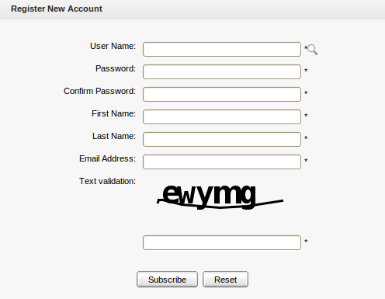Illustration 1: Register Portlet

Account Portlet
This portlet allows users to add a new account and choose their preferred languages for displaying the portal interface.
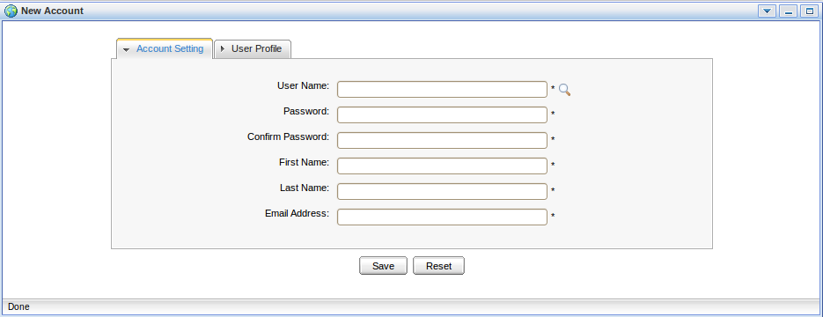Illustration 2: Account Portlet

Organization Portlet
This portlet is used to manage user information, users groups and memberships. The form of this portlet is shown like:
- User Management: This tab allows users to edit, delete, search and view existing users.
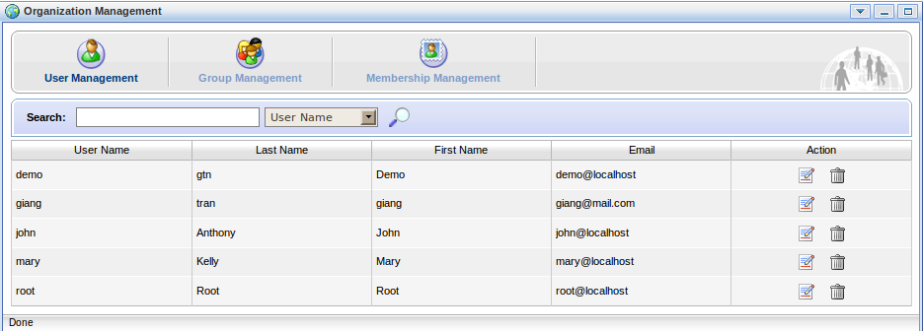Illustration 3: The Organization Portlet interface
- Group Management: This tab allows users to view, add new, edit and delete a users group.
- Membership Management: This tab is used to add, edit and delete memberships.

Application Registry Portlet
This portlet is used to manage different application categories. You can add, edit, set permissions, or delete a category and applications. The form of this portlet is shown as below:
This portlet includes the following functions:
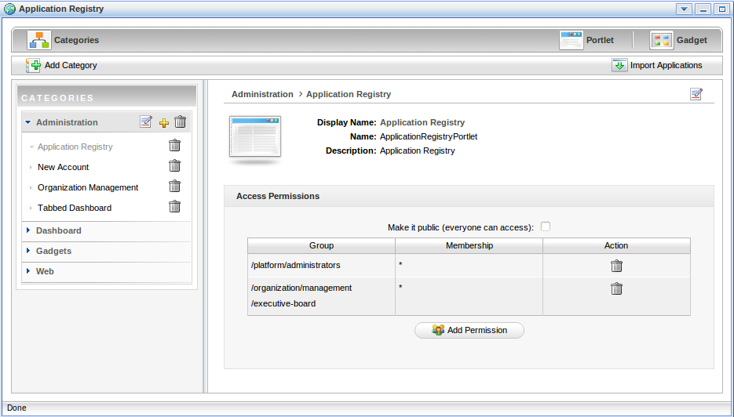Illustration 4: The Application Registry Portlet
- Organize portlets/gadgets into different categories such as: creating a new category, importing default porlet categories, adding a portlet/gadget into a specific category, adding permission to a portlets category, etc.
- List portlets and view detailed information regarding to a specific portlet.
- Manage gadgets, including adding a remote gadget, creating a new gadget or deleting a gadget from the list.

Group Navigation Portlet
The Group Navigation Portlet is used to manage the navigation of different groups. In this portlet, it is possible to add, edit and delete a specific navigation.

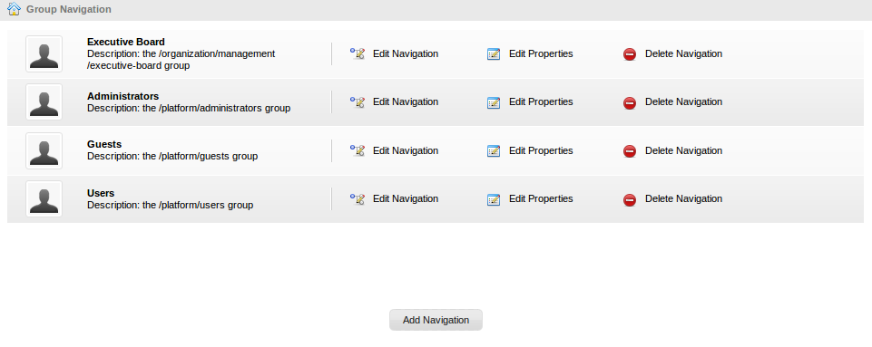Illustration 5: Group Navigation Portlet

Page Management Portlet
The Page Management Portlet is used to manage all pages on the portal. In the Page Management Portlet, it is possible to add, edit and delete a specific page.
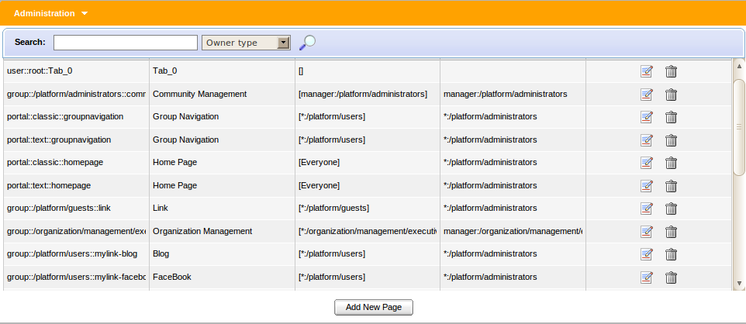Illustration 6: Page Management Portlet
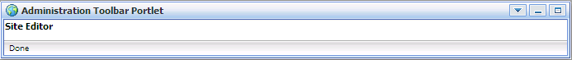Illustration 7: Administration Toolbar Portlet

Portal Navigation Portlet
The portlet is used to manage all portals in the GateIn. In the Portal Navigation Portlet, it is possible to add, edit and delete a portal.
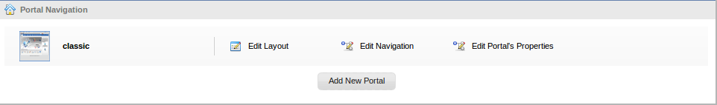Illustration 8: Portal Navigation Portlet

Star Toolbar Portlet
The portlet is used to display a menu that contains a list of actions such as Change Language, Change Skin, Sign Out.
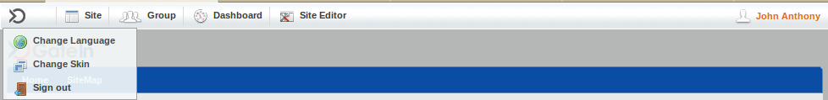Illustration 9: Star Toolbar Portlet

Tabbed Dashboard
The portlet is used to display Dashboard tabs that you can add gadgets inside by dragging and dropping.
Illustration 10: Tabbed Dashboard Portlet

User Info Portlet
The portlet displays personal information of a specific user that can be viewed and edited.
Illustration 11: The User Info Portlet Interface

User Toolbar Dashboard Portlet
The portlet is used to display the main dashboard menu that you can go inside to create dashboard tabs, add and remove gadgets for each tab.
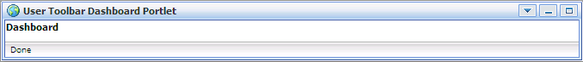Illustration 12: The User Toolbar Dashboard Portlet Interface

User Toolbar Group Portlet
The portlet is used to display the main group menu that you can go inside to create, edit and delete a specific group and the navigation for each group.

User Toolbar Site Portlet
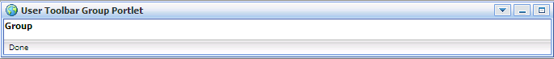Illustration 13: The User Toolbar Group Portlet Interface
The portlet is used to display the site menu that you can go inside to manage all portals.

Interface Portlet

Interface Portlets constitute the interface of the GateIn portal that are the front-end components of the portal. They provide users with ways to interact with the portal. GateIn 3.1 provides the following Interface Portlets:

Banner Portlet
The portlet is considered as the welcome gateway of a portal. It contains the organization's slogan, logo and icon:
Illustration 14: The Banner Portlet interface

Breadcrumbs Portlet
The portlet displays the navigation path of the selected page:
Illustration 15: The Breadcrumbs Portlet interface

Footer Portlet
The portlet provides a footer for a site. This footer can be a text, images that are displayed at the bottom of a web site. It provides information about author/institutional sponsor, revision date, copyright, comments form, and navigational links.
Illustration 16: The Footer Portlet interface

HomePage Portlet
The portlet is the home page for a portal. The home page is a main page (default page) which is the first page displayed when you visit the portal.
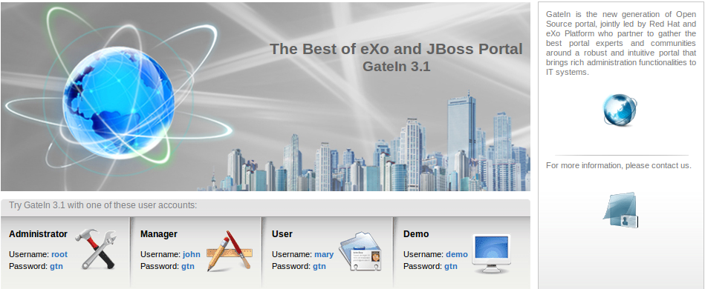Illustration 17: The HomePage Portlet interface

IFrame Portlet
The portlet is used to create IFrame elements for a site. The IFrame is an HTML element which can embed a different HTML document into a HTML document. So, the embedded document is displayed inside a sub-window of the browser window. This does not mean the full inclusion, the embedded document is independent and both documents are considered as separated documents.
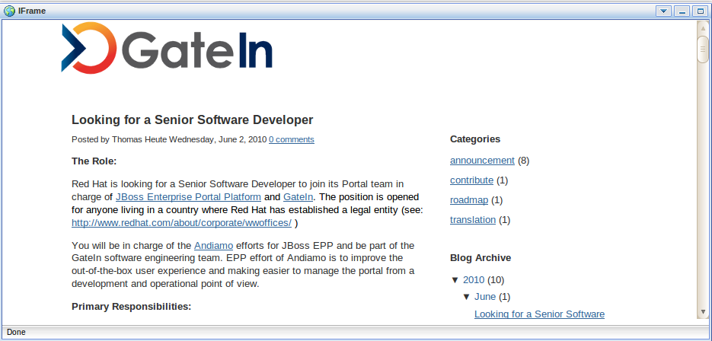Illustration 18: The IFrame Portlet interface

Navigation Portlet
The portlet provides a navigation bar. A navigation bar is a menu that helps users visualize the site structure and provide links to quickly move from page to page:
Note:
Illustration 19: The Navigation Portlet interface
When you create a new page that contains this portlet:
In the Preview mode: the portlet will be viewed as a normal page like above.
In the Save mode: the Navigation portlet will not be displayed normally when you open the page containing this portlet because only the portal's navigation can be shown like below. It means that two navigations can not be shown concurrently.

SiteMap Portlet
The portlet displays a sitemap page of a website. It is a graphical representation of a website. It lists pages on a website, typically organized in hierarchical architecture in order to help visitors easily find pages on the site.
There are two options:
Collapse All: The sitemap will be displayed with the parent path only.
Expand All: The sitemap will be displayed with the parent paths and all their children paths.

Web Browser Portlet
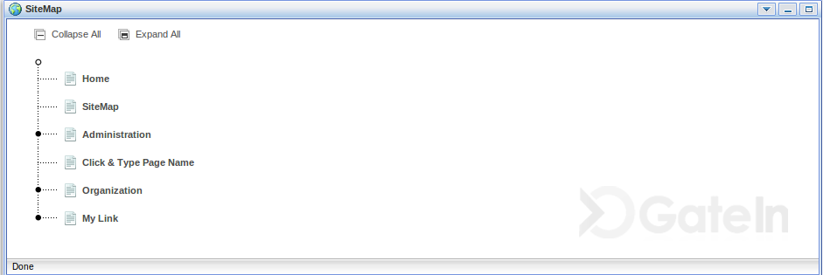Illustration 20: The SiteMap Portlet interface
The portlet provides a web-browser-like application for users. It allows users to connect to other sites over Internet.
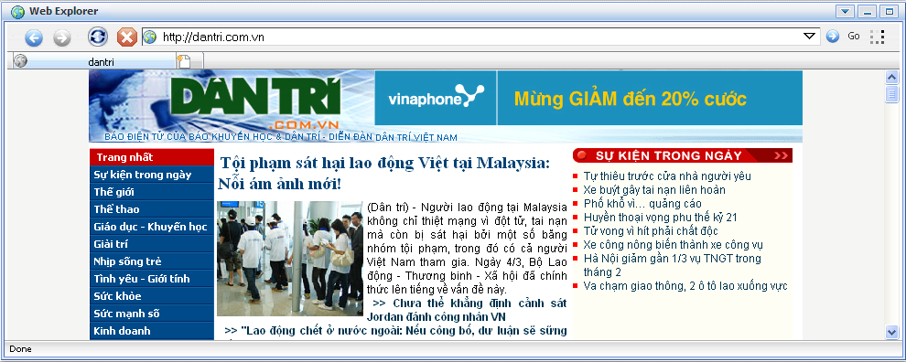Illustration 21: The Browser Portlet interface

Dashboard Portlet
The portlet is used for hosting mini – applications known as gadgets. The dashboard uses a variety of graphical effects for displaying, opening, and using gadgets. Gadgets can be moved around, rearranged, deleted and recreated in the dashboard. More than one instances of the same gadget can be opened at the same time, possibly with different settings.
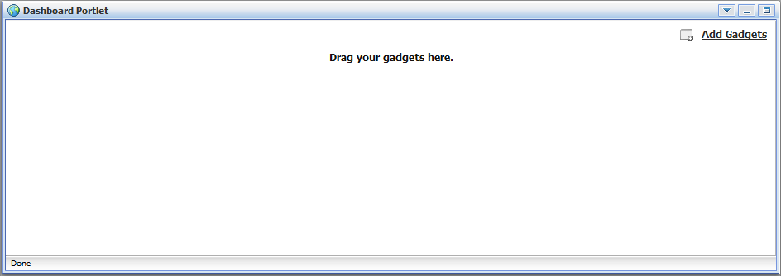Illustration 22: The Dashboard portlet interface

Gadget Wrapper Portlet
This portlet allows users to view a gadget in the canvas mode.
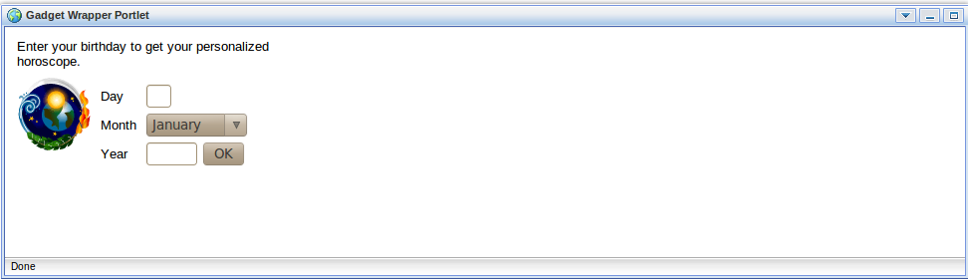Illustration 23: Gadget Wrapper Portlet

Dashboard Portlet
The dashboard portlet is to host mini-applications known as gadgets. The dashboard uses a variety of graphical effects for displaying, opening and using gadgets.
Gadgets within the Dashboard portlet may be moved, or rearranged. Users can create new gadgets and delete unnecessary ones. Also, users can open many gadgets with different settings at one time.

Use the Dashboard Workspace
To use the Dashboard Workspace, do as follows:
Step 1: Click Dashboard on the toolbar.
Step 2: Click Add Gadgets to open the Dashboard Workspace.
The Dashboard Workspace lists all available gadgets. Four default gadgets are provided
in GateIn 3.1; but you can add more.
The followings are default gadgets:
Calendar: A cool calendar keep track of date in style. You also can switch easily between daily, monthly and yearly view and change the skin as you like.
Todo: This mini – application helps you organize your day and work group. It is designed to keep track of your tasks in a convenient way. You can highlight tasks with different colors.
Calculator: This is the coolest calculator for your page. This mini–application lets you perform most basic arithmetic operations and can be themed to match your portal.
RSS Reader: This gadget lets you get a sneak preview of your favorite feeds in one location. This content includes, but not limit to, news, posts, emails, all in one gadget. This gadget is a web–based one for receiving and viewing RSS feeds.
Step 3: Select a gadget in the Dashboard Workspace.
Step 4: Drag and drop the selected gadget into the Workspace.
In addition, many more gadgets can be found at Google Gadget (http://www.google.com/ig/directory?synd=open). GateIn 3.1 is compatible with most gadgets available here.

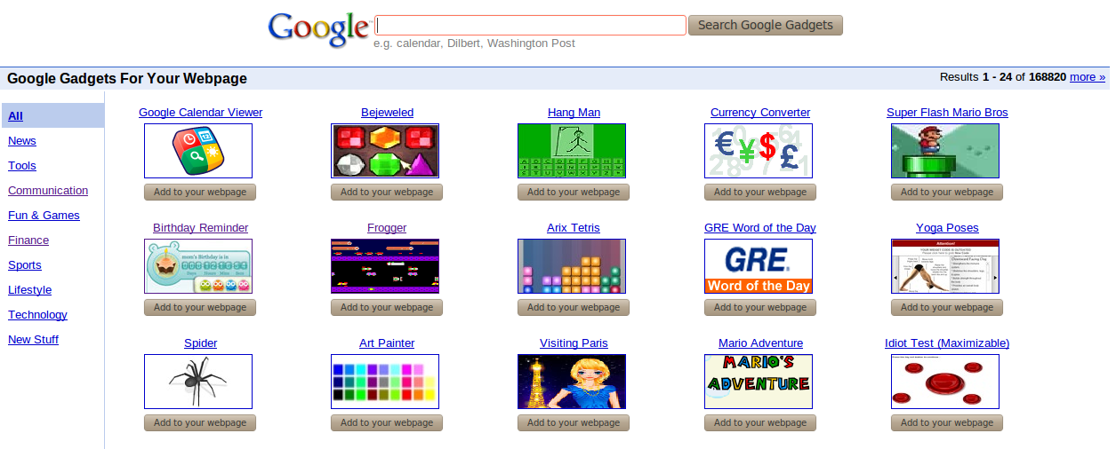Illustration 24: More gadgets on Google

Add More Gadgets
To add more gadegts from external sources, do as follows:
Step 1: Open the URL (.xml or .rss) of your desired gadget.
For example, http://bejeweledg.googlecode.com/svn/trunk/bejeweled.xml.
Step 2: Return to your portal, and click Dashboard on the toolbar.
Step 3: Click Add Gadgets in the Dashboard to open the Dashboard Workspace.
The Dashboard Workspace will appear:
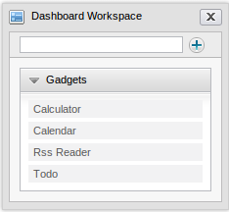
Step 4: Paste the URL achieved in step 1 into the text box next to the icon

Step 5: Click the plus icon to add the new gadget to the page.
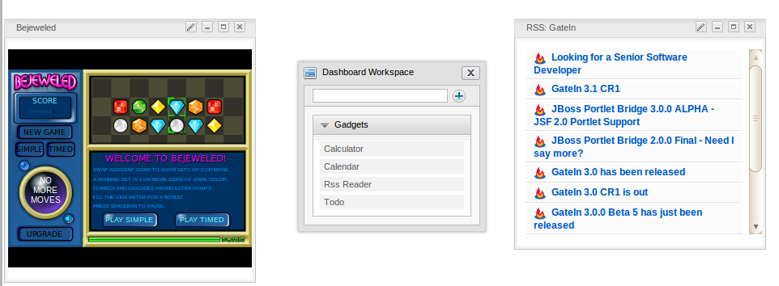

Initial implementation

Requirements

Software
GateIn is a Java application. The GateIn trial version is free download. However, new functions are usually updated without testing and guaranty in trial versions. In order to purchase a full version with guaranty and tested functions, please contact to us at sales@exoplatform.com.
You can get the latest trial version package from this link:
http://forge.objectweb.org/projects/exoplatform. After downloading, you also need to download the following software which supports running GateIn:
- Download JDK (Java Development Kit) with version 1.5 or later.
- Application Server: GateIn Portal is a web application using the client–server model. So we need a server browser. You can use Jboss Application Server, Jonas Application Server or Apache Tomcat.
- Jboss Application Server version 4.2.0 : http://labs.jboss.com/
- Jonas Application Server version 4.8.4: http://wiki.jonas.objectweb.org/
- Apache Tomcat version 6.x http://tomcat.apache.org
- A database is required. By default, HSQL is delivered with GateIn Portal so that you do not need to install a database. GateIn Portal can be used with the following databases:
- HSQL (used by default)
- My SQL
- SQL Server
- Oracle
- PostGreSQL
- DB2

Hardware
Processor: 2.0 Ghz or higher
RAM : at least 512MB

Setup

Establish A Base Structure
To establish a base structure, do as follows:
Step 1: Create a "java" directory which is called $EXO_BASE_DIRECTORY. By default, the $EXO_BASE_DIRECTORY directory will be in your $HOME directory in Linux and in D: drive in Windows.
Step 2: Install JDK and maven2 in the java directory.
Step 3: Set environment variable: JAVA_HOME= EXO_BASE_DIRECTORY/JDK.
Step 4: Create an “exo-dependencies” and “exo-working” directories in the “java” directory.
Step 5: Copy a desired template application server directory to exo-dependencies. The directory name should have the form name of application server -${version}. So the name of the directory may be (tomcat-$, jboss-$, jonas-$).
By the end, you have to have the following directory structure :
java/
exo-dependencies/
tomcat-${version}
jboss-${version}
jonas-${version}

exo-working
jdk1.5
maven2

Configure an environment

To configure a suitable environment for GateIn implementation, do as follows:
Step 1: Copy $EXO_BASE_DIRECTORY/eXoProjects/tools/trunk/config/maven2/template-settings.xml to your $HOME/.m2/settings.xml and adapt the configuration to your environment. If you do this, the maven2/conf/settings.xml will be ignored. This step is mandatory for window environment.
Step 2: For Linux or Cygwin environment, you can bypass this step as the exoenv.sh script can copy and configure the settings.xml file automatically for you;
Step 3: In Linux or Cygwin environment:
- Copy $EXO_BASE_DIRECTORY/eXoProjects/tools/trunk/build/src/main/resources/linux/exoenv.sh to your $HOME or $EXO_BASE_DIRECTORY directory.
- Backup the old one if you have one.
In Window and DOS Environment:
- Copy $EXO_BASE_DIRECTORY/eXoProjects/tools/trunk/build/src/main/resources/window/exoenv.bat to your $HOME or EXO_BASE_DIRECTORY directory.
- Backup the old one if you have one.
Step 4: Update the Configuration: Edit exoenv.sh or exoenv.bat file to adapt it to your environment. You should only have to change the PORTABLE_DIR variable at the beginning.
Step 5: Run the command to setup the environment: In linux or cygwin: source exoenv.sh.
To check that it has worked well, open $EXO_BASE_DIRECTORY/maven2/conf/settings.xml and check that the file corresponds to your environment, especially the definition of the repositories.
On window and dos prompt: exoenv.bat

Run Commands
- Launch Tomcat
In Linux or Cygwin Environment
- Go to $EXO_BASE_DIRECTORY/exo-working/exo-tomcat/bin directory
- Change the rights on .sh files to make them executable : chmod +x *.sh
- Run the command : gatein-dev.sh run or gatein.sh run
- Launch Jonas
On Command line (Windows)
- Run exoenv.bat in java directory
- Go to $EXO_BASE_DIRECTORY/exo-working/exo-jonas/bin/nt directory
- Run the command exo.bat start -fg
- Launch Jboss
On Cygwin
- Go to $EXO_BASE_DIRECTORY/exo-working/exo-jboss/bin directory
- Run the command: run.sh

accounts

Register A New Account

Unregistered users visiting the portal will be limited in the contents and several applications which are not set as public. Meanwhile, users who want to access in-depth contents or perform some actions in various applications, they should register by themselves and then contact the portal administrators to gain certain rights or permissions. To register a new account, do as follows:
Step 1: Click Register on the upper right corner of the GateIn homepage. The Register New Account form will appear.
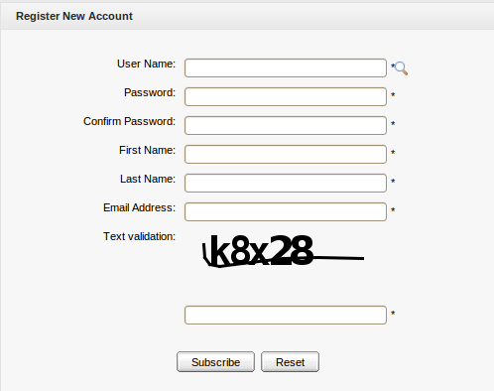Illustration 25: The Register New Account form
Details:
User Name: The user's login name. It must be unique and have at least 3 characters.
Password: The password used to login. It must have at least 6 characters.
Confirm Password: The re-typed password. The Password and Confirm Password must be the same.
First Name: The user's first name. This field must start with a character.
Last Name: The user's last name. This field must start with a character.
Email Address: The user's email. It must be in the right format, for example: username@abc.com.
Text validation: The text which is required to input to validate the registration.
These are required fields, the User Name must contain only alpha, digit and underscore characters and must be unique.
Step 2: Enter values for fields in this form.
Step 2: Click the Subscribe button to accept adding a new account or the Reset button to clear the entered values. After you click the Subscribe button, there will be a message which informs that you have registered your account successfully.
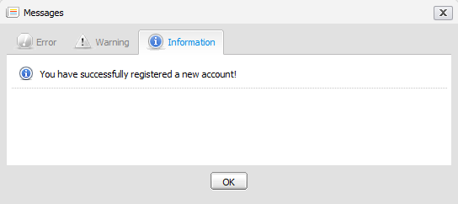
Step 3: Click OK to finish creating your account.
There will be an alert message which informs that you can not add a new account if one of these cases occurs:
- User name is existing or User Name is invalid.
- Password has less than 6 characters.
- Password and Confirm Password are not the same.
- Email Address is in a invalid format.
- Required fields are blank (empty).
- Text verification isn't correct.
After adding a new account, contact with administrator to get rights or only be a visitor.
Note:
1. The magnifying glass icon is used to search whether the entered User Name exists or not. Once a user has registered by himself or the administrator has created a new account, the new user will become a part of the group "/platform/users" with membership by default.
2. The portal's administrator can allow the text validation field to appear or not. To do so, follow these steps:
Step 1: Enter the portal as an administrator.
Step 2: Go to the Register portlet by enter the following URL:
http://localhost:8080/portal/private/classic/register.
Step 3: Hover your mouse over Site Editor on the toolbar.
Step 4: Click Edit Page under the Site Editor.
Step 5: Hover your mouse over the area of Register Portlet and choose the edit icon
The Edit Mode will appear:
Step 6: Deselect the User captcha and click the Save button if you want the Text validation
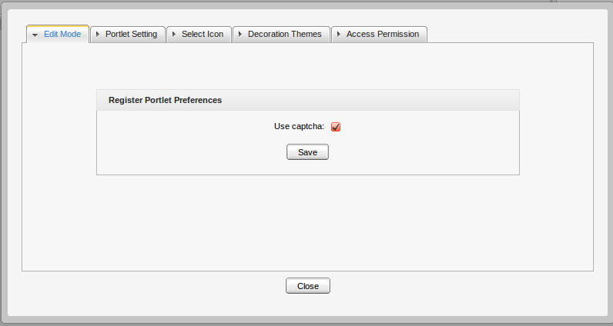Illustration 26: Edit Mode of Register Portlet
field not to exist in the Register New Account form.
Step 7: Click the Close button, then click the Finish icon on the top right of Page Editor so that the change comes into effect.

Note that you can enter the Register portlet through another ways. For example: Click Site --> select Edit Navigation of the classic portal --> right-click Register node --> select Edit Node's Page --> Choose the edit icon.

Sign In and Sign out

Sign In
By default, GateIn initializes some users with specific rights.

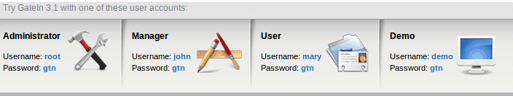
Details:
- Being an administrator, root has the highest right in any portal. Root controls all resources such as: users, groups, memberships, pages, navigations, portlets, etc., Root can do anything in a portal except the private resources of another users.
- Being a manager, john can take some actions that are supported only for a manager.
- Being a visitor, marry is like a freedom user, so she can only visit and read news.
The GateIn may be accessed by using a browser with a regular connection (HTTP). If you are using a default bundle installation in your local computer, you can access it through the URL and by default, the address http://localhost:8080/portal/ runs into a portal named “classic”. Otherwise, you will have to contact your administrator to ask for the initial URL.
With GateIn 3.1, users can sign in the portal via 2 ways:
The 1st way:
Step 1: Click the Sign in link at the top right of the page. The Sign in form appears:
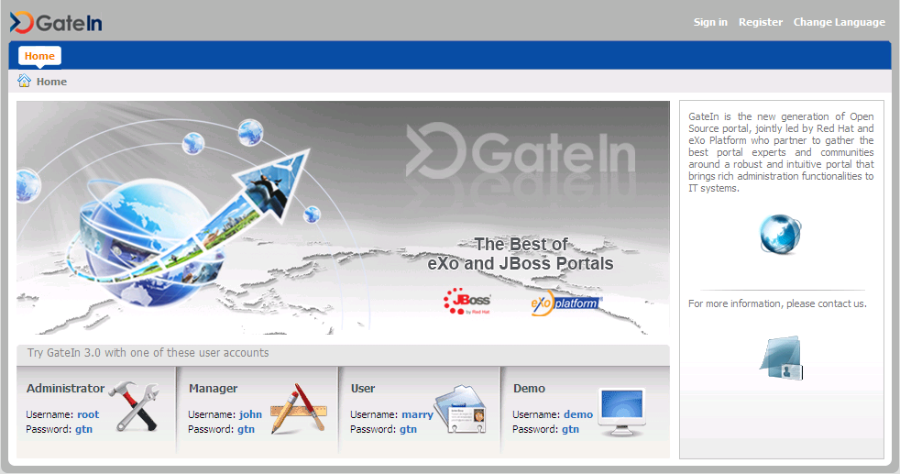Illustration 27: The main screen of GateIn Portal
Details:
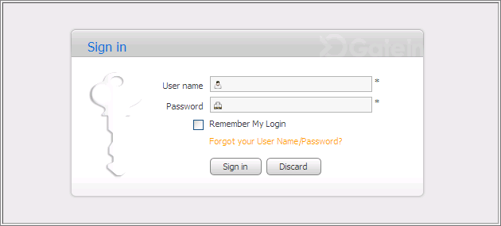Illustration 28: The Sign in form
User Name: To input the registered user name.
Password: To give the password of your user name.
Remember My Login: To allow you to return to the GateIn and to be automatically authenticated based on the cookie value provided by the browser. Thus, you do not have to perform an explicit authentication again.
Forgot your User Name: To follow some steps to get the forgotten user name or password.
Sign in To sign into the GateIn by the inputted user name and password.
Discard To close the Sign In form.
Step 2: Input your registered User name and Password.
Step 3: Select the Remember My Login checkbox when you sign in GateIn 3.1 at the first time if you want to automatically return to GateIn 3.1 without signing in again. You can see the section "Remember User Account" for more details.
Step 4: Click the Sign in button to submit the form or the Discard button to quit.
Note that in case the user name does not exist or the user name/password is invalid, you will be returned to the Sign In form with an alert message. Type your user name or password again.
After signing in successfully, you will be redirected to the homepage and welcomed with your full name on the top right corner of the page.
The 2nd way: Click directly the default user accounts at the lower of screen. You will be redirected to the portal.

Sign out
This feature ends the authenticated session and returns the user to the anonymous portal. To sign out, just hover your mouse over the Sign Out icon on the top right corner and click that icon.
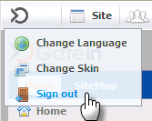

Remember User Account
Users who regularly return to GateIn 3.1 can be automatically authenticated to avoid doing
an explicit authentication each time they access the portal. Follow these steps:
Step 1: Input your registered user name and password.
Step 2: Select the Remember My Login checkbox when logging in GateIn 3.1 at the first
time.
Step 3: Click the Sign In button to submit the form.
To be authenticated for the next time you sign in automatically, do not choose to sign out when leaving the portal.

Change Account Settings
This function allows changing your account information. To do so, click directly your account after logging in to open the Account Profiles form.
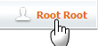
The Account Profiles form will be shown:
To change your Account Profiles, do as follows:
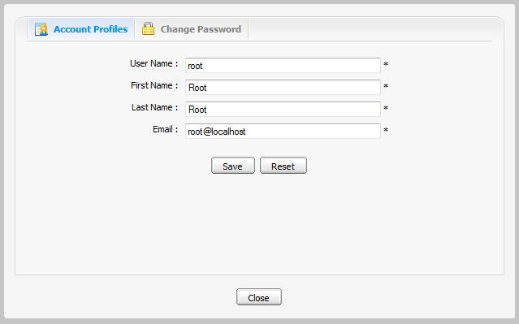Illustration 29: The Account Profiles Dialog
Step 1: Select the Account Profiles tab.
This tab displays current basic information about the current user.
Step 2: Change your First Name, Last Name, Email. Your User Name can not be changed.
Step 3: Click Save to accept changes.
To change your Password, do as follows:
Step 1: Select the Change Password tab.
Step 2: Enter your current password to identify that you are the owner of this account.
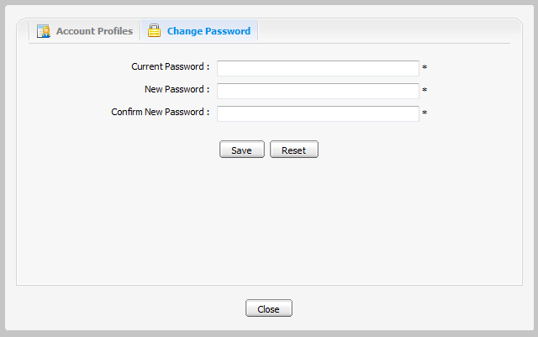Illustration 30: The Change Password tab
Step 3: Enter your new password which must have at least 6 characters.
Step 4: Enter your new password again in the Confirm New Password field.
Step 5: Click the Save button to accept changes.

Note: If the default accounts' passwords have been changed, the user can no longer sign in the portal by clicking the default accounts directly in the lower of the page.

Retrieve Account & Password

In case you forget your account or password, you can recover by following these steps:
Step 1: Click the link 'Forget your User Name/Password?' beneath the Password field in the Sign in form.
This form offers two options:
  - Forgot my password.
  - Forgot my username.
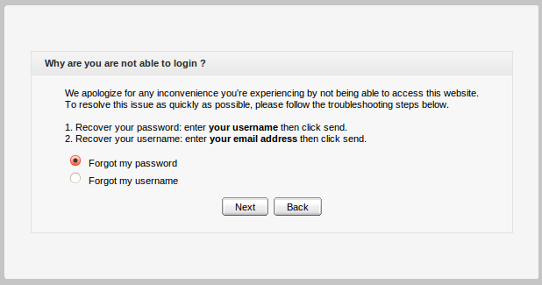
Step 2: Select one appropriate option.
Step 3: Click the Next button to go the next step. You will be prompted to provide identification information, depending on your choice.
- If you selected the Forgot my password option, you will be prompted for your user name:
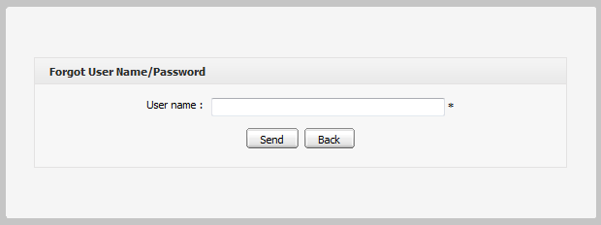
- If you selected the Forgot my username option, you will be prompted for your email:
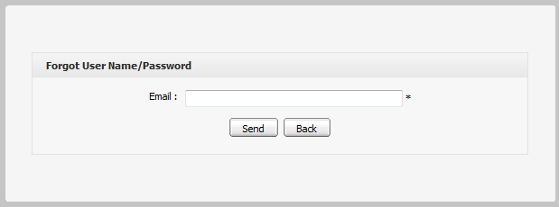
Step 4: Enter your Username or Email in the field of the above form.
Step 5: Click the Send button to send the entered values.
After the form is sent, an email will be sent to your email address with the requested information.
- If you forgot Username: when retrieving Username, your old Username is still remained and reused.
- If you forgot Password: you will be sent a new password (as temporary) and then you will be redirected to change password when you sign in.
Note that the User name/Password that you received only takes effect for one day. It means that if the current duration is over one day from the receipt day, you can not use the received User name/Password. Thus, you have to get another active email.

Gatein administration

Manage portals

Create a new portal
In the current version, only users of at least one of the groups /platform/administrators or /organization/management/executive board can perform this function.
This permission is set in the portal-configuration.xml file.

<value-param>
<name>portal.creator.groups</name>
<description>groups with membership type have permission to manage portal</description>
<value>*:/platform/administrators,*:/organization/management/executive-board</value>
</value-param>

You need a special permission to create a new portal. An administrator can only give you this permission.
Step 1: Click Site on the toolbar to visit the Portal Navigation page.
Step 2: Select the button 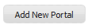.
By default, the Create New Portal window which contains the Portal Setting tab will open:

Step 3: Enter a value for the Portal Name field. This field is required and must be unique. ONLY alphabetic, numeric and underscore characters are allowed for this field and the name must have at least 3 characters.
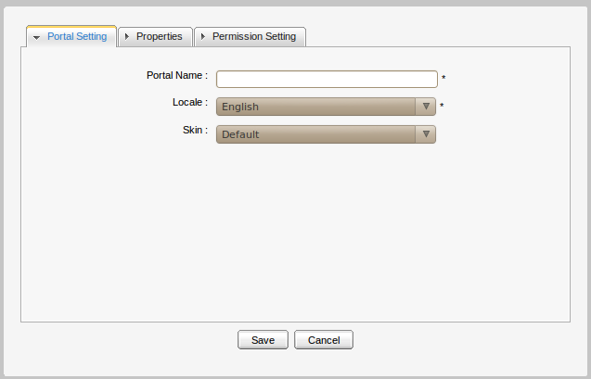Illustration 31: The Portal Setting tab
Step 4: Select the default display language for the portal in the Locale list.
Step 5: Select a skin for the portal by selecting one type. Currently, there are two skin types available, including Default and SimpleSkin.
Step 6: Click the Properties tab to select thr Keep session alive option. There are 3 options:
- Never: The session will never timeout, even if an application requests it.
- On-demand: The session will timeout if an application requests it.
- Always: The session will timeout after a set period.
Step 7: Click the Permission Setting tab and set the permissions for the portal.
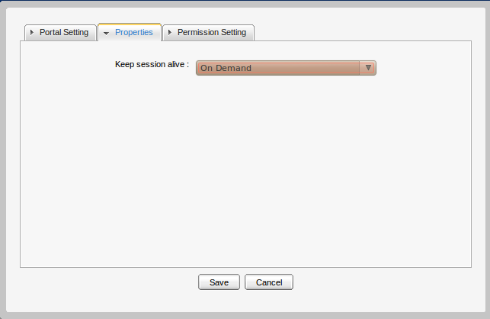Illustration 32: The Properties tab
- By default, the access permission list for portal is empty. You have to select at least one or check the Make it public check box to set access permission to everyone.
- Edit permission is also empty and you have to select one.
Step 8: Click the Save button to accept creating a new portal or the Cancel button to quit.

Access a portal
If you want to access a portal, you must be in the Access Permissions list of that portal.
For example: a portal's Access Permission list:
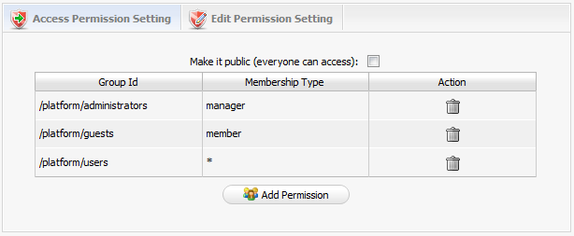
To access this portal, a user must be a “manager” of group /platform/administrators or a “member” of /platform/guests or a user in /platform/user with any membership type. To add more access rights, click the Add Permission button and then select the desired group and membership type.
There is a flexible option for you to choose if you want everyone can access the portal by just selecting the Make it public check box. In this case, the detailed access permission list disappears:
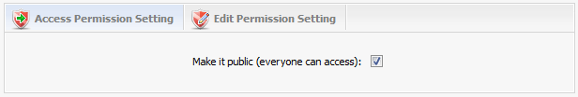
After setting the access permission for the portal, users who have access right can go into that portal in public mode by typing the public URL in browser (e.g: http://localhost:8080/portal or http://localhost:8080/portal/public/[new-portal-name] ). Furthermore, users can access to that portal in private mode by signing in the public mode. There is also a direct URL for the private mode: (eg: http://localhost:8080/portal/private/[new-portal-name]). Users who only have the access permission on the portal can view pages but they can not change any information of that portal.
You can set access permissions for a portal when you create or edit it.

Edit/Delete a portal
The function allows changing information of the current portal such as: properties, or layouts.
To do this, you must have the edit permission, please contact your Administrator to get more permissions. When you have the edit permission, follow one of two ways below to edit the current portal:
The 1st way:
Step 1: Go to the portal that you want to edit.
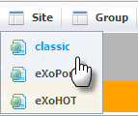
Step 2: Go to the Site Editor --> Edit Layout:
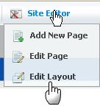
The 2nd way:
Step 1: Click Site and then click that corresponds to the portal that users want to edit.
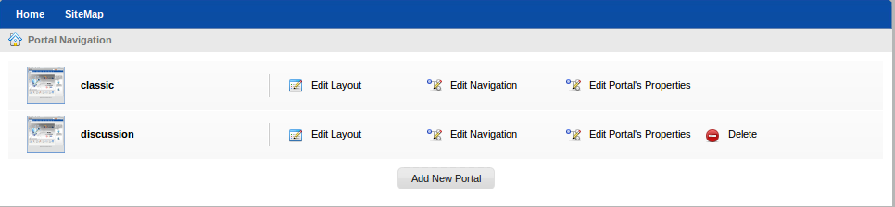

The Edit Site Layout will be displayed:
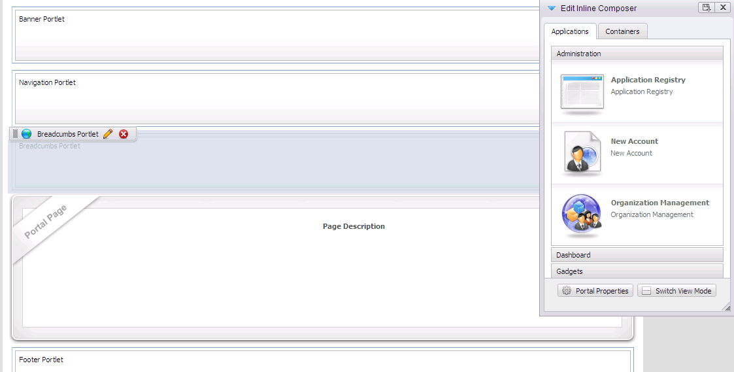
Step 2: Click to edit portal properties.
The form to edit the portal properties will appear:

Step 3: Change the properties of the current portal settings, properties or modify permissions:
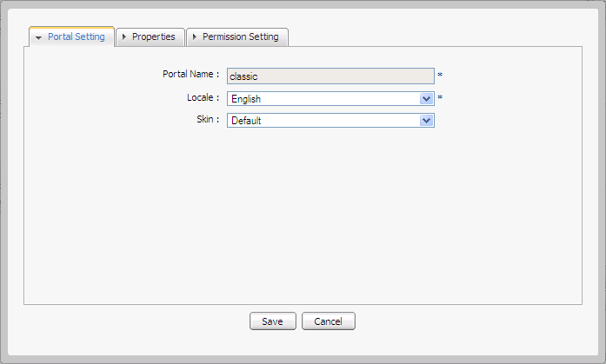Illustration 33: The Portal Setting tab of the portal properties form
For example: a portal's Edit Permission looks like:
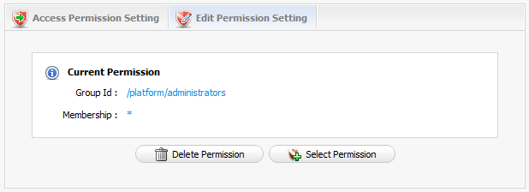
It means any user of the group /platform/administrators can perform this action.
To change any permission, click the Select Permission button and then select a group with the Membership type you want. Only one group can have the Edit Permission on the portal.
You can set the Edit Permission for the portal when you create or edit it.
Step 4: Click the Containers tab to edit the portal container layout by selecting, dragging and dropping
Step 5: Click the edit icon to edit the portlet in the portal or the delete icon to remove the existing portlet
Step 6: Add the other portlets by selecting, dragging and dropping from the Applications tab of the Edit Inline Composer form to the main pane.
Step 7: Click the Finish icon to save changes.
Delete a portal
To delete a portal, users must be in the group that has the Edit Permission on that portal.
Follow these steps:
Step 1: Click Site on the administration tool bar:
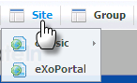
The Portal Navigation page will appear with a list of all portals:
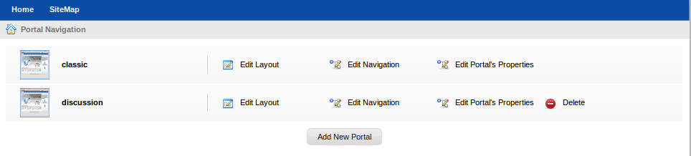Illustration 34: Portal Navigation
Step 2: Click the Delete that corresponds to the portal that you want to delete.
Step 3: Click the OK button on the confirmation message box to accept deleting or Cancel button to quit.
Note: The default portals can not be deleted by any user, including the administrator.

Access a specific portlet
Portlets are used as content bricks of a page. For individual needs, users can compose their pages using any portlet that they have access permission. Some portlets are designed for administrators only, therefore you should restrain the access to these portlets.
Users, including administrators, only have access permissions to portlets other than edit permission. You can give access permission to any group.
The access permission allows performing these followings:
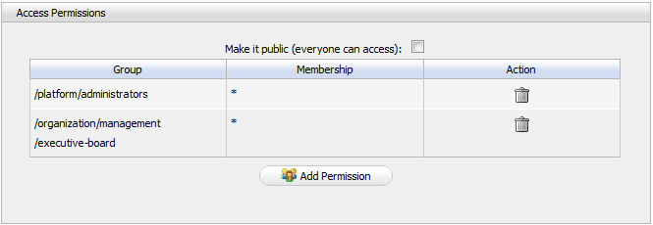Illustration 35: The Access Permissions form
- When you create/edit a page by wizard, at step 3, all portlets under your access permission will be displayed in the Applications tab of the Page Editor form that is ready for you to drag and drop into the page area in the main pane.
- When you edit a node's page in Edit Page and Navigation, all portlets under your access permission will be displayed in the Applications tab of the Page Editor form that are ready for you to drag and drop into a page area in the main pane.
- When you edit a page in Manage Pages, all portlets under your access permission will be displayed in the Applications tab of the Page Editor form that are ready for you to drag and drop into page area in the main pane.
When you edit the current portal, all portlets under your access right will be displayed in the Applications tab of the Page Editor form that are ready for you to drag and drop into the page area on the right pane.

Edit a specific portlet
This section tells you how to access the edit mode of a portlet and edit it.
Step 1: Create or edit a page by following above steps. In this step, there is a container that contains and arranges portlets as contents of that page. You can add a portlet into that page by dragging it from the left pane and dropping it into this container space.
Step 2: Open the form to edit a portlet by clicking the edit portlet iconat the upper left corner of that portlet:
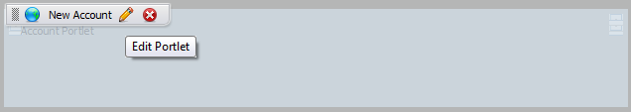
Step 3: Enter new values that you want to edit in this form and then click the Save button to save new values:
Normally, a portlet has 4 components: the Portlet Setting tab, the Select Icon tab, the Decoration Themes tab and the Access Permission tab. In addition, some porlets may also have a Edit Mode tab or a Preferences tab. The administrator can change the interface of a portlet by changing values in the Edit Mode tab or in the Preferences Tab.
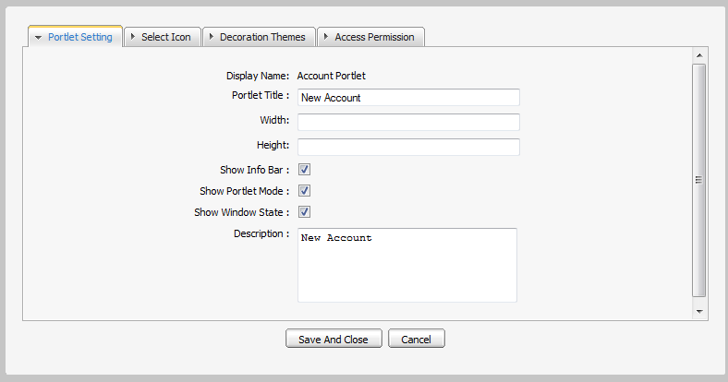Illustration 36: The Portlet Setting tab
The Portlet Setting tab includes:
Display Name: The display portlet name
Portlet Title: The portlet title. The length must be between 3 and 30 characters.
Width: The portlet's vertical size. The value of this field must be in numeric format. This field is not required.
Height: The portlet's horizontal size. The value of this field must be in numeric format. This field is not required .
Show Info Bar: The option allows showing or hidding the information bar.
Show Portlet Mode: The option allows whether showing the portlet mode or not.
Show Window State: The option allows whether showing the portlet's window state or not.
Description: The brief information about the portlet. The length must be between 0 and 255 characters.
Note: If Show Info Bar is not checked, portlet mode and window state will not be displayed in that portlet.

The Select Icon tab allows you to select an icon for the portlet. By clicking on Get Default, you do not have to choose any icon from the list, it will be automatically gotten the suitable icon.
- The Decoration Themes tab allows you to select a theme for the portlet from a theme list. By clicking Get Default , you do not have to choose any theme, it will be automatically set:
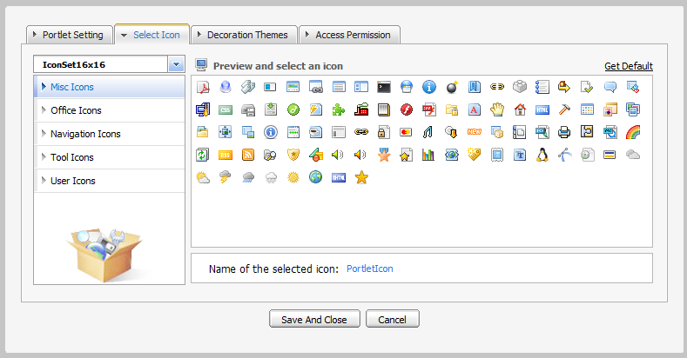Illustration 37: The Portlet Icon tab
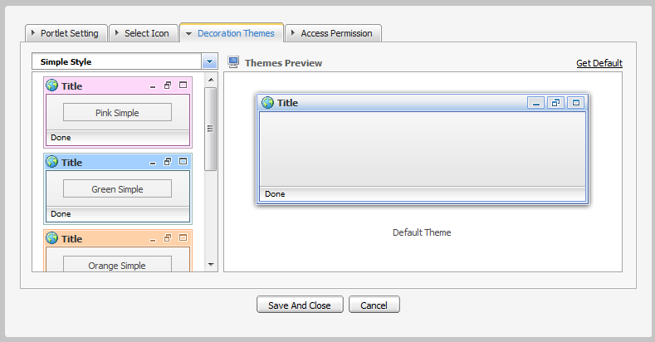Illustration 38: The Decoration Themes tab
- The Access Permission tab allows you to set access permission on the portlet. The porlet can be made public to everyone or restricted to specific groups.
To allow more groups to have access permission, simply click Add Permission to select more groups.
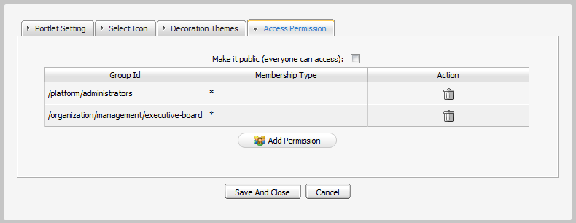Illustration 39: The Access Permisson Tab
- Some Portlets have a Edit Mode and Preferences tab:
Example:
- IFrame and Dashboard portlets have Edit Mode, the administrator can define the interface details in the Edit Mode tab:

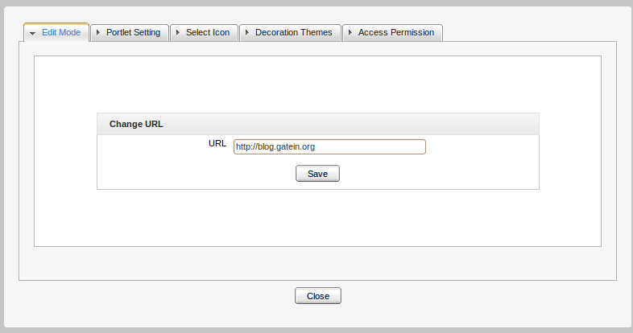Illustration 40: The Edit Mode tab of the IFrame Portlet

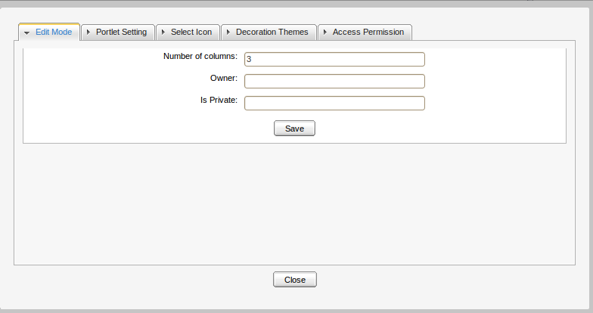Illustration 41: The Edit Mode of the Dashboard Portlet

Edit Portal's navigation
The function allows you to edit the navigation of portal.
Do as follows:
Step 1: Click Site on the toolbar:
The Portal Navigation page will appear with a list of all portals:
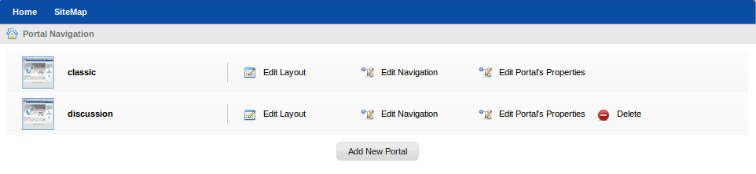Illustration 42: Portal Navigation
Step 2: Click the Edit Navigation link that corresponds to the portal that you want to edit.
The Navigation Management form will be displayed:
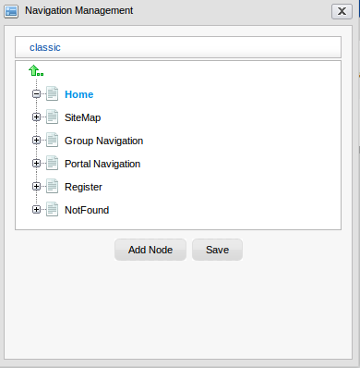
Step 3: Select the navigation that you want to edit.
Step 4: Click Add Node to add or change the node for a specific navigation.
Step 5: Click the Save button to accept the changes.

Edit Portal's Properties
Portal properties such as language, skin and permissions can be set by following these steps:
Step 1: Click Site on the toolbar:
The Portal Navigation page will appear with a list of all portals:
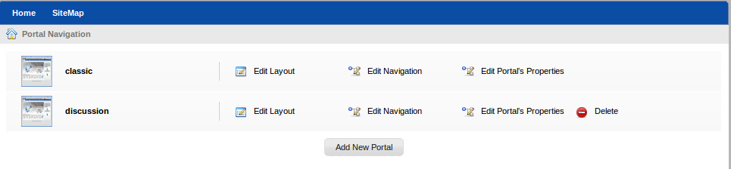
Step 2: Click the Edit Portal's Properties corresponding to the portal that you want to edit.
The form used to edit portal's properties will be displayed below.
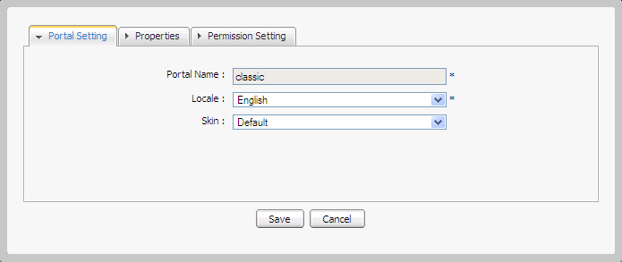
Step 3: Make changes in the Portal properties form.
Step 4: Click the Save button to accept the changes or the Cancel button to discard any change.

Change Portal Skin
GateIn skins are graphic styles that help displaying attractive user interfaces. Each skin has its own characteristics with different backgrounds, icons, and other visual elements, etc. In order to be user-friendly and flexible in use, users are allowed to change skin without editing the portal right.
The skins can be changed permanently or temporarily.

Change the skin permanently
Step 1: Click Site on the toolbar and select the portal that you want to edit.
Step 2: Click the button which corresponds to the portal that you want to edit The portal will be displayed under the edit mode.
Step 3: Click the button to edit portal properties.
Step 4: Select one skin type in the Skin list field to change in the Portal Setting tab. Currently, there are two supported types, including Default and SimpleSkin.
Step 5: Click Save and Finish icon to take affect.

Note: The display skin which is changed by this way will be kept permanently till you change the Skin when you edit the current portal again.

Change the portal's skin temporarily
Step 1: Mouser over the Star menu and click Change Skin.

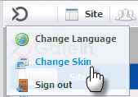
The Skin Setting form is displayed with a list of all supported skins. The left pane contains the skin list and the right pane is used to display the selected skin's template.
Step 2: Select one by clicking the skin type in the combo box. Currently, GateIn 3.1 supports two skin types, including Default and SimpleSkin.
Step 3: Click the Apply button and wait for a few seconds to take effect.

Note: Changing the skin by this way only takes effect on the current session. The next time you sign in, it will return to the portal default skin.

Switch between portals
This function allows users to select and use another portal (gateway, starting site). Only the users who got the appropriate permission by the administrators can perform this action.
To switch between portals, simply click on Site on the administration tool bar and click the portal name that you want to switch.
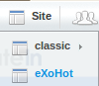

Nodes Management
If you are the portal administrator or the portal administrator has granted you the appropriate permission privileges, you can execute some special actions related to portal nodes, including: copying, editing, cutting, cloning, deleting, adding existing nodes.

Add a new node
Follow these steps:
Step 1: Click Site on the toolbar. The Portal Navigation will be displayed.
Step 2: Click Edit Navigation that corresponds to the portal you want to add a new node.
Step 3: Select a navigation from the navigation list.
Step 4: Select a node from the list to create a node as a sub-node of the selected node or click the arrow up icon to create a new node at the root level of the portal.
Step 5: Right-click the selected navigation or node and select Add new Node option.
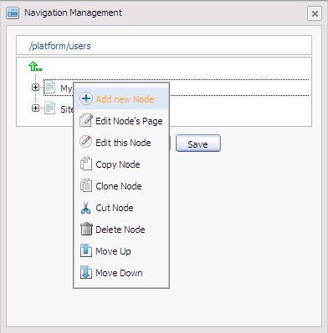
The Add new node form appears:
Details:
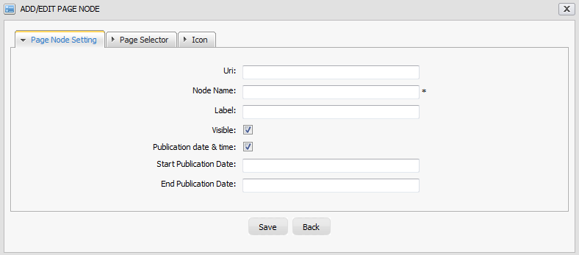Illustration 43: The Page Node Setting tab of the Add/Edit Page Node form
The Page Node Setting tab includes:
Uri: The node's identification. The Uri is automatically created once a new node has been created.
Node Name: The node name which must be unique. Only alphabetic, numeric and underscore characters are allowed and it must contain at least 3 characters.
Label: The node's display name on the screen. This field may be changed and its length must be between 3 and 60 characters.
Visible: This checkbox allows the page and its node to be shown or hidden at the navigation bar, the page navigation bar and the sitemap. See above for more details.
Publication date & time: This option allows this node to be published for a period of time. Two fields, including 'Start Publication Date' and 'End Publication Date' only display when this option is checked.
Start Publication Date: The start date and time to publish the node.
End Publication Date: The end date and time to publish the node.
In the Page Selector tab, you can select a page or not for this node.
Details:
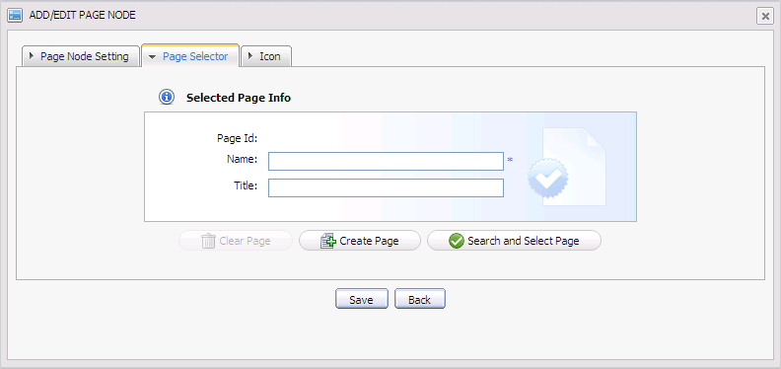Illustration 44: The Page Selector tab of the Add Page Node form
Page Id: The identification string of the page.
Name: The selected page's name.
Title: The selected page's title.
Clear Page: To remove the inputted page information in the fields
Create Page: This is to create a new page with the inputted name and the title.
Search and Select Page: This is to search and select an existing page.
You do not have to input values in these fields. They are automatically displayed after you have selected an exiting page by clicking the Search and Select Page button.
The Select a page form appears:
The list of all existing pages is displayed with basic information. To select a page for creating a node, do as follows:
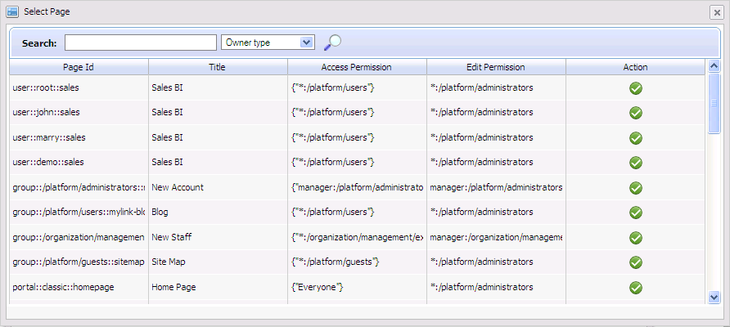Illustration 45: The Select Page form
Step 1: Select a page from list or search a specific page.
Step 2: Enter a search term related to the page that you want to search.
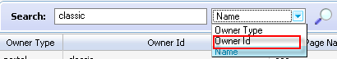
Step 3: Choose the field you wish to search in:
Step 4: Click the magnifying icon to perform the search. All pages matching with the search term will be listed.
Step 5: Click the icon on the row of the desired page.
After selecting a page, the details of this page will be displayed in the Page Selector form.
Note: To select a page, you must be a member in the Access Permission or Edit Permission list of the selected pages. When the page type is 'User', you can not select a page of another users.
If you do not have the access permission for any page in the list, please contact your administrator to get appropriate permissions.

Step 6: Choose one icon in the Icon tab.
Step 7: Click the Save button to accept the new node page or the X button to close the form.

Edit a node
This function is used to edit the node setting and re-select a page for a node.
Follow these steps:
Step 1: Click Site on the toolbar. The Portal Navigation will be displayed.
Step 2: Click Edit Navigation of the portal you want to modify.
Step 3: Right-click the selected node and select Edit this Node in the menu.
The Editing Node form appears with all fields as you saw it when you create a node, the current node's details are displayed in a form.
Step 4: Change values in fields of the current node. Note that the node name can not be changed.
Step 5: Click the Save button to complete changing or the X button to quit.

Copy/Paste a node
These functions are used to reproduce a node to another place.
Do as follows:
Step 1: Click Site on the toolbar. The Portal Navigation will be displayed.
Step 2: Click Edit Navigation of the portal you want to modify.
Step 3: Right-click the selected node and select Copy Node in the menu.

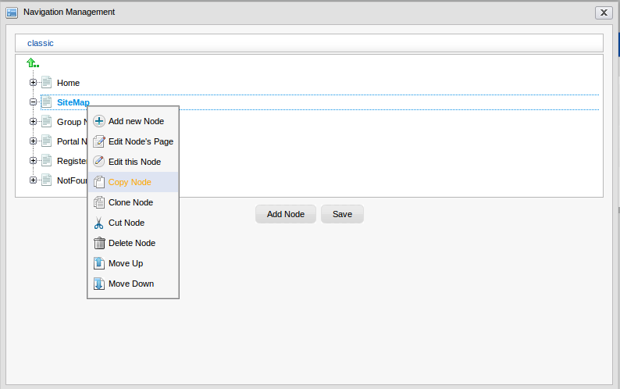
Step 4: Select the position you want to paste this node and select Paste Node.
The node selected at step 3 will be reproduced in a new place.
Step 5: Click the Save button to make change.
Note: Existing two same node names in the same place is not allowed.

Clone a node
This function allows you to make a node copy. The difference between clone node and copy node is that the clone node has its own page with the same content as the selected node. Therefore, there will be a new page that has the same name as the cloned node's page shown in the page list when you access Manage Pages.
Do as follows:
Step 1: Click Site on the toolbar. The Portal Navigation will be displayed.
Step 2: Click Edit Navigation of the portal you want to modify.
Step 3: Right-click the selected node and select Clone Node in the menu.
Step 4: Select the position you want to paste this node and select Paste Node.
The node cloned at step 3 will be reproduced in a new place.
Step 5: Click the Save button to make change.

Cut a node
This function allows users to change the position on a specific node (like changing the page path).
Follow these steps:
Step 1: Click Site on the toolbar. The Portal Navigation will be displayed.
Step 2: Click Edit Navigation of the portal you want to modify.
Step 3: Right-click the selected node and select Cut Node in the menu.
Step 4: Select the position you want to paste this node and select Paste Node.
The node cut at step 3 will be moved to the new position.
Step 5: Click the Save button to make change.
The node at step 3 is moved to a new place.
Note: It is not allowed for two same node names to exist in the same path (node).
Four navigations, including Group Navigation, Portal Navigation, Register, and NotFound can not be cut, including administrators. Also, the above system nodes which have been copied, or cloned can not be cut in the new position. However, you can cut them through cutting the node which contains them, excluding the system nodes.

Delete a node
The function is used to remove a node (link to page).
Follow these steps:
Step 1: Click Site on the toolbar. The Portal Navigation will be displayed.
Step 2: Click Edit Navigation of the portal you want to modify.
Step 3: Right-click the selected node and select Delete Node in the menu.
Step 4: Click the Ok button to accept the deletion or Cancel button to discard.
Step 5: Click the Save button to make change.
A confirmation message will be displayed.
Step 5: Click OK to confirm deleting or Cancel to quit.
Note: When you delete a node, you delete the link to page but the page still exists.
Four navigations, including Group Navigation, Portal Navigation, Register, and NotFound can not
be deleted by any users, including administrators. Also, the above system nodes which have been copied, or cloned can not be deleted in the new position. However, you can delete them through deleting the node which contains them, excluding the system nodes.

Change nodes order
This function is used to change the position of a node up/ down.
Follow these steps:
Step 1: Click Site on the toolbar. The Portal Navigation will be displayed.
Step 2: Click Edit Navigation of the portal you want to modify.
Step 3: Right-click the selected node and select Move Up or Move Down in the menu.
The selected node will be moved up/down.
Step 5: Click the Save button to make change.

Pages Management

Create a new page

Create a new page using Page Creation Wizard
A page creation wizard is available to the portal's administrators that facilitates them to create and publish portal pages quickly and easily. To do so, follow these steps:
Step 1: Go to Site Editor, then select Add New Page
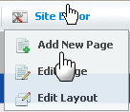
The wizard will be displayed below:
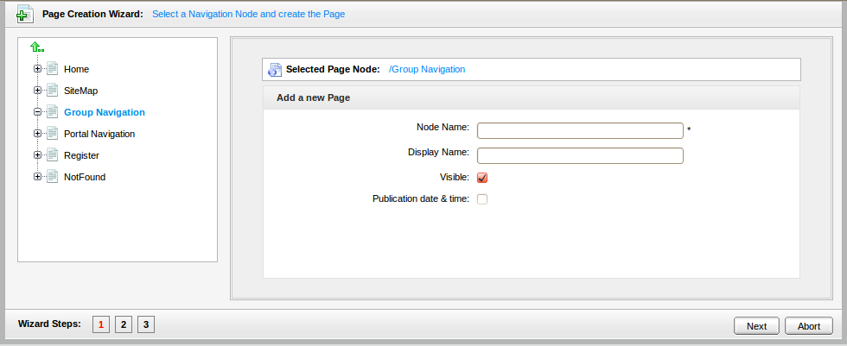Illustration 46: Page Creation Wizard: Select a Navigation Node and create the Page
The Page Creation Wizard is divided into two sections: the left pane contains the existing pages and the right pane displays the Page Editor.
- The left pane is to navigate up and down the node/page structure.
- The right pane is to put parameters for a new page, in which:
Selected Page Node: The path of the selected node to add a new sub page.
Node name: The node name of the added page. This field must start with a character and have length between 3 and 30 characters (required).
Display name: The display name of the node which contains the added page and must have length between 3 and 30 characters.
Visible: This checkbox allows this page (node) on the Navigation bar, Page Navigation and Site Map to be shown or not. By default, the checkbox is checked and it means that this page is shown in Navigation, Page Navigation and Sitemap. If “visible” is checked, the visibility will depend on the “publication date and time” option.
Publication date & time: This option allows the page to be published for a period of time. If this option is checked, the visibility of a page will depend on the publication period start and end date.
Start Publication Date: The start date and time to publish the page.
End Publication Date: The end date and time to publish the page.
Note:
You can set date and time by clicking the Start Publication Date field and the End Publication Date field and select a date in a calendar pop up
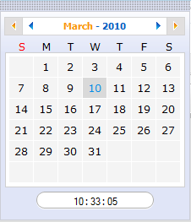
Step 2: Enter values in fields.
Step 3: Click Next or number '2' of the wizard steps to go to step 2.
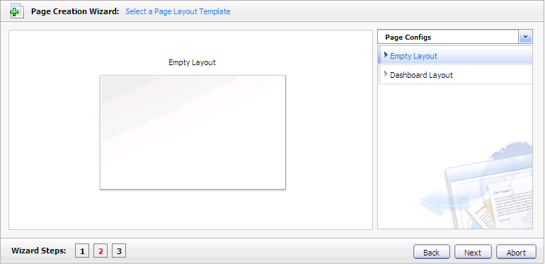Illustration 47: Page Creation Wizard: Step 2- Setting a Page Layout Template
Step 4: Select Empty Layout or click the icon to see more templates.
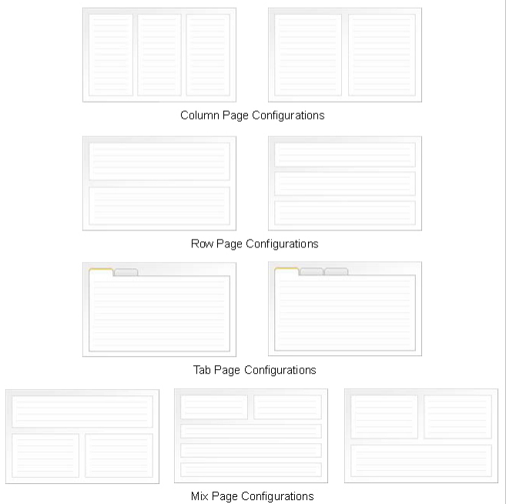Illustration 48: The Page Configurations type
Step 5: Click the Next button or number '3' of the wizard step to go to step 3.
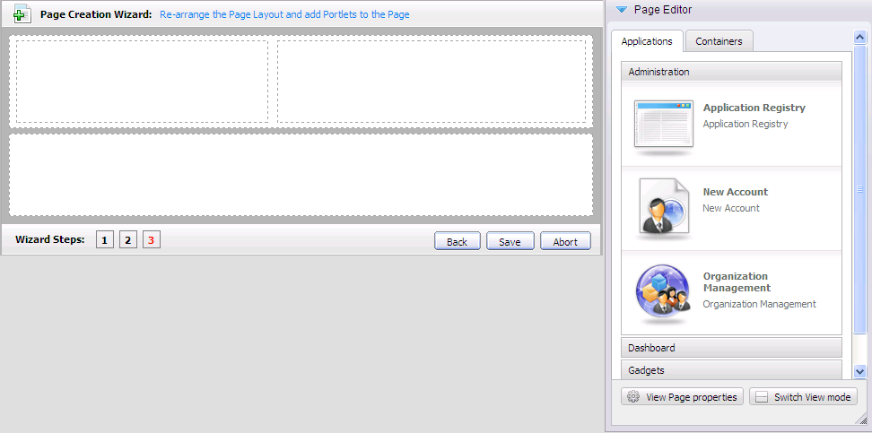Illustration 49: Re-arrange Page Layout and add portlets into the page
The Applications tab lists all the categories and their portlets that you can drag and drop in your page area.
The Containers tab lists the existing containers to re-select the page layout.
  - Add a container into the page area by dragging and dropping the container from user's workspace into the page's area.
  - With each selected container, you can:
- Change the position by pressing icon at the left-top corner of a container, then drag and drop the container to a new position.
- Edit the selected container by clicking the edit icon; or
- Delete the selected container by clicking the deletion icon.
Step 6: Click Save to complete the page's creation or click Abort to discard.

Create a new page using Page Management
Step 1: Go to Group on the toolbar, highlight Administration, then select Page Management.
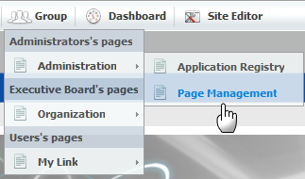
The Manage Page form appears:
Step 2: Click the Add New Page button.
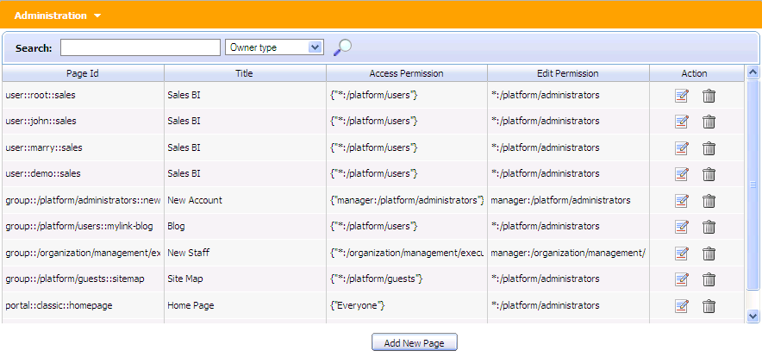Illustration 50: The Manage pages form
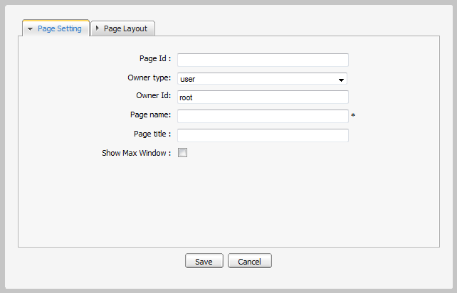
Step 3: Enter values for the Page Setting tab.
Details:
Page Id: The page's identification string. It is automatically generated when you finish creating the page.
Owner type: If the page's Owner type is portal, the page is created for a portal. Therefore, only users who have edit permissions at the portal level can create this page type.
The name of the current portal is automatically selected for Owner id, ensuring that the edit permissions are assigned to users who can edit the current portal.
If the page's Owner type is group, the page is created for a group. As a result, only users who have manage permissions for that group can create this page type.
Owner Id: The identification name of the page's owner. When the owner type is “group”, there will be a list of groups of which you have to select one.
Page Name: The page name. This field is required and must be unique. Only alphabetic, numeric and underscore characters are allowed and its length must be between 3 and 30 characters.
Page title: The page title. This field is optional and must have the length between 3 and 30 characters.
Show Max Window: The option allows whether the page is shown at maximum size or not.
The Page Layout tab allows defining the page layout:
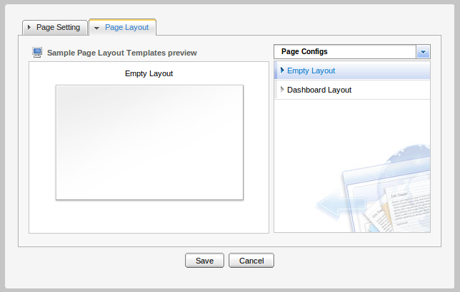Illustration 51: The Page Layout tab of the Add New Page form
Step 4: Click the Save button to accept creating a new page or the Cancel button to quit the form.

Edit a page
Users who have the edit permission of a page can edit/delete that page.

Edit a page using Site Editor
To edit a page from the Site Editor, do as follows:
Step 1: Go to the page that you want to edit.

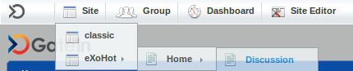
Step 2: Click Site Editor, then highlight Edit Page.
The page will be displayed in the edit mode with the Page Editor that allows to add more portlets or to edit the container. Besides, you can edit the existing port properties or all page properties.
Step 3: Make changes on the page.
Step 4: Click Finish button to accept changes or Abort button to quit without saving any change.

Edit a page using Edit Portal's Navigation
Step 1: Click Site on the administration toolbar, then select Edit Navigation in the Portal Navigation.
Step 2: Select a navigation from the navigation list on the left pane.
Step 3: Select a node.
Step 4: Right-click that node and select Edit node's page in the menu.
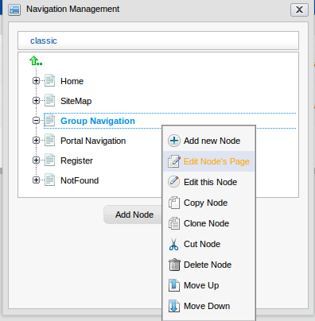
After selecting a node, if users have the edit permission, there will be the Page Editor form.
Step 5: Click the button in the Page Editor form to edit page properties:

Details:
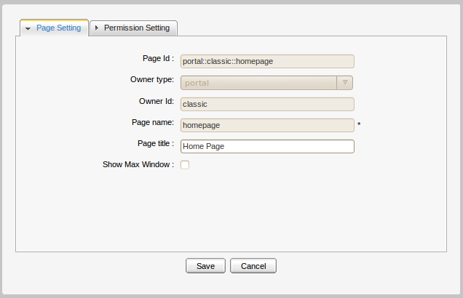Illustration 52: The Page Setting tab of the Portal Properties form
The Page Setting tab includes:
Page Id: The page's identification string which can not be changed.
Owner type: The page type (portal or group or user) which can not be changed.
Owner Id: The identification of the page's owner. It can not be changed.
Page name: The page name which can not be changed.
Page title: The page title which can be changed and must have the length between 3 and 30 characters.
Show Max Window: If checked, the page's portlets will be displayed in the whole page space in a way that no tree space is left.

The Permission Setting: This form is to support for pages of a group or a portal. Because a page of a user is private, no one else can access or edit the user's page, except the creator so you do not have to set permission for it. Permission on each page is set in two levels: Access Permission and Edit Permission.
- Access Permission: It allows users to see content of a page or “borrow” that page for individual needs by selecting a page for their node. Page Access permission can be set to some user groups or set to everyone (also including unregistered users). The Access Permission Setting sub-tab in the Permission Setting tab is shown:
- There is a list of current access permissions on a page. You can click the delete icon to remove the permission or click the Add Permission button to add more or check the Make it public to allow all users to access.
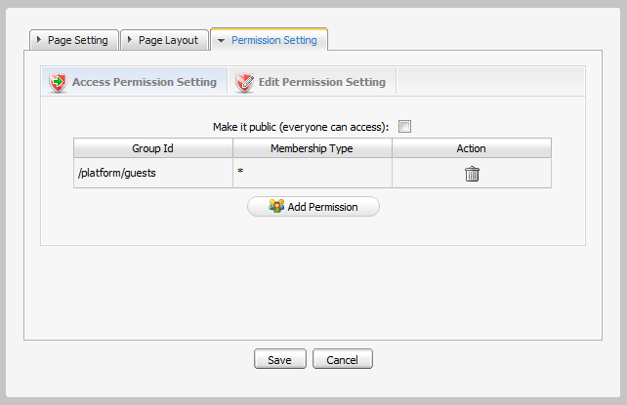Illustration 53: The Access Permission Setting form of the Permission Setting tab
- Edit permission: It allows users to change information of a page. The edit permission is only set for one single group.
The edit permission on a page can be set for one group with one specific membership type (or * means all membership types in group). If you want to re-assign this permission to another group, click the Select Permission to choose another one. The Edit Permission Setting sub-tab in the Permission Setting tab is shown:
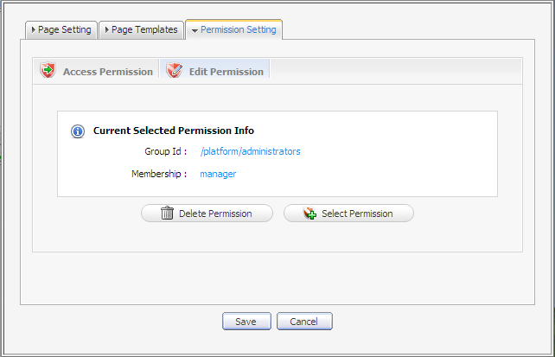Illustration 54: The Edit Permission form
Edit a page container layout
Click the Container tab of the Edit Inline Composer form to show the current container layout and the list of all available container layouts is shown.
If you want to change the current layout, select the layout type from the list on the left pane and then move the cursor to the template you want, then left-click, drag and drop it into the display pane. A new container will be displayed on the destination pane. You can change the position of the current container by clicking the upper-left corner, then drag and drop it to another place on the pane.
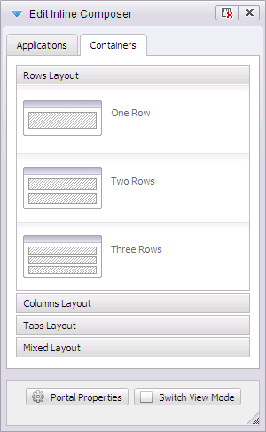
You can remove the current container by clicking the delete icon on the right corner.
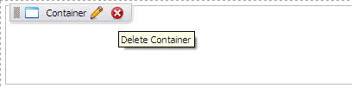
Edit the portlet layout of a page
In the main pane of the page, you can drag and drop to change the position of the portlets. Besides, you can click the Applications tab of the Edit Inline Composer, then select, drag and drop new portlets into the main pane.
You can also remove the current portlet by clicking the delete icon.
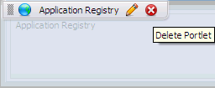

Edit a page using Page Management
Step 1: Go to Group --> Administration --> Page Management
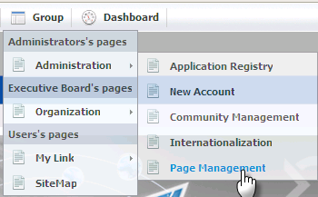
Step 2: Click the icon in the row of a page that you want to edit in the existing page.
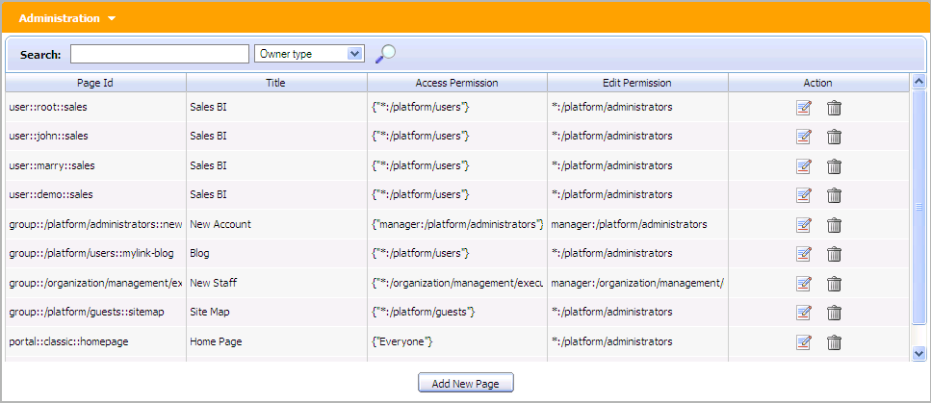
The edit page will be displayed with the Page Editor form.
Step 3: Click the button in the Page Editor form.
The form to edit the page will appear below:
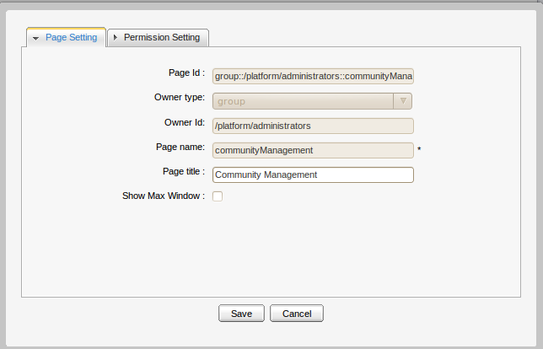
See the above section to learn about fields in Page Setting and Permission Setting tabs.

Delete a page
Step 1: Go to Group -- > Administration --> Page Management
There is a list of all existing pages.
Step 2: Click the trash icon in the row of the page that you want to delete.
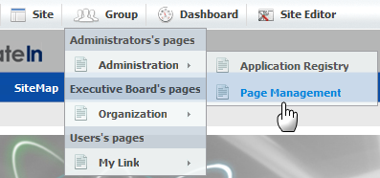
There will be a confirmation message whether you accept deleting a page or not:
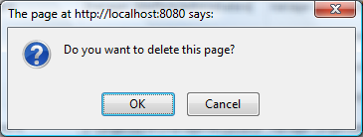
Step 3: Click the OK button in the confirmation message to accept the deletion or Cancel button to discard.

Preview pages
The function allows a page to be seen in the preview mode. Only users who have page's access permission can perform this action. Page access permission's information is displayed in the Access Permission column in the page list. If you are a member of Access group, you can take this action.
Follow these steps:
Step 1: Go to Group --> Administration --> Page Management.
Step 2: Click the Edit icon in the row of the page that you want to see.
The page will be displayed with the edit mode. You can make change if you want.
Step 3: To preview the page, click the button in the Page Editor form.
The page content is displayed in the preview mode.

Edit page container layout
Click the Containers tab of the Page Editor form. The list of container will be displayed. If you want to change the current layout, select a layout type from the list, then left click on the template that you want, drag and drop it into the main pane. The new container will be displayed on the destination pane. You can change position of the current container by left clicking, dragging and dropping it to another place on the pane or remove current container by clicking the delete icon on the right corner.

Edit page portlet layout
If you want to change the current layout, you can select, then drag and drop to change its
position or select another portlets in the Applications tab of the Page Editor form. Next, drag
and drop it into the destination pane. The new portlet will be added and displayed in the
selected pane. You can remove the current portlet by clicking the delete icon.

Users and Groups Management

Select the following path in the main toolbar: Group --> Organization --> Users and groups management.
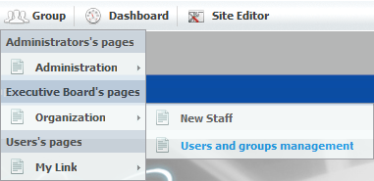
The Organization form is shown:
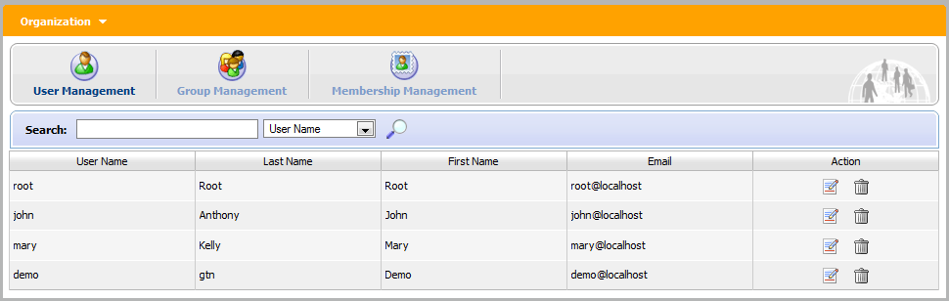Illustration 55: The Organization form

Manage Users
Select the User Management tab in the Organization form. By default, all existing registered users are shown.
Administrators can see, search, edit or even delete them. Each users group or membership in these groups are also available. You can not add a new user but can remove one user from the group.

Search for users
Administrators can use this function to search for specific users by User Name, First Name, Last Name or Email Address. To search for a specific user, do as follows:
Step 1: Type the Search term related to the user that you want to search. You do not need to enter an exact term.
Step 2: Select the information type you want to search against.
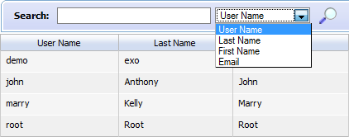
Step 3: Click the magnifying glass icon to perform the search.

Edit a user
Step 1: Click the edit icon corresponding to the user that you want to edit.
Step 2: Select the Account Info tab to view and change the essential user information.
The User Name field can not be changed:
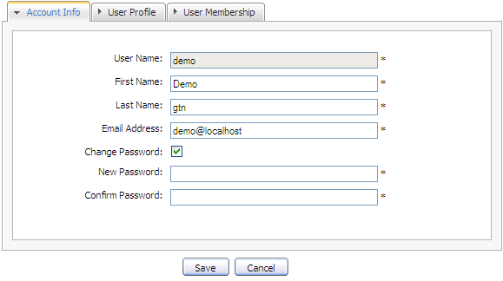Illustration 56: The Account Info tab of the Edit User Info form
The Change Password option allows the user to make a new password when he/she forgets his/her password. When the Change Password option is unchecked, New Password and Confirm Password are hidden. Passwords must contain at least 6 characters (letters, numbers and punctuation marks)
Step 3: Select the User Profile tab to view and change profile information. The Language field is used to set the display language of that user.
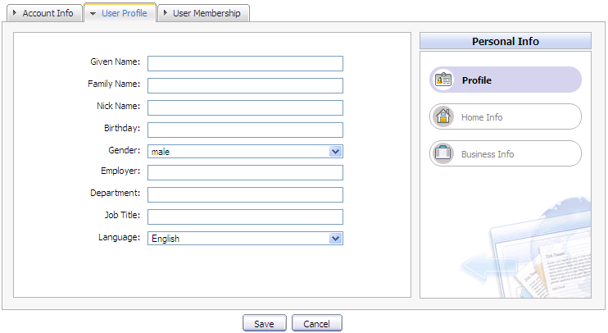Illustration 57: The User Profile tab of the Edit User Info form
Step 4: Select the User Membership tab to see user's information in groups.
      - The User Membership tab indicates to which group the selected user belongs. In the above figure, demo is a member of two groups: guests and users. The parent group of both is platform.
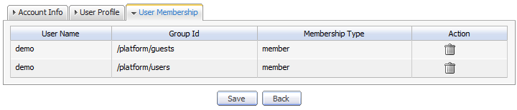Illustration 58: The User Membership tab of the Edit User Info form
      - To remove a user from a group, click the trash icon in the row that corresponds with the user who you want to remove.
Step 5: Click the Save button to accept changes.

Delete a user
Do as follows:
Step 1: Click the trash icon which corresponds to the user which you want to delete in the main User Management form.
Step 2: Click the OK button in the confirmation message to accept or Cancel to quit.

Manage groups
Select the Group Management tab in the Organization form. This tab is used to add new, edit or delete a group.
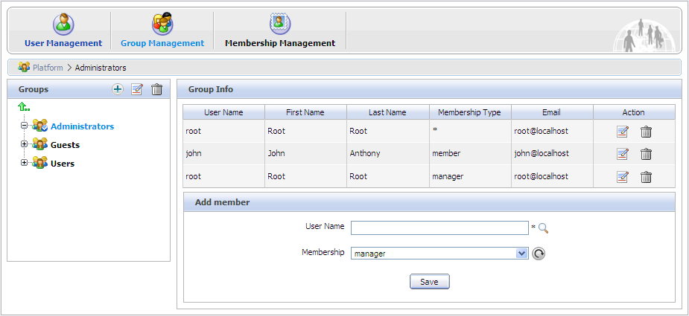Illustration 59: Group Management form

By default, all existing groups will be displayed on the left pane. The right pane shows information about the selected group, including information about members in a specific group and a small form to add a new user to a group.

Add a new group
Step 1: Choose the path to create a new group by selecting the group from the list on the left pane or clicking the arrow up icon if you want to create a group in a higher level. The selected path is displayed in the breadcrumb bar.
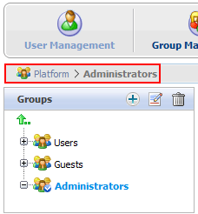
Step 2: Click Add New Group icon . The Add New Group form will be displayed on the right pane.
Details:
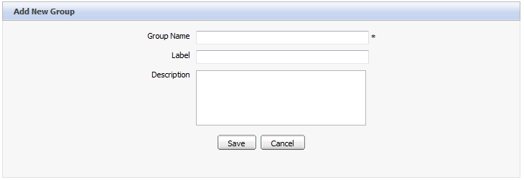Illustration 60: The Add New Group form
Group Name: The new group's name. This field is required and its length must be between 3 and 30 characters.
Label: The group's display name. Any length between 3 to 30 characters is allowed.
Description: The description about the group. Any length between 3 to 30 characters is allowed.
Step 3: Fill in the required fields. Only alphabetic, numeric and underscore characters are allowed and it must be unique.
Step 4: Click Save to accept entered values or Cancel to quit.
Note: When a new group is added, the group creator will become the manager of that group. The creator's user name will be added in the created group with the "manager" membership.

Edit a group
Step 1: Find the group in the existing tree and click the label.
Step 2: Click the edit icon to show the Edit Current Group form of the selected group.
This form is identical with the New Group form. The Group Name can not be changed by any user.
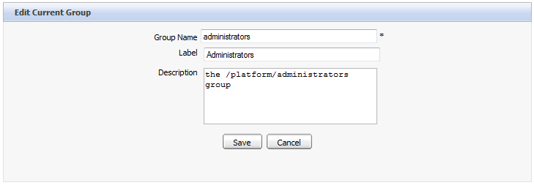Illustration 61: The Edit Current Group form
Step 3: Make change to the Label or Description fields.
Step 4: Click the Save button to accept changes or Back to cancel changes and return to the Group Infor form.

Add a new user to a group
Step 1: Select the path to the group which you want to add a new user to that group by selecting that group from the list on the left pane. The group's information is displayed, including the user list and a form which allows adding a new user.
Step 2: Enter the exact User Name of the user that you want to add to the selected group or you can enter some characters if you are not sure about the exact spelling.
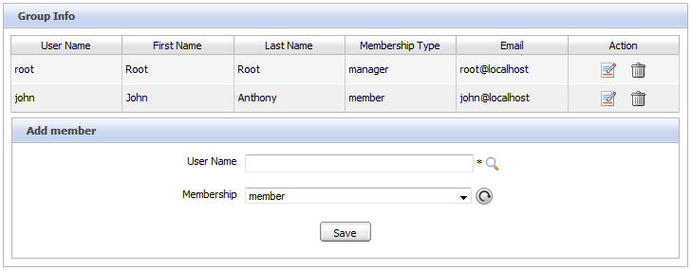Illustration 62: The Add member form
- Click the magnifying glass icon to search by the characters you entered.
- After you click the magnifying icon , there will be a list of all existing users whose User Names include the entered characters. For example, you enter the letter 'o', you will get the following result.
- Select the checkbox of the user(s) that you would like to add to the group.
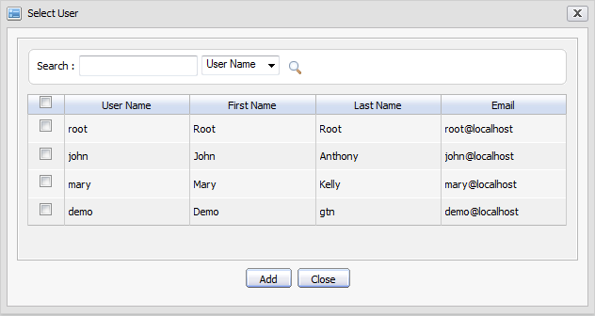Illustration 63: The Select User form
- After clicking the Add button, you will see the complete User Name(s) in the Add member form.
- Select the membership for the user in a group from Memberships list. The refresh icon can be used to update the membership list in case there are any change.
- Click Save to accept adding the selected user to a specific group with the selected membership type.
Note:
- By default, the “manager” membership has the highest right in a group.
- A user can have several membership types in a group. To do that, you have to use the Add member form for each membership type.
- After adding, the user's membership information is also updated. You can check it by opening the User Management form and editing the user you just added.

Edit a user membership in a group
Step 1: Click the Edit icon corresponding to a specific user with a membership in the Action column:
Step 2: Change the membership of the selected user by selecting another value in the Membership list box.
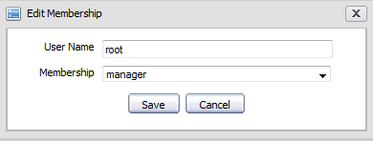Illustration 64: The Edit Membership form
Step 3: Click the Save button to complete changing.

Delete a group
Step 1: Find the group in the tree.
Step 2: Click the trash icon to delete.
Step 3: Click OK in the confirmation message box to accept deleting or Cancel button to quit without deleting.
Note:
- After being deleted, all information related to that group is also deleted (users and navigation related to this group).
- These following groups are mandatory in the portal and you can not delete: Platform; Platform/guests; Platform/users.

Manage Memberships
The user's role in a specific group is managed by using Membership Management.
By default, there are three membership types: Manager, Member and Validator. By default, Manager has the highest right in a group. You can add new, edit or delete a membership type.
Select the Membership Management tab in the Organization portlet. There will be a membership type list and a form to add new/edit:
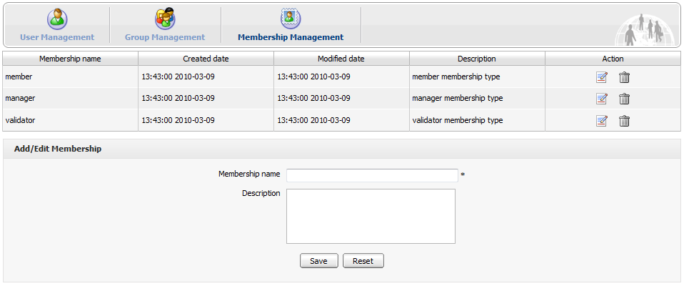Illustration 65: The Membership Management form

Add a new membership type
Step 1: Input values for the Membership name field (required) and the Description field (optional) in the Add/Edit Membership form at the bottom. Only letters, digits, dots, dashes and underscores are allowed for the Membership name. Note that no space is allowed in the Membership name.
Step 2: Click Save to accept adding a new membership or click Reset to clear the entered values.

Edit a membership type
Step 1: Click the edit icon in the Action column.
Step 2: Make desired changes in this form.
Step 3: Click the Save button.

Delete a membership type
Do as follows:
Step 1: Click the trash icon in the row of the membership type that you want to delete.
Step 2: Click the OK button in the confirmation message to accept the deletion.

Navigations Management

Portal's page navigation
Create a navigation
The page navigation of a portal is created automatically when a portal is created.
Delete a navigation
No one can create the portal's page navigation. Thus, no one can delete it. A navigation is deleted automatically after you delete its portal.

User's page navigation
Create a navigation
The page navigation of a user is created automatically when a user is created (registered). You don't have to create it.
Edit a navigation
Only the user who is the owner of the user page navigation can edit it.
Delete a navigation
No one can create a user page navigation so that no one can delete it. A navigation is deleted automatically when its user is deleted.

Group's page navigation
Each group has only one page navigation. Only users of that group have the “manager” membership can create/edit/delete navigation for that group. This right is set in portal-configuration.xml file
<value-param>
<name>navigation.creator.membership.type</name>
<description>specific membership type have full permission with group navigation</description>
<value>manager</value>
</value-param>

Edit Group's page navigation
Follow these steps:
Step 1: Click Group on the administration toolbar:
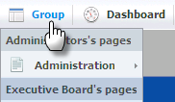
The Group Navigation page will appear:

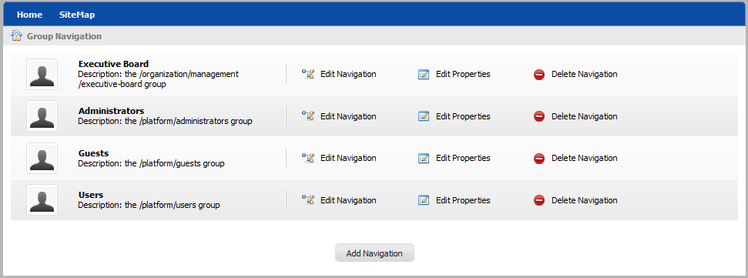Illustration 66: The Group Navigation page
Step 2: Click which corresponds to the group that you want to edit its page navigation.
The form to edit the page navigation will appear:
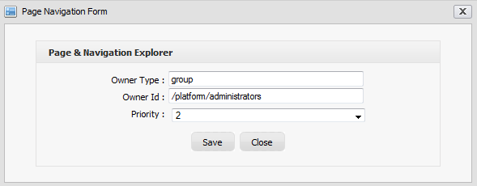
Step 3: Make change to values in this form.
Step 4: Click Save to accept any change or click Cancel to quit.
Note: The priority value determines the display position of the page navigation.

Create a new page navigation
Who can create pages for a group?
Only users who are “manager” of a group can create new pages for that group while the others in this group can not.
To create a page navigation, do as follows:
Step 1: Click on Group on the administration toolbar -->
The Group list form will be displayed with the Add Navigation button.
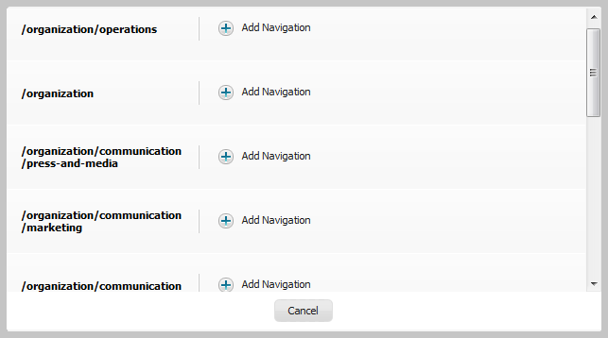
Step 2: Select the Group that you want to add Navigation and click on the button. The new group navigation will be added to the group navigation list.

After being added, the new group navigation is displayed in the group navigation list on the left and ready to be added nodes or pages.
Each group has only one navigation. If you add a new group navigation that exists, an alert
message will appear to show that you can not create that navigation.

Edit group's navigation properties
This function is used to change the priority of a navigation. Only users who have the right can take this action.
Step 1: Click Group on the administration toolbar and click the button of the navigation that you want to edit. The Page Navigation Form that allows you to change the priority of this navigation will appear:

Step 2: Change the priority of this navigation for the Priority field.
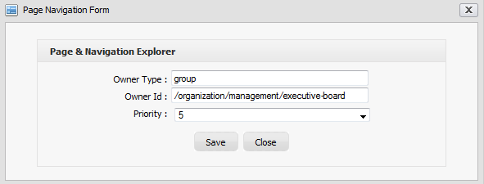Illustration 67: The Edit Navigation form
Step 3: Click Save to accept changes or Close to quit.

Delete a group's navigation
This function is used to delete an existing navigation. It is only supported for a group navigation. A user navigation or a portal navigation will be automatically deleted when the owner user or portal is deleted.
Follow these steps:
Step 1: Click Group on the administration toolbar and click on the button of the navigation that you want to delete
Step 2: Click OK to confirm deleting or Cancel to quit without deleting.
After the navigation deletion has been confirmed, the selected navigation is removed from the list and its nodes (hyperlinks to pages) are also deleted.

Manage Permissions
How to see a page in public
Seeing a page in public means that you can access that page without signing in. To make a page accessible to the public, you have to follow these instructions:
- The current portal in use must be public (everyone can access).
- The node containing the page that you want to see must belong to the public portal.
- The page which is selected by the node above must be in public (everyone can access).

Set an access permission on a portal
The menu path to set access permission for the portal:
- For new portals: click Site --> Create New Portal --> Permission Setting tab --> Access Permission Setting sub-tab.
- For existing portals: Go to the portal that you want to change the edit permission,go to Site Editor --> Edit layout:
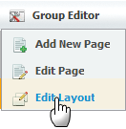
Then click button in the Edit Inline Composer, go to Permission Setting tab --> Access Permission Setting sub tab.
To assign an access permission to users in the public mode (without signing in), you have to set the access permission on a portal. To do that, in the Access Permission Setting sub-tab, check the Make it public option.
If you do not want everyone to access to the portal, do not check the Make it public check box and you have to select group by group. Follow these steps:
Step 1: Click Add Permission.
Step 2: Select the group that you want to add on the left and then select a membership type on the right. In the membership type list, the sign * means allowing any membership type.
Step 3: After you have selected a membership type, the selected permission is displayed in the access right list. Each time you only can select one group with one membership type. If you want to add more, click Add Permission and select again.
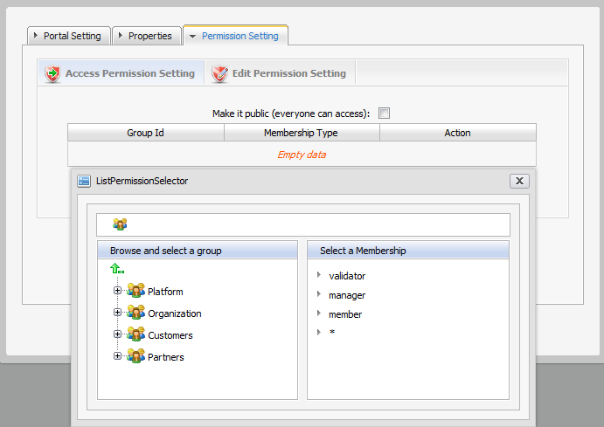

Set an edit permission on a portal
Only users who are in the portal editor group can edit that portal. Access permission can be set for several groups but the edit permission can only be set for a group with a membership type (or every membership type by selecting *). To assign an edit permission to a user, you must add him to the editor group of that portal.
Step 1: Use one of the below paths to assign permission on a portal:
- For new portals: click on Site --> Create New Portal --> Permission Setting tab --> Edit Permission Setting sub tab.
- For existing portals: Go to the portal that you want to change the edit permission, go to Site Editor --> Edit layout:
Then click button in the Edit Inline Composer, go to Permission Setting tab --> Edit Permission Setting sub-tab.
Step 2: Click Select Permission to choose a group.
Step 3: Select a group and a membership type (select * if you want to assign all membership types in the selected group). After a membership has been selected from the right, the selected information is displayed.
Step 4: Click Save to accept.
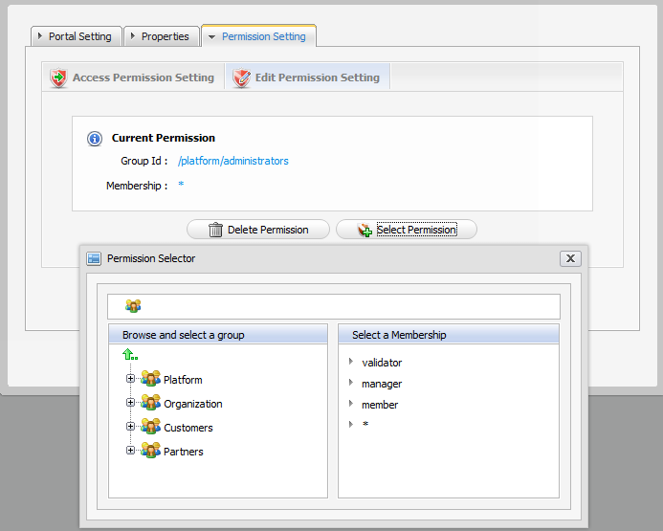

Set a permission on a page
In some cases, some rights on a page are initialized and users who have the edit permission can change the page.
- If the owner type of a page is “user”, you don't have to set permission, no one except the creator has the access and edit permission.
- If the owner type of a page is “group”, initial permissions on page are:
  - Access permission: everyone in that group.
  - Edit permission: the manager of that group.
- If the owner type of a page is portal, initial permissions are:
  - Access permission: users who can access that portal.
  - Edit permission: users who can edit that portal.

Set an access permission on a page
Paths to set the access permission for a page:
- Group--> Administration--> Page Management → Add New Page, select Owner type which is group or portal --> Permission Setting tab --> Access Permission Setting sub-tab.
- Group --> Administration --> Page Management --> Click the edit icon to edit a page you want --> click on View page properties of the Page Editor form--> Permission Setting tab --> Access Permission Setting sub-tab.
- Click Group on the administration toolbar--> Edit Navigation --> select a node which contains the page you want to edit --> right click on that node and select Edit Node's Page --> click on View page properties of the Page Editor form- --> Permission Setting tab --> Access Permission Setting sub tab.
To be able to access to a page (read the page content or perform an action on a page), users have to be in one of the groups that have access permission to that page. There may have several groups that have access permission to a page. If you wish anyone could access to the page, check “Make it public”, otherwise you have to select the groups one by one.
- Click Add Permission.
- Select the group that you want to add on the left and then select a membership type on the right. In the membership type list, * means allowing any membership type.
- After a membership type has been selected, the selected permission is displayed in the access right list. For each time, you can only select one group with one membership type. If you want to add more, click the Add Permission button and select again.

Set an edit permission on a page
Only users who are in the page's editor group can edit it. The access permission can be assigned to several groups but the edit permission only can be set for one single group. To assign edit permission on page to a user, you must add him to the editor group of that page.
Step 1: Use one of the paths below to set the edit permission on a page:
- Group --> Administration → Page Management → Add New Page, select Owner type which is group or portal --> Permission Setting tab --> Edit Permission Setting sub-tab.
- Group --> Administration --> Page Management --> Click the edit icon to edit a page you want --> click on View page properties of the Page Editor form--> Permission Setting tab -->Edit Permission Setting sub-tab.
- Click on Group--> Edit Navigation --> select a node which contains the page you want to edit --> right click on that node and select Edit Node's Page --> click on View page properties of the Page Editor form- --> Permission Setting tab --> Edit Permission Setting sub-tab.
Step 2: Click Select Permission button to set new or change another group.
Step 3: Select a group with a membership type (select * if you want all membership type in the selected group)
After selecting a specific membership from the right, the selected information is displayed.
Step 4: Click the Save button to accept.

Set an access permission on a portlet
Follow these steps:
Step 1: Go to Group --> Administration --> Application Registry on the administration toolbar.
Step 2: Select a category on the left pane that includes the portlet you want to set right. Then all portlets of the selected category are listed immediately and detailed information of each portlet is displayed on the right pane.
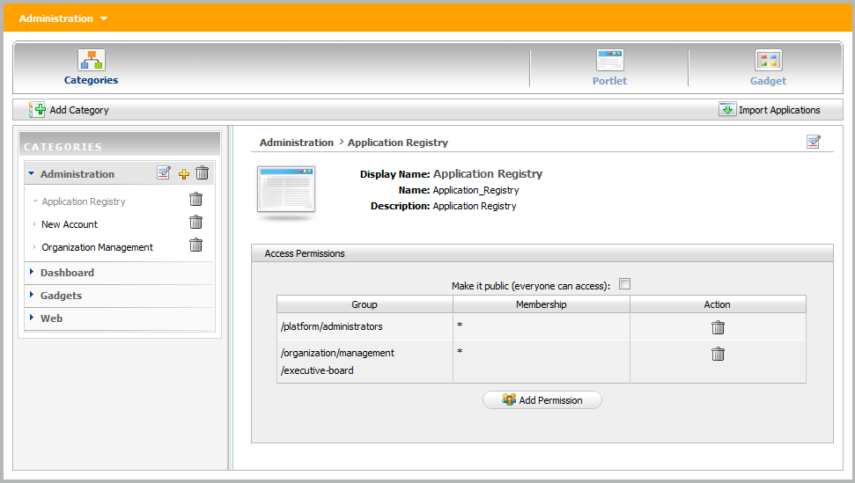
- To set a permission for a portlet:
- Click the Add Permission button to add access permissions to more groups; or check Make it public to allow everyone to access.

Language Administration

Change the display language
The priority order of displaying language is 1. User's language 2. Browser's language 3. Portal 's language. Thus to display your preferred language, you should pay attention to this order to change language type appropriately.

Change the displaying language permanently
Do as any of following ways:
The 1st way:
Step 1: Click Site on the administration toolbar and select the portal that you want to edit.
Step 2: Click the button which corresponds to the portal that you want to edit.
The portal will be displayed under the edit mode.
Step 3: Click the button to edit portal properties.
Step 4: In the Portal Setting tab: You can change display language of a Portal by selecting another language in the Locale field.
Step 5: Click Save and Finish icon to take affect.
The 2nd way:
Step 1: Click Site on the administration toolbar to open the portal list
Step 2: Click Site Editor and select Edit Layout in the menu:
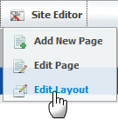
The portal will be displayed under the edit mode.
Step 3: Click the button to edit portal properties.
Step 4: In the Portal Setting tab: You can change display language of a Portal by selecting another language in the Locale field.
Step 5: Click Save and Finish icon to take affect.
The 3rdway: This way is used to set the displaying language for yourself, not for displaying the language of Portal.
Only users having administration role can do this:
Step 1: Go to Star--> Change Language
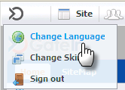
The Interface Language Setting form is displayed with a list of all supported languages. The current using language is marked by the icon.
Step 2: Select another one by clicking on the name of that language.
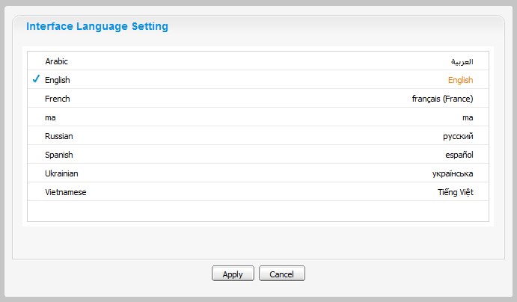Illustration 68: The Interface Language Setting form
Step 3: Click Apply and wait for few seconds to take affect.

Note:
- This displaying language will be kept permanently till you change your displaying language by another one.
- When you change from other language to Arabic or set the displaying language is Arabic. The displaying on Portal will be changed to Right to Left (RTL) direction because when Arabists read, they usually read from Right to left.

Changing the display language for another user
By this way, you can change not only your displaying language but also the displaying language of another users if you have the access right in the Organization portlet.
Do as follows:
Step 1: Go to Group --> Organization --> Users and groups management
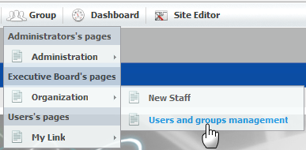
Step 2: Show the form to edit a user in list by clicking the edit icon which corresponds to the user that you want to change the displaying language.
Step 3: Select the User Profile tab:
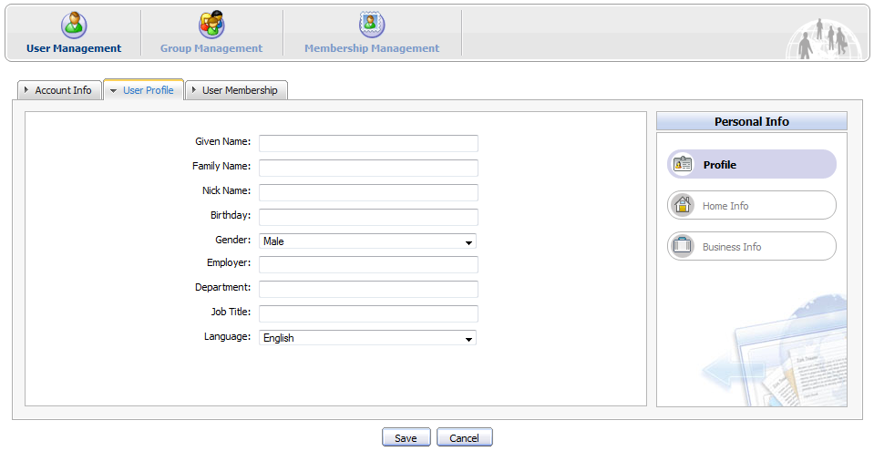
Step 4: Change the displaying language of this user by changing the value of the Language field.
Step 5: Click the Save button to accept and save changes or click the Cancel button to quit.
Thus the next time when the selected user signs in, the displaying language will be the language changed by the administrator.

Portlets/Gadgets/categories/sitemap management

Add a portlet/gadget to a specific category
This function helps you add portlets to a specific category. Follow these steps:
Step 1: Click the Add icon on the title bar of a category to which you want to add portlets. The form to add a portlet into a category will appear on the right pane:
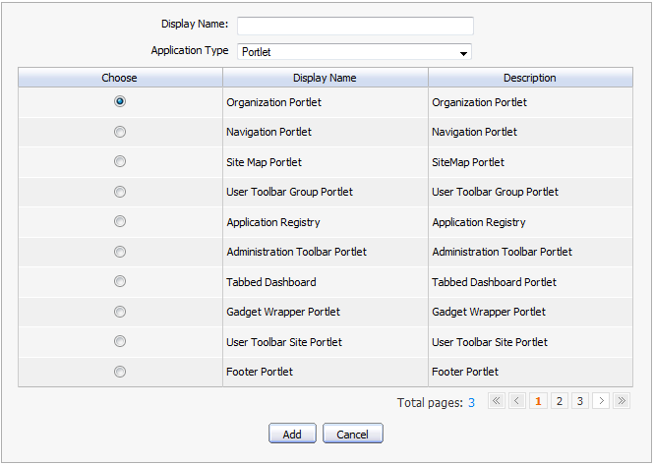
Details:
Display name: The display name of a portlet/gadget that you want to add to a category.
Application Type: The type of the selected object.
Step 2: Select a portlet/gadget by checking the radio button.
Step 3: Enter the display name and select a type for the selected portlet/gadget.
Click on Save to accept adding a portlet/gadget to a category.

Auto-import default portlets/gadgets
This function supports users auto import default portlets/gadgets into different categories and these portlets/gadgets will be listed in left pane. Follow these steps:
Step 1: Click at the right corner on action bar. A dialog will show up:
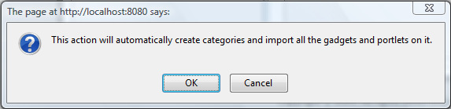
Step 2: Click OK on this message to accept importing portlets and gadgets automatically.
All portlets/gadgets of all categories will be imported and listed on the left pane.

View detailed information of a specific portlet
Follow these steps:
Step 1: Go to the Group --> Administration--> Application Registry page in the Administration toolbar. The form for viewing all portlets will appear, details:
- Left pane: lists all portlets in two parts: Local and Remote
- Right pane: shows detailed information about a portlet: Name, Display name, Description and Access permission.
Step 2: Select one portlet in the list on the left pane. The detailed information of that portlet will be shown on the right pane.

Manage gadgets

Where you can use a gadget
A gadget is a mini web application running on a platform and you can put it in a web page. Only users who are member can use these applications for their individual needs.
You can use gadgets in two places:
- Add gadgets to Dashboard.
- Add gadgets to Desktop page (for WebOS).

Add a gadget
This function helps you add a gadget into the gadget list.
Follow these steps:
Go to the Group --> Administration-->Application Registry page on the Administration toolbar --> Gadget item:
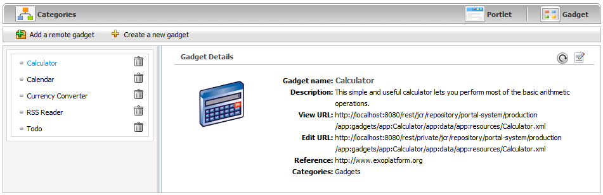
You can add a remote gadget or create a new gadget into the list.

Add a remote gadget
Step 1: Show the form to add a remote gadget by clicking Add a remote gadget:
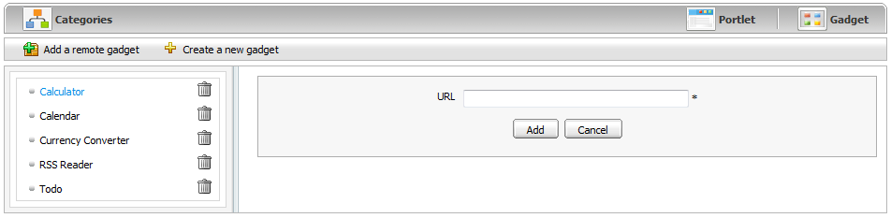
Step 2: Enter a link to a .xml file in the URL field.
Step 3: Click the Add button to accept the inputted url or the Cancel button to quit. The added gadget will be added into gadget list on left pane of the Dashboard portlet
Note:
    - To refresh the remote gadget: Click the Refresh information icon on the upper-right corner of the Gadget Details form to renew and update any changes from the remote gadget.
    - To edit the remote gadget: Click the edit iconto edit the source code of this gadget .

Add a gadget to the Dashboard
This function allows adding gadgets to a specific dashboard by dragging and dropping actions.
When clicking the Dashboard of the main administration tool bar, the Dashboard will appear with the current gadgets in the default tab.
You can use ready-to-use gadgets in your Dashboard. The gadgets of your Dashboard are organized in the dashboard tab. A dashboard task can contain one or more gadgets. You can create new a tab and add new gadgets to an existing tab.
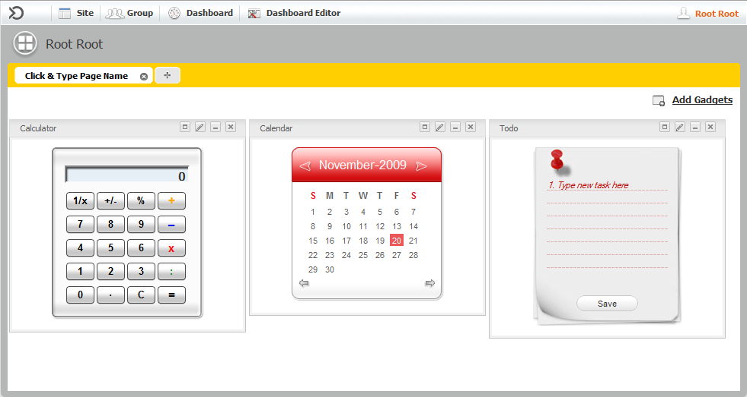Illustration 69: The Dashboard main screen
To add new a dashboard tab, follow these steps:
Step 1: Click the Dashboard --> Click & Type Page Name tab:
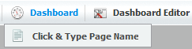
or click the plus icon: 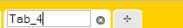
Step 2: Enter a tab name and enter to accept add a new dashboard tab.
To add a new gadget, do as follows:
Step 1: Go to a dashboard tab and click on the button.

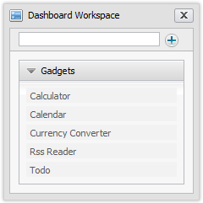
Step 2: Enter the HTML link of the gadget that you want to add to your home page.
Step 3: Click the button to add.
For example:
Add the link below in to the text box : http://www.google.com/ig/modules/colorjunction.xml
Click the button to add. The gadget will be added below:
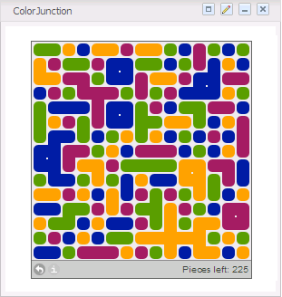
To drag and drop to add gadgets into a dashboard tab, follow these steps:
Step 1: Go to the tab that you want to add gadgets
Step 2: Click the button .
The gadget list will be displayed:
Step 3: Drag and drop the gadget that you want to add into the tab.
Similarly, at the Dashboard Editor, you can Add New Page, Edit Page and Edit Layout of the current dashboard that is being viewed.

Create a new gadget
Step 1: Show the form to add a new gadget by clicking Create a new gadget::
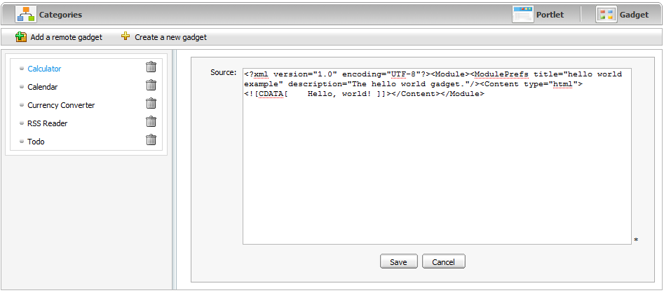
Details:
Source: The source code to create a new gadget. This source will be a .xml file.
Step 2: Enter a value for the Source field in this form.
Step 3: Click Save to create a new gadget.
The created gadget will be added to the gadget list on left pane of the Dashboard portlet.
Furthermore , you also can add a new gadget to the gadget list of the Dashboard portlet by clicking on the Add Gadgets link:
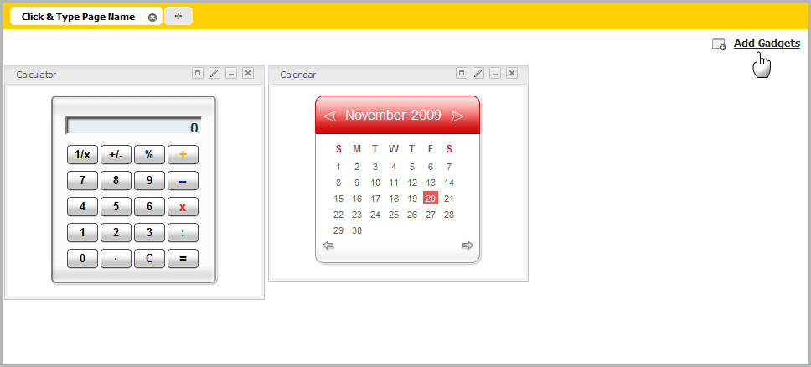
The form to add a new gadget will be shown:
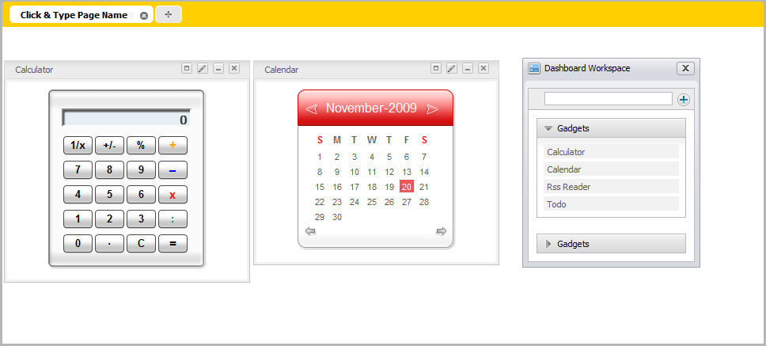
Step 4: Enter a link (remote or local) to a .xml file in text box at the left pane.
Step 5: Click the Add gadget icon to add a new gadget to the gadget list underneath.

Category Management

Add a new category
At first, you have to go to Administration-->Application Registry page.
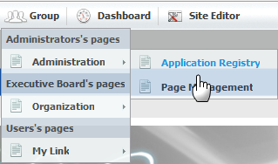
The form to organize portlets/gadgets into different categories will be displayed:
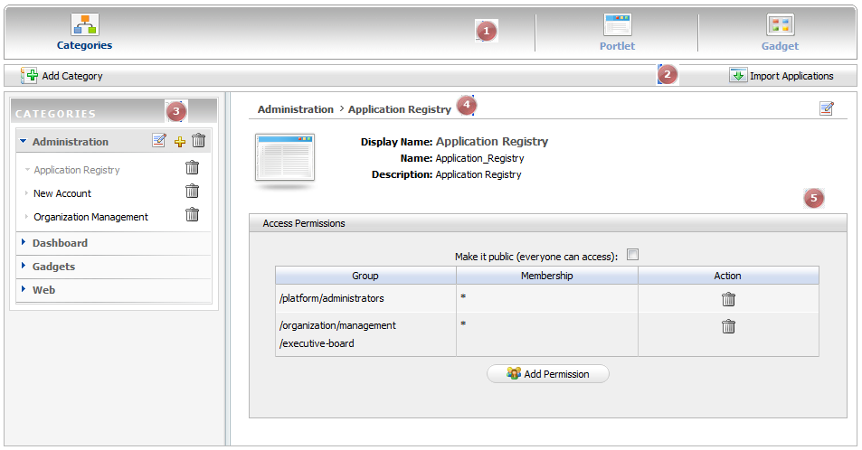
The form includes the following parts:

Indicator | Meaning
 | Tab bar: includes three main items.
 | Action bar: includes some actions related to a category.
 | Left pane: lists all categories and portlets in each category.
 | Breadcrumb bar: the path from a specific category to a specific portlet in that category.
 | Right pane: detail information of a specific portlet.

Step 1: Open a form to add a new category in the right pane by clicking Add Category on the action bar:
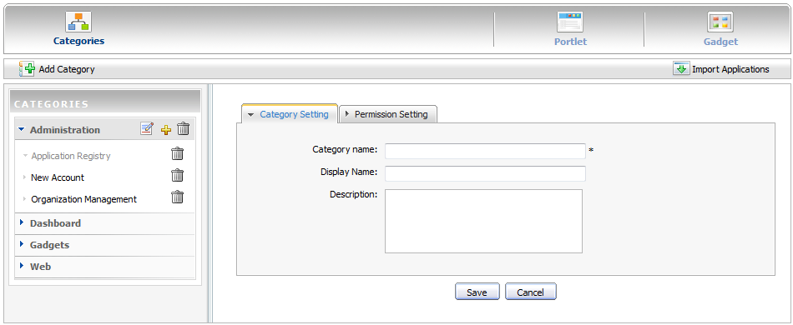
The Category Setting tab: includes common information about a category.
Category name: The name of the category which you want to add. This field is required and its length must be between 3 and 30 characters.
Display name: The display name of the category in list and its length must be between 3 and 30 characters
Description: The brief description of the category. Any length from 0 to 255 characters is allowed.
The Permission Setting tab: is used to set the access permission for a category.
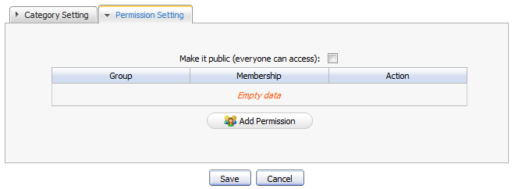
Step 2: Enter values for the required fields in this form.
Step 3: Click the Save button to accept adding a new category to the category list. The new category will be added to the list in the left pane.

Set permissions for a new category
To set a permission for a new category, follow these steps:
Step 1: Do step 1 of adding a new category.
Step 2: Select the Permission Setting tab.
Step 3: Check the Make it public check box to allow all users to access to the category. For more finer permission assignments, go to step 4.
Step 4: Click the button to show the Group and Membership Selector form.

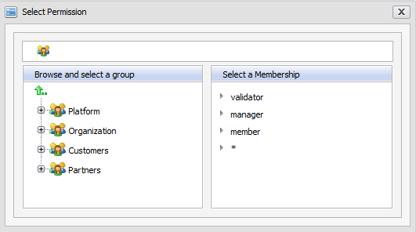
Step 5: Select a specific group on the left pane and then select a membership on the right pane (select * to select all membership types of that group).
The selected group and membership will be shown in a table. It means all users with that membership of the selected group can access this category.

Edit a category
To edit a category in list, follow these steps:
Step 1: Click the edit icon on the title bar of the category that you want to edit.
Step 2: Change the information of the selected category.
Step 3: Click Save to accept changes.

Delete a category
To remove a category from the list, follow these steps:
Step 1: Click the trash can icon on the title bar of a category that you want to delete.
A confirmation message box is displayed.
Step 2: Click OK to delete or click Cancel to quit.

Manage Sitemap
GateIn Site Map provides users with overall view of GateIn, users can go directly pages through the SiteMap without going through the Administration tool bar.
Step 1: Go directly the GateIn SiteMap on the navigation bar or go to Site → classic → SiteMap. The SiteMap page will appear:
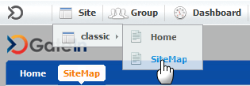
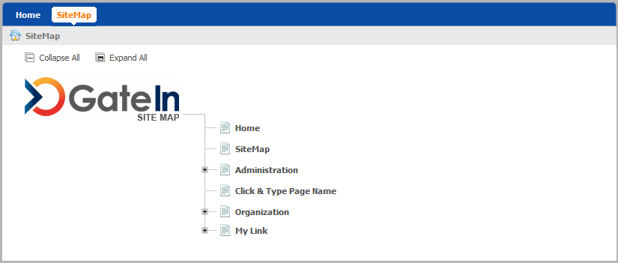

Step 2: Click the Expand All to see all pages inside ( the Collapse All button allows backing to the initial).
Step 3: Click directly on the title of a page that users want to manipulate.

