

eXo Address book User Guide
Version 1.3

eXo Collaboration Suite provides a rich, Web 2.0 browser-based interface with comprehensive messaging and indexing; archival and search capabilities; shared calendars, address books, and much more features soon.
eXo Address Book manages your private and public contacts in your organization. A contact lets you keep important information such as personal or professional address and other contact information such as telephone, fax, email or IM. We support VCard format import/export so that you can consolidate your existing contacts in a single place. Additionally, you can refer your contacts from other applications such as eXo Calendar, eXo Web Mail....
eXo Address Book is an open-source contact management application that is built on foundation of eXo WebOS with several new features designed to make your online contact experience more productive and convenient. All actions are easily reached by contextual menus and intuitive drag and drop. Searching for contacts is very convenient with full text search and criteria based search on contact's properties.

Enjoy eXo Collaboration Suite
eXoTeam
REVISION HISTORY
Version | Date | Writer | Reviewer | Change Record
1.0 | Jun 24, 2008 | Nguyen Thi Thanh Hoa | Hoang Anh Quynh Nga
1.1 | Dec 01, 2008 | Nguyen Thanh Cong | Hoang Anh Quynh Nga | - Check for error typo, English grammar and clarified description  - Update: edit some basic definition, make them more clear.  - Update: Remove Address book in case do not have edit permission  - Update: Share address book/contacts, join 'share to user' and 'share to group' in 1 part to avoid redundant, give more detail about permission and how to edit/delete shared user/group  - Update: add more emails to a contact  - Update: Changes of export contact  - Update new UI  - Make consistency in the way to express.  - Update: View permission and Edit permission on shared contact, make them more clear and exact.  - Update: new illustration, some actions can be done from Mail porlet, give some explanation for clarity, tag list when view contact in Vcard.
1.3 | Jun 29, 2009  May 13, 2010 | Nguyen Thanh Cong | Nguyen Huu Tuan Anh | - Update new screenshots  - Fix typo errors

Contents
1. Preface 9
1.1 About this guide 9
1.2 Who should read this guide? 9
1.3 Objective of this guide 9
1.4 Related documents 9
2. Getting Started 10
2.1 What is eXo Address Book? 10
2.2 Address Book Application interface 10
2.3 eXo Address Book configuration 11
3. How to use eXo Address Book? 12
3.1 Registering a new account 12
3.2 Signing in 15
3.3 Signing out 16
3.4 Address Book 17
3.2.1 Manage address books 17
3.2.2.1 Create an address book 17
3.2.2.2 Editing an address Book 18
3.2.2.3 Remove an address book 20
3.2.2.4 Exporting an address book 20
3.2.2.5 Sharing an address book 22
3.2.2.6 Printing an address book 27
3.5 Contact 28
3.5.1 What is a contact? 28
3.5.2 Contact management 28
Adding a new contact 28
Editing a contact 34
Deleting a contact 35
Coping/pasting a contact 36
Moving a contact 37
Importing contacts 40
Printing contacts 42
Sending mail to a contact 49
3.5.3 Searching contacts 52
Quick search 52
Advanced search 52
3.6 Tagging 53
3.6.1 Tagging a contact 54
3.6.2 Editing a tag 56
3.6.3 Deleting a tag 57
3.6.4 Export contacts in a tag 57
3.6.5 Print contacts in a tag 58
3.7 Contact View Configuration 58
3.7.1 List View 58
3.7.2VCards View 59
3.8 Layout Configuration 60

Illustration Index
Illustration 1: The main screen of the Address Book application 10
Illustration 2: The anonymous home page of the classic portal 13
Illustration 3: The Account Setting tab of the Register form 13
Illustration 4: The User profile tab of the Resgister form 14
Illustration 5: The Sign in form 15
Illustration 6: The classic portal page after signing in successfully 16
Illustration 7: The Add/Edit Address Book form 18
Illustration 8: The Export Address Books form 21
Illustration 9: The File download pop up on Internet Explorer 22
Illustration 10: The File download pop up on Fire fox 22
Illustration 11: The shared address books 23
Illustration 12: The Share Address Book to other users form 24
Illustration 13: The User Selector form 24
Illustration 14: The Group Selector form 25
Illustration 15: The Share table in the Share Address Book to other users form 26
Illustration 16: The Print Preview page 28
Illustration 17: The Add/Edit Contact form 29
Illustration 18: The Profile tab of the Add/Edit Contact form 30
Illustration 19: The Upload Image form 31
Illustration 20: The Work tab of the Add/Edit Contact form 32
Illustration 21: The IM Contact tab of the Add/Edit Contact form 32
Illustration 22: The Home tab of the Add/Edit Contact form 33
Illustration 23: The Note tab of the Add/Edit Contact form 34
Illustration 24: The Add/Edit Contact form with full filled information, available for editing 35
Illustration 25: The Move Contact form 38
Illustration 26: The Export Contacts form 40
Illustration 27: The Import Address Books form 41
Illustration 28: The Single contact print preview form 43
Illustration 29: The Multiple contacts print preview form 44
Illustration 30: The Share contact to other users form 46
Illustration 31: The Send mail form 51
Illustration 32: The search result form 52
Illustration 33: The Advance Search form 53
Illustration 34: Tag list 54
Illustration 35: The Add/Remove tag form 55
Illustration 36: The Export Contacts form 57
Illustration 37: The List View form 59
Illustration 38: The VCards View form 60
Illustration 39: The main screen after hiding the navigation 61

Preface

About this guide
eXo platform™ software is a powerful Open Source corporate portal and content management system. Users of the platform have a customized single point of access to the company's information system and resources. The purpose of this user guide is to provide step by step instructions of how to use Address Book application(the other name is Contacts application) which is part of Collaboration Suite – an extension of eXo portal.
This documentation is a useful guide for you to learn about eXo CS technology in detail. It gives an in depth example and easy explanation of eXo platform technology that not only allows technical but also non-technical people to be more efficient in their daily collaboration.

Who should read this guide?
Welcome to eXo Collaboration Suite material. This document aims at guiding various users of eXo Platform. This material is for anyone interested in learning and using Address Book application. It is also useful for the following groups:
- Users who use eXo Collaboration Suite with Address Book application in their work and business.
- Integrators who want to know more about the rich collaboration features they can advise to their customers on their eXo projects.

Objective of this guide
This user guide will:
- Define some basic concepts used in Address Book application.
- Show the main instructions of Address Book application.
- Guide step by step to do basic actions.

Related documents
- eXo Calendar User Guide v1.3
- eXo Mail User Guide v1.3
- eXo Chat User Guide v1.3

Getting Started

What is eXo Address Book?
eXo Address Book is a web based on contact management application. Using eXo Address Book to store and maintain contact information about friends, family and your professional network... in a single place. You can access it with a simple browser connected to your enterprise network.

Address Book Application interface
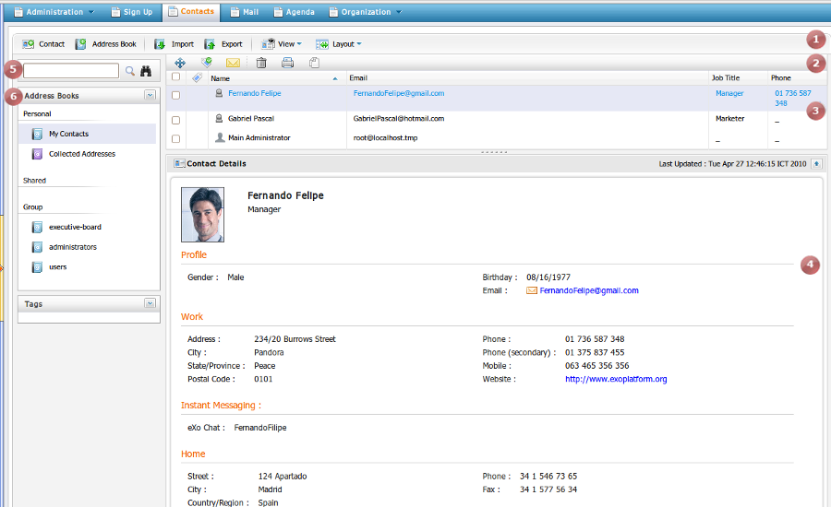Illustration 1: The main screen of the Address Book application
Indicator | Meaning
 | This is the Tool bar which allows adding new contact/address book, importing/ exporting address book
 | This is the Action bar which allows doing many actions such as move, delete, copy, print, add tag selected contacts
 | This is the Contact list which shows all contacts of a specific address book
 | This is the Contact view panel which displays detail informations of selected contact
 | This is the Search panel which allows doing simple and advanced search to find expected contacts.
 | This is the Navigation panel which contains search panel, address books list and tags list

eXo Address Book configuration
By default, there are 3 categories of address books in eXo Address Book application:
Personal address book: The address book which may only be viewed by yourself. It is stored in the Personal list. In eXo Address Book application, the My contacts is the default personal address book which contains your default contact matching with your registration information. In addition, the Collected Address book contains all email contacts that are added automatically during using eXo Mail application. For example, when you receiving an email that is sent from a new sender address. The new sender address will be added into the Collected Address book of the eXo Address Book application automatically.
Shared address book: The address book which are shared with the other users. It is stored on the Shared list. In eXo Address Book application, the shared address book can be viewed and updated by shared users if they are granted edit permission .
Public address book: The address book which are shared by group and can be viewed by everyone. In eXo Address Book application, the public address book contains default contacts of the other users in different groups which can be only viewed and impossible to edit or delete.

How to use eXo Address Book?
Firstly, you need a portal account to use eXo Address Book. You can register a new one or use your existing account. On standard CS portal, we have configured some accounts with specific roles like below:
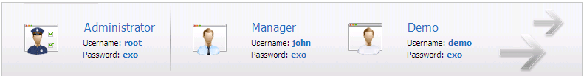

Registering a new account
- To register a new account on the portal, do as follows:
Step 1: Go to the portal by typing URL in address bar (e.g: http://localhost:8080/portal). The anonymous home page will be displayed below:
Step 2: Select the Register on the navigation bar. The Register page will appear:
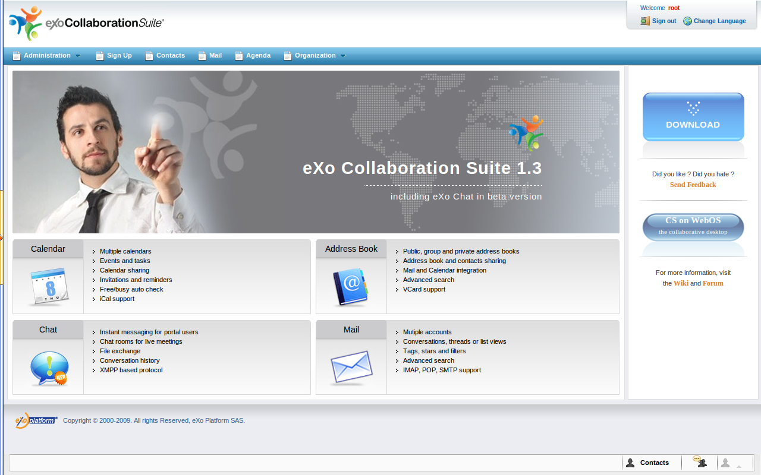Illustration 2: The anonymous home page of the classic portal
The Account Setting tab includes:
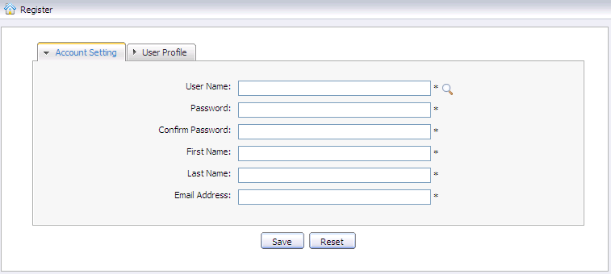Illustration 3: The Account Setting tab of the Register form

User Name: The name of user that will be used to sign in. It must be unique.
Password: The secret string used to login. It must have at least 6 characters.
Confirm Password: The re-typed password. Password and Confirm Password must be the same
First Name: Your first name
Last Name: Your last name
Email Address: Your contact email address. It must be in the right format. For example: flower@gmail.com
Save button: To accept saving new account.
Reset button: To set blank entry for all inputted fields.
Step 3: Click the icon to search and check whether inputted User name is available or not.
Step 4: Input values in all required fields in the Account Setting tab
Step 5: Open the User Profile tab, the fields in this tab are not mandatory. You can input or leave them blank.
Step 6: Complete registering the new account by clicking the Save button.
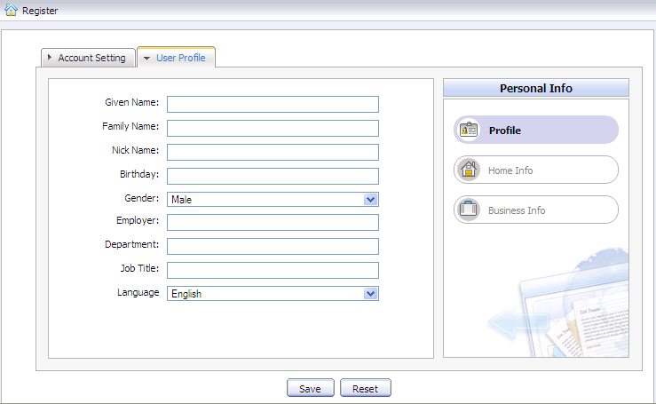Illustration 4: The User profile tab of the Resgister form
There will be an alert messages and you can not add new account successfully if at least one of these cases occurs:
- User name is existing or User Name is invalid
- Password has less than 6 characters.
- Password and Confirm Password are not the same
- Email Address is invalid format
- Required fields are blank (empty)
After registering a new account successfully, you can login and access eXo Mail application.

Signing in
This function is used to allow user to go into portal in private mode.
- To sign in, do as follows:
Step 1: Go to portal in public mode by typing the portal URL in your address bar (e.g: http://localhost:8080/portal)
Step 2: Click the Sign in link at the top right of page. The Sign in form will be displayed.
Step 3: Input your registered User name and Password.
Details:
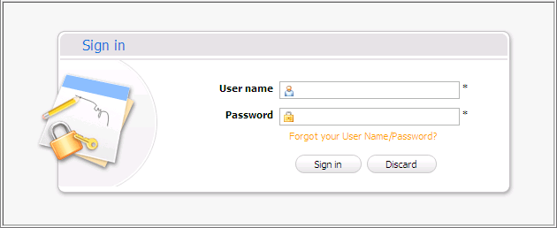Illustration 5: The Sign in form
User name: The registered user name
Password: The registered password
Forgot your User Name/Password To show the guide line that must be followed to get the forgotten User Name/Password
Sign in button To accept signing in
Discard button To exit Sign in form
Step 4: Complete signing in by clicking the Sign in button.
After signing in successfully, you will be redirected to the authenticated home page below:
Illustration 6: The classic portal page after signing in successfully

Signing out
This function allows you to get back to the anonymous portal. It ends your current portal session. To sign out, click the Sign out at the top right corner of the screen.
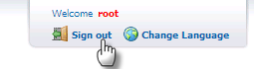

Address Book
What is an address book?
Address book is a book or a database used for storing entries called contacts. Each contact entry usually consists of a few standard fields (for example: first name, last name, company name, address, email, phone number...). An address book makes it easy and efficient to organize and manage contacts . As mention above, eXo Address Book application has three types of address book: Private , Shared and Public.

Manage address books

Create an address book
This function allows adding new an address book. To create an address book, do as follow:
Step 1: Open Add Address book form. There are two ways to do:
The 1st way: Click the button on the main tool bar.
The 2nd way: Click the icon in Address Book bar and select Add in the drop down menu:
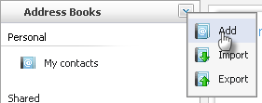
The 3rd way: You can also create address book from Mail portlet ( See eXo Mail User Guide v1.3 for detail)
The Add Address book form will appear below :
Details:
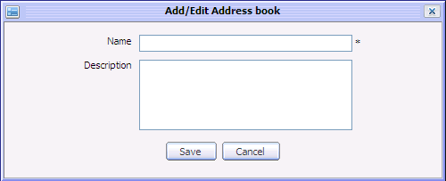Illustration 7: The Add/Edit Address Book form

Name: The display name of the address book. It is mandatory field.
Description: The description of the address book. It is not mandatory field. It can be input or leave blank.
Save button: To accept saving new address book
Cancel button: To exit/close Add/Edit Address book form
Enter values for the Name and Description fields
Complete adding the new address book by clicking the Save button.

Editing an address Book
This function allows making changes(name or description) to your selected address book.
- To edit an address book, do as follows:
Step 1: Right click on an existing address book (e.g eXo Contact address book) then select Edit in drop down menu like below:
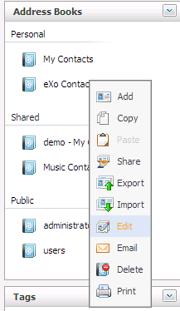
The Add/Edit Address book form will appear with full filled information, available for editing below:
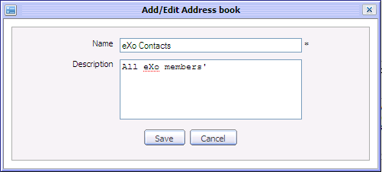
Step 2: Change some values in the form.
Step 3: Click the Save button to accept changes or click the Cancel button to exit the form without changes
Note:
You can only edit a personal address book or a shared address book if you have edit permission on it. You can not edit a public address book.

Remove an address book
This function allows removing an address book from the address book list.
- To remove an address book, do as follows:
Step 1: Right click on an existing address book and then select Delete in the menu:
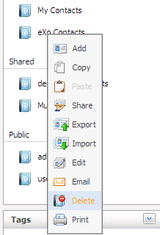
Step 2: Click the OK button in the confirmation message to accept deleting the address book or click the Cancel button to abort.
Note:
- You can not delete your default and public address book.
- You can delete your personal address book which is added by yourself flexibly.

Exporting an address book
This function allows exporting one or more address books into a separate file in your computer that makes it easy for you to backup your address book or import it into another address book application.
- To export an address book, do as follows:
Step 1: Open the Export Address Books form, there are two ways to do this step:
    - The 1st way: Click the Export button in main tool bar
    - The 2nd way: Click the icon in the Address Books bar and select Export in the menu:
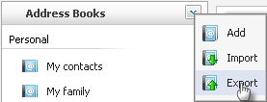
The Export Address Books form will appear with a list of all existing address books like the illustration below:
Step 2: Select the address book(s) which you want to export by ticking on its check box(s) (or tick on the top check box to select all)
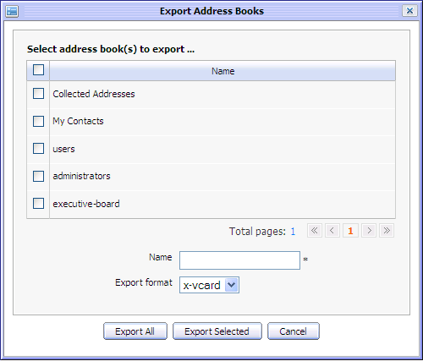Illustration 8: The Export Address Books form
Step 3: Enter a file name for the Name field
Step 4: Select a type of export format in the list box (e.g x-vcard)
Step 5: Click the Export All button to start exporting all the address books or click the Export Selected to export the selected one only.
The browser will show a pop up with 3 choices:
- Open File: To directly open the exported file
- Save File: To save the exported to your local disk
- Cancel File: To cancel exporting file
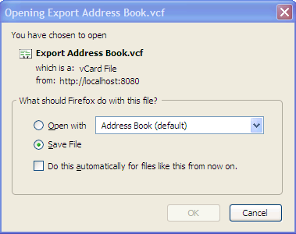Illustration 10: The File download pop up on Fire fox
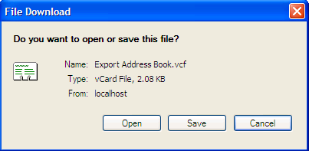Illustration 9: The File download pop up on Internet Explorer

Sharing an address book
This function allows sharing your personal address book with specific groups or individual users. The shared address book will appear in the other user's shared address book list and can be viewed, exported and also added, edited or deleted (if the shared user has edit permission on it).The shared address book is differed with the normal one by shared icon:
- To share a personal address book, do as follows:
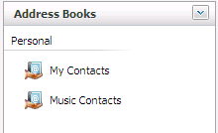Illustration 11: The shared address books
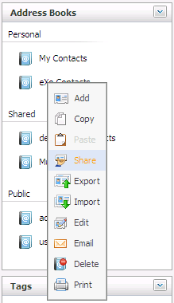
Step 1: Right click on the address book you want to share and select Share in the drop list menu.
Share address book form will appear like below:
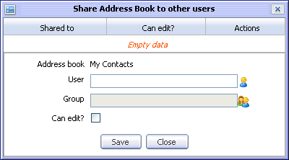Illustration 12: The Share Address Book to other users form
Step 2: Select User/Group to share.
To select User, do as follows:
Click the icon, the User selector form appears:
- User names are available and can be selected by ticking on its check box(s).
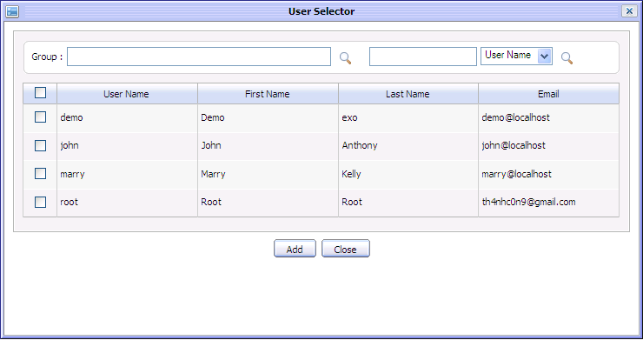Illustration 13: The User Selector form
- To search desired users, enter Group or User Name keyword and click the search icon
- Click the Add button to add selected users to the User field or click the Close button to close this form.
To select Group, do as follows:
Click the icon, the Group selector form appears below:
Browse groups in the left pane to view sub-groups in the right pane then select a sub-group. The selected group is displayed in Group text box.
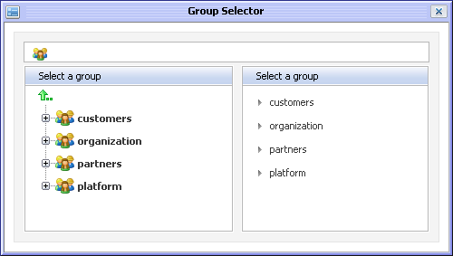Illustration 14: The Group Selector form
Tick on “Can edit?” check box if you want to grant edit permission on this address book to the selected user/group. User/Group(s) having edit permission can view export, import, add, edit and delete the shared address book while User/Group does not have edit permission can view and export only
Step 3: Click the Save button to accept sharing with the selected user/group or click the Close button to quit sharing form.
After sharing successfully, the shared users/groups will be updated into the Share table in the Share Address book to other users form with detail information (User name of shared user or Group name of shared group, can edit or not) below:

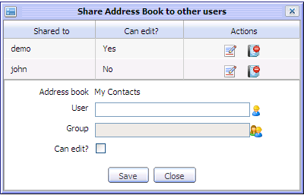
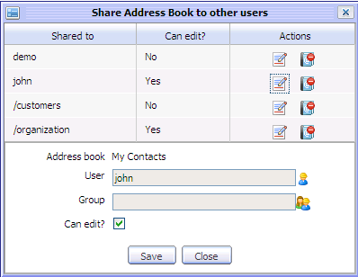
In Actions column, the edit icon is used to change 'Can edit' right of specific user/group. If you want to change 'Can edit' right of specific user/group, click on edit icon corresponding with it. User/group information will be displayed at the text box below, available for changing by ticking or untick 'Can edit?' check box. For example, edit 'john', 'john' information will be loaded and his 'Can edit' right can be reset below:
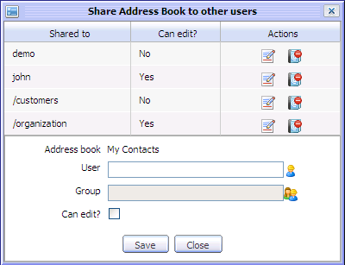Illustration 15: The Share table in the Share Address Book to other users form
In addition, the delete icon is used to remove specific user/group from the Share table. If you want to delete specific user/group, click on the delete icon corresponding to it and select the OK button in the confirmation message below:
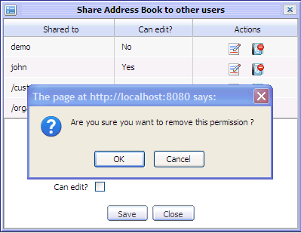
After removing, the deleted user or users in the deleted group can not view the shared address book any more.

Printing an address book
This function allows printing summary information of contacts in form of visit cards. You can print all contacts of an address book at a time.
- To print address book, do as follows:
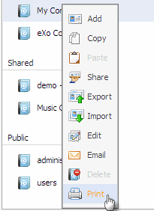
Step 1: Right click on an existing address book which you want to print and select Print item in the drop list menu:

Print preview page appears below:
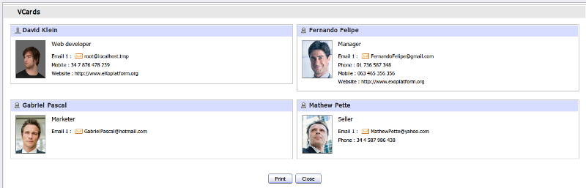Illustration 16: The Print Preview page

Step 2: Click the Print button to start printing or the Close button to exit preview print form.

Contact

What is a contact?
A contact is a person or an organization you’ve added to your contact list. By adding a person as a contact, you can easily check out the person's or the organization's profile (name, address, email and phone number...)

Contact management

Adding a new contact
This function allows adding new contacts to personal address books and shared address books (if you have edit permission).
There are 3 ways to create a contact:
Step 1: Show the Add Contact form. There are two ways to do this step:
The 1st way: Click the icon on the main tool bar .
The 2nd way: Right click on an address book (for example My Contacts), and select Add item in the menu.
The 3rd way: You can also create new contact from Mail portlet ( See eXo Mail User Guide v1.3 for detail)
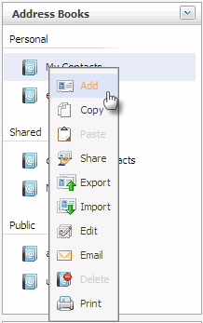
Add/Edit Contact form will appear below:
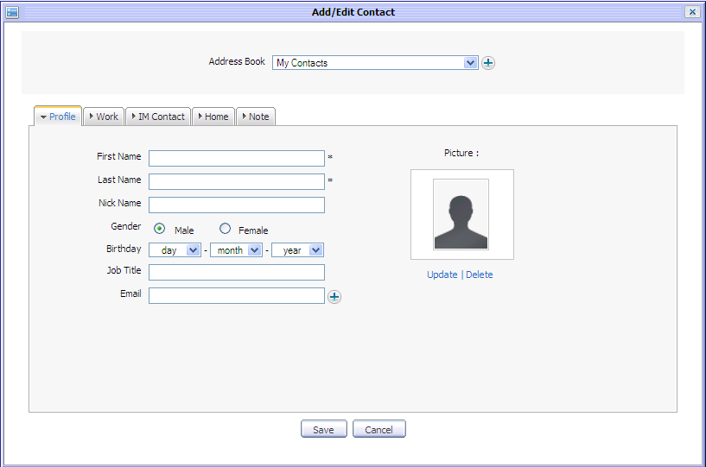Illustration 17: The Add/Edit Contact form
The Add/Edit Contact form consists of the Address Book Selector and the Contact Detail pane
Address Book Selector
The Address Book Selector allows you to select one from the existing list or quickly create a new address book without going out.
To create a new address book, click the icon to open Add/Edit Address Book form and add new like when creating an address book in 3.2.2.1
Contact Detail Pane
It includes 5 tab: Profile, Work, IM Contact, Home and Note.
- The Profile tab contains main information of the contact :
In which, the First Name and the Last Name are mandatory fields. If your want to change picture (avatar) for the contact, click the Update link to upload photo from your computer. The form to upload a photo looks like blow:
Illustration 18: The Profile tab of the Add/Edit Contact form
Details:
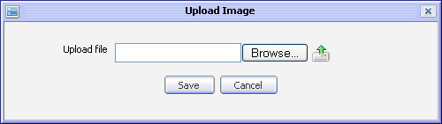Illustration 19: The Upload Image form
Browse button: To select file from your local disk
icon: To upload your selected file
Save button: To accept saving uploaded file
Cancel button: To exit Upload Image form
After uploading successfully selected file, click the Save button to update your new avatar.
If you want to remove your uploaded photo, you can click the Delete link below your picture.
The icon at the Email field allows you to adding more email addresses for the contact. When it is clicked, more Email address fields will appear below:
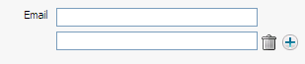
More email addresses can be input in the Email fields or deleted by clicking the icon.
- The Work tab contains work information of the contact:
- The IM Contact tab contains information about chat nick. (IM stands for instant message)
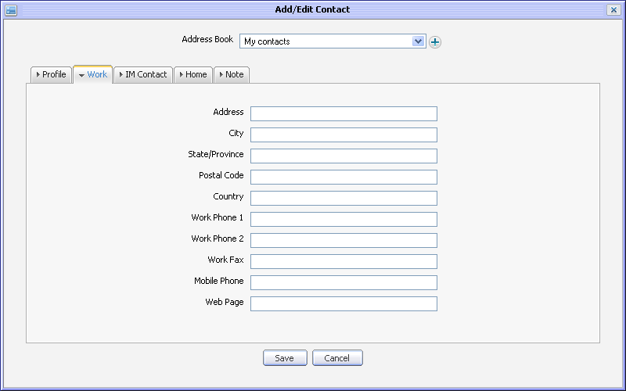Illustration 20: The Work tab of the Add/Edit Contact form
The default one is eXo Chat. You can click the icon to add more.
- The Home tab contains home information of the contact:
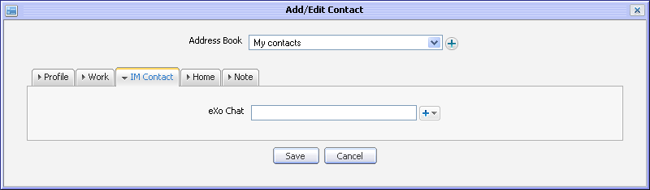Illustration 21: The IM Contact tab of the Add/Edit Contact form
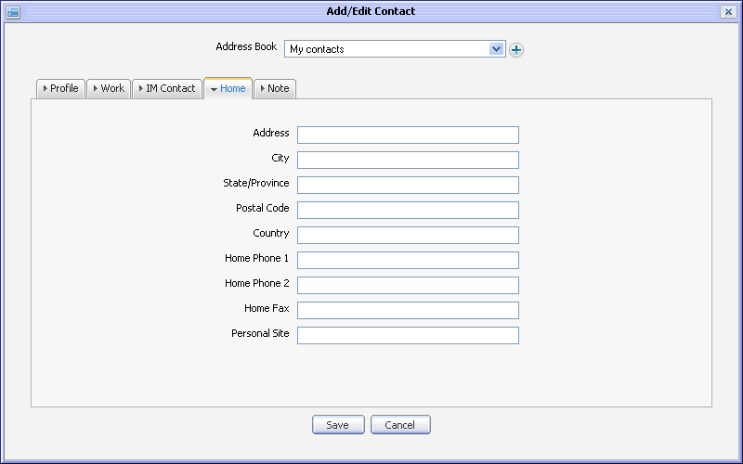Illustration 22: The Home tab of the Add/Edit Contact form
- The Note tab contains note information of the contact:
- Input information into the Add/Edit Contact form
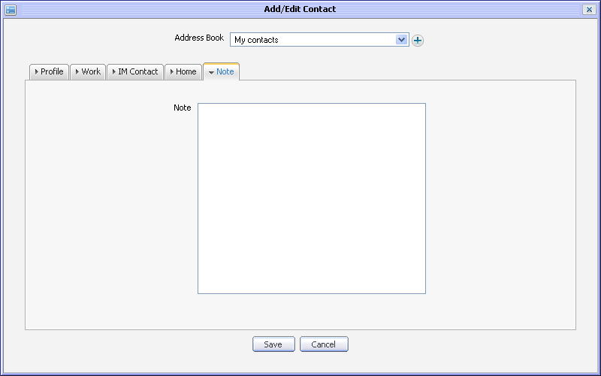Illustration 23: The Note tab of the Add/Edit Contact form
- Click the Save button to accept adding new contact or the Cancel button to exit form without adding.

Editing a contact
This function allows making changes to selected contacts. You can only edit a contact of the personal or shared address books ( if you have edit permission).
Do as follows:
Step 1: Right click on an available contact in list then select Edit in the drop list menu.
The Edit Contact form will appear with full fill information, available for editing:
Step 2: Change the information of the current contact. You can change all information, picture of your expected contact its Address book.
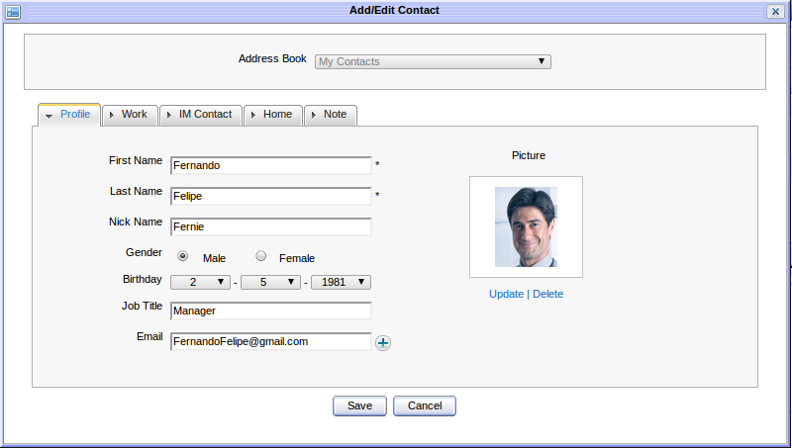Illustration 24: The Add/Edit Contact form with full filled information, available for editing
Step 3: Click the Save button to accept changes or click the Cancel button to cancel this action.
Note:
You can also edit an address book from Mail portlet ( See eXo Mail User Guide v1.3 for detail)

Deleting a contact
This function allows deleting existing contacts. You can only delete a contact of personal or shared address books (if you have edit permission)
There are two ways to delete a contact:
The 1st way:
Step 1: Right click on a contact of address book which is opening and then select Delete in the menu.
Step 2: Click the Delete button on the confirmation message form to delete the selected contact or click the Cancel to quit.
The 2nd way:
Step 1: Tick check box(s) in the first column to select one or more contacts and click the Delete icon on the action bar.
Step 2: Click the Delete button on the confirmation message form to delete the selected contact(s) or click the Cancel to quit.
Note:
You can also delete an address book from Mail portlet ( See eXo Mail User Guide v1.3 for detail)

Coping/pasting a contact
You can copy one or more contacts to another address book:
Step 1: Select Copy function by one of following ways:
The 1st way: Right click on a contact/an address book and select Copy in the drop list menu:
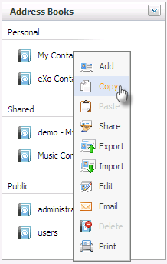
The 2nd way: Select the contacts you want to copy by ticking on check-box in the first column, then click the Copy icon on the action bar.
The 3rd way: Right click on an address book which has one or more contacts and select Copy in the menu.
Step 1: Select a destination address book for coping your selected contacts by right - click on the destination address book and select Paste in the drop list menu:
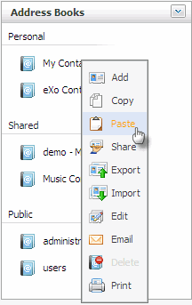
Note:
You can copy contacts of all address books but you can only paste contacts into personal and shared address books (if you have edit permission).

Moving a contact
This function allows moving one or more contacts from one address book to another one.
Do as follows:
The 1st way: Right click on a contact and select Move in the drop list menu
The 2nd way: Select one or more contacts you want to move by ticking check-box(s) in the first column, then click the icon on the action bar.
The Move contact form will appear:
Move contact by right click on the destination address book which you want the contact is moved to. After moving successfully, the form will be automatically closed.
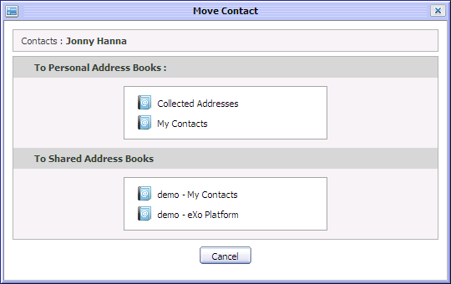Illustration 25: The Move Contact form
Besides, you can click the Cancel button to exit the form without moving.
The 3rd way: Move contacts by using drag and drop feature. You can drag and drop one or more contacts at a time.
Drag and drop one contact: Moving cursor on the corresponding row in the contact in list and when cursor becomes the hand icon , press left-mouse and drag selected contact to the address book in left pane.
Drag and drop many contacts: Select contacts by ticking check box in the first column and moving cursor to contacts in list until it becomes the hand icon icon, press left-mouse and drag selected contact to the address book in left pane.
Note:
You can only move contacts of personal or shared address book if you have edit permission. It impossible to move default contact, contacts in the address book which you do not have edit permission and contacts in public address book.

Exporting contacts
This function allows exporting one or more contacts into a file in your computer.
To export contact, do as follows:
Step 1: Select Export function by one of two ways:
The 1st way: Right click on one contact in contacts list and select Export item in the drop list menu:
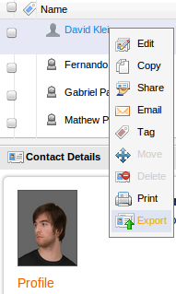
The 2nd way: Right click on a specific address book name and select Export item in the drop list menu:
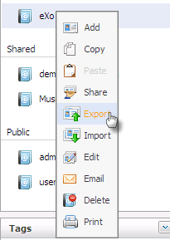
The Export Contacts form will appear below:
Step 2: Select one or more contact(s) which you want to export by ticking on its check box(s).
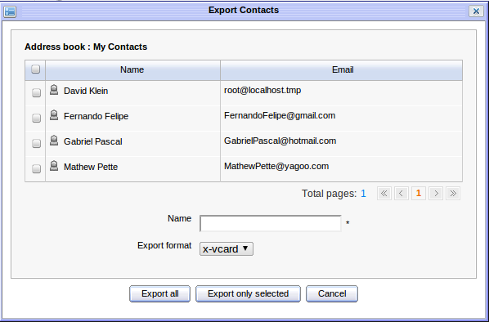Illustration 26: The Export Contacts form
Step 3: Enter file name in the Name field and select export format .(e.g x-card)
Step 4: Click the Export all button to export all contacts in all pages, click the Export only selected button to export selected contacts or click the Cancel button to quit.
The browser may show a pop up with 3 choices:
- Open File: To directly open the exported file
- Save File: To save the exported to your local disk
- Cancel File: To cancel exporting file

Importing contacts
This function allows importing one or more contacts from a file in your computer to a selected address book in eXo Address Book.
- To import contact, do as follows:
Step 1: Select Import function by one of following ways:
The 1st way: Click the icon on the main tool bar.
The 2nd way: Click the icon on the navigation pane and then select Import in the menu:
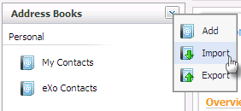
The 3rd way: Right click on a personal or shared address book which you have edit permission and select Import in the drop list menu:
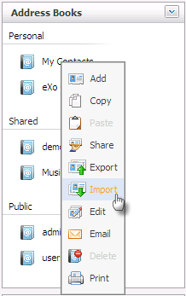
The Import contact form will appear below:
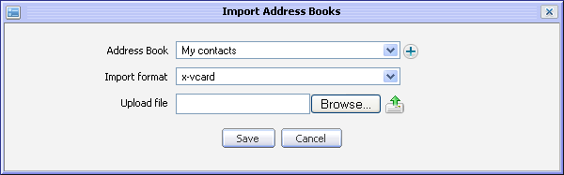Illustration 27: The Import Address Books form
Step 2: Select an address book in the drop down list or create new one by clicking the icon to open Add new category form and create new address book (See 3.2.2.1 for reference)
Step 3: Select the file format in the Import format field. For example: x-vcard
Step 4: Browse a exported file from your computer and click the Upload icon next to the Browse... button to upload the selected file.
Step 5: Click the Save button to accept importing contacts in the selected file or click the Cancel button to quit.
Note:
You can only import contacts to personal or shares address books if you have edit permission.

Printing contacts
Print function allows printing information of the selected contact. You can print one or more contacts at the same time.
Do as follows:
The 1st way:
Step 1: Right click on a contact in the contact list and select Print in the drop list menu below:
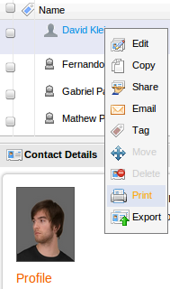
The single contact print preview form appears with the detail information below:
Step 2: Click the Print button to continue printing or click the Close button to quit the Contact print preview form.
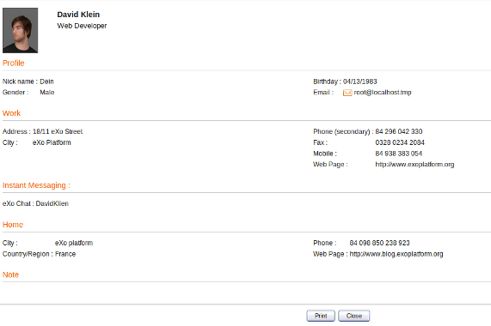Illustration 28: The Single contact print preview form
The 2nd way:
Step 1: Click View in the main menu, then select Vcard below:
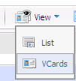
The contacts will be displayed in the Vcard view:
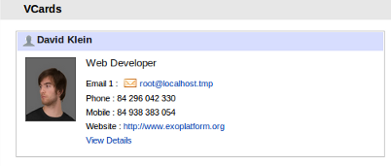
Step 2: Click the View Details link to open the contact in detail pop up. The pop up is shown with Print Preview button that allows you to view and print the contact like the 1st way.
- To Print many contacts:
Step 1: Select contacts you want to print by ticking on its check boxs in the first column and then click the Print icon on the action bar below:
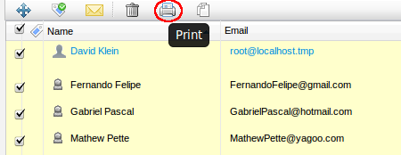
Multiple contacts print preview form appears with summary information:
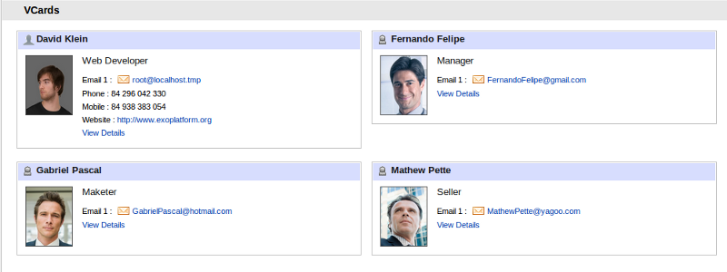Illustration 29: The Multiple contacts print preview form
Step 2: Click the Print button to continue printing or the Cancel button to quit without printing.
Sorting the contact list
This function allows sorting contact list by Name, Email or Job title. You can sort the contact list by click on the title of a column.
For example, click the Name column to sort your contact list by name. The first click will do a descending sort . The second click will do an ascending sort
Sharing a contact
This function allows sharing contact(s) with one or more users, groups. The shared user/group(s) may have view permission or edit permission on the shared contacts
View permission allows users to view, copy, export, print, move and delete the shared contact. However, it is impossible to edit the shared contact. The shared users can not make changes on the shared contact in case having view permission only. However, the move and delete shared contact action can be done.
Edit permission allows users to view, copy, export, print, move and delete and also edit the shared contact. The shared users can make changes on the shared contact in case having edit permission.
Note:
Moving and deleting shared contact action can be done but it only means that the shared user can move or delete the shared contact from his/her shared contact view. The original shared contact still exists in the other shared user's contact view. The shared contact is only deleted completely and no longer sharing with all shared users in case the creator/author of the shared contact removes it.
- To share a contact with a user/group, do as follows:
Step 1: Right click on one contact you want to share (e.g demo exo contact) and select Share in the menu. The Share contact to other users form appears:
To share a contact with users:
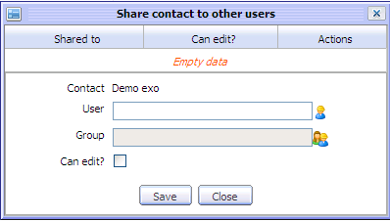Illustration 30: The Share contact to other users form
1. In the Share contact to other users form, click the select user icon to open the User Selector form:
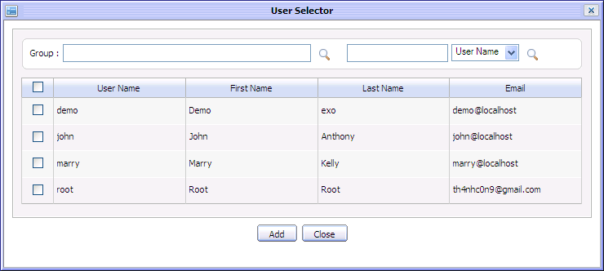
2. Select user(s) by ticking its check box and click the Add button. The selected user will be displayed in the User field.
To share a contact with groups
1. In Share contact form: click the select group icon by Group field.
The Group selector form appears:
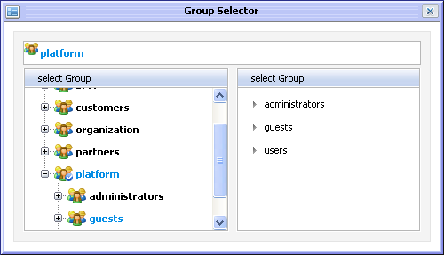
2. Select the group path from the left pane and the group corresponding with the path will be shown at the right pane, available for selecting. The selected group will be displayed in the Group field.
Step 2: Tick on 'Can edit?' check box in form if you want to grant edit permission. User in Group having edit permission can view export, import, add, edit and delete the shared contact while the others do not have edit permission can view and export only.
Step 3: Click the Save button to accept sharing with the selected users or click the Cancel button to quit.
After sharing successfully, the shared users/groups will be updated into the Share table in the Share Address book to other users form with detail information (User name of shared user, group name of shared group, can edit or not):
In Actions column, the edit icon is used to change 'Can edit' right of specific user/group(s). If you want to change 'Can edit' right of specific user/group, click on the edit icon corresponding to it. User/group information will be displayed at the text box below, available for changing by ticking or unticking the Can edit? check box . For example, edit the user named john, john information will be loaded and his 'Can edit' right can be reset below:
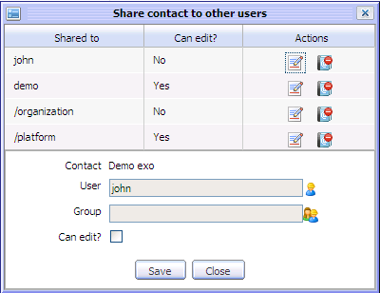
In addition, the delete icon is used to remove specific user/group from the Share table. If you want to delete specific user/group, click on the delete icon corresponding to it and select the OK on delete confirmation message form:
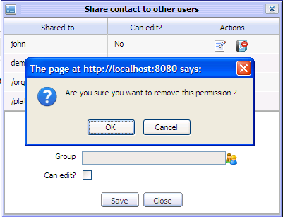
After removing, the deleted user or users in the deleted group can not view the shared contact any more.

Note:
When having shared contacts, the Shared link is shown and set in bold. Shared users can click on the Shared link to view shared contacts from the other users like below:

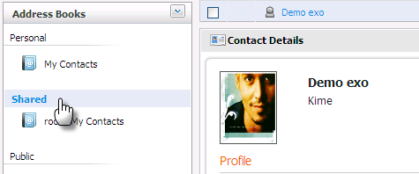
Sending mail to a contact
This function allows you to send an mail directly to one or more contacts in your address book. To do this action, you firstly need to:
- Add at least one account in eXo Mail application (see eXo Mail User guide for more details)
- Have the email address of the contact which you want to send mail.
Email address of selected account will be used to send mail to a contact.
- To send mail to contact, do as follows:
Step 1: Select Email function by one of following ways:
The 1st way: Right click on the contact which you want to send a mail to and select Email in the drop list menu below:
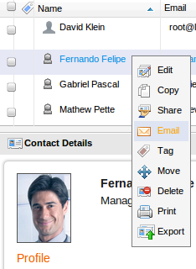
The 2nd way: Select the contact(s) that you want to send mail by ticking on its check box(s) in the first column and then click the Email icon on the action bar below:
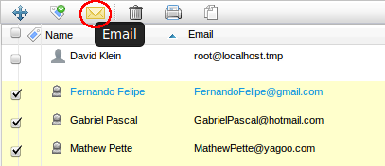
The 3rd way: Right click on the address book which has one or more contacts and select Email in the menu:
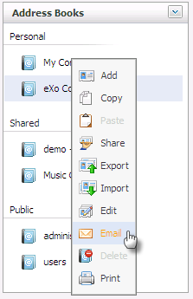
The 4th way: Click on email address of a contact when viewing contact in detail
The Send mail form will appear below:
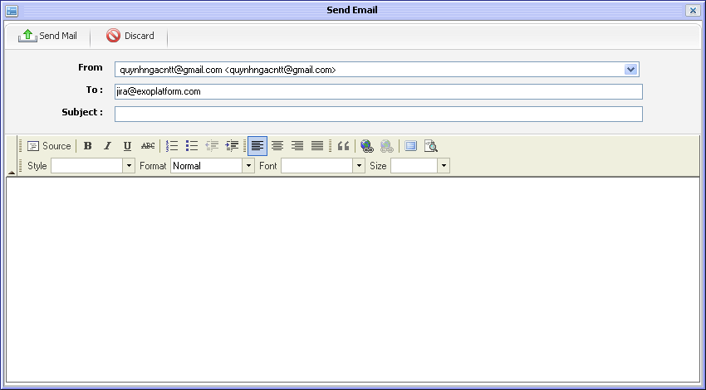Illustration 31: The Send mail form
- The email address of the contacts you want to send mail will be listed in the To field. You can manually edit or input more email addresses for this field.
- Input text to the Subject field and the message content.
- Click the Send Mail button to send your message to the selected contacts.
After sending successfully, the Send mail form will be automatically closed, all email addresses listed in the To field will receive the sent mail.

Searching contacts
The search contact function allows finding contacts easily and fast. There are two search types: Quick search and Advanced search.

Quick search
This function allows you to do a quick search with specific keyword in all your contacts. All contacts having text matching with your search team will be displayed in the search result form.
Do as follows:
Step 1: Enter a word in the Search field at the top of the address book list: 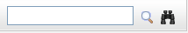
Step 2: Click the Search icon
For example, quick search with “Nguyen” term. All contacts matching with “Nguyen” term are listed in the search results form. The search result form will be displayed like below:

Advanced search
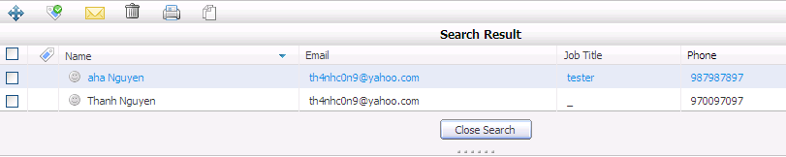Illustration 32: The search result form
This function allows you to make a search with multiple criteria, do as follows:
Step 1: Click the Advanced Search icon by the search area.
The Advanced Search form appears:
Step 2: In this form, you can set one or few criteria for your search :
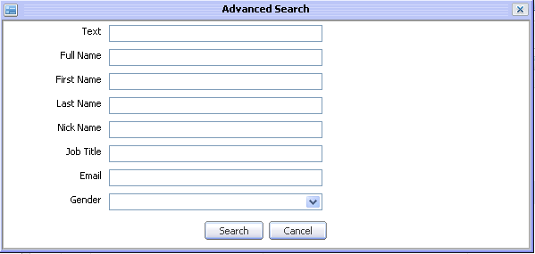Illustration 33: The Advance Search form
- Simple text
- Full name
- First Name
- Last name
- Nick Name
- Job title
- Email
- Gender
Step 3: Click the Search button to do search. All contacts matching with your criteria(s) will be listed in the search result form.

Tagging
eXo contact allows assigning tags to specific contacts. Tags are used as labels which help you filer or categorize your contacts from different address books. A single contact can be assigned to many tags at a time.

Tagging a contact
There are several ways to add or remove tags to a contact. To tag contact, do as follows:
Step 1: Select Tag item by one of following ways:
The 1st way: Right click on the contact which you want tag and select Tag in the drop list menu.
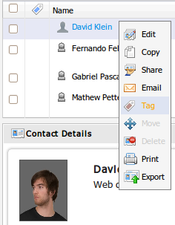
The 2nd way: Select the contact(s) you want to tag by ticking on its check box(s) in the first column and then click the Tag icon on the action bar.
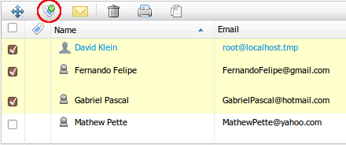
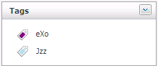Illustration 34: Tag list
The 3rd way: Drag and drop contacts to specific tag in the Tag space in the left pane.
For example add tag to Biz Lee Jiz contact, the Add/Remove contact form appears :
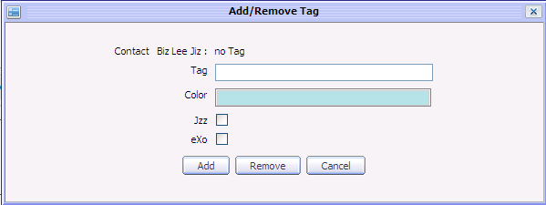Illustration 35: The Add/Remove tag form
Add tag for a contact
      - Enter Tag name.
      - Select color for tag in drop down list
      - Click Add button to add tag.
Update contact to an existing tag
      - Select tags to update by ticking on available tag check box in the form
      - Click the Add button to add tag.
Remove tag from contact
Select tags to remove by ticking on available tag check box in form
Click the Remove button to remove selected tag(s).
Note:
To add tag without the contact list included, “Add new tag” icon at left pane below:
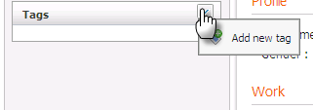
The Add/edit tag will be displayed, available for adding new tag below:
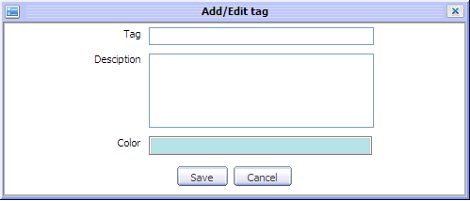
- When opening a tag, you can do all actions on the contacts which are tagged such as move, delete, print, edit, add tag, print, shared,copy, drag and drop,send mail...

Editing a tag
This function allows you making changes to existing tags. To edit tag, do as follows:
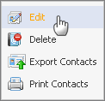
Step 1: Right click on a tag in tag space and select Edit item in the menu:
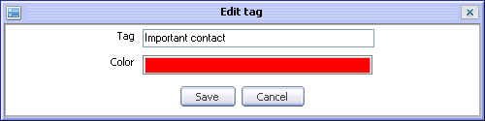
The Edit tag form appears:
Step 2: Make changes in the form such as change the Tag name, color.
Step 3: Click the Save button to accept changes or click the Cancel button to quit.

Deleting a tag
This function allows deleting existing tags. To delete a tag, do as follows:
Step 1: Right click on tag name in tag space and select Delete item in the menu
Step 2: Click the OK button in the confirmation message to accept deleting tag or click the Cancel button to quit.

Export contacts in a tag
This function allows exporting contacts from a tag into a file on your computer.
To export contact in tag, do as follows:
Step 1: Right click on a tag and select Export contact in the drop list menu:
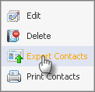
The Export Contact form will appear below:
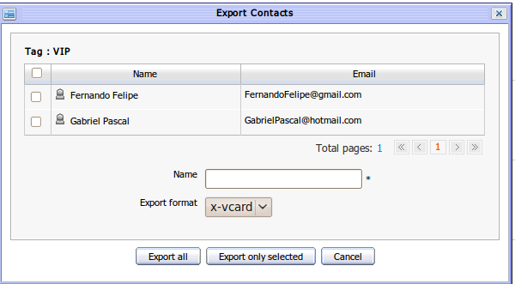Illustration 36: The Export Contacts form
Step 2: Select one or more contacts you want to export by ticking on its check box(s)
Step 2: Enter a file name for the Name field
Step 3: Select file format from the Export format combo box (e.g x-vcard)
Step 4: Click the OK button to accept exporting or click the Cancel button to exit the form.
The browser may show a pop up with 3 choices:
- Open File: To directly open the exported file
- Save File: To save the exported to your local disk
- Cancel File: To cancel exporting file

Print contacts in a tag
This function allows printing all contacts in specific tags. To print contacts in one tag, do as follows:
Step 1: Right click on a tag in the tag space and select Print contacts in the drop list menu.
Step 2: The contact print preview form appears with detail contact information.
Step 3: Click the Print button to continue printing or the Close button to exit Contact print view form.

Contact View Configuration
This function allows personalizing your contact view from many different view types, available for selecting. At present, your contacts can be viewed by List or Vcards.

List View
The list view displays all contacts in list panel and detail information of the selected contact in Contact view panel. To view contacts by list view, do as follows:
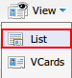
In Main tool bar, click View icon then select List in the menu:
The contacts are displayed in the list below:
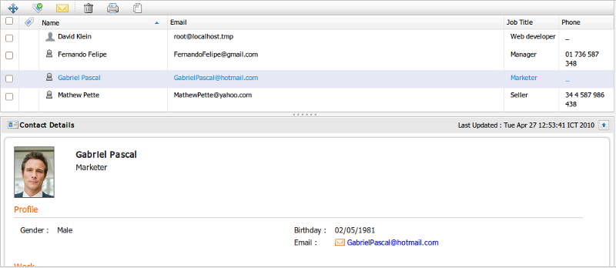Illustration 37: The List View form

VCards View
The Vcards view displays all contacts in Vcard form, do as follows:
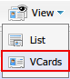
On Main tool bar, click the View icon then select Vcards in the menu:
The contacts are displayed as Thumbnails:
You can click the View Details to see the contact detail in a pop up.
In case the contact is tagged, there is a tag icon is shown at the right corner that shows all the tags of the contact.
You can click on specific tag in the menu pop up for detail.
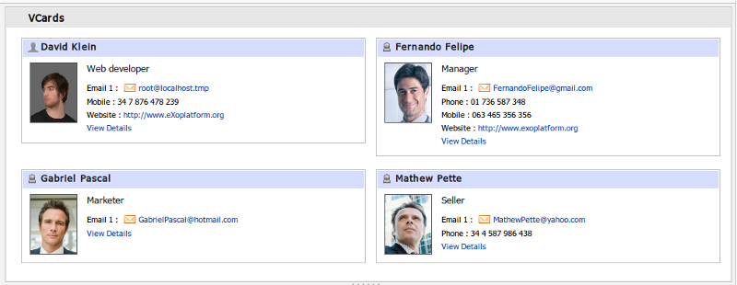Illustration 38: The VCards View form

Layout Configuration
eXo Address Book layout allows you to show or hide differnt parts of Contact interface. To configure the layout, do as follows:
On the main tool bar, click the Custom layout icon and then select an item in the drop down menu.
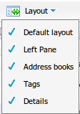
For example, if you select the Navigation item in the drop down menu, the navigation pane in the left area is hidden below:
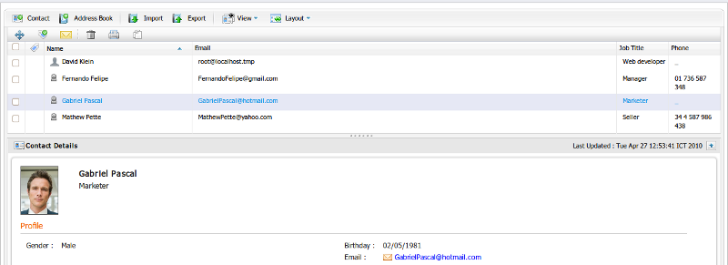Illustration 39: The main screen after hiding the navigation

