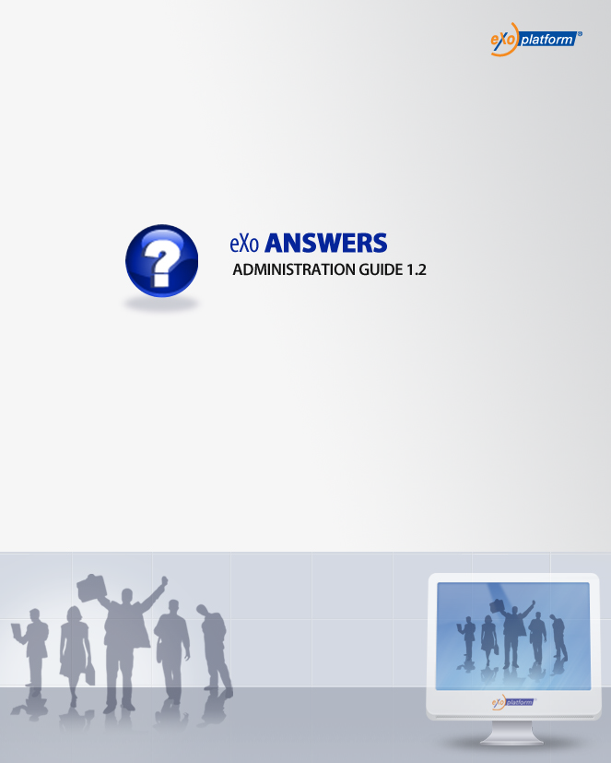
REVISION HISTORY
Version | Date | Written by | Reviewed by | Change Record
1.0 | Jan 01, 2009 | Hoang Anh Quynh Nga | Nguyen Thanh Cong
1.1 | Mar 18, 2009 | Nguyen Thanh Cong | Hoang Anh Quynh Nga | - New FAQ UI with left pane, category tree and question panel  - New Submit Question form: Question title, question detail.  - Add category with order  - Move category by drag and drop feature  - Improve the way to add question in multiple languages.  - Answer question in multiple answers  - View question in multiple answers  - Approve/disapprove answer  - Activate/inactivate answer  - Delete answer  - Vote question  - Vote answer  - Delete answer  - Comment question in multiple languages  - Custom view  - View user profile  - Discussion in Forum  - Set Discussion properties  - Set Enable RSS properties  - Set Vote and comment properties  - RSS feed  - Update Tool bar and Breadcrumb enhancements.  - Update vote question, answer.  - Unvote question and rate up/down answer  - Changes on watch function. - Update Unwatch function  - Change on question template.  - Update User Settings function  - Submit/Edit question form with FCK Editor  - User Setting: manage watch, change and delete avatar.  - Answer question with new feature and UI  - Update Manage Category menu  - Edit answer functions
1.2 | June 09, 2009  August 20,2009 | Nguyen Thanh Cong  Luong Quynh Lien |  | - Setting properties: category scoping  - Email notifications tab in Setting Properties  -Change screenshots.  - Answers portlet.  - FAQ Porltet.
1.2.2 | November 22, 2009  February 4, 2010 | Luong Quynh Lien |  | - Upgrade to 1.2.2  - Review

Table of Contents
1. Preface 8
1. About this guide 8
2. Who should read this guide 8
3. Objective of this guide 8
2. Overview 9
What is Answers application? 9
What is a Category? 9
What is a Question? 9
What is an Answer? 9
What is a Comment? 9
The Answers Application main screen 10
3. How to use the Answers Application? 11
3.1 Signing in/Signing out 12
3.1.1 Signing in 12
3.1.2 Signing out 14
3.2 Category management 14
3.2.1 Adding new categories 14
3.2.2 Adding subcategories 17
3.2.3 Editing categories 18
3.2.4 Deleting categories 18
3.2.5 Moving categories 19
3.2.6 Watching 20
3.2.7 Unwatching 21
3.2.8 Managing watch 21
3.3 Question management 22
3.3.1 Adding questions 23
3.3.2 Answering questions 25
3.3.3 Editing questions 30
3.3.4 Deleting questions 33
3.3.5 Moving questions 34
3.3.6 Sending to friend 35
3.3.7 Approving/disapproving questions 37
3.3.8 Activating/ Inactivating questions 38
3.3.9 Approving/Disapproving answers 39
3.3.10 Activating/Inactivating answers 40
3.3.11 Editing answers 40
3.3.12 Deleting answers 41
3.3.13 Viewing questions 42
3.3.14 Voting questions 46
3.3.15 Removing question vote 46
3.3.16 Rating up/down answers 47
3.3.17 Commenting questions 47
3.3.18 Promoting comments 49
3.4 Search 49
3.4.1 Quick Search 50
3.4.2 Advanced Search 51
3.5 User Settings 55
3.6 Answers Portlet Settings 57
3.7 Printing 65
3.8 Exporting/Importing 67
3.8.1.Exporting 67
3.8.2.Importing 68
3.9 Showing/hiding the left panels 70
3.10 Dragging and dropping 71
3.11 Viewing user profile 72
3.12 Discussing in forum 72
3.13 RSS feed 73
3.14 FAQ Portlet 75

Illustration Index
Illustration 1: The main screen of the Answers application 10
Illustration 2: The Mail work flow of Answers application 11
Illustration 3: The Sign in form 12
Illustration 4: The authenticated homepage 13
Illustration 5: The authenticated Answers application 14
Illustration 6: The Add Category form 15
Illustration 7: The Select a user form 16
Illustration 8: The Select a role form 17
Illustration 9: The Edit Category form 18
Illustration 10: The Move category to form 19
Illustration 11: The watch alert message form 20
Illustration 12: The Watch Manager form 22
Illustration 13: The Edit email for watching form 22
Illustration 14: The Submit question form 23
Illustration 15: The select language combo 24
Illustration 16: The Upload File form 24
Illustration 17: The Answer form 26
Illustration 18: The Related questions form 27
Illustration 19: The Pending questions tab of Manage questions form 29
Illustration 20: The Edit question form 31
Illustration 21: The All question tab of the Manage questions form 32
Illustration 22: The Edit question in the Manage questions form 33
Illustration 23: The Confirm deletion form 34
Illustration 24: The Move question form 35
Illustration 25: The Send question by email form 36
Illustration 26: The question panel in case it has not been answered 42
Illustration 27: The question panel in case it has been answered 43
Illustration 28: The image preview mode 44
Illustration 29: The download file pop up on Fire Fox 45
Illustration 30: The Comment form 48
Illustration 31: The simple Search Result form 50
Illustration 32: The View entry form 51
Illustration 33: The Advanced search form 52
Illustration 34: The Advanced search form with Search in Categories 53
Illustration 35: The Advanced Search form with Search in Entries 54
Illustration 36: The User settings form 56
Illustration 37: The User Watch Manager form 57
Illustration 38: The Display Mode tab 59
Illustration 39: The Email notification tab 60
Illustration 40: The Discussion tab 61
Illustration 41: The Select Category/forum form 61
Illustration 42: The Category Scoping tab 62
Illustration 43: The Portlet Setting tab 63
Illustration 44: The Select Icon tab 64
Illustration 45: The Decoration Themes tab 64
Illustration 46: The print preview page 66
Illustration 47: The Export form 67
Illustration 48: The Import form 69
Illustration 49: The custom View without the left panels 71
Illustration 50: The View User Profile form 72
Illustration 51: The FAQ Portlet in the View mode 75
Illustration 52: The FAQ Portlet in the Edit mode 76

1. Preface

1. About this guide
eXo Platform™ software is a powerful Open Source corporate portal and content management system. Users of the platform have a customized single point of accessing to the company's information system and resources. The purpose of this administration guide is to help users who have administration privileges easily manipulate in Answers application which is a part of Knowledge Suite – an extension of eXo portal.
This documentation is an useful guide for you to learn about eXo Portal technology in details. It gives an in depth examples and easy explanation of eXo Platform technology that not only allows technical but also non-technical people to create and manage very fast and powerful website.

2. Who should read this guide
Welcome to the eXo Knowledge Suite material that guide you through the process of reading this material. This document aims at guiding various users of eXo Portal. This material is useful for anyone interested in learning and using the Answers application, especially this document is intended mainly for users who have administration privileges. It covers administration of users, permissions and all management actions.

3. Objective of this guide
This Administration guide will:
- Define some basic concepts used in the Answers application.
- Show the main instructions of the Answers application.
- Let you set permission and take all management actions of the Answers application along with step by step to take basic actions.

2. Overview

What is Answers application?
Answers is an online document that poses a series of common questions and answers on a specific topic. Answers is a way to answer questions about rules or any problem when using specific system.
The Answers section familiarizes visitors with answers to most commonly asked questions about a site/service or about the entity/subject that is responsible for the site/service. Repeatedly received questions will be added into the Answers and newcomers with Site/Service are encouraged to view the Answers.

What is a Category?
A category is the name for a collection of questions/answers about a specific topic. In eXo Answers application, one category may include one or more sub-categories. One category may also contains both sub-categories and questions inside it.

What is a Question?
A question is user's expression used to ask and get information. In the Answers, all questions related the same topic have to be posted and grouped in the same category.

What is an Answer?
An answer is a response to specific questions. In the Answers, all responses are posted below its questions. Only people have a moderation right can answer questions.

What is a Comment?
A comment is user's opinion on a specific question. In the Answers, all comments are posted below its question. A comment can be promoted to an answer by the administrator.

The Answers Application main screen
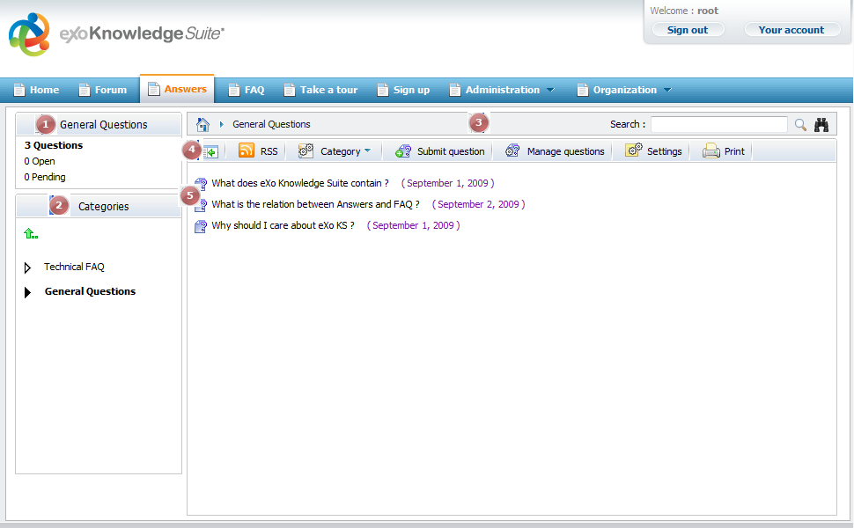Illustration 1: The main screen of the Answers application
Indicator | Meaning
 | This is the Categories Stats panel that displays information of current category that is being viewed including the total number of open questions (question's not answered yet), pending questions (questions that are waiting to be approved) and total of questions.
 | This is the Categories Panel that explorers the category in tree view. A click on one category will browse into it on the Answers view panel.
 | This is the Breadcrumb bar that shows Answers path and search function with simple and advanced option.
 | This is the Action bar that allows administrator to quickly add category, question, manage question, import, export, print, settings...
 | This is the Answers view panel that displays all categories, subcategories and questions.

3. How to use the Answers Application?
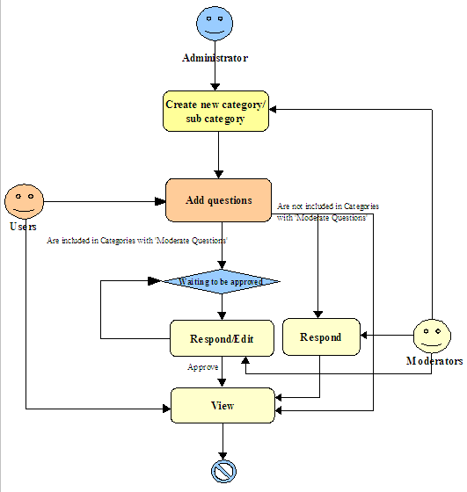Illustration 2: The Mail work flow of Answers application
Explanation:
The administrator creates a new category/sub category. This category/sub category can be set with 'Moderate new questions' or not. If 'Moderate new questions' option is set, all questions in this category/subcategory must be approved/disapproved by the moderators/administrators.
All users can add new questions into a specific category/subcategory.

Signing in/Signing out

3.1.1 Signing in
This function allows you to go into the portal in the private mode.
To sign in, do as follows:
- Go to portal in public mode by inputting URL in the address bar (e.g: http://localhost:8080/portal)
- Click the Sign in link at the top right of a page if you are in the Classic portal.
The Sign in form will appear:
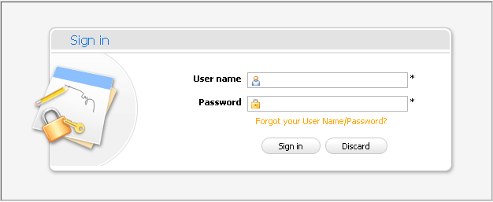Illustration 3: The Sign in form
Details:
User name: The registered user name
Password: The registered password
Forgot your User Name/Password? This link helps users retrieve username and password when they forgot.
Sign in button: To accept signing in.
Discard button: To close the Sign in form.
- Sign in by the administrator account.
- Complete signing in by clicking the Sign in button.
In case, the User Name does not exist or the inputted User name/Password is invalid, there will have an alert message and you can not add a new account if at least one of these cases occurs:
  - The User name is existing or User Name is invalid.
  - The Password has less than 6 characters.
  - The Password and the Confirm Password are not the same
  - The Email Address is invalid format
  - The required fields are blank (empty)
After signing in, you will be redirected to the authenticated home page:
To take actions in the Answers application, you have to go into the Answers application page on the the navigation bar. The main screen of the Answers application will be displayed:
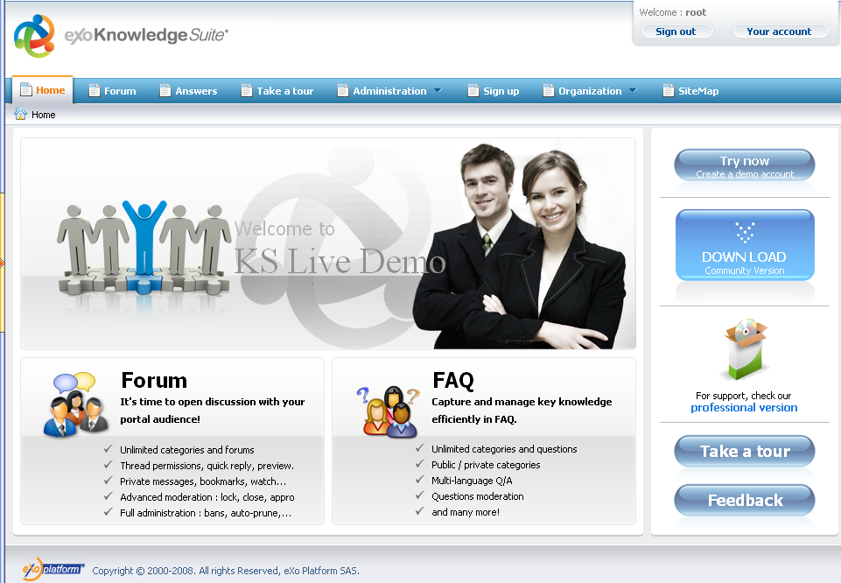Illustration 4: The authenticated homepage

3.1.2 Signing out
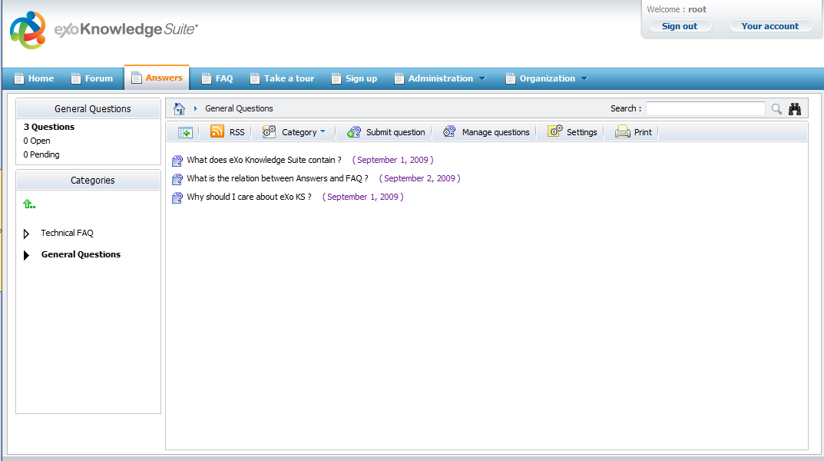Illustration 5: The authenticated Answers application
This function allows you to get back to the anonymous portal. It ends your current portal session.
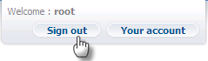
To sign out, click the Sign out button at the top right corner of the screen:

Category management
This section includes all actions related to a category in the Answers application.

Adding new categories
This function is used to add new categories in the Answers application. Only the Answers administrators can take this action.
Do as follows:
- Click on the Category button on the action bar and select Add Category in the menu:
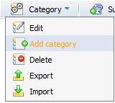
The Add Category form will appear:
- Enter values for fields in this form.
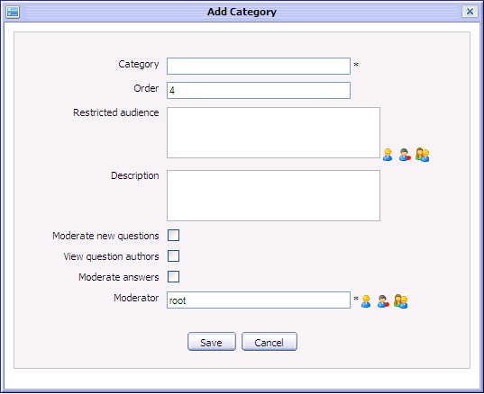Illustration 6: The Add Category form
Details:
Category: The name of the category. This field is required.
Order: The order of the category in category 'tree' in left pane.
Restricted Audience List of all users can access the category. By default, this field is blank means that all users can access this category.
Description: The brief description about the category.
Moderate new questions : This option is to require/ not require approving new question in the category to be visible or not.
View question authors: This option is to display author information of the question added into the category. If it is ticked, author information is shown. If not, author information of all in this category is hidden.
Moderate answers: This option is to require/ not require approving new answer in the category to be visible or not.
Moderator: The list of users/groups that have responsibility to approve/disapprove questions and answer all questions in this category. Default value is root. This field is required.
Save button: To accept adding new category.
Cancel button: To close Add Category form.
The restricted audience and moderator can be inputted manually or selected from the selector tool:
- Click the icon to select users from the group list: Firstly, select a group from the left list and then select a user on the right. The selected users will be displayed in the 'Moderator' field
- Click the icon to select all users with a specific membership in a group. Firstly, select one group from the left pane and the select a membership on the right. The selected role will be displayed in the 'Moderator' field.
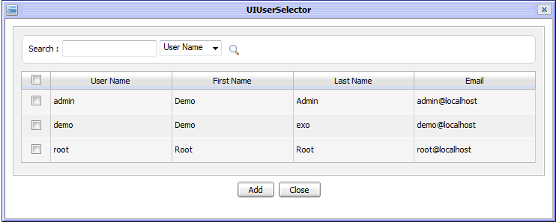Illustration 7: The Select a user form
- Similarly, click the icon to select all users in a specific group.
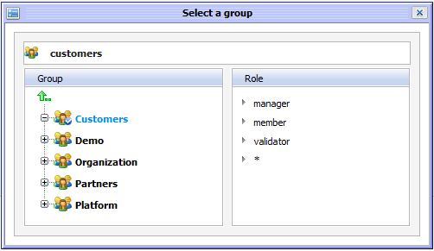Illustration 8: The Select a group form
- Complete adding a new category by clicking the Save button.

Adding subcategories
This function is used to add new subcategory into an existing category.
Do as follows:
- Open the Add Category form by one of two following ways:
The 1st way: Right click on the category that you want to add a subcategory into and select Add Category.
The 2nd way: Go into the category that you want to add a subcategory into and click Category on the main action bar and select Add Category in the menu:
The Add Category form will appear like Illustration 6.
- Enter the required values for fields in the Add Category form.
- Complete adding a new subcategory by clicking the Save button.

Editing categories
This function is used to edit categories or subcategories in the Answers.
Do as follows:
- Open the Edit category form by
The 1st way: Right click on the category/subcategory that you want to edit and then select Edit in the menu.
The 2nd way: Click on the Category on the main action bar and select Edit in the menu.
The Edit category form will appear with detail information, available for editing.
- Change the current category's information.
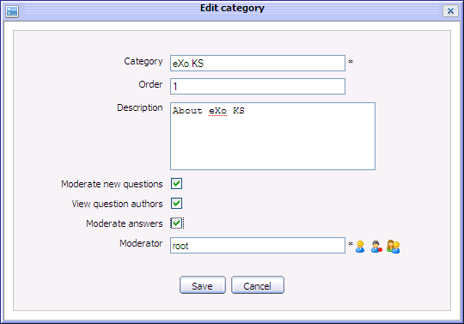Illustration 9: The Edit Category form
- Complete editing a category by clicking the Save button.

Deleting categories
This function is used to delete categories in the Answers.
Do as follows:
The 1st way:
- Right click on the category/subcategory that you want to delete and select Delete in the menu.
- Click the OK button in the confirmation message to accept deleting or click the Cancel button to quit.
The 2nd way:
- Click on the Category button on the main action bar and select Delete in the menu.
- Click the OK button in the confirmation message to accept deleting or click the Cancel button to quit.

Moving categories
This function is used to move a category from the current place to another place.
Do as follows:
- Right click on the category that you want to move and then select Move in the menu :
The Move category to form will appear:
- Move the category by double clicking on the destination category in the category list.
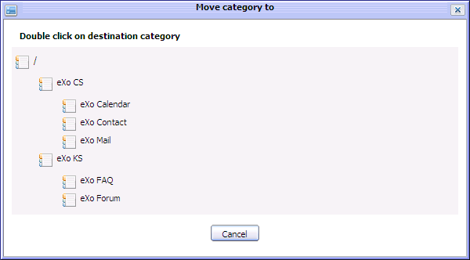Illustration 10: The Move category to form
After being moved, the Move category to form is closed, the moved category is moved to new destination category.
The Cancel button is to close the Move category to form without moving.
Notes:
Only the administrator can move categories to any where in the Answers while the moderator is checked permission when moving categories. The moderator can only move categories to the categories that he is a moderator.

Watching
This function allows logged users to keep track of changes of specific categories in the Answers application such as new edition, new question, question response... You only need registering an account, add watch to specific categories, whenever there is a new changes, users will receive notification mail from the Answers.
To add watch, simply right click on any category in the category list and select Watch in the menu:
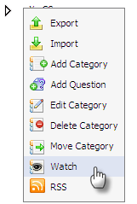
The alert message that informs watching successfully is shown:
Note:
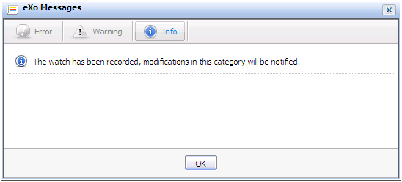Illustration 11: The watch alert message form
After adding a watch successfully, the category which is being watched will be marked by the eye icon .

Unwatching
This function allows you to remove your watches on specific categories. When unwatching, you will not receive notification mails about the categories that you had watched anymore.
To unwatch, simply right click on the category that you are watching and select Unwatch in the menu:
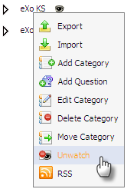

Managing watch
This function allows you to manage watches of categories such as edit, delete...
Do as follows:
- Open the Watch Manager form by clicking on the eye icon of the category which is being watched:
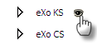
The Watch Manger form is displayed with all email addresses used for watching.
- To view the watched category content, click on the open category icon .
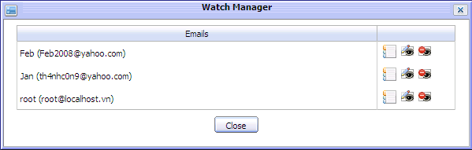Illustration 12: The Watch Manager form
- To edit any email address, do as follows:
- Click the edit icon correspondingly.
The Edit form will be displayed with the current information, available for editing:
Details:
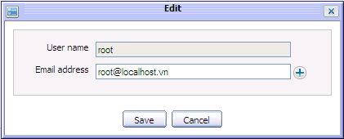Illustration 13: The Edit email for watching form
User name: The registered User name. This field can not be changed.
Email address: The registered email address for watching.
Save button: To accept saving changes.
Cancel button: To close the Edit form.
- Change email address by manually inputting your email into the Email address field. You can also add or remove email addresses for watching.
- Complete editing watch by clicking the Save button.
- To delete this watch in the Watch Manager form, click the delete icon and click the OK in the confirmation message form.

Question management
This section contains all actions related to questions in a category.

Adding questions
This function is used to add question into the Answers home page or a specific category.
Do as follows:
- Show the Submit question form by one of two following ways:
The 1st way: Right click on the category/subcategory that you want to add new questions into and then select Submit Question in the menu.
The 2nd way: In the home page or go into the category that you want to add a question into and then click the button on the tool bar.
The Submit question form will appear like illustration 14.
- Input values for fields in the Submit question form.
Details:
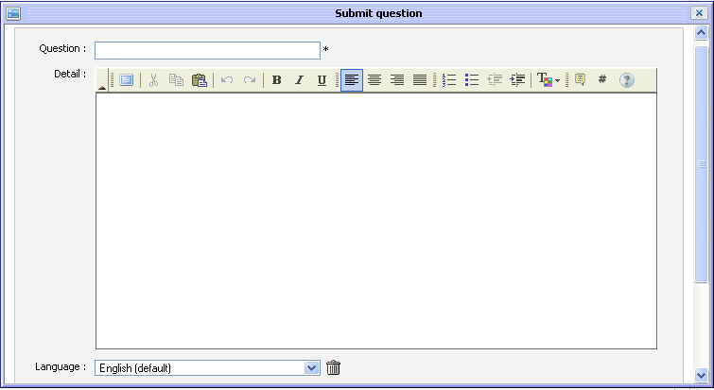Illustration 14: The Submit question form
Question: The brief content of the question.
Detail: The detail explanation of the question. The detail can be decorated by FCK Editor or BBC tags.
Language: The language that is used to add a question. By default, the language is English. The language combo box allows selecting a language option.
Author: The name of the author. This field is required.
Email: The address of the email. This field must be in valid format likes: username@abc.com. This field is required.
Files: The files attached into the question.
Attach a file: To attach files into the question.
Save button: To accept submitting the question.
Cancel button: To close the Submit question form.
To add this question by another language, do as follows:
- Click the language combo box in the Submit question form. The language drop list will be displayed:
- Select a language by clicking on the language that you want add to a question.
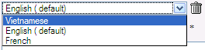Illustration 15: The select language combo
- Click the Save button to accept adding another language or click the Cancel button to quit.
There will have a text box that corresponds to the selected language in the Submit question.
To remove a question in the specific language, simply select the language that you want to delete and click the delete icon besides the language combo box.
After deleting, the corresponding language content will be deleted.
To attach files, click the attach a file link in the Submit question form, the Upload File form will appear:
- Select files to upload by clicking the Browser... to select file's path from local computer.
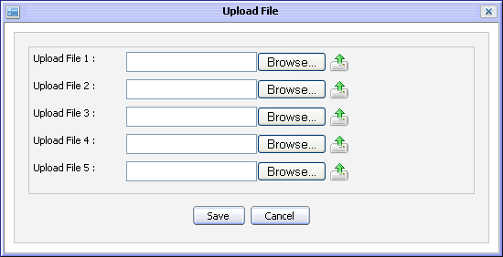Illustration 16: The Upload File form
- Upload the selected files by clicking the icon to upload.
- Complete attaching files to a topic by clicking the Save button.
After being attached, the Submit question form is shown:
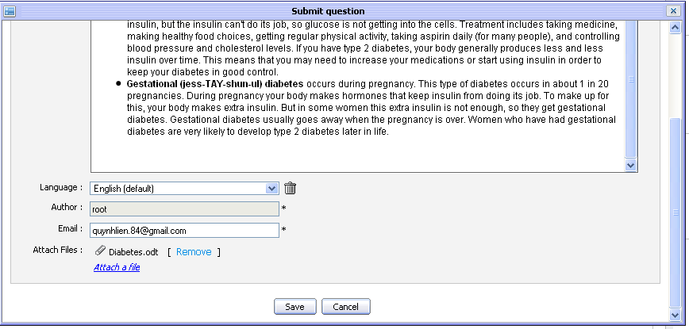
Many different file types can be attached. To remove attached files, simply click on the Remove link beside the file attachments which you want to delete.
- Complete submitting a question by clicking the Save button.
The question is added into the selected category and an alert message is shown to inform that the question is added successfully. In case, the question is added to the category require moderation before displaying, the alert message will have a content to inform that the question will be checked by the moderator for approval.
The question list is shown below:
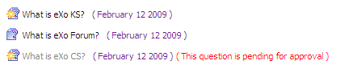
: This icon means that the question has not answered.
: This icon means that the question has been answered.

Answering questions
This function is used to respond/answer questions. A question may have multiple answers and each can be moderated independently.
If you have administration role, you can answer all questions in all categories while with the moderation role you can only answer the questions in the categories that you are the moderator.
Do as follows:
The 1st way:
- Click on the Answer question button in the question panel or right click on the question that you want to answer and select Answer question below:
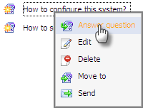
The Answer form will appear:
Details:
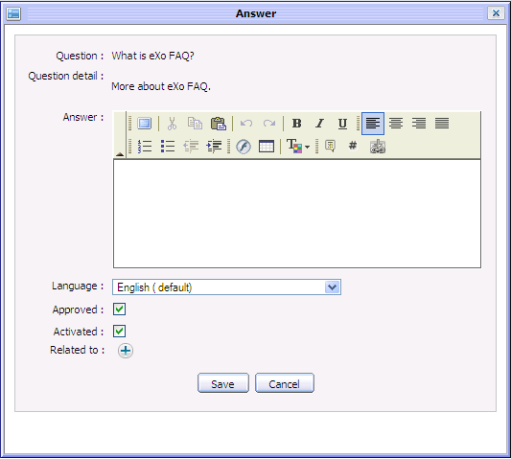Illustration 17: The Answer form
Question: The brief content of the question . It can be viewed only.
Question detail: The detail content of the question. It can be viewed only
Answer: The content of the answer. A question can have multiple answers. The answer can be decorated by the FCK editor or BBC tags.
Language: The language is used to display the content of the Question and the Question detail field and is used to answer a question. You also can answer a question by another language:
- Select another language in value list of the 'Language' field.
- The question is displayed by the selected language.
Approved: This option is to whether approve the question or not.
- If this question is in the category that does not need moderating, this option is checked.
- If this question is in the category that need to be moderated, this option is not checked.
- To approve this question, check this field.
Activated This option is to whether display the answer or not. It means the answer of this question with the selected language will be displayed or not. By default, the answer is always shown.
Related to: All questions related to the question that you want the other users to refer to.
Plus icon To link the current question to the other entry/question(s).
Save button: To accept submitting the answer of the question.
Cancel button: To close the Answer form.
To add related questions, do as follows:
- Click the icon to display the question list in all categories. The Related questions form will appear:
- Select one or more questions in list by checking the check boxes that correspond to the questions.
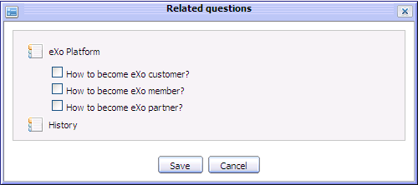Illustration 18: The Related questions form
- Click the Save button to add the selected questions into the Related to field or click the Cancel button to quit.
After adding the related questions, the Answer form will be shown:
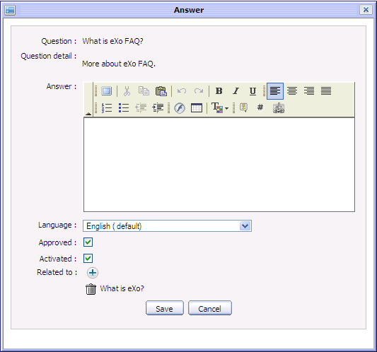
To remove a related question from list, click the remove icon that corresponds to the question that you want to remove.
- Enter values for required fields in the Answer form.
- Complete answering a question by clicking the Save button.
Note: To add more answers, simply click the Answer question button in the question panel to open the Answer form and add more.
The 2nd way:
- Click the button on the tool bar.
The All questions tab allows users to view all questions in all categories. Users also view questions of each existing category by selecting a filter in the Select category field.
- Click the Open questions tab. This tab allows users to view all questions that hasn't been answered yet.
- Click the icon which corresponds to the question that you want to answer.
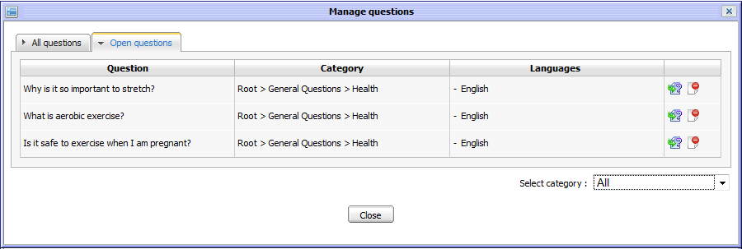Illustration 19: The Open questions tab of Manage questions form
The form to answer question will be displayed under the question list:
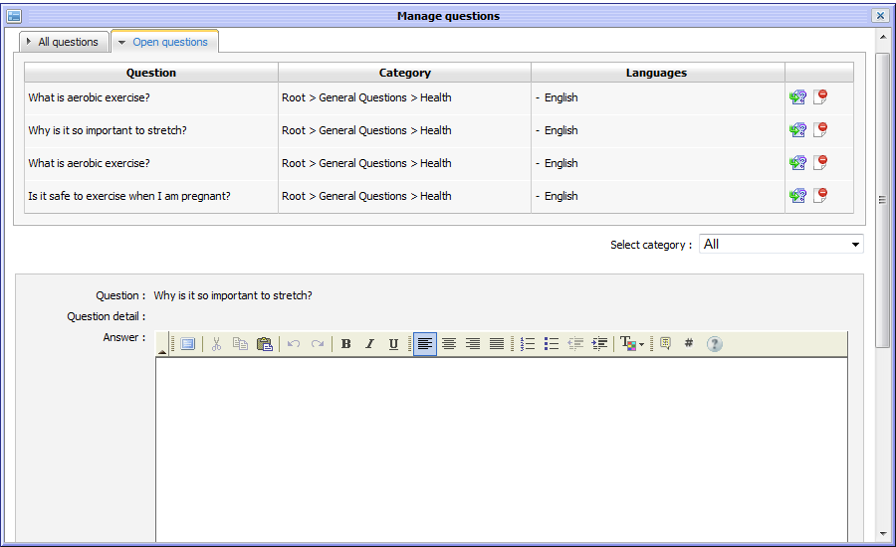
- Enter values for required fields.
- Complete answering question by clicking the Save button.
After being answered, in the administrator/moderator view, the question is displayed:
Questions can be viewed by two ways:
- Quick view: questions can be viewed by question list:
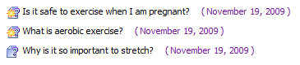
- Detail view: click directly on question that users want to view in detail
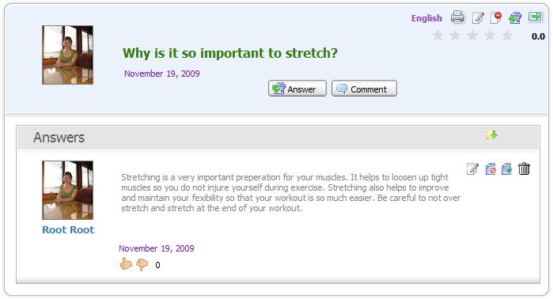

Editing questions
This function is used to edit questions in a specific category.
Only the Answers administrators and moderators of one category can edit question inside it.
Do as follows:
The 1st way:
- Right click on the question that you want to edit and then select Edit in the menu:
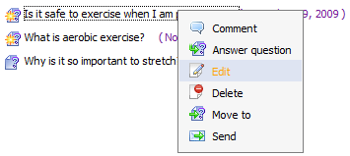
The Edit question form will appear with the current information, available for editing:
Details:
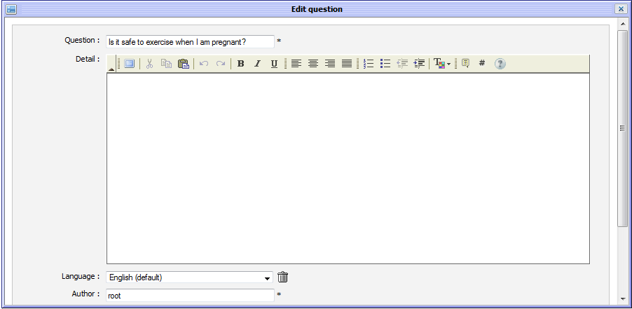Illustration 20: The Edit question form
Question: The brief content of the question.
Detail: The detail explanation of the question. The detail can be decorated by FCK Editor.
Language: The language that is used to add questions. By default, the language is English. Language combo box allows selecting language option.
Author: The author of the edited question.
Email : The email address of the edited question's author.
Validation: This option is to validate the question. It includes activated and approved option .
Approved: This option is to approve the edited question or not.
- If this question is in the category that does not need to be moderated, this option is checked.
- If this question is in the category that needs to be moderated, this option is not checked.
- To approve this question, check this field.
Activated: This option is to whether display this question or not. By default, this option will be checked. It means the question is displayed, all users can view it. But if Answers Administrators or Moderators don't want to display this question, don't select this option.
Files: The files that are attached into the question.
Attach a file: To attached files into the edited question.
Save button: To accept submitting the edited question.
Cancel button: To close the Edit question form.
- Change the current information of the selected question like when adding a new question. You can add more or remove the language option, attach file...
- Complete editing the question by clicking the Save button.
The 2nd way:
- Click the button on the tool bar.
The Manage questions form will appear:
- Click the icon to edit the question in the question list.
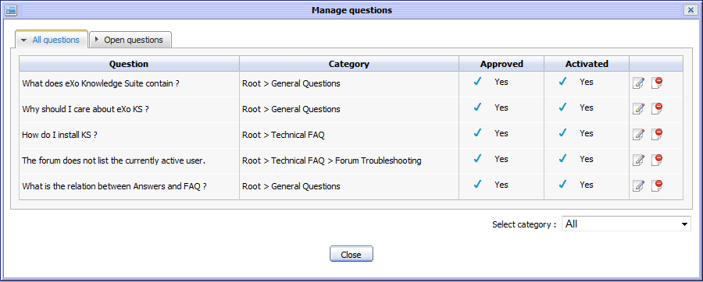Illustration 21: The All question tab of the Manage questions form
The form to edit question will be displayed under the question list:
- Change the current information of the selected question. You can activate, inactivate, approve, approve, attach file or add more language options for the edited question.
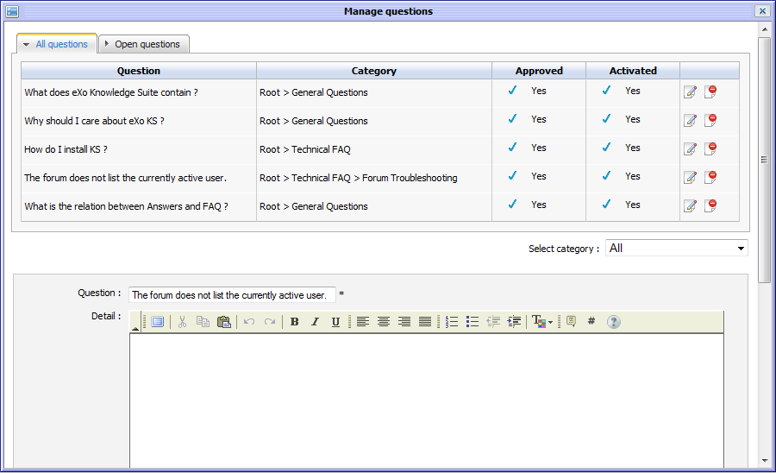Illustration 22: The Edit question in the Manage questions form
- Complete editing a question by clicking the Save button.
Note:
The select category combo box allows filtering the question by a specific category.

Deleting questions
This function is used to remove a questions from a specific category.
Only the Answers administrators and the moderators of the category that contains this question can remove that question.
Do as follows:
The 1st way:
- Right click on the question that you want to delete and then select Delete in the menu.
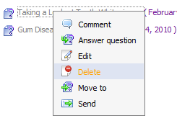
- Click the OK button on the confirmation message to accept deleting or the Cancel button to quit.
The 2nd way:
- Click the button on the tool bar. the Manage questions form will appear like Illustration 20 and Illustration 22
- Click the icon that corresponds to the question in list that you want to delete.
- Click the OK button in the confirmation message to accept deleting the selected question or click the Cancel button to escape without deleting.
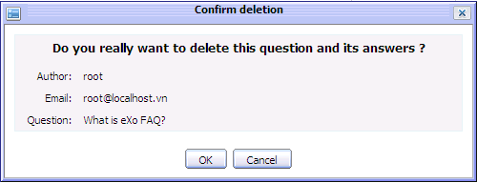Illustration 23: The Confirm deletion form
After being deleted, the selected question will be removed from the list.

Moving questions
This function is used to move one question from one category to another.
Only the Answers administrators and moderators of one category can move questions inside it.
Do as follows:
- Right click on the question that you want to move and then select Move to in the menu.
The Move question form will appear:
- Move the question by double clicking on the destination category in the category list.
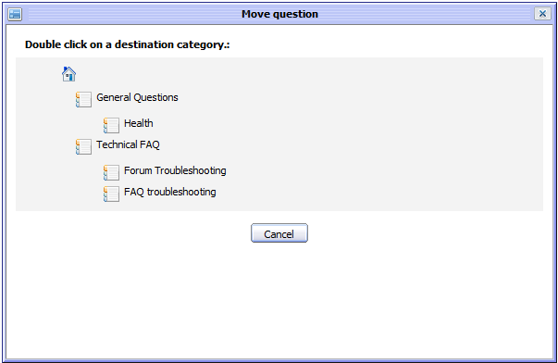Illustration 24: The Move question form
After moving, the Move question form is closed, the question is moved to the new destination category.
The Cancel button is used to escape the Move question form without moving.
Notes:
Only the administrator can move questions to any where in the Answers while the moderator is checked permission when moving question. The moderator can only move question to the category that he is also the moderator.
The Move Notification is only sent to the owner of the questions that have been moved.

Sending to friends
This function is used to send a specific question to your friends via email. When you visit an interesting question, you may want to share with your friends for reference. This action supports this purpose.
In the eXo Answers, only Administrators and Moderators can send pending questions.
Do as follows:
- Show the Send question by email form by one of two following ways:
The 1st way: Right click on the question that you want to send to your friend and then select Send in the menu:
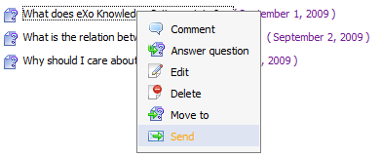
The 2nd way: Click the Send icon at the top right corner of the question when viewing it in details:
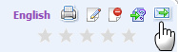
The Send question by email form will be displayed:
Details:
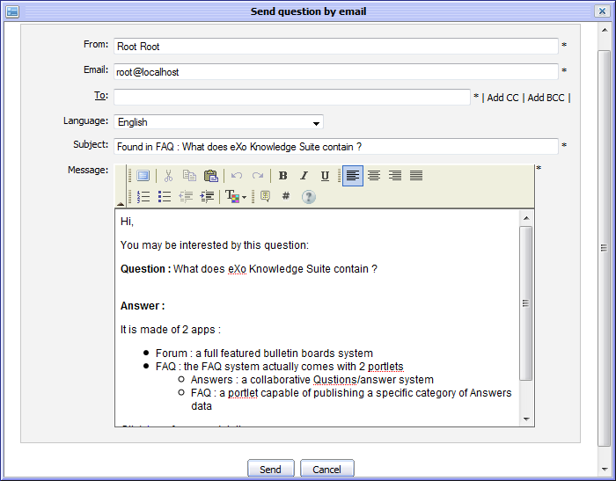Illustration 25: The Send question by email form
From: The name of the sender.
Email The email address of the sender.
To: The email address of the receivers. Using CC and BCC to send this message to more than one person easily and fast by clicking the 'Add CC' or 'Add BCC'. Using the 'Add CC' when you want other users know and refer to this message. Using the 'Add BCC' when you want other users also receive this message but all receivers do not know that you also send this message to others.
Language: The language is used to display content of the question. By default, it is English. However, if the sent question has been submitted in the other language such as French or Vietnamese, you can select the favorite for sending. When the language is changed, the question's subject and message content are changed correspondingly.
Subject: The subject that you want to send to your friend.
Message: The content of the message that you want to send to your friend.
Send button: To accept sending a question to friends.
Cancel button: To close the Send question by email form.
- Enter values for fields in the Send question by email form
- Complete sending the question by clicking the Send button.
The users with email addresses in the To, CC and BBC field will receive this message. The receivers can click the 'here' link in the content of the message to view the question in details in the Answers application.

Approving/disapproving questions
This function is used to moderate questions in a category that is set the 'Require approval on new questions' option.
One category may be set 'Moderate new questions' or not. If the 'Moderate new questions' option is not set, by default all questions in this category are approved and are displayed. But when 'Moderate new questions' is set in one category, the new questions are added in it will be in the unapproved status and need to be moderated.
There are 2 modes for Answers: All and Approved.
- The All mode means that all approved and unapproved questions are displayed and visible for all users.
- The Approved mode means that only the approved questions are displayed and visible while the unapproved questions are not displayed and invisible.
Thus, in the Approved mode, the Moderate question function will determine the unapproved questions will be displayed or not.
Do as follows:
The 1st way:
- Go to the Edit question function which corresponds to the question that you want to approve or not.
- To approve, select the Approved check box. Otherwise, don't select this check box.
After being approved, all users can view these questions normally whatever Answers mode is.
The 2nd way:
- Go to the Answer question function which corresponds to the question that you want to approve or not.
- To approve, select the Approved check box. Otherwise, don't select this check box.
After being approved, all users can view these questions normally whatever Answers mode is.
The 3rd way:
- Click the button on the tool bar. The Manage questions form will appear like Illustration 20 and Illustration 22.
- You can approve by clicking the current status of the question to change. If you want to disapprove, you can do it vice versa.
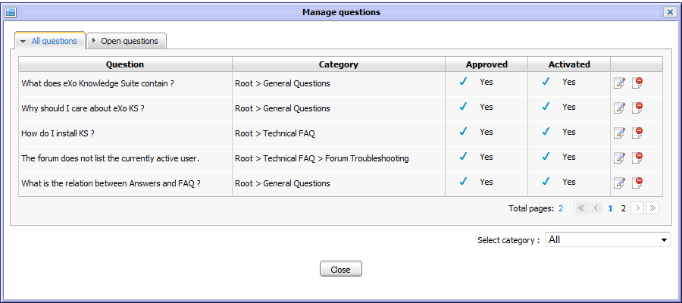

Activating/ Inactivating questions
This function is used to activate/inactivate questions. When a question is activated, it will be displayed and visible for all users to view. If not, it is hidden and invisible.
Do as follows:
The 1st way:
- Go to the Edit question function that corresponds to the question that you do not want to activate or not.
- To activate, select the Activated check box. Otherwise, don't select this check box.
The selected question will not be displayed.
The 2nd way:
- Go to the Answer question function that corresponds to the question that you want to activate or not.
- To activate, select the Activated check box. Otherwise, don't select this check box.
After being activated, all users can view these questions normally whatever the Answers mode is.
The 3rd way:
- Click the button on the tool bar. The Manage questions form will appear like Illustration 20 and Illustration 22.
- Activate the question by clicking the current state of the question:
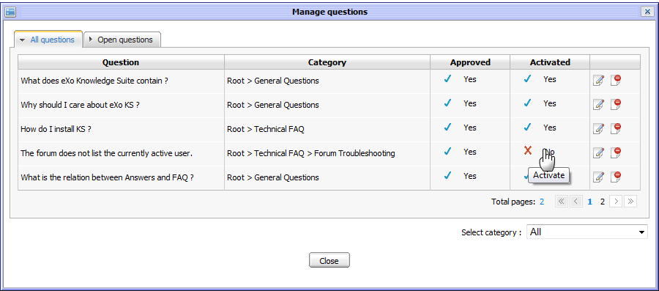
If you want to change a question from inactivated status into activated status, follow the above steps.

Approving/Disapproving answers
This function is used to approve/disapprove answers of specific questions. When the administrator or the moderator view the question answer, if they want to approve/disapprove a specific answer, he can click directly on the approve/disapprove icon beside the answer.
To approve an answer, click its disapproved icon to change the current status:
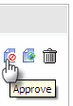
To disapprove an answer, click its approved icon to change the current status:
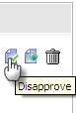
The approved answer will be visible to the normal users while the unapproved question will be invisible.

Activating/Inactivating answers
This function is used to activate/inactive answers of specific questions. When administrators or moderators view an answer, if they want to activate/inactivate a specific answer, he can click directly on the activate/inactive icon besides the answer.
To activate an answer, click its inactivated icon to change the current status:
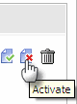
To inactivate an answer, click its activated icon to change the current status:
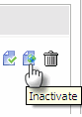
The inactivated answer will be hidden to the normal users while the activated question is shown.

Editing answers
This function allows editing a specific answer of a question.
Do as follows:
- Click on the edit icon corresponding to the answer that you want to edit.
The Answer form will be displayed with the current answer's information, available for editing:
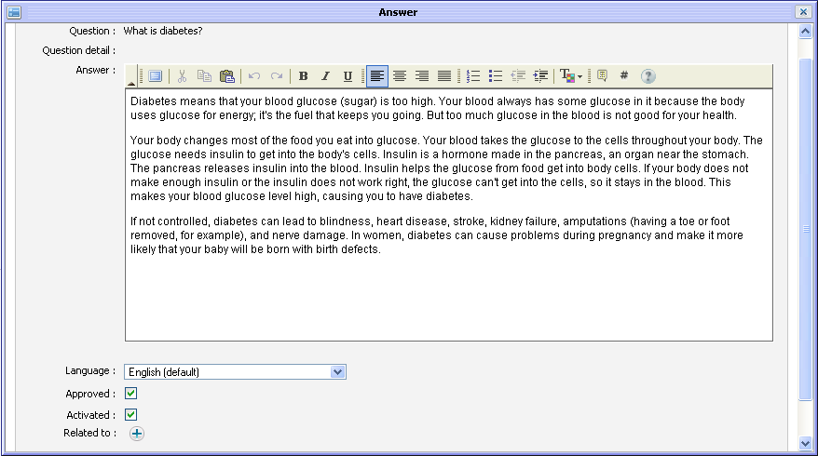
- Make changes in the form
- Click the Save button to accept saving the changes.

Deleting answers
This function is to delete specific answers of a question.
When viewing question, if you are the administrator/moderator, you can see all answers of a specific question.
To delete one answer, simply clicking on the delete icon below the answer you want to delete:
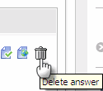
A deletion confirm message is shown. Click the OK button to accept deleting or the Cancel button to cancel.

Viewing questions
Each question in the question list has the collapse/expand mode.
To view a specific question, click on the question title. For an example, click on 'What is areobic exercise?' question
The question details will be shown below:
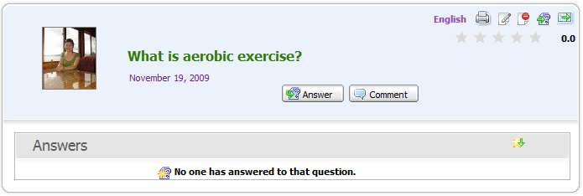Illustration 26: The question panel in case it has not been answered
It includes the question content, the answer content (in case the question has not been answered, 'No one has answered to that question' message is shown).
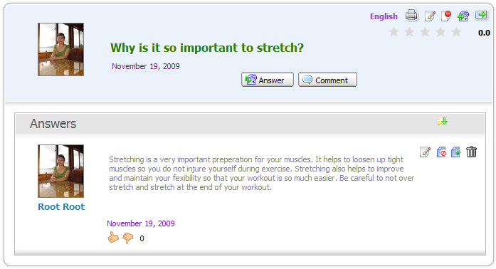Illustration 27: The question panel in case it has been answered
It may include attachments, related questions, languages to display (the default is English). Besides:
: This icon is used to print the question.
: This icon is used to edit a question or an answer.
: This icon is used to delete a question.
: This icon is used to move a question
: This icon is used to send the question.
: This icon is used to sort question by its star rate.
: This icon is to rate up/down the answer.
To view a question in the other languages, simply click on its language options. With the sample above, there are 3 languages: English, Vietnamese and French. By default, the question is displayed in English. To view in French, simply click on the 'French' option, the question will be displayed in French.
To view the image attachment in preview mode, simply click on the image that you want to view, the image will be shown in the preview mode:
To close the image preview mode, left click on the previewed image, preview mode will be closed.
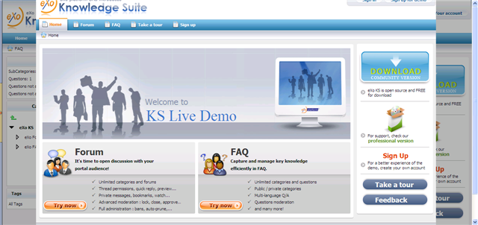Illustration 28: The image preview mode
To download the attachments, click on the attachment title. The download pop up will appear with 3 options:
- Open with: To directly open the attachment with proper application
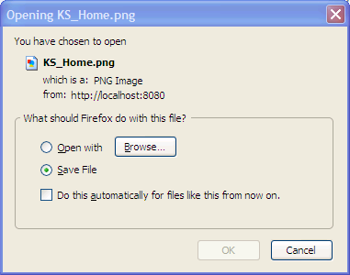Illustration 29: The download file pop up on Fire Fox
- Save File: To save the attachment.
- Cancel: To close down load pop up without downloading.

To close the view question form, click on its title again, its answer and related questions will be hidden.
Besides, in the Manage questions form, the Answers administrators can view all questions in all categories or all questions that have not been answered.
This action supports the administrators to view questions generally.
Do as follows:
- To view question list in general, click the button on the tool bar. The Manage questions form will appear.
This form includes two tabs, in which:
- The All questions tab includes all questions in all categories like Illustration 21
- The Pending questions tab includes all questions that have been not answered like Illustration 20.

Voting questions
This function allows logged users to evaluate a question by voting in form of rating star from 1 to 5. The more star rate the question has, the more interesting it is.
Do as follows:
- Go into the question which you want to vote.
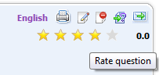
- Rate the question by left clicking on the star. The number selected stars will be changed from gray to yellow. Click the Cancel button if you want to quit the Vote form.
After being voted, the vote statistics is updated.
Note:
Each user can only vote one question at once. The vote function is not available to the anonymous users.

Removing question vote
This function allows you to remove your vote on a specific question that let you vote it again.
Do as follows:
- Go to the question that you have voted it before.
- Click on the vote star at the top right question panel:
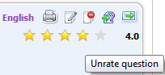
The alert message will appear:
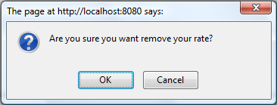
- Click the OK button to confirm removing your vote or the Cancel button to close the alert message without removing.

Rating up/down answers
This function allows you to rate up/down an answer of a specific question. Each voter can only rate Up (+1) or Down (-1).
To rate up/down, simply click on the thumb icon:
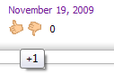
You can not rate twice but you can change your rate. When changing, the old rate will be removed, recalculated and updated with new score.

Commenting questions
This function allows logged users to give comments on specific questions.
Do as follow:
- Click on the Add comment button or right click on a specific question and select Comment in the menu:

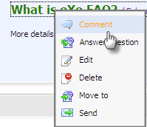
The Comment form will appear:
- Input comment into the text editor
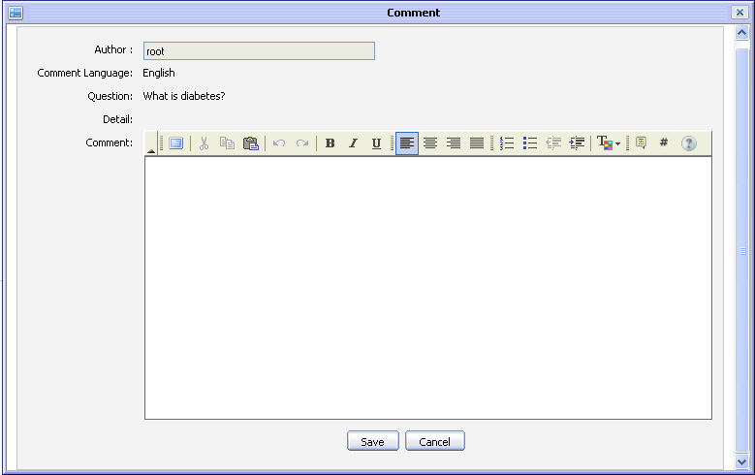Illustration 30: The Comment form
- Click the Save button to accept saving a comment.
After commenting a question, the comment is displayed below:
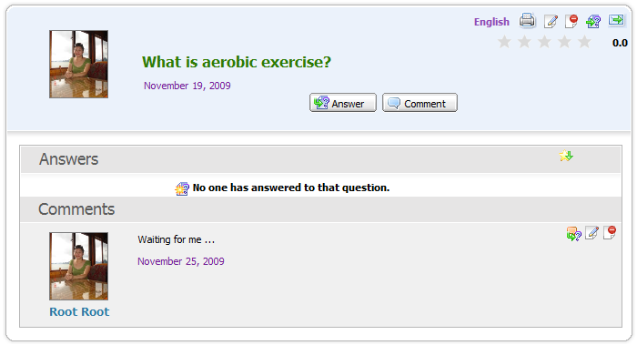
To promote a comment as an answer, click on the icon on the top right of the comment panel.
To edit a comment, simply click on the edit icon on the top right of the comment panel.
To delete a comment, simply click the delete icon on the top right of the comment panel.
Note:
Comments can be written in different languages. If a question is posted in multiple languages, its can have comments in multiple languages, too.

Promoting comments
This function allows promoting comments of a specific question to be its answer.
Do as follow:
- Click on the question which has a comment that users want to promote to be its answer.
- Click on the promote icon to change the comment into the answer of the question.
After being promoted, the comment becomes the answer of its question.

Search
This function is used to search existing categories and questions. With the Quick Search and the Advanced Search, you can find expected result quickly and flexibly.

Quick Search
With the quick search, you can directly type a search term in the search field. All the categories and questions which have a keyword that match with the search term will be displayed in the Search results form .
Do as follows:
- Enter a search term into the search text box at the right top of the Answers screen:
- Click the search icon next to the search box to do search
All categories/questions that match with the search term are listed in the Search results form:
To view a category or a question in details, you can click the icon which corresponds to the category or the question that you want to view.
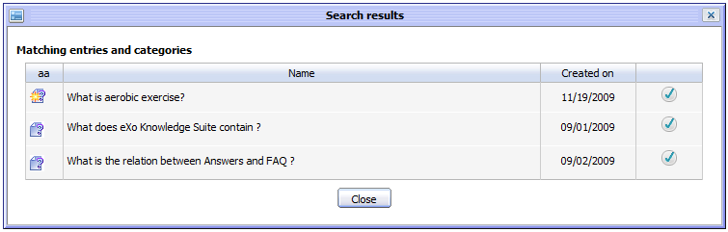Illustration 31: The simple Search Result form
In case, click on the question's title, its detail content will be shown:
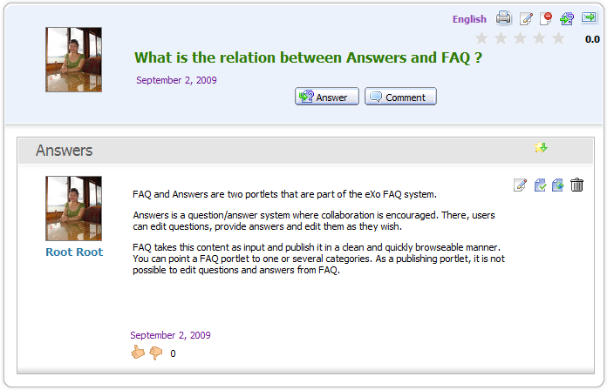Illustration 32: The detail content of a question

Advanced Search
Advanced search allows users to do a search with particular criteria corresponding to the object that is expected to be found. Using the advanced search, you can find questions/categories more exactly.
Do as follows:
- Click the advanced search icon at the right corner of your screen when you go into the Answers application.
By default, you can find both categories and questions concurrently. But if you choose an object in the 'Search in' field, it means that you only search that object.
Details:
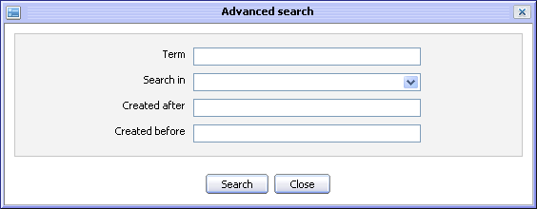Illustration 33: The Advanced search form
Term: The search term which relates to the categories/questions that you want to search.
Search in: The object that you want to search. By default, this field is blank. It means both categories and questions will be searched concurrently.
Created after – Created before: The created date interval in which you want to search for the selected object.
Search button: To accept doing search.
Close button: To close the Advanced search form.
The Advanced Search form will be displayed differently corresponding to each object that is selected in the 'Search Object' field.
With 'Categories object: The Advanced Search form will appear:
Details:
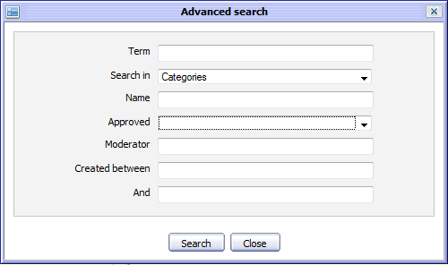Illustration 34: The Advanced search form with Search in Categories
Term: The keyword related to categories that you want to search.
Search in: The object that you want to search. If you want to search categories, value of this field is 'Category'.
Name: The name of categories that you want to search.
Approved: The status of questions in the categories that you want to search. There are two statuses: 'True' and 'False'. With 'true', all questions in these categories were approved. With 'False', all questions in these categories were not approved.
Moderator: The name of all category's moderators that you want to search
Created after – Created before: The created date interval in which you want to search for the categories.
With 'Entries' object, The Advanced Search form will appear:

Details:
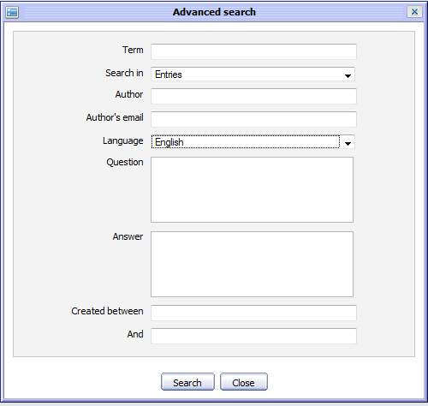Illustration 35: The Advanced Search form with Search in Entries
Text: The keyword related to the questions that you want to search.
Search in: The object that you want to search. If you want to search questions or answers, value of this field is 'Entries'.
Author: The name of the entries 's creator.
Author's mail: The email address of the entries 's creator.
Language: The language of the entries that you want to search
Question: The content of the questions that you want to search.
Answer: The response of the questions that you want to search.
Created between – And: The created date interval in which you want to search for the questions.
- Enter the values of properties corresponding to each object that you want to search
- Complete advanced searching by clicking the Search button.
The list of the found objects will be displayed in the search result form or there will be an alert message which informs that no objects match with the inputted properties.
To view details about one object in the Search results form, select the name of the found object in list or click the icon that corresponds to the object that you want to view.
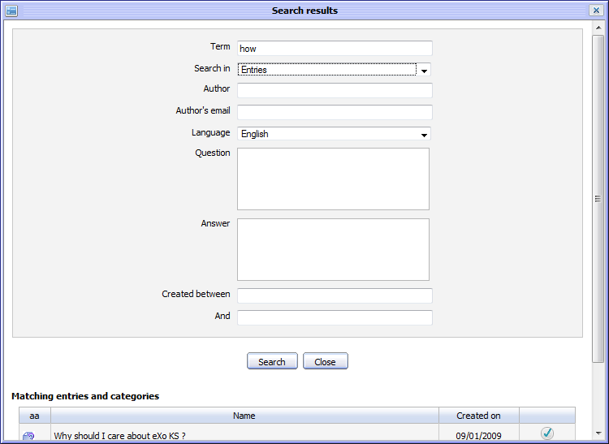Illustration 36: The Search results form

User Settings
This function allows you to set some displaying properties of the Answers application. Besides, it allows you to sort the Answers by popularity, manage watch and change avatar.
Do as follows:
- Click the button on the tool bar, the User settings form will appear:
Details:
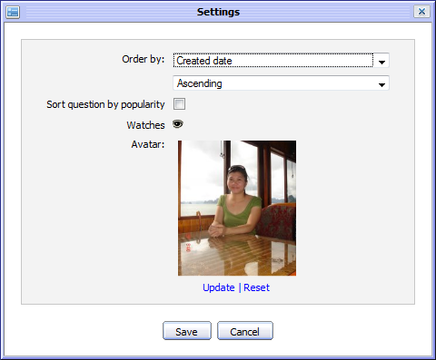Illustration 37: The Settings form
Order by: The way is used to order the entries in list.
- With the 'Created Date': The entries in the question list will be displayed in the order of the entries 's created date.
- With the 'Alphabet': The entries in the question list will be displayed in the alphabet order.
The type of sorting entries in the question list. It may be: Ascending or Descending.
Sort question by popularity: This option is whether to sort question by popularity or not.
Watches: To mange watches of current login users.
Avatar: The avatar of your account.
Update: To change an avatar .
Reset: To remove the current avatar and set by the default one.
Save button: To accept saving current settings.
Cancel button: To close the User Settings form.
- Select values for fields in this form.
- Saving the settings by clicking the Save button.
To manage watches, do as follows:
- Click on the watch icon to open the User Watch Manager form:
- Click on the category title to view in details.
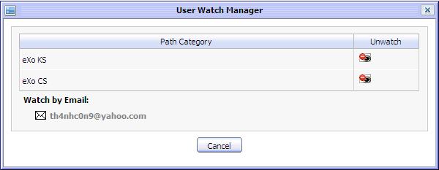Illustration 38: The User Watch Manager form
- Click on the unwatch icon that corresponds to the category that you want to remove a watch.
To change an avatar, do as follows:
- Click on the Upload link to open the Upload File form:
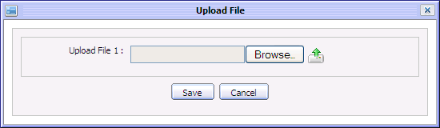
- Click the Browse... button to select a file to upload.
- Click the icon to upload the selected file.
- Click the Save button to accept changing the avatar.

Answers Portlet Settings
This function allows the administrators to set some properties for the Answers application.
Do as follows:
- Go to eXo Start--> Administration--> Advanced -->Manage Pages.
- Click the icon corresponding to the answers page in the page list:
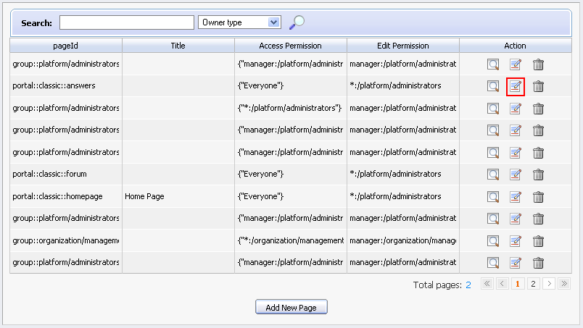
The Answers Portlet will appear:
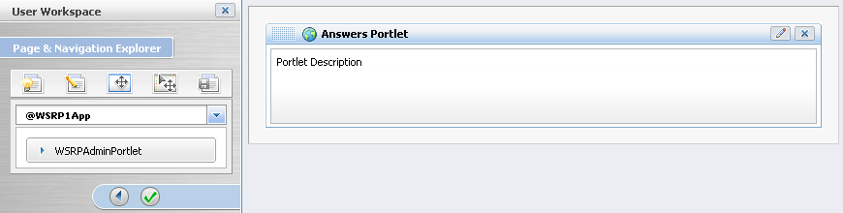
- Click the icon on the right corner of this portlet. The form to edit the Answers portlet will appear:
Details:
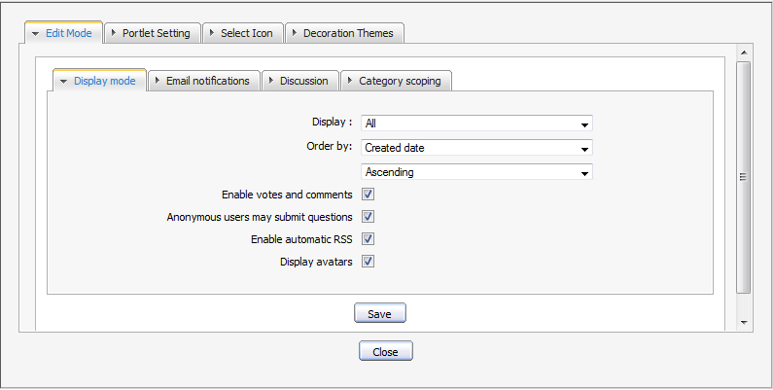Illustration 39: The Display Mode tab
The Display Mode tab includes all default displaying properties of the Answers application.
Display: The mode is used to display all entries in Answers application.
- 'All': all entries (includes: approved and unapproved entries/questions) are displayed in list when users view.
- 'Approved': Only approved entries are displayed in list when users view.
Order by: The way is used to display all entries in the Answers application.
- With 'Created Date': Entries in list will be displayed in oder of the entries 's created date .
- With 'Alphabet': Entries in list will be displayed in alphabet order.
The type of sorting entries in list. It may be: Ascending or Descending.
Enable votes and comment:s: This option is to whether or not allow vote and comment to be available in the Answers. If the Enable vote and comment check box is selected, users can comment and vote in Answers. If not, these functions are disabled.
Anonymous users may submit question:This option is to whether or not allow the anonymous users to submit question in the Answers. If the Anonymous users may submit question check box is selected, anonymous users have a right to submit questions. If it is not selected, anonymous users can't submit questions.
Enable automatic RSS: This option is to whether or not allow RSS feeds function to be available in the Answers or not. If the Enable automatic RSS is selected, users can get RSS information in Answers. If not, the RSS function is disabled.
Display avatars: This option is to allow viewing avatar in the Answers or not. If the Display avatars check box is selected, the avatar of eXo members are shown in Answers. If not, they are hidden.
The Email notifications tab allows defining the content of notification mails. It includes The New question, the Edit/answer tab and the Move Question tab:
Details:
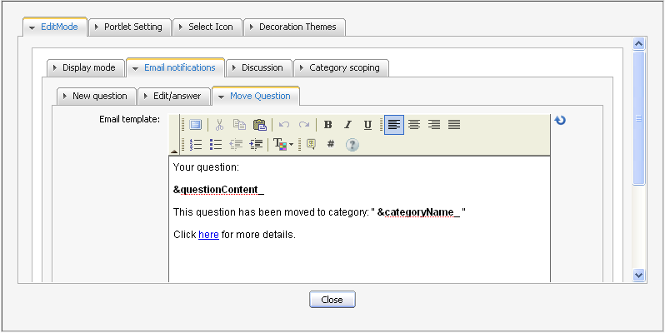Illustration 40: The Email notification tab
The New question tab contains the default content of notification mail about new questions.
The Edit/Answer tab contains the default content of notification mail about the question which is answered or edited.
To change the content of the notification mails, manually edit the text in the FCK editor. The content can be decorated with multi effects such as font style, size, color, image etc...
The Move Question tab contains the default content of notification mail about moving questions.
Notes:
There are some parameters which is used to load the category and question's content dynamically. Thus, you should not edit them.
&categoryName_ : To load the category's name.
&questionContent_ : To load the question's content.
&questionResponse_ To load the question's answer.
Here: To load the link to question in Answers.

The Discussion tab allows enabling/disabling the Forum discussion function in the Answers and set the default forum for this function.
To enable/disable the Forum discussions, simply select/ unselect the Enable Discuss check box.
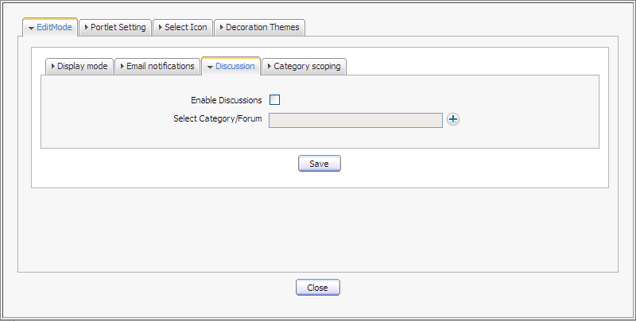Illustration 41: The Discussion tab
To define the default category for discussions, do as follow:
- Click on the to open the Select category/forum form:
The Select category/ forum form will appear:
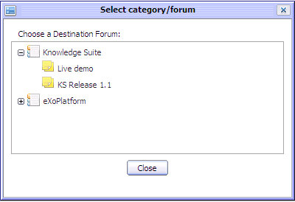Illustration 42: The Select Category/forum form
- Click on specific category/forum title to select it.
- Click the Save button to accept saving changes in the Discussion tab.

The Category scoping tab allows you to hide/show categories in the Answers application. The hidden category will not be displayed in the Answers application.
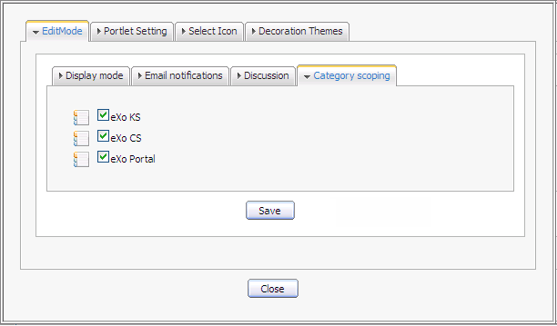Illustration 43: The Category Scoping tab
To hide/show any category, simply unselect or select its check box and click the Save button.
After the Forum portlet settings will be saved. The selected category will be displayed in the Answers application while the unselected category will be hidden.
The Portlet Setting tab includes:
Portlet Id: The identification value of the portlet
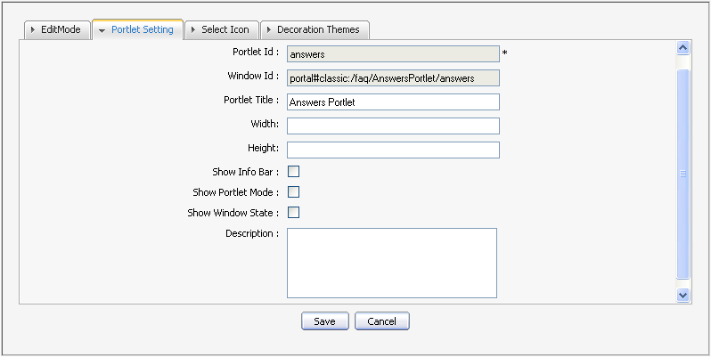Illustration 44: The Portlet Setting tab
Window Id: The identification value of the portlet's window
Portlet Title: The title of the Answers portlet.
Width: The vertical size of the portlet. Value of this field should be in a numeric format. It is not required and you can change.
Height: The horizontal size of the portlet. It is should be in a numeric format. It is not required and you can change.
Show Infor Bar: This option is whether or not to show Information bar of the portlet or not
Show Portlet Mode: This option is whether or not to show portlet mode of the portlet.
Show Window State: This option is whether or not to show window state of the portlet or not
Description: This brief description about the portlet. It must has length from 0 to 255 characters.
The Select Icon tab allows selecting icon for the portlet. By clicking the Get Default, you do not have to choose any icon from list, it will automatically get the default one for the portlet.
The Decoration Themes tab allows selecting theme for the portlet. There are some themes list, by clicking the Get Default, you do not have to choose any theme, it will be automatically set for the portlet.
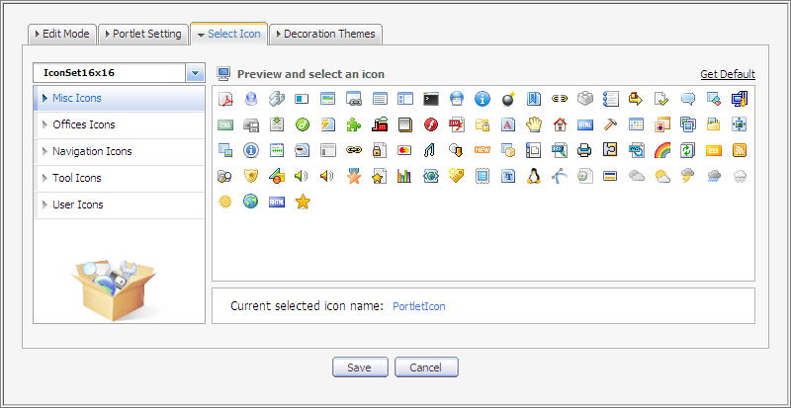Illustration 45: The Select Icon tab
- You can set values in the Display Mode tab to set properties in the Answers or check 'Show Info Bar' and 'Show Portlet Mode' option to set properties.
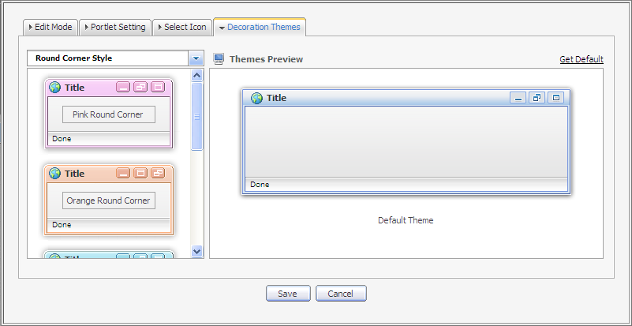Illustration 46: The Decoration Themes tab
- Click the icon to save all changes.
All entries/questions in the Answers will be shown according to your setting in the Edit Mode tab.
Besides, you can also set displaying properties by the below way:
- Open the Answers application and select the Edit function in the menu when you click the icon on the right corner of the Answers portlet.
- The form to edit some displaying properties will appear like the Edit Mode tab above.
- Change values in these fields.
- Click the Save button to save all changes.
Select the View function in the menu to view the Answers application.

Printing
This function is used to print a question or all questions in a specific category.
Do as follows:
- Go to the Answers screen view that you want to print.
- Click the button on the tool bar to print all the questions in the current category in details or click the print icon on the right question panel to print that question only.
The print preview page will appear:
- Click the Print button to set up the printer or click the Close button to quit the print preview mode.
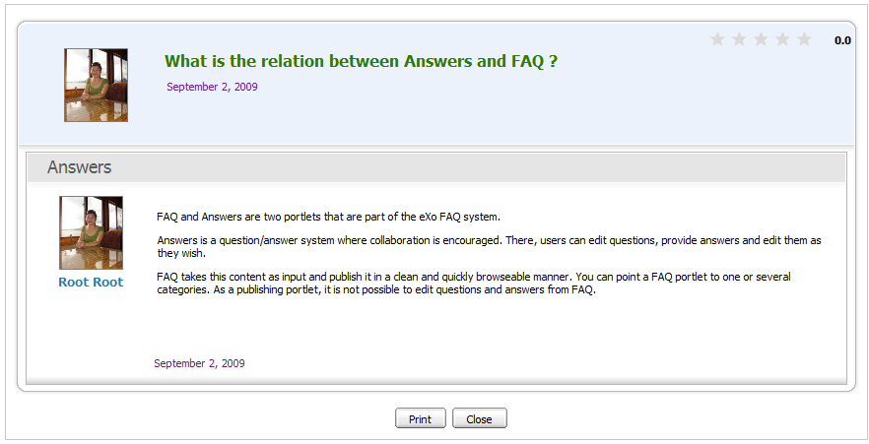Illustration 47: The print preview page

Exporting/Importing

Exporting
This function is used to export categories and questions in the Answers into your local computer in form of *zip file. The Export function can be executed on all categories and questions in the Answers or a specific category.
To export all categories and questions, do as follow:
- Go to Answers application.
- Click on the Manage Category button on the main action bar and select Export in the menu or right click on the category that you want to export and select Export in the menu:
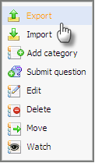
The Export form will appear:
Details:
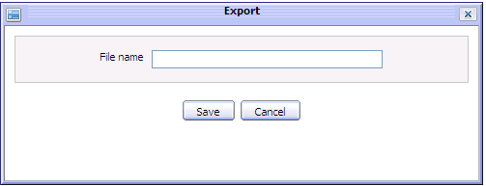Illustration 48: The Export form
File Name: The name of the exported file.
Save button: To accept exporting all categories and questions.
Cancel button: To exit the Export form.
- Input a File name to export.
- Click the Save button to accept exporting all categories and questions.
A download pop up will appear:
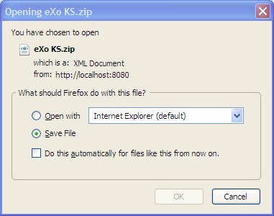
Simply select the Save File option and click the OK button to accept saving the exported file.
Similarly, to export a specific category, go to the Answers application and go to inside specific category. Click on the Export button on the main action bar or right click on the category and select the Export option to open the Export form or and take action like steps above.
The exported file can be used to import exported files into the Answers system.

Importing
This function is used to import categories and questions from a zip file which has a valid content into the Answers system. An exported file can be imported directly into the Answers home page or a specific category in the Answers.
To import a zip file into the Answers home page, do as follow:
- Go to the Answers application
- Click on the Manage Category button and select Import in the menu or right click on the category that you want to import and select Import in the menu:
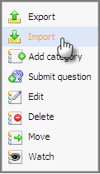
The Import form will appear:
Details:
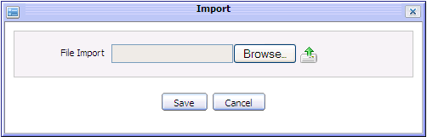Illustration 49: The Import form
File Import: The path of the imported file.
Browser button: To select the imported file path.
button: To upload the selected file.
Save button: To accept importing the uploaded file.
Cancel button: To exit the Import form.
- Click the Browser... button and select a file from the local disk.
- Click the button to upload the selected file. For example, select and upload the exported file named eXo KS.zip. After uploading, the Import form is shown :
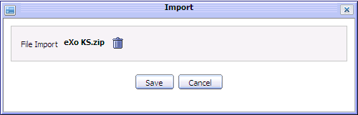
- Click the Save button to accept importing the uploaded file into the Answers system.
After importing, all categories and questions which are defined in the zip file will be imported and displayed properly in the Answers home page.
Similarly, to import a zip file into a specific category, go to the Answers application and go to inside a specific category. Click the Import button on the main action bar or right click on the category and select the Import option to open the Import form and take actions like steps above.
The imported categories and questions will be displayed properly in the selected category.

Showing/hiding the left panels
This function allows personalizing the Answers view by showing/hiding the left panels .
By default, the Answers application is displayed with all panels. In case you want to hide/show all panels on the left, you can click the button on the main action bar.
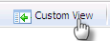
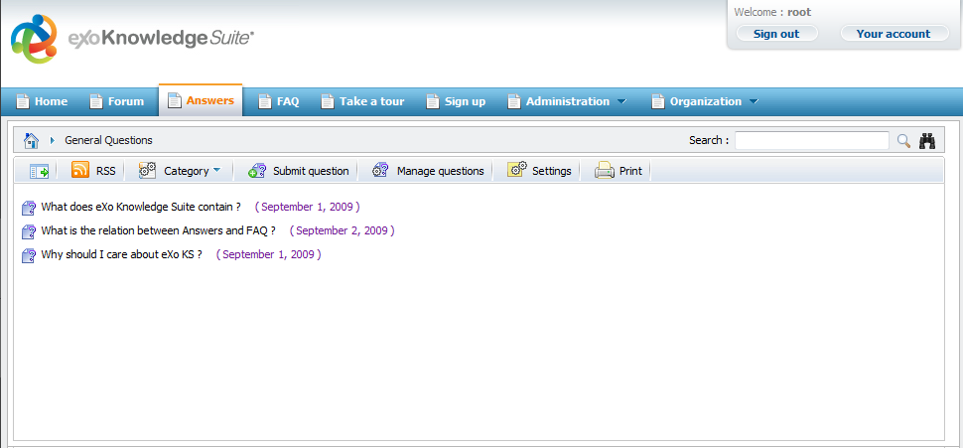Illustration 50: The custom View without the left panels

Dragging and dropping
This feature is used to change the position of categories in the category list or move the subcategory to its parent list.
Do as follows:
- Right click the icon of the category that you want to change the display position
- Drag and drop it above / below the current position or to the green arrow icon.
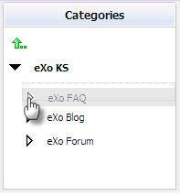
The dropped category will be moved to the new position properly. The category list will be changed properly. The order of all categories will be updated correspondingly.
Note:
This feature is available for the administrator only.

Viewing user profile
This function allows viewing the profile of specific user who submits, answers or comments question.
To view profile of a specific user, simply clicking on his/her user name, the user profile pop up will be displayed:
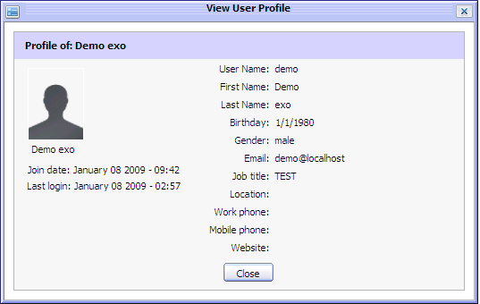Illustration 51: The View User Profile form

Discussing in forum
This function allows discussing a question in the Forum application.
When a question is discussed, it will become a new topic in the Forum application. The new topic is created with the topic title is the question title, the topic content is the question content and the post is the question answer or comment.
To discuss or view the discussion of a question, click on the discuss icon at the top left of the question panel or click on a specific question and select Discuss Forum in the menu:
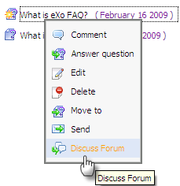
After being discussed, a new topic is created into the forum which is defined as the discussed forum in the Answers Setting and you are redirected directly to the Forum application below:
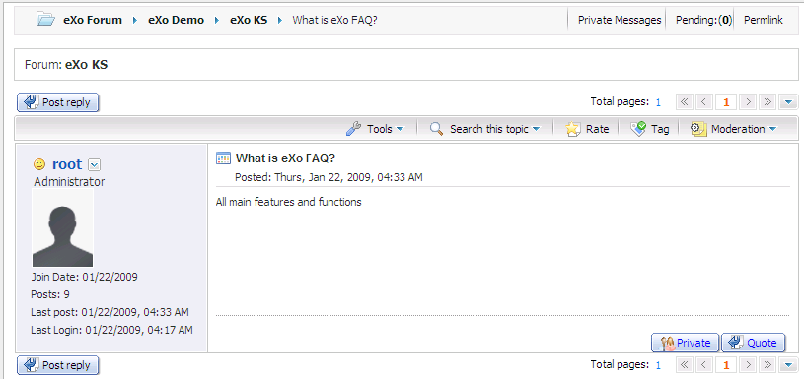
When there is a answer added, a comment added or any edition in a question, an answer or a comment, the discussed topic in the Forum application is changed correspondingly.
However, when the question is clicked to discuss at the first time, its status is pending for approval. You can only view the discussed topic when the Forum administrator/moderator approve it.
After a question is discussed, to view it, simply click on the Discuss forum option in its right click menu.

RSS feed
This function provides RSS feeds. Each time an entry is added or updated, the feed of the corresponding category will be updated.
Do as follows:
- Click on the category that you want to get RSS feed.
- Click the RSS button on the main action bar or select RSS in the right click menu of a specific category:
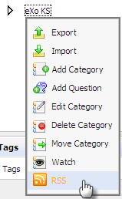
The RSS information page will appear on another tab:
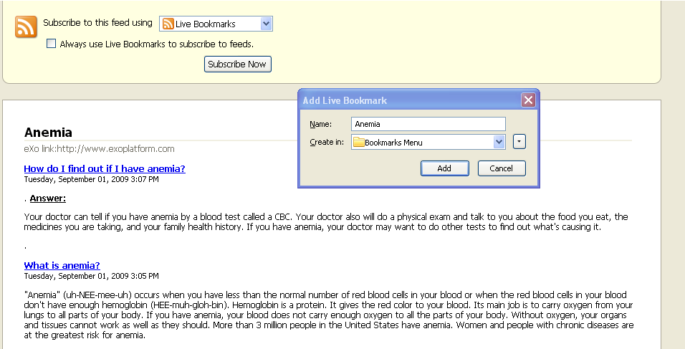
All question information of the category that is being watched are listed.
To add live bookmark, simply clicking on the Subscribe Now button and click the Add button in the menu pop up.

FAQ Portlet
eXo KS facilitates users with the FAQ portlet that helps users quickly and easily view the questions and answers from the Answers portlet by the tree view type.

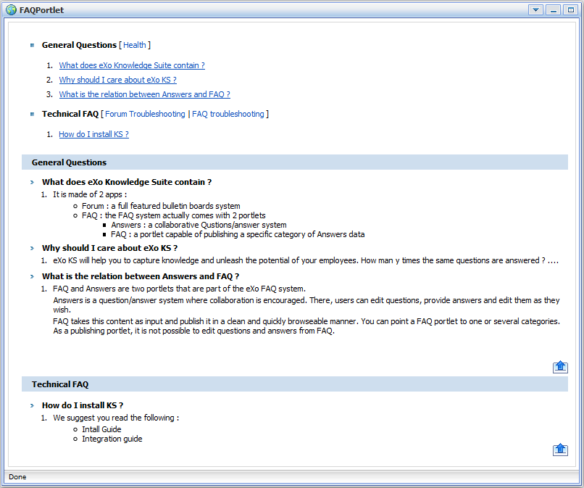Illustration 52: The FAQ Portlet in the View mode
The Edit Mode of the FAQ Portlet: allows users to set the properties to display questions and answers in the View mode.
Click the portlet mode icon to open the menu that will let you select the edit mode:

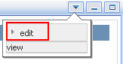
The Edit Mode of the FAQ portlet will appear:
The Displaying Category tab: allows users to select the category which contains questions and answers that will be displayed in the View mode.
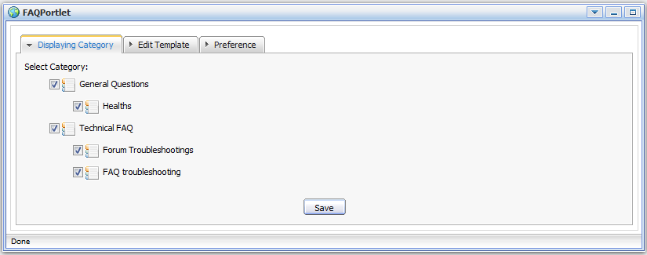Illustration 53: The FAQ Portlet in the Edit mode
- Select the checkboxes which correspond to the categories that you want to display the content in the View mode.
The Edit Template tab: the content template that will be displayed in the View mode. If you want to edit this template, you need to have a knowledge about css.
- Edit the template according to your need (in case you have a knowledge about css).

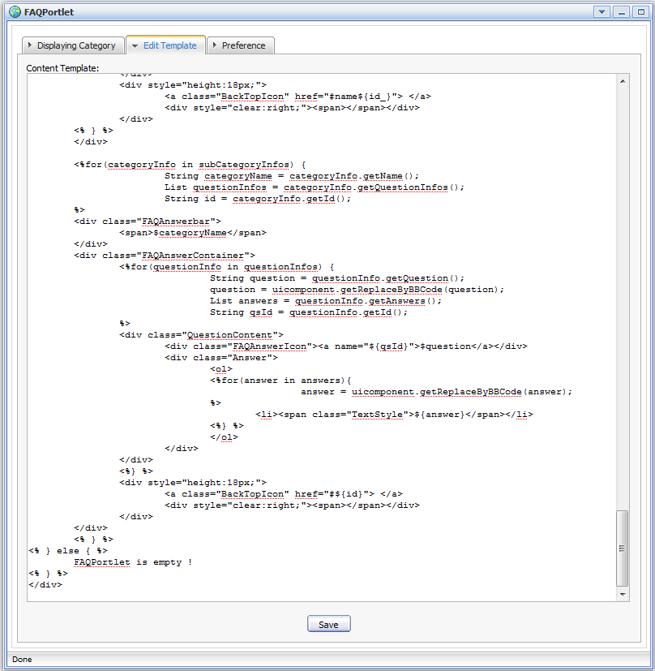
- Click the Save button to save all changes.
The Preference tab: Users need to have a knowledge about Ajax. Ajax (stands for Asynchronous JavaScript and XML) is used here with the purpose of update a whole web page or a part of a web page.
The default value of Use Ajax is false that means a whole page is loaded. When users select the Use Ajax check box, it will load a part of a page.
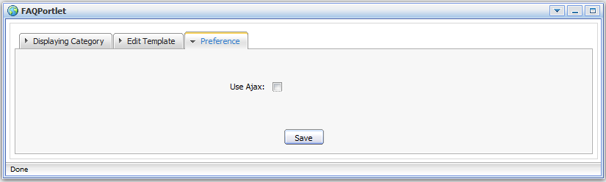Illustration 54: The Preference tab
Click the portlet mode icon and select view in the menu to view all categories, questions and answers in the template that you have just set in the Edit mode.

