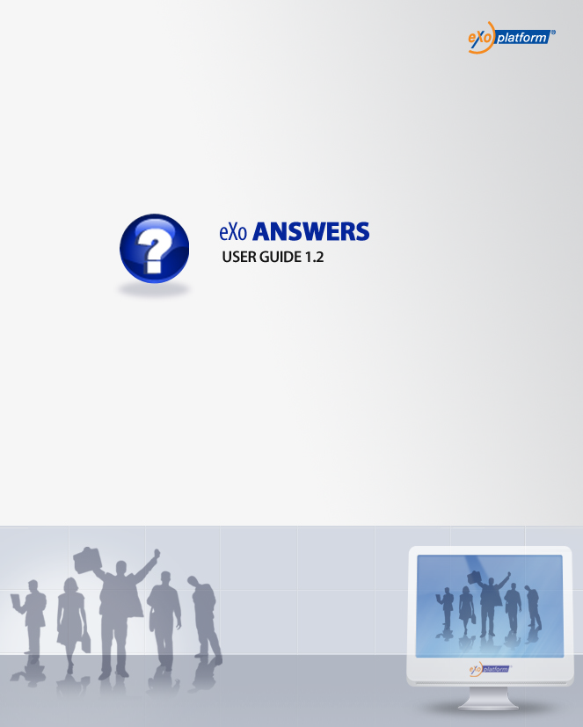
REVISION HISTORY
Version | Date | Written by | Reviewed by | Change Record
1.0 | January 03, 2009 | Hoang Anh Quynh Nga | Nguyen Thanh Cong
1.1 | March 18, 2009 | Nguyen Thanh Cong | Hoang Anh Quynh Nga | - New FAQ UI with left pane, category tree and question panel  - New Submit Question form: Question title, question detail.  - Improve the way to add question in multiple languages.  - View question in multiple answers  - Vote question  - Vote answer  - Comment question in multiple languages  - Custom view  - View user profile  - RSS feeds  - Update Tool bar and Breadcrumb enhancements.  - Update vote question, answer.  - Unvote question and rate up/down answer  - Changes on Watch function  - Update Unwatch function  - Changes on question template.  - Update User Settings function  - Submit question form with FCK Editor  - User Setting: manage watch and change and delete avatar.
1.2 | September 1, 2009 | Luong Quynh Lien |  | - Change screenshots.  - Answers portlet.  - FAQ Portlet
1.2.2 | November 22, 2009  February 4, 2010 | Luong Quynh Lien |  | - Upgrade to 1.2.2  - Review

Table of Contents
1. Preface 5
1. About this guide 5
2. Who should read this guide 5
3. Objective of this guide 5
2. Overview 6
What is Answers application? 6
What is a Category? 6
What is a Question? 6
What is an Answer? 6
What is Comment? 6
The Answers Application main screen 7
3. How to use the Answers Application? 8
3.1 Main Work flow 8
3.2 Register new account 9
3.3 Signing in/Signing out 11
3.3.1 Signing in 11
3.3.2 Signing out 13
3.4 Question management 13
3.4.1 Adding questions 13
3.4.2 Viewing questions 17
3.4.3 Voting questions 20
3.4.4 Removing question vote 21
3.4.5 Rating up/down answers 21
3.4.6 Commenting questions 21
3.4.3 Sending to friends 23
3.4.4 Editing questions 25
3.4.5 Watching 27
3.4.6 Unwatching 28
3.5 Search 28
3.5.1 Quick Search 28
3.5.2 Advanced Search 29
3.6 User Settings 33
3.7 Printing 35
3.8 Showing/hiding the left panels 37
3.9 Viewing user profile 37
3.10 Discussing forum 38
3.11 RSS feed 39
3.12 FAQ Portlet 40

Illustration Index
Illustration 1: The FAQ application main screen 7
Illustration 2: The main work flow of the Answers application 8
Illustration 3: The anonymous home page of the classic portal 9
Illustration 4: The Create my account form 10
Illustration 5: The Sign in form 11
Illustration 6: The authenticated homepage 12
Illustration 7: The authenticated Answers application 13
Illustration 8: The Submit question form 14
Illustration 9: The Select language combo 15
Illustration 10: The Upload File form 15
Illustration 11: The question panel in case it has not been answered 17
Illustration 12: The question panel in case it has been answered 18
Illustration 13: The image preview mode 19
Illustration 14: The download file pop up on Fire Fox 20
Illustration 15: The Comment form 22
Illustration 16: The Send question by email form 24
Illustration 17: The Edit question form 26
Illustration 18: The watch alert message form 27
Illustration 19: The simple Search Result form 29
Illustration 20: The View entry form 29
Illustration 21: The Advanced search form 30
Illustration 22: The Advanced search form with Search in Categories 31
Illustration 23: The Advanced Search form with Search in Entries 32
Illustration 24: The Advanced Search Result form 33
Illustration 25: The User settings form 34
Illustration 26: The User Watch Manager form 35
Illustration 27: The print preview page 36
Illustration 28: The custom view without the left panes 37
Illustration 29: The View User Profile form 38
Illustration 30: The FAQ Portlet in the View mode 41
Illustration 31: The FAQ Portlet in the Edit mode 42

1. Preface

1. About this guide
eXo platform™ software is a powerful Open Source corporate Portal and content management system. Users of the platform have a customized single point of access to the company's information system and resources. The purpose of this user guide is to help users who have administration privileges for the Answers application which is an application of the Knowledge Suite – a module of eXo portal.
This documentation is an useful guide for you to learn about eXo Portal technology in details. It gives an in depth examples and easy explanation of eXo platform technology that not only allows technical but also non-technical people to create and manage very fast and powerful website..

2. Who should read this guide
Welcome to the eXo Knowledge Suite material. This document aims at guiding various users of eXo Platform. This material is for anyone interested in learning and using the Answers application. It is also useful for the following groups:
- Users who use eXo Knowledge Suite with the Answers application in their work and business.
- Integrators who want to know more about the rich knowledge features in order to advise their customers to use eXo products.

3. Objective of this guide
This user guide will:
- Define some basic concepts used in the Answers application.
- Show the main instructions of the Answers application.
- Guide step by step to take basic actions.

2. Overview

What is Answers application?
Answers is an online document that poses a series of common questions and answers on a specific topic. Answers is a way to answer questions about rules or any problem.
The Answers section familiarizes visitors with answers to most commonly asked questions about a site/service or about the entity/subject that is responsible for the site/service. Repeatedly received questions will be added into the Answers.
Newcomers with Site/Service are encouraged to view the Answers.

What is a Category?
A category is the name for a collection of questions/answers about a specific topic. In the eXo Answers application, one category may include one or more sub-categories. One category may also contains both sub-categories and questions inside it.

What is a Question?
A question is user's expression used to ask and get information. In the Answers, all questions related the same topic have to be posted and grouped in the same category.

What is an Answer?
An answer is a response to a specific question. In the Answers, all responses are posted below its questions. Only people who have the moderation right can answer questions.

What is Comment?
A comment is a user's opinion on a specific question. In the Answers, all comments are posted below its question. A comment can be promoted to an answer by the administrator.

The Answers Application main screen
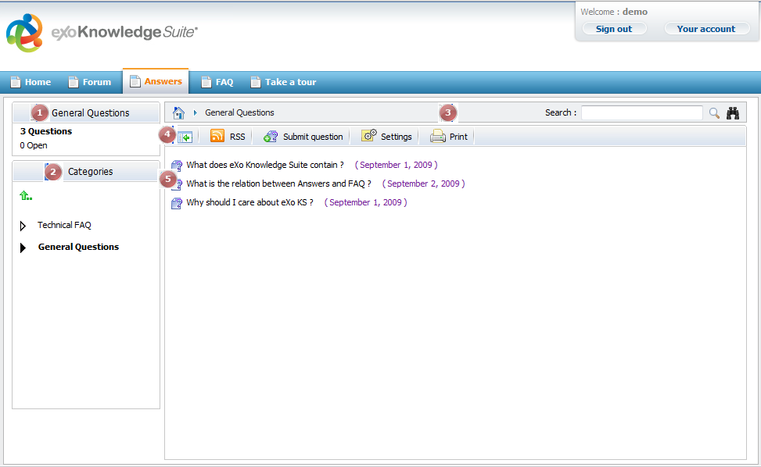Illustration 1: The Answers application main screen

Indicator | Meaning
 | This is the Categories Stats panel that displays information of current category that is being viewed including the total number of open questions (question's not answered yet), pending questions (questions that are waiting to be approved) and total of questions.
 | This is the Categories Panel that explorers the category in tree view. A click on one category will browse into it on Answers view panel.
 | This is the Breadcrumb bar that shows Answers path and search function with simple and advanced option.
 | This is the Action bar that allows users to quickly submit question, print, custom view.
 | This is the Answers view panel that displays all categories, subcategories and questions.

3. How to use the Answers Application?

Main Work flow
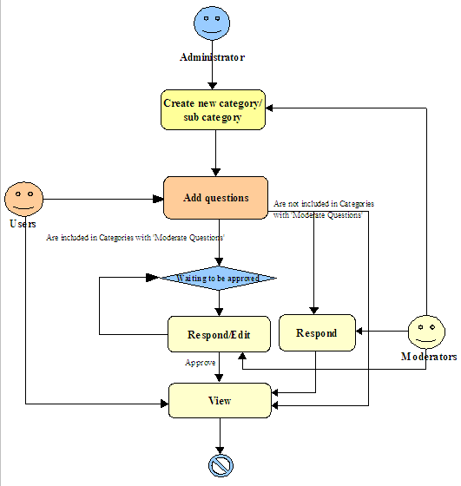Illustration 2: The main work flow of the Answers application
Explanation:
The administrator creates a new category/sub category. This category/Sub category can be set with 'Moderate new questions' or not. If the 'Moderate new questions' option is set, all questions in this category/ subcategory must be approved/disapproved by the moderators/administrators.
All users can add new question into a specific category/subcategory.

Register new account
To register a new account on the portal, do as follows:
- Go to eXo portal by inputting URL in the address bar (e.g: http://localhost:8080/portal). The anonymous home page will be displayed:
- Select the Sign up from the navigation bar. The Create my account page will appear:
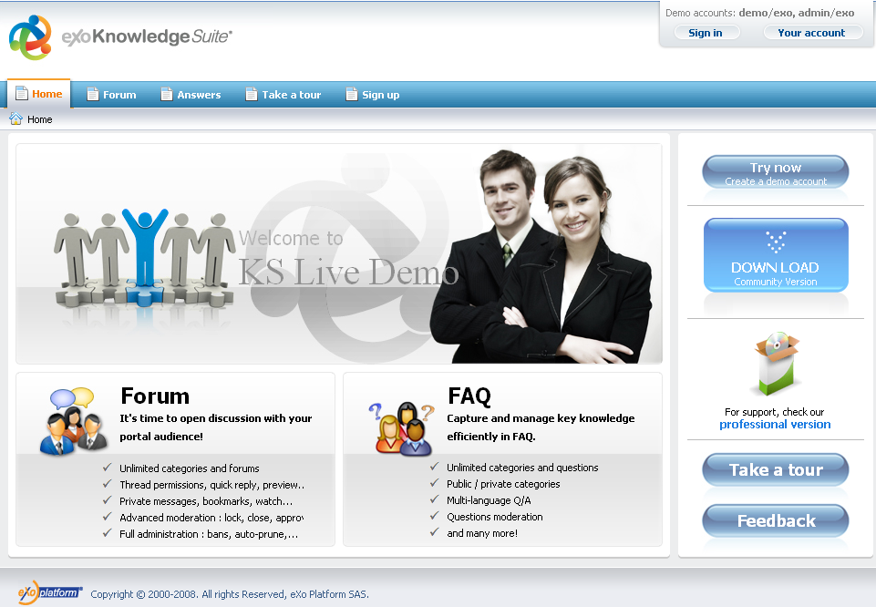Illustration 3: The anonymous home page of the classic portal
Details:
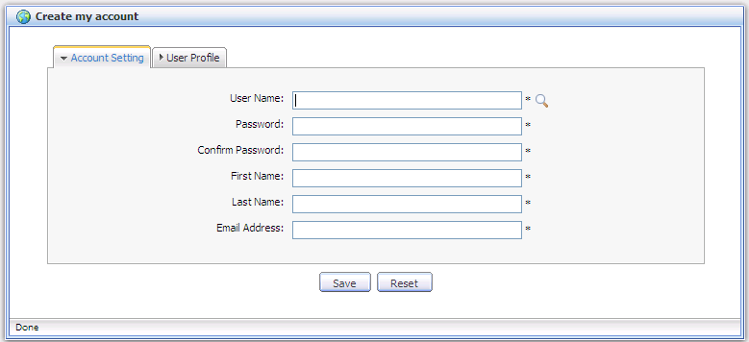Illustration 4: The Create my account form
The Account Setting tab includes:
User Name: The name of the user that will be used to sign in. It must be unique.
Password: The secret string used to login. It must have at least 6 characters.
Confirm Password: The re-typed password. Password and Confirm Password must be the same
First Name: Your first name.
Last Name: Your last name.
Email Address: Your contact email address. It must be in the right format. For example: flower@gmail.com
Save button: To accept saving new account.
Cancel button: To set blank entries for all text fields.
- Click the icon to search and check whether the inputted User name is available or not
- Input the other required fields in the Account Settings tab.
- Input values for the User Profile information, include: Profile information, Home information, Business information. These information are not required, you can input a value or not.
- Complete creating a new account by clicking the Save button.
There will have an alert message and you can not add a new account if at least one of these cases occurs:
  - The User name is existing or User Name is invalid
  - The Password has less than 6 characters.
  - The Password and Confirm Password are not the same
  - The Email Address is invalid format
  - The required fields are blank (empty)
After registering a new account, you can login and access the eXo Answers application.

Signing in/Signing out

Signing in
This function allows users to go into the portal/Answers in the private mode.
Do as follows:
- Go to the portal in public mode by inputting URL in the address bar (e.g: http://localhost:8080/portal)
- Click Sign in link at the top right of page if user in Classic portal. The Sign in form will appear:
Details:
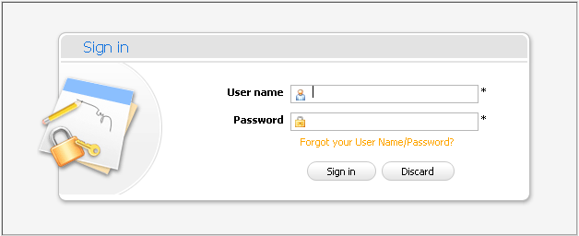Illustration 5: The Sign in form
User name: The registered user name
Password: The registered password
Forgot your User Name/Password? The link helps users retrieve username and password when they forgot.
Sign in button: To accept signing in
Discard button: To close the Sign in form
- Input your registered User name and Password
- Complete signing in by clicking the Sign in button.
In case, the User Name does not exist or the inputted User name/Password is invalid, there will be an alert message that requires users to input the right value. To login again, you click the OK in the alert message and re-enter the User Name and Pass word.
After signing in, you will be redirected to the authenticated homepage:
To take actions in the Answers application, you have to go into the Answers application page on the navigation bar. The main screen of the Answers application will be displayed:
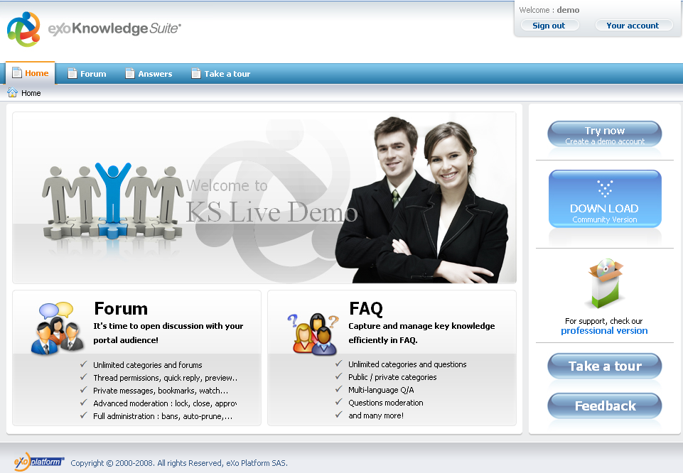Illustration 6: The authenticated homepage

Signing out
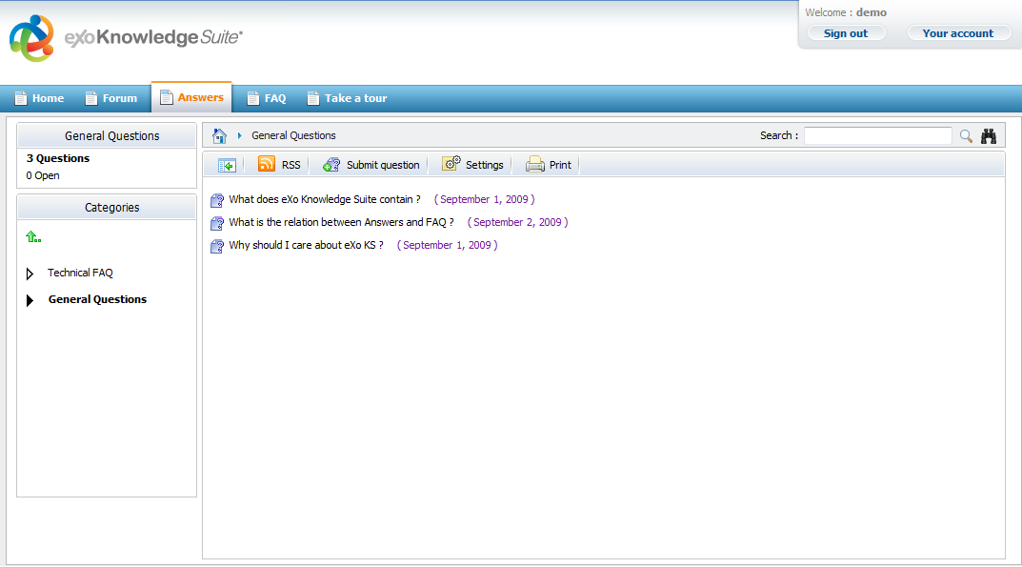Illustration 7: The authenticated Answers application
This function allows you to get back to the anonymous portal. It ends your current portal session.
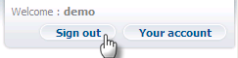
To sign out, click the Sign out button at the top right corner of the screen:

Question management
This section contains all actions related to questions in a category.

Adding questions
This function is used to add questions into the Answers home page or a specific category.
Do as follows:
- Show the Submit question form by one of two following ways:
- The 1st way: Right click on the category/subcategory that you want to add a new question into and then select the Submit Question in the menu.
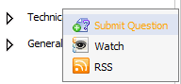
- The 2nd way: In the home page or go into the category that you want to add a question into and then click the button on the tool bar.
The Submit question form will appear:
- Input values for fields in the Submit question form:
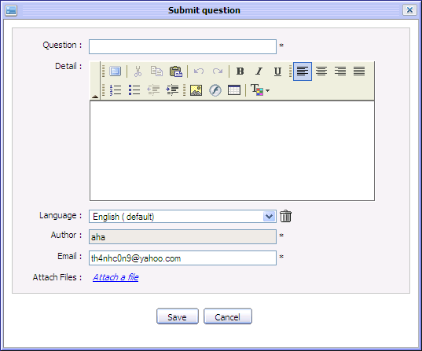Illustration 8: The Submit question form
Details:
Question: The brief content of the question.
Detail: The detail explanation of the question. The detail can be decorated by FCK Editor or BBC tags.
Language: The language that is used to add a question. By default, the language is English. Language combo box allows selecting language options.
Author: The name of the author. This field is required.
Email: The address of the email. This field must be in a valid format likes: username@abc.com. This field is required.
Files: The files attached into the question.
Attach a file: To attach files into the question.
Save button: To accept submitting the question.
Cancel button: To close the Submit question form.
To add this question by another language, do as follows:
- Click the language combo box in the Submit question form. The language drop list will be displayed :
- Select a language by clicking on the language that you want add to the question.
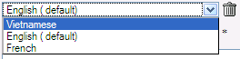Illustration 9: The Select language combo
There will be a text box that corresponds to the selected language in the Submit question form.
To remove a question in a specific language, simply select the language that you want to delete and click on the delete icon beside the language combo box.
After deleting, the corresponding language text box will be deleted.
To attach files, click the attach a file link in the Submit question form, the Upload File form will appear :
- Select files to upload by clicking the Browser... button to select the file's path.
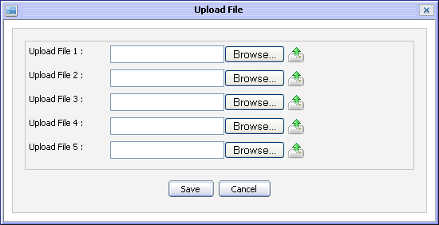Illustration 10: The Upload File form
- Upload the selected files by clicking the icon to upload.
- Complete attaching files to a topic by clicking the Save button.
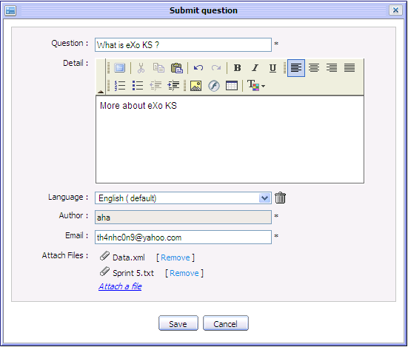
After attaching files, the Submit question form is shown:

Many different file types can be attached. To remove a attached file, simply click on the Remove link beside the the file attachment which you want to delete.
- Complete submitting a question by clicking the Save button.
The question is added into the selected category and the alert message is shown in order to inform that the question is added. In case, the question is added to the category that has the 'Moderate new questions' option, the alert message will have a content to inform that the question will be checked by the moderator for approval.
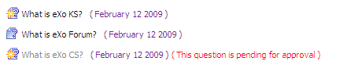
The question list is shown:
: This icon means that the question has not answered.
: This icon means that the question has been answered.

Viewing questions
Each question in list has collapse/expand mode.
To view a specific question, click the question that you want to view in list.
The question details will be shown:
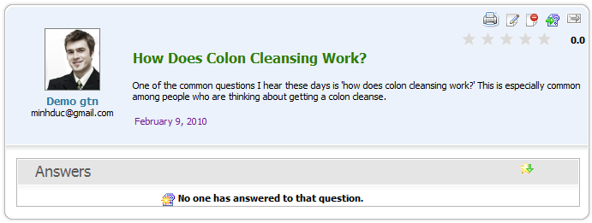Illustration 11: The question panel in case it has not been answered
It includes: question content, answer content (in case the question has not been answered, 'No one has answered to that question' message is shown).
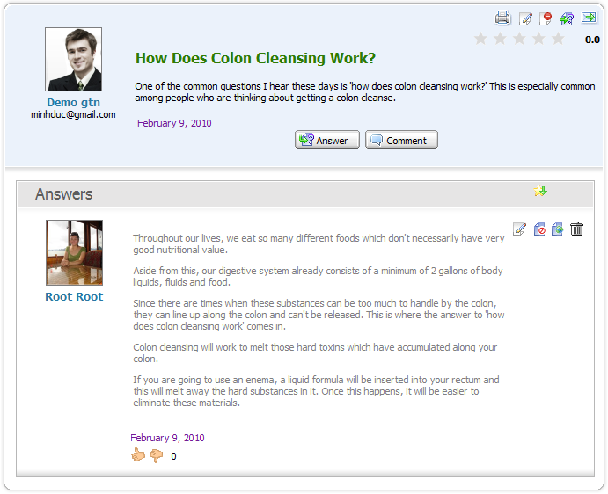Illustration 12: The question panel in case it has been answered
It may include attachments, related questions, languages to display (the default is English). Besides:
: This icon is used to print the question, send icon.
: This icon is used to send the question.
: This icon is used to vote the question.
: This icon is to used to sort questions by its star rate.
: This icon is to rate up/down the answer.
To view the image attachment in the preview mode, simply click on the image that you want to view, the image will be shown in the preview mode.
To close the image preview mode, simply left click on the previewed image, the preview mode will be closed.
To download the attachments, simply click on the attachment title. The download pop up will appear with 3 options:
- Open with: To directly open the attachment with proper application
- Save File: To save the attachment.
- Cancel: To close the down load pop up without downloading.
To view the related question to the question, simply click on the related question's title, its content is displayed:
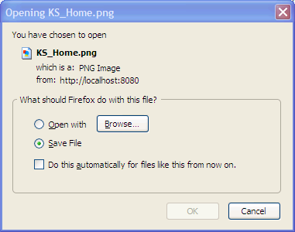Illustration 13: The download file pop up on Fire Fox
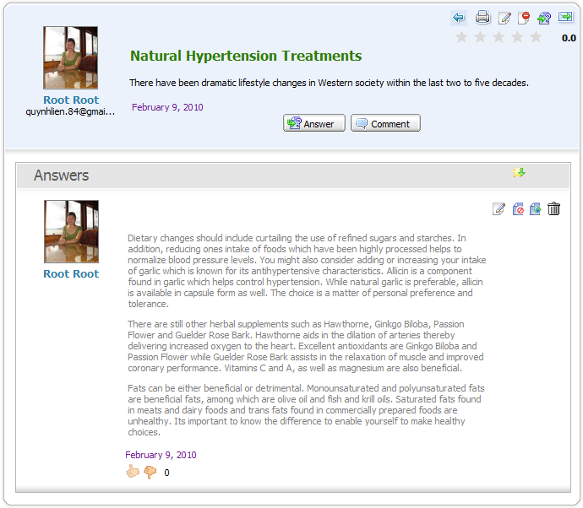
In which, the back icon allows backing the question that contains the related question list.
To close view question form, simply click on its title again, its answer and related questions will be hidden.

Voting questions
This function allows logged users to evaluate a question by voting in form of rating star from 1 to 5. The more star rate the question has, the more interesting it is.
Do as follows:
- Go into the question which you want to vote.
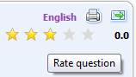
- Rate the question by left click on the star. The number selected star will be changed from gray to yellow. Click the Cancel button if you want to quit the Vote form.

Removing question vote
This function allows you to remove your vote on a specific question that let you vote it again.
Do as follows:
- Go to the question that you have voted it before.
- Click on the vote star at the top right question panel:
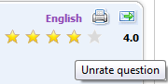
The alert message will appear:
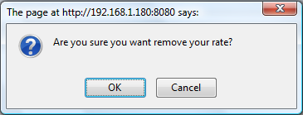
- Click the OK button to confirm removing your vote or the Cancel button to close the alert message without removing.

Rating up/down answers
This function allows you to rate up/down the answer of a specific question. Each voter can only rate Up (+1) or Down (-1).
To rate up/down, simply click on the rate icon:
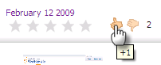
You can not rate twice but you can change your rate. When changing, the old rate will be removed, recalculated and updated with new score.

Commenting questions
This function allows logged users to give comments on specific questions.
Do as follow:
- Click on the Add Comment button or right click on a specific question and select Comment in the menu:
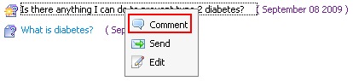
- The Comment form will appear:
- Input a comment into the text editor.
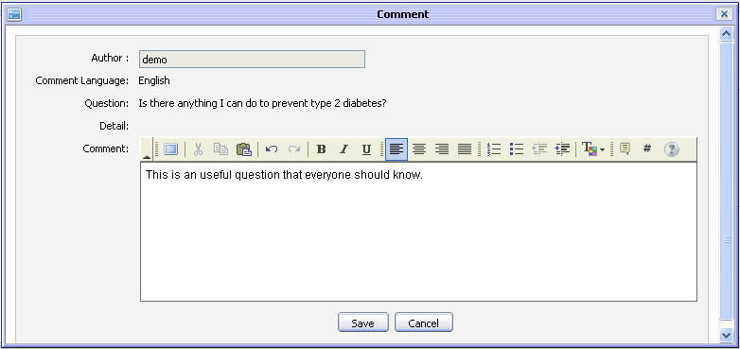Illustration 14: The Comment form
- Click the Save button to accept saving a comment.
After commenting, the comment is displayed:
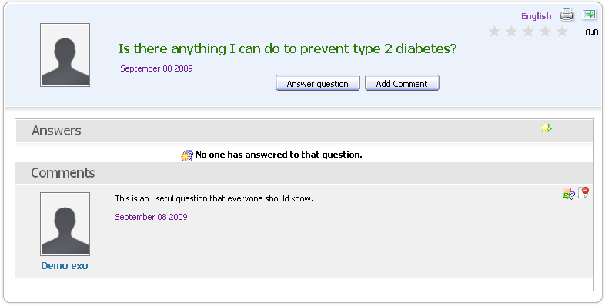
To promote a comment as an answer, simply click on the icon on the top right of the question panel.
To delete a comment, simply click the delete icon on the top right of the question panel.
Note:
- Comments can be written in different languages. If a question is posted in multiple languages, its can have comments in multiple languages, too.
- Only the administrator/moderator or the author of the comment can edit it.
- The comment function is not available to the anonymous user.

Sending to friends
This function is used to send question to friends via email. When you are interested in a question, you can share it with your friends. This action supports this purpose.
In the eXo Answers, one question can be sent when it is approved.
Do as follows:
- Show the Send question by email form by one of two following ways:
- The 1st way: Right click on the question that you want to send to your friends and then select Send in the menu.
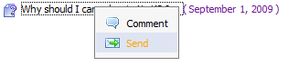
- The 2nd way: Click the Send icon at the top right corner of the question when viewing it in details:
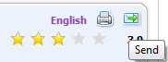
The Send question by email form will be displayed:
- Enter values for fields in the Send question by email form.
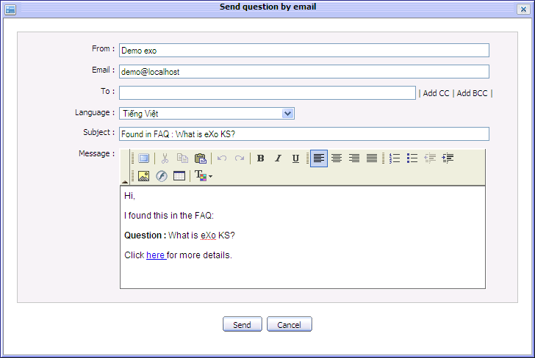Illustration 15: The Send question by email form
Details:
From: The name of the sender.
Email : The email address of the sender.
To: The email address of the receivers. Using CC and BCC to send this message to more than one person easily and fast by clicking the 'Add CC' or 'Add BCC'. Using 'Add CC' when you want other users know and refer to this message. Using 'Add BCC' when you want other users also receive this message but all receivers do not know that you also send this message to others.
Subject: The subject that you want to send to your friend.
Language: The language is used to display a content of the question. By default, it is English. However, if the sent question has been submitted in the other language such as French or Vietnamese, you can select the favorite for sending, When the language is changed, the question's subject and message content are changed correspondingly.
Message: The content of the message that you want to send to your friend.
Send button: To accept sending question to friend.
Cancel button: To close the Send question by email form.
- Complete sending a question by clicking the Send button.
The users with email addresses in the To, CC and BBC field will receive this message. Receivers can click 'here' link in content of the message to view the question in details at the Answers application.
Note:
- Only the administrator can send a pending question.

Editing questions
The owner of the question can edit that question. To edit the question that you have submitted:
- Right click on the question that you have submitted and select edit in the menu:
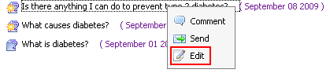
The Edit question form will appear:
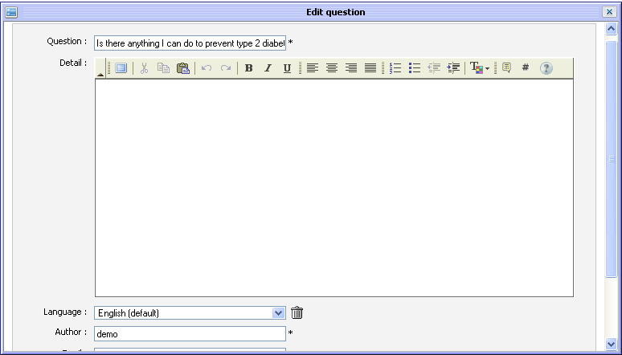Illustration 16: The Edit question form
Details:
Question: The brief content of the question.
Detail: The detail explanation of the question. The detail can be decorated by FCK Editor.
Language: The language that is used to add question. By default, the language is English. Language combo box allows selecting language option.
Author: The author of the edited question.
Email : The email address of the edited question's author.
Validation: This option is to validate the question. It includes activated and approved option .
Approved: This option is to approve the edited question or not.
- If this question is in the category that does not need moderating, this option is checked.
- If this question is in the category that needs to be moderated, this option is not checked.
- To approve this question, check this field.
Activated: This option is to whether display this question or not. By default, this option will be checked. It means the question is displayed, all users can view it. But if Answers Administrators or Moderators don't want to display this question, they don't select this option.
Files: The files attached into the question.
Attach a file: To attach files into the edited question.
Save button: To accept submitting the edited question.
Cancel button: To close the Edit question form.
- Change the current information of the selected question like when adding a new question.
- Complete editing the question by clicking the Save button.

Watching
This function allows logged users to keep track of changes of specific categories in the Answers application such as new edition, new question, question response... You only need registering an account, add watch to specific category, whenever there is a new changes, users will receive notification emails from the Answers.
To add watch, simply right click on any category in list and select Watch in the menu.
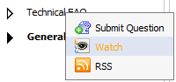
The alert message that informs the watching is shown:
Notes:
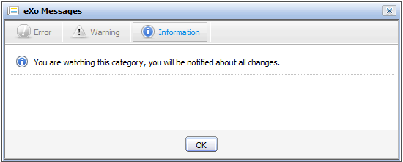Illustration 17: The watch alert message form
This function is not available to anonymous users. Only logged users can watch category in the FAQ.
One user can only have 1 email address for receiving notification mail. It is the default mail when registering account.

Unwatching
This function allows you to remove your watch on a specific category that called unwatch. When unwatching, you will not receive notification mails about the category that you used to add watch anymore from Answers.
To unwatch, simply right click on the category that you are watching and select Unwatch in the menu:
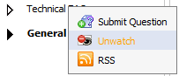

Search
This function is used to search existing categories and questions. With the Quick Search and the Advanced Search, you can find expected result quickly and flexibly.

Quick Search
With the quick search, you can directly type a search term in the search field. All the categories and questions having keyword matching the search term will displayed in the search result form.
Do as follows:
- Enter the search term on the search box at the top right of your screen after you go into the Answers application:
- Click the search icon next to the search box to do search
All categories/questions that match with the search term are listed in the Search results form.
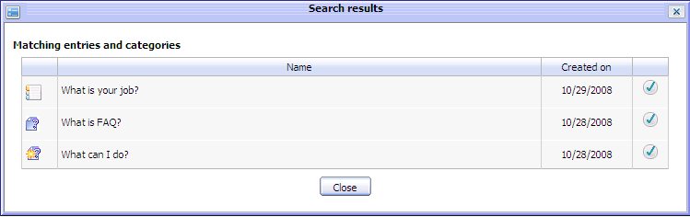Illustration 18: The simple Search Result form
To view a category or a question in details, you can click the icon corresponding to the category or question that you want to view.
In case, click on the question's title, its detail content will be shown in the View entry form :

Advanced Search
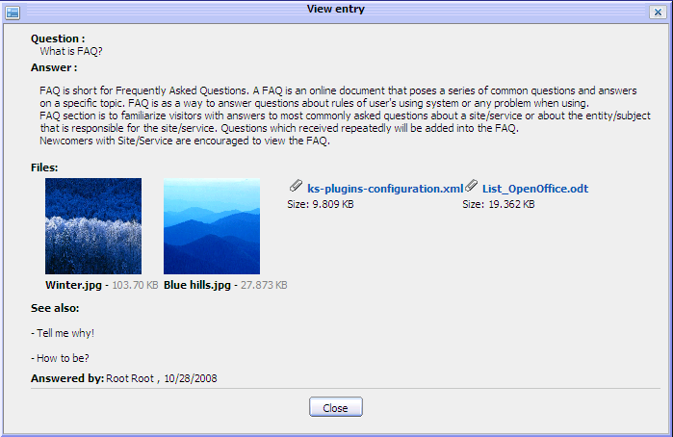Illustration 19: The View entry form
Advanced search allows users to make a search with particular criteria that corresponds to the object that is expected to be found. Using advanced search, users can find forums/topics/posts more exactly.
Do as follows:
- Click the icon at the right corner of your screen when you go into the Answers application. By default, you can find both categories and questions concurrently. But if you choose an object in the 'Search Object' field, it means you only search that object.
Details:
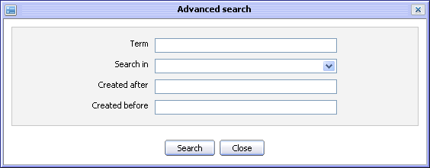Illustration 20: The Advanced search form
Term: The search term related to the categories/questions that you want to search.
Search in: The object that you want to search. By default, this field is blank. It means both categories and questions will be searched concurrently.
Created after – Created before: The created date interval in which you want to search for the selected object.
Search button: To accept doing search.
Close button: To close the Advanced search form.
The Advanced Search form will be displayed different corresponding to each object that is selected in 'Search Object' field.

With 'Category' object, The Advanced Search will appear:
Details:
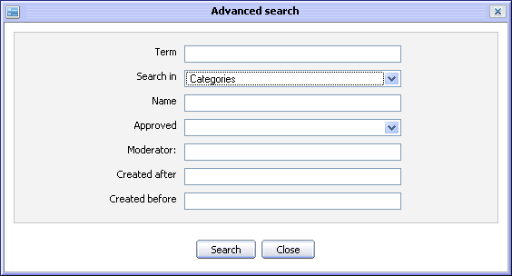Illustration 21: The Advanced search form with Search in Categories
Term: The keyword related to the categories that you want to search.
Search in: The object that you want to search. If you want to search categories, value of this field is 'Category'.
Name: The name of the category that you want to search.
Approved: The status of questions in the categories that you want to search. There are two statuses: 'True' and 'False'. With 'true', all questions in these categories were approved. With 'False', all questions in these categories were not approved.
Moderator: The name of all category's moderators that you want to search
Created after – Created before: The created date interval in which you want to search for the categories.

With 'Entries' object, the Advanced Search form will appear:
Details:
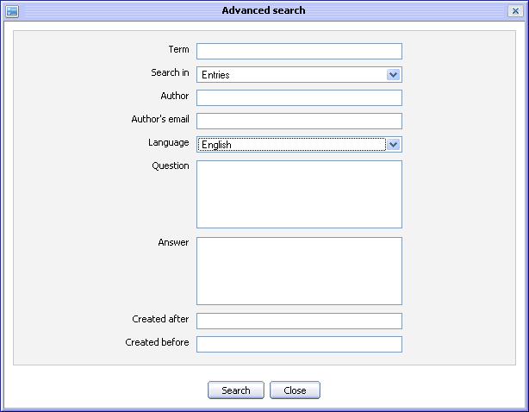Illustration 22: The Advanced Search form with Search in Entries
Text: The keyword related to the questions that you want to search.
Search Object: The object that you want to search. If you want to search questions, value of this field is 'Question'.
Author: The name of the question's creator.
Author's mail: The email address of the question's creator.
Language: The language of the questions that you want to search
Question: The content of the questions that you want to search.
Answer: The response of the questions that you want to search.
Created after – Created before: The created date interval in which you want to search for the questions.
- Enter the values of properties corresponding to each object that you want to search
- Complete the advanced searching by clicking the Search button.
The list of the found objects will be displayed in the search result form like or there will be an inform message to inform no objects match with the inputted properties.
To view details about one object in the search results form, select the name of the found object in list or click the icon corresponding to the object that you want to view.
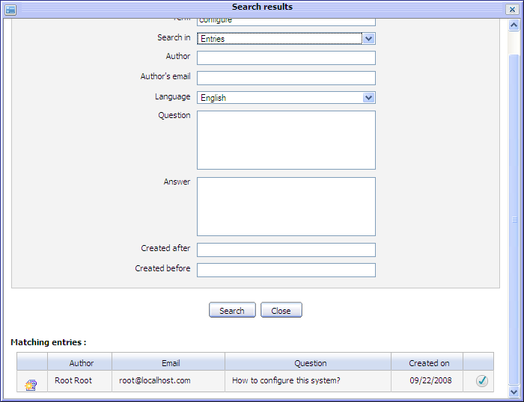Illustration 23: The Advanced Search Result form

User Settings
This function allows users to set some displaying properties of the Answers application. Besides, it allows you to sort the Answers by popularity, manage watch and change a avatar.
Do as follows:
- Click the button on the tool bar, the User Settings form will appear:
Details:
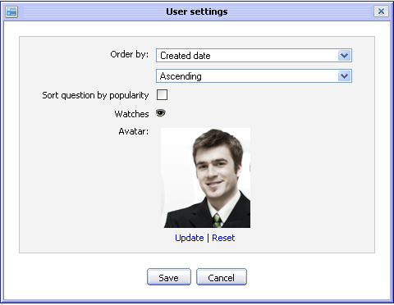Illustration 24: The User settings form
Order by:: The way is used to display the entries list.
- With 'Created Date': Categories and Entries in list will be displayed in the oder of their created date
- With 'Alphabet': Categories and Entries in list will be displayed in the alphabet order.
The type of sorting categories/entries in list. It may be: Ascending or Descending.
Sort question by popularity: This option is whether to sort the question popularity or not.
Watches: To mange watches of current login users.
Avatar: The avatar of your account.
Update: To change avatar.
Reset: To remove the current avatar and set by the default one
Save button: To accept saving current settings.
Cancel button: To close the User Settings form.
- Select values for fields in this form.
- Complete saving the user settings by clicking the Save button.
To manage watches, do as follows:
- Click on the watch icon to open the User Watch Manager form:
- Click on the category title to view it in details.
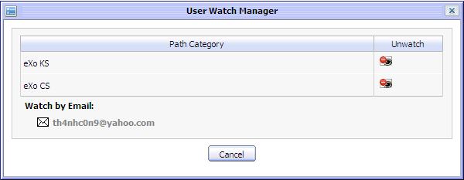Illustration 25: The User Watch Manager form
- Click on the unwatch icon that corresponds to the category that you want to remove watch.
To change the avatar, do as follows:
- Click on the Upload link to open the Upload File form:
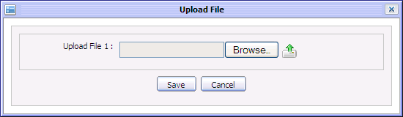
- Click the Browse... button to select file to upload.
- Click the icon to upload the selected file.
- Click the Save button to accept changing the avatar.
Notes:
This function is not available to the anonymous users. Only the logged users can personalize User Settings.

Printing
This function is used to print a question or all questions in a specific category.
Do as follows:
- Go to the Answers screen view that you want to print.
- Click the button on the tool bar to print all the questions in the current category in detail or click the print icon on the right question panel to print that question only.
The print preview page will appear:
- Click the Print button to set up the printer or click the Close button to quit the print preview mode.
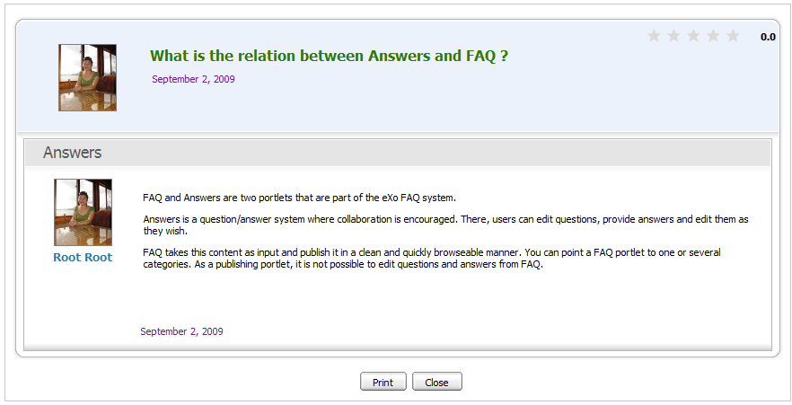Illustration 26: The print preview page

Showing/hiding the left panels
This function allows personalizing the Answers view by showing/hiding the left panels.
By default, the Answers application is displayed will all panels. In case you want to hide/show all panels on the left, you can click on the button on the main action bar.
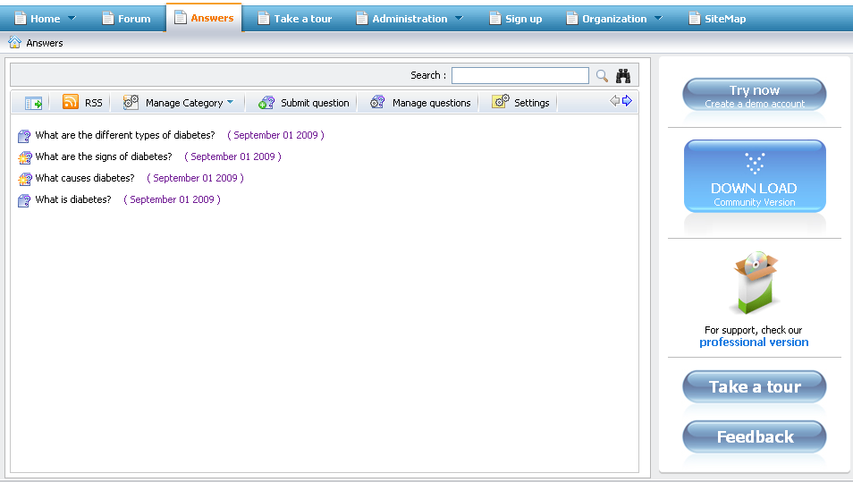Illustration 27: The custom view without the left panes

Viewing user profile
This function allows viewing profile of a specific user who submits, answers or comments question.
To view a profile of a specific user, simply clicking on its user name, the user profile pop up will be displayed:

Discussing forum
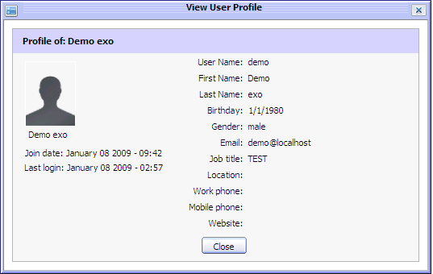Illustration 28: The View User Profile form
This function allows discussing a question in the Forum application.
When a question is discussed, it will become a new topic in the Forum application. The new topic is created with the topic title is the question title, the topic content is the question content and the post is the question answer or comment.
To discuss or view the discussion of a question, click on the discuss icon at the right question panel or right click on a specific question and select Discuss Forum in the menu:
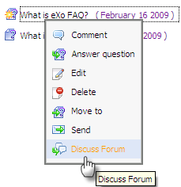
After being discussed, a new topic is created in the Forum application and you are redirected directly to the being discussed topic:
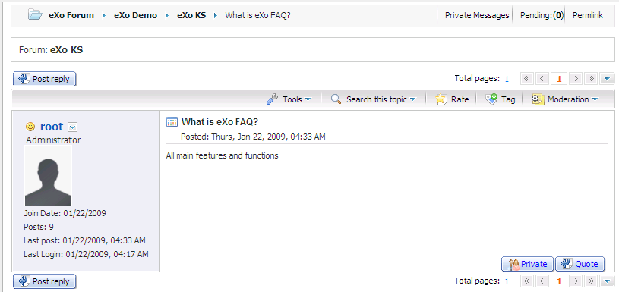
When there is answer added, comment added or any edition in question, answer or answer, the discussed topic in Forum application is changed correspondingly.
However, when the discussed topic is created, its status is pending for approval. You can only view the discussed topic when the Forum administrator/moderator approve it.
After a question is discussed, to view it, simply click on the Discuss forum option in its right click menu.

RSS feed
This function provides RSS feeds. Each time an entry is added or updated, the feed of the corresponding category will be updated.
Do as follows:
- Click on the category that you want to get RSS feed.
- Click the RSS button on the main action bar or select RSS in the right click menu of a specific category:
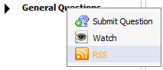
The RSS information page will be displayed and viewed on another tab:
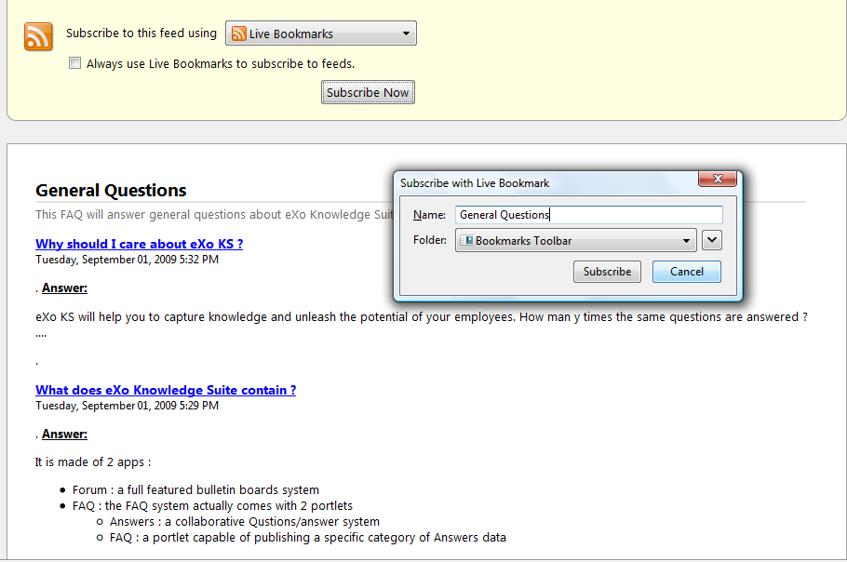
All question information of the category that is being watched are listed.
To add a live bookmark, simply clicking on the Subscribe Now button and click the Subscribe button in the menu pop up.

FAQ Portlet
eXo KS facilitates users with the FAQ portlet that helps users quickly view all the questions and answers from the Answers portlet by the tree view type.

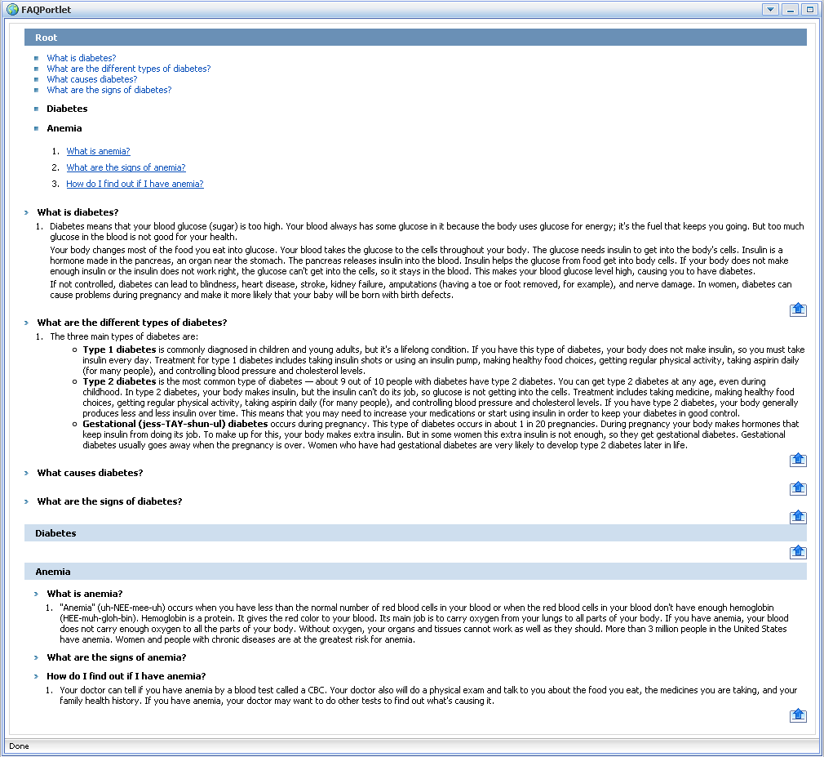Illustration 29: The FAQ Portlet in the View mode
The Edit Mode of the FAQ portlet: allows users to set the properties to display questions and answers in the View mode.
Click the portlet mode icon to open the menu that will let you select the edit mode:
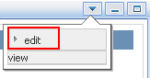

The Edit Mode of the FAQ Portlet will appear:
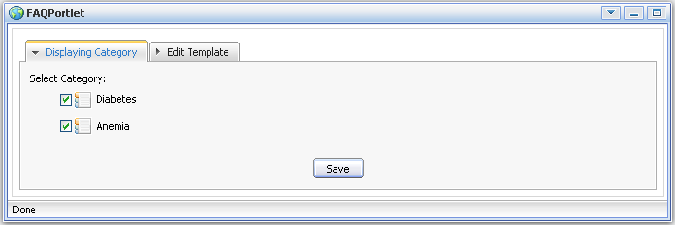Illustration 30: The FAQ Portlet in the Edit mode
The Displaying Category tab: allows users to select the category which contains questions and answers that will be displayed in the View mode.
- Select the checkboxes which correspond to the categories that you want to display the content in the View mode.
The Edit Template tab: the content template that will be displayed in the View mode. If you want to edit this template, you need to have a knowledge about css.
    - Edit the template according to your need (incase you know about css).
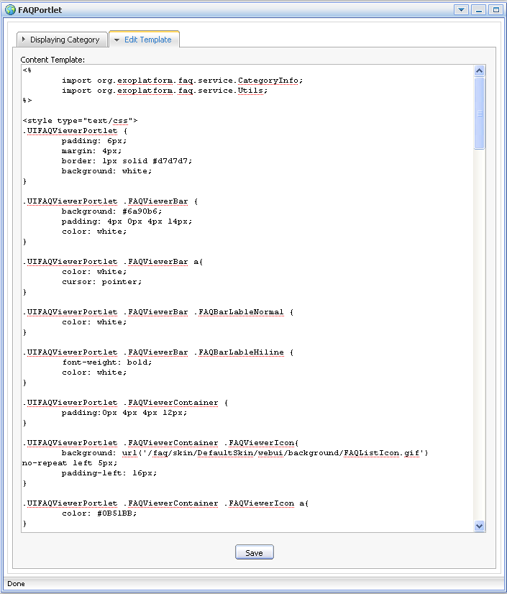
    - Click the Save button to save all changes.
Click the portlet mode icon and select view in the menu to view all the categories, questions and answers in the template that you have just set in the Edit mode.

