

eXo Calendar User Guide
Version 1.3.3

eXo Collaboration Suite provides a rich, Web 2.0 browser-based interface with comprehensive messaging and indexing; archival and search capabilities; shared calendars, address books, emails and much more features soon.
eXo Calendar helps you organize your time more easily and reasonably. It also manages your private and public agendas in your organization. eXo Calendar provides iCal support that you can use to exchange event/task information with other applications .
eXo Calendar is an open-source calendaring application that is built on foundation of eXo WebOS with a variety of new features designed to make your eXo Calendar experience more productive and convenient. Users can easy take all helpful actions on a pop up menu or take some actions with drag and drop event/task. Searching for events/tasks in calendars is also very convenient with full text search and advanced search with many criteria.

eXoTeam
REVISION HISTORY
Version | Date | Writer | Reviewer | Change Record
1.0 | Jun 24, 2008 | Nguyen Thi Thanh Hoa | Hoang Anh Quynh Nga
1.1 | Jan 19, 2009 | Nguyen Thanh Cong | Hoang Anh Quynh Nga | - Update new illustration and illustration index  - Clarify some definition  - Improve the way to express  - Update show a notification popup  - Update all illustrations for different type of calendar view.  - Update detail explanation for status of participants.  - Update: import function with new features, update more ways to perform Calendar settings.  - Feature of advanced search: From & To Date.  - Import/export task and event.  - Update some small changes
1.2 | June 22, 2009 | Nguyen Thanh Cong |  | - Improve the Reminders tab  - Improve the Participants tab.  - Update Calendar settings.  - Update Calendar view
1.3 | June 28,2009 | Nguyen Thanh Cong
1.3.3 | December 22, 2009  May 14, 2010 | Luong Quynh Lien | Nguyen Huu Tuan Anh | - Change screenshots for adding a new event, edit a event.

Contents
1.Preface 12
1.1 About this guide 12
1.2 Objective of this guide 12
1.3 Related documents 12
2.Getting Started 13
What is eXo Calendar? 13
3.How to process in eXo Calendar? 15
3.1 Registering an account 15
3.1.1 Signing in 18
3.1.2 Signing out 19
3.2 Managing Calendar Groups 19
3.2.1 Adding a new calendar group 20
3.2.2 Editing a calendar group 21
3.2.3 Deleting a calendar group 22
3.3 Managing Categories 23
3.3.1 Adding a new category 24
3.3.2 Editing a category 25
3.3.3 Deleting a category 26
3.4 Managing Calendars 27
3.4.1 Adding a new calendar 27
3.4.2 Editing a calendar 31
3.4.3 Removing a calendar 33
3.4.4 Sharing a calendar 34
3.4.5 Change calendar color 37
3.4.6 Exporting calendars 38
3.4.7 Importing calendars 40
3.5 Managing Events 45
3.5.1 Adding a new event 45
3.5.2 Viewing an event 56
3.5.3 Editing an event 57
3.5.4 Deleting an event 58
3.5.5 Dragging and dropping an event 60
3.5.6 Exporting an event 60
3.5.7 Importing an event 61
3.6 Managing Tasks 61
3.6.1 Adding a new task 61
3.6.2 Viewing a task 67
3.6.3 Editing a task 67
3.6.4 Deleting a task 68
3.6.5 Dragging and dropping a task 69
3.6.6 Exporting a task 70
3.6.7 Importing a task 71
3.7 Searching events/tasks 71
3.7.1 Quick Search 71
3.7.2Advanced Search 72
3.8 Calendar View 75
3.9 Calendar Settings 79
3.10 Generating RSS 81
3.11 Generating CalDAV 85

Illustration Index
Illustration 1: The main screen of the Calendar application 14
Illustration 2: The anonymous home page of the classic portal 16
Illustration 3: The Account Setting tab of the Sign Up form 16
Illustration 4: The User Profile tab of the Sign Up form 18
Illustration 5: The Sign in form 19
Illustration 6: The classic portal page after signing successfully 20
Illustration 7: The Calendar groups form 21
Illustration 8: The Calendar groups form 23
Illustration 9: The confirmation message when deleting a calendar group 24
Illustration 10: The Event categories form 25
Illustration 11: The Edit category form 27
Illustration 12: The Calendar details tab of the Calendar form 29
Illustration 13: The Groups tab of the Calendar form 30
Illustration 14: The User Selector form 31
Illustration 15: The Select Membership form 32
Illustration 16: The Calendar form 34
Illustration 17: The Share calendar form 36
Illustration 18: The Calendar view panel with different events/tasks on different calendars 38
Illustration 19: The Export calendars form 41
Illustration 20: The download pop up on Fire Fox 41
Illustration 21: The Import calendars form 43
Illustration 22: Imported calendar 45
Illustration 23: The Quick add event form 47
Illustration 24: The Detail tab of the Add/Edit event form 48
Illustration 25: The Event categories form 49
Illustration 26: The Attach files form 50
Illustration 27: The Reminders tab of the Add/Edit event form 52
Illustration 28: The Select email form 53
Illustration 29: The Participants tab of the Add/Edit events form 54
Illustration 30: The Invitations form 55
Illustration 31: The Select Address form 56
Illustration 32: The Select users form 57
Illustration 33: The Schedule tab of the Add/Edit events form 58
Illustration 34: The Confirm form 59
Illustration 35: The Preview event form 60
Illustration 36: The Add/Edit events form 61
Illustration 37: The Month View of the Calendar panel 62
Illustration 38: The Quick add task form 66
Illustration 39: The Detail tab of the Add/Edit tasks form 67
Illustration 40: The Reminders tab of Add/Edit tasks form 69
Illustration 41: The Search result form 76
Illustration 42: The Advanced Search form 77
Illustration 43: The Day View 80
Illustration 44: The Week View 80
Illustration 45: The Month View 81
Illustration 46: The Year View 81
Illustration 47: The List View 82
Illustration 48: The Work Week View 83
Illustration 49: The Setting tab of Calendar settings form 84
Illustration 50: The Displayed calendars tab of Calendar settings form 85
Illustration 51: The Information tab of the Generate RSS form 86
Illustration 52: The Calendars tab of the Generate RSS form 87
Illustration 53: The Informations tab of the Generate CalDAV form 90
Illustration 54: The Calendars tab of the Generate CalDAV form 91

Preface

About this guide
eXo platform™ software is a powerful Open Source, corporate portal and content management system. Users of the platform have a customized single point of accessing to the company's information system and resources. The purpose of this user guide is to provide step by step instructions on how to use Calendar application which is a part of eXo Collaboration Suite - an extension of eXo portal.
This documentation is an useful guide that helps users learn more about eXo CS technology in details. It gives an in depth example and easy explanation of eXo platform technology that not only allows technical but also non-technical people to be more efficient in their daily collaboration.1.2 Who should read this guide?
Welcome to the eXo Collaboration Suite material. This document aims at guiding various users of eXo Platform. This material is for anyone interested in learning and using the Calendar application. It is also useful for the following groups:
Users who use eXo Collaboration Suite with Calendar application in their work and business.
Integrators who want to know more about the rich collaboration features.

Objective of this guide
This user guide will:
- Define some basic concepts used in calendar application
- Show the main instructions of the calendar application.
- Guide step by step to take basic actions.

Related documents
- eXo Address Book User Guide v1.3.3
- eXo Mail User Guide v1.3.3
- eXo Chat User Guide v1.3.3

Getting Started

What is eXo Calendar?
eXo Calendar is a web based agenda. This application allows users to record events/tasks, such as appointments, meetings, birthday, examination.. on an electronic calendar. With eXo Calendar, it is easy to keep track of all important events/tasks – all in one place.

Using eXo Calendar, you can add events and invitations effortlessly and share with colleagues, friends and family, or only keep things for yourself.
eXo Calendar includes the following features:
- Create multiple personal calendars, manage calendar easily with calendar groups.
- Quickly create an event or a task using a Quick Add dialog.
- Create events and tasks in details, classify events with event categories easily.
- Create all-day events.
- View other attenders 's availability schedules.
- Create recruiting events.
- Get reminders.
- View calendars by various views: day, week, month and year .
- Quickly view events day by day by navigating the mini-calendar.
- Share calendars with others.
- Import/Export calendars.
- Publish your calendars with RSS, CalDAV.
- Search events/tasks in calendars.
- Print your agenda.
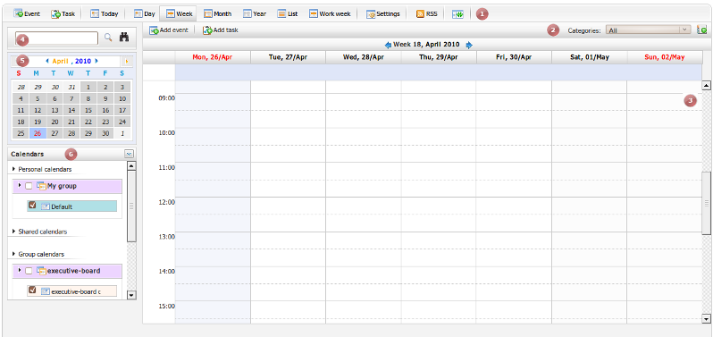Illustration 1: The main screen of the Calendar application
Indicator | Meaning
 | This is the Tool bar that allows quickly adding events/tasks, changing calendar view, setting up calendar...
 | This is the Action bar that allows adding more detail events/tasks and adding new categories
 | This is the Calendar view panel that displays all event/task(s) in the selected calendar at current time.
 | This is the Search Panel that allows searching search.
 | This is the Mini Calendar that allows quickly viewing event/task in selected day.
 | This is the Calendar list that shows the personal calendar, shared calendar and group calendar.

How to process in eXo Calendar?
Like any eXo product, eXo Collaboration Suite portal is displayed in two modes. One is for anonymous users that does not require signing in, called 'public mode'. Another is for registered users who use registered User name and Password to sign in, called 'private mode'.
In the public mode, visitors only can visit some pages in a portal like reading news, register new account... By registering an account, you can access the private mode of a portal and access all applications in eXo Collaboration Suites.
In the private mode, you can take many actions that corresponds to your rights.
On the standard CS portal, we have configured some accounts with specific roles:
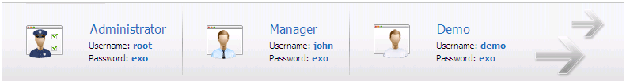

Registering an account
- To register a new account on a portal, do as follows:
Step 1: Go to the Portal by typing the URL in the address bar (e.g: http://localhost:8080/portal). The anonymous home page will be displayed :
Step 2: Select Sign Up on the navigation bar. The Sign Up page will appear:
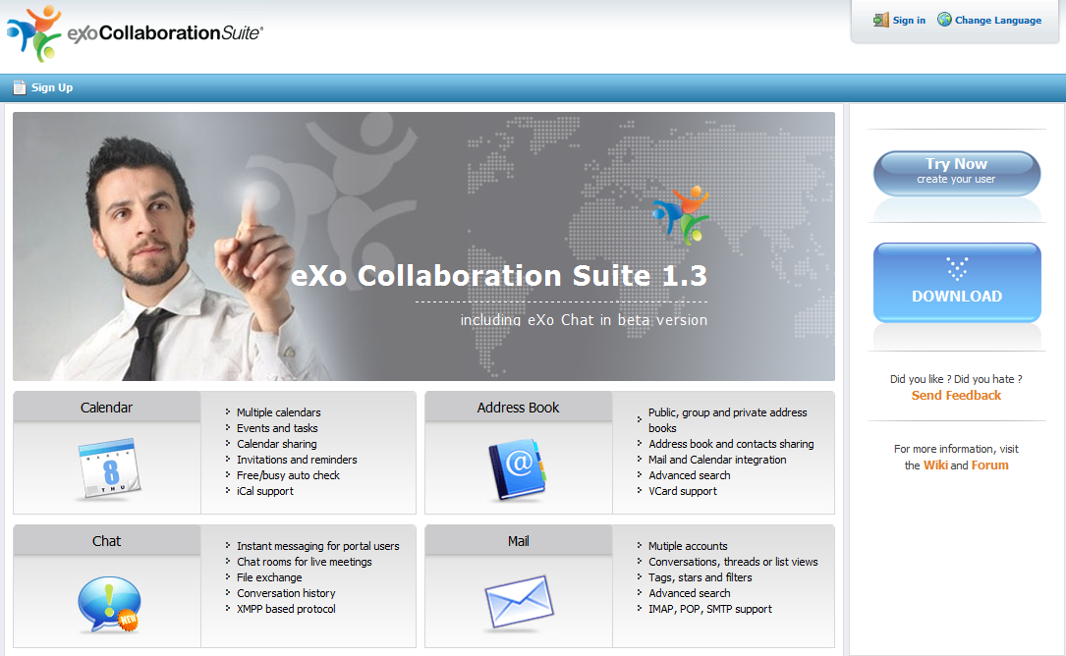Illustration 2: The anonymous home page of the classic portal
Details:
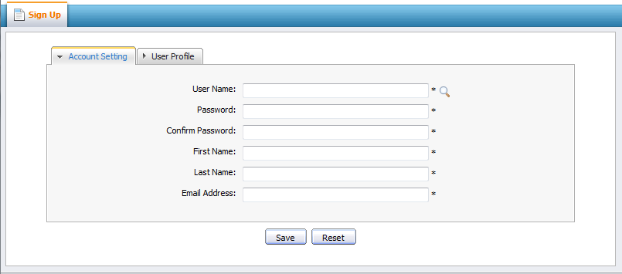Illustration 3: The Account Setting tab of the Sign Up form
The Account Setting Tab includes:
User Name | The name of the user that will be used to sign in. It must be unique.
Password | The secret string used to log in. It must have at least 6 characters.
Confirm Password | The re-typed password. Password and Confirm Password must be the same
First Name | Your first name
Last Name | Your last name
Email Addres | Your contact email address. It must be in the right format. For example: flower@gmail.com
Save button | To accept saving a new account
Reset button | To set blank entry for all inputted fields.
Step 3: Click the icon to search and check whether the inputted User name is available or not.
Step 4: Fill values in all required fields in the form.
Step 5: Open the User Profile tab and the fields in this tab are not required. You can input values into the fields or not.
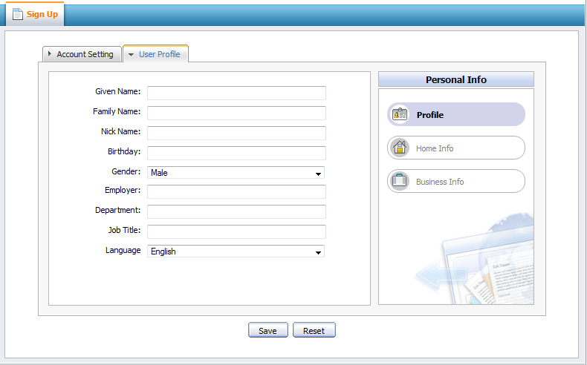Illustration 4: The User Profile tab of the Sign Up form
Step 6: Complete registering a new account by clicking the Save button.
After registering an account successfully, you can login and access to eXo Calendar application.

Signing in
This function allows you to go into portal in the private mode.
- To sign in, do as follows:
Step 1: Go to Portal by typing the portal URL in your browser address bar (e.g: http://localhost:8080/portal)
Step 2: Click the Sign in link at the top right of page. The Sign in form will be displayed.
Step 3: Input your registered User name and Password
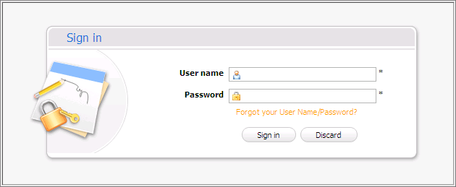Illustration 5: The Sign in form
Details:
User name | The registered user name which is used to sign in
Password | The registered password of the User nameabove.
Forgot your User Name/Password | The steps that have to be followed to get the forgotten User Name/Password.
Sign in button | To accept signing in.
Discard button | To exit the Sign in form without signing in.

Step 4: Complete signing in by clicking the Sign in button.
After signing in successfully, you will be redirected to the authenticated home page :
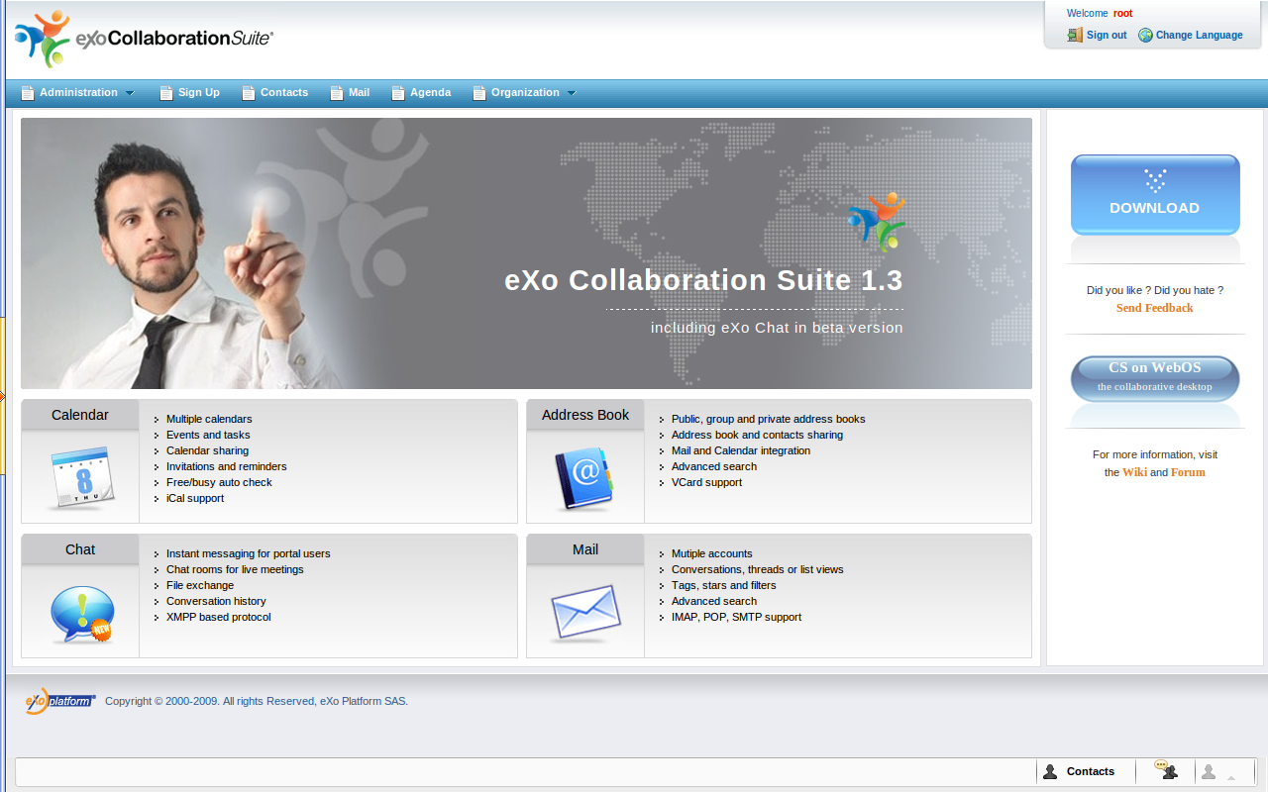Illustration 6: The classic portal page after signing successfully

Signing out
This function allows you to get back to the anonymous portal. It ends your current portal session. To sign out, click the Sign out at the top right corner of the screen:
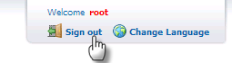

Managing Calendar Groups
The calendar groups allows you to categorize your calendar types easily. One calendar group may contain one or more calendars added by yourself. By default, eXo Calendar provides a group in Personal calendars category named 'My group'.

Adding a new calendar group
This function allows adding new calendar groups in eXo Calendar which allows organizing and personalizing calendars in your own way.
Do as follows:
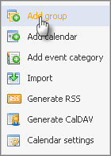
Step 1: Open the Calendar groups form by clicking the Manage Calendars icon at the right of calendars list panel to open the drop-down menu then select Add group in the drop list menu:
The Calendar groups form will appear:
Details:
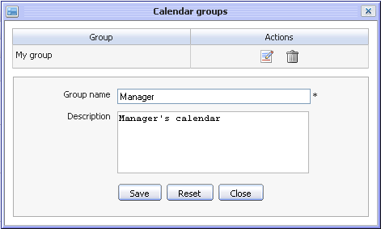Illustration 7: The Calendar groups form
Group | The name of the group that will be displayed in calendar list. This field is required.
Description | The description about the group. This description only appears when you edit the group in this form.
Save button | To accept saving new calendar group
Reset button | To set blank entry for all inputted fields
Close button | To close Calendar groups form without adding new.

Step 2: Input values in the form.
Step 3: Complete adding a new calendar group by clicking the Save button.
After creating a new calendar group, the new created group will appears in the calenders list of the Calendar groups form.
On the top of the form, there is a list of calendar groups that appears in the calendar list which can be edited or deleted.
Note:
In case, adding a new calendar, you can also add new a calendar group by clicking the icon that corresponds to Group fields. When the icon is clicked, the Calendar groups form is shown like illustration 7. (See Manage Calenders 3.4 for details)

Editing a calendar group
This function lets you change the name and the description of the selected group.
Do as follows:
Step 1: Open the Calendar groups form by two way:
The 1st way: Select the Add group item in the menu then click the Edit icon which corresponds to the group that you want to edit.
The 2nd way: Right click on the group name which you want to edit and select Edit in the drop down list menu:
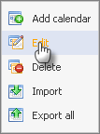
The Calendar groups form will appear:
Step 2: Change values in the Group name or Description fields
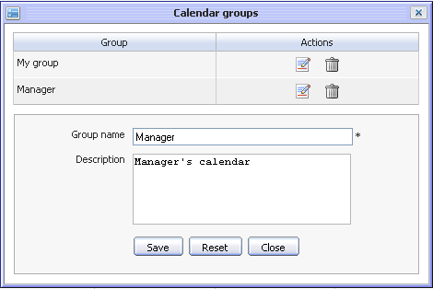Illustration 8: The Calendar groups form
Step 3: Complete editing the calendar group by clicking the Save button.
Note:
In case, adding new calendar, you can also edit a calendar group by clicking the icon that corresponds to the Group field. When the icon is clicked, the Calendar groups form is shown like illustration 8. (See Manage Calenders 3.4 for details)

Deleting a calendar group
This function allows removing calendar groups. When a calendar group is deleted, all calendars inside it are also deleted.
Do as follows:
Step 1: Open the Calendar groups form.
The 1st way: Select the Add group item in the menu and then click the Delete group icon which corresponds to the group that you want to delete.
The 2nd way: Right click on the group's name which you want to edit and select Delete in the drop down list menu:
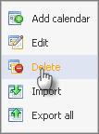
The confirmation message will appear :
Step 2: Complete deleting the selected calendar by clicking the OK button or click the Cancel button to quit without deleting.
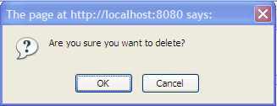Illustration 9: The confirmation message when deleting a calendar group
The selected calendar group is removed from the Group table. Besides, the deleted group and calendars inside it will not be displayed in the calendar list panel.
Note:
In case, adding a new calendar, you can also delete a calendar group by clicking the icon which corresponds to the Group field. When the icon is clicked, the Calendar groups form is shown like the illustration 8. (See Manage Calenders 3.4 for more details)

Managing Categories
Categories are used to classify events and tasks. For example, you could use a 'Meeting' category for all meetings with your colleagues or customers in your company. By default, eXo Calendar provides 5 categories: Calls, Meeting, Holiday, Clients, Anniversary. You can add and view events/tasks in default categories. In addition, you also can edit, delete default categories or create a new category by yourself.

Adding a new category
This function is used to create new categories in eXo Calendar.
Do as follows:
Step 1: On the action bar, click the icon at the right corner:
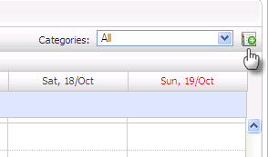
The Event categories form will appear :
Details:
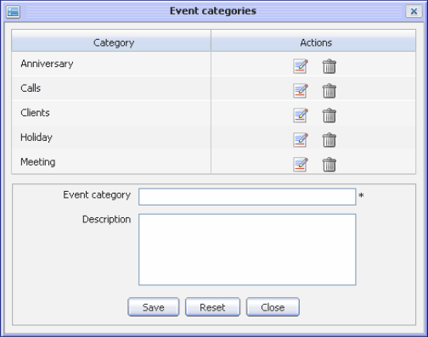Illustration 10: The Event categories form
Event category | The name of the category. This name will appear in the category list.
Description | The description of the category. This description only appears when you edit the category in this form.
Save button | To accept saving a new category.
Reset button | To set blank entry for all inputted fields.
Close button | To exit the Event categories form without adding new.

Step 2: Input values to fields in this form.
Step 3: Complete adding a new category by clicking the Save button.
The new created category will appear in the category list box.
On the top of the form, there is a list of categories which can be edited or deleted.

Editing a category
This function allows changing name and description of the selected category.
Do as follows:
Step 1: Open the Event categories dialog by clicking the icon in the action bar:
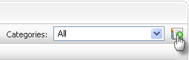
Step 2: Click the Edit icon which corresponds to the category that users want to edit.
The properties of the selected calendar group will appear:
Step 3: Change values in the Event category or the Description field.
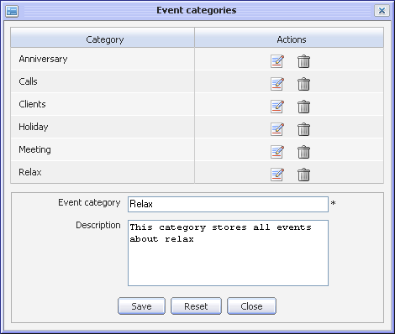Illustration 11: The Edit category form
Step 4: Complete editing by clicking the Save button.

Deleting a category
This function allows removing categories in eXo Calendar; however, all events/tasks in this category still exist.
To remove a category, do as follows:
Step 1: Open the Event categories dialog by clicking the icon in the action bar:
Step 2: Click the Delete icon which corresponds to the category that you want to delete.
Step 3: Complete deleting a category by clicking the OK button in the confirmation message or click the Cancel to quit without deleting.
The deleted category will be removed from the Category table in the form and the categories list box.

Managing Calendars
After being created, a calendar will be categorized in the group that you choose for it. It can be added tasks/events, edited, deleted, exported and shared with the others users. There are three types of calendar: personal calendars, shared calendars and group calendars.

Adding a new calendar
This function allows adding new calendars. All created calendars will be listed under the Personal calendars category on the left navigation pane.
- To create new calendar, do as follows:
Step 1: Open the Calendar form. You can do this step by different ways:
The 1st way: Click the icon at the top right of the calendar list and then select the Add calendar item in the menu:
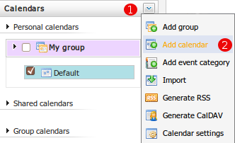
The 2nd way: Right click on the calendar group's name which exists in the list and then select Add calendar in the drop down list menu:
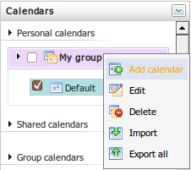
The 3rd way: You can also add new calendars from Mail portlet (See eXo Mail User Guide v1.3 for details)
The Calendar form will appear:
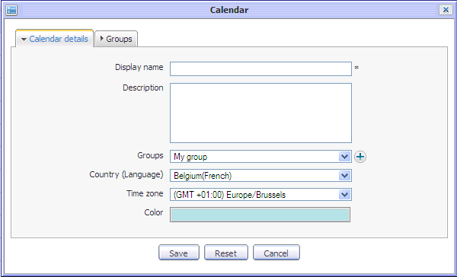Illustration 12: The Calendar details tab of the Calendar form
Details:
  - The Calendar details tab includes:

Display name | The name of the calendar. This field is required .
Description | The description of the calendar.
Groups | The group contains your calendar. A group can be chosen in the existing group list or quick add a new group by clicking the icon at the right Groups combo box. The Calendar group form that allows adding a new group directly in the Calendar form will be displayed.
Country (Language) | The location for the calendar
Time zone | The displayed time zone for the calendar activities. You can personalize your calendar time zone.
Color | The displayed color for the calendar activities. You can personalize it.
Save button | To accept saving a new calendar
Reset button | To set blank entry for all inputted fields
Cancel button | To exit the Calendar form without adding new
  - The Groups tab:
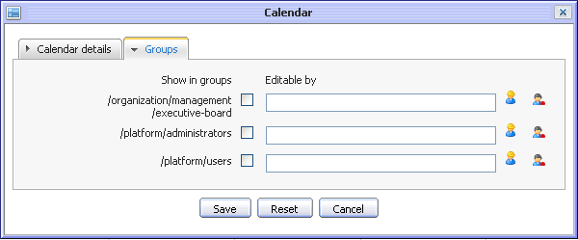Illustration 13: The Groups tab of the Calendar form
The Groups tab allows sharing the calendar with the other groups/users.
- To share a calendar, select the group check box(s) that you want to share. Users of the checked groups will be able to view this calendar. Besides, you can define who can edit the calendar in each group
- To grant the edit permission to individual users in group, follow these steps:
    - Click the icon at the right of the Edit permission column.
    - Select a user in a special group. For example: select john in the administrators group.
- To grant the edit permission to a membership type in group, follow these steps:
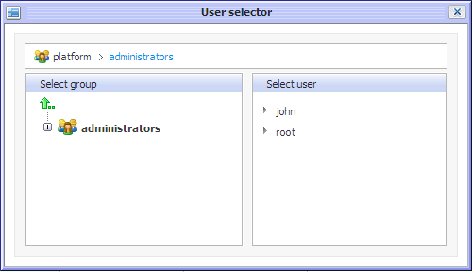Illustration 14: The User Selector form
    - Click the icon at the right of Edit permission column.
    - Select a membership in the group. For example: select the manager role in the administrators group.
Step 2: Enter values in the Calendar form.
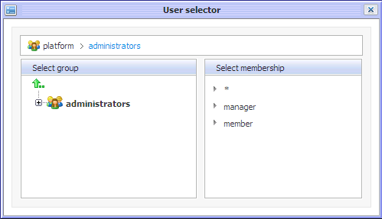Illustration 15: The Select Membership form
Step 3: Complete adding a new calendar by clicking the Save button.
The new added calendar will appear in the calendar list.
Note:
When you fill values in the Group tab, the calendar will appear in the Group calendars category. All members of the corresponding groups will be able to view that calendar. If you don't want your calendar to be a public one, leave the Group tab empty.

Editing a calendar
This function allows you to make changes of the selected calendar.
Do as follows:
Step 1: Right click on the calendar's name (e.g: Relax Calendar) to open the drop-down list menu and then select the Edit item:
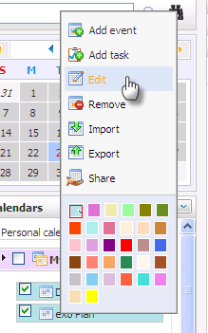
Step 2: The Calendar form will appear with all information displayed, available for editing.
In personal calendar, there is only one tab.
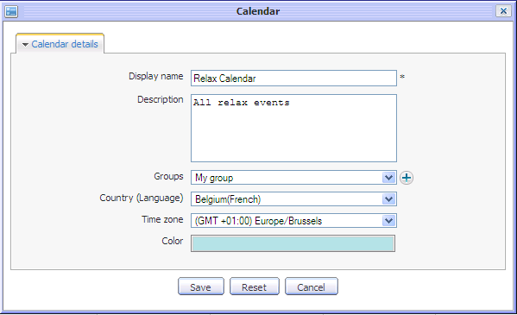
  - In group calendar: (it means the calendar is shared with the users who belong to the shared group).There are 2 tabs: the Calendar details and the Groups tab:
Step 3: Make changes in the Calendar form.
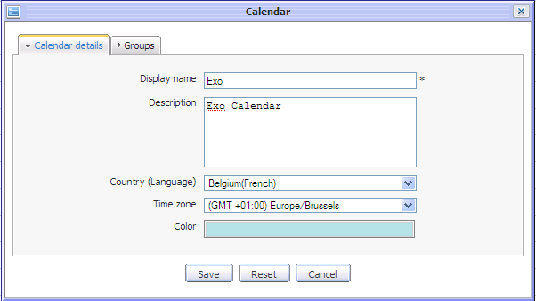Illustration 16: The Calendar form
Step 4: Complete editing the calendar by clicking the Save button.
Note:
You can edit any personal calendar. In addition, you can also edit a shared or group calendar when you have the edit permission on it. For instance, when you right click on the calendar's name that you do not have the edit permission, the Edit item will be disabled in the drop down list menu.
The Edit permission on a calendar allows you to add, edit or delete events/tasks which exist in that calendar.

Removing a calendar
This function allows removing a calendar and all events/tasks stored inside it.
Do as follows:
Step 1: Right click on the calendar's name to open the drop-down list menu then select the Remove item:
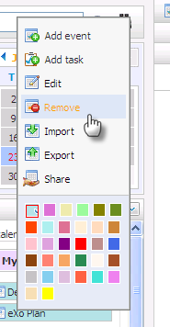
Step 2: Complete removing a calendar by clicking the OK button in the confirmation message or click the Cancel button to quit without removing a calendar.
The removed calendar will not be displayed in the calendars list pane. All events/tasks inside that calendar will also be removed.
Note:
In fact, if you do not have the edit permission on the shared calendar, removing a shared calendar means that you only remove it from your calendar list. Other users will continue seeing and working on it in their calenders list.

Sharing a calendar
This function allows sharing an existing calendar with other users. It means that you allow other users to participate in activities on it.
The permissions in a shared calendar are set in two levels:
- View permission allows you to view a calendar and its events/tasks, but you can not change any information. It means that you can not add/edit/delete events/tasks; edit import, export calendars. For example, right click on the shared calendar's name that you do not have edit permission and select the Add event item in the menu, a warning message shows that you are not allowed to edit this calendar.
- Edit permission allows you to view and change information of a calendar such as edit, delete or add, edit, delete events/tasks inside the shared calendar, export the shared calender. However, you can not import or edit it.
- To share a calendar, do as follows:
Step 1: Right click on the calendar's name to open the drop down list menu then select Share from the menu:
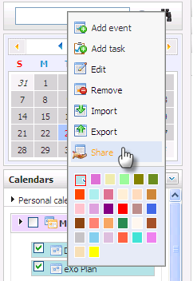
The Share calendar form will appear:
Details:
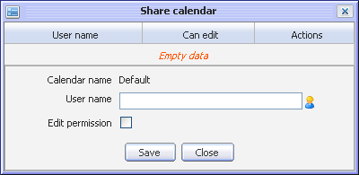Illustration 17: The Share calendar form
Calendar name | The name of the calendar that you choose to share
User name | The name of the users who you want to share your calendar with.
Edit permission | This option allows granting edit permission on a calendar to selected user
Save button | To accept sharing the calendar
Close button | To exit the Share calendar form without sharing.

Step 2: Select users to share, do as following steps:
- Click on the icon at the right of the User name field.
- Select users that you want to share. For example, select John in /platform/ administrator group. (You can also manually input in the User name field). The Shared users are displayed in the User name field.
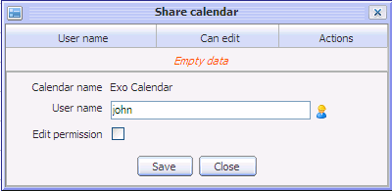
- Select the Edit permission check box if you want to share the edit right with the selected users.
- Complete sharing the calendar by clicking the Save button.
After sharing a calendar successfully, the shared user will be displayed in the Share table below:
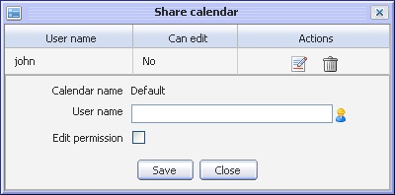
You can:
    - Click the Edit icon to edit permission of a shared user
    - Click the Delete icon that corresponds to the shared user in order to delete him/her from the shared table. The deleted shared users will not able to view the shared calendar any more.

Change calendar color
This function allows changing calendar color to distinguish activities in different calendars. When you are looking at all activities in Calender view panel, different colors mean activities are on different selected calendars.
- To change color, do as follows:
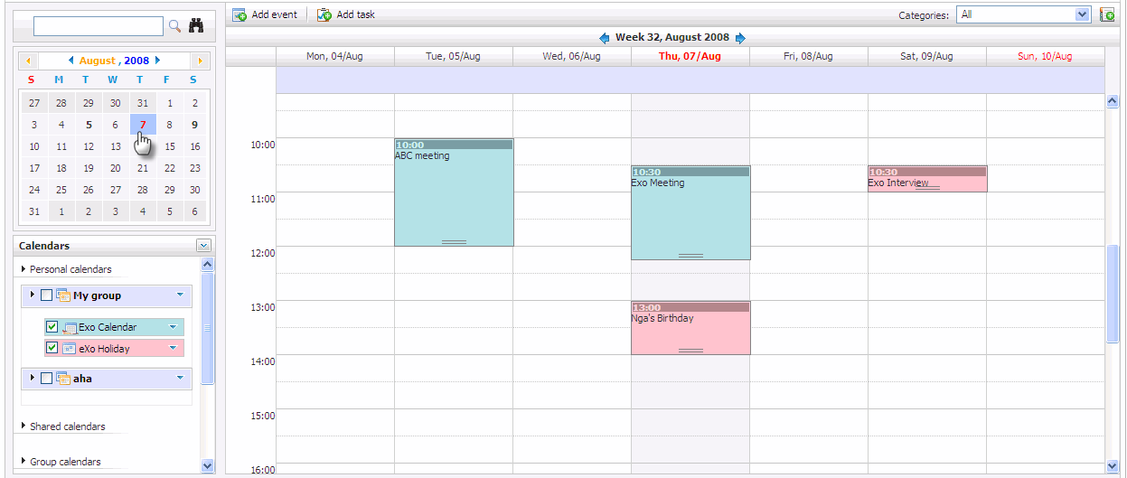Illustration 18: The Calendar view panel with different events/tasks on different calendars
Step 1: Right click on the calendar's name to open the drop-down menu and then select a color for your calendar. There are 32 available colors:
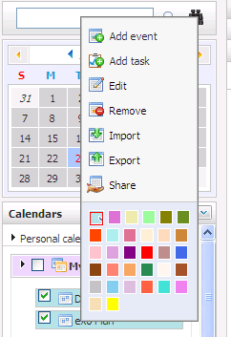
Step 2: Change color by selecting the specific color area.
After being changed a color, the calendar will be displayed with a new selected color.

Exporting calendars
This function allows exporting one calendar to a separate file on your computer. You can only export one calendar which has at least one event inside it. Moreover, you also can export any calendar types including personal , shared and group calendar if you have the edit permission.
Do as follows:
Step 1: Open the Export Calendars form by two ways:
The 1st way: Right click on the calendar group's name to open the drop down list menu then select Export all in the menu:
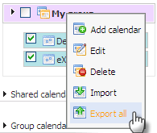
The 2nd way: Right click on the calendar's name and select the Export item in the menu:
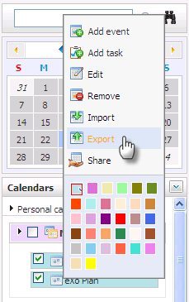
The Export calendars form will appear:
Step 2: Enter a file name in the corresponding field.
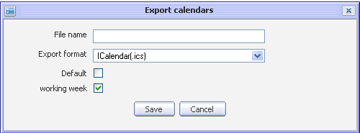Illustration 19: The Export calendars form
Step 3: Select a type of the export format in the list box. For instance, ICalendar (.ics)
Step 4: Select one or more available calendars which you want to export by selecting its check box(s).
Step 5: Click the Save button to accept exporting the selected calendars.
There is a window pop up with 3 choices:
- Download the File: To down the exported file
- Open the File: To directly open the exported file
- Cancel the File: To cancel exporting
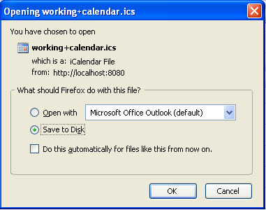Illustration 20: The download pop up on Fire Fox
You can only open the file if you have an application installed on your computer that supports the format of the exported file.
Note:
You can export personal, shared and public calendar which you have edit permission

Importing calendars
This function allows importing one or more calendars in a file from your computer to a selected calendar group in eXo Calendar.
Do as follows:
Step 1: Open the Import Calendars form:
The 1st way: Left click the icon at the right top of the calendar list and then select the Import from the menu:
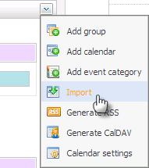
The 2nd way: Right click on the calendar group's name to open the drop down list menu and then select the Import item:
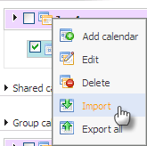
The 3nd way: Right click on the specific calender in the calendar list and select the Import item in the menu:
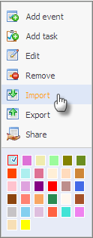
The Import calendars form will appear:
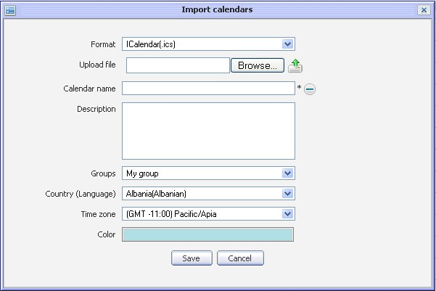Illustration 21: The Import calendars form
Details:

Format | The format of the imported file. There are 2 options: *.ics and *.csv
Upload file | The path of the upload file
Browse button | To select the upload file from local disk
 | To upload the selected file.
Calendar name | The display name of the imported calendar.
 | This icon is used to collapse the current form to a form used to import an uploaded file to existed calendar:
Description | The brief description about the imported calendar.
Groups | The group the imported calendar belongs to.
Country | The country of the imported calendar.
Time zone | The time zone of the imported calendar.
Color | The color of the imported calendar.
Save button | To accept importing calendar.
Cancel button | To exit the Import calendars form.

Step 2: Select type of the import format. For example: IExportedCsv(.csv)
Step 3: Click the Browse... button to select a file (For example: *.csv) which is imported from your computer and then click on the Upload icon to upload the selected file. For example select and upload eXoPlan.csv file.
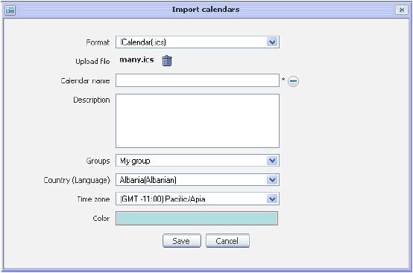
Step 4: Define the properties for the imported calendar.
Step 5: Click the Save button to accept importing a calendar with the selected file .
After importing a calendar, in case the uploaded file is imported into an existing calendar, all events/task(s) inside the uploaded file will be imported into the selected calendar. On the other hand, a new imported calendar will be displayed with predefined display name or its default name in case the Display name field is left blank :
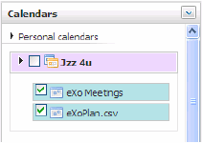Illustration 22: Imported calendar
Note: You can only import calendar to a personal calendar. At present, two file formats are supported for importing *.ics and *.csv

Managing Events

Adding a new event
This function allows adding a new event in eXo Calendar application.
Do as follows:
Step 1: Open the Add Event form.
The 1st way: On the tool bar, click the Event icon for the Quick add event or the Add Event icon for detail one.
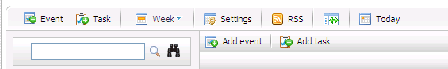
The 2nd way: Create an event directly on the calendar view panel by right clicking on it and select the Add new event item in the drop down list menu or left click directly at the date/time you want to add a new event or drag/drop on calendar view panel to add an event with a specific time.
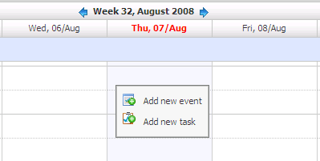
The 3rd way: Create an event directly at the calendars selector level by right clicking on the calendar name and select the Add Event item in the menu:
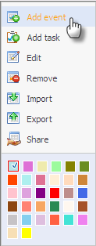
The Quick add event form will appear:
Details:
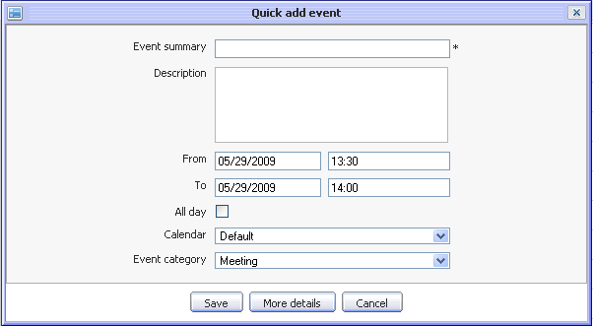Illustration 23: The Quick add event form
Event Summary | The event title. This field is required.
Description | The detail description of the event
From | The start date/time of the event
To | The end date/time of the event
All day | All day option allows setting the event duration to be all day or not. If you don't check this option, you have to define the start date/time and end date/time. By default, the start date and end date is the current date.
Calendar | The calendar will include the event
Event Category | The category will include the event.
Save button | To accept saving a new event
More detail button | To show the event in more details that allows defining more properties for the event. You can see detail about this option here.
Cancel button | To exit the Add event form without adding new

Step 2 : Fill values in the required fields
Step 3: Complete adding a new event by clicking the Save button. The confirmation message will appear:
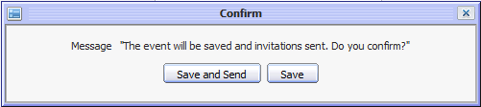Illustration 24: The Confirm form
Step 4: Click the Save and Send button to save and also send an invitation or the Save button to accept adding a new event.
When the More detail button is clicked or add an event by clicking the Add event button in the menu bar, the Event form is displayed with some tabs. (Detail, Reminders, Participants and Schedule) which allows defining an event more details.
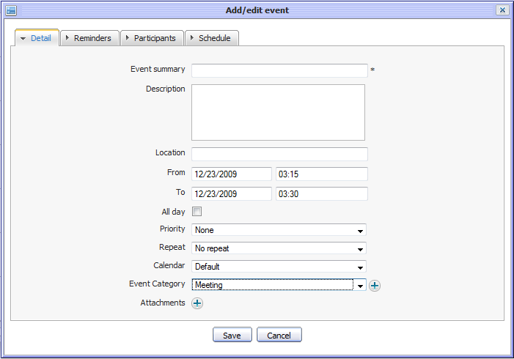Illustration 25: The Detail tab of the Add/Edit event form
- The Detail tab: contains basic information of an event:
Event Summary | The event title. This field is required.
Description | The detail description of the event.
Location | The location where the event will take place.
From | The start date/time of the event.
To | The end date/time of the event.
All day | All day option allows setting the event duration to be all day or not..If you don't check this option, you have to define the start date/time and end date/time. By default, the start date and end date is current date.
Priority | The priority level of this event: None, Normal, High and Low
Repeat: | The repeat time or recurring time for the event, such as weekly team meeting, monthly report... There are many options available: No repeat, Daily, Working days, Weekend, Weekly, Monthly, Yearly
Calendar: | The calendar will include the event
Event Category: | The category will include the event.,You can click the icon to o create a new event category.
Attachments: | The list of attached files to the event. The attachment may be a spreadsheet or a presentation needed for the event. To attach a file, click the button.

- The Reminders tab:
The reminder function is used to remind users who will take part in the event. A reminder includes the summary information about the event such as a title, time, a place where that event will happen.
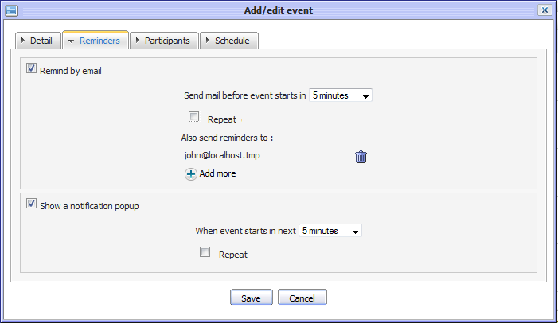Illustration 26: The Reminders tab of the Add/Edit event form
Detail:
Send mail before event starts in | The interval time (in every xxx minutes) that the reminder will be repeated before an event starts.
Repeat every | The check box allows setting the event's email reminder repeat or not.
Also send reminders to | The list of email addresses to which the reminder will be sent. The default value is the email address of the current user. You can select emails from the Select email form by clicking on the icon.
When event starts in next | The interval time (in every xxx minutes) the pop up reminder will be repeated before the event starts.
Repeat | The check box allows setting the event's pop up reminder repeat or not.When the Show a notification pop up is used, the notification pop up about the event will appear when using eXo Calendar at the defined time expectedly.
To select emails to send reminders, click the icon:
- Available email addresses are listed and can be selected by selecting the corresponding check box(s).
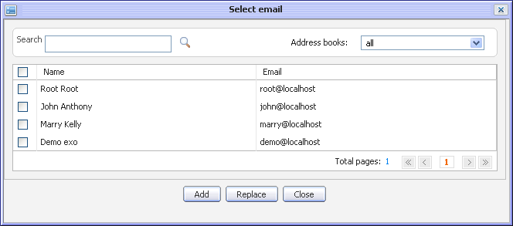Illustration 27: The Select email form
- The Address books and the Search function allow filtering and searching the expected email result.
Click the Add button to add the selected emails to the Also send reminders to fields or click the Replace button to replace existing emails by the selected emails or click the Cancel button to close this form.
After adding email addresses, the email addresses of the selected contacts are displayed in the Also send reminders to field of the Reminders tab.
When the Remind by email function is used, the notification email about the event will be sent at the defined time expectedly.

- The Participants tab:
This tab allows you to select the other users who will join in your event.
Details:
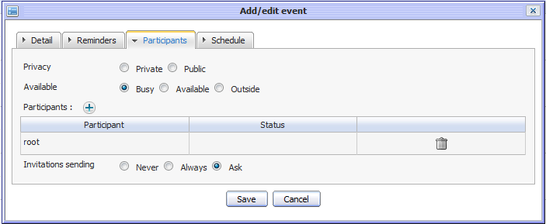Illustration 28: The Participants tab of the Add/Edit events form
Privacy | The privacy of the event. An event may be public or private. Default value of this field is 'Private'. (At present, public or private has information meaning only. There is no effect)
Available | The status of participants. There are 3 options: Busy, Available and Outside.  When 'Busy' or 'Outside' is selected the time the participant takes part in the event/task will be in red as you view the event/task schedule. If you select 'Available' is selected,the time the participant takes part in the event/task will be in white when you view the event/task schedule.
Participants | The list of users who will be participants and receive an invitation by email (If the Send an invitation option is selected). You can click on the icon to add more participants. The Participant table lists all users who will take part in the event and their status. The status may be Yes, No or Pending that depends on the invitation confirmation of the participant: Yes, No or May be.  - Yes: It means the users accept joining the event  - No: It means that the user will not join the event  - If the participant has not confirmed whether he/she participate or not or answer with 'May be' option, the status is Pending: It means that the invitation is pending for the user's approval .  The Action column allows deleting the participant in the list.
Invitations sending | This option will be loaded by default with the value defined in the Calendar Settings. There are 3 options:  - Never: The event invitation will not be sent to any participant.  - Always: The event invitation will always be sent to the participants.  - Asked: There will be a confirmation message which confirms that whether you want to send the invitation or not.

- To select users to participants to invite box:
Click the icon, the Invitations form will appear:
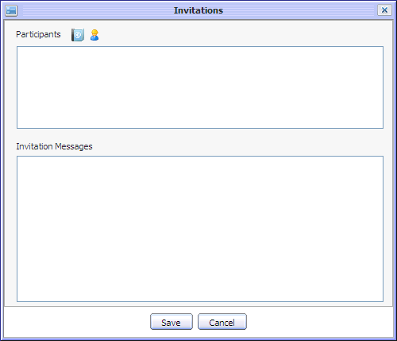Illustration 29: The Invitations form

In details, the Invitations form includes Participants information and the content of the Invitation Messages.
The participants can be added from the Address Book by clicking the icon.
- User names are available in list and can be selected by selecting its check box(s).
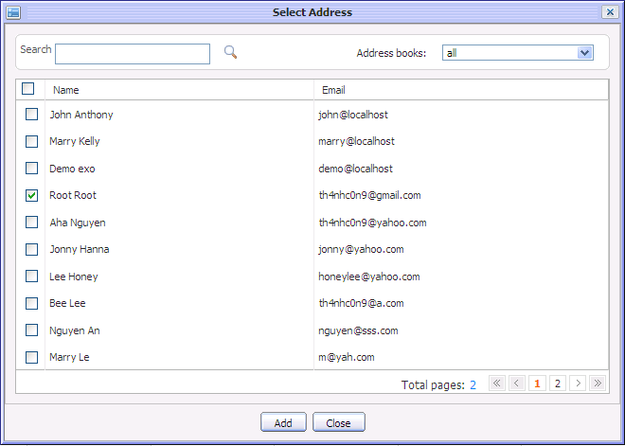Illustration 30: The Select Address form
- To search the desired users, enter a keyword and click the search icon
- Address books filter and the Search function allow filtering and searching expected user result.
- Click the Add button to add the selected users to the Participants table or click the Close button to close this form.
The participants can be also selected from the user picker by clicking on the icon
- Email addresses are available in list and they can be selected by selecting on its check box(s).
- Group and Search function allow filtering and searching the expected mail result..
- Click the Add button to add selected emails to the Participants table or click the Close button to close this form.
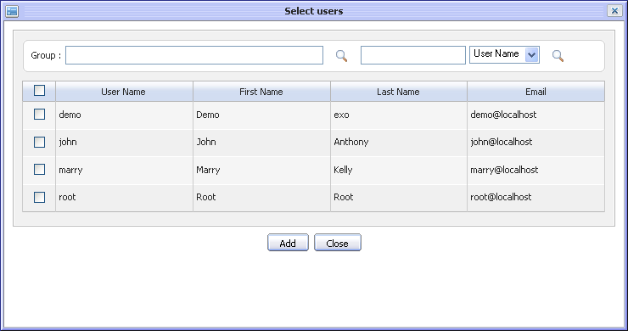Illustration 31: The Select users form
After adding a user, the selected user name is displayed in the Participants table of the Participants tab

- The Schedule tab:
This tab allows you to check the availability of the participants in a defined slot of time (by default, it is the start and end time of the event which you define in the detail tab). By selecting the check box in front of the participants’ names, you may check the availability for all or the selected users.
The selected users in the Participants field of the Participants tab will be displayed in participant list of the Schedule tab.
- To add participants:
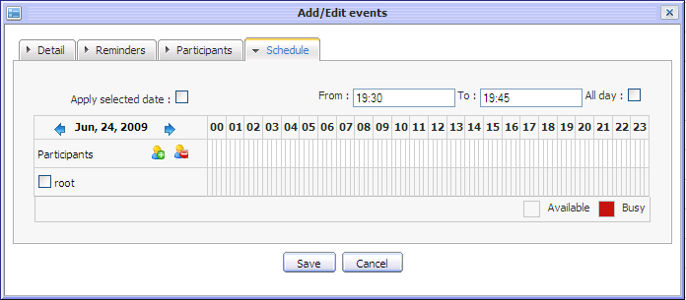Illustration 32: The Schedule tab of the Add/Edit events form
- Click the Add attendee icon on left pane
- The Select users form will appear that allows selecting the attendees.
- To delete participants:
  - Select the participant's name that you want to delete by ticking on User check box and then click the Remove attendee icon on left pane
  - The selected participants are deleted from the participant list of the Schedule tab and Participants tab
- Apply selected date:
  - Add any users to participants list. For example, add john and root who attends to other events.
  - Then, tick on the Apply selected date check box. It means that selected date From/To in the left panel is applied.
Availability time of user John and user root are shown like the illustration below:
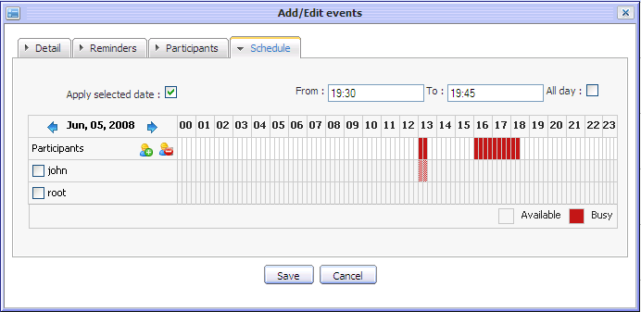
You can select the slot of time to check by moving mouse in time pane. The selected period will become green and the corresponding times will be displayed in 'From' and 'To' fields of the Detail tab.

Viewing an event
To view an event of a specific calendar in more detail, directly right click on the event in the Calendar View Panel and select the View item in the menu:
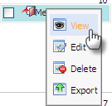
The Preview form will appear:
At the Preview form, if the event includes attachments, you can view the image attachment by clicking the (+) view icon or download any attachment by directly click on the attachment's title, a pop up will be displayed, available for saving the attachment file into your local disk :
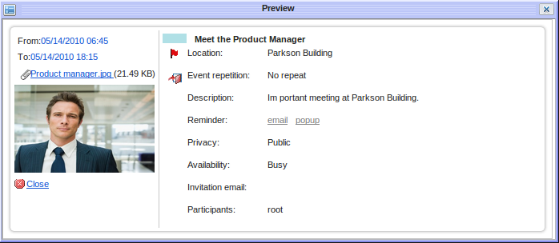Illustration 33: The Preview event form

Editing an event
This function allows making changes to an existing event.
Do as follows:
Step 1: Open the Add/ Edit events form by right clicking on the event that you want to edit and select the Edit item in the menu:
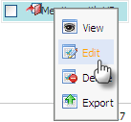
Step 2: The Add/Edit event form is displayed and full filled with all information event, available for editing like when add new event:

Step 3: Modify information of the selected event by following the steps as you create a new event.
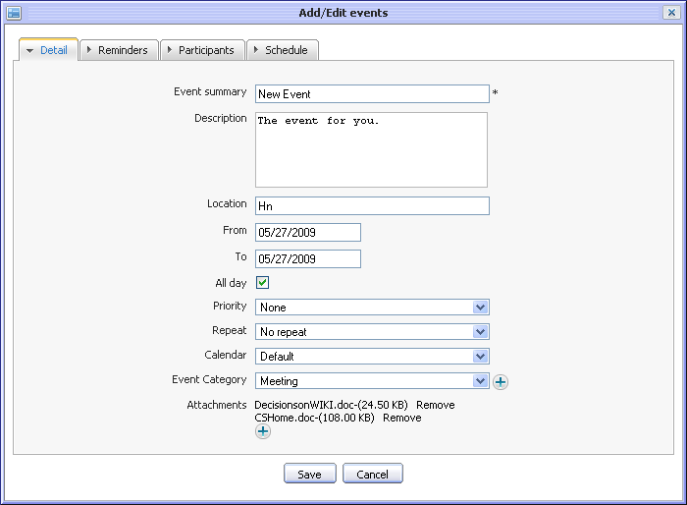Illustration 34: The Add/Edit events form
Step 4: Complete editing by clicking the Save button to accept saving changes.
Note:
- When editing you can add remove the attachment files or download them by directly click on the titles
- If you only want to change the start date and time of the event, you can also use drag and drop feature to edit the time for the event directly on Calendar view panel.
- You can only edit events in personal, shared and group calendars which you have edit permission.

Deleting an event
This function allows removing events from a calendar.
- To delete an event, do as follows:
The 1st way:
- Right click on the event you want to delete and then select Delete item in the menu:
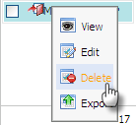
The confirmation message will appear below:
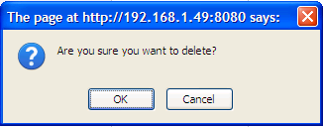
- Complete deleting the event by clicking the OK button in confirmation message.
The 2nd way
- In month view and list view, it possible to tick check box in front of the event name and click the icon on the action bar.
- The confirmation message will appear, click the OK button to accept deleting the selected event or click the Cancel button to exit deleting the event
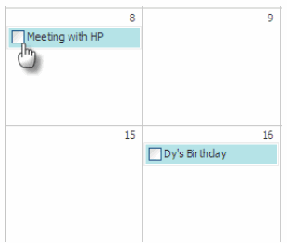Illustration 35: The Month View of the Calendar panel
Note: You can only delete events in the personal, shared and group calendars which you have edit permission.

Dragging and dropping an event
Drag and drop is a nice feature to change the start date and time of an event. Only need to click on the event, drag it and drop it on the new day, new time area in Calendar view panel.
To change the event duration (in day view, week view and working view only), use your mouse and the control at the bottom of the event.
According to the Calendar panel view's features, the drag and drop feature can be applied to the date and time differently.
In Day view, all events are shown in 1 day, you can change the event time in one day only.
In Week and Work Week view, all events are shown in 1 week, you can change both the event time and the event date.
In Month view, all events are shown in 1 moth, you can can change the event date only. You can also change more events at the same time by ticking on their check boxes and using the drag and drop feature.
Note:
You can only drag and drop events in the personal, shared and group calendars which you have edit permission. For example, if you drag and drop an event which you do not have edit permission, a warning message shows that you are not allowed to edit this event/task.

Exporting an event
This function allows exporting one event into a separate file on your computer.
Do as follows:
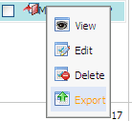
Step 1: Right click on the event that you want to export and select Export in the menu:
Step 2: The Export calendars form will appear below:
Step 3: Enter a file name to export
Step 4: Click the Save button to accept export the event.
The pop up will appear to allow saving the exported file:
Step 5: Click the OK button to save the exported file into your local disk.
Note:
In fact, exporting an event means exporting a calendar with one event only. Therefore, the exported file format and the way to export an event is similar with the way to export a calendar with multiple events and tasks.

Importing an event
This function allows importing an event into a specific calendar.
In fact, importing an event means importing a calendar with one event only. There fore, the way to import an event is similar with import a calendar.
You can see 3.4.7 for details.

Managing Tasks

Adding a new task
This function allows adding a new task in eXo Calendar.
Do as follows:
Step 1: Open the Add task form. You can do this step by three ways:
The 1st way: Click the Task icon for quick add task or the Add Task icon for detail add task on the tool bar:
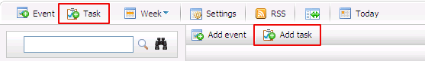
The 2nd way: Create a task directly on the calendar view panel by right click on it and select Add new task item in the drop list menu :
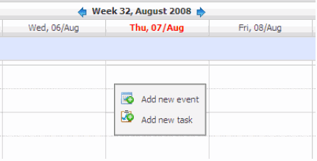
The 3rd way: Create an event directly at the calendars selector level by right clicking on the calendar name and select Add Task item in the menu:
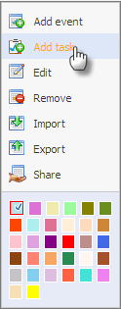
The Quick add task form will appear:
Details:
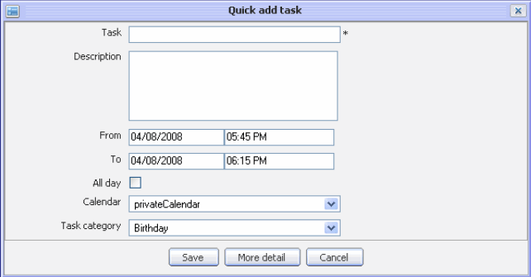Illustration 36: The Quick add task form
Task | The name of the task.
Note | The note of the task.
From | The start date/time of the task.
To | The end date/time of the task.
All day | All day option allows setting the duration of the task to be all day or not. If you don't check this option, you have to select the start date/time and end date/time. By default, the start date and end date is the current date.
Calendar | The calendar will include the task.
Task category | The category will include the task.
Save button | To accept saving new task
More details | To show the event in more detail that allows defining more properties for the task
Cancel button | To exit the Add task form without adding new

Step 2: Fill values to required fields
Step 3: Complete adding new task by clicking the Save button
The added task will be displayed when viewing the calendar in which it is store

If you click the More detail add task by clicking the Add detail task button on the menu bar, the Add/Edit tasks form will be displayed with two tabs (Detail and Reminders) which allows defining task in more details:
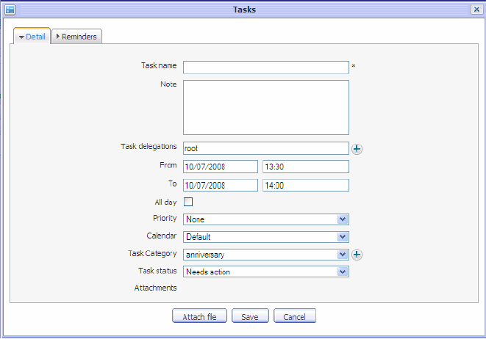Illustration 37: The Detail tab of the Add/Edit tasks form

- The Detail tab allows defining detail task information.

Details:
Task name | The name of the task.
Note | The notice or description of the task
Task delegations | The user(s) to whom you would like to delegate the task. You can manually input or click the icon to select users from the Select users form.
From | The start date/time of the task
To | The end date/time of the task
All day | All day option allows setting the task to be all day or not.
Priority | The priority level of the task.
Calendar | The calendar will include the task.
Task Category | The category will include the task that can be selected from the existing tasks or added a new one by clicking the icon
Task status | The status of the task. This field can be set to:  - Need action  - In Process  - Completed  - Canceled
Attachments | The list of the attached files to the task. The attachment may be a spreadsheet or a presentation needed for the task. To attach file, clicking the button, the Attach files form will appear and files can be attached or removed like when attaching file to event.
  - The Reminders tab: The reminder function is used to remind users who will take part in the task. A reminder includes the summary information about the task such as title, time, place where the task will happen...
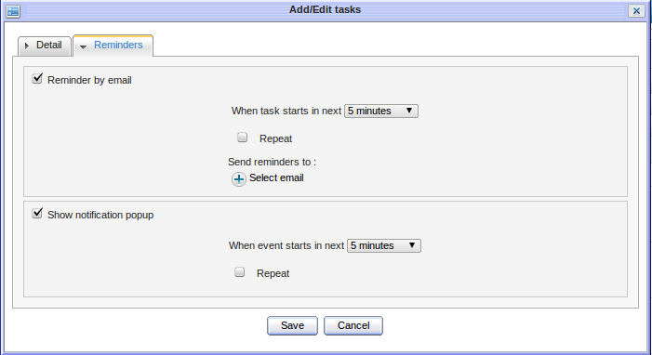Illustration 38: The Reminders tab of Add/Edit tasks form
When task start in next | The time when the mail reminder is sent before the event starts.
Every | The interval time(in every xxx minutes) the reminder will be repeated before the task start.
Send reminders to | The list of email addresses to which the mail reminder will be sent. The default value is the email address of current user. You can click on the icon to select emails from the Select email form.
When event starts in next (2) | The time you will receive pop up reminder before the task starts.
Repeat | The check box allows setting the event's pop up reminder repeat or not.When the Show a notification pop up is used, the notification pop up about the event will appear when using eXo Calendar at the defined time expectedly.

When the Show a notification pop up is used, the notification pop up about the task will appear when using eXo Calendar at the defined time expectedly.

Viewing a task
To view detail of a task of a calendar, right click on the task in the Calendar View Panel and select View item in the menu:
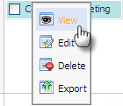
The Preview form will be displayed below:
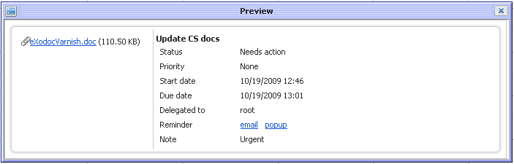
At the Preview form, if the task includes attachments, you can view the attachment by clicking on the attachment's title, a pop up will be displayed, available for saving the attachment file into your local disk.

Editing a task
This function allows making changes to existing tasks.
- To edit a task, do as follows:
Step 1: Right click on the task you want to edit and select edit item in the menu.
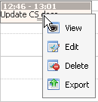
The Add/Edit tasks form will be displayed and full- filled with all task information, available for editing like below:
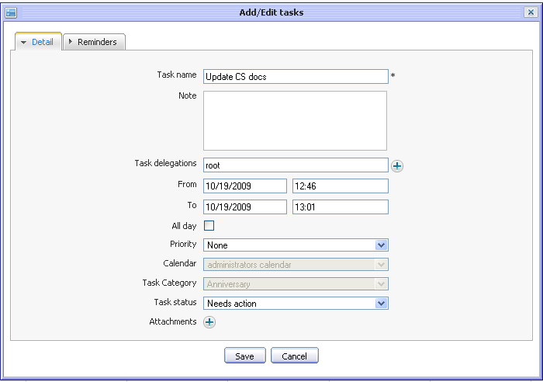
Step 2: Modify information of the selected task by following the steps as you create a new task.
Step 3: Complete editing by clicking Save button.
Note:
- When editing you can add, remove the attachment files or download them by directly click on the titles
- If you only want to change the start date and time of the task, you can also use drag and drop feature to edit the time for the task directly on Calendar view panel.
- You can only edit tasks in personal, shared and group calendars which you have edit permission.

Deleting a task
This function allows removing task from a calendar.
Do as follows:
The 1st way:
- Right click on the task you want to delete and then select Delete item in the menu:
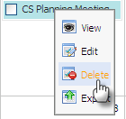
The confirmation message will appear below:
- Complete deleting by clicking the OK button in confirmation message.
The 2nd way:
- In month view and List view, it possible to tick check box in front of task name and then click the button in action bar.
- Confirmation message will appear. Then, click the OK button to accept deleting the selected task or click Cancel button to escape deleting task.
Note:
You can only delete tasks in personal, shared and group calendars which you have edit permission.

Dragging and dropping a task
Similarly to dragging and dropping an event, Drag and drop is a nice feature to change the start date and time of a task. Only need to click on the task, drag it and drop it on the new day, new time area in Calendar view panel.
To change task duration (in day view, week view and working view only), use your mouse and the control at the bottom of the event.
According to Calendar panel view's features, drag and drop feature can be applied to the date and time differently.
In Day view, all tasks are shown in 1 day, you can change the task time in one day only.
In Week and Work Week view, all tasks are shown in 1 week, you can change both the task time and the task date.
In Month view, all tasks are shown in 1 moth, you can can change the task date only. You can also change more tasks at the same time by ticking on their check boxes and using drag and drop feature.
Note:
You can only drag and drop tasks in the personal, shared and group calendars which you have edit permission. For example, if you drag and drop the task which you do not have edit permission, a warning message shows that you are not allowed to edit this event/task'.

Exporting a task
This function allows exporting one task to a separate file on your computer.
Do as follows:
Step 1: Right click on the task that you want to export and select Export in the menu:
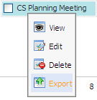
The form to export task will appear:
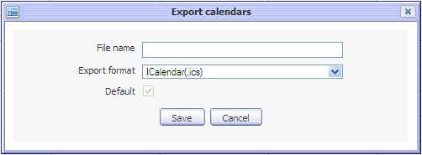
Step 2: Enter a file name to export
Step 3: Click the Save button to accept exporting the task.
The pop up that allows saving the exported file will appear:
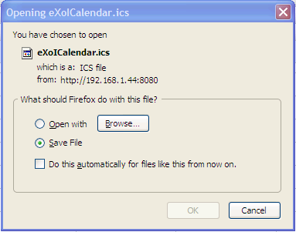
Step 4: Click the OK button to save the exported file into local disk.
Note:
In fact, exporting a task means exporting a calendar with one task only. Therefore, exported file format and the way to export a task is similar with the way to export a calendar with multiple events and tasks.

Importing a task
This function allows importing a task into a specific calendar.
In fact, importing a task means importing a calendar with one task only. There fore, the way to import a task is similar with import a calendar.
You can see 3.4.7 for details.

Searching events/tasks
This function allows finding existing events/tasks according to specific search conditions easily. There are 2 search type: Quick Search and Advanced Search

Quick Search
This function allows you to do a quick search with specific keyword in all your events/tasks. All events/tasks having the text matching with your search team will be displayed in the search result form.
Do as follows:
Step 1: Enter a word in the Search field at the top of the mini calendar: 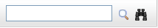
Step 2: Click the Search icon
For example, quick search with “CS” term. All events/tasks matching with “CS” term are listed in the search results form. The Search result form will be displayed like figure below:
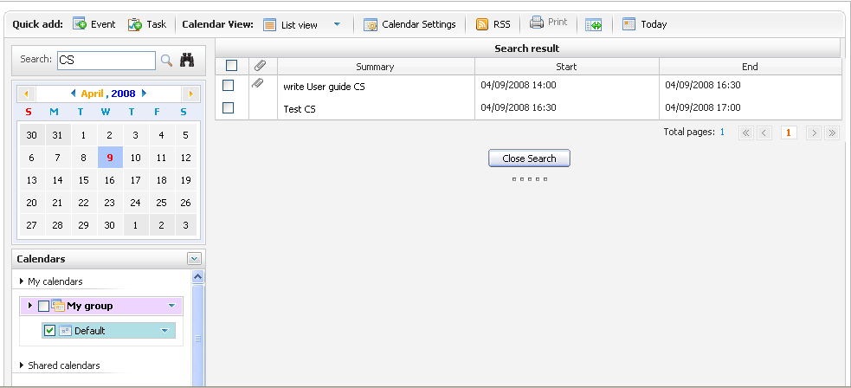Illustration 39: The Search result form

Advanced Search
Advanced Search allows you to make a search with multiple criteria, do as follows:
Step 1: Click the Advanced Search button in the search area.
The Advanced Search form will appear below:
In this form, you can set one, few or all criteria for your search:
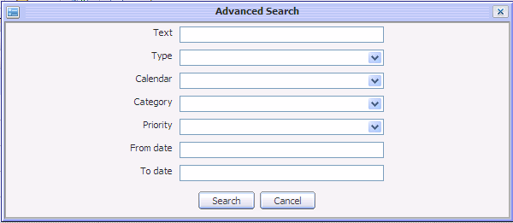Illustration 40: The Advanced Search form
Text: This field allows defining the search term or keyword for searching
Type: This field allows defining search type criteria. There are 3 options: leave Blank for searching both events and tasks, Event for searching event only and Task for searching task only
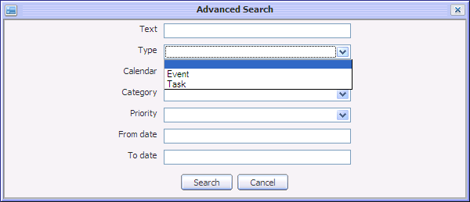
  - Calendar: This field allows defining the calendar in which the search action is done. All your calendars including personal, share and public calendars will be shown in calendar drop list box, available for selecting like below:
  - Category: This field allows defining event/task's category criteria. All categories are listed in Category drop list box, available for selecting. Only event/tasks having category matching category criteria are shown in search result form.
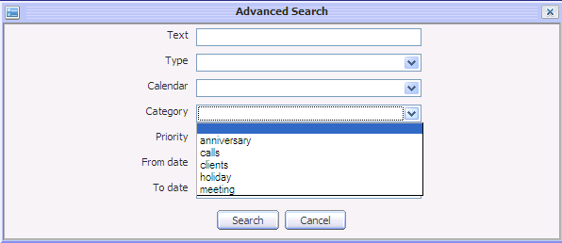
  - Priority: This field allows defining the priority criteria. There are many options: leave blank for searching all, High for searching event/task having high priority, Normal for searching event/task having normal priority and Low for searching event/task having low priority.
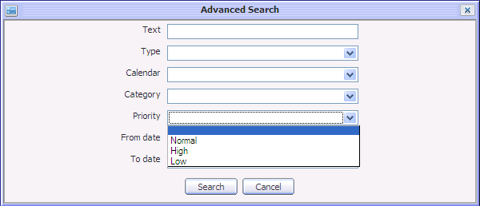
  - From date: This field allows defining 'From date' criteria. Only the event/task(s) having 'To date' greater than or equal entered 'From date' are listed in the search result form. You can manually input or select date from Calendar selector tool.
  - To date: This field allows defining 'To date' criteria. Only the events/task having 'From date' less than or equal to entered 'To date' are listed in search result form. You can manually input or select date from the Calendar selector tool.
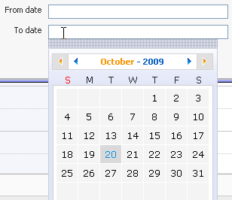
Step 2: Define some search criteria in the Advanced Search form
Step 3: Click the Search button to launch the search. All events/tasks matching with your criteria(s) will be listed in the search result form.
Note:
At the search result form, you can also view, edit or delete event/task by right click on it and select action item in menu pop up.

Calendar View
This function allows personalizing your calendar view by different view types.
By default, the Week view is set and displayed when the calendar is opened at the first time. You can change your view from the main tool bar to make it easy for you to see activities in your calendar. However, changing the calendar view from the main tool bar only has effect for current session. In the next time, you go to eXo calendar, the view will be back to what has been set in your calendar settings.
To change your calendar view, select one view type on the main menu. There are some view types: Day, Week, Month, Year, List, Work Week.
Each calendar view has its own feature.
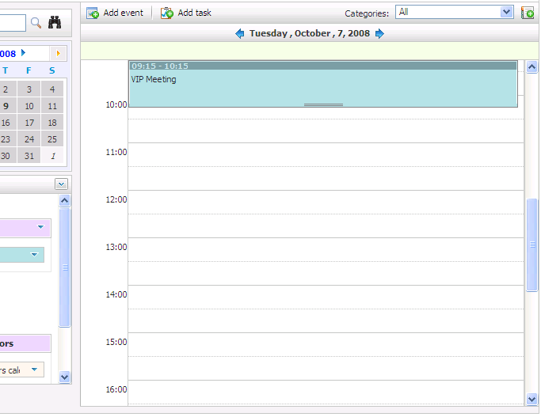Illustration 41: The Day View
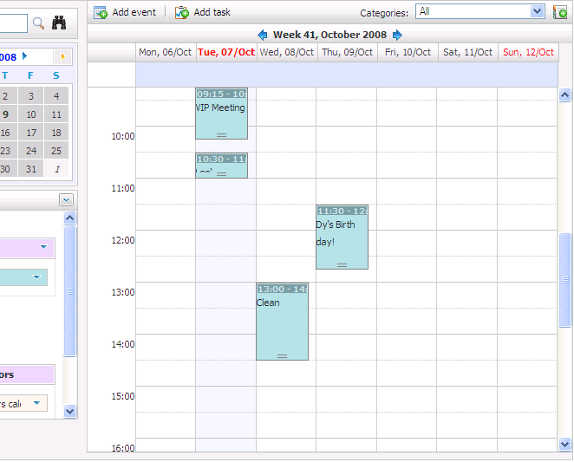Illustration 42: The Week View
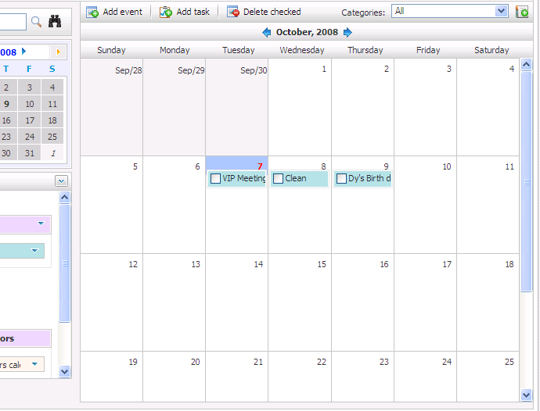Illustration 43: The Month View
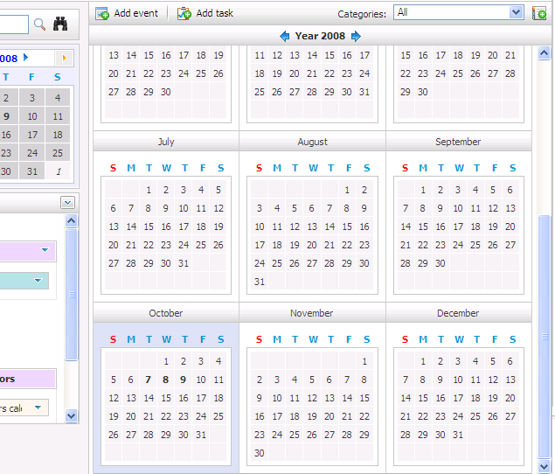Illustration 44: The Year View
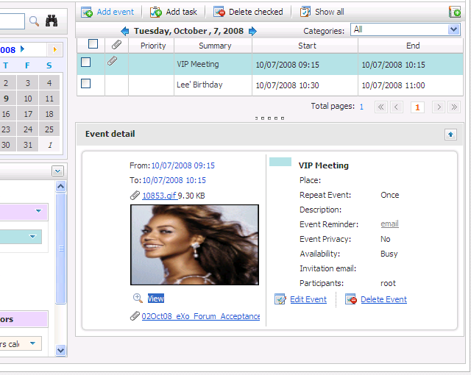Illustration 45: The List View
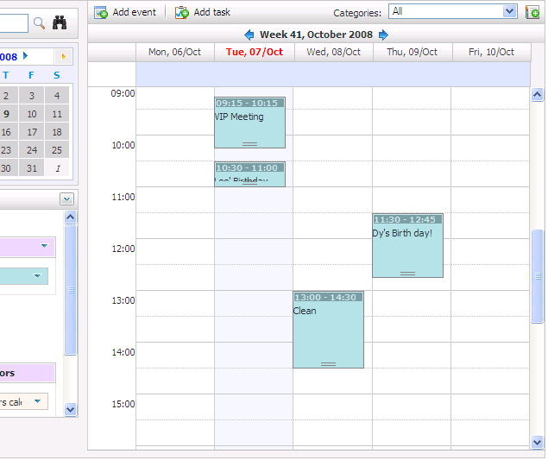Illustration 46: The Work Week View

Calendar Settings
This function allows personalizing your calendar view according to available features. eXo calendar brings you a wide range of custom settings to set your own calendar. To access the settings, do as follows:
The 1st way: Click the on the main tool bar
The 2nd way: Left click on the icon and select Calendar settings in the menu:
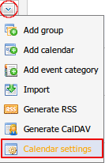
The Calendar settings form will appear:
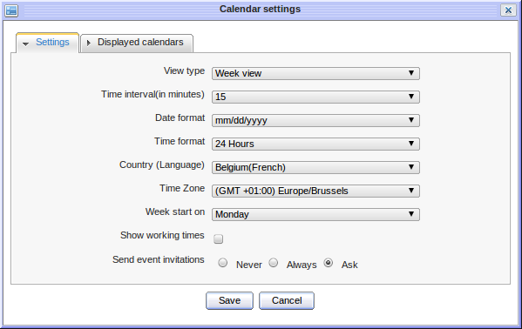Illustration 47: The Setting tab of Calendar settings form
The Settings tab includes:
View type | The view type of Calendar View Panel. You can define default view type when you start the calendar application (day, week, month, year, list or working view)
Time interval(in minutes) | The value (in minute) to define the precision of time intervals. In Day view, Week view or Work Week view, the time 'ruler' will be displayed with the interval likes its definition.
Date format | The date format for the date displayed in Calendar such as Start date, End date of event/task.
Time format | The time format for the time displayed in Calendar such as the time in Start date, End Date, the time displayed in Calendar View Panel.
Country(Language) | The default geographical location displayed in Calendar application.
Time Zone | The default Time zone displayed in Calendar application.
Week start on | The first day of the week displayed in Week view or Work Week view
Show working times | This option allows setting working times when viewing calendar. The working time can be defined by selecting Start and End time.
Send event invitations | When creating an event, you can invite the participants by sending an invitation email. This option is to set by default value for the send event invitations function. There are 3 options:  - Never: The event invitation will not be sent to any participant.  - Always: The event invitation will always be sent to the participants.  - Asked: There will be a confirmation message to ask whether you want to send the invitation or not.

The Displayed calendars tab:
This tab allows you to define the calendars which will be displayed when you open eXo Calendar by simply ticking on its check box.
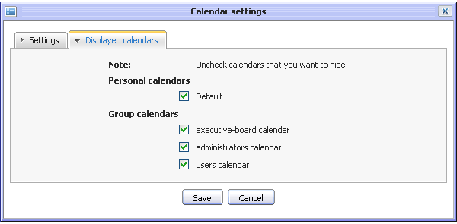Illustration 48: The Displayed calendars tab of Calendar settings form

Generating RSS
This function allows you to publish your calendar as a RSS feed. It will build an URL that can be used to follow events in a RSS reader.
- To generate RSS in calendar, do as follows:
Step 1: Click the icon on the right pane of the calendar list and select Generate RSS item in the menu:
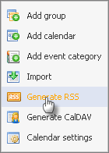
The Generate RSS form will be displayed with two tabs: Informations and Calendar.
Informations tab includes:
Details:
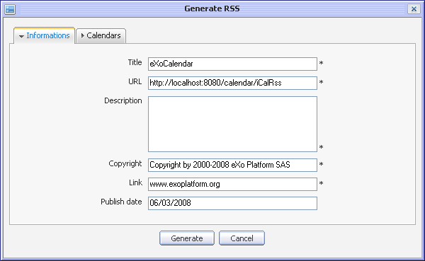Illustration 49: The Information tab of the Generate RSS form
Title | The title of calendar feed when generate RSS. The default value of this field is eXoCalendar.
URL | The URL link of Rss calendar
Description | The brief description about the generated calendar.
Copyright | The name of organization making this product.
Link | The web page address of yours (Default is www.exoplatform.org)
Publish date | The date/time when calendar is generated (default is date/time of the current day)
Generate button | To start generating RSS
Cancel button | To close Generate RSS form

- The Calendars tab:
This tab allows you to select your calendars which you want to generate RSS (as far as it is possible to select multiple calendars ). Tick on check box in front of calendar's name to select calendars which will be generated.
- Fill values in the required fields in the Informations tab
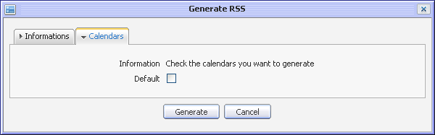Illustration 50: The Calendars tab of the Generate RSS form
- Select the calendars which will be generated RSS by ticking on its check box
- Complete generating by clicking the Save button .
After generating successfully, an informed message dialog will be displayed like below:
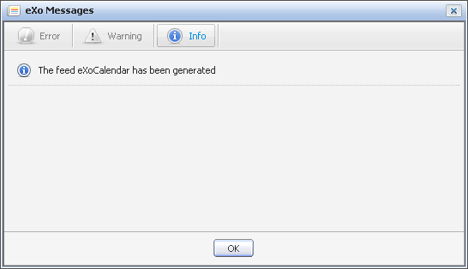
Then, click on the button on the main tool bar, the Calendar Feed form appears and shows Rss title, Rss URL:
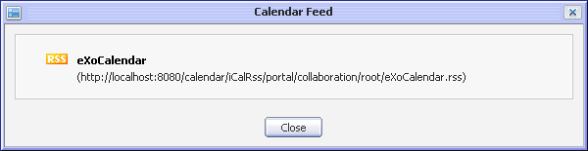
Next, click on the Rss title which is shown in bold text (e.g eXoCalendar), the window is opened:
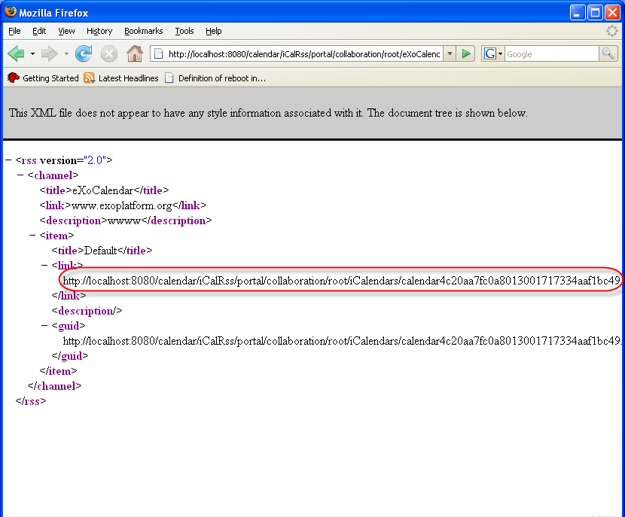
You can copy and paste this address link into any calendar product which supports the Rss format (For instance: Mozilla Sunbird application). Then you can view directly in that application.

Generating CalDAV
This function also allows you to generate your calendar to address link. You can copy and paste this address link to another application which is installed in your computer
- To generate CalDAV in calendars, do as follows:
Step 1: Click the icon on the right pane of the calendar list and select Generate CalDAV item in the menu:
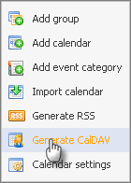
The Generate CalDAV form is displayed with two tabs: Informations and Calendars:
  - The Informations tab includes:
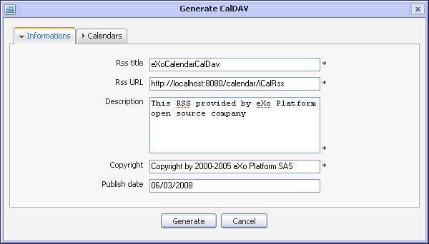Illustration 51: The Informations tab of the Generate CalDAV form
Details:
Rss title | The title of calendar feed of the generated Rss (default is eXoCalendar)
Rss URL | Input URL which stores Rss calendar  ( default is http://localhost:8080/calendar/iCalRss)
Description | The brief description about generated calendar.
Copyright | The name of organization making this product
Publish date | The date/time when calendar is generated (default is current day)
Generate button | To start generating CalDAV
Cancel button | To close Generate CalDAV form

  - The Calendars tab:
This tab allows selecting the calendar which you want to generate CalDAV (as far as it is possible to select multiple calendars).
Step 2: Fill values in required fields in the Informations tab
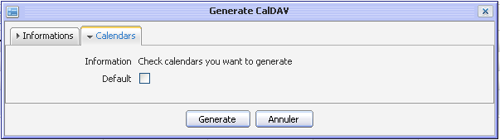Illustration 52: The Calendars tab of the Generate CalDAV form
Step 3: Select calendars which will be generated CalDAV by ticking on its check box.
Step 4: Complete generating CalDAV by click the Save button.
After generating successfully, the inform message will be displayed below:
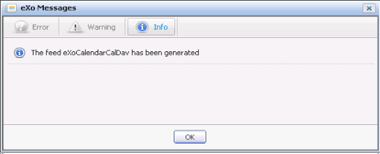
Then, click the button on main tool bar, the Calendar Feed form will appear and show Rss title, Rss URL:
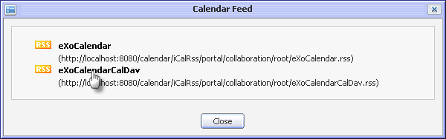
Next, click on the Rss title which is shown in bold text, the window will appear:
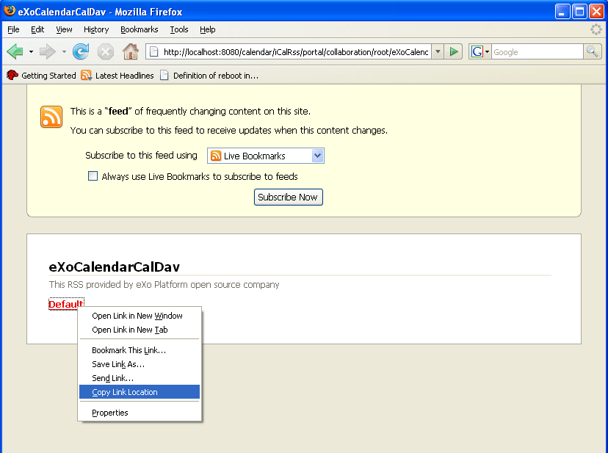
Right click on the Calendar name and select the Copy Link location in the menu, then paste this address link into any calendar product that supports the iCal format (For instance: Mozilla Sunbird application).You can view directly in that application
Note:
When you view the calendar which is generated CalDAV in another application. You must input user name and password.

