

eXo Chat user guide

version 1.3.4
REVISION HISTORY
Version | Date | Written by | Reviewed by | Change Description
1.0 | Oct 20, 2008 | Hoang Anh Quynh Nga
1.3 | June 25, 2009 | Nguyen Thanh Cong |  | Integrate Chat 1.0 with some changes in the CS 1.3
1.3.1 | Sep 26, 2009 | Nguyen Thanh Cong | Luong Quynh Lien | - Add description for action that can be done from the quick chat bar.  - Update some illustrations
1.3.3 | Dec 24, 2009  May 31,2010 | Luong Quynh Lien | Nguyen Huu Tuan Anh | - Update some illustrations.

Contents
1. Preface 6
1.1 About this guide 6
1.2 Who should read this guide? 6
1.3 Objective of this guide 6
2. Getting Started 7
2.1 Basic concepts 7
2.1.1 What is Chat? 7
2.1.2 What is the Chat room? 7
2.2 eXo Chat 7
3. How to process in Chat Application? 9
3.1 Register a new account 9
3.2 Sign in/Sign out 12
3.2.1 Sign in 12
3.2.2 Sign out 13
3.3 Change status 13
3.4 Create a new room 15
3.5 Join a room 19
3.6 Chat instantly 21
3.7 Add a contact 25
3.8 Remove a contact 26
3.9 Add a contact into a room 27
3.10 Leave a room 31
3.11 Configure a room 32
3.12 Send files 32
3.13 Export a chat history 33
3.14 Show messages 35

Illustration Index
Illustration 1: The eXo Chat application interface 9
Illustration 2: The anonymous home page of the classic portal 10
Illustration 3: The Account Setting tab of the Sign up form 11
Illustration 4: The User Profile tab of the Register form 12
Illustration 5: The Sign in form 13
Illustration 6: The classic Portal page after signing in 14
Illustration 7: The New Room form 16
Illustration 8: The General panel of the Room Configuration form 17
Illustration 9: The Security panel of the Room Configuration form 18
Illustration 10: The Conversation window 20
Illustration 11: The Join Room form 21
Illustration 12: The Conversation window after joining a room 22
Illustration 13: The Conversation window when starting chat with the other contact 23
Illustration 14: The Conversation window after sending a instant message 25
Illustration 15: The Add Contact form 26
Illustration 16: The File Upload form 34

Preface

About this guide
eXo platform™ software is a powerful Open Source corporate portal and content management system. Users of the platform have a customized single point of access to the company's information system and resources. The purpose of this user guide is to provide step by step instructions of how to use eXo Chat application which is a part of eXo CS – a extension of eXo portal.
This documentation is a useful guide for you to learn about eXo CS technology in details. It gives an in depth examples and easy explanation of eXo platform technology that not only allows technical but also non-technical people to be more efficiently.

Who should read this guide?
Welcome to the eXo CS material. This document aims at guiding various users of eXo Platform. This material is for anyone interested in learning and using the Chat application. It is also useful for the following groups:
- Users who use eXo CS with Chat application in their work and business, communication.
- Integrators who want to know more about the rich features in order to advice their customers to use products.

Objective of this guide
This user guide will:
- Define some basic concepts used in eXo Chat application
- Show the main instructions of eXo Chat application.
- Guide step by step to take basic actions.

Getting Started

Basic concepts

What is Chat?
Chat describes the way people communicate online in real time. They exchange electronic messages with one or more other computer users in real time. Typically, people in online chat sessions type messages to each other using their keyboards. The message then appears on the screens of all the participants.

What is the Chat room?
Chat room is an online space where participants have simultaneous discussions by typing messages on computer monitor that appear on all chat room participants' monitors.
A chat room is a place on the Internet where people with similar interests can meet and communicate together by typing messages on their computer. People can often enter an un-moderated chat room without any verification of who they are.
A chat room allows several people or even a large group to communicate simultaneously.

eXo Chat
eXo Chat is an application of eXo Collaboration Suites (CS) – an extension of eXo Portal.
With eXo Chat, you can:
- Add contacts into your friends list.
- Communicate with other registered users.
- Create a new room or join one or more existing rooms.
The eXo Chat application interface
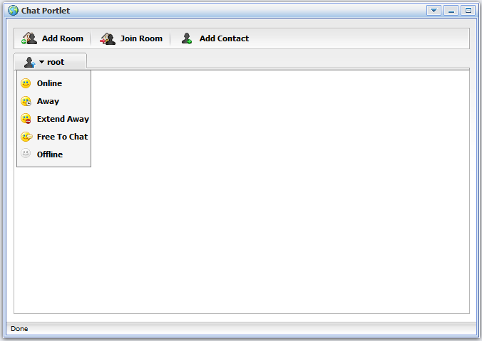Illustration 1: The eXo Chat application interface

How to process in Chat Application?
Firstly, you need a portal account to use eXo Chat. You can register a new one or use your existing account. On standard CS we have configured some accounts with specific roles like:
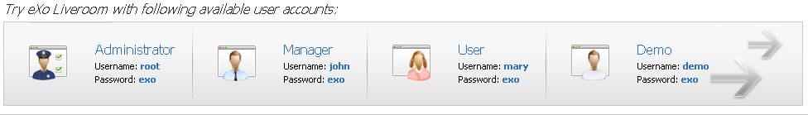
In this document, i will use one of these accounts to guide you through eXo Chat application.

Register a new account
To register a new account on a portal, proceed as follows:
- Go to portal by typing URL in address bar (e.g: http://localhost:8080/portal). The anonymous home page will be displayed:
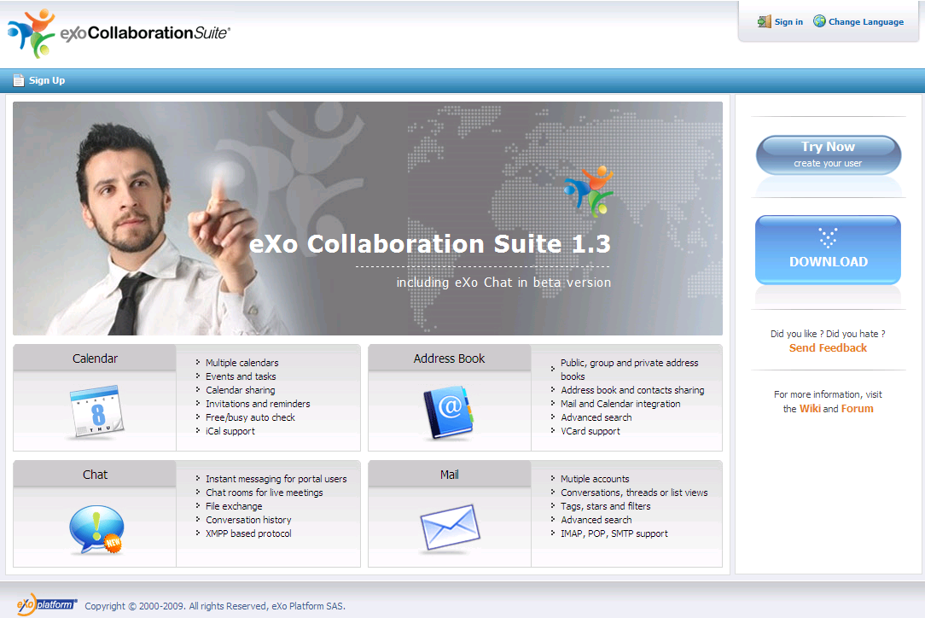Illustration 2: The anonymous home page of the classic portal
- Select the Sign up on the navigation bar. The Sign Up page will appear:
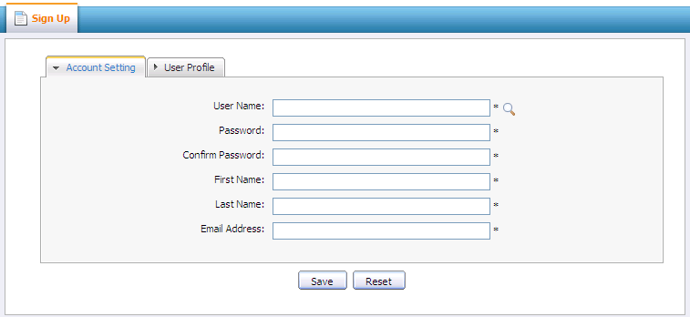
Details:
Illustration 3: The Account Setting tab of the Sign up form
The Account Setting information includes:
User Name: the name that a user uses to sign in. It must be unique. This field must be started with a character.
Password: the secret string used to sign in. It must have at least 6 characters.
Confirm Password: re-type the password above. Password and Confirm Password must be the same.
First Name: Your first name
Last Name: Your last name
Email Address: Your contact email address . It must be in the right format likes username@abc.com
Save button: To accept saving a new account
Reset button: To set blank entry for all inputted fields.
- Click the icon to search and check whether the inputted user name is available or not.
- Input values in all required fields in the Account Setting tab.
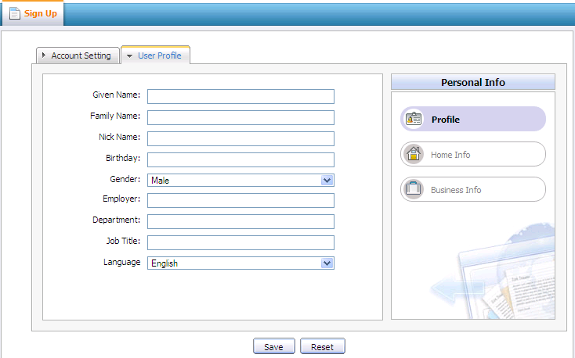Illustration 4: The User Profile tab of the Register form
- Open the User Profile tab, the fields in this tab are not required.
- Click the Save button to accept registering your new account or the Reset button to clean all the inputted values in all fields or click the Cancel button to quit.
There will be an alert messages and you can not add a new account successfully if at least one of these cases occurs:
  - User name is existing or User Name is invalid
  - Password has less than 6 characters.
  - Password and Confirm Password are not the same
  - Email Address is invalid format
  - Required fields are blank (empty)
After registering a new account, you can sign in and access eXo Chat application.

Sign in/Sign out

Sign in
This function allows you to go into eXo portal in the private mode.
To sign in, do as follows:
- Go to Portal by typing the portal URL in your browser address bar (e.g: http://localhost:8080/portal)
- Click the Sign in link at the top right of page. The Sign in form will be displayed.
- Input your registered User name and Password
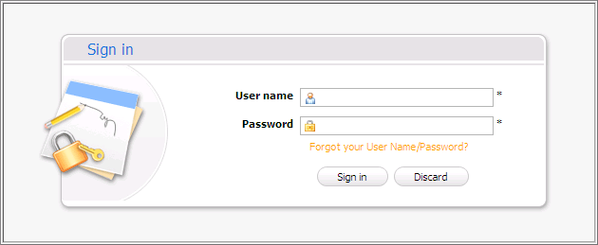Illustration 5: The Sign in form
Details:
User name: The registered user name which is used to sign in
Password: The registered password of the User name above.
Forgot your User The steps have to be followed to get the forgotten User Name
Name/Password Password.
Sign in button: To accept signing in.
Discard button: To exit sign in form without sign in.
- Complete signing in by clicking the Sign in button.
After signing in, you will be redirected to the authenticated home page:
To take actions in the Chat application, you can use the quick chat action bar at the right bottom or click on the Chat logo to go to the Chat portlet.
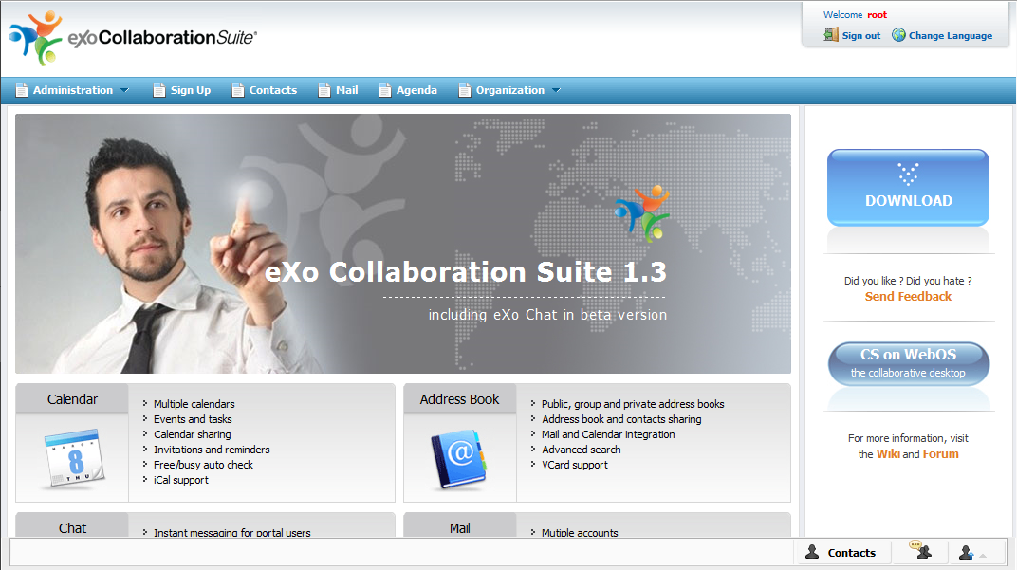Illustration 6: The classic Portal page after signing in

Sign out
This function lets you get back to anonymous portal. It ends your current portal session.
To sign out:
  - In the upper right corner of the screen, click on the Sign out button:
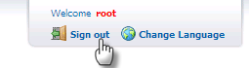

Change status
When you sign in eXo Chat, your logged account has the Online status and other eXo Chat members will see the online icon appending to your account. In some cases, you may want to change your status. This function is used for this purpose.
Do as follows:
- Click the arrow on the account's name in the Chat Portlet to open the status list:
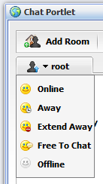

Or click on the account icon in the quick chat bar at the right bottom corner:
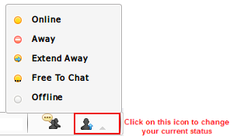

- Select one status in the status list.
- Online: This status means you are available, other users can contact you by sending instant messages. Other users will see the icon beside your account.
- Away: To inform that: you are not available but other users still can send

instant messages to you. Other members will see the icon beside your account.
- Extend Away: Away for an extended period of time. Other members will see the icon beside your account.
- Free to Chat: To inform that you are free to chat with everyone. The icon is appended to your account.
- Offline: Other users will see the icon appending to your account. With this status, the other will not know you are online. It means you are signed out of eXo Chat. In fact, you can chat normally. In vice versa, if someone sends a message when you are not online, you will retrieve that message the next time you sign in eXo Chat.
The logged account will be appended an icon that corresponds to the status which you choose.

Create a new room
eXo Chat makes your communication with the other contacts easier by letting you create a new
room. It means you can add some people into a group to talk together. Chat rooms are set up to handle group discussions, and everyone sees what the others type in, although other people can decide to break off and have their own keyboard chat.
Do as follows:
- Click the button on the action bar in the Chat portlet or click on the chat room icon and select Add Room in the menu pop up.
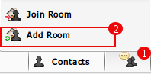

- The New Room form will appear like illustration 7:
Details:
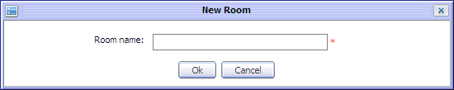Illustration 7: The New Room form
Room name: The name of the room. This field is required
OK button: To accept adding a new room.
Cancel button: To exit/close the New Room form
- Enter a value into the Room name field of this form.
- Click the OK button to accept creating a new room.
After creating a new room, there will be the Room Configuration form to configure some information related to the created room:
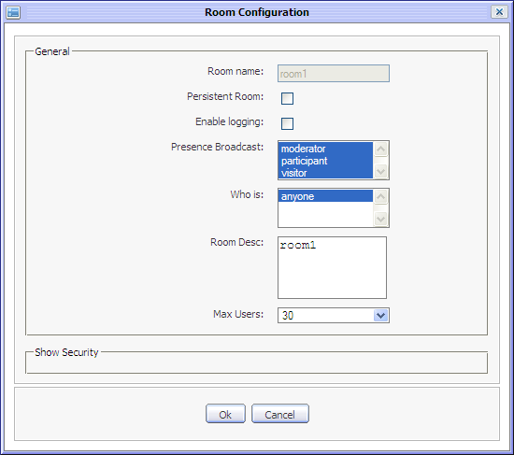Illustration 8: The General panel of the Room Configuration form
Details:
- General: This part contains all general information of the created room
Room name: The name of created room. You can not change value of this field.
Persistent Room: This option is to allow the room will be remain without any member or not.
Enable logging: This option allows to log room's conversations or not.
Presence Broadcast: The groups that will be received a inform message about status changes of the created room's member.
Who is: Users corresponding to the selected groups in ''Presence Broadcast will received the inform message.
Room Desc: The brief description of the created room.
Max users: The maximum users can join the created room.
- Security: This part includes all security information of the created room. To show Security information. Click on the Show Security label to see its details:
Public Room: This option is to allow publishing the created room or not. It means after the room is created, all users can join this room.
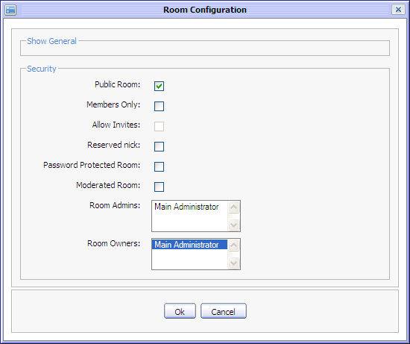Illustration 9: The Security panel of the Room Configuration form
Member Only: This option to publish for members of the created room only or not.
Allow Invites: This option is to allow room's members inviting other users to join the room or not.
Reserved nick: This option is to prevent anonymous users or not. It means if this option is checked, only registered users can join this room.
Password Protected Room: This option is to allow having a password to enter the room or not.
Password: The password is used to protect the room. This field is shown only when 'Password Protected Room' option is check.
Moderated Room: This option to require whether approve/reject the created room or not.
Room Admins: The members that are administration of the created room.
Room Owners: The email address of room's creator.
- Set values in the Room Configuration form.
- Click the OK button in Room Configuration form to accept setting values or click the Cancel button to quit without creating a new room.
After creating a new room, there will be the Conversation window opened with locked status. With this status, both the creator and other members can't join this room to chat. You have to wait until your configuration is confirmed by the server with content 'This room is now unlocked'. It means this room has 'unlocked' status and users can join this room to communicate.
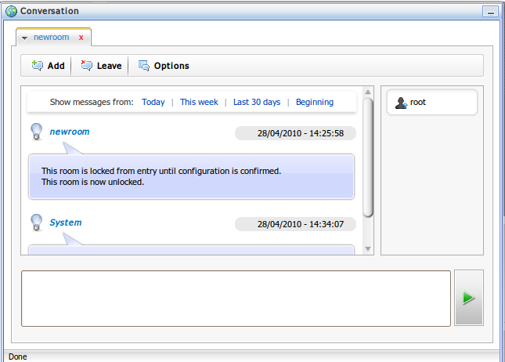Illustration 10: The Conversation window

Join a room
This function allows you to find and chat with other users in different rooms.
To join a room, do as follows:
- Show the Join Room form by clicking the button on the action bar or click on the Chat room icon and select Join Room in the pop up menu:
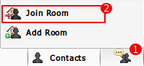

- The Join Room form will appear:
- Select one room in the list by checking the radio button.
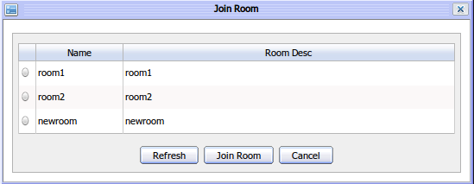
Illustration 11: The Join Room form
- Click the Refresh button to clear the selected rooms or click the Join Room button to join and get the Conversation window to chat with the other users in the room
The Conversation window that corresponds to the selected room appears:
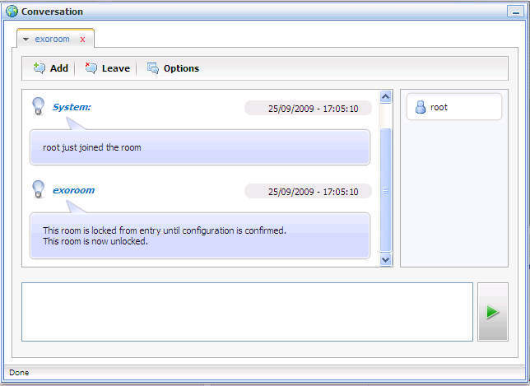Illustration 12: The Conversation window after joining a room

Chat instantly
This function allows exchanging instant messages in real time between two or more people.
The Conversation window consists of a text box where users can type some texts, and a text editor that displays the text typed by user(s) and the scrolls as the chat progresses.
Do as follows:
- Get the Conversation window with a contact by one of the following ways:
- Move the cursor over the contact's name and then clicking on that contact in the friend list.
- Chat with other users in a room by join a room.
- Right click on the contact in the friend list and select the Send message item in the menu. The Conversation window will appear:
- Type the text message that you want to send to the selected contact into the editable text box:
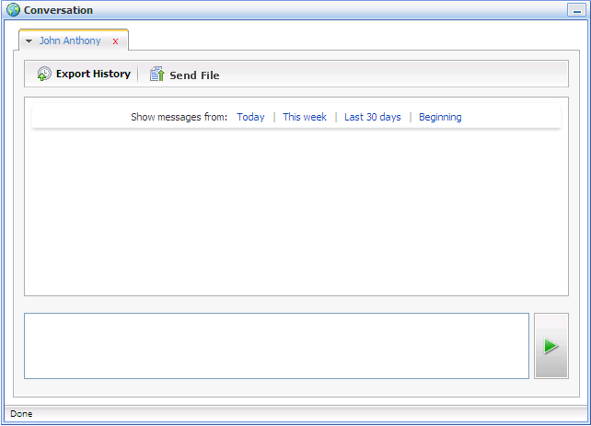Illustration 13: The Conversation window when starting chat with the other contact

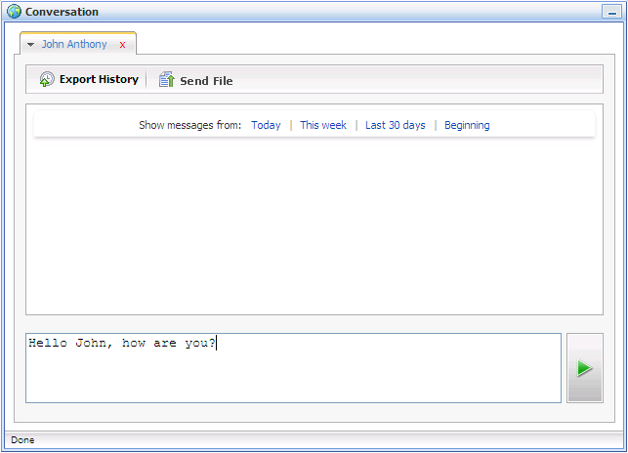
- Press the Enter key on your keyboard or click the green arrow next to the text box to send your message.
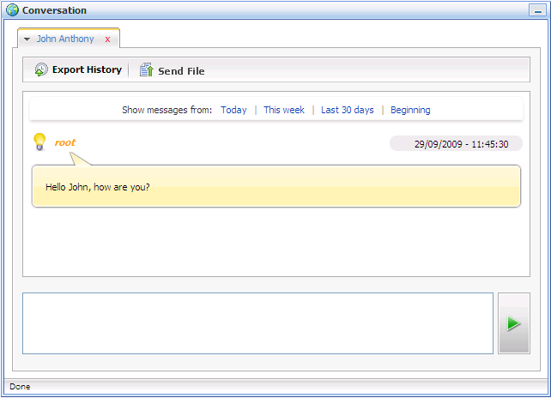Illustration 14: The Conversation window after sending a instant message
The chatting will be taken place until one of them want to stop and leave this room (for chat in a room).
Click the icon on the right corner of the Conversation window to minimize this window. You will see it in the bottom of the Chat Portlet. Click the icon to maximize again.
Note:
When you chat with an offline contact, this contact will receive the message after signing in next time.

Add a contact
This function is used to add a contact into your friend list.
Do as follows:
- Get the Add Contact form by clicking the button on the action bar or click on the Contacts icon and select Add Contact in the menu pop up:
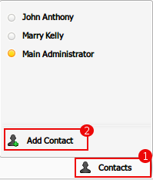

- The Add Contact form will appear:
- Select one or more contacts in the account list by selecting the check boxes. You also can do the quick search in this form to display only contacts that you need:
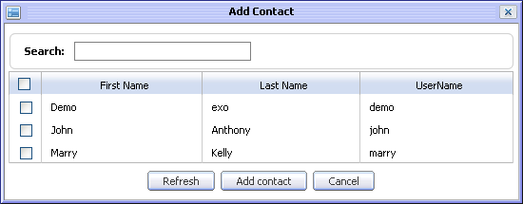Illustration 15: The Add Contact form
- Enter information related to the contacts that you want to quick search into the Search text.
- All contacts in the list that match with the search term will be displayed immediately under. For example:
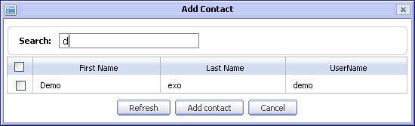
- Select contacts in the found list to add contacts into your friend list.
- Click the Refresh button to clear the selected contacts or click the Add contact button to add contact into your friends list .
The contact that you want to add, will receive a request with the content:
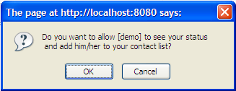

- Click the OK button if he/she accepts your adding.
- Or click the Cancel button to deny your adding.
- If he/she accepts, you also receive a similar alert message. Click the OK button to accept the request .
After adding contacts successfully, the added contacts will be shown in your friends list.

Remove a contact
This function allows you to remove a contact from your friends list.
Do as follows:
- Right click on the contact that you want to remove from your friend list and select Remove in the menu:
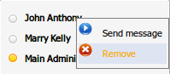

There will have the confirmation message
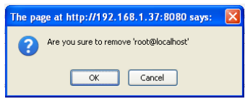

- Accept removing the selected contact by clicking the OK button or click Cancel button to quit without removing.

Add a contact into a room
This function is used to add one or more contacts into a specific room. The added contact will be able to join this room to communicate.
Do as follows:
- Click the button on the Conversation form when you join a room:

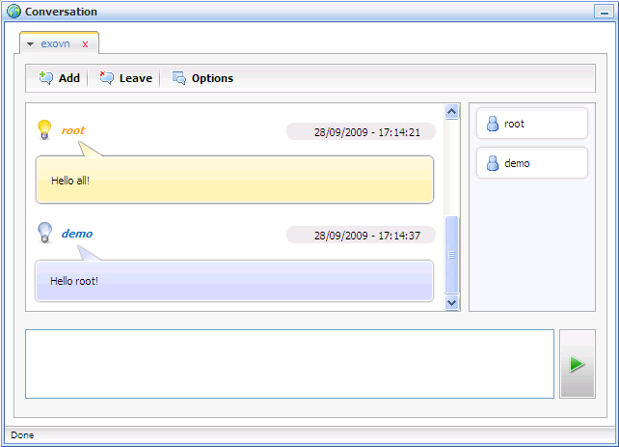
- The Add Contact form will appear:
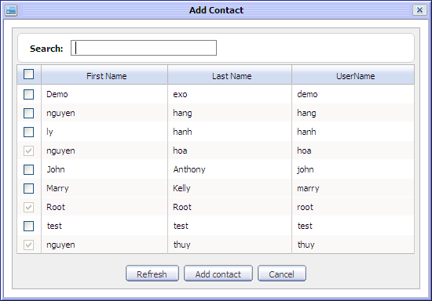
- Select one or more contacts in the list by checking the check boxes. You also can quick search in this form to display only the contacts that you need:
- Enter information related to the contacts that you want to quick search into the Search text.
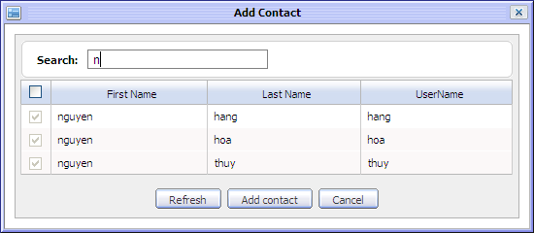
- All contacts in list that match with the search term will be displayed immediately under. For example:
- Click the Refresh button to clear the selected contacts, click the Add contact button to add selected contacts into the room or click the Cancel button to quit.
The users of the added contacts will receive a confirmation message below:
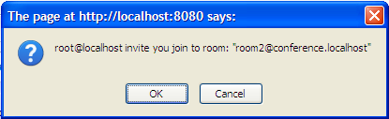

- The users of the added contacts can click the OK button on this message to accept joining this room or the Cancel button to escape.
After adding contacts successfully, your room's Conversation window below:
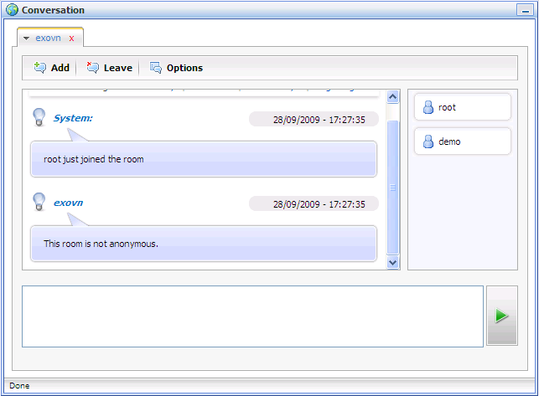
After joining a room, you and the other users can communicate and discuss together in the room board.

Leave a room
This function allows you to leave a chatting room. If you don't want to join the current room any more, you can use this function to escape.
Do as follows:
Click the button on the Conversation form of the current room.
Your Conversation window of this room will be disappeared and you will not receive any instant message from it anymore. In addition, your nick name also disappears from the nick name list of the other member's Conversation window.

Configure a room
This function allows the owner of a chat-room to configure for his/her chat-room's information. Thus if you are not the owner of a chat-room, you can not take this action.
Do as follows:
- Click the button in the Conversation form of that chat-room. The Room Configuration form will appear like when creating a new room.
- Set values for the fields in this form.
- Click the OK button to accept the configuration or click the Cancel button to quit.

Send files
This function allows you send a file to the other contact through the Conversation window.
Do as follows:
- On the Conversation window with the other, click the button on the action bar. You will be directed to select a file on your local computer below:
- Select a file that you want to send to the selected contact.
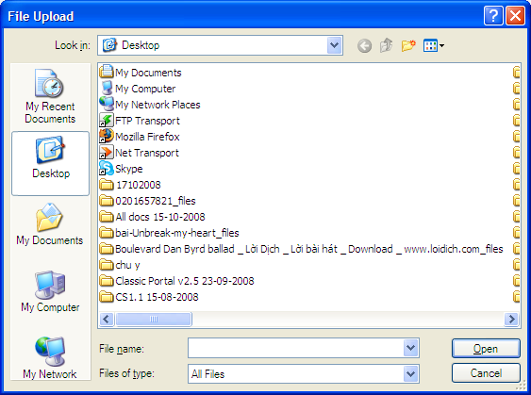Illustration 16: The File Upload form
On the Conversation window of the contact who you want to send files, he/she will receive the sent file:
- Click the Accept under the file's name to accept and save it to the local computer or click the Denial to deny the received file.

Export a chat history
eXo Chat allows you to export and save a conversation if you want.
Do as follows:
Begin exporting a conversation by clicking the button on the Conversation window:

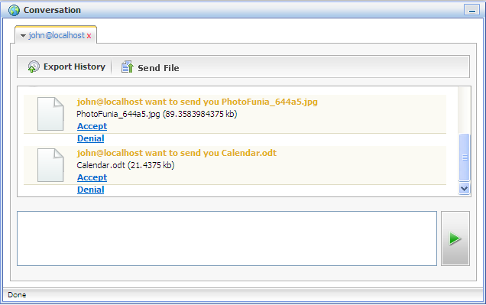
The pop up will appear with two options:
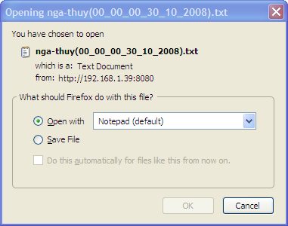

- Open with: To directly open the exported file
- Save File: To save the exported file to your local computer.
After exporting the conversation successfully, you will have a file that recorded all contents in the conversation on the selected location.

Show messages
The chat messages can be shown in a specific time interval.
Do as follows:
- Select a time interval in some default time intervals next to label 'Show messages from:' that you want to show messages.
Details:
- Today: To show all instant messages of the current date.
- This week: To show all instant messages of the current week.
- Last 30 days: To show all instant messages from last 30 days to the current date.
- Begin: To show all instant messages from the beginning of this room to the current date.
All messages with the created time and date will be shown in the Conversation window.

