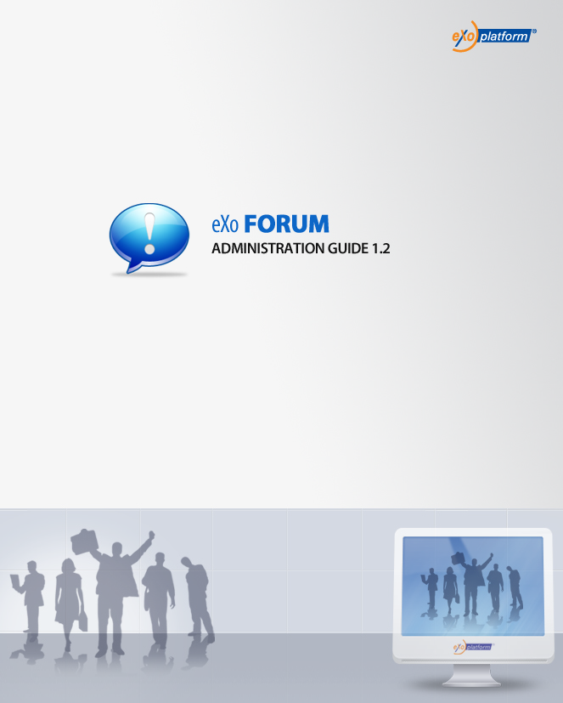
REVISION HISTORY
Version | Date | Written by | Reviewed by | Change description
1.0 | January 03, 2009 | Hoang Anh Quynh Nga | Nguyen Thanh Cong
1.1 | March 18, 2009 | Nguyen Thanh Cong | Hoang Anh Quynh Nga | - Ban IP from icon  - Manage pending list from action bar  - Limit file size uploaded  - User settings: change avatar  - Add forum, automatically subscribe email address  - Notify content tab with new feature.  - User settings: Option to receive notify mails  - Forum Portlet Settings: show/hide category/forum.  - Manage category watch and my watch in user settings.  - One click add watch  - Search in User Management  - Manage Category drop list  - Update/delete avatar.  - Enhance User Profile menu
1.2 | May 22, 2009 | Nguyen Thi Thanh Hoa | Luong Quynh Lien | - Informations of RSS feed  - Add BB Code tab in Administration  - Add poll for topic
1.2 | June 09, 2009  August 20, 2009  May 15, 2010 | Nguyen Thanh Cong  Luong Quynh Lien | Vu Thi Hoa | - Tagging topic  - Export Categories with Export all and Only categories option.  - Enable Panel function  - Auto-prune  - Topics Types  - Permission on Categories  - Screen name  - View post/reply to post links in email notification.  - Moved notification.  - Update screenshots.  - Fix the table of Content

Table of Contents
1. Preface 8
1 About this guide 8
2 Who should read this guide 8
3 Objective of this guide 8
2. Overview 9
2.1 Concept overview 9
2.1.1. What is a Category? 9
2.1.2. What is a Forum? 9
2.1.3. What is Topic? 9
2.1.4. What is Reply? 9
2.2 User groups 9
2.2.1. Administrator 9
2.2.2. Moderator 10
2.2.3. Viewer 10
2.3 The Forum application main screen 11
3. How to use the Forum application? 12
3.1 Signing in/Signing out 13
3.1.1 Signing in 13
3.1.2 Signing out 15
3.2 Category management 16
3.2.1 Adding new categories 16
3.2.2 Edit categories 18
3.2.3 Deleting categories 21
3.2.4 Collapse/Expand a category 21
3.3 Forum management 22
3.3.1 Adding new forums 22
3.3.2 Editing forums 26
3.3.3 Locking forums 28
3.3.4 Unlocking forums 30
3.3.5 Closing forums 31
3.3.6 Opening forums 32
3.3.7 Moving forums 32
3.3.8 Deleting forums 33
3.4 Topic management 34
3.4.1 Adding new topics 34
3.4.2 Editing topics 41
3.4.3 Closing topics 42
3.4.4 Opening topics 42
3.4.5 Locking topics 43
3.4.6 Unlocking topics 44
3.4.7 Sticking topics 44
3.4.8 Un-sticking topics 45
3.4.9 Moving topics 45
3.4.10 Deleting topics 47
3.4.11 Merging topics 47
3.4.12 Search 48
3.4.12.1 Quick Search 48
3.4.12.2 Advanced Search 50
3.4.13 Voting topics 55
3.4.14 Tagging topics 55
3.4.15 Poll management 58
3.4.15.1 Adding polls 58
3.4.15.2 Editing polls 60
3.4.15.3 Closing polls 60
3.4.15.4 Reopening polls 61
3.4.15.5 Removing polls 61
3.4.15.6 Voting 61
3.4.16 Splitting a topic 62
3.4.17 Approving topics 63
3.5 Post management 64
3.5.1 Post reply 64
3.5.2 Post Quick Reply 66
3.5.3 Private posts 67
3.5.4 Quote posts 67
3.5.5 Approving posts 69
3.5.6 Editing posts 70
3.5.7 Moving posts 71
3.5.8 Hiding posts 72
3.5.9 Showing posts 73
3.5.10 Deleting posts 74
3.6 User Management 75
3.6.1 Editing profiles 75
3.6.2 View profile 80
3.7 Bookmark management 81
3.7.1 Adding bookmarks 82
3.7.2 Deleting bookmarks 83
3.8 User settings 83
3.9 Administration 87
3.10 Censor 101
3.11 Watching 103
3.12 Watch management 105
3.13 Sending private messages 107
3.14 Viewing all topics/posts 110
3.15 Exporting 111
3.15.1 Exporting categories 111
3.15.2 Exporting forums 114
3.16 Importing 116
3.16.1 Importing categories 116
3.16.2 Importing forums 117
3.17 Banning IPs 119
3.17.1. Banning IPs from Ban IP Tools 119
3.17.2.Banning IPs from IP icon 121
3.18 Sharing links 122
3.19 Managing the pending list 123
3.20 Forum Portlet Settings 124
3.21 RSS feed 127

Illustration Index
Illustration 1: The Forum Application main screen 9
Illustration 2: The Sign in form 12
Illustration 3: The authenticated homepage 13
Illustration 4: The authenticated Forum application 13
Illustration 5: The Add New Category form 14
Illustration 6: The Select a group form 15
Illustration 7: The Select a group form 16
Illustration 8: The Edit Category form 18
Illustration 9: The Add New Forum form in case using the 1st way 21
Illustration 10: The Add New Forum form in case using the 2nd way 22
Illustration 11: The Moderation options tab of Add New Forum form 23
Illustration 12: The Permissions tab of Add New Forum form 25
Illustration 13: The Edit Forum form 28
Illustration 14: The Move Forum form 32
Illustration 15: The Content tab of the New topic form 34
Illustration 16: The Attach File form 35
Illustration 17:The Icon tab of the New topic form 37
Illustration 18: The Options tab of the New Topic form 38
Illustration 19: The Permissions tab of the New Topic form 39
Illustration 20: The View topic form 40
Illustration 21: The Edit topic form 42
Illustration 22: The Move Topic form 46
Illustration 23: The Merge Topics form 48
Illustration 24: The Advanced Search- Search in Category form 51
Illustration 25: The Advanced Search- Search in Forum form 52
Illustration 26: The Advanced Search- Search in Topic form 53
Illustration 27: The Advanced Search- Search in Post form 54
Illustration 28: The Rate this topic form 55
Illustration 29: The Add Tag pop up 56
Illustration 30: The tag list assigned to a topic screen 57
Illustration 31: The content of a tag screen 57
Illustration 32: The Poll form 61
Illustration 33: The Edit poll form 62
Illustration 34: The Split topic form 65
Illustration 35: The list of all topics in a forum 66
Illustration 36: The unapproved topics list form 67
Illustration 37: The Content tab of the New Post form 68
Illustration 38: The Icons and smiles tab of the New Post form 69
Illustration 39: The Quick Reply form 70
Illustration 40: The Quote form 71
Illustration 41: The Posts to approve form 73
Illustration 42: The Edit post form 74
Illustration 43: The Move Posts form 75
Illustration 44: The Hidden posts form 76
Illustration 45: The User Management form 78
Illustration 46: The Profile tab of the User Management form 79
Illustration 47: The Select forums form 80
Illustration 48: The Settings tab of the User Management form 81
Illustration 49: The Ban user tab of the User Management form 82
Illustration 50: The View User Profile form 84
Illustration 51: The My Bookmarks form 85
Illustration 52: The Profile tab of the User Settings form 86
Illustration 53: The Forum Settings tab of the User Settings form 87
Illustration 54: The User watches tab of the User Settings form 89
Illustration 55: The Sort tab of the Forum Administration form 91
Illustration 56: The Censor tab of the Forum Administration form 93
Illustration 57: The Notify Content tab of the Forum Administration form 94
Illustration 58: The BB Codes tab of the Forum Administration form 96
Illustration 59: Add BBCode form 97
Illustration 60: The Edt BBCode form 99
Illustration 61: The Auto-Prune tab of the Forum Administration form 100
Illustration 62: The Prune Settings form 101
Illustration 63: The Topic Type in the Forum Administration form 102
Illustration 64: The Add Topic Type form 103
Illustration 65: The IP Bans tab of the Forum Administration form 104
Illustration 66: The Hidden posts form 105
Illustration 67: The Watch alert form 106
Illustration 68: The Watch Tools form 109
Illustration 69: The Private Messages form 110
Illustration 70: The Inbox tab of Private Message form 111
Illustration 71: The Compose new message tab of Private Message form 112
Illustration 72: The Posts by user form 113
Illustration 73: The Export Categories form 114
Illustration 74: The Export Forum form 117
Illustration 75: The Import Category form 119
Illustration 76: The Import Forum form 120
Illustration 77: The Ban IP Forum form 122
Illustration 78: The Posts form 122
Illustration 79: The Moderate pending topic and post form 124
Illustration 80: The Edit Mode tab of Forum Portlet settings 126
Illustration 81: The Enaled Panel tab of Edit Mode 127
Illustration 82: The RSS form 128

Preface

About this guide
eXo platform™ software is a powerful Open Source corporate portal and content management system. Users of the platform have a customized single point of access to the company's information system and resources. The purpose of this administrator guide is to provide step by step instructions on how to use the Forum application which is a part of the Knowledge Suite – an extension of eXo Portal.
This documentation is a useful guide for you to learn about eXo Portal technology in details. It gives an in depth examples and easy explanation of eXo platform technology that not only allows technical but also non-technical people to create and manage very fast and powerful website.

Who should read this guide
Welcome to the eXo Knowledge Suite material that guides you how to manipulate eXo Knowledge Suite. This document aims at guiding various users of eXo Portal. This material is not only useful for users interested in learning and using Forum application but is also mainly intended for users who have administration privileges. It covers administration of users, permissions and all management actions.

Objective of this guide
This administration guide will:
- Define some basic concepts used in the Forum application.
- Show the main instructions of the Forum application.
- Let you set permission and take all management actions of the Forum application along with step by step to take basic actions.

Overview

Concept overview

What is a Category?
A category is the name for a collection of content items related in some way. In the eXo Forum, a category can be defined as a domain including various forums which may be related to the same field. A forum application may include many various discussing domains so that it may also include many various categories.

What is a Forum?
A forum is a web application holding on-line discussions and posting user generated content. Thus, a forum is the best place to ask questions about certain development topics.

What is Topic?
A topic is the subject matter of a conversation or discussion in a forum. Each topic contains one original message and all its replies. When you enter a forum, there is a list of topics which are being discussed.

What is Reply?
A reply is a post in a topic. With a message in the topic that you interest, you can read and have any reply if you want. Thus, a reply is your idea about that topic.

User groups

Administrator
Users in the administrator group are users who typically have the right to create, edit, delete, move and modify, etc... any forum and its topic, post. The administrators can also open/close, lock/unlock one forum or topic. It can be said that the administrators have the highest right to do any thing which they want. Otherwise, the administrators also have the right to manage members in the forum and they can set rights for members.
At the runtime of the Forum service, the default administrators, categories and forums are created. These administrators are defined at the Forum Roles Plugin in xml file. These administrators can be changed if the value in xml file is changed. The default administrators are the ones who initialize the Forum and assign role to normal users. A normal user can be an administrator if the default administrator directly assign the administration role to him in the Forum application.

Moderator
Moderators have subset of administrator's rights that allows them to edit, delete and move topics in a special forum which they have the moderation right. Otherwise, the moderator also can open/close, lock/unlock, stick/un-stick, split/merge or approve/disapprove topics in a special forum.
When the administrators create a new forum, they have to set this right to some users or some groups. If not, only the administrators can mange that forum.

Viewer
Viewers includes guests and logged users. Guests only has the view permission while logged users can take some basic actions in the Forum application. By default, all users can view forum, all its topics and replies. However, if the administrator only set the view right for some users or some groups to specific categories, forums or topics, only the users or the groups having the the view right can view them. When having the adding post right, any viewer can add his/her reply to the topic which he/she interests.

The Forum application main screen
Illustration 1: The Forum Application main screen
Indicator | Meaning
 | This is the Breadcrumb bar that shows the forum path, quick search and advanced search and permlink.
 | This is the Main action bar that displays all main function buttons, the number of function buttons depending on the role of user login.
 | This is the Forum panel that displays all categories and forums inside.
 | This is the Statistic Panel that displays Forum statistics about user information.
 | This is the Right Panel that allows taking some advanced actions in Forum, including Download, Sign up, Take a tour, Feedback.

How to use the Forum application?

Administrator

Create new category

Create new Forum
Is not set with 'Moderate Topics'
Is set with 'Moderate Topics'

Waiting to be approved

Approve
Create new Topic
Is not set with 'Posts Moderation'
Is set with 'Posts Moderation'

Waiting to be approved

Create new Post
Approve

Finish
Main Work flow of Forum application

Signing in/Signing out

Signing in
This function allows you to go into eXo Portal in the private mode.
To sign in, do as follows:
- Go to the portal in the public mode by inputting the URL in the address bar (e.g: http://localhost:8080/portal)
- Click the Sign in link at the top right of a page if you are in the classic portal.
The Sign in form will appear:
Details:
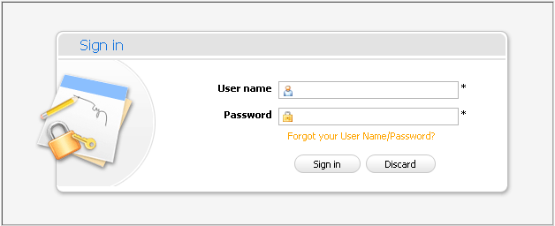Illustration 2: The Sign in form
User name: The registered user name
Password: The registered password
Forgot your User Name/Password? This link helps users to retrieve username and password when users forgot.
Sign in button: To accept signing in.
Discard button: To close the Sign in form
- Login by the administrator account (User name:root and Password: exo)
- Complete signing in by clicking the Sign in button.
In case, the User Name does not exist or invalid inputted User name/Password, there is an alert message that requires to input a correct value. To sign in again, you click the OK button on the alert message and re-enter the User Name and Pass word.
After signing in, you will be redirected to the authenticated home page:
To take actions in the Forum application, you have to go into the Forum Application page on the navigation bar. The main screen of forum application will be displayed:
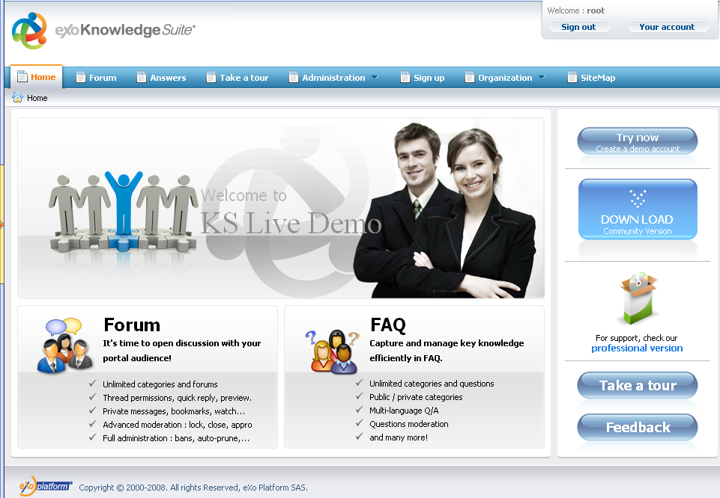Illustration 3: The authenticated homepage
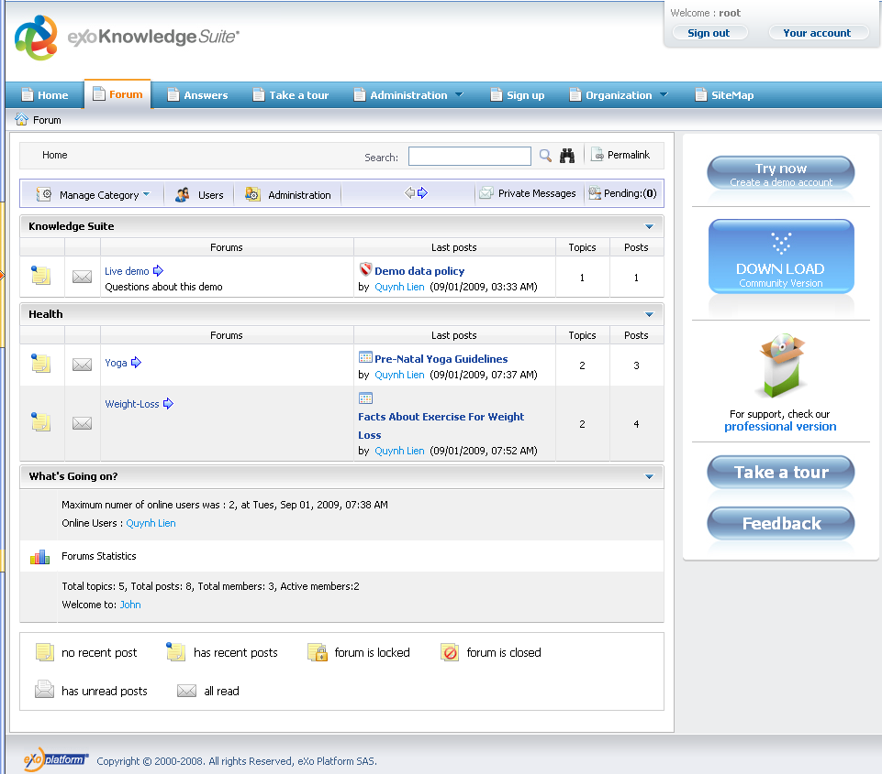Illustration 4: The authenticated Forum application

Signing out
This function allows you to get back to anonymous portal. It ends your current portal session.
To sign out, click the Sign out button at the top right corner of the screen:
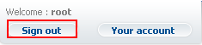

Category management
This section includes all actions related to a category in the Forum application.

Adding new categories
This function allows you to create new categories in the Forum application. Only the administrators can take this action.
Do as follows:
- Click the Manage Category button on the main menu bar and select Add category in the menu.
The Category form will appear :
The Category tab:
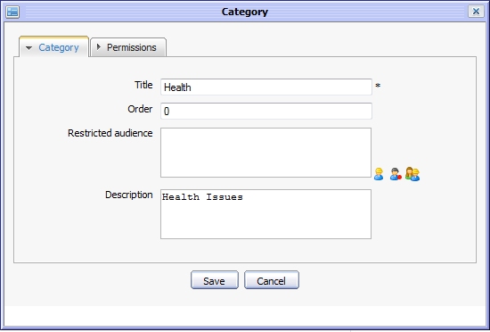Illustration 5: The Category form
- Enter values into fields in this form:
Details:
Title: The title of the category. This field is required and limited by 100 characters.
Order: The order of the category in the category list. The default value of this field is '0'.
Restricted audience: List of all users who can access the category. By default, this field is blank means that all users can access this category.
The Restricted audience can be inputted manually or by using selector tool as below:
- Click the icon if you want to select users from the user list.
- Click the icon to select a user's role. Firstly, select one group from the left pane and then select a membership on the right:
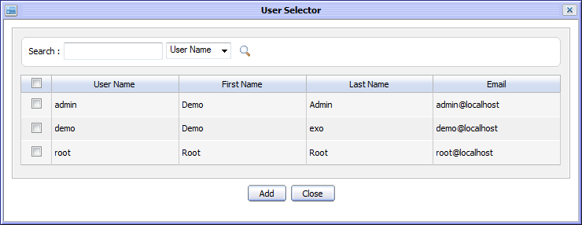Illustration 6: The User Selector form
- Similarly, click the icon to select all users in a specific group.
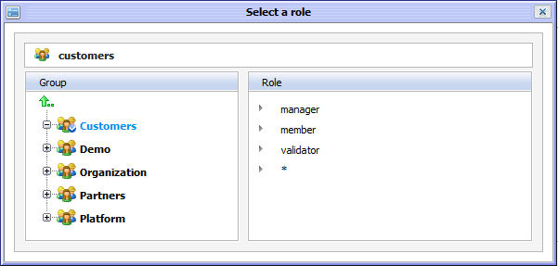Illustration 7: The Select a role form
Description: The description about the category. This field is not required and limited by 100 characters.
Save button: To accept saving a new category.
Cancel button: To close the Add New Category form
The Permissions tab:
Illustration 8: The Permissions tab in the Add New Category form
The selected users who are moderators or can start topics, can post topics in forums or can only view posts in a category can be inputted manually or by using the selector tool. Refer the way to use the selector tool in selecting the restricted audience above.
- Complete adding a new category by clicking the Save button.

Edit categories
This function is used to edit an existing category. Only the administrators can take this action.
Do as follows:
- Go into the category which you want to edit. There are several ways to take this action:
The 1st way: If you are on the forum home page, click on the name of the category that you want to edit:
The icon that corresponds to the forum will let you jump to the last read post of that forum.
The 2nd way: If you are in a forum or in a topic, you can take this action by clicking on the name of the category that you want to edit on the Breadcrumbs bar like this example:
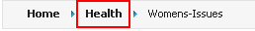
The 3rd way: You can go through forum link and then click the Go button to go to selected category:

- Click the Manage Category and select Edit Category in the menu:
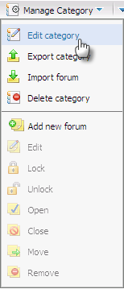
The Edit Category form will appear:
Illustration 9: The Edit Category form
- Change the current category's information in the Category and Permissions tab like when adding a new category.
- Complete editing a category by clicking the Save button.

Deleting categories
This function is used to remove an existing category in the Forum application. Only the administrators can take this action.
Do as follows:
- Go into the category which you want to delete. There are two ways to take this action:
The 1st way: If you are on the forum home page, click on the name of category that you want to delete:

The 2nd way: If you are in a forum or in a topic, you can take this action by clicking on the name of category that you want to delete on the Breadcrumbs bar:
The 3rd way: You can go through forum link and then click the Go button to go into selected category like:

- Click the Manage Category and select Delete category in the menu:

- Click the OK button in the confirm message to accept deleting or the Cancel button to quit.

Collapse/Expand a category
This convenient function allows you to collapse or expand a category by just clicking on the arrow at the end of the category pane as you can see below:
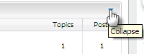
Note that when you log out and then log in again, this state of the category pane will be restored as you left them before log out.

Forum management
This section is about how to mange forums in categories such as add new, edit, lock, unlock, close, open, move, delete etc...

Adding new forums
This function is used to add a new forum into a specific category. Each category includes one or more forums. Only the administrators can add a new forum.
Do as follows:
- Click the Manage Category button on the main menu bar and select Add forum in the menu.
The Forum form will appear with the 'Add Forum to Category' combo box available for selecting the category to which the forum will belong:
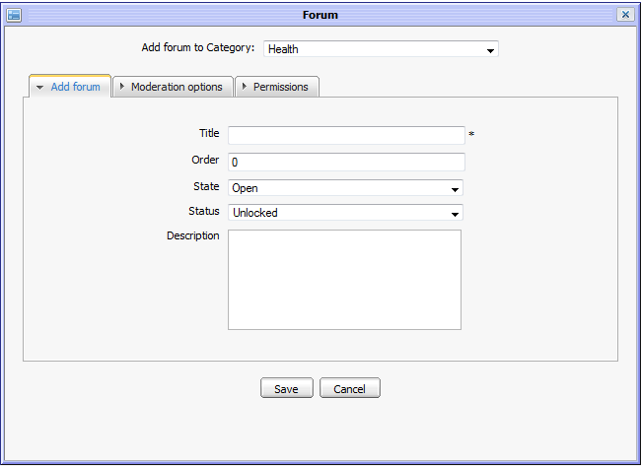Illustration 10: The Forum form in case using the 1st way
Details:
Add Forum to Category: The selected category that a new forum will be added. In this way, because Add new forum function is called inside the selected forum so that this filed is already set with predefined value and can not be changed flexibly like the 1st way.
Title: The title of the forum. This field is required and limited by 100 characters.
Order: The order of the forum in the forum list in one category. The default value of this field is '0'.
State: The state of the forum. The default value of this field is 'Open'. It means that this forum is being opened for users to discuss. The other value is 'Close' . It means that normal users can not see that forum.
Status: The status of the forum. The default value is 'Unlock'. It means that all users can view forum and reply to its topic. The other value is 'Lock'. It means that normal users can only view forum but can't add topics or replies.
Description: The brief description about the forum. This field is limited by 100 characters.
Save button: To accept saving a new forum
Cancel button: To close the Add New Forum form.
The Moderation options tab:
Details:
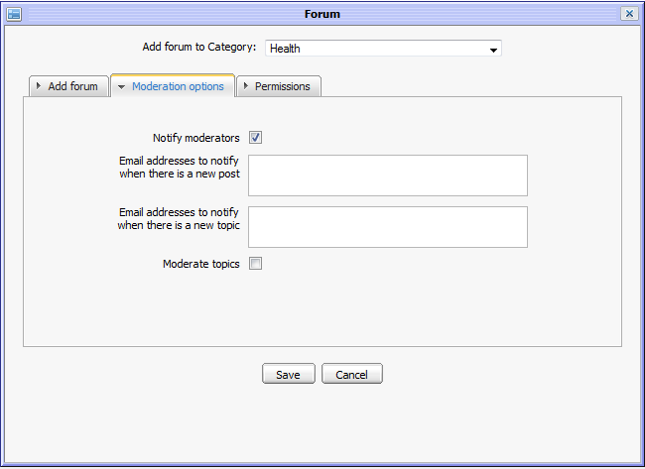Illustration 11: The Moderation options tab of the Forum form
Notify moderators: This option is to whether notify moderators or not.
Email addresses to notify when there is a new post The list of email addresses which will be received notification when there is new post added to forum.
Email addresses to notify when there is a new topic: The list of email addresses which will be received notification when there is a new topic added to a forum. To add emails into this field, do as above.
Moderate topics: This option is to check status of all new topics in the forum. It means: by default, when there is new topic ,this topic is always approved and visible. But when the creator checks this check box , the new topic added to forum will be pending for being checked the approval before being visible.
The Permissions tab:
Details:
Illustration 12: The Permissions tab of the Forum form
Moderators: The list of users or group having the moderation right (can take some actions such as open/close, lock/unlock, Stick/Un-stick, split/merge, approve/disapprove...) all topics in this forum. The creator can manually edit values of this field or select from Selector tool as above.
Who can topics? The list of users who can create topics in this forum. The creator can manually edit a value of this field or select from Selector tool as above.
Who can post?: The list of users who have the right to add posts to all topics in this forum. The creator can manually edit value of this field or select from Selector tool as above.
Who can view posts?: The list of users who have the right to view this forum. The creator can manually edit a value of this field or select from Selector tool as above.
You can enter values for the Moderation options tab or the Permissions tab. By default, if you do not input values for these tabs, only the administrators have management right, the other normal users can only view, add new topic and post reply into this forum. However, if the administrators want to assign some forum actions for some users or some groups, they need to input values for the Moderation options tab or the Permissions tab.
- Enter values for fields in the Forum form.
- Complete adding a new forum by clicking the Save button.

Editing forums
This function is used to edit an existing forum.
To edit a forum, do as follows:
- Select a forum and open the Edit Forum form by 2 ways:
The 1st way:
- Go into the category that includes the forum which you want to edit by one of three ways like in 3.2.2. There is a forum list of this category:
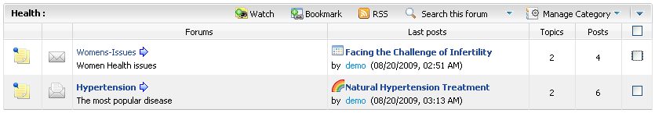
- Select the forum by selecting its check box.
- Click the Manage Category and select Edit in the menu.
The 2nd way:
- Go into the forum which you want to edit, topic list and some information of this forum will be displayed:
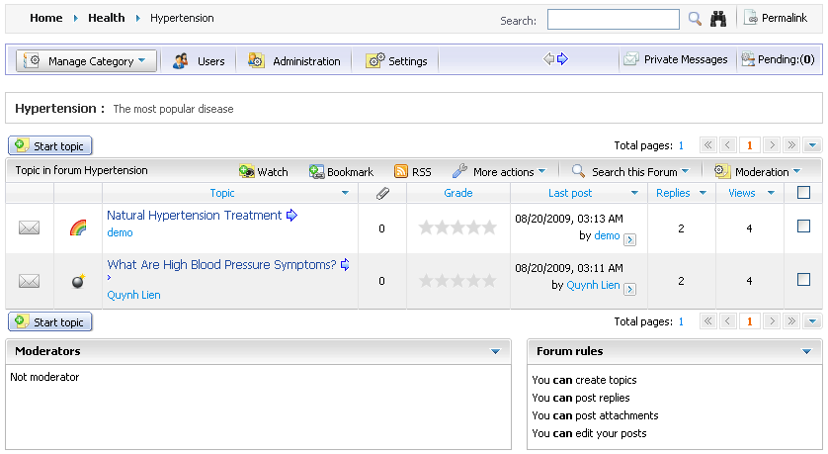
- Click the More actions and select Edit in the menu:
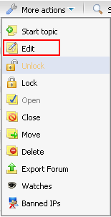
The Edit Forum form will appear with the current information, available for editing:
- Change information of the selected forum like when adding a new forum.
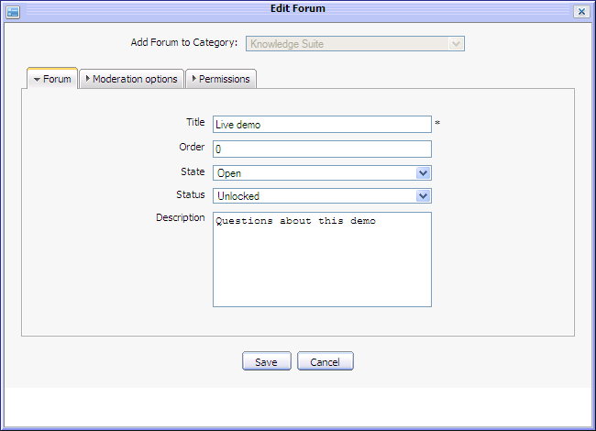Illustration 13: The Edit Forum form
- Complete editing a forum by clicking the Save button.

Locking forums
This function is used to lock a forum. It prevents a specific forum from adding a new topic or posting replies and normal users have the view permission on the locked forum only.
There are two ways to lock a forum.
The 1st way: Only the administrator can do this way.
- Go into the category that includes the forum which you want to lock by one of three ways like in 3.2.2. There is a forums list of this category.
- Select the forums by selecting their check boxes.

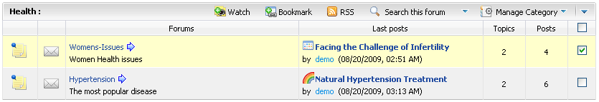
- Click the Manage Category and select Lock in the menu.
The 2nd way:
- Go into the forum which you want to lock.
- Click the More actions on the forum bar and select Lock in the menu.
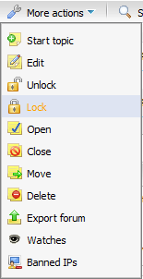
After being locked, all functions of this forum such as Start topic, Post reply... will be disabled The icons that correspond to forums/topics will be changed from normal status into locked status /. Thus, the other users can not add any new topic or post any reply in this forum.

Unlocking forums
This function is used to unlock a forum. When you want to activate the locked forum and allow the other users to take actions on it, you must do this function.
Do as follows:
The 1st way: Only the administrator can do this way.
- Go into the category that includes the locked forum which you want to unlock by one of three ways like in 3.2.2 . There is a forum list of this category.
- Select the locked forum(s) by selecting its check box(s).
- Click the Manage Category and select Unlock in the menu.
The 2nd way:
- Go into the locked forum which you want to unlock.
- Click the More actions on the forum bar and select Unlock in the menu:
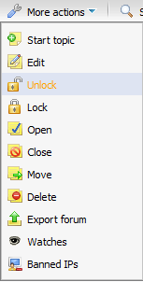
After being unlocked, all functions such as New post, Post reply... will be enabled for users to use. The icons corresponding to forums, topics will be changed from locked status to normal status .

Closing forums
This function is used to close a forum. When a forum is closed, it is invisible and all its functions are disabled.
To close a forum, do as follows:
The 1st way: Only the administrator can do this way.
- Go into the category that includes the forum which you want to close by one of three ways like in 3.2.2. There is a forum list of this category .
- Select forums by selecting their check boxes.
- Click the Manage Category and select Close in the menu.
The 2nd way:
- Go into the forum which you want to close.
- Click the More actions on the forum bar and select Close in the menu:
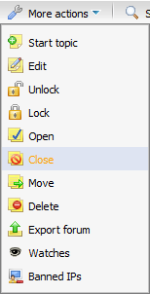
After being closed, this forum will not be displayed, so that normal users can not see the closed forum. For the administrators or moderators, all actions will be disabled and icons corresponding to forum changed from normal status to the closed status for the forum and locked status for the topics inside .

Opening forums
This function is used to open closed forums. When a closed forum is opened, all its function will be enabled.
To take this action, do as follows:
The 1st way:
- Go into the category that includes the forum which you want to close by three ways like in 3.2.2. There will be a forum list of this category.
- Select the closed forums by selecting their check boxes.
- Click the Manage Category and select Open in the menu.
The 2nd way:
- Go into the closed forum which you want to open.
- Click the More actions on the forum bar and select Open in the menu.
After being opened, a forum will be visible to normal users and all its functions such as New topic, Post Reply... will be enabled. The icons corresponding to the forum and its topics will be changed from closed status and locked status for topics inside to normal status.

Moving forums
This function is used to move one forum from current category to another one.
To take this action, do as follows:
The 1st way:
- Go into the category that includes the forum which you want to close by one of three ways like in 3.2.2.
- Select forum(s) in list by selecting its check box(s).
- Click the Manage Category and select Move in the menu.
There will be a list of categories to select a destination category to which the selected forum 'll be moved like illustration 13.
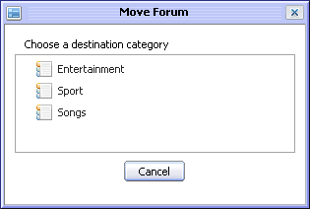Illustration 14: The Move Forum form
- Select one category in the category list to move. If you don't want to move, click the Cancel button to quit.
The 2nd way:
- Go into the forum that you want to move.
- Click the More actions on the forum bar and select Move in the menu.
There is a list of categories to select the destination category to which the selected forum will be moved like illustration 13.
- Select one category in list to move forum. If you don't want to move, click the Cancel button to quit.

Deleting forums
This function is used to remove forums from a category. When a forum is removed, all its topics will be deleted completely.
To take this action, do as follows:
The 1st way: This way only is done by the administrator only.
- Go into the category that includes the forum which you want to delete by three ways like in 3.2.2. There will be a forum list of this category.
- Select forum(s) by ticking its check box(s).
- Click the Manage Category and select Delete in menu.
- Click the OK button in the confirmation message to accept deleting or the Cancel button to quit.
The 2nd way:
- Click the More actions on the forum bar and select Delete in the menu.
- Click the OK button in the confirmation message to accept deleting or the Cancel button to quit.

Topic management
This section is about how to mange topics in forum such as add new, edit, delete, close, open, lock, unlock, stick, move, delete, merge etc...

Adding new topics
This function is used to create new topic inside a forum. A topic is a thread where all members in forum can discuss by giving questions, answers or opinions in form of adding posts or replies.
To add a new topic, do as follows:
- Go into the forum which you want to add a new topic
- Click the button, the New topic form will appear:
- Enter values for fields in this form.
Illustration 15: The Content tab of the New topic form
Details:
The Content information includes:
Title: The title of the topic. This field is required and limited by 100 characters.
Message: The content of the topic.
Files: The files that are attached into this topic.
Preview button: To preview the topic before submitting
Submit button: To accept submitting the topic
Attachment button: To perform attaching files.
Cancel button: To close the New Topic form.
To attach files, do as follows:
- Click the Attachments button, the Attach File form will appear:

Illustration 16: The Attach File form
- Select files to upload by clicking the Browser... button to select file's path from local computer
- Upload the selected files by clicking the icon to upload.
- Complete attaching file for a topic by clicking the Save button.
After attaching files, the New topic form is shown below:

Many different file types can be attached. To remove an attached file, simply click on the Remove link which besides the file attachment that you want to delete.
The Icon tab allows you to select an icon for a topic.
Illustration 17:The Icon tab of the New topic form

The Options tab is used to set some properties for the topic:
Details:
Illustration 18: The Options tab of the New Topic form
Topic Type: The type of the topic that specified by the topic type name and its icon. It can be selected from the existing list or added a new one by clicking the icon.
State: The state of the topic. The default value of this field is 'Open'. The other state is 'Close'
Status: The status of the topic. The default value of this field is 'Unlock'. The other status is 'Lock'
Posts moderation: This option is to require/not require approving new added posts to be visible or not.
Posts notification: This option is to send (or not) notification mails to topic's creator whenever new posts are created.
Sticky: This option allows marking a topic or not. After marking sticky, the topic will be set out by sticky title and located at the top order in topic list.
The Permission tab is used to set the view and post right to some users. You can set information to this tab or not. By default, all users can view and reply this topic.
Details:
Illustration 19: The Permissions tab of the New Topic form
Posters: By default, when this field is blank, it means that all users can post replies in this topic. But if you want to limit number of users, you can manually input or elect users or group for this field.( do as above).
Viewers: By default, when this field is blank, it means all users can view this topic. To limit users who can view it, you can manually input or select users or groups for the Viewers field (do as above).. You can only enter values of this field after you input values for this field.

To preview the topic before submitting, click the button, the View topic form is shown:
- Complete adding a new topic by clicking the Submit button.
Illustration 20: The View topic form
After being added successfully, the new topic will be updated at the topic list in the forum. If it is the newest one, its information will be shown at the Last Post column information of the forum, the topic is located below:
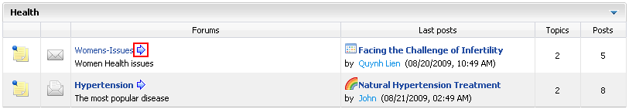
The icon that corresponds to the forum will let you jump to the last read post of that forum by clicking on that icon.
Note:
Beside the Text Editor tool, you can use BB code (Bold tag, Italic tag, Underline tag, Size tag, Color tag, Combined formatting tag, Quote tag, Code tag, Unordered list, Ordered list, Link, Adding image...) to create text and picture effects for topics. For example, you can use Bold tag effect and Color tag effect when inputting text into 'Message' field of the New topic form:
- The topic will be displayed like:

Editing topics
This function is used to edit topics. This action can be also taken by the creator of the topic.
Do as follows:
The 1st way:
- Select one topic in list by selecting its check box.
- Click the Moderation on the forum bar and select Edit in the menu:
The Edit topic form will be displayed:
Illustration 21: The Edit topic form
- Change some information of the selected topic, attach or remove files and enter a brief description about the reason to edit for the Reason field.
- Preview the topic before submitting by clicking the Preview button.
- Complete editing topic by clicking the Submit button or the Cancel button to quit without saving.
The 2nd way:
- Go into the topic which you want to edit.
- Click the More actions on the topic bar and select Edit in menu.
The Edit topic form will be displayed like illustration 20, the current topic's information are displayed in this form.
- Change the topic's information like when creating a new topic.
- Preview the topic before submitting by clicking the Preview button.
- Complete editing topic by clicking the Submit button or the Cancel button to quit without saving.
Notes:
If you change a topic that does not require posts moderation into the one requiring posts moderation, all posts which have been added before do not need to be moderated. Only new posts after you editing are required moderating.

Closing topics
This function is used to close a topic. When a topic is closed, normal users can not view it.
Do as follows:
The 1st way:
- Select topic(s) by selecting its check-box(s).
- Click the Moderation on the forum bar and select Close in the menu.
The 2nd way:
- Go into the topic that you want to close.
- Click the More actions on the topic bar and select Close in the menu.
The 3rd way: Simply Edit the topic, go to the Options tab and change its State.
After being closed , all functions in the closed topic will be disabled and normal users can not view it. Only administrators and moderators can see and mange it. The icon of the closed topic will be changed from normal status to closed status .

Opening topics
This function is used to open closed topics. When a topic is opened, the normal users can view and take actions on it.
Do as follows:
The 1st way:
- Select the closed topic(s) by selecting its check box(s).
- Click the Moderation on the forum bar and select Open in the menu.
The 2nd way:
- Go into the closed topic which you want to open.
- Click the More actions on the topic bar and select Open in the menu.
The 3rd way: Simply Edit the topic, go to the Options tab and change its State.
After the selected topic is opened, all functions in this topic will be enabled. The icon of the opened topic will be changed from the closed status to a normal status.

Locking topics
This function is used to lock one or more topics because of some particular reasons. The locked topic can only be viewed but can not be added post.
Do as follows:
The 1st way:
- Select the unlocked topic(s) by selecting its check box(s).
- Click the Moderation on the forum bar and select Lock in the menu.
The 2nd way:
- Go into the topic which want to lock.
- Click the More actions on the topic bar and select Lock in the menu.
The 3rd way: Simply Edit the topic, go to the Options tab and change its Status.
After being locked, the icon(s) that corresponds to all locked topic(s) will be changed from normal status into the locked status . Some functions of this topic will be disabled and displayed below:
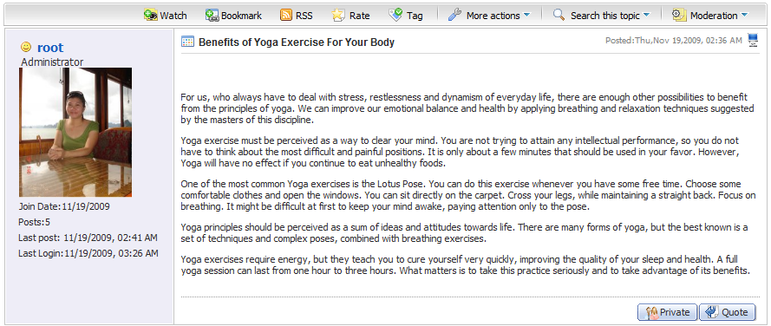

Unlocking topics
This function is used to unlock one or more locked topics.
This action can be also done by the creator of the topic.
Do as follows:
The 1st way:
- Select the locked topic(s) by selecting its check box(s).
- Click the Moderation on the forum bar and select Unlock in the menu.
The 2nd way:
- Go into the locked topic which you want to unlock.
- Click the More actions on the topic bar and select Unlock in the menu.
The 3rd way: Simply Edit the topic, go to the Options tab and change its Status.
After being unlocked, the icon(s) of the unlocked topic(s) will be changed from locked status into normal status and users can normally quote and post replies.
Note:
You can not unlock topics in a locked or closed forum by the above two ways. To do that, you need to unlock or open that forum firstly.

Sticking topics
This function is used to mark a topic in order to set it out and distinguish with another ones. After being sticked, a topic will be arranged in the top order in its topics list.
Do as follows:
The 1st way:
- Select the topic(s) by selecting its check box(s).
- Click the Moderation on the forum bar and select Stick in the menu.
After being sticked, you can see the topic(s) in the top order in list and it is set out by Sticky label and sticky icon .
The 2nd way:
- Go into the topic which you want to stick.
- Click the More actions on the topic bar and select Stick in the menu.
The 3rd way: Simply Edit the topic, go to the Options tab and select the Sticky check box.
Back to the list of topics in this forum, the selected topics will be arranged and marked with the icon in the top order in the topic list.

Un-sticking topics
This function is used to un-sticked the sticked topics.
Do as follows:
The 1st way:
- Select the sticked topic(s) by selecting its check box(s).
- Click the Moderation on the forum bar and select UnStick in menu.
The 2nd way:
- Go into the sticked topic which you want to un-stick.
- Click the More actions on the topic bar and select UnStick in the menu.
After being un-sticked, the sticky label and sticky icon of the sticked topic will be removed and its order will be returned to the original in its topic list.
The 3rd way: Simply Edit the topic, go to the Options tab and untick the Stricky check box.

Moving topics
This function is used to move a topic from one forum to another one.
Do as follows:
The 1st way:
- Select topic(s) by selecting its check box(s).
- Click the Moderation on the forum bar and select Move in the menu.
The Move Topics form will appear:
Illustration 22: The Move Topic form
- Select a destination forum in list to accept moving or click the Cancel button to quit.
The 2nd way:
- Go into the topic which you want to move.
- Click the More actions on the topic bar and select Move in the menu. There is a list of forums which you have to choose destination forum to move like illustration 21.
- Select a destination forum in list to accept moving or the Cancel button to quit.
Note:
Only the administrator and moderator of a forum can move topics inside it. The administrator who have the highest right, can move topic to whatever forums he want without checking for permission or the status of the destination forum. However, the moderator of a forum will be checked for moving permission. He can not move topic to the closed/locked forum which he does not the moderator, move topic to the forum he does not have add topic right or move topic to the forum belonging to the category he is restricted for view permission. Therefore, at destination forum list, only the forums which the moderator have moving permission, are listed for moving.

Deleting topics
This function is used to remove one or more topics from list.
Do as follows:
The 1st way:
- Select the topic(s) by selecting its check box(s).
- Click the Moderation on the forum bar and select Delete in the menu.
- Click the OK button in the confirmation message to accept deleting or the Cancel button to quit.
The 2nd way:
- Go into the topic that you want to delete.
- Click the More actions on the topic bar and select Delete in the menu.
- Click the OK button in the confirmation message to accept deleting or the Cancel button to quit.
The 3rd way: the administrator also can delete a topic by:
- Select the Topics tab in the User Management form. This tab will list all topics created by a user.
- Delete a topic which you want by clicking the icon corresponding to that topic.
The selected topic will be removed from the list.
The 4th way: the administrator also can delete a topic by:
- Open a specific topic and click on one User name and select View all topics by [User name], all topics of this user will be listed.
- Delete a topic which you want by clicking the icon corresponding to that topic.
The selected topic will be removed from list.

Merging topics
This function is used to merge some topics into one topic.
Do as follows:
- Select topic(s) by selecting its check box(s).
- Click the Moderation on the forum bar and select Merge in the menu.
The Merge Topic form will appear:
Details:
Illustration 23: The Merge Topics form
Destination topic: One in the merged topic list is selected to become the destination topic. The topic that is selected to be the destination will be the main entry for the merged topic.
New topic title: The new title of the merged topic.
Save button: To accept merging topic.
Cancel button: To close the Merge Topics form.
- Complete merging a topic by clicking the Save button.
After being merged, many topics will be joined into one topic with the main entry is the topic which is selected to be the destination topic. All posts of the other topics are displayed as posts below the main entry
Note:
The merged topic will inherit all properties of the topic which is selected to be the destination topic such as Posts moderation, permission etc...

Search
This function is used to search existing forums, topics and posts according to specific search conditions. With the Quick Search and the Advanced Search, both anonymous and logged users can find expected result quickly and flexibly.

Quick Search
With the quick search, you can directly type a search term in the search field. All the forums, topics and posts that have a keyword matching the search term will be quickly displayed in the search result form.
Do as follows:
- To quick search any forum, any topic or any post simultaneous:
- Enter a search term into the 'Search' field at the right top of your screen after you have gone into the Forum application:
- Click the icon next to the search box to do search.
All Forums/Topics/Posts in categories that match with the entered search term are listed in the search result form:
- To concurrently quick search forums/topics/posts in a specific category:
- Click on the name of the category that you want to do a quick search:
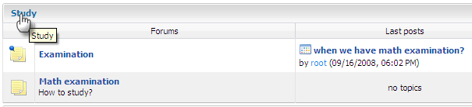
- Show Search box by clicking the button on the category bar.
- Enter the information related to the objects that you want to search into the search box.
- Click the Search button to do search. All matched objects will be displayed in the search result form.
- To quick search topics/posts concurrently in a specific forum:
- Go into the forum that you want to find topics/posts in it.
- Click the button on the forum bar to display the search box and then enter the search term that you want to find in this forum:
- Click the Search button to do search. All topics and posts in this forum that match with the entered keyword are listed in the search result form:
- To quick search posts in a specific topic:
- Go into the topic that you want to find posts in it.
- Click the button on the topic bar to display the search box and then enter the search term that you want to find in this topic.
- Click the Search button to do search
All posts in this topic that match with the entered keyword are listed in the search result form.

Advanced Search
The advanced search allows you to make a search with particular criteria corresponding to the object that is expected to be found. Using the advanced search, you can find forums/topics/posts more exactly.
Do as follows:
- Click the icon at the top right of the screen when you go into the Forum application or the icon when in the search pop up or the search in this category, search in this forum or topic. By default, the advanced search form will be displayed corresponding to the 'Category' object. But with 'Forum' or 'Post' object, properties of these objects will be different.
With a 'Category' object:
Details:
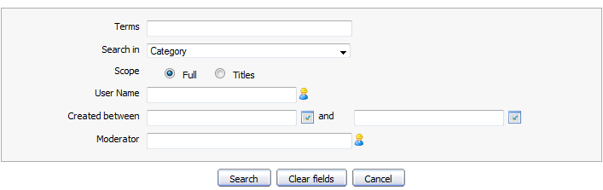Illustration 24: The Advanced Search- Search in Category form
Terms: The keyword that you want to search.
Search in: The object that you want to search. If you want to find categories, the value of this field is 'Category'
Scope: The scope will be used to search. With 'Full' option, the entered keyword will be matched with the entire object (includes both title and content). With 'Titles', the entered keyword only is matched with the object's titles.
User Name: The user name of the object's creator that you want to search. Manual input or click the icon to select users from a specific group.
Created between and: The created date interval in which you want to search for categories. Manually input or click the icon to open the calendar pop up and select date.
Moderator: The user name of the object's moderator that you want to search. Manual input or click the icon to select users from a specific group.
With a 'Forum' object:
Details:
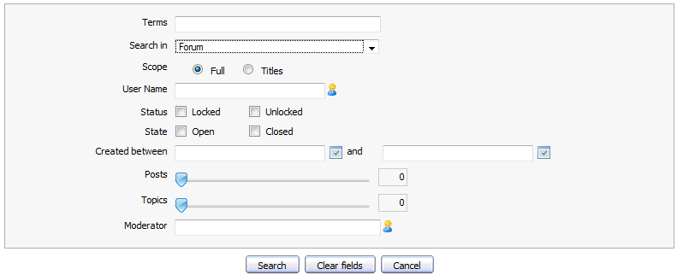Illustration 25: The Advanced Search- Search in Forum form
Terms: The keyword related to forums that you want to search.
Search in: The object that you want to search. If you want to find forums, the value of this field is 'Forum'.
Scope: The scope will be used to search. With the 'Full' option, the entered keyword will be matched with the entire object (includes both title and content). With the 'Title' option, the entered keyword only is matched with the object's titles.
User Name: The user name of the objects that you want to search. Manually input or click the icon to select users from a specific group.
Status: The status of forums that you want to search.
State: The state of forums that you want to search.
Created between – and: The created date interval in which you want to search for forums. Manually input or click the icon to open calendar pop up and select date.
Posts The interval of forum's posts number that you want to search in. Simply click and drag mouse on the slider bar to define the post interval.
Topics The interval of forum's topics number that you want to search in. Simply click and drag mouse on the slider bar to define the topic interval.
Moderator: The user name of the forums 's moderators that you want to find. Manual input or click the icon to select users from a specific group.
With a 'topic' object:
Details:
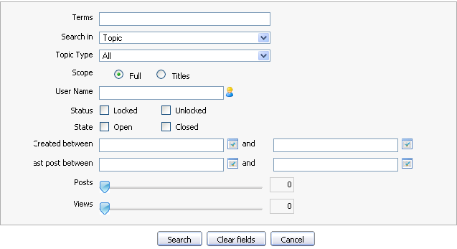Illustration 26: The Advanced Search- Search in Topic form
Terms: The keyword related to the topics that you want to search.
Search in: The object that you want to search. If you want to find topics, value of this field is 'topic'
Topic Type: The type of the topic that specified by the topic type name and its icon. It can be selected from the existing list.
Scope: The scope will be used to search. With 'Full' option , the entered keyword will be matched with the entire object (includes both title and content). With 'Titles' option, the entered keyword only is matched with the object's titles.
User Name: The user name of the objects that you want to search. Manually input or click the icon to select users from a specific group.
Status: The status of the topics that you want to search.
State: The state of the topics that you want to search.
Created between - and: The created date interval in which you want to search for topics. Manually input or click the icon to open calendar pop up and select date.
Last post between - and: The last post 's created date interval in topics that you want to search in. Manually input or click the icon to open the calendar pop up and select date.
Posts: The number of topic's posts interval in which you want to search for those topics. Simply click and drag mouse on the slider bar to define post interval.
Views: The number of views interval of topics that you want to search in. Simply click and drag mouse on the slider bar to define the view interval.
With 'Post' object:
Term: The keyword that you want to search.
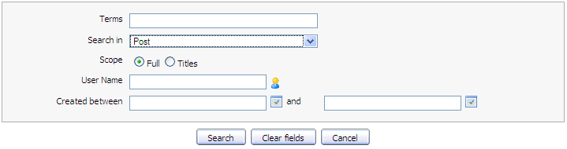Illustration 27: The Advanced Search- Search in Post form
Search in: The object that you want to search. If you want to find posts, the value of this field is 'Post'.
Scope: The type will be used to search. With 'Search Entire', the entered keyword will be matched with the entire object (includes both title and content). With 'Search Title Only', the entered keyword only is matched with the object's titles.
User Name: The user name of the object's create or that you want to search. Manually input or click the icon to select users from a specific group.
Created between-and: The created date interval in which you want to search for posts. Manually input or click the icon to open the calendar pop up and select date.
Search button: To do search on specific criteria.
Reset Fields button: To set blank or default entry for all inputted fields.
Cancel button: To close the search form
- Enter the values of properties corresponding to each object that you want to search.
- Click the Clear Fields button to reset the inputted values, click the Search button to do search or click the Cancel to escape.
The list of the found objects will be displayed in the search result form or there will be an alert message when no objects match with the inputted properties.
Note:
- In case the administrators login and search, also the closed forum/topic and topics/posts pending for approval or censor are shown.
- In case the moderator login and search, also the closed forum/topic and topics/posts pending for approval or censor which belong to the forums managed by the moderator are shown.
- In case the normal user login and search, closed the forum/topic and topics/posts pending for approval or censor are not shown. The normal users have no view permission to these forum/topic(s). Only legal forum/topic/post(s) are shown to normal users.
- Only shown categories/forums which are set in the Forum Portlet Settings are matched. For example, you created a category/forum that is hidden, all topics in this category/forum can not be matched.

Voting topics
This function allows users to evaluate a topic by voting in form of rating star from 1 to 5. The more star rate the topic has, the more interesting it is.
Do as follows:
- Go into the topic which you want to vote.
- Click the button on the topic bar.
The Rate this topic form will appear:
- Rate the topic by left click on the star. The number selected star will be changed from gray to yellow. Click the Cancel button if you want to quit the Rate this topic form.
Illustration 28: The Rate this topic form
Note:
Each user can only vote 1 time for one topic and vote function is not available for closed topic and banned user.

Tagging topics
This function is used to assign tags for each topic. Tag are words which are used as labels to describe or group the same topics, each tag corresponds to a word. For example, you have a tag named 'Interesting' and you can assign different topics to this tag. However, one topic can have various tag names that can be created at the same time, separated by a space and belong to tag groups. Using tags makes it easy for you and others to find your topics.
Do as follows:
- Go into the topic which you want to tag.
- Click the button on the topic bar. The Add Tag pop up will appear:
- Input a new Tag name or an existing one.
In case you input a new tag name, the new one is created. In case using the an existing one, the topic will be tagged into the existing one.
- Click the Add Tag button to accept assigning tag.
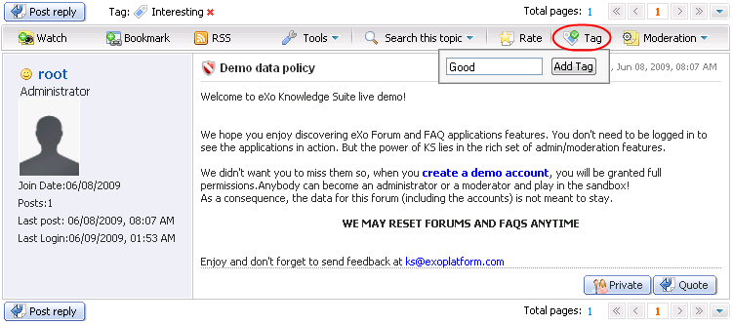Illustration 29: The Add Tag pop up
After assigning a tag to the topic, it will show all the tag names that the topic is assigned.
When viewing a topic, if you are interested in any tag, you can click directly on a tag name to view its content.
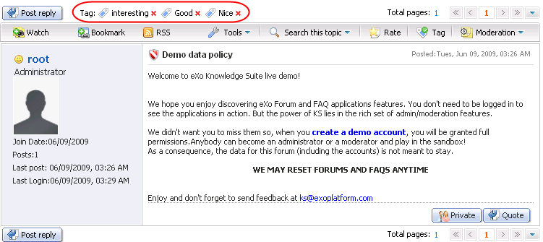Illustration 30: The tag list assigned to a topic screen
The icon that is behind each tag allows you to remove this tag.
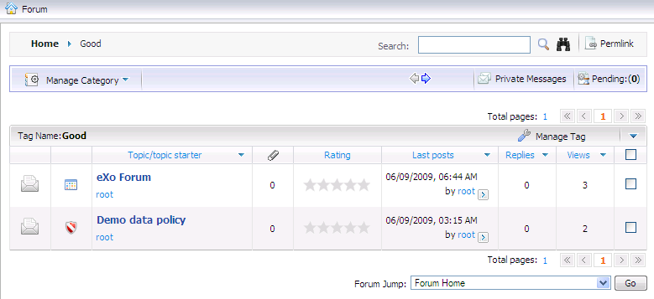Illustration 31: The content of a tag screen
To untag a topic from a tag, simply go to a tag page and click on the Manage Tag and select Untag in the menu popup.
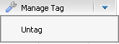
After being untagged, the topic will not be assigned the tag anymore.

Poll management

Adding polls
This function is used to add a poll question into a topic. Each topic has only one poll question and you only add a poll question into a topic when you are the creator of that topic.
To add a poll for a topic, do as follows:
- Go into the topic that you want to add a poll.
- Click the More actions on the topic bar and select Add a poll in the menu:
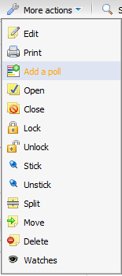
The Poll form will appear:
- Enter values for fields in this form.
Illustration 32: The Poll form
Detail:
Poll Question: The question is used to poll. This field is required.
Poll option: The different answer options for the poll question. By default, there are two options to choose. But if you want to have more, click the icon to add more poll options or click the icon if you want to remove the options.
Close poll after: The number of days that this poll will be closed.
User may change their vote: This option is to allow whether users can change their vote or not.
Allow multiple choice: This option is to allow multiple choice or not. It means users can select several answers for one poll.
Submit poll button: To accept submitting poll.
Reset fields: To set blank or default entry for all inputted fields
Cancel button: To close the Poll form.
- Complete adding a poll for a topic by clicking the Submit poll button. After adding a poll for a topic, an icon will be displayed on a topic.
Note:
The vote for poll question function is only available for members of the Forum and the poll option can only be voted in case the topic is opened.

Editing polls
This function is used to edit the current poll in a specific topic.
To edit a poll, do as follows:
- Click the button on the topic bar.
There will be the edit poll form like when adding a new poll into the topic:
Illustration 33: The Edit poll form
- Change the current poll's information.
- Complete editing the poll topic by clicking the Submit poll button.

Closing polls
This function is used to close polls. A poll can be closed manually by the Close button before its closed day or automatically closed when the closed day is over.
Do as follows:
For manually:
- Go into the topic that has an open poll.
- Click the button on the topic bar to close the poll of this topic.
After closing, the result of this poll will be displayed and it can not be voted on it anymore.
For automatically:
The poll of the topic will be closed after some days. The number of days that the poll will be closed belongs to 'Close poll after' value which is set in the Poll form when adding a poll in topic by the administrator or moderators.

Reopening polls
This function is used to reopening a closed poll.
Do as follows:
- Go into the topic that has a closed poll.
- Click the button to open the poll of this topic.
After opening, all users can vote again normally.

Removing polls
This function is used to remove the poll of a topic.
Do as follows:
- Go into the topic having poll that you want to remove.
- Click the button to remove the poll.
- Click the OK in the confirmation message to accept deleting or the Cancel button to quit.

Voting
This function is used to vote poll of a topic.
Do as follows:
- Go into the topic that has a poll. The poll will be displayed in the selected topic:
- Select one answer that you want. Note that if the poll has multi choice options, many answers can be selected. If not, only one answer can be selected at once like the poll above.
- Click the Vote now button under the poll to vote. After voting, the result of the poll will be displayed:

Splitting a topic
This function is used to divide one topic into some sub topics. Only topics have more than two posts can be divided.
Do as follows:
- Go into the topic that you want to split.
- Click the More actions on the topic bar and select Split in the menu.
The Split topic form will appear:
Details:
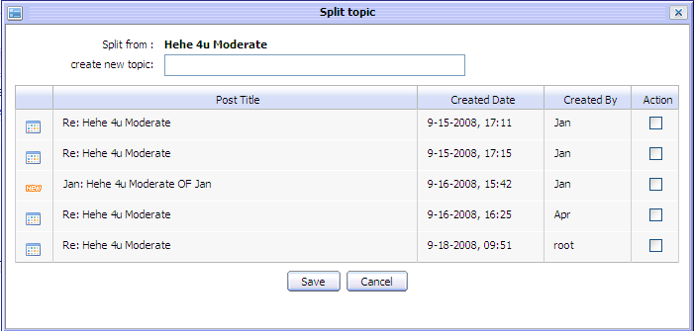Illustration 34: The Split topic form
Create new topic: The name of the new sub topic. This field is required.
Save button: To accept splitting the current topic.
Cancel button: To close the Split topic form.
- Enter value for the Create new topic field.
- Select posts in the post list by selecting its check boxes in the Action column.
- Complete splitting topic by clicking the Save button.
After being splitted, a new topic will be displayed in the topic list with new name. The oldest post in the selected splitted posts will become the main entry of the new topic.

Approving topics
This function is used to approve pending topics in the forum having the 'Moderation topic' option. All new topics added into the 'Moderation topic' forum, will be in 'pending for approval' status. It means that nobody can view these topics except the administrator and moderators of this forum. Only after the topic with status 'pending for approval' is approved, it will be displayed. The status label 'pending for approval' will be removed and the normal users can view and take action on it normally.
To take this action, there are 3 ways:
The 1st way: This way can be used to approve some topics concurrently.
The topics with status 'pending for approval' will be displayed in the topic list:
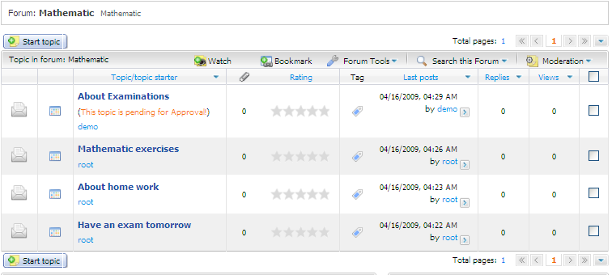Illustration 35: The list of all topics in a forum
- Select topic(s) with status 'This topic is pending for Approval' by selecting its check box(s).
- Click the Moderation on the forum bar and select Approve in the menu.
All selected topics will be approved and displayed normally.
The 2nd way: This way is used to approve a special topic.
- Go into the unapproved topic that you want to approve by clicking its title.
- Click the More actions on the topic bar and select Approve in the menu.
The 3rd way: Approve topics at Unapproved topic list
    - Do not select any 'pending for approval' topic and click Moderation on the forum bar and select Approve in the menu.
'Unapproved topic list' will be displayed. This form lists all 'pending for approval' topics which are available for selecting and approving:
    - Select topic(s) which you want to approve by selecting its check box(s)
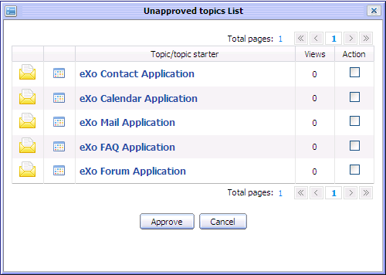Illustration 36: The unapproved topics list form
    - Click the Approve button to accept the approval or the Cancel button to exit without approval.

Post management
This section is about how to mange posts such as add new, edit, delete, move, hide, show etc...

Post reply
This function is used to respond to the main post in a topic. All responses will be displayed in form of post reply in the topic. By default, a post reply will have the title with format Re: <The title of the topic>. However, you can personalize the title of their post reply. Normally, all users can post reply to the main post in a topic but if the administrator and moderators set post right to some users, only the users having add post right can do this action.
Do as follows:
- Go into the topic which you want to post a reply.
- Click the button to post your response to this topic.
The New Post form will appear:
Details
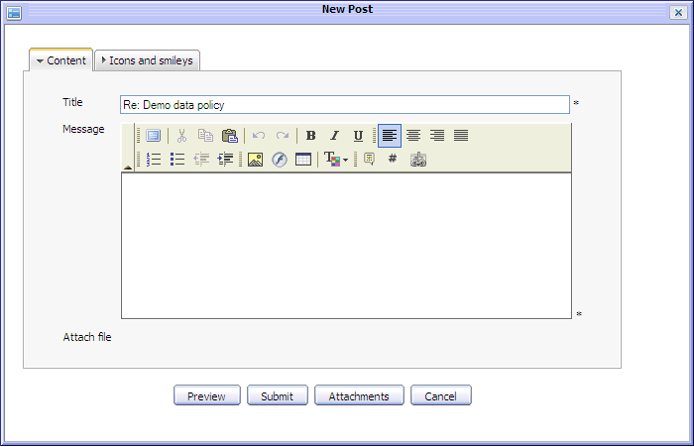Illustration 37: The Content tab of the New Post form
The Content tab includes:
Title: The title of the topic which you want to post reply. You also can change this title.
Message: The content of your reply. The message can be decorated by FCK Editor. There will be an inform message when this content is short. (at least 3 characters)
Attach file: The files attaching with your post reply. If you want to attach a file into this topic, click the Attachments button to open the Attach File form and attach file like above
The Icons and Smiles tab allows you to select an icon for the post. The icons list is shown:
- Enter values for fields, select icon for your post reply (BB code) can also be used to input values for text area field) in the New Post form.
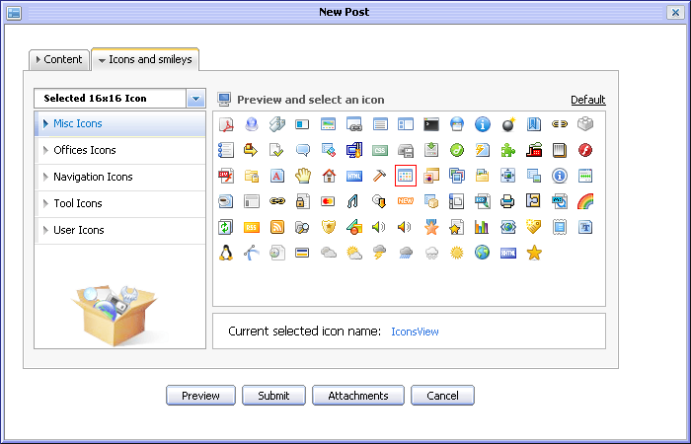Illustration 38: The Icons and smiles tab of the New Post form
- Preview post before submitting by clicking the Preview button.
- Complete adding new post by clicking the Submit button .

Post Quick Reply
This function is used to post a reply more quickly with simple text. However, you can decorate their post by using BB Code tags.
When you go into a topic, by default there will be a form to post quick reply under the list of current topic's posts:
- Enter the content of the message.
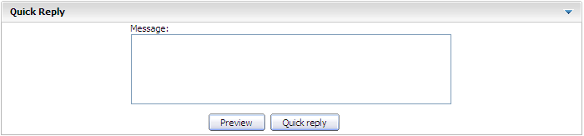Illustration 39: The Quick Reply form
- Preview the message before posting by clicking the Preview button
- Complete quick replying by clicking the Quick reply button.

Private posts
This function is used to respond privately to a post in a topic. Only the creator and the author of the responded post can see the private post.
Do as follows:
- Go into the topic that you want to post reply.
- Click the button under the post that you want to reply. There will be a form like when you post reply.
- Enter values for fields in form.
- Preview post before submitting by clicking the Preview button
- Complete submitting private post by clicking the Submit button.
Note:
Private posts are personal exchanges between two users (creator and receiver). Thus, private posts will not be checking for approval in case the topic having 'Posts moderation' option. A private posts is displayed with label 'This post is private' in order to differ with normal posts.

Quote posts
This function is used to post reply to a specific post in topic in form of using quotation. The message of the post that you are going to quote post also is added into the message content of the reply.
Do as follows:
- Click the button under the post which you want to add quote.
The Quote form will appear:

Details:
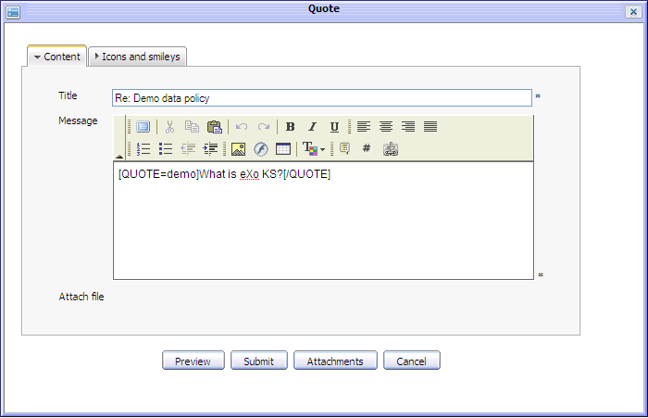Illustration 40: The Quote form
The Content tab includes:
Title: The title of the topic which you want to quote. You also can change this title.
Message: The content of your reply with quote. Quote content is in [Quote] tag.
Attach file: The files attaching with your reply with quote. If you want to attach a file into this post, click the Attachments button to open the Attach File form and do as above.
Preview button: To preview the reply with quote before submitting.
Submit button: To accept submitting the reply with quote
Attachment button: To perform attaching files.
Cancel button: To close New Post form.
The Icons and smiley tab allows changing icon for the reply with quote. It likes Icon and smile tab of the New Post form (See detail)
- Make changes on your quote. e.g adding more comments... Or you also can add your quote into the message by clicking the icon to get [QUOTE] tag and after getting [QUOTE] tag, you enter your quote between [QUOTE] and [/QUOTE].
- Preview your reply with quote by clicking the Preview button.
- Complete replying with quote by clicking the Save button.
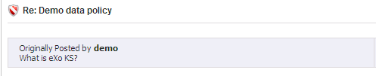
A reply with quote will be displayed:

Approving posts
This function is used to approve pending posts in the topic having 'Post moderation' option. All new posts which are added into the 'Post moderation' topic, will be in 'pending for approval' status. It means that nobody can view these posts except the administrator and moderators of this forum. Only the post with 'pending for approval' status is approved, it will be displayed. The 'pending for approval' status label will be removed and the normal users can view it normally.
Do as follows:
The 1st way:
- Select post(s) with status 'This post is pending for approval' by selecting its check box(s).
- Click the Moderation on the topic bar and select Approve in the menu.
These posts will be approved and shown normally. Thus, normal users can view and do some actions with these posts.
The 2nd way:
- Do not select any 'pending for approval' post, then click the Moderation on the topic bar and select Approve in the menu.
The Posts to approve form is displayed. There is a list of pending posts, available for selecting and approving.
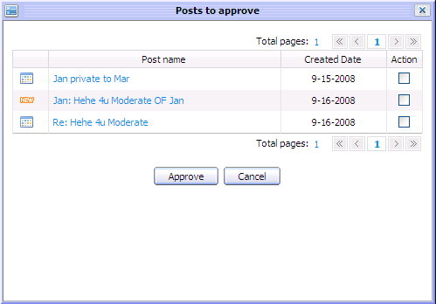Illustration 41: The Posts to approve form
- Select post(s) to approve by selecting its check box(s)
- Click the Approve button to accept approval or the Cancel button to exit with saving.

Editing posts
This function is used to edit posts of topics. Addition to the administrators and moderators, the post creator can also take this action.
Do as follows:
- Click the button under the post that you want to edit.
The Edit Post form will appear:
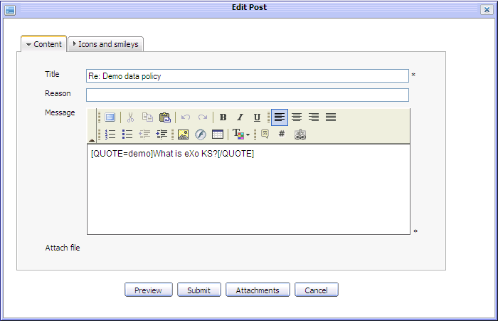Illustration 42: The Edit post form
- Changes the current post's information, add or remove attachment etc...l
- Complete editing the post by clicking the Submit button.

Moving posts
This function is used to move the selected posts from current topic to another one.
Do as follows:
- Select post(s) by selecting its check box(s).
- Click the Moderation on the topic bar and select Move in the menu.
There will be a topic list of different categories with different forums listing all topic inside that you have to select one to move.
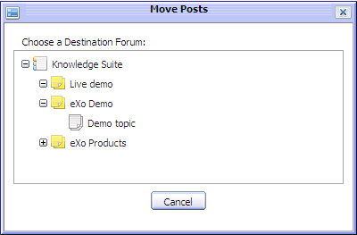Illustration 43: The Move Posts form
- Select a destination topic by clicking the name of a topic in the forum list to accept moving or the Cancel button to quit.
Note:
Only the administrator and moderator of a forum can move post inside it. The administrators who have highest right, can move post to whatever topics of whatever forums he want without checking for permission or the status of the destination forum or topic. However, the forum moderator will be checked for moving permission. He can only move post inside the Forum he has moderation right. Therefore, at the destination topic list, only the topics which the moderator have moving permission, are listed for moving.

Hiding posts
This function is used to hide posts. When a post is hidden, only the administrator and moderator can view and mange it.
Do as follows:
- Select post(s) by selecting its check box(s).
- Click the Moderation on the topic bar and select Hide in menu to accept hiding the selected posts.
After being hidden, the hidden post is marked by 'This post is hidden' label and normal users can not view it.
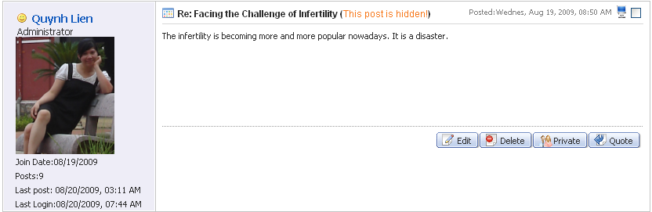

Showing posts
This function is used to show one or more hidden posts. When a hidden post is shown, its 'hidden' label will be removed and it is visible to normal uses.
Do as follows:
The 1st way:
- Select hidden post(s) by selecting its check box(s).
- Click the Moderation on the topic bar and select Show in the menu to directly accept showing the selected post(s).
The 2nd way:
- Click the Moderation on the topic bar and select Show in the menu. There will a list of hidden posts in the Hidden posts form:
- Select hidden post(s) by selecting its check box(s).
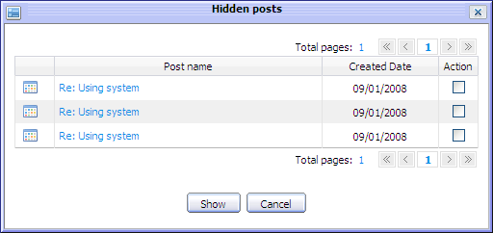Illustration 44: The Hidden posts form
- Click the Show button to accept showing or Cancel button to quit.

Deleting posts
This function is used to remove a post from a topic. The administrator, moderators and the post creator can also take this action.
Do as follows:
The 1st way: This way is only done by the administrator and moderators.
- Select post(s) by selecting its check box(s).
- Click the Moderation on the topic bar and select Delete in the menu.
- Click the OK button in the confirmation message to delete the post or the Cancel button to quit.
The 2nd way: The administrators, moderators and the post creator can also delete this post.
- Click the button under the post that you want to delete.
- Click the OK button in the confirmation message to delete the post or the Cancel button to quit.
The 3rd way: This way is only done by Administrator
- Go to the Posts tab in the User Management form. This tab lists all posts of an user.
- Delete a post by clicking the icon corresponding to that post.
The selected post will be removed from the post list.
The 4th way: This way is only done by the Administrator
- Open specific topic and click on the User name and select View all posts by [User name], all posts of this user will be listed.
- Delete a topic which you want by clicking the icon corresponding to that post.
The selected topic will be removed from the post list.

User Management
This function used to manage all information related to users.
To take this action, click the button on the homepage. There will be a list of users:
In the User Management form, the search function helps quickly finding an expected Users by simply inputting the search term into the search box and clicking the Search icon. The found users will be displayed in the User list table . After searching, there is also the Get all user icon that allows getting all default users in the user list table.
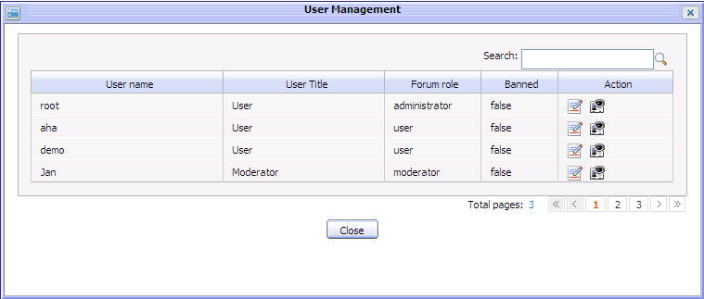Illustration 45: The User Management form

Editing profiles
This function is used to edit an user 's profile.
Do as follows:
- Click the icon corresponding to the user that you want to edit. The information about this user is displayed immediately under the list:
Details:
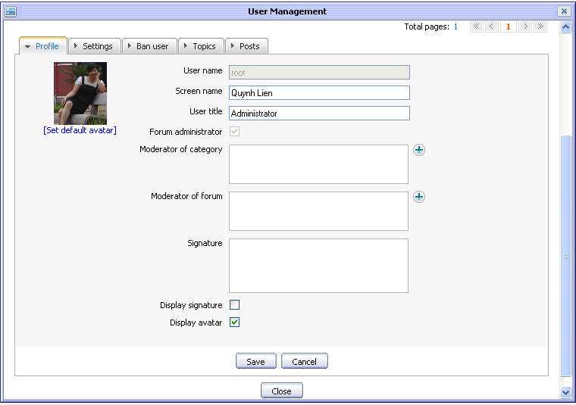Illustration 46: The Profile tab of the User Management form
Profile information includes an user's information. It allows you to edit an user's profile.
User name: The current user name of user. It can not be changed.
Screen name: The name that will be displayed on the screen.
User Title: The title corresponding to the user's role.
Forum administration: The option is to assign Administrator role to the edited user or not. It is set disabled, can not be changed in case the edited user is the default administrator. It means that administration role of the default administrator can not be edited at User Management form.
Moderator of: The list of forums that the edited user can moderate. Click the icon to get forums from the forum list by ticking the check box(s) corresponding to the forum(s) that you want to add. Then click the Add button to complete selecting forum.
Signature: The short text which is created to use as a standard appendage at end of his/her post.
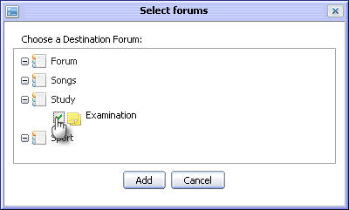Illustration 47: The Select forums form
Display signature: This option is to whether display the signature or not.
Display avatar: This option is to whether show avatar of current user or not.
Set default avatar: This option is set the default avatar for the current user in case his/her avatar is invalid.
Save button: To accept saving changes of the edited user.
Cancel button: To close all detail tab of the edited user.
Close button: To close the User Management form.
The Settings tab allows you to set some properties of the Forum Application:
Details:
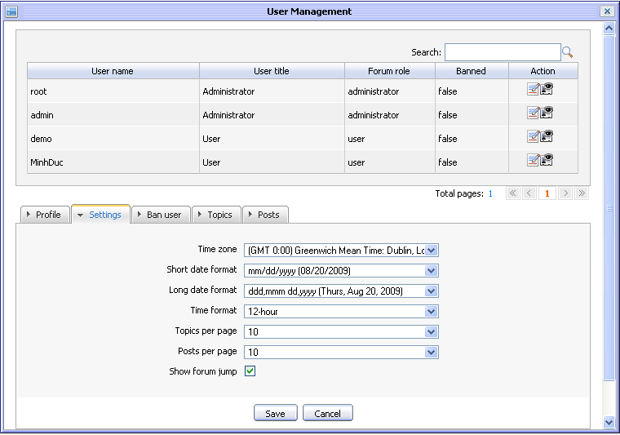Illustration 48: The Settings tab of the User Management form
Time zone: A region that has same time everywhere within it. This field is referred to as local time and as standard time.
Short date format: The format is to display short date in application.
Long date format: The format is to display long date in application.
Time format: The format is to display time in application.
Topics per page: The maximum number of topics can be displayed per page.
Posts per page: The maximum number of posts can be displayed per page.
Show forum jump: This option is whether to display the Forum Jump or not.

The Ban user tab is used to ban a specific user when he/she has invalid or illegal action in forum.
Details:
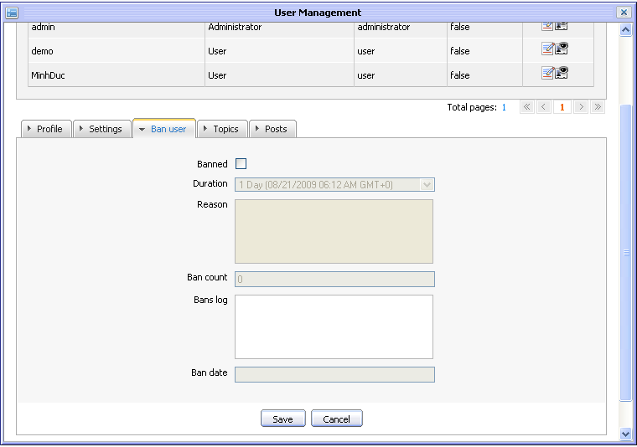Illustration 49: The Ban user tab of the User Management form
Banned: The option is to ban one user or not.
Duration: The last date that this user will be banned. This field only is edited when you ban this user in 'Banned' field. In ban duration, banned user only can view forums and topics but he/she can not post reply or sending message...
Reason: The reason that this user will be banned. This field only is edited when you ban this user in Banned field.
Ban count: The banned number of this user.
Bans log: All reasons of all this user 's bans
Ban date: The start date that this user will be banned.
The Topics tab is a list of topics which are created by this edited user. The administrator can view and delete a topic by clicking on its delete icon.
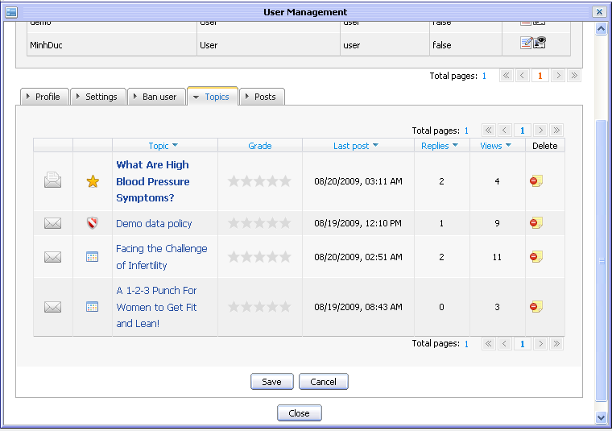
Similarly, the Posts tab is a list of posts which are created by this user. The administrator can view and delete a post by clicking on its delete icon.
- Make changes to any tab of the edited user.
- Complete editing user information by clicking the Save button.

View profile
This function is used to view the detail information about one user.
Do as follows:
The 1st way: Only click the icon in the Action column of the User Management form to view profile
The 2nd way:
- Go to the post of the user who you want to view his/her profile.
- Click the user name and select the View public profile in the menu:
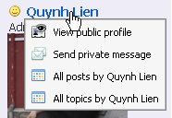
The View User Profile form will appear:
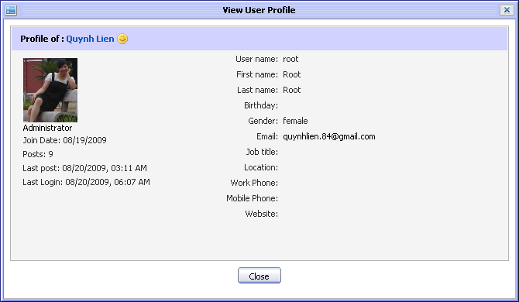Illustration 50: The View User Profile form

Bookmark management
In the eXo Forum, a bookmark is the creation of a link to a category, forum or topic already visited, so that you can return to that category, forum or topic directly, without using a search engine or directory.

Adding bookmarks
This function is used to add a link (a link to a category, a forum, or a topic) into the Bookmark form.
Do as follows:
- Goto inside the object (category , forum or topic) that you want to add bookmark and click the button on its the main bar or right click on the title of the object and select Bookmark in menu.
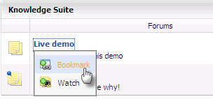
The selected link will be added into the bookmark table.
To view the added link, click the button on the action bar. The list of all added links will display:
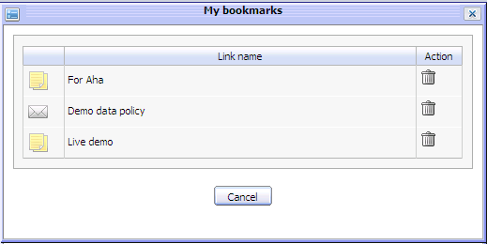Illustration 51: The My Bookmarks form

Deleting bookmarks
This function is used to delete bookmark links from the Bookmark form.
Do as follows:
- Open the My bookmark form by clicking the Bookmark button in main action bar.
- Click the icon corresponding to the link that you want to delete.
The selected link will be removed from the bookmark list.

User settings
This function allows you to personalize your settings in the Forum application.
- Click the button to take this action.
The User Settings form will appear:
The Profile tab includes your common information:
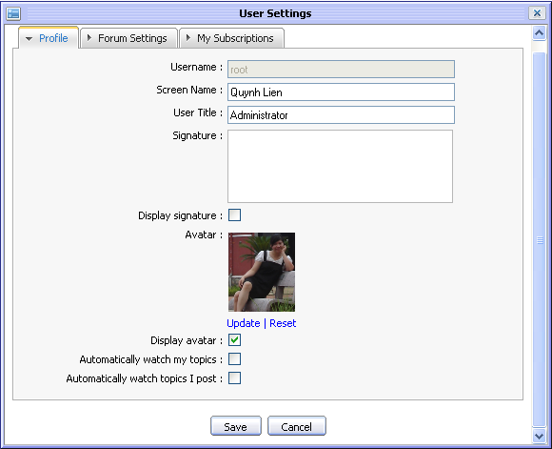Illustration 52: The Profile tab of the User Settings form
User name: Your user name. You can not edit this field.
Screen name: The name that will be displayed on the screen.
User Title: Your title. You can not edit this field. It is set by Administrator and only Administrator can change value of this field.
Signature: Your signature. This signature will be displayed under each post/topic created by you.
Display signature: This option is to display your signature under each port/topic or not.
Display avatar: This option is to display avatar of current user or not. Information in displaying avatar is loaded from Address Book Application. (See eXo Address Book User Guide for more details.)
Avatar: The avatar of your account
Update: To open Upload File form to change avatar.
Reset: To remove the current avatar and set by the default one.
Automatically watch my topics: This option is to add you to the watchers of the topic you create. You will receive notification mail when there is new post added to your posted topic.
Automatically watch topics I posts This option is to add you to the watchers of the topic when you posts to a topic. You will receive notification mail when there is new post added to the topic that you added post.
Save button: To accept saving new setting for your forum view
Cancel button: To close the User Settings form.
The Forum Settings tab includes information related to the Forum application:
Details:
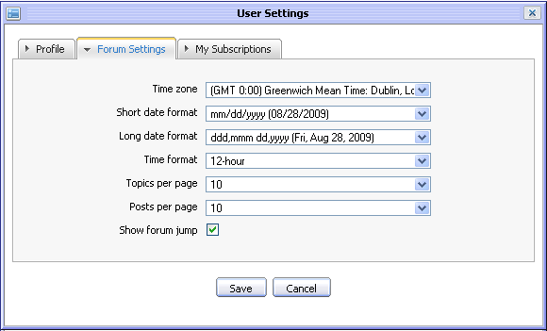Illustration 53: The Forum Settings tab of the User Settings form
Time zone: A region that has same time everywhere within it. This field is referred to as local time and as standard time.
Short date format: The format is to display short date in application.
Long date format: The format is to display long date in application.
Time format: The format is to display time in application.
Topics per page: The maximum number of topics can be displayed per page.
Posts per page: The maximum number of posts can be displayed per page.
Show forum jump: This option is to display Forum link or not.
- Enter and set values in this form.
- Complete saving your settings by clicking the Save button.
To change the avatar, do as follows:
- Click on the Update link to open the Upload File form:
- Click the Browse... button to select file to upload.
- Click the icon to upload the selected file.
- Click the Save button to accept changing avatar.
The My Subscriptions tab lists all your being watched objects (category, forum, topic) that makes it easy for you to manage your watch list in the Forum application.
To view your being watched object, simply click on the object's title in the Title column.
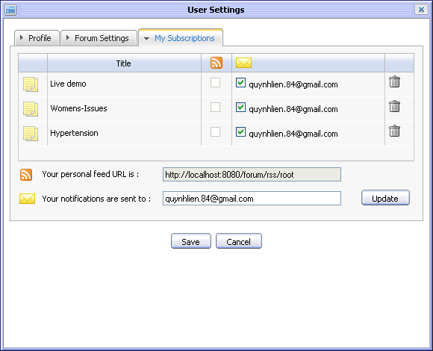Illustration 54: The User watches tab of the User Settings form
To get a new RSS feed that contains the selected RSS feeds in the column, check checkboxes corresponding to RSS feeds that you want and then click on the Save button, the objects(categories, forums, topics) which are selected will be updated to the Your personal feed URL is link. The Your personal feed URL is field is always default for each user. Users can copy and use this link to view detail information of categories/forums or topics.
To send notifications to your friends, check checkboxes in the column and then enter one or more email addresses in the Your notifications are sent to field. Click the Update button to add the entered email addresses in the column:
To remove being watched object from your watch list, simply click on the trash can icon correspondingly. After being removed, you will not receive notification mails about the removed object anymore.

Administration
This section includes some control features of the Forum application and only the administrator can access to these features. To access this function, do as follows:
- Click the button on the action bar. The Forum Administration form will appear to set some control functions. This form includes some tabs: Sort, Censor , Notification, , BB Codes, Auto-Prune, Topic Type and IP Bans.

The Sort tab is used to set some properties related to the sorting of forums and topics.
Details:
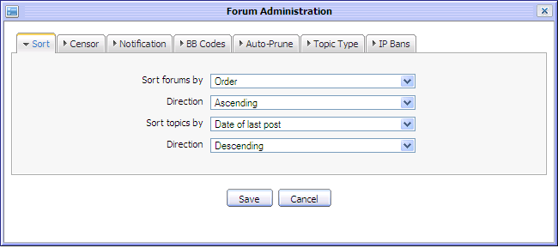Illustration 55: The Sort tab of the Forum Administration form
Sort forums by: The properties are used to sort forums in the forum list. These properties are:
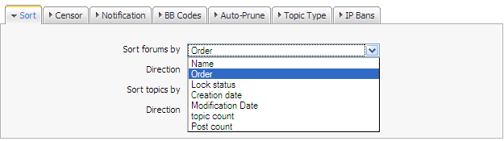
- Name: The name of forums.
- Order: The order of forums
- Lock Status: The lock status of forums.
- Creation Date: The created date of forums.
- Modification Date: The modified date of forums.
- Topic Count: The number of topics in forums.
- Post Count: The number of posts in forums.

Direction: The type of the sorting forums. It may be: Ascending or Descending
Sort topics by: The properties of topics are used to sort topics in list. These properties are:
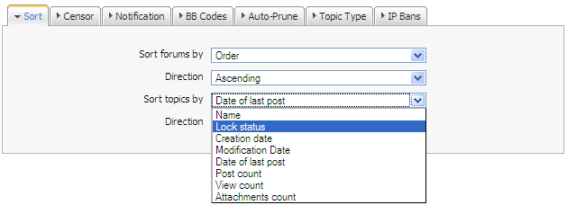

- Name: The name of topic.
- Lock status: Topics with the 'Locked' status.
- Creation Date: The created date of topics.
- Modification Date: The modified date of topics.
- Date of last post: The created date of topic's last post
- Post count: The number of posts in topics.
- View count: The number of views in topics.
- Attachments count: The number of attached files in topics.
Direction: The type of sorting topics
Save button: To accept saving changes in Forum Administration.
Cancel button: To close the Forum Administration form.

The Censor tab includes all censored keywords. The topic/post that is added with one of these keywords will be censored before being displayed. It means that those topics or posts are only displayed after the administrator/moderator have censored them.
The Notification tab allows the administrator to compose the notification email content by manually editing.
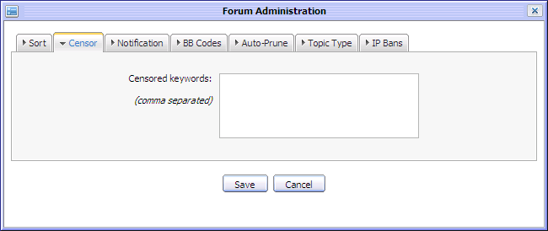Illustration 56: The Censor tab of the Forum Administration form
The content defined in the Notification tab will be used to send notification email to users who have registered for eXo category/forum/topic watching notification and the administrator/moderator/creator who uses 'Topic notification' or 'Post notification' when adding new forums or topics.
Details:
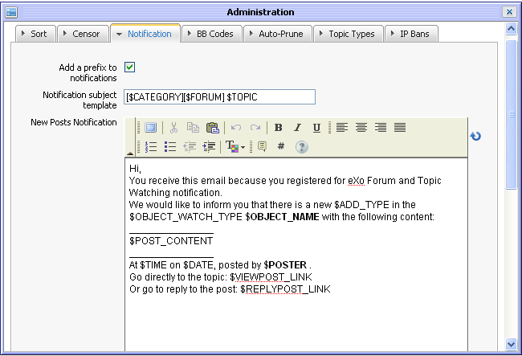Illustration 57: The Notify Content tab of the Forum Administration form
Add a prefix to Notification: This option is to whether add a prefix for the notification email or not.
Notification subject template: The content of the header subject of the notification email. The default template is [$CATEGORY][$FORUM][TOPIC]
New Posts Notification: The template content of the new topic/post notification email. It can be decorated by FCK Editor.
$OBJECT_WATCH_TYPE: This parameter is to show watch object which may be Forum or Topic.
$OBJECT_NAME: This parameter is to show the title of Forum/Topic which is being watched.
$ADD_TYPE: This parameter is to show the added type which may be new topic or post.
@POST_CONTENT: This parameter is to show the content of the new post added.
STIME: This parameter is to show the time of the added post.
$DATE: This parameter is to show the date of the added post.
@POSTER: This parameter is to show the user name of the person who adds post,
$LINK: This parameter is to show the link which refer to the post in Forum.
Content moved Notification: The template content of the topic/post that is moved to the other forum/topic.
$OBJECT_NAME: This parameter is to show the title of topic/post which has been moved to the new destination.
$OBJECT_PARENT_NAME: This parameter is to show the title of the forum/topic destination of the moved object.
Note:
- There are some parameters which is used to load the content dynamically. Thus, you should not edit them.
- In case, the notify content is changed unexpectedly, the administrator can get the default one by clicking on the icon.

After running KS 1.2 application, by default there are some default BB Code tags that are initialized via plugin such as: "B", "I", "HIGHLIGHT", "IMG", "CSS", "URL", "LINK", "GOTO", "QUOTE", "LEFT", "RIGHT", "CENTER", "JUSTIFY", "SIZE", "COLOR", "CSS", "EMAIL", "CODE", "LIST". The BB Code tags can be modified by adding, editing or deleting.
The BB Codes tab allows administrator to manage custom BB Codes. Admin can add or edit/delete an existing BB Code tag definition. The BB Code tag helps users enrich posts with formatting and inclusions.
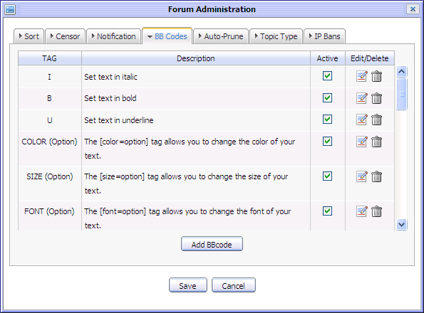Illustration 58: The BB Codes tab of the Forum Administration form

Adding BB Code:
This function allows adding new BB Code used in the Forum.
To add BB Code, do as follows:
- Click on the Add BBCode button.
The Add BBCode form will appear:
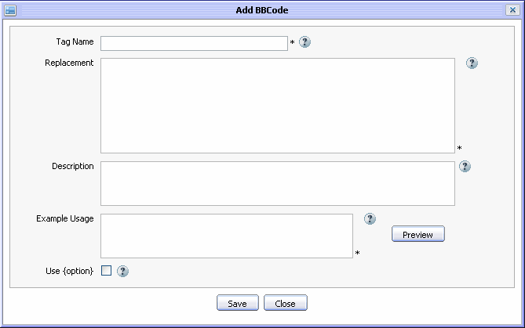Illustration 59: Add BBCode form
- Input values to fields:
Details:
Tag Name: Name of a tag, it is unique in system.
Replacement: A short description that helps users of the tag understand what it does.
Description: html replacement pattern to use when processing the tag.
Example Usage: Working example demonstrating how to use the BB Code.
Use{option}: Allow to create a [tag=option][/tag] style tag, rather than just a [tag][/tag style tag or no.
Help dialog: Display list of supported BB Codes and their syntax.
Preview dialog: Allows to preview a rendered BB Code.
Save button: To accept saving new BB Code tag.
Cancel button: To close the Add BBCode dialog

To Open Help dialog, Click on the icon. The Help dialog appears:
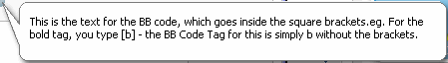
To open the Preview dialog, click on the Preview button. The Preview dialog appears:
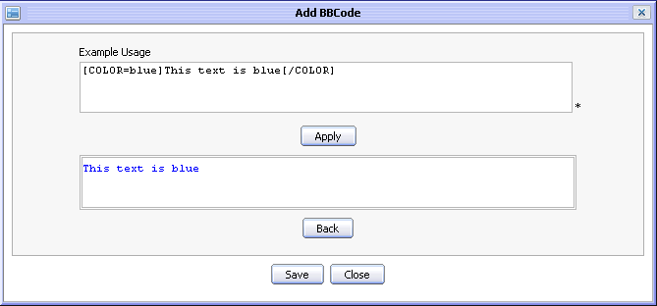
Details:
Example usage text area : By default it is initialized with the Usage Example.
Apply button : Apply the content of Example Usage area to the preview area.
Preview area : Displays the example usage rendered by the BB Code engine (using the replacement pattern).
Back button: Return the Add BBCode form.
Editing BB Code
This function is used to edit an existing BB Code tag.
To edit BB code tag, do as follows:
- Click on the icon that corresponds to the BB Code tag which you want to edit. The Edit BBCode form appears:

- Change information of the selected BB Code tag.
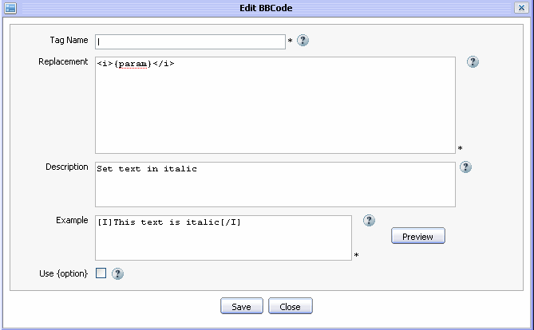Illustration 60: The Edit BBCode form
- Preview the BB Code tag before saving by clicking the Preview button.
- Complete editing BB Code tag by clicking the Save button or the Cancel button to quit without saving.

Deleting BB Code:
This function is used to delete an existing BB Code tag.
To delete a BB code tag, do as follows:
  - Click on the icon corresponding to the BB Code tag which you want to delete. The Confirm message pop up appears.
  - Click the OK button in the confirm message to accept deleting or the Cancel button to quit.

Activate/Deactivate BB Code:
This function is used to activate or deactivate an existing BB Code tag.
To Activate an existing BB Code tag, select the check box that corresponds to the BB Code tag which you want to activate. After activating , that BB code will effect on posts.
To deactivate an existing BB Code tag, do not select the check box that corresponds to the BB Code tag which want to deactivate. After deactivating, that BB Code tag will not effect on posts.

The Auto-Prune tab lists all categories, forums in the Forum Application that allows cleaning old and inactivating topics of your forum. The old topics that have not been added posts for a long time will be inactivated in the forum.
Details:
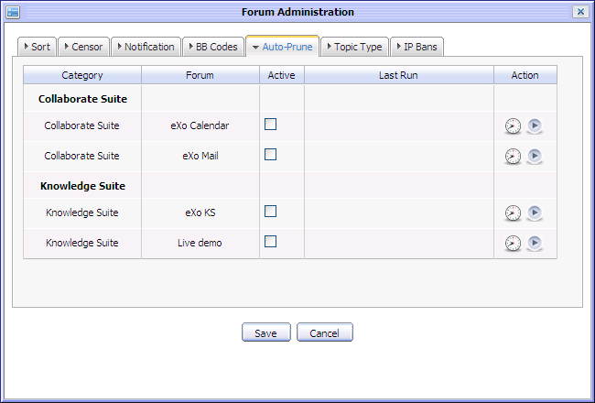Illustration 61: The Auto-Prune tab of the Forum Administration form
The clock icon : To open the Prune Setting form..
The play icon : To play the prune function manually

To set prune for any forum, do as follows:
- Simply click on the prune icon corresponding to the forum that you want to check.
The Prune Settings appears below:
Details:
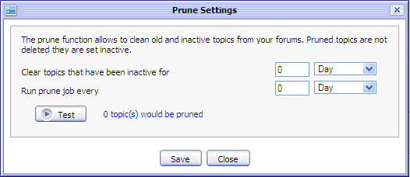Illustration 62: The Prune Settings form
Clear topics that have been inactive for The number of days/weeks/moths that the topic has not been added post will be inactivated.
Run prune job every The number of days/weeks/ moths that the prune job will be executed to check for the old topics and inactivate them.
Test button To check how many topics will be pruned that means how many old topics will be inactivated.
Save button To accept saving the prune setting
Close button To close the Prune Settings form.
- Define some values for the setting
- Click the Save button to accept the setting.
After setting prune successfully, the auto prune function will be run automatically on the forum that has been set to checked for the old/inactivate topics.
Note:
- Only Administrator or Moderator can activate the inactivated topics.
- Normal users can't view the inactivated topics.

The Topic Type tab lists all the topic types and allows defining different topic types for the added topic in the Forum.

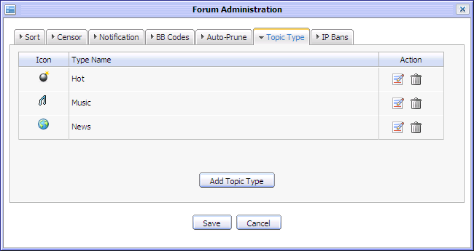Illustration 63: The Topic Type in the Forum Administration form
To add a topic type, do as follows:
- Click on the Add Topic Type button
The Add Topic Type form appears:
Details:
Type Name: The name of the topic type
Type Icon: The icon for the topic type
Save button: To accept saving the topic type
Cancel button: To close the form
- Enter a topic type name
- Select an icon for the topic type
- Click the Save button to accept adding a new topic type.
After adding a topic type, it will be updated in the topic type list in the Add Topic form. Besides, when adding new a topic, the new added topic type is also listed in the Topic Type combo box for selecting.
To edit the topic type, simply click on its corresponding edit icon
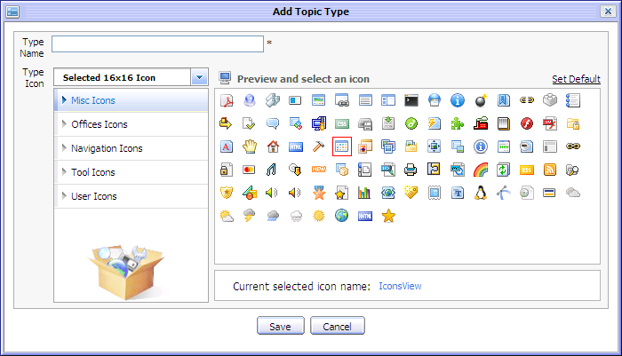Illustration 64: The Add Topic Type form
To delete the topic type, simply click on its corresponding delete icon

The IP bans tab is used to ban some IPs that may be used by illegal users who try to spam or add posts with rebellious or dissolute content. Banned IPs will not be used to add posts to Forum. Any user who uses banned IPs to add post will be recognized as a banned user, he/she can only view and be limited most of basic actions to forum such as add topics, posts, rates...
To ban an IP, simply input the IP into the IP text box and click the [Add] to accept saving the banned IP. After adding the IP ban, the banned IPs will be listed in the IP table. You can view all posts which are added by a specific banned IPs or delete them from the banned IP list.
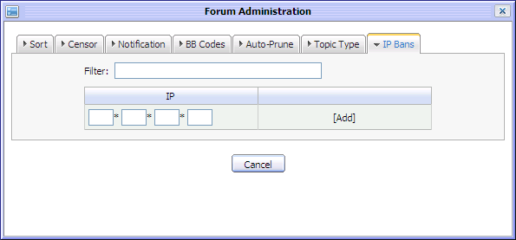Illustration 65: The IP Bans tab of the Forum Administration form
To view all post of a specific IP, click on the [Posts] link in the action column of the banned IPs that you want to view. All posts of the banned IPs will be listed in the View Post form. These posts can be viewed and deleted by the administrator.
To remove a banned IPs from the banned IP list, simply click on the [x] icon in the action column of the banned IP that you want to delete. After being removed from the banned IP list, this IP can be used to take actions in Forum normally.
Besides, the filter function in IP Bans tab helps you filter the banned IP easily.
To filter banned IP, simply input the filter term into the filter text box, all IP matching with filter term will be displayed in the banned IP list.

- Make changes to the Forum Administration form.
- Complete saving changes in the Forum Administration form by clicking the Save button.

Censor
This function is used to censor all topics, posts contain one of censored keywords. After the administrators input censored keywords in the Forum Censor tab, all topics and posts that contain these keywords will have 'This topic is pending for Censor!' satus (for topic) , 'This post is hidden!' status (for post). Only the administrators and moderators can view these topics/posts, the normal users only can view them after they are censored and approved.
Do as follows:
For topic:
- Select topic(s) with status 'This topic is pending for Censor!' by selecting its check box(s).
- Click the Moderation and select Censor in the menu.
For post: similar to the Show post function
The 1st way
1. Select hidden post(s) by selecting its check box(s)
2. Click the Moderation on the topic bar and select Show in the menu to accept showing the selected post(s) directly.
The 2nd way:
- Click the Moderation on the topic bar and select Show in menu. There will a list of hidden posts in the Hidden posts form:
- Select hidden post(s) by selecting its check box(s).
Illustration 66: The Hidden posts form
- Click the Show button to accept showing or the Cancel button to quit.

Watching
This function allows you to keep track new changes to specific category, forum or topic via notification emails. You only need registering an account, whenever there are new changes such new categories, new topics or new posts... you will receive a notification from the Forum application.
Do as follows:
- Go to inside the object (category, forum or topic) that you want to add watch and click the button on its main bar or right click on the title of the object and select Watch in the menu:
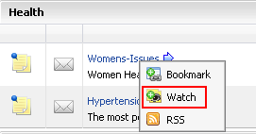
When a category/forum or topic has already watched, the UnWatch item will appear in the right click menu or on its main bar with the purpose of removing the watch subscription on the currently selected category/forum/topic.
The watched objects are also listed in the My Subscriptions tab in the User Settings form. When being unwatched, they also haven't been existed in this list.

The alert message that informs watching successfully is shown:
Users also receive the email notifications about new posts/ replies of the forum that has just been watched.
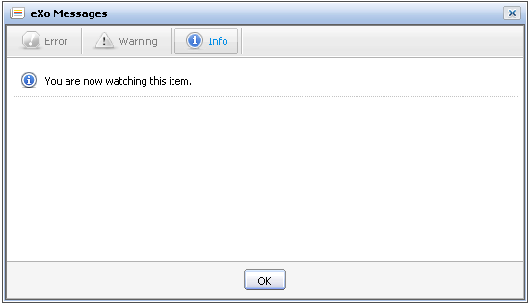Illustration 67: The Watch alert form
- When new replies of the forum that you have watched have been posted, they will be notified in your email.
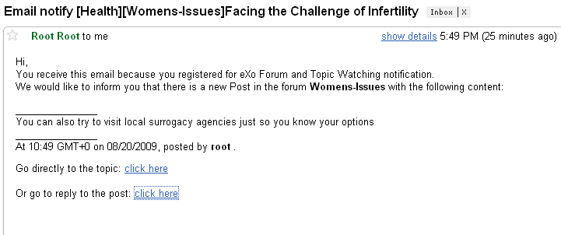
- Click on the first click here in your email to go directly to the topic or the second click here to go to the topic and view the reply that has just been posted. The new reply will be displayed in the Quote form.
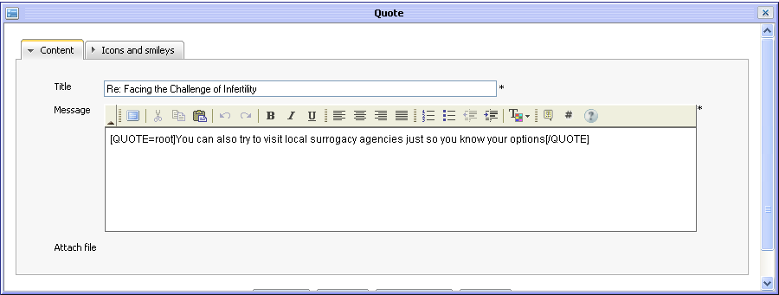

Watch management
This function allows managing watches of a specific category/forum/topic easier. The Watch tools form in specific category/ forum/topic will list all email addresses registered for adding watch by users.
Do as follows:
- Open the Watch Tools form:
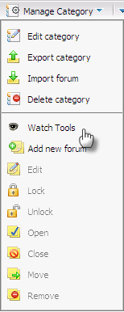
- For Category: Go into a specific category and then select Watch Tools in the menu of the Manage Category:
- For Forum: Go into a specific forum and then select Watch Tools in the menu of the Forum Tools:
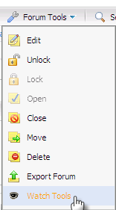
- For Topic: Go into a specific topic and then select Watch Tools in the menu of the Tools:
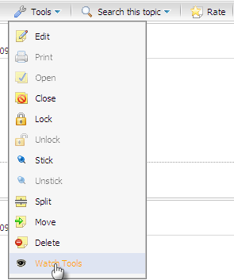
The Watch Tools form will appear:
- To delete a email address in list, click the icon corresponding to that email address. That email address will be removed from the email address list.
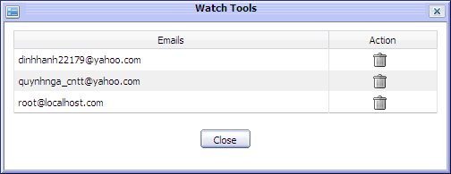Illustration 68: The Watch Tools form

Sending private messages
This function is used to exchange private messages among users.
To send private message, do as follows:
- Go into the topic that contains posts of the user who you want to send private message to.
- Click on a specific user name and select Send private message in the menu:
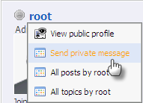
The Private Messages form will appear:
Details:
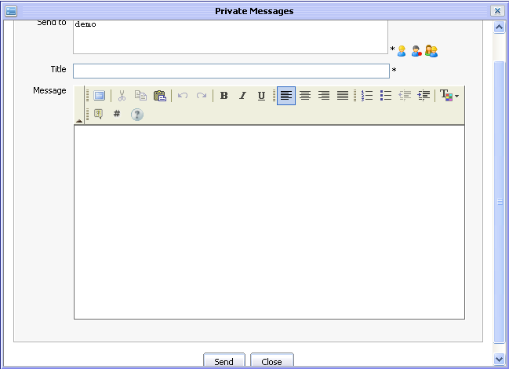Illustration 69: The Private Messages form
Send to: The user names of all users who will receive this private message. By default, value of this field is the user name of selected user. To add more users, do as above.
Title: The subject of private message.
Message: The content of private message.
Send button: To accept sending private message
Close button: To close the Private Messages form.
- Enter values for fields in this form.
- Complete sending message to users in 'Send to' field by clicking the Save button.
After signing in successfully, the receiver will see an alert with content Private Message(number private messages) at the right corner.
To view these private messages, do as follows:
- Click on the inform message:
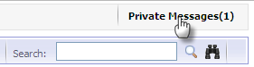
The Private Messages form will appear:
- Select each message in list to view it.
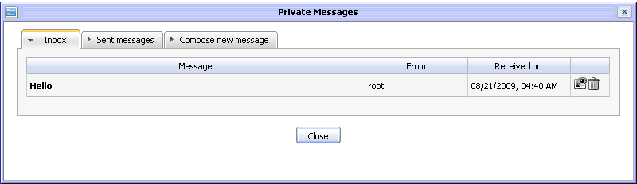Illustration 70: The Inbox tab of Private Message form
Details:
The Inbox tab includes all received messages, the reply and delete icons
The Sent messages tab includes all sent messages, the forward and delete icons.
The Compose new message tab is the form to compose a message.
- Click the icon to reply to the received message. The form to reply is shown:
- Enter the response in 'Message' field. Do as above to add more receivers in the Send to field.
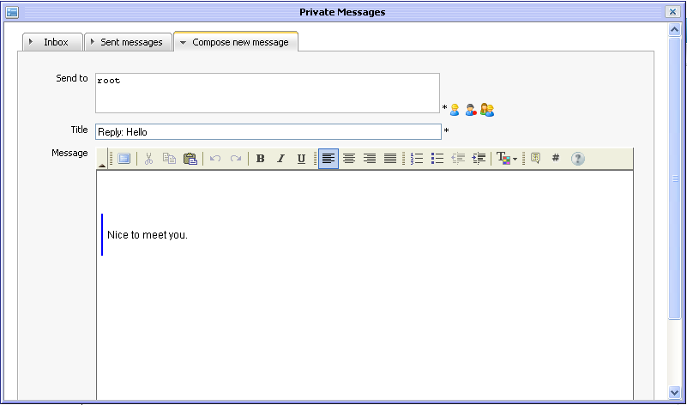Illustration 71: The Compose new message tab of Private Message form
- Click the Send button to send reply to the sender.
- Click the icon to delete the message corresponding to it. Click the OK button in the confirmation message to accept deleting or click the Cancel button to quit.

Viewing all topics/posts
This function is used to view all topics/posts of a specific user.
Do as follows:
- Go into the topic that contains posts of the user who you want to view all his/her topics/posts.
- Click on a specific user name and select All posts by <screen name> or All topics by <screen name>.

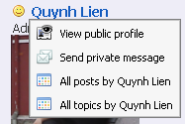
All topics/posts of selected user will be listed in the Posts/topics by user form:
- Select each topic/post in the topic/post list to view it or click the icon to delete a topic/post
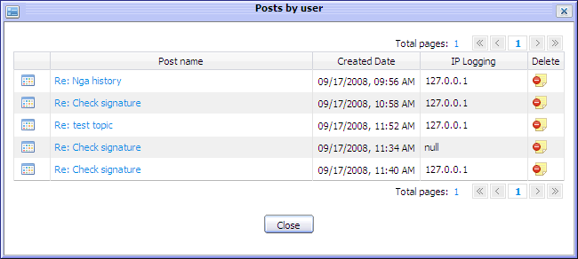Illustration 72: The Posts by user form
- Click the Close button to escape from this form.

Exporting
The export function is a best way to back up data in the Forum. This function allows exporting category and forum in the Forum application into zip or xml file. When a category or a forum is exported, all its forum, topics, posts and its properties are exported exactly. The exported file can be used to import into the Forum application.

Exporting categories
This function is used to export category and all forums inside in form of zip file. You can export all categories or one specific category in the Forum.
To export all categories, do as follow:
- Go to the Forum application and click the Manage Category button on the main menu bar and select Export in menu.
The Export Categories form will appear:
Details:
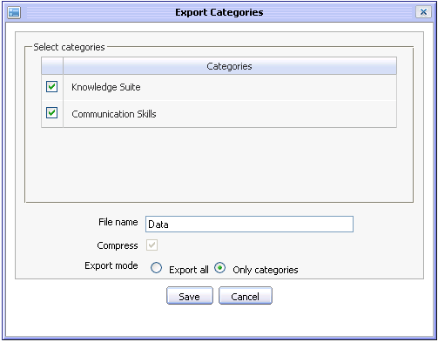Illustration 73: The Export Categories form
Select categories panel: The category list that can be selected to export
File Name: The name of the exported file
Compress: Export all categories is supported exporting in form of zip file only
Export mode: The mode for exporting categories
Export all: This option is to export all data in Forum such as all categories, user profiles,
forum statistics
Only categories: This option is to export the selected categories only.
Save button: To accept exporting all categories
Cancel button: To exit the Export Categories form.
- Select category and input the File name to export.
- Click the Save button to accept exporting all categories in Forum
A down load pop up will appear:

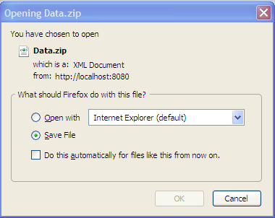
- Simply select the Save File option and click the OK button to accept saving the exported file
.
Similarly, to export a specific category, go to the Forum application and go to inside a specific category. Click on the Manage Category button and select Export category in the menu
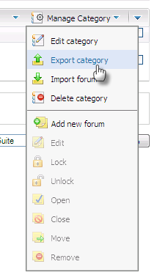
The Export Category form will appear and do action like steps above to export the category.
Notes:
Because only one category is exported, you can choose export format for the exported file zip or xml.

Exporting forums
This function is used to export forums and all topics inside in the Forum application in form of xml or zip file.
Do as follow:
- Go to inside one forum and click on the Forum Tools and select Export Forum in the menu:
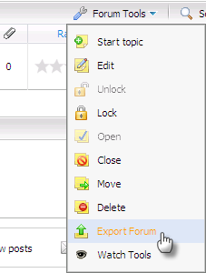
The Export form will appear:
Details:
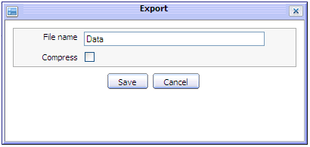Illustration 74: The Export Forum form
File Name: The name of the exported file
Compress: This option is to export file in form of zip or xml format
Save button: To accept exporting forum.
Cancel button: To exit the Export form.
- Input the File name to export
- Tick on the Create Zip file check box to export file in form of zip file or leave it blank to export in form of xml file.
- Click the Save button to accept exporting forum.
A Fire Fox 3 down load pop up will appear :
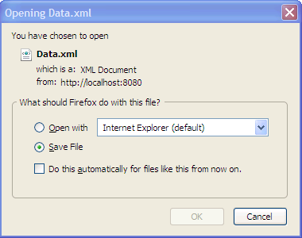
Simply select the Save File option and click the OK button to accept saving the exported file.

Importing
This function allows importing categories and forum into the Forum application from xml or zip file which has valid data format.

Importing categories
This function is used to import category into the Forum application from valid format file. If the imported file contains some categories, some categories can be imported at a time. If the imported file contains only one category, only one category is exported at once.
Do as follow:
- Go to the Forum application and click the Manage Category button on the main menu bar and select Import category in menu.
The Import Category form will appear:
Details:
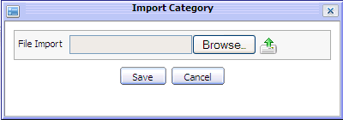Illustration 75: The Import Category form
File Import: The path of the imported file.
Browser button: To select the imported file path.
button: To upload the selected file.
Save button: To accept importing the uploaded file.
Cancel button: To exit Import form.
- Click the Browser button and select the file path.
- Click the button to upload the selected file.
For example, select and upload the exported file named eXo Knowledge Suite.zip. After uploading successfully, the Import Category form is shown:
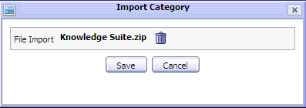
- Click the Save button to accept importing.
After being imported successfully, all categories and forums inside which are defined in the zip file will be imported and displayed properly in Forum home page.

Importing forums
This function is used to import forums into the Forum application from valid format files.
Do as follow:
- Go to inside one category and click the Manage category and select Import forum in the menu:
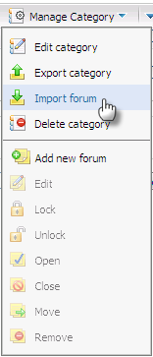
The Import Forum form will appear:
Details:
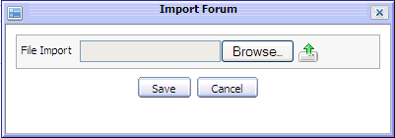Illustration 76: The Import Forum form
File Import: The path of the imported file.
Browser button: To select the imported file path.
button: To upload the selected file.
Save button: To accept importing the uploaded file.
Cancel button: To exit the Import form.
- Click the Browser button and select file from local disk.
- Click the button to upload the selected file.
- Click the Save button to accept importing.
After being imported successfully, the forum and topics inside which are defined in the zip or xml file will be imported into the selected category and displayed properly in Forum home page.

Banning IPs

Banning IPs from Ban IP Tools
This function allows banning some IPs that may be used by illegal users who try to spam or add post with rebellious or dissolute content into specific forum.
Banned IPs can not be used to add post to the Forum. Any user who uses banned IPs to add post, will be recognized as the banned user, he/she can only view and limited most of basic actions to the forum such as add topic, post, rate...
This function is similar to IP bans in the Administration function. However, the Ban IP tool is used both administrators and moderators to ban IP within one specific forum only while IP bans in the Administration form is used to ban the IP on the Forum application, having effect on all forums.
To ban IP on specific forum, do as follows:
- Go to inside the Forum that you want to ban IP
- Click the Forum Tools and select Ban IP Tools in the menu:
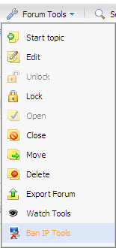
The Ban IP Forum form will appear:
- Input an IP into the IP text boxes.
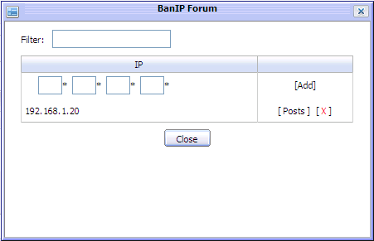Illustration 77: The Ban IP Forum form
- Click the [Add] link to accept banning the IP
After adding IP ban successfully, the banned IP will be listed in IP table. You can view all posts which are added by a specific banned IP or delete it from banned IP list.
To view all post of a specific IP, click on the [Posts] link in the action column of the banned IP that you want to view. All posts of the banned IP will be listed in the View Post form. These posts can be viewed and deleted by the administrator/moderator
To remove a banned IP from the banned IP list, simply click on the [x] in the action column of the banned IP that you want to delete.
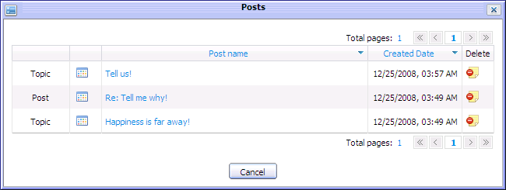Illustration 78: The Posts form
After being removed from banned IP list, this IP can be used to do action in the Forum normally.
Besides, the filter function in IP Bans tab help you to filter the banned IP easily.
To filter banned IP, simply input filter term into the filter text box, all IPs matching with the filter term will be displayed in the banned IP list.

Banning IPs from IP icon
IP can be also banned from the IP information icon when the administrator or the forum moderator views specific topic or post.
To ban IP from IP icon, do as follows:
- Right click on the IP information icon
- Select a ban option in menu:
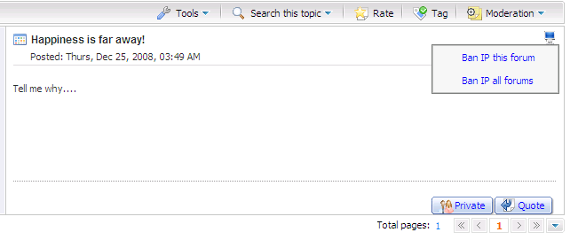
In case the Ban IP this forum is selected, the IP is banned on the current forum.
In case the Ban IP all forum is selected, the IP is banned on all forums in the Forum application.
After banning, when a mouse is over on the banned IP icon , its tool tip will be shown that it is being banned.
Notes:
Only the administrator can ban IP on all forums. The moderator can not ban IP on all forums, he can ban IP on the forum moderated by him.

Sharing links
This function allows you to view and copy the link to a specific forum/topic and share it with your friends or use for your own purpose.
Go into the Forum application and do as follows:
- Go to Forum/topic which you want to share link
- Click Permlink label at the right corner:
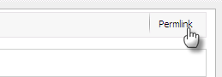
The link of the page you want to share will be displayed in the address bar of the Web explorer . You can copy and share it to the other.

Managing the pending list
This is an advanced action that helps the administrator and moderator manage all pending list in the Forum easily.
The total number of pending topic/posts that need to be approved by the administrator/moderator is shown at the Pending label on the main action bar.
To manage pending list, simply click on the Pending link on the main action bar:
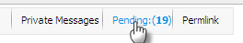
The Moderate pending topic and post form is shown.
In case the administrators login, all topics and posts pending for approval or censor in all forums in the Forum application are listed.
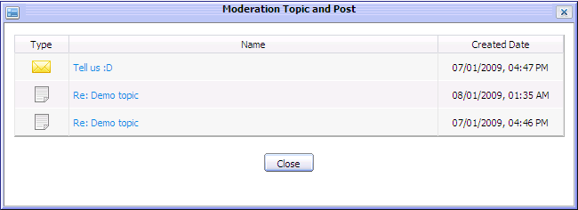Illustration 79: The Moderate pending topic and post form
In case the moderator login, all topics and posts pending for approval or censor in the forum managed by the moderator are listed.
To approve a pending topic/post, do as follows:
- Click on the topic/post name in the pending list
The View topic/post form will appear:
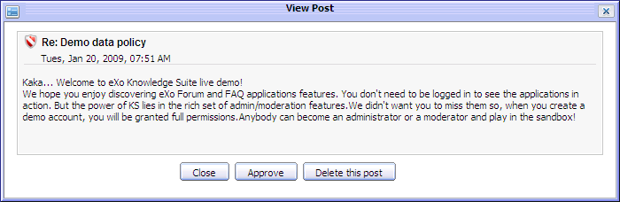
- Click the Approve button to accept approving topic/post
After approving, the pending post/topic will be visible to normal users.
To delete a pending topics/posts, click Delete this topic/Delete this post button, the pending topic/post will be removed completely from the pending list and its forum.

Forum Portlet Settings
In the Edit Mode tab of the Forum portlet settings, the portal administrator can hide/ show category/forum and enable/disable some functions/information in the Forum Application.
Do as follows:
- Login by the portal administrator
- Go to eXo Start --> Administration --> Advanced --> Manage page --> Edit Forum --> Edit mode.
The Edit mode tab of the Forum Portlet Settings is displayed below:
The Scoping tab that allows showing/hiding categories and forums in the Forum Application by simply selecting or unselecting their check boxes.
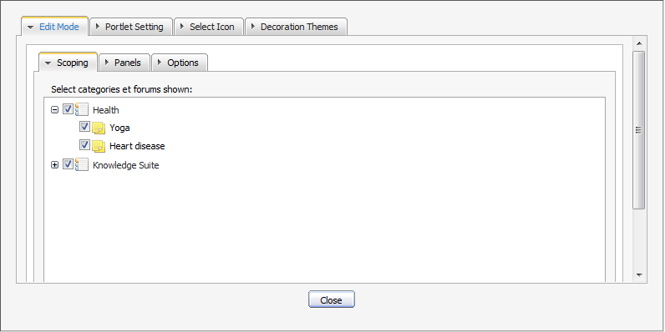Illustration 80: The Edit Mode tab of Forum Portlet settings
- Select/unselect check box(s) of the category/forum that you want to show/hide
- Click the save button in the tab, the form and the page.
The Forum portlet settings will be saved. The selected category/forums will be displayed in the Forum application while the unselected category/forums will be hidden.

The Panels tab that allows enabling/disabling some functions in the Forum Application by simply selecting or unselecting check boxes.

Similarly, select/ unselect check box(s) of the function/information that you want to enable or disable.
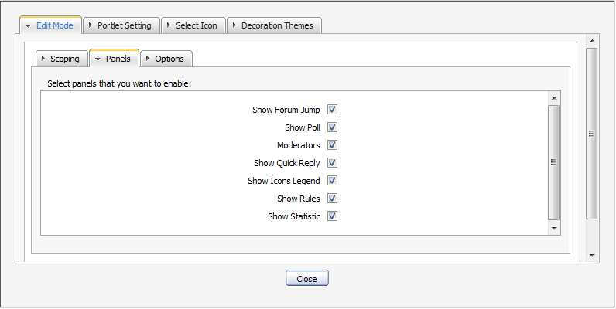Illustration 81: The Panels tab of Edit Mode
Details:
Show Forum Jump: This option is whether to enable Forum Jump function or not.
Show Poll: This option is whether to set visible for the topic poll or not
Moderators This option is whether to show forum moderator information or not.
Show Quick Reply: This option is whether to enable Quick Reply function or not.
Show Icons Legend This option is whether to show the Icon Legend or not
Show Rules: This option is whether to show forum rules information or not.
Show Statistic This option is whether to show the forum statistics or not.
The Options panel: Users need to have a knowledge about Ajax. Ajax (stands for Asynchronous JavaScript and XML) is used here with the purpose of update a whole web page or a part of a web page.
The default value of Use Ajax is false that means a whole page is loaded. If users select the Use Ajax check box, it will load a part of a page.
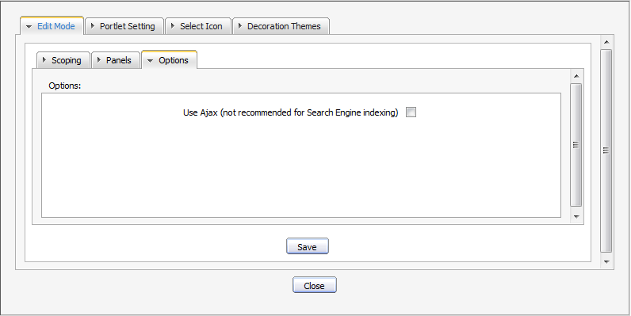Illustration 82: The Options tab of Edit Mode

RSS feed
This function provides RSS feeds that are used to get RSS of a specific category, forum, topic. Each time if there is any change, the feed of the corresponding category, forum or topic will be updated.
Do as following steps:
- Right click on a category, a forum or a topic that you want to get RSS feeds and then select the RSS item in the menu.
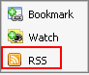
The detail information of the category/forum/topic will be displayed on another tab:
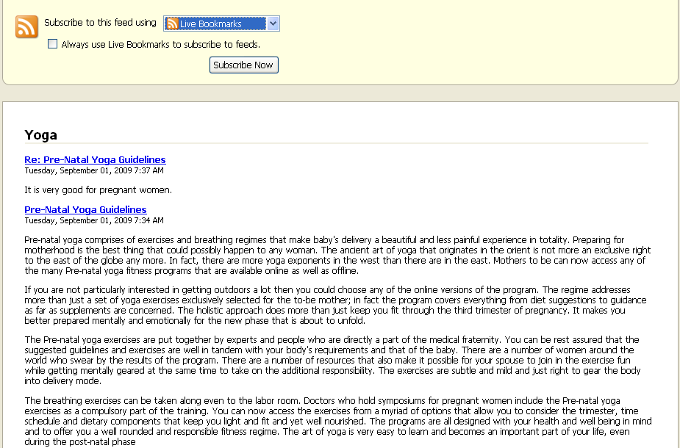
- Category feeds contain all posts in all topics in all forums in a category. The Category Feeds shows title (title of the category), description (category description), link (permlink to the category), pubdate(creation date of the category).
- Forum feeds contain all posts in all topics in a forum. The Forum Feeds shows title (Name of the forum), description (description of the forum), link (permlink of the forum), pubdate (creation date of the forum ).
- Topic feeds contain all posts in a topic. The Topic Feeds shows title (Title of the topic), description (content of the topic's initial post), link (permalink to the topic), pubdate (creation date of the topic).

Notes:
Private posts, Cencoring Topics/Posts, Hiding Posts, Disapproved Topics/Posts don't go to to the feed.

To add live bookmark, simply clicking on the Subscribe Now button and click the Add button in menu pop up:

