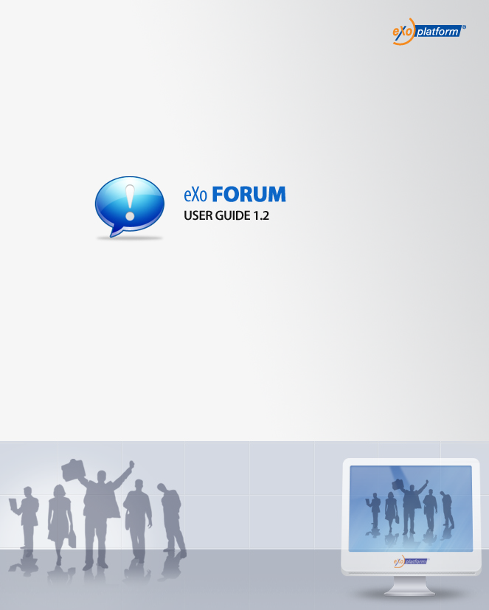
REVISION HISTORY
Version | Date | Written by | Reviewed by | Change Record
1.0 | January 03, 2009 | Hoang Anh Quynh Nga | Nguyen Thanh Cong
1.1 | March 18, 2009 | Nguyen Thanh Cong | Hoang Anh Quynh Nga | - User Setting: change avatar  - User Setting: Option to receive mails, user watches  - One click watch  - Update/delete avatar  - Enhance User Profile menu
1.2 | May 22, 2009 | Nguyen Thi Thanh Hoa | Luong Quynh Lien | - Informations of RSS feed  - Add poll in topic
1.2 | May 09, 2009  August 20  May 15, 2010 | Nguyen Thanh Cong | Vu Thi Hoa | - Tagging topic  - Topics Types.  - Screen name.  - View posts/replies in emal notification.  -Change screenshots.  - Fix the table of Content

Table of Contents
1.Preface 6
1.1 About this guide 6
1.2 Who should read this guide 6
1.3 Objective of this guide 6
2.Overview 7
2.1 Concept overview 7
2.1.1. What is a Category? 7
2.1.2. What is a Forum? 7
2.1.3. What is a Topic? 7
2.1.4. What is a Reply? 7
2.2 User groups 7
2.2.1. Administrator 7
2.2.2. Moderator 8
2.2.3. Viewer 8
2.3 The Forum application main screen 9
3.How to use the Forum application? 10
3.1 Registering a new account 10
3.2 Signing in/Signing out 12
3.2.1 Signing in 12
3.2.2 Signing out 14
3.3 User Settings 15
3.4 Collapse/Expand 18
3.5 Adding topics 19
3.5 Editing topics 27
3.6 Locking topics 29
3.7 Unlocking topics 29
3.8 Voting topics 30
3.9 Search 31
3.9.1 Quick Search 31
3.9.2 Advanced Search 32
3.10 Tagging topics 37
3.11 Adding a poll topic 39
3.12 Post management 42
3.12.1 Post Reply 42
3.12.2 Quick Reply 44
3.12.3 Private Post 45
3.12.4 Quote Post 45
3.12.5 Editing posts 47
3.12.6 Deleting posts 48
3.12.7 Approving posts 48
3.13 Bookmark management 50
3.13.1 Adding bookmarks 50
3.13.2 Deleting bookmarks 51
3.14 Watching 51
3.15 Sending private messages 53
3.16 Viewing all topics/posts 57
3.17 Sharing links 58
3.18 RSS feed 59

Illustration Index
Illustration 1: The Forum application main screen 8
Illustration 2: The anonymous home page of the classic portal 9
Illustration 3: The Create my account form 10
Illustration 4: The Sign in form 11
Illustration 5: The authenticated homepage 12
Illustration 6: The authenticated Forum application 13
Illustration 7: The Profile tab of the User Settings form 14
Illustration 8: The Forum Settings tab of the User Settings form 15
Illustration 9: The My watches tab of the User Settings form 16
Illustration 10: The Content tab of the New topic form 18
Illustration 11: The Attach File form 19
Illustration 12: The Icon tab of the New topic form 21
Illustration 13: The Options tab of the New topic form 22
Illustration 14: The Permissions tab of the New topic form 23
Illustration 15: The Select a group form 23
Illustration 16: The Select a group form 24
Illustration 17: The Preview topic form 25
Illustration 18: The Edit Topic form 27
Illustration 19: The Rate this topic form 29
Illustration 20: The Advanced Search- Search in Category form 32
Illustration 21: The Advanced Search- Search in Forum form 33
Illustration 22: The Advanced Search- Search in Topic form 34
Illustration 23: The Advanced Search- Search in Post form 35
Illustration 24: Tag this topic form 36
Illustration 25: Tag form 37
Illustration 26: The topic list when mouse over on a tag 37
Illustration 27: The Poll form 38
Illustration 28: The Content tab of the New Post form 41
Illustration 29: The Icons and Smiles tab of the New Post form 42
Illustration 30: The Quick Reply form 43
Illustration 31: The Quote form 44
Illustration 32: The Edit post form 45
Illustration 33: The Posts to approve form 47
Illustration 34: The My Bookmarks form 48
Illustration 35: The watch alert form 49
Illustration 36: The Private Messages form 50
Illustration 37: The Inbox tab of the Private Messages form 52
Illustration 38: The Compose new message of the Private Message form 52
Illustration 39: The Posts by user 53
Illustration 40: The RSS form 54

Preface

About this guide
eXo platform™ software is a powerful Open Source corporate portal and content management system. Users of the platform have a customized single point of access to the company's information system and resources. The purpose of this user guide is to provide step by step instructions of how to use the eXo Forum application which is a part of the Knowledge Suite – a extension of eXo portal.
This documentation is an useful guide for you to learn about eXo KS technology in details. It gives an in depth examples and easy explanation of eXo platform technology that not only allows technical but also non-technical people to be more efficiently.

Who should read this guide
Welcome to the eXo Knowledge Suite material. This document aims at guiding various users of eXo Platform. This material is for anyone interested in learning and using the Forum application. It is also useful for the following groups:
- Users who use the eXo Knowledge Suite with the Forum application in their work and business.
- Integrators who want to know more about the rich knowledge features in order to advise their customers to use eXo products.

Objective of this guide
This user guide will:
- Define some basic concepts used in the Forum application.
- Show the main instructions of the Forum application.
- Guide step by step to take basic actions.

Overview

Concept overview

What is a Category?
A Category is the name for a collection of content items that are related in some way. In the eXo Forum, a category can be defined as a domain including various forums which may be related to the same field. The forum application may include many various discussing domains so that it may also include many various categories.

What is a Forum?
A forum is a web application holding on-line discussions and posting user generated content. So a forum is the best place to ask questions about certain development topics.

What is a Topic?
A topic is the subject matter of a conversation or discussion in a forum. Each topic contains one original message and all its replies. When you enter a forum, there is a list of topics which are being discussed.

What is a Reply?
A reply is a post in a topic. With a message in the topic which you interest, you can read and have any reply if you want. Thus, a reply is your idea about that topic.

User groups

Administrator
Users in the administrator group are users who typically have ability to create, edit, delete, move and modify, etc... any forum and its topic, post. The administrators also have the ability to open/close, lock/unlock one forum or topic. It can be said that the administrators have the highest right to do any thing which they want. Otherwise, the administrators also have right to manage members in the forum and they can set right for members.
At the runtime of the Forum service, the default administrators, categories and forums are created. These administrators are defined at the Forum Roles Plugin in xml file. These administrators can be changed if the value in xml file is changed. The default administrators are the ones who initialize the Forum and assign role to normal users. A normal user can be an administrator if the default administrator assigns administration role to him directly in the Forum application.

Moderator
Moderators have subset of administrator's rights that allows them to edit, delete and move topics in a special forum which they have moderation right. Otherwise, the moderators also can open/close, lock/unlock, stick/un-stick, split/merge or approve/disapprove topics in a special forum.
When the administrators create a new forum, they have to set this right to some users or some groups. If not, only the administrators can mange that forum.

Viewer
Viewers includes guests and logged users. A guest only has the view permission while a logged users can take some basic actions in the Forum application. By default, all users can view forum, all its topics and replies. However, if the administrator only set the view right for some users or some groups to specific categories, forums or topics, only the users or the groups that have the view right can view them. When having the add post right, any viewer can add his/her reply to the topic which he/she interests.
Notes:
All users after registering successfully can do basic actions of the Forum application. These users are viewers of this application.

The Forum application main screen
Illustration 1: The Forum application main screen
Indicator | Meaning
 | This is the Breadcrumb bar that shown forum path, quick search, advanced search and permlink.
 | This is the Main action bar that displays all main function buttons, the number of function buttons depending on the role of user login.
 | This is the Forum panel that displays all categories and forums inside.
 | This is the Statistic Panel that displays Forum statistics about user information.
 | This is the Right Panel that allows doing some advanced action in Forum, including Download, Sign up, Take a tour, Feedback.

How to use the Forum application?
Firstly, you need a portal account to use the eXo Forum. You can register a new one or use your existing account. On the standard KS portal we have configured some accounts with specific roles such as:
In this document, one of these accounts is used to guide you through the Forum application.

Registering a new account
To register a new account on eXo portal, proceed as follows:
- Go to the portal by inputting URL in the address bar (e.g: http://localhost:8080/portal). The anonymous home page will be displayed:
- Select the Sign up from the navigation bar. The Create my account page will appear:
Illustration 2: The anonymous home page of the classic portal
Details:
Illustration 3: The Create my account form
The Account Setting tab:
User Name: The name of the user that will be used to sign in. It must be unique.
Password: The secret string used to login. It must have at least 6 characters.
Confirm Password: The re-typed password. Password and Confirm Password must be the same.
First Name: Your first name.
Last Name: Your last name.
Email Address: Your contact email address. It must be in the right format. For example: flower@gmail.com
Save button: To accept saving a new account.
Cancel button: To set blank entries for all text fields.
- Click the icon to search and check whether the inputted User name is available or not.
- Input other required fields in the Account Settings tab.
- Input values for the User Profile tab, include: Profile information, Home information, Business information. These are not required informations, users can input a value or not.
- Complete creating a new account by clicking the Save button.
There will have an alert message and you can not add a new account if at least one of these cases occurs:
  - The User name is existing or User Name is invalid
  - The Password has less than 6 characters.
  - The Password and Confirm Password are not the same
  - The Email Address is invalid format
  - The required fields are blank (empty)
After registering a new account, you can login and access the eXo Forum application.

Signing in/Signing out

Signing in
This function allows you to go into the portal in the private mode.
To sign in, do as follows:
- Go to the portal in the public mode by inputting URL in the address bar (e.g: http://localhost:8080/portal)
- Click the Sign in link at the top right of a page if you in the classic portal. The Sign in form will appear:
Details:
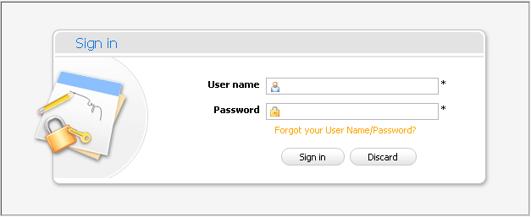Illustration 4: The Sign in form
User name: The registered user name
Password: The registered password
Forgot your User name/Password? The link helps you to retrieve user name and password when users forgot.
Sign in button: To accept signing in
Discard button: To close the Sign in form
- Input your registered User name and Password.
- Complete signing in by clicking the Sign in button.
In case, the User Name does not exist or the inputted User name/Password is invalid, there will have an alert message that requires a user to input the right value. To sign in again, you click the OK in the alert message and re-enter the User Name and Pass word.
After signing in, you will be redirected to the authenticated homepage:
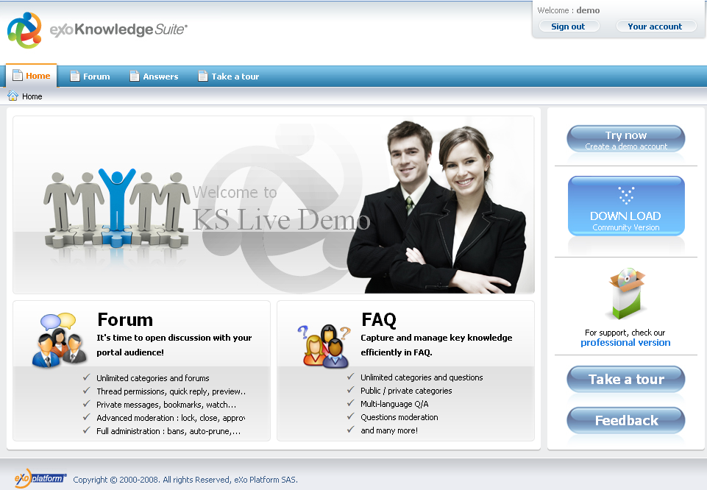Illustration 5: The authenticated homepage
To take actions in the Forum application, you have to go into the Forum Application page on the navigation bar. The main screen of forum application will be displayed:

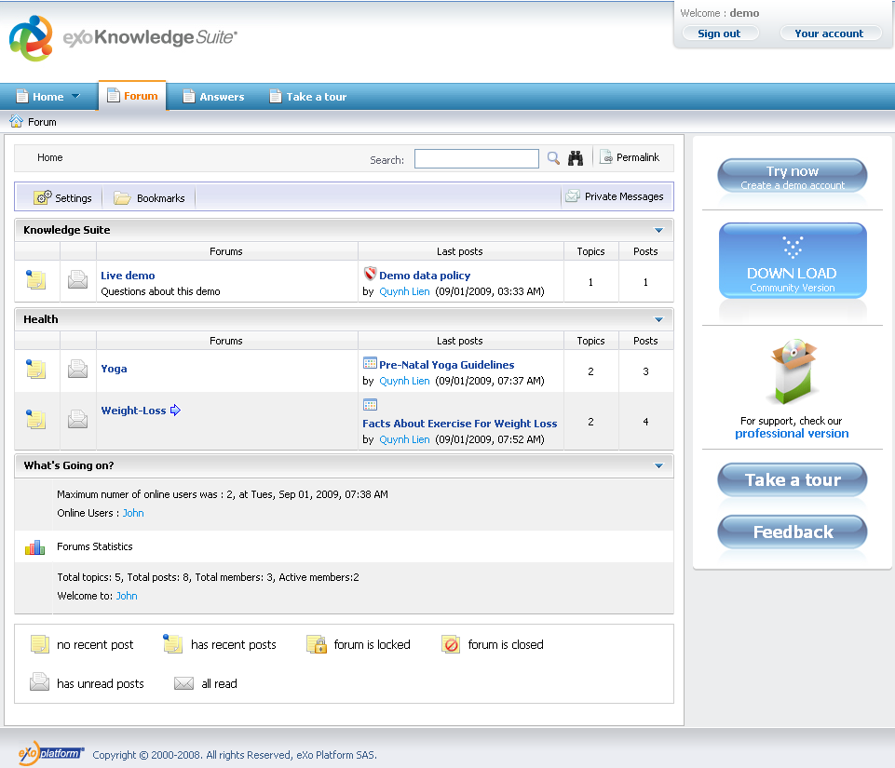Illustration 6: The authenticated Forum application

Signing out
This function allows users to get back to the anonymous portal. It ends your current portal session.
To sign out, click the Sign out button at the top right corner of the screen:
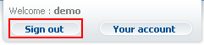

User Settings
This function is used to set some forum properties.
- Show the User Settings form by clicking the button on the main action bar.
The User Settings form will appear:
The Profile tab includes your common information:
Illustration 7: The Profile tab of the User Settings form
User name: Your user name. It can not be edited.
Screen name: The name that will be displayed on the screen.
User Title: Your title. You can not edit this field. It is set by Administrator and only Administrator can change a value of this field.
Signature: Your signature. This signature will be displayed under each post/topic created by you. You can see it in the figure below:
Display signature: This option is whether to display your signature under each post/topic or not.
Avatar: The avatar of your account.
Update: To open Upload File form to change avatar
Reset: To remove the current avatar and set by the default one.
Display avatar: This option is to display your avatar or not. Information in displaying avatar is loaded from Address Book Application. (See eXo Address Book User Guide for more details.)
Automatically watch my topics: This option is to add you to the watchers of the topic you create. You will receive notification mail when there is new post added to your posted topic.
Automatically watch topics I posts This option is to add you to the watchers of the topic when you post to a topic . You will receive notification mail when there is new post added to the topic that you added post.
The Forum Settings tab includes information related to Forum application:
Time zone: A region that has the same time everywhere within it. This field is referred to a local and standard time.
Illustration 8: The Forum Settings tab of the User Settings form
Short date format: The format is to display short date in application.
Long date format: The format is to display long date in application.
Time format: The format is to display time in application.
There are 2 options: 12 hour or 24 hour.
Topics per page: The maximum number of topics can be displayed per page.
Posts per page: The maximum number of posts can be displayed per page.
Show forum jump: The option is to display Forum link at the bottom or not.
Save button: To accept saving new settings.
Cancel button: To close the User Settings form.
- Enter and set values for fields in tabs.
- Complete user setting by clicking the Save button.
To change the avatar, do as follows:
- Click the Upload link to open the Upload File form:
- Click the Browse... button to select a file to upload.
- Click the icon to upload the selected file.
- Click the Save button to accept changing the avatar.
The My Subscriptions tab lists all your being watched objects (category, forum, topic) that makes it easy for you to manage your watch list in the Forum application.
To view your being watched object, simply click on the object's title in the Title column.
Illustration 9: The My Subscription tab of the User Settings form
To get a new RSS feed that contains the selected RSS feeds in the column, check checkboxes that corresponds to RSS feeds that you want and then click on the Save button, the object(categories, forums, topics) which are selected will be updated to the Your pernonal feed URL is link. The Your personal feed URL is fied is always default for each user . Users can copy and use this link to view detail information of categories/forums or topics.
To send notifications to your friends, check checkboxes in the column and then enter one or more email addresses in the Your notifications are sent to field . Click the Update button to add the entered email addresses in the column:
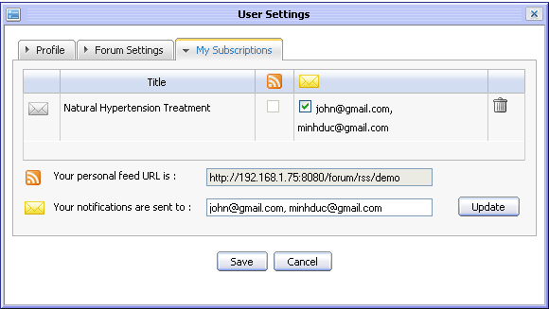
To remove being watched objects from your watch list, simply click on the delete icon correspondingly. After being removed, you will not receive notification mails about the removed object anymore.

Collapse/Expand
This convenient function allows you to collapse or expand a category just by clicking on the arrow at the end of the category pane as you can see below:
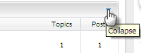
Note that when you log out and then log in again, this state of the category pane will be restored as you left them before log out.

Adding topics
This function is used to create a topic inside a forum. A topic is a thread where all members in the Forum can discuss by giving questions, answers in form of adding post or reply.
Do as follows:
- Go into the forum which you want to add a new topic
- Click the button
The New topic form will appear:
- Enter values for fields in this form:
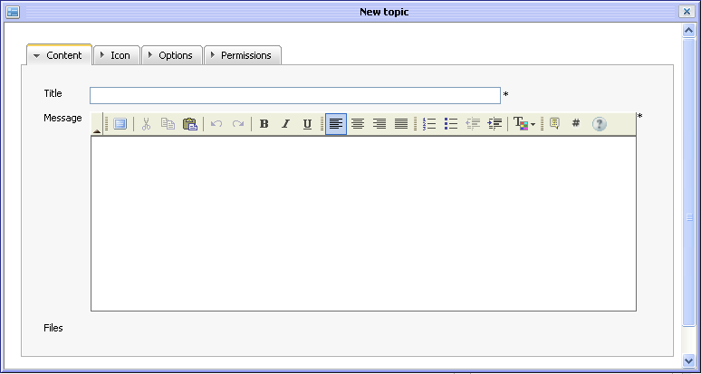Illustration 10: The Content tab of the New topic form
Details:
The Content information tab includes:
Title: The title of the topic. This field is required and limited by 100 characters.
Message: The content of the topic.
Files: The files attached with the topic.
Preview button: To preview the topic before submitting
Submit button: To accept submitting the topic
Attachment button: To perform attaching files.
Cancel button: To close the New Topic form.
To attach a file, do as follows:
- Click the Attachments button, the Attach File form will appear:
- Select files to upload by clicking the Browser... to select file's path from the local computer.
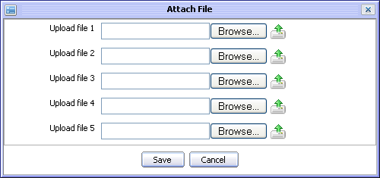Illustration 11: The Attach File form
- Upload the selected files by clicking the icon to upload.
- Complete attaching files to topic by clicking the Save button.
After attaching files, the New topic form is shown:
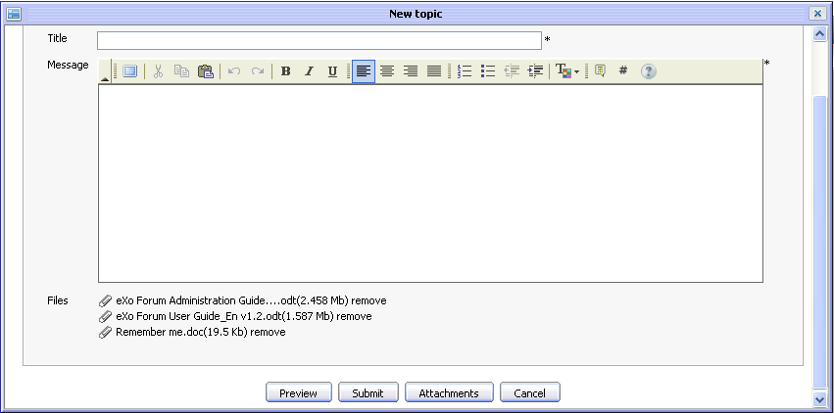
Many different file types can be attached. To remove attach files, simply click on Remove link beside the file attachment which you want to delete.
The Icon tab allows you to select an icon for a topic. There are a list of icon types, available for selecting:
The Options tab is is used to set some properties for a topic.
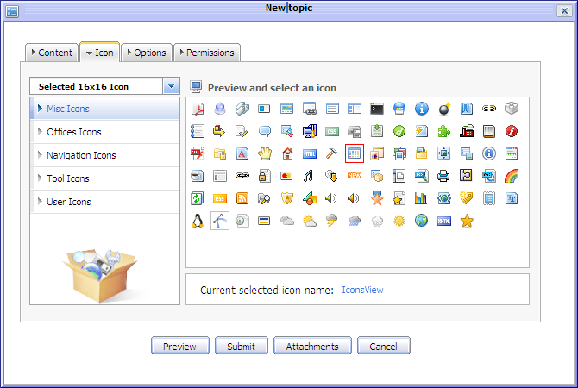Illustration 12: The Icon tab of the New topic form
Details:
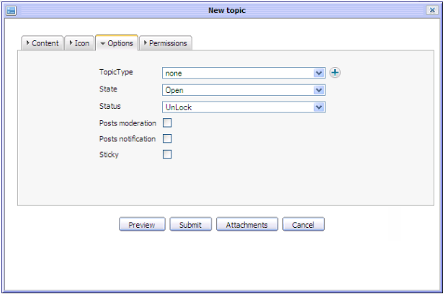Illustration 13: The Options tab of the New topic form
Topic Type: The type of the topic that specified by the topic type name and its icon. It can be selected from the existing list or added the new one by clicking the icon.
State: The state of the topic. The default value of this field is 'Open', the other option is 'Close'.
Status: The status of the topic. The default value of this field is 'Unlock', the other option is 'Lock'
Posts moderation: This option is to whether require/not require approving the new added post to be visible or not.
Posts notification: This option is to send (or not) a notification mail to topic's creator whenever new posts are created.
Sticky: This option allows marking a topic or not. After marking sticky, the topic will be set out by sticky title and located at the top order in the topic list.

The Permission tab is used to set view and post right to some users. You can set information to this tab or not. By default, all users can view and reply in this topic.
Details:
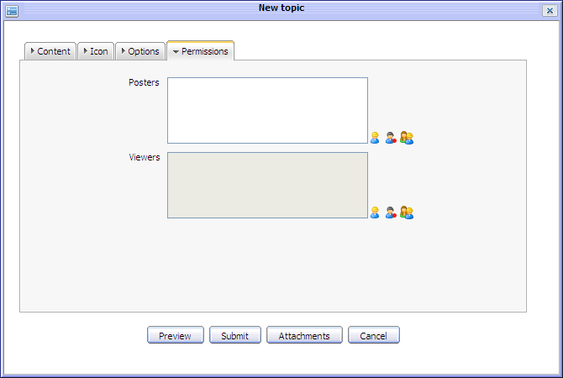Illustration 14: The Permissions tab of the New topic form
Posters: By default, when this field is blank, it means that all users can post replies in this topic. But if you want to limit number of users who can add post to the topic, do as follows:
- Click the icon to select users from the group list. Firstly, select a group from the left list and then select a user on the right. The selected users will be displayed in the 'Poster' field.
- Click the icon to select all users with a specific membership in a group. Firstly, select one group from the left pane and then select a membership on the right :
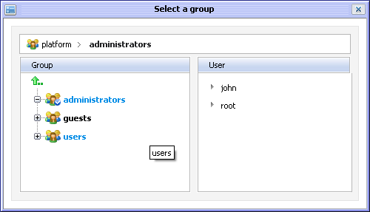Illustration 15: The Select a group form
- Similarly, click the icon to select all users in a specific group.
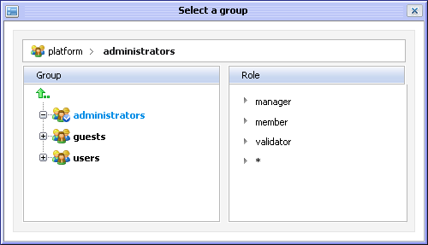Illustration 16: The Select a group form
Viewers: By default, when this field is blank, it means that all users can view this topic. To limit users who can view it, you can manually input or select users or group for the Viewers field (do as above). You only enter values for this field after you have inputted a values for the 'Posters' field.
To preview the topic before submitting, click the button, the View topic form is shown:
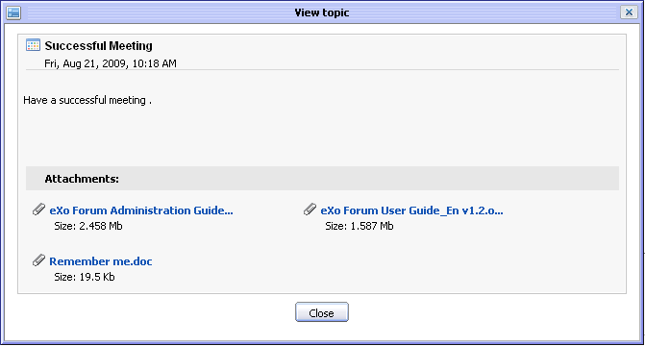Illustration 17: The Preview topic form
- Complete adding a new topic by clicking the Submit button.
After adding a new topic, the new topic will be updated at the topic list in the Forum. If it is the newest one, its information will be shown at the Last Post column information of the Forum that the topic is located:
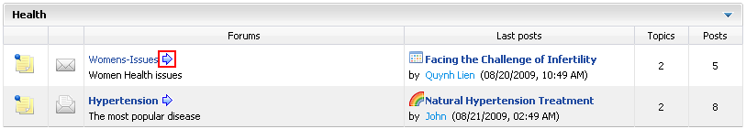
The icon that corresponds to the forum will let users jump to the last read post of that forum by clicking on that icon.
Note:
- In case, the Forum having the 'Topic Moderation' option or the added topic has the censor content, it will be pending for approval by the administrator or the forum moderator before being in visible.
- Beside the Text Editor tool, you can use the BB code (Bold tag, Italic tag, Underline tag, Size tag, Color tag, Combined formatting tag, Quote tag, Code tag, Unordered list, Ordered list, Link, Adding image...) to create text and picture effects for topics. For example, you can use Bold tag effect and Color tag effect when inputing a text into the Message field of the New topic form:
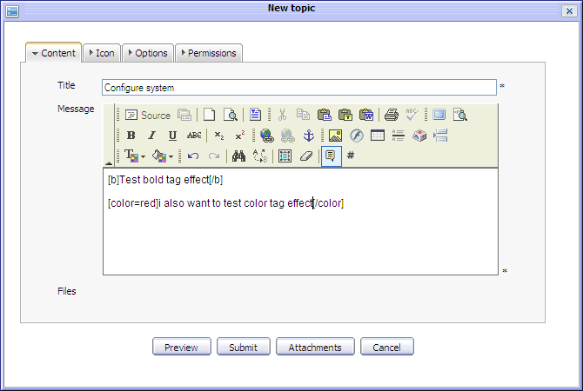
The topic will be displayed :
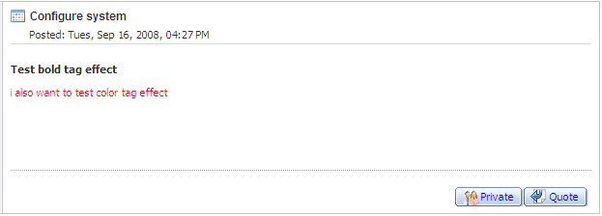

Editing topics
This function is used to edit a topic in a specific forum. You only can edit a topic when you are the creator of that topic.
Do as follows:
- Go into the topic that you want to edit.
- Click the Tools on the topic bar and select Edit in the menu:
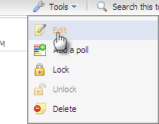
The Edit topic form will appear like when creating a new topic.
- Change some information of the topic, attach or remove files like when adding a new topic. Besides, you can enter a brief description about the reason to edit for the Reason field.
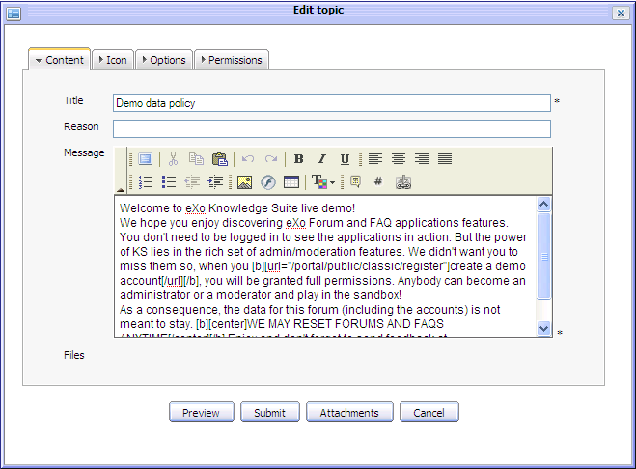Illustration 18: The Edit Topic form
- Click the Preview button to view this topic before submitting.
- Complete editing a topic by clicking the Submit button.
Notes:
- In case, the Forum having the 'Topic Moderation' option or the edited topic has a censor content, it will be pending for approval by the administrator or the forum moderator before being in visible.
- If you change a topic that does not require posts moderation into the one requiring posts moderation, all posts which have been added before do not need to be moderated. Only new posts that after you have edited are required to moderate.

Locking topics
This function is used to lock a topic in a specific forum. It means that other users only view this locked topic but can not take any another action. You only can lock a topic if you are the creator of that topic.
Do as follows:
The 1st way:
- Go into the topic that you want to lock.
- Click the Tools on the topic bar and select Lock in the menu:
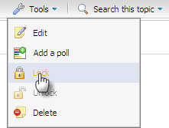
After being locked, the icon that corresponds to the locked topic will be changed from normal status into the locked status . Some functions of this topic will be disabled and the other users can only view this topic.
The 2nd way: Simply edit the topic, go to the Options tab and change its status.

Unlocking topics
This function is used to unlock one locked topic. You only can unlock a topic if you are the creator of that topic.
To unlock a topic, do as follows:
The 1st way:
- Go into the locked topic that you want to unlock.
- Click the Tools on the topic bar and select Unlock in the menu:
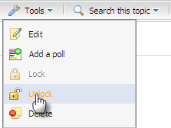
After being unlocked, the icon of the unlocked topic will be changed from locked status into normal status and users can quote and post replies normally.
The 2nd way: Simply Edit the topic, go to the Options tab and change its status.
Note:
You can not unlock your topics in case its forum is locked by the administrator or moderator. To do that, you need to wait for the administrator or moderator unlocks that forum firstly.

Voting topics
This function allows users to evaluate a topic by voting in a form of rating star from 1 to 5. The more star rate the topic has, the more interesting it is.
To vote the topic, do as follows:
- Go into the topic which you want to vote.
- Show the Rate this topic form by clicking the button on the topic bar.
- Rate the topic by left clicking on the star. The number of the selected star will be changed from gray to yellow. Click the Cancel button if you want to quit the Rate this topic form.
Note:
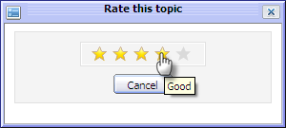Illustration 19: The Rate this topic form
Each user can only vote 1 time for one topic and the vote function is not available for the closed topics and the banned users.

Search
This function is used to search existing forums, topics and posts according to specific search conditions. With the Quick Search and the Advanced Search, both anonymous and logged users can find expected result quickly and flexibly.

Quick Search
With a quick search, users can directly type a search term in the search field. All the forums, topics and posts which have a keyword that matchs the search term will be quickly displayed in search result form.
Do as follows:
- To quick search any forum, any topic or any post concurrently:
- Enter a search term into the Search field at the right top of the screen after signing in the Forum application:
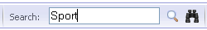
- Click the icon next the search box to do quick search.
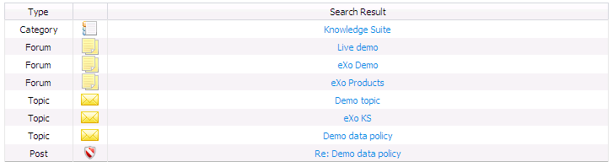
All forums/topics/posts that match with the entered search term are listed in the search results form:
- To quick search forums/topics/posts concurrently in a specific category:
- Click on the name of the category that you want to do a quick search:
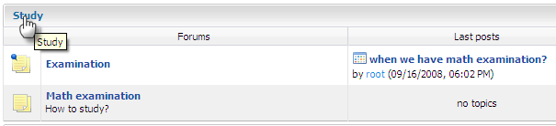
- Show Search box by clicking the button on the category bar.
- Enter the information related to objects that you want to search into the search box.
- Click the Search button to do search.
All matched objects will be listed in the search result form .
- To quick search topics/posts concurrently in a specific forum:
- Go into the forum that you want to find topics/posts in it.
- Click the button on the forum bar to display the box search
- Enter the search term that you want to find in this forum.
- Click the Search button to do search.
All topics and posts in this forum that match with the entered keyword are listed in the search result form.
- To quick search posts in a specific topic:
- Go into the topic that you want to find posts in it.
- Click the button on the topic bar to display the search box.
- Enter the search term that you want to find in this topic.
- Click the Search button to do search.
All posts in this topic that match with the search term are listed in search result form.

Advanced Search
Advanced search allows you to make a search with particular criteria corresponding to the object that is expected to be found. Using the advanced search, you can find forums/topics/posts more exactly.
Do as follows:
- Click the icon at the right top of your screen when you go into the Forum application or the icon in the search pop up of the Search in this category, the Search in this forum or topic. By default, the advanced search form that corresponds to the 'Category' object will be displayed. But with 'Forum' or 'Post' object, the properties of these objects will be different.
With 'Category' object:
Terms: The keyword that you want to search.
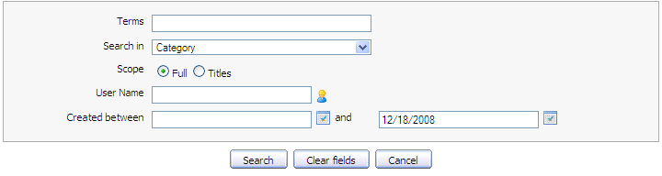Illustration 20: The Advanced Search- Search in Category form
Search in: The object that you want to search. If you want to find categories, the value of this field is 'Category'
Scope: The scope will be used to search. With 'Full' option, the entered keyword will be matched with the entire object (includes both title and content). With 'Titles', the entered keyword only is matched with the object's titles.
User Name: The user name of the object's creator that you want to search. Manually input or click the icon to select users from a specific group.
Created between and: The created date interval in which you want to search for categories. Manually input or click the icon to open the calendar pop up and select date.
With Forum' object:
Details:
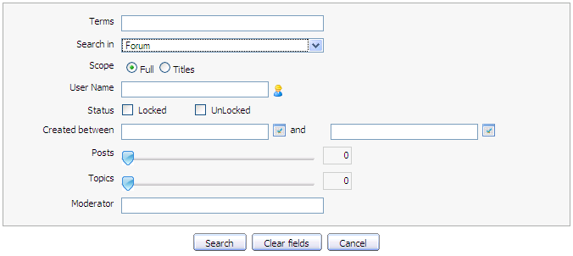Illustration 21: The Advanced Search- Search in Forum form
Terms: The keyword related to the forums that you want to search.
Search in: The object that you want to search. If you want to find forums, the value of this field is 'Forum'.
Scope: The scope will be used to search. With the 'Full' option, the entered keyword will be matched with the entire object (includes both title and content). With the 'Title' option, the entered keyword is only matched with the object's titles.
User Name: The user name of the objects that you want to search. Manually input or click the icon to select users from a specific group.
Status: The status of forums that you want to search.
Created between – and: The created date interval in which you want to search for forums. Manually input or click the icon to open the calendar pop up and select a date.
Posts The interval of forum's posts number that you want to search in. Simply click and drag a mouse to define the post interval.
Topics The interval of forum's topics number that you want to search in.
Moderator: The user name of the forums 's moderators that you want to find.
With a 'topic' object:
Details:
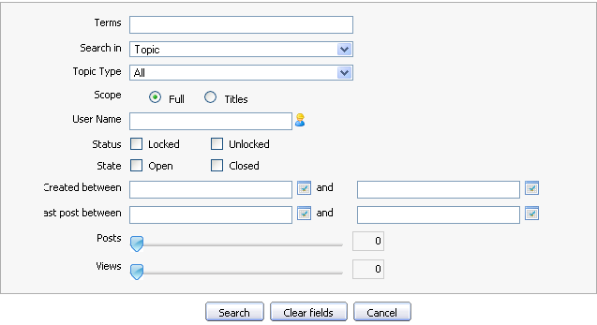Illustration 22: The Advanced Search- Search in Topic form
Terms: The keyword that you want to search.
Topic Type: The type of the topic that specified by the topic type
name and its icon. It can be seleted from the existing list.
Search in: The object that you want to search. If you want to find topics, value of this field is 'topic'
Scope: The scope will be used to search. With 'Full' option , the entered keyword will be matched with the entire object (includes both title and content). With 'Titles' option, the entered keyword only is matched with the object's titles.
User Name: The user name of objects that you want to search. Manually input or click the icon to select users from a specific group.
Status: The status of the topics that you want to search.
Created between - and: The created date interval in which you want to search for topics. Manually input or click the icon to open calendar pop up and select date.
Last post between - and: The last post 's created date interval in topics that you want to search in. Manually input or click the icon to open the calendar pop up and select date.
Posts: The number of topic's posts interval in which you want to search for those topics. Simply click and drag mouse on the slider bar to define post interval.
Views: The number of views interval of topics that you want to search in. Simply click and drag mouse to define the view interval.
With 'Post' object:
Term: The keyword that you want to search.
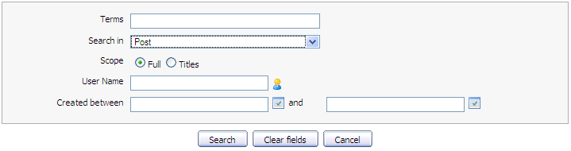Illustration 23: The Advanced Search- Search in Post form
Search in: The object that you want to search. If you want to find posts, the value of this field is 'Post'
Scope: The type will be used to search. With 'Search Entire', the entered keyword will be matched with the entire object (includes both title and content). With 'Search Title Only', the entered keyword only is matched with the object's titles.
User Name: The user name of the object's creator that you want to search. Manually input or click the icon to select users from a specific group.
Created between-and: The created date interval in which you want to search for posts. Manually input or click the icon to open the calendar pop up and select date.
Search button: To do search on specific criteria.
Reset Fields button: To set blank or default entry for all inputted fields.
Cancel button: To close the search form
- Enter the values for properties that correspond to each object that you want to search
- Do search on specific criteria by clicking the Search button.
The list of the the found objects will be displayed in the search result form or there will have an inform message when no objects match with the inputted properties.
Note:
In case the normal user login and search, the closed forum/topic and topics/posts pending for approval or censor are not shown. The normal users have no view permission to these forum/topic(s). Only the legal forum/topic/post(s) are shown to normal users.
Only shown categories/forums restricted to show by administrators in the Forum application are matched when you perform searching.

Tagging topics
This function is used to assign a tag for each topic. Tag are words or keywords which are used as labels to describe or group the same topics, each tag corresponds to a word. For example, you have a tag named 'Interesting' and you can assign different topics to this tag. However, one topic can have various tag names that can be created at the same time, separated by a space and belong to tag groups. Using tags makes it easy for you and others to find your topics.
Do as follows:
- Go into the topic which you want to tag.
- Click button on the topic bar. The Add Tag pop up will appear below:
- Input a new Tag name or an existing one.
In case you input a new tag name, the new one is created. In case using the an existing one, the topic will be tagged into the existing one.
- Click the Add Tag button to accept assigning a tag.
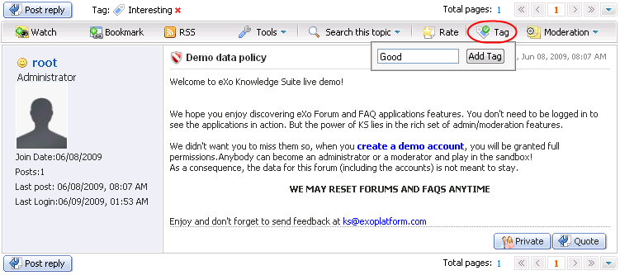Illustration 24: The Add Tag pop up
After assigning a tag to the topic, it will show all the tag names that the topic is assigned.
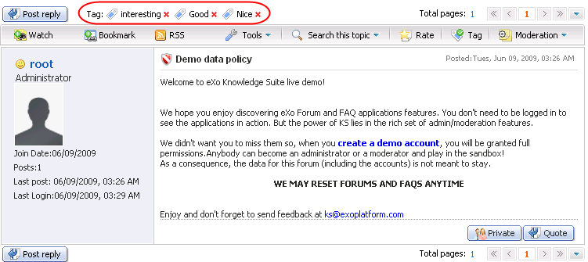
Illustration 25: The Add Tag pop up
When viewing a topic, if you are interested in any tag, you can click directly on the tag name to view its content.
The icon which is behind each tag allows you to remove this tag.
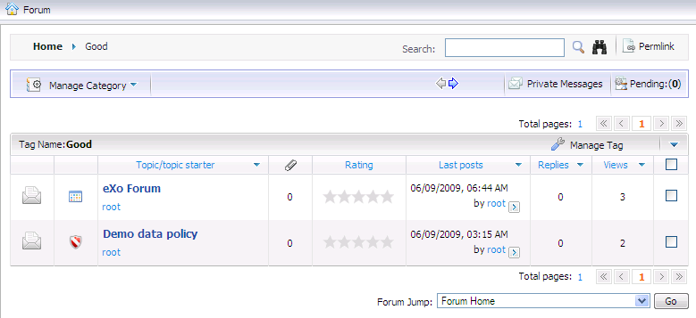Illustration 26: The content of a tag screen
To untag a topic from a tag, simply goto a tag page and click on the Manage Tag and select Untag in the menu popup.
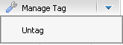
After being untagged, the topic will not be assigned to the tag anymore.

Adding a poll topic
This function is used to add a poll question into a topic. Each topic has only one poll question and you only add a poll question into a topic when you are the creator of that topic.
Do as follows:
- Go into the topic that you want to add a poll question.
- Click the Tools on the topic bar and select Add a poll in the menu.
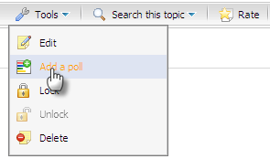
The Poll form will appear:
Details:
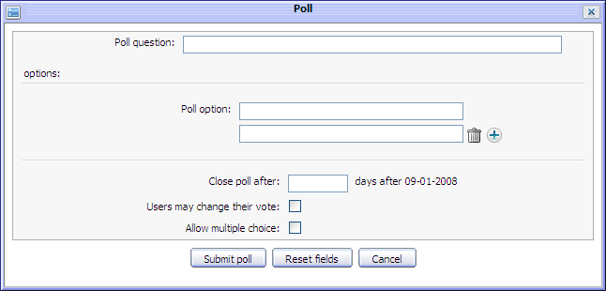Illustration 27: The Poll form
Poll Question: The question is used to poll. This field is required.
Poll option: The different answer options is for the poll question. By default, there are two options to choose. But if you want to have more, click the icon to add more poll options or click the icon if you want to remove options.
Close poll after: The number of days that the poll will be closed.
User may change their vote: This option is to whether allow users to change their vote or not.
Allow multiple choice: This option is to allow multiple choice or not. It means users can have several answers for one poll.
Submit poll button: To accept submitting poll.
Reset fields: To set blank or default entry for all inputted fields
Cancel button: To close the Poll form.
- Enter values for fields in the Poll form.
- Complete adding a poll for a topic by clicking the Submit poll button.
After adding a poll for a topic, an icon will displayed on topic.
Note:
Vote for poll question function is only available for member of the Forum and can only be voted in case the topic is opened.
To vote poll, do as follows:
- Go into the topic that has a poll. The poll will be displayed in the selected topic:
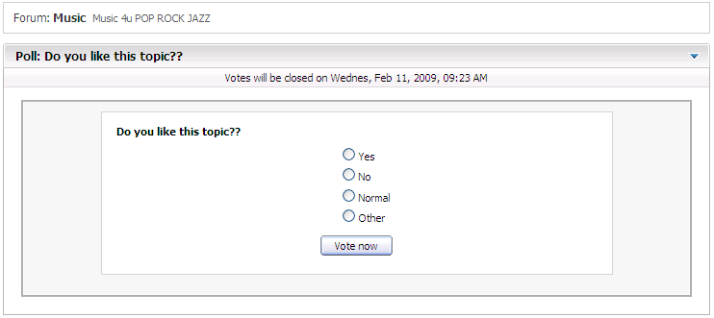
- Select one answer that you want. Note that if the poll has multi choice options, many answers can be selected. If not, only one answer can be selected at one time like a poll above.
- Click the Vote now button under the poll to vote.
After voting, the result of the poll will be displayed immediately:
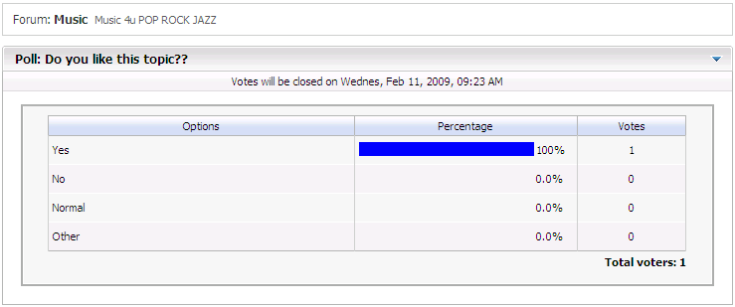

Post management
Posts are posted by users when viewing a specific topic. A topic may contain many posts which show different opinions about the topic. This section is about how to create, edit and delete posts.

Post Reply
This function is used to respond to the main post in a topic. All responses will be displayed in form of post replies in the topic. By default, a post reply will have the title with format Re: <The title of the topic>. However, users can personalize the title of their post reply. Normally, all users can post reply to the main post in a topic but if the administrator and the moderators set post right to some users, only the users having add post right can do this action.
Do as follows:
- Go into the topic which you want to post reply.
- Show the New Post form by clicking the button to post your response to this topic:
Details:
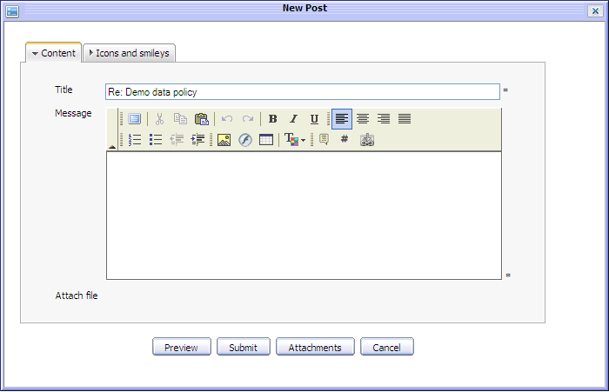Illustration 28: The Content tab of the New Post form
The Content tab includes:
Title: The title of the topic which you want to post a reply. You also can change this title.
Message: The content of your reply. There will be an inform message when this content is short. (at least 3 characters)
Attach file: The attached files of your post reply. If you want to attach a file into this post, click the Attachments button to open the Attach File form and do as above.
Preview button: To preview the post reply before submitting.
Submit button: To accept submitting the post reply.
Attachment button: To perform attaching files.
Cancel button: To close the New Post form.
The Icons and Smiles tab allows users select an icon for the post.
- Enter values for fields in the New Post form. (BB code can be used here). You may attach file, change icon for post or not.
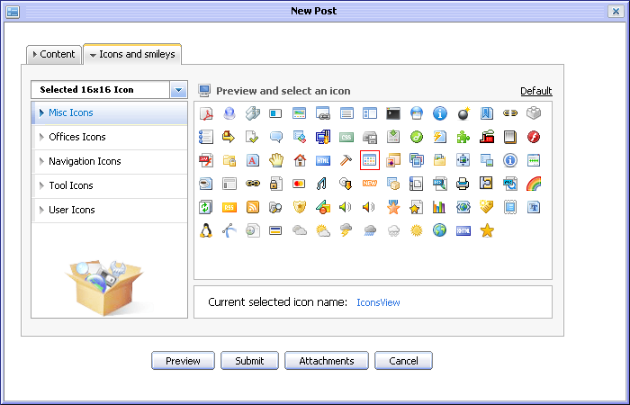Illustration 29: The Icons and Smiles tab of the New Post form
- Complete adding a post by clicking the Submit button.
Notes:
If the topic has the 'Post notification' option or the added post has a censor content, it will be pending for approval by the administrator or the forum moderator before being in visible.

Quick Reply
This function is used to post a reply more quickly with a simple text. However, users can decorate their post by using BB Code tag
When users go into a topic, by default there will be a form to quickly post a reply under the list of the current topic's posts:
- Enter the content of the message that you want to reply
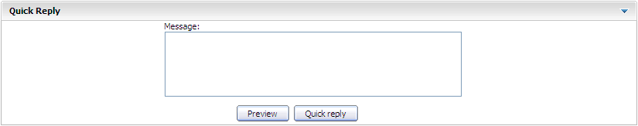Illustration 30: The Quick Reply form
- Preview a message before posting by clicking the Preview button
- Complete adding a quick reply by clicking the Quick reply button.
Notes:
If a topic has the 'Post notification' option or a quick reply has censor content, it will be pending for approval by the administrator or the forum moderator before being in visible.

Private Post
This function is used to respond privately to a post in a topic. Only the creator and the author of the responded post can see the private post.
Do as follows:
- Go into the topic that you want to post a reply.
- Click the button under the post that you want to reply. There will be a form like when you post reply.
- Enter values for fields, change icon...
- Preview a post before submitting by clicking the Preview button
- Complete adding a private post by clicking the Submit button.
Note:
A private post is a personal exchange between two users (creator and receiver). Thus, the private post will not be checking for approval in case the topic has the 'Posts moderation' option. Private message is displayed with label 'This post is private' in order to differ with normal posts.
Besides, you can not add a private post with censor content.

Quote Post
This function is used to post a reply with quotation to a specific post in topic. The message of the post that you are going to quote a post is also added into the message content of the reply.
Do as follows:
- Click the button under the post which you want to add quote.
The Quote form will appear:
Details:
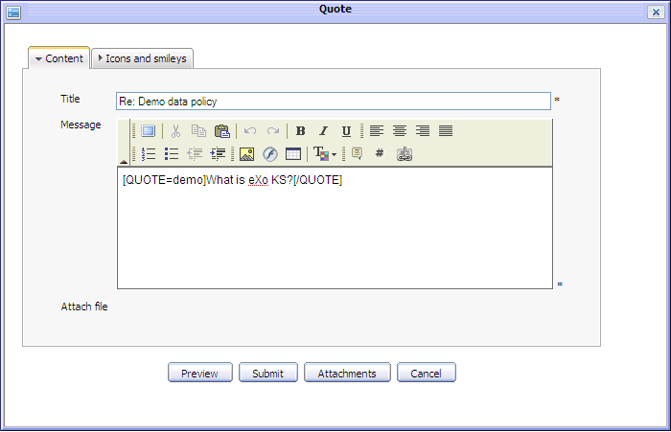Illustration 31: The Quote form
The Content tab includes:
Title: The title of the topic which you want to quote. You also can change this title.
Message: The content of your reply with quote. Quote content is in the [Quote] tag.
Attach file: The files attaching with your reply with quote. If you want to attach a file into this post, click the Attachments button to open the Attach File form and do as above.
Preview button: To preview the reply with quote before submitting.
Submit button: To accept submitting the reply with quote
Attachment button: To perform attaching files.
Cancel button: To close the New Post form.
The Icons and smiley tab allows changing an icon for replying with quote. It likes the Icon and smile tab of the New Post form (See detail)
- Make changes on your quote. e.g adding more comments... Or you also can add your quote into the message by clicking the icon to get [QUOTE] tag and after getting [QUOTE] tag, you enter your quote between [QUOTE] and [/QUOTE].
- Preview your reply with quote by clicking the Preview button.
- Complete replying with quote by clicking the Save button.
A reply with quote will be displayed below:
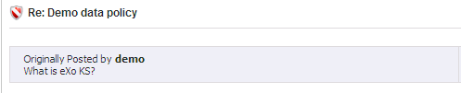
Notes:
If the topic having 'Post notification' option or the added post with post having censor content, it will be pending for approval by the administrator or the forum moderator before visible.

Editing posts
This function is used to edit a post of a topic. The post creator can also do this action.
Do as follows:
- Click the button under the post that you want to edit.
The Edit post form will appear with the current information, available for editing:
- Change current post's information, add or remove attachment etc...like when adding a new post.
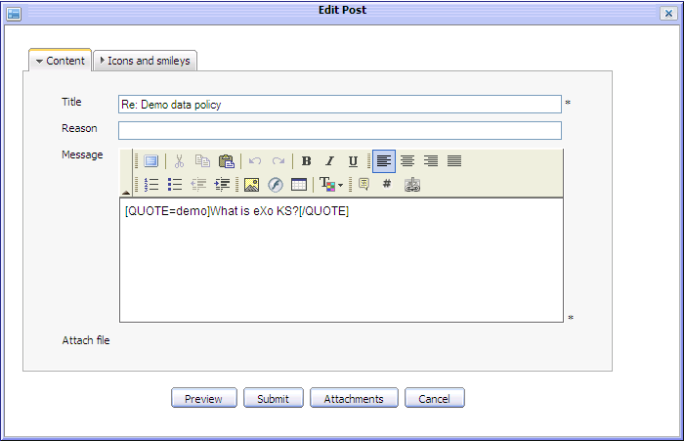Illustration 32: The Edit post form
- Complete editing post by clicking the Submit button.
Notes:
If a topic has the 'Post notification' option or the edited post has a censor content, it will be pending for approval by the administrator or the forum moderator before being in visible.

Deleting posts
This function is used to remove a post from a topic. The post creator can also take this action.
Do as follows:
- Click the button under the post that you want to delete.
- Click the OK button in the confirmation message to accept deleting or the Cancel button to quit.

Approving posts
This function is used to approve pending posts in the topic that has the 'Post moderation' option. All new posts added into the 'Post moderation' topic, will be in the 'pending for approval' status. It means that nobody can view these posts except the administrator, the forum moderators and the topic's creator. Only after the administrator/moderators or the creator approves, the post with 'pending for approval' status will be displayed. The 'pending for approval' status label will be removed and the normal users can view it normally.
Do as follows:
The 1st way:
- Select post(s) with status 'This post is pending for approval' by selecting its check box(s).
- Click the Moderation on the topic bar and select Approve in the menu.
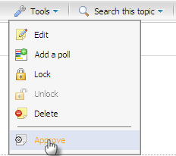
These posts will be approved and shown normally. Thus, the normal users can view and take some actions with these posts.
The 2nd way:
- Do not select any 'pending for approval' post, then click Moderation on the topic bar and select Approve in the menu.
The Posts to approve form will appear:
- Select posts(s) that you want to approve by selecting its check box(s).
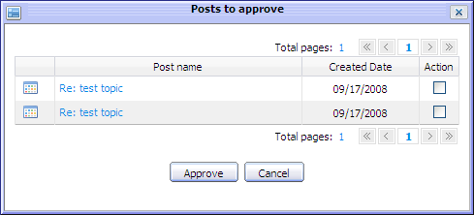Illustration 33: The Posts to approve form
- Click the Approve button to accept approving or click the Cancel button to quit.
These posts will be approved and shown normally. Thus, the normal users can view and take some actions with these posts.

Bookmark management
In the eXo Forum, the bookmark is the creation of a link to a category, forum or topic already visited, so that you can return to that category, forum or topic directly, without using a search engine or directory.

Adding bookmarks
This function is used to add a link (a link to a category, a forum, or a topic) into the Bookmark table.
Do as follows:
- Go to inside the object (category , forum or topic) that you want to bookmark and click the button on its main bar or right click on the title of the object and select Bookmark in the menu:
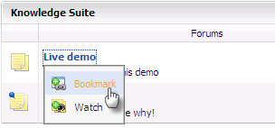
The selected link will be added into the bookmark list.
To view the added link, click the button on the action bar. The list of all added links will appear:

Deleting bookmarks
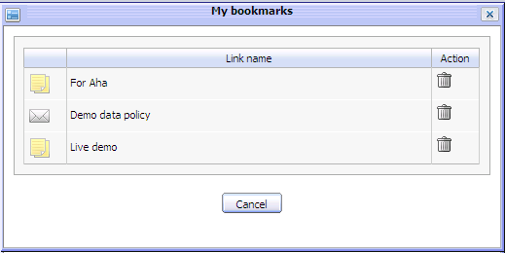Illustration 34: The My Bookmarks form
This function is used to delete a link from the Bookmark table.
To delete bookmark, do as follows:
- Open the My bookmark form by clicking the Bookmark button on the main action bar.
- Click the icon corresponding to the link that you want to delete.
The selected link will be removed from bookmark list.

Watching
This function allows you keep track new changes to specific categories, forums or topics via notification emails. You only need registering an account, whenever there is new changes such new topics , new post... you will receive a notification from the Forum application.
To add watch, simply goto inside the object (category , forum or topic) that you want to add watch and click the button on its main bar or right click on the title of the object and select Watch in the menu:
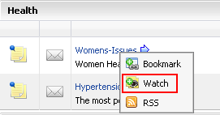
The alert message that informs watching successfully is shown:
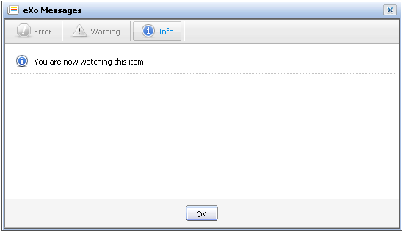Illustration 35: The watch alert form
User also receive the email notifications about new posts/ replies of the forum that has just been watched.
- When new replies of the forum that you have watched have been posted, they will be notified in your email.
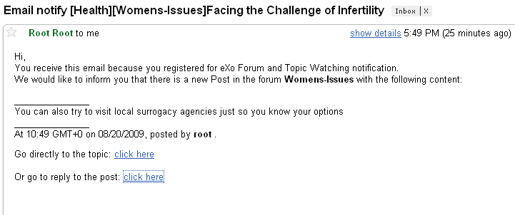
- Click on the first click here in your email to go directly to the topic or the second click here to go to the topic and view the reply that has just been posted. The new reply will be displayed in the Quote form.
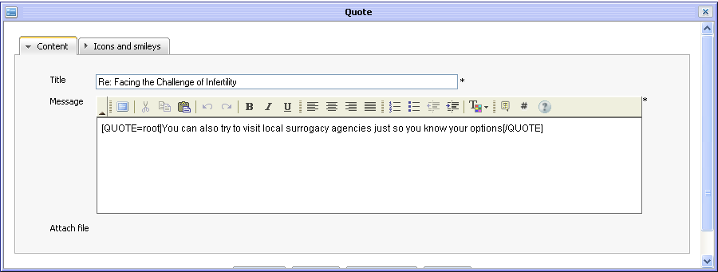

Sending private messages
This function is used to exchange private messages among users.
To send a private message, do as follows:
- Go into the topic that contains posts of the user who you want to send a private message.
- Click on a specific user name and select the Send private Message in the menu in order to open the Private Messages form:

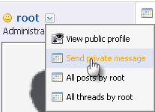
Details:
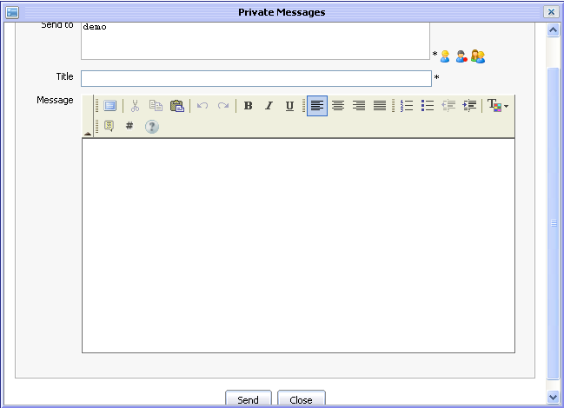Illustration 36: The Private Messages form
Send to: The user names of all users who will receive this private message. By default, the value of this field is the user name of the selected user. To add more users:
- Click the icon to select users from groups list as figure below. Firstly, select a group from the left list and then select a user on the right. The selected users will be displayed in the 'Send To' field.
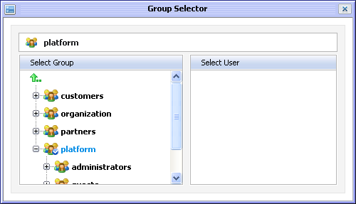
- Click the icon to select all users with a specific membership in a group. Firstly, select one group from the left pane and select then a membership on the right :
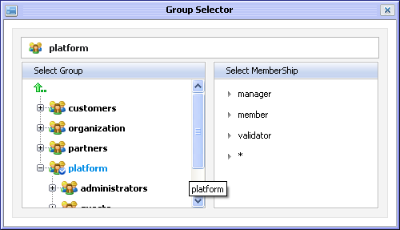
- Similarly, click the icon to select all users in a specific group.
Title: The subject of private message.
Message: The content of private message.
Send button: To accept sending private message
Close button: To close the Private Messages form.
- Enter values for fields in this form.
- Complete sending message to users in 'Send to' field by clicking the Save button.
After signing in successfully, the receiver will see a message alert with Private Message(number private messages) at the right corner.
To view these private messages, do as follows:
- Click on the inform message below:
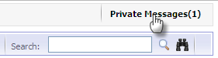
The Private Messages form will appear:
- Select each message in the message list to view it.
Details:
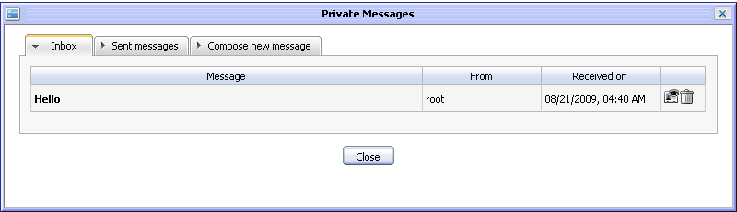Illustration 37: The Inbox tab of the Private Messages form
The Inbox tab includes all received messages, the reply and delete icons
The Sent messages tab includes all sent messages, the forward and delete icons.
The Compose new message tab is the form to compose a message.
- Click the icon to reply to the received message.
The form to reply is below:
- Enter the response in the 'Message' field. Do as above to add more receivers in the 'Send to' field.
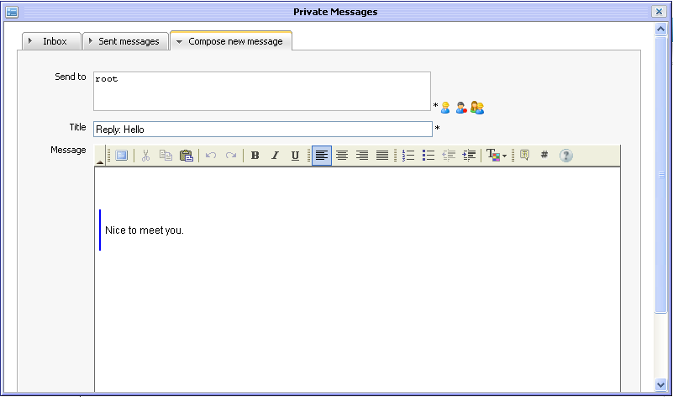Illustration 38: The Compose new message of the Private Message form
- Click the Send button to send reply to the sender.
- Click the icon to delete the message that corresponds to it. Click the OK button in the confirmation message to accept deleting or click the Cancel button to quit.

Viewing all topics/posts
This function is used to view all topics/posts of a specific user.
Do as follows:
- Go into the topic that contains posts of the user who you want to view all his/her topics/posts.
- Click a specific user name and select All posts by <user name> or All topics by <user name>
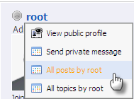
All topics/posts of the selected user will be listed in the Post(s)/topic(s) by user form :
- Click the Close button to escape from this form.
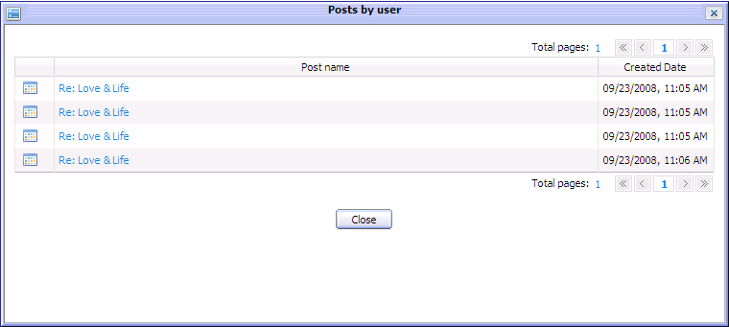Illustration 39: The Posts by user

Sharing links
This function allows you view and copy a link to a specific forum/topic and share it with their friends or use for your own purpose.
Go into the Forum application and do as follows:
- Go to Forum/topic which you want to share link
- Click the Permlink label at the right corner:
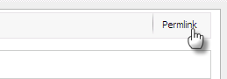
The link of the page you want to share will be displayed in address bar of the Web explorer You can copy and share it to the other .

RSS feed
This function provides RSS feeds used to get RSS of a specific category, forum or topic. Each time if there has any change, the feed of corresponding category, forum or topic will be updated.
Do as following steps:
- Right click on a category or a forum or a topic that you want to get RSS feeds and then select the RSS item in the menu.
- The detail information of the category/forum/topic will be displayed and viewed on another tab:

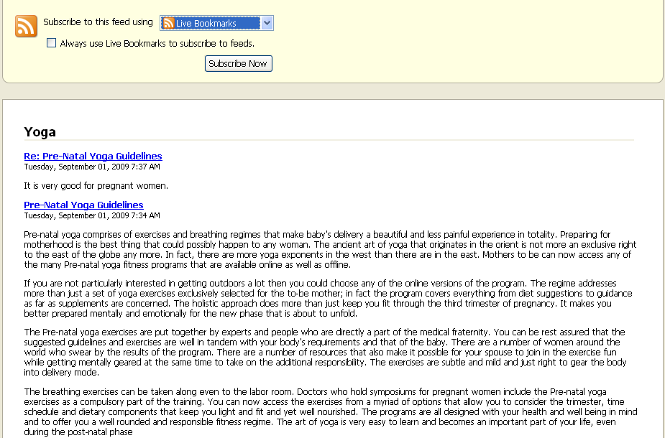
- Category feeds contain all posts in all topics in all forums in a category. The Category Feeds shows title (title of the category), description (category description), link (permlink to the category), pubdate(creation date of the category).
- Forum feeds contain all posts in all topics in a forum. The Forum Feeds shows title (Name of the forum), description (description of the forum), link (permalink of the forum), pubdate (creation date of the forum ).
- Topic feeds contain all posts in a topic. The Topic Feeds shows title (Title of the topic), description (content of the topic's initial post), link (permalink to the topic), pubdate (creation date of the topic).

Notes:
Private posts, Cencoring Topics/Posts, Hiding Posts, Disapprove Topics/Posts don't go to the feed.

- To add a live bookmark, simply clicking on the Subscribe Now button and click the Add button in the menu pop up:

