

eXo Mail User Guide
version 1.3.4

eXo Collaboration provides a rich, Web 2.0 browser-based interface with comprehensive messaging and indexing; archival and search capabilities; share calendars, address books, emails and much more features soon.
eXo Mail is an open-source mail client built on foundation of eXo WebOS with variety of new features designed to make your e-mail experience more productive and convenient, as a new way to view your mails inbox and conversation and help to reduce risks and annoyances such as phishing and junk e-mail. Easy to approach the basics as writing, reading, finding and much more...

eXoTeam
REVISION HISTORY
Version | Date | Writer | Reviewer | Change Record
1.0 | Jun 28, 2008 | Hoang Anh Quynh Nga
1.1 | Dec 02, 2008 | Hoang Anh Quynh Nga | Nguyen Thanh Cong | - Clarify some definition  - Improve the way to express  - Update new illustration  - Update Filter function by right click directly on 1 message  - Detail explanation mail settings.  - Update 2nd way to add/remove star for message  - Update 3rd way to create filter  - Update Step 4- User name & password of Create a new account form changes  - Update new add/edit account feature, Not spam function.  - Update the way to add tag, delete message.  - Update some small changes
1.2 | March 13, 2009 | Hoang Anh Quynh Nga
1.3 | June 16. 2009 | Nguyen Thanh Cong |  | - Managing accounts with new updates  - Managing folder with new updates  - Mail Settings with Return Receipts and Layout options.  - Sending a mail to a selected contacts.  - Synchronizing folders  - Refine the content.
1.3.1 | Oct 20,2009 | Luong Quynh Lien
1.3.3 | Nov 24,2009 | Nguyen Thanh Cong |  | - Update most of UI with small changes of label, menu item.  - Separate View as and Filtering function  - Remove Custom layout

Contents
1. Preface 12
1.1 About this guide 12
1.2 Who should read this guide? 12
1.3 Objective of this guide 12
1.4 Related documents 12
2. Getting Started 13
3. How to process in eXo Mail? 15
3.1 Registering a new account 15
3.2 Signing in/Signing out 17
3.2.1 Signing in 17
3.2.2 Signing out 19
3.3 Managing accounts 19
3.3.1. Adding an account 20
3.3.2. Editing an account 25
3.3.3. Deleting an account 28
3.4 Managing folders 30
3.4.1. Adding a new folder 32
3.4.2. Adding a new sub-folder 33
3.4.3. Renaming a folder 34
3.4.4. Removing a folder 34
3.4.5. Marking all message as read 35
3.5 Mail 36
3.5.1. Getting mails 36
3.5.2. Composing a message 37
3.5.3. Printing 40
3.5.4. Replying message 43
3.5.5. Replying messages to all related people 45
3.5.6. Forwarding messages 47
3.5.7. Moving messages to folders 49
3.5.8. Managing tags 51
3.5.8.1.Tagging a message 51
3.5.8.2.Editing a tag 54
3.5.8.3.Removing a tag 55
3.5.8.4.Emptying a tag 56
3.5.8.5. Changing a tag color 56
3.5.9. Reporting a message as spam 57
3.5.10. Deleting a message 58
3.5.11. Exporting messages 59
3.5.12.More actions 62
3.5.12.1. Marking a message as read 62
3.5.12.2. Mark a message as unread 62
3.5.12.3. Adding a star to a message 63
3.5.12.4. Remove a star from a message 64
3.5.12.5. Importing messages 64
3.5.12.6. Reporting a message as not spam 66
3.5.12.7. Viewing full headers of a message 66
3.5.13. Viewing and filtering mails 67
3.5.13.1 View as 67
View as List 67
View as Thread 68
View as Conversation 69
3.5.13.2. Filtering messages 70
Filtering Unread messages 70
Filtering star messages 70
Filtering message with attachments 70
Viewing all messages 71
3.5.14.Managing filters 71
3.5.14.1. Creating a new filter for your messages 71
3.5.14.2. Editing a filter 76
3.5.14.3. Deleting a filter 76
3.5.15. Managing the Address book 76
3.5.15.1.Adding a new address book 76
3.5.15.2.Adding a new contact 78
3.5.15.3.Editing a contact 80
3.5.15.4.Deleting a contact 81
3.5.15.5.Sending a mail to a selected contacts 81
3.5.16. Adding an event 82
3.5.17. Search 85
3.5.17.1 Quick Search 85
3.5.17.2 Advanced Search 86
3.5.18. Mail Settings 87
3.5.19. Maximizing the Reading Pane 90
3.5.20. Sorting messages 90

Illustration Index
Illustration 1: The main screen of the Mail application 13
Illustration 2: The anonymous home page of the classic portal 15
Illustration 3: The Account Setting tab of the Register form 16
Illustration 4: The User profile tab of the Register form 17
Illustration 5: The Sign in form 18
Illustration 6: The classic portal page after signing in successfully 19
Illustration 7: Step 1- Account name and description of the Create a new account form 20
Illustration 8: Step 2- Mail Identity settings of the Create a new account form 21
Illustration 9: Step 3 – Server information of the Create a new account form 22
Illustration 10: Step 4- User name & password of the Create a new account form 23
Illustration 11: Step 5- Verify information of the Create a new account form 24
Illustration 12: Getting mail automatically 24
Illustration 13: The Identity tab of the Edit Account form 25
Illustration 14: The Incoming tab of the Edit Account form 26
Illustration 15: The Outgoing tab of the Edit Account form 27
Illustration 16: The Fetch Options tab of the Edit Account form 28
Illustration 17: The Delete account form 29
Illustration 18: Delete account in the Edit Account form 30
Illustration 19: The default folder list 31
Illustration 20: The Add a new folder form 33
Illustration 21: The Rename folder form 34
Illustration 22: List of mails in the Mail view panel 36
Illustration 23: The Compose a new message form 37
Illustration 24: The Select email form 38
Illustration 25: The Attach files form 39
Illustration 26: The Print preview form 41
Illustration 27: The Reply form 44
Illustration 28: The Reply to all form 46
Illustration 29: The Forward message form 48
Illustration 30: The Move Message form 49
Illustration 31: The Tag form 51
Illustration 32: The Tag Message form 53
Illustration 33: The Edit tag form 55
Illustration 34: The Export Message form 61
Illustration 35: The download pop up on Fire Fox 61
Illustration 36: The messages with star view 64
Illustration 37: The Import Message form 65
Illustration 38: The Full Message Headers form 67
Illustration 39: View message as list 68
Illustration 40: View message as thread 68
Illustration 41: View message as conservation 69
Illustration 42: The Message Filter form 72
Illustration 43: The Add/Edit Message Filter form 73
Illustration 44: The Message Filter form 74
Illustration 45: The Contacts form 77
Illustration 46: The Add Address Book form 77
Illustration 47: The Contact form 79
Illustration 48: The Change Image form 80
Illustration 49: The Event detail tab of the Add event form 82
Illustration 50: The Event categories form 83
Illustration 51: The Reminders tab of Add event form 84
Illustration 52: The content of an Invitation mail 85
Illustration 53: The Search result form 86
Illustration 54: The Advanced Search form 86
Illustration 55: The General tab of the Mail Settings form 88
Illustration 56: The Return Receipts tab of the Mail Settings form 89
Illustration 57: The Layout tab of the Mail Settings form 90
Illustration 58: The Message list pane 91

Preface

About this guide
eXo platform™ software is a powerful Open Source corporate portal and content management system. Users of the platform have a customized single point of access to the company's information system and resources. The purpose of this user guide is to provide step by step instructions of how to use eXo Mail application which is a part of Collaboration Suite – a extension of eXo portal.
This documentation is a useful guide for you to learn about eXo CS technology in detail. It gives an in depth examples and easy explanation of eXo platform technology that not only allows technical but also non-technical people to be more efficiently in their daily collaboration.

Who should read this guide?
Welcome to the eXo Collaboration Suite material. This document aims at guiding various users of eXo Platform. This material is for anyone interested in learning and using the Mail application. It is also useful for the following groups:
- Users who use eXo Collaboration with Mail application in their work and business.
- Integrators who want to know more about the collaboration features in order to advise their customers to use eXo products.

Objective of this guide
This user guide will:
- Define some basic concepts used in Mail application
- Show the main instructions of Mail application.
- Guide step by step to do basic actions.

Related documents
- eXo Address Book User Guide v1.3.4
- eXo Calendar User Guide v1.3.4
- eXo Chat Guide v1.3.4

Getting Started
eXo Mail is a webmail application of eXo Portal. With a web mail, you can receive your emails whenever and wherever. What you need is just web browser such as: Internet Explorer, Firefox or Safari. It is a web based interface that allows you to check your emails online without downloading it to your computer. Users can keep and receive all important messages, files and pictures forever and it is easy for users to search, organize and view messages. This is an efficient and economic communication mean via Internet.
Additionally, eXo Mail is smoothly integrated with other Collaboration Suite such as Address Book and Calendar, which really help eXo Mail become more powerful and also enhance the its use value.
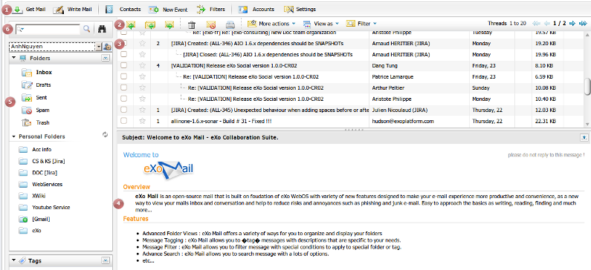Illustration 1: The main screen of the Mail application
Indicator | Meaning
 | This is the Tool bar which displays general actions in eXo Mail .
 | This is the Action bar which give you an easy way to do actions related to a message like send, forward, etc
 | This is the Messages Pane which displays message list stored in a specific folder.
 | This is the Preview Pane which displays the introduction when you go in to the Mail application and displays mail content as you view it.
 | This is the Navigator Pane which displays the mail folder tree of a specific account.
 | This is the Search area which includes search box and actions related to searching.

How to process in eXo Mail?
Firstly, you need to have a portal account to use eXo Mail. You can register a new one or use your existing account. On a standard CS portal we have configured some accounts with specific roles like below:
In this document, one of these accounts is used to guide you through the Mail application.

Registering a new account
- To register a new account on a portal, do as follows:
Step 1: Go to the portal by typing URL in the address bar (e.g: http://localhost:8080/portal). The anonymous home page will be displayed:
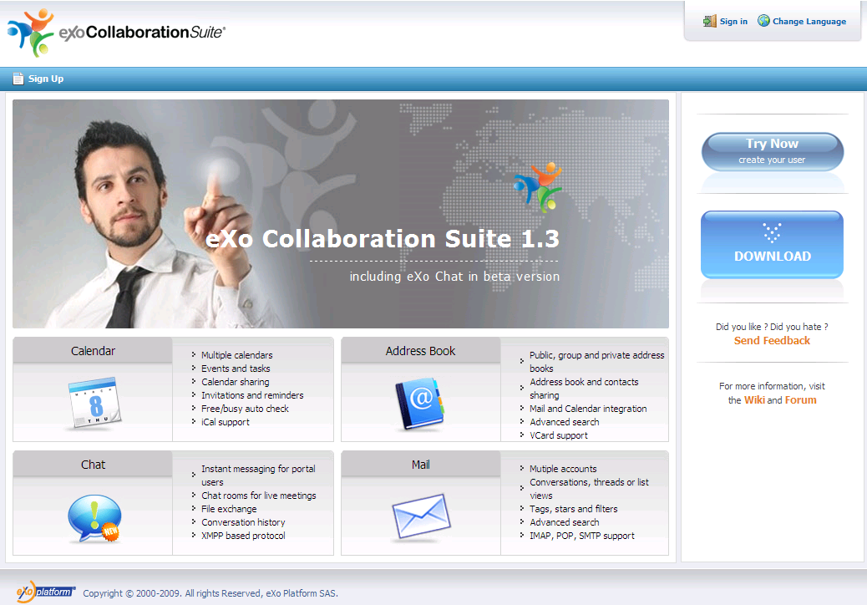Illustration 2: The anonymous home page of the classic portal
Step 2: Select Sign Up on the navigation bar. The Sign up form will appear:
The Account Setting tab includes:
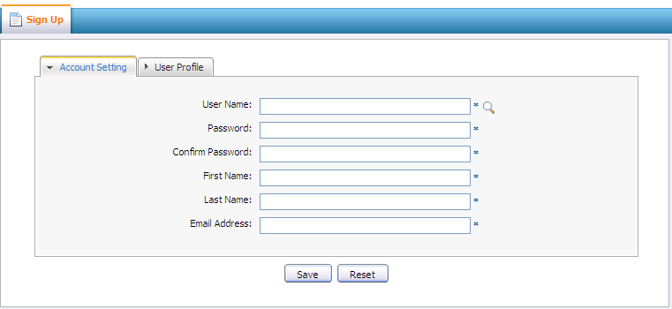Illustration 3: The Account Setting tab of the Register form

User Name: The name of user that will be used to sign in. It must be unique.
Password: The secret string used to login. It must have at least 6 characters.
Confirm Password: The re-typed password. Password and Confirm Password must be the same
First Name: Your first name
Last Name: Your last name
Email Address: Your contact email address. It must be in the right format. For example: flower@gmail.com
Save button: To accept saving new account.
Reset button: To set blank entry for all inputted fields.
Step 3: Click the icon to search and check whether the inputted User name is available or not.
Step 4: Input values in all required fields in the Account Setting tab
Step 5: Open the User Profile tab, these fields in this tab are not mandatory. You can input or leave them blank.
Step 6: Complete registering a new account by clicking the Save button.
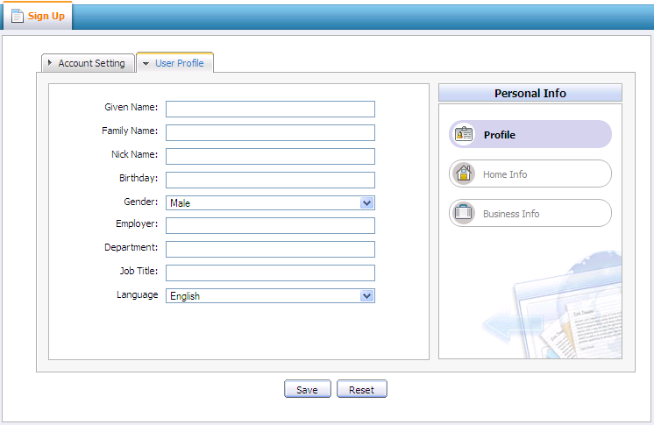Illustration 4: The User profile tab of the Register form
There will be an alert messages if at least one of these cases occurs:
- User name is existing or User Name is invalid
- Password has less than 6 characters.
- Password and Confirm Password are not the same
- Email Address is in invalid format
- Required fields are empty
After registering a new account successfully, you can login to eXo Mail application.

Signing in/Signing out

Signing in
This function is used to allow user to go into portal in private mode.
To sign in, do as follows:
Step 1: Go to portal in public mode by typing the portal URL in your browser address bar (e.g: http://localhost:8080/portal)
Step 2: Click the Sign in link at the top right of the page. The Sign in form will be displayed.
Step 3: Input your registered User name and Password.
Details:
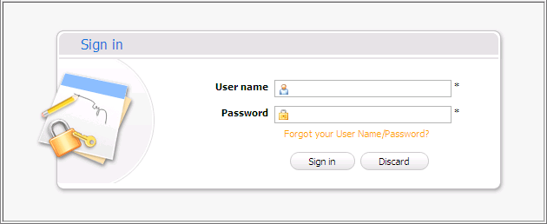Illustration 5: The Sign in form
User name: Your registered user name
Password: Your registered password
Forgot your User Select this check box if you forget your password or username
Name/Password
Sign in button To accept signing in
Discard button To exit the Sign in form
Step 4: Complete signing in by clicking the Sign in button.
After signing in, you will be redirected to the authenticated home page:
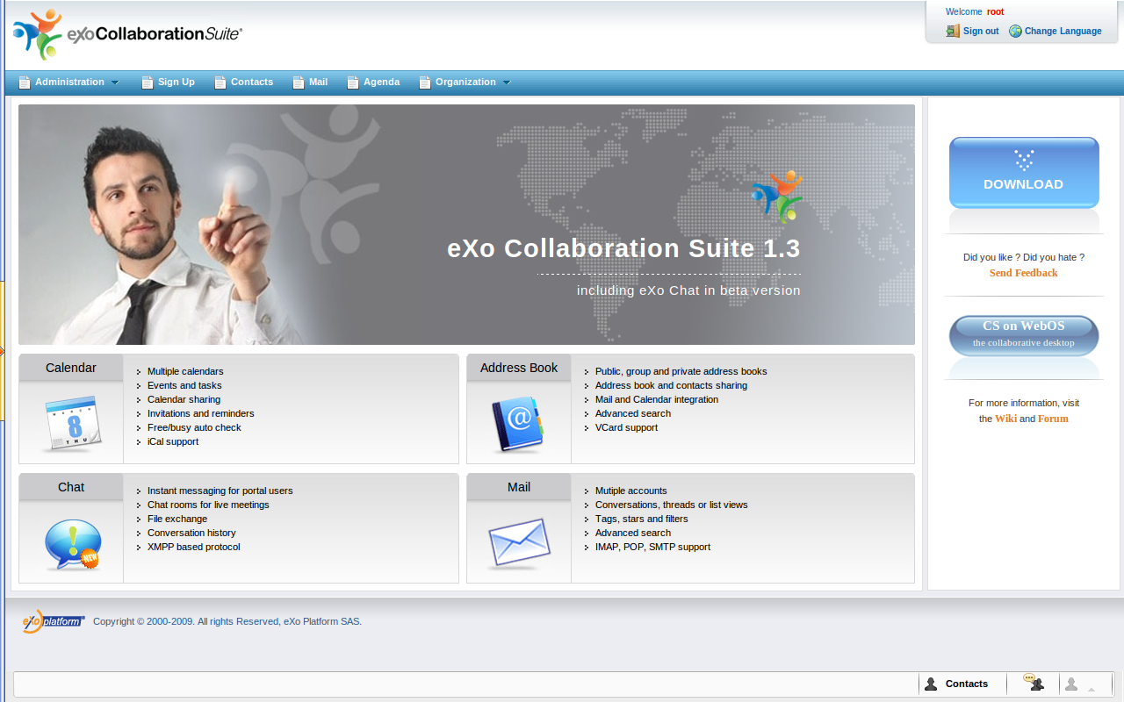Illustration 6: The classic portal page after signing in successfully

Signing out
This function allows you to get back to the anonymous portal. It ends your current portal session. To sign out, click Sign out at the top right corner of the screen.
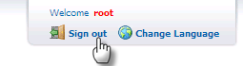

Managing accounts
In order to get mails from the other mail service to eXo Mail, you need to create an eXo Mail account which will connect to your real existing email account. eXo Mail allows you to mange your account such as add, edit, delete account which may get mails from different mail services.

Adding an account
This function is used to create/add an account in eXo Mail.
To add an account, do as follows:
Step 1: Open the Create a new account form by clicking the icon and then select Add account in the drop down list menu:
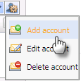
The Create a new account form will appear:
Step 2: This step allows you to add basic information: Account name and Account description. Enter your account name and brief description of your account in corresponding fields.
Details:
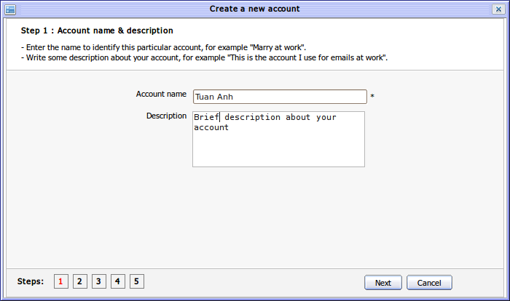Illustration 7: Step 1- Account name and description of the Create a new account form

Account name: The name of the account. This name will be displayed in the account list like figure below. This field is required.
Account description: The brief description of the account.
Step 3: Click the Next to go to the 2nd step.The Mail identify settings form will be displayed. Fill in all required fields in this step then click next to go to the next step.
Details:
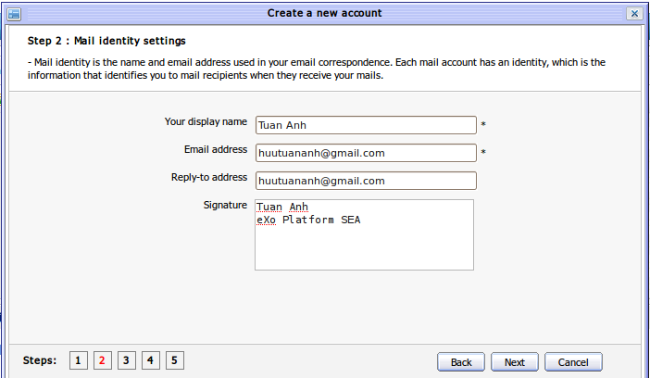Illustration 8: Step 2- Mail Identity settings of the Create a new account form
(*) required
Your display name: The name that you want to display when using the account. This name will be displayed together with your email address when you compose new message.
Email address: The email address corresponding to the account. You have to provide your exact email address.
Reply – to Address: The email address that will receive all replies.
Signature: The signature which is appended at the bottom of your email messages.
Step 4: Fill in all required fields in Server information form:
Details:
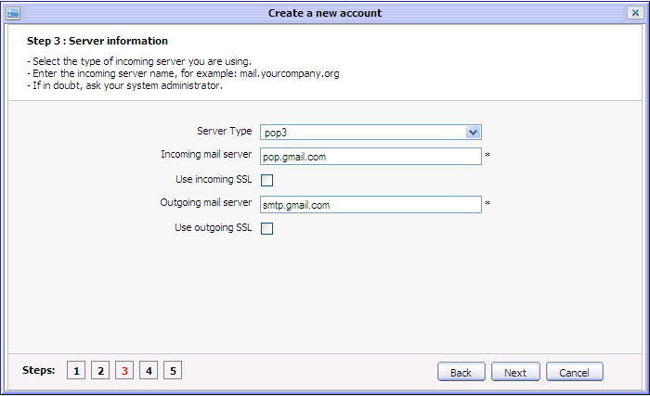Illustration 9: Step 3 – Server information of the Create a new account form
(*) required
Server Type: Type of the mail server. There are two options: POP3 (Post Office Protocol version 3) is a protocol to get email from a remote server or IMAP (Internet Message Access Protocol) which retrieves e-mail from a remote server over a TCP/IP connection. By default, 'pop3' is selected.
Incoming mail server: The incoming mail server of the email provider which you are using. Each email provider has different incoming mail server. By default, value of this field is 'pop.gmail.com'.
Use incoming SSL: SSL is cryptographic protocol which provides secure communication on Internet such as web browsing, email, Internet faxing,etc. Incoming SLL allows using SSL to check incoming emails.
Outgoing mail server: Outgoing mail server of the email provider that corresponds to the incoming mail server. By default, value of this field is 'stmp.gmail.com'.
Use outgoing SSL: This option is to use SSL to send mail in the Mail application.
Step 5: Click the Next button to go to Step 4. The Create a new account form will be displayed like the illustration below:
Details:
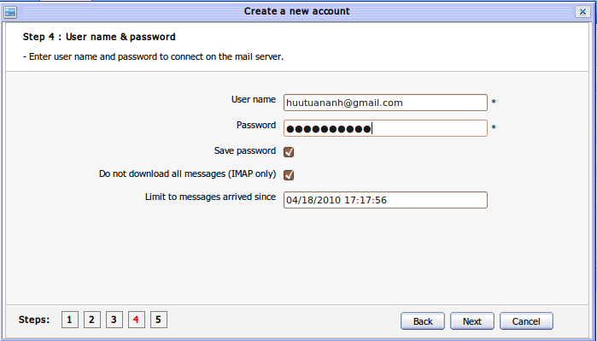Illustration 10: Step 4- User name & password of the Create a new account form
(*) required
User Name: Your email address which you will be used in eXo mail
Password: The password of your email address. It will be used to connect to your email to get messages
Save password: If you select this check-box, the browser will remember your password so that you don't have to re-enter your password to login .If this option is not checked, there will be a message that requires you to enter password anytime you check mail.
Do not download all This option allows checking mail from IMAP only or not.
message (IMAP only):
Limit to messages arrived since: This will filter the messages you want to download by time of receiving.
Step 6: Click Next to go to Step 5, the Verifying information form will be displayed:
This form will display all information to help you verify all of your inputted values from previous steps.
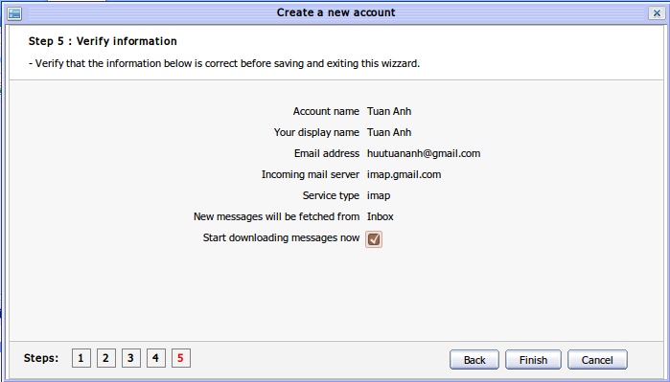Illustration 11: Step 5- Verify information of the Create a new account form
Details:
Start getting mail right now: The option allows getting mail automatically right after finishing creating a new account Otherwise, you have to do it manually.
Step 7: Click the Finish to complete creating your new account, click Back to return to the previous step or the Cancel to cancel creating a new account
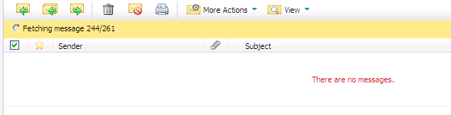Illustration 12: Getting mail automatically

Editing an account
This function allows editing your existing mail accounts. Do as follows:
Step 1: Open the Edit account form. You can do this step in two ways:
The 1st way: Open the Edit Account form by clicking the icon on the left pane then select Edit account from the menu:
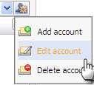
The 2nd way: Open the Edit Account form by clicking the icon on the tool bar.
The Edit Account form will appear:
The Identity tab contains basic information of the account such as account name, your name, your email address, reply-to address, mail signature, etc.
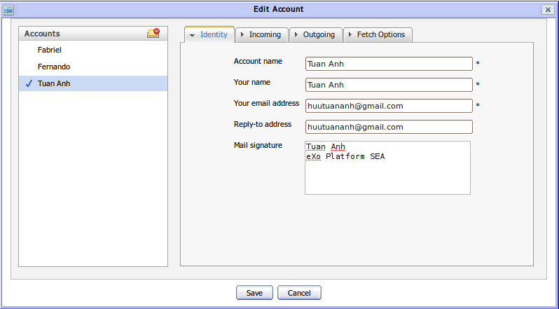Illustration 13: The Identity tab of the Edit Account form
The Incoming tab contains some incoming settings information that is used to check/receive mails such as Server type, Sever name, Port, User name, Password. There are some options such as Remember password and Use secure authentication (SLL).
The Outgoing tab contains some outgoing information that is used to send a mail such as Server name, Port. There are some options such as Use secure authentication (SSL), Enable SMTP authentication.
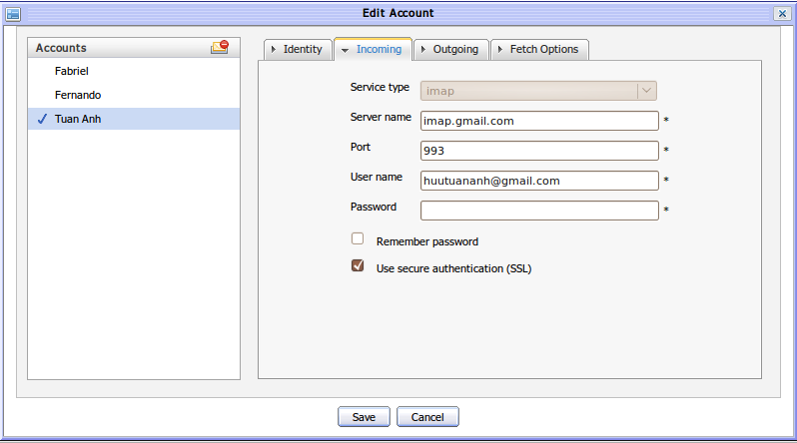Illustration 14: The Incoming tab of the Edit Account form
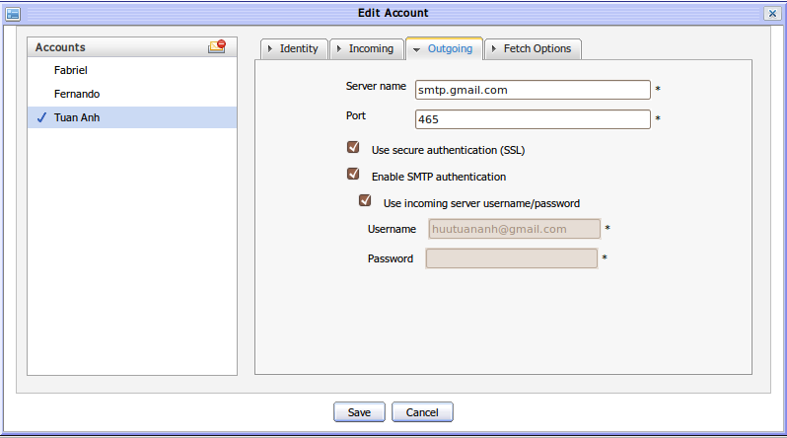Illustration 15: The Outgoing tab of the Edit Account form
When the Enable SMTP authentication is selected, the field group that allows defining the user name and password of the email used for sending mail will appear. If you select the Use incoming server username/password, the incoming email address and its password are displayed and disabled. If the check box is not selected, the incoming email can be manually inputted.
The Fetch Options tab contains some advanced options to customize the way you check mail or the default folder to receive mail, etc.
Details:
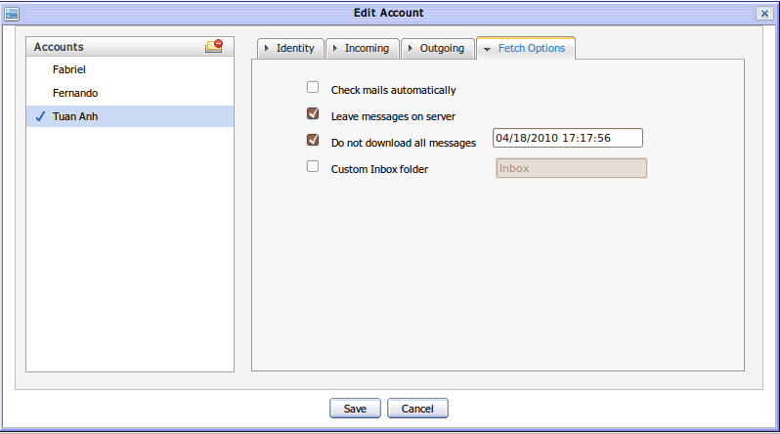Illustration 16: The Fetch Options tab of the Edit Account form
Check mail automatically: The option allows whether to check a mail automatically or not.
Leave message on server: The option allows leaving mails on server after checking mail or getting and deleting them on server. This option is for pop3 Server type. In case, imap server type is used, it is Mark message as delete with similar meaning.
Do not download all messages Limit downloaded messages before a specific date time.
Custom Inbox folder This option allows customizing the folder that will contain the arrived emails. By default, it is the Inbox folder.

Step 2: Change information of the current account.
Step 3: Complete editing by clicking the Save button to accept changes or click the Cancel button to cancel editing.

Deleting an account
This function is used to remove accounts from the account list. There are two ways to take this action:
The 1st ways:
Step 1: Open the Delete account form by clicking the icon on the left pane and then select the Delete account item:
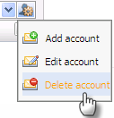
The Delete account form will appear:
Step 2: Click the Delete icon corresponding to the account which you want to delete and then click the OK button to confirm deleting.
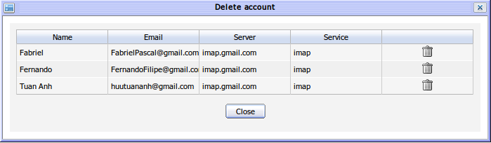Illustration 17: The Delete account form
The 2nd way: You also can delete an account from the Edit Account form:
Step 1: Click the on the left pane and then select the Edit Account. The Edit account form will appear with the account list in the left pane.
Step 2: Select the account that you want to delete from the account list. The current selected account is marked with the icon.Click the icon to remove the selected account:
The selected account will be removed from the account list.
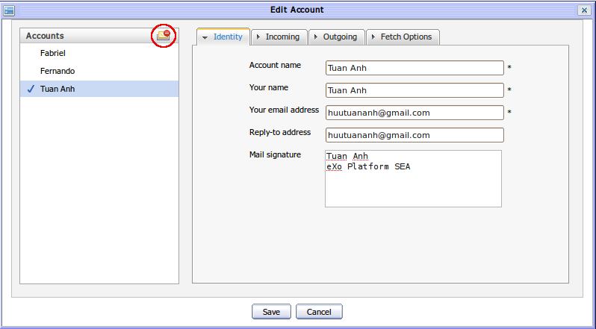Illustration 18: Delete account in the Edit Account form

Managing folders
Folders helps managing your messages easier and more flexible. There are some default folders generated automatically after creating a new account: Inbox, Drafts, Sent, Spam, Trash and Personal Folders list.
Details:
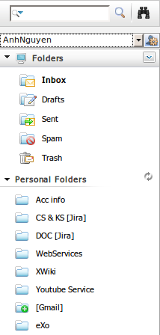Illustration 19: The default folder list

The place which stores all incoming messages normally.
The place which stores all messages that you compose but has not been sent yet.
The place which stores all sent messages.
The place which stores all unnecessary incoming messages .
The place which stores all unnecessary messages that are deleted from all default folders and personal folders

Adding a new folder
This function is used to add a new folder in eXo Mail.
To add a new folder, do as below:
Step 1: Open the Add a new folder form by clicking the arrow icon on the Folders bar and then select Add a new folder in the menu pop up:
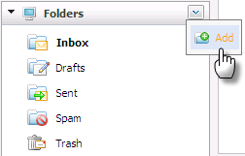
Or you can Right click on default folders and then select New folder:
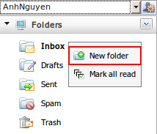
The Add a new folder form will appear:
Details:
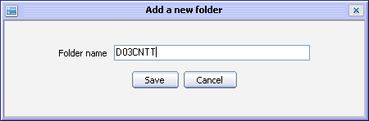Illustration 20: The Add a new folder form
Folder name: The name of a folder. This field is required.
Save button: To accept saving a new folder.
Cancel button: To cancel adding a new folder.
Step 2: Input a Folder name
Step 3: Complete adding a new folder by clicking the Save button .
Note:
The created folder will be saved and displayed in the Personal Folders section.

Adding a new sub-folder
This function is used to create new sub folders in another folder. You can only add new folders into your personal folders except for the default folders (Inbox, Drafts, Sent, Spam, Trash).
To add a new sub-folder, do as follows:
Step 1: Right click on the created folder that you want to add into and then select New Sub-folder in the menu pop up:
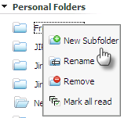
The Add a new folder form will appear.
Step 2: Input a Folder name
Step 3: Complete adding the new sub folder by clicking the Save button.

Renaming a folder
This function is used to change the name of a folder. You can change names of all your personal folders created by yourself except the default ones.
Do as follows:
Step 1: Right click on the folder which you want to rename and select Rename in the drop down list menu.
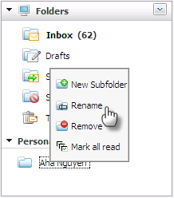
The Rename folder form appears:
Step 2: Input a new name into the New folder name field
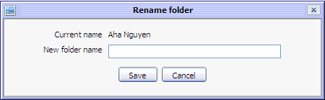Illustration 21: The Rename folder form
Step 3: Complete renaming by clicking the Save button.

Removing a folder
This function is used to remove a folder from the folder list except the default folders. When a folder is removed, its sub folders are also removed.
Do as follows:
Step 1: Right click on the folder that you want to remove and select Remove in the menu pop up:
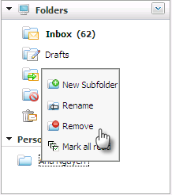
The confirmation message will appear:
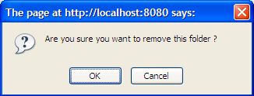
Step 2: Click the OK to confirm deleting

Marking all message as read
This function is used to mark all messages in a specific folder (Inbox, Drafts, Sent, Spam, personal folder) as read.
To do this action, right click on the folder that you want to mark as read and select Mark all read in the menu pop up:
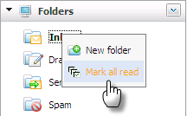
After marking all as read, all unread messages inside this folder will be marked as read. You can see all the unread messages are changed from bold to normal font.

Mail
E-mail is the exchange of computer-stored messages by telecommunication. To send and receive mails, each user must have an email address from service provider. This section shows you the way to do many actions with mails.

Getting mails
This function is used to fetch incoming messages from the server.
To check mail, do as follows:
Step 1: Select a folder that you want to check mail. If there is no folder selected, the default folder that will be checked for new messages is Inbox.
Step 2: Click the button in the tool bar. There will be an inform message with the content 'Synchronizing.etc.'.
Step 3: Click the “Stop” link when you want to stop checking mails. All arrived mails are shown in the message list panel
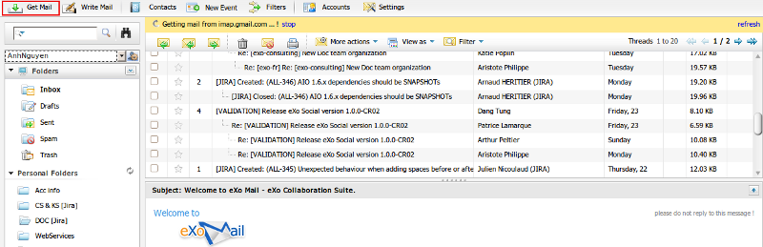Illustration 22: List of mails in the Mail view panel
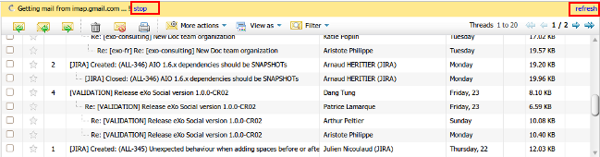
Step 4: Click “Refresh” if you want to refresh fetching mails.
The checking mail process only stop when you perform checking mail again and click on the “Stop” or “Refresh” link when you want to stop getting mail while it is still refresh fetching message.

Composing a message
This function is used to compose a message.
Do as follows:
Step 1: Click the 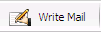 button on the toolbar to compose a message.
The Compose a new message form will appear.
Step 2: Compose the message content.
Step 3: Click the Send Mail button to send your email.
Details:
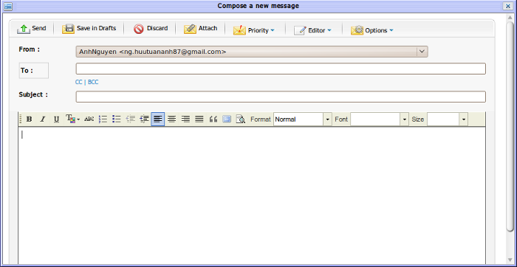Illustration 23: The Compose a new message form
From: The email address from which the email is sent. By default, it will get the current account 's email address .
To: The email address(s) of the recipients of your message. This field is required. You can manually enter email addresses (using the semicolon “,” to separate between email addresses). Besides, you can also select an email address from your address book by doing as follows:
- Click the To button to open the Contacts form:
- From here, you can select the desired emails by selecting its check box(s). The Address book combo box and the Search function allow filtering and finding email address(s) according specific search criteria quickly.
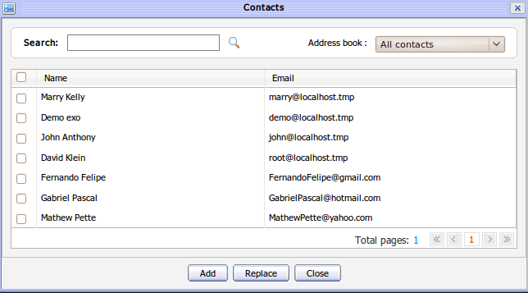Illustration 24: The Select email form
- Click the Add button to add the selected email addresses to 'To' field, click the Replace button to replace the current email addresses in the 'To' field with the new selected email addresses or click Cancel button to quit.
Subject: The subject of the message. The content of this field usually contains the general meaning for the message content.
CC|BCC: You can use CC (Carbon copy) and BCC (Blind carbon copy) to send mail to multiple recipients by clicking on the 'CC' or 'BCC' link. The CC or BBC text field will be displayed for adding more email addresses. The CC mails are public, all recipients can know to whom the mail is sent while the BCC mails are private to the sender and other BCC recipients. Using ' BCC' if you want to send email to multiple recipients but don't want they know their received email was also sent to others.
Similarly, the recipients for 'CC' and 'BCC' field can be selected from the Select Address form by clicking the CC or BB button.
To send the composed message to the email address in the 'To', 'CC' and 'BCC' fields.
To save the composed message as a draft . All drafts are stored in the Draft folder
To exit the Compose a message form
To attach files to the composed message. The Attach files form is like below:
Details:
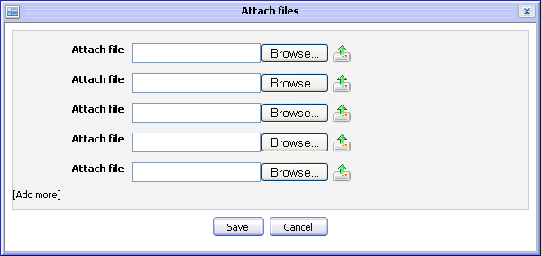Illustration 25: The Attach files form
Browse button: To select a file from your local computer
: To upload the selected file
[Add more]: To attach more files
Save button: To accept saving the attached files in composed message
Cancel button: To exit the Attach file form without adding new.
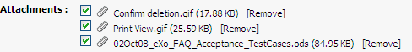
After attaching files, the attached files will be listed like the illustration below:
To remove the attached files, click the [Remove] link next to the the one you want to delete.
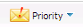 To set the priority for the composed message. There are three priority levels: Low, Normal and High. The message is sent with High priority that will be marked by the red “!” icon. The message is sent with the Low priority will be marked by the gray ''!” icon. By default, the message is sent with the Normal priority.
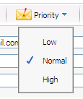
To change the text editor types: Rich text or Plain text. With Rich text editor, the message content can be composed with basic formatting, such as font style, color, size, etc. With the Plain text editor, the message can be composed with simple text only.
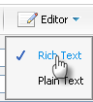
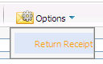
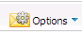 Currently, the options include the Return Receipt option that allows the sender receive a notification mail in case the receivers of the sent email read it. However, the sender only receives the notification in case the mail box of the receivers has been configured in the Setting that allows notifying to the sender about the read message.
The sent mail will be saved in the Sent box. In case, the receipt emails (in the To, CC, BCC fields) are the new ones that do not exist in the sender's Address Book, it will be added automatically to the Collected Address in the Contact portlet.

Printing
This function is used to print the message.
There are some ways to print a message. Do as follows:
The 1st way:
Step 1: Right click on the message which you want to print and select Print in the menu pop up:
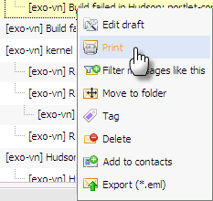
The Print preview form will be displayed with detail information:
Step 2: Click the Print button to accept printing or the Cancel to quit.
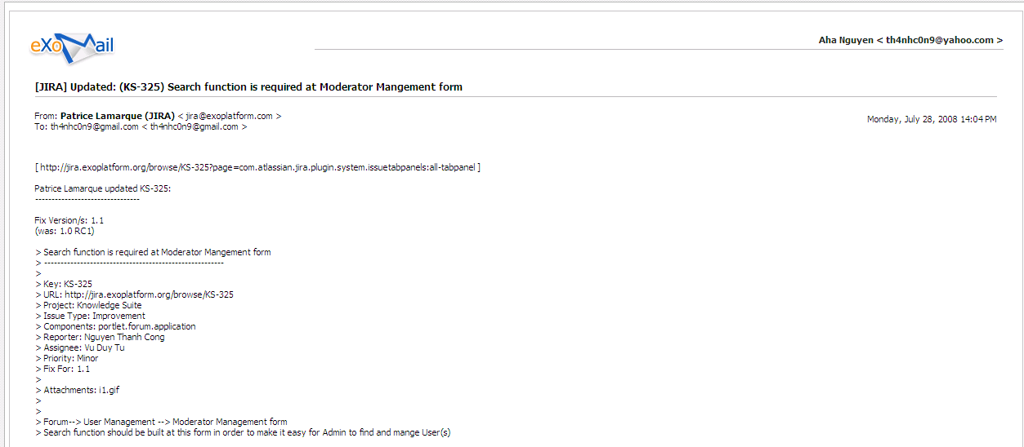Illustration 26: The Print preview form
The 2nd way:
Step 1: Select messages in list that you want to print by selecting its check box(s).
Step 2: Select the icon on the action bar:
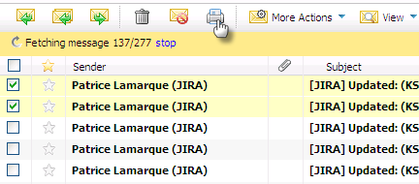
Step 3: At the print preview form, click the Print button to accept printing or the Cancel to quit.
The 3rd way:
Step 1: Open the message that you want to print.
Step 2: Click the icon at the right corner of message's content and select Print in the menu pop up:
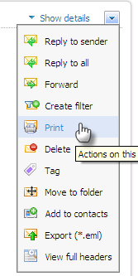
Step 3: At print preview form, click the Print button to accept printing or the Cancel to quit.

Replying message
To reply a message, do as follows:
Step 1: Open the Reply form. You can do this step in 3 ways:
The 1st way: Select the messages in list that you want to reply by selecting its check box(s) and then click the icon in the action bar :
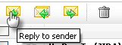
The 2nd way: Right click on the message you want to reply and select Reply in the popup menu:
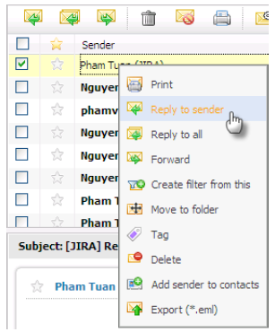
The 3rd way: Open the message that you want to reply by clicking on the name of the message.
Then select the icon on the action tool bar or click the icon under the content of this message or click the icon on the right corner of a message's content and select Reply to Sender.
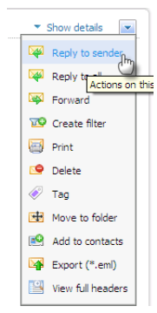
The Reply form will appear in form of the Compose a new message with detail information, available for replying to the sender.
Details:
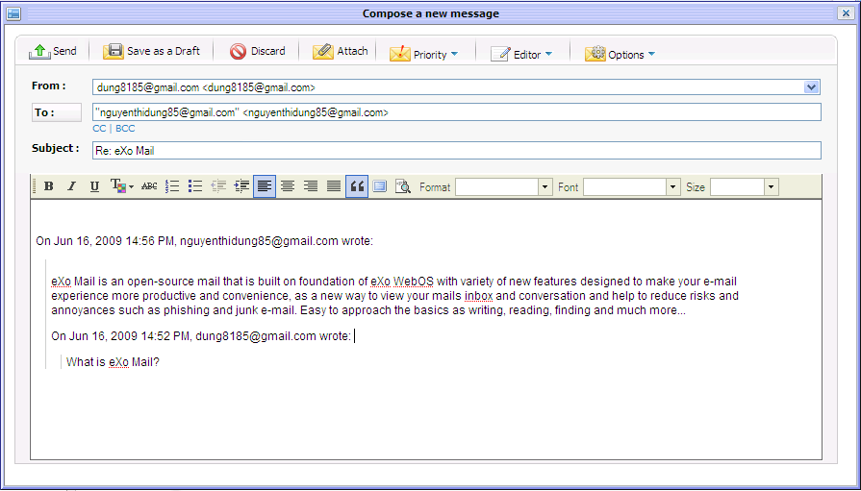Illustration 27: The Reply form
From: The email address of the current account.
To: The email address of the sender
Subject: The subject of the email
Step 2: Compose the message content by inputting text into the text editor.
Step 3: Click the button to accept replying to the sender.
Before replying, you can also take many actions in the Reply form such as attach file, mark message, save as draft, discard...
In case, the receipt emails (in the To, CC, BCC fields) of the sent email are the new ones that do not exist in the sender's Address Book, will be added automatically to the Collected Address in the Contact portlet.

Replying messages to all related people
This function is similar to the Reply to sender function (in the 'To' field) but further more the others who receipted the original mail (in field 'CC' or 'BCC') also receipt this reply.
To reply to all, do as follows:
Step 1: Open the Reply to All form. You can do this step in 3 ways:
The 1st way: Select the message in the list that you want to reply to all by ticking on its check box(s) and click the icon.
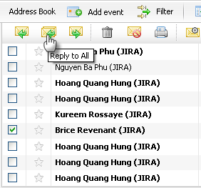
The 2nd way: Right click on the message which you want to reply to all and then select Reply to all in the drop down list menu.
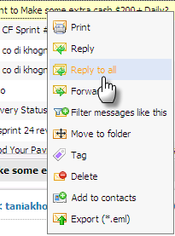
The 3rd way: Open the message which you want to reply to all and then select the icon on the action bar
The Reply to all form is shown in form of the Compose a new message form with detail information, available for replying to all.
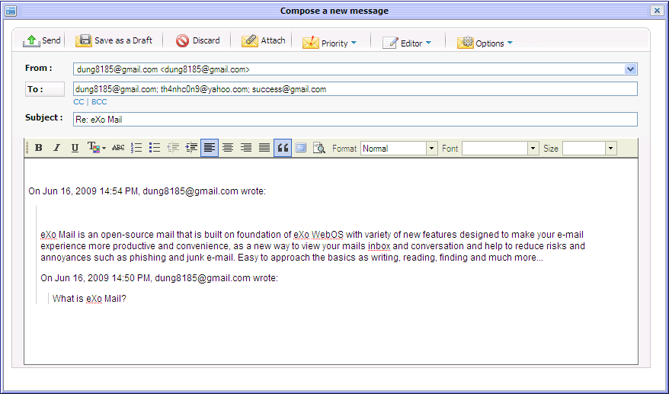Illustration 28: The Reply to all form
Step 2: Compose the message content by inputting text in the text editor.
Step 3: Click the button to accept replying to all.
Before replying to all, you can also do many actions in Reply form such as attach file, mark message, save as draft, discard...
In case, the receipt emails (in the To, CC, BCC fields) of the sent email are the new ones that do not exist in the sender's Address Book, will be added automatically to the Collected Address in the Contact portlet.

Forwarding messages
This function is used to transfer a received message to the other user with the original content.
There are many ways to forward a message:
Step 1: Open the Forward message form. You can do this step by 3 ways:
The 1st way: Select the message which you want to forward and then click the icon on the action bar:
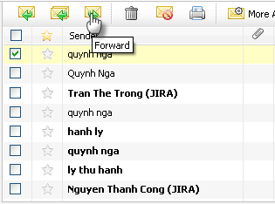
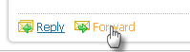
The 2nd way: Open the message which you want to forward and then click the icon at the right corner of message 's content and select Forward in the menu:
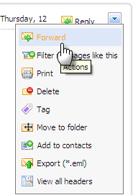
The Compose a new message form will be displayed. From here, you can edit the original email before forwarding it to other recipients.
Step 2: Enter the email address(es) to which the email will be forwarded.
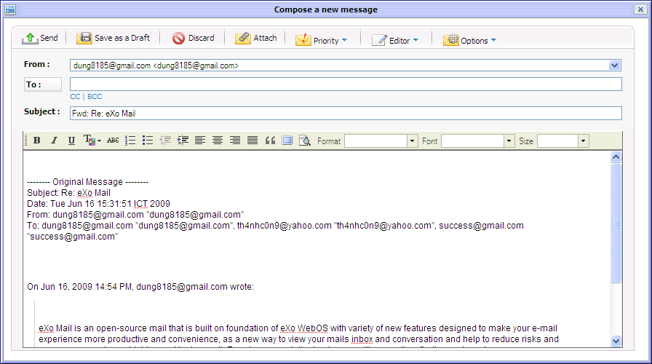Illustration 29: The Forward message form
Step 2: Compose or edit a message by inputting text in text editor.
Step 3: Click the button.

Moving messages to folders
This function is used to move one or more messages to other folders. There are many ways to take this action. Do as one of these following ways:
The 1st way:
Step 1: Select messages which you want to move by selecting its check box(s)
Step 2: Right click on these messages and select Move to folder in the menu.
Step 3: All existing folders are displayed in a list, select one for the destination folder.
Step 4: Click Save to accept moving the messages to the selected folder.
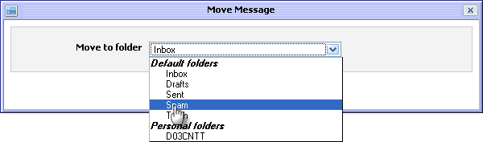Illustration 30: The Move Message form
The 2nd way: Using drag and drop feature.
Check the messages to move and then move a cursor to one of the selected messages until a cursor pointer becomes then press the left mouse, drag and drop messages to the destination folder.
All checked messages will be moved to the destination folder.
The 3rd way:
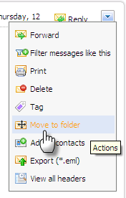
Step 1: Open the message you want to move then click the icon on the right corner of the message content and select Move to Folder in the drop down list menu:
Step 2: At the Move Message form, select the folder in the Move to folder combo box and click the Save button to move the messages to the selected folder or click the Cancel button to quit.
The 4th way:
Step 1: Check the messages that you want to move and then click More Actions on the main bar and select Move message in the menu:
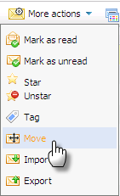
Step 2: Select the folder in the Move to folder combo box and click the Save to move the messages to the selected folder or click the Cancel button to quit.

Managing tags

Tagging a message
eXo Mail allows assigning tags to messages. Tags are used as labels which allows filtering or categorizing messages from different folders. A single message can be assigned to many tags at a time. Tags are a convenient way to label and organize your messages. By using tags, you can find your messages you want more quickly and exactly .
To add a tag for one or more messages, do one of these following ways:
The 1st way: This way is used to create a tag that has not been assigned to any message.
Step 1: Click the icon on the right corner of the Tags bar and select Add a new tag in the drop down list menu.
Details:
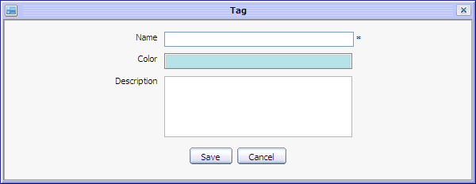Illustration 31: The Tag form
New name: The name of the new tag. This field is required.
Color: The color of the tag.
Description: The brief description of the tag
Save button: To accept saving a tag
Cancel: To exit the Add/Edit Tag form.
Step 2: Enter values to the required fields.
Step 3: Complete adding a tag by clicking the Save button.
A new tag will be updated at the tag list and you can add this tag to any message.
The 2nd way:
Step 1: Select message(s) by selecting its check box(s)
Step 2: Right click on one of the selected messages and select Tag in the menu:
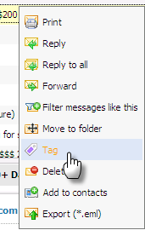
The 3rd way:
Step 1: Select message(s) you want to tag by selecting its check box(s).
Step 2: Select Tag in the More Actions drop down list menu on the action bar:
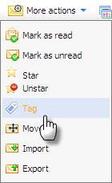
The 4th way:
Step 1: Open a message you want to tag
Step 2: Click the icon at the right corner of the message content and select Tag in the drop down list menu:
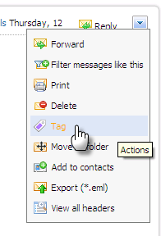
The 5th way:
Step 1: Select message(s) by selecting its check box(s)
Step 2: Drag these messages and then drop them to the container of the tag.
The Tag Message form appears:
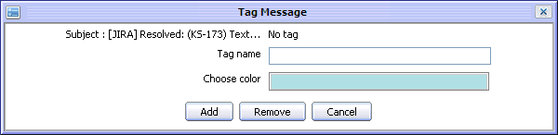Illustration 32: The Tag Message form
Details:
Tag Name: The name of the tag. This is words and keywords which is used to describe same messages.
Choose Color: The color of the tag which can be changed by clicking on color area to choose other color.
Add button: To accept adding message to a new tag
Remove button: To remove tags in case there are some tag existing
Cancel button: To exit the Add Tag form.
Step 3: Fill out this form (Give a tag name, change color)
Step 4: Complete adding a tag by clicking the Add button.
In case there are already tags in list, the Add tag form is displayed:
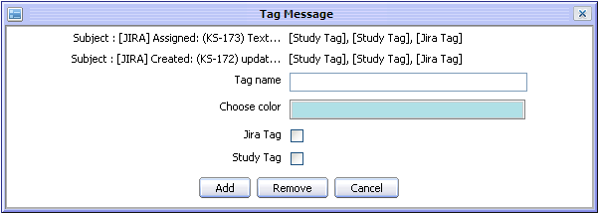
You can add a new tag for your message by inputting a new Tag name or update your messages to existing tags by selecting its check box(s) and click the Add button.
If you want to remove existing tags, your can select its check box(s) and click the Remove button or click the Cancel to close the Tag Message form.
In case you want to tag a message to a specific tag, you can drag and drop it directly to that tag.
The message with tags will be marked by the tag icon like the illustration below:

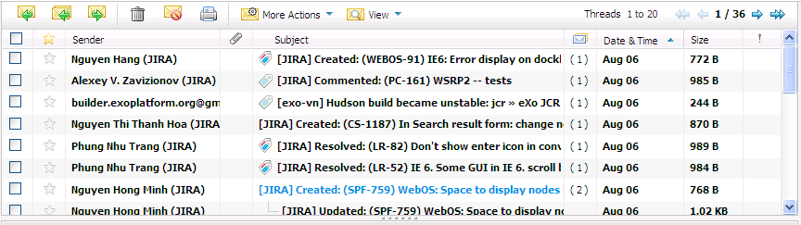
Editing a tag
This function is used to edit tags in the tag list.
Do as follows:
Step 1: Right click on a tag in the tag list on the left pane:
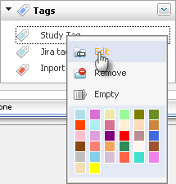
The Edit Tag form will appear:
Step 2: Change the tag's name or description in corresponding fields
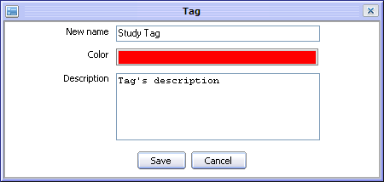Illustration 33: The Edit tag form
Step 3: Complete editing a tag by clicking the Save button or click Cancel to exit the Tag form.

Removing a tag
This function is used to remove tags from the tag list.
To remove a tag, do as follows:
Right click on the tag that you want to remove then select the Remove item in the drop down list menu:
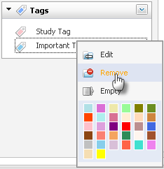
The selected tag will be removed from the tag list and it also will be removed from all messages to which the tag was assigned.

Emptying a tag
This function is used to remove the selected tag from all messages that are tagged with it.
To empty a tag, do as follows:
Right click on a tag that need to be empty and select the Empty item in the drop down list menu:
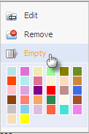
The selected tag will be removed from all messages.

3.5.8.5. Changing a tag color
This function allows changing the tag color so that you can easily organize your tags.
Step 1: Right click on the tag that you want to change and then select one color in the colors palette. There are 32 available colors :
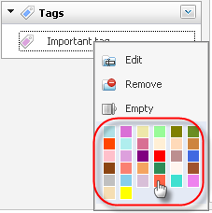

Reporting a message as spam
This function is used to report one or more messages in a specific folder as spam.
To report an email as spam, do as follows:
Check the messages which you want to report as spam by selecting its check box(s) and then click the icon on the action bar:
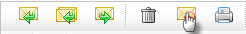
All the selected messages will be moved into the Spam folder. Go into the Spam folder to verify that the selected messages have been moved into it.
After reporting a message as spam, the messages from the sender who has been reported as spam will be moved automatically to the Spam folder.
If you want to remove messages from Spam folder, you can select its check box and click on the Not spam icon on the action bar:
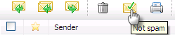
After reporting as 'not spam' successfully, the messages from the sender who has been reported as not spam will be moved automatically to its original folder such as Inbox. Since then, all message from the sender who has been reported as not spam will be received normally.

Deleting a message
This function is used to delete messages permanently by moving messages from its folder to the Trash folder.
To delete a message, do as follows:
The 1st way:
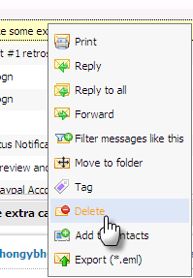
Right click on the message which you want to delete and select Delete in the drop-down menu:
The selected message will be removed completely from its folder.
The 2nd way:
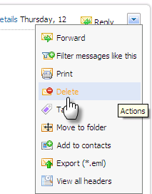
Open the message which you want to delete then click the icon at the right corner of message's content and select Delete in the drop-down menu:
This message will be removed completely from its folder.
The 3rd way:
Select the message that you want to delete and click on the delete icon on the action bar :
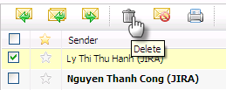

Exporting messages
This function is used to export one message to a file with *.eml format.
To export a message, do as follows:
Step 1: Open the Export Message form by 3 ways
The 1st way: Right click on the message that you want to export to the file *.eml and then select Export in the menu:
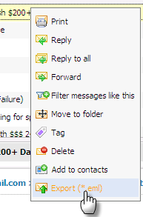
The 2nd way: Check the message to export by selecting its check box(s) and then select Export message in More Actions menu:
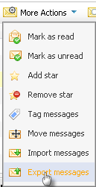
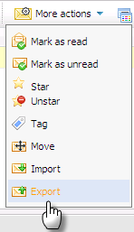
The 3rd way: Open the message to export and then click the icon on the right corner of message's content and select Export (*.eml) item in the menu:
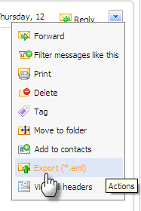
The Export Message form will appear:
Details:
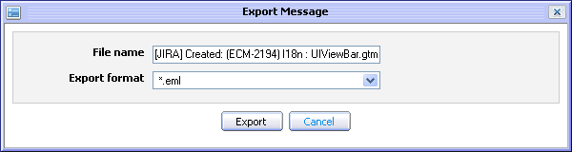Illustration 34: The Export Message form
File name: The name of the file which you want to export to. By default, the subject of the selected message will be used but you can change this name.
Export format: The format of the file which will be exported. By default, type of file is *.eml.
Export button: To start exporting the message
Cancel button: To exit the Export Message form
Step 2: Click the Export button to accept exporting file. A window pop up with 3 options is shown:
- Save file: To save the exported message in your computer.
- Open with: To directly open the exported message without saving.
- Cancel: To close window pop up.
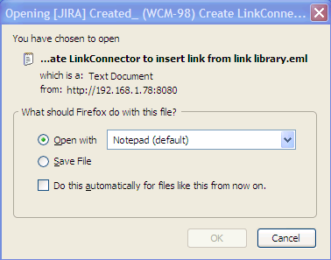Illustration 35: The download pop up on Fire Fox

More actions
This section will show you the way to take some additional actions related to messages.

Marking a message as read
This function allows marking one or more messages as read
To mark message as read, do as follows:
The 1st way:
Step 1: Select messages to mark as read by selecting its check box(s)
Step 2: Select Mark as read in the More Actions drop down list menu on the action bar :
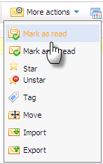
The 2nd way: This function is used to mark all unread messages in a specific folder.
Step 1: Right click on the folder which contains messages that you want to mark as read
Step 2: Select Mark all read in the drop down list menu.
All selected unread messages will be marked as read.

Mark a message as unread
This function allows marking one or more messages as unread by setting bold format on message.
Do as follows:
Step 1: Check the message(s) which you want to mark as unread by selecting its check box(s)
Step 2: Select Mark as unread in the More Actions menu on the action bar:
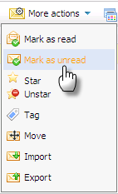
All selected read messages will be marked as unread.

Adding a star to a message
This function allows adding a star to a message to make it more outstanding than others, so you can know what message is important quickly.
Do as follows:
The 1st way:
Step 1: Select message(s) to set star by ticking on its check box(s)
Step 2: Select Star in the More Actions drop down list menu on the action bar:
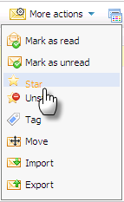
The 2nd way:In the message list pane, click on star icon next to the message which you want to add a star. The selected messages will be appended a icon so that you can identify them easily:

Remove a star from a message
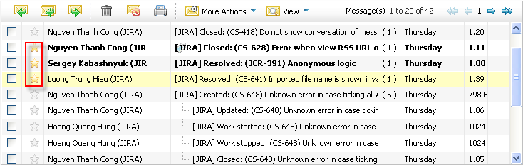Illustration 36: The messages with star view
This function is used to remove a star from a message that was appended with a star.
Do as follows:
The 1st way:
Step 1: Check the starred messages by selecting its check box(s)
Step 2: Select Unstar in the More Actions menu on the action bar:
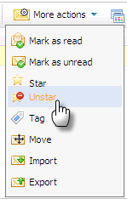
The 2nd way:
In the message list pane, click on the yellow star icon which corresponds to the message that you want to remove star. Stars will be removed from the selected messages.

Importing messages
This function is used to import messages from your computer to specific folder in eXo Mail
Do as follows:
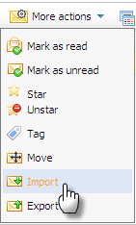
Step 1: Select the Import message in the More Actions menu on the action bar:
The Import Message form will appear:
Details:
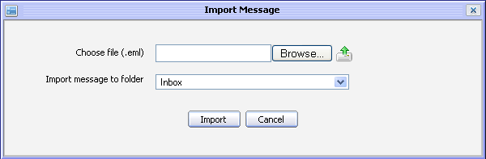Illustration 37: The Import Message form
Choose file (.eml): The name of the file which you want to import from your computer. Click the button to get one file .eml from the computer and then click the icon to upload the file.
Import message to folder: The folder where the message will be imported
Import button: To start importing the message
Cancel: To exit the Import Message form.
Step 2: Enter required values in the Import Message form.
Step 3: Complete importing by clicking the Import button.
Note: By default your imported file must be in *.eml format.

Reporting a message as not spam
This function is used to report one or more messages in the Spam folder not to be spams.
Do as follows:
Step 1: Go into the Spam folder and then check messages that you want to report not be spams.
Step 2: Select the icon on the action bar.
Step 3: All selected messages will be moved back to the Inbox folder.

3.5.12.7. Viewing full headers of a message
The header's information which is displayed by default, only includes: the sender's email address, the receivers 's email address and the email subject. If you want to view full headers of a mail you can do as follows:
Step 1: Open the message which you want to view its full headers
Step 2: Click the icon on the right corner of message's content and select View Full Headers in the drop down list menu:
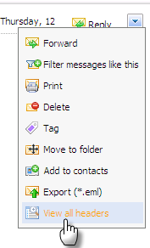
The View message headers pop up will appear:

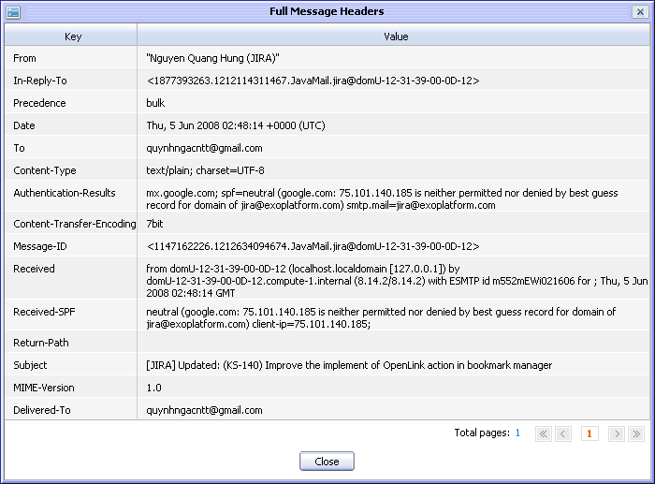Illustration 38: The Full Message Headers form

3.5.13. Viewing and filtering mails
This function is used to view all mails in a specific folder according to some ways that you want to view.

3.5.13.1 View as
This function allows organizing messages list in different manners.

View as List
This view arranges the message in a list . To view messages, click on View as and select List in the menu pop up:
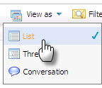
The messages will be arranged:

View as Thread
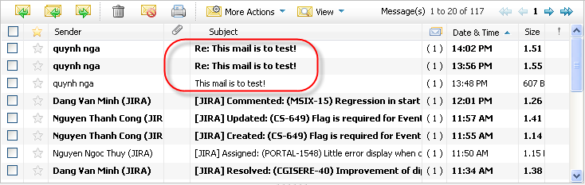Illustration 39: View message as list
This view arranges messages as a tree structure. All replies are shown as sub nodes. To change the view to thread view, click on View as and select Thread in the menu pop up:
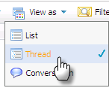
The message and its replies will be displayed:
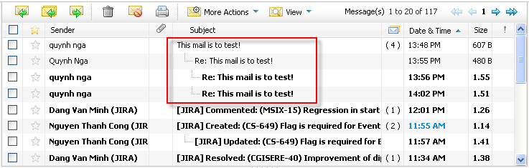Illustration 40: View message as thread

View as Conversation
With this view, the messages which are the replies of one mail will not be displayed in the messages list but on the message pane. To view messages as conversation, click on View as and select Conversation in the menu pop up:
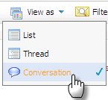
The mail and its replies will be displayed:
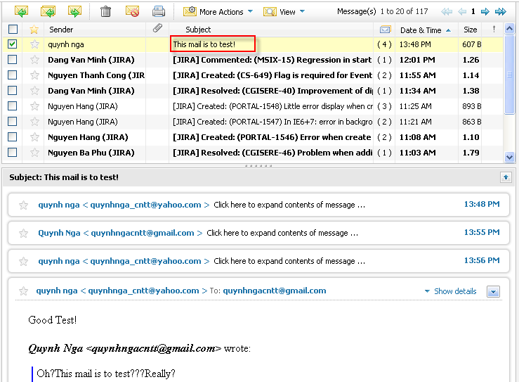Illustration 41: View message as conservation

3.5.13.2. Filtering messages
This function is used to view all messages in a specific folder. Only need to select All messages in the View menu on the action bar to view all messages in current folder.

Filtering Unread messages
This function is used to filter all messages which are not read in the list. Only need to click on the Filter and select Unread in the menu pop up:

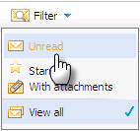
Filtering star messages
This function is used to filter all messages which are appended stars in the list. You only need to click on the Filter and select Starred in the pop-up menu:

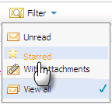
Filtering message with attachments
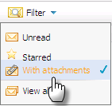
This function is used to filter all messages which has attachments in the list. You only need to click on the Filter and select With attachments in the pop-up menu:

Viewing all messages
This function is used to view all types of messages in the list. You only need to click on the Filter and select View all in the pop-up menu:
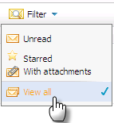

Managing filters
Filters allows you to specify conditions under which incoming messages will be automatically applied actions of your choosing.

Creating a new filter for your messages
This function is used to support you to create new filter.
Do as follows:
The 1st way: This way manually define condition for the new message filter.
Step 1: Click the button on the tool bar. The Message Filter form will appear:
Step 2: Click the icon or click the 'Click here to add a new filter' link to create a new filter.
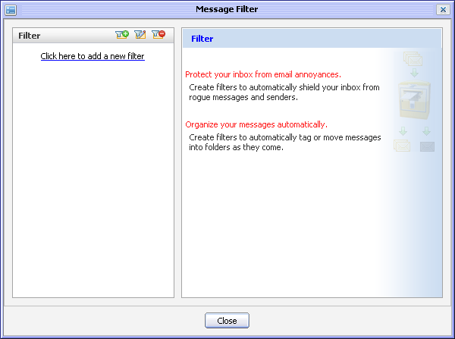Illustration 42: The Message Filter form
The Add/Edit Message Filter will appear:

Details:
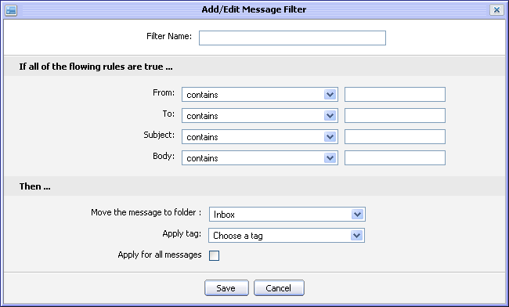Illustration 43: The Add/Edit Message Filter form
(*): required
Filter Name: The name of the filter.
From: This condition is to filter the email address of sender.
To: This condition is to filter the mail address of receiver.
Subject: This condition is to filter the subject of incoming messages.
Body: This condition is to filter the content in the incoming messages.
Move the message to folder: The folder to which the all the messages that satisfy the filter criteria will be moved.
Apply tag: The tag to which all the messages that meet the filter will be applied
Apply for all messages: The option allows applying the filter to all current messages.
Save button: To save the new message filter
Cancel button: To exit the Add/Edit Message Filter form
Step 3: Enter your filter criteria in this form.
Step 4: Complete adding a message filter by clicking the Save button.
After creating a new filter successfully, the created filter will be displayed in the list like the illustration below:
The 2nd way: This way allows creating a new filter by getting condition from one existing message
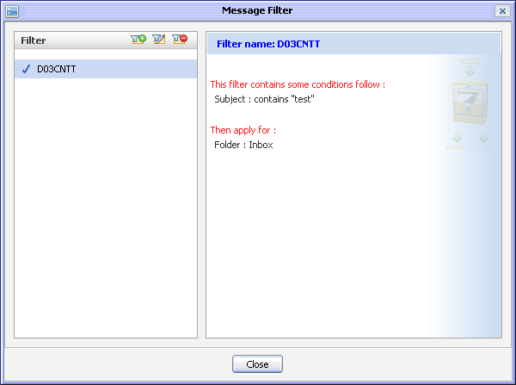Illustration 44: The Message Filter form
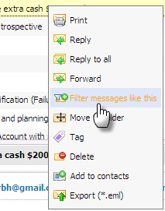
Step 1: Right click on the message which is selected to get filter conditions and select Filter message like this in the pop-up menu:
The Add/Edit Message Filter form will appear with some predefined filter conditions basing on the selected message:
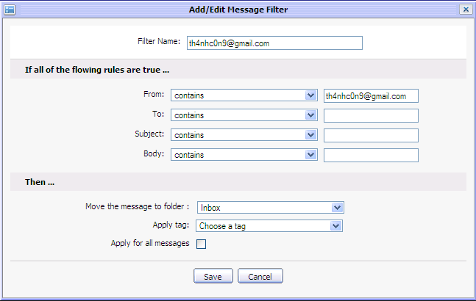
The filter above is created with default criteria “th4nhc0n9@gmail' in “From” field.
Step 2: Leave the filter conditions by default or define more filter conditions
Step 3: Complete adding a new filter by clicking the Save button
The 3rd way:
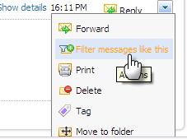
In Message preview pane, click on the icon at the right corner and select Filter message like this in the menu below:
The Add/Edit Message Filter form will be displayed like the 2nd way with predefined criteria. The new filter can be created similarly the ways above.
The created filter will be displayed in the list. All messages which satisfy the conditions will be applied with what you have set with the conditions.

Editing a filter
You can also edit an existing specific filter by doing as follows:
Step 1: Open Message Filter form by clicking the button the tool bar.
The Message Filter form will appear, listing all exiting filters.
Step 2: Select the filter to edit and then click the icon on the filter bar in the Message Filter form. The Add/Edit Message Filter form will be shown with detailed information, available for editing.
Step 3: Change the filter condition.
Step 4: Complete editing by clicking the Save button.

Deleting a filter
To delete a filter, do as follows:
Step 1: Open the Message Filter form by clicking the button on the tool bar.
Step 2: Select the filter you want to to delete and then click the icon on the filter bar in the Message filter form.
The selected filter will be removed from list.

Managing the Address book
The Address book in the Mail application is where your contact information are stored. In this section you will know additional actions related to the address book management.

Adding a new address book
This function is used to add new address books.
Do as follows:
Step 1: Click the button on the tool bar to go into the Contacts form:
Step 2: Click the button to add a new address book. The Add Address Book form will appear:
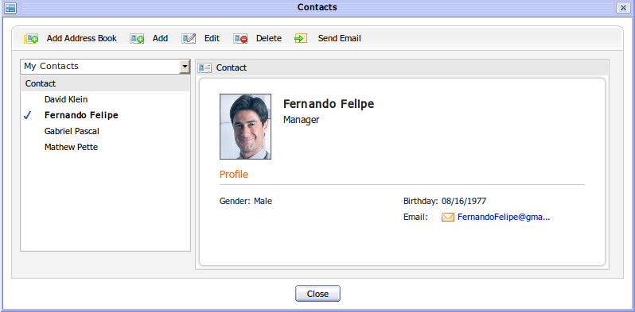Illustration 45: The Contacts form
Details:
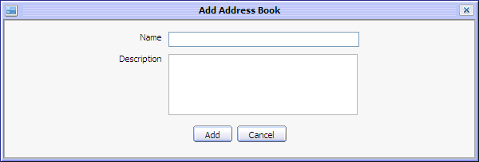Illustration 46: The Add Address Book form
(*)required
Group name: Then name of the Address Book. This field is required.
Description: The brief description of your address book
Add button: To accept adding a new Address book
Cancel button: To exit Add Address Book form
Step 3: Enter values in this form
Step 4: Complete adding a new address book by clicking the Add button.

Adding a new contact
This function is used to add new contact into a group.
To add contact, do as follows:
Step 1: Open Contact form
The 1st way: Click on button on the Address Book form.
The 2nd way: This way is used to add the sender of a message to a specific group.
Right click on a message to add the sender to contacts list and then select Add to contacts.
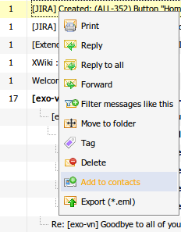
The 3rd way: This way is also used to add a sender of a message to a specific group.
Open the message that you want to add the sender to contact list and then click icon at the right corner of the message content. Select Add to contacts in the drop down list menu:
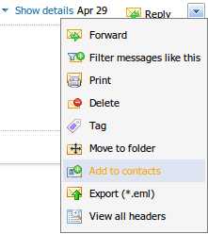
The Contact form will appear:
Details:
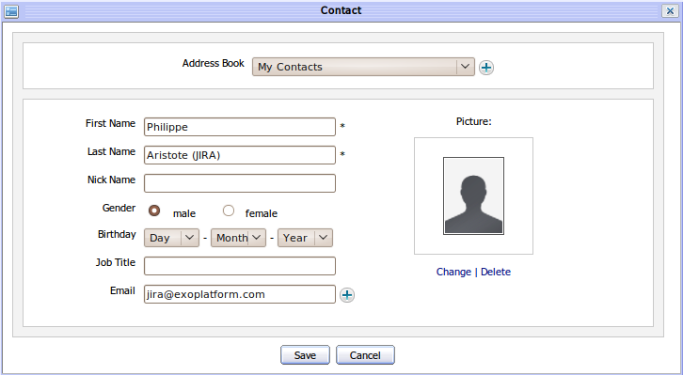Illustration 47: The Contact form
(*): required
Address Book: The address book in which the contact is stored. The address book can be selected from the existing in combo box or created a new one by clicking the icon to add new group immediately .
First Name: The first name of the contact.
Last Name: The last name of the contact This field is required. With second and third way, value of this field is the sender ' s last name of this mail
Nick Name: The nick name of the contact.
Gender: The gender of the contact. There are two options: Male and Female.
Birthday: The birthday of the contact.
Job Title: The job's title of the contact.
Email: The email address of the contact. Click the icon to add more email addresses for this contact. The icon is to remove the added email.
Change : To change the current avatar.
Delete: To delete the current avatar and set it by default.
Save button: To save new contact
Cancel button: To exit Add/Edit New Contact form
To add the picture to the contact, click the Change link to open the Change Image form:
- Select the uploaded file from local computer by clicking the button
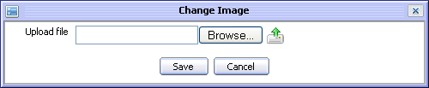Illustration 48: The Change Image form
- Upload the selected file by clicking the icon.
- Click the Save button to accept saving the uploaded file
Step 2: Input contact information, change or remove contact's picture by clicking Change/Remove link
Step 3: Complete adding new contact by clicking the Save button.

Editing a contact
This function is used to edit a contact in a specific group.
Do as follows:
Step 1: Open the Contact form by clicking the button in the main tool bar.
Step 2: Select the contact which you want to edit in the Contacts form
Step 3: Click the button, the Contact form will be shown with the detail information of your selected contact:
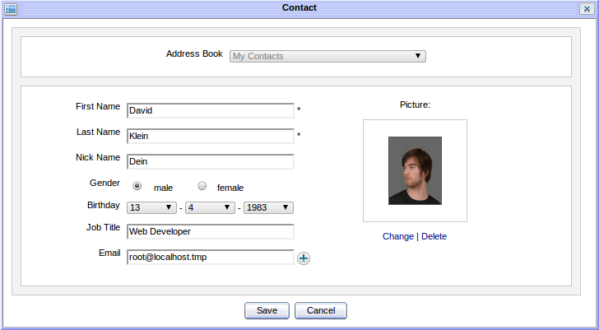
Step 4: Change the contact information.
Step 5: Complete editing by clicking the Save button.

Deleting a contact
This function is used to delete a contact from a specific group.
To delete contact, do as follows:
Step 1: Open the Contact form by clicking the button in the main tool bar.
Step 2: Select the contact which you want to delete in this form
Step 3: Select the button, confirm message will be shown. Click the OK button to delete contact or click the Cancel button to quit.
Notes:
When deleting a contact which is tagged, it is still shown in tag. Only the deleted contact is removed completely from trash folder.

Sending a mail to a selected contacts
This function allows sending a mail to the selected contacts.
Do as follows:
Step 1: Tick on the contacts that you want to send a email
Step 2: Click the button
Step 3: Compose the mail content and send it.

Adding an event
This function interacts with the Calendar application which allows quickly adding new events into your calendar instead of directly going to calendar application to do.
To add event, do as follows:
Step 1: Open the Add event form by clicking the button on the main tool bar.
The Add event form will appear below:
Details:
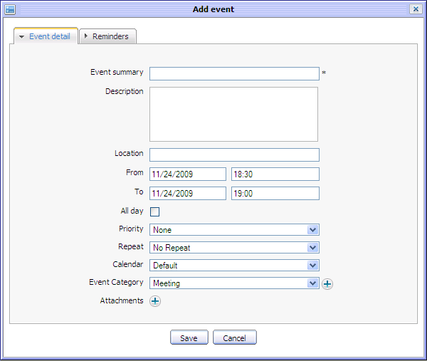Illustration 49: The Event detail tab of the Add event form
(*): required
The Event Detail tab contains basic event information::
Event Summary: The title of the event.
Description: The detailed description of the event
Location: The location where the event will take place
From: The start date/time of the event
To: The end date/time of the event
All day: The option allows selecting the duration of the task to be all day or not. If you don't check this option, you have to select the start date, time and end date, time. By default, the start date and end date is current date.
Priority: The priority level of the task.
Repeat: Interval time that you will be asked for a repeated reminder after every x minutes.
Calendar: The calendar in which the event will be stored.
Event Category: The category the event belongs to. To create a new Event category, click icon, Event categories form appears like below:
Give an event category name and description (optional) then click Save button to create a new category quickly.
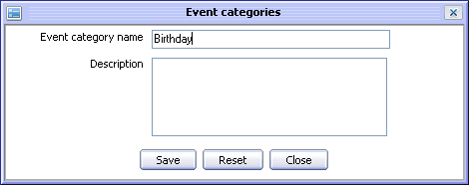Illustration 50: The Event categories form
Attachments: To add attached file to the events
Save button: To accept saving the event.
Cancel button: To exit the Add event form.
The Reminders tab: the reminder function allows you to remind about an event by email.
Reminder by mail:
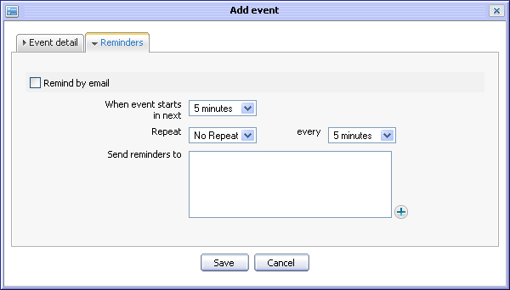Illustration 51: The Reminders tab of Add event form
When event starts in next: The time you will receive mail reminder before event starts.
Repeat: Repeat option allows setting reminder repeat or not for the event.
every: The interval time (in every xxx minutes) the reminder will be repeated before event stars
Send reminder to: List of email addresses to which the reminder will be sent. The default value is the email address of current user. You can manual input email address list or click on the to select emails from the Select email form.
Step 2: Input values into the Add event form
Step 3: Complete adding new event by clicking the Save button.
Notes:
This function support adding new events into the Calendar application through the Email application. (See eXo Calendar User Guide for more detail)
Besides, when you receive an Invitation mail on taking part in a specific event, you can import an event directly in your calendar. The Invitation mail content is like below:
There are 3 options:
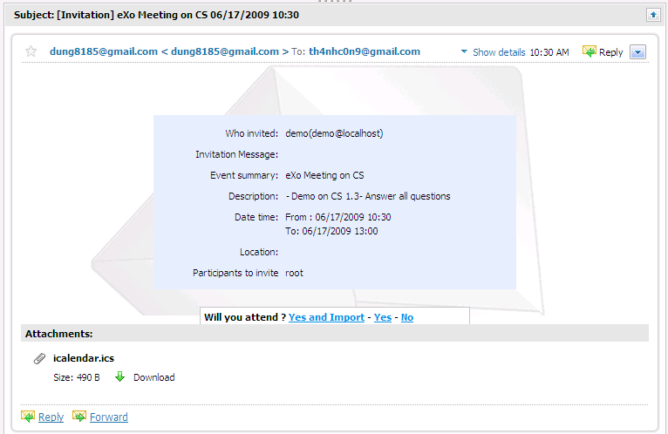Illustration 52: The content of an Invitation mail
Yes and Import: Accept the Invitation and import the event into your calendar to remind you about this event. The event will be imported directly into your Default calendar in the Calendar portlet.
Yes: Accept the invitation without importing it into your calendar.
No: Refuse the invitation.

Search
This function allows you to find your mails. There are two types of searching: quick search and advanced search.

Quick Search
This function allows you to do a quick search with specific keyword in all your messages. All messages containing the text matching with your search term will be displayed in search result form.. To do a quick search, do as follows:
Step 1: Enter a search term in the Search box: 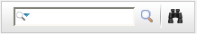
Step 2: Click the icon
For example, with “minh” as the search term, all the messages containing “minh” in the content will be displayed:
Note:
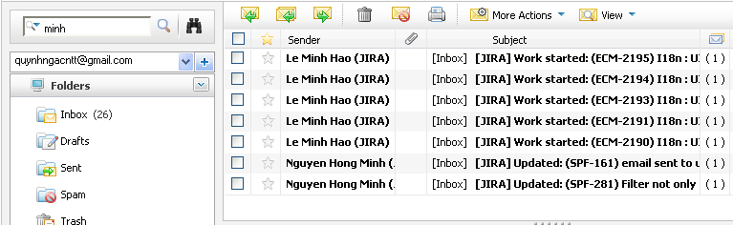Illustration 53: The Search result form
- The default search will not search mails in Spam and Trash folders.
- The messages in Spam and Trash folders can be searched by positioning explicitly into them.

Advanced Search
Advanced search allows you to specify precise search criteria.
Do as follows:
Step 1: Click the icon to the right of the search box.
The Advanced search form will appear:
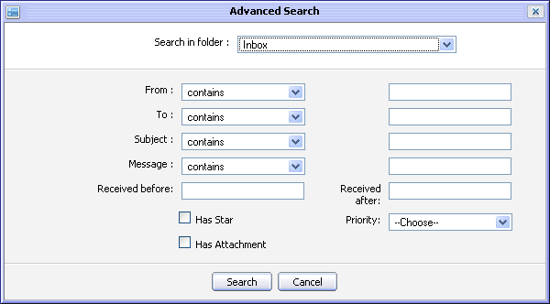Illustration 54: The Advanced Search form
In this form, you can set one, few or all criteria for your search:
Details:
Search in folder: The folder which you want to search .
From: The condition corresponding to the sender's name or mail addresses. There are some options In this drop-down list:
- contains: includes the terms in search box.
- doesn't contain: do not include the term in search box.
- is: include exactly the term in search box
- is not: do not include exactly the term in search box
- starts with: starts with the term in search box
- Does not start with: do not start with the term in search box
To: The condition corresponding to receiver's name or mail address.
Subject: This condition is corresponding to the message subject
Message: This condition is corresponding to the message content
Received before...Received after: The interval time the search messages were receipted
Has Star: This option allows searching messages have star or not.
Has attachment: This option allows searching messages have attachment or not.
Priority: The priority of the search messages
Step 2: Define the Search conditions.
Step 3: Click the Search button
All messages matching with your criteria will be listed in the search result form.

Mail Settings
This function allows you to customize the behavior and layout of eXo Mail to suit your needs.
Do as follows:
Step 1: Click the button on the tool bar.
The Mail Settings form appears with 3 tabs: General, Return Receipts and Layout.
The General tab contains basic setting information.
Details
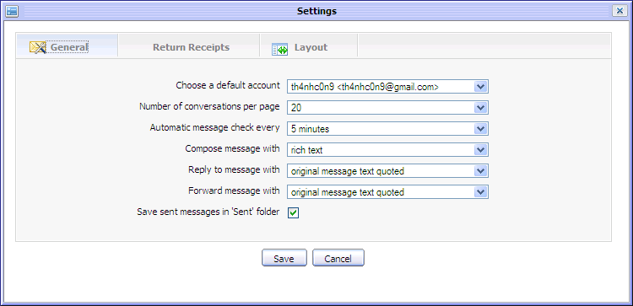Illustration 55: The General tab of the Mail Settings form
Choose a default account: The default account (includes display name and email address) of the current user you want to apply these settings .You can also select one of your accounts in the list.
Number of conversations per page: Change the number of conversations which will be displayed per page. You can select between 10, 20, 30... or 70 messages per page in message list pane.
Automatic message check every: The interval time the system will check mail automatically. You can chose between 5, 10 , 20, 30 minutes or 1 hour.
Compose message with: The default format of the message which is used when composing a message. There are 2 options: rich text and plain text. Rich text allows composing with basic formating such as font style, size, color... while Plain text allows simple text only.
Reply to message with: There are two options. Original message as attachment & Original message text quoted. The fist one allows replying message with attachment. The second one allows replying with text only.
Forward message with: There are two options: Original message as attachment & Original message text quoted and . The first one allows forwarding message with attachment. The second one forwarding message with text only.
Save sent messages in 'Sent' Folder: The option allows saving sent messages in 'Sent' folder or not.
The Return Receipts tab allows setting option for receipt notification.
Details:
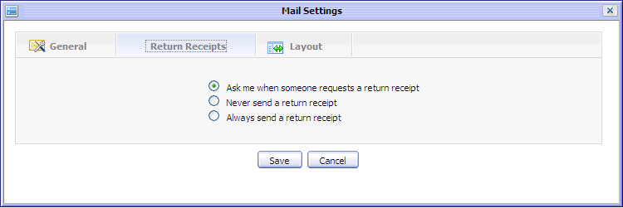Illustration 56: The Return Receipts tab of the Mail Settings form
Ask me when someone request a return receipt: This option allows you to receive an alert to inform about some one want to receive your notification about return receipt.
Never send a return receipt: This option will ignore all requests for a return receipt from you.
Always send a return receipt: This option allows always sending a return receipt to anyone who requests it.

The Layout tab allows personalizing the Mail layout. By default, the Horizontal Split type is set. You can also select the Vertical Split or No Split layout.

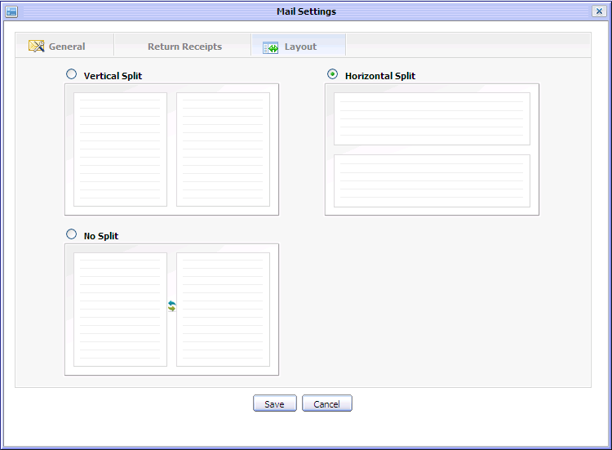Illustration 57: The Layout tab of the Mail Settings form

Maximizing the Reading Pane
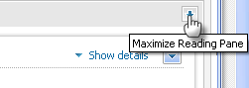
This function is used to maximize their reading pane. To do this action, click the icon on the right corner of the reading pane:

Sorting messages
This function is used to sort messages in the list according to some conditions.
By default, messages in list will be sorted by 'Date & Time ' in ascending order. However, you can also change sort by Sender, Subject, Size and Priority.
To change the sort order , click on a column header of message list pane.
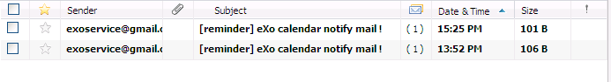Illustration 58: The Message list pane
The descending order is represented by the icon and the ascending order is represented by the icon.

