
GateIn User Guide
Version 3.2
Table of Contents
1 Preface 7
1.1 Overview 7
1.2 Purpose of the guide 7
1.3 References 7
2 Getting Started 9
2.1 Glossary 9
2.1.1 Portal 9
2.1.2 Portlet 9
2.1.3 Toolbar 9
2.1.4 Navigation 9
2.1.4.1 Portal/Site's administration 10
2.1.4.2 Group's navigation 10
2.1.4.3 User's navigation 10
2.1.5 Gadget 10
2.1.6 Access mode 10
2.1.7 Preview mode 11
2.1.8 Layout mode 11
2.1.9 Permission 11
2.2 Initial implementation 12
2.2.1 Requirements 12
2.2.1.1 Software 12
2.2.1.2 Hardware 13
2.2.2 Setup 13
2.2.2.1 Establish a base structure 13
2.2.2.2 Configure an environment 13
2.2.2.3 Run commands 14
2.3 Accounts 15
2.3.1 Register a new account 15
2.3.2 Sign in & sign out 17
2.3.2.1 Sign in 17
2.3.2.2 Sign out 19
2.3.3 Remember user account 20
2.3.4 Change account settings 20
2.3.5 Retrieve account & password 22
2.4 Manage sitemap 24
2.5 Manage language 25
2.5.1 Change the display language permanently 25
2.5.2 Change the display language for another user 26
3 Portlets 28
3.1 Functional portlets 28
3.1.1 Register portlet 28
3.1.2 Account portlet 28
3.1.3 Organization portlet 29
3.1.4 Application registry portlet 29
3.1.5 Group navigation portlet 30
3.1.6 Page management portlet 31
3.1.7 Portal navigation portlet 31
3.1.8 Star toolbar portlet 32
3.1.9 Tabbed dashboard 32
3.1.10 User info portlet 32
3.1.11 User toolbar dashboard portlet 33
3.1.12 User toolbar group portlet 33
3.2 Interface portlet 33
3.2.1 Banner portlet 33
3.2.2 Breadcrumbs portlet 33
3.2.3 Footer portlet 34
3.2.4 HomePage portlet 34
3.2.5 IFrame portlet 34
3.2.6 Navigation portlet 35
3.2.7 SiteMap portlet 35
3.2.8 Web browser portlet 36
3.2.9 Dashboard portlet 36
3.2.10 Gadget wrapper portlet 37
3.3 Dashboard portlet 37
3.3.1 Use the dashboard workspace 37
3.3.2 Add more gadgets 38
4 Administration Guide 40
4.1 Manage GateIn 40
4.1.1 Manage portals 40
4.1.1.1 Create a new portal 40
4.1.1.2 Access a portal 42
4.1.1.3 Edit/Delete a portal 43
4.1.1.4 Access a specific portlet 46
4.1.1.5 Edit a specific portlet 47
4.1.1.6 Edit portal's navigation 51
4.1.1.7 Edit portal's properties 52
4.1.1.8 Change portal skin 53
4.1.1.9 Switch between portals 54
4.1.2 Manage nodes 54
4.1.2.1 Add a new node 54
4.1.2.2 Edit a node 58
4.1.2.3 Copy/Paste a node 58
4.1.2.4 Clone a node 58
4.1.2.5 Cut a node 59
4.1.2.6 Delete a node 59
4.1.2.7 Change nodes order 59
4.1.3 Manage pages with Site Editor 60
4.1.3.1 Create a new page 60
a) Select a Navigation Node and Create a Page 60
b) Select a page layout template. 61
c) Re-agange the page layout and the portlets. 62
4.1.3.2 Create a new page using Page Management 65
4.1.3.3 Edit a page by Site Editor 67
4.1.3.4 Edit a page using Edit Portal's Navigation 68
4.1.3.5 Edit a page using Page Management 72
4.1.3.6 Delete a page 74
4.1.3.7 Preview a page 74
4.1.4 Manage users and groups 75
4.1.4.1 Manage users 75
a)Search for users 75
b)Edit user's information and settings 76
c)Delete an user 77
4.1.4.2 Manage groups 78
a)Add a new group 78
b)Edit a group 79
c) Add a new user to a group 80
d)Edit a user membership in a group 81
e)Delete a group 81
4.1.4.3 Manage memberships 81
a)Add a new membership type 82
b)Edit a membership type 82
c)Delete a membership type 82
4.1.5 Manage navigation 82
4.1.5.1 Portal's page navigation 82
4.1.5.2 User's page navigation 83
4.1.5.3 Group's page navigation 83
a)Edit group's page navigation 83
b)Create a new page navigation 84
c)Edit group's navigation properties 85
d)Delete a group's navigation 86
4.1.6 Manage permissions 86
4.1.6.1 Set an access permission on a portal 86
4.1.6.2 Set an edit permission on a portal 88
4.1.6.3 Set a permission on a page 89
a)Set an access permission on a page 89
4.1.6.4 Set an access permission on a portlet 90
4.2 Manage portlets/gadgets/categories 91
4.2.1 Add a portlet/gadget to a specific category 91
4.2.2 Auto-import default portlets/gadgets 91
4.2.3 View detailed information of a specific portlet 92
4.2.4 Manage gadgets 92
4.2.4.1 Where you can use a gadget 92
4.2.4.2 Add a gadget 92
4.2.4.3 Create a new gadget 96
4.2.5 Manage categories 97
4.2.5.1 Add a new category 97
4.2.5.2 Set permissions for a new category 99
4.2.5.3 Edit a category 100
4.2.5.4 Delete a category 100

Preface

Overview
Beginning as an open source project in the year 2002, eXo is well-known as the industry's first Java portlet container. With the aim of dominating the potential portal market through robust and easy-to-use applications, eXo Project succeeded in attracting consumers in the whole world. eXo actually opened the floodgates to various options in many markets, and customers have been choosing eXo as the best method for their success.
The eXo Project grew into a company in 2003, as a response to customer demands. We can do this because we release our code in the open environment. It's how the DoD found us, when we were just university students hacking away, and it's how we choose to do business with our customers.
Today, eXo is a rapidly growing global company, with U.S. headquarters in San Francisco, California, global headquarters in France, and offices in Tunisia, Ukraine, and Vietnam. The Corporate has established technology leadership and proven values by their large European installed base and strategic partnerships with Red Hat, Capgemini, Atos Origin, and Bull.
GateIn is the perfect merge between Red Hat and eXo Platform in creating a new generation of Open Source portal that is robust and intuitive. With GateIn, both normal users and enterprises can enjoy many personalization and collaboration applications wherever and whenever. Advantages generated in GateIn, such as the interactive user interface, customizable look and feel, flexible internationalization and localization, faciliate the birth of many useful applications with a variety of rich utilities in the world market.

Purpose of the guide
The guide was written as a handbook, aiming at instructing step-by-step on how to use and to implement this application to the utmost. The information included here will give basic steps that makes easy for users to follow through in-depth examples and clear explanations about the eXo Platform technology. Whether you major in technology or not, you are able to learn about or to work on GateIn easily and efficiently.
The information provided in the guide is arranged into such a way that ensures readers to search and implement quickly and easily. We hope that readers can know more and master almost key strengths when using the GateIn 3.2
The guide is an in-depth manual. This guide will focus on the followings:
- Define the basic concepts in GateIn 3.2
- Provide step-by-step instructions to master GateIn 3.2

References
Information
- eXo Platform Home Page: http://www.exoplatform.com/portal/public/website/
- eXo Platform Wiki: http://wiki.exoplatform.com/xwiki/bin/view/Main/
Support
- Forums: http://forums.exoplatform.org
- FAQ: http://faq.exoplatform.org

Getting Started

Glossary

Portal
Portal can be defined as a key environment for making and implementing many applications and contents. In other words, the portal is a web-based application providing means to gather and personalize information via specific portlets with an interactive and consistent look and feel. Users and administrators are able to integrate information, people and processes via a web-based user interface.

Portlet
Portlet is a pluggable component in a portal through which users can access some specific information, including supports, updates, or mini-applications). The portlet produces fragments of a markup code that are aggregated into a portal page. Typically, a portal page is displayed as a non-overlapping portlet windows collection, where each portlet window displays a portlet. Content generated by a portlet can be customized, depending on the configuration set by each user.
Portlets can be divided into two following types:
- Functional Portlet
- Interface Portlet

Toolbar
Toolbar is a set of icons or buttons that is considered as a part of interface. It spans the top of the portal application and provides links to users and administrative actions.
If the current user logged in as an administrator or manager, the extra navigation so-called Site Editor will be displayed in the toolbar. In case of the user as user or demo, there are only three navigation types, including Site, Group, and Dashboard in the toolbar.

Navigation
Navigation is a nodes set (menus) that helps users visualize the site structure and provides hyperlinks to go from one page to another quickly. Each node contains an internal name and a label which is shown on the menu. For any node, you can define either sub-nodes. The horizontal menu at the top of page is called the navigation bar. The GateIn's navigation is established to three levels: portal, group and user. On each level, any node can be defined. The navigation structure of one particular user is made up of portal navigation nodes (that are valid to all users), the nodes of all groups the user belongs to and individual nodes. The users' and groups' nodes are valid for all portals that are defined on the same eXo Portal server.

Portal/Site's administration
This navigation level is to keep links to separate sites and/or portals of the parent portal. Each portal/site has only one navigation and it is automatically generated when a portal/site is created. Only users, who have the edit permission on a portal, can add nodes on this navigation level.
The name of a portal navigation looks like portal:[portal name]'s nav
For example, a portal navigation's name is portal:classic's nav”:
- 'portal' is the navigation level, meaning navigation nodes are defined for all users of a portal.
- 'classic' is the name of portal.
- 'nav' stands for 'navigation'.

Group's navigation
All registered users are organized into groups. There is a navigation keeping the links to all pages of each group, called a group navigation. The content of this navigation differs, depending on the login account. The group's navigation is created manually by users who have the highest right in a group. Before adding nodes or creating pages for a group, you must create the group navigation. Also, there are nodes only applied to members with certain memberships.
The name of group navigation looks like group:[group name]'s nav.
For example, the group navigation name is “group:platform/administrators's nav”:
- 'group' is a type of navigation, meaning nodes are defined for a group.
- 'platform/administrators' is the path of a group, meaning navigation nodes are defined for the 'administrators' - the group that is a sub-group of 'platform' group.
- 'nav' stands for 'navigation'.

User's navigation
Each user has its own navigation that contains links and portlets (or gadgets) selected by the user. A user's navigation is created or deleted automatically when the user is registered or deleted respectively. By default, the user navigation is empty.
The name of user's navigation has the format user:[user name]'s nav.
For example, the user navigation name is “user:john's nav”.
- 'user' is a navigation level, meaning navigation nodes are defined for one individual user.
- 'john' is the name of user.
- 'nav' stands for 'navigation'.

Gadget
Gadget is a mini web application running on a platform that a user can integrate and customize in the website.
To further see default gadgets in GateIn 3.1, please refer to the section "Use the Dashboard Workspace".

Access mode
GateIn has offerred two modes by default:
- Public mode is for guest users (visitors) who have not registered yet. This mode is not required to sign in, so guests can only visit the public pages in a portal. Visitors can also register to get an account. After having registered, they can use the private mode and have to contact their administrators to get more rights or the group manager if they want to become a member of that group.
- Private mode is for registered users who will apply their usernames and passwords to sign in. This mode supports users in taking many actions such as: managing private resources (creating private pages, editing or deleting them), "borrowing" pages from others by creating hyperlinks, changing the language for individual needs, managing private information.

Preview mode
In the preview mode, you can only view.
You can see this mode when you click the Preview Page icon at step 3 of creating a page by wizard or editing a page by wizard.

Layout mode
In the layout mode, you are provided with some layout templates of portal or the page and you can use these templates to edit a portal or a page.

Permission
Permission is one of the most important factors on a portal. Permission settings control actions of user within the portal and set by the portal administrators.
Permission types
Permission types define what a user can do within the portal. There are two available types as follows:
Access Permission enables users to utilize portal contents (sigining in, viewing contents, rearranging portlets, and more). This permission can be set for multiple member groups.
Edit Permission enables users to change portal contents (changing portal or page information, deleting a portal/page). The edit permission is set for only one group at one time.
By default, root is set as the super user or the administrator of GateIn. He can do everything, while the others must get the appropriate rights (permissions) at first.
Rights in GateIn are not assigned to a single user but to a users group with specific membership types.
Similarly, the permission structure is always established as follows: [membership type]:/[group path].
For example: manager:/platform/administrators. It means the right is set for users who are “manager” of the group “administrators”. “Platform” is the parent group of “administrators”.
Seemingly, groups are managed based on a hierarchy structure; but in fact, a sub-group does not have any inheritance from the parent group.
For example: we have a group structure as follows:
+ platform
- administrators
- guest
- user
If users in the group “platform” can perform a function A, it does not mean that users in “administrator” or “guest” can do function A. The roles of users in groups are independent.
Permission levels
Permission levels specify where the users's permission types can be applied into the portal. GateIn offers three permission levels as follows:

Portal: The permission at portal level includes actions permitted in all pages within the portal. Users with the access permission can view (but not edit) all the pages within the portal. Meanwhile, users with the edit permission at the portal level can change any page in the portal.
Page: The permission at page level restricts users to several particular pages. Users are only able to see and/or edit pages they have been given access to, depending on each permission type assigned to them.
Portlet: The permission at portlet level enables users to create a page through dragging and dropping portlets into a page. Some portlets are only used for administrators, while some are for individuals. Thus, administrators need to set proper access permissions for each specific group.
Permission types and levels can be effectively implemented to control who can do and what can be performed within the portal.

Initial implementation

Requirements

Software
GateIn is a Java application. The GateIn trial version is free download. However, new functions are usually updated without testing and guaranty in trial versions. In order to purchase a full version with guaranty and tested functions, please contact to us at sales@exoplatform.com.
You can get the latest trial version package from this link:
http://forge.objectweb.org/projects/exoplatform. After downloading, you also need to download the following software which supports running GateIn:
- Download JDK (Java Development Kit) with version 1.5 or later.
- Application Server: GateIn Portal is a web application using the client–server model. So we need a server browser. You can use Jboss Application Server, Jonas Application Server or Apache Tomcat.
- Jboss Application Server version 4.2.0 : http://labs.jboss.com/
- Jonas Application Server version 4.8.4: http://wiki.jonas.objectweb.org/
- Apache Tomcat version 6.x http://tomcat.apache.org
- A database is required. By default, HSQL is delivered with GateIn Portal so that you do not need to install a database. GateIn Portal can be used with the following databases:
- HSQL (used by default)
- My SQL
- SQL Server
- Oracle
- PostGreSQL
- DB2

Hardware
Processor: 2.0 Ghz or higher
RAM : at least 512MB

Setup

Establish a base structure
To establish a base structure, do as follows:
Step 1: Create a "java" directory which is called $EXO_BASE_DIRECTORY. By default, the $EXO_BASE_DIRECTORY directory will be in your $HOME directory in Linux and in D: drive in Windows.
Step 2: Install JDK and maven2 in the java directory.
Step 3: Set environment variable: JAVA_HOME= EXO_BASE_DIRECTORY/JDK.
Step 4: Create an “exo-dependencies” and “exo-working” directories in the “java” directory.
Step 5: Copy a desired template application server directory to exo-dependencies. The directory name should have the form name of application server -${version}. So the name of the directory may be (tomcat-$, jboss-$, jonas-$).
By the end, you have to have the following directory structure:
java/
exo-dependencies/
tomcat-${version}
jboss-${version}
jonas-${version}

exo-working
jdk1.5
maven2

Configure an environment
To configure a suitable environment for GateIn implementation, do as follows:
Step 1: Copy $EXO_BASE_DIRECTORY/eXoProjects/tools/trunk/config/maven2/template-settings.xml to your $HOME/.m2/settings.xml and adapt the configuration to your environment. If you do this, the maven2/conf/settings.xml will be ignored. This step is mandatory for window environment.
Step 2: For Linux or Cygwin environment, you can bypass this step as the exoenv.sh script can copy and configure the settings.xml file automatically for you;
Step 3: In Linux or Cygwin environment:
-Copy $EXO_BASE_DIRECTORY/eXoProjects/tools/trunk/build/src/main/resources/linux/exoenv.sh to your $HOME or $EXO_BASE_DIRECTORY directory.
- Backup the old one if you have one.
In Window and DOS Environment:
- Copy $EXO_BASE_DIRECTORY/eXoProjects/tools/trunk/build/src/main/resources/window/exoenv.bat to your $HOME or EXO_BASE_DIRECTORY directory.
- Backup the old one if you have one.
Step 4: Update the Configuration: Edit exoenv.sh or exoenv.bat file to adapt it to your environment. You should only have to change the PORTABLE_DIR variable at the beginning.
Step 5: Run the command to setup the environment: In linux or cygwin: source exoenv.sh.
To check that it has worked well, open $EXO_BASE_DIRECTORY/maven2/conf/settings.xml and check that the file corresponds to your environment, especially the definition of the repositories.
On window and dos prompt: exoenv.bat

Run commands
- Launch Tomcat
In Linux or Cygwin Environment
- Go to $EXO_BASE_DIRECTORY/exo-working/exo-tomcat/bin directory.
- Change the rights on .sh files to make them executable : chmod +x *.sh
- Run the command : gatein-dev.sh run or gatein.sh run
- Launch Jonas
On Command line (Windows)
- Run exoenv.bat in java directory.
- Go to $EXO_BASE_DIRECTORY/exo-working/exo-jonas/bin/nt directory
- Run the command exo.bat start -fg
- Launch Jboss
On Cygwin
- Go to $EXO_BASE_DIRECTORY/exo-working/exo-jboss/bin directory,
- Run the command: run.sh

Accounts

Register a new account
Unregistered users visiting the portal will be limited in the contents and several applications which are not set as public. Meanwhile, users who want to access in-depth contents or perform some actions in various applications, they should register by themselves, then contact the portal administrators to gain certain rights or permissions. To register a new account, do as follows:
Step 1: Click Register on the upper right corner of the GateIn homepage. The Register New Account form will appear.
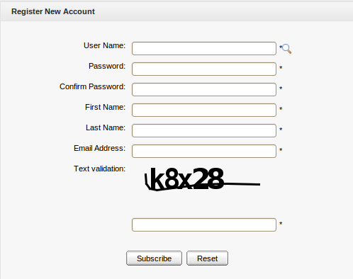Illustration 1: The Register New Account form
Details:
User Name: The user's login name that must be unique with at least 3 characters. Only alpha, digit, and underscore characters are allowed.
Password: The password used to login that must have at least 6 characters.
Confirm Password: The re-typed password. The Password and Confirm Password must be the same.
First Name: The user's first name. This field must start with a character.
Last Name: The user's last name. This field must start with a character.
Email Address: The user's email that must be in the right format, for example username@abc.com.
Text validation: The text which is required to input to validate the registration.
(*) Required.
Step 2: Enter values for fields in this form.
Step 3: Click Subscribe to accept adding a new account, or Reset to clear the entered values. After you have clicked Subscribe, there will be a message which informs that you have registered your account successfully.
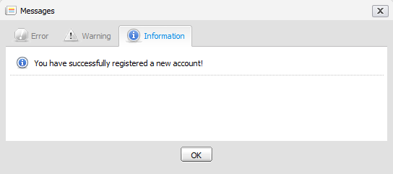
Step 4: Click OK to finish creating your account.
You cannot add a new account if one of alert messages appears:
- User name is existing or User Name is invalid.
- Password has less than 6 characters.
- Password and Confirm Password are not the same.
- Email Address is in a invalid format.
- Required fields are blank (empty).
- Text verification isn't correct.
After adding a new account, contact with your administrator to get rights or only be a visitor.
Note:
1. The magnifying glass icon is used to search whether the entered User Name exists or not. Once a user has registered by himself or the administrator has created a new account, the new user will become a part of the group "/platform/users" with membership by default.
2. The portal's administrator can allow the text validation field to appear or not. do as follows:
Step 1: Enter the portal as an administrator.
Step 2: Go to the Register portlet by entering the following URL:
http://localhost:8080/portal/private/classic/register.
Step 3: Hover your mouse over Site Editor on the toolbar.
Step 4: Click Edit Page under the Site Editor.
Step 5: Hover your mouse over the area of Register Portlet and choose .
The Edit Mode will appear:
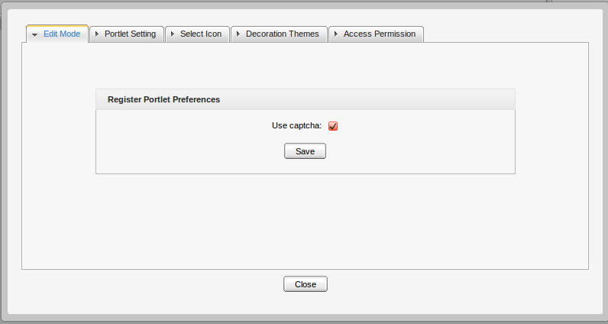Illustration 2: Edit mode of register portlet
Step 6: Deselect the User captcha. Click Save if you want the Text validation
field not to exist in the Register New Account form.
Step 7: Click Close, then click the Finish icon on the top right of Page Editor to take effect.

Note that you can enter the Register portlet through another ways. For example, select Site → Edit Navigation (of the classic portal). Then, right-click the Register node and select Edit Node's Page → the edit icon.

Sign in & sign out

Sign in
By default, GateIn initializes some users with specific rights.
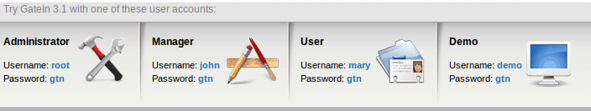
Details:
- Being an administrator, root has the highest right in any portal. Root controls all resources, such as users, groups, memberships, pages, navigations, portlets. Root can do anything in a portal except the private resources of another users.
- Being a manager, john can take some actions that are supported only for a manager.
- Being a visitor, marry is like a freedom user, so she can only visit and read news.
GateIn may be accessed by using a browser with a regular connection (HTTP). If you are using a default bundle installation in your local computer, you can access it through the URL. By default, the address http://localhost:8080/portal/ runs into a portal named “classic”. Otherwise, you will have to contact your administrator to ask for the initial URL.
With GateIn 3.1, users can sign in the portal via 2 ways:
The 1st way:
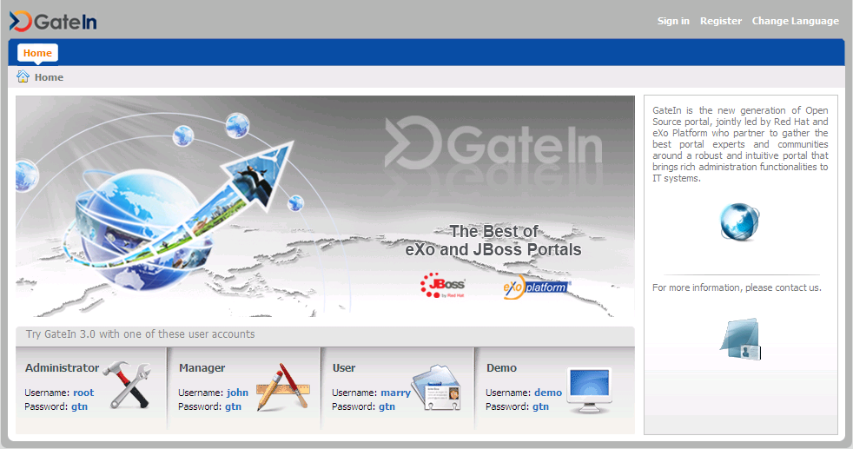Illustration 3: The main screen of GateIn Portal
Step 1: Click the Sign in link at the top right of the page. The Sign in form appears:
Details:
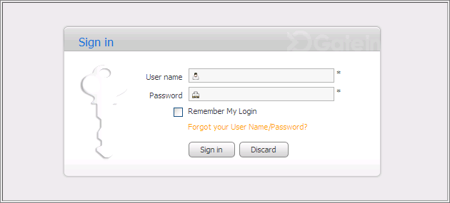Illustration 4: The Sign in form
User Name: To input the registered user name.
Password: To give the password of your user name.
Remember My Login: To allow you to return to the GateIn and to be automatically authenticated based on the cookie value provided by the browser. Thus, you do not have to perform an explicit authentication again.
Forgot your User Name: To follow some steps to get the forgotten user name or password.
Sign in To sign into the GateIn by the inputted user name and password.
Discard To close the Sign In form.
Step 2: Input your registered User name and Password.
Step 3: Select the Remember My Login checkbox when you sign in GateIn 3.1 at the first time if you want to automatically return to GateIn 3.1 without signing in again. You can see the section "Remember User Account" for more details.
Step 4: Click the Sign in button to submit the form or the Discard button to quit.
Note that in case the user name does not exist or the user name/password is invalid, you will be returned to the Sign In form with an alert message. Type your user name or password again.
After signing in successfully, you will be redirected to the homepage and welcomed with your full name on the top right corner of the page.
The 2nd way: Click directly the default user accounts at the lower of screen. You will be redirected to the portal.

Sign out
This feature ends the authenticated session and returns the user to the anonymous portal. To sign out, just hover your mouse over the Sign Out icon on the top right corner and click that icon.
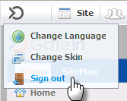

Remember user account
Users who regularly return to GateIn 3.1 can be automatically authenticated to avoid doing an explicit authentication each time they access the portal. do as follows:
Step 1: Input your registered user name and password.
Step 2: Select Remember My Login when logging in GateIn 3.1 for the first
time.
Step 3: Click Sign In to submit the form.
To be authenticated for the next time you sign in automatically, donot select to sign out when leaving the portal.

Change account settings
The function is to change your account information. To do so, click directly your account after logging in to open the Account Profiles form.
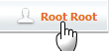
The Account Profiles form will be shown:
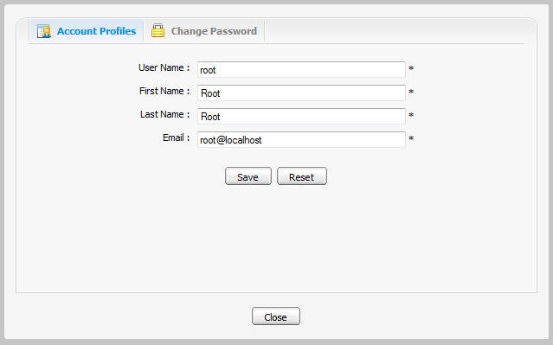Illustration 5: The Account Profiles Dialog
To change your Account Profiles, do as follows:
Step 1: Select the Account Profiles tab.
This tab displays current basic information about the current user.
Step 2: Change your First Name, Last Name, Email. Your User Name can not be changed.
Step 3: Click Save to accept changes.

To change your Password, do as follows:
Step 1: Select the Change Password tab.
Step 2: Enter your current password to identify that you are the owner of this account.
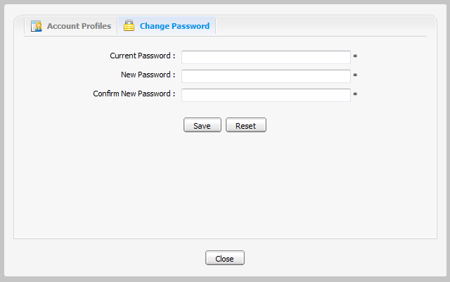Illustration 6: The Change Password tab
Step 3: Enter your new password which must have at least 6 characters.
Step 4: Enter your new password again in the Confirm New Password field.
Step 5: Click Save to accept changes.

Note: If the default accounts' passwords have been changed, the user can no longer sign in the portal by clicking the default accounts directly in the lower of the page.

Retrieve account & password
In case you forget your account or password, you can recover following these steps:
Step 1: Click the link 'Forget your User Name/Password?' beneath the Password field in the Sign in form.
This form offers two options:
  - Forgot my password.
  - Forgot my username.
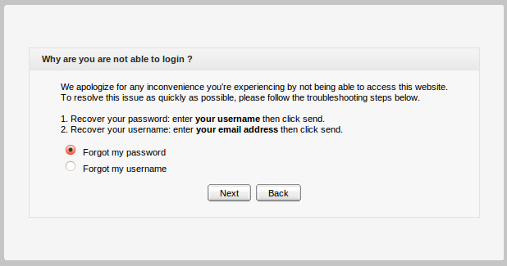
Step 2: Select one appropriate option.
Step 3: Click Next to go the next step. You will be prompted to provide identification information, depending on your choice.
- If you select Forgot my password, you will be prompted for your user name:
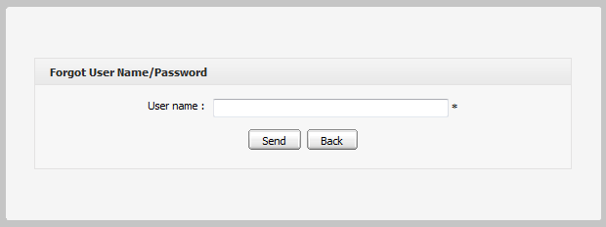
- If you selected Forgot my username, you will be prompted for your email:
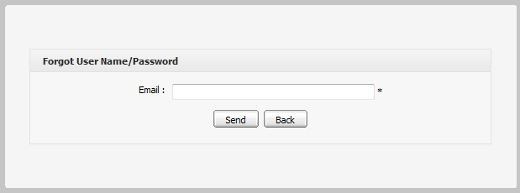
Step 4: Enter your Username or Email in the field of the above form.
Step 5: Click Send to submit the entered values.
After the form has been submited, an email will be sent to your email address with the requested information.
- If you forgot Username: when retrieving Username, your old Username is still remained and reused.
- If you forgot Password: you will be sent a new password (as temporary), then you will be redirected to change password when you sign in.
Note that the User name/Password that you received only takes effect for one day. It means that if the current duration is over one day from the receipt day, you cannot use the received User name/Password. Thus, you have to get another active email.

Manage sitemap
GateIn Site Map provides users with overall view of GateIn. Users can go directly pages through the SiteMap without going through the Administration toolbar.
Step 1: Go directly to the GateIn SiteMap on the navigation bar; or go to Site → Classic → SiteMap. The SiteMap page will appear:

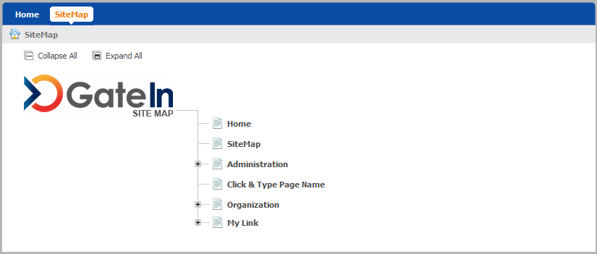
Step 2: Click Expand All to see all pages inside (Collapse All enables you to back to the initial display).
Step 3: Click directly the title of page you want to manipulate.

Manage language
The priority order of display language is 1. User's language 2. Browser's language 3. Portal 's language. Thus, to display your preferred language, you should pay attention to this order to change the language type appropriately.

Change the display language permanently
Do as any of following ways:
The 1st way:
Step 1: Click Site on the administration toolbar and select the portal that you want to edit.
Step 2: Click which corresponds to the portal that you want to edit.
The portal will be displayed under the edit mode.
Step 3: Click to edit portal properties.
Step 4: In the Portal Setting tab: You can change display language of Portal by selecting another language in the Locale field.
Step 5: Click Save and Finish icon to take affect.
The 2nd way:
Step 1: Click Site on the administration toolbar to open the portal list
Step 2: Click Site Editor and select Edit Layout in the menu:
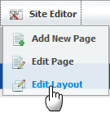
The portal will be displayed under the edit mode.
Step 3: Click the button to edit portal properties.
Step 4: In the Portal Setting tab, you can change the display language of Portal by selecting another language in the Locale field.
Step 5: Click Save and Finish icon to take affect.
The 3rdway: This way is used to set the display language for yourself, not for displaying the language of Portal.
Only users having administration role can do this:
Step 1: Go to Star → Change Language.
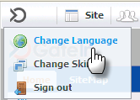
The Interface Language Setting form is displayed with a list of all supported languages. The currently used language is marked by the icon .
Step 2: Select another one by clicking the name of that language.
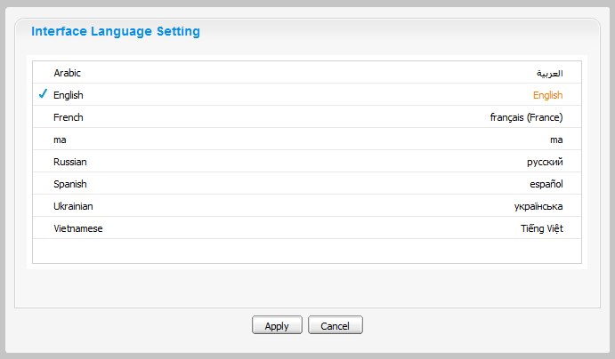Illustration 7: The Interface Language Setting form
Step 3: Click Apply and wait for few seconds to take affect.

Note:
- This display language will be kept permanently till you change your display language by another one.
- When you change from other language to Arabic or set the display language is Arabic. The display language on Portal will be changed to Right to Left (RTL) direction because when Arabists read, they usually read from Right to left.

Change the display language for another user
By this way, you can change not only your display language but also the display language of another users if you have the access right in the Organization portlet.
Do as follows:
Step 1: Go to Group → Organization → Users and groups management
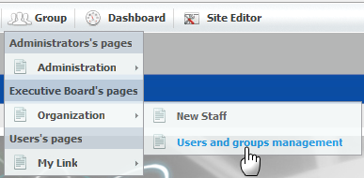
Step 2: Show the form to edit a user in list by clicking the edit icon which corresponds to the user that you want to change the display language.
Step 3: Select the User Profile tab:
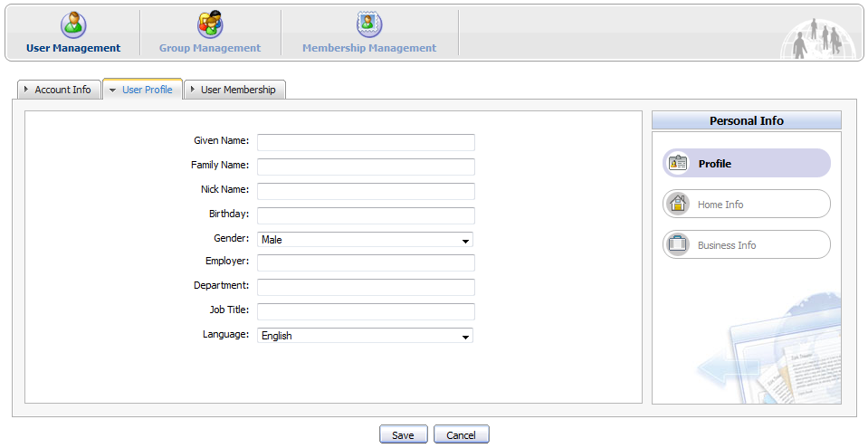
Step 4: Change the display language of this user by changing the value of the Language field.
Step 5: Click Save to accept changes, or Cancel to quit.
Thus, for the next time when the selected user signs in, the display language will be the language changed by the administrator.

Portlets

Functional portlets
Functional portlets support all functions of a portal. They are built into the portal and accessed via toolbar links when the portal-related tasks are performed.

Register portlet
This portlet is used to register a new account, including User Name, Password, Confirm Password, First Name, Last Name, Email Address, and Text validation.
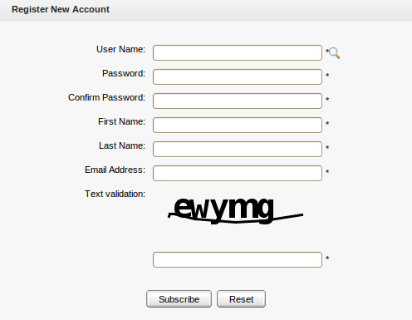Illustration 8: Register Portlet

Account portlet
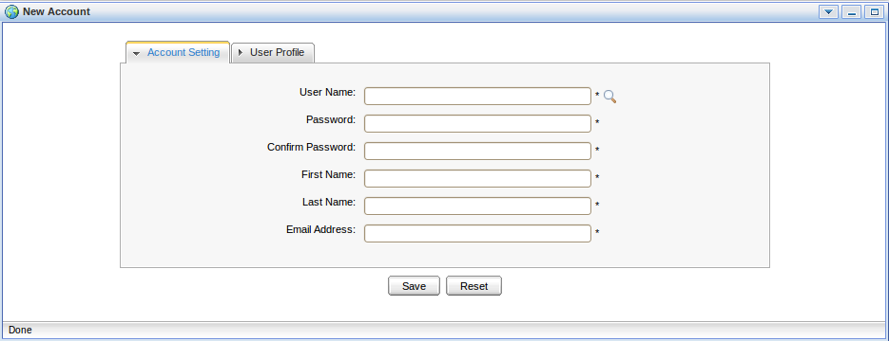
This portlet enables users to add a new account and choose their preferred languages for displaying the portal interface.

Organization portlet
This portlet is to manage user information, users groups and memberships. The form of this portlet is shown like:
- User Management: To edit, delete, search and view existing users.
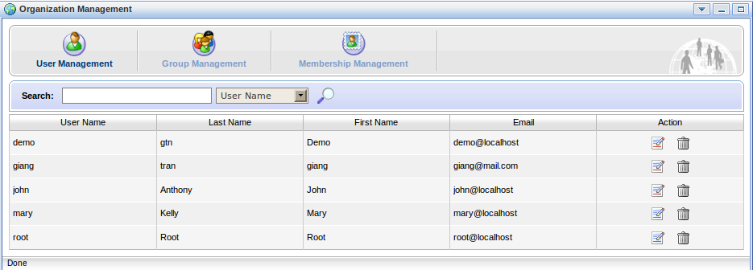Illustration 9: The Organization Portlet interface
- Group Management: To view, add new, edit and delete a users group.
- Membership Management: To add, edit and delete memberships.

Application registry portlet
This portlet is used to manage different application categories. You can add, edit, set permissions, or delete categories, applications. The form of this portlet is shown as below:
This portlet includes the following functions:
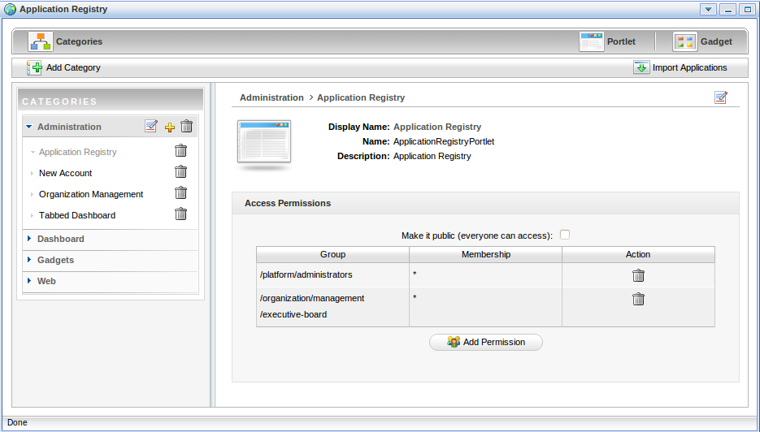Illustration 10: The Application Registry Portlet
- Organize portlets/gadgets into different categories, such as creating a new category, importing default porlet categories, adding a portlet/gadget into a specific category, adding permission to a portlets category, and more.
- List portlets and view detailed information regarding to a specific portlet.
- Manage gadgets, including adding a remote gadget, creating a new gadget or deleting a gadget from the list.

Group navigation portlet
The Group Navigation portlet is to manage the navigation of different groups. In this portlet, you can add, edit, or delete a specific navigation.

Page management portlet
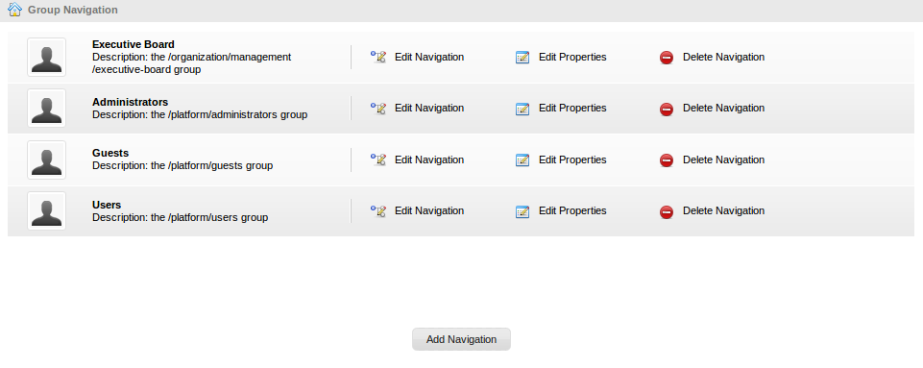Illustration 11: Group Navigation Portlet
The Page Management portlet is used to manage all pages on the portal. In the Page Management portlet, you can add, edit, or delete a specific page.
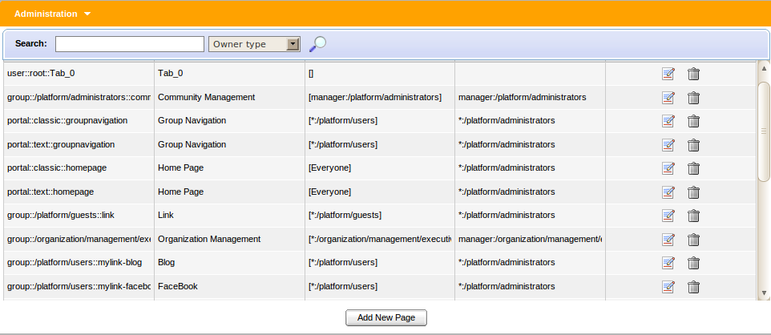Illustration 12: Page Management Portlet

Portal navigation portlet
The portlet is to manage all portals in the GateIn. In the Portal Navigation portlet, you can add, edit, or delete a portal.
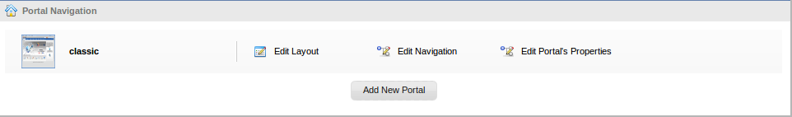Illustration 13: Portal Navigation Portlet

Star toolbar portlet
The portlet displays a list of actions, such as Change Language, Change Skin, Sign Out.
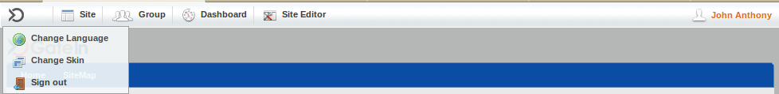Illustration 14: Star Toolbar Portlet

Tabbed dashboard
The portlet displays Dashboard tabs that you can add gadgets inside by dragging and dropping them.

User info portlet
The portlet displays personal information of a specific user that can be viewed and edited.
Illustration 15: The User Info Portlet Interface

User toolbar dashboard portlet
The portlet displays the main dashboard menu that you can go inside to create dashboard tabs, add, or remove gadgets for each tab.
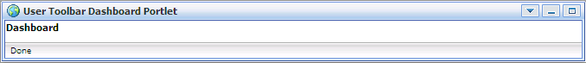Illustration 16: The User toolbar dashboard portlet interface

User toolbar group portlet
The portlet display the main group menu that you can go inside to create, edit and delete a specific group and the navigation for each group.
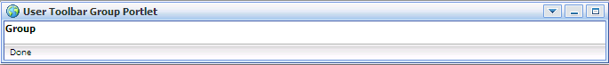Illustration 17: The User toolbar group portlet interface

Interface portlet
Interface portlets constitute the interface of the GateIn portal that are the front-end components of the portal. They provide users with ways to interact with the portal. GateIn 3.1 provides the following Interface portlets:

Banner portlet
Illustration 18: The Banner portlet interface
The portlet is the welcome gateway of a portal. It contains slogan, logo and icon of an organization.

Breadcrumbs portlet
The portlet displays the navigation path of the selected page.
Illustration 19: The Breadcrumbs portlet interface

Footer portlet
The portlet provides a footer for a site. This footer can be a text, images that are displayed at the bottom of a website. It provides information about author/institutional sponsor, revision date, copyright, comments form, and navigational links.
Illustration 20: The Footer Portlet interface

HomePage portlet
The portlet is the homepage for a portal. The homepage is a main page (default page) which is the first page displayed when you visit the portal.
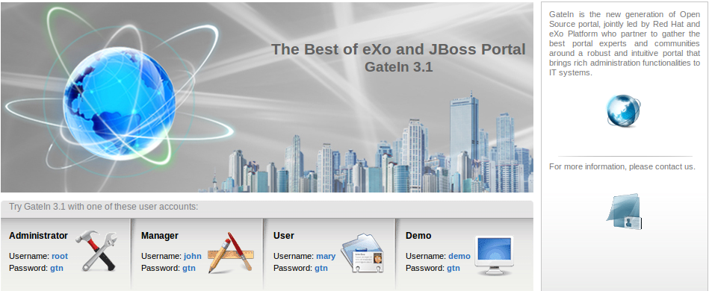Illustration 21: The HomePage Portlet interface

IFrame portlet
The portlet is used to create IFrame elements for a site. The IFrame is an HTML element which can embed a different HTML document into a HTML document. So, the embedded document is displayed inside a sub-window of the browser window. This doesnot mean the full inclusion, the embedded document is independent and both documents are considered as separated documents.
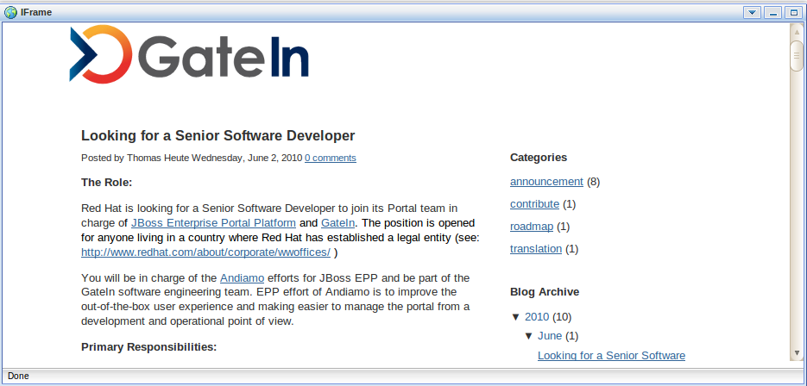Illustration 22: The IFrame Portlet interface

Navigation portlet
The portlet provides a navigation bar. A navigation bar is a menu that helps users visualize the site structure and provide links to quickly move from page to page:
Note:
Illustration 23: The Navigation Portlet interface
When you create a new page that contains this portlet:
In the Preview mode: the portlet will be viewed as a normal page like above.
In the Save mode: the Navigation portlet will not be displayed normally when you open the page containing this portlet, because only the portal's navigation can be shown. It means that two navigations cannot be shown concurrently.

SiteMap portlet
The portlet displays a sitemap page of website. It is a graphical representation of a website. It lists pages on a website, typically organized in the hierarchical architecture to help visitors easily find pages on the site.
There are two options:
Collapse All: The sitemap will be displayed with the parent path only.
Expand All: The sitemap will be displayed with the parent paths and all their children paths.
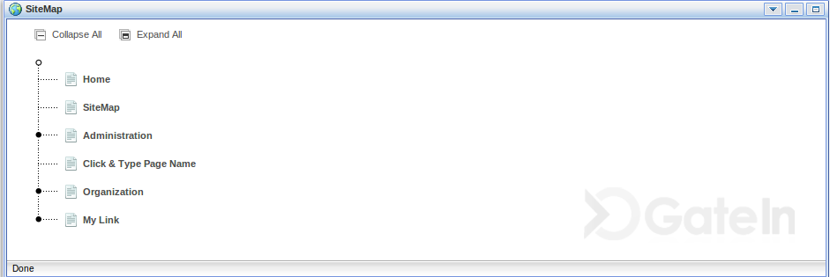Illustration 24: The SiteMap Portlet interface

Web browser portlet
The portlet provides a web-browser-like application for users. It enables users to connect to other sites over Internet.
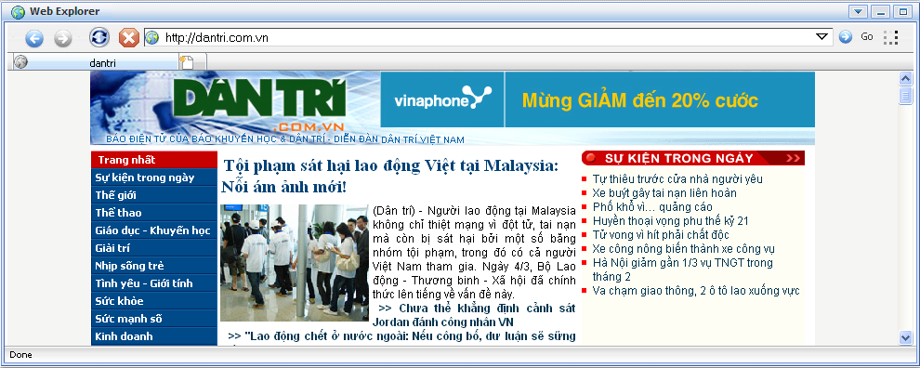Illustration 25: The Browser Portlet interface

Dashboard portlet
The portlet is used for hosting mini–applications known as gadgets. The dashboard uses a variety of graphical effects for displaying, opening, and using gadgets. Gadgets can be moved around, rearranged, deleted and recreated in the dashboard. More than one instances of the same gadget can be opened at the same time, possibly with different settings.
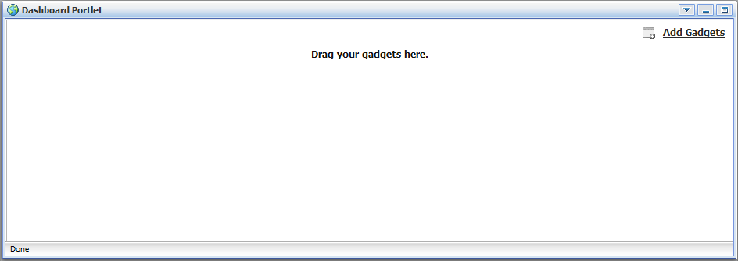Illustration 26: The Dashboard portlet interface

Gadget wrapper portlet
This portlet allows users to view a gadget in the canvas mode.
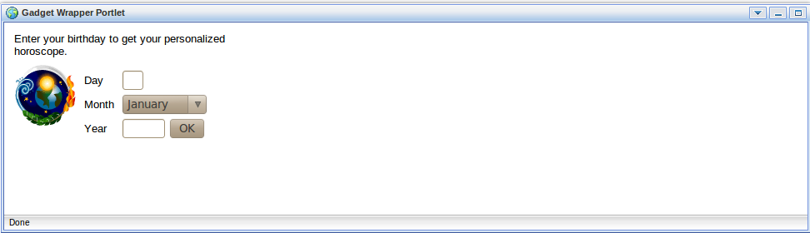Illustration 27: Gadget Wrapper Portlet

Dashboard portlet
The dashboard portlet is to host mini-applications known as gadgets. The dashboard uses a variety of graphical effects for displaying, opening and using gadgets.
Gadgets within the Dashboard portlet may be moved, or rearranged. Users can create new gadgets and delete unnecessary ones. Also, users can open many gadgets with different settings at one time.

Use the dashboard workspace
To use the Dashboard Workspace, do as follows:
Step 1: Click Dashboard on the toolbar.
Step 2: Click Add Gadgets to open the Dashboard Workspace.
The Dashboard Workspace lists all available gadgets. Four default gadgets are provided
in GateIn 3.1; but you can add more.
The followings are default gadgets:
Calendar is to keep track of date in style. You also can switch easily between daily, monthly and yearly views and change the skin as you like.
Todo helps you organize your day and work group keeping track of your tasks in a convenient way. You can highlight tasks with different colors.
Calculator lets you perform most basic arithmetic operations. This mini-application can be themed to match your portal.
RSS Reader lets you get a sneak preview of your favorite feeds in one location. This content includes, but not limit to, news, posts, emails, all in one gadget. This gadget is a web–based one for receiving and viewing RSS feeds.
Step 3: Select a gadget in the Dashboard Workspace.
Step 4: Drag and drop the selected gadget into the Workspace.
In addition, many more gadgets can be found at the website: http://www.google.com/ig/directory?synd=open. GateIn 3.1 is compatible with most gadgets available here.
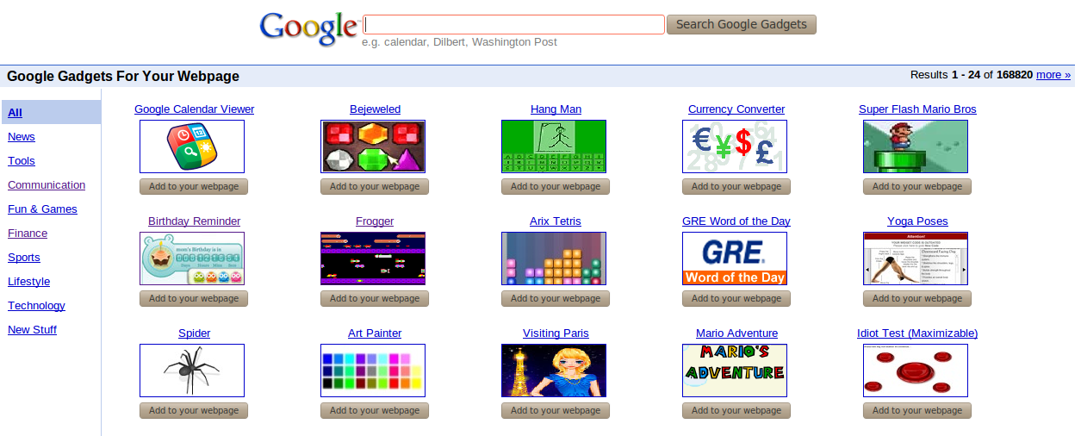

Add more gadgets
To add more gadegts from external sources, do as follows:
Step 1: Open the URL (.xml or .rss) of your desired gadget.
For example, http://bejeweledg.googlecode.com/svn/trunk/bejeweled.xml.
Step 2: Return to your portal, and click Dashboard on the toolbar.
Step 3: Click Add Gadgets in the Dashboard to open the Dashboard Workspace.
The Dashboard Workspace will appear:
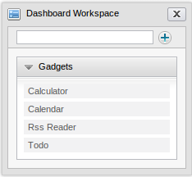
Step 4: Paste the URL achieved in step 1 into the text box next to the icon .
Step 5: Click the plus icon to add the new gadget to the page.
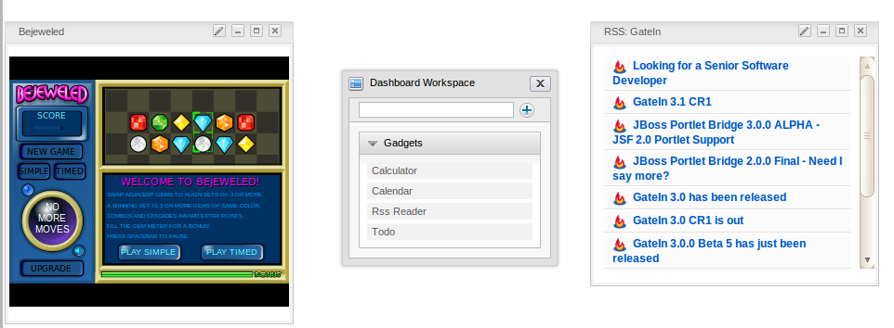

Administration Guide
Note that functions stated in the following part are advanced and for users as administrators only.

Manage GateIn

Manage portals

Create a new portal
Only users of at least one of the groups /platform/administrators or /organization/management/executive board can perform this function.
This permission is set in the portal-configuration.xml file.

<value-param>
<name>portal.creator.groups</name>
<description>groups with membership type have permission to manage portal</description>
<value>*:/platform/administrators,*:/organization/management/executive-board</value>
</value-param>

Step 1: Click Site on the Aministration bar to visit the Portal Navigation page.
Step 2: Click the button 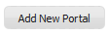.
By default, the Create New Portal window which contains the Portal Setting tab will open:

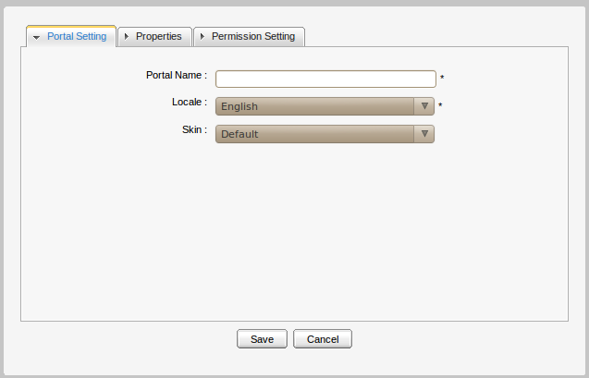Illustration 28: The Portal Setting tab
Step 3: Enter a value for the Portal Name field. This field is required and must be unique. ONLY alphabetic, numeric and underscore characters are allowed for this field and the name must have at least 3 characters and less than 30 characters
Step 4: Select the default display language for the portal in the Locale list.
Step 5: Select a skin for the portal by selecting one type. Currently, there are two skin types available, including Default and SimpleSkin.
Step 6: Click the Properties tab to select Keep session alive. There are 3 options:
- Never: The session will never timeout, even if an application requests it.
- On-demand: The session will timeout if an application requests it.
- Always: The session will timeout after a set period.
Step 7: Click the Permission Setting tab and set the permissions for the portal.
- By default, the access permission list for portal is empty. You have to select at least one or check Make it public to set access permission to everyone.
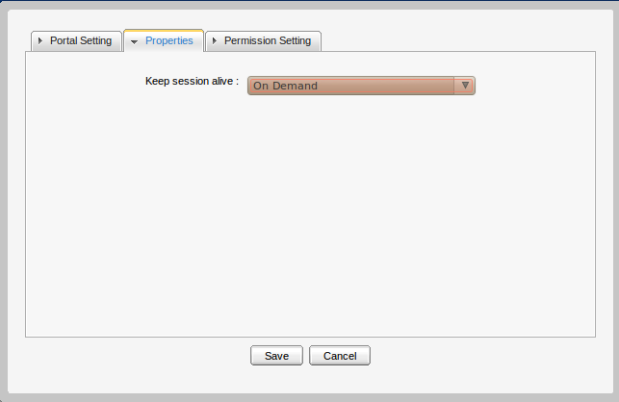Illustration 29: The Properties tab
- Edit permission is also empty and you have to select one.
Step 8: Click Save to accept creating the new portal, or Cancel to quit.

Access a portal
If you want to access a portal, you must be in the Access Permissions list of that portal.
For example: a portal's Access Permission list:
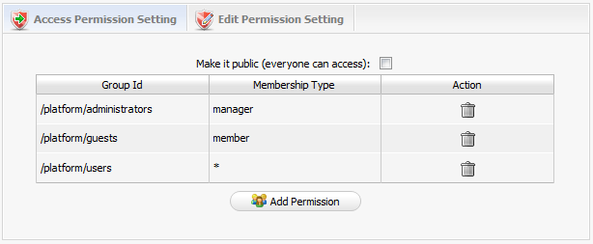
To access this portal, a user must be a “manager” of group /platform/administrators or a “member” of /platform/guests or a user in /platform/user with any membership type. To add more access rights, click the Add Permission button and then select the desired group and membership type.
There is a flexible option for you to choose if you want everyone can access the portal by just selecting Make it public. In this case, the detailed access permission list disappears:
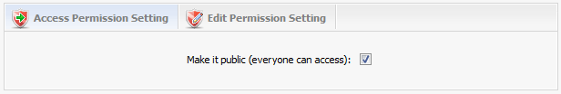
After setting the access permission for the portal, users who have access right can go into that portal in public mode by typing the public URL in browser (for example, http://localhost:8080/portal or http://localhost:8080/portal/public/[new-portal-name]). Furthermore, users can access to that portal in private mode by signing in the public mode. There is also a direct URL for the private mode: (for example, http://localhost:8080/portal/private/[new-portal-name]). Users who only have the access permission on the portal can view pages but they cannot change any information of that portal.
You can set access permissions for a portal when you create or edit it.

Edit/Delete a portal
The function is to change information of the current portal, such as properties, or layouts.
To do this, you must have the edit permission. Please contact your Administrator to get more permissions. When you have the edit permission, follow one of two ways below to edit the current portal:
The 1st way:
Step 1: Go to the portal that you want to edit.
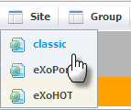
Step 2: Go to Site Editor → Edit Layout:
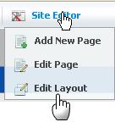
The 2nd way:
Step 1: Click Site, then click that corresponds to the portal that users want to edit.
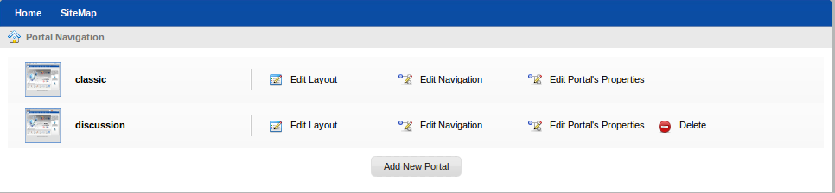

The Edit Site Layout will be displayed:
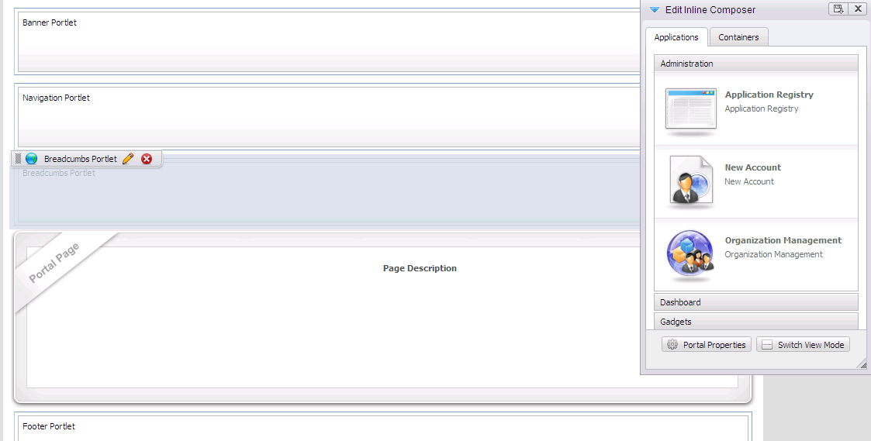
Step 2: Click to edit portal properties.
The form to edit the portal properties will appear:

Step 3: Change the properties of the current portal settings, properties or modify permissions:
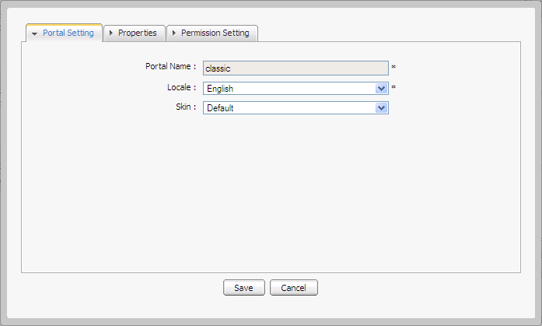Illustration 30: The Portal Setting tab of the portal properties form
For example: a portal's Edit Permission looks like:
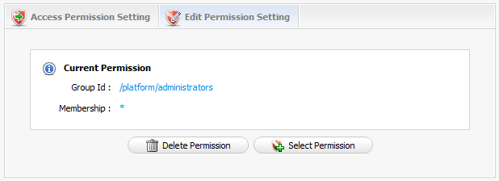
It means any user of the group /platform/administrators can perform this action.
To change any permission, click Select Permission, then select a group with the Membership type you want. Only one group can have the Edit Permission on the portal.
You can set Edit Permission for the portal when you create or edit it.
Step 4: Click the Containers tab to edit the portal container layout by selecting, dragging and dropping it.
Step 5: Click the edit icon to edit the portlet in the portal or the delete icon to remove the existing portlet.

Step 6: Add other portlets by selecting, dragging and dropping from the Applications tab of the Edit Inline Composer form to the main panel.
Step 7: Click the Finish icon to save changes.

Delete a portal
To delete a portal, users must be in the group that has the Edit Permission on that portal.
do as follows:
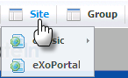
Step 1: Click Site on the administration toolbar.
The Portal Navigation page will appear with a list of all portals:

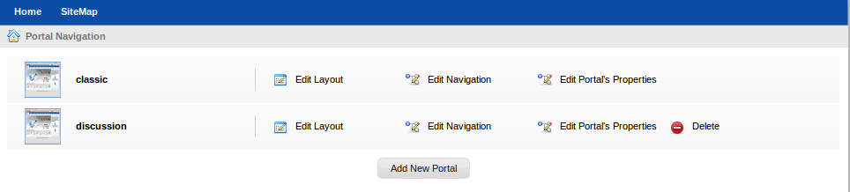Illustration 31: Portal Navigation
Step 2: Click Delete that corresponds to the portal you want to delete.
Step 3: Click OK on the confirmation message box to accept deleting, or Cancel to quit.
Note:
The default portals cannot be deleted by any user, including the administrator.

Access a specific portlet
Portlets are used as content bricks of a page. For individual needs, users can compose their pages using any portlet that they have access permission. Some portlets are designed for administrators only, therefore you should restrain the access to these portlets.
Users, including administrators, only have access permissions to portlets other than edit permission. You can give access permission to any group.
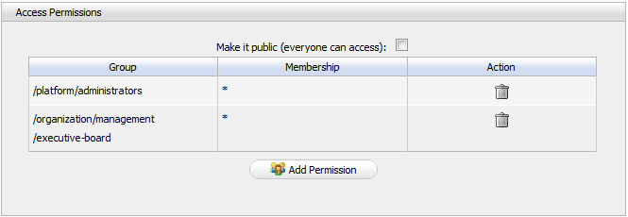Illustration 32: The Access Permissions form
The access permission enables performing these followings:
- When you create/edit a page by wizard, at step 3, all portlets under your access permission will be displayed in the Applications tab of the Page Editor form that is ready for you to drag and drop into the page area in the main panel.
- When you edit a node's page in Edit Page and Navigation, all portlets under your access permission will be displayed in the Applications tab of the Page Editor form that are ready for you to drag and drop into a page area in the main panel.
- When you edit a page in Manage Pages, all portlets under your access permission will be displayed in the Applications tab of the Page Editor form that are ready for you to drag and drop into page area in the main panel.
When you edit the current portal, all portlets under your access right will be displayed in the Applications tab of the Page Editor form that are ready for you to drag and drop into the page area on the right panel.

Edit a specific portlet
This section tells you how to access the edit mode of a portlet and edit it.
Step 1: Create or edit a page by following above steps. In this step, there is a container that contains and arranges portlets as contents of that page. You can add a portlet into that page by dragging it from the left panel and dropping it into this container space.
Step 2: Open the form to edit a portlet by clicking the edit portlet iconat the upper left corner of that portlet:
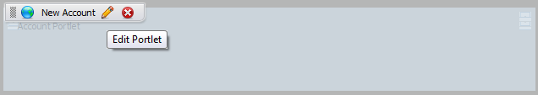
Step 3: Enter new values that you want to edit in this form, then click the Save button to save new values:
Normally, a portlet has 4 components: the Portlet Setting tab, the Select Icon tab, the Decoration Themes tab and the Access Permission tab. In addition, some porlets may also have a Edit Mode tab or a Preferences tab. The administrator can change the interface of a portlet by changing values in the Edit Mode tab or in the Preferences Tab.
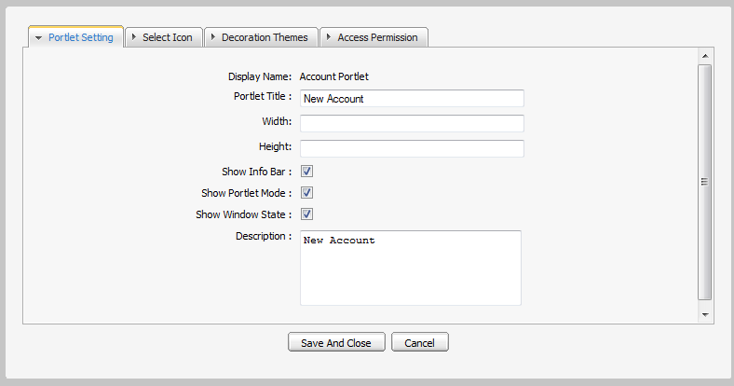Illustration 33: The Portlet Setting tab
The Portlet Setting tab includes:
Display Name: The display portlet name
Portlet Title: The portlet title. The length must be between 3 and 30 characters.
Width: The portlet's vertical size. The value of this field must be in numeric format. This field is not required.
Height: The portlet's horizontal size. The value of this field must be in numeric format. This field is not required .
Show Info Bar: The option allows showing or hidding the information bar.
Show Portlet Mode: The option allows whether showing the portlet mode or not.
Show Window State: The option allows whether showing the portlet's window state or not.
Description: The brief information about the portlet. The length must be between 0 and 255 characters.
Note: If Show Info Bar is not checked, portlet mode and window state will not be displayed in that portlet.

The Select Icon tab enables you to select an icon for the portlet. By clicking Get Default, you donot have to choose any icon from the list, it will be automatically gotten the suitable icon.
- The Decoration Themes tab enables you to select a theme for the portlet from a theme list. By clicking Get Default, you do not have to choose any theme, it will be automatically set:
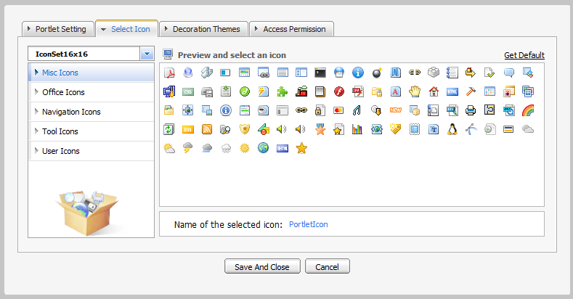Illustration 34: The Portlet Icon tab
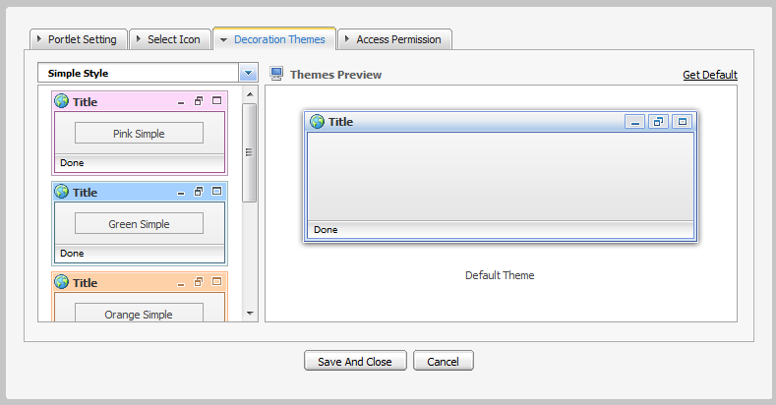Illustration 35: The Decoration Themes tab
- The Access Permission tab enables you to set access permission on the portlet. The porlet can be made public to everyone or restricted to specific groups.
To allow more groups to have access permission, simply click Add Permission to select more groups.
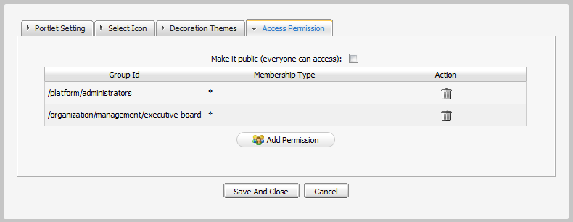Illustration 36: The Access Permisson Tab
- Some portlets have a Edit Mode and Preferences tab:
Example:
- IFrame and Dashboard portlets have the Edit Mode, the administrator can define the interface details in the Edit Mode tab:
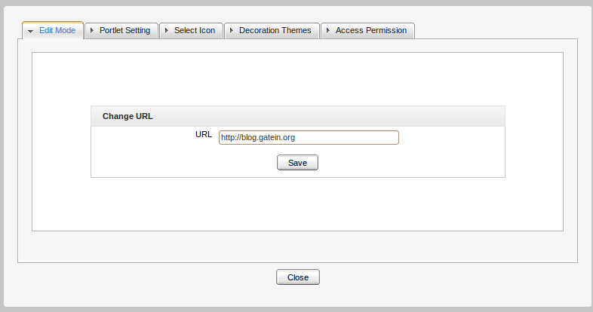Illustration 37: The Edit Mode tab of the IFrame Portlet

Edit portal's navigation
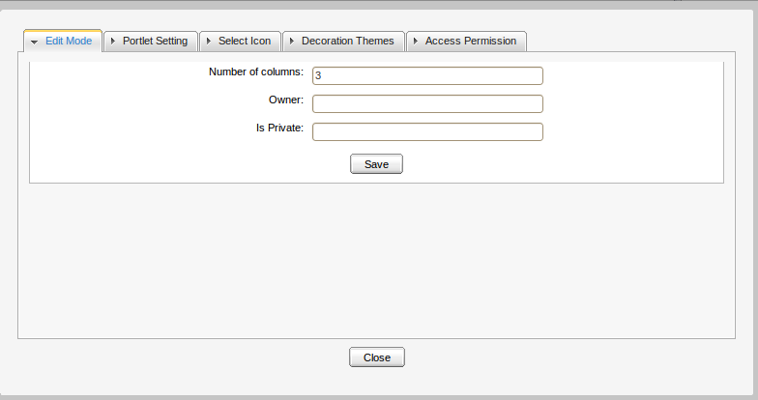Illustration 38: The Edit Mode of the Dashboard Portlet
The function enables you to edit the navigation of portal.
Do as follows:
Step 1: Click Site on the toolbar:
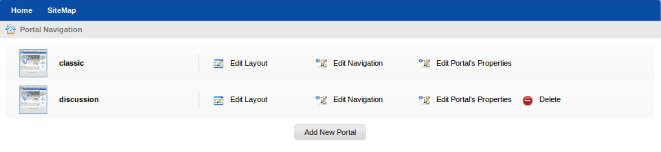Illustration 39: Portal Navigation
The Portal Navigation page will appear with a list of all portals:

Step 2: Click the Edit Navigation link that corresponds to the portal you want to edit.
The Navigation Management form will be displayed:
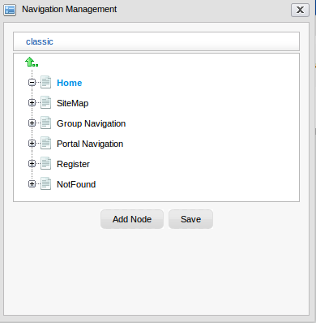
Step 3: Select the navigation that you want to edit.
Step 4: Click Add Node to add or change the node for a specific navigation.
Step 5: Click Save to accept changes.

Edit portal's properties
Portal properties such as language, skin and permissions can be set by following these steps:
Step 1: Click Site on the toolbar:

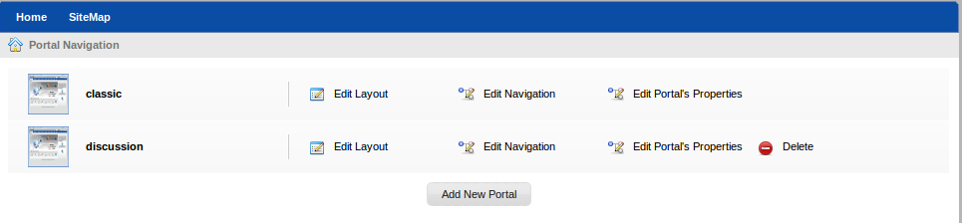
The Portal Navigation page will appear with a list of all portals:

Step 2: Click Edit Portal's Properties corresponding to the portal that you want to edit.
The form used to edit portal's properties will be displayed below.
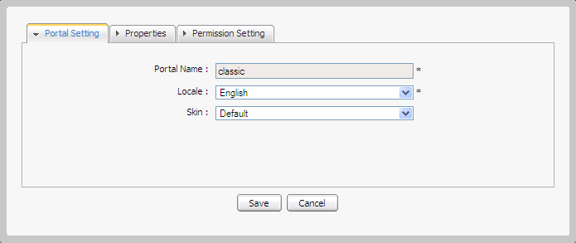
Step 3: Make changes in the Portal properties form.
Step 4: Click Save to accept the changes, or Cancel to discard any change.

Change portal skin
GateIn skins are graphic styles that help displaying attractive user interfaces. Each skin has its own characteristics with different backgrounds, icons, and other visual elements, etc. In order to be user-friendly and flexible in use, users are allowed to change skin without editing the portal right.
The skins can be changed permanently or temporarily.
Change the skin permanently
Step 1: Click Site on the toolbar and select the portal that you want to edit.
Step 2: Click which corresponds to the portal that you want to edit The portal will be displayed under the edit mode.
Step 3: Click to edit portal properties.
Step 4: Select one skin type in the Skin lists field to change in the Portal Setting tab. Currently, there are two supported types, including Default and SimpleSkin.
Step 5: Click Save and select to take affect.

Note: The display skin which is changed by this way will be kept permanently till you change the skin when you edit the current portal again.
Change the skin temporarily
Step 1: Mouser over the Star menu and click Change Skin.

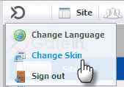
The Skin Setting form is displayed with a list of all supported skins. The left panel contains the skin list and the right panel is used to display the selected skin's template.
Step 2: Select one by clicking the skin type in the combo box. Currently, GateIn 3.1 supports two skin types, including Default and SimpleSkin.
Step 3: Click Apply and wait for a few seconds to take effect.

Note: Changing the skin by this way only takes effect on the current session. The next time you sign in, it will return to the portal default skin.

Switch between portals
This function enables users to select and use another portal (gateway, starting site). Only the users who got the appropriate permission by the administrators can perform this action.
To switch between portals, simply click Site on the administration tool bar and click the portal name you want to switch.
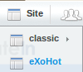

Manage nodes
If you are the portal administrator or the portal administrator has granted you the appropriate permission privileges, you can execute some special actions related to portal nodes, including copying, editing, cutting, cloning, deleting, adding existing nodes.

Add a new node
do as follows:
Step 1: Click Site on the toolbar. The Portal Navigation will be displayed.
Step 2: Click Edit Navigation that corresponds to the portal you want to add a new node.
Step 3: Select a navigation from the navigation list.
Step 4: Select a node from the list to create a node as a sub-node of the selected node or click the arrow up icon to create a new node at the root level of the portal.
Step 5: Right-click the selected navigation or node and select Add new Node.
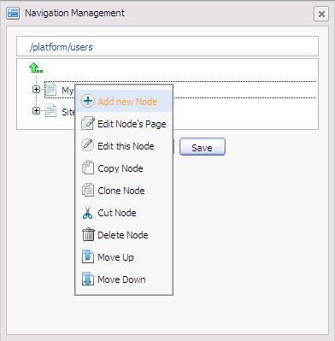
The Add new node form appears:
Details:
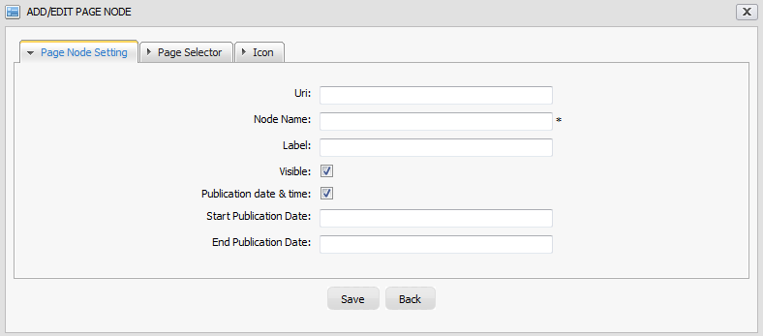Illustration 40: The Page Node Setting tab of the Add/Edit Page Node form
The Page Node Setting tab includes:
Uri: The node's identification. The Uri is automatically created once a new node has been created.
Node Name: The node name which must be unique. Only alphabetic, numeric and underscore characters are allowed and it must contain at least 3 characters.
Label: The node's display name on the screen. This field may be changed and its length must be between 3 and 60 characters.
Visible: This checkbox allows the page and its node to be shown or hidden at the navigation bar, the page navigation bar and the sitemap. See above for more details.
Publication date & time: This option enables this node to be published for a period of time. Two fields, including 'Start Publication Date' and 'End Publication Date' only display when this option is checked.
Start Publication Date: The start date and time to publish the node.
End Publication Date: The end date and time to publish the node.
In the Page Selector tab, you can select a page or not for this node.
Details:
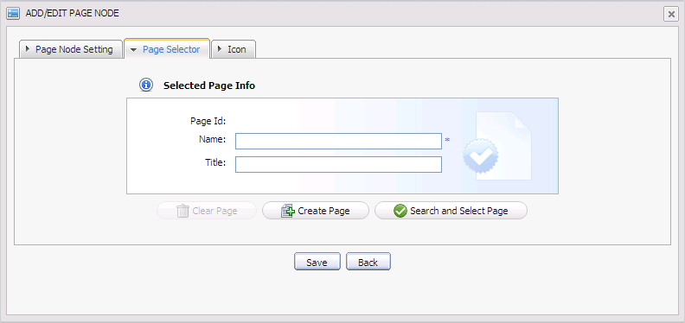Illustration 41: The Page Selector tab of the Add Page Node form
Page Id: The identification string of the page.
Name: The selected page's name.
Title: The selected page's title.
Clear Page: This is to remove the inputted page information in the fields
Create Page: This is to create a new page with the inputted name and the title.
Search and Select Page: This is to search and select an existing page.
You donot have to input values in these fields. They are automatically displayed after you have selected an exiting page by clicking Search and Select Page.
The Select a page form appears:
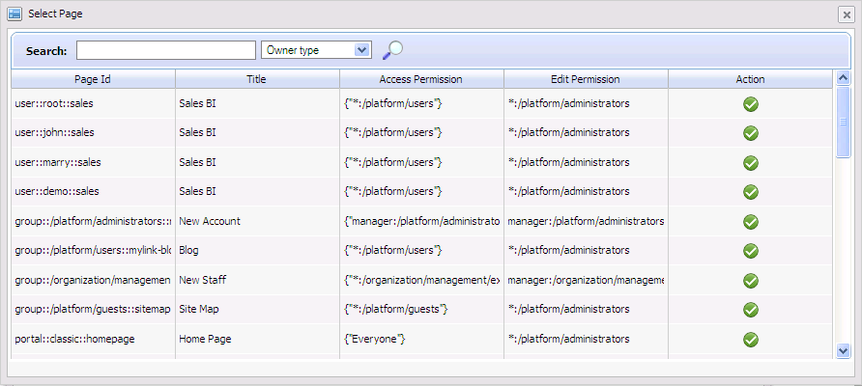Illustration 42: The Select Page form
The list of all existing pages is displayed with basic information. To select a page for creating a node, do as follows:
Step 1: Select a page from the list or search a specific page.
Step 2: Enter a search term related to the page that you want to search.
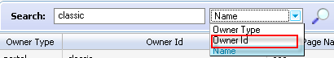
Step 3: Choose the field you wish to search in:
Step 4: Click the magnifying icon to perform the search. All pages matching with the search term will be listed.
Step 5: Click the icon on the row of the desired page.
After selecting a page, the details of this page will be displayed in the Page Selector form.

Note:
To select a page, you must be a member in the Access Permission or Edit Permission list of the selected pages. When the page type is 'User', you can not select a page of another users.
If you do not have the access permission for any page in the list, please contact your administrator to get appropriate permissions.

Step 6: Choose one icon in the Icon tab.
Step 7: Click Save to accept the new node page, or X to close the form.

Edit a node
This function is used to edit the node setting and re-select a page for a node.
do as follows:
Step 1: Click Site on the toolbar. The Portal Navigation will be displayed.
Step 2: Click Edit Navigation of the portal you want to modify.
Step 3: Right-click the selected node and select Edit this Node in the menu.
The Editing Node form appears with all fields as you saw it when you create a node, the current node's details are displayed in a form.
Step 4: Change values in fields of the current node. Note that the node name can not be changed.
Step 5: Click Save to complete changing or X to quit.

Copy/Paste a node
These functions are used to reproduce a node to another place.
Do as follows:
Step 1: Click Site on the toolbar. The Portal Navigation will be displayed.
Step 2: Click Edit Navigation of the portal you want to modify.
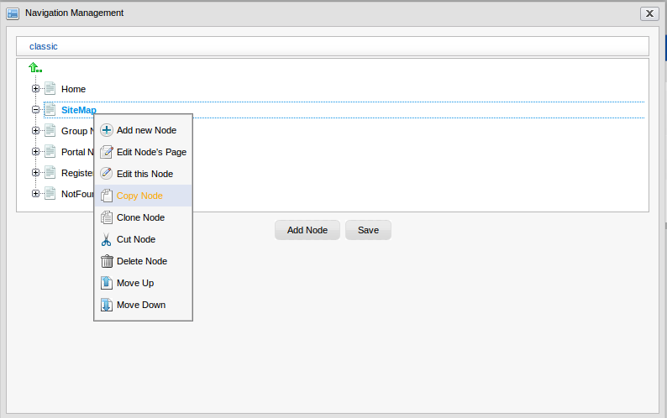
Step 3: Right-click the selected node and select Copy Node in the menu.

Step 4: Select the position you want to paste this node and select Paste Node.
The node selected at step 3 will be reproduced in a new place.
Step 5: Click Save to make change.
Note: Existing two same node names in the same place is not allowed.

Clone a node
This function allows you to make a node copy. The difference between clone node and copy node is that the clone node has its own page with the same content as the selected node. Therefore, there will be a new page that has the same name as the cloned node's page shown in the page list when you access Manage Pages.
Do as follows:
Step 1: Click Site on the toolbar. The Portal Navigation will be displayed.
Step 2: Click Edit Navigation of the portal you want to modify.
Step 3: Right-click the selected node and select Clone Node in the menu.
Step 4: Select the position you want to paste this node and select Paste Node.
The node cloned at step 3 will be reproduced in a new place.
Step 5: Click Save to make change.

Cut a node
This function allows users to change the position on a specific node (like changing the page path).
do as follows:
Step 1: Click Site on the toolbar. The Portal Navigation will be displayed.
Step 2: Click Edit Navigation of the portal you want to modify.
Step 3: Right-click the selected node and select Cut Node in the menu.
Step 4: Select the position you want to paste this node and select Paste Node.
The node cut at step 3 will be moved to the new position.
Step 5: Click Save to make change.
The node at step 3 is moved to a new place.

Note: It is not allowed for two same node names to exist in the same path (node).
Four navigations, including Group Navigation, Portal Navigation, Register, and NotFound can not be cut, including administrators. Also, the above system nodes which have been copied, or cloned can not be cut in the new position. However, you can cut them through cutting the node which contains them, excluding the system nodes.

Delete a node
The function is used to remove a node (link to page).
do as follows:
Step 1: Click Site on the toolbar. The Portal Navigation will be displayed.
Step 2: Click Edit Navigation of the portal you want to modify.
Step 3: Right-click the selected node and select Delete Node in the menu.
Step 4: Click the Ok to accept the deletion or Cancel to discard.
Step 5: Click the Save to make change.
A confirmation message will be displayed.
Step 6: Click OK to confirm deleting or Cancel to quit.

Note: When you delete a node, you delete the link to page but the page still exists. Four navigations, including Group Navigation, Portal Navigation, Register, and NotFound can not be deleted by any users, including administrators. Also, the above system nodes which have been copied, or cloned can not be deleted in the new position. However, you can delete them through deleting the node which contains them, excluding the system nodes.

Change nodes order
This function is used to change the position of a node up/ down.
do as follows:
Step 1: Click Site on the toolbar. The Portal Navigation will be displayed.
Step 2: Click Edit Navigation of the portal you want to modify.
Step 3: Right-click the selected node and select Move Up or Move Down in the menu.
The selected node will be moved up/down.
Step 5: Click Save to make change.

Manage pages

Create a new page with Site Editor
A page creation wizard is available to the portal's administrators and facilitates them to create and publish portal pages quickly and easily. The whole process to create a new page can be devided into 3 specific steps:
- Select a Navigation Node and create the page
- Select page layout template
- Re-arange page layout and add portlets

Select a Navigation Node and Create a Page
In this first step, you have to set the Node Name and Display Name of your page. You are also able to decide the pages visibility and how long the page will be published . Do as follows:
Go to on the Administration bar→ Add New Page.
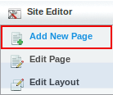
The wizard will be displayed like below:
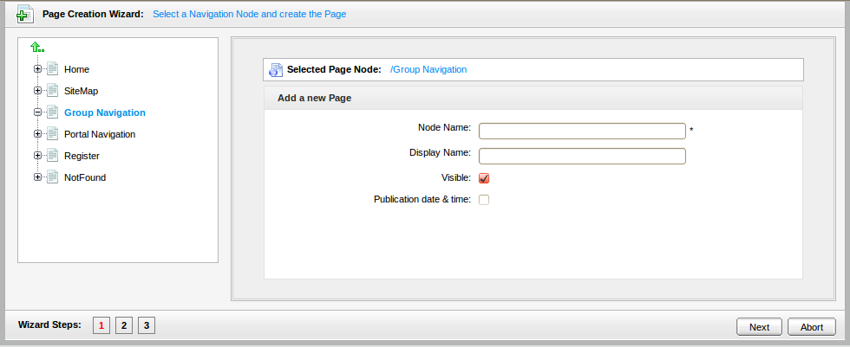Illustration 43: Step 1:Select a Navigation Node and create the Page
The Page Creation Wizard in this step is divided into two panels: the left panel contains the existing pages (navigation node) that's displayed in tree structure. The right panel displays the Page Editor, where you can make changes to selected navigation node.
Using the left panel to navigate up and down the node/page structure.
Using the right panel is to put parameters for a new page, in which:
Selected Page Node: The path of the selected node to add a new sub page.
Node name: The node name of the added page. This field must start with a character and have length between 3 and 30 characters (required field).
Display name: The display name of the node which contains the added page and must have length between 3 and 30 characters.
Visible: This checkbox allows this page (node) to be shown on the Navigation bar, Page Navigation and Site Map to be shown or not. By default, the checkbox is checked and it means that this page is shown in Navigation, Page Navigation and Sitemap. When this option is checked, the visibility will depend on the “publication date and time” option.
Publication date & time: This option allows the page to be published for a period of time. If this option is checked, your page will be shown from selected pertiod of time.
Start Publication Date: The start date and time to publish the page.
End Publication Date: The end date and time to publish the page.
Note: You can set date and time by clicking the Start Publication Date field and the End Publication Date field and select a date in a calendar pop up
When you finish, click Next to go to the next step: Select a page layout template

Select a page layout template.
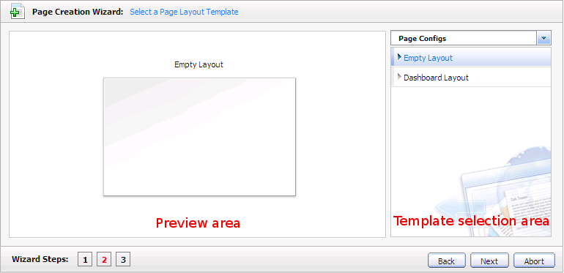Illustration 44: Step 2- Setting a Page Layout Template
Select Empty Layout or click the icon to see more templates.
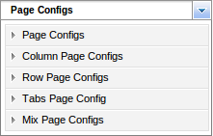
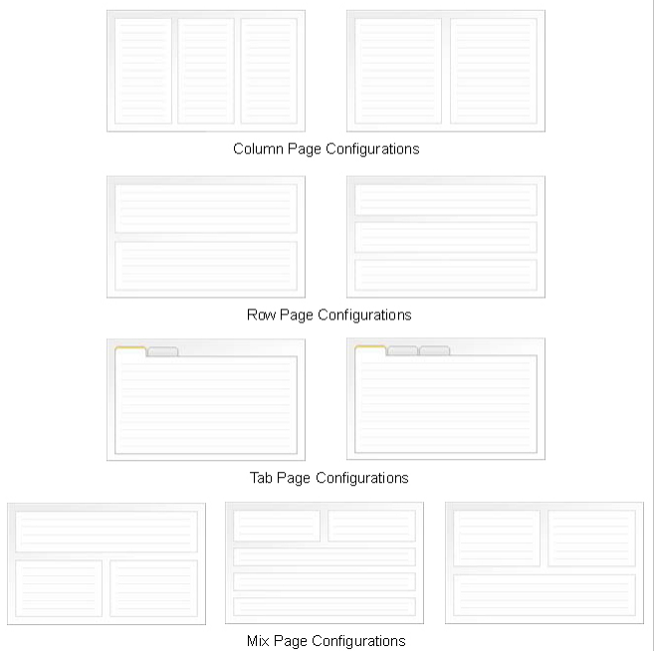Illustration 45: The Page configurations types
Chose a page template, when you finish click Next to go to the last step .

Re-agange the page layout and the portlets.
In this step, you will use Page Editor to add all available Portlets and Containers to your page as well as to view page properties or preview changes.
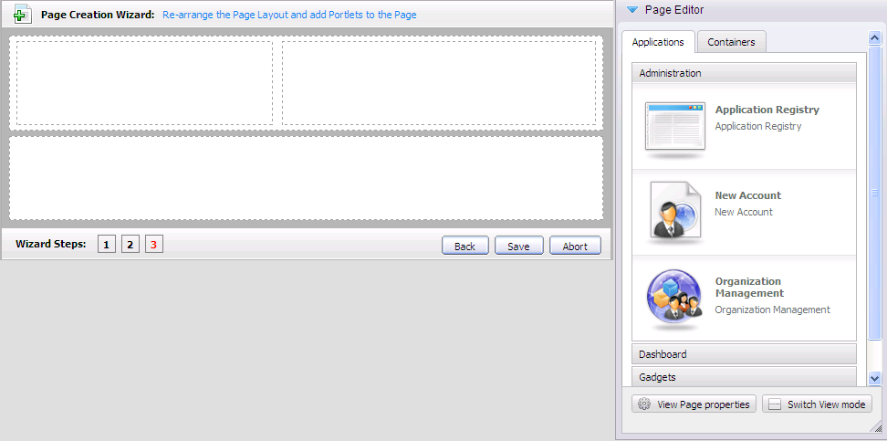Illustration 46: Step 3: Re-arrange Page Layout and add portlets into the page
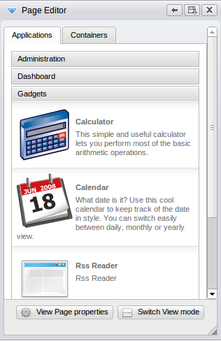Illustration 47: The Page Editor

- The Applications tab lists all the categories and their portlets that you easily can drag and drop in your page area:
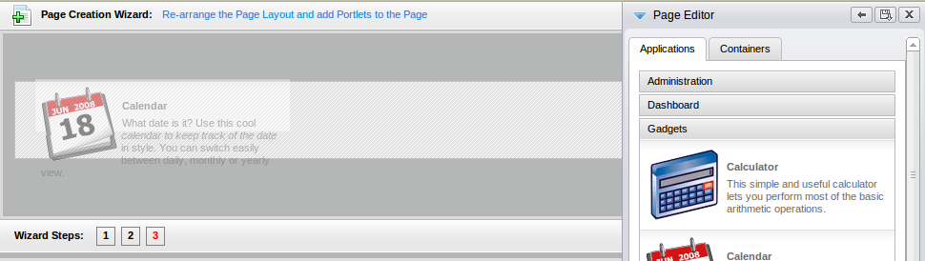
A new portlet will be displayed on the position of your choise. When you hover your mouse over that portlet , a small tool bar will appear and let you move, edit or delete that porlet:
: Edit portlet. See 4.1.1.5: Edit a specific portlet for detailed information about portlet editing.
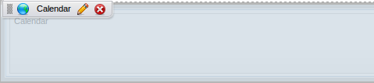Illustration 48: A tool bar will appear when mouse over
: Delete portlet
- The Containers tab contains all the existing containers that's needed to build the page layout.
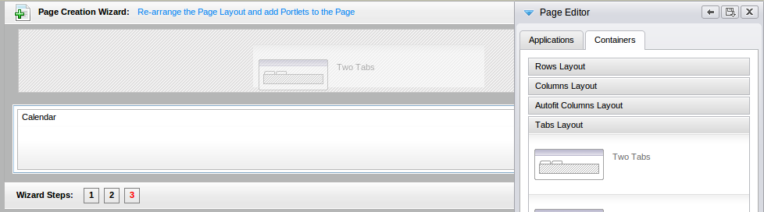
Add a container into the page area by dragging and dropping the container from Page Editor into the page's area.
Similar to portlet, with each selected container, when hover your mouse over container you can:
- Change the containers position by mouse over to left-top corner of a container, then drag and to the new place.
- Edit or delete the selected container by clicking the corresponding icon
- To preview all the changes, click button on the Page Editor.
- When you are satisfied with the result, clickon the Page Editor to save all the changes.
Note: If you clickon the Page Editor after making changes to the page, I you will receive a confirmation message asking you to save the changes or not.

Create a new page using Page Management
Step 1: Go to Group on the toolbar → Administration → Page Management.
The Manage Page page will appear:
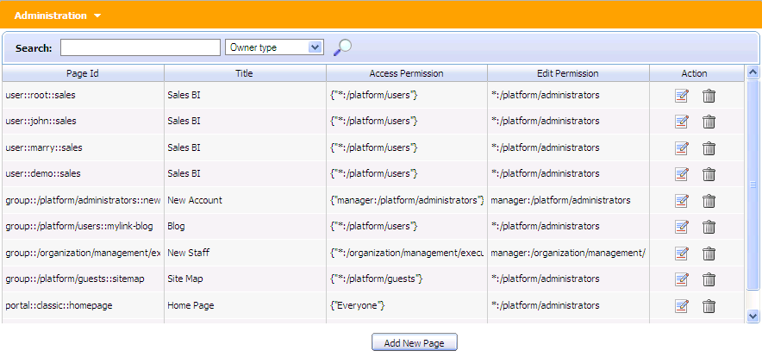Illustration 49: The Manage pages page
Step 2: Click Add New Page.

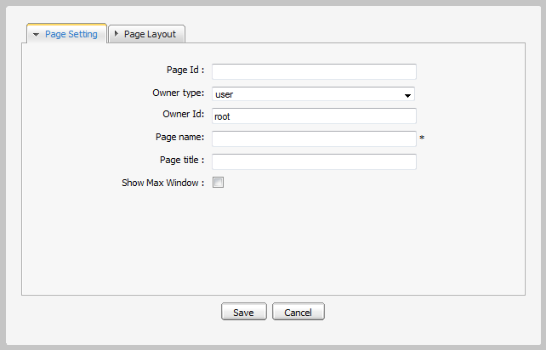
Step 3: Enter values for the Page Setting tab.
Details:
Page Id: The page's identification string. It is automatically generated when you finish creating the page.
Owner type: If the page's Owner type is portal, the page is created for a portal. Therefore, only users who have edit permissions at the portal level can create this page type.
The name of the current portal is automatically selected for Owner id, ensuring that the edit permissions are assigned to users who can edit the current portal.
If the page's Owner type is group, the page is created for a group. As a result, only users who have manage permissions for that group can create this page type.
Owner Id: The identification name of the page's owner. When the owner type is “group”, there will be a list of groups of which you have to select one.
Page Name: The page name. This field is required and must be unique. Only alphabetic, numeric and underscore characters are allowed and its length must be between 3 and 30 characters.
Page title: The page title. This field is optional and must have the length between 3 and 30 characters.
Show Max Window: The option allows whether the page is shown at maximum size or not.
The Page Layout tab enables defining the page layout:

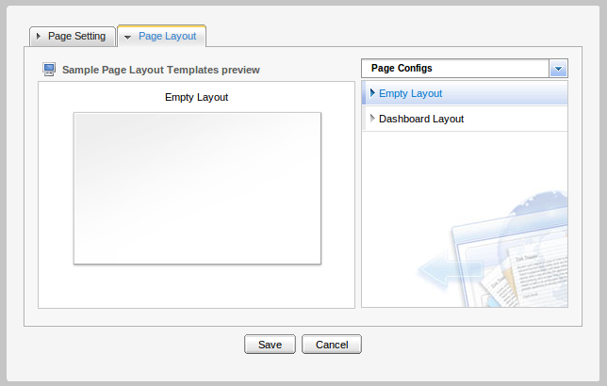Illustration 50: The Page Layout tab of the Add New Page form
Step 4: Click Save to accept creating a new page, or Cancel to quit the form.

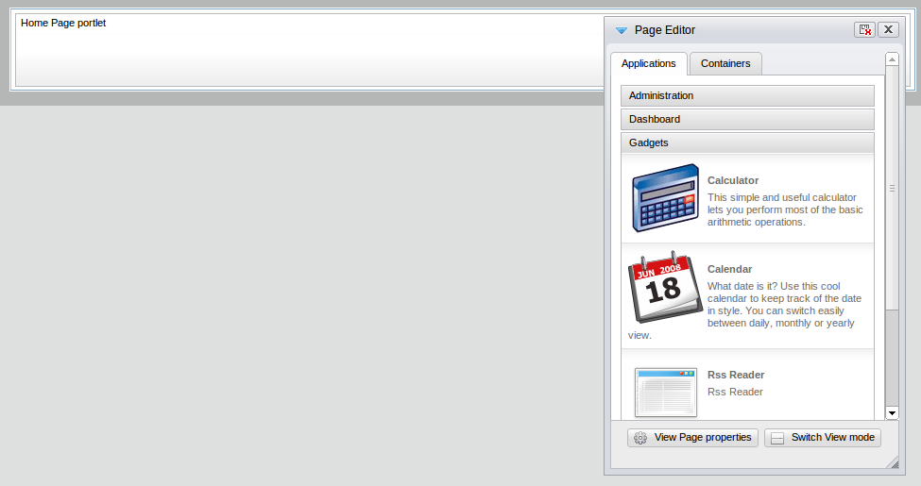Illustration 51: A page in edit mode
Step 3: Make changes to the selected page by using the Page Editor
Step 4: Clickto save all changes oron the page editor to quit the edit mode
Note: There will be a notification if you quit the edit mode after making changes to the page.

View a page properties
To view page properties, you have to open the Page Editor. There are 2 different ways to open this editor:
The 1st way:
Step 1: Clickon the Administration bar → Edit Navigation in the Portal Navigation page.
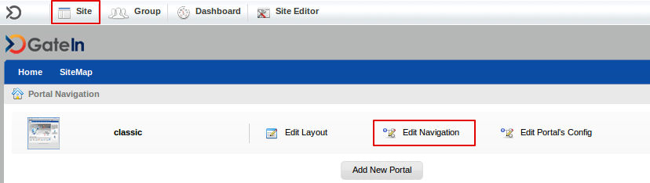
The Navigation Managemet will be displayed
Step 2: Select a node from Navigation Managemet
Step 4: Right-click on that node and select Edit Node's Page in the menu.
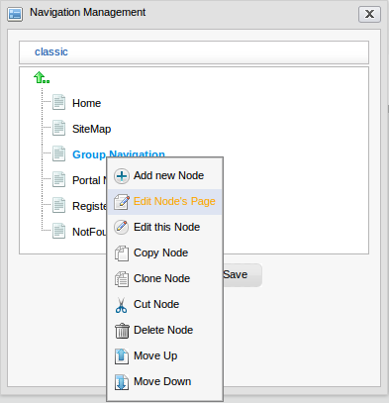
The Page Editor will appear.
The 2nd way:
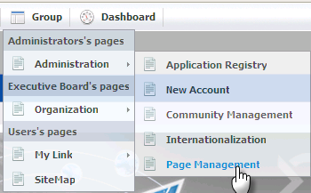
Step 1: Go to Group → Administration → Page Management.
Step 2: Click the coresponding icon of a page that you want to edit
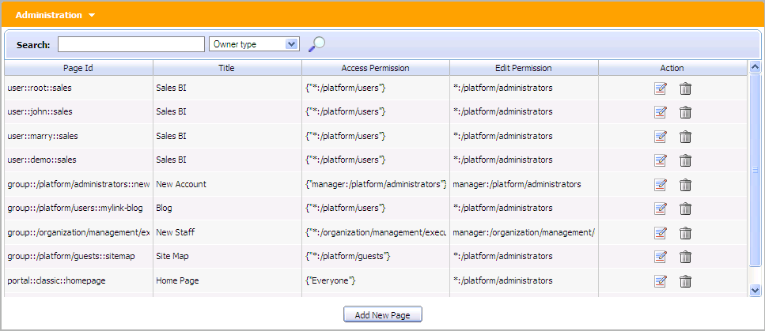
The edit page will be displayed with the Page Editor .

After following one of above ways, to View Page properties do as follow:
Step 1: Click in the Page Editor to edit page properties:

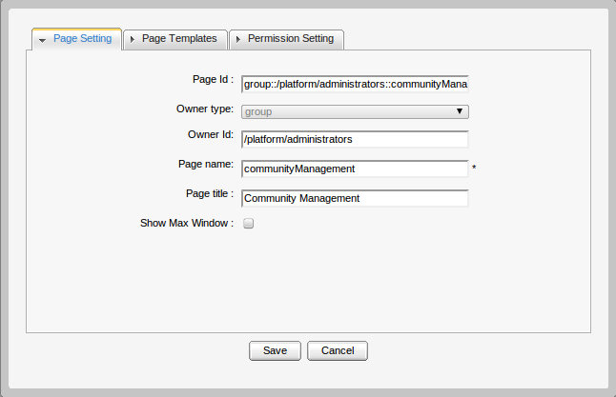Illustration 52: The Page Setting tab of the Portal Properties form
- The Page Setting tab includes:
Page Id: The page's identification string . It can not be changed.
Owner type: The page type (portal or group or user). It can not be changed.
Owner Id: The identification of the page's owner. It can not be changed.
Page name: The page name. It can not be changed.
Page title: The page title which can be changed and must have the length between 3 and 30 characters.
Show Max Window: If checked, the page's portlets will be displayed in the whole page space.

- The Page Templates tab: You can change the page template in this tab.

- The Permission Setting tab: is to support for pages of a group or a portal. Because a page of a user is private, no one can access or edit the user's page, except the creator so you do not have to set permission for it. Permission on each page is set in two levels: Access Permission and Edit Permission.
- Access Permission: It allows users to see content of a page or “borrow” that page for individual needs by selecting a page for their node. Page Access permission can be set to some user groups or set to everyone (also including unregistered users). The Access Permission Setting sub-tab in the Permission Setting tab is shown:

- There is a list of current access permissions on a page. You can click the delete icon to remove the permission or click the Add Permission button to add more. Check the Make it public if you want to allow all users to access.
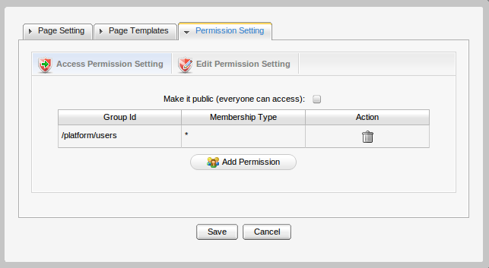Illustration 53: The Access permission setting form of the Permission Setting tab
- Edit Permission Setting: allows you to change information of a page. The edit permission is only set for one single group.
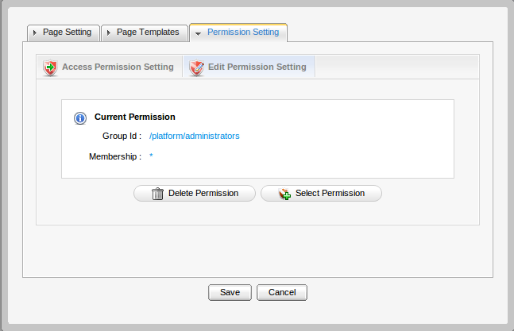Illustration 54: The Edit Permission form
The edit permission on a page can be set for one group with one specific membership type (or * means all membership types in group). If you want to re-assign this permission to another group, click the Select Permission to choose another one.
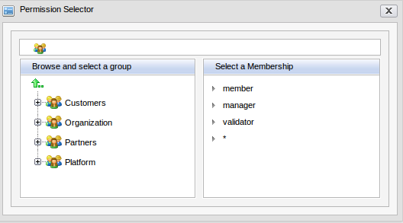
Step 3: Click in the Page Editor .
The form to edit the page will appear below:
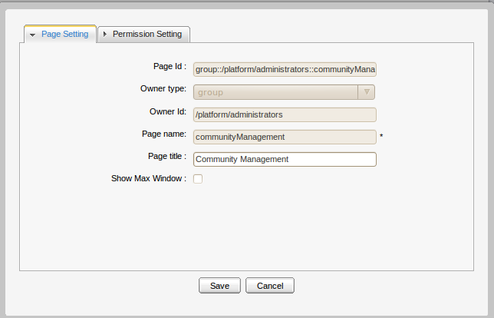

Delete a page
Step 1: Go to Group → Administration → Page Management.
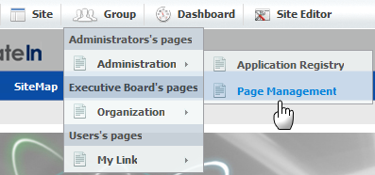
There will be a list of all existing pages and their information:
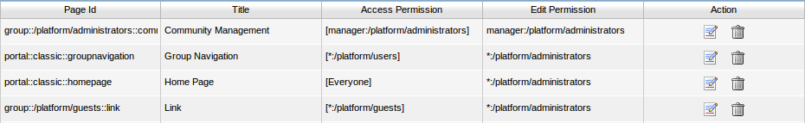
Step 2: Click the coresponding trash iconof page that you want to delete.
There will be a confirmation message appears:
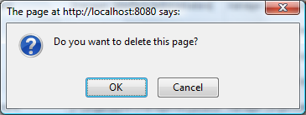
Step 3: Click OK in the confirmation message to accept the deletion, or Cancel to discard.

Manage users and groups
Select Group → Organization → Users and groups management.
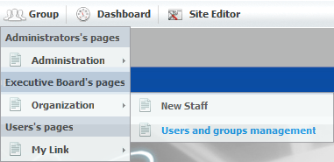
The Organization form is shown:
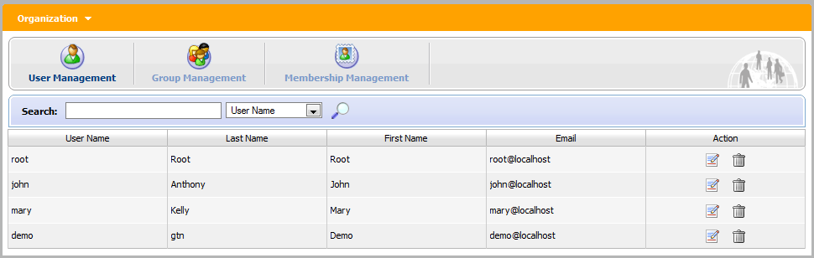Illustration 55: The Organization form

Manage users
Administrator can easily find, edit information of user via User Management page.
Select Group → Organization → Users and groups management. Select the User Management tab in the Organization form. By default, all existing registered users will shown.
Administrators can see, search, edit or even remove users. Each users group or membership in these groups are also available. You can not add a new user but can remove users from their group.

Search for users
Administrators can use this function to search for specific users by User Name, First Name, Last Name or Email Address. To search for a specific user, do as follows:
Step 1: Type the Search term related to the user that you want to search. You do not need to enter an exact term.
Step 2: Select the information type you want to search against.
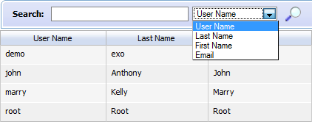
Step 3: Click the magnifying glass icon to perform the search.

Edit user's information and settings
Click the edit iconcorresponding to the user that you want to edit. All user's information and settings are displayed in 3 tabs: Accounft Info, User Profile, User Membership.
- In Account Info tab you can view and change the essential user's information.
Check the Change Password box if you want to change the user's password. The length of the password must be between 6 and 30 characters. When the Change Password option is unchecked, New Password and Confirm Password field are hidden.
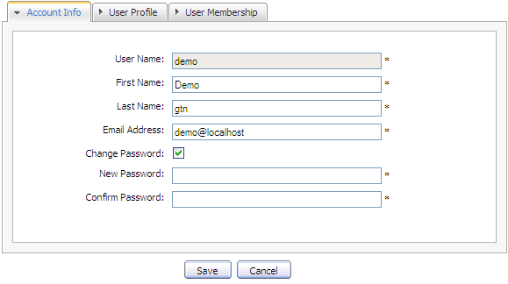Illustration 56: The Account Info tab of the Edit User Info form
Note: You can not edit the User name of the selected user.
- In User Profile tab you can view and change profile information of selected user. You can also change the display Language for that user by chosing a language in the language list. All available languages will be displayed in alphabetical order
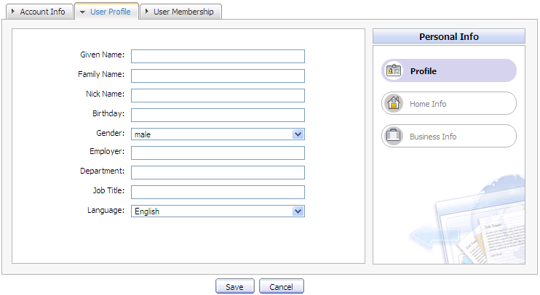Illustration 57: The User Profile tab of the Edit User Info form
- User Membership tab is to view user's information in groups.
- The User Membership tab indicates to the group to which the selected user belongs. In the above illustration, demo is a member of two groups: guests and users. The parent group of both is platform.
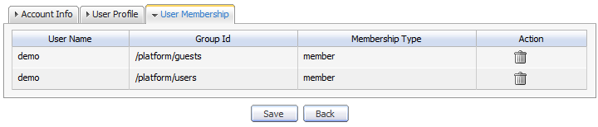Illustration 58: The User Membership tab of the Edit User Info form
- To remove a user from a group, click the trash icon correspondingly
After you are satisfied with all changes you can click Save to finish.

Delete an user
Do as follows:
Step 1: Click the trash icon which corresponds to the user who you want to delete in the main User Management form.
Step 2: Click OK in the confirmation message to accept or Cancel to quit.

Manage groups
Select the Group Management tab in the Organization form. This tab is used to add new, edit or delete a group.
By default, all existing groups will be displayed on the left panel. The right panel shows information about the selected group, including information about members in a specific group and a small form to add a new user to a group.
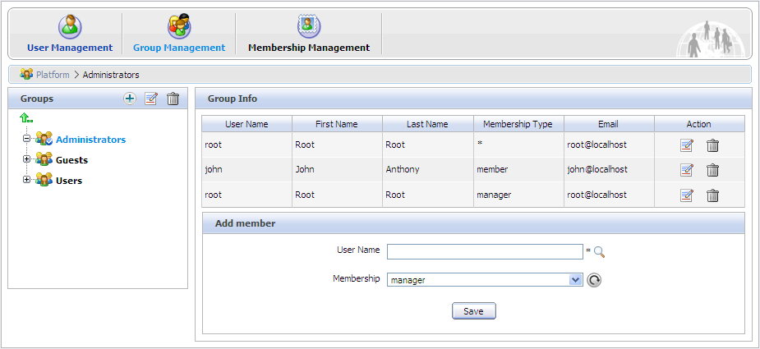Illustration 59: Group Management form

Add a new group
Step 1: Choose the path to create a new group by selecting the group from the list on the left panel or clicking the arrow up icon if you want to create a group in a higher level. The selected path is displayed in the breadcrumb bar.
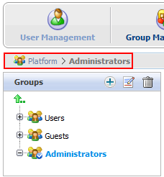
Step 2: Click Add New Group icon . The Add New Group form will be displayed on the right panel.
Details:
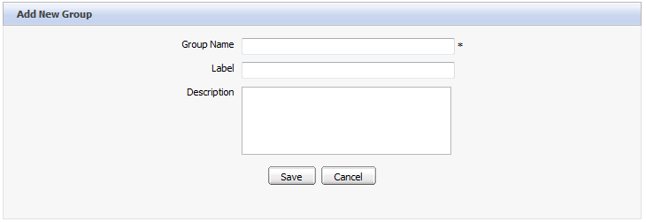Illustration 60: The Add New Group form
Group Name: The new group's name. This field is required and its length must be between 3 and 30 characters.
Label: The group's display name. Any length between 3 to 30 characters is allowed.
Description: The description about the group. Any length between 3 to 30 characters is allowed.
Step 3: Fill in the required fields. Only alphabetic, numeric and underscore characters are allowed and it must be unique.
Step 4: Click Save to accept entered values, or Cancel to quit.
Note: When a new group is added, the group creator will become the manager of that group. The creator's user name will be added in the created group with the "manager" membership.

Edit a group
Step 1: Find the group in the existing tree and click the label.
Step 2: Click the edit icon to show the Edit Current Group form of the selected group.
This form is identical with the New Group form. The Group Name can not be changed by any user.
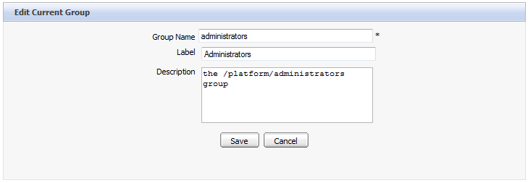Illustration 61: The Edit Current Group form
Step 3: Make change to the Label or Description fields.
Step 4: Click Save to accept changes, or Back to return to the Group Infor form without any changes.

Add a new user to a group
Step 1: Select the path to the group which you want to add a new user to that group by selecting that group from the list on the left panel. The group's information is displayed, including the user list and a form which allows adding a new user.
Step 2: Enter the exact User Name of the user that you want to add to the selected group or you can enter some characters if you are not sure about the exact spelling.
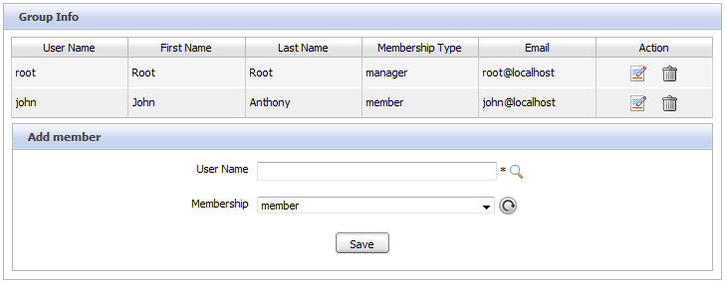Illustration 62: The Add member form
- Click the magnifying glass icon to search by the characters you entered.
- After you click the magnifying icon , there will be a list of all existing users whose User Names include the entered characters. For example, if you enter the 'o', you will get the following result.
- Select the checkbox of the user(s) that you would like to add to the group.
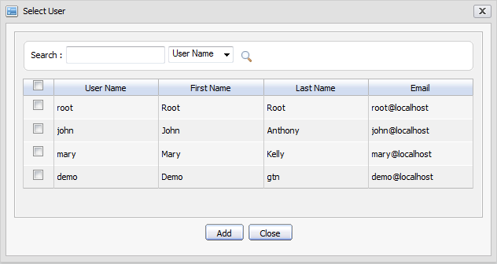Illustration 63: The Select User form
- After clicking the Add button, you will see the complete User Name(s) in the Add member form.
- Select the membership for the user in a group from Memberships list. The refresh icon can be used to update the membership list in case there are any change.
- Click Save to accept adding the selected user to a specific group with the selected membership type.
Note:
- By default, the “manager” membership has the highest right in a group.
- A user can have several membership types in a group. To do that, you have to use the Add member form for each membership type.
- After adding, the user's membership information is also updated. You can check it by opening the User Management form and editing the user you just added.

Edit a user membership in a group
Step 1: Click the Edit icon corresponding to a specific user with a membership in the Action column:
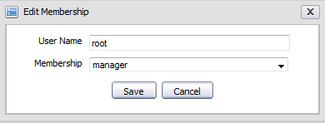Illustration 64: The Edit Membership form
Step 2: Change the membership of the selected user by selecting another value in the Membership list box.
Step 3: Click Save to complete changing.

Delete a group
Step 1: Find the group in the tree.
Step 2: Click the trash icon to delete.
Step 3: Click OK in the confirmation message box to accept deleting, or Cancel to quit without deleting.
Note:
- After being deleted, all information related to that group is also deleted (users and navigation related to this group).
- These following groups are mandatory in the portal, so you cannot delete: Platform; Platform/guests; Platform/users.

Manage memberships
The user's role in a specific group is managed by using Membership Management.
By default, there are three membership types: Manager, Member and Validator. By default, Manager has the highest right in a group.
Select the Membership Management tab in the Organization portlet. There will be a membership type list and a form to add new/edit:
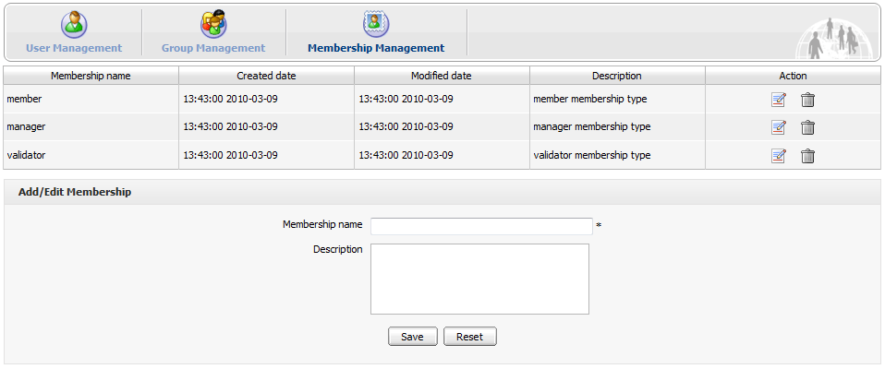Illustration 65: The Membership Management form

Add a new membership type
Step 1: Input values for the Membership name field (required) and the Description field (optional) in the Add/Edit Membership form at the bottom. Only letters, digits, dots, dashes and underscores are allowed for the Membership name. Note that no space is allowed in the Membership name.
Step 2: Click Save to accept adding a new membership, or click Reset to clear the entered values.

Edit a membership type
Step 1: Click the edit icon in the Action column.
Step 2: Make desired changes in this form.
Step 3: Click Save.

Delete a membership type
Do as follows:
Step 1: Click in the row of the membership type you want to delete.
Step 2: Click OK in the confirmation message to accept the deletion.

Manage navigation

Portal's page navigation
Create a navigation
The page navigation of portal is created automatically when a portal is created.
Delete a navigation
You can delete a navigation, a navigation will be deleted automatically after you have deleted its portal.

User's page navigation
Create a navigation
The page navigation of a user is created automatically when a user is created (registered). You donot have to create it.
Edit a navigation
Only the user who is the owner of the user page navigation can edit it.
Delete a navigation
No one can create a user page navigation so that no one can delete it. A navigation is deleted automatically when its user is deleted.

Group's page navigation
Each group has only one page navigation. Only users of that group have the “manager” membership can create/edit/delete navigation for that group. This right is set in the portal-configuration.xml file.
<value-param>
<name>navigation.creator.membership.type</name>
<description>specific membership type have full permission with group navigation</description>
<value>manager</value>

Edit group's page navigation
Do as follows:
Step 1: Click Group on the administration toolbar:
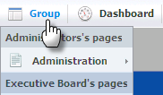
The Group Navigation page will appear:

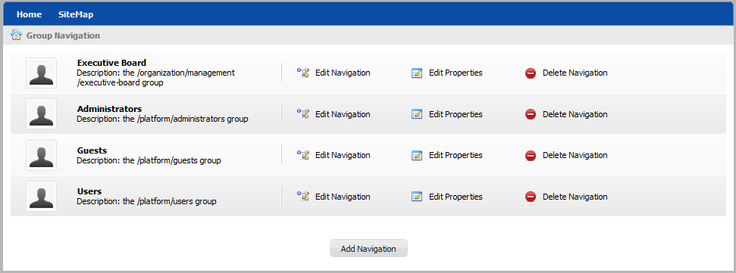Illustration 66: The Group Navigation page
Step 2: Click which corresponds to the group you want to edit its page navigation.
The form to edit the page navigation will appear:
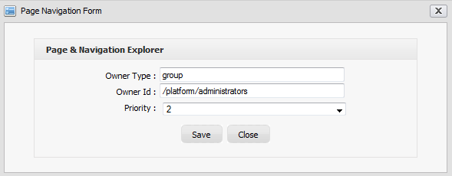
Step 3: Make change to values in this form.
Step 4: Click Save to accept any change, or Cancel to quit.
Note: The priority value determines the display position of the page navigation.

Create a new page navigation
Who can create pages for a group?
Only users who are “manager” of a group can create new pages for that group while the others in this group can not.
To create a page navigation, do as follows:
Step 1: Click Group on the administration toolbar, then select .
The Group list form will be displayed with the Add Navigation button.
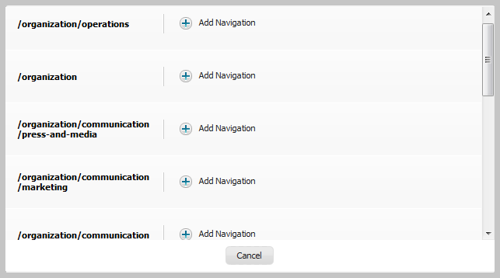
Step 2: Select the Group that you want to add Navigation and click the button . The new group navigation will be added to the group navigation list.

After being added, the new group navigation is displayed in the group navigation list on the left and ready to be added nodes or pages.
Each group has only one navigation. If you add a new group navigation that exists, an alert message will appear to show that you can not create that navigation.

Edit group's navigation properties
This function is to change the priority of a navigation. Only users who have the right can take this action.
Step 1: Click Group on the administration toolbar, then click of the navigation you want to edit. The Page Navigation Form enabling you to change the priority of this navigation will appear:

Step 2: Change the priority of this navigation for the Priority field.
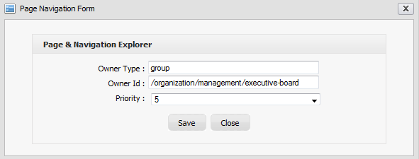Illustration 67: The Edit Navigation form
Step 3: Click Save to accept changes, or Close to quit.

Delete a group's navigation
This function is used to delete an existing navigation. It is only supported for a group navigation. A user navigation or a portal navigation will be automatically deleted when the owner user or portal is deleted.
Do as follows:
Step 1: Click Group on the administration toolbar and clickof the navigation you want to delete.
Step 2: Click OK to confirm deleting, or Cancel to quit without deleting.
After the navigation deletion has been confirmed, the selected navigation is removed from the list and its nodes (hyperlinks to pages) are also deleted.

Manage permissions
How to see a page in public
Seeing a page in public means that you can access that page without signing in. To make a page accessible to the public, you have to follow these instructions:
- The current portal in use must be public (everyone can access).
- The node containing the page that you want to see must belong to the public portal.
- The page which is selected by the node above must be in public (everyone can access).

Set an access permission on a portal
To set access permission for the portal, do as follows:
- For new portals: click Site → Create New Portal → Permission Setting tab → Access Permission Setting sub-tab.
- For existing portals: Go to the portal that you want to change the edit permission by selecting Site Editor → Edit layout:

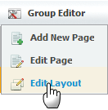
Then click in the Edit Inline Composer, go to Permission Setting tab → Access Permission Setting sub-tab.
To assign an access permission to users in the public mode (without signing in), you have to set the access permission on a portal. To do that, in the Access Permission Setting sub-tab, check Make it public.
If you do not want everyone to access to the portal, do not check Make it public and you have to select group by group. do as follows:
Step 1: Click Add Permission.
Step 2: Select the group that you want to add on the left and then select a membership type on the right. In the membership type list, the sign * means enabling any membership type.
Step 3: After you have selected a membership type, the selected permission is displayed in the access right list. Each time you only can select one group with one membership type. If you want to add more, click Add Permission and select again.
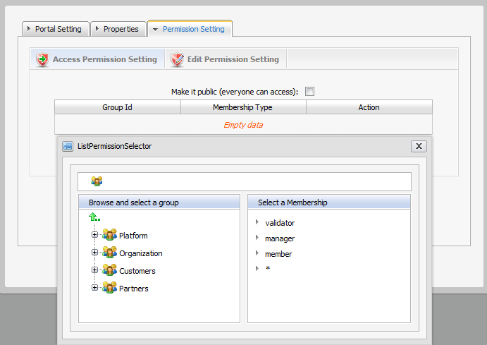

Set an edit permission on a portal
Only users who are in the portal editor group can edit that portal. Access permission can be set for several groups but the edit permission can only be set for a group with a membership type (or every membership type by selecting *). To assign an edit permission to a user, you must add him to the editor group of that portal.
Step 1: To assign permission on a portal, do as follows:
- For new portals: click Site → Create New Portal → Permission Setting tab → Edit Permission Setting sub-tab.
- For existing portals: Go to the portal you want to change the edit permission selecting Site Editor → Edit layout:
Then, click in the Edit Inline Composer, go to Permission Setting tab → Edit Permission Setting sub-tab.
Step 2: Click Select Permission to choose a group.
Step 3: Select a group and a membership type (select * if you want to assign all membership types in the selected group). After a membership has been selected from the right, the selected information is displayed.
Step 4: Click Save to accept.
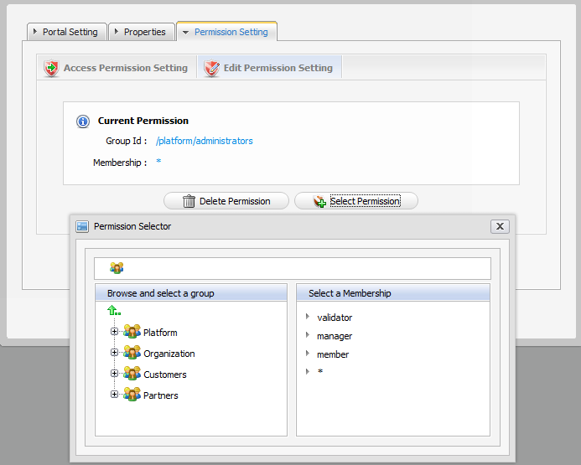

Set a permission on a page
In some cases, some rights on a page are initialized and users who have the edit permission can change the page.
- If the owner type of a page is “user”, you don't have to set permission, no one except the creator has the access and edit permission.
- If the owner type of a page is “group”, initial permissions on page are:
- Access permission: everyone in that group.
- Edit permission: the manager of that group.
- If the owner type of a page is portal, initial permissions are:
- Access permission: users who can access that portal.
- Edit permission: users who can edit that portal.

Set an access permission on a page
Do as follows:
- Click Group → Administration → Page Management → Add New Page, select Owner type which is group or portal → Permission Setting tab → Access Permission Setting sub-tab.
- Click Group → Administration → Page Management → → View page properties (of the Page Editor form) → Permission Setting tab → Access Permission Setting sub-tab.
- Click Group (on the Administration bar) → Edit Navigation. Then, select and right-click the node which contains the page you want to edit. Select Edit Node's Page → View page properties of the Page Editor form → Permission Setting tab → Access Permission Setting sub-tab.
To access to a page (read the page content or perform an action on a page), users have to be in one of the groups that have access permission to that page. There may have several groups that have access permission to a page. If you wish anyone could access to the page, check “Make it public”, otherwise you have to select the groups one by one.
- Click Add Permission.
- Select the group that you want to add on the left and then select a membership type on the right. In the membership type list, * means allowing any membership type.
- After a membership type has been selected, the selected permission is displayed in the access right list. For each time, you can only select one group with one membership type. If you want to add more, click the Add Permission button and select again.

Set an edit permission on a page
Only users who are in the page's editor group can edit it. The access permission can be assigned to several groups but the edit permission only can be set for one single group. To assign edit permission on page to a user, you must add him to the editor group of that page.
Step 1: Select:
- Group → Administration → Page Management → Add New Page → Owner type (which is group or portal) → Permission Setting tab → Edit Permission Setting sub-tab.
- Group → Administration → Page Management → → View page properties of the Page Editor form → Permission Setting tab → Edit Permission Setting sub-tab.
- Group → Edit Navigation. Select and right-click the node which contains the page you want to edit. Then, select Edit Node's Page → View page properties of the Page Editor form → Permission Setting tab → Edit Permission Setting sub-tab.
Step 2: Click Select Permission to set new or change another groups.
Step 3: Select a group with a membership type (select * if you want all membership type in the selected group)
After selecting a specific membership from the right, the selected information is displayed.
Step 4: Click Save to accept.

Set an access permission on a portlet
Do as follows:
Step 1: Go to Group → Administration → Application Registry on the Administration bar.
Step 2: Select a category on the left panel that includes the portlet you want to set right. Then all portlets of the selected category are listed immediately and detailed information of each portlet is displayed on the right panel.
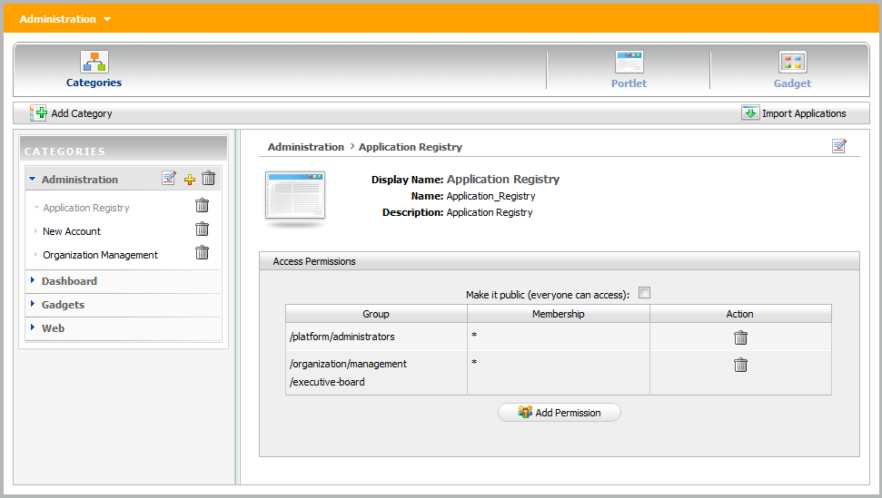
Click the Add Permission button to add access permissions to more groups; or check Make it public to allow everyone to access.

Manage portlets/gadgets/categories

Add a portlet/gadget to a specific category
This function helps you add portlets to a specific category. Do as follows:
Step 1: Click the Add icon on the title bar of a category to which you want to add portlets. The form to add a portlet into a category will appear on the right panel:
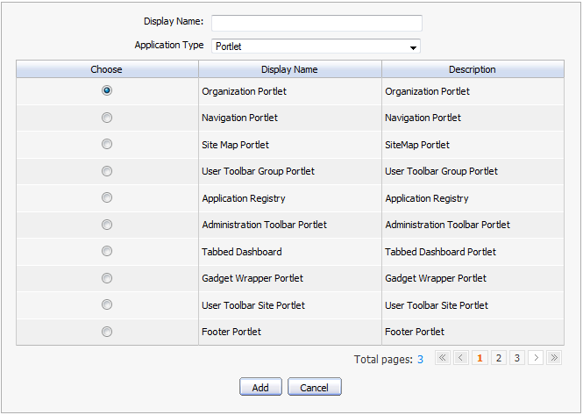
Details:
Display name: The display name of a portlet/gadget that you want to add to a category.
Application Type: The type of the selected object.
Step 2: Select a portlet and/or gadget.
Step 3: Enter the display name and select a type for the selected portlet/gadget.
Click Save to accept adding a portler and/or gadget to a category.

Auto-import default portlets/gadgets
This function supports users auto-import default portlets/gadgets into different categories and these portlets/gadgets will be listed in left panel. do as follows:
Step 1: Clickat the right corner on the action bar. A dialog will appear:

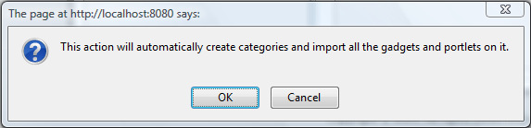
Step 2: Click OK on this message to accept importing portlets and gadgets automatically.
All portlets and gadgets of all categories will be imported and listed on the left panel.

View detailed information of a specific portlet
Do as follows:
Step 1: Go to the Group → Administration → Application Registry page in the Administration bar. The form for viewing all portlets will appear, details:
- Left panel: lists all portlets in two parts: Local and Remote
- Right panel: shows detailed information about a portlet: Name, Display name, Description and Access permission.
Step 2: Select one portlet in the list on the left panel. The detailed information of that portlet will be shown on the right panel.

Manage gadgets

Where you can use a gadget
A gadget is a mini web application running on a platform and you can put it in a web page. Only users who are member can use these applications for their needs.
You can use gadgets in two places:
- Add gadgets to Dashboard.
- Add gadgets to Desktop page (for WebOS).

Add a gadget
This function helps you add a gadget into the gadget list.
do as follows:
Go to the Group → Administration → Application Registry page (on the Administration bar) → Gadget:
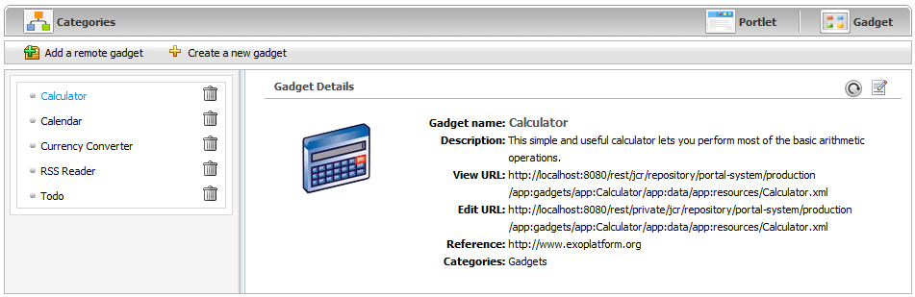
You can add a remote gadget or create a new gadget into the list.

Add a remote gadget
Step 1: Show the form to add a remote gadget by clicking Add a remote gadget:
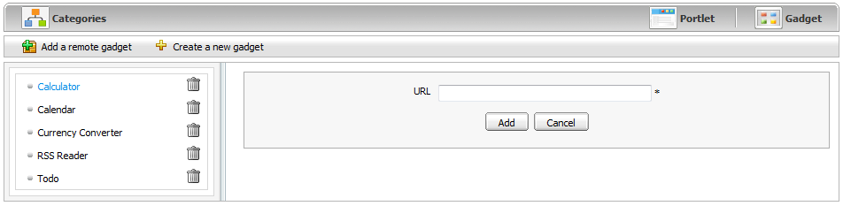
Step 2: Enter a link to a .xml file in the URL field.
Step 3: Click Add to accept the inputted url, or Cancel to quit. The added gadget will be added into gadget list on left panel of the Dashboard portlet
Note:
- To refresh the remote gadget: Click the Refresh information icon on the upper-right corner of the Gadget Details form to renew and update any changes from the remote gadget.
- To edit the remote gadget: Click the edit iconto edit the source code of this gadget .

Add a gadget to the Dashboard
This function allows adding gadgets to a specific dashboard simply by dragging and dropping the gadget you want.
When clicking the Dashboard of the main Administration bar, the Dashboard will appear with the current gadgets in the default tab.
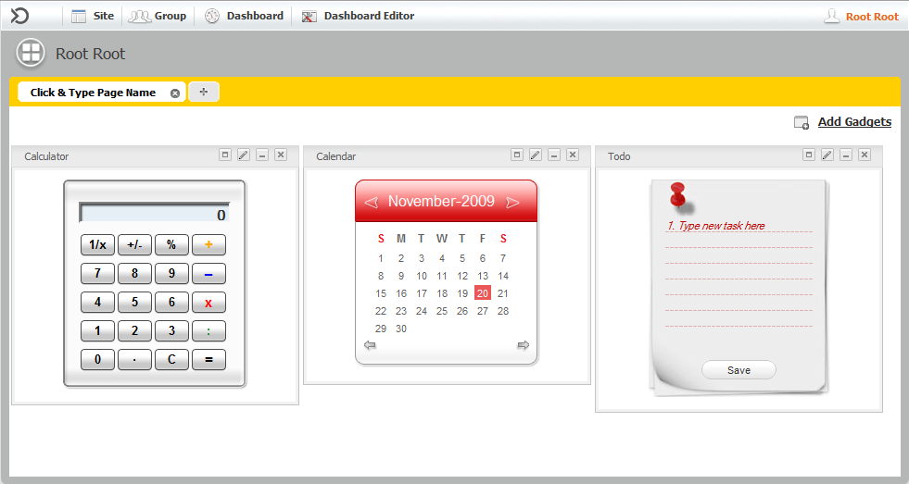Illustration 68: The Dashboard main screen
You can use ready-to-use gadgets in your Dashboard. The gadgets of your Dashboard are organized in the dashboard tab. A dashboard task can contain one or more gadgets. You can create new a tab and add new gadgets to an existing tab.

To add new a dashboard tab, do as follows:
Step 1: Click Dashboard → Click & Type Page Name tab:
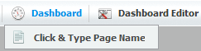
or click the plus icon: 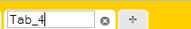
Step 2: Enter a tab name and enter to accept add a new dashboard tab.

Add a new gadget, do as follows:
Step 1: Go to a dashboard tab and click .

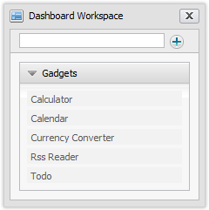
Step 2: Enter the HTML link of the gadget that you want to add to your homepage.
Step 3: Clickto add.
For example:
Add the link below in to the text box : http://www.google.com/ig/modules/colorjunction.xml
then click. The gadget will be added:
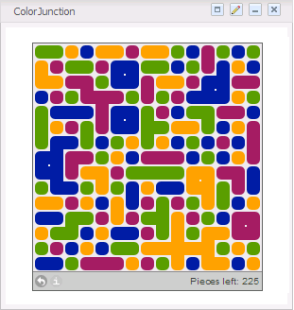
You can also drag and drop gadgets into a dashboard tab, do as follows:
Similarly, at the Dashboard Editor, you can add a new page, edit a page, and edit the layout of current dashboard which is being viewed.

Create a new gadget
Step 1: Show the form to add a new gadget by clicking Create a new gadget:
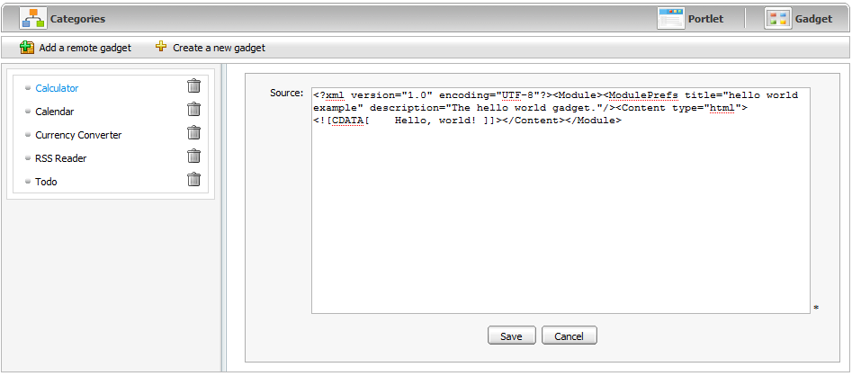
Details:
Source: The source code to create a new gadget. This source will be a .xml file.

Step 2: Enter a value for the Source field in this form.
Step 3: Click Save to create a new gadget.
The created gadget will be added to the gadget list on left panel of the Dashboard portlet.
Furthermore , you also can add a new gadget to the gadget list of the Dashboard portlet by clicking the Add Gadgets link:
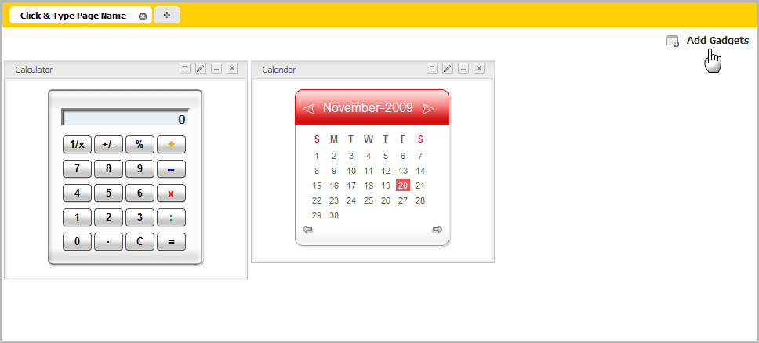
The form to add a new gadget will be shown:
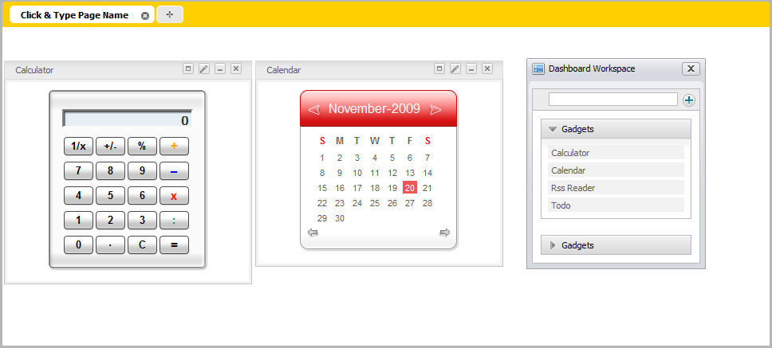
Step 4: Enter a link (remote or local) to a .xml file in text box at the left panel.
Step 5: Click to add a new gadget to the gadget list underneath.

Manage categories

Add a new category
First, you have to go to Administration → Application Registry page.
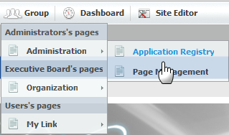
The form to organize portlets/gadgets into different categories will be displayed:
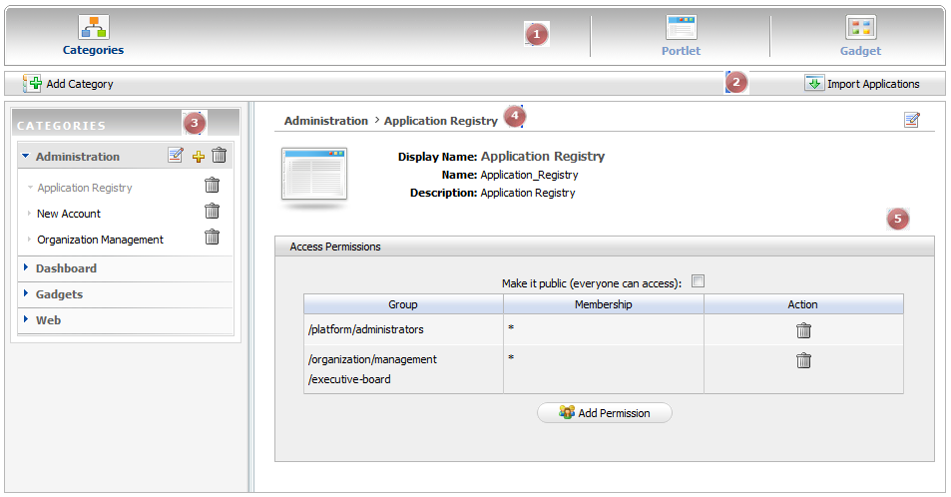
The form includes the following parts:

Indicator | Meaning
 | Tab bar: includes three main items.
 | Action bar: includes some actions related to a category.
 | Left panel: lists all categories and portlets in each category.
 | Breadcrumb bar: the path from a specific category to a specific portlet in that category.
 | Right panel: detail information of a specific portlet.
Step 1: Open a form to add a new category in the right panel by clicking on the action bar:
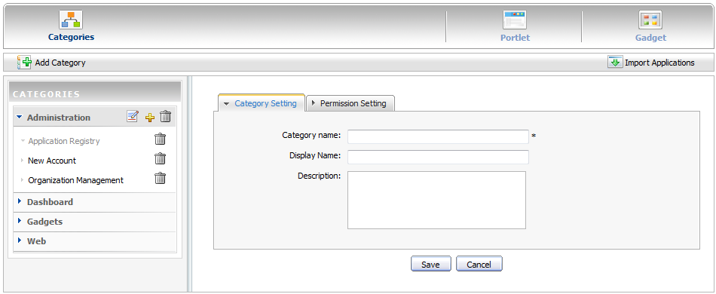
The Category Setting tab includes common information about a category.
Category name: The name of the category which you want to add. This field is required and its length must be between 3 and 30 characters.
Display name: The display name of the category in list and its length must be between 3 and 30 characters.
Description: The brief description of the category with any length from 0 to 255 characters.
The Permission Setting tab is used to set the access permission for a category.
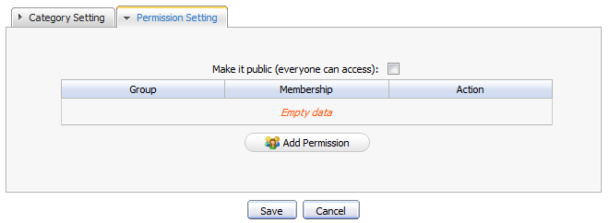
Step 2: Enter values for the required fields in this form.
Step 3: Click Save to accept adding a new category to the category list. The new category will be added to the list in the left panel.

Set permissions for a new category
To set a permission for a new category, do as follows:
Step 1: Go to Administration → Application Registry page then click clicking on the action bar.
Step 2: Select the Permission Setting tab.
Step 3: Check the Make it public check box to allow all users to access to the category. For more finer permission assignments, go to step 4.
Step 4: Click to show the Group and Membership Selector form.
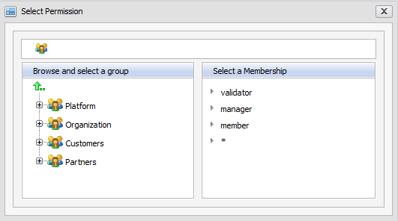

Step 5: Select a specific group on the left panel, then select a membership on the right panel (select "*" if you want to select all membership types of that group).
The selected group and membership will be shown in a table. It means all users with the membership of the selected group can access this category.

Edit a category
To edit a category in list, do as follows:
Step 1: Click the edit icon on the title bar of the category that you want to edit.
Step 2: Change the information of the selected category.
Step 3: Click Save to accept changes.

Delete a category
To remove a category from the list, do as follows:
Step 1: Click the trash icon on the title bar of a category that you want to delete. A confirmation message box will be displayed.
Step 2: Click OK to delete, or Cancel to quit.

