
GateIn User Guide
Version 3.1

Table of Contents
1 Preface 5
1.1 Overview 5
1.2 Purpose of the guide 5
1.3 References and related documents 5
Related documents 5
Information 5
Support 6
2 Glossary 7
2.1 Portal 7
2.2 Portlet 7
2.3 Toolbar 7
2.4 Navigation 7
2.4.1 Portal/Site's administration 7
2.4.2 Group's navigation 8
2.4.3 User's navigation 8
2.5 Gadget 8
2.6 Access mode 8
2.7 Preview mode 9
2.8 Layout mode 9
2.9 Permission 9
2.9.1 Permission types 9
2.9.2 Permission levels 10
3 Portlets 11
3.1 Functional portlet 11
3.1.1 Register portlet 11
3.1.2 Account portlet 11
3.1.3 Organization portlet 12
3.1.4 Application registry portlet 12
3.1.5 Group navigation portlet 13
3.1.6 Page management portlet 14
3.1.7 Portal navigation portlet 15
3.1.8 Star toolbar portlet 15
3.1.9 Tabbed dashboard 15
3.1.10 User info portlet 15
3.1.11 User toolbar dashboard portlet 15
3.1.12 User toolbar group portlet 16
3.1.13 User toolbar site portlet 16
3.2 Interface portlet 16
3.2.1 Banner portlet 16
3.2.2 Breadcrumbs portlet 16
3.2.3 Footer portlet 16
3.2.4 HomePage portlet 17
3.2.5 IFrame portlet 17
3.2.6 Navigation portlet 18
3.2.7 SiteMap portlet 18
3.2.8 Web browser portlet 18
3.2.9 Dashboard portlet 19
3.2.10 Gadget wrapper portlet 19
3.3 Dashboard portlet 20
3.3.1 Use the dashboard workspace 20
3.3.2 Add more gadgets 21
4 Initial Implementation 23
4.1 Requirements 23
4.1.1 Software 23
4.1.2 Hardware 23
4.2 Setup 24
4.2.1 Establish a base structure 24
4.2.2 Configure an environment 24
4.2.3 Run commands 25
5 GateIn Administration 26
5.1 Account 26
5.1.1 Register a new account 26
5.1.2 Sign in and Sign out 27
5.1.2.1 Sign in 27
5.1.2.2 Sign out 29
5.1.3 Remember user account 30
5.1.4 Change account settings 30
5.1.5 Retrieve account & password 32
5.2 Language administration 34
5.2.1 Change the display language permanently 34
5.2.2 Change the display language for another user 35
5.3 Sitemap management 36

Preface

Overview
Beginning as an open source project in the year 2002, eXo is well-known as the industry's first Java portlet container. With the aim of dominating the potential portal market through robust and easy-to-use applications, eXo Project succeeded in attracting consumers in the whole world. eXo actually opened the floodgates to various options in many markets, and customers have been choosing eXo as the best method for their success.
The eXo Project grew into a company in 2003, as a response to customer demands. We can do this because we release our code in the open environment. It's how the DoD found us, when we were just university students hacking away, and it's how we choose to do business with our customers.
Today, eXo is a rapidly growing global company, with U.S. headquarters in San Francisco, California, global headquarters in France, and offices in Tunisia, Ukraine, and Vietnam. The Corporate has established technology leadership and proven values by their large European installed base and strategic partnerships with Red Hat, Capgemini, Atos Origin, and Bull.
GateIn is the perfect merge between Red Hat and eXo Platform in creating a new generation of Open Source portal that is robust and intuitive. With GateIn, both normal users and enterprises can enjoy many personalization and collaboration applications wherever and whenever. Advantages generated in GateIn, such as the interactive user interface, customizable look and feel, flexible internationalization and localization, faciliate the birth of many useful applications with a variety of rich utilities in the world market.

Purpose of the guide
The guide was written as a handbook, aiming at instructing step-by-step on how to use and to implement this application to the utmost. The information included herein will give basic steps that makes it easy for users to follow through in-depth examples and clear explanations regarding to the eXo Platform technology. Whether you major in technology or not, you are able to learn about or to work on GateIn 3.1 easily and efficiently.
The information provided in the guide is arranged into such a way that ensures readers to search and implement quickly and easily. With the aim of helping users better understand about GateIn 3.1, we hope that readers can know more and master almost key strengths when using the GateIn 3.1.
The guide provides basic instructions for users. This user guide will focus on the followings:
- Define the basic concepts in GateIn 3.1.

References and related documents

Related documents
- GateIn Administrator Guide 3.1

Information
- eXo Platform Home Page: http://www.exoplatform.com/portal/public/website/
- eXo Platform Wiki: http://wiki.exoplatform.com/xwiki/bin/view/Main/

Support
- Forums: http://forums.exoplatform.org
- FAQ: http://faq.exoplatform.org

Glossary

Portal
Portal can be defined as a key environment for making and implementing many applications and contents. In other words, the portal is a web-based application providing means to gather and personalize information via specific portlets with an interactive and consistent look and feel. Users and administrators are able to integrate information, people and processes via a web-based user interface.

Portlet
Portlet is a pluggable component in a portal through which users can access some specific information, including supports, updates, or mini-applications). The portlet produces fragments of a markup code that are aggregated into a portal page. Typically, a portal page is displayed as a non-overlapping portlet windows collection, where each portlet window displays a portlet. Content generated by a portlet can be customized, depending on the configuration set by each user.
Portlets can be divided into two following types:
- Functional Portlet
- Interface Portlet

Toolbar
Toolbar is a set of icons or buttons that is considered as a part of interface. It spans the top of the portal application and provides links to users and administrative actions.
If the current user logged in as an administrator or manager, the extra navigation so-called Site Editor will be displayed in the toolbar. In case of the user as user or demo, there are only three navigation types, including Site, Group, and Dashboard in the toolbar.

Navigation
Navigation is a nodes set (menus) that helps users visualize the site structure and provides hyperlinks to move from one page to another quickly. Each node contains an internal name and a label which is shown on the menu. For any node, you can define either sub-nodes. The horizontal menu at the top of page is called the navigation bar. The GateIn's navigation is established to three levels: portal, group and user. On each level, any node can be defined. The navigation structure of one particular user is made up of portal navigation nodes (that are valid to all users), the nodes of all groups the user belongs to and individual nodes. The users' and groups' nodes are valid for all portals that are defined on the same eXo Portal server.

Portal/Site's administration
This navigation level is to keep links to separate sites and/or portals of the parent portal. Each portal/site has only one navigation and it is automatically generated when a portal/site is created. Only users, who have the edit permission on a portal, can add nodes on this navigation level.
The name of a portal navigation looks like portal:[portal name]'s nav
For example, a portal navigation's name is portal:classic's nav”:
- 'portal' is the navigation level, meaning navigation nodes are defined for all users of a portal.
- 'classic' is the name of portal.
- 'nav' stands for 'navigation'.

Group's navigation
All registered users are organized into groups. There is a navigation keeping the links to all pages of each group, called a group navigation. The content of this navigation differs, depending on the login account. The group's navigation is created manually by users who have the highest right in a group. Before adding nodes or creating pages for a group, you must create the group navigation. Also, there are nodes only applied to members with certain memberships.
The name of group navigation looks like group:[group name]'s nav.
For example, the group navigation name is “group:platform/administrators's nav”:
- 'group' is a type of navigation, meaning nodes are defined for a group.
- 'platform/administrators' is the path of a group, meaning navigation nodes are defined for the 'administrators' - the group that is a sub-group of 'platform' group.
- 'nav' stands for 'navigation'.

User's navigation
Each user has its own navigation that contains links and portlets (or gadgets) selected by the user. A user's navigation is created or deleted automatically when the user is registered or deleted respectively. By default, the user navigation is empty.
The name of user's navigation has the format user:[user name]'s nav.
For example, the user navigation name is “user:john's nav”.
- 'user' is a navigation level, meaning navigation nodes are defined for one individual user.
- 'john' is the name of user.
- 'nav' stands for 'navigation'.

Gadget
Gadget is a mini web application running on a platform that a user can integrate and customize in the website.
To further see default gadgets in GateIn 3.1, please refer to the section "Use the dashboard workspace".

Access mode
GateIn has offerred two modes by default:
- Public mode is for guest users (visitors) who have not registered yet. This mode is not required to sign in, so guests can only visit the public pages in a portal. Visitors can also register to get an account. After having registered, they can use the private mode and have to contact their administrators to get more rights or the group manager if they want to become a member of that group.
- Private mode is for registered users who will apply their usernames and passwords to sign in. This mode supports users in taking many actions such as: managing private resources (creating private pages, editing or deleting them), "borrowing" pages from others by creating hyperlinks, changing the language for individual needs, managing private information.

Preview mode
In the preview mode, you can only view.
You can see this mode when you click the Preview Page icon at step 3 of creating a page by wizard or editing a page by wizard.

Layout mode
In the layout mode, you are provided with some layout templates of portal or the page and you can use these templates to edit a portal or a page.

Permission
Permission is one of the most important factors on a portal. Permission settings control actions of user within the portal and set by the portal administrators.

Permission types
Permission types define what a user can do within the portal. There are two available types as follows:
Access Permission enables users to utilize portal contents (sigining in, viewing contents, rearranging portlets, and more). This permission can be set for multiple member groups.
Edit Permission enables users to change portal contents (changing portal or page information, deleting a portal/page). The edit permission is set for only one group at one time.
By default, root is set as the super user or the administrator of GateIn. He can do everything, while the others must get the appropriate rights (permissions) at first.
Rights in GateIn are not assigned to a single user but to a users group with specific membership types.
Similarly, the permission structure is always established as follows: [membership type]:/[group path].
For example: manager:/platform/administrators. It means the right is set for users who are “manager” of the group “administrators”. “Platform” is the parent group of “administrators”.
Seemingly, groups are managed based on a hierarchy structure; but in fact, a sub-group does not have any inheritance from the parent group.
For example: we have a group structure as follows:
+ platform
- administrators
- guest
- user
If users in the group “platform” can perform a function A, it does not mean that users in “administrator” or “guest” can do function A. The roles of users in groups are independent.

Permission levels
Permission levels specify where the users's permission types can be applied into the portal. GateIn offers three permission levels as follows:

Portal: The permission at portal level includes actions permitted in all pages within the portal. Users with the access permission can view (but not edit) all the pages within the portal. Meanwhile, users with the edit permission at the portal level can change any page in the portal.
Page: The permission at page level restricts users to several particular pages. Users are only able to see and/or edit pages they have been given access to, depending on each permission type assigned to them.
Portlet: The permission at portlet level enables users to create a page through dragging and dropping portlets into a page. Some portlets are only used for administrators, while some are for individuals. Thus, administrators need to set proper access permissions for each specific group.
Permission types and levels can be effectively implemented to control who can do and what can be performed within the portal.

Portlets

Functional portlet
Functional portlets support all functions of a portal. They are built into the portal and accessed via toolbar links when the portal-related tasks are performed.

Register portlet
This portlet is used to register a new account, including fields: User Name, Password, Confirm Password, First Name, Last Name, Email Address, and Text validation.
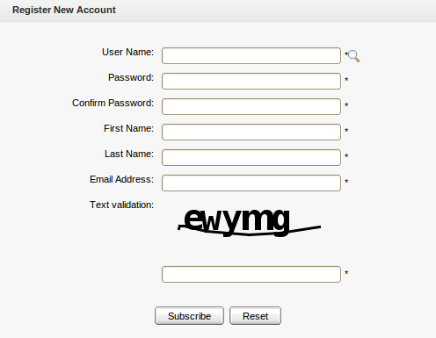Illustration 1: Register Portlet

Account portlet
This portlet enables users to add a new account and choose their preferred languages for displaying the portal interface.
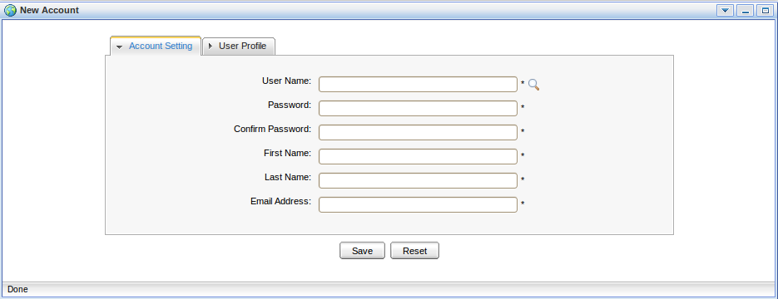Illustration 2: Account Portlet

Organization portlet
This portlet is to manage user information, users groups and memberships. The form of this portlet is shown like:

- User Management: To edit, delete, search and view existing users.
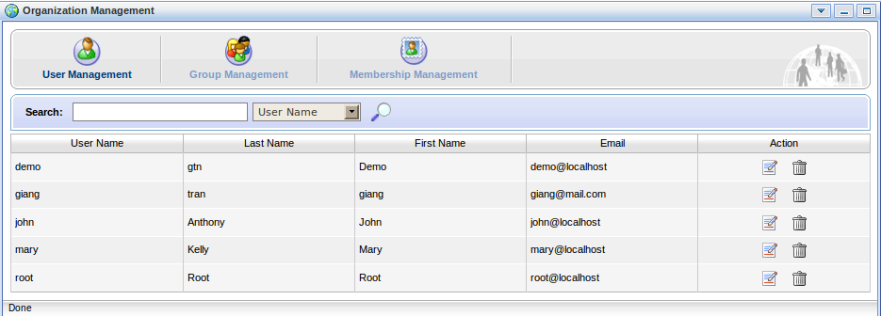Illustration 3: The Organization Portlet interface
- Group Management: To view, add new, edit and delete a users group.
- Membership Management: To add, edit and delete memberships.

Application registry portlet
This portlet is used to manage different application categories. You can add, edit, set permissions, or delete categories and applications. The portlet form is shown as below:
This portlet includes the following functions:
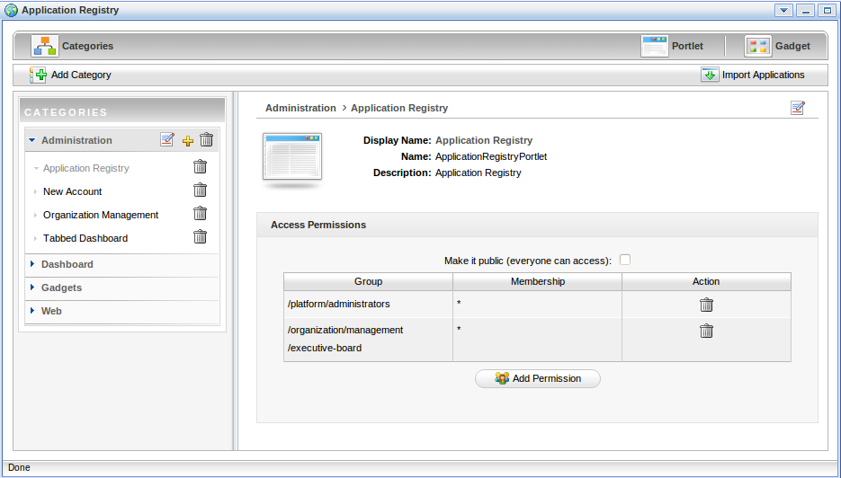Illustration 4: The Application Registry Portlet
- Organize portlets/gadgets into different categories such as: creating a new category, importing default porlet categories, adding a portlet/gadget into a specific category, adding permission to a portlets category, etc.
- List portlets and view detailed information regarding to a specific portlet.
- Manage gadgets that includes: adding a remote gadget, creating a new gadget or deleting a gadget from the list.

Group navigation portlet
The Group Navigation portlet is to manage the navigation of different groups. In this portlet, it is possible to add, edit and delete a specific navigation.

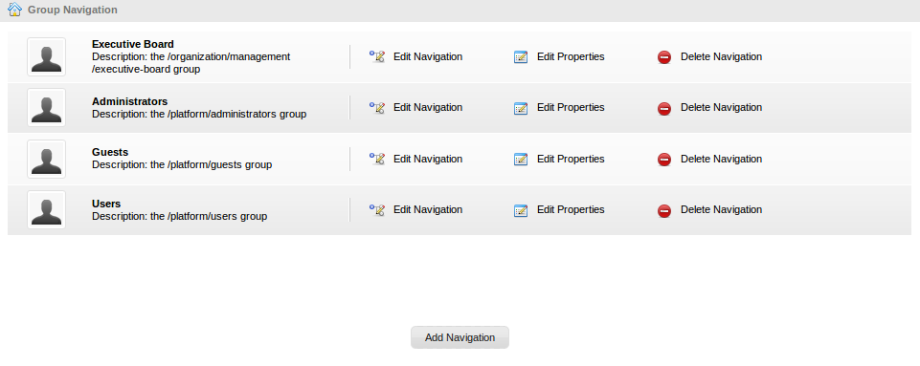Illustration 5: Group Navigation Portlet

Page management portlet
The Page Management portlet is to manage all pages on the portal. In the Page Management Portlet, it is possible to add, edit and delete a specific page.
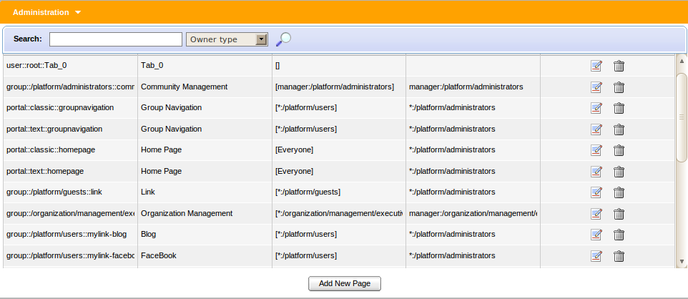Illustration 6: Page Management Portlet

Portal navigation portlet
The portlet is to manage all portals in the GateIn. In the Portal Navigation portlet, you can add, edit and delete a portal.
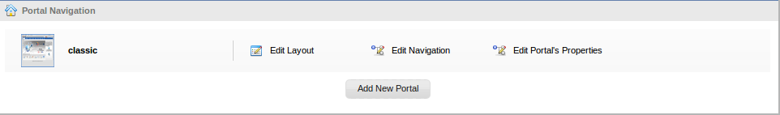Illustration 7: Portal Navigation Portlet

Star toolbar portlet
The portlet displays a list of actions such as Change Language, Change Skin, Sign Out.
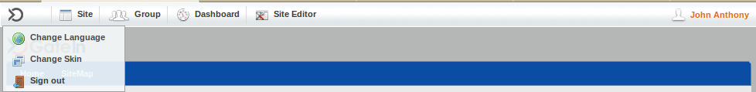Illustration 8: Star Toolbar Portlet

Tabbed dashboard
The portlet displays Dashboard tabs that you can add gadgets inside by dragging and dropping them.
Illustration 9: Tabbed Dashboard Portlet

User info portlet
The portlet displays personal information of a specific user that can be viewed and edited.
Illustration 10: The User Info Portlet Interface

User toolbar dashboard portlet
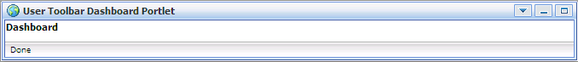Illustration 11: The User Toolbar Dashboard Portlet Interface
The portlet displays the main dashboard menu that you can go inside to create dashboard tabs, add and remove gadgets for each tab.

User toolbar group portlet
The portlet displays the main group menu that you can go inside to create, edit and delete a specific group and the navigation for each group.

User toolbar site portlet
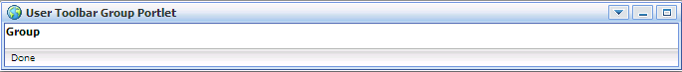Illustration 12: The User Toolbar Group Portlet Interface
The portlet displays the site menu that you can go inside to manage all portals.

Interface portlet

Interface portlets constitute the interface of the GateIn that are the front-end components of the portal. They provide users with ways to interact with the portal. GateIn 3.1 provides the following Interface Portlets:

Banner portlet
Illustration 13: The Banner Portlet interface
The portlet is considered as the welcome gateway of a portal. It contains the organization's slogan, logo and icon:

Breadcrumbs portlet
The portlet displays the navigation path of the selected page:
Illustration 14: The Breadcrumbs Portlet interface

Footer portlet
The portlet provides a footer for a site. This footer can be text, images that are displayed at the website bottom. It provides information about author/institutional sponsor, revision date, copyright, comments form, and navigational links.
Illustration 15: The Footer Portlet interface

HomePage portlet
This is the GateIn homepage. The homepage is a main page (default page) which is the first page displayed when you visit the portal.
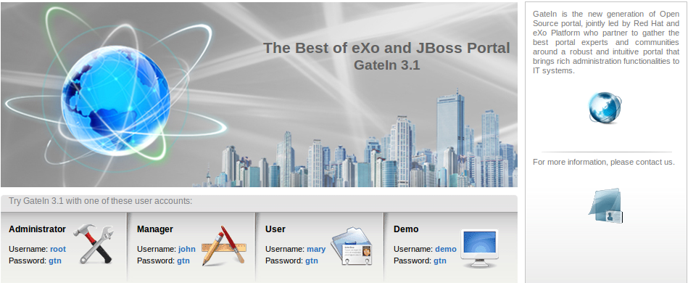Illustration 16: The HomePage Portlet interface

IFrame portlet
The portlet is to create IFrame elements for a site. The IFrame is an HTML element which can embed a different HTML document into a HTML document. So, the embedded document is displayed inside a sub-window of the browser window. This doesnot mean the full inclusion, the embedded document is independent and both documents are considered as separated documents.
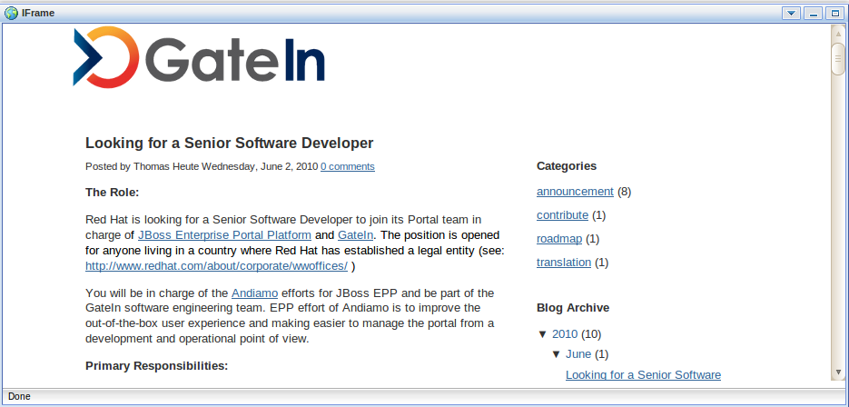Illustration 17: The IFrame Portlet interface

Navigation portlet
The portlet provides a navigation bar. A navigation bar is a menu that helps users visualize the site structure and provide links to move from one page to another quickly:
Illustration 18: The Navigation Portlet interface
Note:
When you create a new page that contains this portlet:
In the Preview mode: the portlet will be viewed as a normal page like above.
In the Save mode: the Navigation portlet will not be displayed normally when you open the page containing this portlet because only the portal's navigation can be shown like below. It means that two navigations can not be shown at the same time.

SiteMap portlet
The portlet displays a sitemap page of a website. It is a graphical representation of a website. It lists pages on a website, which is typically organized in the hierarchical architecture to help visitors find pages on the site easily.
There are two options:
Collapse All: The sitemap will be displayed with the parent path only.
Expand All: The sitemap will be displayed with the parent paths and all their children paths.

Web browser portlet
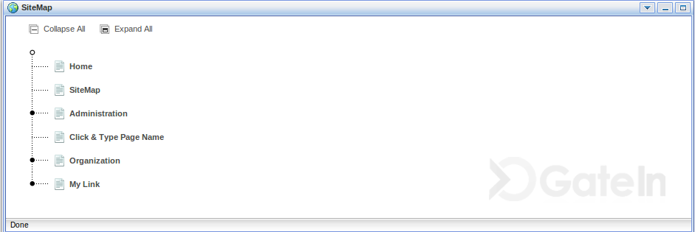Illustration 19: The SiteMap Portlet interface
The portlet provides a web-browser-like application for users. It enables users to connect to other sites over Internet.
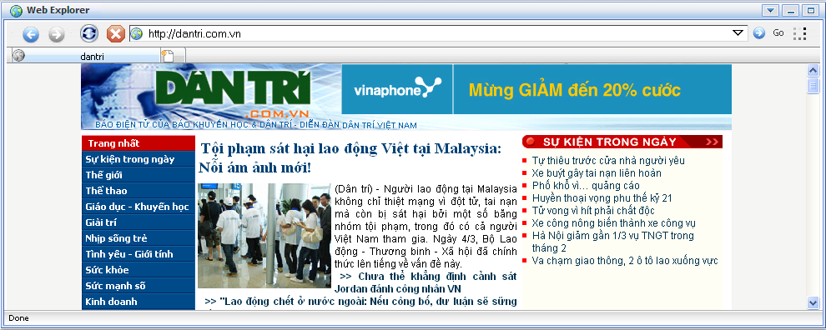Illustration 20: The Browser Portlet interface

Dashboard portlet
The portlet is used for hosting mini-applications known as gadgets. The dashboard uses a variety of graphical effects for displaying, opening, and using gadgets. Gadgets can be moved around, rearranged, deleted and recreated in the dashboard. More than one instance of the same gadgets can be opened at the same time, possibly with different settings.
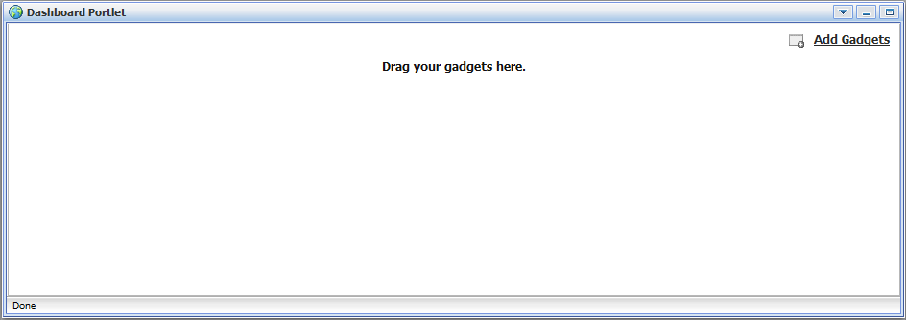Illustration 21: The Dashboard portlet interface

Gadget wrapper portlet
This portlet enables users to view a gadget in the canvas mode.
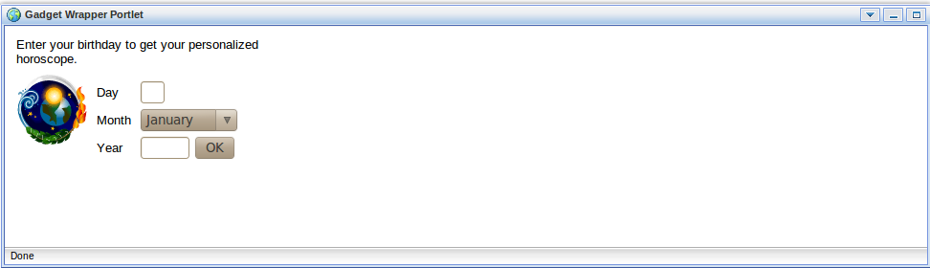Illustration 22: Gadget Wrapper Portlet

Dashboard portlet
The dashboard portlet is to host mini-applications known as gadgets. The dashboard uses a variety of graphical effects for displaying, opening and using gadgets.
Gadgets within the Dashboard portlet may be moved, or rearranged. Users can create new gadgets and delete unnecessary ones. Also, users can open many gadgets with different settings at one time.

Use the dashboard workspace
To use the Dashboard Workspace, do as follows:
Step 1: Click Dashboard on the toolbar.
Step 2: Click Add Gadgets to open the Dashboard Workspace.
The Dashboard Workspace lists all available gadgets. Four default gadgets are provided
in GateIn 3.1; but you can add more.
The followings are default gadgets:
Calendar: A cool calendar keeps track of date in style. You also can switch between daily, monthly and yearly views and change the skins as you like easily.
Todo: This mini-application helps you organize your day and work group. It is designed to keep track of your tasks in a convenient way. You can highlight tasks with different colors.
Calculator: This is the coolest calculator for your page. This mini-application lets you perform most basic arithmetic operations and can be themed to match with your portal.
RSS Reader: This gadget lets you get a sneak preview of your favorite feeds in one location. This content includes, but not limit to, news, posts, emails, all in one gadget. This gadget is a web–based one for receiving and viewing RSS feeds.
Step 3: Select a gadget in the Dashboard Workspace.
Step 4: Drag and drop the selected gadget into the Workspace.
In addition, many more gadgets can be found at Google Gadget: http://www.google.com/ig/directory?synd=open. GateIn 3.1 is compatible with most gadgets available here.
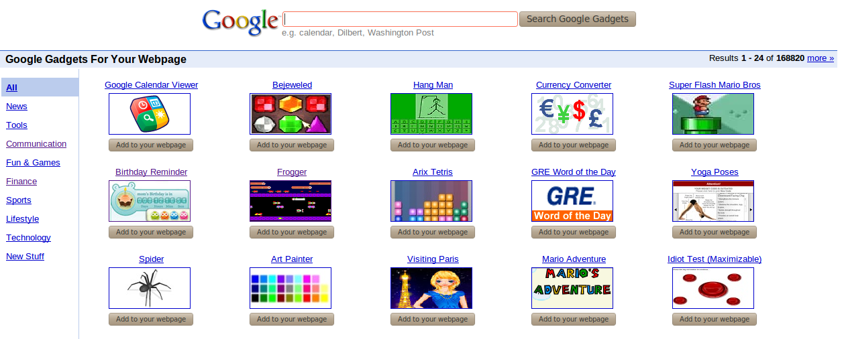Illustration 23: More gadgets on Google

Add more gadgets
To add more gadgets from external sources, do as follows:
Step 1: Open the URL (.xml or .rss) of your desired gadget.
For example, http://bejeweledg.googlecode.com/svn/trunk/bejeweled.xml.
Step 2: Return to your portal, and click Dashboard on the administration toolbar.
Step 3: Click Add Gadgets in the Dashboard to open the Dashboard Workspace.
The Dashboard Workspace will appear:
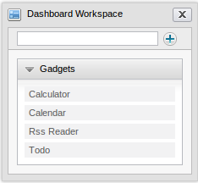
Step 4: Paste the URL achieved in step 1 into the text box next to .
Step 5: Click the plus icon to add the new gadget to the page.

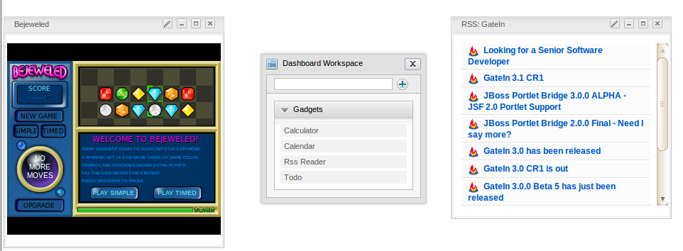
Initial Implementation

Requirements

Software
GateIn is a Java application. The GateIn trial version is free download. However, new functions are usually updated without test and guaranty in trial versions. In order to purchase a full version with guaranty and tested functions, please contact us at sales@exoplatform.com.
You can get the latest trial version package from this link:
http://forge.objectweb.org/projects/exoplatform. After downloading, you also need to download the following software which supports running GateIn:
- Download JDK (Java Development Kit) with version 1.5 or later.
- Application Server: GateIn is a web application using the client–server model. So we need a server browser. You can use Jboss Application Server, Jonas Application Server or Apache Tomcat.
- Jboss Application Server version 4.2.0 : http://labs.jboss.com/
- Jonas Application Server version 4.8.4: http://wiki.jonas.objectweb.org/
- Apache Tomcat version 6.x http://tomcat.apache.org
- A database is required. By default, HSQL is delivered with GateIn so that you do not need to install a database. GateIn can be used with the following databases:
- HSQL (used by default)
- My SQL
- SQL Server
- Oracle
- PostGreSQL
- DB2

Hardware
Processor: 2.0 Ghz or higher
RAM : at least 512MB

Setup

Establish a base structure
To establish a base structure, do as follows:
Step 1: Create a "java" directory which is called $EXO_BASE_DIRECTORY. By default, the $EXO_BASE_DIRECTORY directory will be in your $HOME directory in Linux and in D: drive in Windows.
Step 2: Install JDK and maven2 in the java directory.
Step 3: Set environment variable: JAVA_HOME= EXO_BASE_DIRECTORY/JDK.
Step 4: Create an “exo-dependencies” and “exo-working” directories in the “java” directory.
Step 5: Copy a desired template application server directory to exo-dependencies. The directory name should have the form name of application server -${version}. So the name of the directory may be (tomcat-$, jboss-$, jonas-$).
By the end, you have to have the following directory structure:
java/
exo-dependencies/
tomcat-${version}
jboss-${version}
jonas-${version}

exo-working
jdk1.5
maven2

Configure an environment
To configure a suitable environment for GateIn implementation, do as follows:
Step 1: Copy $EXO_BASE_DIRECTORY/eXoProjects/tools/trunk/config/maven2/template-settings.xml to your $HOME/.m2/settings.xml and adapt the configuration to your environment. If you do this, the maven2/conf/settings.xml will be ignored. This step is mandatory for window environment.
Step 2: For Linux or Cygwin environment, you can bypass this step as the exoenv.sh script can copy and configure the settings.xml file automatically for you;
Step 3: In Linux or Cygwin environment:
- Copy $EXO_BASE_DIRECTORY/eXoProjects/tools/trunk/build/src/main/resources/linux/exoenv.sh to your $HOME or $EXO_BASE_DIRECTORY directory.
- Backup the old one if you have one.
In Window and DOS Environment:
- Copy $EXO_BASE_DIRECTORY/eXoProjects/tools/trunk/build/src/main/resources/window/exoenv.bat to your $HOME or EXO_BASE_DIRECTORY directory.
- Backup the old one if you have one.
Step 4: Update the Configuration: Edit exoenv.sh or exoenv.bat file to adapt it to your environment. You should only have to change the PORTABLE_DIR variable at the beginning.
Step 5: Run the command to setup the environment: In linux or cygwin: source exoenv.sh.
To check that it has worked well, open $EXO_BASE_DIRECTORY/maven2/conf/settings.xml and check that the file corresponds to your environment, especially the definition of the repositories.
On window and dos prompt: exoenv.bat

Run commands
- Launch Tomcat
In Linux or Cygwin Environment
- Go to $EXO_BASE_DIRECTORY/exo-working/exo-tomcat/bin directory
- Change the rights on .sh files to make them executable : chmod +x *.sh
- Run the command : gatein-dev.sh run or gatein.sh run
- Launch Jonas
On Command line (Windows)
- Run exoenv.bat in java directory
- Go to $EXO_BASE_DIRECTORY/exo-working/exo-jonas/bin/nt directory
- Run the command exo.bat start -fg
- Launch Jboss
On Cygwin
- Go to $EXO_BASE_DIRECTORY/exo-working/exo-jboss/bin directory
- Run the command: run.sh

GateIn Administration

Account

Register a new account
Unregistered users visiting the portal will be limited to several contents and applications which are not set as public. Meanwhile, users who want to access in-depth contents or perform some actions in various applications, they should register by themselves and then contact the portal administrators to gain certain rights or permissions. To register a new account, do as follows:
Step 1: Click Register on the upper right corner of the GateIn homepage. The Register New Account form will appear.
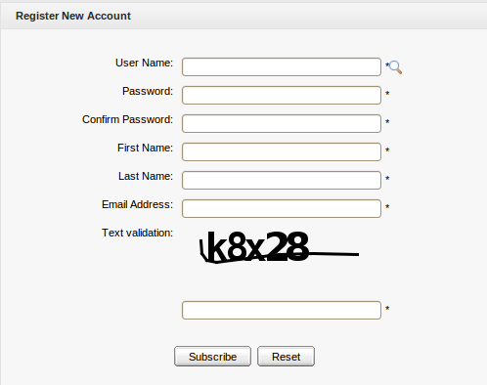Illustration 24: The Register New Account form
Details:
User Name: The user's login name that must be unique with at least 3 characters.
Password: The password used to login that must have at least 6 characters.
Confirm Password: The re-typed password. The Password and Confirm Password must be the same.
First Name: The user's first name which must start with a character.
Last Name: The user's last name which must start with a character.
Email Address: The user's email which must be in the right format, for example: username@abc.com.
Text validation: The text which is required to enter to validate the registration.
These are required fields, the User Name must contain only alpha, digit and underscore characters and must be unique.
Step 2: Enter values for fields in this form.
Step 3: Click Subscribe to accept adding a new account or Reset to clear the entered values. After you click Subscribe, there will be a message which informs that you have registered your account successfully.
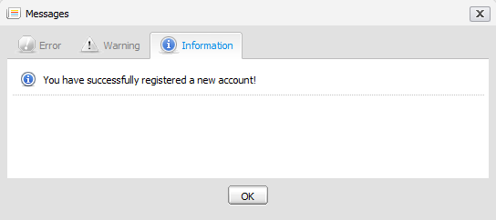
Step 4: Click OK to finish creating your account.
There will be an alert message which informs that you can not add a new account if one of these cases occurs:
- User name is existing or User Name is invalid.
- Password has less than 6 characters.
- Password and Confirm Password are not the same.
- Email Address is in a invalid format.
- Required fields are blank (empty).
- Text verification isn't correct.
After adding a new account, contact with administrator to get rights or only be a visitor.
Note:
1. The magnifying glass icon is used to search whether the entered User Name exists or not. Once a user has registered by himself or the administrator has created a new account, the new user will become a part of the group "/platform/users" with membership by default.
2. The text validation can appear or not, depending on the customization of portal's administrator.

Sign in and Sign out

Sign in
By default, GateIn initializes some users with specific rights.

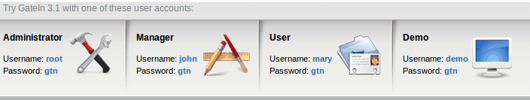
Details:
- Being an administrator, root has the highest right in any portal. Root controls all resources such as: users, groups, memberships, pages, navigations, portlets. Root can do anything in a portal except the private resources of another users.
- Being a manager, john can take some actions that are supported only for a manager.
- Being a visitor, marry is like a freedom user, so she can only visit and read news.
GateIn may be accessed by using a browser with a regular connection (HTTP). If you are using a default bundle installation in your local computer, you can access it through the URL and by default, the address: http://localhost:8080/portal/ runs into a portal named “classic”. Otherwise, you will have to contact your administrator to ask for the initial URL.
With GateIn 3.1, users can sign in the portal via 2 ways:
The 1st way:
Step 1: Click the Sign in link at the page's top right. The Sign in form appears:
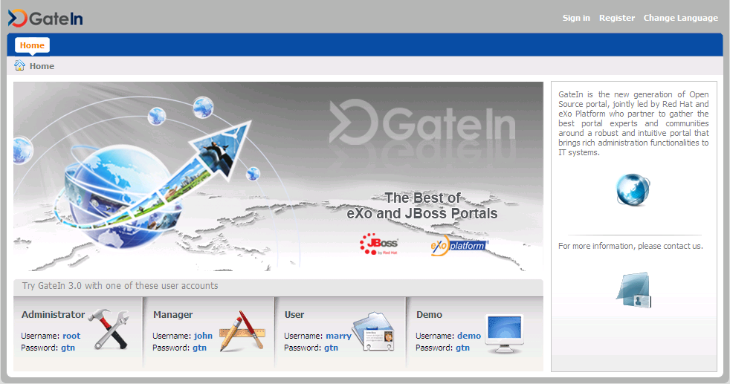Illustration 25: The main screen of GateIn Portal
Details:
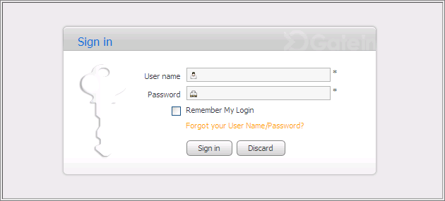Illustration 26: The Sign in form
User Name: To input the registered user name.
Password: To give the password of your user name.
Remember My Login: To allow you to return to GateIn and to be automatically authenticated based on the cookie value provided by the browser. Thus, you do not have to perform an explicit authentication again.
Forgot your User Name: To follow some steps to get the forgotten user name or password.
Sign in To sign into GateIn by the inputted username and password.
Discard To close the Sign In form.
Step 2: Input your registered User name and Password.
Step 3: Select the Remember My Login checkbox when you sign in GateIn 3.1 at the first time if you want to automatically return to GateIn 3.1 without signing in again. You can see the section "Remember User Account" for more details.
Step 4: Click Sign in to submit the form or the Discard button to quit.
Note that in case the username does not exist or the username/password is invalid, you will be returned to the Sign In form with an alert message. Type your username or password again.
After signing in successfully, you will be redirected to the homepage and welcomed with your full name on the top right corner of the page.

The 2nd way: Click directly the default user accounts at the lower of screen. You will be directed to the portal.

Sign out
This feature ends the authenticated session and returns the user to the anonymous portal. To sign out, just hover your mouse over the Sign Out icon on the top right corner and click that icon.
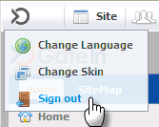

Remember user account
Users who regularly return to GateIn 3.1 can be automatically authenticated to avoid doing an explicit authentication each time they access the portal. Follow these steps:
Step 1: Input your registered username and password.
Step 2: Select the Remember My Login checkbox when logging in GateIn 3.1 at the first time.
Step 3: Click Sign In to submit the form.
To be authenticated for the next time you sign in automatically, do not sign out when you leave the portal.

Change account settings
This function allows you to change your account information. To do so, click directly your account after logging in to open the Account Profiles form.
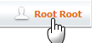
The Account Profiles form will be shown:
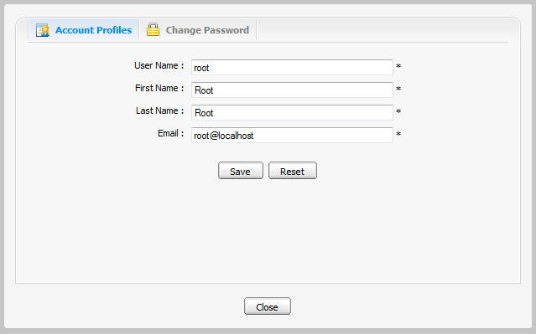Illustration 27: The Account Profiles Dialog
To change your Account Profiles, do as follows:
Step 1: Select the Account Profiles tab.
This tab displays basic information about the current user.
Step 2: Change your First Name, Last Name, Email. Your User Name can not be changed.
Step 3: Click Save to accept changes.

To change your Password, do as follows:
Step 1: Select the Change Password tab.
Step 2: Enter your current password to identify that you are the owner of this account.
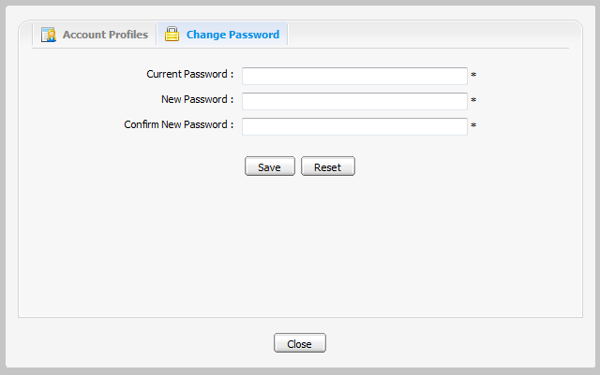Illustration 28: The Change Password tab
Step 3: Enter your new password which must have at least 6 characters.
Step 4: Enter your new password again in the Confirm New Password field.
Step 5: Click Save to accept changes.

Note: If the default accounts' passwords have been changed, the user can no longer sign in the portal by clicking the default accounts directly in the lower of the page.

Retrieve account & password
In case you forget your account or password, you can recover by following these steps:
Step 1: Click the link 'Forget your User Name/Password?' beneath the Password field in the Sign in form.
This form offers two options:
  - Forgot my password.
  - Forgot my username.
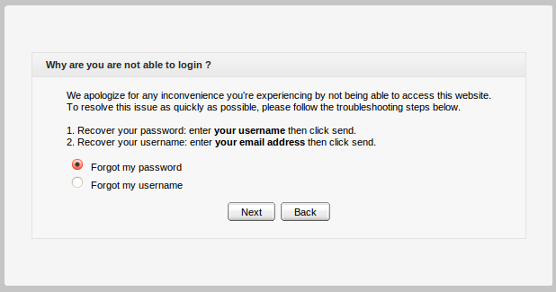
Step 2: Select one appropriate option.
Step 3: Click Next to go the next step. You will be prompted to provide identification information, depending on your choice.
- If you select the Forgot my password, you will be prompted for your user name:
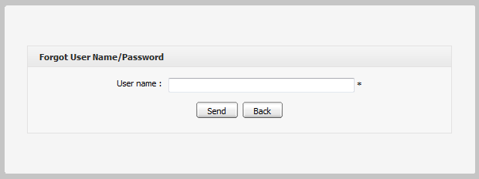
- If you select Forgot my username , you will be prompted for your email:
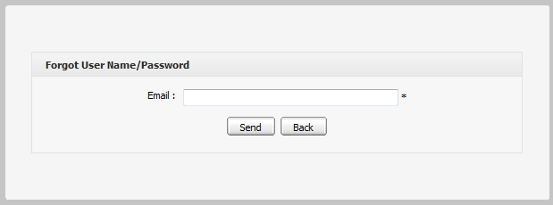
Step 4: Enter your Username or Email.
Step 5: Click Send to submit the entered values.
After the form is sent, an email will be sent to your email address with the requested information.
- If you forgot Username: when your Username is retrieved, your old Username is recovered and can be reused.
- If you forgot Password: you will be sent a new password (as temporary) and then you will be redirected to change password when you sign in.
Note that the User name/Password that you received only takes effect for one day. It means that if the current duration is over one day as from the receipt day, you can not use the received User name/Password. Thus, you have to get another active email.

Language administration
The priority order of display language is: 1. User's language 2. Browser's language 3. Portal 's language. Thus, to display your preferred language, you should pay attention to this order to change language type appropriately.

Change the display language permanently
Do as any of following ways:
The 1st way:
Step 1: Click Site on the administration toolbar and select the portal that you want to edit.
Step 2: Click which corresponds to the portal that you want to edit.
The portal will be displayed under the edit mode.
Step 3: Click to edit portal properties.
Step 4: In the Portal Setting tab: You can change display language of a Portal by selecting another language in the Locale field.
Step 5: Click Save and Finish icon to take affect.
The 2nd way:
Step 1: Click Site on the administration toolbar to open the portal list
Step 2: Click Site Editor and select Edit Layout in the menu:
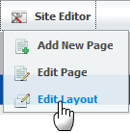
The portal will be displayed under the edit mode.
Step 3: Click to edit portal properties.
Step 4: In the Portal Setting tab: You can change display language of a Portal by selecting another language in the Locale field.
Step 5: Click Save and Finish icon to take affect.
The 3rdway: This way is used to set the display language for yourself, not for displaying the language of Portal.
Only users having administration role can do this:
Step 1: Go to Star | Change Language.
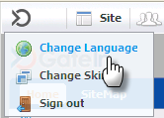
The Interface Language Setting form is displayed with a list of all supported languages. The currently used language is marked by the icon .
Step 2: Select another one by clicking the name of language.
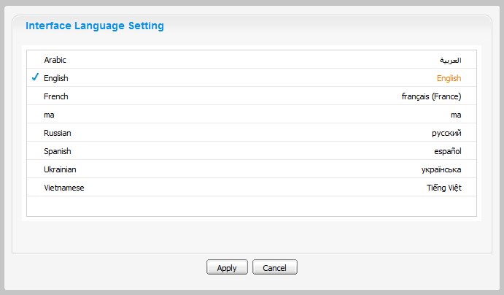Illustration 29: The Interface Language Setting form
Step 3: Click Apply and wait for few seconds to take affect.

Note:
- This display language will be kept permanently till you change your display language by another one.
- When you change from other language to Arabic or set the display language is Arabic. The display language on Portal will be changed to Right to Left (RTL) direction because when Arabists read, they usually read from Right to left.

Change the display language for another user
By this way, you can change not only your display language but also the display language of another users if you have the access right in the Organization portlet.
Do as follows:
Step 1: Go to Group | Organization | Users and groups management.
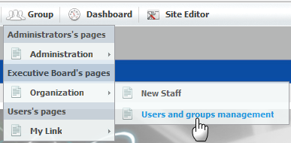
Step 2: Show the form to edit a user in list by clicking the edit icon which corresponds to the user that you want to change the display language.
Step 3: Select the User Profile tab:
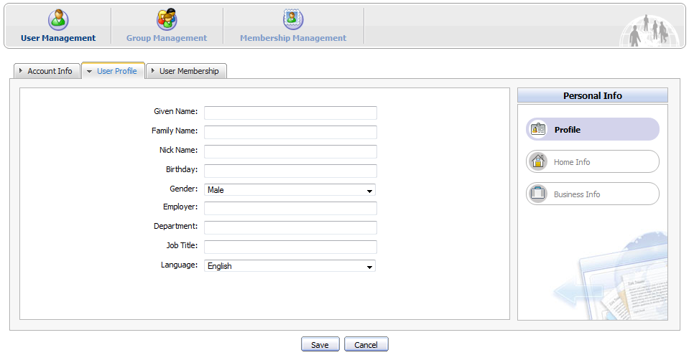
Step 4: Change the display language of this user by changing the value of the Language field.
Step 5: Click Save to accept and save changes, or Cancel to quit.
The next time when the selected user signs in, the display language will be the language changed by the administrator.

Sitemap management

GateIn Site Map provides users with overall view of GateIn, users can go directly pages through the SiteMap without going through the Administration tool bar.

Step 1: Go to the GateIn SiteMap on the navigation bar or go to Site | Classic | SiteMap. The SiteMap page will appear:

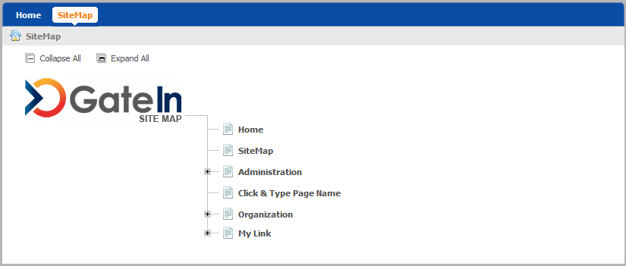
Step 2: Click the Expand All to see all pages inside (Collapse All enables users to back to the initial display).
Step 3: Click directly the title of a page that users want to manipulate.

