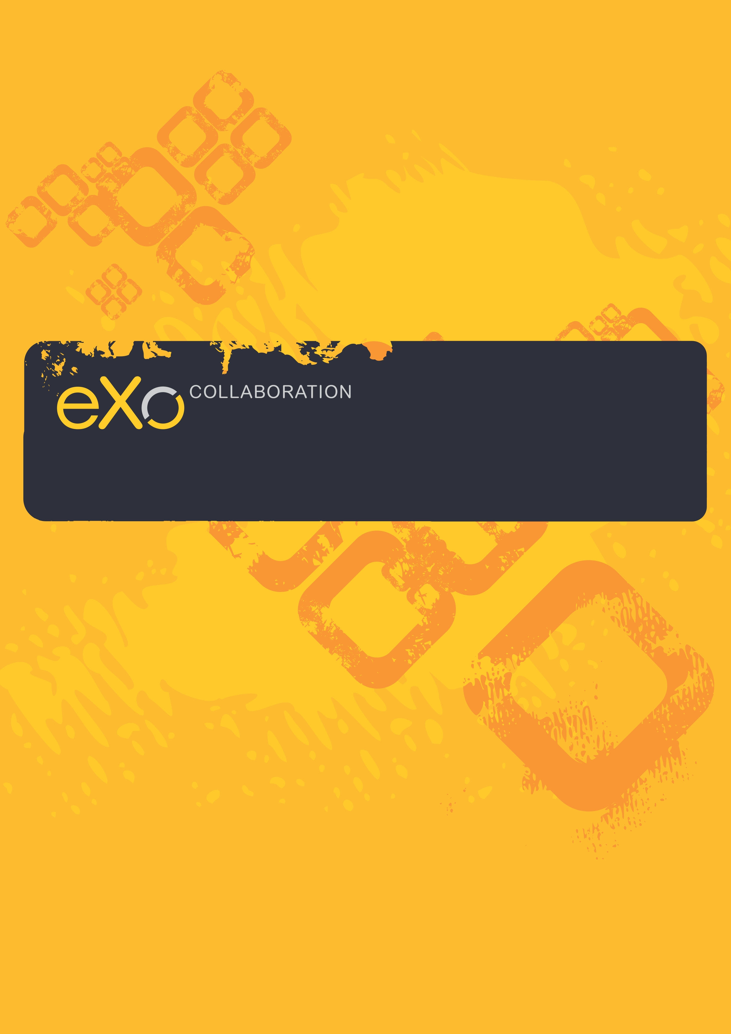
Mail User Guide
Version 2.1

Contents
1 Preface 4
1.1 Overview 4
1.2 Why uses Mails application? 4
1.3 About this document 5
1.4 References & Related documents 5
Related Documents 5
2 Overall Introduction 7
3 How to use Mail? 8
3.1 Account Management 8
3.1.1 Add an account 8
3.1.2 Edit an account 12
3.1.3 Delete an account 15
3.2 Folders Management 17
3.2.1 Add a new folder 18
3.2.2 Add a new sub-folder 19
3.2.3 Rename a folder 20
3.2.4 Remove a folder 21
3.2.5 Mark all messages as read 21
3.3 Mail Management 22
3.3.1Get mails 22
3.3.2 Compose a message 23
3.3.3 Print 27
3.3.4 Reply messages to the sender 29
3.3.5 Reply messages to all related people 31
3.3.6 Forward messages 32
3.3.7 Move messages to folders 34
3.3.8 Manage tags 36
3.3.9 Report a message as spam 41
3.3.10 Delete a message 42
3.3.11 Export messages 43
3.3.12 More actions 46
3.3.13 View and filter mails 51
3.3.14 Manage filters 54
3.3.15 Manage the Address Book 59
3.3.16 Add an event 65
3.3.17 Search 68
3.3.18 Mail Settings 70
3.3.19 Maximize the Reading Pane 73
3.3.20 Sort messages 73
4 Next Steps 74

Preface

Overview
Beginning as an Open Source project in the year 2002, eXo is well-known as the industry's first Java portlet container. With the aim of dominating the potential portal market through robust and easy-to-use applications, eXo Project succeeded in attracting consumers in the whole world. eXo actually opened the floodgates to various options in many markets, and customers have been choosing eXo as the best method for their success.
The eXo Platform™ software is a powerful Open Source corporate portal and content management system. Users of the platform have a customized single point of access to the company's information system and resources.
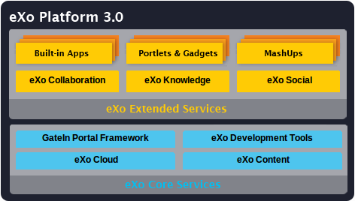
Developed on eXo Platform 3.0, eXo Collaboration is one of eXo Extended Services that provides a rich, Web 2.1 browser-based interface with comprehensive messaging and indexing; archival and search capabilities; shared calendars, address books, emails and much more features. Accordingly, Mail is an open-source mail client that is built on the eXo WebOS foundation with a variety of new features designed to make your e-mail experience more productive and convenient, as a new way to view your mails inbox and conversation and help minimizing risks and annoyances such as phishing and junk e-mail, etc. With Mail application of eXo Collaboration, you are easy to approach the basics such as writing, reading, finding and much more.

Why uses Mails application?
The application provides many useful features to users as summarized below:
- User Interface is clean with drag-and-drop and right-click contextual menus.
- Users can create and use multiple accounts, so different email addresses can be displayed in the same web interface.
- With multiple views, users can see in various ways, including list, thread or conversation.
- Message tags will make it easier to find and sort archived content.
- Filtering function allows users to define rules to contain results as fast as possible.
- Rich Text Editor provides users with message display and composition.
- Many standard mail protocols, such as POP3, IMAP, SMTP, SSL are supported.
- Calendar Integration helps accepting received event invitations in one-click and creating new calendar events without having to leave the inbox.

About this document
The intended reader of this manual is users of Mail application of eXo Collaboration. This manual will explain all the basic and advanced features that Mail provides. It gives an in depth examples and easy explanation of using Mail application.
The material is useful for anyone interested in learning and using the Mail application, especially for users who have administration privileges. It covers administration of users, permissions and all management actions.
From above, the aim of Mail User Guide can be summarized as follows:
- Define some basic concepts used in the Mail application.
- Show the main instructions of the Mail application.
- Guide step-by-step to do basic actions.

References & Related documents

Related Documents
- GateIn Guide
- eXo Collaboration Calendar User Guide 2.1
- eXo Collaboration Address Book User Guide 2.1
- eXo Collaboration Chat User Guide 2.1
Information
- eXo Home Page
- eXo Wiki
Support
- Forums
- FAQ
Download
- eXo Content
- eXo Development tools
- Gatein Portal Framework
- eXo Collaboration
- eXo Knowledge
- eXo Social
Resource Center
- Video demos, tutorials, webinar archives, features & benefits tables and more

Overall Introduction
Mail is a webmail application of GateIn. With the webmail, you can receive your emails whenever and wherever just by using a common web browser such as: Internet Explorer, Firefox or Safari, etc. It is a web based interface that allows you to view your emails through the Internet without downloading it to your computer. Users can keep updated and receive all important messages, files and pictures at all times and easy for users to look for and view messages. This is actually an efficient and economic communication mean via Internet.
Additionally, eXo Mail is smoothly integrated with other Collaboration Suite modules such as Address Book and Calendar.
To go to eXo Mail, click on from the navigation bar :
or click on right from the Chat bar:

How to use Mail?

Account Management
In order to get mails from the other mail service to Mail applicaation of eXo Collabroation, you need to create an account in Mail which connects to a real existing email account. Mail allows you to mange your account such as adding, editing, deleting accounts which may get mails from different mail services at one time.

Add an account
The function is used to add an account in Mail through step 1 to step 5.
To add an account, do as follows:
Step 1: Open the Create a new account form by clicking the icon and then select Add account in the drop-down list:
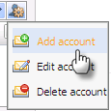
The Create a new account form will appear with 5 steps that correspond to 5 tabs.
Step 2: Fill values in step 1. This step allows you to add basic information: Account name and Description.
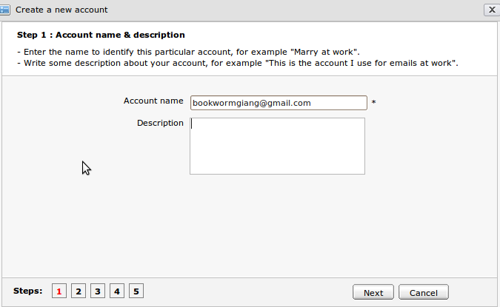Illustration 1: Step 1: Account name & description

Details:
Account name | The account name which will be displayed in the account list. (Required).
Account description | The account's brief description.
Step 3: Click Next or the number 2 to go to and fill values in the Step 2. The Mail identify settings form will be displayed:
Details:
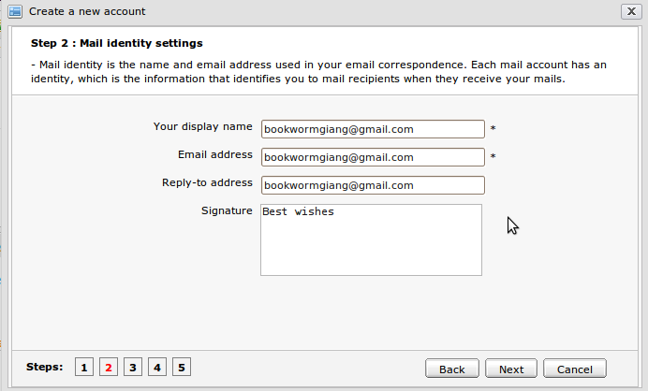Illustration 2: Step 2- Mail Identity settings of the Create a new account form
Your display name | The name to be displayed when you use the account. This name will be displayed together with user's email address when the user composes a new message. (*Required).
Email address | The email address which corresponds to the account. It must be exactly. (*Required).
Reply – to Address | The email address that will receive all replies. (Not required).
Signature | The signature which is displayed at the bottom of your message.

Step 4: Click Next or the number 3 to go to and fill values in the Step 3, the Server information form is displayed.
Details:
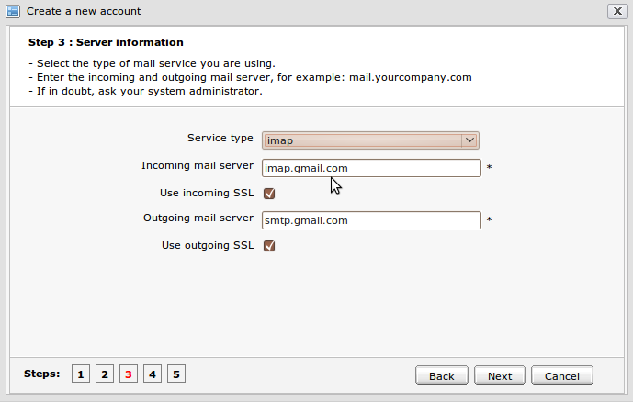Illustration 3: Step 3 – Server information of the Create a new account form
Server Type | Type of the mail server. There are two choices: POP3 (Post Office Protocol version 3) is a protocol to get email from a remote server or IMAP (Internet Message Access Protocol) which retrieves e-mail from a remote server over a TCP/IP connection. By default, 'pop3' is selected.
Incoming mail server | The incoming mail server of the email provider which you are using. In order to properly use, users need to configure this field. Each email provider has different incoming mail server. By default, the value of this field is 'pop.gmail.com'.
Use incoming SSL | The option allows using SSL (Secure Sockets Layer) or not. SSL is cryptographic protocol which provides secure communication on Internet such as web browsing, email, Internet faxing, etc. Incoming SLL allows using SSL to check incoming emails.
Outgoing mail server | The outgoing mail server of the email provider that corresponds to the incoming mail server. By default, the value of this field is 'stmp.gmail.com'.
Use outgoing SSL | This option is to use SSL to send mail in the Mail application.

Step 5: Click Next or the number 4 to go to and fill value in the Step 4. The Create a new account form is displayed:
Details:
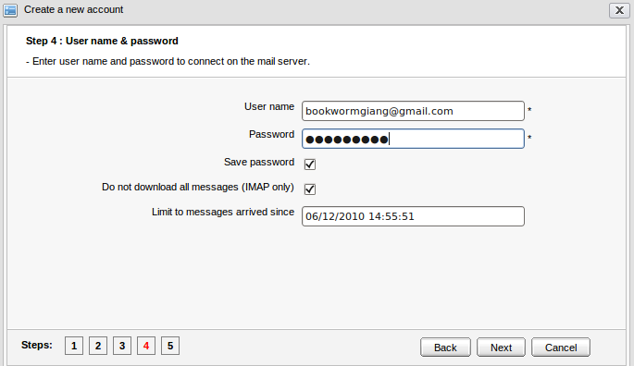Illustration 4: Step 4- User name & password of the Create a new account form
User Name | The email address which is used in Mail without logging in directly. (*Required).
Password | The password that corresponds to the email address in 'User name'. It will be used to archive your mail in 'User name' as you use it to sign in your mail. (*Required).
Save password | The option allows saving password or not. If this option is checked, each time when you check mails, you needn't enter a password again. If this option is not checked, there will be a message that requires you to enter your password anytime you check mail.
Do not download all messages (IMAP only) | The option allows checking mail from Image only or not.
Limit to messages arrived since | The date since then the emails are gotten.

Step 6: Click Next or the number 5 to go to and fill values in the Step 5, the Verifying information form is displayed:
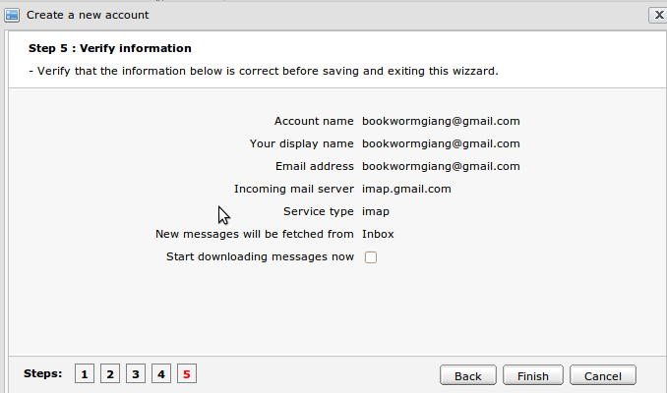Illustration 5: Step 5- Verify information of the Create a new account form
The form will display all information to verify the inputed values from step 1 to step 4 when a new account is created.
Details:
Start downloading messages now: The option allows getting messages automatically right after finishing creating a new account like the figure below. Otherwise, you have to do it manually.
Step 7: Click Finish to complete creating a new account, or Back to return to the previous step or Cancel to cancel creating a new account.
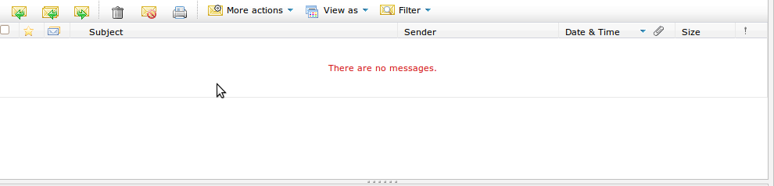Illustration 6: Getting mail automatically

Edit an account
The function allows making changes to existing mail accounts. Do as follows:
Step 1: Open the Edit account form by two ways:
The 1st way: Open the Edit Account form by clicking the icon on the left pane and select the Edit account item:
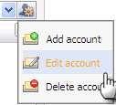
The 2nd way: Open the Edit Account form by clicking the icon on the toolbar.
The Edit Account form will appear:
The Identity tab contains basic information of the account such as account name, your name, your email address, reply-to address, mail signature, etc.
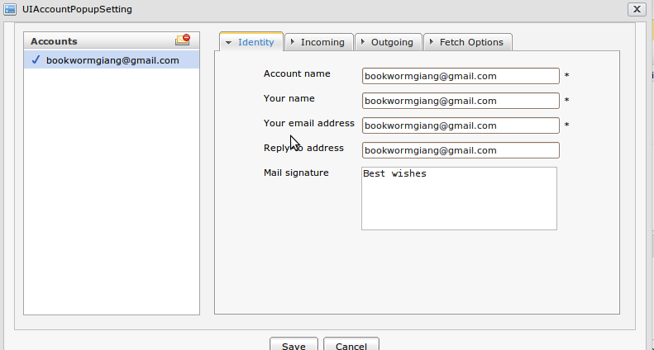Illustration 7: The Identity tab of the Edit Account form
The Incoming tab contains some incoming settings information that is used to check/receive mails such as Server type, Sever name, Port, User name, Password. There are some options such as Remember password and Use secure authentication (SLL).
The Outgoing tab contains some outgoing information that is used to send a mail such as Server name, Port. There are some options such as Use secure authentication (SSL), Enable SMTP authentication, Use incoming server username/password.
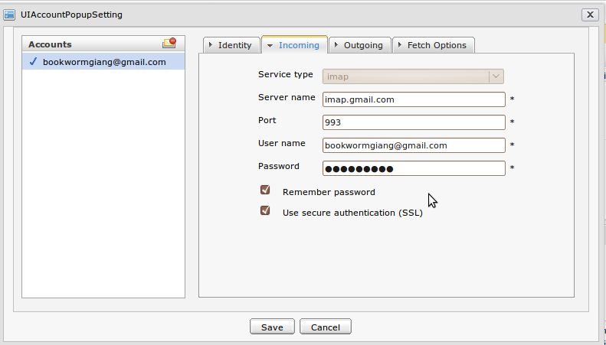Illustration 8: The Incoming tab of the Edit Account form
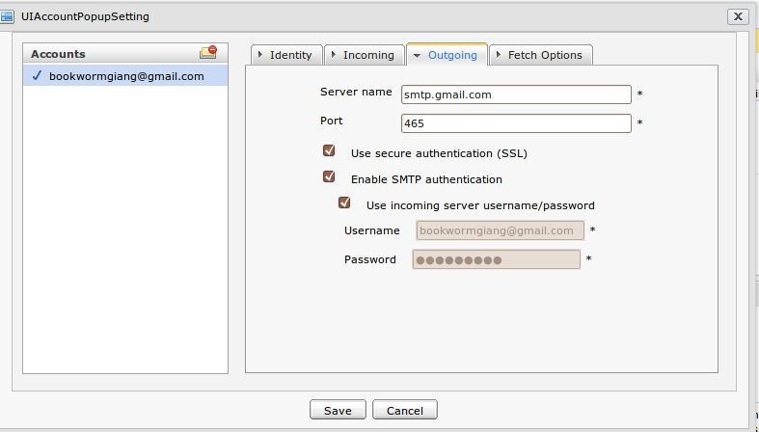Illustration 9: The Outgoing tab of the Edit Account form
When the Enable SMTP authentication is selected, the field group that allows defining the user name and password of the email used for sending mail will appear. If the Use incoming server username/password check box is selected, the incoming email address and its password are displayed and disabled. If the check box is not selected, the incoming email can be manually inputted.
The Fetch Options tab contains some advanced options to customize the way to check mail, the default folder to receive mail, etc.
Details:
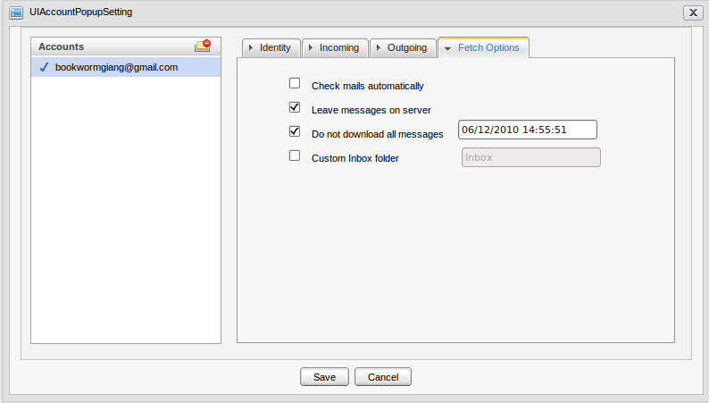Illustration 10: The Fetch Options tab of the Edit Account form
Check mails automatically | The option allows checking a mail automatically or not.
Leave message on server | The option allows leaving mails on server after checking mails or getting and deletingthem on server. This option is for pop3 Server type. In case the IMAP server type is used, it is Mark message as delete with the similar meaning.
Do not download all messages | Limit downloaded messages before a specific date time.
Custom Inbox folder | This option allows customizing the folder that will contain the arrived emails. By default, it is the Inbox folder.

Step 2: Change information of the current account.
Step 3: Complete editing by clicking Save to accept changes or click Cancel to cancel editing.

Delete an account
The function is used to remove accounts from the account list. There are two ways to take this action:
The 1st ways:
Step 1: Open the Delete account form by clicking the icon on the left pane and then select the Delete account item:
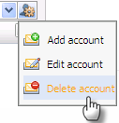
The Delete account form will appear:
Step 2: Click the Delete icon corresponding to the account which you want to delete and then click the OK button to confirm deleting.
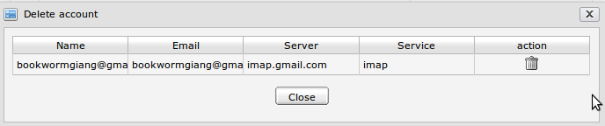Illustration 11: The Delete account form
The 2nd way: You also can delete an account from the Edit Account form:

Step 1: Click the icon on the left pane and then select the Edit Account. The Edit Account form will appear with the account list in the left pane.
Step 2: Select the account that you want to delete from the account list. The selected account will be marked by the icon and click:

The selected account will be removed from the account list.
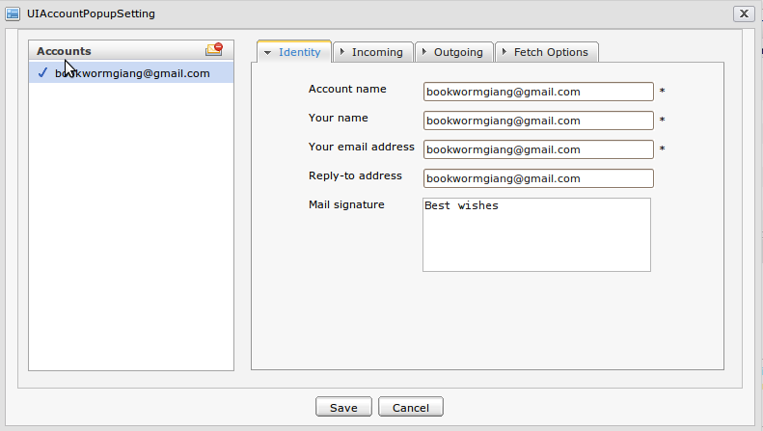Illustration 12: Delete account in the Edit Account form

Folders Management
Folders helps managing your messages more easily and flexibly. There are some default folders generated automatically after creating a new account: Inbox, Drafts, Sent, Spam, Trash and Personal Folders list.
Details:
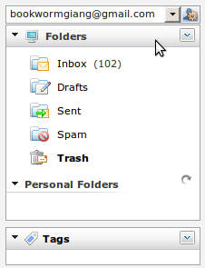Illustration 13: The default folder list

Inbox | The place which stores all incoming messages normally.
Drafts | The place which stores all messages which have been composed but not been sent yet.
Sent | The place which stores all sent messages.
Spam | The place which stores all unnecessary incoming messages.
Trash | The place which stores all unnecessary messages that are deleted from all default folders and personal folders.
Personal Folders | The list of the personal folders which corresponds to the created folders in the sever mail box.

Add a new folder
The function is used to add a new folder in Mail.
To add a new folder, do as follows:
Step 1: Open the Add a new folder form by clicking the arrow icon on the Folders bar and then select Add in the pop-up list:

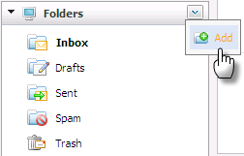
The Add a new folder form will appear:

Details:
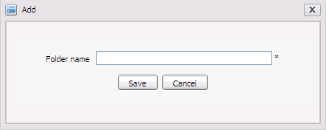Illustration 14: The Add a new folder form
Folder name | To enter name of a folder. (*Required).
Save button | To accept saving a new folder.
Cancel button | To cancel adding a new folder.

Step 2: Input a Folder name
Step 3: Complete adding a new folder by clicking the Save button.
The created folder will be saved and displayed in the Personal Folders section.

Add a new sub-folder
The function is used to create new sub folders into a folder. You can only add new folders, personal folders except for the default folders (Inbox, Drafts, Sent, Spam, Trash).
Do as follows:
Step 1: Right-click the created folder that you want to add to and then select New Subfolder in the pop-up list:

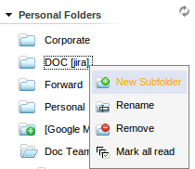
The Add a new folder form will appear.
Step 2: Input a Folder name.
Step 3: Complete adding the new sub folder by clicking the Save button.

Rename a folder
The function is used to change the folder's name. You can change names of all your personal folders which are created by yourself except the default ones.
Do as follows:
Step 1: Right-click the folder which you want to rename and select Rename in the drop-down list.
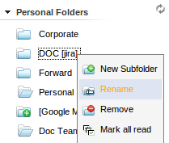
The Rename folder form appears:
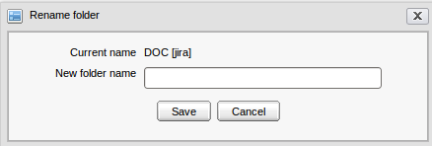Illustration 15: The Rename folder form

Details:
Current name | The current name of the folder that you want to change. It can not be changed directly.
New folder name | The new name of the folder.

Step 2: Input a new name into the New folder name field.
Step 3: Complete renaming by clicking the Save button.

Remove a folder
The function is used to remove a folder from the folder list except the default folders. When a folder is removed, its sub-folders are also removed.
Do as follows:
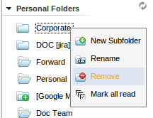
Step 1: Right-click the folder that you want to remove and select Remove in the menu pop up:

The confirmation message will appear below:
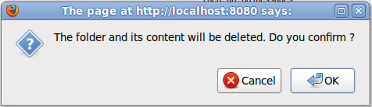
Step 2: Click OK to confirm deleting.

Mark all messages as read
The function is used to mark all messages in a specific folder (default and personal folders) as read.
To take this action, right-click the folder that you want to mark as read and select Mark all read in the pop-up list:
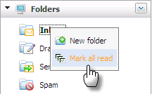
After being marked all as read, all unread messages inside the folder will be marked as read. All unread messages are changed from bold to normal font.

Mail Management
E-mail (electronic mail) is the exchange of computer-stored messages by telecommunication. To send and receive mails, each user must have an email address from service provider. This section shows you the way to do many actions with mails.

Get mails
The function is used to fetch incoming messages from the server.
To check mail, do as follows:
Step 1: Click the folder that you want to check mail. If no folder is selected, the default folder that will be checked for new messages is the Inbox folder.
Step 2: Click the button in the toolbar. There will be an notification message with the content 'Fetching email messages'.
Step 3: Click the “Stop” link when you want to stop checking mails. All arrived mails are shown in the message list pane.
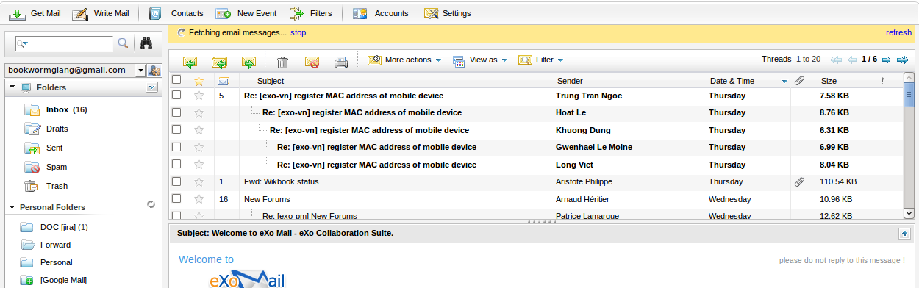Illustration 16: The list of mails in the Mail view pane
Step 4: Click the “Refresh” link if you want to refresh fetching mails.
The checking mail process is only already stopped when you perform checking mail again and click the “Stop” or “Refresh” link when you want to stop getting mail while it is still doing or is refreshing the fetching message.

Compose a message
The function is used to compose a message.
Do as follows:
Step 1: Click the button 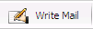on the toolbar to compose a message.
The Compose a new message form will appear:
Step 2: Compose the message content.
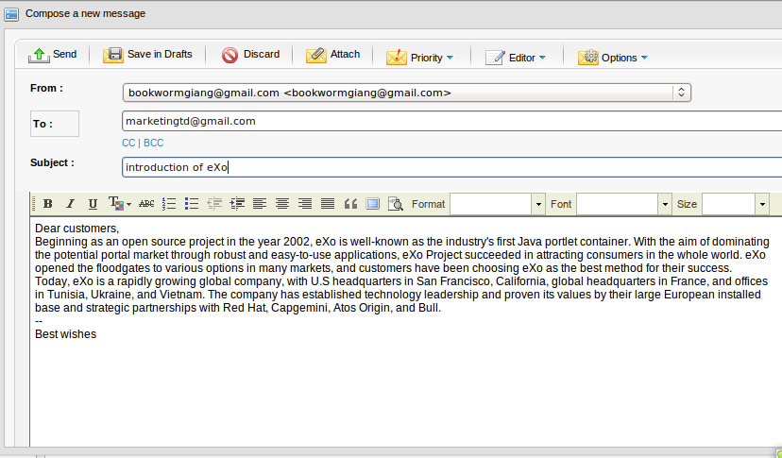Illustration 17: The Compose a new message form
- Click the To button to open the Contacts form:
- Select the desired emails by selecting its checkbox(es). The Address book combo box and the Search function allow filtering and finding expected email address(s) according to specific conditions quickly.
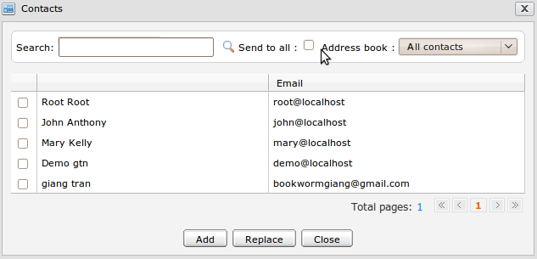Illustration 18: The Select email form
- Send to all option also allows you to send mail to All contacts or specific groups. To do this, select your expected group in the address drop list, tick the Send to all check box and click the Add button. For example, you can select the All contacts in the Address book drop list and click the Add button to add the group you want to send mail. The form will be displayed below:
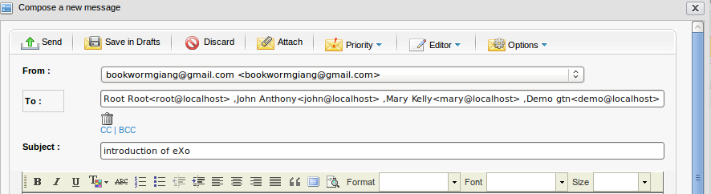
- If you don't want to send mail to any added group, you can click the delete icon corresponding to that group to remove.
- Click the Add button to add the selected email addresses to 'To' field, click the Replace button to replace the current email addresses in the 'To' field with the new selected email addresses or click the Cancel button to quit.
Besides, the auto complete contact function allows filtering and listing the receiver's email addresses in a pop up according to the alphabet you input into the fields, including To, CC or BCC. For example, your friend name is Alex, you do not remember her email address, you can enter the character 'A' in the To field, all the contacts have 'A' alphabet (also including Alex) are listed in a pop that makes it easy for you to select.
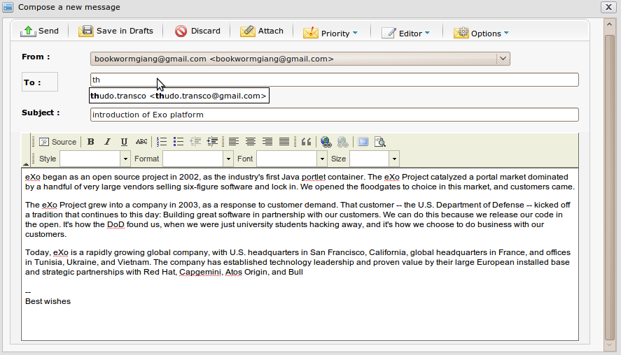Illustration 19: The address list of the auto complete contact function

Details:

Browse button Subject | The message's subject. The field's content usually contains the general meaning for the message content.
CC|BCC CC | BCC | You can use CC and BCC to send mail to more than one person easily and fast by clicking the 'CC' or 'BCC' link. The CC or BBC text field will be displayed for adding more email addresses. The CC mails are public, all receivers can know to whom the mail is sent while the BCC mails are private to the sender and the BCC receivers. Using ' BCC' when you want 'To' and 'CC' users also receive this mail but do not know that you also send this email to others.  Similarly, the receivers for 'CC' and 'BCC' fields can be selected from the Select Address form by clicking the CC or BB button and full fill by the auto complete contact function.
 | To send the composed message to the email address in the 'To', 'CC' and 'BCC' fields.
 | To save the composed message as a draft in the Draft folder.
 | To exit the Compose a message form.
 | To attach a file to the composed message. ( See the attach file below)

The Attach files form is below:
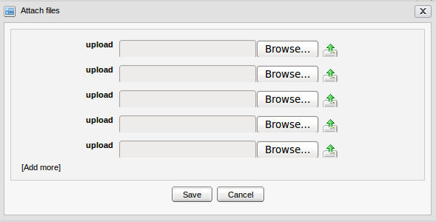Illustration 20: Attach File form
Details:

Browse button | To select a file from your local computer.
 | To upload the selected file.
[Add more] | To attach more files.
Save button | To accept saving the attached files in composed message.
Cancel button | To exit the Attach file form without adding new.

After being attached files, the attached files are shown below:
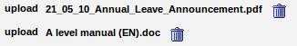
To remove the attached files, click the icon which corresponds to the attachment that you want to delete.
If the attachment's check box is selected, it means the message will be sent with the selected attachment.
If not, the unselected attachments is not sent.
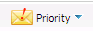 To set a status for the composed message. There are three options to view: Low, Normal and High. Each status has its own icon. The message is sent with High priority that will be marked by the “!” icon in red. The message is sent with the Low priority will be marked by the ''!” icon in gray. By default, the message is sent with the Normal priority. It means that no icon is used to set out.
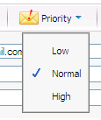
To change the text editor types: Rich text or Plain text. With the Rich text editor, the message content can be composed with many effects such as font style, color, size, etc. With the Plain text editor, the message can be composed with simple text only.
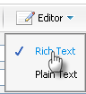
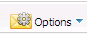Currently, the options consist the Return Receipt option that allows the sender to receive a notification mail in case the receivers of the sent email read it. However, the sender only receives the notification in case the mail box of the receivers has been configured in the Setting that allows notifying to the sender about the read message.
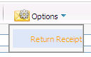
Step 3: Complete sending a mail by clicking the Send Mail button.
After sending a mail, the sent mail will be saved in the Sent box. In case the receipt emails (in the To, CC, BCC fields) of the sent email are the new ones that do not exist in the sender's Address Book, they will be added automatically to the Collected Address in the Contact portlet.

Print
The function is used to print a specific message in the mail list.
There are some ways to print a message. Do as follows:
The 1st way:
Step 1: Right-click the message which you want to print and select Print in the pop-up:
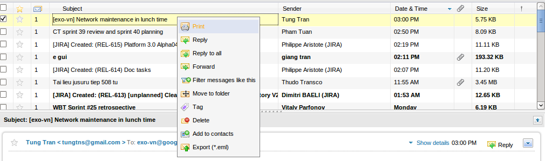
The Print preview form will be displayed with detail information available for printing:
Step 2: Click the Print button to accept printing or the Close button to quit.
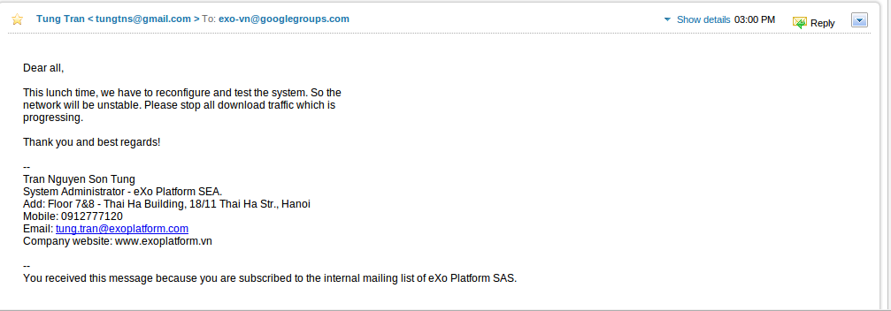Illustration 21: The Print preview form
The 2nd way:
Step 1: Select messages in list that you want to print by ticking its checkbox(es).
Step 2: Select the Print icon on the action bar.
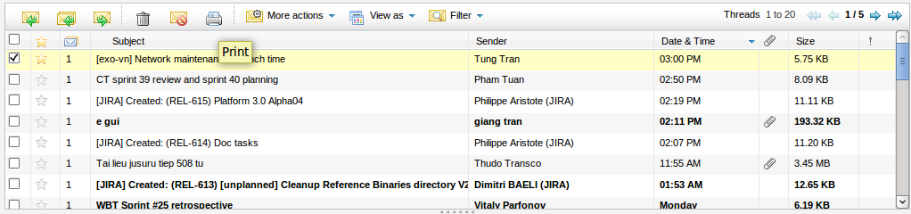
Step 3: At the print preview form, click the Print button to accept printing or the Close to quit.
The 3rd way:
Step 1: Open the message which you want to print.
Step 2: Click the icon at the right corner of message's content and select the Print item in the pop-up list:
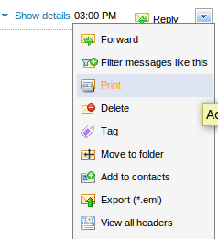
Step 3: Click the Print button to accept printing or the Close button to quit in the print preview form.

Reply messages to the sender
The function is used to reply to the sender (email address in the 'From' field) of a specific message.
To reply to a sender, do as follows:
Step 1: Open the Reply form by three ways:
The 1st way: Select the messages in list that you want to answer by selecting its check box(es) and then click the iconin the action bar :
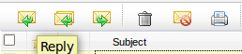
The 2nd way: Right-click the message you want to reply and select the Reply item in the drop-down list:
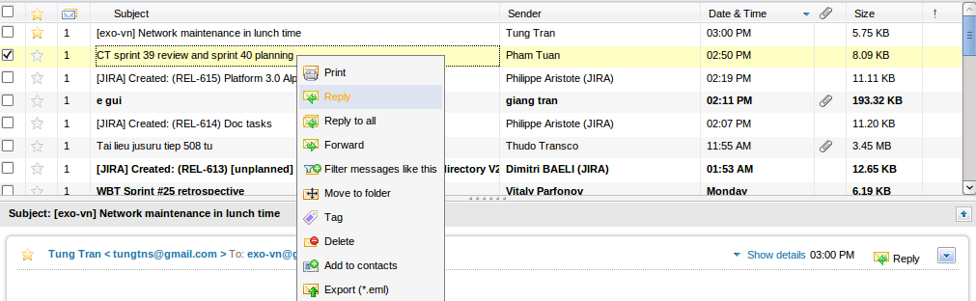
The 3rd way: Open the message that you want to reply by clicking the message's name.
Then, select the icon upper the message's content.
The Reply form will appear in form of the Compose a new message with detailed information, available for replying to the sender.
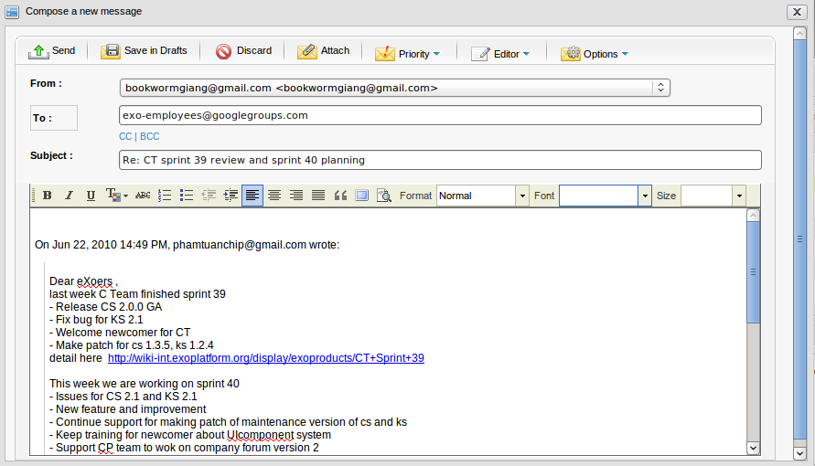Illustration 22: The Reply form
Step 2: Compose the message content by inputing text into the text editor.
Step 3: Click the button to accept replying to the sender.
Before replying, you can also take many actions in the Reply form such as attaching file, marking message, saving as draft, discarding.
In case the receipt emails (in the To, CC, BCC fields) of the sent email are new ones that do not exist in the sender's Address Book, they will be added automatically to the Collected Address in the Contact portlet.

Reply messages to all related people
The function is similar to the Reply to sender function (in the 'To' field). However, the others who received the original mail (in field 'CC' or 'BCC') also receive this reply.
To reply to all, do as follows:
Step 1: Open Reply to All form by three ways:
The 1st way: Select the message in the list that you want to reply to all by ticking on its checkbox(es) and click the icon .
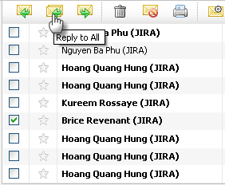
The 2nd way: Right-click the message which you want to reply to all and then select Reply to all in the drop-down list.
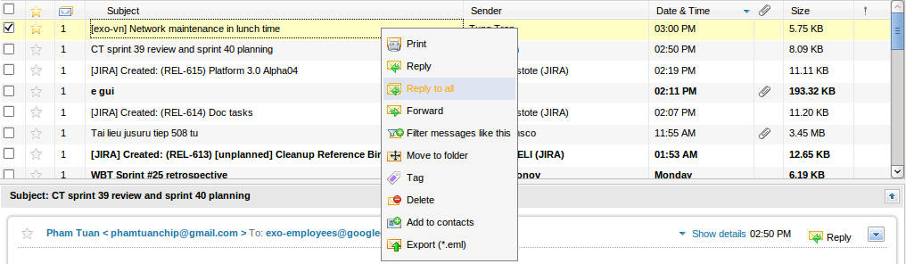
The 3rd way: Open the message which you want to reply to all and then select the icon on the action bar.
The Reply to all form is shown in form of the Compose a new message with detailed information, available for replying to all.
Details:
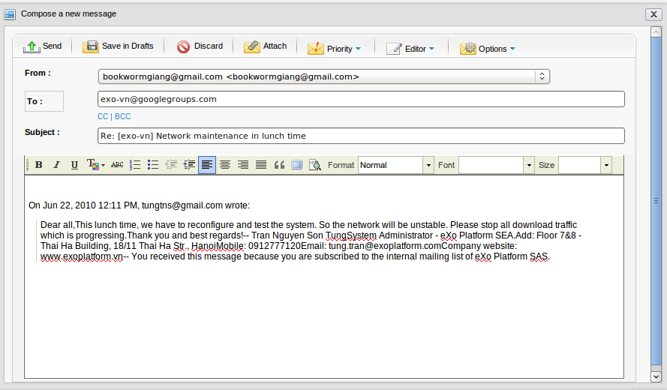Illustration 23: The Reply to all form

Form | The email address of current account which received this mail.
To | The email addresses of the sender and all receivers.
CC | The email addresses of CC receivers which are listed in the CC field of the original message.
Subject | The email's subject.

Step 2: Compose the message content by inputing text in the text editor.
Step 3: Click the button to accept replying to all.
Before replying to all, you can also do many actions in Reply form such as attach file, mark message, save as draft, discard, etc.
In case the receipt emails (in the To, CC, BCC fields) of the sent email are the new ones that do not exist in the sender's Address Book, will be added automatically to the Collected Address in the Contact portlet.

Forward messages
The function is used to transfer a received message to the other users with the original content.
There are many ways to forward a message:
Step 1: Open the Forward message form by 3 ways:
The 1st way: Select the message which you want to forward and then click the icon on the action bar:
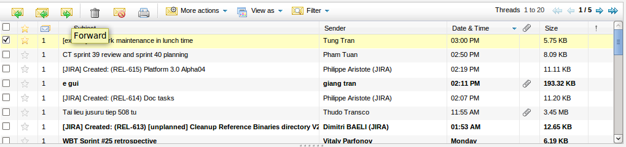
The 2nd way: Open the message which you want to forward and then click the icon at the right corner of message 's content and select Forward in the menu:
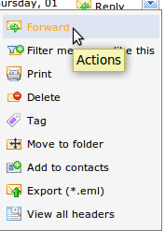
The Forward message form will be shown in the form of the Compose a new message form with detailed information available for forwarding the message.
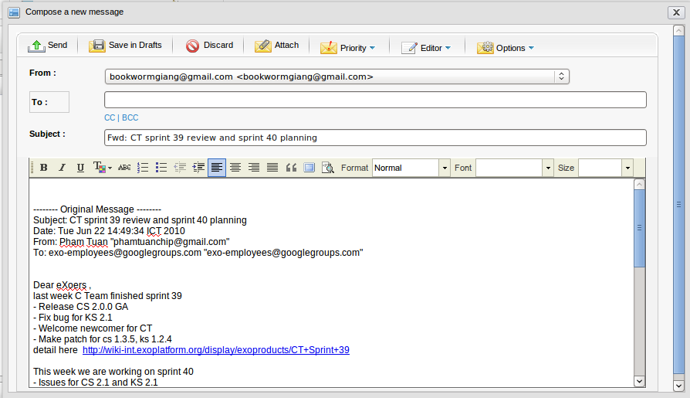Illustration 24: The Forward message form
Step 2: Compose or edit a message by inputting text in text editor.
Step 3: Click the button to accept replying to all.
Before forwarding, you can also take many actions in the Forward form like when composing a new message such as attaching file, marking message, saving in draft, etc.
In case the receipt emails (in To, CC, BCC fields) of the sent email are the new ones that do not exist in the sender's Address Book, they will be added automatically to the Collected Address in the Contact portlet.

Move messages to folders
The function is used to move one or more messages to other folders. There are many ways to take this action. Follow one of following ways:
The 1st way:
Step 1: Select messages which you want to move by selecting its checkbox(es).
Step 2: Right-click these messages and select Move to folder in the menu.
Step 3: All existing folders are displayed in a list, select one for the destination folder.
Step 4: Click Save to accept moving the messages to the selected folder.
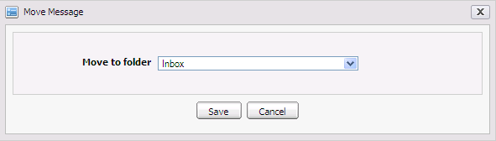Illustration 25: The Move Message form
The 2nd way: Using the drag and drop feature.
Step 1: Check the messages to move and then move a cursor to one of the selected messages until a cursor pointer becomes then press the left mouse, drag these messages and drop them to the folder which you want to move to.
Step 2: All checked messages will be moved to the destination folder.
The 3rd way:
Step 1: Open the message to move to the other folder and then click the icon on the right corner of the message 's content and select Move to Folder item in the drop-down list:
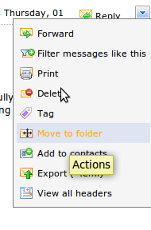
Step 2: At the Move Message form, select the folder in the Move to folder combo box and click Save to move the messages to the selected folder or click Cancel to quit.
The 4th way:
Step 1: Check the messages that you want to move and then click More Actions on the main bar and select Move in the menu:
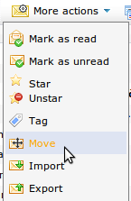
Step 2: At the Move Message form, select the folder in the Move to folder combo box and click Save to move the messages to the selected folder or click Cancel to quit.

Manage tags

Tag a message
Mail allows assigning tags to messages. Tags are used as labels which allows filtering or categorizing messages from different folders. A single message can be assigned to many tags at one time. Using tags makes it easy for you to find your messages independently from the folder where you stored them.
To assign a tag for one or more messages, follow one of following ways:
The 1st way: This way is used to create a tag that has not assigned to any message.
Step 1: Click the icon on the Tags bar of right pane and select Add a new tag in the drop-down list.
Details:
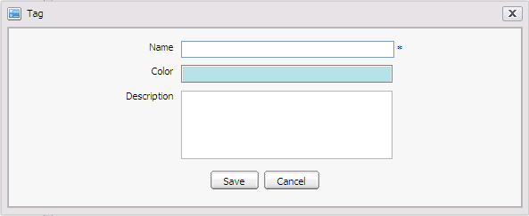Illustration 26: The Tag form
New name | The new tag's name. (*Required)
Color | The tag's color.
Description | The tag's brief description.

Step 2: Enter values to the required fields.
Step 3: Complete adding a tag by clicking the Save button.
A new tag will be updated at the tag list and you can add this tag to any message.
The 2nd way:
Step 1: Select message(s) by selecting its checkbox(es).
Step 2: Right-click one of the selected messages and select Tag in the menu:
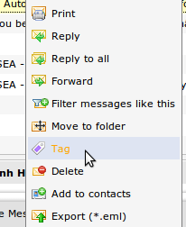
The 3rd way:
Step 1: Select message(s) by selecting its checkbox(es).
Step 2: Select Tag item in the More Actions drop down list menu on the action bar:
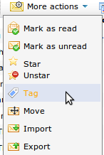
The 4th way:
Step 1: Click one message to open it.
Step 2: Click the icon at the right corner of the message's content and select Tag in the drop-down list:
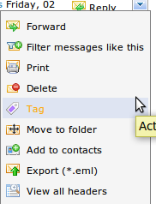
The 5th way:
Step 1: Select message(s) by selecting its checkbox(es).
Step 2: Drag these messages and then drop them to the container of the tag in the More actions.
Step 3: Click Tag, The Tag Message form appears:
Details:
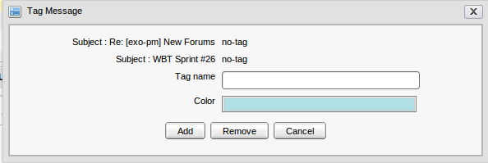Illustration 27: The Tag Message form

Tag Name | The tag's name. This field contains words and keywords which are used to describe the same messages.
Choose Color | The color of the tag which can be changed by clicking on the color area to choose other colors.
Add button | To accept adding message to a new tag.
Remove button | To remove tags in case there are some existing tags.
Cancel button | To exit the Add Tag form.

Step 4: Fill out this form (Give a tag name, change color).
Step 5: Complete adding a tag by clicking the Add button.
In case there are already tags in list, the Add tag form is displayed:
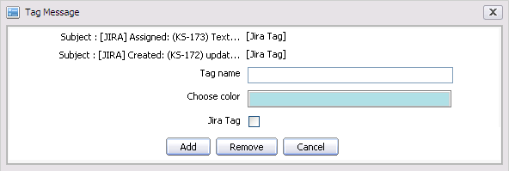
You can add a new tag for your message by inputing a new Tag name or update your messages to existing tags by selecting its checkbox(es) and click the Add button.
If you want to remove existing tags, your can select its checkbox(es) and click the Remove button or click the Cancel button to close the Tag Message form.
In case you want to tag a message to a specific tag, you can drag and drop it directly to that tag.
The messages with added tags will be marked by the tag icon like below:

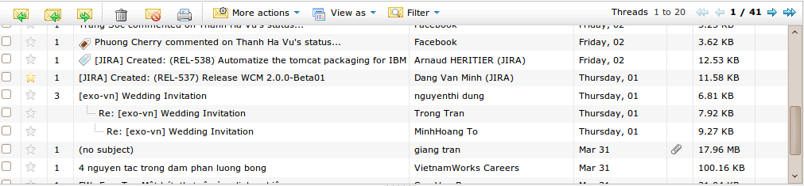
Edit a tag
The function is used to edit tags in the tag list.
Do as follows:
Step 1: Right-click a tag in the tag list on the left pane and choose Edit:
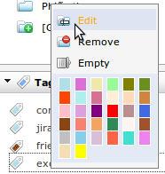
The Edit Tag form will appear:
Step 2: Change the tag's information.
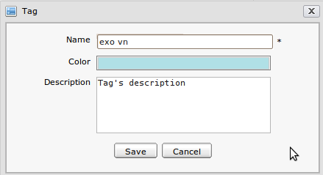Illustration 28: The Edit tag form
Step 3: Complete editing a tag by clicking Save or click Cancel to exit the Tag form.

Remove a tag
The function is used to remove tags from the tag list.
To remove a tag, do as follows:
Right-click the tag that you want to remove from the tag list and then select the Remove item in the drop-down list:
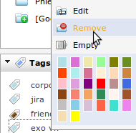
The selected tag will be removed from the tag list and it will also be removed from all messages to which the tag was assigned.

3.5.8.4 Empty a tag
The function is used to remove the selected tag from all messages that are tagged with it.
To empty a tag, do as follows:
Right-click a tag that need to be emptied and select the Empty item in the drop-down list:
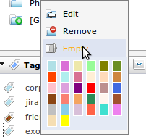
The selected tag will be removed from all messages. After emptying, click the emptied tag, no message is shown in the message list pane.

Change tag's color
The function allows changing the color of a tag in the tag list by right-clicking the tag that you want to change and then select one color in the colors area. There are 32 available colors in the colors area:

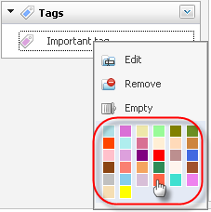
Report a message as spam
The function is used to report one or more messages in a specific folder as spam.
To report an email as spam, do as follows:
Check the messages which you want to report as spam by selecting its checkbox(es) and then click the icon on the action bar:
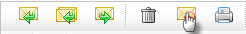
All the selected messages will be moved into the Spam folder. Go into the Spam folder to verify that the selected messages have been moved into it.
After reporting a message as spam, the messages from the sender who has been reported as spam will be moved automatically to the Spam folder.
In the Spam folder, if you want to edit one message and notify that it is not spam, you can select its check box and click the Not spam icon on the action bar:

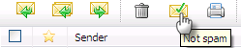
After reporting as 'not spam' successfully, the messages from the sender who has been reported as not spam will be moved automatically to its original folder such as Inbox. Since then, all message from the sender who has been reported as not spam will be received normally.

Delete a message
The function is used to delete messages permanently by moving messages from its folder to the Trash folder.
To delete a message, do as follows:
The 1st way:
Right-click the message which you want to delete and select Delete in the menu:
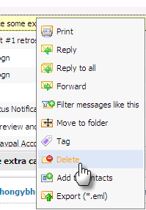
The selected message will be removed completely from its folder.
The 2nd way:
Open the message which you want to delete and then click the icon at the right corner of message's content and select Delete in the menu:
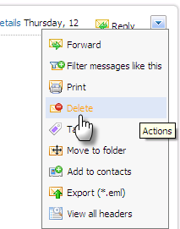
This message will be removed completely from its folder.
The 3rd way:
Select the message that you want to delete and click the trash icon on the action bar:
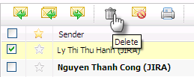

Export messages
The function is used to export one message to a file with the *.eml format.
To export a message, do as follows:
Step 1: Open the Export Message form by 3 ways:
The 1st way: Right-click the message that you want to export to the file *.eml and then select Export in the menu:
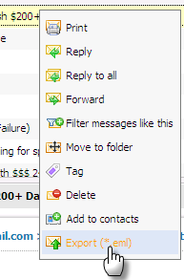
The 2nd way: Check the message to export by selecting its checkbox(es) and then select the Export message item in the More Actions menu:
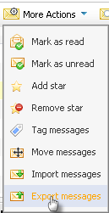
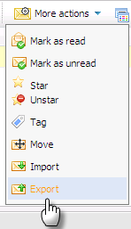
The 3rd way: Open the message to export and then click the icon on the right corner of message's content and select the item Export (*.eml) in the menu:
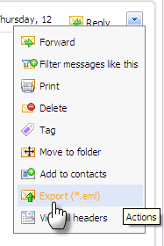
The Export Message form will appear:
Details:
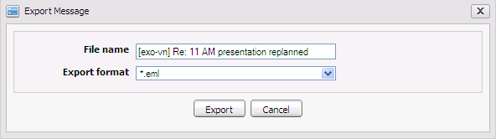Illustration 29: The Export Message form
File name | The name of file which you want to export to. By default, the subject of the selected message will be used but you can change this name.
Export format | The format of the file which will be exported. By default, the type of file is *.eml.
Export button | To start exporting the message.
Cancel button | To exit the Export Message form.

Step 2: Click the Export button to accept the exporting file. A pop-up window with 4 options is shown:
- Open with: To directly open the exported message without saving.
- Save file: To save the exported message in your computer.
- OK: To accept the above choice.
- Cancel: To close window pop up.

More actions
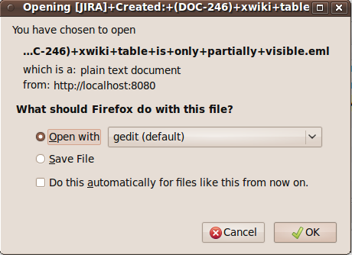Illustration 30: The download pop up on Fire Fox
The section will show you the way to take some additional actions related to messages.

Mark a message as read
The function allows marking one or more messages as read by removing bold format of message.
To mark message as read, do as follows:
The 1st way:
Step 1: Select messages to mark as read by selecting its checkbox(es).
Step 2: Select the Mark as read item in the More Actions drop down list menu on the action bar:

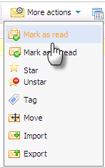
The 2nd way: This function is used to mark all unread messages in a specific folder.
Step 1: Right-click the folder which contains messages that you want to mark as read.
Step 2: Select Mark all read in the drop down list menu.
All selected unread messages will be marked as read.

Mark a message as unread
The function allows marking one or more messages as unread by setting the bold format on message.
Do as follows:
Step 1: Check the message(s) which you want to mark as unread by selecting its checkbox(es)
Step 2: Select Mark as unread in the More Actions menu on the action bar:
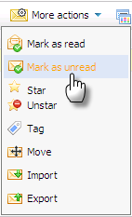
All selected read messages will be marked as unread.

Add a star to a message
The function allows adding a star to a message to make it more outstanding than others.
Do as follows:
The 1st way:
Step 1: Select message(s) to set star by ticking on its checkbox(es)
Step 2: Select the Star item in the More Actions drop-down list on the action bar:
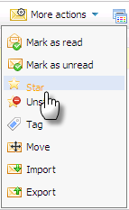
The 2nd way:
In the message list pane, click the gray star icon that corresponds to the message which you want to add a star.
After marking, the selected messages will be appended a icon so that you can identify them easily:

Remove a star from a message
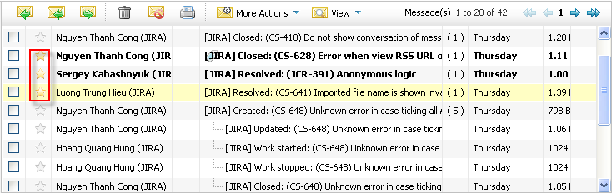Illustration 31: The messages with star view
The function is used to remove a star from a message that was appended with a star.
Do as follows:
The 1st way:
Step 1: Check the starred messages by selecting its checkbox(es)
Step 2: Select Unstar in the More Actions menu on the action bar:
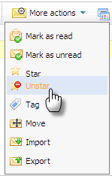
The 2nd way:
In the message list pane, click the yellow star icon which corresponds to the message that you want to remove star.
Stars will be removed from the selected messages. It is changed form yellow to gray color.

Import messages
The function is used to import messages from your computer to specific folder.
Do as follows:
Step 1: Select the Import message in the More Actions menu on the action bar:
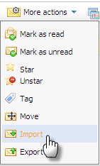
The Import Message form will appear:
Details:
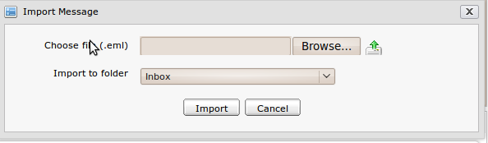Illustration 32: The Import Message form
Choose file (.eml): | The name of the file which you want to import from your computer. Click the button to get one file .eml from the computer and then click the iconto upload the file.
Import message to folder | The folder where the message will be imported.
Import button | To start importing the message.
Cancel | To exit the Import Message form.

Step 2: Enter required values in the Import Message form.
Step 3: Complete importing by clicking the Import button.

By default, your imported file must be in the *.eml format.

Report a message as not spam
This function is used to report one or more messages in the Spam folder not to be spams.
Do as follows:
Step 1: Go into the Spam folder and then check messages that you want to report not be spams.
Step 2: Select the icon on the action bar.
Step 3: All selected messages will be moved back the Inbox folder.

View full headers of a message
The header's information which is displayed by default, just including: the sender's email address, the receivers' email addresses and the subject of the mail. If you want to view full headers of a mail, you can do as follows:
Step 1: Open the message which you want to view its full headers.
Step 2: Click the icon on the right corner of message's content and select View Full Headers in the drop down list menu:
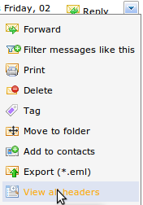
The View message headers pop-up will appear:

View and filter mails
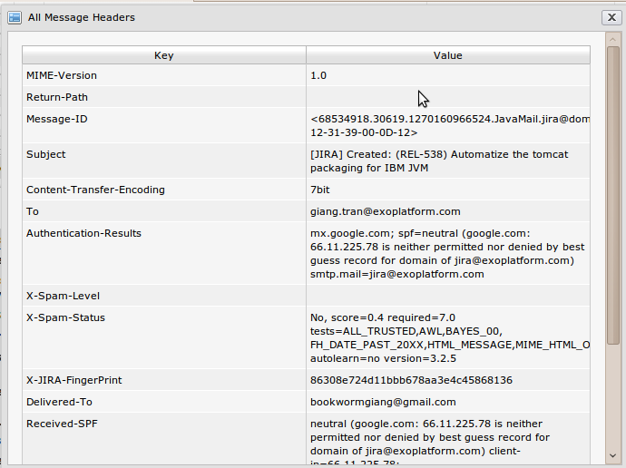Illustration 33: The Full Message Headers form
The function is used to view all mails in a specific folder according to some ways that you want to view.

View as
The function allows organizing the messages list in different manners.

View as List
This view arranges the message as a list. To view messages according to this way, click View as and select List item in the menu pop up:
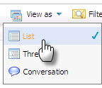
The messages will be arranged:

View as Thread
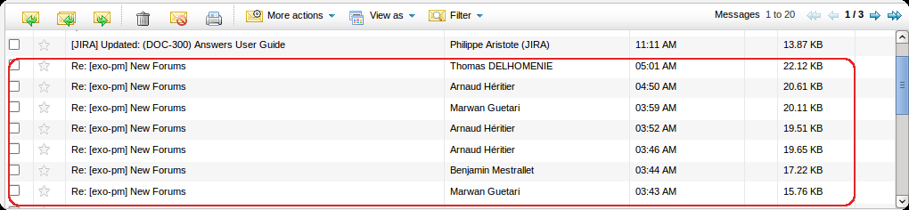Illustration 34: View message as list
This view arranges messages as a tree structure. All replies are shown as sub nodes. To change the view to thread view, click View as and select Thread in the pop-up menu:
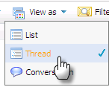
The message and its replies will be displayed:
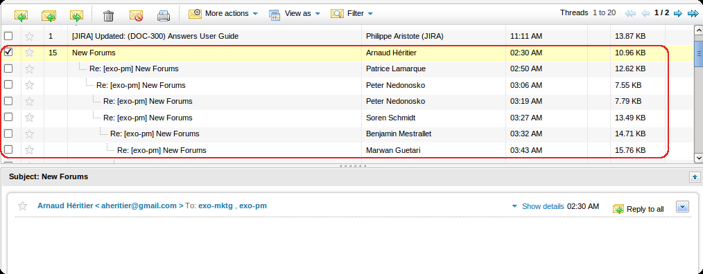Illustration 35: View message as thread

View as Conversation
With this view, the messages which are the replies of one mail will not be displayed in the messages list but on the message pane. To view messages as conversation, click View as and select Conversation in the pop-up menu:
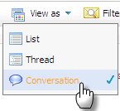
The mail and its replies will be displayed:

Filter messages
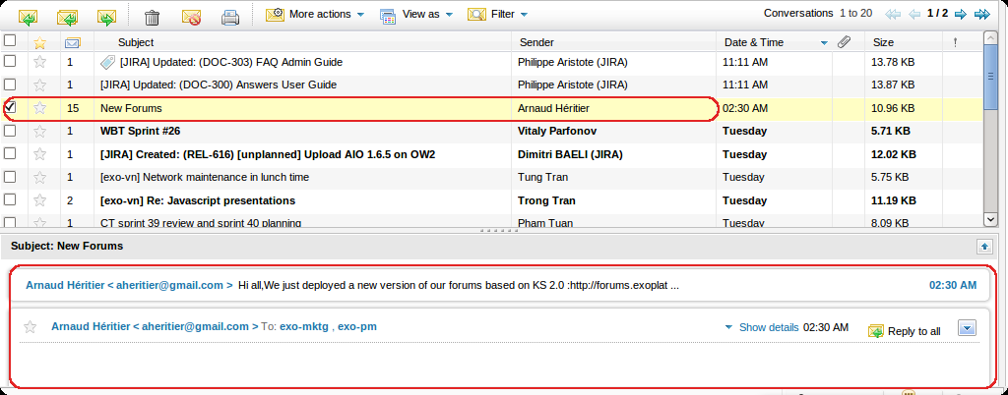Illustration 36: View message as conservation
The function is used to view all messages in a specific folder. Only select All messages in the View menu on the action bar to view all messages in the current folder.
Filter Unread messages
This function is used to filter all messages which are not read in the list. Only click Filter and select Unread in the pop-up menu:
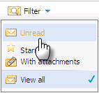
Filter star messages
The function is used to filter all messages which are appended stars in the list. Only need to click Filter and select Starred in the pop-up menu:
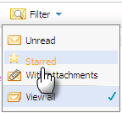
Filter message with attachments
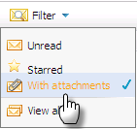
The function is used to filter all messages which has attachments in the list. Only click Filter and select With attachments in the pop-up menu:
View all messages
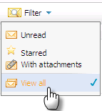
The function is used to view all types of messages in the list. Only click Filter and select View all in the pop-up menu:

Manage filters
Filters allow setting up rules to apply for incoming messages. Rules allow matching some criteria and applying actions to messages. This section includes some actions relating to filtering mails.

Add a new filter
The function is used to add a new filter.
Do as follows:
The 1st way: This way manually define condition for the new message filter.
Step 1: First of all, click the button on the toolbar. The Message Filter form will appear:

Step 2: Click the icon or press the 'Click here to add a new filter' link to create a new filter.
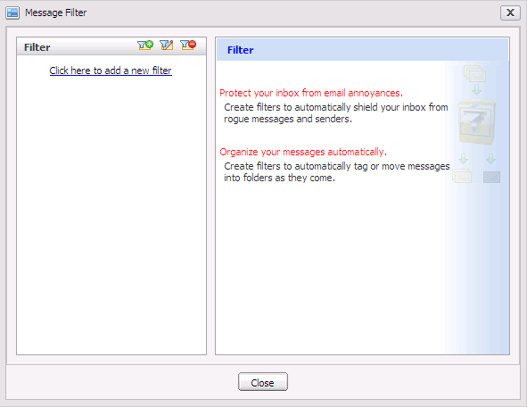Illustration 37: The Message Filter form
The Add/Edit Message Filter will appear:
Details:
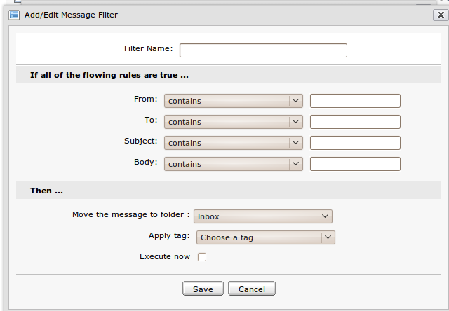Illustration 38: The Add/Edit Message Filter form
Filter Name | The filter's name. (Required).
From | This condition is to filter the email address of sender.
To | This condition is to filter the mail address of receiver.
Subject | This condition is to filter the subject of incoming messages.
Body | This condition is to filter the body of incoming messages.
Move the message to folder | The folder to which the messages satisfying with the filter will be moved.
Apply tag | The tag to which the messages satisfying with the filter will be applied
Apply for all messages | The option allows applying the filter to all current messages.
Execute now | To take the action immediately.
Save button | To save a new message filter.
Cancel button | To exit the Add/Edit Message Filter form.

Step 3: Define one or more rules in this form.
Step 4: Complete adding the message filter by clicking the Save button.
After you have created a new filter successfully, the created filter will be displayed in the list below:
The 2nd way: This way allows creating a new filter by getting conditions from one existing message.
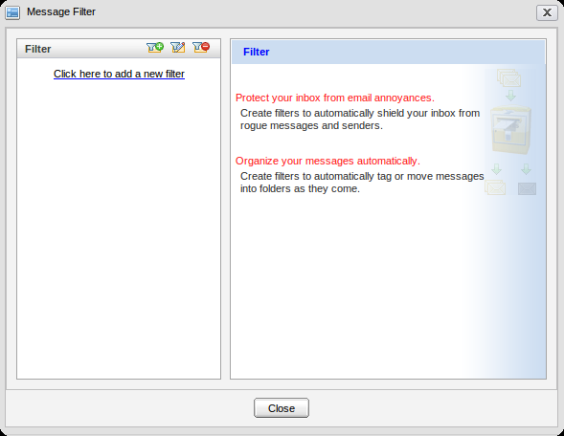Illustration 39: The Message Filter form
Step 1: Right-click the message which is selected to get filter conditions and select Filter message like this in the menu:
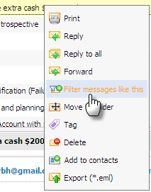
The Add/Edit Message Filter form will appear with some predefined filter conditions basing on the selected message:
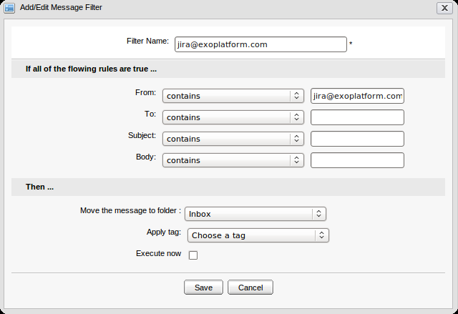
The filter above is created with default criteria “viet@exoplatform.com” in “From” field.
Step 2: Leave the filter conditions by default or define more filter conditions.
Step 3: Complete adding a new filter by clicking the Save button.
The 3rd way:
In the Message preview pane, click the icon at the right corner and select Filter message like this in the menu below:
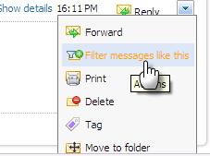
The Add/Edit Message Filter form will be displayed like the 2nd way with predefined criteria. The new filter can be created through similar ways above.
After creating a filter, the created filter will be displayed in the list. All messages which satisfies with filter conditions will be effected. Messages will be moved into specific folder or tag, etc.

Edit a filter
The function is used to make changes on a specific filter.
Do as follows:
Step 1: Open Message Filter form by clicking the button on the toolbar.
The Message Filter form will appear and list all exiting filters.
Step 2: Select the filter to edit and then click the iconon the filter bar in the Message Filter form. The Add/Edit Message Filter form will be shown with detailed information, available for editing.
Step 3: Change the filter's condition.
Step 4: Complete editing by clicking the Save button.

Delete a filter
The function is used to remove a filter from the filter list.
Do as follows:
Step 1: Open the Message Filter form by clicking on the toolbar.
Step 2: Select the filter you want to delete and then click the icon on the filter bar in the Message filter form.
The selected filter will be removed from list.

Manage the Address Book
The Address book in the Mail application provides you with a list of contacts which can be retrieved for sending mail. This section will explain some additional actions related to the address book management.

Add a new address book
This function is used to add new address books.
Do as follows:
Step 1: Click the button on the toolbar to go into the Contacts form:
Step 2: Click the Add Address Book button to add a new address book. The Add Address Book form will appear:
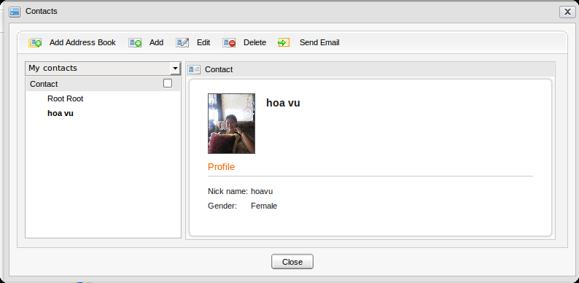Illustration 40: The Address Book form
Details:
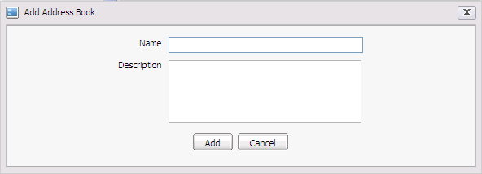Illustration 41: The Add Address Book form
Group name | The name of the Address Book. (Required).
Description | The group description.
Add button | To accept adding a new Group.
Cancel button | To exit Add Address Book form.

Step 3: Enter values in this form.
Step 4: Complete adding a new address book by clicking the Add button.

Add a new contact
The function is used to add a new contact to a group.
To add the contact, do as follows:
Step 1: Open the Add new Contact form.
The 1st way: Click the button on the Address Book form.
The 2nd way: This way is used to add the sender of a message to a specific group.
Right-click a message to add the sender to contacts list and then select Add to contacts.
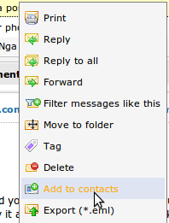
The 3rd way: This way is also used to add a sender of a message to a specific group.
Open the message that you want to add the sender to the contact list and then clickat the right corner of the message's content. Select the Add to contacts item in the drop-down list:
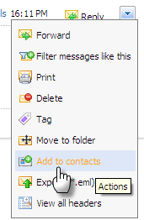
The Add/Edit New Contact will appear:
Details:
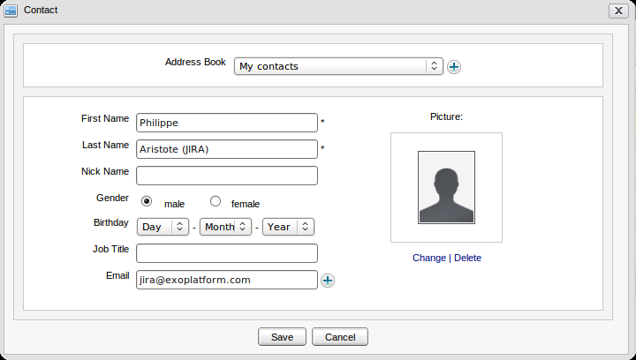Illustration 42: The Add new Contact form

Address Book | The address book in which the contact is stored. The address book can be selected from the existing in the combo box or created new by clicking the icon to add a new group immediately.
First Name | The first name of the contact. With second and third way, value of this field is the sender's first name of this mail. (Required).
Last Name | The last name of the contact. With second and third way, value of this field is the sender's last name of this mail. (Required).
Nick Name | The nick name of the contact.
Gender | The gender of the contact. There are two options: Male and Female.
Birthday | The birthday of the contact.
Job Title | The job's title of the contact.
Email | The email address of the contact. With second and third way, value of this field is the sender ' s email of this mail. The iconis to add more email addresses for this contact. The icon is to remove the added email.
Change | To change the current avatar.
Delete | To delete the current avatar and set it by default.
Save button | To save new contacts.
Cancel button | To exit the Add/Edit New Contact form.

To add the picture to the contact, click the Change link to open the Change Image form:
- Select the uploaded file from local computer by clicking the button
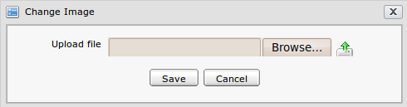Illustration 43: The Change Image form
- Upload the selected file by clicking the icon.
- Click the Save button to accept saving the uploaded file.
Step 2: Input contact information, change or remove contact's picture by clicking Change/Remove link.
Step 3: Complete adding new contacts by clicking the Save button.

Edit a contact
The function is used to edit a contact in a specific group.
Do as follows:
Step 1: Open the Contacts form by clicking the button in the main toolbar.
Step 2: Select the contact which you want to edit in the Contacts form.
Step 3: Click the button, the Contact form will be shown with detailed information, available for editing.
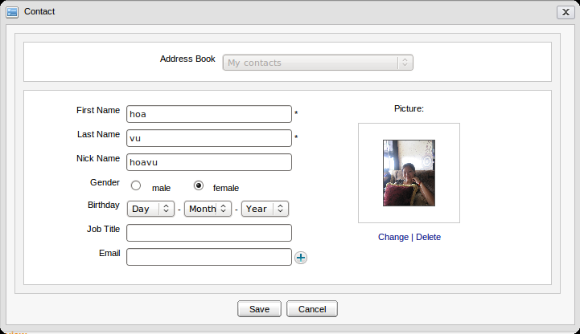
Step 4: Change the contact 's information.
Step 5: Complete editing by clicking the Save button.

Delete a contact
The function is used to delete a contact from a specific group.
To delete a contact, do as follows:
Step 1: Open the Contacts form by clicking the button in the main toolbar.
Step 2: Select the contact which you want to delete in the Address Book form.
Step 3: Select the button , the confirmation message will be shown. Click OK to delete contact or click Cancel to quit.

When you delete a contact which is tagged, it is still shown in tag. Only the deleted contact is removed completely from trash folder, the deleted contact is not shown in tag.

3.5.15.5 Send a mail to a selected contact
The function allows sending a mail to the selected contacts.
Do as follows:
Step 1: Tick on the contacts that you want to send a email.
Step 2: Click the button .
The Compose a new message form appears with the To field is input with all the selected emails.
Step 3: Compose the mail content and send it.

Add an event
The function interacts with the Calendar application which allows quickly adding new events into your calendar instead of directly going to calendar application to do.
To add an event, do as follows:
Step 1: Open the Add event form by clicking the button on the main toolbar.
The Add event form will appear below:
Details:
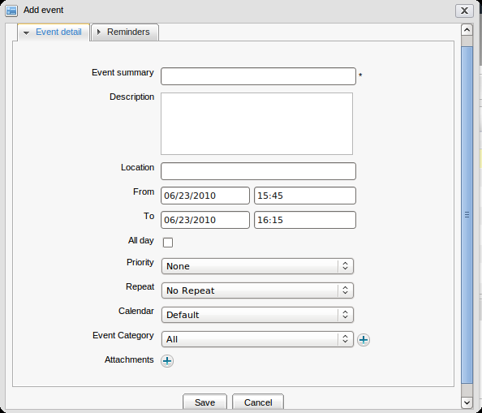Illustration 44: The Event detail tab of the Add event form
The Event Detail tab contains basic event information:
Event Summary | The title of the event.
Description | The detailed description of the event.
Location | The location where the event will take place.
From | The start date/time of the event.
To | The end date/time of the event.
All day | The option allows selecting the duration of the task to be all day or not. If you don't check this option, you have to select the start date, time and end date. By default, the start date and end date is current date.
Priority | The priority level of the task.
Repeat | Interval time that you will be asked for a repeated reminder after every x minutes.
Calendar | The calendar in which the event will be stored.
Event Category | The category the event belongs to. To create a new Event category, click the icon , the Event categories form appears as below:
- Give an event category name and description (optional) then click the Save button to create a new category quickly.
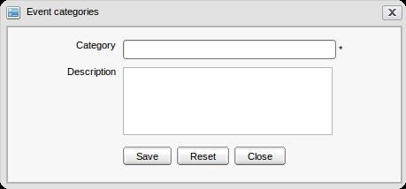Illustration 45: Event categories form

Attachments | To add attached file to the events.
Save button | To accept saving the event.
Cancel button | To exit the Add event form.
The Reminders tab: the reminder function allows you to remind about an event via a mail.
Reminder by mail:
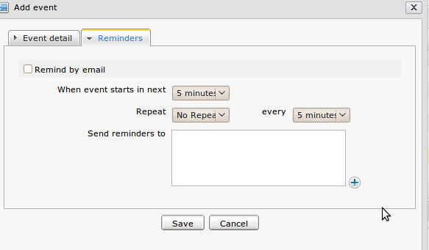Illustration 46: The Reminders tab of Add event form

When event starts in next | The time you will receive the mail reminder before event starts.
Repeat | The option allows setting reminder repetition mode or not for the event.
every | The interval time (in every xxx minutes) the reminder will be repeated before event stars.
Send reminder to | List of email addresses to which the reminder will be sent. The default value is the email address of current user. You can input email address list or click to select emails from the Select email form manually.

After adding email addresses successfully, the email addresses of selected contacts are displayed in the 'Send reminders to' field of the Reminders tab.
Step 2: Input values into the Add event form.
Step 3: Complete adding new event by clicking the Save button.
This function supports in adding new events into the Calendar application through the Email application. (See Calendar User Guide for more details).

Besides, when you receive an Invitation mail on taking part in a specific event, you can import an event directly in your calendar. The Invitation mail content is shown as below:
There are 3 options:
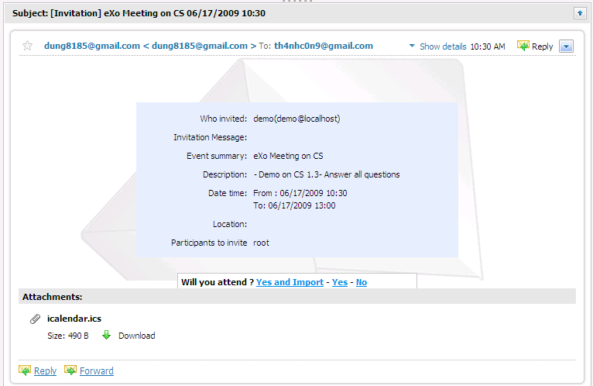Illustration 47: The content of an Invitation mail
The Yes and Import option means that you accept taking part in the event in the Invitation mail and import the event into your calendar to remind you about this event. The event will be imported directly into your Default calendar in the Calendar portlet.
The Yes option means that you accept taking part in the event without importing it into your calendar.
The No option means that you refuse taking part in the event in the Invitation mail.

Search
The function allows you to find mails. There are two types of searching: quick search and advanced search.

Quick Search
The function allows you to do a quick search with specific keywords in all your messages. All messages from the different folder having the text matching with your search team will be displayed in search result form. To do a quick search, do as follows:
Step 1: Enter a search term into the Search field: 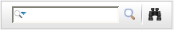
Step 2: Click the icon .
For example, quick search with “jira” term. All messages matching with “jira” term are listed in the search results form. The Search result form will be displayed:
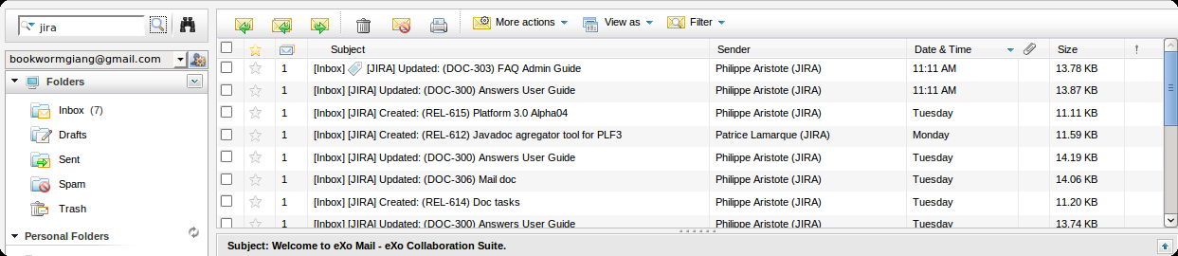Illustration 48: Search results
- The default search is not done in the Spam and Trash folders.
- The messages in Spam and Trash folders can be searched by positioning explicitly into them.

Advanced Search
The Advanced Search allows you to specify precise search criteria.
Do as follows:
Step 1: Click the icon to the right of the search box.
The Advanced search form will appear:
In this form, you can set one, few or all criteria for your search:
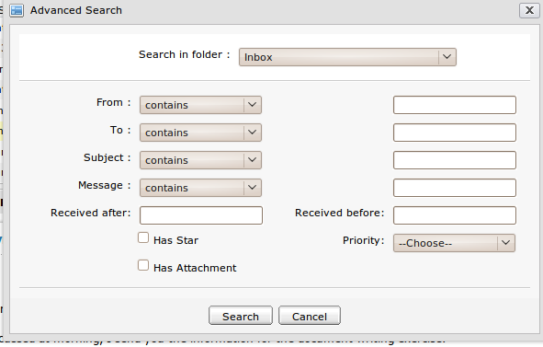Illustration 49: The Advanced Search form
Details:

Search in folder | The folder which you want to search in.
From | The condition corresponding to the sender's name or mail addresses.There are some options:  - contains: includes the terms in search box.  - doesn't contain: do not include the term in search box.  - is: include exactly the term in search box  - is not: do not include exactly the term in search box  - starts with: starts with the term in search box  - Does not start with: do not start with the term in search box
To | The condition corresponding to receiver 's name or mail address.
Subject | This condition which corresponds to the message subject.
Message | This condition which corresponds to the message content
Received before & Received after: | The interval time when the search messages were receipted  Has Star: This option allows searching messages have star or not.  Has attachment: This option allows searching messages have attachment or not.  Priority: The priority of the search messages

Step 2: Define the Search conditions.
Step 3: Click the Search button to launch the search.
All messages matching with your criteria will be listed in the search result form.
Or click Cancel to quit.

Mail Settings
The function allows you to customize the behavior and layout of Mail for your own needs.
Do as follows:
Step 1: Click the button on the toolbar.
The Mail Settings form appears with 3 tabs: General, Return Receipts and Layout.
The General tab contains basic setting information.
Details:
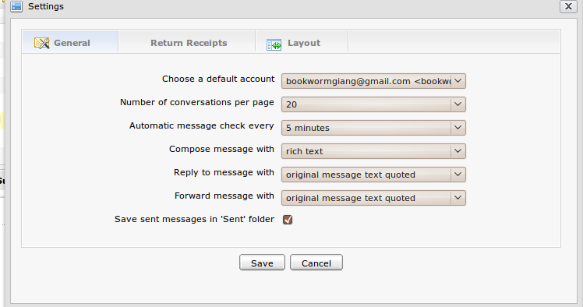Illustration 50: The General tab of the Mail Settings form
Choose a default account | The default account (including display name and email address) of the current user. User can select one of accounts in list.
Number of conversations per page | The number of conversations which will be displayed per page. The options including 10, 20, 30, etc or 70 message per one page in message list pane will be selected.
Automatic message check every | The interval time the system will check mail automatically. 5 minutes, 10 minutes, 20 minutes, 30 minutes or 1 hour will be selected. If 20 minutes is selected, after 20 minutes, the mail application will automatically get mail one time.
Compose message with | The default format of the message which is used when composing a message. There are 2 options: rich text and plain text. Rich text allows composing with some effects such font style, size, color, etc while the Plain text allows simple text only.
Reply to message with | There are two options. One allows replying message with attachment. Another allows replying with text only.
Forward message with | There are two options. One allows forwarding message with attachment. Another allows forwarding message with text only.
Save sent messages in 'Sent' Folder | The option allows saving sent messages in 'Sent' folder or not.

The Return Receipts tab allows setting the option for receipt notification.
For example, after reading a new mail in your Inbox, you can determine whether to send a notification to the sender or not to inform that you have read the message.
Details:
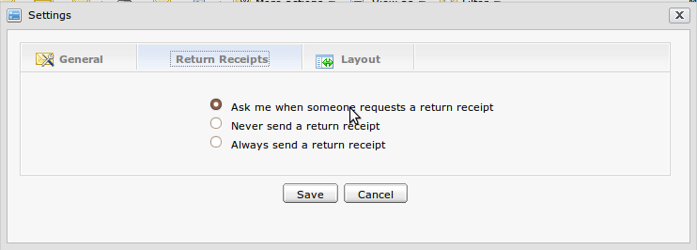Illustration 51: The Return Receipts tab of the Mail Settings form
Ask me when someone requests a return receipt | This option allows you to receive an alert to inform that someone wants to receive your notification about the returned receipt.
Never send a return receipt | This option will ignore all requests for a return receipt from you.
Always send a return receipt | The option allows sending a returned receipt to anyone under request at all times.

The Layout tab allows personalizing the Mail layout. By default, the Horizontal Split type is set. Besides, you can select the Vertical Split or the No Split.
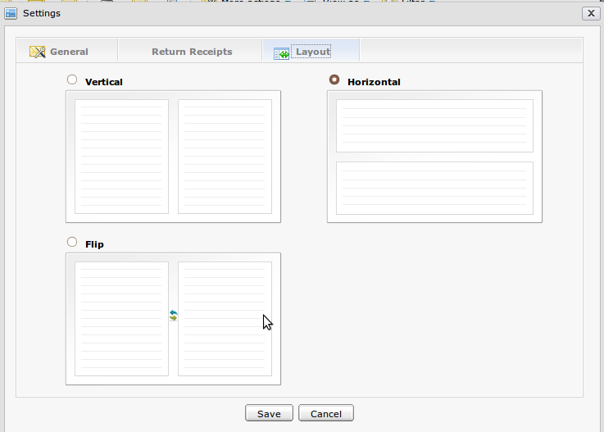Illustration 52: The Layout tab of the Mail Settings form

Step 2: Change your Mail settings.
Step 3: Click the Save button to accept the changes.

Maximize the Reading Pane
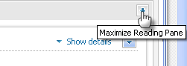
The function is used to maximize their reading pane. To do this action, click the icon on the right corner of the reading pane:

Sort messages
The function is used to sort messages in the list according to some conditions.
By default, messages in list will be sorted by 'Date & Time ' in the ascending order. However, you can also change sort by Sender, Subject, Size and Priority.
To change the sort order, click a column header of message list pane.
Illustration 53: The Message list pane
The first click will sort messages in the list into descending order. It is represented by the icon.
The second click will sort messages in the list into the ascending order. It is represented by the icon .

Next Steps
This user manual has provided a thorough explanation of glossaries and features within Mail. Now, you have known how to create, and manage mails with many various functions, including views, filter, Rich Text Editor, standard mail protocols and calendar integration. The following links can connect you with resources to learn more and contribute to the open source development process.
- Learn more about eXo Platform 3.0
- Video demos, tutorial and more on the eXo Resource Center
- Access another eXo documents on the eXo Wiki
- Ask questions about Mail in the Forum

