Packet Tracer – Using the Ping Command

1. Topology

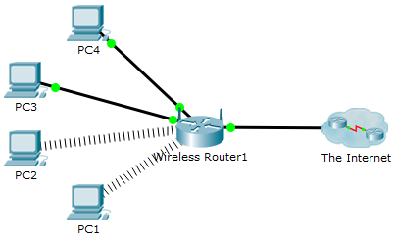

1. Objectives

Use the **ping** command to identify an incorrect configuration on a PC.

1. Background / Scenario

A small business owner learns that some users are unable to access a website. All PCs are configured with static IP addressing. Use the **ping** command to identify the issue.

* + 1. Verify connectivity.

Access the **Desktop** tab > **Web Browser** of each PC and enter the URL **www.cisco.pka**. Identify any PCs that are not connecting to the web server.

**Note**: All of the devices require time to complete the boot process. Please allow up to one minute before receiving a web response.

Which PCs are unable to connect to the web server?

* + 1. Ping the web server from PC2.
       1. On PC2, access the **Command Prompt** from the **Desktop** tab.
       2. Type **ping www.cisco.pka**.

Did the ping return a reply? What is the IP address displayed in the reply, if any?

____________________________________________________________________________________

* + 1. Ping the web server from PC1.
       1. On PC1, access the **Command Prompt** from the **Desktop** tab.
       2. Type **ping www.cisco.pka**.
       3. Did the **ping** return a reply? What is the IP address returned, if any?

____________________________________________________________________________________

* + 1. Ping the IP address of the web server from PC2.
       1. On PC2, access the **Command Prompt** from the **Desktop** tab.
       2. Attempt to reach the IP address of the web server with the command **ping 192.15.2.10**.
       3. Did the **ping** return a reply? If so, then PC2 is able to reach the web server via IP address, but not domain name. This could indicate a problem with the DNS server configuration on PC2.
    2. Compare the DNS server information on PC2 with other PCs on the local network.
       1. Access the **Command Prompt** of PC1.
       2. Using the command **ipconfig /all**, examine the DNS server configuration on PC1.
       3. Access the **Command Prompt** of PC2.
       4. Using the command **ipconfig /all**, examine the DNS server configuration on PC2. Do the two configurations match?
    3. Make any necessary configuration changes on PC2.
       1. Navigate to the **Desktop** tab of PC2, make any necessary configuration changes in **IP Configuration**.
       2. Using the **Web Browser** within the **Desktop** tab, connect to **www.cisco.pka** to verify that the configuration changes resolved the problem.
       3. Click the **Check Results** button at the bottom of this instruction window to check your work.