Packet Tracer – Troubleshooting a Wireless

1. Topology

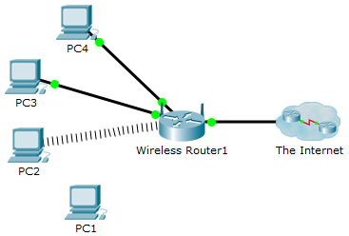

1. Objectives

Identify and correct any misconfiguration of a wireless device.

1. Background / Scenario

A small business owner learns that a wireless user is unable to access the network. All of the PCs are configured with static IP addressing. Identify and resolve the issue.

* + 1. Verify connectivity.

Access the **Desktop > Web Browser** of each wireless PC and type **www.cisco.pka** into the URL. Identify any PCs that are not connecting to the web server.

**Note**: All of the devices require time to complete the boot process. Please allow up to one minute before receiving a web response.

Which wireless PCs are unable to connect to the web server?

* + 1. Examine the IP configuration of the PCs.
       1. On the PC that is unable to connect, access the **Command Prompt** from the **Desktop** tab.
       2. Type the **ipconfig /all** command.
       3. What IP addressing information is available?

____________________________________________________________________________________

____________________________________________________________________________________

* + 1. Examine the Wireless Settings on the Wireless Client.
       1. On the **Desktop** tab of any PC that is unable to connect. Click **PC Wireless** to access the wireless configurations.
       2. Click **Connect** tab and record the associated SSID.
    2. Examine the Wireless Settings on the Wireless Router.
       1. Access the Wireless Router from the web browser of a wired PC. Use the username **admin** and password **admin** to access the wireless router. What IP address did you use? (Hint: default gateway)

____________________________________________________________________________________

* + - 1. On the **Basic Setup** page, examine the **DHCP Server Setting** configuration. Is DHCP enabled?
      2. Click the **Wireless** tab.
      3. Examine the setup information under the **Wireless** tab. What is the SSID? Does it match the SSID configured on the client?

____________________________________________________________________________________

* + - 1. Click the **Wireless Security** submenu.
      2. Examine the security settings. What is the wireless security mode? What is the passphrase?

____________________________________________________________________________________

* + 1. Make any necessary configuration changes on the Wireless Clients
       1. On the **Desktop** tab of any PC that is unable to connect. Click **PC Wireless** to correct the wireless configurations.
       2. Click **Connect** tab. Select the Academy wireless network and click **Connect**.
       3. Enter the passphrase (Pre-shared Key) recorded from the wireless router. Click **Connect**.
       4. Using the **Web Browser** within the **Desktop** tab connect to **www.cisco.pka** to verify that the configuration changes resolved the problem.
       5. Click the **Check Results** button at the bottom of this instruction window to check your work.