SUPERMARKET SALES ANALYSIS
Data Analytics Project Report

1. Problem Statement
The objective is to analyze supermarket transaction data to understand sales performance across products, categories, branches, customer types, payment methods, and customer ratings. The analysis aims to convert transaction records into practical recommendations for inventory planning and customer service.

2. Dataset
This package contains 500 generated sample transactions. The data includes product, category, branch, city, customer type, quantity, unit price, payment method, rating, and calculated sales. This is a demonstration dataset; replace it with the official assignment dataset if one was supplied.

3. Methodology
- Load the CSV file using pandas.
- Inspect dataset dimensions, missing values, duplicate rows, and data types.
- Remove duplicate records and rows with invalid required fields.
- Calculate sales as Quantity × Unit Price.
- Group the data by product, category, branch, payment method, and customer type.
- Create charts to communicate sales patterns.
- Translate observed patterns into cautious, data-supported business recommendations.

4. Key Results (Generated Sample Data)
Number of transactions analyzed: 500
Total sales: ₹142,645.31
Average transaction value: ₹285.29
Total units sold: 1,720
Average customer rating: 4.01 / 5
Highest-sales product: Rice (₹24,340.47)
Highest-sales branch: Branch C (Mumbai) (₹54,493.85)
Highest-sales category: Beverages (₹44,793.30)
Most-used payment method: UPI (139 transactions)
Average transaction by customer type: Member: ₹292.26; Normal: ₹276.84.
These values are computed from the generated sample data in this package. They are not the figures from any external or official dataset.

5. Visual Analysis

Sales by Product
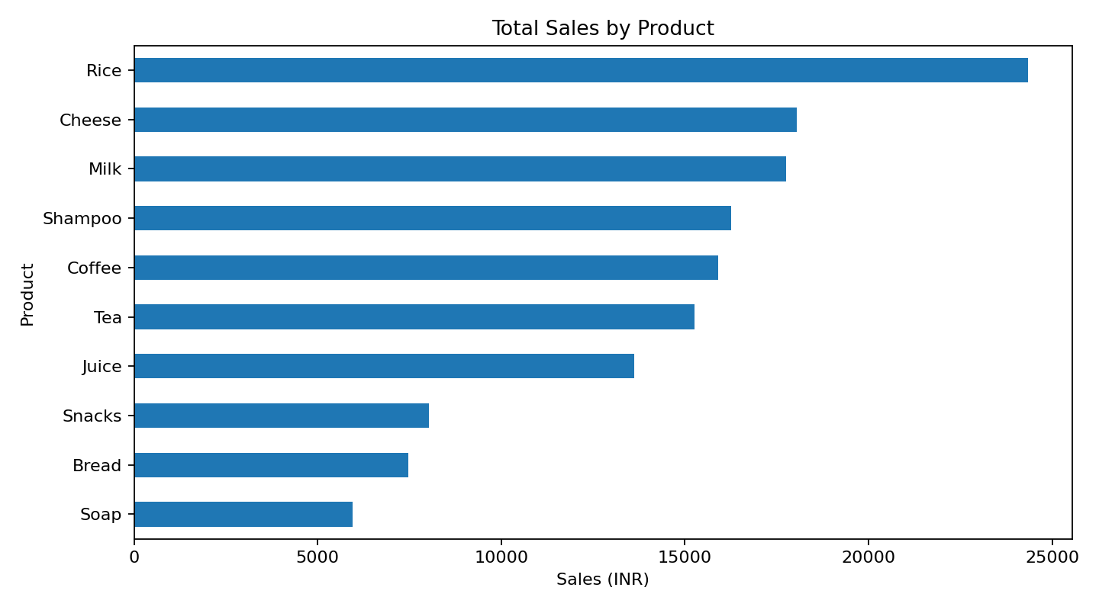

Sales by Branch
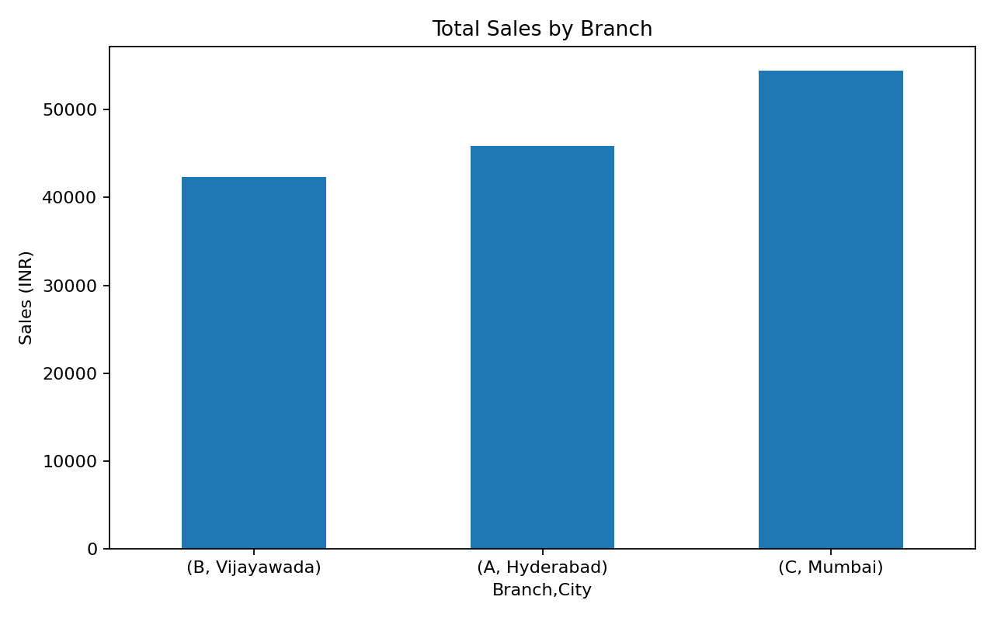

Sales by Category
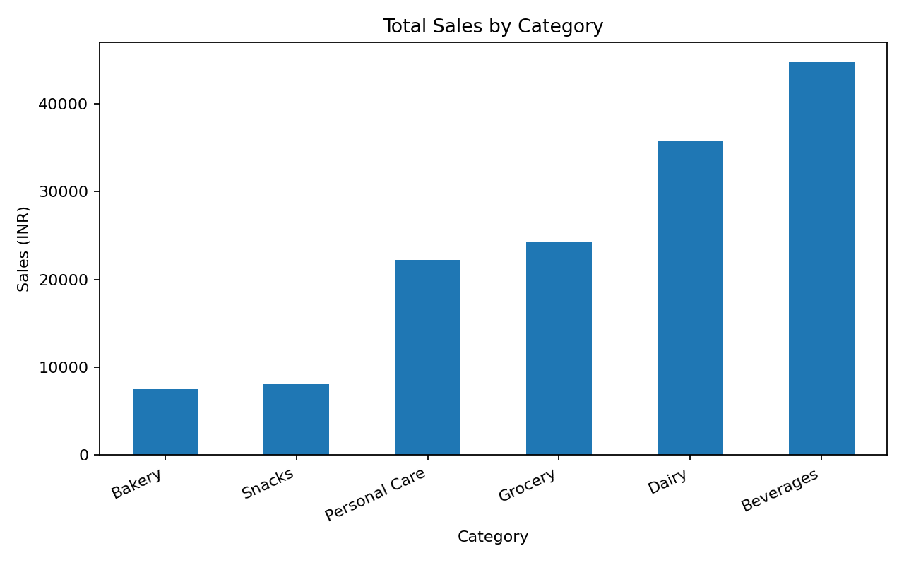

Transactions by Payment Method
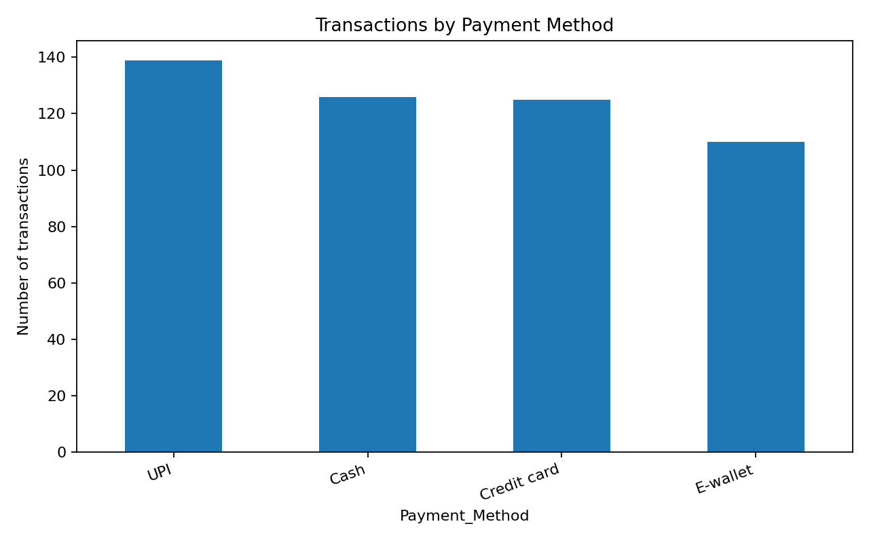

Average Spend by Customer Type
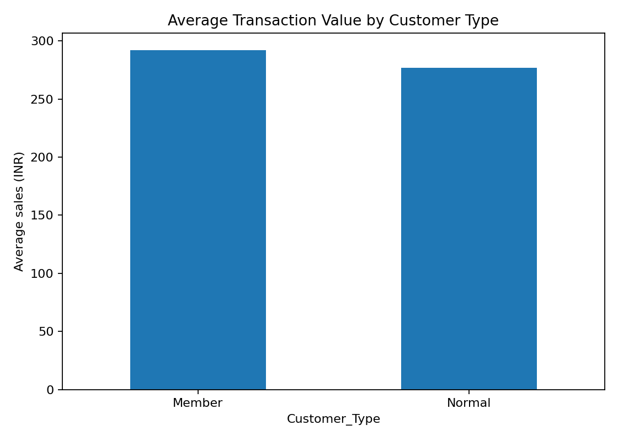

6. Business Recommendations
- Review stock levels for the highest-revenue product (Rice) while also considering margin, stock-out frequency, and demand stability.
- Investigate what drives sales at the leading branch (Branch C). Compare footfall, product availability, local demand, and operating hours before copying its practices.
- Use the leading category (Beverages) to inform replenishment, but avoid relying on revenue alone; track profit margin and units sold too.
- Keep the most-used payment method (UPI) convenient while retaining other payment choices for customer preference.
- Compare Member and Normal customer spending using transaction counts and variability before designing loyalty discounts.
- Use ratings as a service-quality signal, but review low-rating comments and sample size before deciding on interventions.

7. Limitations
The dataset is synthetic and cannot establish real-world supermarket behavior. Revenue is not the same as profit. The analysis is descriptive and does not prove that one factor caused higher sales. Findings must be recalculated against the assigned dataset before final submission.

8. Conclusion
The project demonstrates a basic end-to-end data analytics workflow: loading and validating data, deriving sales, summarizing performance, visualizing patterns, and producing business recommendations. The quality of conclusions depends on using a reliable dataset and verifying every reported result.

