Original Data: Draft

Chris Bohlman

11/15/2016

Context:

The context to this report is to check known data in order to view how the program works. Because the results of the linearity of this data set is know, I wanted to check my program writing to see if my results were on par with what was already observed. Through this, I could then look back upon my programming and see if what I did was correct. Here are the results I computed compared with what was obtained in the original report.

This data was originally gathered on March 23, 2013.

Ints vs. Counts:

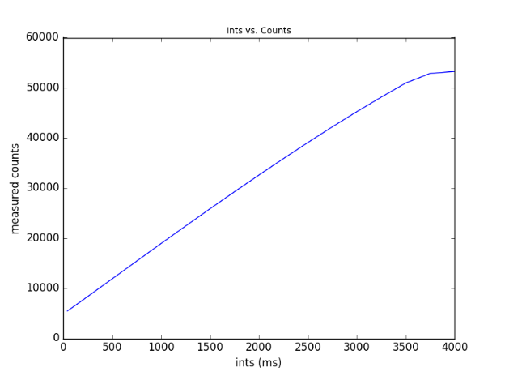

To determine the integration time vs the counts of each picture, I read files in through fits, adjusted the parameters of the read in’s area equal to original analysis’ parameters (200 to 350 in the x direction and 0 to 200 on the y axis). The program I wrote analyzed counts in that section of the image for each picture, got the ints measurement from each of the headers in the picture.

The data was stored in ‘int’ and ‘counts’ arrays, respectively. I graphed ints on x axis and counts on y axis.

It looks exactly like original data, which makes sense, as it’s just plotting raw data.

Ints vs. Counts with linear relationship:

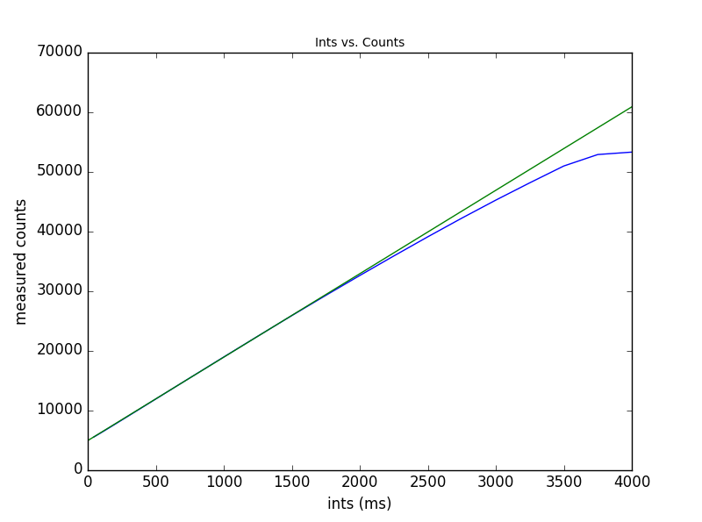

Coefficients for the line: [ 4894.75638298 13.98609149]

Coefficients for original data as reported previously: [13.9820 4892.02]

Explanation of difference: I would attribute this to the program’s calculation of the coefficients. I used the same ranges and values for the data compared to the original report, so I believe that the small difference was due to polyfit error.

I can cross check the polyfit by finding programs online that determine the coefficients for a set of data. I will link the programs and provide the coefficients here:

I can also check the ployfit due to the differences in the data that Katie used and the data that I used. I can find the exact data Katie used in the idl file online, and determine the coefficients, and see if they match up with her’s or match up with mine.

I also wrote a program to determine coefficients… but it needs an error measurement. *What is the error for this data?*

True counts vs. Measured Counts with linear:

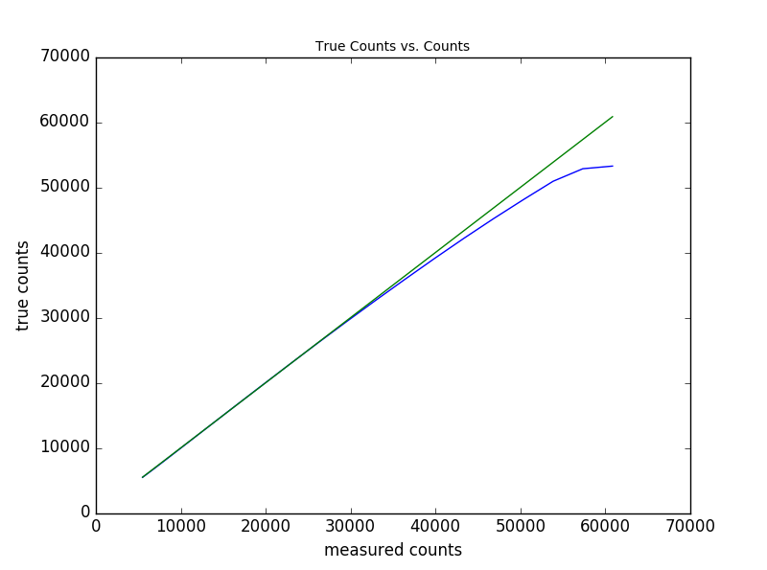

Is there a basis of comparison I can use for this one?

True counts vs. Measured Counts with all:

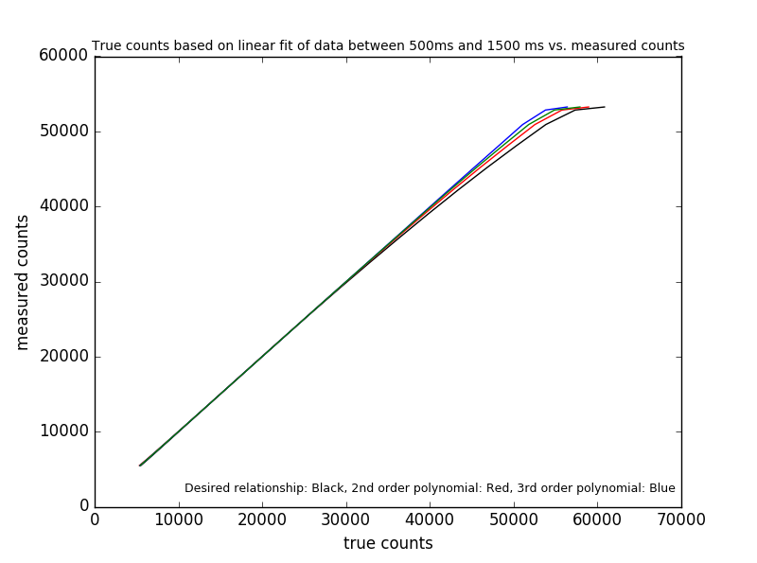

Coefficients first order: [ 13.98203447 4904.12914894]

Coefficients second order: [ -2.11825705e-04 1.44034324e+01 4.72047176e+03]

Coefficients third order: [ -9.65189646e-08 7.72773376e-05 1.41351347e+01 4.79620246e+03]

Report coefficients third order: [4.6e-11 -1.41e-6 1.00273 112.575] BUT WHAT ARE THESE FOR?? ☹

For the discrepancy in this data, I should use the same resources to determine fits for the data, and check the idl file for the exact data that Katie used. This should provide me with an accurate measurement of who’s coefficients are more right.

*Are there idl coefficients for second order?*

Coefs 3 for original report: poly_fit(counts_mean[idx],counts_true[idx],3)

Counts_mean: 5470.80 6239.40 6931.00 7630.10 9034.70 10446.9 11858.9 15388.0 18899.9 22385.8 25837.5 29225.3 32558.6 35832.9; 39044.7 42172.1 45193.2 48096.0 50914.0 52842.4 53251.4

Counts_true: 5493.25 6290.22 6989.32 7688.42 9086.62 10484.8 11883.0 15378.5 18874.0 22369.5 25865.0 29360.5 32856.0 36351.5; 39847.0 43342.5 46838.0 50333.5 53829.0 57324.5 60820.0

From my report:

Mean counts: [5480.8000000000002, 6250.25, 6942.4499999999998, 7642.0, 9046.9500000000007, 10459.4, 11871.049999999999, 15400.200000000001, 18912.25, 22397.25, 25848.049999999999, 29237.75, 32570.099999999999, 35843.5, 39055.150000000001, 42181.050000000003, 45201.599999999999, 48105.050000000003, 50914.199999999997, 52842.050000000003, 53250.300000000003]

True counts: [5493.246, 6290.22, 6989.32, 7688.42, 9086.619999999999, 10484.82, 11883.02, 15378.52, 18874.02, 22369.52, 25865.02, 29360.52, 32856.020000000004, 36351.520000000004, 39847.020000000004, 43342.520000000004, 46838.020000000004, 50333.520000000004, 53829.020000000004, 57324.520000000004, 60820.020000000004]

When I get the coefficients of third order of mean counts and true counts:

[ 2.05521182e-10 -1.33210758e-05 1.25133285e+00 -1.21357215e+03]

Compared to report: [4.6e-11 -1.41e-6 1.00273 112.575]

Still a discrepancy?

I’m still unsure of how Katie got

Error of Linearity vs. True Counts

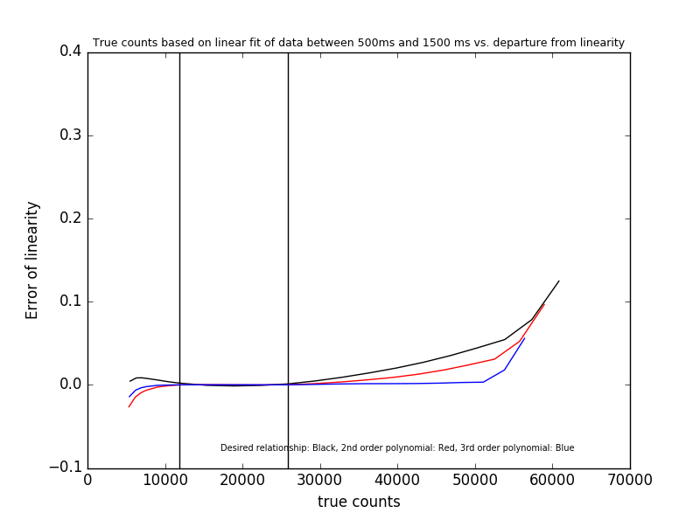

Again, no line seems to really line up with the desired relationship for some reason. This is in contrast to the data set on the other report, as with that, the third order relationship seemed to line up pretty well. To add to this mystery, the error of linearity graph for this data set looks very similar to the graph of linearity of the previous data set. Whether this is due to the program or some other factors is currently unknown. I am currently taking steps to see if the data fit for this data is actually correct.

In comparison to the original report, the third order line went pretty well with the original data fit. In fact, the desired relationship line in the original report lines up pretty well with mine in the data, but the rest fall apart.

Analyzing the Data:

From the error of linearity plot, I discovered that the second order equation behaved more closely to the desired relationship. Now, the reason I couldn’t add fourth order is because there were only 23 items on each list (due to me averaging the ints and counts into separate lists), so the fourth order polyfit had some odd behavior. After consolidating my data and limits and methods across three python files, I finally came up with that error of linearity graph, which was a marked improvement over what I was producing previously. However, because I couldn’t get any order to exactly match up to the desired relationship, I was at a loss for things to do. That’s why I am writing this report and organizing all my files: to get some ideas or something, or to notice a method that I did wrong.

Here’s to hoping that happens.