Clio Linearity Calibration: March 2013 Data

Chris Bohlman

1/25/2017

Context:

The Clio infrared camera is an instrument used in the Magellan Adaptive Optics system, located at the Las Campanas Observatory located in the Atacama Desert in Chile. Since the Earth’s atmosphere is mostly opaque to infrared light, infrared astronomy should be conducted at high elevations, past as much of the atmosphere as possible. Also, adaptive optics are used to gather data and correct for the turbulence of the atmosphere. However, Clio is specifically sensitive from 1 µm to 5 µm.

The context to this report is to analyze a set of images to calibrate the infrared camera Clio. To do this, a program must be written to judge how exactly the images should be corrected for linearity. Now, this data has previously been corrected for linearity by Katie Morzinski. However, I chose to also attempt to correct this data, as I want to use what I have done for this specific set of data as a template for correcting data that hasn’t been corrected yet.

This data was originally gathered on March 23, 2013, with the Clio camera in the MagAO system at the Las Campanas observatory in Chile.

Now, linearity is what we want to achieve with the data set. The supposed relationship between the integration time and counts readings should be linear, however, due to external factors, the higher the integration time, the more counts are dropped from the reading. Thus, the data is rendered useless. It is therefore the goal of this report to demonstrate that through curve fitting and other programming tools, we can correct this data and make sure that a larger portion of it turns out to be linear, making the data useful. This is known as linearity, and it is crucial to the correction of this data.

Ints vs. Counts:

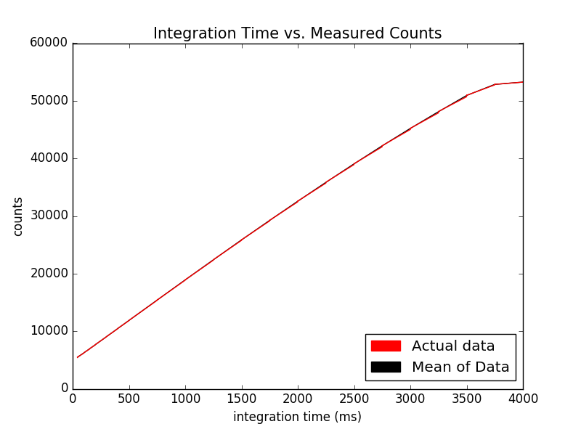

To determine the integration time vs the counts of each picture, I read files in through the FITS package from astropy in Python, and adjusted the parameters of the read in’s area equal to original analysis’ parameters (200 to 350 in the x direction and 0 to 200 on the y axis) These parameters are due to the bright side of the images always being on the right half, so we wanted to really capture that part of the image. The program I wrote analyzed counts in that section of the image for each picture, and got the integration time’s measurement from the specific header for each image. In the context of this project, the integration time is best thought of the exposure time for the camera. Therefore, an increasing amount of ints means that the camera was open longer.

The data was stored in ‘int’ and ‘counts’ arrays, respectively. I graphed the integration time, which were in milliseconds, on the x axis and counts on the y axis.

Where in my code this is calculated:

File: linearityCodeMarch2013Data.py

Images are opened and data is read in: open_images(), lines 29-62

Mean of counts is taken: avg_ints_counts(), lines 64-78

Graph is printed: print_graph(), lines 197-209

Ints vs. Counts with linear relationship:

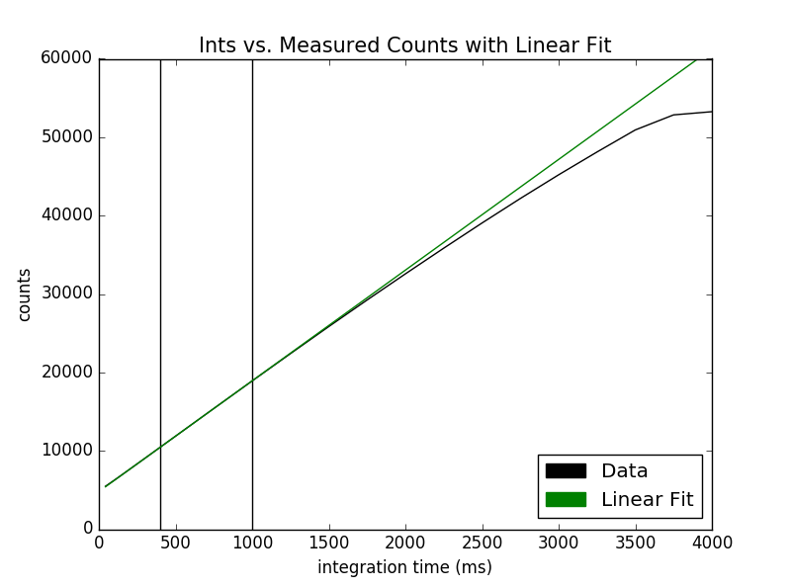

The first step in correcting for linearity was trying to find the straightest part of the data to add a linear fit to demonstrate the supposed linearity we were trying to achieve. I determined that the straightest part was between 400 ms and 1000 ms, right at the beginning of the data set, but not too early (because of dark current noise). The region of choice is in between the bars above. I chose this region among others because after graphing the linear fit in relation to other regions in the straight-line section of this graph, I zoomed into each of the fits, and found that this fit’s separation was minimal enough to provide a good fit for the rest and was a stellar fit.

The coefficients of the line were m = 14.12 and b= 4803.05, if y = mx + b.

This line shows that the data is only strictly linear up to about 20,000 counts, so the linearity correction must be applied to any values above this.

Where in my code this is calculated:

File: linearityCodeMarch2013Data.py

Linear fit is found: make_true_counts(), lines 81-86

Graph is printed: print_graph(), lines 213-229

True counts vs. Measured Counts with all:

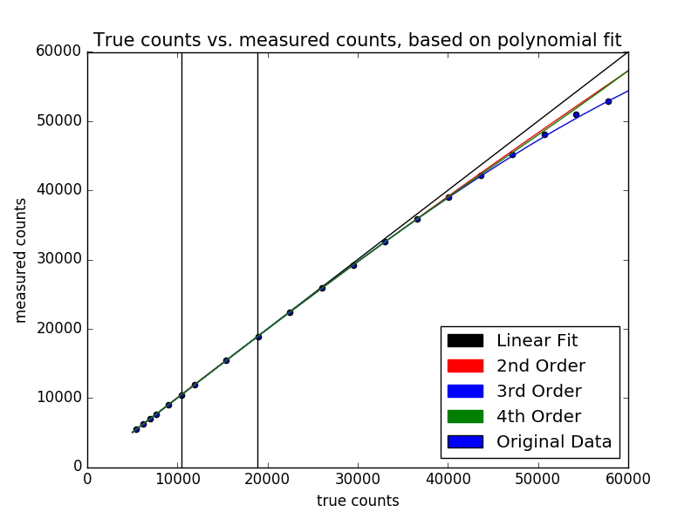

The next step was to calculate the true counts. The true counts represented what the data would look like if it was perfectly linear, and there was no calibration needed. On the above graph, this is the linear fit represents. However, we also wanted to fix the data for second, third, and fourth order polynomials, so we took the set of data up to about 40,000 counts, and created a function in each of those orders that would convert counts to true counts. By applying these function coefficients that were generated to counts for each order, 3 more true counts graphs were generated. By plotting the original data on the same graph, we could see the third order fit was the most accurate in this case.

The bars in the graph also represent where the linear fit was chosen from for all orders of the fits.

Where in my code this is calculated:

File: linearityCodeMarch2013Data.py

True counts are found: make_true_counts(), lines 88-114

Graph is printed: print_graph(), lines 233-256

Error of Linearity vs. True Counts

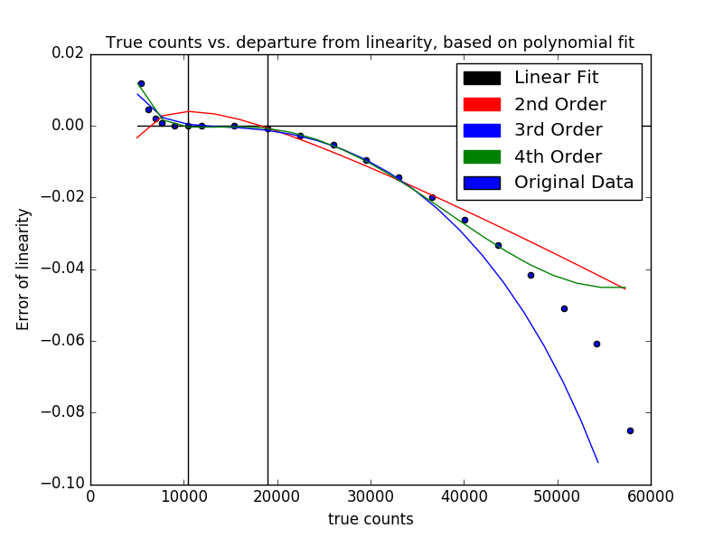

To confirm the results from the previous page that the third order fit was superior, we decided to calculate the error of linearity for each of the different polynomial fits. The error of linearity was calculated by:

Error of linearity = $\frac{true counts-measured counts}{true counts}$

With true counts referring to the specific true counts of each fit, calculated earlier.

As seen from the picture, 3rd and 4th order come very close to the fit, and diverge at about the same point from the original data. However, only the 3rd order fit still behaves in the same way as the original data. Therefore, from this graph, we can adequately support the claim that either the 3rd order or the 4th order fit is the best fit for this data. Since both were fairly close, I applied both to the raw data separately in order to demonstrate which one corrected the data the best.

Where in my code this is calculated:

File: linearityCodeMarch2013Data.py

Error is calculated: error(), lines 161-191

Graph is printed: print_graph(), lines 260-283

Corrected Counts vs Ints:

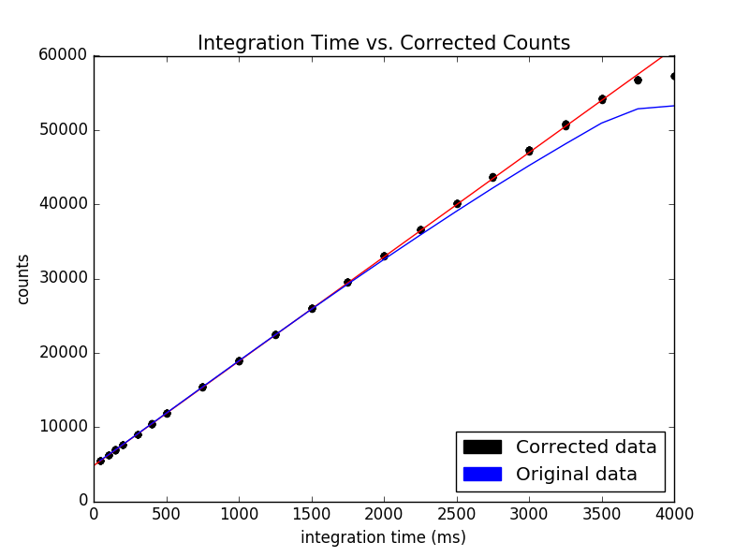

This is the graph for 3rd order corrected data, which happens to be linear up to ~52,000 counts. Now, the process for this was as follows:

First, I made sure that the 3rd order coefficients were converting counts to true counts, so I personally had to recalculate my coefficients with counts in the x axis, and true counts in the y axis in the coefficients-calculating function in Python. I then reopened all the images back up, and calculated the ints as I did previously, reading them in through each image header. However, for the counts, if the counts read in were above 20,000, I took the counts from the image and applied my calculated third order coefficients to output a corrected and calibrated value for counts. I then graphed the resulting new counts, and found out that the corrected data was linear up to about 50,000 counts.

Equation that linearized the data: $y=ax^{3}+bx^{2}+cx+d$

Where x is the measurement of counts from the image, y is the corrected counts,

*a* = 6.28e-11, -2.55e-06, *c* = 1.036, and *d* = -1.71e+02

Where in my code this is calculated:

File: linearityCodeMarch2013Data.py

Correction is applied: make_true_counts(), lines 116-159

Graph is printed: print_graph(), lines 287-305