Clio Linearity Calibration: November 2014 Data

Chris Bohlman

1/25/2017

Context:

The Clio infrared camera is an instrument used in the Magellan Adaptive Optics system, located at the Las Campanas Observatory located in the Atacama Desert in Chile. Clio specialized in infrared photometry, and adaptive optics are used to ensure that the turbulence of the atmosphere are corrected for and clearer pictures can be taken. Specifically, Clio is sensitive from 1 µm to 5 µm.

Now, the goal of this report was to analyze a set of images to calibrate the infrared camera CLIO. The code to calibrate this data set was written from August 2016 – January 2017 and adapted from code that I have previously wrote to analyze another data set from the Clio camera.

In the end, linearity is what we want to achieve with the data set. The supposed relationship in the data between the integration time and counts readings should be linear, however, due to saturation from increased brightness, non-linearity appears within the data trends. Thus, the data is rendered useless. It is therefore the objective of this report to demonstrate that through curve fitting and other programming tools, we can correct this data and make sure that a larger portion of it turns out to be linear. This is known as linearity, and it is crucial to preserving the viability of the data.

This data was originally gathered in November of 2014, with the Clio camera in the MagAO system at the Las Campanas observatory in Chile.

Ints vs. Counts:

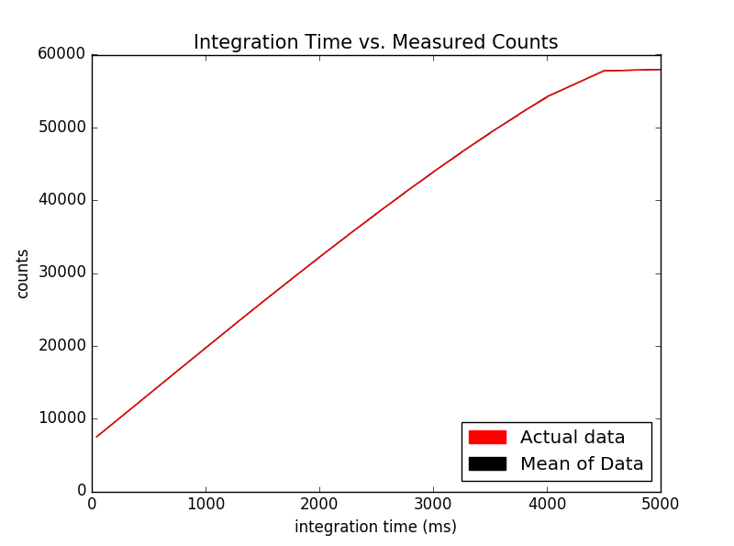

To determine the integration time vs the counts of each picture, I read files in through the FITS package from astropy in Python, and adjusted the parameters of the read in’s area equal to original analysis’ parameters (33 to 180 in the x direction and 20 to 180 on the y axis) These parameters are due to the bright side of the images always being on the right half, so we wanted to really capture that part of the image. The program I wrote analyzed counts in that section of the image for each picture, and got the integration time’s measurement from the specific header for each image. In the context of this project, the integration time is best thought of the exposure time for the camera. Therefore, an increasing amount of ints means that the camera was open longer.

The data was stored in ‘int’ and ‘counts’ arrays, respectively. I graphed the integration time, which were in milliseconds, on the x axis and counts on the y axis.

Where in my code this is calculated:

File: linearityReportNovember2014Data.py

Images are opened and data is read in: open_images(), lines 31-53

Mean of counts is taken: avg_ints_counts(), lines 55-63

Graph is printed: print_graph(), lines 168-180

Ints vs. Counts with linear relationship:

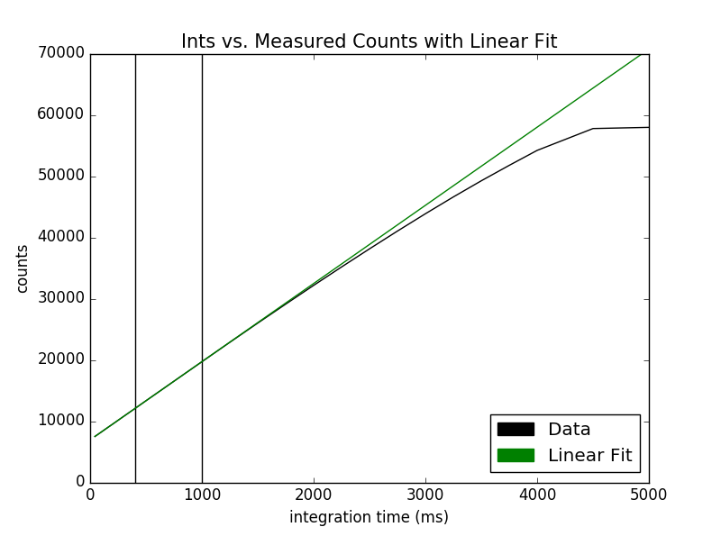

The first step in correcting for linearity was trying to find the straightest part of the data to add a linear fit to demonstrate the supposed linearity we were trying to achieve. I determined that the straightest part was between 400 ms and 1000 ms, making sure to not use the very early data (due dark current making noise). The region of choice is in between the bars above. I chose this region among others because after graphing the linear fit in relation to other regions in the straight-line section of this graph, I zoomed into each of the fits, and found that this fit’s separation was minimal enough to provide a good fit for the rest and was a stellar fit.

The coefficients of the line were m = 12.76 and b= 6946.92, if y = mx + b.

This line shows that the data is only strictly linear up to about 20,000 counts, so the linearity correction must be applied to any values above this.

Where in my code this is calculated:

File: linearityReportNovember2014Data.py

Linear fit is found: make_true_counts(), lines 66-71

Graph is printed: print_graph(), lines 184-200

True counts vs. Measured Counts with linear:

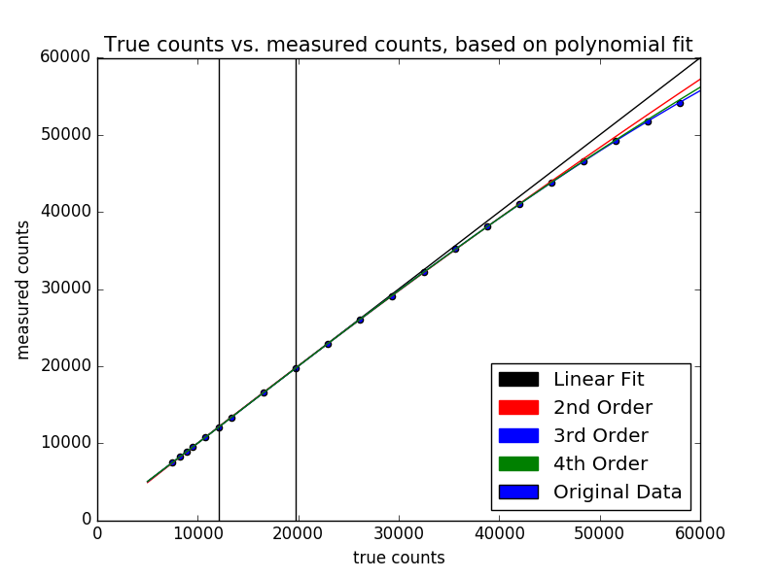

The next step was to calculate the true counts. The true counts represented what the data would look like if it was perfectly linear, and there was no calibration needed. On the above graph, this is the linear fit represents. However, we also wanted to fix the data for second, third, and fourth order polynomials, so we took the set of data up to about 44,000 counts, and created a function in each of those orders that would convert counts to true counts. By applying these function coefficients that were generated to counts for each order, 3 more true counts graphs were generated. By plotting the original data on the same graph, we could see the third order fit was the most accurate in this case.

The bars in the graph also represent where the linear fit was chosen from for all orders of the fits.

Where in my code this is calculated:

File: linearityReportNovember2014Data.py

True counts are found: make_true_counts(), lines 73-99

Graph is printed: print_graph(), lines 204-227

Error of Linearity vs. True Counts

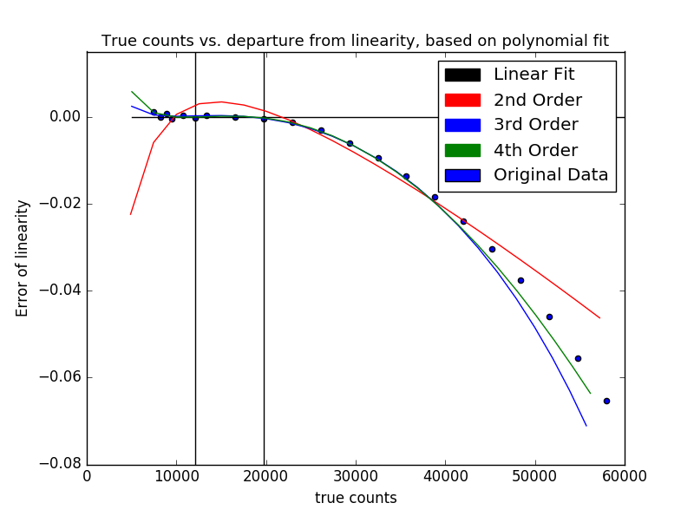

To confirm the results from the previous page that the third order fit was superior, we decided to calculate the error of linearity for each of the different polynomial fits. The error of linearity was calculated by:

Error of linearity = $\frac{true counts-measured counts}{true counts}$

With true counts referring to the specific true counts of each fit, calculated earlier.

As seen from the picture, 3rd and 4th order come very close to the fit, and diverge at about the same point from the original data. However, the fourth order fit is closer to the data, so I chose that to correct the counts. After adjusting formulae and boundaries within my program, I have concluded this is the closest to the data error of linearity I could possibly get.

Where in my code this is calculated:

File: linearityReportNovember2014Data.py

Error is calculated: error(), lines 132-162

Graph is printed: print_graph(), lines 231-252

Corrected Counts vs Ints:

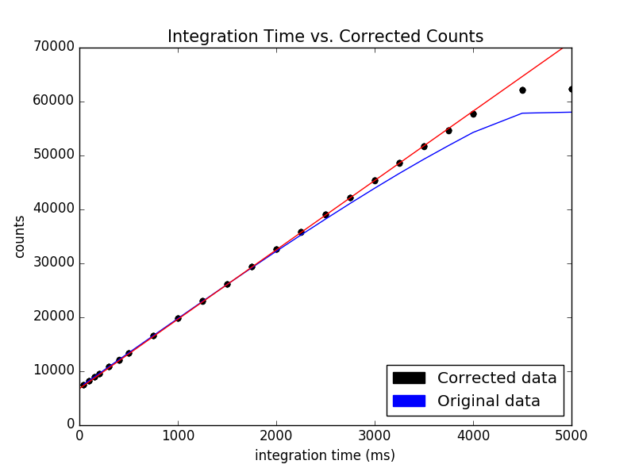

This is the graph for 4th order corrected data, which happens to be linear up to ~50,000 counts. Now, the process for this was as follows:

First, I made sure that the 4th order coefficients were converting counts to true counts, so I personally had to recalculate my coefficients with counts in the x axis, and true counts in the y axis in the coefficients-calculating function in Python. I then reopened all the images back up, and calculated the ints as I did previously, reading them in through each image header. However, for the counts, if the counts read in were above 20,000, I took the counts from the image and applied my calculated third order coefficients to output a corrected and calibrated value for counts. I then graphed the resulting new counts, and found out that the corrected data was linear up to about 50,000 counts.

Equation that linearized the data: $y=ax^{4}+bx^{3}+cx^{2}+dx+e$

Where x is the measurement of counts from the image, y is the corrected counts, and with:

a = 3.67e-16, b = -7.58e-11, c = 2.69e-06, d = 9.66e-01, e = 1.39e+02

Where in my code this is calculated:

File: linearityReportNovember2014Data.py

Correction is applied: make_true_counts(), lines 101-130

Graph is printed: print_graph(), lines 256-273