Checklist for Tokenlab Testing

**Have I looked at the Tokablab_Roadmap.pdf file to make sure I haven’t missed anything.**

**The crowdsale has two stages .. Countdown and Real sale**

**The countdown will be for 7 days**

**Have I incorporated the FAQ’s correctly.**

**Have I incorporated the roadmap**

**Have I copied the link to the Whitepaper?**

**Make sure I have links to twitter, slack, facebook, bitcoin talk**

**Have I setup the subscribe to email through the mail chimp**

**Make sure to use Tokenlab TM**

**The menu items should have anchors to the page.**

**There is a video you need to get from trupix.**

**Make sure we have the Team and the Advisors.**

**This is very important… The sale is in USD. Make sure there is a separate oracle that will update the Token balance after the exp has been received.**

**Make sure to implement community participation.**

**The price for 1 LAB for the exclusive sale .08 cents. In the wireframe its incorrect.**

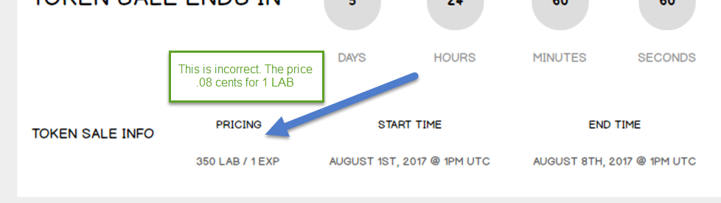

**When using the wallet make sure to have the following text.**

**Tokenlab.io does not hold your keys for you. We cannot access accounts, recover keys, reset passwords, nor reverse transactions. Protect your keys & always check that you are on correct URL. You are responsible for your security.**

**The crowdsale will last 2 weeks or if the 1.25 m dollars come first then we end it before that.**

**Show the projected participation info that we gathered during the count down phase.**

**Here are the limits for the crowdsale**

