Proposed Plume Mapping
Off- and On-Axis Project
Prepared by: Victoria Preston and Jyun-Nai Wu

Intent and Overview
The YBW-Sentry field is a recently discovered off-axis venting site at the EPR featuring multiple high temperature black smoking chimneys and diffuse flow. Interest in understanding the character of the plume structure at YBW-Sentry, in order to estimate heat/energetic flux and build a complementary “map” of the water column to detailed bathymetric data, is of interest in order to help complete the picture of how YBW-Sentry is formed and it’s overall impact on the EPR. To better characterize the YBW-Sentry plume structures requires understanding (1) the background water column profile at the EPR, (2) the character of on-axis-venting, and (3) the character of the off-axis venting field. With this data in hand, complementary studies on eDNA transportation and historical water column changes pre- and post-eruption can be conducted.

Using AUV Sentry, HOV Alvin, and a CTD Rosette, we aim to characterize off- and on-axis venting at the EPR during this cruise with several operations. When possible, operations are opportunistically proposed to complement other ongoing science team efforts or parallelize with other research activities. In short, we suggest a series of Sentry and Rosette operations at both YBW-Sentry and the EPR at P-Vent and Bio-9, with complementary data collected with Alvin when possible.

Off-Axis: YBW-Sentry
To characterize the YBW-Sentry site, we propose at least 1 Rosette cast, and up to 2 Sentry dives. Ideally, the Rosette cast occurs before the Sentry dives, so estimation of the neutrally-buoyant height can be possible. Data to collect with each platform include:
- Vertical cast with rosette: shows the water column and water samples for fluid chemistry/eDNA can be collected
  - Use cast to place an initial estimate on the neutrally-buoyant layer
- Sentry dive 1: target the near-bottom water column at 10-20m and 40m with survey patterns to measure the extent of the merging buoyant plumes from the region. Also perform a magnetics survey.
- Sentry dive 2: using results from the first dive, plan a higher water column survey (100-150m) above the bottom to measure the neutrally-buoyant layer.
- Alvin exploration: imaging of venting structures (particularly taking PIV suitable videos at the orifice of vents), measurement of orifice area and temperature, and surveying the location of venting structures would all be significantly useful for modeling the plume. Notes on locations of diffuse flow and temperature would also be useful.
  - Alvin should also be used to deploy and recover a current tiltmeter for the duration of Sentry operations (ideally also Rosette) for computing the impact of crossflow on measurements

To make use of our time, we suggest the following order of operations:
- Rosette cast during mapping box 4/5 in Northwest area to be mapped
- Alvin places current tiltmeter and performs initial survey of the venting sites
- Sentry AUV dive that night
- Mapping with AUV (box 5/5 in the Northwest) as algorithm computes idealized pathway; additional Alvin dive, if possible, for further recon
- Sentry AUV dive the following night
- Alvin retrieves the current tiltmeter

On Axis: Bio9 and P-Vent
To get a snapshot of on-axis venting, we can focus on P-Vent and Bio9, which are located approximately 60m apart on the southern area of the EPR that is our study region. Activities at this area would look similar to those at YBW-Sentry; Alvin temperature, vent measurement, and other basic venting information can be collected, historical time-series of currents can be used, a Rosette cast could be used to identify a neutrally-buoyant layer, and Sentry would be used to do a concerted survey. If time, it would be advantageous to do Rosette tow-yos along the axis or a Sentry dive dedicated to a broader water column survey.

To best make use of time, we suggest leveraging the re-occupy line Sentry survey to perform an additional water column survey at the end of the line transit, and to deploy a Rosette in the Bio9/P Vent area. While Alvin performs planned operations at the vents, notes and images useful for water column mapping can be conducted. If there is additional time, more dedicated dives or Rosette casts/tows can be completed.

Desiderata
At the end of these efforts, we would like:
- Vent Observations
  - Vent/orifice locations
  - Estimates of orifice/vent area
  - Fluid temperature at the vent
  - Possibly footage of plume fluids exiting the vents suitable for PIV analysis
- Water Column surveys
  - YBW-Sentry 2-layer dive (with magnetics) + 1 upper-layer diversity
  - YBW-Sentry Rosette cast (vertical)
  - Bio9/Pvent 2-layer survey (tagged with re-occupy line) + 1 focused plume surveyed
  - Bio9/Pvent Rosette cast (vertical)
  - Tow-Yos at both/either Bio9/Pvent and/or YBW-Sentry
- Tiltmeter data
  - Relevant current data for all YBW-Sentry operations
  - At least most recent historical data for Bio9/Pvent to compute predictive currents model

This data should assist with:
- Off-axis and on-axis venting comparisons
- Pre-eruption analysis of venting plumes at two key sites (to be compared with data collected after eruption; ideally collected in the same way)
- Magnetics analysis of YBW-Sentry
- Understanding the form of plume structures in the water column and forcing characteristics
Sentry Dive Plan
YBW-Sentry, Dive 1 Proposal A
Prepared by: Victoria Preston, Jyun-Nai Wu

Goal: We would like to confirm the presence of water column anomalies above the YBW-Sentry field and ultimately constrain the forward projected size of the plume(s) emitted by the field. This requires looking at two layers of the water column below an expected neutrally-buoyant height for the field to create snapshots of the initial buoyant structure of the plumes.

Motivation: There are several scientific objectives with each Sentry dive at YBW-Sentry field:
- Understand the magnetic character of the field (to assist in dating the longevity of the system)
- Quantify the heat and energy flux of the field (to characterize the energy of the venting structure and compare it relative to other venting sites along the EPR; especially interesting since YBW-Sentry is an off-axis site)
- Map the spatiotemporal structure of the plumes emitted by the field (to model the impact on the water column, local deposition effects, and complement model development work for hydrothermalism in general)
This dive should set the stage for follow-up exploration of the field with Sentry, CTD Rosettes, or Alvin by enabling estimates of the venting character to be estimated from in situ water column measurements.

Description: The first dive will consist of two surveys directly above the field; one at approximately 20m and one at approximately 40m above the site. Ideally these are dives done in depth-hold mode, and so absolute altitude will not be constantly 20m or 40m. Both dives will be in the form of a spiral trajectory (way points will be provided), which initially spirals from outside the field into the center, then spirals from the center back out. All designed dives will be centered over 9.9055599, -104.294361.
- Dive recommendations
  - When diving with Sentry, targeting to the Northwest of the field may be advantageous as it is unstructured area and will be near the intended starting coordinate for the first survey.
- Survey 1 (160m by 100m box oriented to be longer N-S; 5m resolution between spiral arms; 2572m depth hold)
  - This survey is designed to capture any possible advecting plumes in the basin over the course of the survey; flown at 20m altitude above the venting site, this should easily detect anomalies from active venting.
- Survey 2 (200m by 140m box oriented to be longer N-S; 5m resolution between spiral arms; 2617m depth hold)
  - This survey is designed to capture the dissipation of plume fluids as they rise through the water column to help constrain the rates of mixing/entrainment that the fluids experience. It is also designed to intersect with moving plumes no matter their orientation. It is wider than the first survey as there is more uncertainty about the distance traveled by the plume under different advecting circumstances.
- Holding pattern
  - As is standard, if Sentry is put into a holding pattern, we might recommend putting the vehicle in a holding pattern 60m or higher in the water column to the west of the field, in an attempt to gather opportunistic data under the assumption of current crossflow.

Estimated Time: 7.79hrs at 1knot

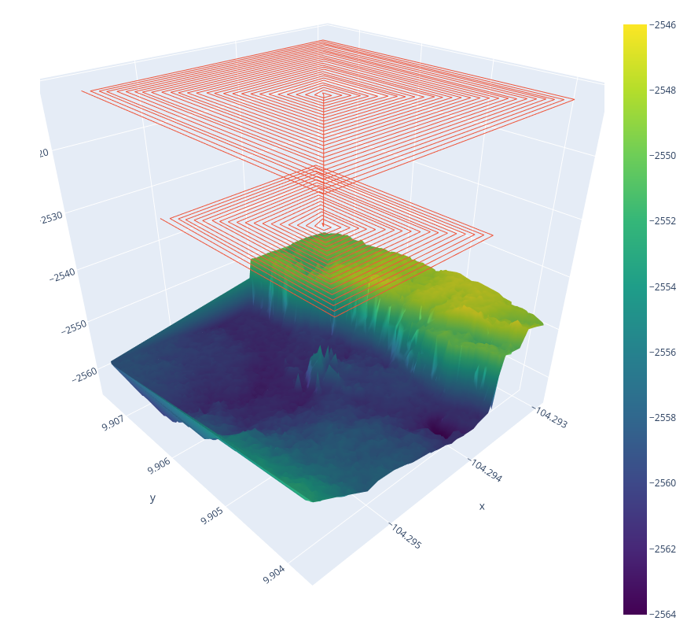
Sentry Dive Plan
YBW-Sentry, Dive 1 Proposal B
Prepared by: Victoria Preston, Jyun-Nai Wu

Goal: We would like to confirm the presence of water column anomalies above the YBW-Sentry field and ultimately constrain the forward projected size of the plume(s) emitted by the field. This requires looking at two layers of the water column below an expected neutrally-buoyant height for the field to create snapshots of the initial buoyant structure of the plumes. We would also like to run surveys suitable for post-processed magnetics.

Motivation: There are several scientific objectives with each Sentry dive at YBW-Sentry field:
- Understand the magnetic character of the field (to assist in dating the longevity of the system)
- Quantify the heat and energy flux of the field (to characterize the energy of the venting structure and compare it relative to other venting sites along the EPR; especially interesting since YBW-Sentry is an off-axis site)
- Map the spatiotemporal structure of the plumes emitted by the field (to model the impact on the water column, local deposition effects, and complement model development work for hydrothermalism in general)
This dive should set the stage for follow-up exploration of the field with Sentry, CTD Rosettes, or Alvin by enabling estimates of the venting character to be estimated from in situ water column measurements.

Description: The first dive will consist of four surveys directly above the field; two at approximately 20m and two at approximately 40m above the site. Ideally these are dives done in depth-hold mode, and so absolute altitude will not be constantly 20m or 40m. All dives will be in the form of a lawnmowing trajectory (way points will be provided), and each pair of dives for the different depths will together form a “waffle” pattern. All designed dives will be centered over 9.9055599, -104.294361.
- Dive recommendations
  - When diving with Sentry, targeting to the Northwest of the field may be advantageous as it is unstructured area and will be near the intended starting coordinate for the first survey.
- Survey 1 and 2 (180m by 180m boxes with 90 degree rotation; 5m resolution between the rows; 2572m depth hold)
  - This pair of surveys is designed to capture any possible advecting plumes in the basin; flown at 20m altitude above the venting site, this should easily detect anomalies from active venting.
- Survey 3 and 4 (200m by 160m boxes with 90 degree rotation; 5m resolution between rows; 2617m depth hold)
  - This pair of surveys is designed to capture the dissipation of plume fluids as they rise through the water column to help constrain the rates of mixing/entrainment that the fluids experience. It is wider than the first survey as there is more uncertainty about the distance traveled by the plume under different advecting circumstances.
- Holding pattern
  - As is standard, if Sentry is put into a holding pattern, we might recommend putting the vehicle in a holding pattern 60m or higher in the water column to the west of the field, in an attempt to gather opportunistic data under the assumption of current crossflow.

Estimated Time: 7.6hrs at 1knot

