PURCHASE REQUEST

1. As a USER, I want to login to the system so that I can perform the operations
- Login operation can be performed by using the login credentials.
- User can be an admin or a normal user.
- The login credentials are verified
- After successful verification:
    - Administrator is redirected to admin page
    - Normal user is redirected to corresponding home page

2. As a normal user I should be able to make purchase request that are assigned to administrator
- User can mention the item name and description
- User should be able to catagorise the items groups that are available
- User should be able to assign priority to requests
- User should be able to mention the project that requires the purchase
- User should have the privilage to cancel request before sending
- User should be able to see the status of his/her request which can be
    - appreved
    - rejected
    - pending

3. As an admin, I should have the privilage to process the requests
- Admin should be able to view all the request based on the priorities
- Admin should have privilage to approve, reject or edit the requests

WIREFRAMES

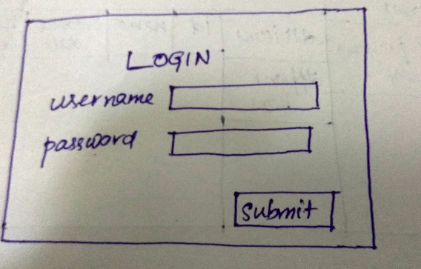
1.LOGIN

2. NEW REQUEST
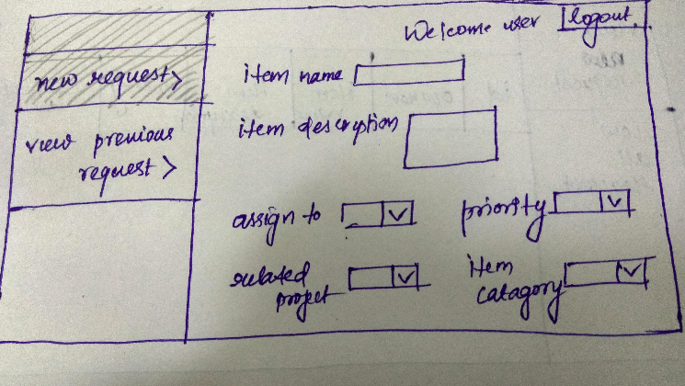

3. VIEW PREVIOUS REQUEST
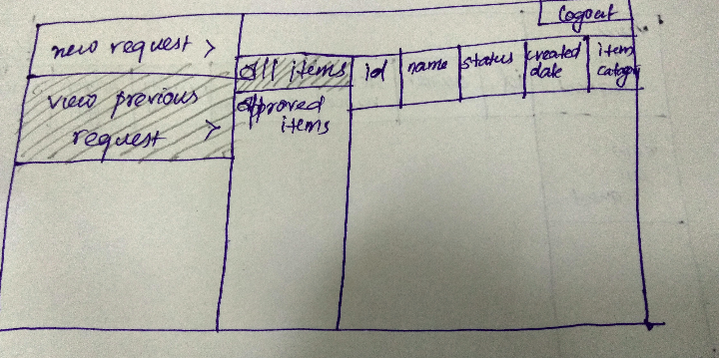

4. VIEW APPROVED ITEMS
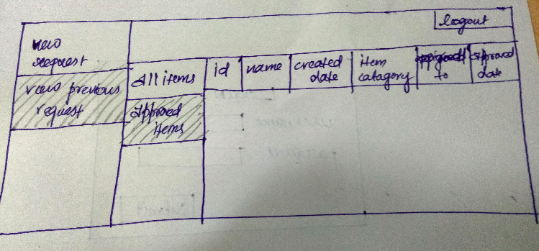

5. ADMIN - VIEW PENDING REQUEST

