I want admin to be able to see both tutors and clents addresses, phone number,s, emails.

I  have to see state and country

In the registration forms (of both tutors and  students), I want to add - online, offline, full time, online and offline, and make it searchable.

 All. for some reasons, it feels like phone numbers seems to default to 231. Lets fix that. ( NOT DONE)

 Tutors and students should be able to communicate with each other after students have put money in wallet.

 I also want to fix the chat or messages between tutors and clients. (it does not work now) in the dashboard. It used to work before, so its a quick fix.

  (I figured out that message works, but it goes to admin email instead of to tutor directly)   (ONLY STUDENT CAN SEND, TUTORS CANT SEND, I WAS ABLE TO SEND MY PHONE NUMBER EASILY WITHOUT BOOKING THE TUTOR - BOOKING DOES NOT WORK). Sending phone numbers  without booking the tutors should not be allowed. Skype, phone or email sould not be able to be sent by tutors.

Contact admin (on dashboards) - it does not work

There is also a testing part that I need fix - everything is already done, but the system will not allow me to upload tests because  i can do the subjects.. It wont let me upload diagnostic test.(

I need to upload the tests

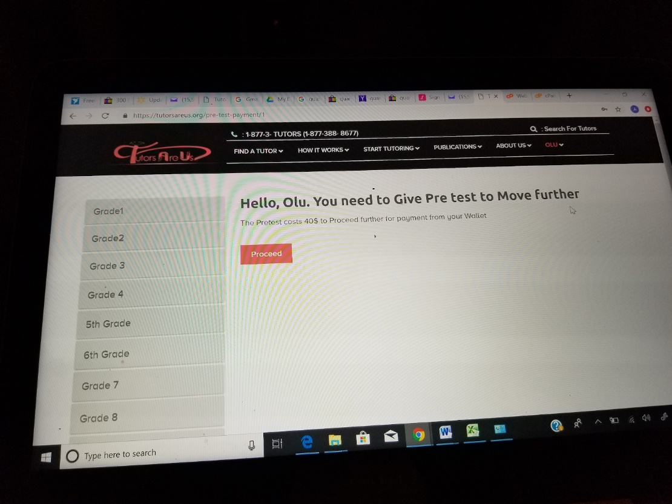

Please can we change the sentence to -  Hello Olu, take the pretest to proceed. You will be charged $40

 Check above, someone tried to fix it but, got sentence all wrong

:done