**AJAY KUMAR**

**B.Tech. - Computer Engineering**

**Ph:** +91-7027979708

**Email:** ajaytanwar01234@gmail.com

Faridabad, Haryana, India - 121006

# BRIEF OVERVIEW / CAREER OBJECTIVE / SUMMARY

A motivated individual with in-depth knowledge of languages and development tools, seeking a position in a growth-oriented company where I can use my skills to the advantage of the company while having the scope to develop my skills

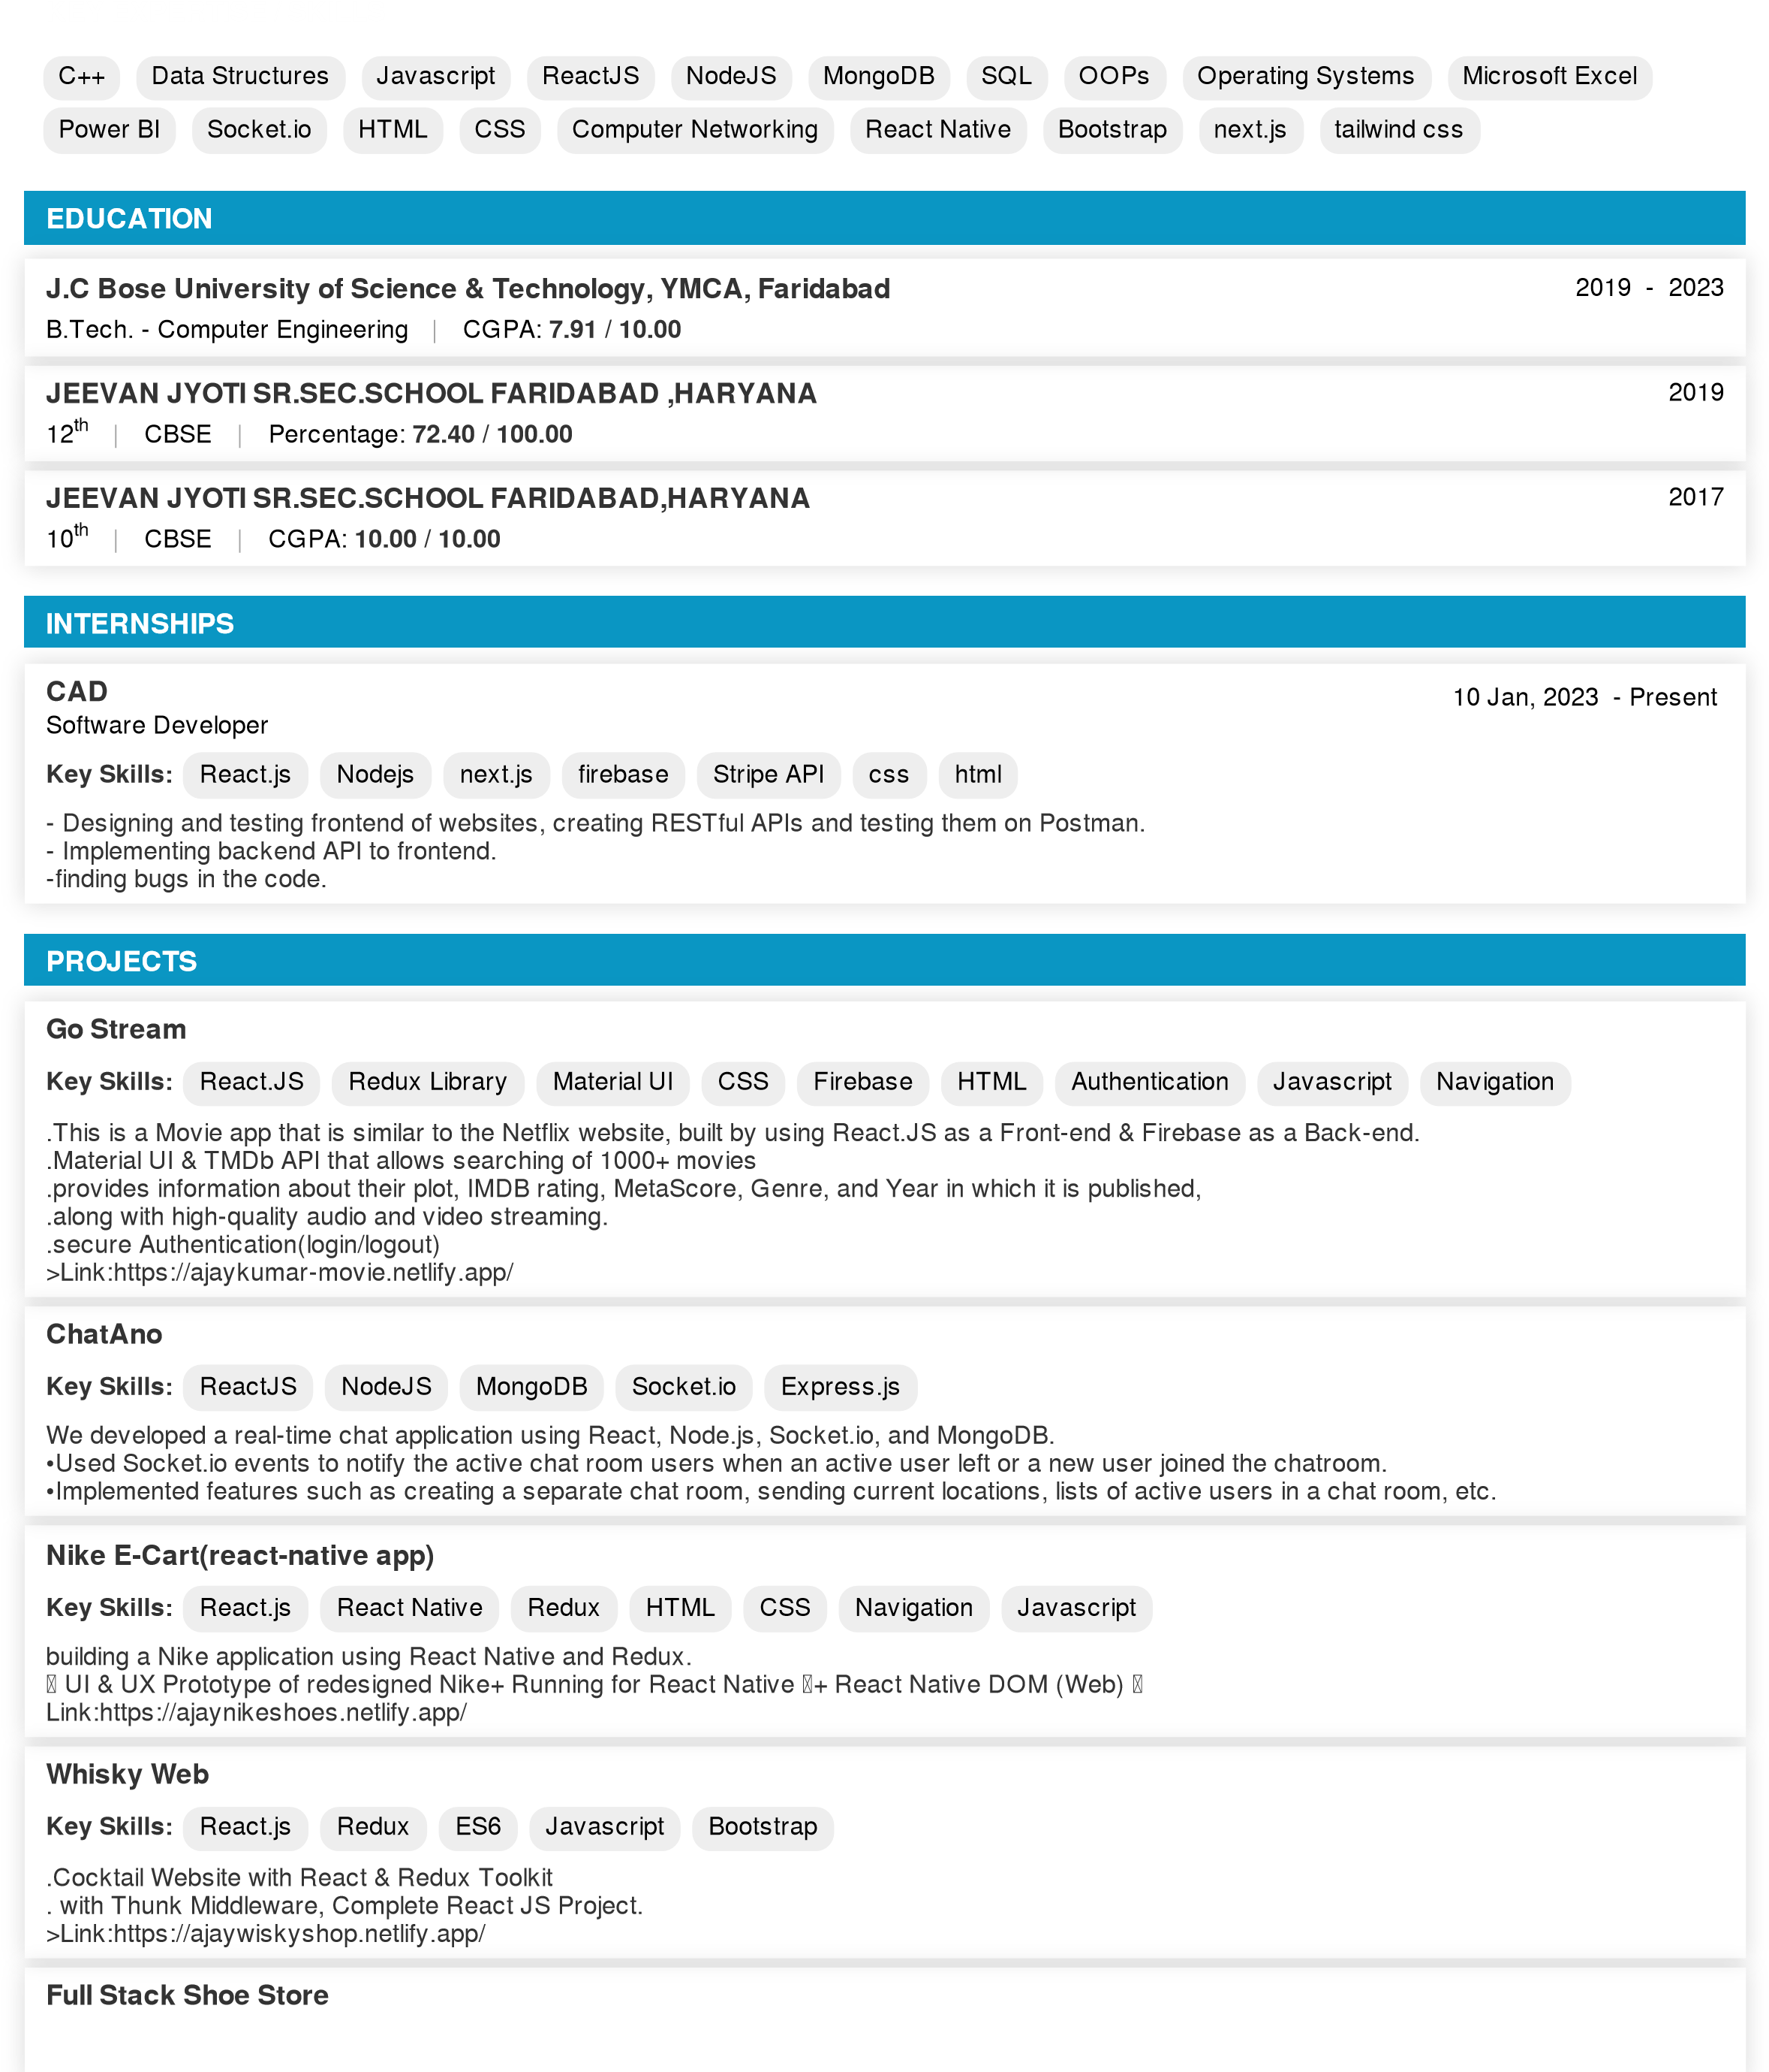

**Key Skills:**

Next.js

tailwind css

redux toolkit

Stripe

Redux fundamentals

HTML

css

React.js

cart functionality

Responsiveness

This is a fully functional, fully responsive, and beautiful looking full stack e-commerce project with the latest trending top-notch technologies, I have

covered all important topics of creating an e-commerce website such as product listing, product detail page, shopping cart, payment gateway, and so

on…

Technology used:

-

Next.js 13

-

A core feature of Next.js

-

Server side rendering (SSR, SSG) in Next.js

-

Dynamic Routing in Next.js

-

Rapid UI building with Tailwind CSS

-

Mobile-first responsive approach

-

Functional Programming through utility methods

-

Strapi Headless CMS and its features

-

How to fetch data from stripe APIs in the next.js application

-

Redux fundamentals and its best usage for cart functionality

-

Complete cart functionality with add, update, and delete actions

-

Project deployment for frontend and backend

PROJECT LINK:https://shoe-store-frontend-ruddy.vercel.app/

**ACHIEVEMENTS**

Secured global rank 991 out of 21911 in Biweekly Contest 80 organized by CodingNinjas on Jun 11, 2022.

# PERSONAL INTERESTS / HOBBIES

Cricket Fitness Freak

Learning new technologies

# WEB LINKS / IMs

WhatsApp - 7027979708

LinkedIn - <https://www.linkedin.com/in/ajay-kumar-320371205/>

Other - <https://www.codingninjas.com/codestudio/profile/8f634c11-9ed3-47af-bddf-043bb9150093>

Personal - <https://ajaykumar-movie.netlify.app/>

Personal - <https://ajaywiskyshop.netlify.app/>

Personal - <https://ajaynikeshoes.netlify.app/>

Personal - <https://shoe-store-frontend-ruddy.vercel.app/>

Github - <https://github.com/Ajtanwar95>

# PERSONAL DETAILS

**Gender:** Male **Date of Birth:** 25 Jun, 2002

**Marital Status:** Single **Known Languages:** ENGLISH , HINDI

**Current Address:** FARIDABAD,SEC-7, HARYANA, Faridabad, **Phone Numbers:** +91-7027979708, +91-7027979708

Haryana, India - 121006

**Emails:** ajaytanwar01234@gmail.com , 19001003006@jcboseust.ac.in