**Ayushi Aggarwal** 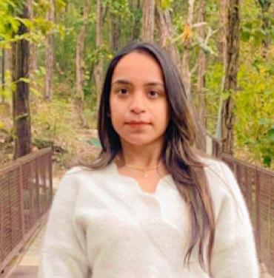

**Phone: +918755751073**

Email: [ayushiaggarwal1308@gmail.com](mailto:ayushiaggarwal1308@gmail.com)

LinkedIn: https://www.linkedin.com/in/ayushi-aggarwal-924130256

|  |
| --- |
| **Career Objective** |

I am a meticulous and detail-oriented candidate with excellent observational and communication skills looking for an entry level position to kickstart my career and make the best of my potential and display my skills.

|  |
| --- |
| **Academic Details** |

|  |  |  |  |
| --- | --- | --- | --- |
| Year(s) | Qualification – Degree | Board/University | Percentage / CGPA |
| 2020-2023 | Bachelors in computer application (Internet of Things) | University of Petroleum and Energy Studies | 7.10/10 |
| 2019-2020 | XII | CBSE | 82% |
| 2017-2018 | X | CBSE | 78 % |

|  |  |
| --- | --- |
| **Subject Electives** | C programming, Java, JavaScript, Python, Html, Tailwind CSS, Bootstrap, React, PHP, CSS, Shell Scripting |
| **Technical Proficiency / Skills** | Web Designing, MS Excel, WordPress, Photoshop, CorelDraw, |

|  |
| --- |
| **Working Experience** |
| * IBM Worked on a project IoT Based Smart Umbrella System for 2 Months using Raspberry Pi. * FANTASTIQO 1 Months Successfully completed Internship in the field of Human Resource Management * Action in Community and Trainingfor your SRIJAN- Social Internship (June-July 2021). * Trion 3 Months Created websites on WordPress * Worked as a Web Developer in Pearl Organization |

|  |
| --- |
| **Projects (Major / Minor)** |
| * **Hospital Management System Using Java**   This includes registration of patients, storing their details into the system.  Easy monitoring of supplies in inventory.   * **Online Voting System**   This helps in E-voting. Which is created using PHP JavaScript   * **Website Created Using WordPress –**   [Products – amruthamfarms.com](https://amruthamfarms.com/products/)   * **Websites -**   <https://www.tutoriapakistan.com/>  <https://www.remedebio.com/>  <https://www.onewaycabservice.org/>   * **Movie App**   I have made this Movie App with the Help of HTML, CSS & JavaScript.  In this Movie App you can Watch any Latest Release Hollywood or Bollywood Movie from YouTube**.**   * **Hoverboard**   It is a web-based project.  The hoverboard effect project has a cool effect of painting on a box by hovering over it.  Languages used in this project is HTML, CSS, JavaScript   * **Quiz**   Languages used in this project is Html CSS JavaScript |

|  |
| --- |
| **Rewards And Recognition** |
| * I actively participated in various events of ACM. * Received certificate of appreciation for outstanding efforts as a Group leader in SRIJAN Social Internship * Participated in VFX and video Editing Workshop organized by UPES (University of Petroleum and Energy Studies) ACM AND ACM –W Student |