1. Link logo with homepage
2. <https://www.samwebstudio.co.in/antenna/beta/control-panel/category-management>

Remove add data button from here.

If there is a sub-category or a product inside any category, then main category should not deleted.

3. <https://www.samwebstudio.co.in/antenna/beta/category-list/mobile-network-booster> When there is no banner, use default image as banner

When no category image uploaded, Use No-image available image.

4. When adding product

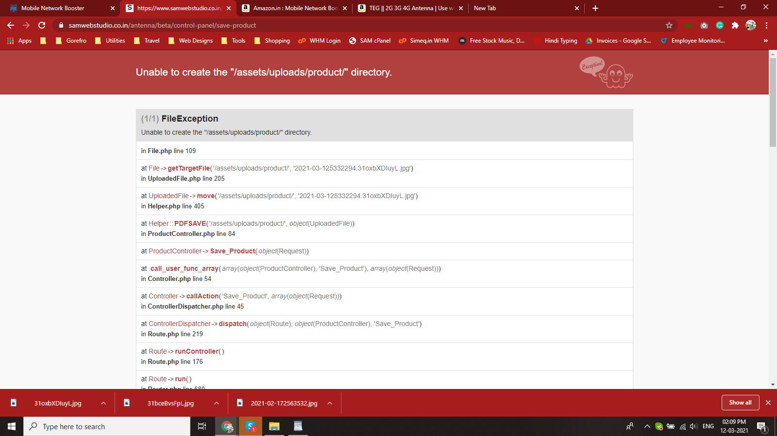

5. <https://www.samwebstudio.co.in/antenna/beta/control-panel/add-our-team>

Remove Email ID and phone number field from here.

6. <https://www.samwebstudio.co.in/antenna/beta/control-panel/client-management>

Page height is too long

7. <https://www.samwebstudio.co.in/antenna/beta/product-listing/military-antenna/detail.php> Error

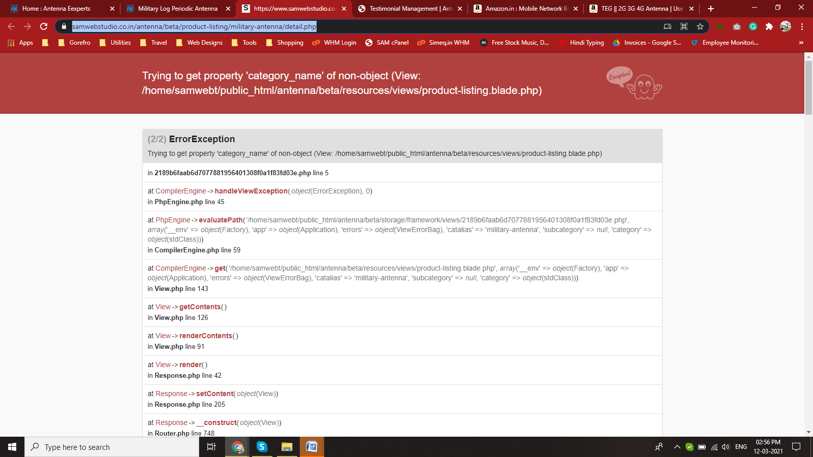

8. Change Cell to mobile number. No thank you message on submitting the form.

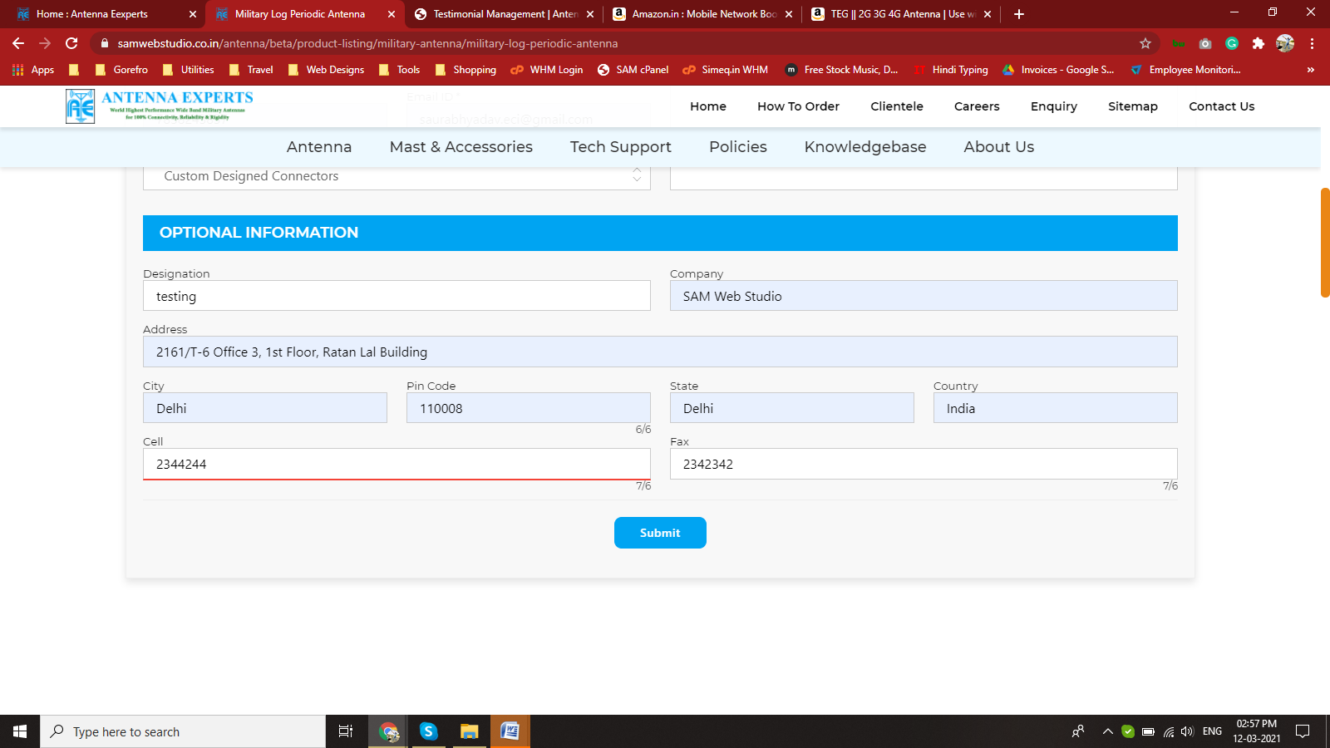

9. FAQ management to be corrected.

10. Sitemap missing

11. <https://www.samwebstudio.co.in/antenna/html/enquiry.php> Remove Fax from all forms, it doesn’t work anymore. Cell to be rename as mobile. When you press key up / down in cell field, it shows counting.

No Thank you message on submitting.

12. <https://www.samwebstudio.co.in/antenna/beta/save-career>

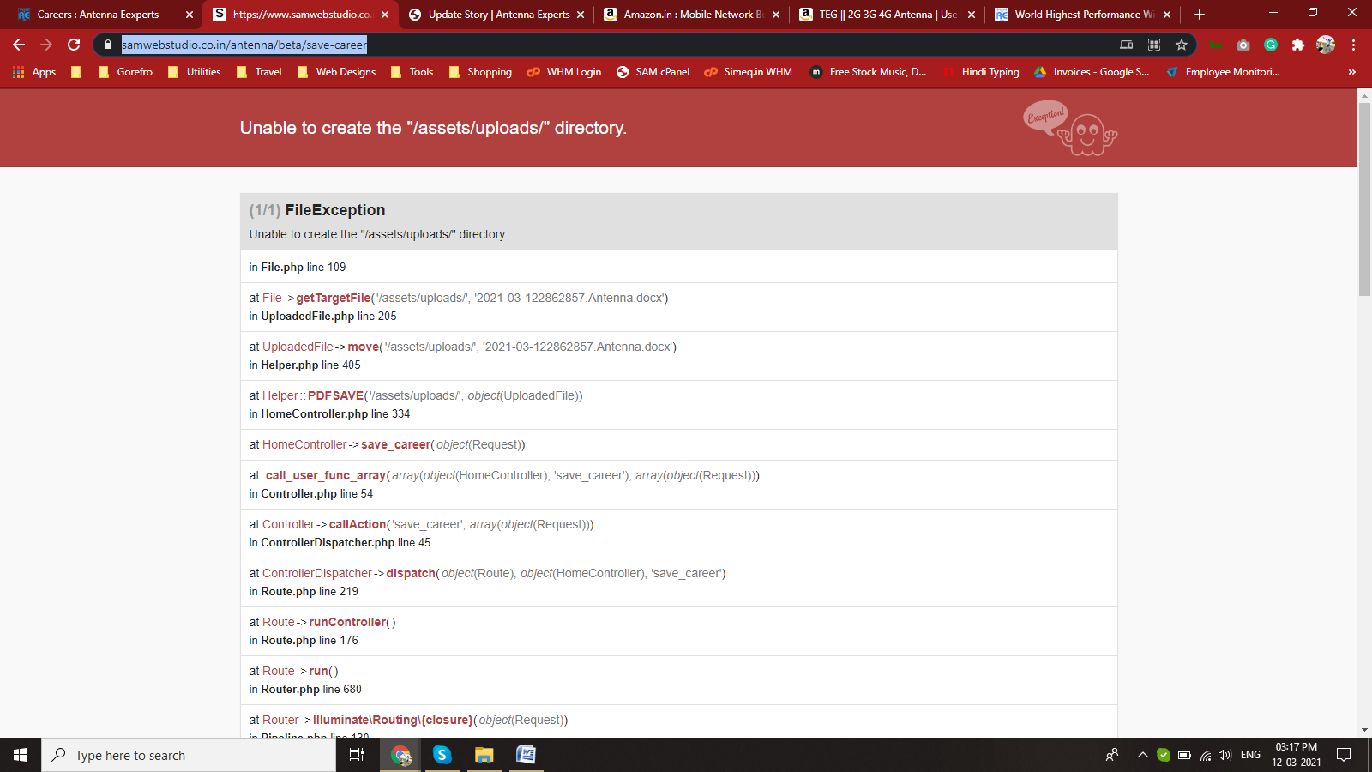

<https://www.samwebstudio.co.in/antenna/beta/control-panel/career> add content management link on this page.