Industrial Internship Report
Python Programming internship Learning and Project Documentation
Prepared by Sai Yogesh Velagapudi
Organization | upSkill Campus
Industry collaboration | UniConverge Technologies and The IoT Academy
Domain | Python
Internship period | 13 August 2026 to 28 September 2026
Duration | 47 calendar days inclusive
Certificate reference | USC360325TIA
Project | WardSpace
Repository | https://github.com/expertX221/WardSpace
WardSpace combines an interactive 3D home-care environment, synthetic patient monitoring, explainable risk assessment and simulated caregiver response. Python provides the local HTTP service, validation, scoring and SQLite persistence.
Executive Summary
This report documents the Python internship of Sai Yogesh Velagapudi and presents WardSpace as the project selected for this report. It explains the problem, intended users, inputs and outputs, implementation, tests and future scope. The internship dates and certificate reference are retained from the original report.
The application demonstrates how readings and caregiver events can be brought together in a home-care interface. It generates five vital-sign streams, assigns a transparent Low, Medium or High demonstration risk category, records acknowledgments and responses, and buffers events during disconnection. The local Python implementation needs no third-party Python packages.
The repository includes October and November 2026 extensions after the recorded internship period. These are described as subsequent project development, not as work verified to have occurred during the internship. All patient data is synthetic and the software is not clinically validated.

Contents
1 Preface and organizations
2 Objectives and project scope
3 Problem statement and target users
4 Input data and expected outputs
5 Existing approach and proposed solution
6 Python libraries and system design
7 Implementation workflow
8 Testing and evaluation
9 Project screenshots
10 Learning outcomes and future scope
11 Conclusion and references

1 Preface and organizations
The internship connects Python programming with practical software development, testing and technical documentation. I acknowledge upSkill Campus, UniConverge Technologies and The IoT Academy for the internship context and training support described in the original report. The original report records AICTE collaboration in the completion certificate.
upSkill Campus is the internship and career-development platform identified in the source report. UniConverge Technologies is the industry collaborator, with activities described there across IoT, cloud computing and software development. The IoT Academy is the associated training partner.

2 Objectives and project scope
The project objectives are to simulate home-care monitoring, validate incoming data, make rule-based decisions understandable, persist a care-event history, and demonstrate recovery from connectivity interruptions. The Python learning objectives include modular functions, HTTP handling, JSON processing, exception handling, database transactions and automated testing.
The engineering workflow comprises requirements analysis, data and interface design, implementation, verification and documentation. These phases describe project organization; they are not a dated weekly internship diary.

3 Problem statement and target users
Home-care monitoring involves several related tasks: reviewing measurements, noticing changes, recording observations and confirming whether a caregiver has responded. When readings and responses are presented separately, it can be difficult to reconstruct an alert and understand what action was recorded. Intermittent connectivity further complicates keeping a consistent history.
WardSpace addresses this demonstration problem by combining a spatial patient view with synthetic telemetry, explainable threshold checks and a persistent event timeline. It seeks to show the complete path from sensing to response while preserving queued events during a simulated outage. Its outputs support inspection of the prototype rather than diagnosis or treatment.
Intended user | Use in the prototype
Family and home caregivers | Review synthetic readings, enter observations, acknowledge alerts and record simulated responses.
Care coordinators | Inspect event history and unresolved handoff states.
Students and reviewers | Explore Python APIs, data validation, persistence and 3D interaction.
Researchers and developers | Evaluate workflow reconstruction and reliability using fabricated cases.

4 Input data and expected outputs
The browser generates readings approximately every three seconds for stable, fever, deterioration and recovery scenarios. The project includes data/scenarios.csv as synthetic examples, not a clinical evaluation dataset. No physical sensor or real patient record is required.
Input | Representation and validation in risk.py
Heart rate hr | Numeric, 25 to 240 beats per minute
Oxygen saturation spo2 | Numeric, 50 to 100 percent
Temperature temp | Numeric, 30 to 44 degrees Celsius
Respiratory rate rr | Numeric, 4 to 65 breaths per minute
Systolic pressure sys | Numeric, 50 to 240 mmHg
Caregiver note | Text with limited recognition of breathless, confused, chest pain and dizzy
Care events | reading, note, attendance, acknowledge and response
Event metadata | Unique id, browser session, timestamp at, data and optional note
Boolean values, non-numeric values, non-finite numbers and out-of-range readings are rejected. Each event has a unique identifier and a session identifier. The server records receivedAt and recalculates risk for reading events.
Outputs include vital cards and trends, a risk level with score and reasons, a simulated alert and response timeline, persisted history, connectivity and stale-data indicators, and downloadable JSON or filtered CSV history.

5 Existing approach and proposed solution
A conceptual manual baseline uses separate notes and measurement logs, requiring a reviewer to compare readings and reconstruct the response sequence. This comparison motivates the project; no measured comparison with a commercial product is claimed.
WardSpace combines these activities in one interface. A browser outbox saves events before submission, the backend validates and stores them, and repeated event identifiers return the existing event. The interface shows immediate local feedback while the server stores its own recalculation for comparison. The intended benefits are traceability, repeatable scoring and clearer workflow visibility.

6 Python libraries and system design
Component | Actual role
Python 3.10 or later | Local server and deterministic risk scoring
http.server and functools | ThreadingHTTPServer, static files and request handlers
sqlite3 and contextlib | SQLite transactions and managed connections
json, urllib.parse and pathlib | Payload serialization, query parsing and file paths
time and uuid | Time and identifier utilities imported by the server
math and re | Finite-number checks and limited note pattern matching
unittest | Automated Python regression tests
Blender bpy | Procedural scene creation in build_room.py, executed inside Blender
Three.js and JavaScript | Browser 3D rendering and application interaction
Vercel and Neon Postgres | Hosted Node API and cloud persistence
esbuild | Frontend bundling
The local application uses the Python standard library rather than Flask, Django, FastAPI, NumPy or pandas. Blender has its own Python environment for generating the scene. The hosted backend uses Node.js and PostgreSQL; it should not be described as a Python web framework.
Data flow: browser synthetic readings → durable browser outbox → POST /api/events → validation and risk assessment → SQLite locally or Neon Postgres in the hosted deployment → acknowledgment to the browser. GET /api/events requires a session and returns that session’s recent events.

7 Implementation workflow
server.py serves public assets and implements the event API. risk.py contains assess, which checks values and returns level, score, reasons and a model label. build_room.py creates the Blender room and exports room.glb and room.png. The public directory contains the browser interface, rendered assets and service-worker resources.
Rule | Demonstration score contribution
SpO2 below 92 percent | 4
Heart rate below 50 or above 110 | 2
Respiratory rate below 10 or above 24 | 2
Temperature at least 38 degrees Celsius | 2
Systolic pressure below 90 mmHg | 3
Supported non-negated note keyword | 2
Risk categories | Low 0–1; Medium 2–3; High 4 or more
These thresholds are illustrative software rules and are not clinical recommendations. Keyword negation handling is limited and does not provide general clinical language understanding.
To run locally, open the repository directory, use Python 3.10 or later, execute python server.py and visit http://127.0.0.1:8000. Bundled viewer assets permit local startup without a frontend rebuild. Rebuilding requires Node.js dependencies and npm run build.
The backend limits payloads to 16 KB, validates event types and session identifiers, and uses parameterized database queries. Offline events are replayed sequentially. A simulated power outage stops synthetic generation; readings older than ten seconds are marked stale. Browser closure stops collection and timers.

8 Testing and evaluation
During report preparation on 10 November 2026, the repository Python suite was executed from its project directory with python -m unittest discover -s tests. All six tests passed. This is a current verification result, not evidence of a test run during the internship.
The test files cover risk logic and local server behavior. The execution includes event ingestion, duplicate handling and session-scoped history access. These automated checks do not establish clinical effectiveness, production security or real notification delivery.
Additional acceptance checks should exercise each scenario, alert acknowledgment, simulated response, offline queue replay, malformed input, stale data, and CSV/JSON export. No measured latency, memory benchmark or clinical accuracy is asserted.
Subsequent AI extension: MODEL_CARD.md reports a Qwen3.5-4B LoRA handoff model trained through AutoScientist by Adaption on 1,800 synthetic histories, with 300 separate held-out cases. It reports a platform best win rate of 91.54 percent. That figure is not held-out accuracy or clinical validation. The model card states trained-model inference is pending and the reserved-case metrics are unmeasured. This experiment is dated November 2026, after the internship.

9 Project screenshots
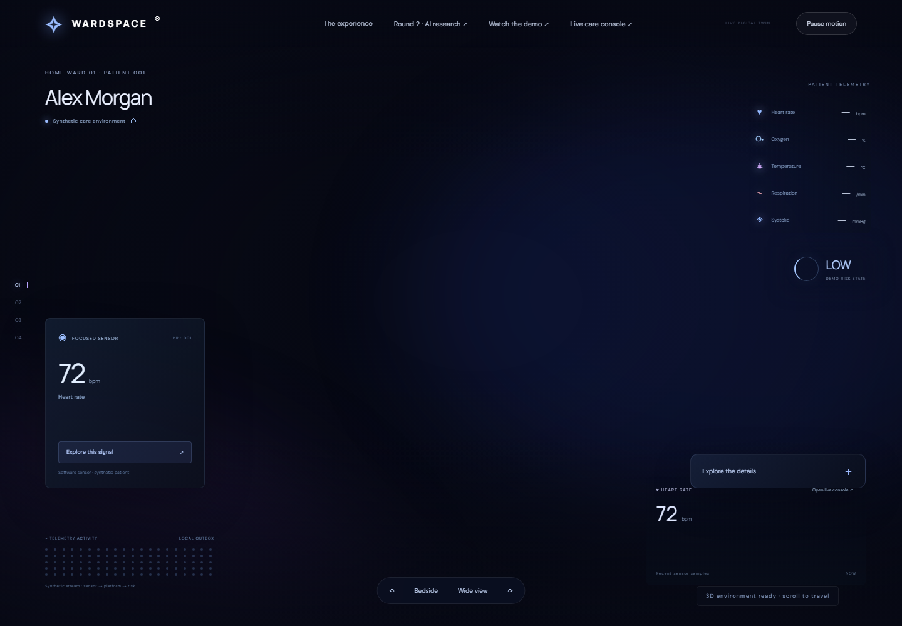
Figure 1 Live WardSpace overview captured during report preparation
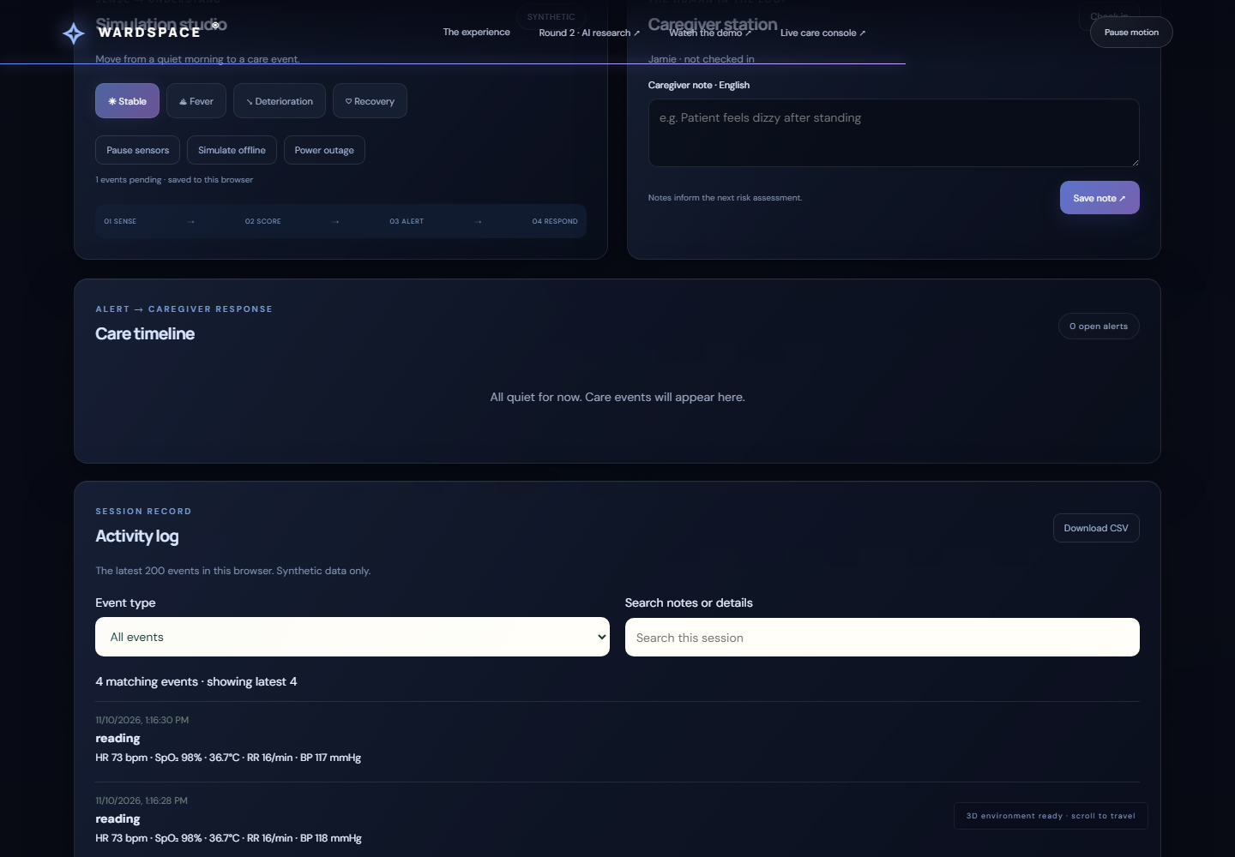
Figure 2 Live WardSpace interface further down the page
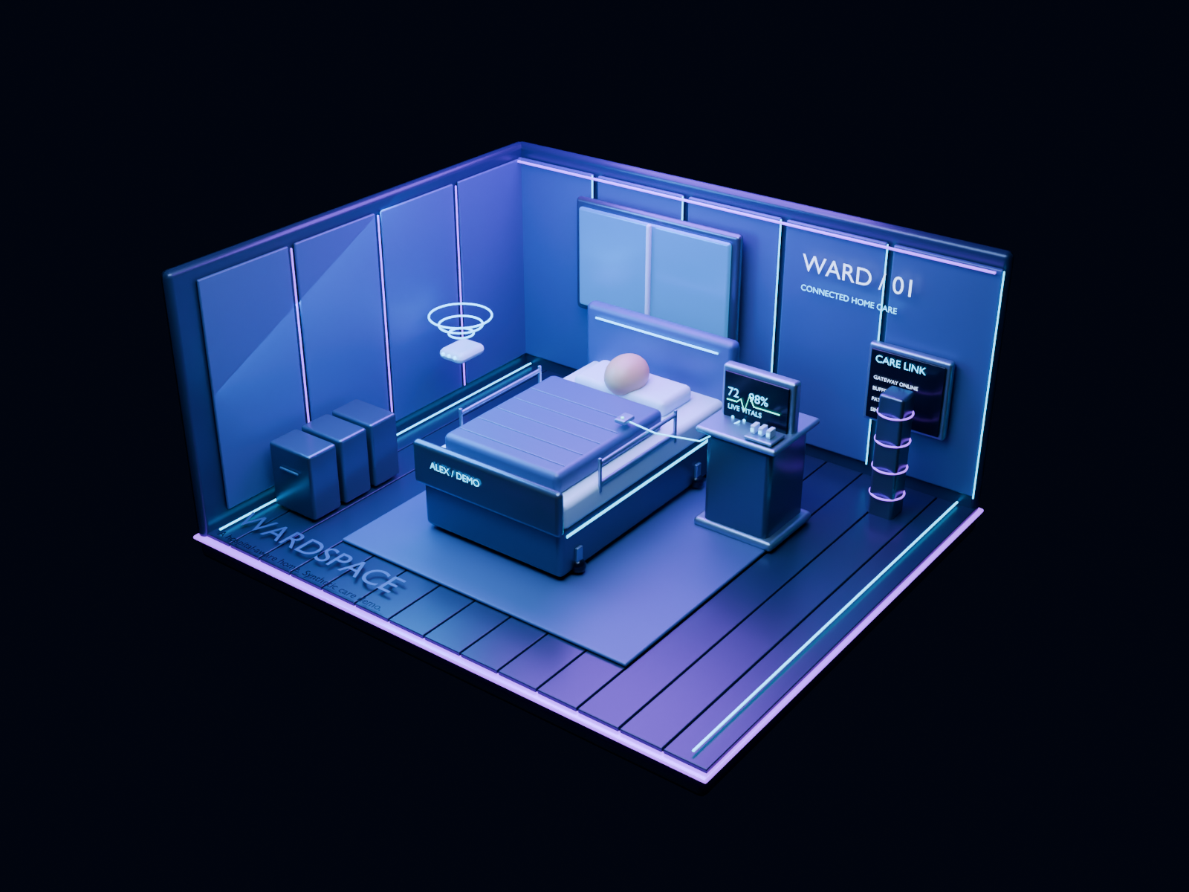
Figure 3 Original Blender room render distributed with the repository

10 Learning outcomes and future scope
WardSpace illustrates decomposition of a web application into input validation, scoring, persistence and presentation. The Python implementation demonstrates request handling, JSON processing, SQLite transactions and clear error responses. Comparing browser and server rules highlights the importance of consistent logic across execution environments.
The event model demonstrates why unique identifiers and idempotent ingestion matter when retrying interrupted requests. Tests make changes easier to verify. Repository documentation and explicit limitations help reviewers distinguish a working demonstration from a production service.
Future development should add authenticated roles, stronger audit integrity, retention controls, rate limiting and reliable notification delivery. Real sensor integration requires trusted timestamps and validation. Any clinical use would need clinician-defined protocols, suitable longitudinal data and prospective evaluation. The AI extension additionally needs a working compatible inference endpoint and evaluation on its reserved cases.

11 Conclusion and references
WardSpace provides a concrete Python-supported home-care simulation with explainable scoring, persistent events and a 3D interface. The report replaces generic project placeholders with implementation details and current test evidence. Its demonstrated contribution is an inspectable software workflow using synthetic data; clinical deployment remains outside its validated scope.
Original supplied internship report:
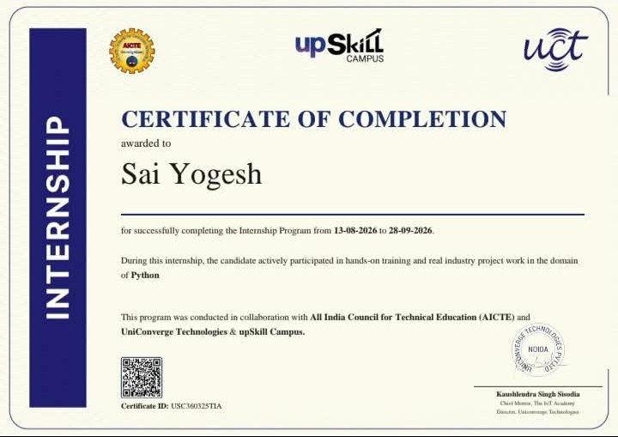
Project repository: https://github.com/expertX221/WardSpace
Implementation and setup: https://github.com/expertX221/WardSpace/blob/main/README.md
Architecture: https://github.com/expertX221/WardSpace/blob/main/ARCHITECTURE.md
Python server: https://github.com/expertX221/WardSpace/blob/main/server.py
Risk logic: https://github.com/expertX221/WardSpace/blob/main/risk.py
AI experiment: https://github.com/expertX221/WardSpace/blob/main/MODEL_CARD.md
Live demonstration: https://wardspace-healthcare.vercel.app/

