

HRMSPortalGuide

**E X P E R T C A L L E R S ( E C P L )**

# HRMS Portal Guide

Version 1.0

 ECPL

1877/4 HBR Layout 2nd Block 1st stage, 80ft Main Road

Bangalore – 560043.

Phone: 1877-374-0211 • Email: [info@expertcallers.com](mailto:info@expertcallers.com)

Link: <http://hrms.ecpl.com/>(click the link to follow)

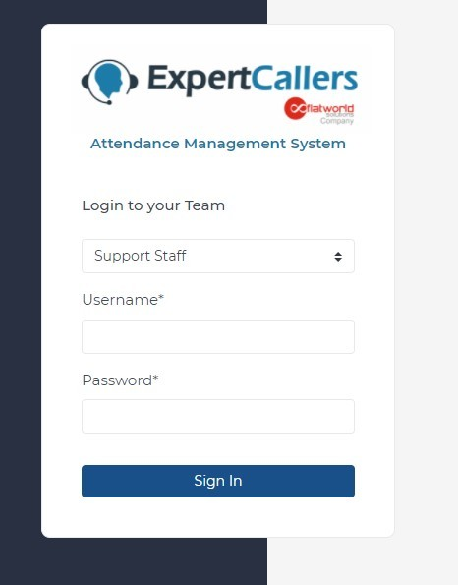

Step 1: Select your appropriate team.

Step 2: Enter the username and password provided to you. Step 3: Click Sign in.

Send Email to [cc@expertcallers.com](mailto:cc@expertcallers.com) (Click link to follow), requesting to reset the password.

# Change Password:

Step 1: Click on **SETTINGS** from sidebar (refer dashboard layout).

Step 2: 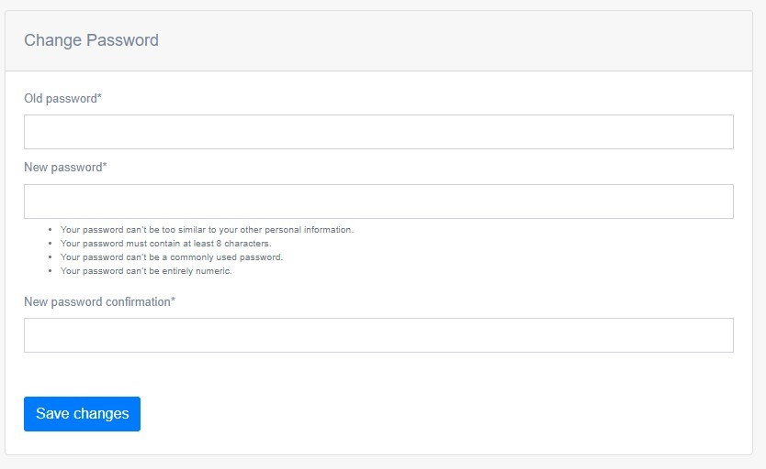 Use the above form to change your password.

# Change Profile Image:

Step 1: Click on **SETTINGS** from sidebar (refer dashboard layout).

Step 2: 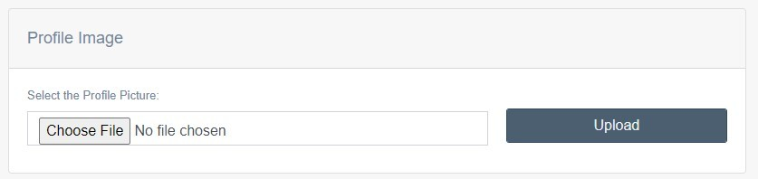 Use the above form to change your profile image.

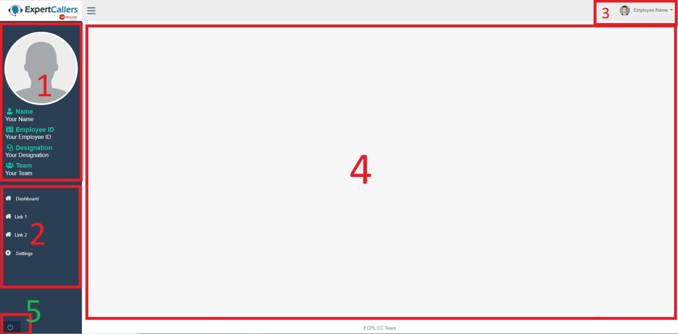

1. Contains the basic user information.
2. Contains the link to the pages you have access to.

Note: The Area where 1 and 2 are present is collectively known as **SIDEBAR.**

1. Contains the Employee Name and when clicked on, it shows logout option.
2. **BODY**: Contains the items for that page.
3. **Logout Button**. (Left bottom corner)

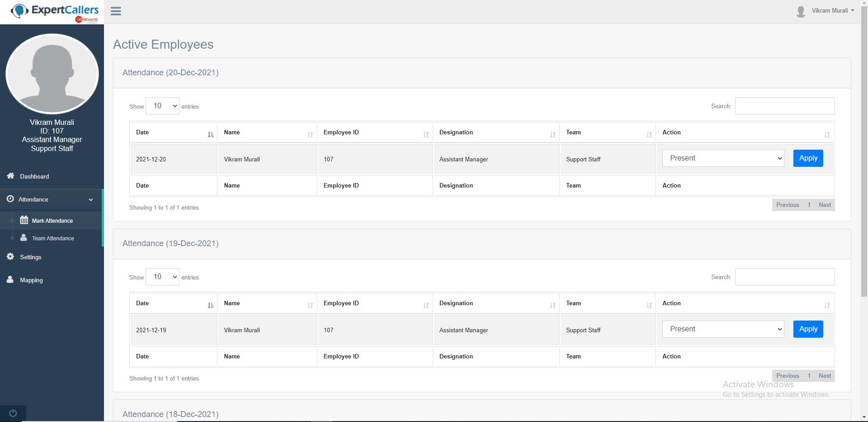

Step 1: Click on Attendance from the sidebar followed by mark attendance.

Step 2: In body there will be three tables indicating 3 different dates, choose the appropriate date table to mark your attendance for that date.

Step 3: In each table, in action column you will see a dropdown followed by button. Select the appropriate status from drop down and click on apply.

Note: Please refer dashboard layout.

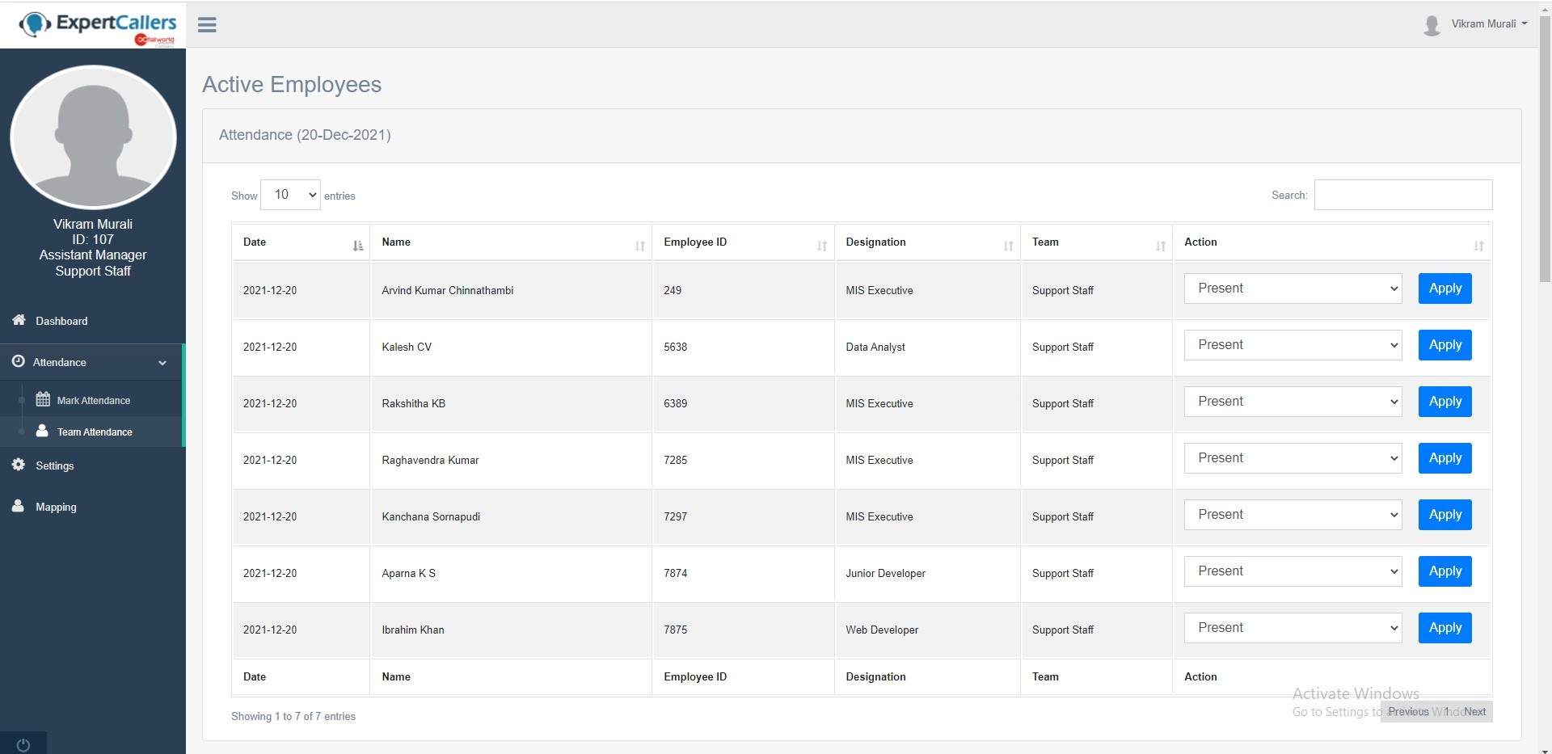

Step 1: Click on Attendance from the sidebar followed by team attendance.

Step 2: In body there will be three tables indicating 3 different dates, choose the appropriate date table to mark team’s attendance for that date.

Step 3: In each table, in action column you will see one dropdown followed by button. Select the appropriate status from dropdown and click on apply.

Note: While Marking team’s attendance, please verify the employee's name and ID before clicking Apply.

Step 1: Once you are logged in, in dashboard body you can see the attendance report option which will look like :

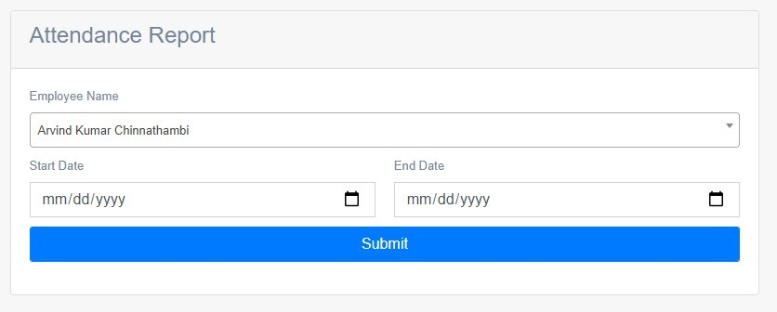

Step 2: Choose the Employee from the dropdown, whose attendance report is needed. Step 3: Choose the period (start and end date) and click on **Submit.**

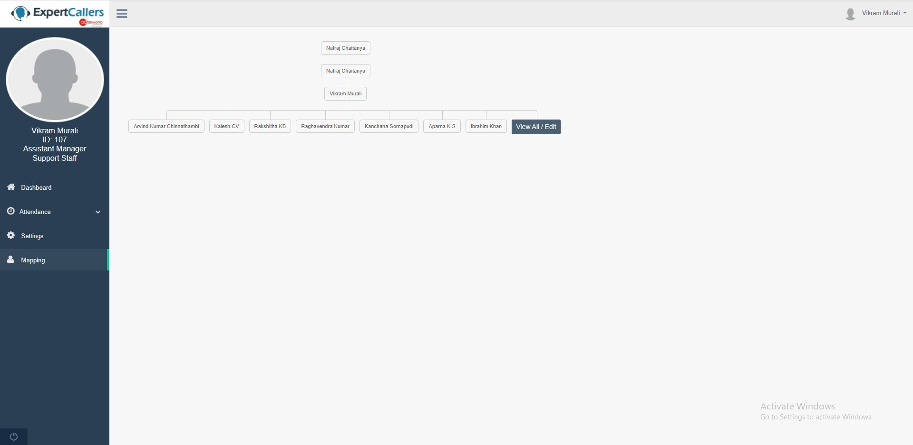

Step 1: Click on Mapping from the sidebar. You can see the full tree structure of your team.

To view all/edit the employee’s mapping click on **view ALL/Edit** button which is present at the end of tree.

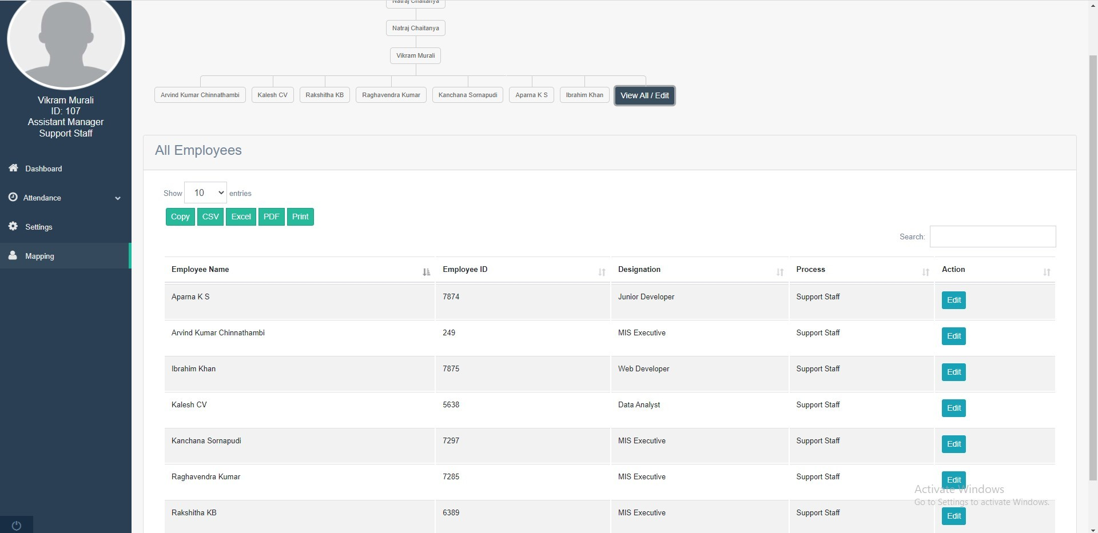

The above table will appear on clicking **view ALL/Edit** button, where you can see your full team.

# To Edit Mapping:

Step 1: From the above-mentioned table under mapping, click on **Edit** button.

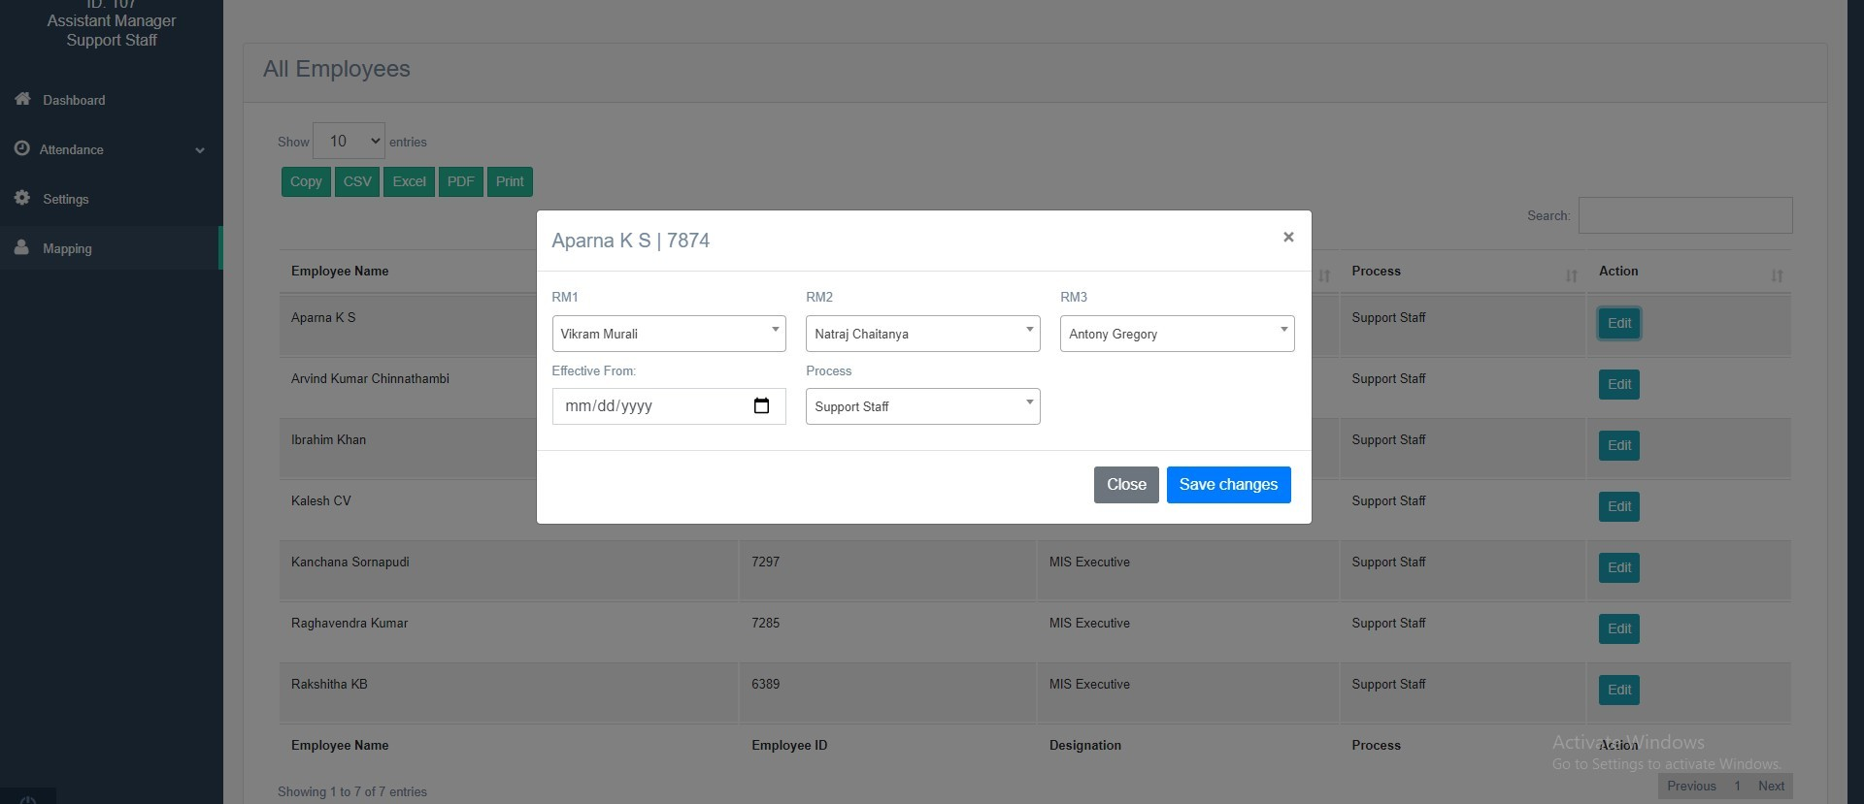

Step 2: Choose the appropriate options and click save changes.

Note: The mapping or any changes won’t be done immediately after the above steps. It will be in pending status as the OM has to approve it.