Chapter Insert
Project Planning and Management
to be incorporated into the CMP600 Dissertation
Early Risk Prediction Agent
Marcel Bucur · Student ID 2310-111665

Note on placement
This document supplies the project-planning and project-management material required by the CMP600 brief and absent from the dissertation as originally submitted. The four sub-sections that follow — Work Breakdown Structure, Gantt Chart, Milestones, Resource Planning and Risk Assessment — collectively form the missing Section 3.11 (proposed). The final sub-section, Project Management and Version Control (Section 3.12 proposed), maps the project's agile board, milestones and retrospective cards to the brief's requirement that the project be managed in an agile fashion with a Trello-style or Jira-style board.
Numbering uses 3.11.x and 3.12.x on the assumption that this chapter insert follows the existing Section 3.10 ("Limitations of Methodology"). The final numbering may be adjusted to suit the dissertation's overall structure.

3.11 Project Planning
The project was decomposed into four sequential sprints over an eight-month module window, each closed by a retrospective card and gated by one or more milestones. The four-sprint structure was chosen to give roughly equal time to research, design, build and evaluation, and to allow a deliberate pivot point between Sprints 2 and 3 — a pivot which became the dissertation's primary empirical contribution. Sprint themes, dates and outputs are summarised in Table 3.11.
Sprint | Period | Theme | Key output | Milestone
1 | Oct – Nov 2025 | Research & Proposal | Approved proposal; literature base for Chapter 2 | M1
2 | Nov 2025 – Jan 2026 | Risk engine design | Working n8n prototype; four no-code limits surfaced | M2
3 | Jan – Mar 2026 | Hybrid pivot & UI | React + PHP hybrid system; live deployment | M3
4 | Mar – May 2026 | Evaluation & write-up | Four-dimensional evaluation; Chapters 5–7; Viva Pack | M4, M5
Table 3.11. Sprint summary across the eight-month module window.

3.11.1 Work Breakdown Structure
The work breakdown structure (WBS) decomposes the project into twenty-eight numbered activities grouped under the four sprints (Table 3.11.1). Top-level rows mark the sprint header; child rows enumerate the activities that produced each sprint's output. Five rows are marked with a star to indicate the milestone gate that closed each sprint.
ID | Activity
1 | Research & Proposal
1.1 | Literature review — EWS & learning analytics
1.2 | Literature review — no-code & low-code AI
1.3 | Define research question & sub-questions
1.4 | Identify risk factors from literature
1.5 | Write and submit proposal ★ M1
2 | Design & Risk Engine
2.1 | Design risk-scoring algorithm (35/35/30)
2.2 | Define trend penalty and streak bonus
2.3 | Build n8n prototype workflow
2.4 | Test risk engine on synthetic data
2.5 | Document architecture decisions ★ M2
3 | Hybrid Pivot & UI
3.1 | Document four limits of pure no-code
3.2 | Port risk engine to TypeScript
3.3 | Build dashboard (Overview / Students / Export)
3.4 | Implement Teacher Review control
3.5 | Build PHP registration & persistence layer
3.6 | Integrate optional AI sentiment (Gemini)
3.7 | Deploy to commodity shared hosting ★ M3
4 | Evaluation & Write-up
4.1 | Generate synthetic data
4.2 | Four-dimensional evaluation ★ M4
4.3 | Write Chapter 5 — Evaluation
4.4 | Write Chapter 6 — Discussion
4.5 | Write Chapter 7 — Conclusion
4.6 | Assemble Viva Pack
4.7 | Final submission ★ M5
Table 3.11.1. Work breakdown structure (★ marks milestone-bearing tasks).

3.11.2 Gantt Chart
The Gantt chart in Figure 3.11.2 maps each WBS activity onto the eight-month module window (October 2025 to May 2026). Cells are shaded with the sprint's colour for the months during which the activity was active; the five milestone gates (M1 to M5) are marked with a red diamond in the month in which the gate was met. The chart presents the plan as it ran — including the Sprint 2 → Sprint 3 transition during which the n8n prototype was retired in favour of the hybrid architecture.
ID | Activity | Oct 2025 | Nov 2025 | Dec 2025 | Jan 2026 | Feb 2026 | Mar 2026 | Apr 2026 | May 2026
1.1 | Lit. review — EWS & LA
1.2 | Lit. review — no-code
1.3 | Define RQ & sub-questions
1.4 | Identify risk factors
1.5 | Write & submit Proposal |  | ◆ M1
2.1 | Design risk-scoring algorithm
2.2 | Trend penalty & streak bonus
2.3 | Build n8n prototype
2.4 | Test on synthetic data
2.5 | Document architecture |  |  |  | ◆ M2
3.1 | Four no-code limits write-up
3.2 | Port engine to TypeScript
3.3 | Build dashboard (3 tabs)
3.4 | Teacher Review control
3.5 | PHP registration layer
3.6 | Optional AI sentiment
3.7 | Deploy to shared hosting |  |  |  |  |  | ◆ M3
4.1 | Generate synthetic data
4.2 | Four-dimensional evaluation |  |  |  |  |  |  | ◆ M4
4.3 | Write Ch.5 Evaluation
4.4 | Write Ch.6 Discussion
4.5 | Write Ch.7 Conclusion
4.6 | Assemble Viva Pack
4.7 | Final submission |  |  |  |  |  |  |  | ◆ M5
Figure 3.11.2. Gantt chart of WBS activities across the eight-month module window.
Legend
Sprint 1 — Research | Sprint 2 — Risk Engine | Sprint 3 — Hybrid & UI | Sprint 4 — Evaluation | ◆ Milestone

3.11.3 Milestones
Each milestone was treated as a hard gate: work could not move into the next sprint until the milestone's acceptance criterion was satisfied (Table 3.11.3). All five milestones were closed against the four-sprint plan and are visible on the GitHub project board as closed milestones at 100% completion (Figure 3.12.2 below).
Milestone | Target date | Acceptance criterion
M1 — Proposal approved | Nov 2025 | Research question, sub-questions and methodology documented and approved by supervisor.
M2 — Risk engine prototype | Jan 2026 | n8n workflow scores synthetic CSVs end-to-end with weights documented (Sections 4.1 – 4.5).
M3 — Hybrid architecture | Mar 2026 | Live system at marcel.deansygrove.co.uk with all three dashboard tabs functional.
M4 — Evaluation complete | Apr 2026 | Four-dimensional framework applied across five archetypes × four cohort sizes (Chapter 5).
M5 — Final submission | May 2026 | Dissertation, product ZIP and Viva Pack delivered to Turnitin portals.
Table 3.11.3. Milestone gates with target dates and acceptance criteria.

3.11.4 Resource Planning
The project was deliberately scoped to be deliverable on a single-student budget, with no paid services beyond shared web hosting. The use of free tiers throughout — including Google Gemini's free quota for sentiment analysis and n8n's self-hosted free build for the prototype phase — also reinforces the dissertation's practicality argument: the resulting artefact runs without specialist machine-learning infrastructure or institutional data-science investment (Section 5.2).
Resource | Detail | Cost / source
Author time | Approximately 10 hours per week sustained, with peaks during Sprints 3 and 4. | In-kind
Supervisor | Six 45-minute tutorials across the year, plus asynchronous email contact. | Module-included
Hardware | Personal laptop only; no cloud GPU usage. | Existing
Development tools | VS Code, Node.js, PHP, MySQL, Git, GitHub. | Free / open source
No-code platform | n8n (self-hosted) for the prototype phase in Sprint 2. | Free
AI service | Google Gemini (gemini-2.5-flash) free tier for sentiment analysis. | Free tier
Hosting | 20i shared LAMP hosting for the live demonstration deployment. | ≈ £3 per month
Project management | GitHub Projects (sprints, backlog, retrospectives) — see Section 3.11.7. | Free
Table 3.11.4. Resources used over the project window.

3.11.5 Risk Assessment
Risks were enumerated during proposal preparation and reviewed at every sprint retrospective. Likelihood (L) and Impact (I) are coded as Low / Medium / High and colour-shaded for ease of reading (Table 3.11.5). The most significant risk — that pure n8n would not deliver the full system — materialised during Sprint 2 and was converted into the dissertation's primary empirical contribution rather than treated as a failure. The remaining risks were either avoided (synthetic-data evaluation, environment-variable secrets) or contained through standard practice (cloud backup, asynchronous supervisor contact).
Risk | L | I | Mitigation
Pure n8n cannot deliver the full system. | M | H | Treat the pivot as a finding rather than a failure. Materialised in Sprint 2 and became the dissertation's primary empirical contribution (Section 4.2).
Real student-outcome data not available within the ethics window. | H | M | Evaluate against synthetic data only across five literature-derived archetypes. Real-world accuracy named as future work (Section 7.5).
Gemini API costs or quotas at scale. | L | M | Use free tier for evaluation. The engine degrades gracefully from four-factor to three-factor mode if AI is disabled.
Scope creep eats writing time. | M | H | Hard sprint boundaries with milestones; feature freeze after Sprint 3; cut rather than slip.
Laptop failure during peak build. | L | H | Daily commits to GitHub; backup of the dissertation file to cloud storage after each session.
Supervisor availability constraints. | M | M | Book the six tutorials early in the year; prepare a written agenda for each; use email asynchronously.
Credentials accidentally committed. | M | H | Use environment variables and `.gitignore`; secret-scan the repository before final submission.
Live demo URL unavailable before viva. | L | H | Keep a local fallback running; bundle a packaged ZIP of the application within the Viva Pack.
Table 3.11.5. Project risks with likelihood, impact and mitigations.

3.12 Project Management and Version Control
The CMP600 brief requires that the project be managed in an agile fashion, with a Trello-style or Jira-style board used to plan and organise the work, and that the supervisor be added to the board. Each sprint should have a planning card outlining the planned activities, individual task cards drawn from the backlog, and a retrospective card written at the end of the sprint.
This requirement was implemented using GitHub Projects (v2) rather than Trello or Jira, for three reasons. First, GitHub Projects shares the agile-board paradigm (configurable columns, drag-and-drop cards, label-based filtering) with Trello and Jira and therefore satisfies the brief's intent. Second, keeping the planning artefact in the same platform as the source code, the issue tracker and the deliverable executable produces a single auditable record. Third, GitHub Projects is free, public, and outlasts the academic year — examiners and external readers can inspect the board long after a personal Trello account would have been cleaned up.
The board is available at: https://github.com/users/expertul76/projects/3.

3.12.1 Structure of the board
The board has five status columns — Backlog, Sprint Planning, In Progress, Done and Retrospective — and is populated with thirty-two cards: one planning card and one retrospective card per sprint, plus the task cards drawn from the WBS. Cards carry sprint-specific labels (sprint-1 through sprint-4) and category labels (research, design, build, evaluation, writing) so the board can be filtered to show any sprint's activity in isolation. The columns at the time of submission are shown in Figure 3.12.1.
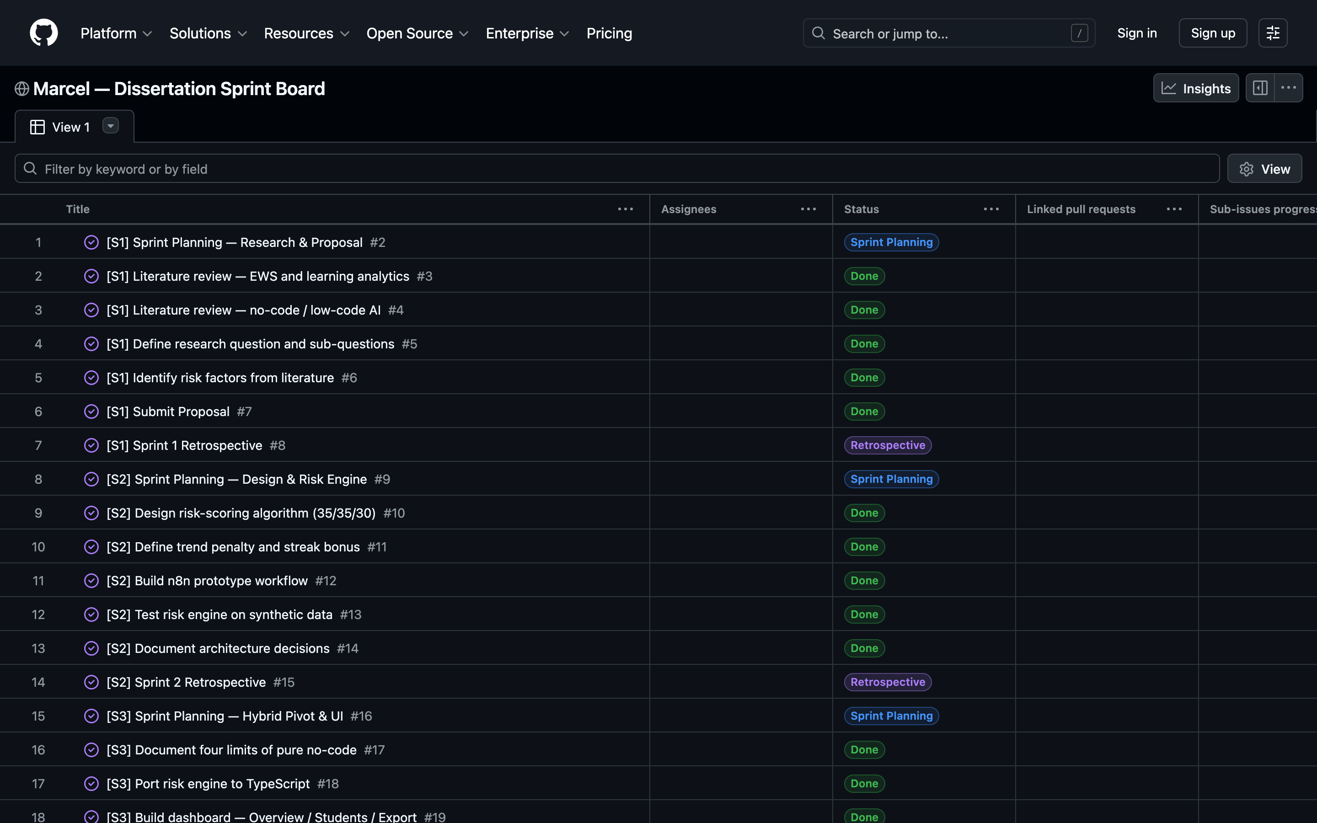
Figure 3.12.1. GitHub Projects board for the dissertation, showing Sprint Planning, Done and Retrospective cards across the four sprints. Each card is an issue in the same repository as the code.

3.12.2 Per-sprint view
Filtering the board by sprint label gives a view comparable to a Trello board for that sprint alone. Figure 3.12.2 shows Sprint 1 in isolation: the planning card, the four research tasks, the proposal submission card, and the closing retrospective. The same filter pattern is used for Sprints 2 to 4.
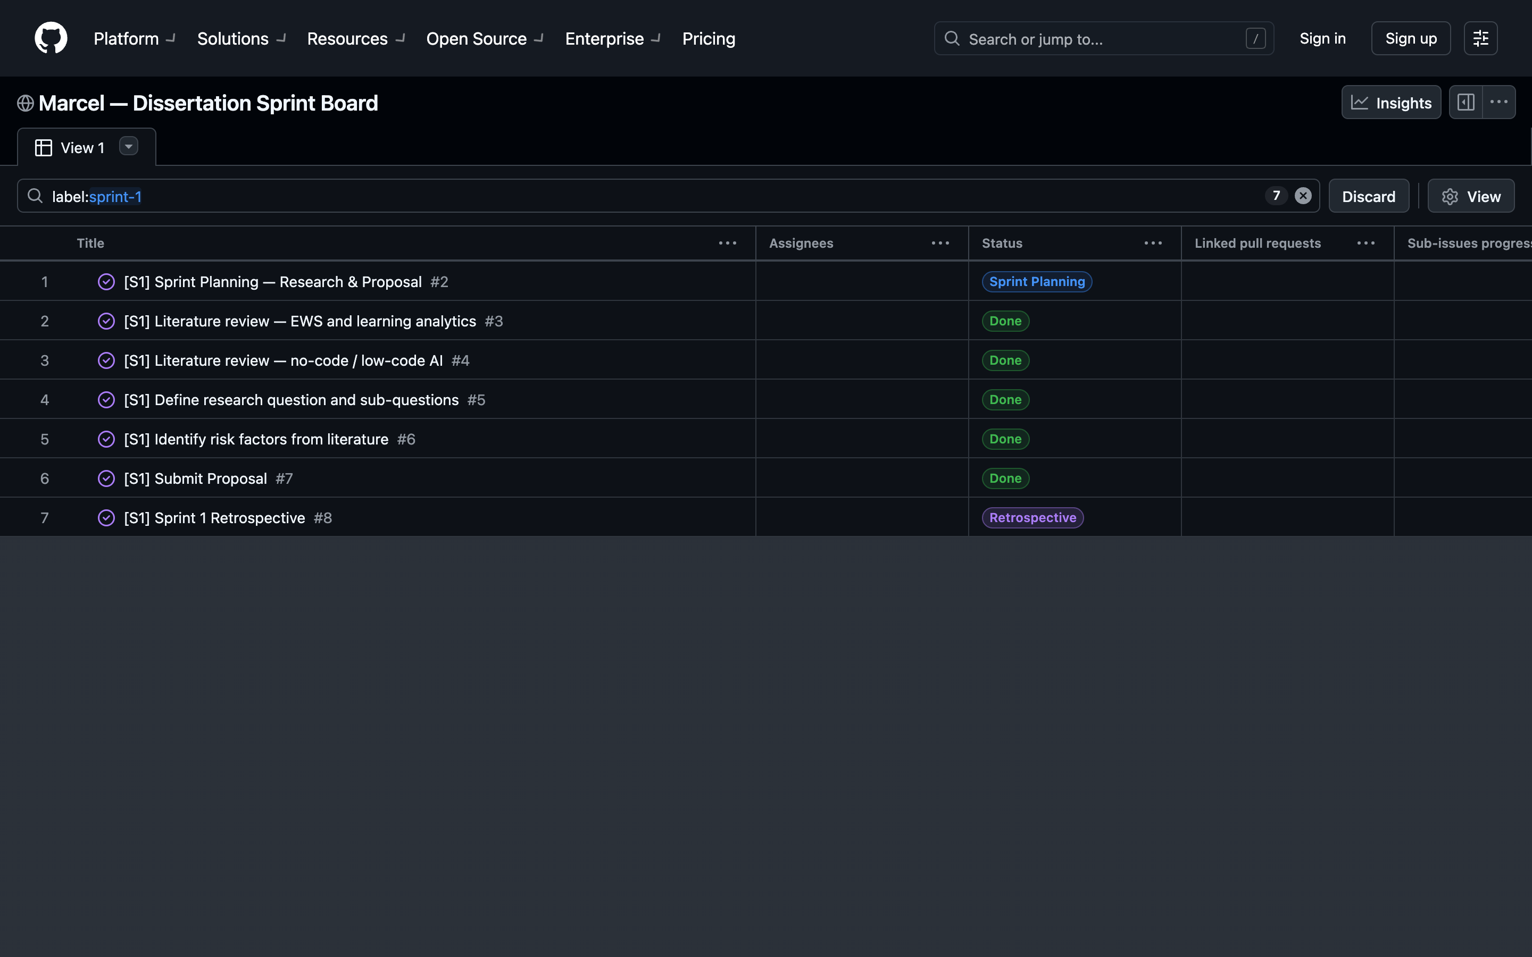
Figure 3.12.2. Sprint 1 viewed in isolation by applying the label:sprint-1 filter to the project board.

3.12.3 Milestones
Each sprint closes against one or more named milestones (M1 to M5). All five milestones were satisfied and closed against the four-sprint plan; the closed-milestones page of the repository (Figure 3.12.3) shows each at 100% completion with the count of issues closed under each gate.
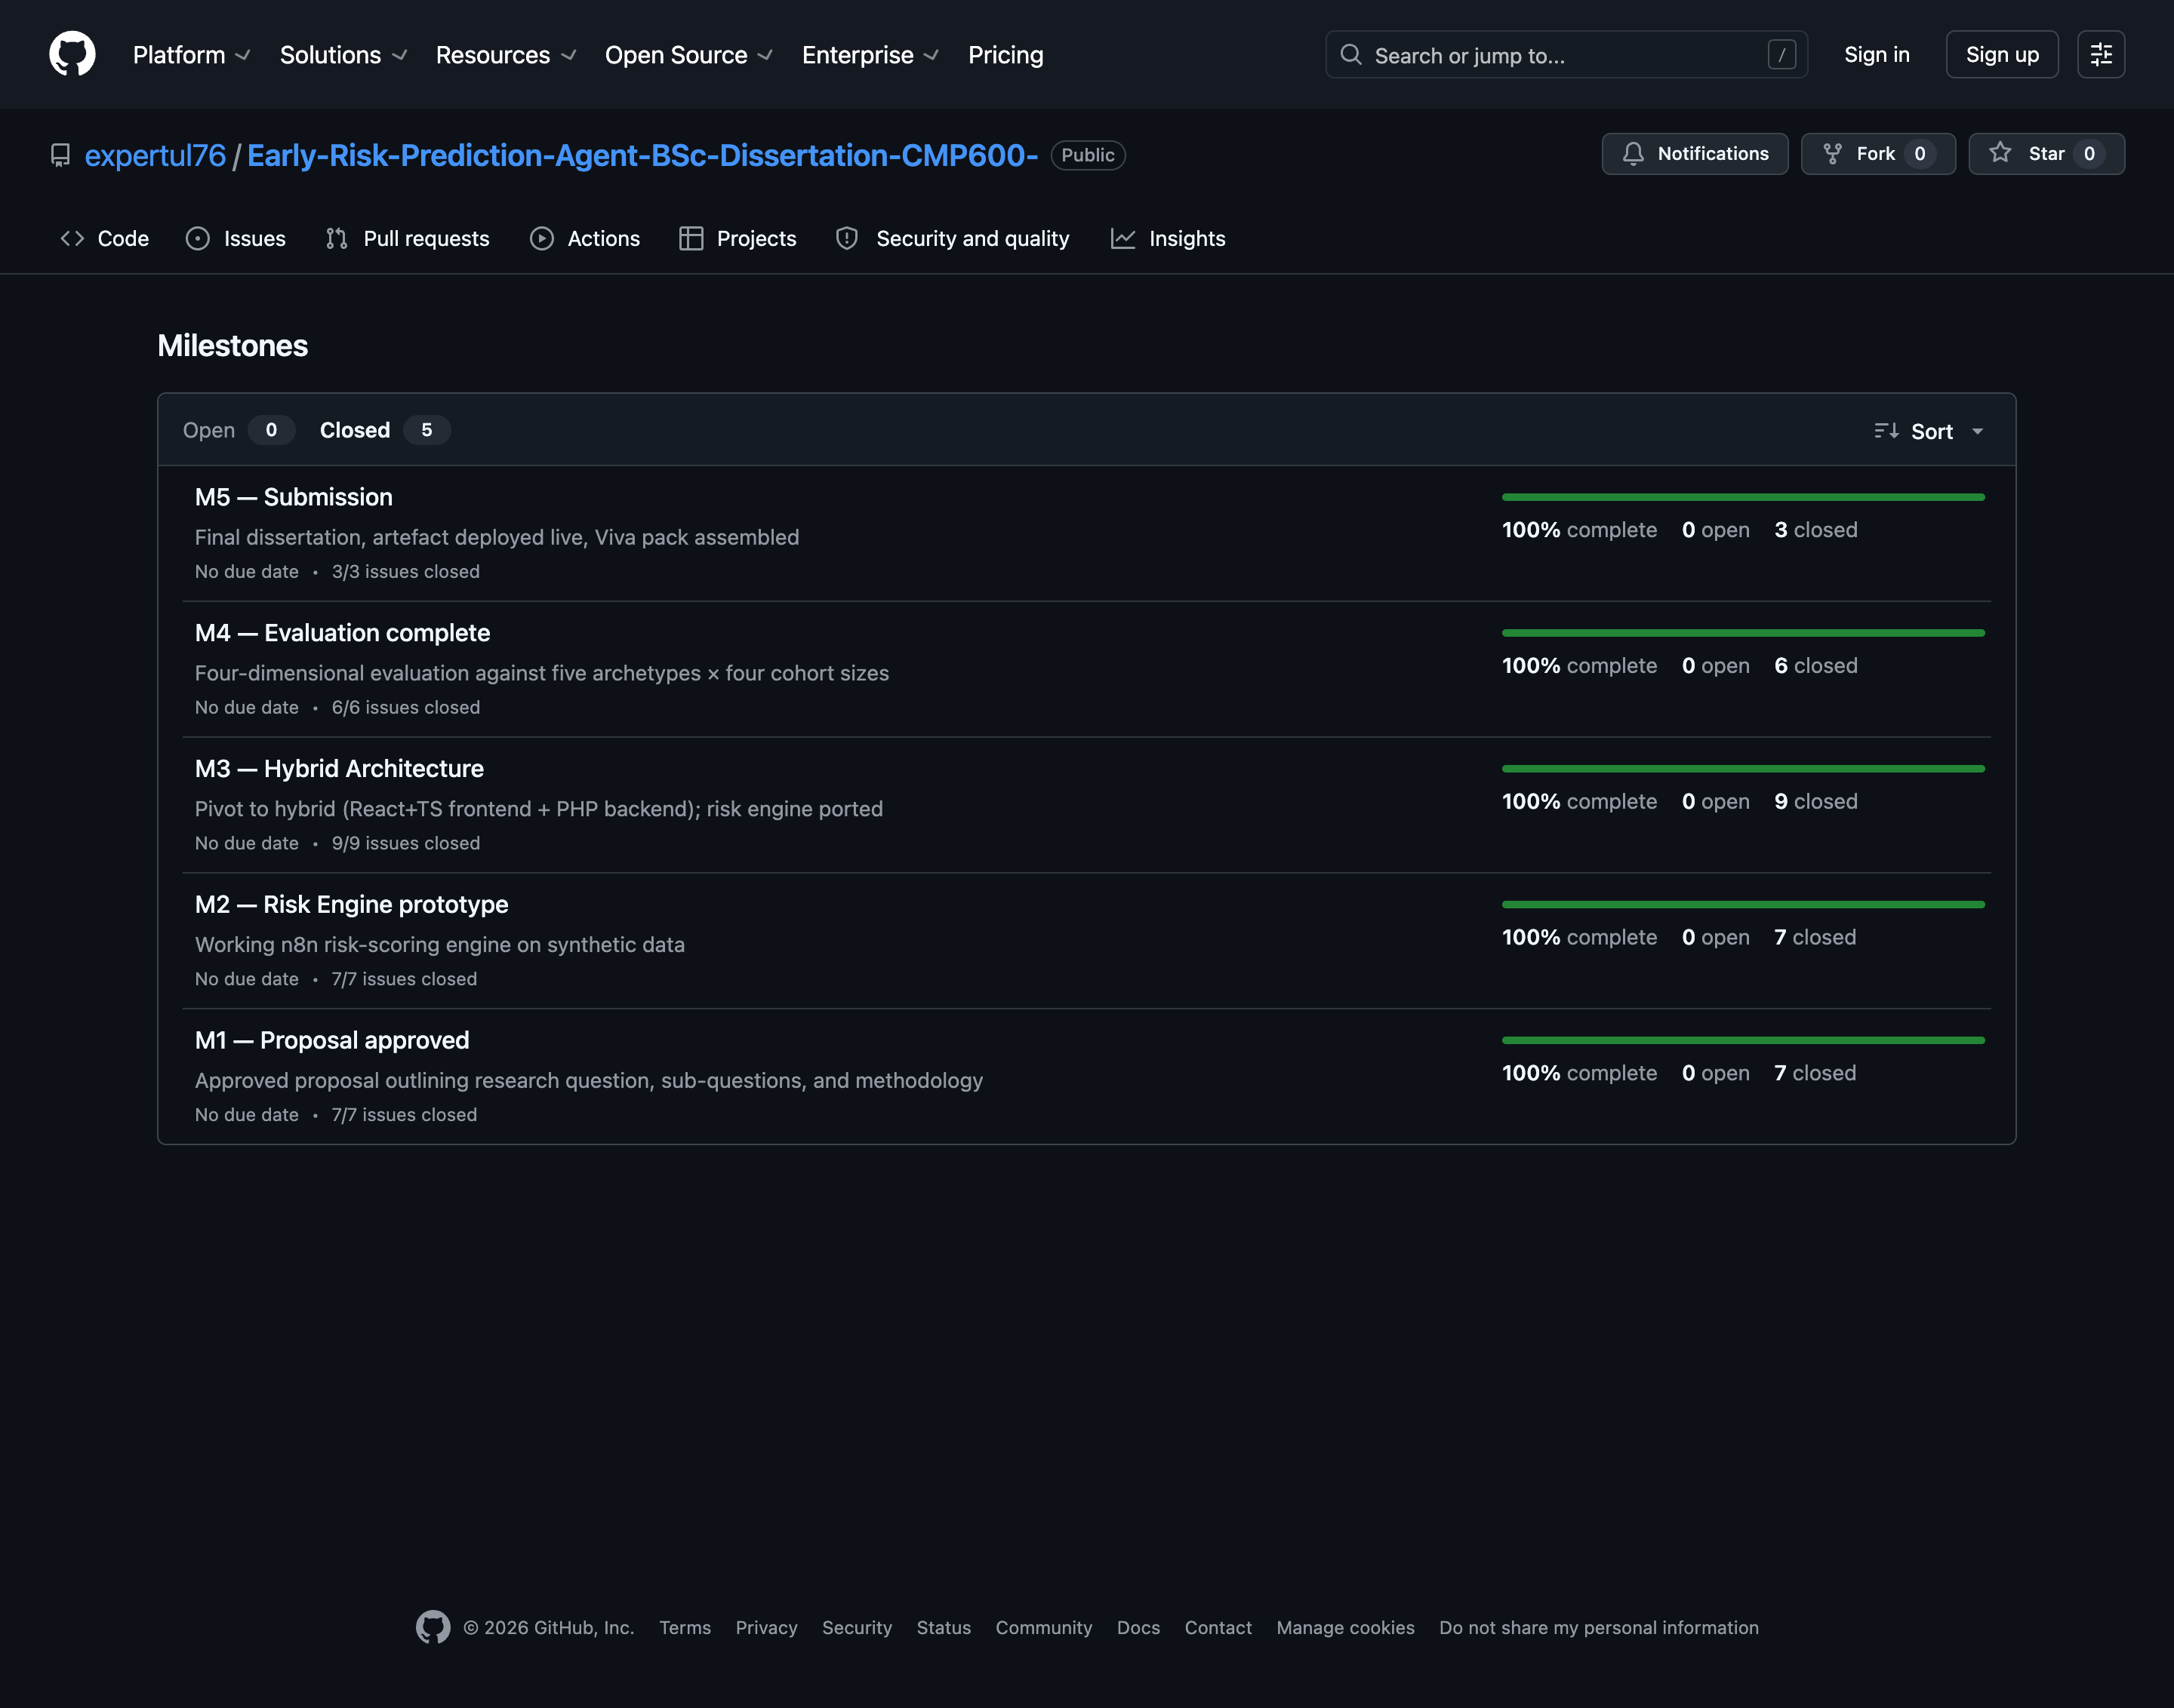
Figure 3.12.3. Closed milestones for the repository. Each milestone shows the number of issues closed against it and is at 100% completion.

3.12.4 Retrospectives
Each sprint produced a retrospective card that records what worked, what did not, and what was carried forward. The four retrospectives — collected in Figure 3.12.4 — were used as the agenda for the corresponding supervisor tutorial and as the primary source for the design rationale narrative in Chapters 4 to 7.
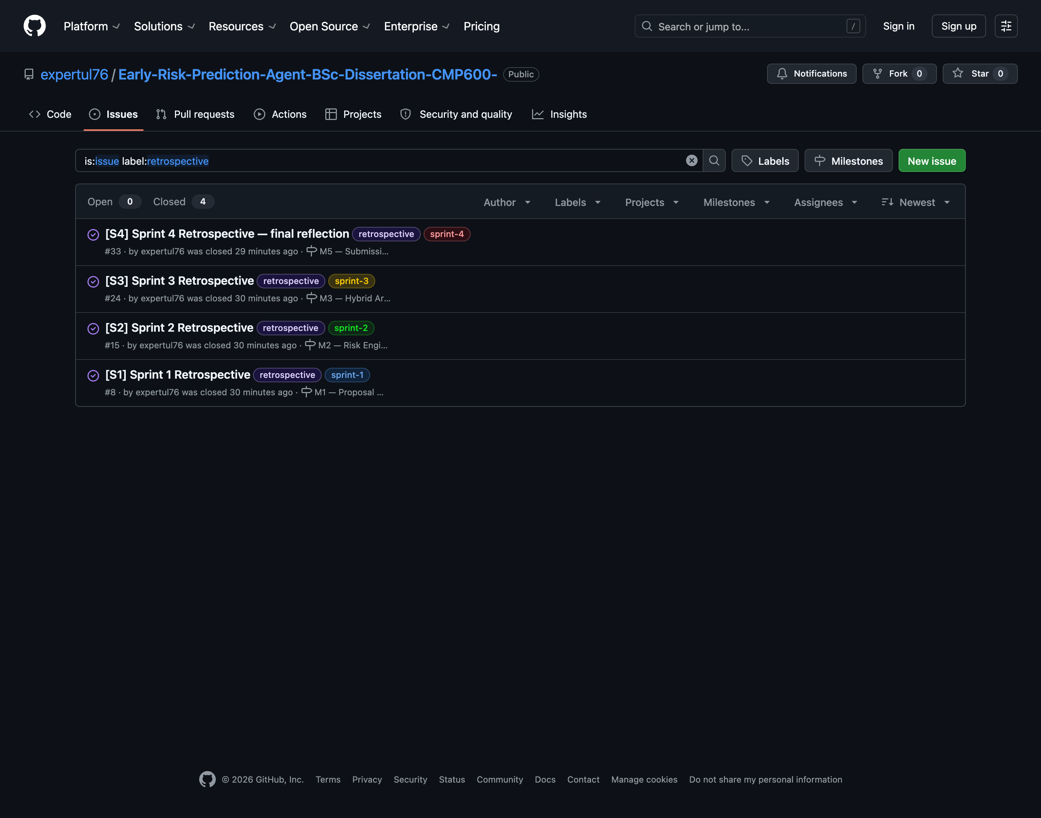
Figure 3.12.4. The four sprint retrospective cards, viewed through the label:retrospective filter on the issues tracker.

3.12.5 Version control
Source code, planning documents and the dissertation itself are tracked in Git from the start of Sprint 2 onwards. The full code-base is published at:
https://github.com/expertul76/Early-Risk-Prediction-Agent-BSc-Dissertation-CMP600-
Commits are made under the author's verified GitHub identity (expertul76). Secrets — including database credentials and the Google Gemini API key — are read from environment variables at run time, not committed to version control; an example environment-variable file (register/config.example.php) ships with the repository so an institution can stand up a fresh deployment without modifying source. This satisfies the CMP600 brief's requirement that the project product be presented with an executable uploaded to a repository such as GitHub, and that version control evidence be visible alongside the project documentation.

3.12.6 Summary of evidence
Taken together, the artefacts in this section evidence the four learning outcomes of CMP600 as follows. LO1 (planning and delivery of a substantial independent project) is evidenced by the WBS, Gantt chart, milestones and the closed cards on the project board. LO3 and LO4 (applying theory to practice and justifying solutions) are evidenced by the design-rationale text in Section 4 and the four-limit finding triggered by the Sprint 2 retrospective. LO5 (reflective critical evaluation of personal learning) is evidenced by the retrospective cards (Figure 3.12.4) and by the honest enumeration of limitations and future work in Chapter 7.

