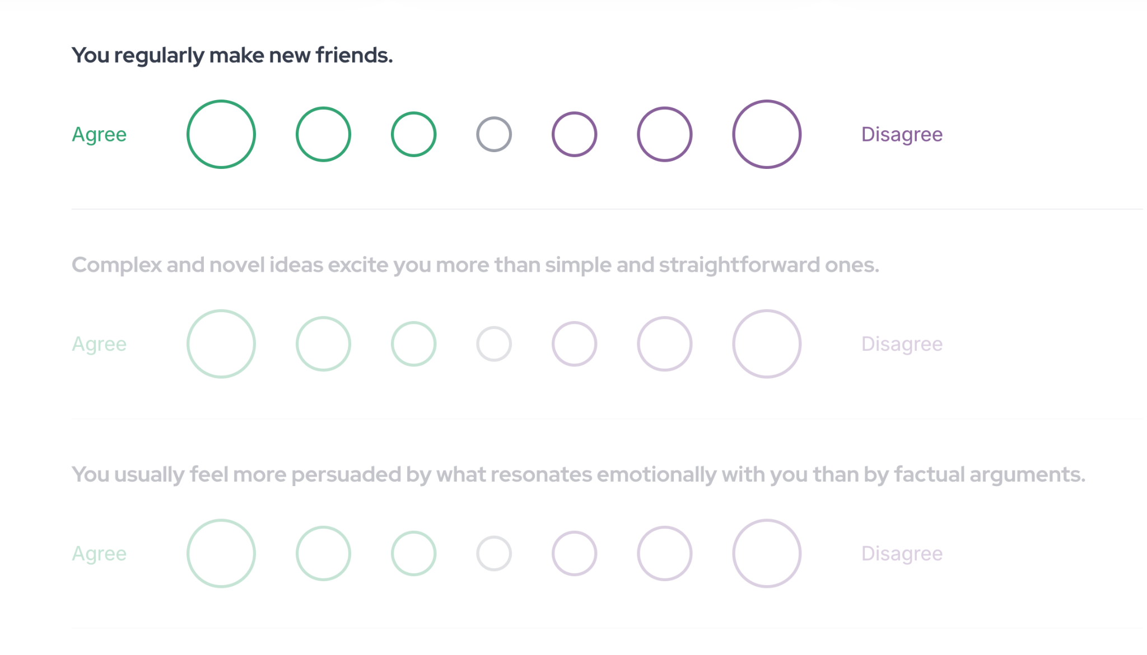

https://www.16personalities.com/

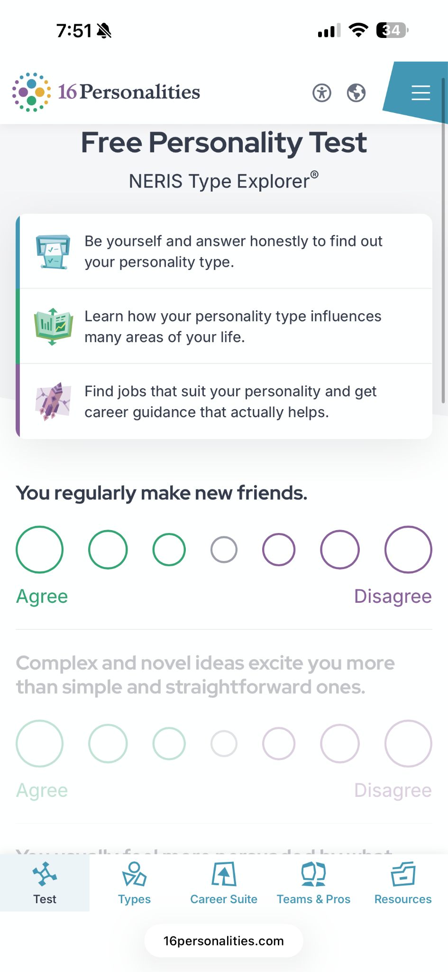

No need for menu at the bottom. Only pointing out design references for the quiz questions here.
https://www.crystalknows.com/
Use as reference for overall layout.
My current design colors, fonts, logo should stay.

