

**Mashwerna**

By

**Graduation Project Report**

**Submitted in Partial Fulfillment of the Requirements for the Degree of**

**Bachelor of Science in Computer Science**

**Department of Computer Science**

**Faculty of Sciences & Arts**

2023-2024



**Mashwerna**

By

**Graduation Project Report**

**Submitted in Partial Fulfillment of the Requirements for the Degree of**

**Bachelor of Science in Computer Science**

**Department of Computer Science**

**Faculty of Sciences & Arts**

**Supervised by:**

**Dr.Ali Abo Molhem**

**Prof. /Dr**………………………

Position and title

2023-2024



**The Report Defense Committee for Nancy Dayekh & Certifies**

**that this is the approved version of the following report**

**Mashwerna**

**APPROVED BY:**

**Supervisor Signature: _______________________________________**

(Name typed under the line)

**Examiner Signature: ________________________________________**

(Name typed under the line)

**Examiner Signature: ________________________________________**

(Name typed under the line)

**Dedication:**

I dedicate this project first and foremost to our family - for their constant encouragement, love, and sacrifices that have allowed us to pursue our ambitions and achieve this milestone.

To my professors and mentors - for their guidance, wisdom, and dedication to teaching, which have influenced my academic career and encouraged me to strive for excellence.

To my friends - for their encouragement, humor, and never-ending solidarity, which made the school experience not only useful but also enjoyable and unforgettable.

Last but not least, to Dr. Ali Abu Melhem - for his dedication to providing the best and for guiding me throughout the academic year and the creation of this work.

**Acknowledgments:**

We would like to thank the administration of the Islamic University of Lebanon and the Faculty of Sciences and Arts, represented by Dean Dr. Ali Raad and the Head of the Department of Computer Science. We wish to express our sincere gratitude to our project supervisor, Dr. Ali Abo Molhem, for his guidance, constant support, and encouragement throughout the completion of our final year project. Our completion of this project could not have been accomplished without the support of Dr. Ali Abo Molhem. A warm thank you is extended to Dr. Ali for sharing his resources, opinions, knowledge, experience, and skills in programming and development methodology so generously.

**Abstract :**

Tourism is a vital industry that significantly contributes to the economy of many countries. In our current day, social media became a main source of information for travelers seeking recommendations and reviews about various destinations. However, the current social media platforms often lack dedicated spaces that focus solely on promoting tourism. The purpose of this report is to address the development of a social media app along with an admin panel webpage. The primary objective behind this project is to provide a tourism-oriented platform that fosters user engagement within the travel and blogging community. This app will go beyond standard social media features, allowing users to share travel experiences, interact with other travelers and tourism-related pages, and discover new destinations.

The problem countered by this project is the scarcity of social media platforms that promote tourism which creates a struggle for travelers to find communities that shares their interests and offers valuable insights. Additionally, the existing platforms lack authenticity, unbiased opinions. These platforms market and sponsor content that neglect negative aspects of a location, which portrays an idealized picture of the place. Hence, leading to unrealistic expectations and potential disappointment.

This project aims to address these issues by developing a social media platform specifically designed to promote tourism. The platform will focus on providing travelers with a place to share, chat, discover authentic reviews and information about various destinations. By offering a community of genuine travel enthusiasts and bloggers, the platform will serve as a reliable source for people to explore new places confidently. Alongside with the platform, the accompanying admin panel will serve as a way of filtering and moderating content to keep the app’s space safe, positive, and to enforce the application’s policies.

The app while incorporating standard social media platform features such as likes, comments, and chats, offers some unique features like posting your own experience, moments in the form of an album and it goes by the name ‘activity’. An activity is either a user’s documentation to a certain place (or an event in it) regardless of him owning the place or not, or a capturing of his experience and moments in this place. An Activity is made up of a bunch of media with detailed descriptions, is it basically the pillar of the application where everything from descriptions, critiques, and information is done. Activities similar to posts, can be liked and commented on, also they can be bookmarked.

Furthermore, activities are categorized by their home cities and types each into a city and an activityType respectively. This approach makes the app more organized, the search easier, and the usage friendly.

This project promises quite well results. The app provided users with a well tourist-oriented community that shares true unhindered opinions and offer valuable insights about destinations.

In conclusion, this project faces the void in tourism, blogging, and travelling that the other platforms don’t take put in their considerations. The project’s approach delivers a community that ensures valuable interactions where unbiased, unsponsored endorsements and insights, descriptions, information for famous destinations are give

**Table of Contents**

* **Title Page**
* **Signature Page**
* **Acknowledgments**
* **Abstract ………………………………………………….**  iv
* **General Introduction …...……………….…...…………………….**  Page Number
* **Chapter: 1 ……………...………** Page Number

1.1.Introduction:**…………………………………………….……….** Page

1.2. Objective: **……….……….……….……….……….………...…...**

1.3-Scope: **…………………………………………….……….…….**

1.4 -Technology Constraints: **…………………………………………**

1.5- Problem: **……….……….……….……….……….……….…….**

1.6-Solutions: **……….……….……….……….……….……….…….**

* **Chapter: 2………….…...………** Page Number

2.1 -Functional & conceptual Study **……………………………….**

2.1.1-Funcational Requirements: **………………………………**

2.1.2-NonFuncational Requirements: **………………………….**

2.2-UML Use Case Diagram **………………………………………...**

2.2.1 –Use Case Diagram **……………………………………...**

2.3- Data Flow Diagrams (DFD)**…………………………………….**

2.3.1- Context Diagram (DFD level-0) **……………………….**

2.3.2- DFD Level 1 Diagram **………………………….**

* **Chapter: 3……………..……………………..……………………..……**

3.1-System Design: **……………..……………………..………………….**

3.1.1-ER-Diagram : **……………..……………………..…………**

ER Diagram Figure **……………..……………………..…**

* **Chapter : 4……………..……………………..……………………..……**

Implementation: **……………..……………………..………………….**

4.1-Introducation: **……………..……………………..…………..**

4.2-Mobile Application Part: **……………..……………………..…**

**List of Tables**

**General Introduction:**

The importance of this project is reflected by the lack of social media platforms that shed light on tourism and exploration directly and fairly. This lack escalates the need to a community where travelers among users can interact with each other, post their honest opinions on different locations, and exchange information. This project ensures all of the above problems are solved by supplying an application that has the same anatomy and backbone of modern social media platforms with some extra perks. Along with an admin panel that is responsible for monitoring and moderating the content for a friendly, positive, and policy abiding environment.

The development process for this project follows a systematic and structured approach. It begins with requirement gathering which is identifying the key features and functionalities of the social media platform and the admin panel side by side with the preferences and necessities of potential users. Then the development phase starts. It involves the creation of a user-friendly interface implementing all the functionalities. Then, the project is tested heavily and sent to users to obtain feedback to allow more improvement. Finally, the project ends with an evaluation of the results, effects, and recommendations for more improvement and better versions to come

**Chapter: 1 Introduction**

**1.1 Introduction:**

This chapter introduces the project's aims, objectives, and scope, along with the technological constraints involved. It outlines the problems that led to the creation of the platform and the solution it offers.

The importance of this project is reflected by the lack of social media platforms that shed light on tourism and exploration directly and fairly. This lack escalates the need to a community where travelers among users can interact with each other, post their honest opinions on different locations, and exchange information. This project ensures all of the above problems are solved by supplying an application that has the same anatomy and backbone of modern social media platforms with some extra perks. Along with an admin panel that is responsible for monitoring and moderating the content for a friendly, positive, and policy abiding environment.

**1.2 Objectives**

Mashwerna, a social media app aims to add a platform where users can interact, get authentic reviews for destinations far from sponsored and paid content. The main objectives of the project are:

* Promote tourism.
* Provide a social media platform for users to share their travel experiences, reviews, and recommendations.
* Offer a user-friendly interface that facilitates the user’s experience.

**1.3 Project Scope:**

Our project addresses the gaps and limitations in the tourism platforms. It is designed to enhance the travel experience for users and blend it with a seamless social media experience.

The platform embraces common social media methodologies (likes, comments, chats …) along with some extra features like rating to help facilitate the user experience and get the most out of both the social media and tourism platforms in one.

**1.4 Technological Constraints:**

Software used: vscode, xampp

Languages: HTML, CSS, SQL, Javascript, Php, dart

Frameworks & Libraries:

* Backend: Laravel
* Frontend: flutter, react.js, TailwindCSS

Hardware: Laptop

**1.5 Problem:**

Standard tourism and travel platforms all follow the same pattern causing some problems:

* Lack of interaction between users.
* Lack of authenticity and showing only positive aspects of a place.
* Biased opinions that are based on sponsorships and paid collaborations.

**1.6 Solution:**

By blending social media and tourism, Mashwerna will:

* Provide users a space to chat, interact, and discover various locations.
* Capture their own moments and experiences in certain locations.
* Share their own businesses on the platform.
* Rate and review destinations.

Serve authentic reviews, as the reviews are only from true users and no sponsored content will be available

**Chapter: 2 Functional and Conceptional Study**

**2.1 Introduction**

This chapter outlines both the functional and non-functional requirements for the project. Additionally, it presents UML use case and data flow diagrams with all relevant details.

**2.2 Functional Requirements**

2.2.1 User

* Signup: to access all features, guests should register and login. Otherwise, they can only view the app and search.
* Login: users must login to access their profiles.
* Activities: users can crud (create, read, update, delete) their own activities and view other users’ activities. Also, they’re able to like, comment on, and bookmark them.
* Cities: users are able to view main cities and browse their activities.
* Search: users can choose their type (restaurants, hotels ...) and search based on the city name.
* Chats: users can send messages and chat with other users.
* Rating: users can give a rating out of 5 to any other user.

2.2.1 Admin

* Users: admins can view and delete users that violate the terms.
* Activities: admins can view and delete inappropriate activities.
* Comments: admins can view and delete inappropriate comments.
* Cities: admins can crud (create, read, update, delete) cities.
* ActivityTypes: admins can crud (create, read, update, delete) ActivityTypes.
* Search: admins can search for users, cities, ActivityTypes, and activities and view each.

2.2.1 Super Admin

* Super admins are almost same as admins, but they have the right to promote/demote users into admin/user.

**2.3 Non-functional Requirements**

**2.3.1 Security**

* Emails: email forms are checked during registration and login.
* Authentication: Jwt authentication is used to ensure the encryption of every request from and to the server.

Passwords: passwords are hashed and stored in the database for extra security.

**2.3.2 Performance**

* Response time: the average response time for login and for rendering pages in a stable environment is 1 sec.
* Concurrency: the project should be able to handle a vast number of concurrent users.

**2.3.3 Maintainability**

* **Bug fixes**: the app will be continuously monitored for bugs.
* Enhancements: regular updates will be released with new features and improvements based on user feedback.

**2.4 UML Data Flow and Use Case Diagrams**

**2.4.1- Use Case Diagrams:**

**2.4 UML Data Flow and Use Case Diagrams**

**2.4.1- Use Case Diagrams:**

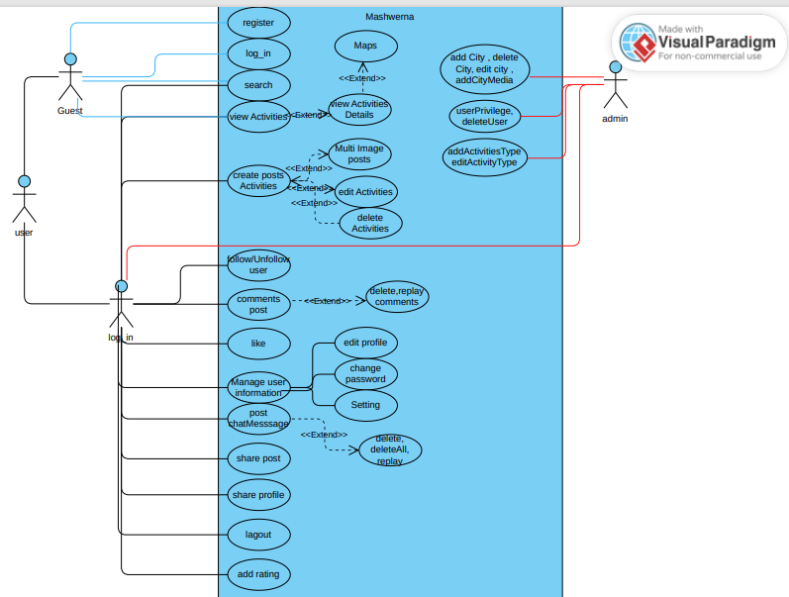

**2.4.2- Use Case Scenarios:**

In this section, I will explain all the mentioned use cases in detail, including primary actors, main flow, and alternative flow. Additionally, I will provide a short description for each use case to make all points clear.

*sign in use case*

check Table 1-Sign in Use Case scenario to see related details regarding sign in use case.

Table 1 – Sign In Use Case

|  |  |
| --- | --- |
| Use Case ID: | USR-1 |
| Use Case Name: | Sign In |
| Created By: | Nancy Dayekh & |
| Date Created: |  |

|  |  |
| --- | --- |
| Description: | This use case allows the customer to log in to the system to access the relevant functions according to the user's role. To log in to the system, all customers have to enter their email and password. |
| Primary actor: | User |
| Secondary actor: | None |
| Preconditions: | The customer has to have a registered account. |
| Post conditions: | The system will allow the user to access all functionalities available to their role. |
| Main How: | 1. The user enters a valid email and password.  2. The user submits the email and password.  3. The system validates the email and password:  4. The system verifies the email and password  5. The system grants access to the user and redirects to the home page.  5. The use case ends. |
| Altemative flow: | 3а. Missing email or password:  1- The system prompts for user email and password  2- The use case resumes at main flow step 1.  4a. Invalid email or password:  - The system displays an "invalid email or password" message.  2. The system prompts for user email and password.  3. The use case resumes at main flow step 1 |

***SignUp Use Case***

For more details about register use case, see Table 2 - Register use case scenario

Table 2 – SignUp Use Case

|  |  |
| --- | --- |
| Use Case ID: | USR-2 |
| Use Case Name : | SigUp |
| Created By: | Nancy Dayekh & |
| Date Created: |  |

|  |  |
| --- | --- |
| Description: | This use case allows a new user to register for an account in the system by providing necessary details such as email, password, and  other required personal information. |
| Primary actor: | User |
| Secondary actor: | None |
| Preconditions: | The user is not currently registered in the system. |
| Post conditions: | The user is successfully registered and can log in using their email and password. |
| Main How: | 1. The user navigates to the Home page  2. The user enters required details (email, password, name. ...)  3. The user submits the registration form  4. The system validates the entered details  5. The system creates a new account for the customer. |

*Search Use Case*

see Table 3 – Search use case scenario

Table 2 –Search Use Case

|  |  |
| --- | --- |
| Use Case ID: | USR-3 |
| Use Case Name : | Search |
| Created By: | Nancy Dayekh & |
| Date Created: |  |

|  |  |
| --- | --- |
| Description: | This page allows users to search by inputting a city name. After entering the city, users can click a button to view activities, restaurants, hotels, festivals, or excitement options in that city |
| Primary actor: | User |
| Secondary actor: | None |
| Preconditions: | The user can search in the system. |
| Post conditions: | The user or guest can search and view activities, restaurants, hotels, festivals, or excitement options in the specified city |
| Main How: | 1. The user navigates to the search page. 2. The user enters the name of a city in the search bar. 3. The user clicks the search button. 4. The system displays activities, restaurants, hotels, festivals, or excitement options in the specified city |

**Chapter Two:**

**Chapter Four: Implementation**

**4.1-Introduction:**

This chapter describes the whole the view of our app and website, it shows the design of our project in addition to stating the main role of each page.

In this section, we delve into the architecture of "Mashwerna," presenting a detailed view of each page within the application and the admin dashboard. Our implementation showcases an interface designed to deliver optimal performance and service. We've crafted a straightforward and age-inclusive interface, aiming for simplicity and visual comfort. With user experience as my guiding principle, we ensured that navigating through "Mashwerna" is a smooth and intuitive process, allowing users to transition from one page to the next with ease. This design approach underscores my commitment to providing a hassle-free environment for both casual visitors and administrators managing the backend operations

Below we are going to view different pages of my application and admin dashboard and how they

are going to be in detail.

**4.2-Mobile Application Part:**

**4.2.1-User Login page**

This page users can access their accounts by entering their email and password in the designated fields. The interface is thoughtfully designed for clarity and ease of use, featuring intuitive controls such as the password visibility toggle for enhanced security and convenience. Real-time validation ensures that all required fields are properly filled before submission, prompting users to correct any errors with clear error messages for invalid email or password entries.

Upon successful authentication, users are promptly notified with a subtle yet effective message, confirming their access to the application's main page. The page's sleek design, complemented by a welcoming background image, creates an inviting atmosphere, making the sign-in process both straightforward and visually appealing.

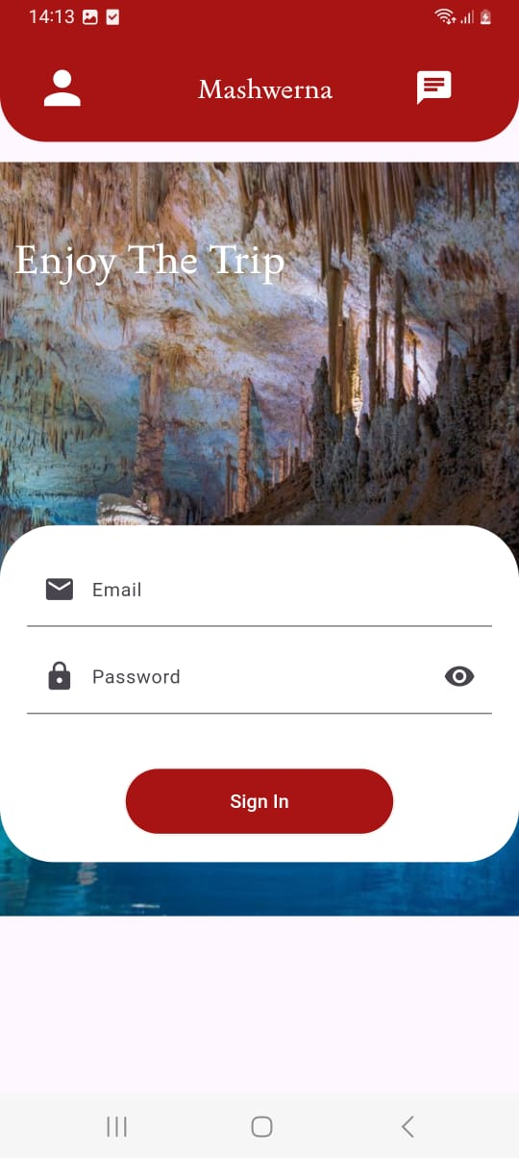  
  
 *Figure - sign in Page*

**4.2.2-User registration page:**

Welcome to our user-friendly registration page! Here, users can create a new account by entering their email, username, and password. They also have the option to upload a profile picture using the convenient camera icon. Real-time validation ensures that all fields are correctly filled out; any errors prompt users to complete or correct their inputs before submission. Upon successful registration, user information is securely sent to the server, and users are redirected to the main application page for immediate access.

Passwords must meet security standards, requiring a minimum of 8 characters. Additionally, email addresses are checked to ensure they do not already exist in the database, ensuring data integrity and security. The page features a sleek design with a welcoming background image, creating an inviting atmosphere that makes the registration process both straightforward and visually appealing.

This design prioritizes clarity, ease of use, and security, providing a seamless experience for users to join and enjoy our application.

*Figure -signup Page*

**4.2.3-Home Page:**

This page offers a comprehensive user experience with a clear display of categories for easy navigation. It features real-time weather updates for Lebanon, ensuring users are informed at all times. The top navigation bar provides access to user profiles and login, alongside a chat icon for instant messaging. Users can explore various activities presented on the page, each linked to detailed profiles for further engagement. The app supports dynamic content updates with a refresh feature for activities, enhancing user interaction. A bottom navigation bar facilitates seamless navigation across different sections of the application, ensuring a fluid and intuitive browsing experience.

**4.2.3-Add Post Page:**

this page consists of input fields for capturing activity details, including name, description, contact information, and location. Users benefit from intuitive dropdown menus for selecting activity types and cities, simplifying data entry and enhancing user experience. Additionally, the interface supports seamless image uploads, allowing users to upload either single or multiple images effortlessly. With robust user authentication mechanisms in place, the app ensures secure access to these features, making it a perfect blend of user-friendliness and societal utility.

**4.2.4-Notifications:**

The Notifications page enhances user engagement by delivering real-time updates on interactions related to their platform activities. Users receive notifications detailing actions such as likes, comments, replies, and follows. Each notification includes sender details, showcasing their profile picture and name for easy recognition. Users can interact directly from the notification list by following or unfollowing senders and viewing detailed activity information. Tapping on a sender's profile picture or name navigates users to their profile, fostering seamless interaction and exploration. Additionally, users can reply to comments or engage in discussions directly from the notification interface, thereby enriching their participation and connectivity on the Mashwerna.

**4.2.5-Search:**

The Search page empowers users to explore destinations by entering a city name. Upon inputting the city, users can effortlessly navigate through various options such as activities, restaurants, hotels, festivals, and exciting attractions available within that locale. Featuring intuitive buttons and a streamlined search bar, this page ensures a seamless and engaging exploration experience, encouraging users to discover new places and plan their adventures with ease

**4.2.6- User profile:**

The Profile User page offers comprehensive insights into a user's profile, showcasing essential details such as their profile picture, email, name, and engagement metrics like posts, followers, and following. Users can seamlessly navigate to edit their profile or explore settings. This page also facilitates interaction with user activities, enabling actions such as editing, deleting, and sharing posts. With intuitive controls for liking and saving activities, alongside robust sharing capabilities, the Profile User page ensures a dynamic and engaging user experience.

**4.2.7- Edit Profile page:**

The Edit Profile page empowers users to update their profile details with ease. It offers intuitive fields for modifying profile information such as name and email, accompanied by an option to upload a new profile picture. Ensuring a seamless experience, users can confidently save changes, which are securely processed and validated, affirming the integrity of their information.

**4.2.8- Edit Password:**

The Edit Password page offers users a secure platform to modify their account credentials. It features dedicated fields for entering the current password, specifying a new password, and confirming it. This process ensures stringent security measures by validating password changes before finalizing them, thereby safeguarding user accounts against unauthorized access

**4.2.9-Setting:**

**4.2.10-chat login page:**

The chat user login page displays user profiles showcasing names, profile pictures, and messages from all users who have communicated with the logged-in user. Clicking on a user's name or profile picture seamlessly accesses a chat interface for exchanging messages. This page ensures a streamlined and secure user experience, continually updating message previews through asynchronous operations to reflect the latest conversations. Enhance engagement with real-time messaging capabilities, fostering dynamic interaction.

**4.2.11- Chats:**

On this page, users can send messages to each other and manage their conversations seamlessly. Each message is displayed with sender details and timestamp, ensuring clarity and context in conversations. Users have the capability to delete individual messages or clear their entire chat history, providing flexibility and control over their interactions. the page guarantees a responsive and secure messaging experience. This approach ensures that users can engage in meaningful conversations while maintaining control over their communication history within the app.

**4.2.12- view organization pages**

This page allows users to view various activities, hotels, restaurants, excitement options, or festivals. Users can see detailed information about each activity, such as the name, location, and contact details, along with a picture of the activity. Each activity card also displays the profile picture of the user who posted the activity, which users can click to view more information about the poster. The page is designed to provide an engaging and interactive experience, making it easy for users to explore and discover activities that interest them**.**

**4.2.13-Profile User page**

The user profile page is meticulously crafted to present a wealth of information about the user in an aesthetically pleasing layout. It prominently features the user's profile picture, name, and email address, ensuring these details are easily accessible and visually appealing. Users can quickly gauge their social presence with counts for followers, following, and posted activities displayed prominently. Interaction is streamlined with intuitive buttons to follow or unfollow other users directly from the page, providing immediate feedback. Additionally, users can engage in direct messaging, facilitating seamless communication. The activities section showcases the user's posted content in a visually engaging grid format, with each item clickable to reveal more details. This design prioritizes clarity, usability, and visual appeal, offering a seamless experience for navigating and interacting with user profiles.

**4.2.14-view details**

This page presents detailed activity information based on the provided ID. It seamlessly showcases captivating images and encourages user engagement through features like liking, commenting, and effortless sharing across social media platforms. Integrated with Google Maps, the screen offers a visual tour of activity locations, empowering users to explore routes and navigate directly within the app. Furthermore, users can rate activities and share insights through comments, with the average rating prominently displayed. This holistic approach ensures a captivating and interactive user experience, tailored for exploring and engaging with comprehensive activity details.

**4.2.15- Comment**

This page presents detailed activity comments, offering users a seamless experience for engaging with community feedback. Each comment is enriched with user profiles, including names and avatars, fostering a personalized interaction. Users can effortlessly reply to comments and add their own, enhancing dialogue and community engagement. Integrated with secure authentication, the page ensures that only logged-in users can participate, promoting a safe and trusted environment. Additionally, users have the ability to delete their own comments, providing control over their contributions. comments are dynamically fetched and updated, ensuring real-time interactions. Overall, this design prioritizes user interaction, security, and real-time updates, providing a robust platform for meaningful engagement and community interaction within the app.

**4.3- Admin panel**

**4.3.1- Introduction**

**The website is dedicated for admins to moderate and revise content that is being posted. With the help of the website, admins can search and delete users, activities, activities’ comments, activities’ ratings. Also, admins create/manage the categories that activities rely on (cities, activity types) meaning they have full access over them.**

**4.3.2- Login Page**

**The login page is very simple it contains the login form with a modest and appealing design.**

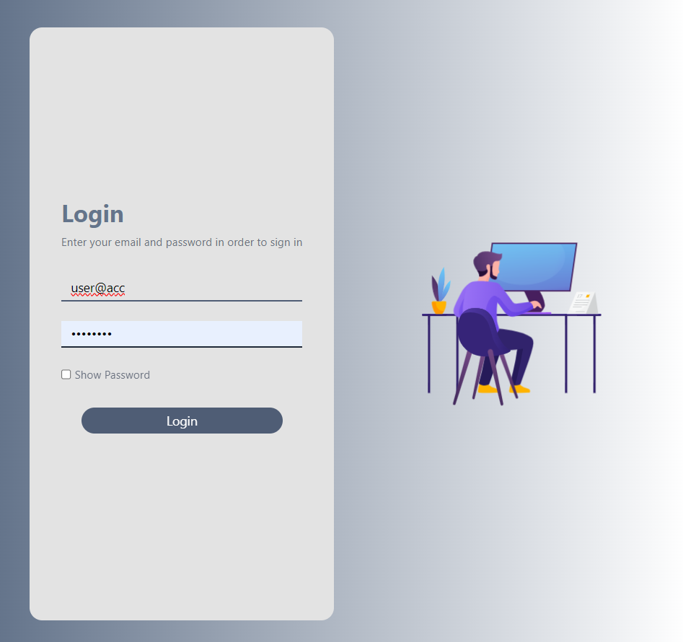

**4.3.2- Management Page**

**The management page with a simple navbar containing user details and a logout button, includes an overview of all categories with a search feature for each one except for activity types which doesn’t need one. Each category can be accessed, edited, and deleted, if possible from there.**

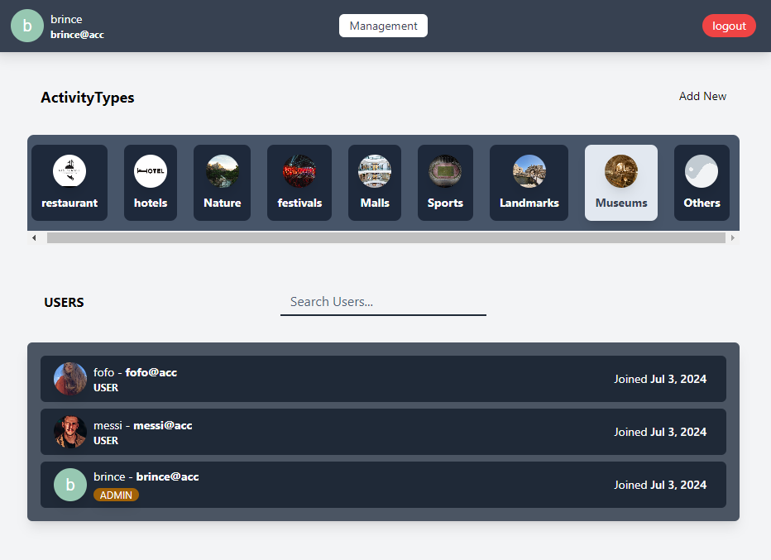

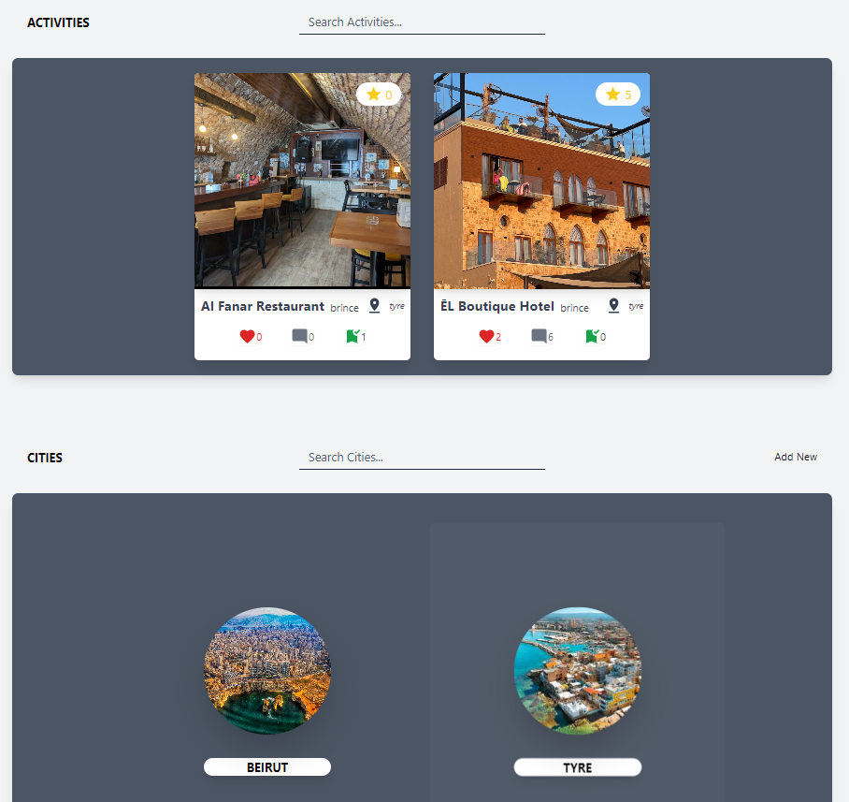

**4.3.3- Activity Types**

**Activity types are categories that organize the activities. Each activity belongs to a single activity type. When clicked on, each one’s details can be updated or deleted. Also, admins can add new activity types by clicking on the ‘add new’ button.**

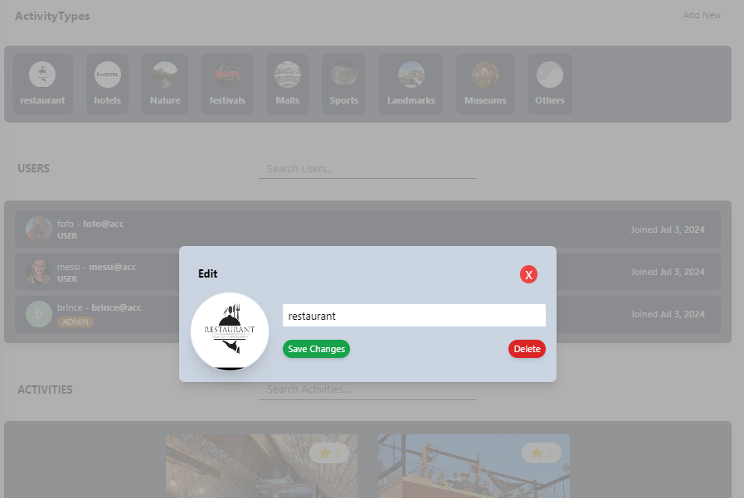

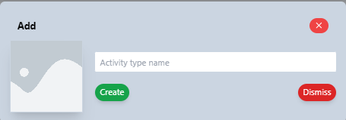

**4.3.4- Users**

**Admins can search users by their id, name, or email and view each user details.**

**Super admins can do the same and promote/demote users into admin/users.**

**4.3.5- Activities**

**Admins can search for activities and view any of them. All Activity details are**

**visible for admins from pictures to likes, comments, and ratings. Admins can delete inappropriate activities or comments and ratings in the activity itself.**

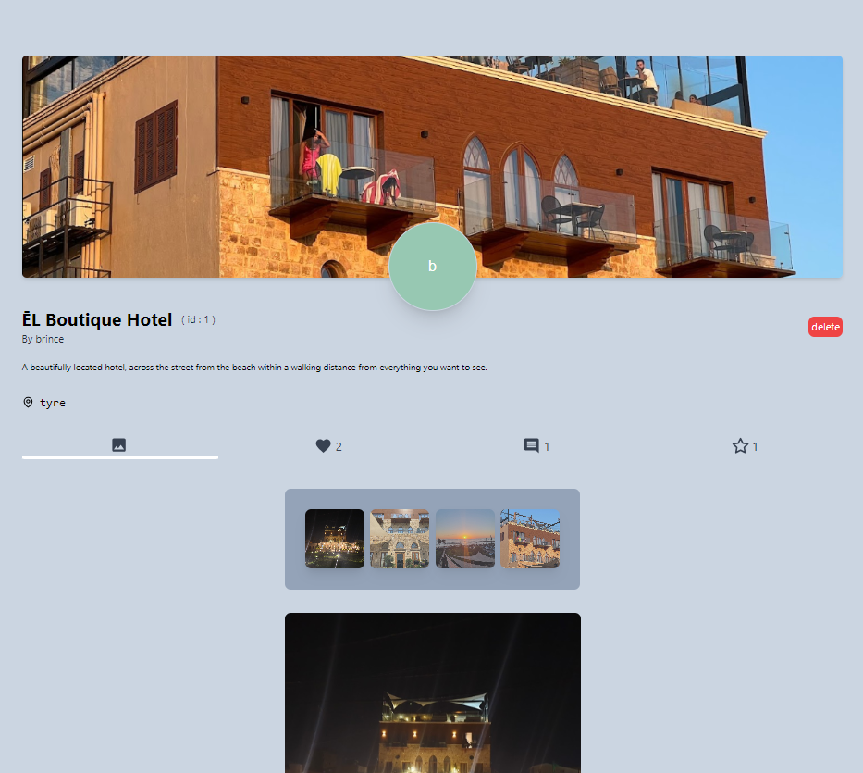

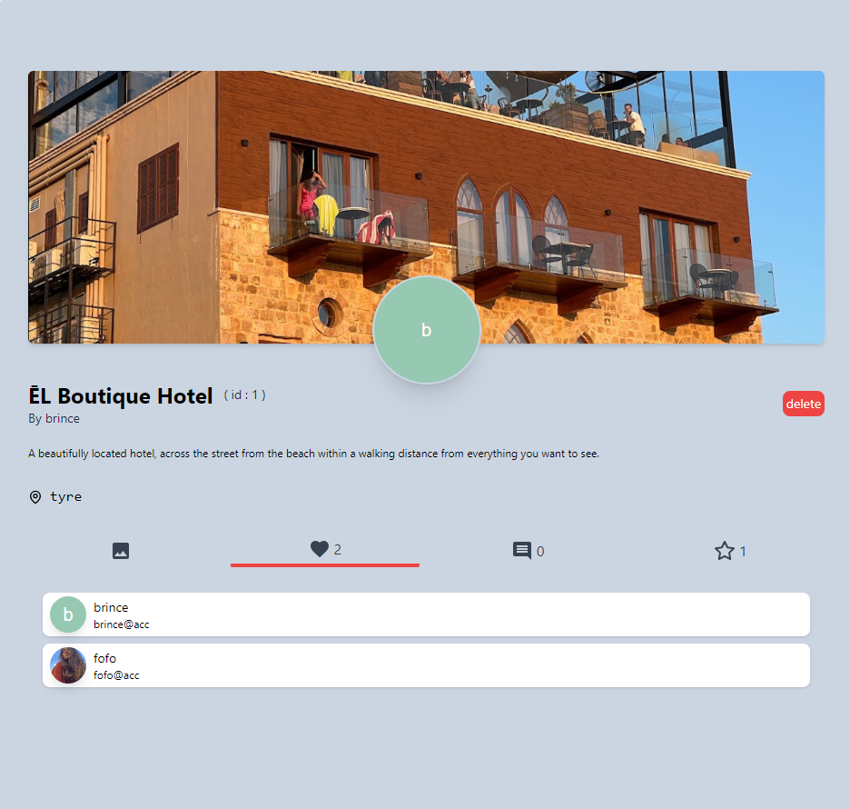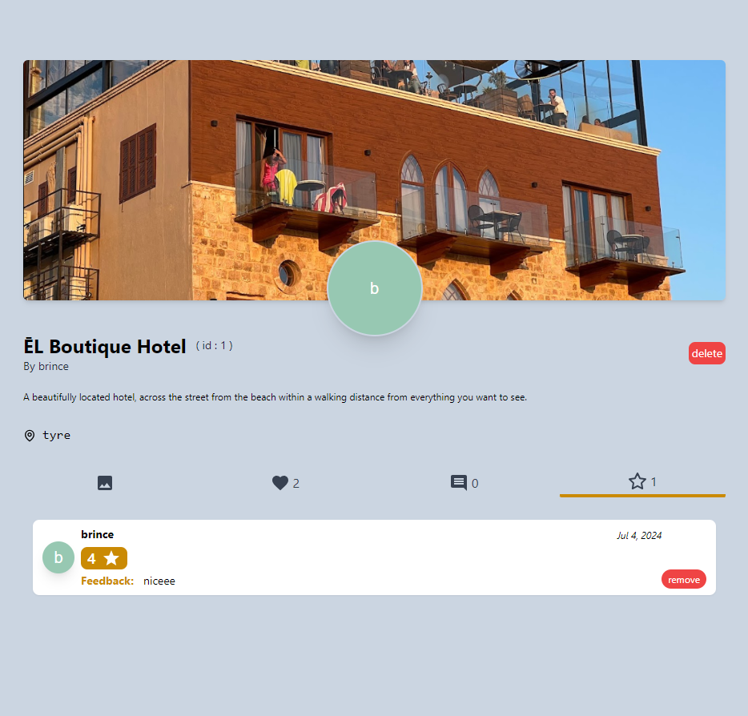

**4.3.4- Cities**

**Admins have full access over cities, they can crud (create, read, edit, delete) them and view their respective activities.**

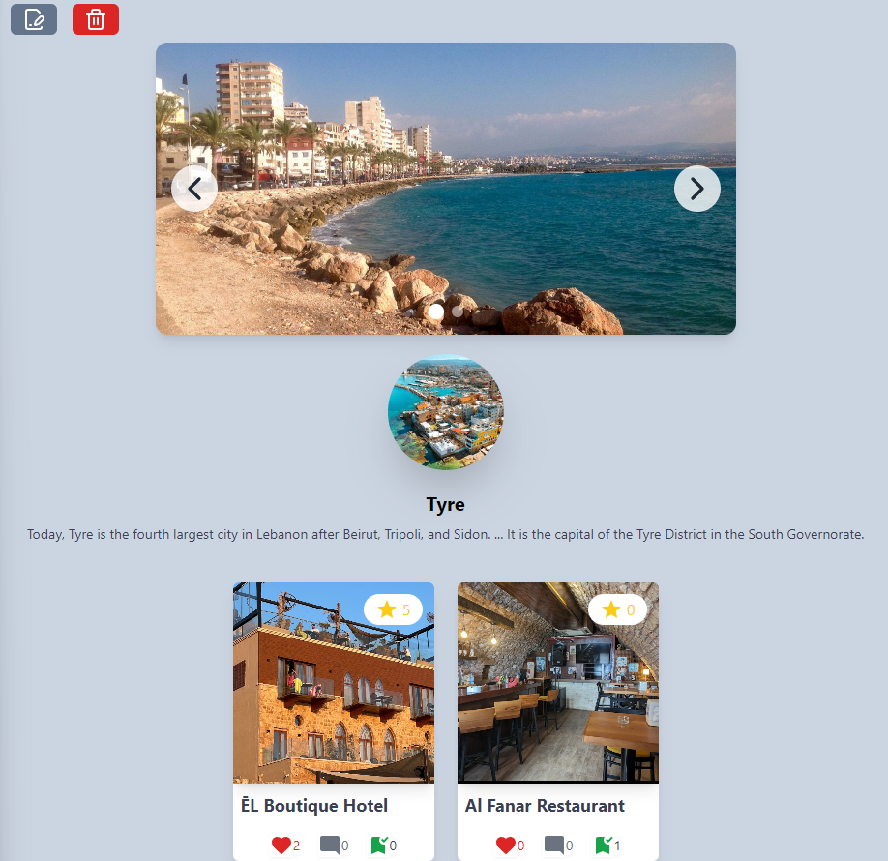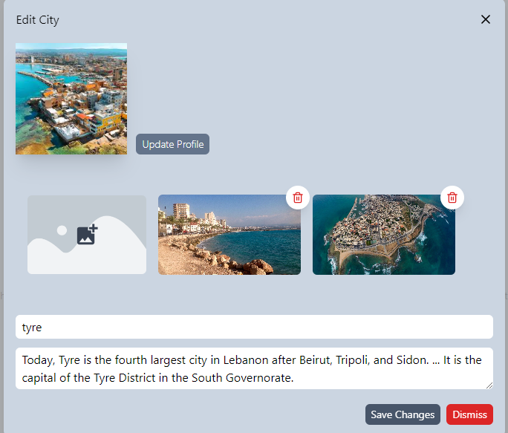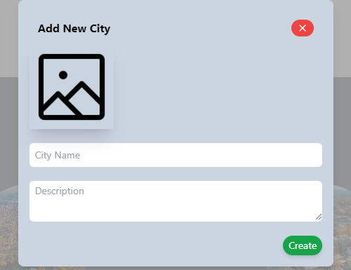

**Chapter 5:**

**5.1-Conclusion**

Mashwerna stands as a transformative force in the intersection of social media and tourism, addressing critical deficiencies present in existing platforms. By establishing a platform where travelers can authentically engage, share their genuine experiences, and exchange invaluable insights, Mashwerna fosters a community-centric approach to exploration. Seamlessly blending conventional social media functionalities with innovative features such as impartial destination reviews and robust user interactions, Mashwerna guarantees a comprehensive and enriching user experience.

Mashwerna embodies a commitment to promoting tourism, facilitating meaningful interactions, and upholding a positive and policy-compliant environment through meticulous content moderation and administration. With Mashwerna, the future of social media-driven travel experiences is not only vibrant but also accessible to all individuals seeking authentic adventures and genuine community connections.

In conclusion, Mashwerna revolutionizes social media and tourism by addressing key deficiencies in current platforms. By fostering authentic engagement, enabling users to share genuine experiences and insights, and integrating innovative features like unbiased destination reviews, Mashwerna offers a comprehensive and enriching user experience. With a commitment to promoting tourism, facilitating meaningful interactions, and ensuring a positive environment through diligent moderation, Mashwerna paves the way for a vibrant future where everyone can enjoy authentic adventures and connect within a supportive community.

**5.2-Future Work:**

"Mashwerna" might undergo many enhancements aimed at providing users with greater customization options, improved communication features, and the integration of AI technology. Here's a glimpse of our future vision for "Mashwerna".

1. Customization: Providing users with enhanced customization options is important for future iterations of Mashwerna. Introducing features that allow users to personalize their profiles, travel preferences, and feed preferences would foster a more tailored experience. This could include personalized travel guides based on user interests, and the ability to filter content and recommendations according to specific criteria such as budget, travel style, or destination type.
2. Communication: Enhancing communication tools within Mashwerna can facilitate more meaningful interactions among users. Integrating real-time messaging functionalities, group chat options for travel planning, and forums for discussing travel tips and experiences would encourage community engagement and foster a supportive environment. Improving communication channels between users and local businesses or tourism authorities could also facilitate seamless collaboration and information sharing.
3. AI Integration: AI integration holds immense potential for Mashwerna evolution. By incorporating AI-driven analytics, the platform can analyze user behavior, trends, and preferences to continuously refine its recommendation algorithms. This could include predictive analytics for travel trends, sentiment analysis of user reviews to ensure authenticity, and automated content moderation to maintain a positive user experience. Moreover, AI can assist in detecting and preventing fraudulent activities, ensuring the integrity of user-generated content and reviews.

**References**

1. Flutter Documentation:  
   a. Flutter. "Flutter Documentation." Accessed April 1, 2024.  
   <https://docs.flutter.dev/>  
   b. YouTube - Dart Language:  
   <https://www.youtube.com/watch?v=kgN7veo9tC0&list=PL93xoMrxRJIsYc9L0XBSaiiuq01JTMQ_o>  
   c. YouTube - Basic Flutter:  
   <https://www.youtube.com/watch?v=FVgQcfXHeGo&list=PLeWmXrh004782w91CeXQ4bK8ivREDau-x>
2. Laravel Documentation:  
   a. Laravel. "Laravel Documentation." Accessed April 1, 2024.  
   [https://laravel.com/docs/11.x/readmes](https://v17.angular.io/docs)

b. Youtube - Hosting Laravel on 000webhost:

1. <https://www.youtube.com/watch?v=2kOZUjKa9OE>
2. React.js Documentation:  
   React.js. "React.js Documentation." Accessed April 1, 2024.  
   <https://react.dev/learn>
3. TailwindCSS Documentation:  
   TailwindCSS. "TailwindCSS Documentation." Accessed April 1, 2024.  
   <https://v2.tailwindcss.com/docs>
4. Design Inspiration for Applications and Websites:  
   a. Pinterest: <https://www.pinterest.com/>  
   b. Google Images