Volume
1

eXPlainPMT User Guide
Table of Contents
What is eXPlainPMT 2
Creating a Project 3
Creating a Project Team 4
Adding Users to a Project Steps: 4
Creating Users for a Project Steps: 5
Creating Iterations 6
Iteration Creation Steps: 6
Assigning Stories to an Iteration: 8
Creating Stories 9
Story Creation Steps: 9
Assigning Stories to an Iteration: 11
Creating Initiatives 12
Creating Initiatives Steps: 12
Assigning Initiatives to Stories: 13
Creating Acceptance Tests 14
Creating Acceptance Test Steps: 15
Assigned Acceptance Tests to Stories: 16
Creating Milestones 17
Creating Milestones Steps: 18
Updating User Profiles 20
Viewing Stats 20
Viewing the Dashboard 21

What is eXPlainPMT

exPlainPMT is a tool which allows agile teams to manage work from initial customer engagement including creating stories to gaining acceptance for a set of deliverables. This tool attempts to manage project work on a commitment basis. Stories are created and estimated using a unitless measurement referred to as story points. Stories are assigned a risk and priority and are held in a backlog. Once it is time to start the project, iterations are created and stories are assigned to the iterations. Stories which have been assigned to an iteration can also have an owner assigned.

Creating a Project
A project is the container for all release, stories, iterations, acceptance tests, tasks and users. After creating a user account, creating a project is the next step to managing your agile projects using eXPlainPMT. To create a project, navigate to the projects tab and click the Create New Project link.

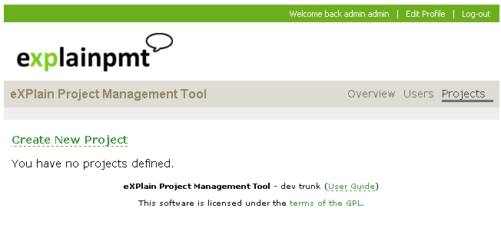

A project consists of a name, description, and planned number of iterations. The planned number of iterations is used when calculating the projects velocity and planned velocity.

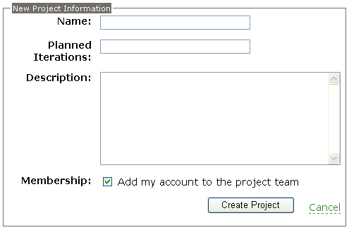

Creating a Project Team
A project team is comprised of the users permitted to access and edit a projects information including: stories, iterations, acceptance tests, milestones, initiatives, and releases. To create or add a user to the project team in eXPlainPMT, navigate to the Team tab.

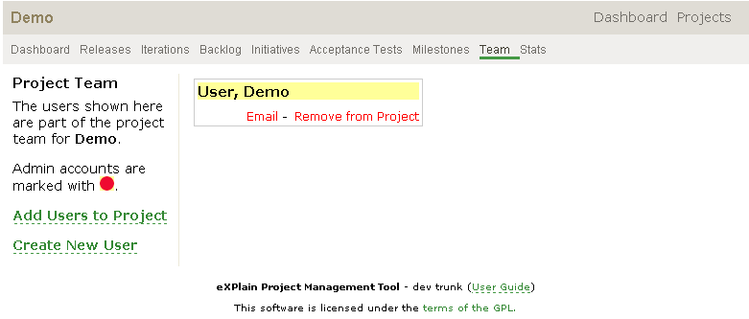

From this tab, a user has the ability to add a user to the project. This is used if the user already exists in eXPlainPMT. A user can create a new user for the project. Users can also be removed from the project from this tab.

Adding Users to a Project Steps:
- Click the Add Users to Project Link.

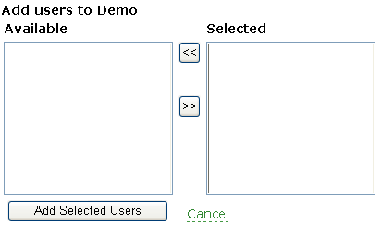

- Users are selected from the Available list. Multiple users can be selected by using the CTRL key.
- Once users are selected, the key is pressed to add the users to the selected list.
- Once all users are added to the selected list, the Add Selected Users button is clicked to add the users to the current project.

Creating Users for a Project Steps:
- From the Team tab, click the Create New User link.

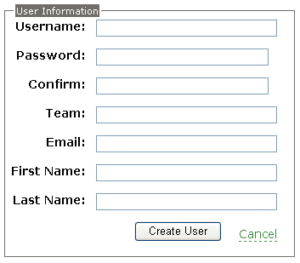

- Fill in the appropriate user information. Usernames must be at least 4 characters long and passwords must be at least 6 characters long.
- Once the user is created, it will display in the Team tab.

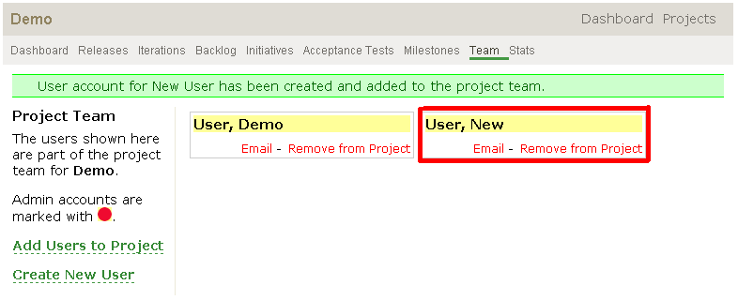

Creating Iterations
An iteration is a time boxed (typically 1 to 3 weeks long) plan, where stories are developed, tested, demonstrated, and prepared for production. Stories are placed into the iteration in order of the most valuable to the customer. To create an iteration in eXPlainPMT, navigate to the iterations tab.

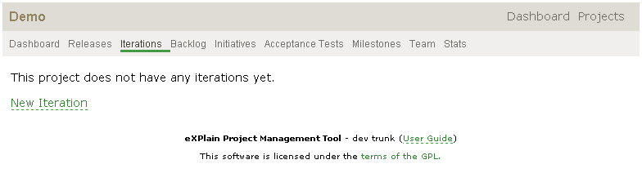

Iteration Creation Steps:

- Click the “Create New Iteration” link.
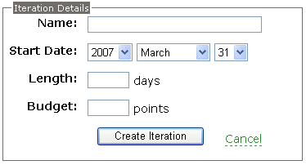

- Fill in the appropriate information regarding your iteration. The length of an iteration is typically 7 to 21 days.

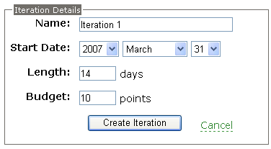

- Once the iteration has been created, the iterations tab will display your iteration.

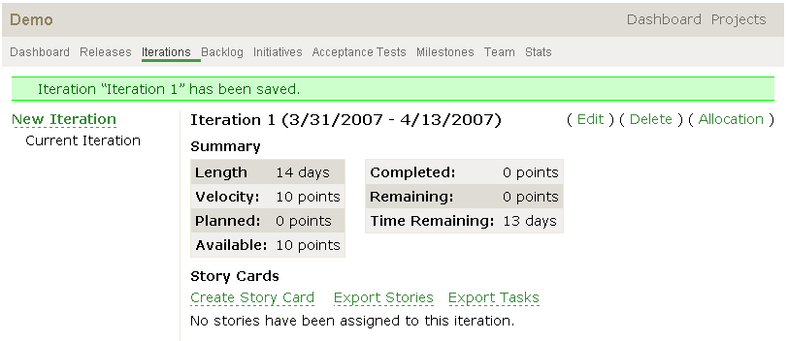

**Once you create many iterations, you will be able to navigate from one iteration to another in the left menu.

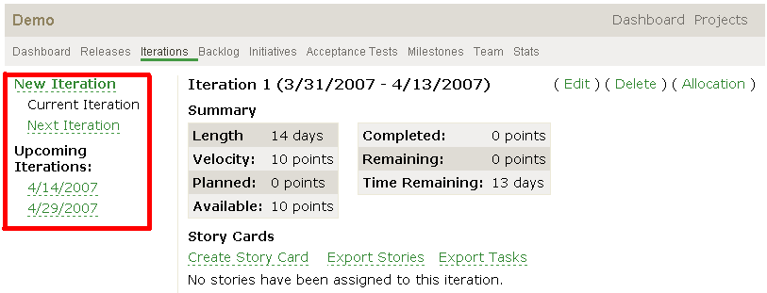

Assigning Stories to an Iteration:
Once stories are created and iterations are created, you have the ability to assign stories to an iteration. To assign stories, navigate to the iteration you would like to add stories to.

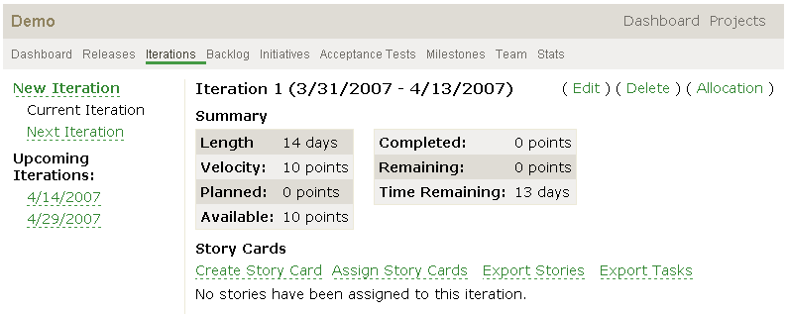

Once you are in the context of the iteration, click the “Assign Story Cards” link. A window will appear with all stories which have not been assigned to an iteration and are defined with the title, status, priority, risk and points.

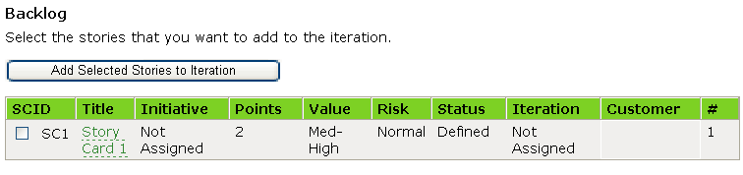

Check all stories to be added and click the “Add Selected Stories to Iteration” button. Once the stories have been added, the iteration will display the assigned stories.

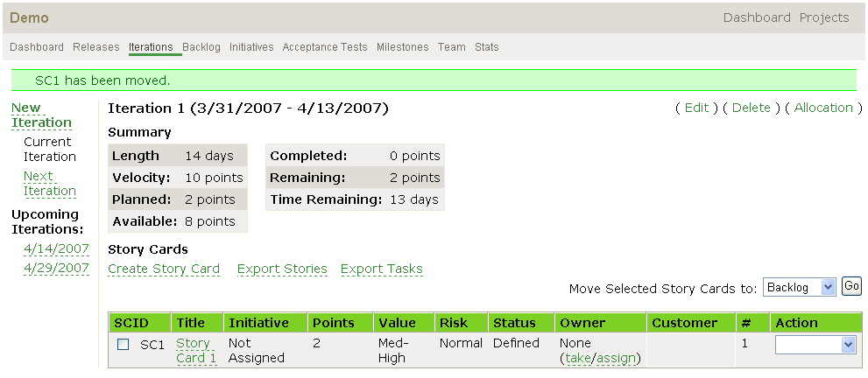

Creating Stories
Stories are pieces of business value that can be implemented, tested, demonstrated, and can fit within an iteration. To create a story in eXPlainPMT, navigate to the backlog tab. A backlog is the accumulation of stories which have not yet been completed or scheduled for an iteration.

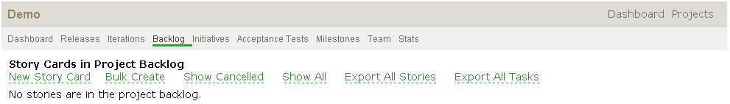

Story Creation Steps:
- Click the “New Story Card” link. The below window will appear.

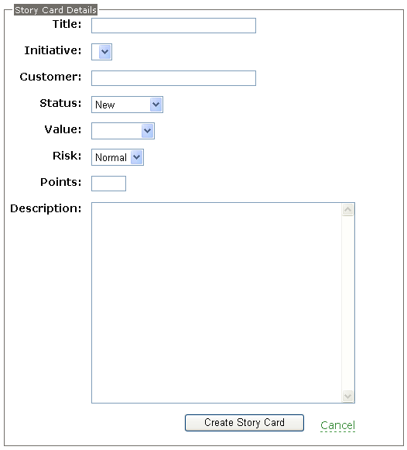

- Fill in the appropriate information regarding your story.

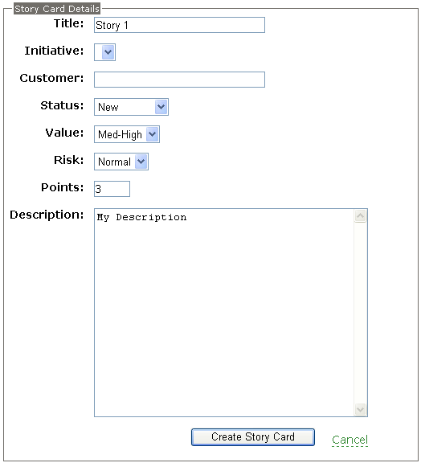

- Once you have created the story, the backlog will now display your story.

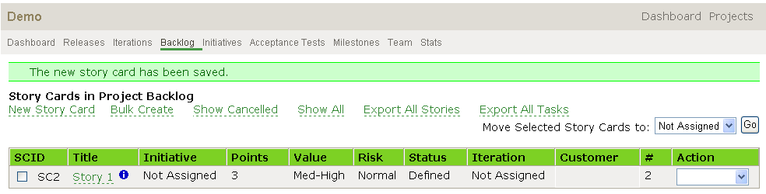

**Currently a story must have the title, status, priority, risk, and points defined for a story to be assigned to an iteration.
**The SCID is the unique identifier for stories within the project.

Assigning Stories to an Iteration:
Once stories are created and iterations are created, you have the ability to assign stories to an iteration. To assign stories, navigate to the backlog tab.

Check all stories to be added to the iteration. Once you have checked all stories to be moved, select the appropriate iteration from the “Move Selected Story Cards to:” dropdown and click “Go”.

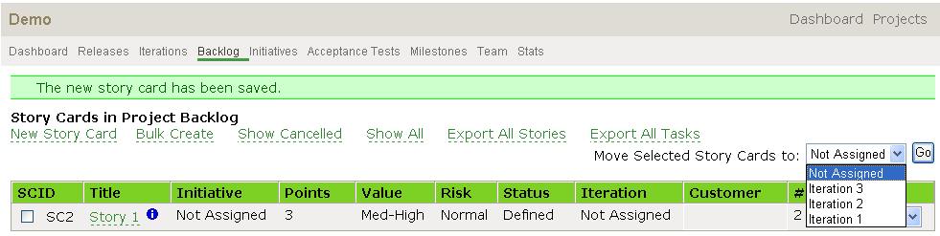

The story will be added to the selected iteration and will no longer appear in the backlog.

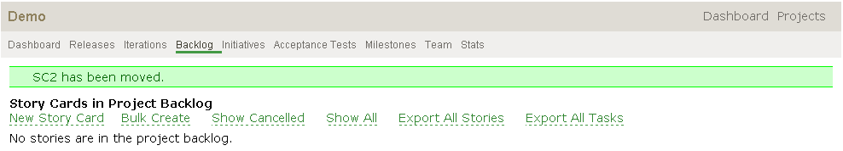

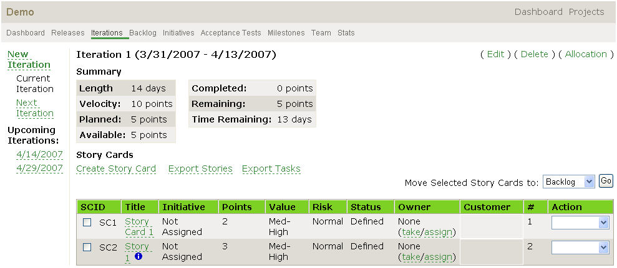

Creating Initiatives
An initiative is a way for teams to perform a logical grouping of stories. To create initiatives in eXPlainPMT, navigate to the initiatives tab.

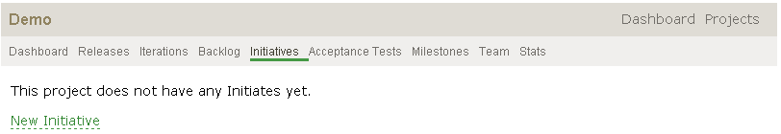

Creating Initiatives Steps:

- Click the “New Initiative” link.

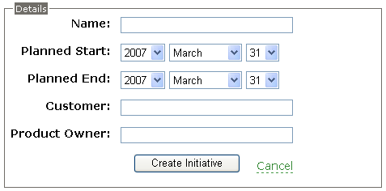

- Fill in the appropriate information for your initiative.

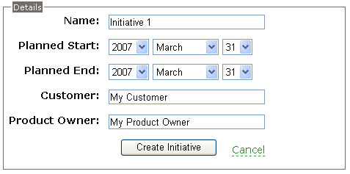

- Once the initiative has been created, it will be displayed on the initiatives tab.

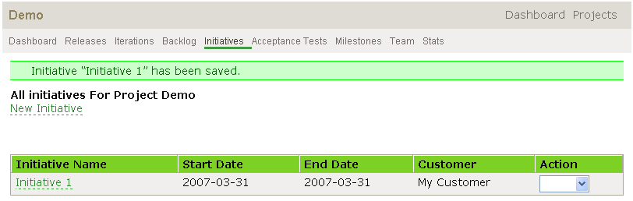

Assigning Initiatives to Stories:

Once you have created initiatives, you can assign them to stories. When you are creating a story, you can select any created initiative for your project to associate with the story.

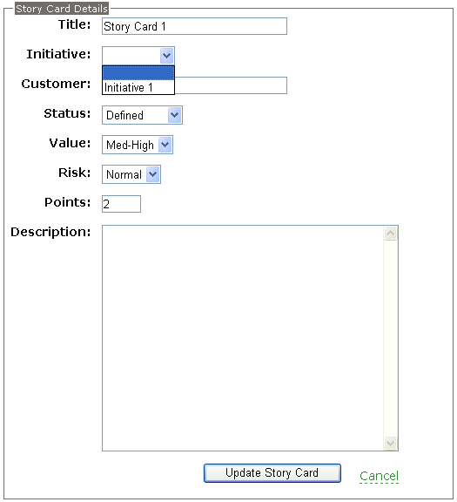
After you have associated an initiative to a story, the initiative will appear with the story.

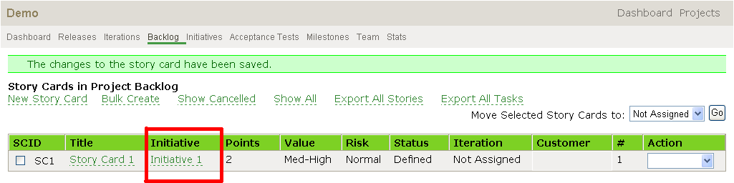

Creating Acceptance Tests
Acceptance testing is used to determine behavioral intent for a deliverable and provide formal completion criteria for a deliverable. To create Acceptance Tests in eXPlainPMT, navigate to the Acceptance Tests tab.

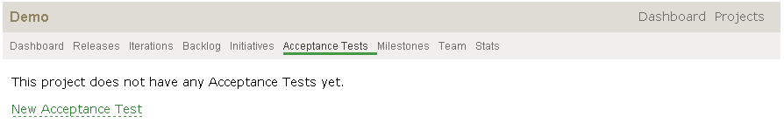

Creating Acceptance Test Steps:

- Click the New Acceptance Test link:
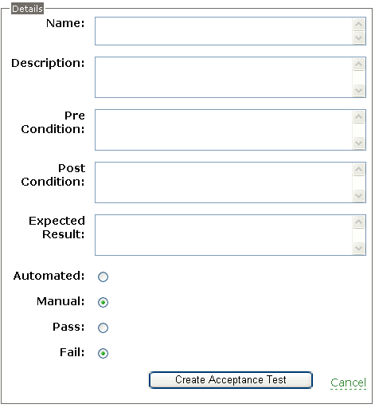

- Fill in the appropriate information for your Acceptance Test.

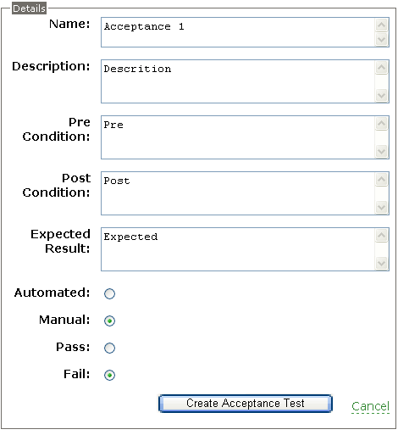

- Once you create the Acceptance Test, it will be displayed on the Acceptance Test tab.
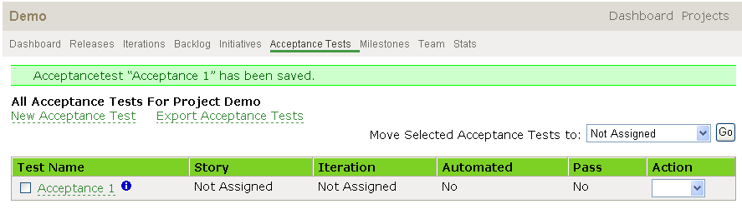

4. You can also create Acceptance Tests from the story card view.

Assigned Acceptance Tests to Stories:
Once you have created Acceptance Tests, they can be associated with a user story. The story does not have to be assigned to an iteration at this point. You can check one or many Acceptance Tests from the Acceptance Test tab and then assign them using the dropdown of stories.

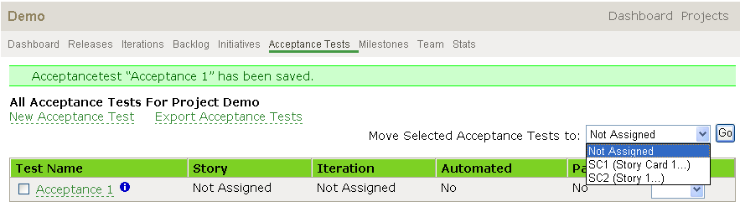

Once an Acceptance Test is assigned to a story, the story column displays the story’s id.
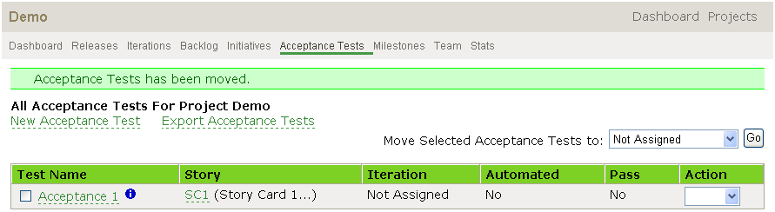

Also, when you open a story, you will see its Acceptance Tests.

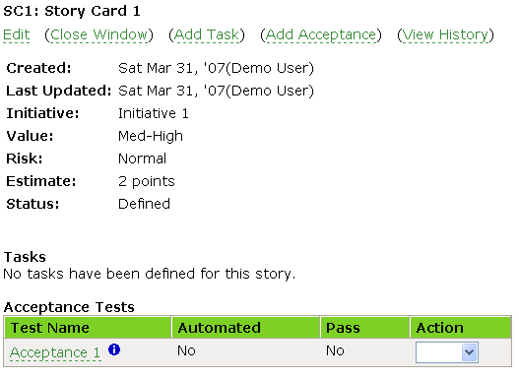

Creating Milestones
Milestones are generic calendar events that give a project team visibility into any generic calendar item. To create a Milestone in eXPlainPMT, navigate to the Milestones tab.
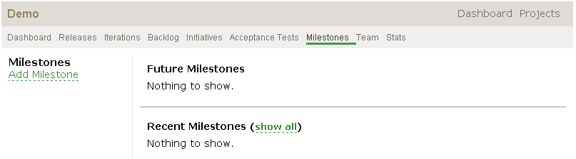

Creating Milestones Steps:
- Click the Add Milestone Link.

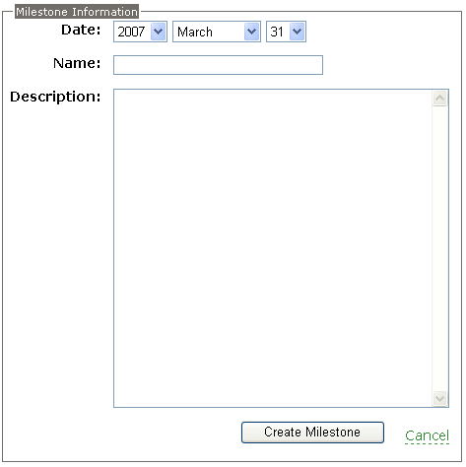

- Fill in the appropriate information regarding your Milestone.
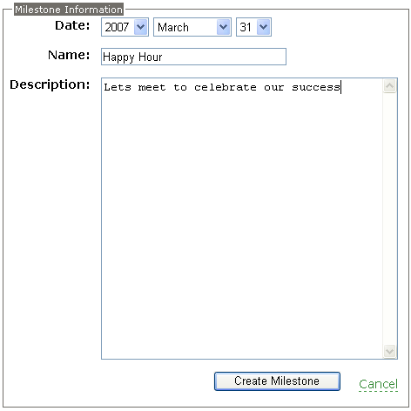

- Once you have created your Milestone, it will appear in the Milestones tab.

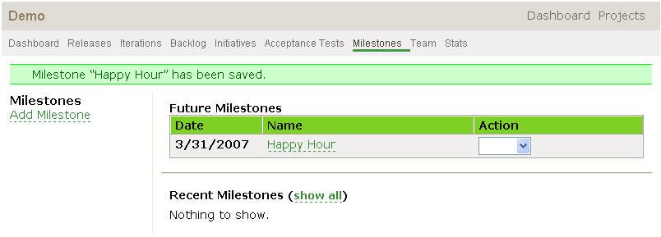

- If the milestone occurs within the next two weeks, it will also be displayed on the Dashboard page for all active users on your project.
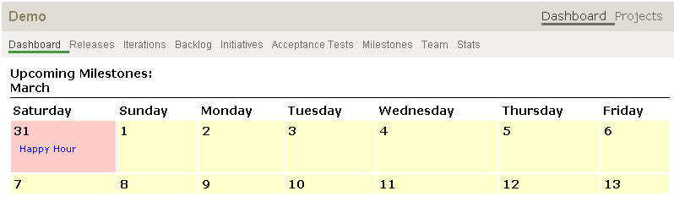

Updating User Profiles
A user can update their user profile in eXPlainPMT by clicking the edit profile link in the top right portion of the application.

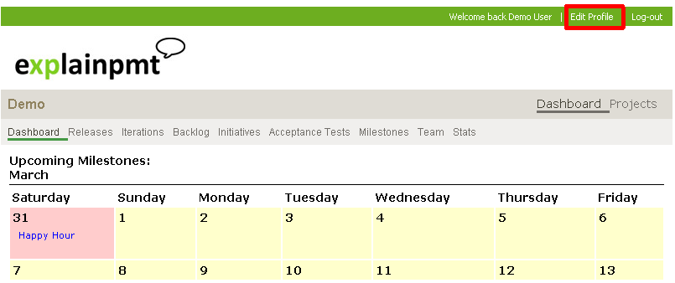

Once the user clicks the edit profile, they have the ability to change their username, password, email information, and name.

Viewing Stats
eXPlainPMT has the ability to generate a project burndown and provide critical statistical information regarding your project. Velocity, iteration gap, planned burndown, actual completion, trended completion, and planned velocity are all metrics which are calculated when the Stats tab is viewed.
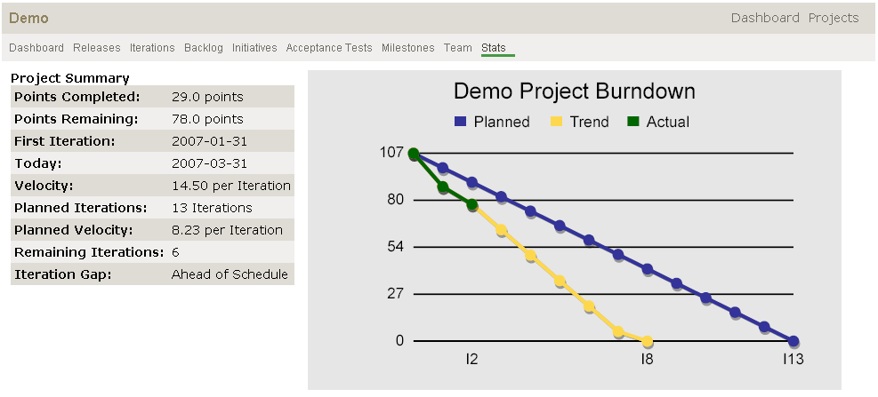

Viewing the Dashboard
The dashboard displays upcoming milestones and also displays stories/tasks that the current logged in users is responsible for completing. The dashboard will also display all stories/tasks and milestones across all projects that the user is associated with.

