S3: positive

S4: negative

S5: small

S6: average

S7s8s9s10: product(0-32/33-64/65-96/97-128)

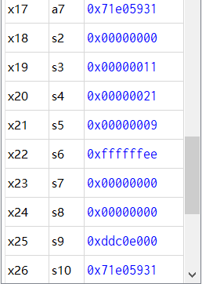

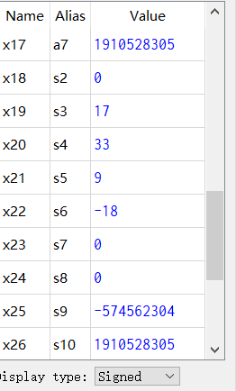

以上两个是50个数据

S7(prod 1-32 bit)

S8(prod 33-64 bit)

S9 (prod 65-96 bit)

S10 (prod 97-128 bit)

是prod

Testcase for calculateAverage

.data

ArrayPart1: .word -68,-66,-64,-62,-60,-58,-56,-54,-52,-50

ArrayPart2: .word -48,-46,-44,-42,-40,-38,-36,-34,-32,-60

ArrayPart3: .word -56,-52,-48,-44,-40,-60,-54,-48,-63,-55

ArrayPart4: .word 48,46,61,57,53,63,57,63,55,57

ArrayPart5: .word -7,11,2,-4,-2,8,6,2,3,1

(arraySize = 50)

###############################################################

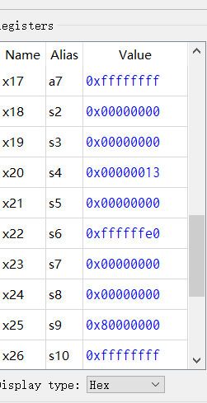

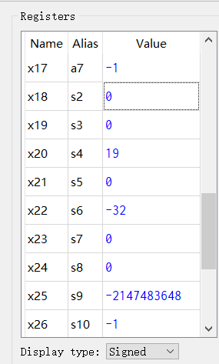

以上两个是数据

Testcase 3 (complete) for calculateProduct

.data

Array1: .word -32,-32,-32,-32,-32,-32,-32,-32,-32,-32

Array2: .word -32,-32,-32,-32,-32,-32,-32,-32,-32

arraySize = 19

##########################################################################

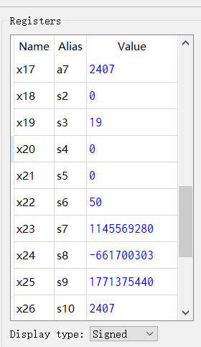

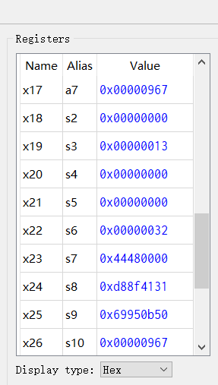

这个是19个50的输出

Testcase 2 (hard) for calculateProduct

.data

Array: .word 50,50,50,50,50,50,50,50,50,50,50,50,50,50,50,50,50,50,50

arraySize = 19