**2021 Microsoft "Imagine Cup" Challenge**

Cardiovascular interventional assisted training system based on virtual Reality technology

[Team Name]

|  |  |  |  |
| --- | --- | --- | --- |
| The name | Unit departments | Email address | Contact phone number |
| Zhi-kai Yang | School of Biomedical Engineering, Shanghai Jiao Tong University | 302807330@qq.com | 18647826268 |
| Peng-cheng xu | Michigan College, Shanghai Jiao Tong University | xu_pengcheng@sjtu.edu.cn | 18930386735 |
| De kun Yang | School of Biomedical Engineering, Shanghai Jiao Tong University | 2692760599@sjtu.edu.cn | 183019665756 |
| Yu-feng Chen | Department of Measurement and Control Instrument, School of Electrical Engineering, Shanghai Jiaotong University | 852870338@qq.com | 15221311267 |

[Team Profile]

The four students in the team are all students of Shanghai Jiao Tong University, among whom Yang Zhikai is the master and the other three are undergraduates.

1. Yang Zhi-kai, project leader, undergraduate, graduated from computer science and technology major, master degree studying at Shanghai jiao tong university school of biomedical engineering, the research direction for surgical navigation, not only to master a certain knowledge of medicine, also has good capability of software development, competition winning attended many disciplines, such as the national design competition won the first prize in the national college students' computer, Intel cup undergraduate electronic design contest embedded system project invitational national third prize.
2. Xu Pengcheng is an undergraduate student at University Michigan -Shanghai Jiao Tong University Joint Institute , Electrical and Computer Engineering.
3. Chen Yufeng majored in measurement and Control Technology and Instrument in Shanghai Jiao Tong University.
4. Yang Dekun is an undergraduate majoring in biomedical Engineering at Shanghai Jiao Tong University.

Yang Zhikai was responsible for joint debugging of hardware and software equipment and project leadership; Xu Pengcheng and Yang Dekun were responsible for image processing and machine learning at the software level; Chen Yufeng was responsible for data collection, research and completion of project reports.

[1. Project Introduction]

Virtual reality (VR) technology is a new and high technology, also known as aura technology or artificial environment. Virtual reality uses computer simulation to create a three-dimensional world, providing users with visual, auditory, tactile and other sensory simulation. Virtual reality technology is used in video games, flight training simulation, geographic information system, environment simulation and other fields. Highly immersive environment simulation enables users to have an immersive experience. With the rapid development of virtual reality technology in recent years, the application of virtual reality technology has attracted more and more attention in the field of science and technology, and some industry giants such as Google and Facebook have also entered into this industry.In the near future, virtual reality technology will be more widely used and come into our daily life comprehensively.

In the late 20th century, the rapid development of high and new technology and is widely used in the medical field, greatly promote the development and application of virtual reality technology, as a virtual reality technology in the field of medical application of minimally invasive surgery simulation, after 10 years of development, in the European and American countries has been widely applied in the teaching and training of surgeons.This project is committed to the research and development of the core technologies of magnetic navigation and AR image processing for interventional surgery. Relying on the years of research and accumulation of IGSTs Laboratory in the simulation technology of endovascular interventional surgery, this project applies the technology of medical virtual reality into practice and completes the upgrade of the traditional training system for interventional surgery.

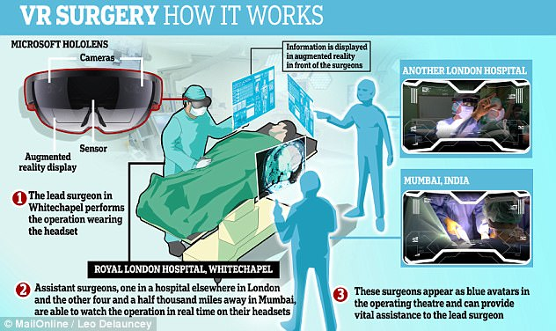

**FIG. 1 Schematic diagram of VR surgery in Royal Hospital, London**

Interventional medical engineering is one of the important contributions of medicine to human civilization at the end of the 20th century. The extensive application of interventional surgery makes the original surgical teaching and training system face severe challenges. Interventional surgery is usually highly dependent on a variety of functional surgical instruments and has detailed requirements for complex surgical procedures. These are unmatched by traditional surgery. The experience of European and American countries shows that virtual environment with VR technology assisted display, as an advanced training means, can provide efficient training for surgeons.Moreover, the skill of the surgeon can be quantitatively evaluated. The promotion of virtual surgery system has a revolutionary impact on the modern medical teaching and training system, which greatly alleviates the contradiction between the backward traditional medical teaching and the rapidly developing interventional surgery technology.

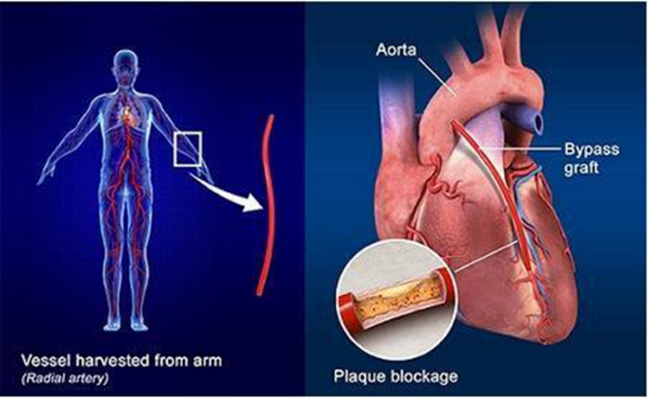

**FIG. 2 Principles of interventional surgery**

At present, the development of virtual surgery technology in China is in the initial stage, and no domestic enterprises have set foot in this field. Especially in the simulation of intravascular interventional surgery, due to the complexity and particularity of the surgery itself, there are high technical requirements for the design, development and implementation of the system, which sets a high threshold for domestic enterprises to enter this field. At present, only a few companies in the United States, Israel, Sweden and other countries can develop and implement the vascular interventional surgery simulation system, so the research and development of a real domestic cardiovascular interventional surgery simulation system has a great market value and application prospect.

In this project, magnetic navigation equipment and medical HD camera are used to build the hardware platform required for surgery. At the software level, magnetic navigation algorithm, image processing algorithm and machine learning algorithm are used to respectively realize the functions of 3D data acquisition, image positioning, real-time warning and route prompt of surgical training.

Innovative:

1. In the current operation, multiple angles of X-ray coronary angiography images (two-dimensional inferred three-dimensional positions) are used, which will prolong the exposure time of X-ray, while electromagnetic navigation system can be used to display the three-dimensional position of medical devices with sensors in real time by tracking the position of sensors.Therefore, the electromagnetic navigation system for coronary interventional surgery can not only retain the advantages of minimally invasive surgery, but also eliminate the shortcomings of insufficient X-ray guidance information.

2. The intervention surgery training system can provide real-time surgery warning and training guidance, and doctors can carry out more operations in this set of training equipment, making progress in human-computer interaction.

3. The use of virtual reality technology and AR glasses is an innovation of traditional display technology, which makes the visual experience in surgical training more intuitive and realistic and can enhance the training effect of doctors.

[2. Overall solution]

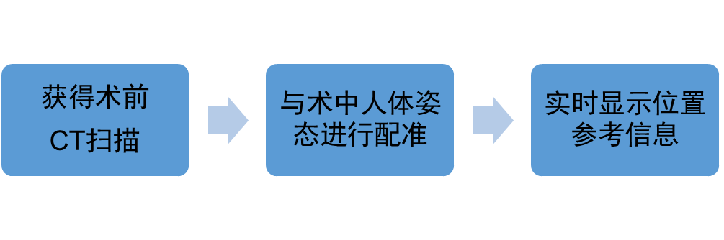

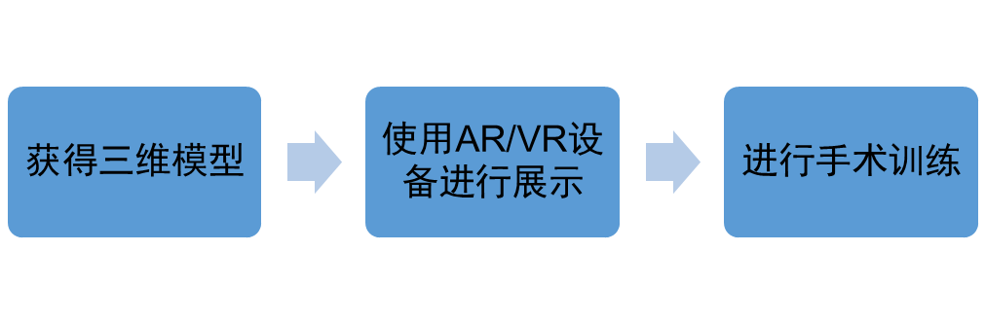

1. The magnetic navigation hardware is realized by the electromagnetic positioning system independently developed by the team: Aurora electromagnetic tracking system and Philips FD10X machine. The data is 3d point set.

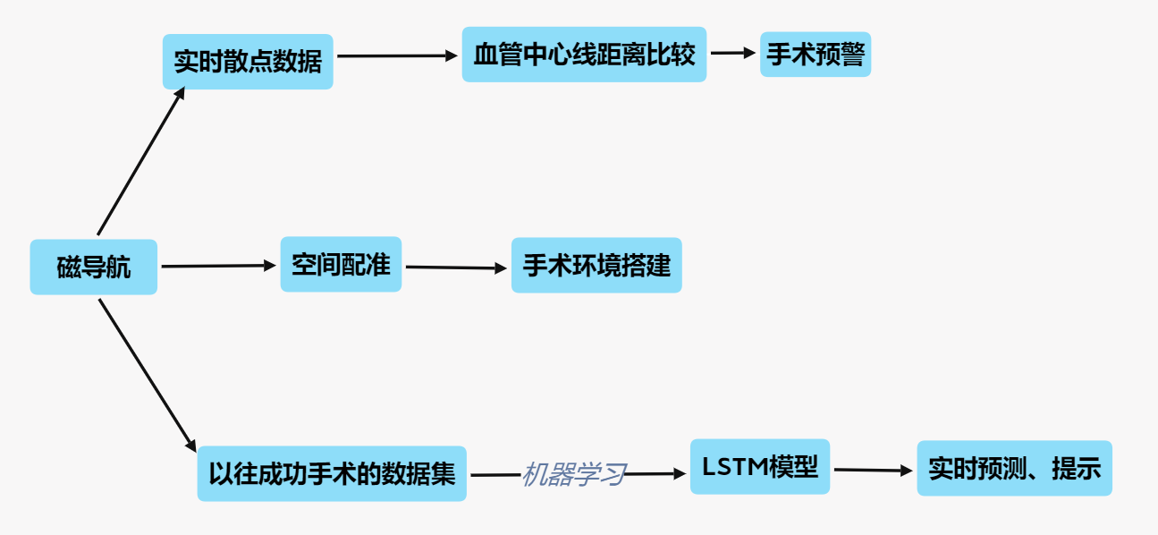

**Figure 3 Mind map of magnetic navigation process**

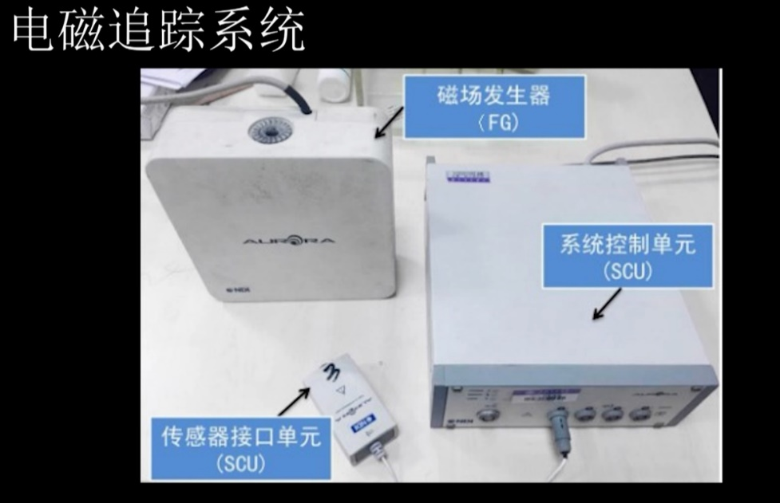

**Figure 4 Magnetic navigation equipment**

2. Surgical early warning technique, coronary image processing algorithm, vascular enhancement algorithm based on Hessian matrix eigenvalue analysis, and Dijkstra algorithm to extract three-dimensional coronary centerlines.

3. Path navigation method, using machine learning algorithm to train THE LSTM model.

4. Image positioning method in virtual reality technology, AR image processing algorithm is applied. Through high-frequency image scanning of medical camera, the 3D model in the software can be positioned to the real surgical environment.

[3. Method Content]

1. Preoperative data analysis of 4D CT modeling, extraction and segmentation of cardiac coronary artery in CT modeling: obtain 3d model files of surgical objects, and segmentation modeling is more applicable than overall modeling.

Image segmentation is the technique and process of dividing an image into several specific and unique regions and proposing the object of interest. The purpose of image segmentation is to simplify or change the representation of the image to make it easier to understand and analyze. There is no unified solution to the image segmentation problem, and this technique usually needs to be combined with the knowledge of related fields, so as to solve the image segmentation problem in this field more effectively.

By processing the medical image data obtained in the process of patient diagnosis, CT can be used to segment the accurate human organs and tissues, so as to establish the digital virtual human database.

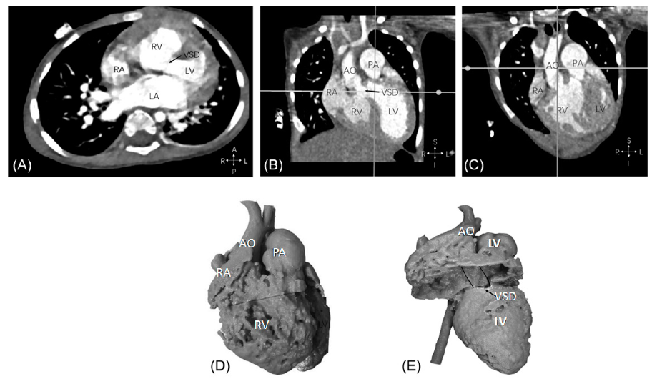

**FIG. 5 Modeling by 4D-CT scan of the heart**

1. Camera AR image positioning: to scan the 3 d model of positioning to the real operation on the object, you need to use the performance good medical camera to real-time scanning operation environment, to extract the primary, the positioning of the landmark at the software level to AR image processing algorithm is used, the visual effect of the model to manipulate the perspective transformation. The expected ideal situation is the high-precision coincidence between AR image and real image, and the movement within a small range does not affect the accuracy and accuracy of the coincidence when the physician wears AR glasses.

Implementation idea: Projection of OpenGL images into OpenCV.

Two cameras: the camera used in OpenGL, and a real camera

Two world coordinates: OpenGL, OpenCV (or real world).

The camera in OpenGL is used to simulate the actual camera in use (internal and external), and the two world coordinates are coincident at the same time, so that objects in OpenGL can be rendered to the position we specify.

The specific process

1. The arUCO module is used to calibrate the real camera to get the internal and external parameters of the real camera
2. Use OpenCV to get the location of the real camera (i.e. Rvec&tvec)

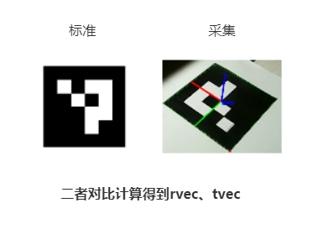

View Matrix is calculated by RVEC and TVEC to move OpenGL camera

The form of View Matrix is:

Where R is the rotation matrix of 3x3, t is the translation matrix of 3x1; View Matrix is 4x4 Matrix.

After that, the two world coordinate systems need to be processed by matrix transformation.For example, in the figure below, the two coordinate systems have the same X-axis direction, and the Y-axis and z-axis are opposite, so we only need to reverse the Y-axis and z-axis.

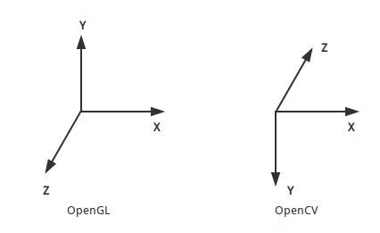

**FIG. 6 Coordinate system (Matrix Transformation)**

The final effect of this project is as follows:

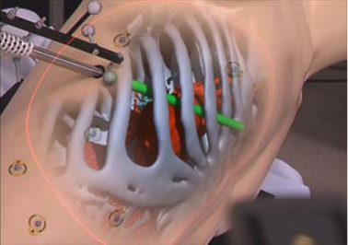

**Figure 7. The team has implemented laparoscopic surgery**

1. Intraoperative X-ray registration analysis of the probe was used to complete intraoperative coordinate calibration of the probe in preoperative modeling: the probe was used to select the vertices of the operating cuboid space respectively, and each vertex was marked corresponding to the magnetic detection space, so as to achieve one-to-one correspondence between the real space and the virtual space and complete coordinate calibration.

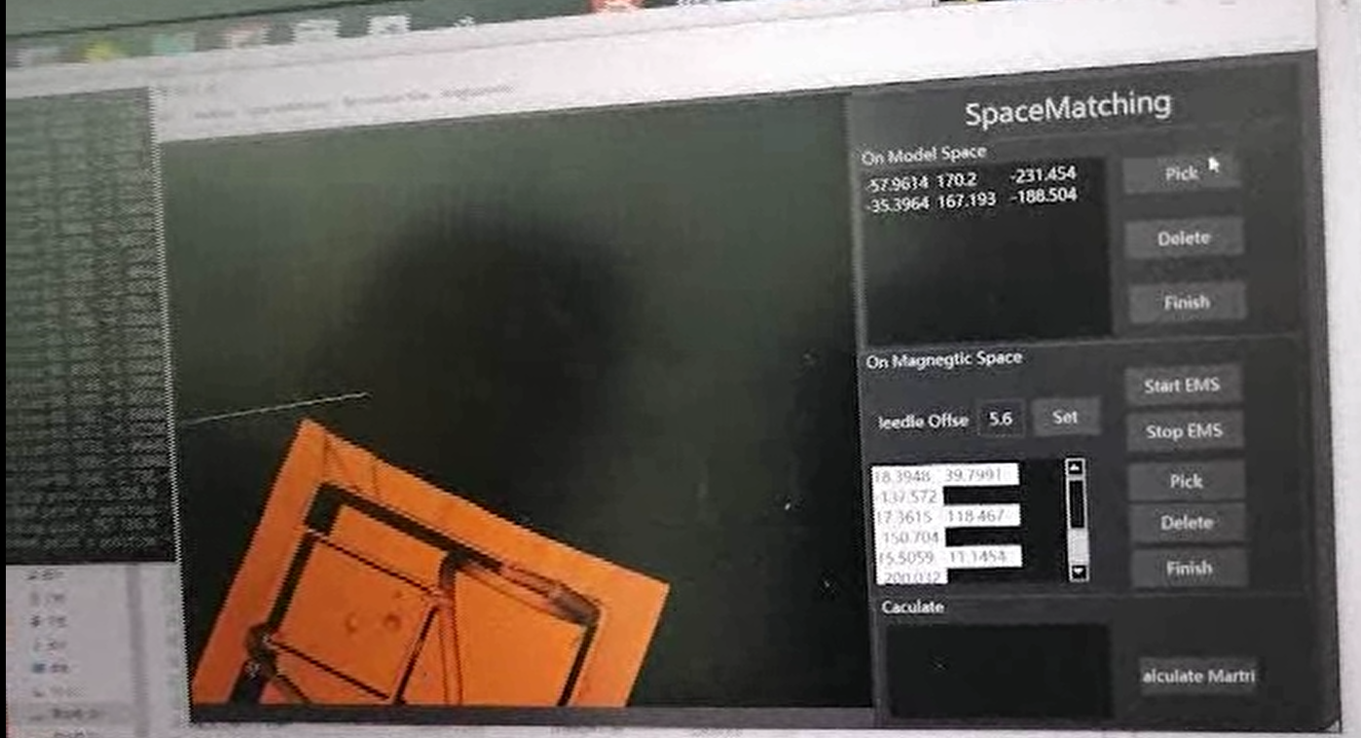

**FIG. 8 UI interface of registration software**

1. Intraoperative continuous magnetic navigation data analysis and warning: The 3D coordinate information of the magnetic probe is recorded at a sampling rate of 60Hz and stored with the data type of Kdtree.Preoperative coronary image processing algorithm is a vessel enhancement algorithm based on Hessian matrix eigenvalue analysis, and Dijkstra algorithm is used to extract three-dimensional coronary centerlines.This function is to calculate the distance r between the probe position and the vessel center line in real time. If the distance R is greater than the vessel radius r here, it means that the catheter in the operation has touched the vessel wall at the moment and deformed. The training system will issue warning instructions, reminding the physician to adjust the catheter position immediately.

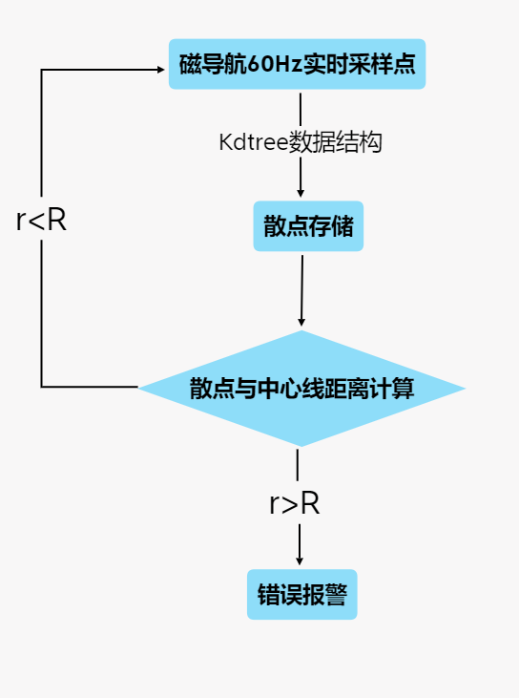 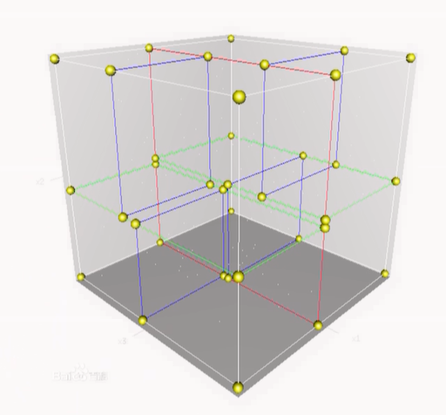

**FIG. 9 Center line distance monitoring and alarm flow chart**

1. Intraoperative route planning: For a specific set of surgical training equipment, experienced surgeons will first perform correct surgical operations on the equipment, and after repeated for a certain number of times, the correct data will be used for machine learning to train the LSTM model. After the successful training of the model, the location data was collected at the sampling rate of 60Hz during the formal training, which was then substituted into the model in real time, and the next location information prediction was calculated through the model and fed back to the doctors in the training.

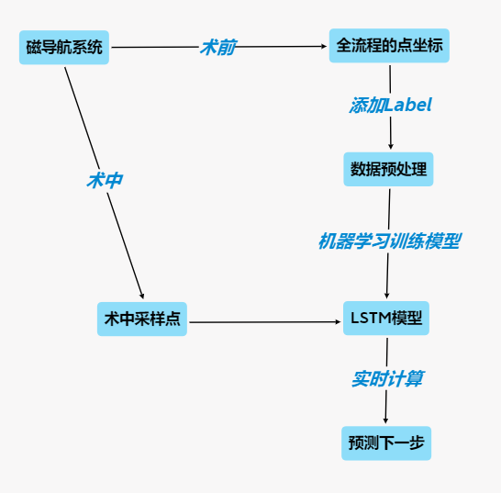

**FIG. 10 Flow chart of route planning machine learning algorithm**

1. Optimize the whole software: select the appropriate image processing algorithm, improve the positioning accuracy of camera image; Test the reliability of machine learning model, increase the amount of training data, and constantly adjust; Choose an appropriate balance point between delay and sampling rate, and give consideration to both processing speed and calculation accuracy.
2. Construction of human-computer interaction interface: The display of the training system will be presented together with AR glasses through the traditional screen, which provides the most basic information display, ensures the stability of training and enables cooperating physicians to understand the situation at the same time.Basic key functions such as magnetic probe coordinate calibration button, image display switch button and Angle adjustment button are expected to be arranged on the instrument connected with the display screen. On the other hand, AR glasses are only used for image display, instead of actually controlling images, because they can make them lighter and easier to use, and provide a more intuitive and realistic display effect than traditional displays.

[4. Conclusion and Improvement Direction]

This work can directly register the catheter or guide wire, with better accuracy.The machine learning algorithm of LSTM model and the distance algorithm of blood vessel center line based on Kdtree data type realize real-time warning and auxiliary guidance of surgical training.At the same time, the application of virtual reality technology can enhance the visual degree of surgery, improve the training effect of doctors.

Prospect analysis: In order to assist in coronary intervention surgery, this work is a space registration technology scheme applicable to the electromagnetic navigation system of coronary intervention surgery. However, it has only undergone model verification now. The future improvement directions of the project are as follows:

1. Add more sensors to improve the accuracy of cardiovascular surgery simulation, such as catheter direction and other issues, and handle branches well.

2. Perform performance optimization on the level of software, practice human-computer interaction, adjust it according to users' perception, and strive for practicality and ease of use.

3. Add operation information display function on AR glasses and display screen to make the system more practical.AR system development based on Unity combined with HoloLens.

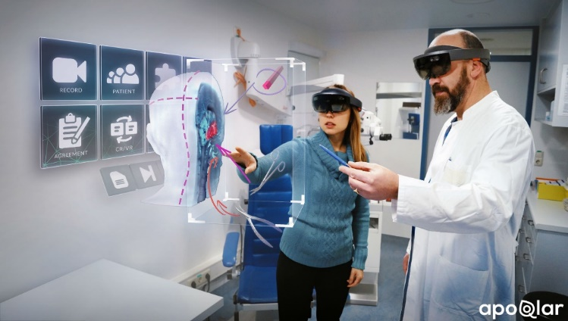

**Figure 11 Surgical information display (Hololens)**

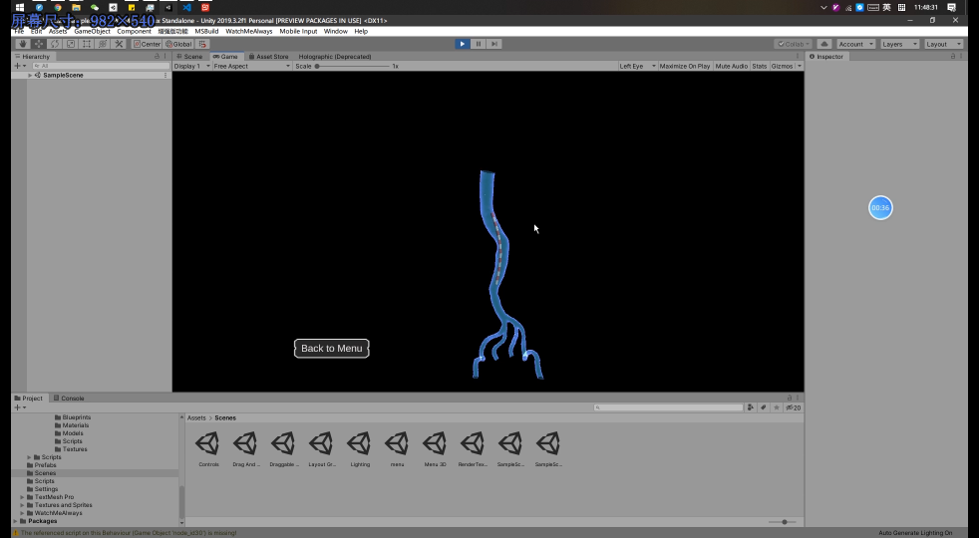

**Figure 12 Unity AR system development**