**Simulated genotype data**

n=1000 # sample size

p1=0.17 # allele frequency of the cis-SNP

pC=0.13 # allele frequency of the causal variant

r=0.8 # LD correlation between the cis-SNP and causal variant

p2=0.5 # allele frequency of the trans-SNP

m=1000 # number of simulation

Qsq=0.5 # variance explained by the causal variant

Simulating data based on model y = mean + xC * b + e

where xC is the genotype variable of the causal variant with b being the effect size.

Analysis model: y = mean + x1*b1 + x2*b2 + x1*x2*b12 + e

Where x1 = cis-SNP, x2 = trans-SNP, x1*x2 = interaction between the two.

AONVA test (4 vs. 2 df test)

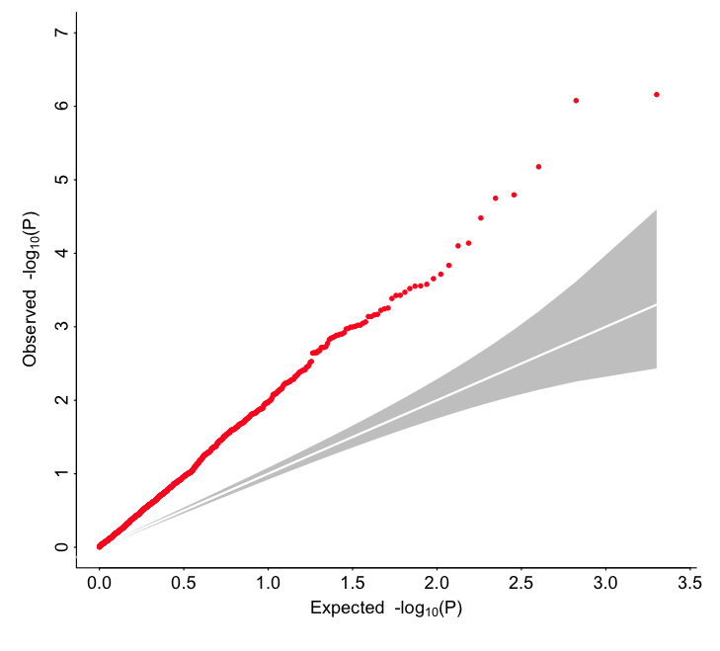

**ARIC data**

Trait: vWF

The ABO blood group locus on chr16 is known to explain > 10% of variance

“cis-SNP”: rs612169

“trans-SNPs”: all SNPs on chr22 with MAF > 0.01

ANOVA test for interaction (4 vs. 2 df test)

**QQ plot for the interaction test (7831 SNPs on chr22 with MAF > 0.01)**

**Smallest p-value: 2.2e-18**

