Lab 10
Roll Number : 244CA009
Name: Aryan Narang

Q1:
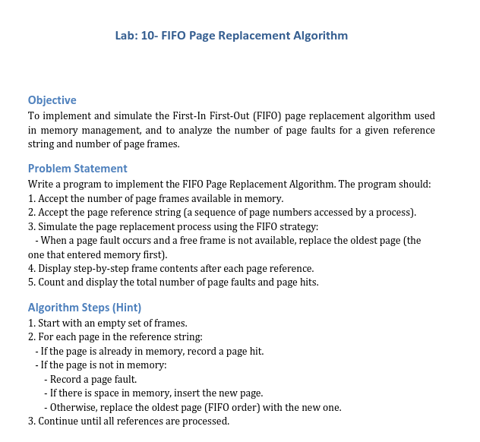

Output:
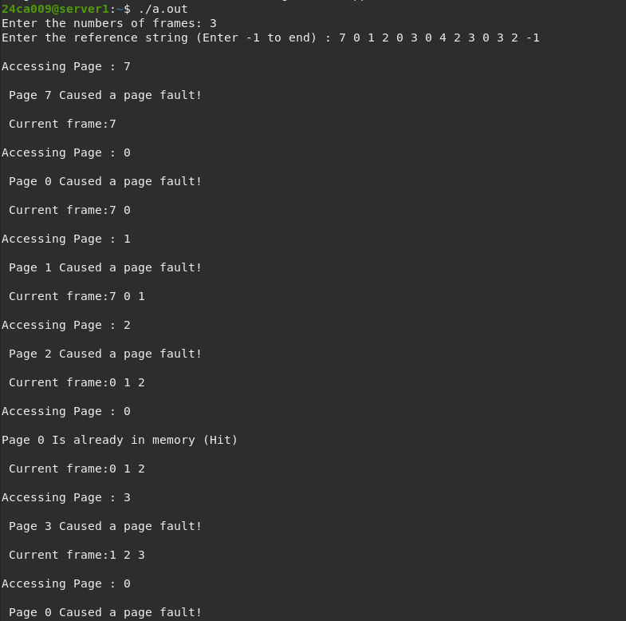
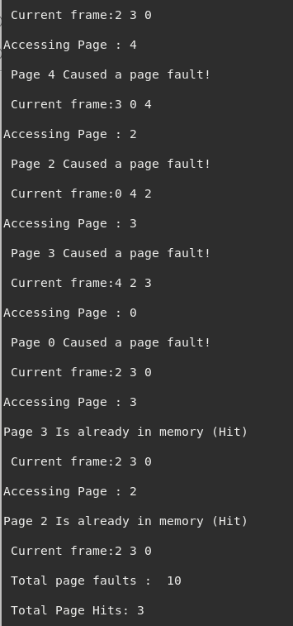

Code:
#include<iostream>
#include<vector>
#include<queue>
#include<unordered_set>
#include<iomanip>
using namespace std;
void fifopagereplacement(int numframes,const vector<int>& referenceString){
queue<int> frames;
unordered_set<int> pagesinmemory;
int pagefaults=0;
int pagehits=0;
for(int i =0;i<referenceString.size();i++){
int currentpage=referenceString[i];
cout<<"\nAccessing Page : "<<currentpage<<endl;
if(pagesinmemory.find(currentpage) != pagesinmemory.end()){
cout<<"\nPage "<<currentpage<<" Is already in memory (Hit)"<<endl;
pagehits++;

}
else{

cout<<"\n Page "<<currentpage<<" Caused a page fault!"<<endl;
pagefaults++;

if(frames.size()<numframes){

frames.push(currentpage);
pagesinmemory.insert(currentpage);
}
else{
int oldestpage=frames.front();
frames.pop();
pagesinmemory.erase(oldestpage);
frames.push(currentpage);
pagesinmemory.insert(currentpage);
}
}
cout<<"\n Current frame:" ;
queue<int> tempframes=frames;
while(!tempframes.empty()){
cout<<tempframes.front()<<" ";
tempframes.pop();
}
cout<<endl;

}
cout<<"\n Total page faults : "<<pagefaults<<endl;
cout<<"\n Total Page Hits: "<< pagehits<<endl;

}

int main(){

int numframes;
cout<<"Enter the numbers of frames: ";
cin>>numframes;
vector<int>referenceString;
int page;
cout<<"Enter the reference string (Enter -1 to end) : ";
while(cin>>page&& page!=-1){
referenceString.push_back(page);

}
fifopagereplacement(numframes,referenceString);

return 0;
}

